Review Article
Methodology for writing review articles in biological sciences: A systematic and scholarly guide

Abstract
Review articles (RA) play a central role in the advancement of biological sciences by synthesizing dispersed knowledge, identifying conceptual trends, evaluating methodological progress and proposing future research directions. Unlike primary research articles, reviews demand a high level of critical judgment, scholarly balance and methodological rigor in literature selection, organization and interpretation. In this aspect, there is a lack of easy methodological framework on how to write a review article on biological sciences. Therefore, present study provides a comprehensive, systematic and scholarly guide to writing high-quality review articles tailored to the standards of leading journals in biological sciences. It outlines the conceptual foundations, planning strategies, literature search methodology, critical synthesis approaches, structural organization, writing style, ethical considerations, contemporary software-supported workflows and quality assurance processes essential for producing authoritative and impactful reviews for a global readership. The article will be useful for researchers and scholars of biological sciences.
Keywords: Conceptual integration, critical appraisal, evidence synthesis, methodological rigor
Introduction
The exponential growth of scientific literature in biological sciences has made review articles (RAs) indispensable for researchers, educators, policymakers and interdisciplinary audiences (Khare et al., 2014). RAs distill vast bodies of research into coherent narratives, offering clarity, critical evaluation and intellectual integration. High-quality reviews do not merely summarize existing studies (Calderon et al., 2025). They contextualize findings, assess methodological strengths and weaknesses, reconcile conflicting evidence and generate new conceptual frameworks (Ghosh and Choudhury, 2025). Writing such reviews requires a structured methodology that is both systematic and scholarly (Amobonye et al., 2024). Despite the considerable importance of review articles (RAs) in the biological sciences, there remains a lack of clear, accessible methodological frameworks and many researchers face difficulties in writing effective RAs. Beginner researchers need to understand the structure and purpose of an RAs and how to write one properly. A well-written RA helps to synthesize existing knowledge in a specific subject, highlight limitations in current studies and clearly identify research gaps (Robinson et al., 2013). Present study is designed to support author(s) in developing review articles that meet rigorous expectations, emphasizing methodological transparency, intellectual depth and clarity of communication so that the review serves as a reliable reference point for a diverse and global scientific community.
Defining the scope and purpose of the review: The foundation of a successful review article lies in a clearly defined scope and purpose. Author(s) must begin by articulating the central theme, research domain and conceptual boundaries of the review. A well-defined scope ensures coherence, prevents superficial coverage and enables meaningful synthesis. The purpose of the review should be addressed in easy way. Reviews may aim to synthesize recent advances, critically evaluate competing hypotheses, integrate methodological developments, bridge sub-disciplines along with gaps identification and future work plans (Ward et al., 2009). The scope should balance breadth and depth of the selected subject for writing RAs. Overly broad reviews risk becoming descriptive and unfocused, while excessively narrow reviews may limit relevance (Whittemore and Knafl, 2005). Author(s) should consider the journal’s audience and ensure that the topic has conceptual significance and general interest within biological sciences. Keeping the mentioned aspects of scope and purpose, author(s) can write a good RA on desired subject (Murphy, 2012).
Conceptual framework and review design: A scholarly review requires an underlying conceptual framework that organizes the literature into a coherent structure (Figures 1-2).
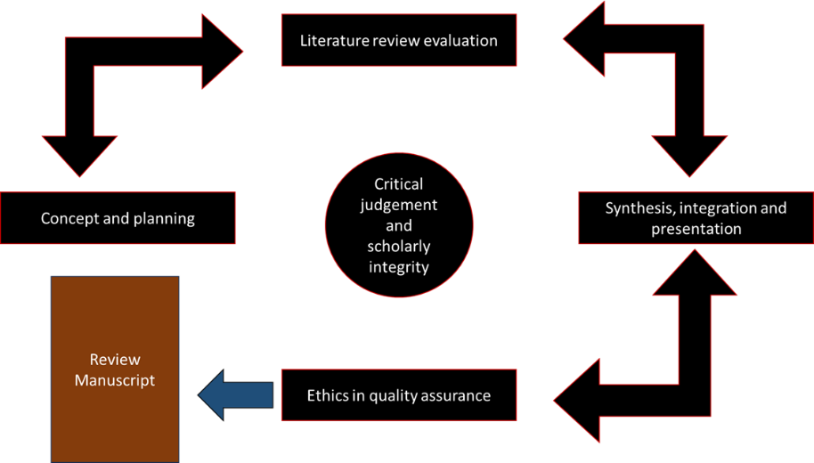
Figure 1: A systematic and scholarly workflow for writing review articles in biological sciences
This framework may be thematic, chronological, methodological, theoretical or problem-oriented depending on the nature of the topic. Before writing RAs, author(s) should design the review architecture by identifying the key concepts, variables, processes and methodological approaches that define the field. These elements form the backbone of the narrative and help integrate diverse studies into a unified perspective. Review design also involves deciding the type of review (Tranfield et al., 2023). Narrative reviews emphasize conceptual synthesis and interpretation, while systematic reviews prioritize methodological transparency and comprehensive coverage. In many biological contexts, high-impact reviews adopt a hybrid approach by combining a structured literature identification process with narrative critical analysis that integrates ideas, mechanisms and methodological evolution (Luft et al., 2022).
Literature search strategy: A rigorous and transparent literature search strategy is essential for credibility and completeness. Author(s) should identify relevant databases, keywords and search combinations that comprehensively capture the field. Search terms should reflect core concepts, synonyms, methodological variations and emerging terminology. Keywords are the most important aspects of writing RAs. Author(s) should make a list of keywords on the subject or title of the manuscript of RAs and search the literature from different databases and platforms. The search process should be iterative and allow refinement as familiarity with the literature increases. Author(s) should document the rationale for including or excluding studies, focusing on relevance, quality and contribution to the review’s objectives. Special attention should be given to seminal works, landmark studies and recent advances (Grewal et al., 2016; Kumar, 2025).
Example of literature search strategy: A well-structured literature search strategy is a critical first step in any scientific research, as it ensures the identification, evaluation and synthesis of existing knowledge relevant to the research topic (Gionfriddo et al., 2024). In studies related to medicinal plants, biodiversity, ethnobotany, phytochemistry, animal diversity, plant diversity and wetlands, literature searches must be interdisciplinary, systematic and comprehensive. Such searches typically integrate biological, ecological, chemical and socio-cultural perspectives. The strategy generally involves identifying appropriate databases, defining inclusion and exclusion criteria, selecting relevant keywords and Boolean operators and refining searches iteratively to capture both classical and recent scientific literature (Finfgeld-Connett and Johnson, 2013). For medicinal plant research, the literature search focuses on documenting plant species with therapeutic value, their traditional uses, pharmacological properties and conservation status.
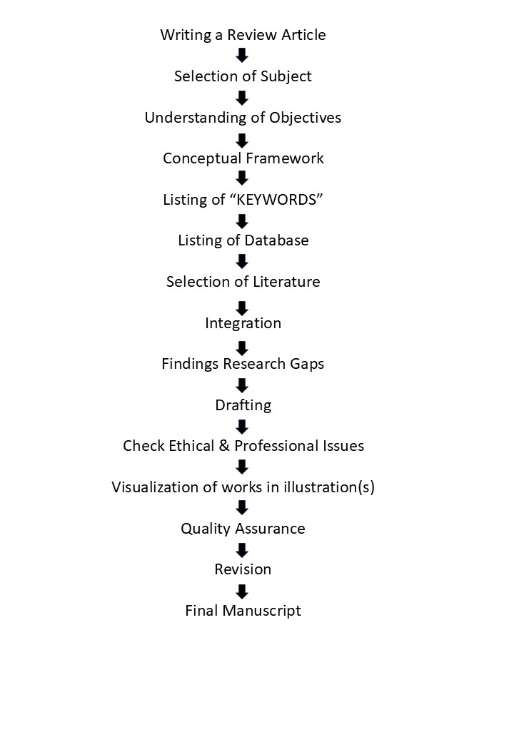
Figure 2: Systematic way to write a Review Article
Major databases such as PubMed, Scopus, Web of Science, Google Scholar, ScienceDirect and CAB Abstracts are commonly used. Searches often begin broadly and are then narrowed to specific taxa, regions or disease categories using Boolean operators (Farlane et al., 2022). Typical search keywords include “medicinal plants”, “herbal medicine”, “traditional medicine”, “plant-based drugs”, “ethnomedicine”, “medicinal flora”, “pharmacognosy” and “therapeutic plants.” These terms may be combined with geographic identifiers such as “India”, “Himalayas”, “Western Ghats”, “tropical regions” or “wetland ecosystems” using Boolean operators (AND, OR). A search string such as “medicinal plants AND traditional knowledge AND India” helps retrieve region-specific ethnomedical studies. Inclusion criteria may prioritize peer-reviewed articles, review papers, ethnobotanical surveys and pharmacological studies published within the last 20-30 years, while excluding non-scientific sources or poorly documented reports. In the context of biodiversity research, the literature search strategy aims to assess species richness, ecosystem diversity, genetic diversity, threats and conservation measures. Biodiversity-related literature spans ecology, taxonomy, conservation biology and environmental science. Key databases include Biodiversity Heritage Library, GBIF, IUCN Red List, JSTOR, SpringerLink and Wiley Online Library (Shanmughavel, 2007). Commonly used keywords are “biodiversity”, “biological diversity”, “species richness”, “ecosystem diversity”, “alpha diversity”, “beta diversity”, “gamma diversity”, “biodiversity hotspots”, “endemism”, “species distribution” and “conservation biology.” These may be paired with habitat-specific terms such as “wetlands”, “forests”, “grasslands” or “aquatic ecosystems.” Search strings like “biodiversity assessment AND wetlands” or “species richness AND tropical ecosystems” allow for targeted retrieval of ecological studies. Grey literature, including reports from conservation organizations and government agencies, is also valuable for biodiversity research and may be included after careful evaluation. For ethnobotanical studies, literature searches emphasize the relationship between humans and plants, especially traditional knowledge systems related to plant use for medicine, food, rituals and livelihoods. Ethnobotanical literature is often found in interdisciplinary journals and regional publications. Databases such as Anthropological Index Online, PubMed, Scopus, Google Scholar and local university repositories are particularly useful (Falagas et al., 2008; Gusenbauer and Haddaway, 2020; Sulaiman, 2025). Search keywords typically include “ethnobotany”, “traditional plant knowledge”, “indigenous knowledge”, “folk medicine”, “tribal medicine”, “plant use patterns”, “cultural ethnobotany” and “ethnopharmacology.” These terms are frequently combined with social identifiers such as “tribal communities”, “indigenous people”, “rural communities” or specific ethnic group names. For example, “ethnobotany AND tribal communities AND medicinal plants” yields studies documenting indigenous plant knowledge. Ethnobotanical searches may also include older literature, as classical surveys often provide baseline data that remain relevant for contemporary research. The phytochemical literature search focuses on identifying bioactive compounds present in plants, their chemical characterization, extraction methods, and biological activities. This area is highly technical and relies heavily on chemistry and pharmacology databases such as PubChem, SciFinder, PubMed, ScienceDirect and SpringerLink (Pitchai et al., 2010; Ming et al., 2013; Kim et al., 2016; Kim, 2016; Southan, 2018). Common search keywords include “phytochemistry”, “secondary metabolites”, “alkaloids”, “flavonoids”, “terpenoids”, “phenolic compounds”, “plant extracts”, “bioactive compounds”, “GC-MS analysis”, “HPLC” and “LC-MS.” These keywords are often combined with specific plant species names or genera to retrieve targeted studies. For instance, a search query such as “phytochemical screening AND medicinal plants” helps identify research on plant-based chemical constituents. Inclusion criteria typically emphasize experimental studies, analytical methods and peer-reviewed chemical analyses, while excluding non-empirical or anecdotal reports. In studies addressing animal diversity, the literature search aims to document faunal composition, species abundance, habitat associations and conservation status. Relevant databases include Zoological Record, Web of Science, Scopus, IUCN Red List and GBIF (Ball-Damerow et al., 2019; Heberling et al., 2021; Steinke et al., 2025). Frequently used keywords include “animal diversity”, “faunal diversity”, “species composition”, “vertebrate diversity”, “invertebrate diversity”, “wildlife ecology”, “faunal assessment”, “population dynamics” and “habitat preference.” These are often paired with habitat-specific terms such as “wetlands”, “forests”, “riverine systems” or “protected areas.” A search string like “animal diversity AND wetland ecosystems” retrieves studies focused on faunal assemblages in aquatic habitats. Long-term monitoring studies and biodiversity inventories are particularly valuable sources in this field. For plant diversity research, literature searches focus on floristic composition, vegetation structure, community ecology and conservation status of plant species. Key databases include JSTOR, Scopus, Web of Science, Botanical Survey reports and regional floras (Rhee and Crosby, 2005; Molina-Venegas et al., 2021; Xiao et al., 2023; Wagensommer, 2023). Typical search keywords are “plant diversity”, “floristic diversity”, “vegetation analysis”, “plant community structure”, “species composition”, “floristic survey”, “phytosociology” and “endemic plant species.” These may be combined with geographic or habitat descriptors such as “wetlands”, “forest ecosystems”, “alpine regions” or “coastal areas.” Searches like “plant diversity AND wetland vegetation” help identify habitat-specific plant studies. Classical floras and taxonomic monographs are often included to ensure accurate species identification and nomenclature. In wetland-related research, literature searches are inherently multidisciplinary, encompassing ecology, hydrology, biodiversity, ecosystem services and conservation management. Databases such as Scopus, Web of Science, Wetlands International publications, Ramsar Convention documents and Google Scholar are commonly used (Xu et al., 2019; Bridgewater and Kim, 2021; Yadav and Goyal, 2022; Alikhanova and Bull, 2023; Zhao et al., 2025). Search keywords include “wetlands”, “wetland ecosystems”, “marshes”, “swamps”, “floodplains”, “aquatic vegetation”, “wetland biodiversity”, “ecosystem services”, “wetland conservation” and “Ramsar sites.” These terms are often combined with biological components such as “plant diversity”, “animal diversity” or “medicinal plants.” For example, “wetlands AND biodiversity conservation” retrieves studies addressing ecological significance and management strategies. Both scientific articles and policy documents are important sources in wetland research.
Selection and evaluation of literature: Not all published studies contribute equally to a scholarly review. Therefore, rigorous literature selection demands critical appraisal rather than mere inclusion. Academic integrity requires systematic evaluation of the quality, methodological robustness and interpretative validity of each source. Authors should carefully examine experimental or study design, sample size adequacy, analytical techniques, reproducibility of findings and conceptual coherence. Importantly, conflicting or divergent findings must be acknowledged and integrated rather than excluded, as they often reveal theoretical gaps or methodological limitations within the field. Such critical analysis strengthens the intellectual depth of the review and reflects scholarly maturity. While priority should be given to peer-reviewed publications, well-established reports, theoretical contributions and relevant methodological guidelines may also be incorporated where appropriate (Mostafapour et al., 2024; Figure 3).
Synthesis and critical integration: Synthesis is the defining contribution of an excellent review (Figure 4). A review becomes influential not when it accumulates summaries of individual studies, but when it transforms a dispersed literature into a coherent account of what is known, how it is known, why disagreements persist, and what can be done next as future research works in biological sciences.
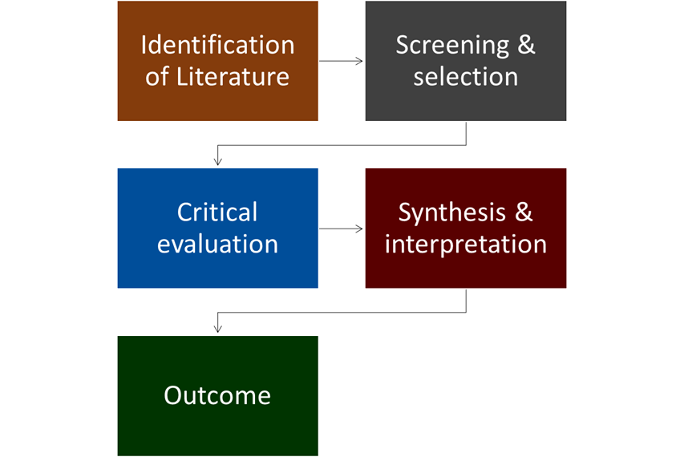
Figure 3: Literature Selection & Evaluation Framework
Critical synthesis, therefore, requires more than summarization. It requires selecting an organizing logic, interrogating evidence quality, tracing mechanisms and building integrative claims that remain faithful to underlying data while advancing understanding (Barnett-Page and Thomas, 2009).
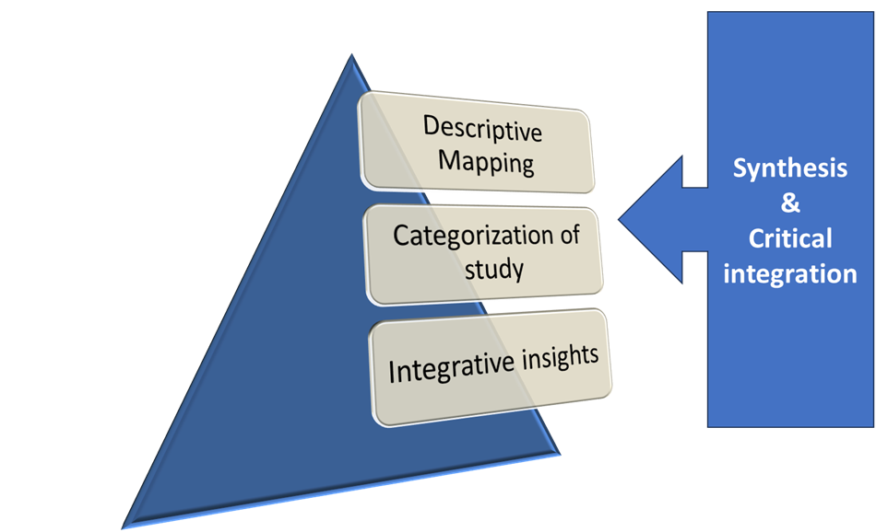
Figure 4: Levels of synthesis and critical integration
A strong approach to synthesis is to work in levels which are followings:
- The first level establishes a descriptive map of the field by grouping studies into meaningful categories such as biological level of organization, organismal system, experimental paradigm, data type or analytical approach.
- The second level evaluates the internal validity and external generalizability of each category by examining study design, sampling decisions, measurement fidelity and analytical assumptions.
- The third level integrates across categories to infer patterns, boundary conditions and candidate mechanisms.
Comparative logic is central to synthesis. Author(s) should explicitly compare studies that appear similar but yield different conclusions and identify the dimensions along which they differ, such as experimental context, species or population characteristics, environmental conditions, time scales, statistical models or definitions of key constructs. Many apparent contradictions in biological sciences arise from hidden heterogeneity, including differences in life history, spatial and temporal resolution, trait measurement, laboratory versus field context and unmeasured covariates that shift effect direction. Through the addition of the above dimensions, the review converts conflict into insight, clarifies where consensus genuinely exists and identifies circumstances under which findings can be expected to replicate. A robust synthesis also addresses methodological drift and analytic flexibility. In many biological domains, the same research question can be operationalized through different proxies, endpoints or statistical frameworks, each carrying distinct assumptions. Good reviews should evaluate how these choices shape conclusions, including sensitivity to preprocessing decisions, model specification, covariate selection, phylogenetic correction where relevant, multiple testing procedures and the handling of missing data. Where possible, reviews should highlight convergent evidence from independent methods, such as experimental manipulation, comparative observational designs, genetic inference and mechanistic modelling, because convergence across methods often provides stronger support than repetition within a single methodological tradition (Clement, 2022).
Contemporary models, software and techniques that support high-quality reviews: Contemporary RAs writing increasingly benefit from a structured workflow supported by specialized software and computational techniques. These tools do not replace scholarly judgment, but they can improve efficiency, transparency and reproducibility when used thoughtfully and ethically (Brittain et al., 2020). For literature discovery, organization and deduplication, reference managers remain foundational. Platforms such as Zotero, EndNote and Mendeley support importing records from databases, managing full-text PDFs, tracking annotations and maintaining consistent bibliographic metadata. Complementing these, semantic discovery and literature-mapping platforms help to identify influential clusters, emerging themes and related work across disciplines, which is especially useful when terminology changes over time or when a field spans multiple sub-communities that rarely cite each other. Screening and collaboration are often the most time-intensive phases of a review. Dedicated review-management platforms such as Rayyan and Covidence support blinded dual screening, conflict resolution, tagging and structured data extraction. Machine learning-assisted screening is increasingly used to prioritize likely-relevant records while maintaining transparent human oversight, particularly when initial searches yield thousands of records. Open-source tools such as ASReview offer active-learning workflows that can accelerate screening in large datasets while keeping the human reviewer in control of inclusion decisions. For synthesis development, bibliometric and science-mapping methods can complement close reading by revealing structural features of a literature. Tools such as VOSviewer and packages such as bibliometrix can visualize co-citation patterns, co-authorship networks and keyword co-occurrence. Finally, responsible use of generative artificial intelligence is emerging as a practical consideration. When journal policies permit, AI systems may assist with early-stage tasks such as generating alternative outlines, suggesting search-term expansions or improving sentence clarity. However, AI outputs must be treated as unverified drafts. Author(s) remain responsible for factual accuracy, balance and originality and should apply safeguards such as verification against primary sources, avoidance of fabricated claims and transparent disclosure when required (Schmidt et al., 2021).
Structural organization of the review: A clear and logical structure enhances readability and comprehension during the writing of RAs. They typically follow a hierarchical organization, beginning with a broad context and progressively focusing on specific themes or mechanisms. An effective structure includes an introduction that establishes relevance, main sections organized around key concepts or questions and a concluding section that synthesizes insights and outlines future perspectives. Subsections should be balanced and reflect their relative importance. Transitions between sections are essential for narrative flow. Author(s) should guide readers through the intellectual progression of the review, explicitly linking sections and reinforcing the overarching framework (Gülpınar and Güçlü, 2013)
Writing style and scholarly tone: The writing style of a review article should be precise, clear and accessible to an international audience. Author(s) should avoid unnecessary jargon, define specialized terms and use consistent terminology throughout the manuscript. A scholarly tone balances authority with objectivity. Assertions should be reasoned and nuanced. Paragraphs should focus on a single central idea, introduced by a topic sentence and developed through explanation and analysis. Varied sentence structure, consistent tense usage and careful signposting of arguments enhance clarity and engagement for a wide readership (Ghosh and Choudhury, 2025).
Ethical and professional considerations: Ethical integrity is an important part of writing RAs. Author(s) must ensure accurate representation of original studies and avoid misinterpretation or selective reporting. Balanced discussion of competing viewpoints reflects intellectual honesty and respect for the scientific process. Plagiarism, including self-plagiarism, must be strictly avoided. Even when summarizing widely known concepts, author(s) should use original phrasing and contribute genuine analytical perspectives. Transparency in methodology and acknowledgment of limitations strengthen credibility. Collaborative reviews should define authorship roles and responsibilities clearly to ensure accountability and coherence. Before using the published illustrations and photos, there is a need to obtain permission from the authors and give proper citations (Carver et al., 2011).
Visual and conceptual aids: Figures, tables and conceptual diagrams can greatly enhance the explanatory power of a review by synthesizing information and clarifying complex relationships. Visual aids should support the conceptual framework of the review, illustrate mechanisms and summarize evidence patterns rather than merely reproduce results. Effective visuals should be clear, well-labelled and integrated into the narrative, with captions that explain purpose and interpretive value. Thoughtful visuals can broaden accessibility for global readers and help communicate central ideas efficiently (Traboco et al., 2022). Therefore, illustrations are essential for writing good RAs.
How to use published photos and illustrations: When preparing a review article, the use of photographs, diagrams, graphs and other illustrations from previously published sources must follow strict ethical and legal standards (Vaidyanathan, 2022). The primary precaution is to respect copyright ownership, as most published figures are protected intellectual property of the publisher or author. Authors should never assume that a figure can be freely reused simply because it is publicly accessible (Mondal, 2025). Before incorporating any image or illustration from an existing publication, it is essential to verify the copyright status of the material and the licensing terms under which it was published (Huh, 2012; Morrison and Desautels, 2016). One of the most appropriate ways to use illustrations from published papers is through proper citation and attribution. Whenever a figure or photograph is reproduced or adapted, the source must be clearly acknowledged in the figure caption. Typical attribution statements include phrases such as “Reproduced with permission from…” or “Adapted from…” followed by the complete citation of the original article. Failure to provide accurate attribution constitutes plagiarism, even if the original authors are cited elsewhere in the text. Citations must correspond exactly to the reference list of the review article. A critical precaution is to determine whether formal permission is required (Liberati et al., 2009; Backhouse, 2023). For figures published under traditional copyright, explicit permission must usually be obtained from the publisher via permission-request platforms such as Rights Link or Copyright Clearance Centre. The permission request should specify how the figure will be used (e.g., reuse in a review article, print and online formats). Documentation of granted permissions should be retained, as journals may request proof during the submission or review process (Huh, 2012). In contrast, figures published under Open Access licenses, particularly Creative Commons (CC) licenses, may be reused without formal permission provided that license conditions are met. For example, a CC BY license allows reuse, adaptation and redistribution as long as proper credit is given. However, licenses such as CC BY-NC restrict commercial use and CC BY-ND prohibit modifications. Authors must carefully read the specific Creative Commons license and ensure that their intended use complies with its terms (Calder and Yngve, 2012; Mondal, 2025). An ethically preferred practice in review articles is to redraw or recreate figures rather than directly copying them. Conceptual diagrams, workflows, summary charts and graphical models can be recreated using the original design while conveying the same scientific information. When redrawing, the figure should still acknowledge the source with a caption such as “Concept redrawn and modified based on…”. This approach minimizes copyright concerns and demonstrates scholarly synthesis rather than replication (Sharma and Singh, 2011; Masic, 2014; Resnik and Shamoo, 2017; Lalwani, 2025; Quaia, 2025). Photographs, especially those depicting organisms, field sites, laboratory setups or microscopic images, require special caution. Field photographs may involve ethical considerations related to biodiversity conservation, endangered species or indigenous knowledge. If photographs include identifiable people or culturally sensitive materials, consent and ethical approval may be required. Authors should avoid using images that could misrepresent ecological conditions or cultural practices. When possible, using author-generated photographs or images from trusted open repositories is strongly recommended (Ghasemi and Dehpour, 2009; Forero et al., 2021). Another important precaution is to avoid excessive or unnecessary figure reuse. Review articles should use illustrations strategically to enhance understanding, not to replicate entire sections of previously published work. Overuse of reproduced figures may raise concerns about originality and may be discouraged by journals. Figures should be selected only when they add substantial interpretative or comparative value to the review (Honeyman-Buck, 2016; Prager et al., 2019; Puljak and Lund, 2023; Standvoss et al., 2024). Maintaining scientific accuracy and contextual integrity is also essential. Figures should not be taken out of context or used in a way that alters their original meaning. If data are summarized or modified, the changes must be clearly explained in the caption or text (Bebeau et al., 1999; Chen et al., 2024). Misrepresentation of original results, whether intentional or accidental, is considered scientific misconduct (Resnik and Stewart, 2012). Journal-specific guidelines must always be followed. Most journals provide detailed instructions regarding figure reuse, permissions and acceptable formats. Authors should carefully review the “Instructions for Authors” section of the target journal before submission. Some journals allow limited reuse of figures under fair use policies, while others require explicit permission regardless of usage extent (Divecha et al., 2023).
Revision, refinement and quality assurance: Revision is a critical stage in the writing of RAs. Author(s) should evaluate the manuscript for logical consistency, completeness and narrative coherence. Revisions should strengthen synthesis, refine arguments and improve clarity. Language quality is especially important for a global readership. Grammar, syntax and punctuation should be carefully reviewed to ensure professionalism and readability. Feedback from colleagues with complementary expertise can identify blind spots and improve balance. Final quality assurance includes aligning the manuscript with the journal’s scope, stylistic standards and expectations for conceptual contribution (De Cassai et al., 2025).
Conclusion
Drafting a high-quality review article in biological sciences demands methodological rigour, critical insight and clear communication, which is a true scholarly challenge. Addressing a systematic approach to scope definition, literature selection, synthesis and presentation, author(s) can produce RAs that advance the understanding of the subject and will be helpful in future research. As biological research continues to expand and diversify, the role of well-crafted RAs becomes increasingly vital. Methodologically sound and intellectually integrative reviews not only summarize knowledge but also shape scientific discourse. Using the principles and contemporary workflow practices outlined here, author(s) can contribute enduring works that serve the global biological community.

Disclaimer (Artificial Intelligence)
Authors hereby declare that ChatGPT 5.2 is used to get ideas and edit the write-up during the writing of the manuscript.

References

Alikhanova S and Bull JW. (2023). Review of Nature-based Solutions in Dryland Ecosystems: the Aral Sea Case Study. Environ Manage. 72(3): 457-472.

Amobonye A, Lalung J, Mheta G and Pillai S. (2024). Writing a Scientific Review Article: Comprehensive Insights for Beginners. Scientific World Journal. 2024: 7822269. doi: 10.1155/2024/7822269

Backhouse SH. (2023). A Behaviourally Informed Approach to Reducing the Risk of Inadvertent Anti-doping Rule Violations from Supplement Use. Sports Med. 53(S1):67-84.

Ball-Damerow JE, Brenskelle L, Barve N, Soltis PS, Sierwald P, Bieler R, LaFrance R, Ariño AH and Guralnick RP. (2019). Research applications of primary biodiversity databases in the digital age. PLoS One. 14(9):e0215794. doi: 10.1371/journal.pone.0215794.

Barnett-Page E and Thomas J. (2009). Methods for the synthesis of qualitative research: a critical review. BMC Medical Research Methodology. 9: 59. doi: 10.1186/1471-2288-9-59

Bebeau MJ, Rest JR and Narvaez D. (1999). Beyond the promise: A perspective on research in moral education. Educational Researcher. 28(4):18–26.

Bridgewater P and Kim RE. (2021). 50 Years on, w(h)ither the Ramsar convention? A case of institutional drift. Biodivers Conserv. 30(13):3919-3937.

Brittain S, Ibbett H, de Lange E, Dorward L, Hoyte S, Marino A, Milner-Gulland EJ, Newth J, Rakotonarivo S, Veríssimo D and Lewis J. (2020). Ethical considerations when conservation research involves people. Conservation biology: the journal of the Society for Conservation Biology. 34(4): 925–933.

Calder PC and Yngve A. (2012). Open access, the creative commons attribution licence, and the Nutrition Society journals. Public Health Nutr. 15(12):2167-8.

Calderon ME, Ghattas HPE, Salolin VVP, García-González OY, Fermin MMD, Rueda CDE, Campos CT, Sanchez CC and Teran HC. (2025). A comprehensive guide to conduct a systematic review and meta-analysis in medical research. Medicine. 104(33): e41868. doi: 10.1097/MD.0000000000041868

Carver JD, Dellva B, Emmanuel PJ and Parchure R. (2011). Ethical considerations in scientific writing. Indian Journal of Sexually Transmitted Diseases and AIDS. 32(2): 124-128.

Chen Z, Chen C, Yang G, He X, Chi X, Zeng Z and Chen X. (2024). Research integrity in the era of artificial intelligence: Challenges and responses. Medicine. 103(27): e38811. doi: 10.1097/MD.0000000000038811.

Clement JJ. (2022). Multiple Levels of Heuristic Reasoning Processes in Scientific Model Construction. Front. Psychol. 13:750713. doi: 10.3389/fpsyg.2022.750713

De Cassai A, Dost B, Tulgar S and Boscolo A. (2025). Methodological standards for conducting high-quality systematic reviews. Biology. 14(8): 973. doi: 10.3390/biology14080973

Divecha CA, Tullu MS and Karande S. (2023). Utilizing tables, figures, charts and graphs to enhance the readability of a research paper. Journal of Postgraduate Medicine. 69(3): 125-131.

Falagas ME, Pitsouni EI, Malietzis GA and Pappas G. (2008). Comparison of PubMed, Scopus, Web of Science, and Google Scholar: strengths and weaknesses. FASEB journal: official publication of the Federation of American Societies for Experimental Biology. 22(2): 338–342.

Farlane AM, Rose RT and Shokraneh F. (2022). Search strategy formulation for systematic reviews: Issues, challenges and opportunities. Intelligent Systems with Applications. 15 (200091). https://doi.org/10.1016/j.iswa.2022.200091

Finfgeld-Connett D and Johnson ED. (2013). Literature search strategies for conducting knowledge-building and theory-generating qualitative systematic reviews. Journal of Advanced Nursing. 69(1): 194-204.

Forero DA, Curioso WH and Patrinos GP. (2021). The importance of adherence to international standards for depositing open data in public repositories. BMC Res Notes. 14(1): 405. doi: 10.1186/s13104-021-05817-z.

Ghasemi M and Dehpour AR. (2009). Ethical considerations in animal studies. J Med Ethics Hist Med. 2:12.

Ghosh A and Choudhury S. (2025). Understanding different types of review articles: A primer for early career researchers. Indian Journal of Psychiatry. 67(5): 535-541.

Gionfriddo MR, McClendon C, Nolfi DA, Kalarchian MA and Covvey JR. (2024). Back to the basics: Guidance for designing good literature searches. Research in Social and Administrative Pharmacy. 20(4): 463-468.

Grewal A, Kataria H and Dhawan I. (2016). Literature search for research planning and identification of research problem. Indian Journal of Anaesthesia. 60(9): 635-639.

Gülpınar Ö and Güçlü AG. (2013). How to write a review article? Turkish Journal of Urology. 39(S1): 44-48.

Gusenbauer M and Haddaway NR. (2020). Which academic search systems are suitable for systematic reviews or meta-analyses? Evaluating retrieval qualities of Google Scholar, PubMed, and 26 other resources. Research Synthesis Methods. 11(2): 181-217.

Heberling JM, Miller JT, Noesgaard D, Weingart SB and Schigel D. (2021). Data integration enables global biodiversity synthesis. Proceedings of the National Academy of Sciences of the United States of America. 118(6): e2018093118. doi: 10.1073/pnas.2018093118.

Honeyman-Buck J. (2016). Redundant Publication-How to Avoid Duplication. J Digit Imaging. 29(1): 1-2.

Huh S. (2012). How Should Authors Address Copyright Issues before Submission of Manuscripts? Arch Plast Surg. 39(5): 445-447.

Khare R, Leaman R and Lu Z. (2014). Accessing biomedical literature in the current information landscape. Methods in Molecular Biology. 1159: 11-31.

Kim S, Thiessen PA, Bolton EE, Chen J, Fu G, Gindulyte A, Han L, He J, He S, Shoemaker BA, Wang J, Yu B, Zhang J and Bryant SH. (2016). PubChem Substance and Compound databases. Nucleic Acids Res. 44(D1): D1202-D1203.

Kim S. (2016). Getting the most out of PubChem for virtual screening. Expert Opinion on Drug Discovery. 2016 Sep;11(9):843-55.

Kumar S. (2025). Data collection from literature for biological sciences, medicinal plants research, ethnobotany, and pharmacology: a methodological overview. Journal of Biodiversity and Conservation. 9(2): 167-169.

Lalwani N. (2025). Plagiarism in Publications: All about Being Fair! Indian J Radiol Imaging. 35(S1): S36-S45.

Liberati A, Altman DG, Tetzlaff J, Mulrow C, Gøtzsche PC, Ioannidis JP, Clarke M, Devereaux PJ, Kleijnen J and Moher D. (2009). The PRISMA statement for reporting systematic reviews and meta-analyses of studies that evaluate health care interventions: explanation and elaboration. PLoS Med. 6(7): e1000100. doi: 10.1371/journal.pmed.1000100.

Luft JA, Jeong S, Idsardi R and Gardner G. (2022). Literature Reviews, Theoretical Frameworks, and Conceptual Frameworks: An Introduction for New Biology Education Researchers. CBE--Life Sciences Education (LSE). 21(3): rm33. doi: 10.1187/cbe.21-05-0134

Masic I. (2014). Plagiarism in scientific research and publications and how to prevent it. Mater Sociomed. 26(2):141-146.

Ming H, Tiejun C, Yanli W and Stephen BH. (2013). Web search and data mining of natural products and their bioactivities in PubChem. Sci China Chem. 56(10). Doi:10.1007/s11426-013-4910-0.

Molina-Venegas R, Rodríguez MÁ, Pardo-de-Santayana M and Mabberley DJ. (2021). A global database of plant services for humankind. PLoS One. 16(6): e0253069. doi: 10.1371/journal.pone.0253069

Mondal H. (2025). Copyright and creative commons licenses in scholarly publishing: A practical guide for researchers. J Clin Imaging Sci. 15: 32. doi: 10.25259/JCIS_22_2025.

Morrison H and Desautels L. (2016). Open access, copyright and licensing: basics for open access publishers. J Orthop Case Rep. 6(1):1-2.

Mostafapour M, Fortier JH, Pacheco K, Murray H and Garber G. (2024). Evaluating Literature Reviews Conducted by Humans Versus ChatGPT: Comparative Study. JMIR AI. 3: e56537. doi: 10.2196/56537

Murphy CM. (2012). Writing an effective review article. Journal of Medical Toxicology. 8(2): 89-90.

Pitchai D, Manikkam R, Rajendran SR and Pitchai G. (2010). Database on pharmacophore analysis of active principles, from medicinal plants. Bioinformation. 5(2): 43-45.

Prager EM, Chambers KE, Plotkin JL, McArthur DL, Bandrowski AE, Bansal N, Martone ME, Bergstrom HC, Bespalov A and Graf C. (2019). Improving transparency and scientific rigor in academic publishing. Brain Behav. 9(1): e01141. doi: 10.1002/brb3.1141. Epub 2018 Dec 2.

Puljak L and Lund H. (2023). Definition, harms, and prevention of redundant systematic reviews. Syst Rev. 12(1): 63. doi: 10.1186/s13643-023-02191-8.

Quaia E. (2025). Self-Plagiarism and Redundant Publications: A True Scientific Misconduct. Tomography. 11(9):102. doi: 10.3390/tomography11090102.

Resnik DB and Shamoo AE. (2017). Reproducibility and Research Integrity. Account Res. 24(2):116-123.

Resnik DB and Stewart CN Jr. (2012). Misconduct versus honest error and scientific disagreement. Account Res. 19(1): 56-63.

Rhee SY and Crosby B. (2005). Biological databases for plant research. Plant Physiol. 138(1):1-3.

Robinson KA, Akinyede O, Dutta T, Sawin VI, Li T, Spencer, MR, Turkelson CM and Weston C. (2013). Framework for Determining Research Gaps During Systematic Review: Evaluation. Agency for Healthcare Research and Quality, Rockville, Maryland.

Schmidt L, Finnerty Mutlu AN, Elmore R, Olorisade BK, Thomas J and Higgins JPT. (2021). Data extraction methods for systematic review (semi)automation: Update of a living systematic review. F1000Res. 10: 401. doi: 10.12688/f1000research.51117.3

Shanmughavel P. (2007). An overview on biodiversity information in databases. Bioinformation. 1(9): 367-369.

Sharma BB and Singh V. (2011). Ethics in writing: Learning to stay away from plagiarism and scientific misconduct. Lung India. 28(2):148-50.

Southan C. (2018). Caveat Usor: Assessing Differences between Major Chemistry Databases. ChemMedChem. 13(6): 470-481.

Standvoss K, Kazezian V, Lewke BR, Bastian K, Chidambaram S, Arafat S, Alsharif U, Herrera-Melendez A, Knipper AD, Seco BMS, Soto NN, Rakitzis O, Steinecker I, van Kronenberg Till P, Zarebidaki F, Abbasi P and Weissgerber TL. (2024). Shortcut citations in the methods section: Frequency, problems, and strategies for responsible reuse. PLoS Biol. 22(4): e3002562. doi: 10.1371/journal.pbio.3002562.

Steinke D, Gemeinholzer B, Martínez-Meyer E, Noesgaard D, Young A and Schigel D. (2025). Globally aggregated biodiversity data impact predictive and descriptive research. Proceedings of the National Academy of Sciences of the United States of America. 122(50):e2519119122. doi: 10.1073/pnas.2519119122.

Sulaiman N. (2025). Botanical Ethnoknowledge Index: a new quantitative assessment method for cross-cultural analysis. Journal of Ethnobiology and Ethnomedicine. 21(1): 20. doi: 10.1186/s13002-025-00772-6

Traboco L, Pandian H, Nikiphorou E and Gupta L. (2022). Designing Infographics: Visual Representations for Enhancing Education, Communication, and Scientific Research. Journal of Korean Medical Science. 37(27): e214. doi: 10.3346/jkms.2022.37.e214

Tranfield D, Denyer D and Smart P. (2003). Towards a methodology for developing evidence-informed management knowledge by means of systematic review. British Journal of Management. 14: 207–222.

Vaidyanathan AK. (2022). Images in scientific writing. J Indian Prosthodont Soc. 22(2): 107-110.

Wagensommer RP. (2023). Floristic Studies in the Light of Biodiversity Knowledge and Conservation. Plants. 12(16): 2973. doi: 10.3390/plants12162973.

Ward V, House A and Hamer S. (2009). Developing a framework for transferring knowledge into action: A thematic analysis of the literature. Journal of Health Services Research and Policy. 14: 156–164.

Whittemore R and Knafl K. (2005). The integrative review: Updated methodology. Journal of Advanced Nursing. 52: 546–553.

Xiao C, Zhang Z, Ma K and Lin Q. (2023). Mapping Asia Plants: Historical Outline and Review of Sources on Floristic Diversity in South Asia. Plants. 12(8): 1617. doi: 10.3390/plants12081617

Xu T, Weng B, Yan D, Wang K, Li X, Bi W, Li M, Cheng X and Liu Y. (2019). Wetlands of International Importance: Status, Threats, and Future Protection. International Journal of Environmental Research and Public Health. 16(10): 1818. doi: 10.3390/ijerph16101818

Yadav S and Goyal VC. (2022). Current Status of Ponds in India: A Framework for Restoration, Policies and Circular Economy. Wetlands (Wilmington). 42(8):107. doi: 10.1007/s13157-022-01624-9.

Zhao Z, Li T and Ma C. (2025). Ecological Conservation and Sustainable Development of Wetlands: Current Status, Challenges, and Future Directions in Remote Sensing Research on Ramsar Wetlands. Environmental Management. 76(1): 26. https://doi.org/10.1007/s00267-025-02338-4

