COMPARATIVE OCCLUSAL ANALYSIS IN INDIVIDUALS WITH MUSCULAR TEMPOROMANDIBULAR DYSFUNCTION DURING PERIODS WITH AND WITHOUT PAIN USING SCANNING AND ELECTRONIC OCCLUSAL ANALYSIS
ABSTRACT
Temporomandibular Dysfunction (TMD) is a term that encompasses clinical problems involving the masticatory muscles, the temporomandibular joint (TMJ), and its associated structures. In the management of TMD, the number of occlusal contact points in individuals has been investigated as a way to complement the diagnosis, since the limited evidence suggests that this condition influences contact points. This study aims to evaluate the contact area of ​​teeth in patients with muscular temporomandibular dysfunction (TMD) using digital scanning and electronic occlusal analysis, both with and without myofascial pain. This research is a quantitative and longitudinal study, where the population consisted of 15 individuals that were evaluated using the Diagnostic Criteria for Temporomandibular Disorders (DC/TMD). Those diagnosed with muscular TMD (local myalgia, myofascial pain with or without referral) were included in the study. For data collection, after analyzing pain intensity using the visual analog scale (VAS), the patients' dental arches were scanned while the patient was seated, following the Frankfurt plane parallel to the ground, using a support to ensure parallelism (T1). At a second time point (T2), up to 7 days after the painful episode, the patients underwent further scans. The scanning was performed using a 3shape scanner. The results obtained in phases T1 and T2 were tabulated and evaluated. When comparing the number of contact points, a significant difference was found between the two study time points, with averages of 19.5 and 21.9 in T1 and T2 respectively (p<0.0001). The Visual Analog Scale showed an average score of 8 in T1, while in T2 the average reported by the patients was 0. When comparing the VAS scores at the two study time points, a significant difference was detected between them (p<0.0001). It can be concluded that the contact surface of the posterior teeth increased significantly in patients during the pain-free period when compared to the pain period.
Keywords: Temporomandibular Dysfunction; Myalgia; Occlusion, Myofascial pain
INTRODUCTION
The temporomandibular joint (TMJ) is defined as a complex structure formed by two synovial cavities and an articular disc that allows movement between the mandible and the temporal bone. Thus, this structure allows movements of elevation, depression, protrusion, retrusion, and rotation. Anatomically, it is covered by an articular capsule that extends from the base of the skull to the ramus of the mandible, possessing ligaments that provide support (Allori et al., 2010; Rubis et al., 2014; Graff-Radford, Abbott, 2016).
Due to its complexity, the TMJ is prone to associated disorders. The American Academy of Orofacial Pain (AAOP) defines Temporomandibular Dysfunction (TMD) as a term that encompasses clinical problems involving the masticatory muscles, the TMJ, and its associated structures. Consequently, this leads to signs and symptoms, with pain being the main one, involving neuromuscular and musculoskeletal conditions (Hilgenberg et al., 2012).
In the diagnosis, the higher prevalence of muscular TMD stands out, with muscle pain being the most common complaint, which can cause mild sensitivity to severe discomfort. Symptoms are usually associated with a feeling of muscle fatigue and tightness. Patients usually describe the location of the pain as wide or diffuse, and the pain tends to be bilateral (Okeson, 2011).
Historically, there was an association between dental malocclusion and the development of TMD, something that current studies no longer support (Kahn et al., 1999). More recent hypotheses even suggest that occlusal imperfections observed in patients with pain can be considered as consequences and not causes of TMD. In this context, there is no data available on the direct effect of muscle pain on occlusal contacts (Mobilio, Catapano, 2011).
The association between occlusion and TMD is controversial, with current etiology based on behavioral, psychological, and neurological components. Treatment includes pharmacological therapy, therapeutic exercises, complementary therapies, among others (Kuc et al., 2021). It is added that occlusal balance as a treatment modality in the pursuit of relieving myofascial pain symptoms has been successful for some people (Thumati, 2015).
In the management of TMD, the number of occlusal contact points in individuals with and without TMD has been investigated as a way to complement the diagnosis, since the few existing evidence points to this condition influencing the contact points (Mobilio, Catapano, 2011; Lauriti et al., 2014; Abe et al., 2022). Some evidence suggests that certain conditions, including orofacial pain, can cause alterations in the dental contact surface and contact points in patients with TMD; however, the influence of painful episodes on this is not fully understood, which justifies this study.
To evaluate the contact surface of teeth and contact points in patients with muscular TMD using digital scanning and electronic occlusal analysis; To compare changes in the contact surface in each patient when they are in pain and without pain; To assess whether there is a change in the number of tooth contacts in individuals with muscular TMD in the pain-free and pain-free phases.
MATERIALS AND METHODS
Study type, Ethical aspects, and population
This research was submitted to the Research Ethics Committee of the São Leopoldo Mandic Faculty. The proposed study adhered to all criteria prescribed by Resolution 466 of 2012, revoked by Resolution 466 of 2012 of the National Health Council (CNS), which deals with ethics in research with human beings under opinion number 5.936.678.
Sample
The study population consisted of individuals over 18 years of age who sought care at an imaging clinic (Ortoclin Odontologia Digital, Umuarama-PR). Individuals were invited to participate in the research, and after signing the informed consent form, they were included in the study. They were evaluated using the Diagnostic Criteria for Research in Temporomandibular Dysfunction (DC/TMD). The population consisted of 15 individuals, based on the study by Mobilio and Catapano (2011), where 11 individuals were selected; however, to obtain a larger effect size and a test power of 0.80, the sample was increased by 4 patients. Individuals eligible to answer the questionnaires and diagnosed with muscular TMD were included. Individuals over 18 years of age, of both sexes, were eligible. Individuals with shortened dental arches and those using bite plates and/or undergoing other TMD treatment were excluded.
Data collected
For data collection, the Visual Analogue Scale (VAS) was applied. Initially, the individual was scanned in a seated position, following the Frankfurt plane parallel to the ground, using a support that ensured parallelism. In a second phase, the patients arrived without complaints of pain, where the VAS was applied again. Those who presented scores of 0 were subjected to scanning, and the measurement of mouth opening was repeated. This second phase was carried out up to 7 days after the end of the painful episode, where the individual was advised to contact the responsible researchers after the pain subsided. The scanning was performed with the 3shape scanner during the painful episode and after the pain-free episode.
The scanning was performed to verify the contact points, as well as to quantify the number of contacts of teeth and dental surfaces, verifying the electronic occlusal analysis and scanning (Figure 1). Thus, the selected patients were scanned with the 3Shape scanner at a time of pain, and after one week, when they were pain-free, a new scan was performed.
Figure 1 - Electronic occlusal analysis and scanning
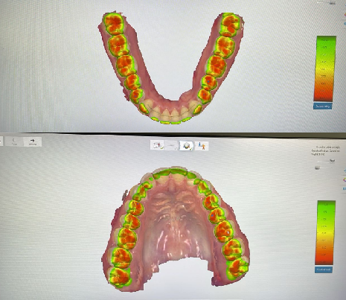
Statistical Methodology
The data were tabulated in Microsoft Office Excel® software and exported to GraphPad Prism 9.5.1 for statistical analysis. The normality of the data was tested using the Kolmogorov-Smirnov and Shapiro-Wilk tests, demonstrating a normal distribution for the contact points variable and an absence of normality for the VAS variable. For the comparative analysis of the groups, the paired t-test and Wilcoxon test were used. The analysis was performed on 15 participants from the clinic where the study was conducted. The confidence interval adopted was 95%, and p<0.05 (5%) was considered statistically significant.
RESULTS and DISCUSSION

When comparing the number of contact points, a significant difference was evident between the two time points of the study, with averages of 19.5 and 21.9 at T1 and T2, respectively (Graph 1, Paired t-test, P<0.0001).
Graph 1 – Number of contact points at different times.
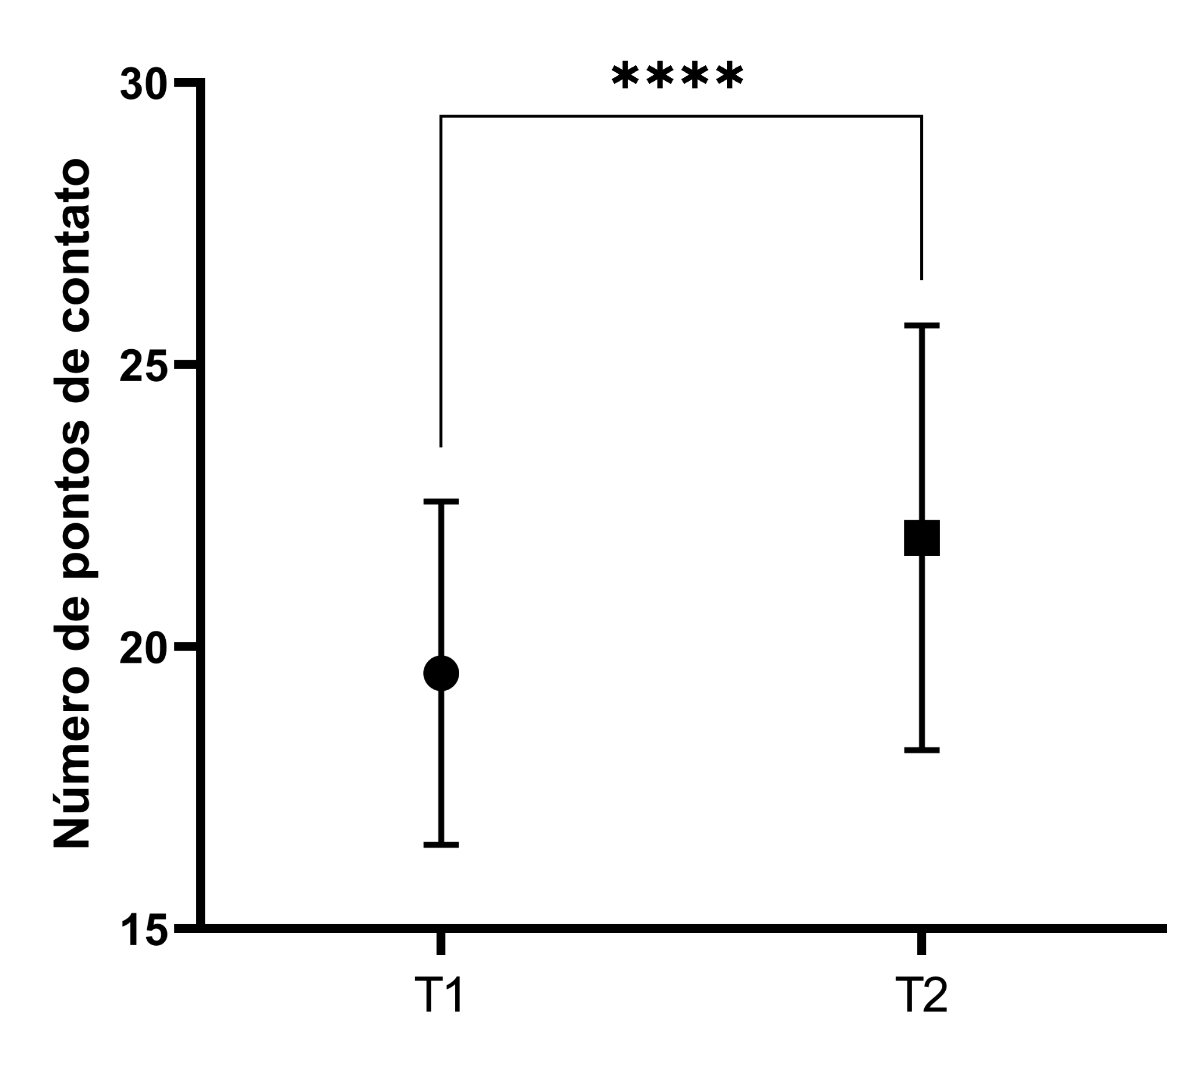
The Visual Analogue Scale showed an average score of 8 at T1, while at T2 the average reported by patients was 0. When comparing the VAS scores at the two time points of the study, a significant difference was detected between them (Graph 2, Wilcoxon test, P<0.0001).
Graph 2 - Evaluation of the Visual Analogue Scale at different times
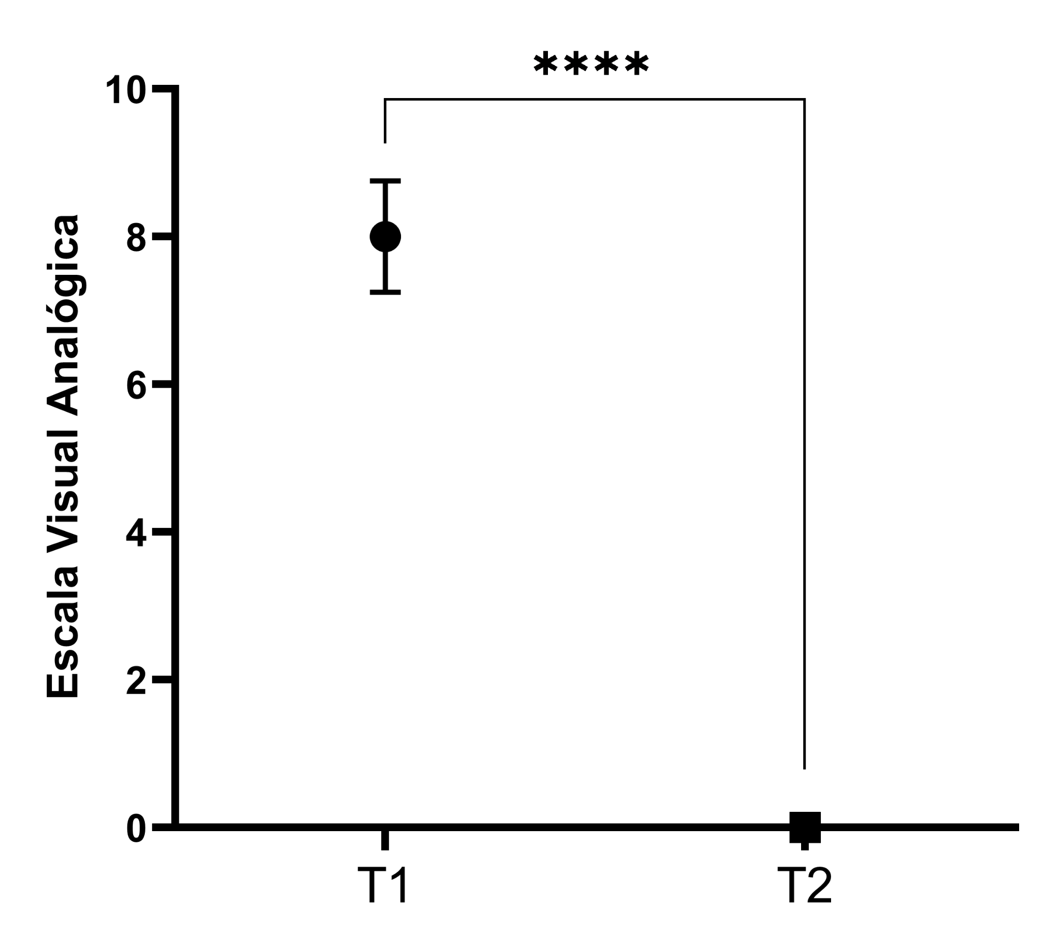
The existence of a correlation between the number of contact points and the Visual Analogue Scale score was also investigated. No significant correlation was detected (r=-0.2599, P=0.1654, Spearman correlation test). Despite the lack of a significant correlation, a trend can be observed that points to lower VAS scores as the number of contact points increases (Graph 3).
Graph 3 – Trend curve Number of contact points X VAS.
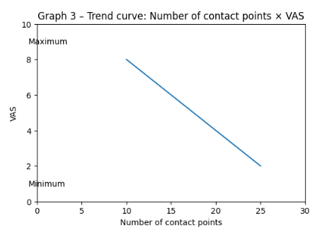
This study aimed to evaluate possible changes in the contact surface of teeth with or without pain in patients with muscular TMD at a clinic specializing in orofacial pain. Patients diagnosed with muscular TMD using the Diagnostic Criteria for Research in Temporomandibular Dysfunction (DC/TMD) were considered. They were evaluated at different times, where at one time the patient presented pain and at another time there was no pain, both times identified by the VAS scale, in order to compare possible changes in occlusal contacts.
In this context, the individual adaptability of patients should be considered by physicians to prevent maladaptive iatrogenic behaviors. In fact, orthodontists and general dentists should be aware of the multifactorial etiology of TMD and should be instructed on the tools available for managing patients before, during, and after any intervention.
Currently in the technological world, all of Dentistry is being updated, where a revolution is taking place in digital systems for visualizing occlusal contact points; however, there are few clinical studies that verify the accuracy when compared to conventional methods (Segundo, 2022). The digital technologies available on the market today allow for a precise replication of occlusion, which is fundamental for stability in maximum intercuspation and dynamic occlusion. The software generates standardized occlusal morphologies and requires significant adjustments (Risciotti et al., 2024).
In the quest to study the exact location of occlusal contacts along the surface of teeth, several qualitative occlusal indicators have been studied over the years, such as Mylar paper, impression material index (alginate, polyether and silicone), transparent acetate sheet, wax, articulated wax paper and silk strips. These materials have variations because they are obviously very different in terms of handling and marking of occlusal contacts, thus resulting in differences in both the size and number of occlusal markings. This causes many methods to produce false-positive markings. Thus, due to the limitations of qualitative methods and the evolution of technology, quantitative methods have emerged, thus limiting the subjectivity of qualitative methods (Segundo, 2022).
In this context, the individual adaptability of patients should be considered by physicians to prevent maladaptive iatrogenic behaviors. In fact, orthodontists and general dentists should be aware of the multifactorial etiology of TMD and should be instructed on the tools available for managing patients before, during, and after any intervention.
Premature occlusal contacts are a possible cause of headaches, facial pain, and TMD, affecting masticatory function and also causing asymmetry in the stomatognathic system. As a consequence, changes in occlusal position are cited due to joint and muscle pain, causing mandibular deviation and leading to excessive pressure in the articular and bilaminar zone (Lauriti et al., 2014). In addition, occlusal interference can lead to symptoms due to functional mandibular deviation and periodontal changes resulting from pain. This functional alteration between the dental arches causes a negative neuromuscular influence, bringing TMD symptoms (Lauriti et al., 2014).
In the present study, after data collection, when comparing the number of contact points during pain and without pain, a significant difference was observed between the two moments of the study, with averages of 19.5 and 21.9 before and after data collection using the Visual Analogue Scale, presenting an average score of 8 during pain and 0 during the pain-free period. A possible explanation could be that the absence of pain allows the patient to touch their teeth more securely and thus have a greater number of contacts.
Similar changes were reported by Quiudini Júnior (2023), who evaluated the effectiveness of Dry Needling and Instrumental Myofascial Release therapies in the cervico-cranio-mandibular system through pain, molar force, and distribution of occlusal contacts in 30 individuals with muscular TMD. The study was a prospective experimental self-controlled cohort study in the pre/post-intervention and pre/post one month of therapeutic interventions, where after 1 month of intervention, especially in the instrumental myofascial release technique, the number of contacts was greater.
The results of the present study and that of Quiudini Júnior (2023) can be justified by the explanation of Thumati et al. (2017). The authors reported a case of a patient whose symptoms of muscular TMD responded well to occlusal adjustment therapy that was guided by precise closure and excursive time measurements. Prolonged disocclusion time increases levels of excursive muscle activity, and adequately reducing the disconnection time to less than 0.4 s can reduce muscle hyperactivity and related myofascial pain symptoms (Thumati et al., 2017).
However, these findings contradict those of Terra (2013), who evaluated the position and intensity of occlusal contacts in 40 individuals with muscular TMD after using a stabilizing splint, comparing them to a control group without TMD for eight weeks. No changes in occlusal contact were identified. Also noteworthy is the study by Mobilio and Catapano (2011), who evaluated the effect of experimental mandibular muscle pain on the number and position of posterior occlusal contacts in 11 individuals. Thirty days after each individual received an injection in the central part of the right masseter muscle consisting of 0.5 mL of hypertonic or isotonic saline solution, they were assessed for pain intensity using the VAS (Visual Analogue Scale). Three occlusal bite checks (polyvinylsiloxane) in the maximum intercuspation position were obtained during the experimental session: the first before injection, the second between 60 and 90 seconds after injection, and the third 15 minutes after injection. The evaluation of contacts was performed on dental models using different colors, where no significant difference was found between the total number of occlusal contacts. This is in line with the present study, where no significant correlation was detected between the number of contacts and the VAS scores, although the data showed a trend between the increase in the number of contacts and the lower VAS scores.
Different results can be explained by the existence of different methods for evaluating occlusion, such as traditional methods, using carbon paper, and digital methods. The traditional method can be influenced by external factors such as intraoral conditions, the thickness and quality of the carbon paper, and the professional's subjectivity in interpreting the markings. The great advantage of the digital system is that it allows the analysis of the position and distribution of occlusal contacts in real time (Terra, 2013). For this reason, the present study chose the digital method, as it is something that will increasingly become the reality in the clinic.
In recent decades, the use of occlusal disorders as an etiological factor for TMD (Temporomandibular Disorder) has been questioned, and the lack of evidence supporting this is a consensus among TMD specialists. However, a large number of general practitioners still believe that occlusal disorders can cause pain. Therefore, further studies on this subject are necessary, as is raising awareness of the importance of treating pain first before evaluating occlusion, a fact that increases the importance of studies like this one. This research, using digital scanning, concludes that there was an increase in contacts due to the painful episode. This suggests and reinforces the evidence that pain causes these alterations, and not occlusal contacts that cause TMD.
CONCLUSION
This research concludes that the contact surface of posterior teeth increased significantly in patients during the pain-free period compared to the pain period. The observed changes in contact surface were an increase in the contact area without alteration in the location of these areas; thus, the number of tooth contacts in individuals with muscular TMD experiencing pain was higher than in pain-free periods.
Consent
As per international standards or university standards, patient(s) written consent has been collected and preserved by the author(s).
Ethical Approval:
As per international standards or university standards written ethical approval has been collected and preserved by the author(s).

Disclaimer (Artificial intelligence)

Author(s) hereby declare that NO generative AI technologies such as Large Language Models (ChatGPT, COPILOT, etc.) and text-to-image generators have been used during the writing or editing of this manuscript.
REFERENCES
- Abe KI, Sakaguchi K, Mehta NR, Correa LP, Abdallah EF, Yokoyama A. Effect of body posture on stability and balance of occlusal contacts. Cranio. 2022; 13(1):1-11.
- Allori AC, Chang CC, Farinã R, Grayson BH, Warren SM, McCarthy JG. Current Concepts in Pediatric Temporomandibular Joint Disorderns: Part 1.Etiology, Epidemiology, and Classification. Plastic and Reconstructive Surgery. 2010;126(4):1263-75.
- Graff-Radford SB, Abbott JJ. Temporomandibular Disorders and Headache. Oral Maxillofacial Surg Clin N am. 2016;28(3):335-49
- Hilgenberg PB, Saldanha ADD, Cunha CO, Rubo JH, Conti PCR. Temporomandibular disorders, otologic symptoms and depression levels in tinnitus patients. Journal of Oral Rehabilitation. 2012;39(4):239-44.
- Kahn J, Tallents RH, Katzberg RW, Ross ME, Murphy WC. Prevalence of dental occlusal variables and intraarticular temporomandibular disorders: molar relationship, lateral guidance, and nonworking side contacts. J Prosthet Dent. 1999 Oct;82(4):410-5.
- Kuć J, Szarejko KD, Gołębiewska M. Comparative Evaluation of Occlusion before and after Soft Tissue Mobilization in Patients with Temporomandibular Disorder-Myofascial Pain with Referral. Int J Environ Res Public Health. 2021 Jun 18;18(12):6568.
- Lauriti L, Motta LJ, de Godoy CH, Biasotto-Gonzalez DA, Politti F, Mesquita-Ferrari RA, et al. Influence of temporomandibular disorder on temporal and masseter muscles and occlusal contacts in adolescents: an electromyographic study. BMC Musculoskelet Disord. 2014 Apr 10;15:123.
- Mobilio N, Catapano S. Effect of experimental jaw muscle pain on occlusal contacts. J Oral Rehabil. 2011;38(6):404-9.
- Okeson JP, de Leeuw R. Differential diagnosis of temporomandibular disorders and other orofacial pain disorders. Dent Clin North Am. 2011;55(1): 105-20.
- Quidini Junior PR, Siéssere S, de Mello EC, Rodrigues S, Regalo I, Gonçalves LM, et al. Effect of dry needling and instrumental myofascial release on masticatory, facial, and cervical muscles of patients with temporomandibular disorders of muscular origin. J Clin Exp Dent. 2023 May 1;15(5):e366-e375.
- Risciotti E, Squadrito N, Montanari D, Iannello G, Macca U, Tallarico M, et al. Digital Protocol to Record Occlusal Analysis in Prosthodontics: A Pilot Study. J Clin Med. 2024 Feb 28;13(5):1370.
- Rubis, L. M., Rubis, D., & Winchester, B. (2014). A collaborative approach between chiropractic and dentistry to address temporomandibular dysfunction: a case report. Journal of chiropractic medicine, 13(1), 55-61.
- Segundo HVDM. Avaliação da Exatidão e Reprodutibilidade dos Pontos de Contatos Reais por Meio de Software de Escaneamento. 2022.
- Terra MC. Evaluation of the distribution and intensity of occlusal touches in patients with temporomandibular dysfunction of muscular origin, undergoing the use of an intraoral device. Dissertation (Master's) — Federal University of Mato Grosso do Sul, 2014.
- Thumati P. The influence of immediate complete anterior guidance development technique on subjective symptoms in Myofascial pain patients: Verified using digital analysis of occlusion (Tek-scan) for analysing occlusion: A 3 years clinical observation. J Indian Prosthodont Soc. 2015 Jul-Sep;15(3):218-23.

