Ms_PSIJ_152915.docx
by SINGHHimanshu

Submission date: 04-Feb-2026 01:06PM (UTC+0800)
Submission ID: 2693334607
File name: Ms_PSIJ_152915.docx (534.04K)
Word count: 3011
Character count: 16704

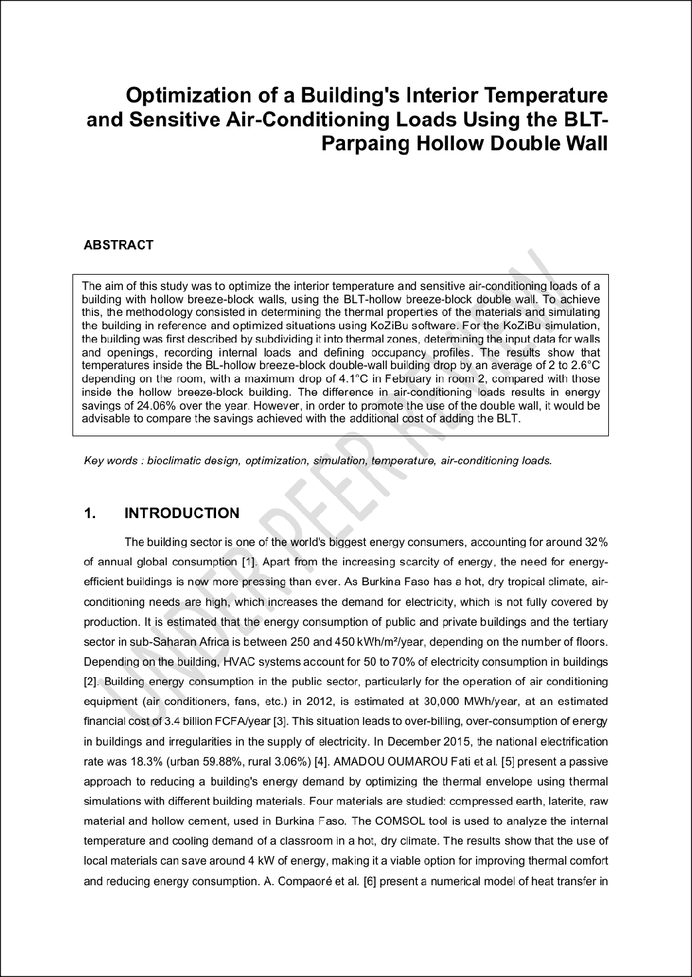
14
13
4
1
7
1
1
6

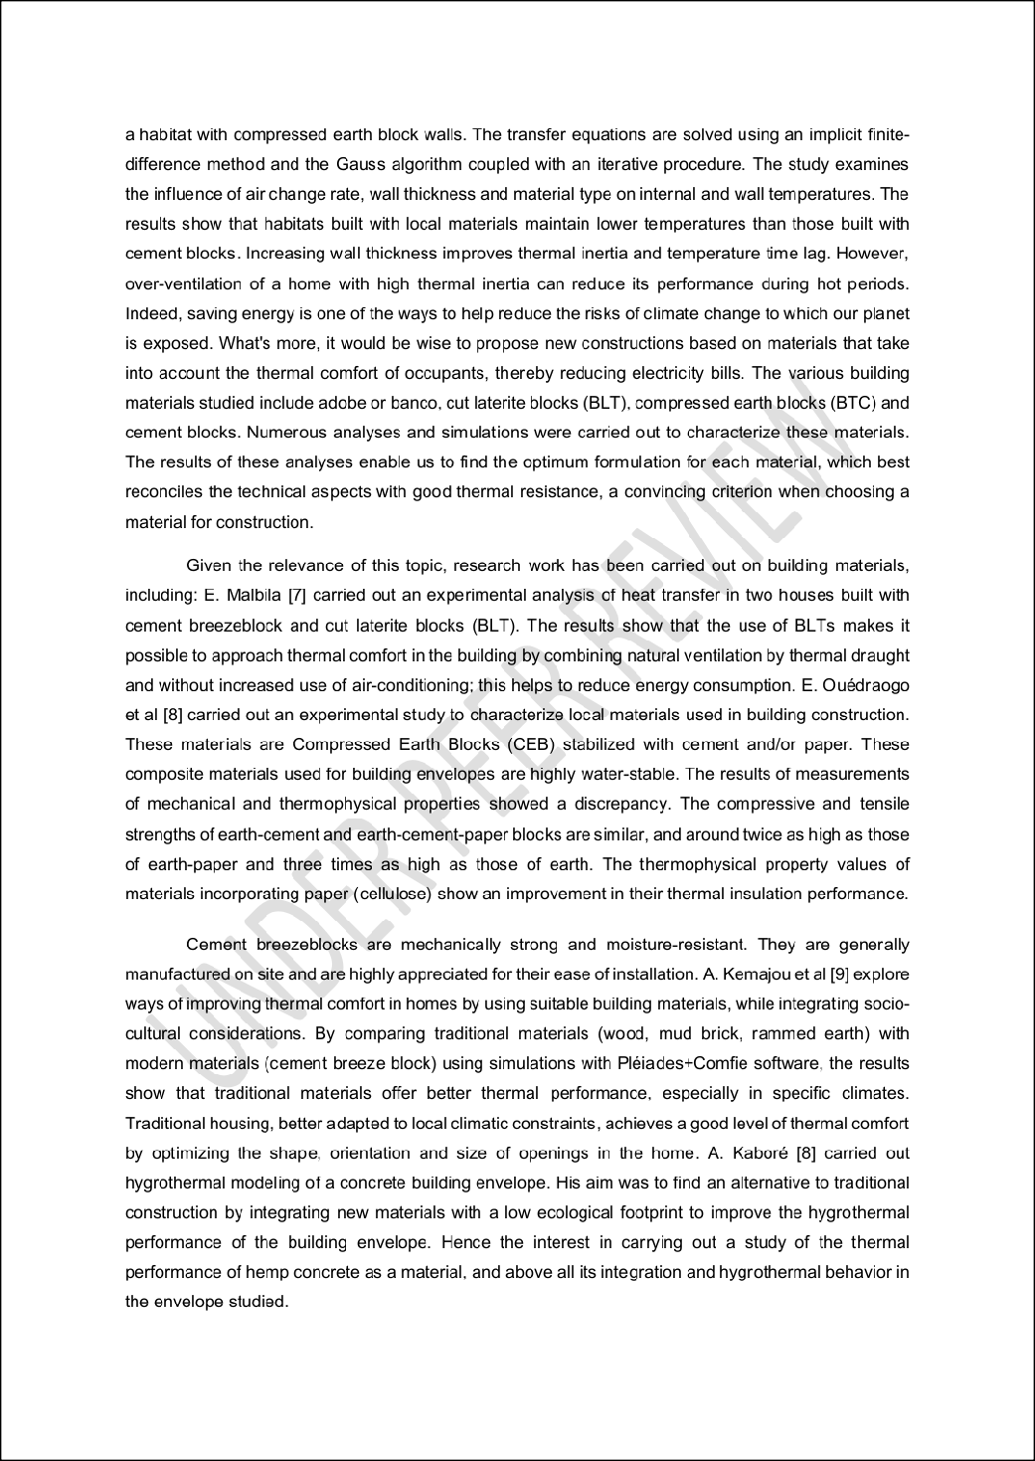
8
17
12
12

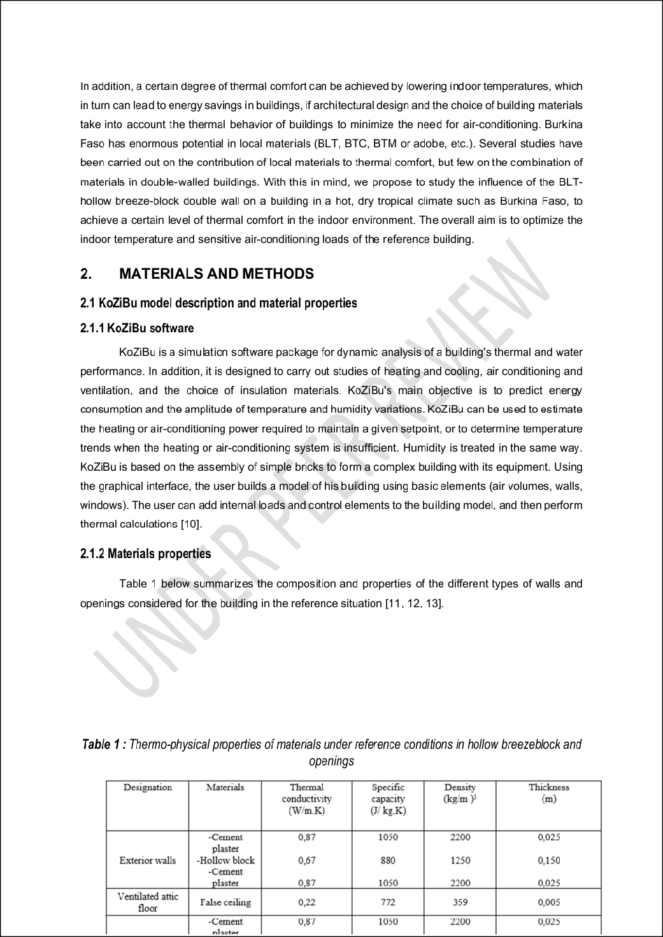
10
7
16
3
2
3
2

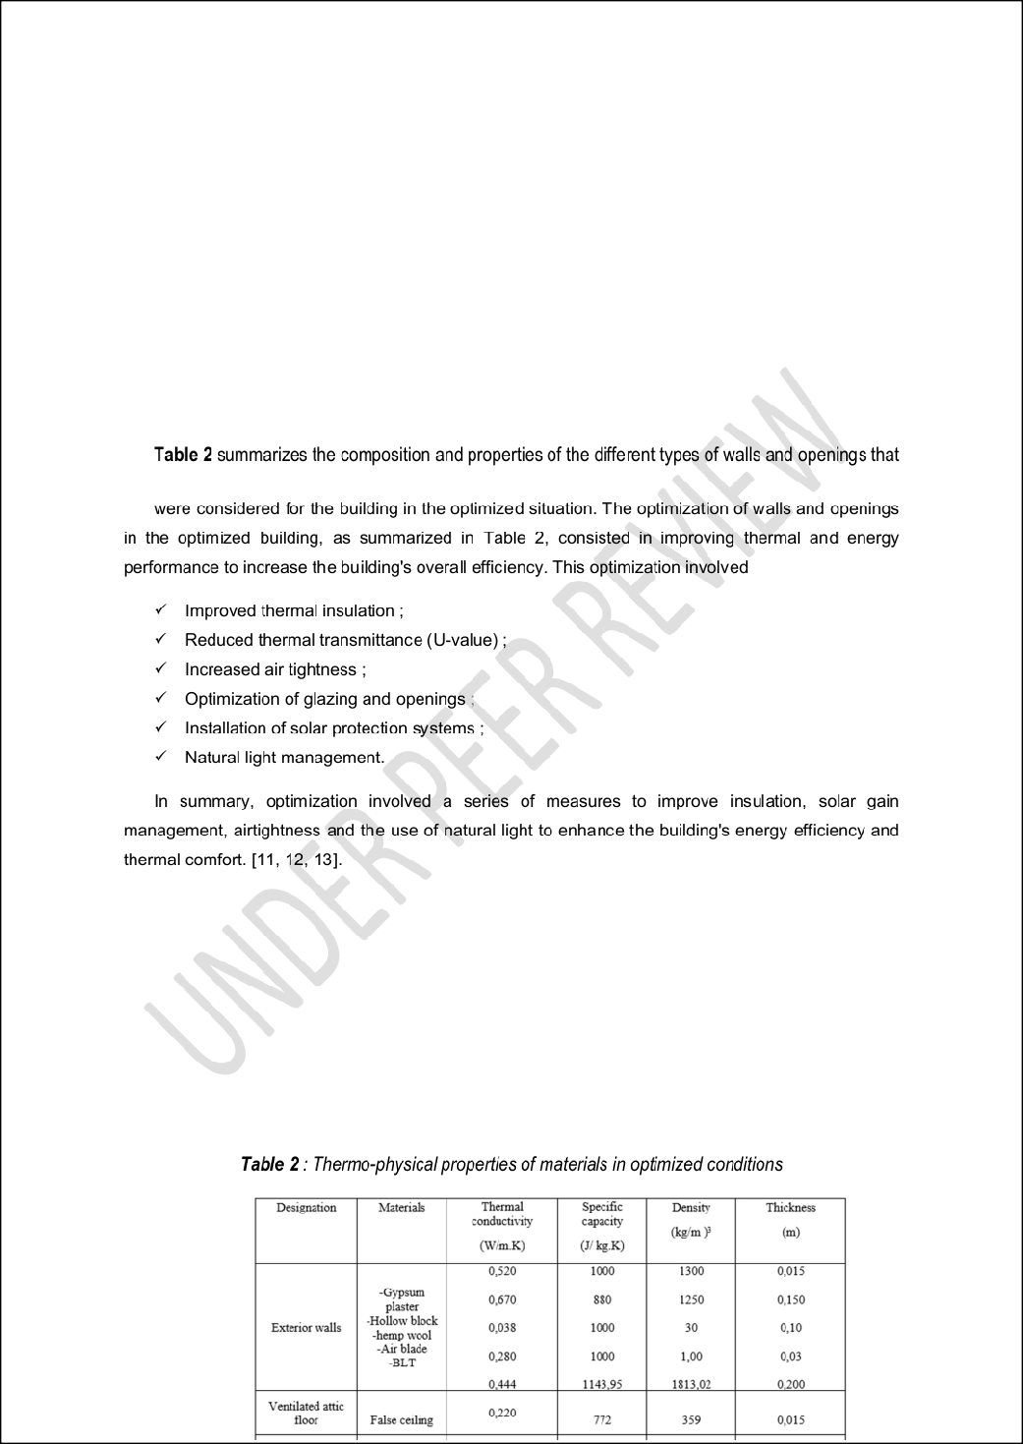
18

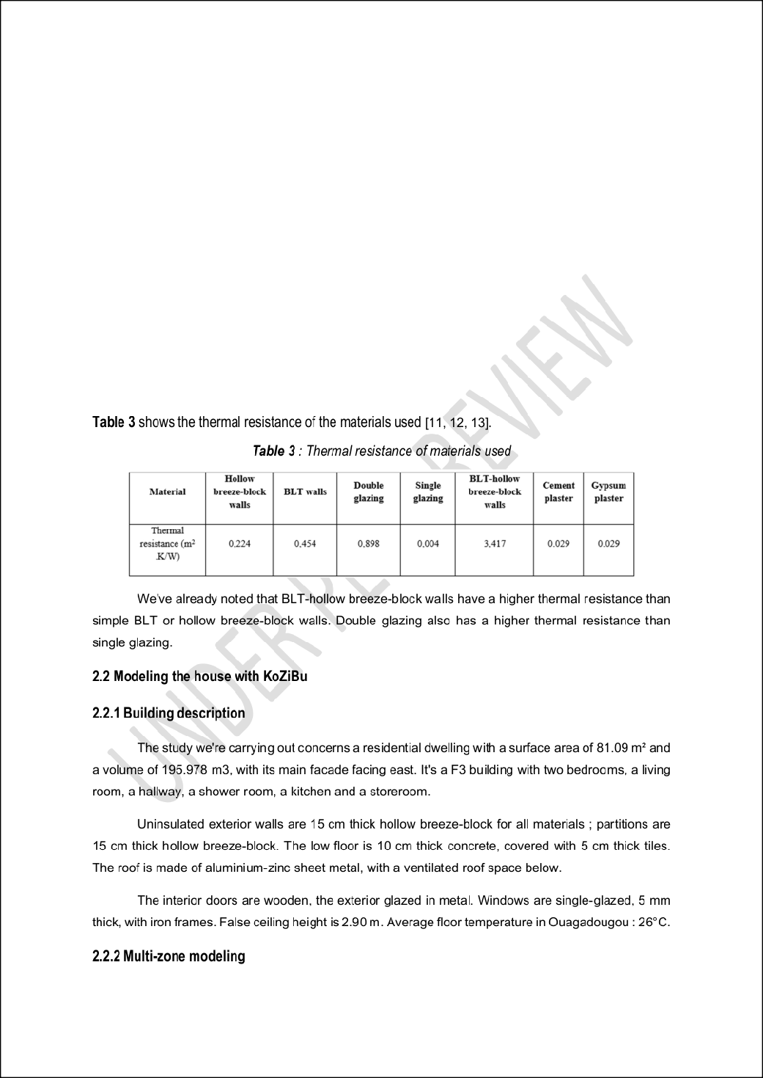
15

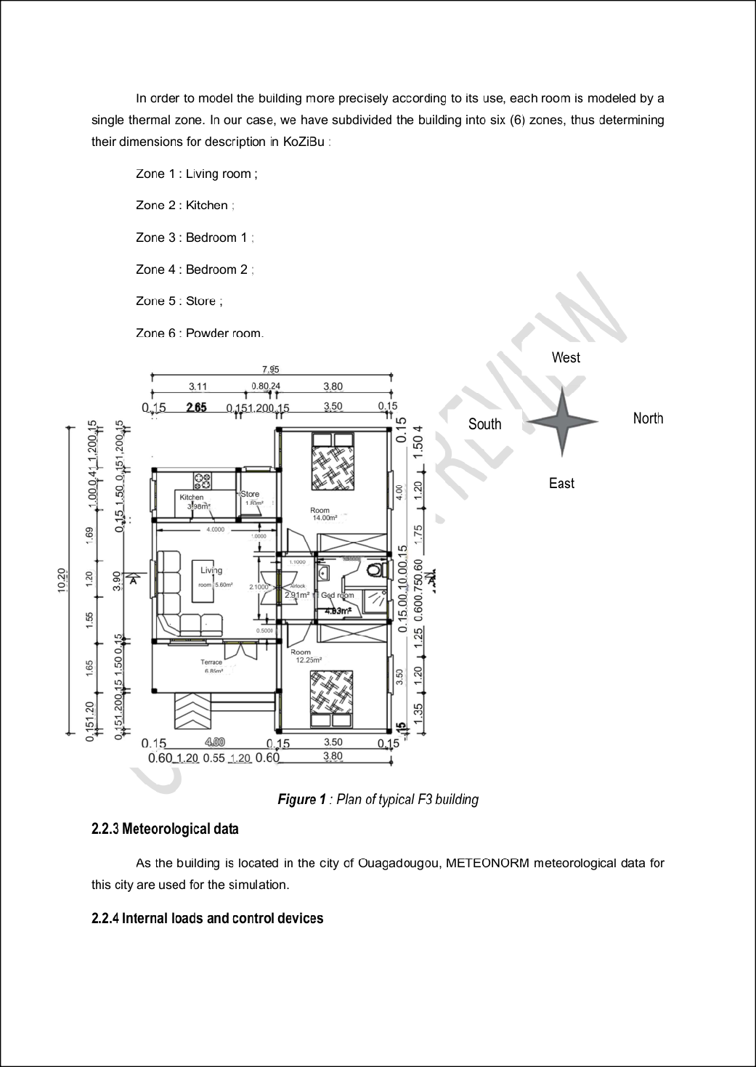
11
9

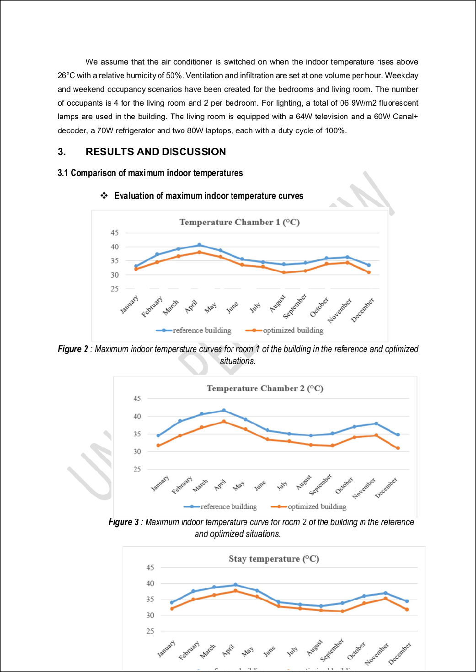
4
9
7

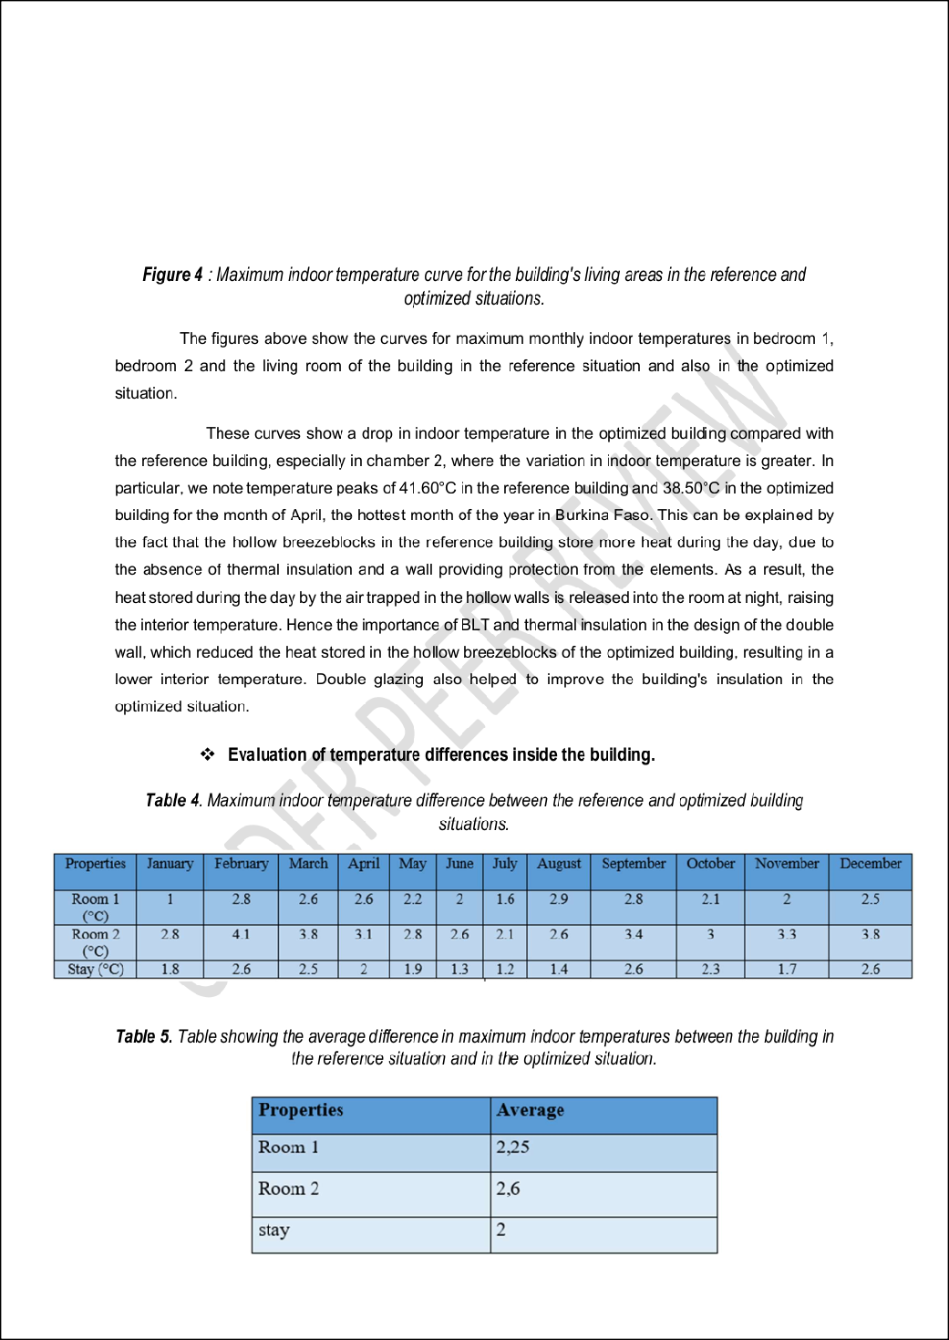
6

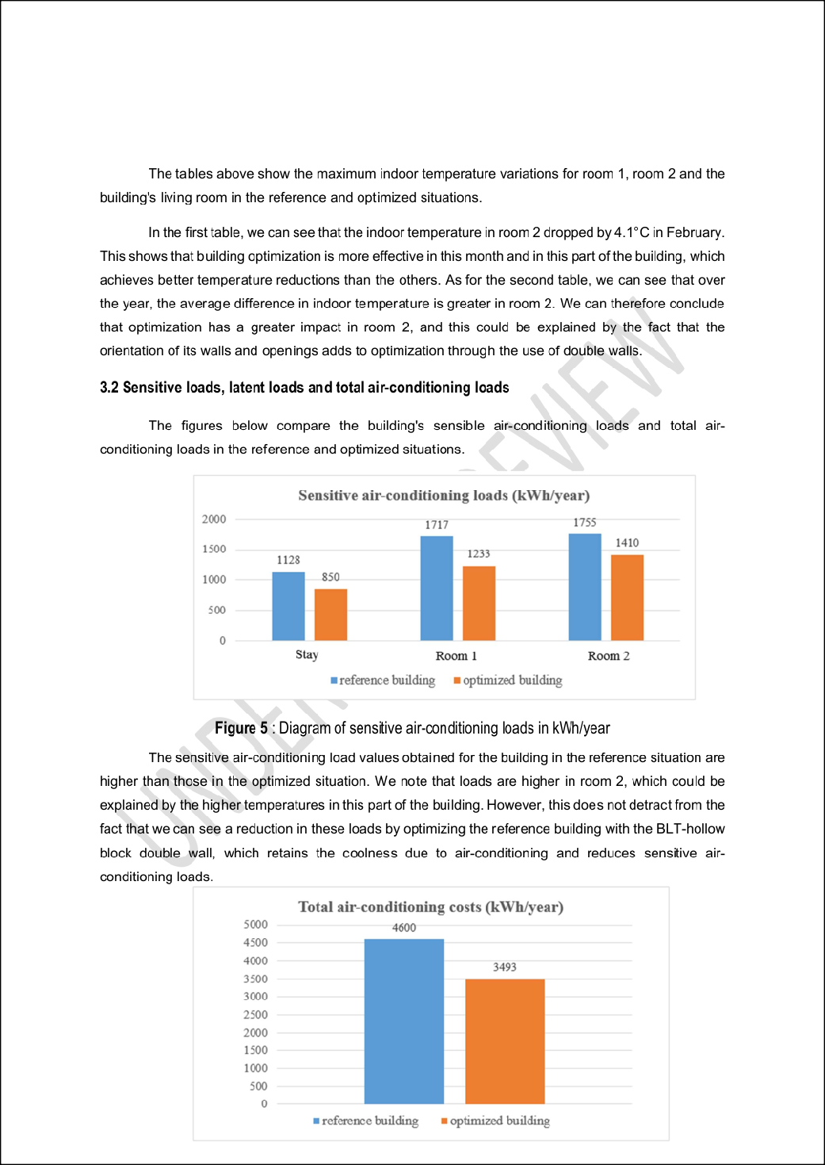

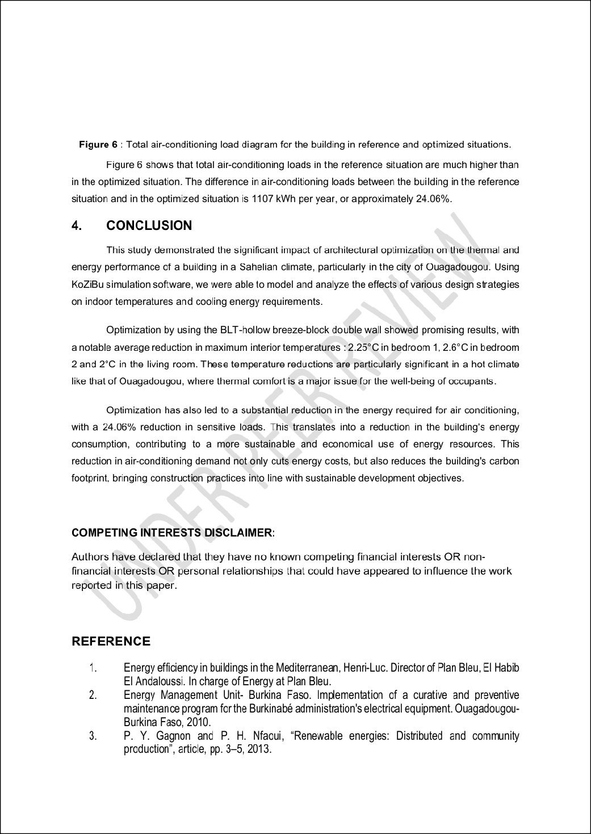
5

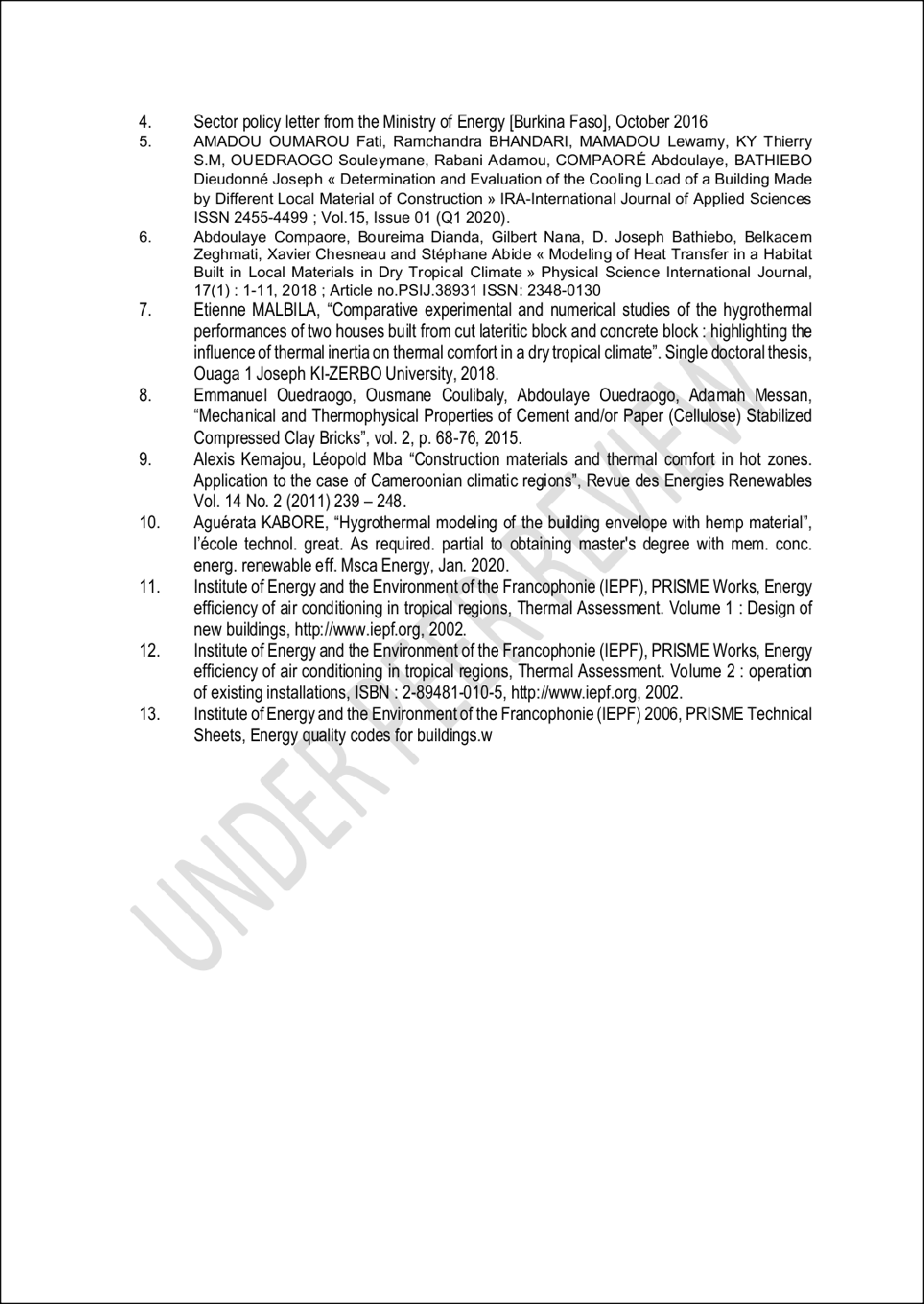

Ms_PSIJ_152915.docx

ORIGINALITY REPORT
15

%
SIMILARITY INDEX
9%
INTERNET SOURCES
9%
PUBLICATIONS
6%
STUDENT PAPERS

PRIMARY SOURCES
article.sciencepublishinggroup.com
Internet Source %
1
2
2

Submitted to University of Pretoria
Student Paper %
2
1

Submitted to Dublin City University
Student Paper %
3
1%

4 David Y.K. Toguyeni, Ousmane Coulibaly, Abdoulaye Ouedraogo, Jean Koulidiati, Yvan
Dutil, Daniel Rousse. "Study of the influence of roof insulation involving local materials on cooling loads of houses built of clay and straw", Energy and Buildings, 2012
Publication
1

strategicjournals.com
Internet Source %
5
1

www.researchgate.net
Internet Source %
6
1%

7 Henri Hounkpatin, Victorin Chégnimonhan, Guy Sèmassou, Dirk Nathaniels, Basile
Kounouhewa. "Simulation of the Thermal Behavior of Various Local Roofings for a Residential House in the Humid Tropics", Advances in Research, 2018
Publication
1

www.sciencedomain.org
Internet Source %
8

9

10

11

12

13

14

15

16

17
www.davidpublisher.com
Internet Source

Y. El Maatoufi, S. Nasla, Y. Jamil, K. Gueraoui,
M. Cherraj. "STUDY OF THE EFFECT OF STABILIZATION, BY LIME AND SUGARCANE FIBERS, ON THE PHYSICO-MECHANICAL AND THERMAL PROPERTIES OF COMPRESSED
EARTH BLOCKS (CEB) USED IN THE
CONSTRUCTION OF A SOIL FROM EL GHARB
IN MOROCCO", JP Journal of Heat and Mass Transfer, 2022
Publication
mediatum.ub.tum.de
Internet Source

revue.ummto.dz
Internet Source

Di Shi, Jiayuan Ye, Wensheng Zhang, Weiguo Shen. "Properties, mineralogy and microstructure evolution of 4-year calcium silicate slag-based alkali-activated materials", Cement and Concrete Composites, 2023
Publication
research-advances.org
Internet Source

Filippin, C.. "Energy-efficient housing for low- income students in a highly variable environment of central Argentina", Renewable Energy, 200701
Publication
www.mdpi.com
Internet Source

Yassine El Mendili, Mohamed-Hichem Benzaama, Lukáš Bejček, Romain Mège,
1%
1%

1%
1%
<1%

<1%
<1%

<1%
<1%

18
Franck Hennequart, Badreddine El Haddaji. "Algae-based earth materials for sustainable construction: Toward a new generation of bio- stabilized building solutions", Resources, Conservation and Recycling, 2025
Publication

Simos Yannas. "Environmentally Friendly Cities - Proceedings of Plea 98 Passive and Low Energy Architecture, 1998 Lisbon, Portugal, June 1998", Routledge, 2014
Publication

<1%

Exclude quotes On Exclude bibliography On
Exclude matches Off

