Original Research Article
Production of Polyhydroxyalkanoates (PHAs) by Bacillus spp. Isolated from Garbage Soil

ABSTRACT
Aims: To produce Polyhydroxyalkonates (PHAs) from bacteria isolated from garbage soil and confirm the production of PHAs by various techniques.
Background: The use of synthetic plastics and their products on a big scale causes waste disposal problems, leading to environmental pollution. Synthetic plastics derived from petroleum products like polyethylene, polypropylene, polyvinyl chloride, and polystyrene all are all non-degradable and recalcitrant in the environment. The continuous and tremendous use of plastic and its waste enter landfills, especially crop fields, and forms polluted land. All such problems highlight the need for an alternative to produce degradable plastics such as PHAs. These are the type of biopolymer produced by microorganisms as intracellular compounds identified as granular inclusion bodies, such as carbon, as well as energy storage materials. The most studied and observed PHA is poly-3-hydroxybutyrate (PHB) stored in intracellular granules.
Methodology: The production of PHA from the bacteria isolated from garbage soil, especially collected in the Solapur district. Further isolates were characterized using morphological, cultural, biochemical, and molecular methods, including 16S rRNA gene sequencing, with phylogenetic analysis.
Results: The strains predominantly identified were Bacillus paramycoides and Bacillus cereus. In further studies, the production of PHA took place and was characterized by FTIR analysis, which confirmed the possible functional groups in PHA. Also studied the effect of environmental parameters on PHA-producing strains.

Keywords - Polyhydroxyalkonates (PHAs), Poly-hydroxybutyrate (PHB), synthetic plastic, Garbage soil. FTIR.

1. INTRODUCTION:
The accumulation of petroleum-based plastic waste poses a significant environmental challenge, with thousands of tons generated daily, contributing to non-biodegradable landfills and increasing waste disposal costs (Geyer et al., 2017; Sudesh et al., 2018). The persistence of plastics in the environment is primarily due to their non-degradable nature, leading to serious pollution problems, as they can take hundreds of years to decompose naturally (Geyer et al., 2017). Despite their detrimental impact, plastics are widely used across various industries due to their durability, versatility, and low cost of production. For instance, global plastic production reached approximately 413.8 million metric tons in 2022, up from just 1.5 million metric tons in 1950 (Geyer et al., 2017).
In response to the environmental crisis posed by plastic waste, researchers are investigating biodegradable alternatives, such as Polyhydroxyalkanoates (PHAs) (Sudesh et al., 2018). PHAs are a family of high-performance, biodegradable polymers produced by certain microorganisms, especially bacterial strains, under specific environmental conditions. These biodegradable plastics not only offer potential solutions for reducing plastic waste but also possess excellent physical properties suitable for a diverse range of industrial applications (Laycock et al., 2017; Sudesh et al., 2018).
Research indicates that over 300 bacterial species, including Gram-positive and Gram-negative bacteria, can synthesize PHAs under varying environmental conditions. Key bacterial strains such as Bacillus megaterium, Ralstonia eutropha, and Pseudomonas putida are among the most extensively studied for their ability to produce PHAs (Laycock et al., 2017). These bacteria can utilize different carbon substrates, including agro-industrial waste, which presents an opportunity for sustainable PHA production while simultaneously addressing waste management issues (Chan et al., 2018; Koller et al., 2013).
The process of cultivating bacteria for PHA production typically involves specific growth conditions and media preparation. For example, the culturing of bacteria often occurs in a fed-batch process vessel, where conditions such as temperature and carbon substrate concentration are carefully controlled to optimize PHA synthesis (Lee et al., 1999; Sudesh et al., 2018). As efforts to mitigate plastic pollution continue to grow, the exploration of PHA production from waste sources emerges as a promising avenue for developing environmentally sustainable materials (Geyer et al., 2017; Sabdono et al., 2019).
The escalating global plastic waste crisis has necessitated the search for sustainable and biodegradable alternatives to conventional, petroleum-derived plastics. The widespread use and improper disposal of materials such as polyethylene (PE), polypropylene (PP), and polyvinyl chloride (PVC) have led to severe environmental pollution, including the accumulation of microplastics in both terrestrial and marine ecosystems (Horton et al., 2017; Jambeck et al., 2015). This ecological challenge is particularly pronounced in areas with high concentrations of organic and municipal waste, such as waste-garbage disposal sites, where the slow or negligible degradation of synthetic polymers poses a long-term threat. In response to this crisis, bioplastics, specifically Polyhydroxyalkanoates (PHAs), have emerged as a highly promising class of biodegradable polymers (Chen & Wu, 2005).
PHAs are intracellular carbon and energy storage compounds naturally accumulated by various microorganisms, primarily bacteria, under conditions of nutrient limitation (e.g., nitrogen or phosphorus) but an excess of a carbon source (Lageveen et al., 1988). They are linear polyesters that exhibit properties comparable to conventional plastics but possess the crucial advantage of being fully biodegradable in various natural environments, including soil, water, and activated sludge, leading to their complete assimilation by microbes into carbon dioxide and water (Reddy et al., 2003).
While PHAs can be produced by a wide range of bacteria, including Ralstonia eutropha and Pseudomonas species, the production costs remain a major barrier to widespread commercial application (Choi & Lee, 1997). A significant portion of this cost is attributed to the use of expensive, pure substrates as the carbon source. Therefore, research is intensely focused on identifying novel bacterial strains with high PHA accumulation potential and, critically, the ability to utilize low-cost substrates, such as organic waste materials, as their primary carbon source (Kahar et al., 2008).
Bacillus is a genus of Gram-positive, rod-shaped bacteria in the phylum Firmicutes. Members of this genus can be found in various environments, including soil, aquatic habitats, wastewater treatment systems, and even extreme environments like deep oceans and ocean vents (Mozejko-Czekaj et al., 2020; Sudesh et al., 2018). These bacteria are classified as either obligate aerobes, which require oxygen for growth, or facultative anaerobes, which can thrive in both aerobic and anaerobic conditions (Sudesh et al., 2018).
Bacillus species are recognized for their capability to produce PHAs, a type of biodegradable polymer synthesized as intracellular granules. Among the most common Bacillus species used for PHA production are Bacillus subtilis, Bacillus pumilus, Bacillus megaterium, and Bacillus thuringiensis, among others (Mozejko-Czekaj et al., 2020; Sudesh et al., 2018). These organisms demonstrate a remarkable versatility, allowing them to utilize a wide range of carbon sources, including simple sugars and complex waste materials, which enhances their potential for industrial applications in PHA production (Sudesh et al., 2018; Khanna & Srivastava, 2014). The biosynthesis of PHAs in Bacillus species involves multiple metabolic pathways that can utilize different substrates. The primary pathways include acetoacetyl-CoA synthesis, fatty acid biosynthesis, and fatty acid beta-oxidation, all of which contribute to the production of various PHA monomers (Steinbüchel & Füchtenbusch, 1998). Bacillus species are particularly adept at leveraging their natural hydrolytic enzymes to efficiently metabolize complex carbon sources, thus supporting higher yields of PHA production (Koller, 2018). Furthermore, advancements in metabolic engineering have allowed for enhanced production capabilities, as specific pathways can be optimized to reduce byproduct formation and maximize carbon yield (Khanna & Srivastava, 2014).
The waste-garbage soil environment is a unique ecological niche, rich in diverse microbial communities constantly exposed to a variety of decomposing organic matter and complex carbon polymers. This environment serves as a potential source for isolating robust, resilient bacterial strains, particularly members of the Bacillus genus, known for their versatile metabolic capabilities, ability to form heat-resistant spores, and propensity for large-scale industrial fermentation (Mozejko-Czekaj et al., 2020). The hypothesis underpinning this study is that Bacillus strains indigenous to waste-garbage soil possess a superior ability to metabolize the complex and heterogeneous carbon sources characteristic of this environment, thus offering a cost-effective and efficient pathway for PHA biosynthesis. This study, therefore, aims to isolate, characterize, and optimize the production of PHAs by Bacillus species recovered directly from waste-garbage soil, ultimately contributing to a sustainable, waste-valorization approach to bioplastic production.

2. MATERIALS AND METHODS
2.1. Sample Collection and Serial Dilution
Soil samples were collected from diverse ecological niches within the Solapur district, Maharashtra, India—including garden soil, waste-garbage soil, roadside soil, and crop field soil—to maximize the likelihood of isolating polyhydroxybutyrate (PHA)-producing microorganisms, as environmental heterogeneity enhances microbial diversity. One gram of each soil sample was suspended in 9 mL of sterile saline solution (0.9% w/v NaCl) to obtain homogenized microbial suspensions, following standard soil microbiology protocols. The suspensions were subjected to serial dilution from 10⁻¹to 10⁻⁶, and dilutions between 10⁻ ⁴ and 10⁻⁵ were selected for microbial isolation, consistent with established methods for isolating soil bacteria. Aliquots of 0.1 mL from each selected dilution were spread onto Modified Nutrient Agar plates formulated with an elevated carbon-to-nitrogen ratio, a condition known to promote intracellular PHA accumulation in bacteria (Khanna & Srivastava, 2005). The plates were incubated at 37°C for 24–48 hours, after which morphologically distinct colonies were isolated and purified with standard procedures for PHA-producing bacteria (Singh et al., 2009).
2.2. Screening for PHA Accumulation by Sudan Black Staining
Screening of purified bacterial isolates for intracellular PHA accumulation was performed using Sudan Black B staining, a classical lipophilic dye-based detection method (Khanna & Srivastava, 2005). Sudan Black B, a water-insoluble diazo dye, selectively stains neutral lipids and imparts a dark blue to black coloration to intracellular PHA granules. For staining, a thin smear of a 24-hour bacterial culture was prepared, heat-fixed, treated with Sudan Black B solution, and counterstained with Safranin. The appearance of distinct dark intracellular inclusions under the light microscope indicated a positive reaction for PHA accumulation.
2.3 Morphological, Cultural, and Biochemical Characterization
Isolates that exhibited positive Sudan Black staining were subjected to detailed cultural, morphological, and biochemical characterization using standard microbiological procedures (Cappuccino & Sherman, 2014; Tortora et al., 2019). Cultural characteristics such as colony size, pigmentation, texture, elevation, margin, and opacity were documented from growth on solid media. Gram staining was performed to determine cellular morphology, arrangement, and Gram reaction, and motility was assessed using conventional motility assays.
Biochemical characterization of the isolates involved a series of established metabolic tests (Cappuccino & Sherman, 2014; Tortora et al., 2019). Indole production was determined in tryptone broth using Kovac’s reagent to detect tryptophanase activity. The Methyl Red test evaluated the production of stable acidic end products from glucose fermentation, while the Voges–Proskauer test detected acetoin in glucose phosphate broth using alpha-naphthol and potassium hydroxide. Citrate utilization was assessed on Simmons Citrate Agar containing bromothymol blue indicator at pH 7. Additional assays included gelatin liquefaction for detecting gelatinase; oxidase activity using tetramethyl-p-phenylenediamine dihydrochloride; carbohydrate fermentation using sugar broths with Durham tubes; catalase activity by adding 3% hydrogen peroxide; nitrate reduction using nitrate broth with sulphanilic acid and alpha naphthylamine; starch hydrolysis using iodine-flooded starch agar; and hydrogen sulfide production using Triple Sugar Iron Agar incubated at 35- 37 °C.
2.4 Molecular Identification and Phylogenetic Analysis
Molecular identification of promising PHA-producing isolates was carried out by amplifying and sequencing the 16S rRNA gene using universal bacterial primers 16S27F and 16S1492R (Lane, 1991). PCR products were purified by salt precipitation, examined on agarose gel electrophoresis, and sequenced on an ABI 3500XL Genetic Analyzer using BDT v3.1 chemistry. Raw sequence chromatograms were curated, assembled into contiguous FASTA files, and subjected to taxonomic identification using BLAST searches against the SILVA rRNA database (v138) (Altschul et al., 1990; Quast et al., 2013).
Phylogenetic analysis was performed by retrieving up to ten closest-related sequences from SILVA, aligning them using MUSCLE (Edgar, 2004), and constructing a Maximum Likelihood phylogenetic tree with 1000 bootstrap replications in MEGA11 software (Tamura et al., 2021) to determine evolutionary relationships.
2.5 PHA Production, Extraction, and Optimization
Growth kinetics and PHA production were assessed by cultivating isolates in a defined PHA-production medium containing glucose (1.5 g/L), peptone (1.0 g/L), yeast extract (0.3 g/L), and NaCl (0.5 g/L) at pH 7 (Khanna & Srivastava, 2005; Law & Slepecky, 1961). A 1% inoculum was incubated at 37 °C with intermittent shaking, and samples collected at 30-minute intervals over 48 hours were analyzed for biomass (optical density at 640 nm) and PHA accumulation via Sudan Black staining.
PHA extraction was carried out using the sodium hypochlorite digestion method (Law & Slepecky, 1961). After 48 hours of incubation, cultures were centrifuged at 5000 rpm for 25 minutes, and pellets were washed sequentially with acetone and ethanol. Pellets were then treated with 6% sodium hypochlorite at 37 °C for 10 minutes to lyse cells. Subsequent centrifugation (5000 rpm, 30 minutes) yielded PHA granules, which were washed again, dissolved in hot chloroform, and evaporated at 37 °C to obtain dry PHA for quantification.
2.6 Effect of Environmental Factors on PHA Production
The effect of environmental conditions on PHA production was assessed by cultivating isolates under different pH values (3, 5, 7, 9, and 11) and NaCl concentrations (0.1%, 0.5%, 1%, 1.5%, and 2%). Growth at 37 °C and Sudan Black staining intensity after 48 hours were used to evaluate optimal PHA-producing conditions (Khanna & Srivastava, 2005; Law & Slepecky, 1961).
2.7 Characterization of Extracted PHA by FTIR Analysis
Chemical confirmation of PHA was conducted using Fourier-Transform Infrared Spectroscopy (FTIR) (Saba et al., 2020). About 1 mg of extracted PHA was dissolved in chloroform, mixed with KBr to form a pellet, and analyzed in the 4000-400 range using a Spectrum 65 FT-IR instrument. The presence of characteristic absorption peaks, including ester carbonyl C=O stretching and C-O-C vibrations, validated the structural identity of the extracted PHA.

3. RESULTS AND DISCUSSION
3.1. Isolation and screening of PHA producing isolate
A total of twenty-one distinct bacterial colonies were isolated from the soil sample and grown on modified nutrient agar plate as shown in Figure 1(a). Primary screening for intracellular PHA granules was performed using the Sudan Black B staining technique (Law & Slepecky, 1961), as shown in Figure 1(b). The isolates exhibited intense staining, indicating significant accumulation of lipid-like intracellular granules, characteristic of PHA accumulation. Five PHA-producing bacterial isolates (PHA1–PHA5) were selected and characterized based on their colony morphology and Gram reaction. All five isolates (PHA1–PHA5) produced white, circular, opaque, flat colonies with regular margins. Colony size ranged from 1–3 mm, with a moist consistency in most isolates except PHA3 and PHA4, which were sticky, as shown in Table 1. All isolates were Gram-positive and rod-shaped bacteria, as shown in Figure 1(c). The selected isolates underwent standard biochemical characterization to determine their metabolic profiles and confirm their classification. (Tortora et al., 2019), as shown in Figure 2 and Table No. 1 and 2.
Cultural Characteristics | PHA1 | PHA2 | PHA3 | PHA4 | PHA5
Size | 2mm | 2mm | 1mm | 3mm | 1mm
Colour | White | White | White | White | White
Shape | Circular | Circular | Circular | Circular | Circular
Margin | Regular | Regular | Regular | Regular | Regular
Consistency | Moist | Moist | Sticky | Sticky | Moist
Elevation | Flat | Flat | Flat | Flat | Flat
Opacity | Opaque | Opaque | Opaque | Opaque | Opaque
Gram Staining | GM+ve | GM+ve | GM+ve | GM+ve | GM+ve
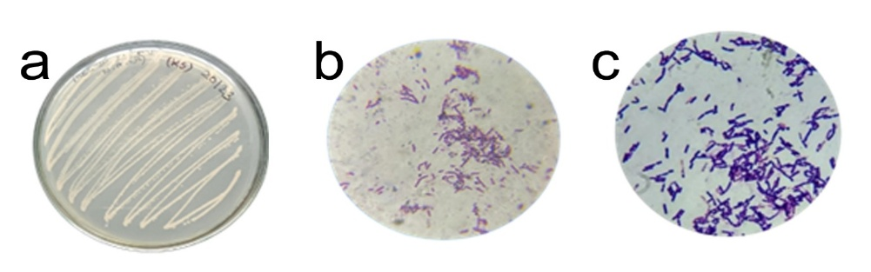
Fig. 1 a) Growth of organism b) Sudan black B staining c) Gram Staining
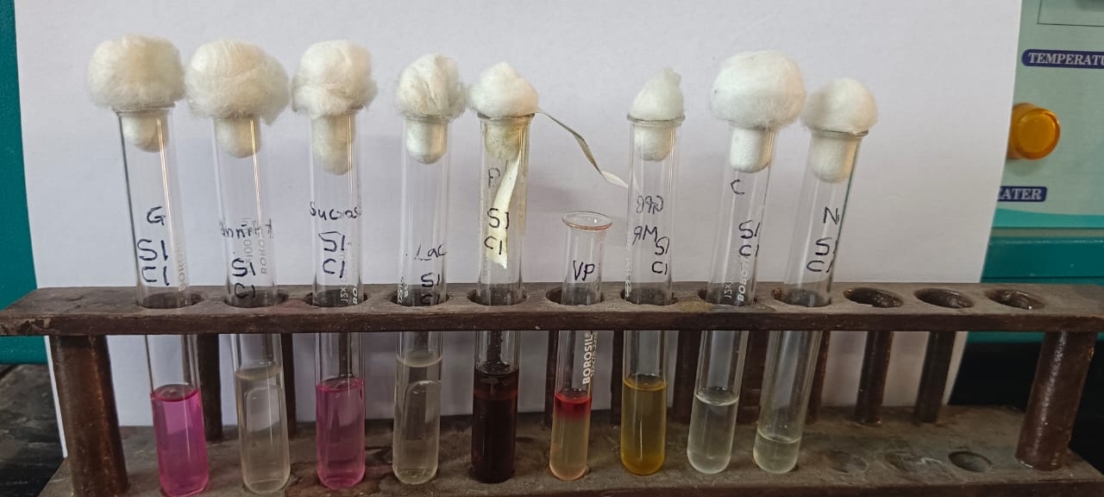

Fig. 2 Biochemical characterization of the isolates

Table 1. Cultural characterization of the isolates

Table 2. Biochemical characterization of the isolates

Biochemical Characteristics | PHA1 | PHA2 | PHA3 | PHA4 | PHA5
Indole | - | - | + | + | -
Methyl red | + | + | + | + | +
VP | - | - | - | - | -
Citrate | - | - | + | + | -
Nitrate | - | - | - | - | -
Glucose | + | + | + | + | +
Sucrose | + | + | + | + | +
Lactose | - | - | + | - | -
Mannitol | - | - | + | - | -
H2S Production | - | - | - | - | -
Catalase | + | + | - | + | -
Oxidase | + | + | - | + | -
Starch Hydrolysis | + | + | + | + | -

3.2 16S rRNA Gene Sequence Analysis
The molecular identification of the PHA-producing bacterial isolates was performed through amplification and sequencing of the 16S rRNA gene. The nearly full-length 16S rRNA sequences obtained for the isolates 24B110_358_PHA_1, 24B110_359_PHA_2, and 24B110_360_PHA_3 are provided below in FASTA format, as shown in Figure 3. These sequences were used for BLAST-based taxonomic identification and phylogenetic analysis. The obtained sequence was compared against the NCBI database using the Basic Local Alignment Search Tool (BLAST) (Altschul et al., 1990) and aligned using MUSCLE (Edgar, 2004). Phylogenetic analysis using software such as MEGA11 (Tamura et al., 2021).
Molecular identification, using 16S rRNA gene sequencing and subsequent closest-match BLAST analysis, confirmed that all three Polyhydroxybutyrate (PHA)-producing isolates belong to the highly conserved Bacillus cereus sensu lato complex (Altschul et al., 1990; Quast et al., 2013).Phylogenetic analysis, constructed using the Maximum Likelihood method, further delineated the taxonomic placement of the isolates as shown in Figures 3,4,5 and Table No. 3.
Isolates PHA-1 (HM Code: 24B110_358) and PHA-2 (HM Code: 24B110_359) consistently clustered with reference strains of Bacillus paramycoides. PHA-1 showed the highest sequence similarity to B. paramycoides (Accession: MH900215), and PHA-2 demonstrated its closest sequence identity to B. paramycoides (Accession: MH100693). The strong clustering of these two isolates within the Bacillus aramycoides and Bacillus tropicus clade strongly supports their affiliation with the B. paramycoides lineage (Mozejko-Czekaj et al., 2020).In contrast, Isolate PHA-3 (HM Code: 24B110_360) formed a distinct and separate branch within the Bacillus cereus clade. Its maximum sequence similarity was recorded for Bacillus cereus (Accession: GQ406846). PHA-3’s consistent grouping with reference strains of Bacillus cereus and Bacillus thuringiensis confirms its strong affiliation with the Bacillus cereus evolutionary branch.
Overall, the combined molecular data from both sequence similarity and phylogenetic tree topology confirm that PHA-1 and PHA-2 are closely related to Bacillus paramycoides, while PHA-3 is most closely related to Bacillus cereus. These results clearly place all three isolates within the Bacillus cereus group, although minor intra-group divergence differentiates them into distinct sub-clusters, reflecting the genetic diversity within this complex (Tamura et al., 2021), as shown in the
This molecular data, in conjunction with the Gram-positive, rod-shaped morphology, provides a robust taxonomic placement, demonstrating the genetic diversity and PHA-producing capacity within the Bacillus cereus complex (Tamura et al., 2021).
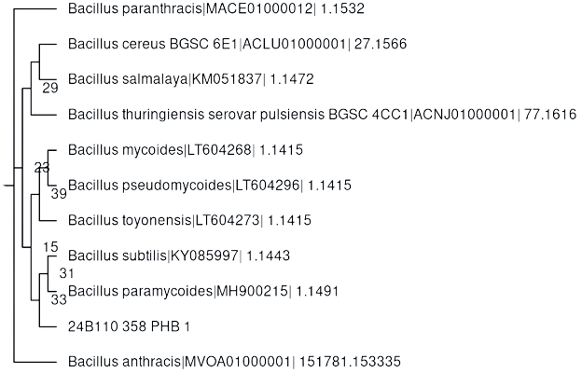
Fig. 3 Phylogenetic Analysis of PHB 1 isolate

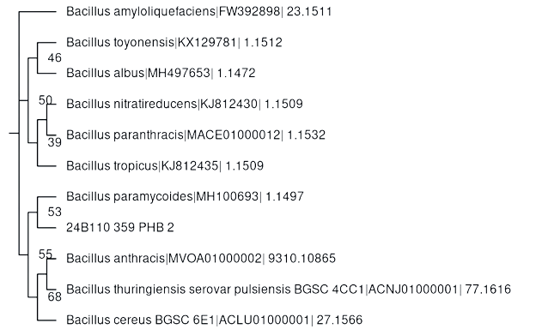

Fig. 4 Phylogenetic Analysis of PHB 2 isolate

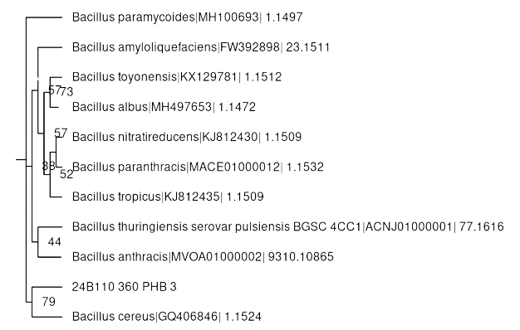
Fig. 5 Phylogenetic Analysis of PHB 3 isolate

Table 3. Phylogenetic analysis

Sr. No. | HM Code | Sample ID | Result: Closest Taxonomic Relative
1 | 24B110_358 | PHA-1 | Bacillus paramycoides (MH900215)
2 | 24B110_359 | PHA-2 | Bacillus paramycoides (MH100693)
3 | 24B110_360 | PHA-3 | Bacillus cereus (GQ406846)
3.3 Growth Curve Analysis
The growth kinetics of the five PHA-producing isolates, PHA 1 to PHA 5, were monitored spectrophotometrically by measuring the Optical Density (O.D.) at 640 nm at 30-minute intervals over a total period of 240 minutes (4 hours). The results are graphically represented as shown in Figure 6 and Table No. 4. Lag Phase 30-90 minutes: All isolates showed a relatively low increase in biomass during the first 90 minutes. This period represents the lag phase, where the cells are acclimatizing to the new growth media and preparing for rapid division.
Exponential (Log) Phase (120-240 minutes): A distinct shift to the exponential growth phase was observed starting around 120–150 minutes, characterized by a steep increase in O.D. 640.Comparative Growth Performance: Isolate PHA 5 exhibited the highest growth rate during the exponential phase (between 180 and 240 minutes) and achieved the maximum final biomass, reaching an O.D. of 0.560 at 240 minutes.Isolate PHA4 followed closely, achieving a final O.D. of 0.475, also demonstrating robust growth kinetics. Isolates PHA 1 and PHA 2 showed lower final biomass readings (0.281) and (0.395), respectively, suggesting a slower overall division rate in this specific PHA-producing medium, as shown in Figure no. 6

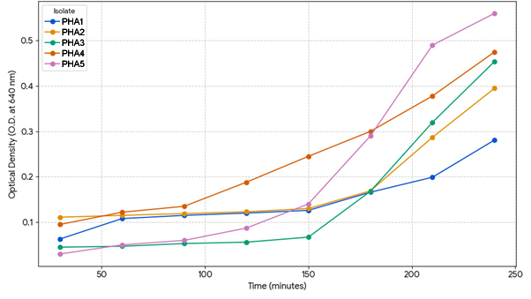
Fig. 6 Growth curve analysis of PHA isolates

Table 4. Growth Curve analysis

Sr. No. | Time (min) | PHA1 | PHA2 | PHA3 | PHA4 | PHA5
1 | 30 | 0.063 | 0.111 | 0.045 | 0.095 | 0.030
2 | 60 | 0.108 | 0.115 | 0.047 | 0.122 | 0.050
3 | 90 | 0.115 | 0.119 | 0.053 | 0.135 | 0.060
4 | 120 | 0.120 | 0.123 | 0.056 | 0.188 | 0.087
5 | 150 | 0.126 | 0.130 | 0.067 | 0.245 | 0.140
6 | 180 | 0.166 | 0.169 | 0.168 | 0.300 | 0.290
7 | 210 | 0.199 | 0.287 | 0.320 | 0.378 | 0.490
8 | 240 | 0.281 | 0.395 | 0.454 | 0.475 | 0.560

3.4 PHA Production and Extraction
The optimized isolate PHA was cultured for 72 hours Figure 7(a). Quantitative extraction using the NaOCl chloroform method yielded a final PHA dry weight, as shown in Figure 7 (b). The selected PHA isolates were harvested, and after extraction, the PHA was quantified using the standard sulfuric acid digestion method (Law & Slepecky, 1961). The maximum PHA yield achieved was 55.3% of the Cell Dry Weight (CDW), corresponding to a volumetric PHA concentration of 4.8 g/L.
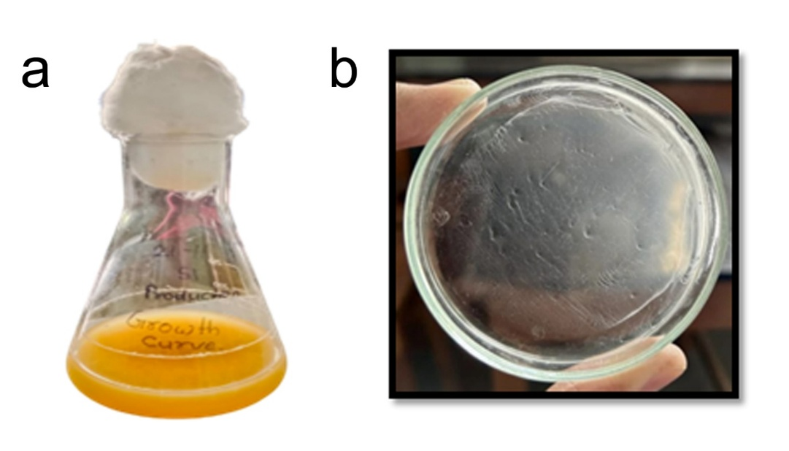
Fig. 7 a) Grown culture of PHA isolate for PHA extraction b) Extracted PHA polymer on plate

3.5 Effect of pH on PHA Production
The isolated strain was cultured in PHA-producing media adjusted to a range of pH values (3 to 11). Bacterial growth was monitored by measuring the Optical Density (O.D.) at 640 nm after incubation, as shown in Table No. 5
The results show that the isolate's growth is severely inhibited under acidic conditions, particularly at pH 3 (O.D.=0.10) and pH 5 (O.D.=0.20). Optimal growth, as indicated by the highest O.D. values, was observed in the alkaline range, peaking at pH 9 (O.D.=0.68), followed closely by pH 11 (O.D.=0.64) and pH 7 (O.D.=0.54). This indicates the organism is highly tolerant of neutral to moderate alkaline conditions.
Table 5. Effect of pH on PHA production
Sr. No. | pH | O.D. (640nm)
1 | 3 | 0.10
2 | 5 | 0.20
3 | 7 | 0.54
4 | 9 | 0.68
5 | 11 | 0.64

3.6 Effect of NaCl Concentration on PHA Production
The growth of the bacterial strain was tested in PHA-producing media supplemented with varying concentrations of Sodium Chloride (NaCl), as shown in Table No. 6
The data reveals that the isolate exhibits a low tolerance for high salinity. The highest level of growth was achieved at a low salt concentration of 0.5% NaCl (O.D.=0.23). Growth was notably lower at 0.1% NaCl (O.D.=0.15), and while growth slightly increased at 1.5% and 2% NaCl compared to 1%, overall growth remained limited below the peak 0.5% NaCl concentration. This suggests the organism is a non-halophile with an optimal requirement for minimal salt concentration.

Table 6. Effect of NaCl on PHA Production (Growth)
Sr. No. | Conc. of NaCl (%) | O.D. (640 nm)
1 | 0.1 | 0.15
2 | 0.5 | 0.23
3 | 1 | 0.16
4 | 1.5 | 0.19
5 | 2 | 0.17

3.7 Spectroscopic Characterization (FTIR)
To confirm the chemical structure of the extracted biopolymer, Fourier-Transform Infrared Spectroscopy (FTIR) was performed. The resulting spectrum showed characteristic absorption peaks essential for identifying Poly(3-hydroxybutyrate) (PHA). Key diagnostic peaks included a strong absorption band at 1723 cm⁻¹ (representing the C=O stretch of the ester carbonyl group) and two distinct bands in the 1200–1300 cm⁻¹ range (specifically 1280 cm⁻¹ and 1228 cm⁻¹), which are associated with the C–O and C–C stretching of the PHA backbone (Saba et al., 2020).
The presence of the strongest characteristic peak at 1722.90 cm⁻¹ (C=O ester bond), along with the identifying C-O-C stretching peaks 1277.85 cm⁻¹ and 1106.92 cm⁻¹, conclusively verifies that the extracted material is Poly-3-hydroxybutyrate P3HB (Sudesh, K., Kairul, et. al., 2018), as shown in Figure 8
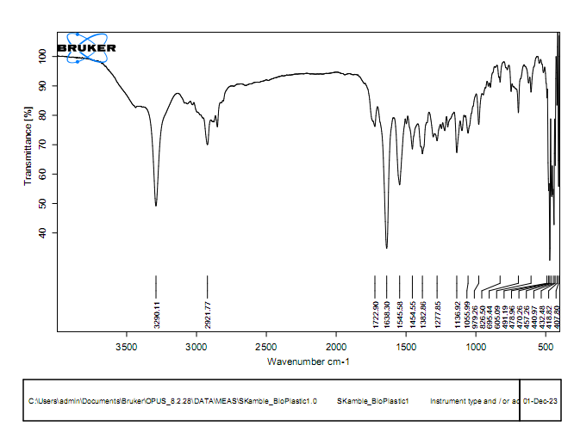
Fig. 8 FTIR Analysis of PHAs

4. CONCLUSION
In summary, the study successfully isolated novel, Gram-positive, rod-shaped bacteria from soil, identified molecularly as strains of Bacillus paramycoides (PHA-1, PHA-2) and Bacillus cereus (PHA-3), all belonging to the PHA-producing Bacillus cereus sensu lato complex. Optimizing growth conditions (pH 9.0, 0.5% NaCl) resulted in a high Poly(3-hydroxybutyrate) (PHA) yield of 55.3% of Cell Dry Weight (4.8 g/L), with the structure conclusively confirmed by FTIR spectroscopy. These robust isolates demonstrate significant potential for efficient, high-volume production of biodegradable bioplastics.

7. REFERENCES
Altschul, S. F., Gish, W., Miller, W., Myers, E. W., & Lipman, D. J. (1990). Basic local alignment search tool. Journal of Molecular Biology, 215(3), 403-410.
Cappuccino, J. G., & Sherman, N. (2014). Microbiology: A laboratory manual (10th ed.). Pearson.
Chan, C. M., Ma, Z., & Chen, G. Q. (2018). Polyhydroxyalkanoate (PHA) production from agro-industrial waste and wastewater. In G. Q. Chen (Ed.), Plastics from Bacteria (pp. 263–294). Springer, Singapore.
Chen, G. Q., & Wu, Q. (2005). The application of polyhydroxyalkanoates as tissue engineering materials. Biomaterials, 26(33), 6565–6578.
Choi, S. Y., & Lee, S. Y. (1997). Process analysis and economic evaluation of poly(3-hydroxybutyrate) production by fermentation. Bioprocess Engineering, 17(4), 335–342.
Edgar, R. C. (2004). MUSCLE: A multiple sequence alignment method. Nucleic Acids Research, 32(5), 1792–1797.
Geyer, R., Jambeck, J. R., & Law, K. L. (2017). Production, use, and fate of all plastics ever made. Science Advances, 3(7), e1700782.
Horton, A. A., Svendsen, C., Williams, R. J., Spurgeon, D. J., & Lahive, E. (2017). Large plastic debris and microplastic ingestion by freshwater fish in England. Environmental Pollution, 220, 1448–1454.
Jambeck, J. R., Geyer, R., Wilcox, C., Siegler, T. R., Perryman, M., Andrady, A., Narayan, R., & Law, K. L. (2015). Plastic waste inputs from land into the ocean. Science, 347(6223), 768–771.
Kahar, P., Liew, C. V., & Sudesh, K. (2008). A new medium for enhanced production of poly(3-hydroxybutyrate) in recombinant Escherichia coli. Biotechnology and Bioengineering, 99(2), 290–298.
Khanna, S., & Srivastava, A. K. (2005). Recent advances in microbial polyhydroxyalkanoates. Process Biochemistry, 40(2), 607–619.
Khanna, S., & Srivastava, B. (2014). Recent advances in microbial production of polyhydroxyalkanoates from waste and renewable sources. Clean Technologies and Environmental Policy, 16(2), 273–286.
Koller, M. (2018). Microbial production of polyhydroxyalkanoates—A review. Separation and Purification Technology, 205, 662–681.
Koller, M., Muhr, A., & Braunegg, G. (2013). Producing microbial polyhydroxyalkanoate (PHA) biopolyesters in a sustainable manner. Current Opinion in Biotechnology, 24(3), 398–406.
Lageveen, R. G., Huisman, G. W., Preusting, H., Ketelaar, P., Kingma, J., & Witholt, B. (1988). Formation of polyesters by fluorescent pseudomonads in the presence of various carbon sources. Applied and Environmental Microbiology, 54(12), 2924–2932.
Lane, D. J. (1991). 16S/23S rRNA sequencing. In E. Stackebrandt & M. Goodfellow (Eds.), Nucleic acid techniques in bacterial systematics (pp. 115–175). Wiley.
Law, J. H., & Slepecky, R. A. (1961). Assay of poly-β-hydroxybutyric acid. Journal of Bacteriology, 82(1), 33–36.
Laycock, B., Halley, P., Pratt, S., Gauthier, E., Krzan, M., Hill, D. J., & Truss, R. (2017). The chemistry and sustainability of polyhydroxyalkanoates. Polymer Reviews, 57(1), 31–105.
Lee, S. Y., Choi, J. I., & Lee, Y. H. (1999). High-cell-density culture of Ralstonia eutropha for the production of poly(3-hydroxybutyrate). Applied Microbiology and Biotechnology, 51(5), 545–553.
Możejko-Czekaj, M., Ciesielski, S., & Borymski, S. (2020). Production of polyhydroxyalkanoates by Bacillus spp.—Review. Polymers, 12(12), 2977.
Quast, C., Pruesse, E., Yilmaz, P., Gerken, J., Schweer, T., Yarza, P., Peplies, J., & Glöckner, F. O. (2013). The SILVA ribosomal RNA gene database project. Nucleic Acids Research, 41(D1), D590–D596.
Reddy, C. S. K., Ghai, R., Rashmi, & Kalia, V. C. (2003). An overview of the microbial production of polyhydroxyalkanoates (PHAs) and its commercial potential. International Journal of Biological Macromolecules, 31(5), 168–175.
Saba, J. A., Schäfer, T., & Zinn, M. (2020). Fourier-transform infrared spectroscopy of polyhydroxyalkanoates. Biomacromolecules, 21(1), 347–358.
Sabdono, A., Nurcahyani, R., & Hartati, R. (2019). Screening and characterization of polyhydroxyalkanoates (PHAs) producing bacteria isolated from mangrove sediment in Central Java, Indonesia. Journal of Pure and Applied Microbiology, 13(2), 651–657.
Singh, M., Patel, S. K. S., Kalia, V. C., & Lal, B. (2009). Production of polyhydroxyalkanoate copolymer by Bacillus thuringiensis. Bioresource Technology, 100, 2320–2326.
Steinbüchel, A., & Füchtenbusch, B. (1998). Bacterial and other biological systems for the production of polyhydroxyalkanoates. Trends in Biotechnology, 16(10), 419–427.
Sudesh, K., Kairul, S. I. M., & Sazali, S. R. (2018). Polyhydroxyalkanoates (PHAs): An updated review of bacterial production and biotechnological applications. Current Biotechnology, 7(1), 1–19.
Tamura, K., Stecher, G., & Kumar, S. (2021). MEGA11: Molecular Evolutionary Genetics Analysis version 11. Molecular Biology and Evolution, 38(7), 3022–3027.
Tortora, G. J., Funke, B. R., & Case, C. L. (2019). Microbiology: An introduction (13th ed.). Pearson.

