Case report

High-Rise Syndrome–Associated Stillbirth and Obstructive Dystocia in a Pregnant Rhesus Macaque (Macaca mulatta)

ABSTRACT
Stillbirth in non-human primates represents failure of the maternal–fetal–placental unit and may result from abnormal fetal presentation, maternal compromise, or trauma. Documentation of trauma-associated dystocia in free-ranging rhesus macaques remains limited. An adult pregnant rhesus macaque (Macaca mulatta) was rescued following suspected fall-related blunt abdominal trauma. The animal presented unconscious in lateral recumbency with respiratory depression, cardiovascular instability, hyperthermia, and multiple abdominal contusions. Per-vaginal examination revealed full cervical dilation with bilateral forelimb flexion, confirming obstructive dystocia secondary to fetal malposture. Emergency stabilization was initiated using intravenous fluid therapy, cardiopulmonary resuscitation, corticosteroids, and supportive care. Per-vaginal mutation was performed to correct limb flexion, followed by assisted extraction using obstetrical forceps, resulting in delivery of a dead female fetus. Morphometric assessment indicated near-term gestation (approximately 168 days), consistent with established gestational parameters for the species. Maternal parameters improved following intervention, and hemorrhage was effectively controlled. The findings suggest that blunt abdominal trauma during advanced gestation may contribute to fetal compromise and secondary obstructive dystocia. This case underscores the importance of rapid clinical stabilization and timely obstetrical management in trauma-associated reproductive emergencies in urban free-ranging primates.
Keywords: Fetal malpresentation; Obstetrical intervention; rhesus macaque; Stillbirth; Trauma-associated dystocia.
INTRODUCTION
The rhesus macaque (Macaca mulatta) is a well-characterized non-human primate with established reproductive parameters, including a mean gestation length of approximately 166 days under captive colony conditions (Silk et al. 1993). Parturition in rhesus macaques has been described as typically rapid and behaviourally coordinated, with delivery usually occurring within a short duration under normal physiological conditions (Brandt & Mitchell 1973). Successful pregnancy depends upon the integrity of the maternal–fetal–placental unit, and disruption of this system may result in fetal compromise, dystocia, or stillbirth. Stillbirth in non-human primates is recognized as a form of reproductive failure arising from late-gestation fetal death and has been documented in both captive and free-ranging populations (Roura-Torres et al. 2024; Saiyed et al. 2018). Colony-based analyses in macaques indicate that stillbirths are frequently multifactorial in origin, involving placental abnormalities, maternal compromise, fetal trauma, or abnormal presentation (Sesbuppha et al. 2008). Abnormal fetal positioning has been specifically associated with increased risk of stillbirth in cynomolgus macaques, emphasizing the importance of fetal orientation during labor (Cho et al. 1985). Reports of stillbirth in free-ranging macaques further highlight the ecological and behavioral complexity surrounding reproductive failure (Kaigaishi & Yamamoto 2023).
Dystocia in non-human primates may result from fetal malposture, uterine dysfunction, or maternal systemic compromise, and is a recognized risk factor for perinatal mortality (Stockinger et al. 2011). In veterinary obstetrics, prompt intervention is recommended when obstructive dystocia is identified to safeguard maternal survival (Noakes et al. 2018). Trauma during advanced gestation presents an additional threat, as blunt abdominal injury may impair uteroplacental circulation and precipitate intrauterine fetal death. Although fall-related trauma (“high-rise syndrome”) is well described in companion animals (Davis 2006), its reproductive consequences in non-human primates are rarely documented. Case reports of reproductive failure in other species further emphasize the clinical importance of timely obstetrical management in compromised pregnancies (Sahu et al. 2024a). The present study describes trauma-associated stillbirth complicated by obstructive dystocia in a near-term rhesus macaque, emphasizing emergency stabilization and assisted obstetrical intervention as critical components of maternal survival.

Case presentation and History
An adult female rhesus macaque (Macaca mulatta), weighing approximately 6–7 kg, was rescued from a roadside area in Bareilly, Uttar Pradesh, India, following suspected fall-related trauma. The reproductive history was unknown. According to the rescuers, the animal was found in a lateral recumbent position and was unconscious at the time of retrieval. In one instance, history included straining and vulvar discharge observed since morning prior to rescue. On initial presentation, the animal exhibited severe systemic compromise. Mentation was comatose, with absent voluntary responses. The macaque remained in lateral recumbency and demonstrated labored breathing (Fig. 1). Ocular examination revealed sunken eyeballs, suggestive of dehydration and circulatory insufficiency. Mucous membranes were pale pink to congested in different examinations, indicating variable peripheral perfusion status.

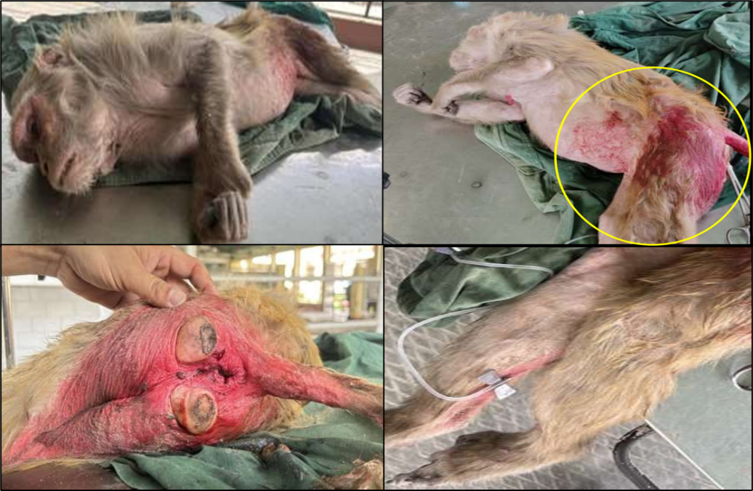

Fig. 1. Clinical findings at presentation in a pregnant rhesus macaque (Macaca mulatta) following suspected high-rise trauma, illustrating lateral recumbency, abdominal and perineal contusions, and intravenous catheter placement for emergency resuscitation.

Rectal temperature ranged between 103°F and 105°F, indicating hyperthermia. Cardiovascular assessment revealed marked bradycardia in one evaluation (<60 bpm) and weak tachycardia in another (~70 bpm), reflecting cardiovascular instability. Respiratory rate ranged from 10 to 15 cycles per minute, consistent with hypoventilation and respiratory depression. Physical examination identified multiple contusions and bruises over the ventral abdomen, lateral body wall, caudal hindlimbs, and perineal region, strongly suggestive of blunt force trauma. A consolidated summary of signalment, anamnesis, and clinical findings at admission is presented in Table 1. The combination of abdominal trauma, altered mentation, respiratory compromise, and evidence of active vulvar discharge raised suspicion of advanced gestation complicated by trauma-associated fetal compromise and possible dystocia. The patient was immediately stabilized under emergency protocols prior to obstetrical assessment and intervention.
Table 1. Signalment, Anamnesis and Clinical Findings at Presentation
Category | Parameter | Findings
Signalment | Case number | G73
Signalment | Species | rhesus macaque (Macaca mulatta)
Signalment | Sex | Female
Signalment | Weight | ~7 kg
Signalment | Coat color | Brown
Signalment | Age | Not determined
Signalment | Rescue location | Bareilly, Uttar Pradesh, India
Anamnesis | History source | NGO rescue report
Anamnesis | History of trauma | Suspected fall from height (high-rise trauma)
Anamnesis | Condition at retrieval | Unconscious, lateral recumbency
Anamnesis | Reported prior signs | Straining and vulvar discharge since morning
Anamnesis | Breathing difficulty | Present
Anamnesis | Previous medical history | Unknown
Clinical Examination | General appearance | Depressed
Clinical Examination | Mentation | Comatose
Clinical Examination | Posture | Lateral recumbency
Clinical Examination | Mucous membranes | Pale pink to congested
Clinical Examination | Eyeball condition | Sunken
Clinical Examination | Rectal temperature | 103–105°F
Clinical Examination | Heart rate | <60–70 bpm (cardiovascular instability)
Clinical Examination | Respiratory rate | 10–15 cycles/min
Clinical Examination | External injuries | Contusions over ventral abdomen, lateral body wall, caudal hindlimbs, perineal region
Emergency Stabilization and Obstetrical Management
Immediate resuscitative measures were initiated. The posterior tibial vein was catheterized, and intravenous fluid therapy was administered using Ringer’s lactate (200 mL) followed by dextrose normal saline (100 mL) to address hypovolemia and circulatory compromise. Due to weak cardiac activity and hypoventilation, cardiopulmonary resuscitation was performed using cycles of 30 chest compressions followed by two assisted breaths. Dexamethasone (0.5 mg/kg IV) was administered to mitigate traumatic shock and systemic inflammatory response.
Following partial stabilization, per-vaginal examination revealed full cervical dilation. A fetus was palpable within the birth canal; however, both forelimbs were flexed and retained, confirming obstructive dystocia secondary to fetal malposture. A per-vaginal mutation procedure was performed to correct limb flexion, and both forelimbs were carefully extended into the pelvic canal. Subsequently, controlled traction using obstetrical forceps enabled forced extraction of a dead female fetus. Post-extraction management included administration of oxytocin (10 IU intramuscularly and 5 IU intravenously) to enhance uterine contraction and reduce postpartum hemorrhage. Enrofloxacin (5 mg/kg IM) was administered for antimicrobial coverage, tranexamic acid (10 mg/kg IV) for hemorrhage control, and meloxicam (0.3 mg/kg IM) for analgesia. Neuroprotective supplementation and tetanus toxoid were also administered. Gauze tamponing of the vaginal canal was performed to assist in hemorrhage control.
RESULTS
Emergency stabilization followed by obstetrical intervention resulted in successful extraction of a dead female fetus. Per-vaginal examination revealed full cervical dilation with bilateral forelimb flexion, confirming obstructive dystocia secondary to fetal malposture. Mutation was performed to extend both forelimbs into the pelvic canal, after which controlled traction using obstetrical forceps enabled delivery without surgical intervention (Fig. 2).

Fig. 2. Assisted vaginal delivery of a dead near-term female fetus following per-vaginal mutation and controlled traction using obstetrical forceps in a pregnant rhesus macaque (Macaca mulatta). Bilateral forelimb flexion causing obstructive dystocia was corrected prior to extraction.
The fetus showed absence of reflexes and no detectable cardiac activity at extraction. Cranial deformation was observed, likely associated with prolonged compression within the birth canal. Morphometric evaluation (Fig. 3) revealed a crown–rump length of 160 mm, femur length of 49 mm, fetal limb length of 145 mm, and head circumference of 191 mm. These measurements correspond to approximately 168 days of gestation, consistent with near-term pregnancy in rhesus macaques (Silk et al. 1993). Maternal parameters improved following fluid resuscitation, corticosteroid administration, uterotonic therapy, and antimicrobial coverage. Hemorrhage was effectively controlled, and the dam regained consciousness during post-procedural monitoring. No immediate post-extraction complications were observed.

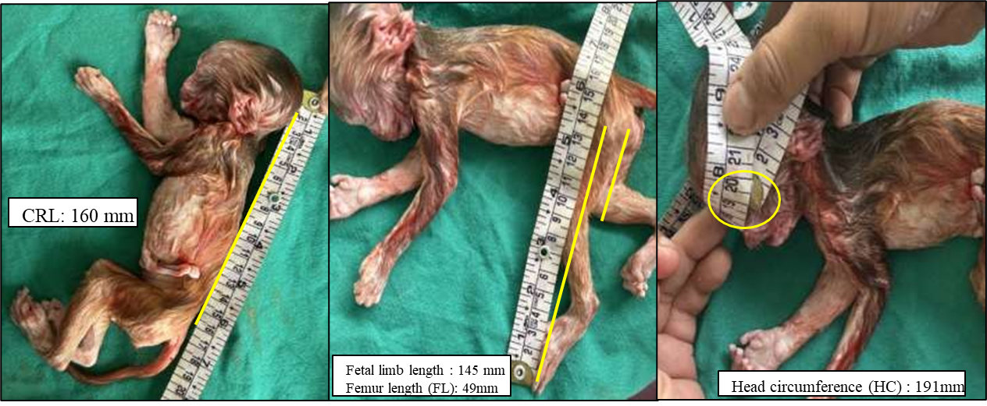
Fig. 3. Extracted near-term female fetus from a rhesus macaque (Macaca mulatta) following assisted obstetrical intervention, showing cranial deformation consistent with prolonged compression within the birth canal. Morphometric measurements included crown–rump length (160 mm), femur length (49 mm), total fetal limb length (145 mm), and head circumference (191 mm). These parameters correspond to approximately 168 days of gestation, consistent with near-term pregnancy in rhesus macaques (Silk et al., 1993).
DISCUSSION
This case documents trauma-associated stillbirth complicated by obstructive dystocia in a near-term rhesus macaque. The animal presented with systemic compromise and external signs of blunt abdominal trauma, suggesting that traumatic insult likely preceded obstetrical obstruction. In pregnant mammals, abdominal trauma may impair uteroplacental perfusion and result in fetal hypoxia or intrauterine fetal death. Although placental examination was not performed, the clinical context supports trauma as a plausible initiating factor. Stillbirth in non-human primates is frequently multifactorial and reflects failure of the maternal–fetal–placental unit (Roura-Torres et al. 2024; Sesbuppha et al. 2008). In macaque populations, abnormal fetal presentation has been associated with increased risk of stillbirth (Cho et al. 1985). The bilateral forelimb flexion observed in this case produced mechanical obstruction, necessitating per-vaginal correction. Dystocia itself is recognized as a contributor to perinatal mortality in macaques, particularly when associated with malposture and prolonged parturition (Stockinger et al. 2011).
Normal parturition in rhesus macaques is typically rapid (Brandt & Mitchell 1973). Deviation from physiological presentation may prolong delivery and increase fetal risk. Whether fetal death occurred prior to the onset of dystocia or secondary to prolonged obstruction cannot be definitively determined; however, the presence of systemic maternal compromise at presentation suggests that intrauterine fetal demise may have preceded assisted extraction. Fetal morphometry confirmed advanced gestation consistent with established gestational norms for rhesus macaques (Silk et al. 1993), making prematurity unlikely as the primary cause of death. Cranial deformation observed at delivery may have resulted from compression within the birth canal during obstructed labor.
Stillbirths have been documented in both captive and free-ranging primate populations (Saiyed et al. 2018; Kaigaishi & Yamamoto 2023), yet reports linking trauma and obstructive dystocia in rhesus macaques remain limited. Urban free-ranging macaques increasingly encounter anthropogenic hazards, including falls from height. While fall-related trauma is well described in companion animals (Davis 2006), its reproductive implications in primates are insufficiently documented. From a clinical perspective, rapid stabilization, correction of fetal malposture, and timely assisted extraction were essential for maternal survival, consistent with established veterinary obstetrical principles (Noakes et al. 2018). This case highlights the need for structured emergency obstetrical protocols in wildlife rescue and urban primate management contexts.
Statements and Declarations
Competing Interests
The authors declare that they have no competing.

References
Brandt, E. M., & Mitchell, G. (1973). Labor and delivery behavior in rhesus monkeys (Macaca mulatta). American Journal of Physical Anthropology, 38(2), 519–522. https://doi.org/10.1002/ajpa.1330380259
Cho, F., Hanari, K., Suzuki, M. T., & Honjo, S. (1985). Relationship between fetal position and stillbirth in the cynomolgus monkeys (Macaca fascicularis): Retrospective analysis. Journal of Medical Primatology, 14(3), 169–174. https://doi.org/10.1111/j.1600-0684.1985.tb00398.x
Davis, K. L. (2006). The everything cat book. Simon & Schuster.
Kaigaishi, Y., & Yamamoto, S. (2023). A report of stillbirth and subsequent maternal cannibalism observed in a free-ranging group of Japanese macaques at Awajishima, Japan. Primates. https://doi.org/10.1007/s10329-023-01091-8
Noakes, D. E., Parkinson, T. J., & England, G. C. W. (Eds.). (2018). Arthur’s veterinary reproduction and obstetrics (10th ed.). Elsevier Health Sciences.
Roura-Torres, B., Amblard-Rambert, P., Lepou, P., Kappeler, P. M., & Charpentier, M. J. E. (2024). Stillbirth of a mandrill (Mandrillus sphinx) in the wild: Perinatal behaviors and delivery sequences. Primates, 65(2), 75–80.
Sahu, U. K., Singh, K., Pandiyan, N., Kumar, B., & Khan, M. H. (2024a). Fetal mummification in a doe: A case report. The Indian Journal of Animal Reproduction, 45(1), 107–108.
Saiyed, S. T., Liubicich, R. C., Fidino, M., & Ross, S. R. (2018). Stillbirth rates across three ape species in accredited American zoos. American Journal of Primatology, 80(6), e22870. https://doi.org/10.1002/ajp.22870
Sesbuppha, W., Chantip, S., Dick, E. J., Jr., Schlabritz-Loutsevitch, N. E., Guardado-Mendoza, R., Butler, S. D., Frost, P. A., & Hubbard, G. B. (2008). Stillbirths in Macaca fascicularis. Journal of Medical Primatology, 37(4), 169–172. https://doi.org/10.1111/j.1600-0684.2007.00275.x
Silk, J., Short, J., Roberts, J., & Kusnitz, J. (1993). Gestation length in rhesus macaques (Macaca mulatta). International Journal of Primatology, 14(1), 95–104.
Stockinger, D. E., Torrence, A. E., Hukkanen, R. R., Vogel, K. W., Hotchkiss, C. E., & Ha, J. C. (2011). Risk factors for dystocia in pigtailed macaques (Macaca nemestrina). Comparative Medicine, 61(2), 170–175.

