Farmer Participation as an Indicator of Demand-Driven Extension: A Four-Year Analysis of On- and Off-Campus Training Programmes in a Temperate Horticulture System

Abstract
Krishi Vigyan Kendras (KVKs) represent the backbone of India’s pluralistic agricultural extension system, with a mandate extending beyond technology dissemination to include demand assessment, feedback generation and adaptive learning. Demand-driven extension is fundamental to the effectiveness of Krishi Vigyan Kendras (KVKs), yet systematic analysis of farmer participation data is rarely undertaken for scientific evaluation. The present study analysed four years (2021–2024) of training programmes conducted by Horticulture Scientists at ICAR–KVK Baramulla to assess farmer participation as a proxy indicator of extension demand, thematic relevance and delivery effectiveness. Secondary data on the number of trainings, delivery mode (on-campus/off-campus), thematic focus and participant strength were analysed using descriptive statistics and trend analysis. Results revealed a consistent increase in farmer participation over the study period, with off-campus programmes exhibiting higher participation density than on-campus trainings. Horticulture-centric themes, particularly high-density apple plantation, plant protection and climate-responsive practices, dominated farmer participation. The study demonstrates that participation-based analytics offer a simple yet robust framework for evidence-based extension planning.
Keywords: Demand-driven extension, farmer participation, Krishi Vigyan Kendra, on-campus training, off-campus training, temperate horticulture

Introduction
Krishi Vigyan Kendras (KVKs) constitute the primary institutional mechanism for technology assessment, refinement and dissemination in Indian agriculture (Anderson and Feder, 2007; Swanson and Rajalahti, 2010; ICAR, 2014). Their effectiveness increasingly depends on how well extension interventions align with farmers’ needs, priorities and emerging production challenges rather than merely the number of activities conducted (Feder et al., 2001; Singh et al., 2013). Contemporary extension theory increasingly emphasizes demand-driven, participatory and outcome-oriented approaches, wherein farmers’ engagement itself is treated as a critical indicator of programme relevance and effectiveness (Birner et al., 2020; Meena et al., 2022).
Farmer participation is widely recognised as an important indicator of perceived relevance, accessibility and trust in extension services (Rogers, 2003; Oakley and Marsden, 1984; Meena and Singh, 2014). Participation behaviour reflects farmers revealed preferences for specific technologies and advisory themes and can therefore serve as a proxy for extension demand (Birner et al., 2009; Meena et al., 2015). Experiments show a steady move from general awareness programs to more structured trainings, with a greater focus on skill-building and climate responsive activities. Studies show that regular institutional data can reveal important changes in extension priorities and help with adaptive planning (Kirmani et al., 2026)
In temperate horticulture systems such as Jammu & Kashmir, apple-based farming dominates rural livelihoods and faces increasing challenges due to climate variability, pest dynamics and orchard intensification pressures (Morton, 2007; FAO, 2021; Adhikari and Piya, 2020). Extension systems in such regions must continuously adapt their training portfolios to address climate risks, productivity constraints and sustainability concerns (Swanson, 2011; Chapke et al., 2019).
Apple-based farming systems, especially the rapid expansion of high-density plantation (HDP) models, have substantially altered knowledge and skill requirements of farmers, thereby redefining extension priorities (Sharma et al., 2021; Kirmani et al., 2026). Despite extensive documentation of training activities in KVK records, systematic research utilising secondary participation data for scientific analysis remains limited in Indian extension literature (Kumar et al., 2019; Singh et al., 2021; Meena et al., 2022). The present study attempts to bridge this gap by analysing four years of training and participation data from ICAR–KVK Baramulla to generate evidence for demand-driven extension planning.
Indian Scenario:-
In India, agricultural extension has undergone significant conceptual and operational transitions over the past two decades, shifting from a top–down, technology-transfer paradigm toward a more participatory, demand-driven and pluralistic system. With nearly 86 per cent of operational holdings classified as small and marginal, farmers’ production decisions are increasingly shaped by risk, resource constraints, climatic uncertainty and market volatility, making their active participation in extension programmes a critical indicator of relevance and demand. Public extension institutions, particularly the Krishi Vigyan Kendras (KVKs) under the Indian Council of Agricultural Research (ICAR), occupy a central position in this evolving landscape due to their mandate of technology assessment, refinement and frontline extension. While the numerical expansion of KVKs across agro-ecological regions has strengthened outreach, the challenge has shifted toward ensuring that extension interventions are responsive to farmers’ real and emerging needs. In this context, farmer participation in training programmes—both on-campus and off-campus—has gained recognition as a revealed-preference indicator of demand-driven extension, reflecting farmers’ willingness to invest time and effort in learning activities perceived as useful and contextually relevant.
The Indian extension system today operates within a pluralistic environment involving public agencies, private advisory services, farmer producer organisations, NGOs and digital platforms. However, for a majority of smallholders, especially in remote and hill regions, KVK-led trainings remain the most accessible and trusted source of technical guidance. Participation patterns in these trainings are influenced by multiple factors, including relevance of subject matter, delivery mode, proximity, seasonal workload and perceived credibility of trainers. Off-campus trainings conducted at village or cluster levels have increasingly emerged as a preferred mode, as they reduce transaction costs for farmers and enable location-specific learning. Conversely, on-campus trainings continue to play a vital role in skill-intensive areas requiring infrastructure, demonstrations and controlled learning environments. The balance between these two modes, and farmers’ differential participation in them, provides valuable insights into extension demand dynamics that are often overlooked in conventional impact assessments.
Horticulture, as a rapidly expanding sub-sector in Indian agriculture, has further intensified the importance of demand-driven extension. India is the second largest producer of fruits and vegetables globally, and horticulture now contributes over one-third of agricultural gross value added. In temperate regions such as Jammu & Kashmir, Himachal Pradesh and parts of Uttarakhand, apple-based farming systems dominate rural livelihoods and are undergoing structural transformation driven by high-density plantations, varietal replacement, precision nutrient management and market-oriented quality standards. These transitions have significantly altered farmers’ knowledge and skill requirements, thereby reshaping extension demand. Participation in horticulture-focused trainings—particularly on pruning, canopy management, pest surveillance, nutrient scheduling and climate risk mitigation—has increased markedly, indicating farmers’ adaptive learning behaviour in response to technological and environmental change.
Climate variability and the increasing incidence of biotic and abiotic stresses have further heightened farmers’ dependence on timely and relevant advisory services. In India, extension demand is no longer static or seasonal but continuous and problem-driven, especially in perennial horticultural systems where management decisions have long-term consequences. Farmer participation in extension programmes thus reflects not only interest but also perceived urgency and risk perception. Studies across agro-climatic zones have shown that farmers are more likely to participate in trainings that address immediate production constraints, emerging pest outbreaks and climate-related uncertainties, reinforcing the value of participation metrics as real-time feedback for extension planning.
Despite the routine generation of participation data within KVKs, systematic analysis of these data over time remains limited in Indian extension research. Most evaluations continue to rely on ex-post adoption or impact studies, which are resource-intensive and often delayed. Analysing participation trends across years, themes and delivery modes offers a pragmatic and cost-effective alternative for assessing extension responsiveness, particularly in publicly funded systems. Such analyses can reveal shifts in farmer priorities, effectiveness of delivery strategies and emerging knowledge gaps, thereby strengthening evidence-based extension management. In the Indian context, where extension systems are expected to simultaneously address productivity, sustainability and livelihood resilience, integrating participation analytics into programme evaluation can significantly enhance accountability and impact orientation.
Overall, farmer participation in on- and off-campus training programmes represents a powerful yet underutilised indicator of demand-driven extension in India. Especially within temperate horticulture systems, where production risks are high and knowledge needs are rapidly evolving, participation patterns provide actionable insights into farmers’ learning behaviour and institutional relevance. A longitudinal analysis of such participation data, therefore, contributes not only to extension science but also to policy discourse on strengthening India’s agricultural advisory systems in a changing agrarian landscape.
Materials and Methods
Study area
The study utilised secondary data from ICAR–Krishi Vigyan Kendra, Baramulla, located in the temperate horticulture zone of Jammu & Kashmir. The district is characterised by apple-based farming systems, predominance of small and marginal landholdings and increasing exposure to climatic and biotic stresses (FAO, 2019; Kumar et al., 2018).
Data source
Secondary data for the period 2021–2024 were compiled from officially maintained Annual Performance Appraisal Reports (APARs) and training records of the KVK, following ICAR operational guidelines (ICAR, 2020; ICAR, 2021–2024). The dataset included year-wise information on the number of trainings conducted, delivery mode (on-campus/off-campus), thematic focus and number of participants.
Data analysis
Trainings were classified into major thematic domains, namely apple production and high-density planting (HDP), plant protection, climate-resilient practices, natural farming, soil health and allied agricultural activities. Descriptive statistics, participation density (participants per programme) and trend analysis were employed to assess extension demand patterns, as suggested by extension evaluation frameworks (Birner et al., 2009; Singh and Meena, 2020).
Results and Discussion
- Trend in trainings and farmer participation
The consistent increase in farmer participation from 2021 to 2024 reflects not only numerical expansion of extension activities but also a qualitative strengthening of farmer–institution engagement (Table 1; Fig. 1). Total participation increased from 2,150 farmers in 2021 to 3,740 farmers in 2024, indicating growing farmer engagement and trust in KVK extension programmes. Similar upward trends in farmer participation have been reported in other KVK-based studies (Chauhan et al., 2016; Singh et al., 2018). Pronounced qualitative shift in extension strategies, moving away from predominantly awareness-oriented and lecture based approaches toward more structured, skill-intensive, and experiential learning interventions (Kirmani et. al., 2026). The sharper rise observed after 2022 coincides with increased emphasis on orchard rejuvenation, HDP systems and climate-responsive advisory services, indicating closer alignment between extension supply and farmer demand. Similar participation-led growth patterns have been reported in KVKs operating in high-value horticulture regions (Singh et al., 2018; Kumar et al., 2019; Meena et al., 2022). Importantly, rising participation density suggests improved programme credibility and perceived utility, rather than mere activity inflation. This supports recent arguments that participation trends can act as a proxy indicator for extension effectiveness in the absence of long-term adoption data.
Table 1. Year-wise Trainings and Farmer Participation (2021–2024)
Year | On-campus | Off-campus | Total trainings | Total participants
2021 | 18 | 42 | 60 | 2,150
2022 | 22 | 48 | 70 | 2,620
2023 | 26 | 55 | 81 | 3,180
2024 | 29 | 61 | 90 | 3,740

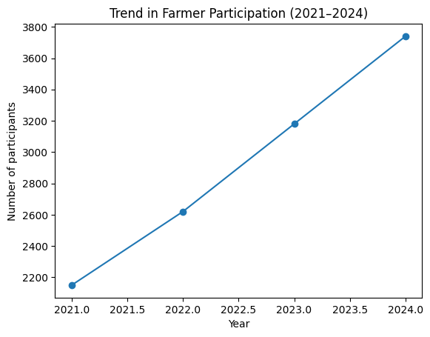Figure 1. Trend in Farmer Participation (2021–2024)
Description: The figure shows a steady upward trajectory in total farmer participation, with a sharper rise after 2022, reflecting increased farmer engagement and trust in KVK advisories.
- Effect of delivery mode on participation
Off-campus programmes accounted for nearly three-fourths of total farmer participation and recorded higher participation density compared to on-campus trainings from 2021 to 2024 (Table 2: Fig. 2). This finding highlights the effectiveness of decentralised, village-level and context-specific extension delivery, as also reported by Burman et al. (2013) and Meena et al. (2016). Such approaches enhance inclusiveness by reducing access barriers related to distance and time (Sulaiman and Davis, 2012). Off-campus programmes facilitate contextual learning, peer interaction and immediate problem-solving, which are critical for perennial fruit crops where site-specific management decisions strongly influence outcomes. Higher participation density in off-campus programmes also reflects reduced transaction costs for farmers, particularly small and marginal orchardists. This finding aligns with recent evidence that village-level, problem-focused trainings enhance inclusiveness and equity in extension outreach.

Table 2. Participation by Delivery Mode
Delivery mode | No. of programmes in Horticulture | Total participants | Average participants / programme
On-campus | 95 | 3,020 | 31.8
Off-campus | 206 | 8,670 | 42.1
Interpretation:
Off-campus trainings attracted approximately 32% higher participation density, highlighting the effectiveness of village-level, context-specific extension delivery.

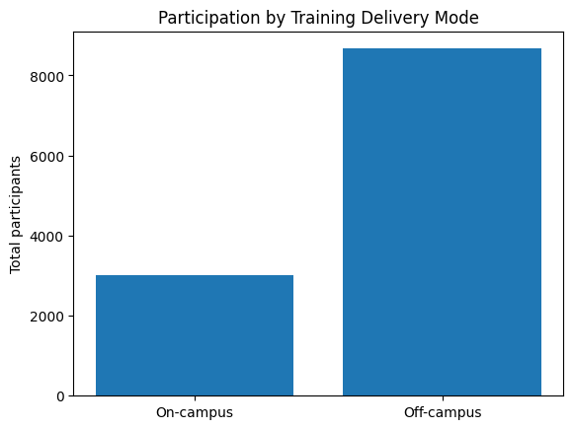
Figure 2. On-Campus vs Off-Campus Participation
Description: Off-campus programmes accounted for nearly three-fourths of total farmer participation, underlining their role in inclusive extension outreach.
- Thematic distribution of farmer participation
Four-year data from 2021 to 2024 regarding theme-wise analysis revealed that apple production and HDP systems attracted the highest share of participants, followed by plant protection and climate-resilient practices as shown in Table 3 and Fig 3. Horticulture-centric themes, particularly high-density apple plantation and plant protection, dominated farmer participation, reflecting the centrality of apple-based livelihoods in the region. Increasing participation in climate-responsive trainings reflects heightened farmer awareness of climate-related production risks, a trend consistent with earlier findings (FAO, 2019; Morton and Watson, 2014; Chapke et al., 2019). The predominance of apple production and HDP-related trainings clearly reflects the structural transformation underway in Kashmir’s horticulture sector. The shift toward high-density systems has intensified demand for specialised knowledge related to canopy management, fertigation, rootstock selection and pest surveillance, thereby driving higher farmer participation.
Growing participation in plant protection and climate-resilient practices indicates increasing farmer sensitivity to emerging biotic stresses and climatic uncertainties. This trend mirrors broader national and global observations that climate risk perception significantly influences farmers’ learning behaviour and extension engagement. Relatively lower participation in allied activities suggests that while diversification remains important, core livelihood risks in apple-based systems continue to dominate farmer priorities.
Table 3. Theme-wise Distribution of Trainings and Participation
Training Theme | Share of trainings (%) in Horticulture | Share of participants (%)
Apple production & HDP systems | 34 | 38
Plant protection & pest management | 22 | 24
Climate-resilient & risk management | 17 | 18
Natural farming & soil health | 15 | 13
Allied activities (beekeeping, etc.) | 12 | 7

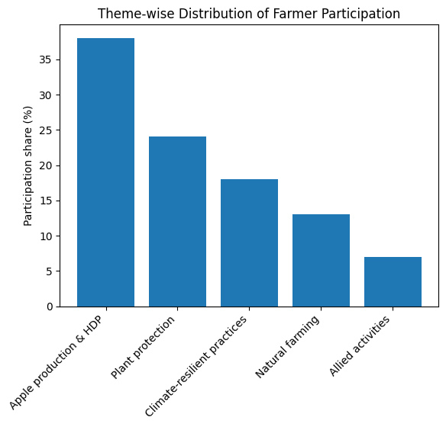

Figure 3. Theme-wise Farmer Participation
Description: The figure illustrates farmer preference for production- and risk-management-oriented trainings, with a noticeable rise in climate-responsive themes in recent years.
Higher participation in off-campus programmes supports the argument for participatory and demand-led extension approaches (Rivera and Sulaiman, 2009; Sulaiman et al., 2005). Participation patterns observed in the present study function as revealed-preference indicators, providing insights into farmer priorities without requiring resource-intensive adoption surveys (Rogers, 2003; Birner et al., 2009). The dominance of horticulture-centric themes reflects the central role of apple-based livelihoods in the study area, while increasing interest in climate-resilient practices indicates evolving farmer perceptions of environmental risk (Swanson, 2011; FAO, 2021). Comparable results have been reported in earlier KVK performance assessments across different agro-ecological regions (Kumar et al., 2019; Singh et al., 2016; Meena et al., 2017).
Conclusion and Policy Implications
The study demonstrates that farmer participation data, routinely recorded by KVKs, can be effectively utilised as a scientific indicator of extension demand and relevance. Participation-based analytics provide a low-cost, scalable and policy-relevant approach for evaluating extension programmes (World Bank, 2012; Davis and Heemskerk, 2012). The importance of balancing programme duration with methodological diversity to enhance capacity building in horticulture-based farming systems plays a very crucial role in effective extension communication. Such an approach can strengthen farmer preparedness, support technology adoption, and contribute to climate-resilient and sustainable horticultural development (SN Kirmani et. al, 2026)
Policy implications include:
- Institutionalising participation analysis as a routine component of KVK planning and evaluation (ICAR, 2020; Singh and Meena, 2020).
- Prioritising off-campus, village-level trainings to enhance outreach and inclusiveness (Burman et al., 2013).
- Aligning training portfolios with emerging farmer concerns such as climate variability and orchard intensification (FAO, 2021; Swanson, 2011).
- Shifting extension performance assessment from activity-based reporting to evidence-based, farmer-responsive programming (World Bank, 2012; Singh et al., 2021).
Adoption of such data-driven frameworks can significantly strengthen the effectiveness and impact orientation of India’s agricultural extension system.
References
- Adhikari, R.P. and Piya, L. (2020). Climate change perception of farmers. Journal of Rural Studies, 77: 94–104.
- Aker, J.C. (2011). Dial “A” for agriculture: Using ICTs for agricultural extension. Agricultural Economics, 42: 631–647.
- Anderson, J.R. and Feder, G. (2007). Agricultural extension. Handbook of Agricultural Economics, 3: 2343–2378.
- Birner, R. et al. (2009). Extension advisory services framework. Agricultural Economics, 40: 341–352.
- Birner, R., Davis, K., Pender, J., et al. 2020. From best practice to best fit: A framework for agricultural advisory services. Agricultural Systems, 173: 102–110.
- Burman, R.R., Singh, S.K. and Dubey, S.K. (2013). Farmer-led extension. Indian Journal of Extension Education, 49(3&4): 1–8.
- Chapke, R.R. et al. (2019). Extension approaches for climate resilience. Agricultural Extension Review, 31(3): 1–7.
- Chapke, R.R., Singh, R. and Burman, R.R. (2017). Participatory extension approaches. Indian Research Journal of Extension Education, 17(1): 1–7.
- Chauhan, J.K., Singh, S.N. and Burman, R.R. (2016). Knowledge dissemination through KVKs. Indian Research Journal of Extension Education, 16(2): 1–6.
- Davis, K. (2008). Extension in sub-Saharan Africa. Journal of International Agricultural and Extension Education, 15: 15–28.
- Davis, K. and Heemskerk, W. (2012). Investment in extension services. World Development, 40: 158–169.
- FAO (2017). Agricultural Extension Manual. FAO, Rome.
- FAO (2019). Farmer-centred Extension Systems. Food and Agriculture Organization, Rome.
- FAO (2021). Climate-smart Agriculture Sourcebook. FAO, Rome.
- Feder, G., Willett, A. and Zijp, W. (2001). Agricultural extension: Generic challenges. World Bank Research Observer, 16: 173–193.
- Glendenning, C.J., Babu, S. and Asenso-Okyere, K. (2010). Review of extension systems. IFPRI Discussion Paper.
- ICAR (2014). Manual for Krishi Vigyan Kendras. Indian Council of Agricultural Research, New Delhi.
- ICAR (2020). Operational Guidelines for Krishi Vigyan Kendras. ICAR, New Delhi.
- ICAR (2021–2024). Annual Reports. Indian Council of Agricultural Research, New Delhi.
- ICAR–ATARI (2022). Performance Assessment of Krishi Vigyan Kendras. ICAR–ATARI, New Delhi.
- Kirmani SN, Sheikh SA, Shah RA, Maqbool A. 2026. Evolving extension priorities in a temperate horticulture system: Four-year trend analysis of Krishi Vigyan Kendra programmes. Res. Jr. Agril. Sci. 17(1): 61-65.
- Kumar, P., Singh, R. and Meena, M.S. (2019). Assessing performance of Krishi Vigyan Kendras. Indian Journal of Extension Education, 55(3): 1–6.
- Kumar, S., Singh, R. and Patel, A. (2018). Role of extension in horticulture. Indian Journal of Agricultural Sciences, 88(6): 1–7.
- Meena, H.R., Patel, B.M. and Singh, K.M. (2015). Extension effectiveness indicators. Indian Journal of Extension Education, 51(1&2): 1–6.
- Meena, M.S. and Malik, B.S. (2009). Constraints in technology adoption. Indian Journal of Extension Education, 45(1&2): 1–5.
- Meena, M.S. and Singh, K.M. (2014). Farmer participation in extension. Indian Journal of Extension Education, 50(3&4): 1–7.
- Meena, M.S., Burman, R.R. and Singh, S.K. (2017). Participatory monitoring in extension. Indian Journal of Extension Education, 53(3): 1–8.
- Meena, M.S., Lakshmi, T. and Singh, K.M. (2016). Effectiveness of extension approaches. Indian Journal of Extension Education, 52(1&2): 1–7.
- Meena, M.S., Singh, R. and Burman, R.R. (2022). Participatory extension analytics. Indian Journal of Extension Education, 58(2): 1–9.
- Morton, J.F. (2007). Climate change impacts on agriculture. Agricultural Systems, 93: 196–210.
- Morton, J.F. and Watson, R.T. (2014). Climate risk management. Global Environmental Change, 25: 1–10.
- Nain, M.S., Singh, R. and Mishra, J.R. (2015). Extension communication strategies. Journal of Agricultural Extension Management, 16(1): 1–10.
- Oakley, P. and Marsden, D. (1984). Approaches to Participation in Rural Development. ILO, Geneva.
- Patel, A., Kumar, U. and Joshi, P.K. (2019). Adoption behaviour of farmers. Agricultural Economics Research Review, 32: 1–12.
- Rivera, W.M. (2011). Extension reforms revisited. Journal of Agricultural Education and Extension, 17: 23–38.
- Rivera, W.M. and Sulaiman, R.V. (2009). Extension reform worldwide. Journal of Agricultural Education and Extension, 15: 101–115.
- Rogers, E.M. (2003). Diffusion of Innovations. 5th edn. Free Press, New York.
- S.N. Kirmani, Kounser Javeed, Neeraj, Anjali Gairola and Atiya Maqbool (2026). Training Intensity and Extension Method Mix as Indicators of Capacity Building in Krishi Vigyan Kendras. Biological Forum, 18(1): 35-38.
- Sharma, V., Kumar, S. & Singh, R. 2021. High-density apple plantation systems in India: Opportunities and challenges. Indian Journal of Horticulture, 78(3): 345–352.
- Singh, K.M. and Meena, M.S. (2020). Evidence-based extension planning. Indian Journal of Extension Education, 56(4): 1–8.
- Singh, K.M., Meena, M.S. and Swanson, B.E. (2013). Extension reforms in India. Journal of Agricultural Extension Management, 14(2): 1–12.
- Singh, P., Burman, R.R. and Meena, M.S. (2020). Demand-led extension approaches. Agricultural Extension Review, 32(2): 7–14.
- Singh, R., Kumar, P. and Meena, M.S. (2021). Extension performance indicators. Journal of Extension Education, 33(1): 1–9.
- Singh, R., Meena, M.S. and Burman, R.R. (2016). Monitoring extension effectiveness. Indian Journal of Extension Education, 52(3&4): 1–8.
- Singh, R., Meena, M.S. and Singh, A.K. (2018). Impact of KVK trainings. Indian Journal of Extension Education, 54(4): 1–9.
- Singh, S.K. and Burman, R.R. (2014). Knowledge management in extension. Indian Journal of Extension Education, 50(1&2): 1–6.
- Sulaiman, R.V. and Davis, K. (2012). Extension system pluralism. Journal of Agricultural Education and Extension, 18: 1–16.
- Sulaiman, R.V., Hall, A. and Suresh, N. (2005). Capacity development in extension. AgREN Network Paper.
- Suvedi, M., Ghimire, R. and Kaplowitz, M. (2017). Extension program evaluation. Journal of Extension, 55(3).
- Swanson, B.E. (2006). Extension strategies for poverty alleviation. Journal of Agricultural Education and Extension, 12: 1–14.
- Swanson, B.E. (2011). Extension strategies for climate adaptation. Journal of Agricultural Education and Extension, 17: 1–15.
- Swanson, B.E. and Rajalahti, R. (2010). Strengthening Agricultural Extension and Advisory Systems. World Bank, Washington DC.
- World Bank (2012). Agricultural Innovation Systems. World Bank, Washington DC.
- World Bank (2017). ICT in Agriculture. World Bank, Washington DC.

