Original Research Article
Impact of compost-amended substrates on the rooting of Irvingia gabonensis cuttings in a nursery on the outskirts of Taï National Park (Ivory Coast)

Summary
Human activities around Taï National Park are exacerbating the degradation of forest habitats and the decline of Irvingia gabonensis, a species heavily exploited by local communities. This increasing pressure on natural stands threatens the species' long-term availability and justifies the implementation of domestication strategies. However, seedling production remains limited by the difficulty of rapidly obtaining vigorous seedlings. Therefore, cuttings offer a relevant option, as they allow for the production of uniform plants in a relatively short time. However, the success of cuttings depends heavily on nursery conditions and, above all, on the nature of the substrate used. With this in mind, two types of soil (soil collected within and outside the park) amended with three different compost formulations were used (T1, T2, T3, T4, T5, and T6). The best success rates were observed with cuttings grown on soil from the Park, enriched with compost (T1, T2 and T3) for, respectively, 87%, 60% and 80%.LThe lowest recovery rates were observed with thecuttings planted on soil taken from outside the park, enriched with compost (T4, T5 and T6) for, respectively, 47%, 13% and 27%No regrowth was observed on the control substrates.This study has shown that propagation by cuttings on substrates enriched with compost is a promising avenue for the large-scale valorization of Irvingia gabonensis.
Keywords :Utility species; human activity; scarcity; domestication ; cuttings

INTRODUCTION
Tropical forests are among the most biodiverse ecosystems and constitute an essential pillar of human well-being. They provide a diversity of resources indispensable for the subsistence of populations, particularly in rural areas where the forest plays a major economic, social, and cultural role [1]. Through these multiple functions, numerous forest species are exploited for food, medicine, crafts, and other basic needs. However, these natural environments, which harbor a large proportion of these useful species, are currently under increasing pressure from human activities. In this context, the future availability of forest species is becoming highly dependent not only on harvesting methods but also on the capacity of ecosystems to regenerate in sometimes degraded environmental conditions [2 ; 3].
The issue of the accelerated disappearance of natural plant resources due to human activities is well documented in the scientific literature. Several studies have shown that agricultural expansion, the exploitation of forest products, and changes in land use lead to a significant reduction in habitats and a decrease in useful plant populations ([4 ; 5 ; 6 ; 7 ; 8 ; 9]). In Côte d'Ivoire, this dynamic is resulting in a rapid decline in forest cover, largely attributable to the overexploitation of plants with high utility value and the pressure exerted on natural ecosystems [10]. This situation represents a major challenge, as forest degradation progressively limits rural communities' access to resources essential for their food and income.
This study is situated within this context. Indeed, human activities around Taï National Park contribute to the progressive degradation of forest habitats and the decline of Irvingia gabonensis, a species heavily exploited by local communities. This increasing pressure on natural stands jeopardizes the species' long-term availability and underscores the need to implement domestication strategies. Although several studies have highlighted the importance of promoting and preserving plant species essential to rural communities ([11 ; 12 ; 13 ; 14]), seedling production remains limited due to slow germination and the difficulty of rapidly obtaining vigorous seedlings. From this perspective, propagation by cuttings appears to be a relevant alternative, as it allows for the production of uniform plants in a relatively short time. However, the success of this technique depends heavily on nursery conditions, particularly the nature of the substrate used. With this in mind, two types of soil (taken from within the park and from outside the park), amended with three different compost formulations, were evaluated through six treatments (T1, T2, T3, T4, T5, and T6).
Thus, the objective of this work is to identify the substrates most favorable to the success of Irvingia gabonensis cuttings, with a view to facilitating its domestication and sustainable integration into the cultivation systems on the periphery of the Taï National Park.

MATERIALS AND METHODS

Plant material
The cuttings used came from the lateral stems of young trees Irvingia gabonensis, less than six years old. These cuttings had four to six nodes and measured 3 to 5 cm in length.

Methods

Choice of study site
The trials were conducted in sector ADK/V6 of Taï National Park (PNT), located in the Nawa region, specifically in the sub-prefecture of Buyo (Fig. 1). This site, in the immediate vicinity of Village V, was chosen because it offered favorable conditions for conducting vegetative propagation tests. Indeed, the monitoring station is located very close to the park's inner boundary, providing the experimental area with a relatively pristine ecological environment.
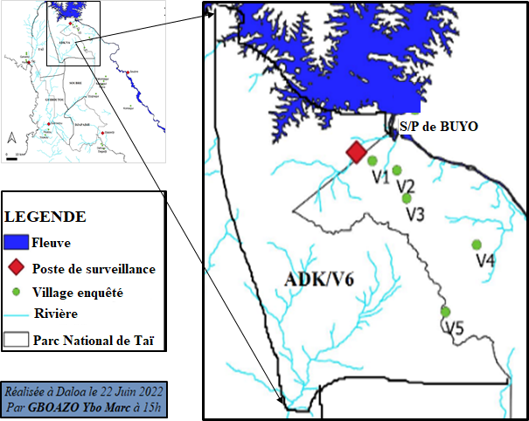
Fig.1. Location of the study site

Data collection

Installation of the shade structure
A 96 m² (8 m x 12 m) shade structure was made with local materials (palm fronds, wooden posts, Chinese bamboo and raffia) and covered with palm leaves to reduce solar intensity on the seedlings (Fig.2).
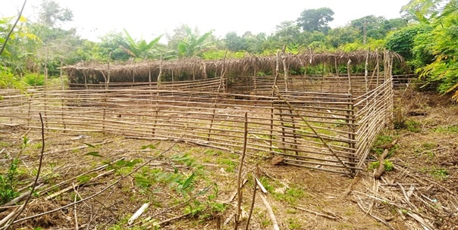
Fig.2. Shade structure to shelter the cuttings

Compost production
The composts were made from three (3) organic materials: sawdust, cow dung, and rice straw (rice straw collected from the lowlands). To do this, three (3) pits, each 1 m x 1 m x 50 cm and 1.5 m apart, were dug in the ground. Plastic tarpaulins, measuring 3 m x 2 m, were placed in each pit to hold the organic materials..Organic matter was introduced into the holes (Fig. 3) according to the formulations below:
- F1: 1 bag (50 kg) of sawdust + 1 bag (50 kg) of cow dung + 30 liters of water
- F2: 1 bag (50 kg) of rice straw + 1 bag (50 kg) of cow dung + 15 liters of water
- F3: 1 bag (50 kg) of sawdust + 1 bag (50 kg) of rice straw + 1 bag of cow dung + 30 liters of water
The amounts of water added to the mixtures were carefully chosen to optimize the decomposition of organic matter: 30 liters of water in T1 and T3 promote the moisture needed for microbial activity due to the presence of sawdust, while 15 liters of water in T2, containing rice straw, avoids excessive saturation while maintaining adequate moisture to stimulate decomposition.
The mixture was prepared every two weeks for two months. This regular mixing helps balance the moisture and prevents areas that are too dry or too wet, which is essential for efficient decomposition. The initial watering ensured excellent moisture retention in the compost, thus eliminating the need for any further watering.

Experimental setup
The composts obtained (C1, C2, and C3) were mixed with two types of soil. The first, designated "Tp," was soil collected directly from the park, due to the location of the trials there. The second, called "Tv," came from a village plantation located approximately 20 kilometers from the park. This remote sampling was carried out in a way that respected local soil conditions while introducing slight variations related to land use. Thus, six substrates, referred to as treatments (T1, T2, T3, T4, T5, and T6), were obtained (Table I).
A block hasA block was prepared to accommodate the cuttings. This block was subdivided into two (2) sub-blocks, each further subdivided into three (3) compartments. Within each compartment, eighteen (18) sachets containing the different treatments were randomly arranged to receive fifteen (15) cuttings (Fig. 3). Thus, the block contained a total of one hundred and eight (108) cuttings (1 block × 2 sub-blocks × 3 compartments × 18 cuttings). For the control group, a block, subdivided into five (5) compartments, was prepared (Fig. 4). Within each compartment, fifteen (15) sachets containing homogeneous substrates Tp, Tv, sawdust, rice straw, and cow dung (respectively, T01, T02, T03, T04, and T05) were arranged to receive fifteen (15) cuttings (Table II). A total of twenty-five (25) cuttings were cultivated on these five (5) control substrates.
Table I. Associations of soil types and composts
Substrates | Composition of the cutting treatment | Block | Number of repetitions (sub-blocks) | Number of compartments in the sub-blocks | Total number of sachets (cuttings)
T1 | ½ Tp + ½ C1 | 1 | 2 | 3 | 34
T2 | ½ Tp + ½ C2
T3 | ½ Tp + ½ C3
T4 | ½ TV + ½ C1
T5 | ½ TV + ½ C2
T6 | ½ TV + ½ C3

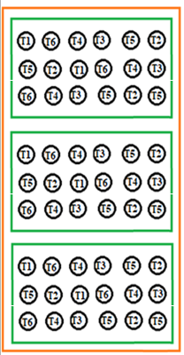
Fig.3.Diagram of the adopted experimental setup

Table II. Sample substrates
Sample substrates | Witness composition
T01 | Tp
T02 | TV
T03 | Sawdust
T04 | Rice straw
T05 | Beef dung

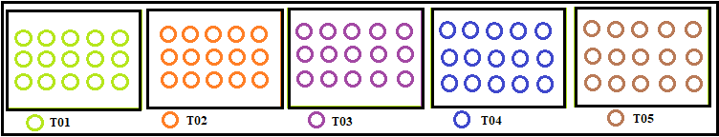
Fig.4. Diagram of the experimental setup of the control block

Planting, cutting care, and measured parameters
All the cuttings were planted (F on the same day.
The cuttings were planted in such a way as to leave three (3) dormant buds (nodes) in contact with the soil and three (3) other buds exposed to the air. Adjusting the position of the buds during planting aims to optimize both root development and above-ground growth.
After planting, the cuttings were monitored regularly. Watering was done every two days, very early in the morning, except in case of rain. Systematic observations began one week after planting the cuttings and were repeated every two (2) weeks to track their development. During each observation, for each trial and each treatment, we recorded:
- the number of cuttings that have taken root, that is to say, that have produced a leafy bud;
- the number of dead cuttings;
- the number of surviving cuttings at the end of the trial.
These parameters made it possible to monitor the survival and development of the cuttings during the experiment, as well as to evaluate the effectiveness of the treatments (types of substrates enriched with compost) applied..
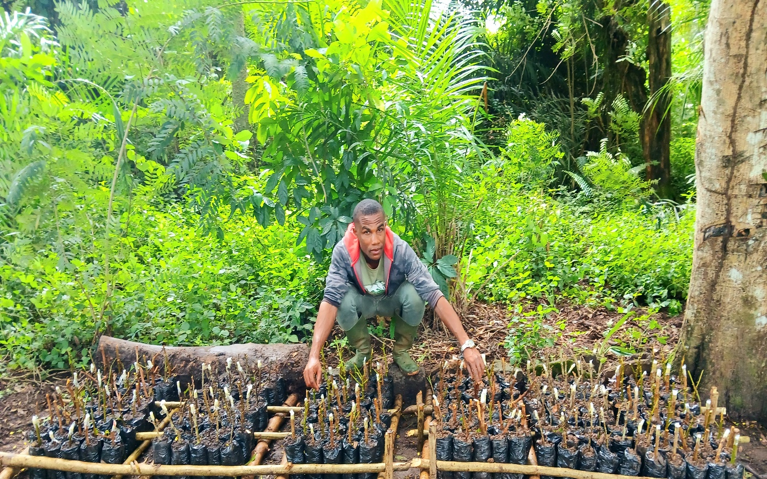
Fig.5. Distribution of cuttings on different types of substrates enriched with compost

Data processing
Excel was used for data entry. R software version 4.3.2 was used to perform statistical analyses, including analysis of variance (ANOVA) to compare recurrence rates by treatment.

Parameters determined
Success rate (TRb) of cuttings
The recovery rate was determined using the adapted formula of [15] :
TRb =$\frac{n}{N}×100$ (1)
ni: number of cuttings taken; N: total number of cuttings
Survival rate (Ts) of cuttings
The recovery rate was determined using the adapted formula of [16] :
Ts =$\frac{n}{N}×100$ (2)
ni : number of living cuttings at the end of the trial ; N: total number of cuttings planted

RESULTS AND DISCUSSION

Results
The control substrates did not promote the recovery of the cuttings.
On the other hand, soil types enriched with composts favored the recovery of some cuttings (Figure 5), with a significant effect on the recovery rate (p = 0.002; ANOVA test).
The success rates of the cuttings are shown in Table III. The best success rates for these cuttings were observed with soil from the Park, enriched with compost (T1, T2, and T3), at 87%, 60%, and 80%, respectively. The lowest success rates were observed with cuttings grown on soil taken from outside the Park and enriched with compost (T4, T5, and T6), at, respectively,
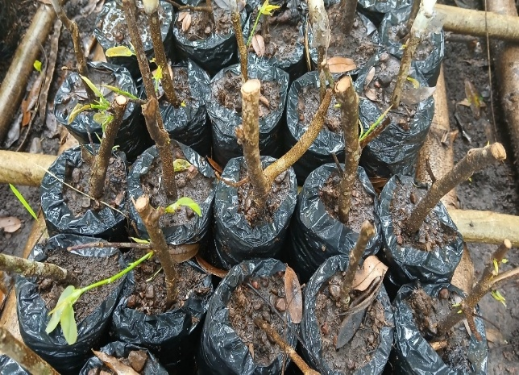
Fig. 6. Replanting of some cuttings three (3) weeks after planting
Table III. Cutting survival rate three (3) weeks after planting
Treatments | Recovery rate per treatment (%)
T0 (Tp, Tv, F1, F2 and F3) | 0
T1 (½ Tp + ½ F1) | 87a
T2 (½ Tp + ½ F2) | 60ab
T3 (½ Tp + ½ F3) | 80a
T4 (½ TV + ½ F1) | 47b
T5 (½ TV + ½ F2) | 13c
T6 (½ TV + ½ F3) | 27c
For each column, values ​​followed by the same letter are not statistically different at the 5% threshold.
T_{P}:land of the Park;T_{v}:land of a village on the outskirts of the Park;F1: sawdust + cow dung; F2:rice straw +cow dung; F3: sawdust + rice straw.

Discussion
The results revealed that the treatments promoted the recovery of some cuttings ofI. gabonensis, with a significant effect on the survival rate (p = 0.002; ANOVA test). The survival rate of cuttings grown in soil taken from the Park and enriched with compost was significantly higher than that of cuttings grown in soil taken from outside the Park. The addition of compost may have had an impact on soil fertility and texture. Parallel studies conducted on the propagation of I. gabonensis corroborate this observation. The study carried out by [17] in Cameroon demonstrated that soil type could directly influence the survival rate of cuttings of this species. They observed that nutrient-rich and well-aerated soils, such as those from forests or forested areas, promote higher survival rates of cuttings, unlike less fertile soils due to over-farming. Another study conducted by [18] reported similar results in the context of the propagation of this species in Cameroon. These authors found that forest soils gave higher success rates compared to savannah soils, highlighting the importance of soil composition and quality in the success of cuttings.

CONCLUSION
This study highlighted the significant influence of applied treatments on the survival rate of Irvingia gabonensis cuttings. Statistical analysis (ANOVA) confirmed that the treatments had a significant effect on the survival rate (p = 0.002), although survival was observed only in a portion of the cuttings placed in culture.
The results showed that cuttings planted on soil taken from the Park and enriched with compost had significantly higher success rates than those planted on soil taken from outside the Park.
Ultimately, these results offer promising avenues for improving vegetative propagation techniques for I. gabonensis. They indicate that the use of forest substrates, particularly those enriched with compost, is a promising option for optimizing the success rate of cuttings. However, further studies on rooting dynamics, long-term plant growth, and the durability of these substrates are needed to strengthen the reliability and applicability of this method in domestication and development programs for the species.

REFERENCES
- Joris (1998). Indigenous knowledge and anthropological constraints within the framework of conservation programs in Central Africa. Eves HE, Hardin R. and Rupp S. (eds.). Use of natural resources in the Sangha River trinational region. Histories, Knowledge and Institutions. Bulletin Series, Yale School of Forestry and Environmental Studies, 102 : 140-150.
- N'Da DH, Adou YCY, N'Guessan KE, Koné M. & Sangne ​​YS (2008). Analysis of the floristic diversity of the Marahoué National Park, Centre-West of Côte d'Ivoire. Afrique Science, 4: 552-579.
- Dadjo C. (2011). Ethnobotanical, morphological and spatial characterization of Vitex doniana Sweet (Verbenaceae) in South Benin, Agronomy Engineering Thesis, Faculty of Agronomic Sciences of the University of Abomey-Calavi, Benin, 86 p.
- Rice RA & Greenberg R. (2000). Cocoa cultivation and the conservation of biological diversity. AMBIO: A Journal of the Human Environment, 29 (3): 167 - 173.
- Oszwald J. (2005). Dynamics of agroforestry formations in Ivory Coast (from the 1980s to the 2000s). Doctoral thesis in Geography, UFR of Geography and Planning, Laboratory of Geography of Anthropogenic Environments (UMR CNRS 8141), University of Science and Technology of Lille, France, 304 p.
- Kelatwang S. & Garzuglia M. (2006). Changes in Forest Area in Africa 1990 - 2005. International Forestry Review, 8 (1): 21-30.
- Traoré L., Ouedraogo I., Ouedraogo A. & Thiombiano A. (2011). Perceptions, uses and vulnerability of woody plant resources in the Southwest of Burkina Faso. International Journal of Biological and Chemical Sciences, 5 (1) : 258-278.
- Dimobe K., Wala K., Batawila K., Dourma M., Woegan YA & Akpagana K. (2012). Spatial analysis of the different forms of anthropogenic pressures in the Oti-Mandouri wildlife reserve (Togo), VertigO, 13 – 17.
- Adingra OM, Kassi JND & Yongo OD (2014). Systematic and phytogeographic analysis of the Bamo classified forest (Côte d'Ivoire). Journal of Animal & Plant Sciences, 23 (2): 3626-3636.
- Kouamé NF (1998). Influence of logging on the vegetation and flora of the classified forest of Haut Sassandra (Central-West of Côte d'Ivoire). Doctoral thesis, University of Cocody-Abidjan, 227 p.
- Schreckenberg K., Awono A., Degrande A., Mbosso C., Ndoye O. & Tchoundjeu Z. (2006). Domesticating indigenous fruit trees as a contribution to poverty reduction. Forests Trees and Livelihoods, 16 (1): 35-51.
- Kouamé N., Gnahoua GM, Kouassi KE, & Traore D. (2008). Spontaneous food plants of the Fromager region (Central-West of Côte d'Ivoire) : flora, habitats and parts consumed. Sciences & Nature, 5(1) : 61-70.
- N’Dri KMT, Gnahoua GM & Mangara A. (2012). Germination tests of Ricinodendron heudelotii in the cheese-making region of central-west Côte d'Ivoire. Journal of Applied Biosciences, 56 : 4133-4141.
- Ouattara ND, Gaille E., Stauffer FW & Bakayoko A. (2016). Floristic and ethnobotanical diversity of edible wild plants in the Department of Bondoukou (Northeast Côte d'Ivoire). Journal of Applied Biosciences, 98 : 9284-9300.
- Duan T., Yang Z. & Gao X. (2022). "Impact of different pre-sowing treatments on the germination of wild plant species." Journal of Plant Research, 135 (1) : 89-98.
- Duan T., Yang Z. & Gao X. (2022). "Impact of different pre-sowing treatments on the germination of wild plant species." Journal of Plant Research, 135 (1) : 89-98.
- Ndam N. J. Ndam R. S. & Tchoundjeu Z. (2016). Propagation of Irvingia gabonensis in Congo : Effect of different soil types and treatments on cutting success. African Journal of Agricultural Research, 11 (1) : 123 - 130.
- Atangana A., Khasa D., Chang S. & Degrande A. (2014). Tropical Agroforestry. Science & Business Media, 6 (3): 23-33.

