Short Communication

Identification of Sweet Potato Accessions Tolerant to Water Deficit

Abstract
Water deficit is a major constraint to sweet potato (Ipomoea batatas L.) production, particularly in tropical regions experiencing high climatic variability. This study aimed to evaluate the agronomic response of 40 sweet potato accessions subjected to two water regimes (irrigated and water deficit) in order to identify genotypes tolerant to water stress. The experiment was conducted using a split-plot design, and several agronomic traits were assessed. Water stress tolerance and sensitivity indices were calculated and complemented by multivariate statistical analyses. The results showed that water deficit caused a significant reduction in yield and its components, particularly the number of marketable storage roots. A high inter-accession variability was observed. Some accessions maintained high yields under water stress, with tolerance indices above 70%, whereas others exhibited marked sensitivity. Multivariate analysis clearly discriminated tolerant accessions from sensitive ones. These findings highlight promising genotypes for breeding programs aimed at improving sweet potato resilience to water deficit.
Keywords : Sweet potato; water deficit; tolerance index; yield; varietal selection
1. Introduction
Sweet potato (Ipomoea batatas L.), a member of the Convolvulaceae family, is a root and tuber crop consumed by more than two billion people worldwide (Lebot et al., 2009). In Côte d’Ivoire, this crop plays a crucial role in food and nutritional security, particularly due to its high β-carotene content, a precursor of vitamin A (Laurie et al., 2018). Its adaptability to a wide range of agro-ecological conditions and its high yield potential make sweet potato a strategic crop (Agili et al., 2012).
However, sweet potato production is strongly constrained by abiotic stresses, particularly water deficit, which can lead to substantial yield losses. Water stress is one of the most limiting factors for sweet potato production and may cause yield reductions of up to 60%, depending on the intensity and duration of the deficit (Kivuva et al., 2014).
Although sweet potato is often considered relatively drought tolerant, a high variability in response to water stress exists among accessions (Saraswati, 2007). This stress can be mitigated through the cultivation of drought-tolerant varieties (Diallo, 2009). Water therefore plays a critical role in sweet potato growth and yield (Saraswati, 2007).
In this context, the present study aims to evaluate the impact of water deficit on the agronomic performance of 40 sweet potato accessions in order to identify drought-tolerant genotypes.
2. MATERIALS AND METHODS
2.1. Study site
The study was conducted at the Food Crops Research Station (SRCV) of the National Center for Agronomic Research (CNRA) in Bouaké, located in the Gbèkè region of Côte d’Ivoire. Bouaké is situated at 7°69′ N latitude and 5°03′ W longitude and covers an area of approximately 72 km² (Allouko, 2011). The site lies within a transition zone between the southern forest climate and the northern savanna climate, with average temperatures around 27 °C and variations of 3–5 °C (Kouame et al., 2018).
2.2. Plant material
The plant material consisted of 40 sweet potato accessions obtained from the SRCV collection of the CNRA in BOUAKE.
2.3. Experimental design and treatments
The experiment was conducted under station conditions using a split-plot design with two factors: accession (40 sweet potato accessions) and water regime (irrigated and water deficit), with two replications.
Plants were established from healthy vine cuttings. Uniform irrigation was applied during the first two months after planting to ensure proper crop establishment.
Water deficit treatment was imposed from the onset of storage root formation and bulking (two months after planting) by withholding irrigation, while the control treatment was maintained at field capacity. Accessions were randomly distributed within each experimental plot.
2.4. Data collection
Agronomic evaluation was based on eight measured variables (Table 1).
Table 1. Agronomic traits measured
Traits | Code | Description
Number of plants emerged | NP | Total number of plants emerged per plot
Percentage of productive plants (%) | PPP | Proportion of plants producing storage roots
Number of marketable storage roots | NRTC | Number of storage roots > 200 g
Weight of marketable storage roots (g) | PRTC | Weight of storage roots > 200 g
Total storage root weight (g) | PRTT | Total weight of storage roots
Storage root yield (t ha⁻¹) | RENDt | Total yield at harvest
Aboveground biomass weight (g) | PBA | Weight of aboveground biomass
Stress tolerance index | IT | IT = (Ps / Pt) × 100
Stress sensitivity index | IS | IS = 1 − (Ps / Pt)
Ps : parameter under water stress conditions; Pt: parameter under non-limiting water conditions (Fischer and Maurer, 1978; Fernandez, 1992; Bouslama and Schapaugh, 1984).
2.5. Statistical analysis
Data were subjected to a two-factor analysis of variance (ANOVA) considering accession and water regime, using the R software. Mean comparisons were performed using Fisher’s least significant difference (LSD) test at the 5% significance level.
Principal component analysis (PCA) and hierarchical cluster analysis (HCA) were conducted to discriminate accessions based on their agronomic performance and water stress tolerance indices.
3. RESULTS AND DISCUSSION
3.1. Results
3.1.1. Impact of water deficit on agronomic parameters
Figure 1 shows the impact of water deficit on the evaluated agronomic parameters. Water deficit slightly affected plant establishment (NP and PPP, reduction < 20%), whereas it caused a strong decrease in yield and its components (> 30%). The number of marketable storage roots was the most sensitive parameter, with a reduction greater than 50%.
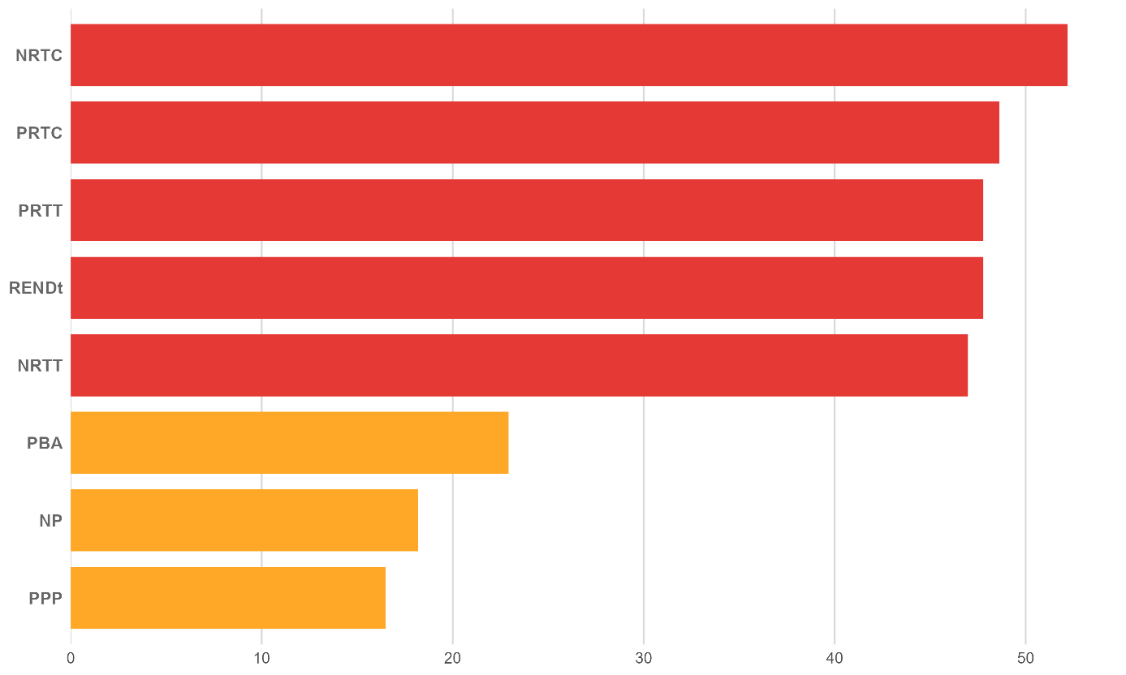
Figure 1. Impact of water stress on agronomic parameters
3.1.2. Tolerance and sensitivity indices
The tolerance and sensitivity indices applied to yield revealed a high variability among accessions (Table II). Nine accessions showed a high tolerance index (≥70%) and a low sensitivity index (≤0.30), namely CNRAPD19/00003, CNRAPD19/00030, CNRAPD17/00004, CNRAPD19/00016, CIP4 (BF52XCIP4), CIP-196062-1, WOSSO WELEMENT, SONGRE, and ALEDA OKLOE. Conversely, some accessions (ABLI, GBAGBO2, LIBERIA, TU ORANGE, and WOSSO BROU) recorded an almost total loss of yield under water stress.
Table II. Tolerance and sensitivity indices relative to yield
No | ACCESSIONS | REND_Pt (t ha⁻¹) | REND_Ps (t ha⁻¹) | IT_REND  (%) | IS_REND
1 | CNRAPD19/00003 | 31.56 | 25.26 | 80.04 | 0.2
2 | CNRAPD19/00030 | 15.15 | 12.1 | 79.85 | 0.2
3 | CNRAPD17/00004 | 35.29 | 27.97 | 79.26 | 0.21
4 | CNRAPD19/00016 | 35.21 | 26.46 | 75.16 | 0.25
5 | CIP4 (BF52XCIP4) | 37.95 | 28.32 | 74.63 | 0.25
6 | CIP-196062-1 | 33.85 | 25.18 | 74.39 | 0.26
7 | WOSSO WELEMENT | 42.33 | 31.14 | 73.57 | 0.26
8 | SONGRE | 10.21 | 7.53 | 73.69 | 0.26
9 | ALEDA OKLOE | 6.8 | 4.77 | 70.2 | 0.3
10 | CNRAPD19/00111 | 13.6 | 9.41 | 69.17 | 0.31
11 | CNRAPD17/00003 | 33.13 | 21.87 | 66 | 0.34
12 | MAN LOUEZIN | 5.92 | 3.79 | 64.08 | 0.36
13 | INCONNU 8 | 20.69 | 12.55 | 60.68 | 0.39
14 | POURPRE | 6.327 | 3.79 | 59.96 | 0.4
15 | IRENE | 12.75 | 7.35 | 57.64 | 0.42
16 | FATONI2 | 53.02 | 30.34 | 57.22 | 0.43
17 | ALEDA OFFOUE | 32.61 | 14.04 | 43.06 | 0.57
18 | CNRAPD19/00110 | 18.39 | 7.86 | 42.73 | 0.57
19 | AFFOU1 | 12.39 | 5.27 | 42.52 | 0.57
20 | CNRAPD17/00007 | 19.933 | 8.44 | 42.34 | 0.58
21 | CNRAPD19/00001 | 12.45 | 5.23 | 41.99 | 0.58
22 | J21 | 38.49 | 15.88 | 41.26 | 0.59
23 | TIB-440060 | 46.91 | 17.69 | 37.71 | 0.62
24 | WELEMENT GBASSOLHON | 42.59 | 15.79 | 37.09 | 0.63
25 | CNRAPD17/00010 | 26.65 | 9.82 | 36.85 | 0.63
26 | CNRAPD19/00036 | 21.63 | 7.83 | 36.21 | 0.64
27 | CNRAPD17/00015 | 15.53 | 5.58 | 35.92 | 0.64
28 | WOSSO GBE | 7.91 | 2.75 | 34.74 | 0.65
29 | GOTCHAN GOUN | 17.99 | 4.9 | 27.68 | 0.72
30 | CNRAPD17/00013 | 11.15 | 3.07 | 27.5 | 0.73
31 | ABOBO GARAGE | 4.587 | 1.26 | 27.47 | 0.73
32 | CNRAPD19/00085 | 24.01 | 6.55 | 27.26 | 0.73
33 | LAHO DANGHO | 5.1 | 0.867 | 16.99 | 0.83
34 | PATATE RAPIDE | 35.33 | 5.86 | 16.59 | 0.83
35 | LOMOKAHA | 13.57 | 0.27 | 2.015 | 0.98
36 | ABLI | 4.16 | 0 | 0 | 1
37 | GBAGBO2 | 3.16 | 0 | 0 | 1
38 | LIBERIA | 1.74 | 0 | 0 | 1
39 | TU ORANGE | 2.07 | 0 | 0 | 1
40 | WOSSO BROU | 4.19 | 0 | 0 | 1
IT_REND : yield tolerance index; IS_REND: yield sensitivity index
REND_Pt : yield under normal conditions; REND_Ps: yield under water stress conditions

3.1.3. Principal component analysis (PCA) and hierarchical cluster analysis (HCA) of accessions
PCA and HCA made it possible to distinguish three distinct groups (Figure 2), explaining 89% of the total variance. The tolerant group includes accessions with high yield and high tolerance index, notably FATONI2, CIP4 (BF52XCIP4), WOSSO WELEMENT, CNRAPD17/00003, CIP-196062-1, CNRAPD19/00003, CNRAPD17/00004, and CNRA19/00016, whereas the sensitive group exhibited low performance under water stress.
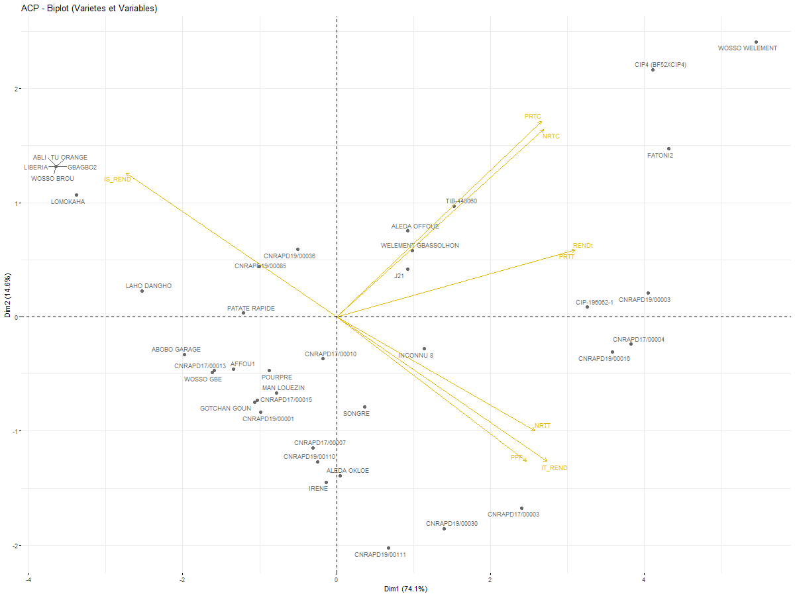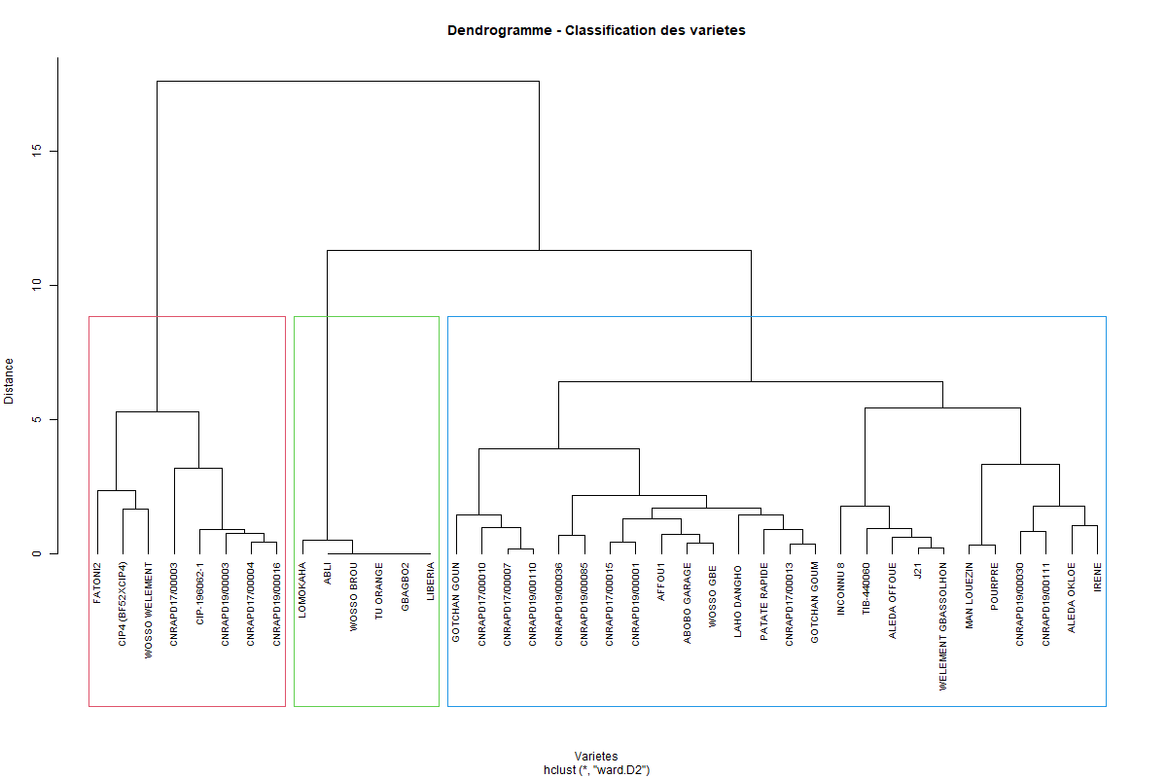
Figure 2. Representation of agronomic traits and accessions in the F1 and F2 factorial plane
3.1.4. ANOVA results of the effects of accession and treatment
ANOVA revealed a highly significant effect of water regime, accession, and their interaction on all evaluated agronomic parameters (p < 0.05).
Table 3- Impact of water regime, accession, and their interaction on assessed agronomic parameters
Parameter | Source of variation | df | SS | F | p-value
NP | Water regime | 1 | 0.73 | 0.989 | < 0.0001
NP | Accession | 14 | 30.42 | 2.931 | < 0.0001
NP | Water regime x Accession | 14 | 9.75 | 0.939 | < 0.0001
NP | Residuals | 29 | 21.5 | - | -
PPP | Water regime | 1 | 259.78 | 0.411 | < 0.0001
PPP | Accession | 14 | 15054.03 | 1.703 | < 0.0001
PPP | Water regime x Accession | 14 | 7371.35 | 0.834 | < 0.0001
PPP | Residuals | 29 | 18308.33 | - | -
NRTC | Water regime | 1 | 2.46 | 1.41 | < 0.0001
NRTC | Accession | 14 | 115.25 | 4.727 | 0.0002
NRTC | Water regime x Accession | 14 | 17.73 | 0.727 | < 0.0001
NRTC | Residuals | 29 | 50.5 | - | -
NRTT | Water regime | 1 | 1228.2 | 10.62 | < 0.0001
NRTT | Accession | 14 | 6072.74 | 3.751 | < 0.0001
NRTT | Water regime x Accession | 14 | 886.69 | 0.548 | < 0.0001
NRTT | Residuals | 29 | 3354 | - | -
PRTC | Water regime | 1 | 228740.3 | 1.053 | < 0.0001
PRTC | Accession | 14 | 21918841 | 7.204 | < 0.0001
PRTC | Water regime x Accession | 14 | 2618268 | 0.861 | < 0.0001
PRTC | Residuals | 29 | 6302267 | - | -
PRTT | Water regime | 1 | 5137761 | 12.783 | < 0.0001
PRTT | Accession | 14 | 47715625 | 8.48 | < 0.0001
PRTT | Water regime x Accession | 14 | 2319911 | 0.412 | < 0.0001
PRTT | Residuals | 29 | 11655859 | - | -
REND | Water regime | 1 | 913.38 | 12.783 | < 0.0001
REND | Accession | 14 | 8482.78 | 8.48 | < 0.0001
REND | Water regime x Accession | 14 | 412.43 | 0.412 | < 0.0001
REND | Residuals | 29 | 2072.15 | - | -
PBA | Water regime | 1 | 0.78 | 1.322 | < 0.0001
PBA | Accession | 14 | 2627655 | 3.475 | < 0.0001
PBA | Water regime x Accession | 14 | 306215.5 | 0.405 | < 0.0001
PBA | Residuals | 29 | 1566408 | - | -

3.2. Discussion
The study aimed to evaluate 40 sweet potato (Ipomoea batatas) accessions under two water regimes: normal conditions and water deficit applied two months after planting. It made it possible to highlight a strong variability among agronomic parameters and among tolerance indices of the varieties. This demonstrates the importance of identifying genotypes adapted to water stress in the context of climate change (FAO, 2021).
Water deficit had a negative effect on growth and production parameters. Stress applied during the vegetative stage influences plant growth. According to Wang et al. (2003), when stress is applied during the flowering stage, the reduction becomes even more pronounced. The percentage of productive plants and the number of emerged plants were less affected by water stress (less than 20%), because irrigation was applied during the first two months to stabilize feeder roots. In contrast, storage root weight and total yield were strongly affected by water stress, with reductions exceeding 40%. Water deficit results from rainfall irregularity, which constitutes a limiting factor for agricultural production (Belkhodja and Bidai, 2004; Toumi, 2022).
The evaluation of tolerance indices proposed by Fischer and Maurer made it possible to classify accessions according to their sensitivity. Accession CNRA PD19/00030 showed a yield reduction of less than 20% under water deficit conditions, indicating better tolerance. Varieties can develop mechanisms of resistance to water deficit (Diallo, 2009). Conversely, some accessions such as ABLI, GBAGBO2, LIBERIA, TU-ORANGE, and WOSSO BROU experienced an almost 100% loss of yield under water deficit conditions, making them highly sensitive to drought. Moreau (1987) showed that parameters such as plant height, root volume, yield, and weight undergo increasingly marked reductions as water deficit intensifies. According to the work of Toumi (2022) on Robinia pseudoacacia plants, the application of water stress through irrigation withdrawal can cause a significant reduction in stem growth, reaching more than 70%, as well as a cessation of new leaf formation from the second week of irrigation stoppage. Tolerance and sensitivity indices are essential elements to assist breeders in varietal selection.
Yield and its components were higher under non-limiting water conditions compared to water stress conditions and varied according to varieties. These results are consistent with those of Diallo (2009), who worked on drought resistance in rice and showed that the evaluated varieties exhibited highly variable behaviors depending on the assessment parameters. Variations in the number and weight of storage roots observed in these sweet potato cultivars under reduced water conditions were also reported by Sen et al. (1990) and Chebouti et al. (2000).
Water shortage can induce morphological, anatomical, physiological, biochemical, and molecular modifications that affect yield and may lead to plant death if stress persists (Wang et al., 2003). Aboveground biomass is a good indicator of water stress tolerance. Better biomass under stress can be associated with the ability to sustain photosynthesis and storage root growth. Prabawardani (2007) also showed that water deficit reduces vine length and internode length in evaluated sweet potato varieties.
Plant responses to water stress occur through three mechanisms: escape, avoidance, and tolerance (Blum, 2011; Clavel et al., 2005). Tolerance is the ability of a plant to withstand drought without significantly affecting its production. These species tend to have a longer growth cycle. Varieties such as FATONI2 and WOSSO WELEMENT tend to present a long cycle according to previous results.
Thus, eight accessions achieved yields above 20 t ha⁻¹ even under water stress conditions. These varieties could better withstand reduced rainfall. Some varieties such as ALEDA OKLOE, POURPRE, CNRA PD19/00111, and MAN LOUEZIN exhibited low yields but showed tolerance indices higher than 60%. These varieties may possess drought tolerance genes and could contain genes of interest for genetic improvement and be used in breeding programs (Ndolo et al., 2022).
These results confirm the existence of exploitable genetic variability and highlight accessions capable of maintaining high yield under water deficit, thus constituting priority candidates for varietal selection programs.
4. CONCLUSION
This study made it possible to highlight the variability among the 40 sweet potato accessions evaluated under water deficit applied two months after planting. The results showed that water stress leads to a significant reduction in yield and its components, confirming the sensitivity of this crop. However, some accessions exhibited high tolerance indices and higher yields even under stress conditions. These genotypes constitute promising candidates for varietal selection and for strengthening the resilience of agricultural systems in the face of climatic variability.
COMPETING INTERESTS
Authors have declared that no competing interests exist.
REFERENCES
Agili S., Nyende P., Ngamau K., & Masinde P. (2012).
Selection, yield evaluation and drought-tolerance indices of orange-flesh sweetpotato (Ipomoea batatas L.) hybrid clone. Report / conference communication (CGIAR / technical documents).
Allouko J. R. (2011). Study of the pre-fattening of Oreochromis niloticus in rice-fish farming ponds. Advanced Agronomy Diploma Thesis, Félix Houphouët-Boigny National Institute, Yamoussoukro, Côte d'Ivoire, 50p.
Belkhodja M. & Bidai Y. (2004). Response of Atriplex halimus L. seeds to salinity at the germination stage. Sécheresse, 15(4): 331–335.
Blum, A. (2011). Plant breeding for water-limited environments. Springer Science & Business Media.
Chebouti A., Nacer H. & Zerguini A. (2000). Effect of water stress on the growth and production of cultivated plants. Review of Arid Regions, Institute of Arid Regions (IRA), Médenine, Tunisia.
Clavel D., Drame N. K., Diop N. D. & Zuily-Fodil Y. (2005). Adaptation to drought and varietal creation: the case of groundnut in the Sahelian zone. Fundamental Review, 12(3): 248–260.
Diallo D. (2009). Physiological evaluation of water stress resistance in NERICA rice (Oryza spp L.): case of WAB 450 IBP 28HB and WAB 450 IBP 91HB cultivated in the Republic of Guinea. Single doctoral thesis, University of Ouagadougou, Burkina Faso.
FAO. (2021). Sweet potato production. Food and Agriculture Organization of the United Nations, http://www.fao.org/faostat/fr/#data (accessed September 1, 2021).
Kivuva M., Musembi J., Githiri M., Yencho C G.; Sibiya, Julia. (2014). Assessment of production constraints and farmers' preferences for sweetpotato genotypes. Journal of Plant Breeding and Genetics, 2(1), 15–29.
Kouamé B., Ehounou J.-N., Kassin K. E., Dekoula C. S., Yao G. F., N'goran E. K., Kouakou B. J., Koné B. & Soro N. (2018). Characterization of key agroclimatic parameters of the growing season in the forest-savannah contact zone of Ivory Coast. European Scientific Journal, 14(36).
Laurie M.; Faber M., Claasen N. (2018). Incorporating orange-fleshed sweet potato into the food system as a strategy for improved nutrition: the context of South Africa. Food Research International, 104, 77–85.
Lebot V., Champagne A., Malapa R. & Shiley D. (2009). NIR determination of major constituents in tropical root and tuber crop flours. Journal of Agricultural and Food Chemistry, 57(22): 10539–10547.
Moreau D. (1987). Analysis of rice yield development: diagnostic tools. La Fayette, Paris, France.
Ndolo P.J., et al. (2022). Sweetpotato breeding and seed systems for food security in Sub-Saharan Africa. Open Agriculture, 7(1): 8–22.
Prabawardani S. (2007). Physiological and growth responses of selected sweet potato (Ipomoea batatas (L.) Lam.) cultivars to water stress. PhD thesis, James Cook University, Australia.
Saraswati, P. (2007). Physiological and growth responses of selected sweet potato (Ipomoea batatas (L.) Lam.) cultivars to water stress. PhD thesis, James Cook University, Australia. Available at: http://eprints.jcu.edu.au/29800/
Sen H., Mukhopadhyaya S. K. & Gosami S. B. (1990). Maintenance of some promising sweet potato hybrids in Rajendranagar. Journal of Crops, 16(1): 46–47.
Toumi M., Barris S., Berka S. & Aid F. (2022). Effects of water stress on the physiology and morphology of black locust (Robinia pseudoacacia) plants from Algeria. Bois et Forêts des Tropiques, 354: 7–17.
Wang W., Vinocur B. & Altman A. (2003). Plant responses to drought, salinity and extreme temperatures: towards genetic engineering for stress tolerance. Planta, 218(1): 1–14.

