ECOFREINDLY MANAGEMENT OF ASH WEEVIL, MYLLOCERUS VIRIDANUS FABR.(COLEOPTERA: CURCULIONIDAE) IN MORINGA CONCANENSIS NIMMO SEEDLINGS RAISED FROM DIVERSE SEED SOURCES

ABSTRACT
A reconnaissance survey was conducted in Barmer, Churu and Jodhpur District of Rajasthan to document the occurrence of the Konkan Moringa, M. concanensis Nimmo and collection of seeds for multiplication as this tree is categorised under threatened species in Rajasthan. Seeds were collected from the marked trees and raised seedlings in poly house with an overall germination of 62%. Physical parameters of pods like pod length, pod width, seeds per pod were also recorded. Findings revealed that average pod length varied s from 10.3cm to 24.0cm with an average of 17.03 cm. Pod width varied s from 1.1-2.6cm with an average of 1.63cm. No. Number of seeds per pod varied from 5.0-14.0 with an average of 8.73. Seedlings of approximately 45-60 days old exhibited notable infestation by the ash weevil Myllocerus viridanus Fabr.(Coleoptera: Curculionidae), a defoliating pest was recorded. The occurrence of this ash weevil on M. concanensis reported here represents a new host association not previously described in the literature. The adult of ash weevils caused s characteristic marginal and interveinal notching on tender leaves, whereas larvae feed fed on fine roots, leading to stunted growth and poor plant vigour. Preliminary damage assessment revealed significant leaf loss in infested plants. All seedlings examined exhibited the presence of the pest, resulting in a 100% infestation incidence across the population. The mean number of damaged leaves per seedling was approximately 25.29, corresponding to an average damage intensity of 77.6% relative to total foliage, indicating that more than three-fourths of the foliage was affected. This high proportion of damaged leaf area showed s that plants were in severe infestation pressure, with the majority of seedlings experiencing substantial defoliation. An eco-friendly management approach using N neem oil was evaluated and application at 1% concentration proved highly effective in significantly reducing foliar damage.
KEYWORDS: Ash Weevil, Damage intensity, Defoliators, Ecofriendly Management, Infestation
1 INTRODUCTION
Moringa concanensis (Nimmo) is an important medicinal plant species of Rajasthan belonging s to the family Moringaceae. This species is an important native tree species distributed mainly in Pakistan, Asia Minor, Africa and Arabia (Mughal et al., 1999), and in the dry regions of India. In India, it is mainly found in the H hilly region of Eastern Ghats (Pullaiah and Chennaiah, 1997), Western Ghats (Prasanna, 2000), Rajasthan, Gujarat, and parts of southern peninsular India. In Rajasthan, it is found in Jodhpur, Barmer (Bhandari, 1990); Churu, Jhalawar, Jaisalmer, Pali and Tonk (Shetty & and Singh, 1987), Nagaur, Pali, Bundi, Jalore (Kumar and Purohit, 2015). This species holds potential as a genetic resource for tree improvement due to its resilience to drought and high temperatures. It is a large tree having bipinnate leaves, leaflets 15-30 mm long and petals with red streaks at base (Figure 1). This species possesses significant potential for agroforestry, soil conservation, and nutraceutical applications. Despite its ecological and medicinal significance, it remains poorly documented and faces threats from habitat loss, overharvesting, and hybridization. This species is a lesser-known relative of the widely cultivated Moringa oleifera and categorized as threatened plant in Rajasthan. To support the conservation and propagation of M.concanensis, a systematic improvement programme was initiated to document its distribution, examine phenological behaviour and morphological characteristics of M. concanensis across selected populations and establish seedlings under nursery conditions. During the seedling stage, a severe infestation of the ash weevil, Myllocerus viridanus (Coleoptera: Curculionidae), was observed, indicating the susceptibility of this species to insect pests. However, information on the insect pest problems associated with this species is extremely limited. Therefore, the present study was undertaken to quantifying the extent of damage caused by ash weevil and to explore eco-friendly management strategies that can be integrated into conservation and nursery production practices.
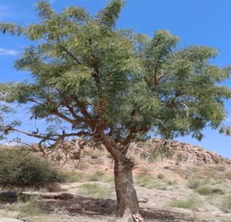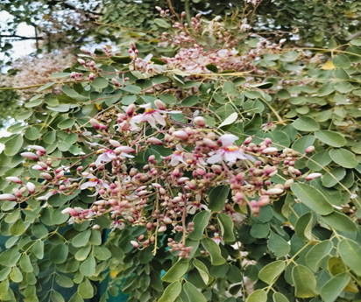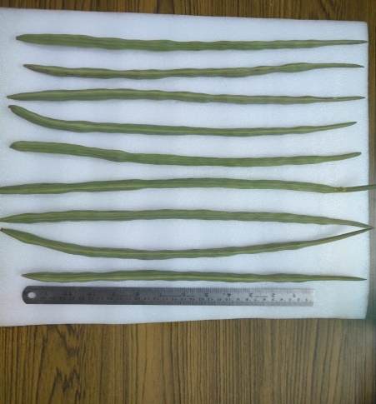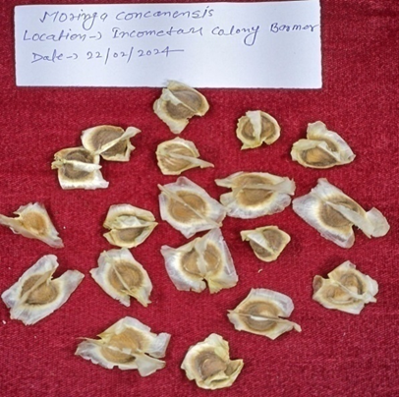
Figure 1: Tree, S seeds, pods and fruits of M.concanensis

2 MATERIALS AND METHODS
2.1 SURVEY AND IDENTIFICATION OF TREES: An extensive survey was carried out during 2023-2024 in Barmer, Churu and Jodhpur district of Rajasthan to identify and select natural populations or individuals of M.concanenesis. The data on height, girth at breast height (GBH), crown diameter, health of the trees and the flowering and fruiting patterns were recorded for the marked trees. Thereafter, seeds were collected from identified trees in the month of February-March, 2024 and seed morphometric characters like pod length (cm), pod width (cm) were estimated using Leica Q win and 100 seed weight (g) using electronic balance followed by raising seedlings under nursery conditions in April,2024. When the seedlings were 45-60 days old in the month of mid-June,2024, a notable infestation of Ash weevil, Myllocerus viridanus was recorded.
2.2 MANAGEMENT TRIAL: Completely randomised design (CRD)
Neem Oil Treatment-4 (Water, 0.5%, 0.75%, 1.0%), 25 seedlings/treatment
2.3 DATA RECORDED: Total number of leaves, Number of damaged leaves, foliar damage intensity
3 RESULTS AND DISCUSSION
3.1 Fruit and seed characteristics: A total 20 trees were identified and marked from three districts (Barmer, Churu and Jodhpur) of Rajasthan. The data on height, girth, crown diameter, health of the trees were recorded and the fruiting behaviour of the selected trees were scored on a scale of 1 to 5. Morphometric analysis of M. concanensis pods collected from populations in Rajasthan revealed substantial variation across all measured traits (Table 1). The pod length showed a mean of 17.3 cm, with individual pods ranging from 10.3 cm to 24.0 cm, indicating considerable size diversity within the sample. The standard deviation of approximately 4.1 cm highlights moderate variability in pod length, suggesting differences in growth conditions, genetic makeup, or both. Pod width also exhibited noticeable variation. The average width was 1.63 cm, but values spanned from 0.9 cm to 2.6 cm, with a standard deviation of about 0.35 cm. This variation, though smaller in absolute terms compared to length, reflects morphological heterogeneity in pod girth that may influence seed development and dispersal.

Table 1: Variation in morphometric traits in M.concanensis pods collected from Rajasthan
Traits | Mean | Minimum | Maximum | Std. Dev.
Pod Length (cm) | 17.3 cm | 10.3 | 24.0 | ~4.1
Pod Width (cm) | 1.63 cm | 0.9 | 2.6 | ~0.35
Seeds per Pod | 8.9 seeds | 5.0 | 14.0 | ~2.2

Similarly, seeds per pod varied from 5 to 14, with a mean of 8.9 seeds and a standard deviation of approximately 2.2 seeds. This trait showed relative variation, suggesting differences in reproductive output among individual plants or populations. Overall, pod length exhibited the greatest absolute variation, followed by seed number and then pod width. These morphometric differences within the Rajasthan of M. concanensis collection could be attributed to environmental gradients, ecological adaptation, or underlying genetic diversity. Such variability is important for conservation, selection, and breeding programs, as it may reflect adaptive potential and resource allocation strategies within the species.
3.2 Seedling Growth: Seeds collected from different locations were raised in root trainers and poly bags containing a mixture of 30:40:30 ratio of sand, compost, and soil and overall, 62% of germination was recorded (Figure 2). After approximately 45-60 days of germination, a substantial infestation of the ash weevil, Myllocerus viridanus (Coleoptera: Curculionidae) was found on the leaves of all the seedlings of M. concanensis (Figure 3).

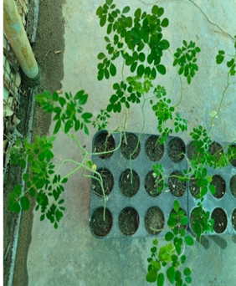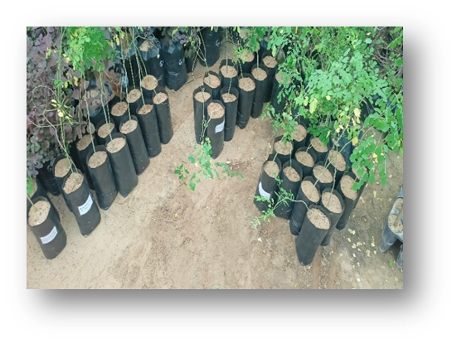
Figure 2: Seedlings raised in root trainers and polybags in nursery conditions

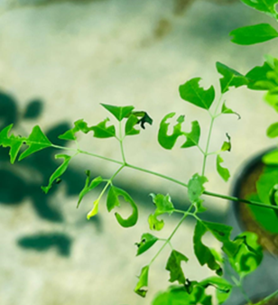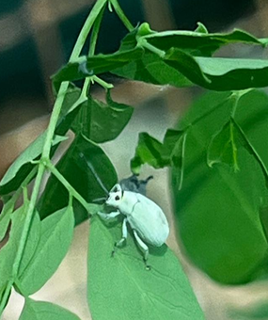
Figure 3: Plant infected with ash weevil
3.3 Infestation of insects: The i Infestation of the weevil was recorded during middle of the June,2024 when the seedlings were 45-60 days old. It was also observed that the infestation was become became severe in the month of October-December,2024. Adult weevils produced characteristic marginal and interveinal notching on young, expanding leaves, resulting in considerable reduction of photosynthetically active leaf area. Seedlings examined were found to be infested, indicating a 100% incidence level. Quantitative damage evaluation showed an average of 25.29 damaged leaves per seedling, corresponding to an average foliar damage intensity of 77.6% relative to total leaf number (Figure 4). Thus, present findings identify this the species Myllocerus viridanus as a significant defoliator of early juvenile stage of M. concanensis and suggest its eco-friendly management approaches.

Figure 4: Graphical representation of damage percentage
3.4 Insect Morphology: The adult measures approximately 3–4.5 mm in body length and exhibits a pale greenish-white coloration with a characteristic chalky efflorescent coating. The head tapers anteriorly, with the eyes positioned dorsally and the forehead bearing a rounded impression. The rostrum is distinctly longer than the head and the mandibles are reddish brown. Antennae are black to piceous. The prothorax is subconical, and the elytra display very narrow striae. The legs are black and covered with green scales.
3.4.1 Symptoms: Its adults bite the edges of the leaves and the grubs (larva) eat the roots due to which the plant withers and dies. When the infection becomes severe, the growth of the plants gets restricted and the plant starts weakening from the roots.
3.5 Management trial: A completely randomized design (CRD) was followed with four treatments and 25 seedlings per treatment (total n = 100):
- Control (Water)
- Neem Oil 0.5%
- Neem Oil 0.75%
- Neem Oil 1%
Each seedling served as an experimental unit. Commercially available neem oil was used at different concentration 0.5%,0.75%, and1%(v/v) and water as control (Figure 6).
Each seedling was uniformly sprayed using a hand sprayer. Applications were carried out once and seedlings were observed after a 7days interval.
Data Collection
For each seedling, the following observations were recorded:
- Total number of leaves
- Number of damaged leaves
- Foliar damage intensity (%), calculated as:
Damage Intensity (%) = (Damaged Leaves/Total Leaves) ×100
The present study demonstrates the high efficacy of neem oil in reducing foliar damage in infested seedlings. The pre-treatment damage intensity of 77.6% confirmed heavy pest pressure, making the experiment suitable for evaluating botanical insecticides. In the present experimental using four treatments—Control (water), Neem 0.5%, Neem 0.75%, and Neem 1%, each with 25 seedlings, one-way ANOVA revealed highly significant differences among treatments (F = 582.94, p < 0.0001). Tukey HSD confirmed that all neem oil treatments significantly reduced foliar damage compared to the control, with a clear dose-dependent trend. Mean damage intensity decreased from 78% in the control to 50% (0.5%), 35% (0.75%), and 20% (1% neem oil) Figure 5. Neem oil at 1% concentration proved most effective, showing the lowest damage intensity. The results demonstrated that increasing neem oil concentration enhances protection against leaf-damaging pests. These findings support the use of neem oil as a safe, nature friendly and effective botanical pesticide for managing foliar pests in nursery seedlings. Given its broad-spectrum activity, affordability and environmental compatibility, neem oil presents a strong alternative to synthetic insecticides, especially in sustainable and low-input production systems.

Figure 5: Graphical representation of Mean Damage Intensity

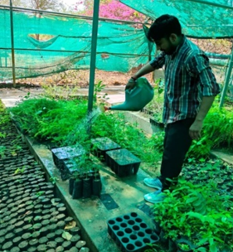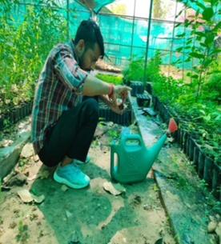
Figure 6: Use of botanicals for management of Ash weevil
The outcomes of the present study align well with the observations reported by Arthanari et al. (2021). In their investigation, neem oil (Azadirachta indica) was tested at five concentrations ranging from 1 to 5 ml/L, against M. viridanus in controlled laboratory conditions. Their bioassay identified lethal concentration values of LC₃₀ (3.096 ml/L), LC₅₀ (3.471 ml/L), and LC₉₀ (4.589 ml/L), following the direct application of neem oil sprays to adult insects. They recorded a clear dose-responsive trend, with mortality progressively increasing from 34% to 100% as the neem oil concentration rose. This gradual escalation in insect mortality mirrors the pattern observed in the current experiment, further supporting the effectiveness of neem oil as a botanical insecticide. Thacker et al. (2003), also reported the similar impact of neem oil on the feeding behavior of the large pine weevil (Hylobius abietis L.), a major pest of regenerating conifer plantations across northern Europe. Their evaluations, carried out under both laboratory and field conditions, consistently demonstrated that neem oil substantially reduced feeding activity in the weevils. This strong antifeedant response observed in their study aligns with our results, further highlighting the broad-spectrum deterrent potential of neem-based formulations against various herbivorous pests.
4 CONCLUSIONS
The present study demonstrates the high efficacy of neem oil in reducing foliar damage in infested seedlings. Neem oil at 1% concentration proved most effective, showing the lowest damage intensity. The results demonstrate that increasing neem oil application enhances protection against leaf-damaging pests. These findings support the use of neem oil as a nature friendly management measure against insect pest of nurseries, especially in sustainable and low-input production systems.

REFERENCES
Arthanari, M., Senthilkumar, D., & Jayachandran, R. (2022). Combined toxicity effects of neem oil and mild soap on Myllocerus viridanus in Morus alb. Journal of Biopesticides, 14,119-124.
Bhandari, M.M. (1990). Flora of the Indian Desert. Scientific Publishers, Jodhpur (Revised Edition).
Kumar, S., & Purohit, C.S. (2015). Conservation of Threatened desert plants. Scientific Publishers
Mughal, M.H., Ali, G., Srivastava, P.S., & Iqbal, M. (1999). Improvement of Drumstick (Moringa
pterygosperma Gaertn.)- unique source of food and medicine through tissue culture. Hamdard Med., 42, 37–42.
Prasanna, P.V. (2000). Moringaceae In: N.P. & S. Karthikeyan (Ed.) Flora of Maharashtra state Dicotyledones. Botanical Survey of India, Kolkata, 1,589–590.
Pullaiah, T., & Chennaiah, E. (1997). Flora of Andhra Pradesh. Vol.1, Scientific Publishers, Jodhpur
Shashikala, M., Bhavana, B., Geethasree, M.S., Sirisha, E., Prabhas, K.G., & Mathew,C.(2025). Exploring Moringa concanensis: A Hidden Plant with Medicinal and Pharmacological Properties. International Journal of Pharmaceutical and Bio-Medical Science, 05,06.
Shetty, B.V., & Singh, V. (1988). Flora of India Series 2. Flora of Rajasthan. Botanical Survey of India, 1,196–197.
Thacker, J. R. M., Bryan, W. J., McGinley, C., Heritage, S., & Strang, R. H. C. (2003). Field and laboratory studies on the effects of neem (Azadirachta indica) oil on the feeding activity of the large pine weevil (Hylobius abietis L.) and implications for pest control in commercial conifer plantations. Crop Protection, 22(5),753–760. https://doi.org/10.1016/S0261-2194(03)00041-3.

