Ethnoentomological Assessment of Public Knowledge and Consumption Practices of
Cybister tripunctatus in Manipur

Abstract


Ethnoentomology offers important critical analysis of the cultures, nutrition, and ecology of insects to indigenous societies, especially in biodiversity hotspots such as Northeast India. One edible insect that is a predaceous diving beetle is Cybister tripunctatus (Coleoptera: Dytiscidae), which is considered as the important source of protein and lipid profile, as well as supposed medicinal benefits in traditional food systems of Manipur. In spite of its popularity, systematic evaluations of the knowledge of the population, its consumption and perceptions of the population changes are scarce, particularly with the pressures on the habitat and changes in
Commented [MA1]: Delete and replace with (Ethnoentomological)
diet. The included 300 respondents in the five districts of Manipur (Bishnupur,
Commented [MA2]: Delete and replace with (One edible insect, the predaceous diving beetle Cybister tripunctatus (Coleoptera: Dytiscidae), is considered an important source of protein and lipid profile, as well as a potential medicinal benefit in traditional food systems of Manipur. Despite its popularity, systematic evaluations of the population's knowledge, consumption, and perceptions of population changes are scarce, particularly amid pressures on the habitat and changes in diet.)
surveyed
Thoubal, Kakching, Imphal West, and Imphal East) by means of systematic sampling in order to measure familiarity, encounter situations, consumption reasons, and attitudes toward species abundance.
The study showed a high familiarity (78%) and consumption rates (82%) among the respondents, with an encounter during fishing being the most frequent (48.72%), and therapeutic benefits (72%), and nutrition (70%) reasons. Non-consumers (18%) identified unavailability as the primary impediment, with 56% of them reporting a population decline in the last decade. The demographics demonstrated that older females (60% of all participants) were more engaged, which indicated the presence of gendered and generational knowledge relations among the respondents. This study emphasizes the need for integrated conservation strategies, including wetland protection, and promote the continuation of entomophagy traditions and food security in Manipur. In the future, ecological monitoring should be undertaken to confirm perceptual data and research on sustainable harvesting models.
Commented [MA3]: Delete and replace with (survey)
Commented [MA4]: Delete and replace with (promotes)
Keywords: Diving Beetle, Cybister, Edible insect, Entomophagy, Food security

Introduction


Cybister tripunctatus (Coleoptera: Dytiscidae), locally known as Tharaikokpi /Tengbi, is a predaceous diving beetle that is widely found in fresh water environments, including ponds, lakes, paddy fields, and slow-moving streams in South and Southeast Asia, including Manipur, Northeast India (Fukuoka et al., 2024; Ohba and Inatani, 2012). The species is valuable in Manipur as it is an important component of aquatic life and also as an edible insect. The beetle is usually picked or trapped in a wetland and agricultural water bodies and is eaten in a fried, roasted, or curry dish (Garg, 2023). Manipur is considered to be a hotspot of edible insect diversity, with many species of Diptera, Coleoptera, Hemiptera, Orthoptera, and Hymenoptera being eaten and sometimes used medically as well. These customs are so deeply entrenched in the local cultural identity and domestic food systems, especially in the Meitei and among other tribal communities living in the valley and hill districts of Manipur (Babu and Singh, 2021; Haldhar et al., 2021). Earlier studies on edible insects in Manipur have documented more than 60 species being consumed, which have been identified as viable sources of protein, fat, and micronutrients and may serve as a means of nutritional security to rural and economically disadvantaged communities (Sanjenbam et al., 2024; Shantibala et al., 2014; Thangjam et al., 2020.). In the larger context, C. tripunctatus has been reported among the widely-used aquatic insects, which are known of their taste and high energy content in their flesh (Mozhui et al., 2020).
Commented [MA6]: Delete and replace with (for)
Commented [MA5]: Delete and replace with (freshwater)
C. tripunctatus has ethno-medical importance in Manipur besides its nutritional importance. Local individuals and communities, like the Tangkhul Naga, have documented its use in medicine and other folk medicine remedies and practices, also record the usage of its larvae or adults in remedies for ailments such as small pox, allergy, and cough, usually in combination with other components such as honey or medicinal plants (Singh et al., 2023). Recent biochemical and metabolite-profiling studies have reported several bioactive compounds in C. tripunctatus, supporting the idea that traditional perceptions of its therapeutic value may have a physiological basis. These findings position the species at the interface of food, health, and culture, making it a particularly relevant model for ethno-entomological investigations (Chanu et al., 2025; Singh et al., 2023). At the same time, traditional knowledge and practices related to edible insects are increasingly under pressure from rapid socio- economic change, modernization of diets, habitat degradation, and declining edible insect’s
Commented [MA7]: Delete and replace with (their)


population (Hlongwane et al., 2021). Urbanization, wetland encroachment, agrochemical use, overexploitation, and shifting preferences toward commercially processed foods can reduce both the availability of wild edible insects and the transmission of knowledge about their collection, preparation, and medicinal uses in different generations or age categories (Piña- Domínguez et al., 2022; Yen, 2009). For aquatic insects such as C. tripunctatus, alterations in wetland ecosystems and paddy field management may directly impact population abundance, while reduced interaction of younger generations with traditional fishing and farming activities may erode species recognition and utilization (Ohba and Inatani, 2012). For instance, C. tripunctatus population is declining, and it is even included in the Red data list of some countries like Japan (Ohba and Inatani, 2012). Understanding current levels of public awareness and use is therefore critical for anticipating how these practices may change in the future.
Commented [MA9]: Delete and replace with (red)
Commented [MA8]: Delete and replace with (Insect populations)
Although the use of edible insects is acknowledged to be vital in Manipur, most of the research done has been on the compilation of species, description of culinary and medicinal application and nutritional content. There is relatively little systematic community-level information on the level of recognition of C. tripunctatus, its frequency of use, the underlying reasons, and the ways in which the population of this organism is viewed. Furthermore, quantitative data on the distribution of knowledge and consumption by age, gender, and educational variables, as well as encounter contexts such as fishing, farming, markets, or natural water bodies in influencing familiarity with the species are limited. This information is critical in connecting the ethnoentomological knowledge to the conservation planning and sustainable use approaches. In this context, the present study undertakes an ethnoentomological survey of general knowledge and consumption patterns of C. tripunctatus in five districts in Manipur. The study aims to give a background knowledge to future efforts in the implementation of sustainable harvesting, habitat management, and conservation of traditional food and medicinal knowledge concerning this culturally significant aquatic beetle by combining descriptive statistics and local perceptions.
Commented [MA10]: Delete and replace with (how)

Materials and Methods

The survey consists of 300 respondents from five districts of Manipur: Bishnupur (150 respondents), Thoubal (25), Kakching (25), Imphal West (50), and Imphal East (50) (Fig.1, 4).
Commented [MA11]: Delete
systematic sampling, which took into account the
The sampling method used was the
ecological presence of C. tripunctatus and the cultural significance of the same in the regions


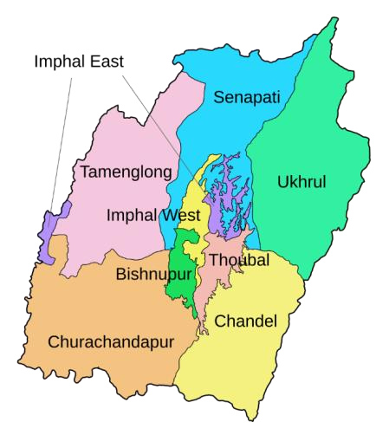
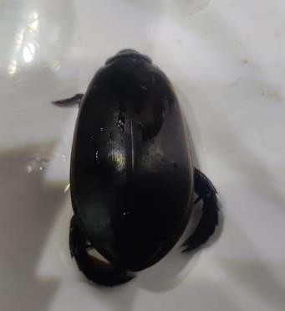


of study. All the potential respondents were approached face-to-face, the aims of the study were properly explained to them, and the informed consent was acquired before proceeding to the actual study (Fig. 2, 3). Those who declined to take part were not given additional coercion and
Commented [MA15]: Delete and replace with (on)
Commented [MA14]: Delete and replace with (the setting)
Commented [MA13]: Delete and replace with (the socio- demographic)
were not included in the study. The survey tool included part of socio-demographic profile, knowledge of C. tripunctatus, and setting of exposure, frequency and purpose of consumption, information of medicinal or therapeutic use, and perceived population changes over the past 10 years. Descriptive statistics such as frequencies and percentages were used to summarize
Figure 1. (A) Map of Manipur with Districts; (B) Cybister tripunctatus (Dorsal view)
responses and compile them.
Commented [MA12]: Delete

A | B

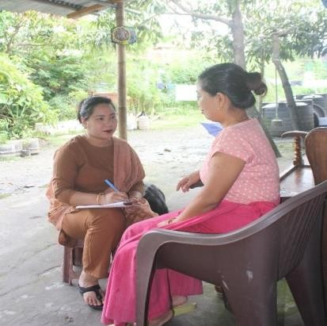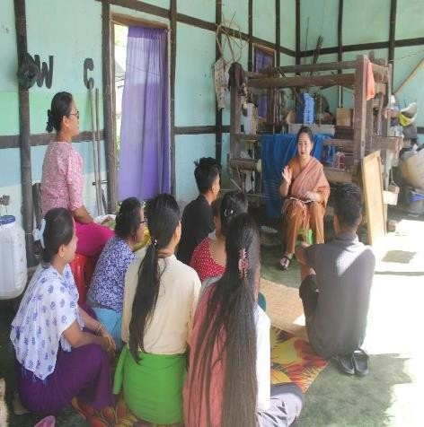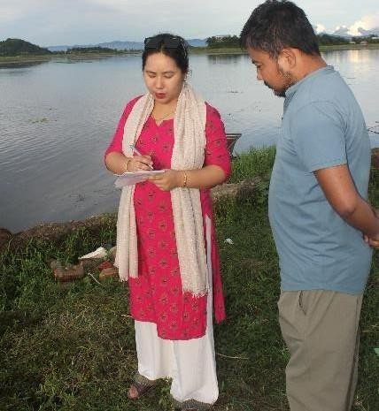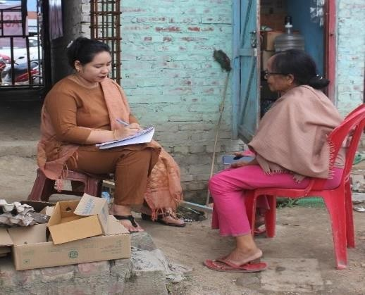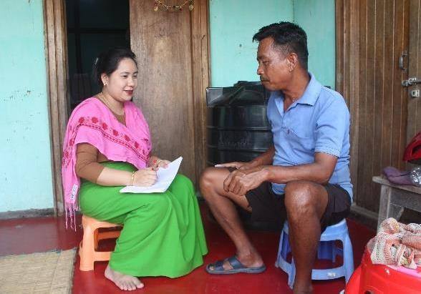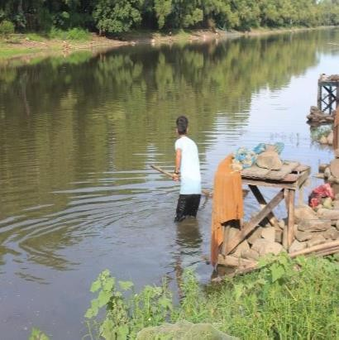

Figure 2. Primary data collection through respondent interviews focusing on indigenous therapeutic practices involving Cybister tripunctatus

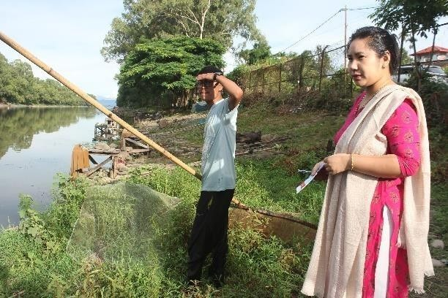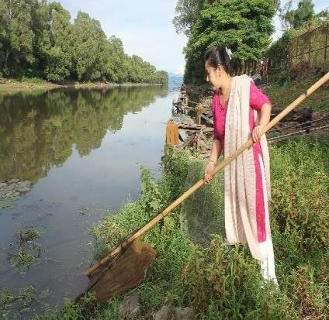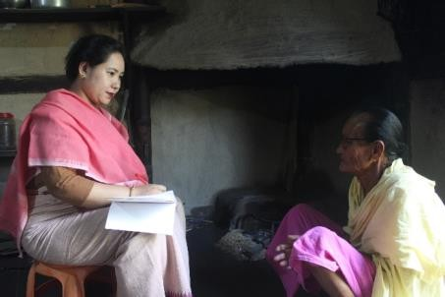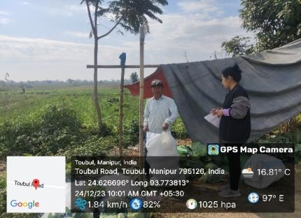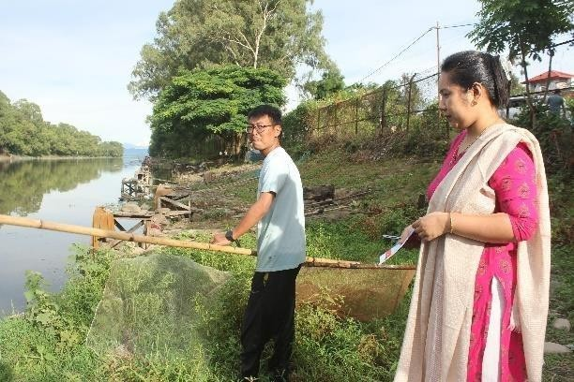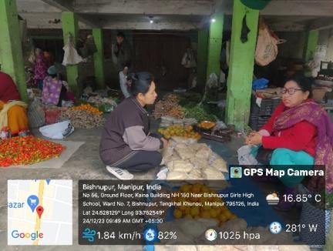

Figure 3. Transcription of the responses of the respondent on the traditional medicinal uses of Cybister tripunctatus

RESPONDENT
RESPONDENTS

Results

Socio-demographic profile

The overall population of 300 respondents was a relatively older group with 60% or (180 respondents) aged above 50 years, 30% (90 respondents) aged between 25 and 50 years and 10% (30 respondents) aged below 25 years (Fig. 4). Among the respondents, females were majority (60 percent/ 180 respondents) and males with 40 percent (120 respondents). There


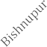

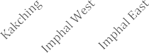


Encounter and familiarity situations
160
140
120
100
80
60
40
20
0
150
50
50
25 25
DISTRICT
was a heterogeneity in the level of education; 30% (90 respondents) had obtained higher secondary education, 22% (66 respondents) had been graduated, and 16% (48 respondents) had attained postgraduate education or higher. The rest of the respondents were 12% (36 respondents) no formal education, 6% (18 respondents) primary education, and 14% (42 respondents) high school education. This finding suggests that the knowledge and practices concerning C. tripunctatus are encoded in different levels of education, although older and
female respondents were well represented.
200
180
160
140
120
100
80
60
40
20
0
Under 25 25–50 Above 50
B

Figure 4. Graphical analysis; (A) Number of respondents interviewed district wise;
(B) Number of respondents under various age groups
Commented [MA19]: Delete and replace with (with high)
Commented [MA18]: Delete and replace with (with primary)
Commented [MA17]: Delete and replace with (with no)
Commented [MA16]: Delete

The knowledge on C. tripunctatus was very high, with 78% (234 respondents) admitting that they were aware of the species. These respondents were most likely to encounter the beetle when fishing (48.72%/114 respondents), when in natural ponds or rivers (28.21% or 66 respondents), or in local markets (10.26% or 24 respondents) (Fig. 5). The same patterns

have been compared to past ethnobiological studies that aquatic edible insects in Manipur are often harvested in wetlands, paddy fields, and lentic water bodies, and also traded as food. The
Preeminence of fishing and farming as contact situations supports the close relationship between conventional agro-wetland systems and the overall knowledge of this species.
Respondents
Local Markets
Natural Ponds/Rivers
Fishing/Farming
0
20
40
60
80
100 120

Figure 5. Graphical representation of the number of respondents according to the patterns and motivations of consumption.

Patterns and motives of consumption

The percentage of participants who reported consumption of C. tripunctatus was high, with 82 percent (246 people). In this group of consumers, a similar proportion (48.78%, 120 respondents in total) stated that they occasionally and frequently consumed it, indicating that although the species is consumed frequently, the level of consumption across households is different. Tasting (90 percent of consumers), medicinal or curative (72 percent), nutritional (70 percent), and traditional practices (58 percent) were the primary drivers of consumption (Fig.
6). These reasons correlate with reported nutritional and health-related properties of C.
tripunctatus and other edible aquatic insects.



Figure 6. Graphical representation showing the number of respondents by consumption patterns and motivations

The non-consumers were reported to be 18% (54 respondents). The main causes of non- consumption of C. tripunctatus among them were that they were unavailable (44.44%), and lacked awareness regarding its edibility (22.22%). These results show that access and knowledge gaps are more likely than direct cultural or religious taboos to be the barrier to use, but they might be locally operative and were not very prominent in the current dataset.
Awareness of medicinal uses

During the study, 34% (102 respondents) were aware of medicinal or therapeutic use of C. tripunctatus. The ethnomedicine of Manipur in general tends to involve edible insects, such as aquatic ones, into folk medicine, whether in the treatment of respiratory issues, joint pains, or urinary tract infections. Though the current survey did not list individual treatment in detail, the percentage of those who had acquired medicinal use knowledge implies that C. tripunctatus has a dual identity in local knowledge system as both food and a treatment resource.
Perceived population trends
250

200

150

100

50

0
Taste Preference Medicinal Nutritional Traditional
Benefits Benefits Practice
Commented [MA20]: Delete and replace with (the medicinal)
Commented [MA21]: Delete and replace with (in)
Commented [MA22]: Delete and replace with (the local)
In response to the questions on the change in C. tripunctatus population in the last 10 years, 56 percent (168 respondents) of the respondents felt that the population had decreased, 42 percent (126 respondents) believed that the population had not changed, and only 2 percent (6 respondents) felt the population had increased. The views are symptomatic of wider issues in Manipur and beyond that wild
Commented [MA23]: Delete and replace with (,and wild)
edible insect populations are experiencing problems due to
habitat loss, overexploitation, use of agrochemicals, and wetland habitat change. Although the

current research was based on perception as opposed to quantitative ecological evidence, most of the current perspective of decline implies that monitoring and sustainable management interventions are necessary.

Discussion

The familiarity (78%) and consumption (82%) of C. tripunctatus in this survey are high enough to support the fact that C. tripunctatus is a culturally and nutritionally significant food insect in Manipur. These results are similar to other previous ethnobiological and nutritional research reports that record widespread utilization of aquatic insects and note their role in dietary diversity and food security (Shantibala et al., 2012, 2014). The strong influence of taste and perceived health benefits are consumption drivers which indicate the combination of sensory preference and traditional beliefs on health to perpetuate entomophagy of the area.
some of the main carriers of ethnoentomological knowledge because of the age and gender of the sample, the considerable role of older and female respondents in fishing, farming, and cooking food (Hlongwane et al., 2021; Manditsera et al., 2018). Gendered and generational knowledge and practice patterns towards edible insects have been observed to be similar to those of other ethnobiological contexts, with more detailed identification of species and methods of preparation frequently being passed down to older generations (Hlongwane et al., 2021). The comparative lesser knowledge of younger age groups, implied by the age structure, can be an indication of the constant loss of traditional knowledge as dietary shifts and livelihood changes gain faster (Morris et al., 2023).
It is likely that women and the elderly are
Commented [MA25]: Delete and replace with (comparatively)
Commented [MA24]: Delete and replace with (Women and the elderly are likely)
The observation that non-consumption is highly caused by unavailability and ignorance of edibility has significant conservation and sustainable use. Perceived scarcity, on the one hand, is consistent with the majority perspective of the respondents that populations have decreased in the past decade; on the other hand, the unavailability may also represent changes in wetland management, market supply chains, and changes in the abandonment of the traditional foraging practice (Piña-Domínguez et al., 2022). Studies on edible aquatic insects in Manipur highlight the importance of wetlands like Loktak Lake as important focus of practice, although they also indicate that a growing use of such environments poses a risk to biodiversity and the practice of entomophagy (Babu and Singh, 2021).
Commented [MA28]: Delete and replace with (of)
Commented [MA27]: Delete and replace with (an important)
Commented [MA26]: Delete and replace with (implication for conservation)
The average awareness (34%) on medicinal applications is an indication of untapped aspect of edible insects in the local health systems. Studies in Manipur and its surrounding
Commented [MA29]: Delete and replace with (an untapped)

areas on entomotherapy reports
Commented [MA30]: Delete and replace with (report)
that some edible insects are used in folk medicine, and
bioactive compounds with antioxidant and therapeutic capability were reported (Mozhui et al., 2021, 2021). By combining the traditional medicinal knowledge with biochemical and pharmacological research, it may become possible to unlock new possibilities of validating and even exploiting these bioresources, but needs to be weighed against conservation interests.
Commented [MA31]: Delete and replace with (this needs)

In general, the perceived population decrease of C. tripunctatus, reported by a majority of respondents, is aligned with the larger issue of the sustainability of wild insect harvesting (Piña-Dominguez et al., 2022). Ethnoentomological and nutritional research has become more and more proactive in proposing the grow or semi-domestication of major edible insect taxa, such as aquatic beetles, as a method of achieving conservation as well as livelihood results (Mozhui et al., 2020). The possible strategies applied to C. tripunctatus in Manipur may include wetlands habitat protection, the community based guidelines of harvesting, feasibility study on controlled production, as well as documentation and transmission of traditional knowledge to the younger generations.
Commented [MA32]: Delete and replace with (community-based)

Conclusion

This ethnoentomological survey illustrates that Cybister tripunctatus is also extensively familiar and eaten in various districts of Manipur that represents a meeting of cultural tradition, sensory preference, conceived health benefits, and nutritional value. The species is being encountered mostly in fishing situations, and the use is highly practiced among older and female subjects, which implies the agro-wetland livelihoods and food preparation roles in the house as central to the continuity of the knowledge and practice. Meanwhile, the perceptions towards the shrinking populations, lack of accessibility, and loss of awareness in particular
Commented [MA34]: Delete and replace with (perceived)
Commented [MA33]: Delete and replace with (which)
among the non-consumers signal emerging risks to the long-term sustainability of C.
tripunctatus based food cultures.
Commented [MA35]: Delete and replace with (C. tripunctatus-based)

Considering the current studies and existing evidence on the nutritional and bioactive potential of C. tripunctatus and other edible aquatic insects in Manipur, the necessity to have integrated solutions, connecting ethnoentomological knowledge, ecology surveillance schemes, and sustainable use criteria, is evident. The future research should include quantitative population measurements, a more detailed examination of the process of intergenerational knowledge transfer, and the discussion of the possible model of the community-based management or cultivation. These would assist in keeping C. tripunctatus as
Commented [MA37]: Delete
Commented [MA36]: Delete and replace with (a discussion)

a source of food security, health, and cultural identity of the local people of Manipur and reduce pressure on the wild populations.

References

Babu, S., & Singh, M. O. K. (2021). Cultural entomology and edible insect diversity in a wetland ecosystem: A case study from the Loushi pat basin, Manipur. Indian Journal of Traditional Knowledge (IJTK), 20(1), Article 1.
https://doi.org/10.56042/ijtk.v20i1.29055

Chanu, Y. L., Sanjenbam, R., Huidrom, S., Nongmaithem, B. D., Ngangbam, A. K., Singh, O. L., & Meetei, K. B. (2025). Cybister tripunctatus Bioactive Metabolite Profiling in Manipur, India. Journal of Biology and Nature, 17(2), 557–564.
Fukuoka, T., Tamura, R., Ohba, S. Y., & Yuma, M. (2024). Different habitat use of two Cybister (Coleoptera: Dytiscidae) species larvae in a paddy field water system. Entomological Science, 27(4), e12595. https://doi.org/10.1111/ens.12595
Garg, S. (2023). Edible Insects Contribution to Nutritional Security in Tribal Communities of North-East India: A Review. Shrinkhla Ek Shodhparak Vaicharik Patrika. https://doi.org/10.5281/ZENODO.10401046
Haldhar, S. M., Thangjam, R., Kadam, V., Jakhar, B. L., Loganathan, R., Singh, K. I., Rolania, K., Singh, S., Dhaka, S. R., & Singh, K. M. (2021). A review on entomophagy: Natural food insects for ethnic and tribal communities of North-East India. Journal of Environmental Biology, 42(6), 1425–1432. https://doi.org/10.22438/jeb/42/6/MRN-
1809

Hlongwane, Z. T., Slotow, R., & Munyai, T. C. (2021). Indigenous Knowledge about Consumption of Edible Insects in South Africa. Insects, 12(1), 22.
https://doi.org/10.3390/insects12010022

Manditsera, F. A., Lakemond, C. M. M., Fogliano, V., Zvidzai, C. J., & Luning, P. A. (2018). Consumption patterns of edible insects in rural and urban areas of Zimbabwe: Taste, nutritional value and availability are key elements for keeping the insect eating habit. Food Security, 10(3), 561–570. https://doi.org/10.1007/s12571-018-0801-8
Morris, K. E., Watako, A. O., & Akuno, W. (2023). Youth Knowledge on the Utilization of Edible Insects as Food and Feed. Turkish Journal of Agriculture - Food Science and Technology, 11(6), 1134–1141. https://doi.org/10.24925/turjaf.v11i6.1134-1141.5118
Mozhui, L., Kakati, L. N., Kiewhuo, P., & Changkija, S. (2020). Traditional Knowledge of the Utilization of Edible Insects in Nagaland, North-East India. Foods, 9(7), Article 7. https://doi.org/10.3390/foods9070852
Mozhui, L., Kakati, L. N., & Meyer-Rochow, V. B. (2021). Entomotherapy: A study of medicinal insects of seven ethnic groups in Nagaland, North-East India. Journal of Ethnobiology and Ethnomedicine, 17(1), 17. https://doi.org/10.1186/s13002-021-
00444-1

Ohba, S., & Inatani, Y. (2012). Feeding Preferences of the Endangered Diving Beetle Cybister tripunctatus orientalis Gschwendtner (Coleoptera: Dytiscidae). Psyche: A Journal of Entomology, 2012(1), 139714. https://doi.org/10.1155/2012/139714
Piña-Domínguez, I. A., Ruiz-May, E., Hernández-Rodríguez, D., Zepeda, R. C., & Melgar- Lalanne, G. (2022). Environmental effects of harvesting some Mexican wild edible insects: An overview. Frontiers in Sustainable Food Systems, 6. https://doi.org/10.3389/fsufs.2022.1021861
Sanjenbam, R., Chanu, Y. L., Nongmaithem, B. D., Ngangbam, A. K., Meetei, K. B., & Singh,

O. L. (2025). Evaluation of Antioxidant Properties in Three Commercially Important Edible Insects from Manipur. Journal of Advances in Biology & Biotechnology, 28(5), 345–352. https://doi.org/10.9734/jabb/2025/v28i52296

Sanjenbam, R., Laxmi Chanu, Y., Nongmaithem, B. D., Kumar Ngangbam, A., & Lukhoi Singh, O. (2024). Edible Insects: A Sustainable Solution for Nutrition, Medicine, and Economic Development of Manipur, India. Ecology, Environment and Conservation, 30(01), 92–98. https://doi.org/10.53550/EEC.2024.v30i01.017
Shantibala, T., Lokeshwari, R. K., & Debaraj, H. (2014). Nutritional and antinutritional composition of the five species of aquatic edible insects consumed in Manipur, India. Journal of Insect Science, 14(1), 14. https://doi.org/10.1093/jis/14.1.14
Shantibala, T., Lokeshwari, R., Thingnam, G., & Somkuwar, B. G. (2012). MEIMAN: Database exploring Medicinal and Edible insects of Manipur. Bioinformation, 8(10),
489. https://doi.org/10.6026/97320630008489

Singh, O. I., Singh, L. R., Rajan, J. P., Devi, K. S., & Singh, K. B. (2023). Essential Minerals Content in the Ethnozoological Products Used in the Folklore Medicines by the Tangkhul Tribe of Manipur, India. Journal of Chemical Health Risks, 13(4s), 184-194 Thangjam, R., Kadam, V., Ningthoujam, K., & Sorokhaibam, M. (2020). A review on edible insects and their utilization in Northeastern Himalaya. Journal of Entomology and
Zoology Studies, 8(3), 1309-1318.

Yen, A. L. (2009). Edible insects: Traditional knowledge or western phobia? Entomological Research, 39(5), 289–298. https://doi.org/10.1111/j.1748-5967.2009.00239.x

