Original Research Article
First Records of Two Argyrodes Simon, 1864 Spiders
(Arachnida: Araneae: Theridiidae) Species in Chhattisgarh State, India

Abstract
This study describes a new distributional record of two cobweb spider species of the genus Argyrodes Simon, 1864 in Chhattisgarh. Two Argyrodes spider species, Argyrodes fissifrons O. Pickard-Cambridge, 1869 and Argyrodes nephilae Taczanowski, 1873 were recorded from the forest region of Gariaband district in the state. With this record, there are now three species of this genus found in Chhattisgarh. Argyrodes nephilae is a species that was last recorded in Telangana in 2010, and has now been recorded again in Chhattisgarh state after 16 years. This is the second state where it has been recorded. Therefore, this study adds two new species to the Arachnofaunal list of the state.

Keywords: Argyrodes, Chhattisgarh, Gariaband, Genus, Species, Theridiidae.

Introduction
The genus Argyrodes Simon, 1864 is a special spider genus belonging to the family Theridiidae, and its members are commonly known as Dewdrop spiders. This genus was first described by Eugène Louis Simon in 1864 (WSC, 2026). This genus is considered special because the species within it exhibit a unique behavior known as kleptoparasitism (Singh et. al., 2023). These Argyrodes spiders live in the nests of other spiders, such as orb-weaver spiders, and feed on the food that the host spider does not consume. Species of this genus are found throughout the world in tropical, subtropical, and temperate regions. To date, 85 species of this genus have been recorded worldwide, with 32 synonyms (WSC, 2026). Argyrodes fissifrons was first recorded in 1869, while Argyrodes nephilae was first recorded in 1873. Argyrodes fissifrons was first recorded in Maharashtra state and then gradually recorded in four other states of India (Kelkar et al., 2006). On the other hand, Argyrodes nephilae was first recorded in Telangana state and has not yet been observed in any other state (Javed et al., 2010). In Chhattisgarh, only six species of cobweb spiders have been recorded so far, including three from the Deobhog region (Nichat et al., 2024a), four species from the North Gariaband forest region (Nichat et al.,2025), one species of Meotipa sahyadri from the Gariaband forest region (Nayak et al., 2025a), and two species from Raigarh and Sarguja. In this state, only one species of the genus Argyrodes, Argyrodes argentatus, has been recorded so far in the Chhura region of Gariaband district; no other species of this genus have been observed (Nichat et al.,2025).

Material And Methods
The spider's specimens were collected from two sites in the forest region of Gariaband district in Chhattisgarh state of India (Fig. 1). The first Argyrodes fissifrons (O. Pickard-Cambridge, 1869) were collected from the Raipur - Deobhog Highway forest region in Gariaband on the web of Nephila pilipes (Fabricius, 1793) spider. The second one, Argyrodes nephilae (Taczanowski, 1873), was collected from Bhuteshwar nath forest area of Gariaband on Sal tree. Both spider specimens were carefully collected by simple capturing methods and preserved in 70% alcohol. Its photographs were taken by INFINIX smart HD camera and Google Maps camera 1.4.13. Recent standard research articles have been used for its identification, which have been published in standard journals till 2025 and on some websites, World Spider Catalogue, 2026.

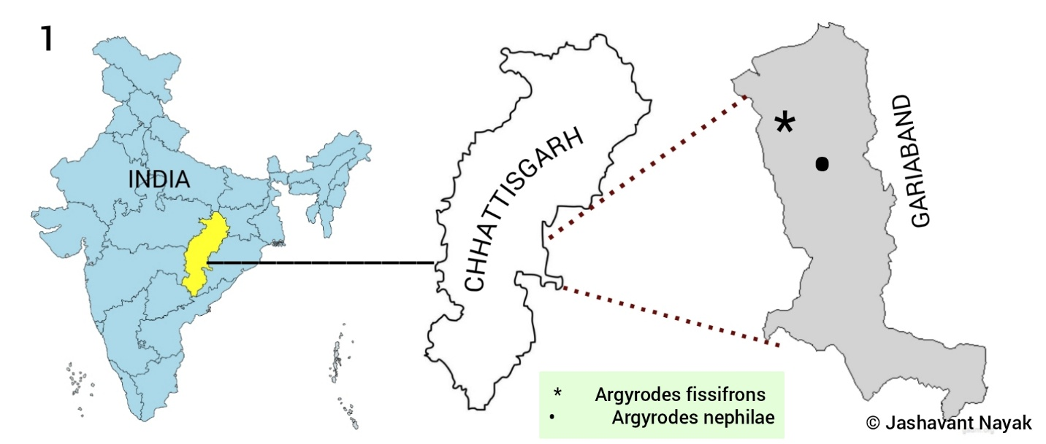

Figure 1 : The map represents new distribution of two cobweb spider species in Chhattisgarh state

Result
In this study, two cobweb spider species from the Gariaband district of Chhattisgarh state have been recorded for the first time in this state. These are the seventh and eighth spider species to be recorded in this state. Besides these, only six species of cobweb spiders belonging to the family Theridiidae have been recorded so far from various parts of Chhattisgarh. Their brief location and morphological details are provided in this section.
TAXONOMY
Family: Theridiidae Sundevall, 1833
Argyrodes Simon, 1864
Argyrodes fissifrons O. Pickard-Cambridge, 1869

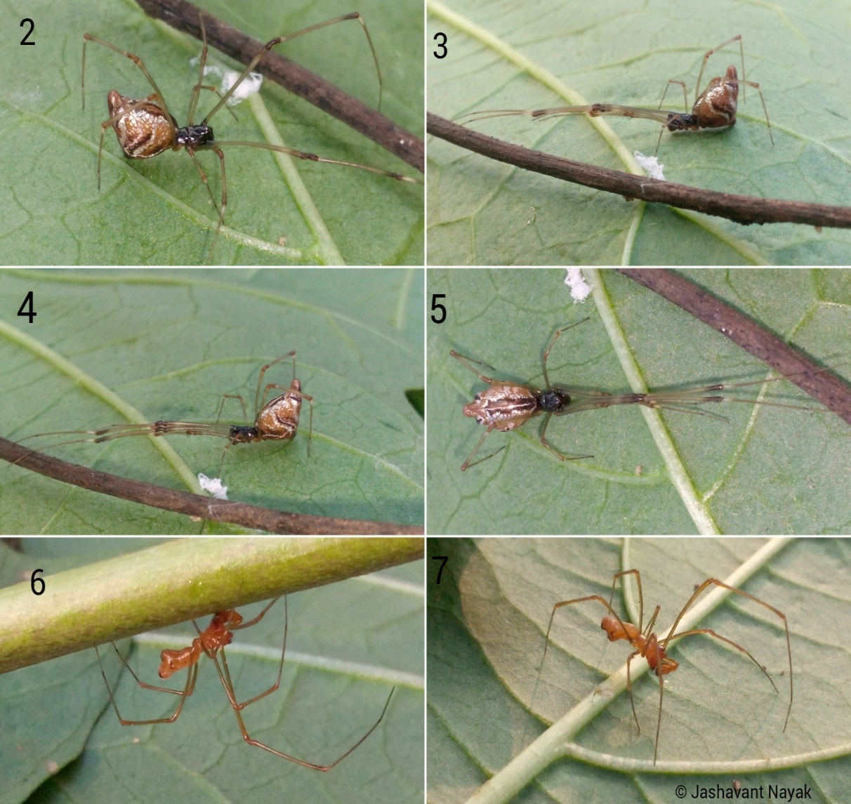
(Fig. 2-7)

Habitus: Argyrodes fissifrons O. Pickard-Cambridge, 1869; 2-5 female; 2- anterolateral view, 3-4 lateral view, 5- dorsal view; 6-7: male

Material Examination
Argyrodes fissifrons O. Pickard-Cambridge, 1869: 1 female and 1 male specimen were collected from Bhuteshwar nath (Bindranawagarh) forest region of Gariaband in Chhattisgarh state, Lat. 20.599551° & Long. 82.05244°, Date 25.viii.2025, 10:43 AM (GTM +05:30) Collected by Jashavant Nayak. Both species have been preserved in 70% alcohol and are safely kept in the Department of Zoology at Govt. D. B. Girls Post Graduate College, Raipur, Chhattisgarh, India. The species were collected on the Saal tree.
Specimen Description
Female: The female is larger than the male. The cephalothorax is black, flattened dorsoventrally and square shaped. Chelicerae are broad, curved internally and black. The abdomen is triangular, oval-shaped and larger than the cephalothorax, brown with silver and black marks. Hairs are completely absent from it. The ventral part is flat and whitish, with a black brown stripe located on the dorsal carapace. Stripe is surrounded by small silver patches. Padipals are absent. The first pair's legs are longer than all legs, while the third pair are smaller than all. The leg formula is 1243.
Male: The male is smaller than the female due to sexual dimorphism. The cephalothorax is similar in size to the abdomen; It is dark orange, cylindrical with a wide anterior region. Padipals are dark orange, strong and oval-shaped. Cymbium is brown and completely hairy. The abdomen is cylindrical, pale orange with small white patches that are distributed on the dorsal and lateral parts. The anterior portion is conical shaped while the posterior portion is wide with ventral and dorsal lobes. Spinnerets are located on the posterior tip of the abdomen. All legs are strong, long, wide and dark orange. The first pair of legs is longer and stronger than all legs. The leg formula is similar to female species.
Diagnosis: This species was identified based on its diagnostic characteristics such as a large and long body, a conical abdomen with two lateral lobes, and the morphological pattern on the abdomen. For a diagnosis of the species, see Simon, E. (1864)
Global Distribution: Sri Lanka to Indonesia, Papua New Guinea, China, Australia (Queensland) (WSC, 2026).
Indian Distribution: Kerala (Pooja et al., 2016; Vineetha & George, 2021), Maharashtra (Kelkar et al., 2006), Tamil Nadu (Kapoor, 2008; Kadam & Rajkumar, 2020), Uttar Pradesh (Hore & Uniyal, 2008; Uniyal & Hore, 2009).
Habitat: Argyrodes fissifrons is a spider that resembles other spiders in the Tetragnathidae family and lives in the webs of orb-weaving spiders. This spider hangs upside down in the web and spends its entire life there.
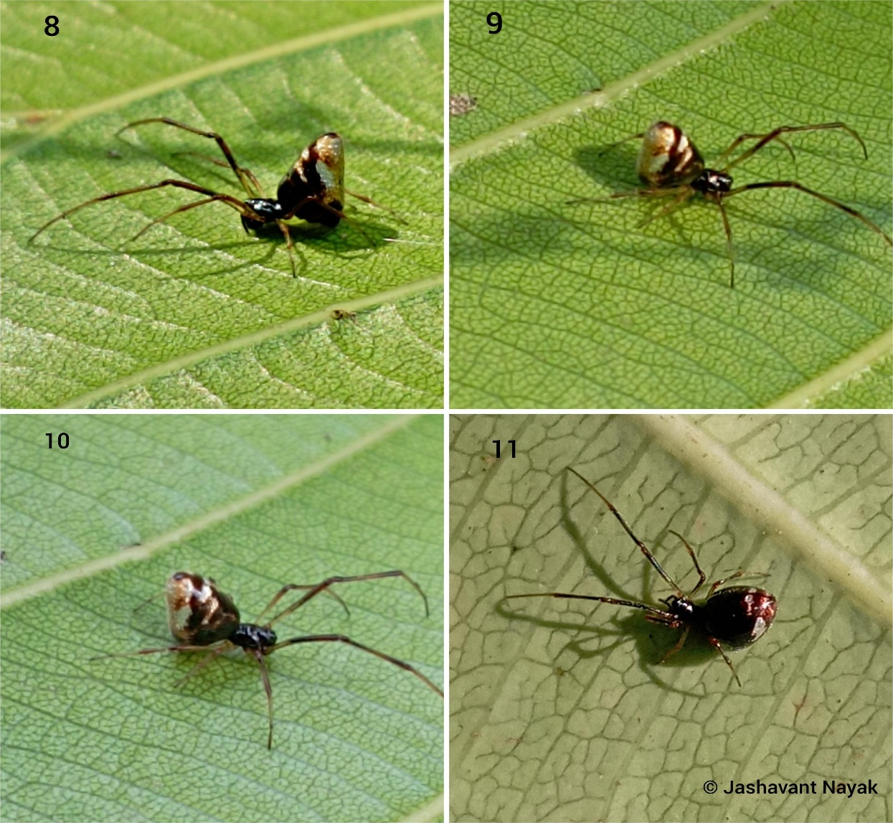
Argyrodes nephilae Taczanowski, 1873
(Fig. 8-11)
Habitus: Argyrodes nephilae Taczanowski, 1873; 8-Lateral view; 9 & 10- Anterolateral view; 11-Dorsal view.

Material Examination
Argyrodes nephilae Taczanowski, 1873: 1 female specimen was collected from Deobhog-Raipur National Highway (Amadi) forest region of Gariaband in Chhattisgarh state, Lat. 20.49011° & Long. 82.088275°, Date 05.xii.2025, 11:53 AM (GTM +05:30) Collected by Jashavant Nayak. This species has been preserved in 70% alcohol and is safely kept in the Department of Zoology at Govt. D. B. Girls Post Graduate College, Raipur, Chhattisgarh, India. The specimen was collected on the large web of Nephila pilipes.
Specimen Description
Female: Cephalothorax is small, flattened, and black. The chelicerae are strong, black and thick. The abdomen is larger than the cephalothorax. It is laterally triangular and oval; the anterior portion is dark black, while the dorsal and posterior portions are pale brown. Small hairs are not observed on the abdomen region. Two pairs of whitish markings are present on the top dorsal portion. Legs are brown. Leg formula is 1243, where the first pair of legs is longer, stronger, darker and more active than all legs. The femur of the first pair's legs is dark blackish and hairy.
Diagnosis
The specimen is identified by its cone-shaped abdomen, black colored head, leg arrangement and habitat. The keys that are also helpful are black spots on the dorsal abdomen with a whitish-brownish color combination. For a diagnosis of the species, see Javed et al., (2010).
Global Distribution: USA to Argentina, Galapagos, India (WSC, 2026).
Distribution: Telangana (Javed et al., 2010).
Habitat: This is a kleptoparasitic spider that is found in the webs of large web-building spiders, such as orb-weaver spiders and spiders of the Nephila species, and lives by feeding on the leftover food materials of the host species.

Discussion
Two species of cobweb spiders belonging to the genus Argyrodes have been collected from the forest region of Gariaband district in Chhattisgarh state. These are the first recorded instances of these species in Chhattisgarh. Their discovery suggests that there are likely many more spider species belonging to the family Theridiidae in Chhattisgarh, and it is crucial to find them to accurately and comprehensively represent the state's Arachnofaunal diversity and species richness. According to recent data, only one species, Argyrodes argentatus, has been documented in Gariaband district. With the discovery of these two new species, the total number of Argyrodes species recorded in the district has now reached three. These species are very important from a biodiversity perspective, as they play a role in pest control and occupy a trophic level in the food chain within the forest ecosystem. Further study of these species can reveal their greater importance to both nature and human society. Spiders are mostly found in areas with dense vegetation and moderate temperatures, and Chhattisgarh, especially Gariaband, is largely covered by forests. Therefore, there is a high probability of finding more species of this family in this region.
This study is limited to showing the new distribution of these two species in the Gariaband district; these species may also be found in other districts of Chhattisgarh state, which would require further extensive studies.

Conclusion
The recording of these two cobweb spider species in a biodiversity-rich region like Chhattisgarh is a very significant study. This research has revealed the presence of two unique spider species in this state. This study will facilitate the identification of these spiders and related species, and will also help in understanding their morphological variations. This adds two cobweb spider species to the state's arachnofauna list, which currently has a very limited number of recorded cobweb spider species.

References
González, A., & Castro, D. del C. (1996). Neotropical spiders of the genus Argyrodes Simon (Araneae, Theridiidae). Bulletin of the British Arachnological Society, 10(4), 127–137.
Hore, U. & Uniyal, V.P. (2008). Diversity and composition of spider assemblages in five vegetation types of the Terai Conservation Area, India. The Journal of Arachnology, American Arachnological Society, 36(2): 251–258.
Javed, S.M.M., Srinivasulu, C. & Tampal, F. (2010). Addition to araneofauna of Andhra Pradesh, India: occurrence of three species of Argyrodes Simon, 1864 (Araneae: Theridiidae). Journal of Threatened Taxa, 2: 980-985. doi:10.11609/JoTT.o2194.980-5
Kadam, G. & Rajkumar, M. (2020). Exploring the “tigers of microhabitat” in SACON campus. SACON News, 17(4): 6-10.
Kapoor, V. (2008). Effects of rainforest fragmentation and shade-coffee plantations on spider communities in the Western Ghats, India. Journal of Insect Conservation, 12: 53–68.
Kelkar, N., Pethe, H. & Dixit, T. (2006). Spiders of Fergusson College Campus, Pune. Fergusson College Magazine, 97: 35-37.
Nayak J. & Sori P. (2025). Hamadruas hieroglyphica Thorell, 1887 (Aranae: Oxyopidae): First Description of a lynx Spider In Chhattisgarh, India. International Research Journal of Modernization in Engineering Technology and Science: 7(3): 632-634. DOI: https://www.doi.org/10.56726/IRJMETS68434
Nayak J., Sori. P., Bharti D. (2025a). Description of a New Spider Meotipa sahyadri Kulkarni, Vartak, Deshpande & Halali, 2017 (Aranae: Theridiidae) in Chhattisgarh, India. International Journal of Research Publication and Reviews 6(2) 4518-4521. https://doi.org/10.55248/gengpi.6.0225.1026
Nayak, J., Chaure, M., Majumdar, M., Nichat, A. R., & Harris, K. K. (2025b). Assessment of orb weaver spider (Araneidae Clerck, 1757) diversity in Gariaband forest region with a new endemic species in Chhattisgarh region, India. International Journal of Fauna and Biological Studies, 12(5), 61–67. https://doi.org/10.22271/23940522.2025.v12.i5a.1131
Nayak, J., Chaure, M., Warte, H. K., Majumdar, M., Harris, K. K., & Nichat, A. R.(2025c). A new distribution of the spider genus Storenomorpha Simon, 1884 (Araneae:Zodariidae) in Chhattisgarh State, India. Asian Journal of Research in Zoology, 8(4), 127–133. https://doi.org/10.9734/ajriz/2025/v8i4224
Nayak, J., Warte, H. K., Sahu, L., & Singh, L. (2026). New distribution of two cobweb (Araneae: Theridiidae Sundevall, 1833) spiders in Chhattisgarh State, India. Asian Journal of Research in Zoology, 9(1), 1–9. https://doi.org/10.9734/ajriz/2026/v9i1235
Nichat A. R., Warte H. K., Nayak J., (2024). Spider diversity (Arachnida:Aranae) in Deobhog region Gariyaband Chhattisgarh India : International Journal of Innovation and Science and Engineering. : 11 (8) : 39 – 45. https://ijiset.com/vol11/v11s8/IJISET_V11_I08_03.pdf
Nichat A. R., Warte H.K., Shaffi S.A. & Nayak J., (2024b). A study of biodiversity of spider species (arachnida : aranae : araneomorphae) in kokasara region, Kala-handi, Odisha, India : African Journal of Biological Sciences : 6 (15) : 9550- 9560. https://doi.org/10.48047/AFJBS.6.15.2024.9550-9560
Nichat A. R., Harris K. K., Warte H. K., Dubey M., Sori P. & Nayak J. (2025). Spiders Diversity in North East Gariaband Forest Regions of Chhattisgarh, India. Uttar Pradesh Journal of Zoology, 46(4):119-127. DOI:https://doi.org/10.56557/upjoz/2025/v46i44808
Pickard-Cambridge, O. (1869). Catalogue of a collection of Ceylon Araneida lately received from Mr J. Nietner, with descriptions of new species and characters of a new genus. I. Journal of the Linnean Society of London, Zoology 10(46): 373-397, pl. 11-13. doi: 10.1111/j.1096-3642.1869.tb00667.x
Pooja, A., Anilkumar & Sudhikumar, A.V. (2016). Diversity of spiders in Chettuva mangrove ecosystem, Kerala. In: Perspective on Biodiversity of India. Volume II Part. 1 (Eds. Bijukumar, A., Pradeep, N.S., Ajit Kumar, K.G. & Rajendran, P.G.), Centre for Innovation in Science and Social Action, Thiruvananthapuram, India, pp. 225-232.
Simon, E. (1864). Histoire naturelle des Araignées (Aranéides). Roret, Paris, 540 pp. doi: 10.5962/bhl.title.47654
Sundevall, C. J. (1833). Conspectus Arachnidum. C. F. Berling, Londini Gothorum [= Lund], pp. 1-39.
Taczanowski, L. (1873). Les aranéides de la Guyane française. Horae Societatis Entomologicae Rossicae 9: 113-150, 261-286.
Uniyal, V.P. & Hore, U. (2009). Effect of Management Practices on Spider Diversity in Terai Conservation Area (TCA). Final Project Report, Wild Life Institute of India. 222 pp.
Vineetha, V.P. & George, J. (2021). Diversity of spiders (Araneae: Arachnida) in selected mangrove ecosystems of Northmalabar, Kerala, India. International Journal of Entomology Research, 6(2): 170-174.
World Spider Catalog (2026). World Spider Catalog. Version 26. Natural History Museum Bern, online at http://wsc.nmbe.ch, accessed on {02/01/2026}. doi: 10.24436/2

