Original Research Article
COMPARATIVE THERAPEUTIC EFFICACY OF MARBOFLOXACIN AND CEFOVECIN IN CLINICAL CANINE PYODERMA CASES

ABSTRACT

Pyoderma is defined as a pyogenic bacterial infection of the skin. In the present study, the comparative therapeutic efficacy of cefovecin and marbofloxacin was evaluated in dogs clinically affected with pyoderma. This study was carried out to compare clinico-therapeutic efficacies of marbofloxacin and cefovecin in clinical cases of pyoderma in dogs. Canine pyoderma cases were screened from clinical cases presenting with various skin disorders at Veterinary Clinical Complex, Jabalpur (MP) from July-December, 2025. Among 444 dogs presented with dermatological disorders, 75 dogs (16.89%) were diagnosed with pyoderma. Therapeutic evaluation was carried out based on clinical response scoring, which included assessment of pruritus score, lesion score (presence and distribution of lesions) and coat condition score. The overall therapeutic response was determined by comparing pre-treatment (day 0) and post-treatment (28 day) scores. A comparative trial conducted on 12 dogs demonstrated that both treatment regimens resulted in significant improvement in pruritus, resolution of skin lesions and enhancement of coat condition. However, the cefovecin-treated group showed significantly higher clinical efficacy compared to the marbofloxacin-treated group, as evidenced by greater reduction in clinical response scoring.

Keywords: Marbofloxacin, Cefovecin, Pyoderma, Clinical response score

- INTRODUCTION

The skin is the largest immune organ and the first obstacle to the penetration of the pathogenic microorganisms into the host’s body. Skin serves as both an anatomical and physiological protective barrier. It protects the body from external factors which includes different factors such as chemical, physical and microbiological insults. Skin also provides mechanical protection, elasticity for movement, regulates temperature and facilitates sensory perception, allowing us to sense cold, hot, pressure and pain upon touch (Miller et al., 2013). Pyoderma is defined as any purulent skin disease and illustrates infections in epidermis and dermis or hair follicles. Based on the depth of infection, canine pyoderma is classified into surface, superficial and deep pyoderma (Beco et al., 2013). Canine pyoderma is among the most common indications for antimicrobial prescription in dogs (Summers et al., 2014). Most predominately an isolated bacterium from the canine pyoderma is a coagulase positive Staphylococcus intermedius. Along with that Proteus spp., Escherichia coli, Pseudomonas spp., Fusobacterium spp., Stretpococcus spp. are also responsible for the canine pyoderma (Nijamuddin et al., 2025). Currently, Incorrect and insufficient treatment protocols for various skin infections have contributed to the development of antimicrobial resistant strains, resulting in persistent and hard to manage skin conditions (Hillier et al., 2014).

- MATERIALS AND METHODS

A screening was conducted on the basis of history and presence of clinical signs indicative of canine pyoderma along with acetate tape impression smear examination (Udenberg et al., 2014). Multiple swab samples were collected from diverse skin lesions as per the guidelines mentioned by Hillier et al. (2014) and immediately processed in the microbiology laboratory for isolation and characterization of the causative pathogens. Collected swabs were dipped into the tube containing brain heart infusion broth and incubated at 37°C for 24 hours. One loopful of this pre-enrichment culture was streaked onto 5% Sheep Blood Agar, Nutrient Agar and Mannitol Salt Agar plates for isolation of respective bacterial spp. Further, plates were incubated at 37°C for 24-48 hours. Colonies were further checked for purity by Gram’s reaction. Surface pyoderma is characterized by non-pruritic pustules not associated with hair follicles, which may progress to epidermal collarettes and scaling, with inflammation in skin folds causing erythema, oedema, crusting and possible depigmentation. Superficial pyoderma presents with primary lesions such as pustules and papules and secondary lesions including alopecia, scaling, crusts, hyperpigmentation, lichenification, pruritus and epidermal collarettes. Deep pyoderma is marked by alopecia, ulcerating papules, marked inflammation, swelling and draining tracts, particularly over pressure points (Coyner, 2013).
After confirmation of pyoderma, 12 dogs were randomly distributed into two therapeutic groups i.e., marbofloxacin group (G1) and cefovecin group (G2). In the therapeutic group (G1) Marbofloxacin was prescribed @ 2.75 mg/kg OD, PO for 28 days along with Chlorhexidine 4% w/v topically 28 days and in group (G2) Cefovecin was given @ 8 mg/kg subcutaneously on two occasions about 14 days apart along with Chlorhexidine 4% w/v topically for 28 days. In the study, all animals considered in the therapeutic trial were provided supportive treatment i.e., zinc supplementation, antipruritic drug levocitrizine @ 0.25 mg/kg body weight orally and vitamin supplementation given in all the treatment groups.
The clinical response scoring (CRS) was assigned to all dogs in the treatment group by subsequent follow up examination on day ‘0’ (day of presentation) and day ‘28’ (post-treatment) which is based on the protocol given by Loeffler et al. (2011).

Table no. 1: Clinical response scoring in dogs affected with pyoderma

Clinical score | Pruritus(Scratching, rubbing, chewing or licking) | Presence and distribution of papules/pustule, collarette and crust/scale | Coat condition
1 | Absent | Absent | Very good
2 | Minimal | One or two lesion are present | Good
3 | Mild | Involving less than 5% of the skin | Fair
4 | Moderate | Involving 5-50% of the skin | Poor
5 | Severe | Involving more than 50% of the skin | Very poor

The overall therapeutic response to treatment was assessed on day 28 (post treatment) in both therapeutic groups G1 and G2 respectively. The evaluation of therapeutic response was given by standard protocol given by Loeffler et al. (2011).

Table no. 2: Evaluation of therapeutic response in dogs affected with pyoderma

Condition of dog | Clinical scale
All clinical signs resolved | 1
Much improved | 2
Improved but further treatment required for pyoderma | 3
No change | 4
Worse | 5

Statistical analysis

To test the significance of ordinal score, non parametric Wilcoxon signed rank test and Mann-Whitney test for independent samples. All tests were based on least significant difference at 5 per cent level significance as per the standard procedure IMB SPSS computer software (version 30.0).

- RESULT AND DISCUSSION
Twelve dogs suffered from pyoderma were randomly allocated into two groups with six animals each. All dogs included in the study showed evidence of pruritus in areas associated with pyoderma lesions. No adverse reactions were recorded in any of the treatment groups.
Clinical Score: Based on the clinical response scoring in all animals (n=6) treated with cefovecin showed marked improvement in the skin condition. Marbofloxacin group also showed good response in the improvement of skin condition in pyoderma affected dogs but cefovecin showed better results as compared to marbofloxacin.

Pruritus Score: In cefovecin group (G2) mean ranked pruritus score on the day of presentation (day 0) and day 28 (post treatment) were 4.333 and 1.333, respectively. The mean difference between the day of presentation (day 0) and day 28 (post treatment) was 3.000. The overall change was observed in reduction of pruritus on the day of presentation (day 0) to day 28 was 255.00%. A significant reduction in mean rank was noted between days. In marbofloxacin group (G1) mean ranked pruritus score on day of presentation (day 0) and day 28 were 4.167 followed by 2.333 on day 28. The mean difference between the day of presentation (day 0) and day 28 (post treatment) were 1.833. The overall change was observed in lowering of pruritus score on day 0 to day 28 was 78%. A non significant reduction in mean rank was noted between days. There was significant reduction in pruritus score was observed on day 28 in cefovecin group (G2) as compared to marbofloxacin treated group (G1). Similar observations were reported by Fuji et al. (2007), who demonstrated that cefovecin showed higher therapeutic efficacy (87.5%) on the 14th day of the treatment protocol in the management of canine pyoderma, compared to orbifloxacin (73.3%). Stegemann et al. (2007) found that cefovecin showed 96.9% success rate a compared to amoxicillin clavulanic acid 92.5% in the treatment of pyoderma. Six et al. (2008) concluded that the use of cefovecin in the treatment of pyoderma showed 92.4% success rate.
The results of the present study cefovecin exhibited a faster onset of action and better therapeutic efficacy than marbofloxacin. In both groups, antipruritic drugs and zinc supplementation were used as ancillary therapy for the control of pruritus.
Presence and distribution of lesions Score: Various lesions were found in cases of pyoderma including erythema, papules, pustules, epidermal collarettes, scales, crusts, hyperpigmentation, alopecia and a moth eaten appearance. In cefovecin group (G2) mean ranked of presence and distribution of lesion score on the day of presentation (day 0) and day 28 (post treatment) were 4.333 and 1.167, respectively. The mean difference between the day of presentation (day 0) and day 28 (post treatment) was 3.167. The overall change was observed in reduction of presence and distribution of lesion score on the day of presentation (day 0) to day 28 (post treatment) was 271.43%. A significant reduction in mean rank was noted between days. In marbofloxacin group (G1) mean ranked presence and distribution of lesion score on day of presentation (day 0) and day 28 (post treatment) were 4.167 followed by 2.333 on day 28. The mean difference between the day of presentation (day 0) and day 28 (post treatment) were 1.833. The overall change was observed in lowering of presence and distribution of lesion on day 0 to day 28 was 78%. A significant reduction in mean rank was noted between days. There was significant reduction in score was observed on day 28 in cefovecin group (G2) as compared to marbofloxacin treated group (G1).
Coat condition Score: Assessment of the coat condition score showed that both treatment regimens had a significant effect on improving coat condition during the study period. In cefovecin group (G2) mean ranked of coat condition score on the day of presentation (day 0) and day 28 (post treatment) were 4.500 and 1.167, respectively. The mean difference between the day of presentation (day 0) and day 28 (post treatment) was 3.333. The overall change was observed in reduction of coat condition score on the day of presentation (day 0) to day 28 (post treatment) was 285.71%. A significant reduction in mean rank was noted between days. In marbofloxacin group (G1) mean ranked of coat condition score on day of presentation (day 0) and day 28 (post treatment) were 4.167 followed by 2.333 on day 28. The mean difference between the day of presentation (day 0) and day 28 (post treatment) were 2.166. The overall change was observed in lowering of presence and distribution of lesion on day 0 to day 28 was 100%. A significant reduction in mean rank was noted between days. There was significant reduction in score was observed on day 28 in cefovecin group (G2) as compared to marbofloxacin treated group (G1).
Table no. 3: Mean rank score in dogs affected with pyoderma in different treatment groups at different intervals

Group | Mean  Day 0 | Mean  Day 28 | Mean  difference | %  change | Wilcoxon  Test (W) | p-  value
Pruritus Score
G1 | 4.167 | 2.333 | 1.833 | 78.57 | 15 | 0.059
G2 | 4.333 | 1.333 | 3.000 | 225.00 | 21 | 0.036*
Presence/distribution of lesions clinical score
G1 | 4.167 | 2.333 | 1.833 | 78.57 | 21 | 0.036*
G2 | 4.333 | 1.167 | 3.167 | 271.43 | 21 | 0.036*
Coat condition Score
G1 | 4.333 | 2.167 | 2.167 | 100.00 | 21 | 0.036*
G2 | 4.500 | 1.167 | 3.333 | 285.71 | 21 | 0.036*
*Significant at p<0.05
Response to treatment on basis of evaluation of therapeutic response: The overall therapeutic response in dogs from both treatment groups (G1 and G2) was assessed at the end of the treatment period (day 28 post treatment) based on the clinical condition of the animals. The clinical scoring system was formulated according to the degree of improvement observed on day 28 (post treatment) in both groups. The mean ranks recorded for therapeutic groups G1 and G2 on day 28 (post treatment) were 9.080 and 3.920, respectively. The significantly lower mean rank of G2 compared to G1 indicates that group G2 achieved greater clinical improvement in dogs affected with pyoderma. The present observation were similar to the findings of Paradis et al. (2001) reported that dogs affected with pyoderma were treated with marbofloxacin at a dosage of 2.75 mg/kg administered orally once daily for 28 days. Complete recovery was observed in 86.1% of the dogs, while partial improvement was noted in 8.3%, while Sorah and Tayebali (2020) concluded that cefovecin showed 96.9% success rate in the treatment of dogs affected with pyoderma. The present observations are in agreement with the findings of Borio et al. (2015), who reported that the use of chlorhexidine in dogs affected with pyoderma resulted in complete clinical recovery, thereby supporting its effectiveness as an alternative therapeutic option for the management of superficial pyoderma.
In general antimicrobial efficacy of any drug depends on several pharmacodynamic and pharmacokinetic factors. Marbofloxacin is a third-generation fluoroquinolone with bactericidal activity, formulated specifically for veterinary applications. Marbofloxacin is a fluoroquinolone antibiotic that is used to treat the infection caused by gram positive and gram negative bacteria. Marbofloxacin are potent bactericidal agent that inhibits DNA gyrase and DNA topoisomerase which block the bacterial growth. Marbofloxacin showed good activity against Staphylococcus spp. and Streptococcus spp. by mainly blocking DNA separation during cell division and damage to the bacterial DNA ultimately leads to the bacterial cell death (Paradis et al., 2001).
Cefovecin is a β-lactam, bactericidal antibiotic that acts by inhibiting bacterial cell wall synthesis through binding to penicillin-binding proteins (PBPs), thereby interfering with peptidoglycan formation. It has demonstrated good antimicrobial activity against Staphylococcus intermedius, coagulase-negative staphylococci, β-hemolytic streptococci, and anaerobic bacteria (Stegemann et al., 2007). Cefovecin is rapidly and completely absorbed following parenteral administration, achieving peak plasma concentrations within a few hours and exhibiting full bioavailability. The drug has a prolonged elimination half-life of approximately 5.5 days, which permits extended dosing intervals (Six et al., 2008).
Chlorhexidine is most active against the gram positive bacteria and in higher concentration it penetrates the plasma membrane, resulting in cell lysis, leakage of intracellular contents, coagulation and precipitation of cytoplasmic proteins through phosphate compound formation, ultimately leading to bacterial death (Abbood et al., 2023).

Table no. 4: Post therapeutic clinical response in dogs affected with pyoderma in different treatment groups
Particulars | Average rank of G1 | Average rank of G2 | Mann- Whitney U | Test Statistics Z | Two tailed probability
Values | 9.080 | 3.920 | 2.500 | 2.762 | p = 0.006*
*Significant at p<0.05

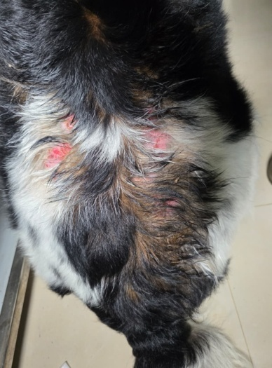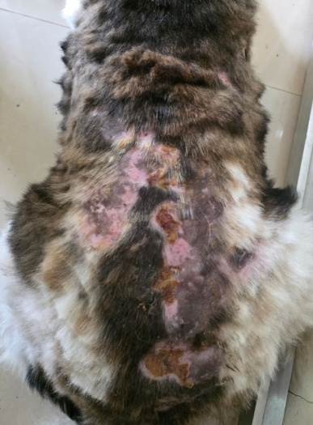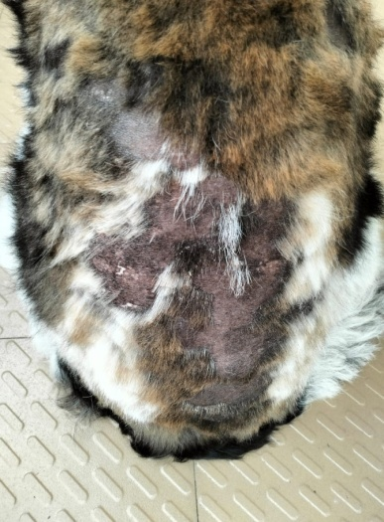
(b)
(c)

(a)
Fig. 1. Pyoderma affected dog treated with Marbofloxacin and Chlorhexidine (G1): (a) Day 0 (pre treatment) (b) Day 14 (post treatment) and (c) Day 28 (post treatment)
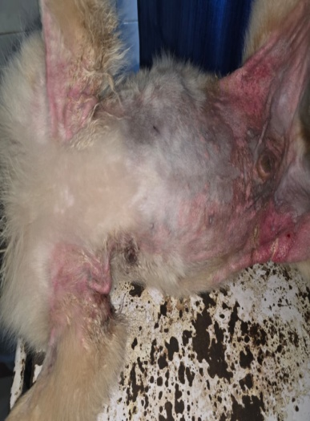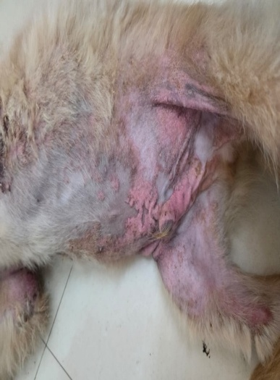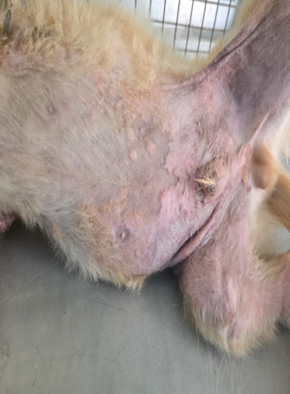
(c)
(b)
(a)
Fig. 2. Pyoderma affected dog treated with Cefovecin and Chlorhexidine (G2): (a) Day 0 (pre treatment) (b) Day 14 (post treatment) and (c) Day 28 (post treatment)
- Conclusion
The findings of the present study indicate that both cefovecin and marbofloxacin are effective therapeutic agents for the treatment of canine pyoderma. Despite this cefovecin demonstrated superior clinical efficacy, as evidenced by a more rapid resolution of lesions and a greater reduction in dermatological scores at the end of the 28 day treatment period compared to marbofloxacin. Cefovecin is a β-lactam bactericidal antibiotic, exerts its action by inhibiting bacterial cell wall synthesis through binding to penicillin-binding proteins (PBPs). Its prolonged peak plasma concentration contributes to quicker and more complete recovery from pyoderma in dogs, thereby enhancing overall clinical outcomes and reducing the duration of treatment. Therefore, cefovecin may be considered a preferred therapeutic option for the management of canine pyoderma.
Disclaimer (Artificial Intelligence)
Author(s) hereby declares that no AL technologi3s such as Large Language Models (ChatGPT, COPILOT, etc.) and text-to-image generators have been used during the writing or editing of this manuscript.

References
Abbood, H. M., Hijazi, K., And Gould, I. M. (2023).Chlorhexidine resistance or cross-resistance, that is the question. Antibiotics, 12(5), 798.
Beco, L., Guaguère, E., Lorente Méndez, C., Noli, C., Nuttall, T., and Vroom, M. (2013). Suggested guidelines for using systemic antimicrobials in bacterial skin infections: Part 2Antimicrobial choice, treatment regimens and compliance. Veterinary Record, 172(6), 156–160.
Borio, S., Colombo, S., La Rosa, G., De Lucia, M., Damborg, P. and Guardabassi, L. (2015). Effectiveness of a combined (4% chlorhexidine digluconate shampoo and solution) protocol in MRS and non‐MRS canine superficial pyoderma: a randomized, blinded, antibiotic‐controlled study. Veterinary dermatology, 26(5), 339-e72.
Coyner, K. S. (2013). Managing MRSA, MRSP And MRSS dermatologic infections in pets. Veterinary Medicine, 108(1), 32-38.
Fujii, T., Takatsu, S., Stegemann, M. R., Ogata, M., and Kamata, S. (2007). Clinical efficacy and safety of an injectable formulation of cefovecin in the treatment of bacterial skin infections of dogs. Japanese Journal of Veterinary Dermatology, 13(2), 81–88.
Hillier, A., Lloyd, D.H., Scott, J., Blondeau, J.M., Boothe, D., Breitschwerdt, E., Guardabassi, L., Papich, M.G., Turnidge, J.D. and Sykes, J.E. (2014). Guidelines for the diagnosis and antimicrobial therapy of canine superficial bacterial folliculitis. Veterinary Dermatology. 25(1): 163-e43.
Loeffler, A., Cobb, M.A., Bond, R. and Lloyd, D.H. (2011). Comparison of a novel clinical scoring system with conventional methods for assessing therapeutic success in canine superficial bacterial folliculitis. Veterinary Dermatology, 22(6), 518-523.
Miller, W.H., Griffin, C.E. and Campbell, K.L. (2013). Bacterial skin disease. In: Muller and Kirk’s Small Animal dermatology, 7th Edn., Saunders, an imprint of Elsevier Incorporation, St. Loius, Missouri, pp 354-432.
Nijamuddin, K., Mallinath, K. C., Sanjeev Kumar, M., Basavarajawati, Rajendrakumar, T., Sachin., A. and Shazaan, M. (2025). Staphylococcus pseudintermedius as the principal pathogen in canine pyoderma: A molecular and phenotypic study in North-Eastern Karnataka. International Journal of Advanced Biochemistry Research, 9(12), 283–288.
Paradis, M., Abbey, L., Baker, B., Coyne, M., Hannigan, M., Joffe, D., Pukay, B., Trettien, A., Waisglass, S. and Wellington, J. (2001). Evaluation of the clinical efficacy of marbofloxacin (Zeniquin®) tablets for the treatment of canine pyoderma: an open clinical trial. Veterinary Dermatology, 12(3), 163-169.
Six, R., Cherni, J., Chesebrough, R., Cleaver, D., Lindeman, C. J., Papp, G., Skogerboe, T. L., Weigel, D. J., Boucher, J. F. and Stegemann, M. R. (2008). Efficacy and safety of cefovecin in treating bacterial folliculitis, abscesses, or infected wounds in dogs. Journal of the American Veterinary Medical Association, 233(3), 433–439.
Sorah, E. and Tayebali, H. (2020). Cefovecin sodium for skin and soft tissue infections. Today’s Veterinary Practice, 11(6), 74-80.
Stegemann, M. R., Passmore, C. A., Sherington, J., Lindeman, C. J. and Papp, G. (2006). Antimicrobial activity and spectrum of cefovecin, a new extended-spectrum cephalosporin, against pathogens collected from dogs and cats in Europe and North America. Antimicrobial Agents and Chemotherapy, 50(7), 2286–2292.
Summers, J. F., Hendricks, A. and Brodbelt, D. C. (2014). Prescribing practices of primary-care veterinary practitioners in dogs diagnosed with bacterial pyoderma. Biomedical and Veterinary Research. 10(1), 240.

Udenberg, T. J., Griffin, C. E., Rosenkrantz, W. S., Ghubash, R. M., Angus, J. C., Polissar, N. L. and Neradilek, M. B. (2014). Reproducibility of a quantitative cutaneous cytological technique. Veterinary dermatology, 25(5), 435-e67.

