Original Research Article

Optimizing Growth and Yield in Black Gram: Impact of Plant Spacing and Foliar Nutrient Application

.
ABSTRACT

Proper spacing improves light interception, reduces competition for soil nutrients and moisture, and supports healthier canopy architecture. Foliar feeding provides rapid nutrient uptake during critical growth stages, enhancing photosynthetic activity, pod formation, and overall yield. Therefore, to realize higher yield potential in Black gram, field experiments were conducted at the Pulse Research Station, Navsari Agricultural University, during summer 2022, in a randomized block design with 12 treatment combinations, replicated 4 times, using the black gram variety “GU-3 (Anjani)”. The two factors under investigation comprised of (Factor 1) spacing level: S1– 45 cm × 10 cm, S2 – 60cm × 10 cm and (Factor 2) foliar application of nutrients: N1 -1 % urea, N2 – 2 % urea, N3 -1 % LUP, N4 – 2 % LUP, N5- 1 % novel and N6 – 2 % novel. Plant height at 60 DAS (40.25 cm) and harvest (50.90 cm), seed yield (963 kg ha⁻¹), straw yield (2197 kg ha⁻¹), and harvest index (30.41) were maximum with spacing of 45 × 10. In contrast, 60×10 cm spacing recorded more branches plant⁻¹ (5.45 and 5.16 at 60 DAS and harvest) and higher pods plant⁻¹ (29.36). Among foliar nutrient treatments, 2% novel spray (N6) reported highest plants height at 60 DAS (43.35 cm) and harvest (54.35 cm), and maximum branches plant⁻¹ (5.77 and 5.47), remaining statistically at par with N4 (2 % LUP) and N5 (1 % novel). The highest pods plant⁻¹ (32.02) and seeds pod⁻¹ were also obtained with 2% novel, comparable only to 2% LUP (N4). The highest seed yield (1019 kg ha⁻¹) and straw yield (2349 kg ha⁻¹) were achieved with 2 % novel spray, again at par with N4 and N5.

Keywords: Black gram, spacing, foliar nutrition, growth, productivity

1. INTRODUCTION

India is the world’s largest producer and consumer of pulses, accounting for 33.6% of global pulse area and 24.0% of total production (Anonymous 2022). Black gram, predominantly cultivated under rainfed conditions with suboptimal management, exhibits low productivity. Its yield is constrained by agronomic, physiological, biochemical, biotic, and environmental factors. Enhancing productivity requires improved agronomic practices and the adoption of high-yielding, disease and pest-resistant varieties suited to diverse agro-ecological regions. Additionally, optimal sowing time, variety choice, and row spacing are critical non-monetary inputs that significantly influence crop growth, yield attributes, and grain quality in black gram. Maintaining an optimum plant population facilitates maximum light interception, photosynthetic activity, assimilation, and accumulation of more photosynthates, which promote luxuriant crop growth and a better crop canopy area, thereby producing higher seed yield and the best yield quality traits. Maximum or minimum plant population can induce different physiological changes in the plant, which may reduce black gram yield (Pandey et al., 2022). The establishment of an optimal plant population is essential to achieving maximum yield, as overcrowding increases pest attacks and competition for nutrients, light, and water. Optimal spacing allows plants to grow in both their aerial and underground parts, using nutrients and solar radiation efficiently, thereby increasing grain yield (Kumar and Rajput, 2020). The main cause of declining productivity is the lack of nutrients during critical crop stages. Soil-applied nutrients often suffer losses—nitrogen through leaching and volatilization, and phosphorus through fixation—leading to deficiencies at flowering and pod formation.
In contrast, foliar-applied nutrients are quickly absorbed as they penetrate the leaf cuticle or stomata, enter plant cells, and enhance nutrient uptake and utilization (Ramesh et al., 2020). Foliar application of nutrients and growth regulators at pre-flowering and flowering stages reduces flower drop in black gram (Ganapathy et al., 2008). It offers quick and efficient nutrient use, avoids losses from leaching and fixation, and helps regulate nutrient uptake. Therefore, the present study was conducted to evaluate the effects of different spacing and foliar nutrition treatments on the growth and yield of black gram.

2. material and methods

The field experiment was carried out during the summer season of 2022 on plot no. 6 at the Pulse Research Station, Navsari Agricultural University, Navsari, Gujarat. Geographically, the experimental field is located at 20° 93’ N Latitude, 72° 89’ S Longitude and has an altitude of 10 m above mean sea level. The area where the experiment was conducted comes in tropical, warm and humid climatic condition. The area is located under the South Gujarat Heavy Rainfall Zone I, AES – III, and receives an average annual rainfall of 1600 mm, entirely from the south–west monsoon. The meteorological data for important weekly weather parameters, such as maximum and minimum temperatures, relative humidity, bright sunshine hours, and rainfall, during the experimental period (February to May 2022) obtained from the meteorological observatory of the Navsari Agricultural University, Navsari, are presented graphically in Figure 1. Monsoon commences at the second fortnight of June and lasts by end of September where July and August are months with heavy precipitation. During crop growth, the range of maximum temperatures was 30.6 °C to 39.5 °C, and the range of minimum temperatures was 13.4 °C to 27.7 °C. The highest RH was recorded in March, and the lowest was recorded in April. It was observed that the highest wind velocity 10.2 km hr-1 was recorded during the 21st standard week (24th – 30th May) and the lowest wind velocity 2.3 km hr-1 was recorded during the 7th standard week (22th – 28th February). The Bright Sunshine Hours (BSSH) ranged from 6.7 hrs/day in the 21st standard week (24th – 30th May) to 8.8 hrs/day in the 19th standard week (10th – 16th May) during the experimental period.

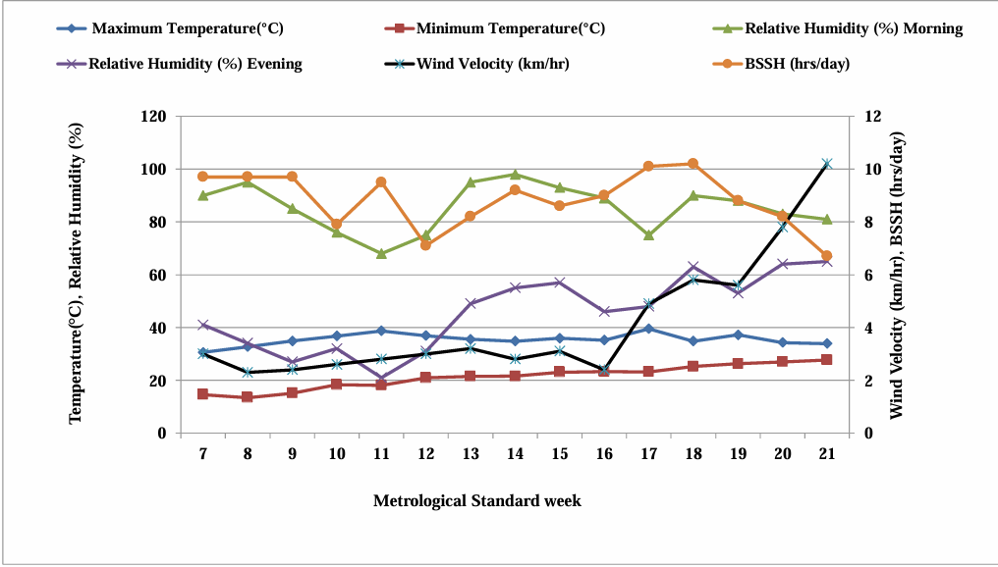

Fig. 1: Graphical representation of mean weekly weather parameters for the cropping season (February to May 2022 )

2.1 SITE DESCRIPTION AND METHODOLOGY

The texture of the experimental soil was deep black in colour which was analyzed using the Bouyoucous hydrometer method (Piper 1966). The soil pH was about 7.8 (basic), determined by standard pH methods as per Jackson (1973). Organic carbon content was low (0.44%) using the dichromate oxidation method (Walkley and Black, 1934). Available nitrogen content was also low (237 kg/ha), analyzed through the alkaline KMnO4 method (Subbiah and Asija 1956). The soil exhibited high levels of available phosphorus (54.29 kg/ha) and potassium (296 kg/ha), evaluated using the NaHCO3 method and ammonium acetate extraction method, respectively (Jackson 1973). Twelve treatment combinations were laid out in a Randomized Block Design (RBD) with four replications. The treatments were assigned at random in each replication. Total 12 treatment combinations consisting 2 factors i.e., 6 Foliar applications of nutrient and 2 different rows spacing as under were studied in this experiment. Factor 1 contains 2 treatments: S1 (45 X 10 cm) and S2 (60 X 10 cm). Factor 2 contains 6 treatments, including foliar application of nutrients: N1: 1% Urea, N2: 2% Urea, N3: 1% LUP (liquid urea phosphate), N4: 2% LUP, N5: 1% Novel, N6: 2% Novel. Novel organic liquid nutrient is a product of Navsari Agricultural University, patented in 2012. Novel organic liquid nutrients are banana pseudo stem sap obtained as a byproduct during extraction of fiber from banana pseudo stem. The recommended dose (20:40:0 kg N: P₂O₅:K2O ha-1) of fertilizer was applied as diammonium phosphate and Urea, as sources of phosphorus and nitrogen, respectively. The total quantities of nitrogen, phosphorus, and potassium were side-dressed at the time of sowing, in furrows opened 5 cm away from the seed row. Foliar application of nutrients were performed as per the treatment. Representative plants from each net plot were collected for post-harvest studies. Picking was done first in border areas and thereafter from net plot area. For second picking, plants from each net plot were harvested, bundled, tagged, and then brought to the threshing floor for sun drying and threshing. After drying, the weight of bundles (grain + straw) were recorded. After separating the grains from the pods obtained from the second picking, the grains from the first picking of the same plot were mixed with them and weighed. The weight of grain (previous and final) and straw were recorded treatment-wise and then converted into kg ha ⁻¹.

2.2. STATISTICAL ANALYSIS

Data from various field observations and those collected in the laboratory were subjected to statistical analysis using the standard analysis of variance technique as described by Panse and Sukhatme (1967) in “Statistical procedure for agricultural research”. The significance of treatment effect was tested by ‘F’ test (Panse and Sukhatme, 1967). The standard error of differences was computed and recorded along with the summary results. Critical difference for different groups of treatments and their interaction at 5 % level of significance were calculated wherever ‘F’ test was significant. The results were then interpreted logically to derive a definite conclusion.

3. results and discussion

3.1. Impact of spacing and foliar application of nutrients on growth parameters

The growth characteristics differ significantly with respect to the application of foliar nutrients under different space regimes (Table 1). The data show that S1 (closer spacing at 45×10 cm) produced taller plants than S2 (60×10 cm) at all stages, and the % increase of S1 over S2 at 30 DAS, 60 DAS, and at harvest is 2.8 %, 12.49 %, and 9.11 %, respectively. This may be due to inter-row competition between plants for sunlight, water, nutrients, and space. Closer spacing promotes vertical growth rather than horizontal growth. The findings were in close agreement with those of Tanya and Kumar (2015) and Rashmitha et al. (2021). Among foliar nutrients, N6: 2 % Novel spray, recorded maximum plant height at all the stages, which is 28.34% higher than N1(1 % Urea) and 11.03 % higher than N2(2 % Urea) at harvest. The foliar application of nutrients during a crucial crop growth stage, which aids in controlling cell division and multiplication as well as cell elongation and development of leaves and other plant parts, may be the cause of this increase in plant height. Champaneri et al. observed similar findings (2021). A different statistical trend was observed in the number of branches, with a significantly higher number recorded with 60 × 10 cm spacing compared with 45 × 10 cm spacing at 60 DAS and at harvest. This could be explained by the fact that plants with wider spacing have greater horizontal growth and canopy area, since there are fewer plants, which reduces competition for available resources compared to those with closer spacing. Observations provided by Ganvit et al. (2022) and Rashmita et al. (2021) support these findings. On the other hand, application of 2% Novel recorded a significantly higher number of branches at 60 DAS and at harvest, and was closely followed by 2% LUP and 1% Novel. Growth regulators, including gibberellic acid, naphthalene acetic acid, and cytokinin, which promote meristematic activity and enhance cell division and elongation, may be present in new plus organic liquid nutrients. Maheswari et al. (2017) have also reported similar results.

Table 1: Impact of spacing and foliar application of nutrients on growth parameters.

Treatments | Plant height (cm) |  |  | Number of branches plant-1
Treatments | 30 DAS | 60 DAS | At harvest | 30 DAS | 60 DAS | At harvest
Spacing
S1: 45×10 cm | 19.84 | 40.25 | 50.90 | 2.87 | 4.79 | 4.60
S2: 60×10 cm | 19.30 | 35.78 | 46.65 | 3.01 | 5.45 | 5.16
SEm (±) | 0.30 | 0.61 | 0.75 | 0.05 | 0.08 | 0.07
CD at 5 % | NS | 1.78 | 2.16 | NS | 0.23 | 0.20
Foliar Application of nutrients
N1: 1% Urea | 19.06 | 31.30 | 42.35 | 2.82 4 | 4.22 | 4.07
N2: 2% Urea | 19.71 | 37.82 | 48.95 | 2.95 | 5.15 | 4.75
N3: 1% LUP | 20.32 | 34.20 | 44.05 | 3.05 | 4.57 | 4.37
N4: 2% LUP | 19.50 | 42.00 | 52.47 | 2.92 | 5.62 | 5.40
N5: 1% Novel | 19.10 | 39.45 | 50.52 | 2.95 | 5.4 | 5.22
N6: 2 % Novel | 19.72 | 43.35 | 54.35 | 2.97 | 5.77 | 5.47
SEm (±) | 0.52 | 1.07 | 1.30 | 0.09 | 0.14 | 0.12
CD at 5 % | NS | 3.08 | 3.74 | NS | 0.41 | 0.35

3.2. Impact of spacing and foliar application of nutrients on yield attributes

There was a significant difference in various yield attributes (Number of pods per plant, length of the pod, no of seeds per pod ⁻¹, and 1000 seed weight) of black gram with respect to different spacing and foliar nutrients as mentioned in Table 2. The perusal of the data (Table 2) revealed that treatment S2(60 ×10 cm spacing) recorded a significantly higher number of
Table 2: Impact of spacing and foliar application of nutrients on yield attributes

Treatments | No. of pods plant-1 | Pod length (cm) | Number of seeds pod-1 | Test weight (g)
Spacing
S1: 45×10 cm | 27.19 | 5.40 | 6.37 | 47.47
S2: 60×10 cm | 29.36 | 5.56 | 6.45 | 48.83
SEm (±) | 0.43 | 0.06 | 0.06 | 0.70
CD at 5 % | 1.24 | NS | NS | NS
Foliar Application of nutrients
N1: 1% Urea | 24.52 | 5.20 | 6.05 | 46.15
N2: 2% Urea | 27.85 | 5.52 | 6.35 | 48.12
N3: 1% LUP | 25.70 | 5.34 | 6.25 | 47.21
N4: 2% LUP | 30.12 | 5.63 | 6.62 | 49.25
N5: 1% Novel | 29.45 | 5.54 | 6.42 | 48.52
N6: 2 % Novel | 32.02 | 5.66 | 6.77 | 49.66
SEm (±) | 0.74 | 0.11 | 0.11 | 1.21
CD at 5 % | 2.15 | NS | 0.33 | NS

pods per plant (29.36), length of the pod (5.56cm), no of seeds per pod ⁻¹(6.45), and 1000 seed weight (48.83 g). Compared to S1(45 ×10 cm), the number of pods per plant increased by 7.98%, pod length improvement by 2.96%, number of seeds per pod by 1.26% and test weight by 2.87% under S2(60 ×10 cm spacing). This might be due to greater accumulation and assimilation of food reserves and a better source-to-sink relationship in wider-spaced rows, which might have affected pod development; hence, pod formation was comparatively higher in wider-spaced rows. Bhatt (2020) and Pandey et al. (2022) both support this conclusion. Foliar application of nutrients had significant effects on the number of pod plants⁻¹. A significantly higher number of pod plant⁻¹ (32.02) were recorded with the application of 2 % novel at pre-flowering, flowering and pod formation stage, numerically greater pod length value (5.66 cm), higher number of seed pod⁻¹ (6.77) and greater test weight value (49.66 g), which remained at par with 2% LUP and closely followed by 1 % novel. Among all the treatments, 1% Urea resulted in the lowest values of yield attributes. This may be because Novel plus organic nutrient improves photosynthetic activity, thereby increasing carbohydrate and photosynthate production and improving the allocation of photosynthates to the economic part, i.e., pods, which ultimately contributes to increased pod number and quantitative traits. It also provides macro and micronutrients at critical stages. Another explanation could be the enhancement of the plant's vegetative development, brought about by foliar spraying with nutrients in sufficient amounts and readily accessible forms, which positively affects yield characteristics. The results of Patel et al. (2017), Maheswari et al. (2017), and Champaneri et al. (2021) are corroborated by these observations.

3.3. Impact of spacing and foliar application of nutrients on seed and stover yield
The seed and stover yield of black gram recorded under different treatments of foliar nutrients and plant spacing is presented graphically in Figure 2. Significantly higher grain yield observed in the 45 cm line sowing plot (963 kg ha⁻¹), while 847 kg ha⁻¹ under 60 cm line sowing. The increase in yield with 45 cm row spacing over 60 cm row spacing was to the tune of 13.70 %. This may be possible because more plants per unit area lead to higher seed yield per unit area. This is consistent with the findings of Kabir and Sarkar (2008), Gurjar et al. (2018), and Kumar et al. (2018), which reported higher grain yield with closer spacing.

Fig. 2: Impact of spacing and foliar application of nutrients on seed and stover yield
Among foliar application treatments, 2 % novel application (N6) registered a significantly higher grain yield (1019 kg ha⁻¹) and was at par with N4 (2 % LUP application), and N5 (1 % novel application). Exceptionally lower yield was observed with 1% urea application (743 kg ha⁻¹). The increase in yield with the 2% novel application (N6) over 1% urea application was 37.14%. Easy nutrient assimilation and a balanced NPK ratio, which influences crop production, may be the cause of the yield rise. When water-soluble nutrients are sprayed, more nutrients and water are absorbed, increasing photosynthesis and improving food accumulation in edible portions. 45 × 10 cm line sowing recorded significantly higher straw yield (2197 kg ha⁻¹) in comparison to 60 × 10 cm line sowing (2032 kg ha⁻¹). This result was supported by the findings of Gurjar et al. (2018) and Kuri et al. (2018). The assessment of results revealed that among foliar application treatments, significantly higher straw yield (2349 kg ha⁻¹) of black gram was obtained with 2 % novel spray, which remained at par with 2 % LUP spray (2257 kg ha⁻¹) and 1 % novel spray (2194 kg ha⁻¹). The yield improvement may be attributed to the sustained nutrient availability provided through foliar application during the crop’s reproductive stage. This consistent nutrient supply likely enhanced key yield components—such as pod number per plant, seed number per pod, and pod length—which collectively exerted a direct positive effect on grain yield.
4. CORRELATIONS
The correlogram analysis revealed strong positive associations among seed yield, straw yield, and harvest index, indicating that treatments that enhance biomass production also improve grain yield and dry matter partitioning efficiency. The close relationship between seed yield and harvest index highlights the role of balanced source–sink dynamics under optimized spacing and foliar nutrient application. The correlogram analysis revealed strong

positive correlations among seed yield, straw yield, and harvest index, with seed yield showing particularly high association with straw yield (r = 0.98) and harvest index (r = 0.90). These relationships corroborate the PCA results, which identified pod-related traits as major contributors to yield variability. The integrated multivariate analyses confirm that optimized spacing and higher foliar nutrient concentrations enhance biomass production, yield attributes, and assimilate partitioning efficiency in black gram. The correlogram revealed a very strong positive correlation between seed yield and straw yield (r = 0.98), indicating that treatments that promoted higher total biomass also increased grain yield. This suggests that enhanced photosynthetic capacity and vegetative growth under improved spacing and foliar nutrient management directly contributed to higher economic yield.Seed yield also showed a strong positive association with harvest index (r = 0.90), demonstrating that increases in grain yield were accompanied by efficient partitioning of assimilates towards reproductive structures. This reflects improved source–sink balance rather than mere vegetative luxuriance. The correlation between straw yield and harvest index (r = 0.79), though comparatively lower, remained positive, indicating that higher biomass accumulation did not negatively affect dry matter allocation to seeds.
4.1 with attributes
These correlation patterns strongly complement the PCA of yield attributes, where pod-related traits (pods per plant, seeds per pod, and pod length) were the major contributors to variability along PC1, while test weight influenced PC2. Treatments that clustered in the positive quadrant of PC1 in the PCA biplot particularly higher concentrations of Novel and LUP also recorded superior seed and straw yields, as reflected in their strong positive correlations.

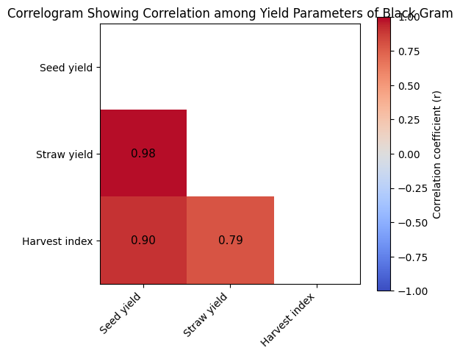

Fig. 3: Correlogram showing Pearson’s correlation coefficients among seed yield, straw yield, and harvest index of black gram as influenced by spacing and foliar application of nutrients.

Conclusion

This study's findings can be summarized as follows: between two levels of row spacing, 45 × 10 cm was superior for plant height and black gram yield, but 60 × 10 cm had more branches. Among foliar application treatments, maximum yield was attained with 2% novel spray and remained at par with 2% LUP and 1% novel spray. The interaction effect between spacing and foliar application of nutrients could not exert any significant influence on black gram. It can be concluded that maximum yield and net return from summer black gram can be secured by sowing the crop with 45 ×10 cm spacing and apply three spray of either 2 % Novel or 2% LUP at pre-flowering, flowering, and pod formation stage along with RDF (20: 40:00 kg N, P₂O₅, K₂O/ ha) in South Gujrat condition.

Definitions, Acronyms, Abbreviations

(B:C ratio): Benefit Cost Ratio
CD : Critical Difference
LUP: liquid urea phosphate

References

Anonymous. (2022). Area, production and yield along with coverage under irrigation, in: “agricultural statistics at a glance 2021". Ministry of agriculture & farmer welfare, government of india, 45-112.
Bhatt, k. R. (2020). Effect of plant spacing on yield and yield contributing traits of black gram (vigna mungo l. Hepper) during autumn season at gokuleshwor, baitadi, nepal. Acta scientiarum agronomy, 4, 1–4.
Champaneri, D. D., Patel, N. K., Desai, C. S., & Desai, D. H. (2021). Efficacy of novel organic liquid nutrient and novel plus organic liquid nutrient on quantitative traits of Indian bean [Lablab purpureus (L.) Sweet]. International Journal of Plant & Soil Science, 33, 105–115.
Ganapathy, M., Baradhan, G., & Ramesh, N. (2008). Effect of foliar nutrition on reproductive efficiency and grain yield of rice fallow pulses. Legume Research – An International Journal, 31, 142.
Ganvit, K. J., Patel, V. J., & Desai, N. B. (2022). Effect of spacing and nutrient management on yield and economics of summer blackgram (Vigna mungo L. Heeper) under organic conditions. Biological Forum – An International Journal, 14, 1637–1641.
Gurjar, R., Patel, K. V., Patel, H. P., & Mistry, C. R. (2018). Effects of sowing dates and spacing on semi rabi greengram. International Journal of Chemical Studies, 6, 2850–2853.
Kabir, M. H., & Sarkar, M. A. R. (2008). Seed yield of mungbean as affected by variety and plant spacing in Kharif-I season. Journal of the Bangladesh Agricultural University, 6, 239–244.
Kumar, R., Tomar, G. S., Kumawat, N., & Morya, J. (2018). Performance of blackgram (Phaseolus mungo L.) cultivars as influenced by row spacings and molybdenum. Journal of Applied and Natural Science, 10, 753–758.
Kumar, S., & Rajput, A. S. (2020). Effect of variety and spacing on growth and yield of black gram (Vigna mungo L.) under Vertisol of Chhattisgarh. International Journal of Chemical Studies, 8, 594–601.
Kuri, S., Shivaramu, H. S., Thimmegowda, M. N., Yogananda, S. B., Prakash, S. S., & Murukannappa, S. M. (2018). Effect of row spacing, varieties and sowing dates on growth and yield of pigeonpea. International Journal of Current Microbiology and Applied Sciences, 7, 1125–1128.
Maheswari, U. M., Karthik, A., & Kumar, A. R. (2017). Effect of foliar nutrition on growth, yield attributes and seed yield of pulse crops. International Journal of Current Microbiology and Applied Sciences, 6, 4134–4139.
Pandey, A., Singh, R., & Indu, T. (2022). Effect of spacing on growth and yield of varieties of black gram (Vigna mungo L.). Journal of Pharmaceutical Innovation, 11, 855–858.
Patel, H. B., Shah, K. A., Barvaliya, M. M., & Patel, S. A. (2017). Response of green gram (Vigna radiata L.) to different level of phosphorus and organic liquid fertilizer. International Journal of Current Microbiology and Applied Sciences, 6, 3443–3451.
Ramesh, T., Rathika, S., Sangeetha, S., Satheesh, S., Ponpradeepa, M., & Pavithra, A. (2020). Enhancement of black gram productivity through foliar spray of nutrients and growth hormones: A review. International Journal of Current Microbiology and Applied Sciences, 9, 1594–1603.
Rashmitha, B., Umesha, C., & Meshram, R. M. (2021). Influence of spacing and phosphorus levels on growth and yield of blackgram (Vigna mungo L.). Biological Forum – An International Journal, 13, 82–85.
Tanya, S. D., & Kumar, M. (2015). Comparative study on effect of spacing on the growth and yield of different varieties of black gram (Vigna radiata L.) under Subabul (Leucaena leucocephala) based agrosilviculture system. International Journal of Advanced Research, 3, 1190–1196.

