Nutritional Optimization for Apis mellifera: Impact of Novel Artificial Diet Formulations on Colony Strength of Apis mellifera During Floral Dearth in Pantnagar

Abstract
Several protein-rich dietary items, including defatted soy flour, parched gramme, brewer's yeast, sucrose, skimmed milk powder, natural pollen and sugar, glucose, honey, Vitamin B, and Vitamin C, were combined to create eight diet formulations. The This diets were administered to colonies of Apis mellifera at the Honey Bee Research and Training Centre in Pantnagar, during a time of dearth in the rainy season. The quantification of food consumption by bees was conducted at regular intervals of 5 days. The most favourable outcomes were achieved with a dietary composition consisting of Soya Bari flour, Pollen, Skimmed milk powder, Honey, and Dry yeast, with an average intake of 65.98 g per colony. The colonies consumed more prepared diet in July and August, a period that lacked natural pollen..
Keywords: Apis mellifera, Soya Bari flour, Diets, Pollen
Introduction
The honeybee (Apis mellifera) is the most significant managed pollinator globally, underpinning the reproductive success of numerous wild plant species and the yield of high-value agricultural crops (Gallai et al., 2009). Despite their ecological importance, honeybee colonies are currently facing a multifactorial decline driven by habitat loss, pesticide exposure, and emerging pathogens (Goulson et al., 2015). At the centre of these stressors lies nutritional stress. The conversion of diverse landscapes into monocultures has created a sort of "floral deserts" where bees lack access to the diverse pollen sources which are required to satisfy their physiological needs like essential amino acids and lipids (Brodschneider & Crailsheim, 2010; Wright et al., 2018). When natural pollen is unavailable such as during seasonal dearth or migratory transport, colonies experience a rapid decrease in their brood rearing and immune function. Pollen is the sole source of protein for honeybees, and its absence triggers a reduction in vitellogenin titers, a key glycol-lipoprotein that regulates honeybee longevity and nursing behaviour (Amdam et al., 2003). To maintain colony vigor during these critical windows, the development of an effective artificial "pollen substitute" is essential. However, creating a diet that honeybees will readily consume and successfully metabolize remains a significant challenge in apicultural science. The efficacy of an artificial diet is governed by its palatability, digestibility, and nutrient profile. This study evaluates different dietary formulations on bee colonies during periods of nectar scarcity
Methodology
Total eighteen treatments of soy bari and parched gram were taken dried and grinded separately. For each treatment 3 bees colonies with 8 frames were selected with almost same age. Flours of various grains were sieved with fine mesh to make with them similar with pollen size. All the ingredients were mixed and kept for 3-4 hours as per ratios described in table 1. Equal amount 100 g of each combination were taken as one treatment. Half of the treatments are fed as in dry form(powder) and other half treatments are used in patty form. Super chambers are placed on the selected colonies to facilitate the meeting and to protect the feed from moisture and other factors. Feed is placed on the top of the frames inside the hive by placing it on the butter paper above the polythene sheet. Feeding experiment was conducted during dearth period (July to August). Quantity of given pollen substitute were recorded initially and after five days and difference were calculated to find the fed quantity of pollen substitute by bees. The brood area in the colonies was recorded with the help of wire grid method (Seeley and Mikhetev, 2003; Amir and Peveling, 2004). The bee population in the colonies were recorded by photographic method (Jeffree,1951). The collected data was tabulated and subjected to statistical analysis following RBD.
Table 1: percent constituents in each diet.
Diet No. | Form | Soya Bari Flour | Parched Gram | Brewer Yeast | Sugar | Sucrose | Pollen | Vit. B | Vit. C | Skimmed Milk Powder | Honey | Glucose
Diet 1 | Powder | 33.4 | — | 16.7 | 30.3 | 11.7 | 7.72 | 0.18 | — | — | — | —
Diet 2 | Powder | 33.4 | — | 16.7 | 30.3 | 11.7 | 7.72 | — | 0.18 | — | — | —
Diet 3 | Powder | 33.4 | — | 16.7 | 30.3 | 11.7 | 7.9 | — | — | — | — | —
Diet 4 | Powder | 33.4 | — | 16.7 | — | — | 7.9 | — | — | 11.7 | 30.3 | —
Diet 5 | Powder | — | 33.4 | 16.7 | 30.3 | 11.7 | 7.72 | 0.18 | — | — | — | —
Diet 6 | Powder | — | 33.4 | 16.7 | 30.3 | 11.7 | 7.72 | — | 0.18 | — | — | —
Diet 7 | Powder | — | 33.4 | 16.7 | 30.3 | 11.7 | 7.9 | — | — | — | — | —
Diet 8 | Powder | — | 33.4 | 16.7 | — | — | 7.9 | — | — | 11.7 | 30.3 | —
Diet 9 | Powder | 16.7 | 16.7 | 16.7 | 33.3 | — | — | — | — | — | — | 16.7
Diet 10 | Patty | 33.4 | — | 16.7 | 30.3 | 11.7 | 7.72 | 0.18 | — | — | — | —
Diet 11 | Patty | 33.4 | — | 16.7 | 30.3 | 11.7 | 7.72 | — | 0.18 | — | — | —
Diet 12 | Patty | 33.4 | — | 16.7 | 30.3 | 11.7 | 7.9 | — | — | — | — | —
Diet 13 | Patty | 33.4 | — | 16.7 | — | — | 7.9 | — | — | 11.7 | 30.3 | —
Diet 14 | Patty | — | 33.4 | 16.7 | 30.3 | 11.7 | 7.72 | 0.18 | — | — | — | —
Diet 15 | Patty | — | 33.4 | 16.7 | 30.3 | 11.7 | 7.72 | — | 0.18 | — | — | —
Diet 16 | Patty | — | 33.4 | 16.7 | 30.3 | 11.7 | 7.9 | — | — | — | — | —
Diet 17 | Patty | — | 33.4 | 16.7 | — | — | 7.9 | — | — | 11.7 | 30.3 | —
Diet 18 | Patty | 16.7 | 16.7 | 16.7 | 33.3 | — | — | — | — | — | — | 16.7

Fig 1-Patty Diet Fig2- Powdered Diet
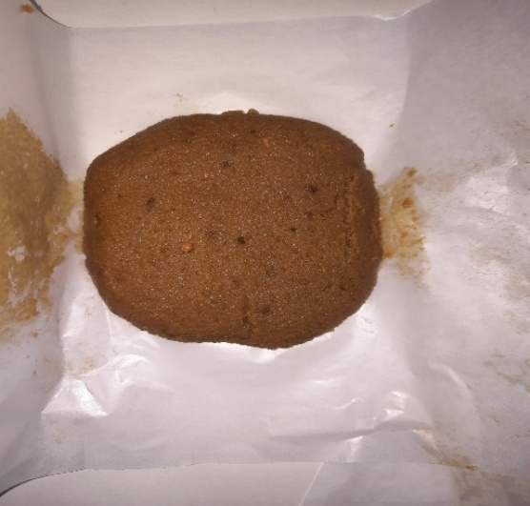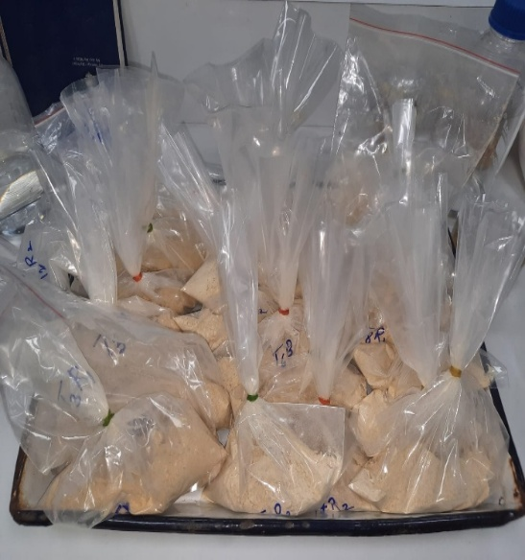

Fig3- Powdered Diet consumed by bees Fig4- Patty Diet consumed by bees

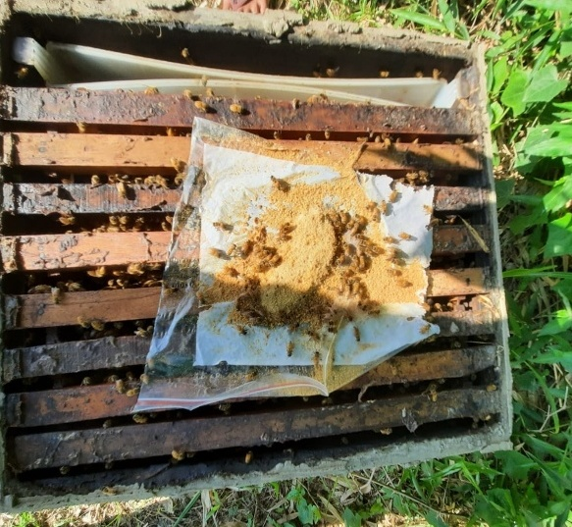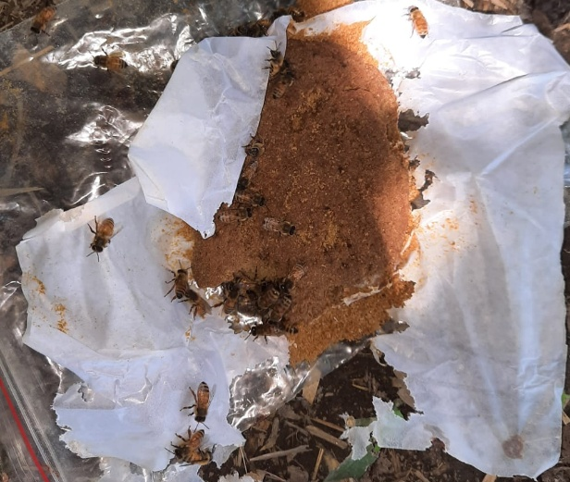

Fig 5- Colony strength and Brood area measurement by Grid method

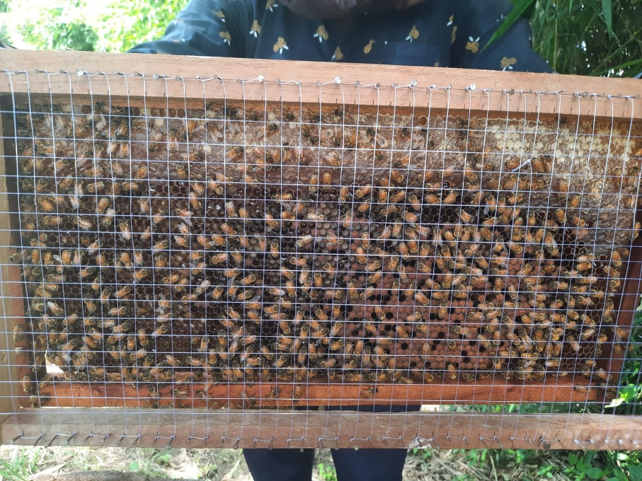

Table no. 2 Evaluation of mean brood cell area of colony enriched with vitamins and minerals (dry form)
Mean Brood cell area (cm²)
Interval | Diet 1 | Diet 2 | Diet 3 | Diet 4 | Diet 5 | Diet 6 | Diet 7 | Diet 8 | Diet 9 | Control
3rd July | 2389.59  (49.56) | 2486.64  (49.87) | 2214.63  (47.06) | 3149.47  (56.12) | 1695.75  (41.19) | 1893.67  (43.52) | 1298.65  (36.04) | 2661.41  (51.59) | 849.77  (29.16) | 456.21  (21.38)
8th July | 2413.84  (49.90) | 2591.19  (50.91) | 2286.21  (47.82) | 3187.32  (56.46) | 1736.26  (41.68) | 1941.05  (44.06) | 1342.46  (36.65) | 2748.77  (52.43) | 874.89  (29.59) | 516.31  (22.74)
13th July | 2455.87  (50.35) | 2599.93  (50.99) | 2299.22  (47.96) | 3215.07  (56.70) | 1799.87  (42.43) | 1966.51  (44.35) | 1386.93  (37.25) | 2778.84  (52.72) | 976.9  (31.27) | 645.51  (25.42)
18th July | 2489.68  (50.46) | 2681.99  (51.79) | 2310.97  (48.08) | 3233.68  (56.86) | 1817.48  (42.64) | 2005.08  (44.78) | 1424.84  (37.75) | 2857.98  (53.46) | 989.97  (31.47) | 714.71  (26.75)
23rd July | 2534.96  (50.54) | 2789.9  (52.82) | 2346.46  (48.44) | 3275.36  (57.23) | 1848.82  (43.00) | 2019.01  (44.94) | 1458.35  (38.20) | 2896.98  (53.83) | 1015.47  (31.88) | 789.97  (28.12)
28th July | 2546.37  (50.89) | 2855.5  (53.44) | 2385.63  (48.84) | 3326.78  (57.67) | 1915.85  (43.78) | 2096.09  (45.79) | 1535.06  (39.18) | 2946.87  (54.29) | 1065.98  (32.66) | 868.67  (29.49)
2nd Aug | 2554.32  (51.08) | 2879.6  (53.67) | 2401.19  (49.00) | 3399.08  (58.30) | 1976.36  (44.46) | 2117.05  (46.01) | 1597.93  (39.98) | 3078.84  (55.49) | 1123.98  (33.54) | 888.81  (29.82)
7th Aug | 2589.23  (51.72) | 2912.34  (53.97) | 2435.05  (49.35) | 3446.87  (58.71) | 2016.85  (44.91) | 2147.25  (46.34) | 1636.39  (40.46) | 3167.57  (56.29) | 1178.46  (34.34) | 891.97  (29.88)
12th Aug | 2609.04  (51.86) | 2943.85  (54.26) | 2469.01  (49.69) | 3514.56  (59.28) | 2064.08  (45.43) | 2187.95  (46.78) | 1674.96  (40.93) | 3197.64  (56.55) | 1234.95  (35.15) | 941.91  (30.70)
17th Aug | 2674.96  (51.94) | 2967.06  (54.47) | 2487.04  (49.87) | 3543.76  (59.53) | 2095.49  (45.78) | 2213.89  (47.06) | 1714.84  (41.41) | 3245.76  (56.97) | 1296.57  (36.02) | 963.71  (31.05)
22nd Aug | 2689.59  (52.04) | 2997.05  (54.75) | 2499.03  (50.00) | 3587.94  (59.90) | 2147.57  (46.35) | 2247.87  (47.42) | 1789.68  (42.31) | 3308.87  (57.52) | 1355.98  (36.83) | 989.04  (31.46)
27th Aug | 2697.5  (52.60) | 3024.89  (55.00) | 2503.4  (50.03) | 3614.87  (60.13) | 2168.9  (46.58) | 2278.96  (47.74) | 1825.85  (42.74) | 3374.38  (58.09) | 1406.978  (37.52) | 993.03  (31.52)
Mean | 2553.746 | 2810.828 | 2386.487 | 3374.563 | 1940.273 | 2092.865 | 1557.162 | 3021.993 | 1114.158 | 804.9875
CD at 5% T (Treatment) 0.26
I (Period) 0.29
T× I (Treatment× Period) 0.92

Table no. 3 Evaluation of mean brood cell area of colony enriched with vitamins and minerals (patty form)
Mean Brood cell area (cm²)
Interval | Diet 10 | Diet 11 | Diet 12 | Diet 13 | Diet 14 | Diet 15 | Diet 16 | Diet 17 | Diet 18 | Control
3rd July | 1846.74  (42.98) | 2135.15  (46.21) | 1587.81  (39.85) | 2886.86  (53.73) | 1658.33  (40.73) | 1733.61  (41.64) | 1456.06  (38.16) | 2776.19  (52.69) | 703.99  (26.55) | 456.21  (21.38)
8th July | 1859.19  (43.13) | 2177.70  (46.67) | 1615.84  (40.21) | 2897.98  (53.83) | 1699.3  (41.23) | 1752.96  (41.87) | 1521.84  (39.02) | 2894.17  (53.79) | 739.17  (27.20) | 516.31  (22.74)
13th July | 1896.91  (43.56) | 2197.71  (46.88) | 1656.96  (40.71) | 2931.12  (54.14) | 1710.09  (41.36) | 1785.76  (42.27) | 1548.248  (39.36) | 2919.94  (54.04) | 786.76  (28.06) | 645.51  (25.42)
18th July | 1941.20  (44.06) | 2209.05  (47.00) | 1697.41  (41.21) | 2977.97  (54.57) | 1746.19  (41.79) | 1804.17  (42.48) | 1560.454  (39.51) | 2974.84  (54.54) | 809.81  (28.47) | 714.71  (26.75)
23rd July | 1987.71  (44.59) | 2233.83  (47.27) | 1737.05  (41.68) | 3103.01  (55.71) | 1763.17  (42.00) | 1854.07  (43.07) | 1611.381  (40.15) | 2998.87  (54.76) | 836.77  (28.94) | 789.97  (28.12)
28th July | 2010.91  (44.85) | 2261.97  (47.56) | 1783.00  (42.23) | 3137.98  (56.02) | 1792.21  (42.34) | 1893.54  (43.52) | 1616.56  (40.21) | 3027.65  (55.03) | 879.03  (29.66) | 868.67  (29.49)
2nd Aug | 2079.88  (45.60) | 2286.43  (47.82) | 1829.51  (42.78) | 3157.95  (56.20) | 1811.37  (42.57) | 1935.61  (44.00) | 1670.355  (40.88) | 3059.64  955.32) | 910.87  (30.19) | 888.81  (29.82)
7th Aug | 2097.99  (45.81) | 2311.37  (48.08) | 1877.69  (43.34) | 3189.76  (56.48) | 1861.15  (43.14) | 1988.67  (44.60) | 1699.94  (41.23) | 3137.43  (56.02) | 956.67  (30.94) | 891.97  (29.88)
12th Aug | 2156.05  (46.43) | 2339.11  (48.37) | 1926.07  (43.895) | 3215.56  (56.71) | 1887.69  (43.45) | 2017.73  (44.92) | 1725.96  (41.55) | 3148.97  (56.11) | 978.65  (31.29) | 941.91  (30.70)
17th Aug | 2186.56  (46.77) | 2368.13  (48.67) | 1968.48  (44.37) | 3249.6  (57.01) | 1923.96  (43.87) | 2045.06  (45.23) | 1748.05  (41.81) | 3189.65  (56.48) | 1017.73  (31.91) | 963.71  (31.05)
22nd Aug | 2224.06  (47.17) | 2394.74  (48.94) | 1994.96  (44.67) | 3296.08  (57.41) | 1956.63  (44.24) | 2097.48  (45.80) | 1778.47  (42.17) | 3248.67  (57.00) | 1096.83  (33.13) | 989.04  (31.46)
27th Aug | 2279.67  (47.75) | 2451.81  (49.51) | 2079.65  (45.61) | 3329.16  (57.70) | 1997.58  (44.70) | 2143.96  (46.31) | 1789.64  (42.31) | 3265.09  (57.14) | 1145.58  (33.85) | 993.03  (31.52)
Mean | 2047.24 | 2280.58 | 1812.87 | 3114.42 | 1817.31 | 1921.05 | 1643.91 | 3053.43 | 905.16 | 804.9875
CD at 5% T (Treatment) 0.25
I (Period) 0.29
T× I (Treatment ×Period) 0.89

Table no. 4 Evaluation of mean strength of colony enriched with vitamins and minerals (dry form)

Mean Strength of colony (numbers)
Interval | Diet 1 | Diet 2 | Diet 3 | Diet 4 | Diet 5 | Diet 6 | Diet 7 | Diet 8 | Diet 9 | control
3rd July | 11746.00  (108.37) | 12071.00  (109.85) | 10622.00  (103.06) | 15175.00  (123.18) | 8752.00  (93.54) | 9126.00  (95.53) | 7742.00  (87.99) | 13475.00  (116.07) | 6410.00  (80.05) | 5552.00  (74.51)
8th July | 11792.00  (108.59) | 12110.00  (110.04) | 10689.00  (103.38) | 15199.00  (123.28) | 8788.00  (93.74) | 9210.00  (95.96) | 7789.00  (88.24) | 13489.00  (116.13) | 6422.00  (80.14) | 5610.00  (74.90)
13th July | 11806.00  (108.65) | 12174.00  (110.33) | 10710.00  (103.48) | 15210.00  (123.31) | 8801.00  (93.81) | 9234.00  (96.08) | 7810.00  (88.37) | 13507.00  (116.20) | 6436.00  (80.22) | 5623.00  (74.99)
18th July | 11832.00  (108.77) | 12121.00  (110.09) | 10735.00  (103.60) | 15245.00  (123.46) | 8825.00  (93.94) | 9246.00  (96.16) | 7825.00  (88.46) | 13527.00  (116.29) | 6465.00  (80.40) | 5652.00  (75.18)
23rd July | 11856.00  (108.88) | 12189.00  (110.40) | 10758.00  (103.71) | 15274.00  (123.59) | 8836.00  (93.99) | 9275.00  (96.30) | 7845.00  (88.56) | 13545.00  (116.36) | 6479.00  (80.49) | 5671.00  (75.31)
28th July | 11895.00  (109.05) | 12209.00  (110.48) | 10796.00  (103.89) | 15289.00  (123.65) | 8875.00  (94.21) | 9298.00  (96.42) | 7861.00  (88.66) | 13580.00  (116.53) | 6497.00  (80.6) | 5689.00  (75.42)
2nd Aug | 11910.00  (109.12) | 12231.00  (110.59) | 10805.00  (103.94) | 15332.00  (123.81) | 8910.00  (94.39) | 9331.00  (96.59) | 7891.00  (88.83) | 13621.00  (116.70) | 6510.00  (80.68) | 5732.00  (75.71)
7th Aug | 11936.00  (109.24) | 12287.00  (110.84) | 10836.00  (104.10) | 15374.00  (123.99) | 8935.00  (94.53) | 9352.00  (96.70) | 7911.00  (88.93) | 13648.00  (116.82) | 6536.00  (80.85) | 5754.00  (75.85)
12th Aug | 11955.00  (109.33) | 12313.00  (110.96) | 10867.00  (104.24) | 15410.00  (124.14) | 8942.00  (94.56) | 9388.00  (96.88) | 7939.00  (89.10) | 13696.00  (117.02) | 6569.00  (81.04) | 5774.00  (75.99)
17th Aug | 11976.00  (109.42) | 12313.00  (110.95) | 10922.00  (104.51) | 15456.00  (124.32) | 8965.00  (94.68) | 9410.00  (96.99) | 7945.00  (89.13) | 13727.00  (117.15) | 6591.00  (81.18) | 5819.00  (76.28)
22nd Aug | 11976.00  (109.43) | 12379.00  (111.25) | 10967.00  (104.72) | 15478.00  (124.39) | 8987.00  (94.80) | 9455.00  (97.22) | 7997.00  (89.43) | 13729.00  (117.15) | 6623.00  (81.38) | 5856.00  (76.52)
27th Aug | 12017.00  (109.60) | 12481.00  (111.70) | 10997.00  (104.86) | 15511.00  (124.54) | 9005.00  (94.88) | 9498.00  (97.46) | 8038.00  (89.65) | 13824.00  (117.57) | 6654.00  (81.57) | 5889.00  (76.73)
Mean | 11891.42 | 12239.83 | 10808.67 | 15329.42 | 8885.08 | 9318.58 | 7882.75 | 13614.00 | 6516.00 | 5718.42
CD at 5% T (Treatment) 0.68
I (Period) 0.74
T× I (Treatment Period) N/A

Table no. 5 Evaluation of mean strength of colony enriched with vitamins and minerals (patty form)
Mean Strength of colony (numbers)
Interval | Diet 10 | Diet 11 | Diet 12 | Diet 13 | Diet 14 | Diet 15 | Diet 16 | Diet 17 | Diet 18 | control
3rd July | 10271.50  (101.34) | 11023.00  (104.99) | 9225.00  (96.03) | 14104.00  (118.75) | 7632.00  (87.36) | 8812.00  (93.87) | 7104.00  (84.28) | 12576.00  (112.14) | 6512.00  (80.69) | 5552.00  (74.51)
8th July | 10319.75  (101.58) | 11067.00  (105.19) | 9289.00  (96.37) | 14135.00  (118.89) | 7681.00  (87.63) | 8839.00  (94.02) | 7122.00  (84.39) | 12619.00  (112.33) | 6529.00  (80.80) | 5610.00  (74.90)
13th July | 10379.00  (101.87) | 1048.00  (32.38) | 9330.00  (96.59) | 14166.00  (119.02) | 7714.00  (87.83) | 8849.00  (94.06) | 7154.00  (84.58) | 12648.00  (112.46) | 6567.00  (81.04) | 5623.00  (74.99)
18th July | 10423.75  102.1 | 11056.00  105.152 | 9388.00  96.884 | 14199.00  119.15 | 7764.00  88.112 | 8859.00  (94.11) | 7189.00  (84.78) | 12697.00  (112.68) | 6619.00  (81.36) | 5652.00  (75.18)
23rd July | 10466.00  (102.29) | 11089.00  (105.30) | 9421.00  (97.06) | 14215.00  (119.21) | 7789.00  (88.26) | 8889.00  (94.28) | 7224.00  (84.99) | 12742.00  (112.88) | 6673.00  (81.68) | 5671.00  (75.31)
28th July | 10499.00  (102.45) | 11110.00  (105.40) | 9498.00  (97.45) | 14264.00  (119.43) | 7799.00  (88.31) | 8910.00  (94.39) | 7256.00  (85.18) | 12786.00  (113.07) | 6725.00  (82.00) | 5689.00  (75.42)
2nd Aug | 10500.00  (102.47) | 11135.00  (105.52) | 9526.00  (97.60) | 14289.00  (119.52) | 7816.00  (88.41) | 8924.00  (94.46) | 7296.00  (85.42) | 12821.00  (113.21) | 6735.00  (82.07) | 5732.00  (75.71)
7th Aug | 10557.00  (102.75) | 11168.00  (105.68) | 9586.00  (97.90) | 14309.00  (119.62) | 7832.00  (88.50) | 8939.00  (94.53) | 7346.00  (85.71) | 12858.00  (113.38) | 6769.00  (82.27) | 5754.00  (75.85)
12th Aug | 10587.00  (102.89) | 11191.00  (105.78) | 9623.00  (98.10) | 14356.00  (119.81) | 7894.00  (88.85) | 8950.00  (94.59) | 7367.00  (85.83) | 12898.00  (113.57) | 6811.00  (82.53) | 5774.00  (75.99)
17th Aug | 10616.00  (103.03) | 11231.00  (105.97) | 9677.00  (98.36) | 14396.00  (119.98) | 7923.00  (89.01) | 8972.00  (94.72) | 7418.00  (86.12) | 12928.00  (113.70) | 6849.00  (82.76) | 5819.00  (76.28)
22nd Aug | 10672.00  (103.31) | 11272.00  (106.17) | 9716.00  (98.56) | 14427.00  (120.10) | 7987.00  (89.37) | 8998.00  (94.86) | 7489.00  (86.53) | 12976.00  (113.91) | 6891.00  (83.00) | 5856.00  (76.52)
27th Aug | 10714.00  (103.51) | 11298.00  (106.29) | 9749.00  (98.72) | 14487.00  (120.36) | 8016.00  (89.53) | 9002.00  (94.88) | 7529.00  (86.76) | 13064.00  (114.29) | 6913.00  (83.14) | 5889.00  (76.73)
Mean | 10500.42 | 10307.33 | 9502.33 | 14278.92 | 7820.58 | 8911.92 | 7291.17 | 12801.08 | 6716.08 | 5718.42
CD at 5% T (Treatment) 0.57
I (Period) 0.66
T× I (Treatment× Period) 2.00

Table No. 6 Quantity of feed consumed in different time intervals of various diets (dry form).
Feeding interval | Qt. given | Diet 1 | Diet 2 | Diet 3 | Diet 4 | Diet 5 | Diet 6 | Diet 7 | Diet 8 | Diet 9
3rd July | 100 | 25.37  (5.13) | 39.04  (6.32) | 41.30  (6.50) | 79.14  (8.95) | 28.84  (5.46) | 23.94  (4.99) | 40.94  (6.47) | 69.80  (8.41) | 11.54  (3.54)
8th July | 100 | 59.70  (7.79) | 72.84  (8.59) | 44.34  (6.73) | 87.27  (9.39) | 55.37  (7.50) | 54.92  (7.47) | 34.20  (5.93) | 73.94  (8.65) | 33.84  (5.90)
13th July | 100 | 24.79  (5.07) | 41.23  (6.49) | 40.71  (6.45) | 50.86  (7.20) | 49.78  (7.12) | 34.80  (5.98) | 23.87  (4.98) | 48.80  (7.05) | 8.70  (3.11)
18th July | 100 | 65.86  (8.17) | 30.18  (5.58) | 55.76  (7.53) | 54.37  (7.44) | 36.86  (6.15) | 45.80  (6.84) | 21.76  (4.77) | 51.73  (7.26) | 10.47  (3.38)
23rd July | 100 | 20.78  (4.66) | 31.74  (5.72) | 8.76  (3.12) | 43.87  (6.69) | 30.54  (5.61) | 39.76  (6.38) | 37.66  (6.21) | 43.87  (6.69) | 21.46  (4.73)
28th July | 100 | 49.76  (7.12) | 49.76  (7.12) | 38.79  (6.30) | 68.70  (8.34) | 21.71  (4.76) | 20.86  (4.67) | 19.84  (4.56) | 60.43  (7.83) | 9.86  (3.29)
2nd Aug | 100 | 60.76  (7.85) | 38.76  (6.30) | 50.49  (7.17) | 65.98  (8.18) | 11.78  (3.57) | 14.76  (3.96) | 19.17  (4.49) | 62.71  (7.98) | 22.79  (4.87)
7th Aug | 100 | 39.04  (6.32) | 64.79  (8.11) | 48.76  (7.05) | 79.46  (8.96) | 26.48  (5.24) | 25.86  (5.18) | 14.86  (3.98) | 70.87  (8.47) | 24.81  (5.08)
12th Aug | 100 | 21.76  (4.77) | 48.76  (7.05) | 47.85  (6.98) | 72.86  (8.59) | 20.79  (4.66) | 11.79  (3.57) | 28.84  (5.46) | 70.41  (8.45) | 6.76  (2.78)
17th Aug | 100 | 50.86  (7.20) | 66.76  (8.23) | 21.86  (4.78) | 60.50  (7.84) | 8.76  (3.12) | 10.40  (3.37) | 6.76  (2.78) | 55.87  (7.54) | 5.70  (2.58)
22nd Aug | 100 | 9.76  (3.28) | 68.79  (8.35) | 19.16  (4.48) | 48.06  (7.00) | 14.89  (3.98) | 17.89  (4.34) | 11.44  (3.52) | 40.77  (6.46) | 25.97  (5.19)
27th Aug | 100 | 41.79  (6.54) | 49.71  (7.12) | 37.87  (6.23) | 80.70  (9.03) | 31.75  (5.72) | 16.79  (4.21) | 10.76  (3.42) | 49.79  (7.12) | 14.76  (3.96)
Mean | 100 | 39.19 | 50.19 | 37.97 | 65.98 | 28.12 | 26.46 | 22.50 | 58.24 | 16.38
CD at 5% T (Treatment) 0.03
I (Period) 0.04
T× I (Treatment× Period) 0.12

Table No. 7 Quantity of feed consumed in different time intervals of various diets (patty form).
Feeding interval | Qt. given | Diet 10 | Diet 11 | Diet 12 | Diet 13 | Diet 14 | Diet 15 | Diet 16 | Diet 17 | Diet 18
3rd July | 100 | 20.77  (4.66) | 9.50  (3.24) | 22.40  (4.83) | 49.84  (7.13) | 6.14  (2.67) | 30.17  (5.54) | 26.37  (5.23) | 7.30  (2.88) | 7.87  (2.97)
8th July | 100 | 20.04  (4.58) | 57.17 (7.62) | 38.80  (6.30) | 48.17  (7.01) | 35.90  (6.07) | 31.97  (5.68) | 73.00  (8.60) | 56.97  7.613 | 28.84  5.463
13th July | 100 | 39.1  (6.33) | 41.46 (6.51) | 41.80  (6.54) | 31.06  (5.66) | 10.11  (3.33) | 41.86  (6.54) | 30.09  (5.57) | 19.48  (4.52) | 6.76  (2.78)
18th July | 100 | 48  (7.00) | 39.76 (6.38) | 41.76  (6.53) | 14.17  (3.89) | 14.86  3.982 | 31.18  (5.57) | 14.19  (3.89) | 31.79  (5.72) | 4.76  (2.4)
23rd July | 100 | 38.76  (6.33) | 38.89 (6.31) | 39.00  (6.32) | 25.86  (5.18) | 21.80  (4.77) | 19.17  (4.18) | 15.00  (4) | 24.86  (5.08) | 8.49  (3.08)
28th July | 100 | 29.06  (5.48) | 12.71 (3.70) | 38.76  (6.30) | 39.76  (6.38) | 22.79  (4.87) | 14.71  (3.74) | 18.79  (4.44) | 23.79  (4.97) | 5.46  (2.54)
2nd Aug | 100 | 19.66  (4.54) | 36.18 (6.09) | 30.86  (5.64) | 41.70  (6.53) | 28.80  (5.45) | 11.78  (3.49) | 18.07  (4.36) | 20.79  (4.66) | 19.76  (4.55)
7th Aug | 100 | 8.71  (3.11) | 24.98 (5.09) | 12.01  (3.60) | 43.86  (6.69) | 29.18  (5.49) | 10.00  (3.31) | 22.76  (4.87) | 19.86  (4.56) | 14.01  (3.87)
12th Aug | 100 | 10.11  (3.33) | 21.79 (4.77) | 10.76  (3.42) | 40.00  (6.40) | 30.71  (5.63) | 9.04  (3.16) | 24.89  (5.08) | 17.49  (4.3) | 10.09  (3.33)
17th Aug | 100 | 14.86  (3.98) | 25.84 (5.18) | 15.86  (4.10) | 38.71  (6.30) | 41.00  (6.48) | 12.81  (3.70) | 31.72  (5.72) | 25.46  (5.14) | 4.76  (2.4)
22nd Aug | 100 | 15.86  (4.11) | 10.00 (3.31) | 18.71  (4.44) | 9.76  (3.28) | 18.71  (4.44) | 20.86  (4.65) | 3.86  (2.20) | 21.96  (4.79) | 2.30  (1.81)
27th Aug | 100 | 18.71  (4.44) | 18.91 (4.46) | 9.76  (3.28) | 25.78  (5.17) | 31.48  (5.69) | 31.81  (5.65) | 12.96  (3.73) | 48.71  (7.05) | 7.60  (2.93)
Mean | 100 | 23.63 | 28.10 | 26.71 | 34.06 | 24.29 | 22.11 | 24.31 | 26.54 | 10.06
CD at 5% T (Treatment) 0.15
I (Period) 0.18
T× I (Treatment ×Period) 0.54

Results and Discussion
Results obtained in dry form of pollen substitute diet revealed that irrespective of different feeding periods, maximum consumption was observed in case of Diet 4 (65.98 gm per colony). The amount of consumption of Diet 8 (58.24 gm per colony) was next followed by Diet 2 and Diet 1 values being 49.53 and 39.18 gm per colony respectively. Consumption of Diet 9 was significantly lowest i.e., 16.38 gm than all the other pollen substitute diets in dry form.
Likewise in patty form of pollen substitute diet, results revealed that maximum consumption was observed in case of Diet 13 (34.06 gm per colony). The amount of consumption of Diet 11 (28.10 gm per colony) was next followed by Diet 17 and Diet 12 values being 26.74 and 26.71gm per colony respectively. Consumption of Diet 18 was significantly lowest i.e., 10.06 gm than all the other pollen substitute diets in patty form. The current findings mirror those of several previous researchers who have explored supplemental feeding in apiculture (Wahl, 1963; Forster, 1966, 1968; Stanger & Gripp, 1972; Alexandru et al., 1977). Similarly, our results align with more recent observations by Ericsson and Herbert (1980), Silva (1985), Farooqui (1986), DeGrandi-Hoffman et al. (2008), and Sihag (2011).
In dry form of pollen substitute diet, the maximum amount (3374.56 cm² per colony) of sealed brood was observed in colonies given Diet 4. This value was stastistally at par with the sealed brood area (3021.99 cm² per colony) in the colonies fed on diet 8. Minimum sealed brood area (804.98 cm² per colony) was observed in control colonies. In patty form of pollen substitute diet, the maximum amount (3114.42 cm² per colony) of sealed brood was observed in colonies given Diet 13. This value was stastistally at par with the sealed brood area (3053.43 cm² per colony) in the colonies fed on diet 17. The results of this study demonstrate that colonies fed artificial diets produced significantly more brood than the control group. These findings align with previous research that observed increased brood rearing when bees were provided with pollen supplements or substitutes (Chhuneja et al. 1993, Nabors 2000, Castagnino et al. 2004, Saffari et al. 2010, and Sihag and Gupta 2011)..
Results from the dry form of pollen substitute diet revealed that the maximum bee population (15329 bees per colony) was observed in the colonies given Diet 4 which was statistically at par, to the colonies fed Diet 8 i.e.,13614 bees per colony. Similarly, from the patty form of pollen substitute diet, the maximum bee population (14278.92 bees per colony) was observed in the colonies given Diet 13 which was statistically at par, to the colonies fed Diet 17 i.e.,12801 bees per colony. Bee population was recorded to be minimum (5718.42 bees per colony) in the control colonies. The findings of this investigation indicate that supplementing diets with pollen or its extracts significantly boosts bee populations. These results are consistent with prior research by Peng et al. (1984), DeGrandi-Hoffman et al. (2008), Saffari et al. (2010), and Sihag et al. (2011), all of whom noted that colonies receiving artificial diets maintained substantially larger populations than unfed control groups.
References
Alexandru, V., Nicolaide, N., & Matache, G. (1977). Research on the biological value of some protein substitutes for pollen. Apicultura, 2, 5–8.
Amdam, G. V., Simões, Z. L. P., Guidugli, K. R., Norberg, K., & Omholt, S. W. (2003). Hormonal control of honey bee germ-line differentiation and longevity. Nature, 424(6944), 63–66.
Amir, A. M., & Peveling, R. (2004). Effect of dietary protein on the development of the hypopharyngeal glands of the honeybee (Apis mellifera L.). Journal of Apicultural Research, 43(4), 185–188.
Brodschneider, R., & Crailsheim, K. (2010). Nutrition and health in honey bees. Apidologie, 41(3), 278–294.
Castagnino, G. L. B., Message, D., Monteiro, A. S., & Guedes, R. N. C. (2004). Protéicos de substituição para a abelha Apis mellifera L. (Hymenoptera: Apidae). Revista Ceres, 51, 211–220.
Chhuneja, P. K., Brar, H. S., & Goyal, N. P. (1993). Studies on some pollen substitutes for Apis mellifera L. Indian Bee Journal, 55(3-4), 17–25.
DeGrandi-Hoffman, G., Wardell, G., Ahumada-Segura, F., Rinderer, T., Frakes, R., & Foster, S. (2008). Comparisons of pollen substitute diets for honey bees: Consumption rates by colonies and effects on brood rearing and adult survivor ship. Journal of Apicultural Research, 47(4), 265–270.
Ericsson, J. M., & Herbert, E. W. (1980). Development of a pollen substitute for honey bees. American Bee Journal, 120(2), 122–123.
Farooqui, T. M. (1986). Studies on the nutritional requirements of Apis mellifera L. [Doctoral dissertation]. G.B. Pant University of Agriculture and Technology, Pantnagar, India.
Forster, I. W. (1966). Pollen supplements for honey bees. New Zealand Journal of Agricultural Research, 9, 590–597.
Forster, I. W. (1968). Further studies on pollen supplements and substitutes for honey bees. New Zealand Journal of Agricultural Research, 11, 657–664.
Gallai, N., Salles, J. M., Settele, J., & Vaissière, B. E. (2009). Economic valuation of the vulnerability of world agriculture confronted with pollinator decline. Ecological Economics, 68(3), 810–821.
Goulson, D., Nicholls, E., Botías, C., & Rotheray, E. L. (2015). Bee declines driven by combined stress from parasites, pesticides, and lack of flowers. Science, 347(6229), 1255957.
Jeffree, E. P. (1951). A photographic method of recording breeding and settling areas in the honeybee colony. Annual Review of Applied Biology, 38(1), 253–256.
Kumar, R., Mishra, R. C., & Agrawal, O. P. (2013). A study on consumption of some artificial diet formulations by Apis mellifera colonies. Journal of Entomological Research, 37(2), 143–146.
Nabors, R. (2000). The effects of spring feeding on honey bee colonies. American Bee Journal, 140(3), 221–223.
Peng, Y. S., Nasr, M. E., Marston, J. M., & Fang, Y. (1984). The effects of pollen substitutes on the development of the honeybee (Apis mellifera L.). Journal of Apicultural Research, 23(3), 125–131.
Ricigliano, V. A., Mott, B. M., Floyd, A. S., Copeland, D. C., Carroll, M. J., & Anderson, K. E. (2017). Nutri-epigenetics and longevity in honey bees. Current Opinion in Insect Science, 22, 144–154.
Saffari, A., Kevan, P. G., & Atkinson, J. L. (2010). A comparative study of three artificial protein diets for honey bees. Journal of Apicultural Research, 49(2), 193–198.
Schmidt, J. O., Thoenes, S. C., & Levin, M. D. (1987). Survival of honey bees, Apis mellifera (Hymenoptera: Apidae), fed various pollen sources. Annals of the Entomological Society of America, 80(2), 176–183.
Seeley, T. D., & Mikheyev, A. S. (2003). Reproductive decisions by honey bee colonies: Tuning investment in male production in relation to colony size. Behavioral Ecology and Sociobiology, 54(1), 19–27.
Sihag, R. C., & Gupta, M. (2011). Development of an artificial pollen substitute for the honeybee Apis mellifera L. Journal of Apicultural Science, 55(2), 25–35.
Silva, I. C. (1985). Effect of protein supplements on honey bee colony performance. [Master’s thesis]. University of California, Davis.
Stanger, W., & Gripp, H. (1972). Protein feeding of honey bees. American Bee Journal, 112, 296–297.
Wahl, O. (1963). Analysis of the biological value of different pollen and pollen substitutes for the honey bee. Zeitschrift für Bienenforschung, 6(8), 209–272.
Wright, G. A., Nicolson, S. W., & Shafir, S. (2018). The nutritional ecology of pollinating insects. Annual Review of Entomology, 63, 41–67.

