Original Research Article

Inter-simple sequence repeat markers reveal a moderate genetic diversity among Fusarium species causing common bean root rot in Uganda

.

ABSTRACT

Aims: The present study aimed to determine the genetic diversity and population structure of Fusarium species causing common bean root rot in Uganda
Study design: The isolates collected from a previous disease survey in Uganda was used in the current study
Place and Duration of Study: The isolates were collected from 6 different agro-ecological zones of Uganda. Isolation was conducted at the legumes pathology laboratory of the National Agricultural Research Organization at Namulonge, Kampala. The isolates were collected in 2019.
Methodology: DNA was extracted from 101 Fusarium species isolates using a modification of the cetyl trimethyl ammonium bromide protocol. Seventeen inter-simple sequence repeat primers were used in the polymerase chain reaction. The bands were scored for presence and absence using 1 and 0, respectively. The genetic diversity and population structure were determined using parameters such as polymorphic information content, allele divergence frequency, Principal component analysis, and admixture analysis. Analysis of molecular variance was also conducted.
Results: The average polymorphic information content of the isolates was 84%. The average Wright's fixation index (Fst) and expected heterozygosity were 0.2. The result of the analysis of molecular variance revealed that 0.2% of the variation was between the agro-ecological zones, while 99.8% of the variation was within agro-ecological zones. Admixture analysis showed that the isolates have an admixed ancestry.
Conclusion: Since the isolates from the different agro-ecological zones were similar, released varieties may not face extreme variants when they are planted in agro-ecological zones where they were not screened

Key words: Common bean, genetic diversity, Fusarium root rot, intersimple sequence repeat

1. INTRODUCTION

The common bean is the third most important grain legume in the world after peanuts and soybeans (Melotto et al., 2005). Globally, common beans serve as a vital source of protein and micronutrients, particularly in Latin America, the Caribbean, and Sub-Saharan Africa (Mbui et al., 2025). The common bean is valued for its high protein content, which contributes to its status as one of the most important pulse crops globally (Celmeli et al., 2018). Globally, 37.8 million hectares were harvested in 2023, yielding 28.5 million tonnes and feeding 300 million people (FAOSTAT, 2025). In sub-Saharan Africa, it is the most important legume for consumption, rich in proteins, vitamins, carbohydrates, and minerals, which guarantees food security in the region (Michiani et al., 2019; Buruchara et al., 2011). In 2019 in Uganda, common bean production declined to 438,000 tons from 1,008,410 tons in 2016, yet area planted has increased to 800,000 hectares from 670,737 hectares with an average yield of 0.6 tons per hectare (UBOS, 2022; FAOSTAT, 2018). Uganda Bureau of Statistics (UBOS) attributed this decline to reduced productivity.

The production of common bean in sub-Saharan Africa has been threatened by some biotic and Abiotic factors (Miklas et al., 2006; Li et al., 2014). Root rots of common bean have been reported to cause major damage in common bean when environmental factors are favourable for the disease (Abawi & Corrales, 1990). Fusarium root rot of common bean was reported to be the second most prevalent root rot in Uganda after Southern blight (Paparu et al., 2018). In the field, it is reported to cause yield loss of up to 86% when conditions are favourable for the pathogen (Abawi & Corrales, 1990). Many management options have been recommended for the disease however, the use of host plant resistance is the most effective management strategy for the disease for the poor resource-constrained farmers in Sub-Saharan Africa (CIAT, 2003).

In a Survey by Paparu et al., (2018) and Erima et al., (2024), the varieties of beans grown by farmers in Uganda were susceptible to Fusarium root rot. Therefore, there is a need to initiate programs to breed for Fusarium root rot resistance in common bean. However, to undertake the above activity, it is important to understand the genetic diversity and population structure of Fusarium species causing common bean root rot in Uganda. Several approaches have been reportedly used to study genetic diversity and population of different eukaryotic organisms. Zietkiewicz et al., (1994) used simple sequence repeats (SSR) and inter-simple sequence repeats (ISSR) while Puri et al., (2012) used SSR to characterize Fusarium species causing head blight in wheat. Fourie et al., (2011) used Restriction fragment length polymorphism (RFLP) and randomly amplified polymorphic DNA (RAPD) to characterize Fusarium species in the Fusarium oxysporum species complex. The major disadvantages of some of the above methods are: the low reproducibility of RAPD, the high cost of RFLP, and the need to know the flank sequences to develop SSR primers (Pradeep et al., 2002).

Inter-simple sequence repeats are multi-locus, mostly dominant fragments of DNA that are flanked by simple sequence repeats at both ends (Ng et al. 2015). Inter-simple sequence PCR involves the use of microsatellite sequences as primers for the polymerase chain reaction to generate multi-locus markers. It combines the advantages of SSR markers and AFLP, where it is highly polymorphic and useful in studies such as genetic diversity, phylogeny, gene tagging, genome mapping, and evolutionary biology (Pradeep et al., 2002). ISSR has high genetic variability and can generate multi-locus data from the genome (Anne, 2006). It costs less and does not require prior sequence information (Ng et al. 2015). The main objective of the current study was to use inter-simple sequence repeats to determine the genetic diversity and population structure of Fusarium species causing common bean root rot in Uganda.

2. material and methods

2.1 Origin of Fusarium species isolates

One hundred and one pure cultures of Fusarium species previously characterized morphologically and pathogenically by Erima et al., (2024) were used in this study. The composition of the isolates across the six agro-ecological zones of Uganda was as follows: Lake Victoria Crescent and Mbale Farmlands (LVC) - 38 isolates, Western Mixed Farming System (WMFS) - 22 isolates, North Eastern Dry Land (NEDL) - 19 isolates, Northern Mixed Farming System (NMFS) - 16 isolates, South Western Highlands (SWH) - 5 isolates, and Eastern Highlands (EH) - 1 isolate. Information on pathogenicity, growth rate, and the species to which the Fusarium isolates belonged was obtained from Erima et al. (2025).

2.2 DNA extraction from Fusarium species isolates

The pure cultures of Fusarium species isolates were re-initiated from filter papers on PDA (Hi Media, Mumbai, India (39g in one liter of distilled water)). DNA was extracted from two-week-old mycelia of the 101 previously mentioned isolates using a modified Cetyltrimethylammonium bromide (CTAB) protocol previously used by Joint Research Council (JRC), European Commission (JRC, 2025). Actively growing mycelia were harvested by scraping them off the surface of the PDA plate into sterile Petri dishes. The mycelia were oven-dried overnight at 30°C. About 0.02g of the mycelia was loaded into 2ml Eppendorf tubes containing beads. The mycelia were ground into a fine powder using an automated tissue homogenizer and cell lyser Geno Grinder 1600 MiniG (Cole-Palmer, Illinois, USA) for 3 minutes at 1450 rounds per minute (rpm). Seven hundred microliters (700μl) of DNA extraction buffer (2% CTAB, 50mM EDTA, pH 8.0, 100mM Tris-Base pH 8.0, 2% PVP-40, 1% NaSO₃, 1.4M NaCl, and 1% β-2-mercaptoethanol) was added, and the mycelia were homogenized for another 2 minutes in the Geno grinder. Samples were incubated at 65°C for 30 minutes with occasional shaking. Tubes were then centrifuged at 12,000 revolutions per minute for 10 minutes. Five hundred microliters (500μl) of the supernatant was picked and transferred into new 2ml Eppendorf tubes. Four hundred fifty microliters (450μl) of chloroform and isoamyl alcohol in the ratio of 24:1 was added to each sample, and the tubes were shaken for 2 minutes. Samples were then centrifuged at 10,000 revolutions per minute for 10 minutes. Four hundred microliters (400μl) of supernatant containing DNA was transferred into well-labeled 1.5ml Eppendorf tubes. Four hundred and fifty microliters (450μl) of Isopropanol (stored at -20°C) and 40µl of 3M Sodium Acetate solution were added to the DNA and incubated at -20°C for 2 hours to precipitate the DNA. The tubes were then centrifuged at 15,000 rpm for 15 minutes to separate the DNA from Isopropanol. The supernatant was decanted, and the pellets were washed with 500 µl of 70% ethanol by centrifuging at 7000 rpm for 10 minutes. The supernatant was decanted, and DNA pellets were air-dried for 1 hour at room temperature (25-30°C). DNA pellets were then suspended in 100 µl of elution buffer. The DNA concentration was assessed using a NanoDrop ND-1000 (Thermo Scientific, Waltham, Massachusetts, USA) and stored at -80°C. Generally, the concentration of all the samples was above 500ng/μl while the A260/A280 ratios ranged from 1.9 to 2.1. The concentration of the isolates was then standardized to 100ng/ μl.

2.3 PCR amplification of the DNA using ISSR markers

Seventeen primers previously used by Berrego-Benjumea et al., (2014) to characterize Fusarium species in Asparagus field were optimized to determine their correct annealing temperature (Table 1). A PCR master mix (Bioneer Corporation, South Korea) was used in the amplification reactions according to the manufacturer’s instructions. A total reaction volume of 30µl was used, and it consisted of 15µl premix, 1µl of each primer, 3µl of DNA, and 11µl of DNase-free water. The PCR conditions included an initial denaturation at 95°C for 5 min followed by 35 cycles of denaturation at 95°C for 3 min, annealing at the various annealing temperatures for the respective primers for 40 sec, extension at 72°C for 1 min, and a final extension at 72°C for 5 min. Five microliters of PCR products from each sample were electrophoresed alongside the 100bp DNA ladder in a 1.5% W/v agarose gel containing Gel-red fluorescent dye (Botium) in 1x TBE buffer at 100V for 1 hour. Gels were documented using a bench-top Transilluminator (BioDoc-ItTM Imaging System 8.0, Cole-Palmer, Illinois, USA). All seventeen primers were run for all the samples; primers that did not produce polymorphic bands were excluded from further runs. Out of all the primers, primers 6 and 8 were able to produce many polymorphic bands. The PCR runs for these two primers were replicated, and the reproducible bands were scored for the final analysis.

Table 1. The primers used in PCR amplification of ISSR markers in 101 Fusarium species isolates and their annealing temperatures
Sl./no. | Primer sequences (5’-3’) | Annealing temperature (ºC) | S/no | Primer sequences (5’-3’) | Annealing temperature (ºC)
1 | (AAG)6 | 44 | 10 | (GA)8C | 47.4
2 | (AC)8T | 52.5 | 11 | (GA)8T | 46
3 | (ACA)5, | 43 | 12 | (GACA)4, | 47.9
4 | (AG)8TA | 47.8 | 13 | (GAG)4GC | 48
5 | (AG)8TC | 49.4 | 14 | (GT)6CC | 47
6 | (CAA)5 | 43 | 15 | (GTC)6 | 58.8
7 | (CCA)5 | 45.3 | 16 | (GTG)5 | 52.6
8 | (CTC)4 | 40 | 17 | (AG)8T | 47.4
9 | (GA)6GG | 44

2.4 Data analysis
The bands were scored by allocating 1 for presence of a band at a loci and 0 for absence of a band at a loci using GelAnalyzer v23.1 software. According to Lun wen et al., (2017) a band is considered a locus and the total number of bands is the total number of band sizes observed across all the samples. They defined polymorphic bands as bands that show variation in a study (Present in some samples and absent in others). The polymorphic information content (PIC) was calculated as;
$$PIC =\frac{Number of polymorphic bands}{Total number of bands } x 100$$
The analysis of population structure of the Fusarium species isolates was conducted using R v4.5.2 (R core team 2018) and Structure v2.3.3. Genetic diversity was determined using polymorphic information content (PIC) (Liu et al., 2005). Sparse non-negative matrix factorization (SNMF) was used to create genetic clusters of the isolates by varying the K values from K1 to K10 (Frichot et al., 2014). A cross-entropy plot was generated to identify the minimum number of clusters that can explain the variation between clusters. Principal component analysis (PCA) was also used to determine the population structure of the isolates. Expected heterozygosity (He) and genetic distance between different agro-ecological zones were determined. Allele divergence frequency between the agro-ecological zones, genetic distance, and Wright's fixation indices were determined using GenAIEx software. Analysis of molecular variance (AMOVA) was conducted to assess the variation among the isolates based on geographical origin and genetic clusters using the “poppr” and “adegenet” packages in R software (Kamvar et al., 2014; R core team, 2018). Genetic variation was partitioned into variation within and between agro-ecological zones and genetic clusters. A phylogenetic tree was generated using DARwin v6.

3. results and discussion

3.1 Results

3.1.1 PCR amplification of sequences using the ISSR primers

Out of the 17 primers, primers 6 and 8 were able to amplify and produce polymorphic markers and were used for downstream analysis. The sizes of the DNA fragments ranged from 200 to 1600 base pairs (Figure 1) for both primers 6 and 8. Primer 6 had a total of 296 loci with bands across all the samples, while primer 8 had 529 loci with bands across all the samples. Lun Wen et al., (2015) defined the total number of bands as the different band sizes observed across all the samples. Primer 6 had 14 bands, while primer 8 had 12 bands. The polymorphic bands of primer 6 were 10, while those of primer 8 were 12. The polymorphic information content of primers 6 and 8 were 83% and 85.7% respectively.

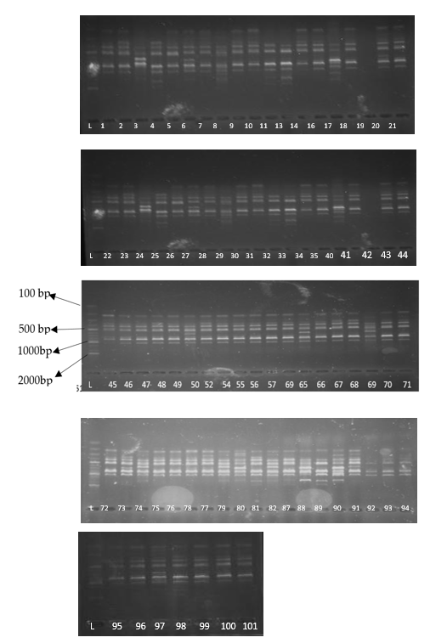

Figure 1. Primer 8 DNA finger print of the different Fusarium species isolates following electrophoresis on agarose. L is the 100bp ladder while the numbers represent the ID’s of the different isolates

3.1.2 Population structure and genetic diversity of Fusarium species isolates

The average Wright's fixation index (Fst) ranged from 0.1 to 0.6 for with an average of 0.2. The expected heterozygosity ranged from 0.1 to 0.2 with an average of 0.17 (Table 2 and Figure 2). Significant differences were observed in Fst between different agro-ecological zones (F = 2.4, P<0.001). The average Fst of isolates from Eastern Highland and Lake Victoria crescent and Mbale farmlands were similar, while that of Northern Mixed Farming System and South Western Highlands and Western Mixed Farming System were also similar. The Fst of isolates from North Eastern Dry Land was significantly different from that of the other agro-ecological zones. Significant differences were also observed in the expected heterozygosity (He) across the different agro-ecological zones (F = 5.1, P < 0.001). The He of strains from North Eastern Dry land was low and was significantly different from the rest of the agro-ecological zones.

Table 2. The average Wrights fixation indices (Fst) and expected heterozygosity (He) per agroecology

S/no | Agro-ecology* | Fst | He
1 | EH | 0.2 | 0.2
2 | LVC | 0.2 | 0.2
3 | NEDL | 0.6 | 0.1
4 | NMFS | 0.1 | 0.2
5 | WMFS | 0.1 | 0.2
6 | SWH | 0.1 | 0.2
*EH- Eastern Highlands, LVC- Lake Victoria Crescent and Mbale Farmlands, NEDL- North Eastern Dry Lands, NMFS- Northern Mixed Farming System, WMFS- Western Mixed Farming System, SWH- South Western Highlands

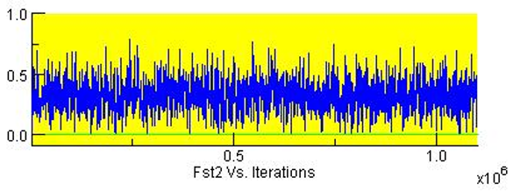
Figure 2. The Fst of different Fusarium isolates from Ugandan common bean agro-ecological zones

The average allele frequency divergence between the isolates from the different agro-ecological zones was 0.003. (Table 3). The average allele frequency divergence between the North Eastern Dry Land and other agro-ecological zones was 0.225. This is 75 times higher compared to the average. The result of the principal component analysis revealed that the population of Fusarium species from the different agro-ecological zones in Uganda is admixed, with principal component 1 accounting for 17.9 percent of the variation, while principal component 2 accounted for 14.7% of the variation (Figure 3A). The isolates from the different agro-ecological zones were also present in all the axis of the PCA plot. The result of population structure analysis revealed that there are 3 optimum populations that can explain the genetic variation among the Fusarium species isolates (Figure 3B). The result of admixture analysis revealed that the different genetic populations of Fusarium species were admixed and have a shared ancestry (Figure 3C). A pairwise comparison of genetic distance and similarity coefficients between different agro-ecological zones were 0 and 1, respectively, for all the agro-ecological zones.

Table 3. Pairwise allele frequency divergence among different agro-ecological zones

Agro-ecology* | EH | LVC | NEDL | NMFS | WMFS | SWH
EH | - | 0.0043 | 0.275 | 0.006 | 0.004 | 0.001
LVC | 0.043 | - | 0.232 | 0.003 | 0.001 | 0.001
NEDL | 0.275 | 0.232 | - | 0.277 | 0.236 | 0.255
NMFS | 0.001 | 0.003 | 0.277 | - | 0.004 | 0.002
WMFS | 0.004 | 0.001 | 0.236 | 0.004 | - | 0.002
SWH | 0.001 | 0.001 | 0.255 | 0.002 | 0.001 | -
*EH- Eastern Highlands, LVC- Lake Victoria Crescent and Mbale Farmlands, NEDL- North Eastern Dry Lands, NMFS- Northern Mixed Farming System, WMFS- Western Mixed Farming System, SWH- South Western Highlands

A phylogenetic tree was generated using unweighted pair group method with arithmetic mean and the isolates clustered into the 3 optimum genetic clusters (Figure 4). The clusters to which the isolates belong are summarised in Table S1. The identities of the different Fusarium species were obtained from Erima et al., (2025). Genetic cluster 1 had 8 isolates constituting 8% of isolates and consisted of species such as F. oxysporum, F, brevicaudatum, F. falciforme and some unidentified isolates. Genetic cluster two had 6 isolates constituting 6% of total isolates which belonged to F. solani and some unidentified species. Genetic cluster 3 had 87 isolates constituting 86% of isolates belonging to F. falciforme, F. equiseti, F. brevicaudatum, F. oxysporum, F. solani, F. brachygiborum, F. commune, C. rhizophaga, F. fabacearum, F. delphimoides, F. duofalcatisporum, and some unidentified isolates. The disease severity index (DSI) and the growth rate of the isolates were obtained from Erima et al. (2024). No significant differences were observed in the DSI and growth rate among the isolates from the different genetic clusters (F 1.9, P = 0.184 and F = 0.42, P = 0.958) for DSI and Growth rate, respectively.

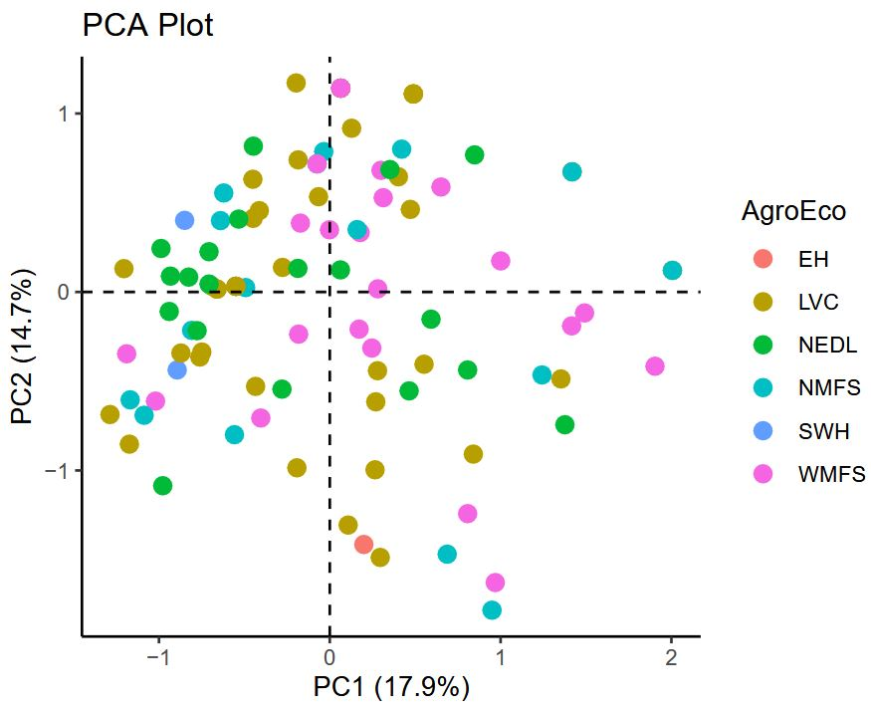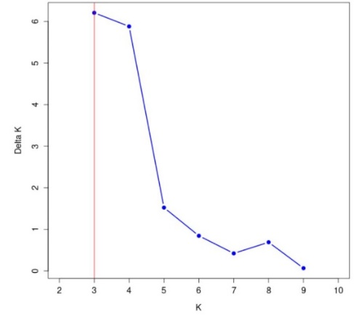
- B)
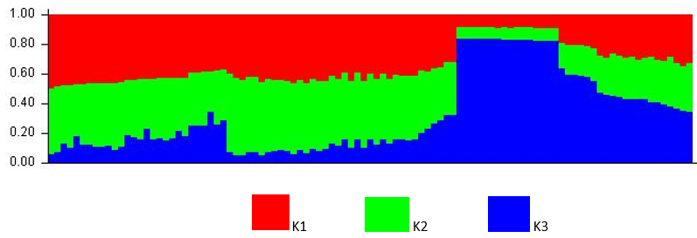
C)
Figure 3. A- Principal component plot for Fusarium species isolates from different agro-ecological zones. B- K mean plot showing peak at cluster 3. C-The admixture plot for the different Fusarium species isolates clusters

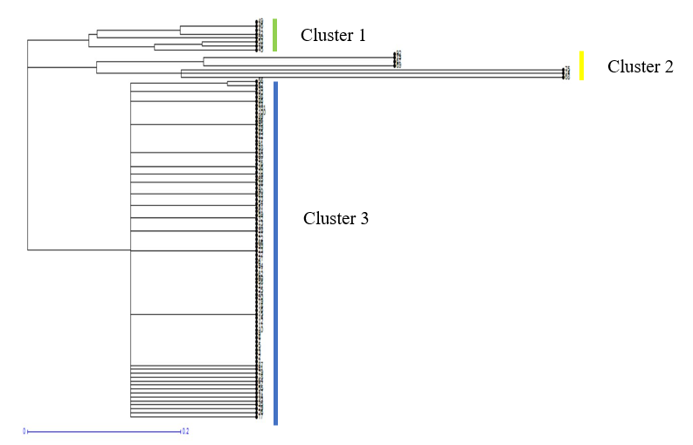

Figure 4. Phylogenetic tree of the different Fusarium species isolates generated using the unweighted pair group method with arithmetic mean. The isolates formed 3 clusters.

The result of the analysis of molecular variance revealed that 0.2% of variation was between agro-ecological zones, while 98.8% of the variation was within samples in agro-ecological zones (Table 4). There was a low Phi between the agro-ecological zones of 0.002. Analysis of molecular variance was also conducted between the genetic clusters. The results showed that the variation between clusters was 15.8% while that within clusters was 84.2%. (Table 5). There was a low Phi between clusters of 0.158.

Table 4. Analysis of molecular variance output for Fusarium species isolates from six agro-ecological zones of Uganda

Sources of variation | Df | SS | MSS | Sigma | Percentage
Between agro-ecological zones | 5 | 35.7 | 7.15 | 0.015 | 0.2
Within agro-ecological zones | 88 | 609.9 | 6.90 | 6.930 | 98.8
Total | 93 | 645.6 | 6.94 | 6.940 | 100

Table 5. Analysis of molecular variance output for Fusarium species isolates from the three genetic clusters

Sources of variation | Df | SS | MSS | Percentage
Between genetic clusters | 2 | 39.1 | 19.5 | 15.8
Within genetic clusters | 88 | 584.7 | 6.7 | 84.2
Total | 90 | 623.9 | 67.0 | 100

3.2 Discussion

In the current study, we used 101 hyphal-tipped Fusarium species isolates previously collected from various agro-ecological zones of Uganda and stored at the National Crops Resources Research Institute. The genetic diversity and population structure of the isolates were studied using ISSR markers previously used by Borrego-Benjumea et al., (2017). Following the polymerase chain reaction, 2 suitable primers out of the 17 tested were used. The amplified products ranged in size from 200 to 1600bp, which is in range with findings reported by Pradeep et al., (2002). After scoring the bands, the polymorphic information content of the different isolates in the current study was high for both primers. This finding indicates that the average genetic diversity among Fusarium species is relatively high. While studying the genetic diversity among Fusarium graminearum and F. Culmorum using ISSR markers, Albayrak et al (2016) noted that the amplicon sizes ranged from 200 to 3500 bp. They obtained 405 bands, of which 5.9% were polymorphic. This is contrary to our study, where the polymorphic information content for both primers was above 83%.

The average Wright’s fixation index (Fst) of the isolates per agro-ecological zone was moderate. This shows a moderate genetic diversity among the Fusarium species isolates. Bayraktar et al (2008) also reported a moderate Fst among Fusarium oxysporum f. sp. ciceris isolates on chickpea. However, Jambhulkar et al. (2024), while studying genetic diversity among Fusarium species causing Fusarium stock rot in maize, reported a high Fst of 0.98 between the agro-ecological zones. They concluded that most of the variation is within the agro-ecological zones rather than within agro-ecological zones. The average allele frequency divergence among the isolates from different agro-ecological zones was low. However, the allele frequency divergence of isolates from North Eastern Dry Land was 75 times higher than for isolates from other agro-ecological zones. This suggests that the isolates from North Eastern Dry Land were relatively distinct from the isolates from other agro-ecological zones. This can be supported by the fact that there is little or no movement of grains from other agro-ecological zones to North Eastern Dry Land and vice versa, which limits sexual reproduction between the isolates. This is because Fusarium root rot in Uganda is mostly seed-transmitted, and many farmers often end up buying infected grains from the market and planting (MAAIF, 2025). The ISSR markers used in this study revealed that there is no genetic distance between isolates from different agro-ecological zones. A moderate genetic distance of 0.36 among isolates causing common bean root rot in Iran was reported by Karimian et al., (2023) using RAPD. Albayrak et al (2016), while studying genetic diversity among F. graminearum and F. culmorum using ISSR markers reported intra-species similarities of 80% to 81% respectively. They also reported that the isolates clustered according to their species and geographical zone of origin, which is contrary to our findings. Factors such as gene flow, spontaneous natural mutations, and genetic drift contribute to the variation in pathogen population (Wang et al. 2022). Baruah et al. (2025), while studying the distribution and genetic diversity of Fusarium oxysporum f. sp. cubense in banana, obtained five genetic clusters, and the isolates from the same clusters originated from different agro-ecological zones.

In the current study, the expected heterozygosity was low. This again shows a moderate to low genetic diversity among the Fusarium species isolates in Uganda. The expected heterozygosity of isolates from the North Eastern dryland was lower than for the rest of the agro-ecological zones. This is probably because in the Northeastern dry land, farmers mostly keep cattle, and bean farmers are located 5 to 10km apart. This limits the exchange of genetic materials through sexual reproduction, which could increase the heterozygosity (Jambhulkar et al. 2024). The low expected heterozygosity in North Eastern Dry Land can also be caused by limited movement of infected grains from other regions, as farmers keep the previous harvest for the next season's crop. While studying genetic variability among Fusarium species causing common bean root rot in Kenya using SSR markers, Mwang'ombe et al., (2008) reported expected and observed heterozygosity of 0.48 to 0.85 and 0.4 to 0.8, respectively. They observed an association between SSR phylogenetic groups and pathogenicity, contrary to our study were there were on significant differences in the DSI and growth rate of isolates from different genetic clusters.

The result of the analysis of molecular variance revealed that only 0.2% of the variation was between the agro-ecological zones, while 98.8% of the variation was within the zones. The AMOVA results also showed that 15.8% of the variation was between genetic clusters, while 84.4% of the variation was within the genetic clusters. The low percentage of genetic variation between the agro-ecological zones shows that the Fusarium species isolates in Uganda are highly mobile and/or are interbreeding. This is also supported by the low Phi sample value of 0.002. The low percentage of genetic variation between the agro-ecological zones has been facilitated by the fact that there is a lot of grain movement in Uganda, and farmers often use these grains as seeds the following season (MAAIF, 2025). This leads to the spread of similar isolates across different agro-ecological zones in Uganda. The genetic variation between the genetic clusters was low (15.8%), this figure is still significant. This suggests that populations are not completely homogeneous. This could be due to the presence of local adaptations or historical events that have shaped the genetic structure of these populations (Jambhulkar et al. 2024). Other studies have reported higher within and lower between genetic cluster variance among Fusarium species; Baruah et al. (2025) reported within population variance of 96% while only 4% of between population variance among Fusarium oxysporum f. sp. cubense. Similar findings were reported by Bayraktar et al (2008) in Fusarium oxysporum f. sp. ciceris isolates on chickpea. They concluded that the population of their isolates were not highly divergent. Jambhulkar et al. (2024) also reported a within-genetic-cluster variance of 89.6 while within genetic cluster variance of 10.4 .

4. Conclusion

The findings of the current study show that the population of Fusarium species in Uganda is not stratified, with little genetic variation between isolates from different agro-ecological zones and genetic clusters. The limited stratification in the population favours breeding for resistance to the Fusarium root rot because released varieties will not face very extreme variants when they are planted in new agro-ecological zones.

AcknowledgEments

We acknowledge the Bill and Melinda Gates Foundation Grant number OPP1084135 for funding the research. We also thank the legumes department of the National Agricultural Research Organisation and Makerere University Regional Centre for Crop Improvement, where the research was conducted. We Appreciate the Plantain Breeding Program, International Institute of Tropical Agriculture, Oyo state, Nigeria, whose staff guided in data analysis.

Competing interests

Authors have declared that no competing interests exist.

References

Abawi, G.S., & Corrales. (1990). Root rots of beans in Latin America and Africa: Diagnosis, research methodologies, and management strategies (No. 35). Ciat. https://hdl.handle.net/10568/54258
Anne, C. (2006). Choosing the right molecular genetic markers for studying biodiversity: from molecular evolution to practical aspects. Genetica, 127(1), 101-120. DOI: 10.1007/s10709-005-2485-1
Borrego-Benjumea, A., Basallote-Ureba, M. J., Melero-Vara, J. M., & Abbasi, P. A. (2014). Characterization of Fusarium isolates from asparagus fields in southwestern Ontario and influence of soil organic amendments on Fusarium crown and root rot. Phytopathology 104(4), 403-415. DOI: 10.1094/PHYTO-08-13-0231-R
Buruchara R, Chirwa R, Sperling L, Mukankusi C, Rubyogo JC, Muthoni Rand Abang MM (2011) Development and delivery of bean research varieties in Africa: the Pan-Africa bean research alliance (PABRA) model. African Crop Science Journal 19, 227–245.
Celmeli, T., Sari, H., Canci, H., Sari, D., Adak, A., Eker, T., & Toker, C. (2018). The nutritional content of common bean (Phaseolus vulgaris L.) landraces in comparison to modern varieties. Agronomy, 8(9), 166. https://doi.org/10.3390/agronomy8090166
Erima, S.; Moses, N., Allan, N., Cnadiru, A., Nakibuule, J., Edema, R., & Paparu, P. (2024) Morphological and pathogenic characterisation of Fusarium species causing common bean root rot in Uganda. Journal of Scientific agriculture, 8, 7-14, DOI: 10.25081/jsa.2024.v8.8849
FAO. (2018). Retrieved from; https://www.fao.org/news/story/en/item/1187738/icode/ on 02/Fed/2023
FAOSTAT (2025). FAOSTAT Statistics Database. Available at: http://www.fao.org/faostat [Accessed 30 Apr. 2025].
Fourie, G., Steenkamp, E.T., Ploetz, R.C., Gordon, T., & Viljoen, A. (2011). Current status of the taxonomic position of Fusarium oxysporum formae specialis cubense within the Fusarium oxysporum complex. Infect. Genet. Evol, 11, 533–554. DOI: 10.1016/j.meegid.2011.01.012
Frichot, E., Mathieu, F., Trouillon, T., Bouchard, G., & François, O. (2014). Fast and efficient estimation of Individual ancestry coefficients. Genetics, 196(4), 973-983. DOI: 10.1534/genetics.113.160572
Joint Research Council, European commission. Http://joint-research-centre.ec.europa.eu/tools-and-laboratories/standardisation_en. Retrieved on 05/05/2024
Kamvar, Z. N., Tabima, J. F., & Grünwald, N. J. (2014). Poppr: an R package for genetic analysis of populations with clonal, partially clonal, and/or sexual reproduction. PeerJ, 2, 281. • DOI: 10.7717/peerj.281
Karimian, B., Nikkhah, M., Abbasi, M., & Ghazanfari, K. (2010). Genetic diversity of Fusarium oxysporum from common bean and distribution of mating type alleles. Iranian Journal of Biotechnology, 8,(2), 90-97
Li, Y.P., You, M.P., Barbetti, M.J. (2014). Species of Pythium associated with seedling root and hypocotyl I disease on common bean (Phaseolus vulgaris) in Western Australia. Plant Dis. 2014, 98, 1241–1247.
Liu, K., & Muse, S. V. (2005). PowerMarker: an integrated analysis environment for genetic marker analysis. Bioinformatics, 21(9), 2128-2129.
Machiani, M. A., Rezaei-Chiyaneh, E., Javanmard, A., Maggi, F., & Morshedloo, M. R. (2019). Evaluation of common bean (Phaseolus vulgaris L.) seed yield and quali-quantitative production of the essential oils from fennel (Foeniculum vulgare Mill.) and dragonhead (Dracocephalum moldavica L.) in an intercropping system under humic acid application. Journal of Cleaner Production, 235, 112-122. Doi: 10.1016/j.jclepro.2019.06.241
Melotto, M., Monteiro-Vitorello, C.B., Bruschi, A.G., & Camargo, L.E. (2005) Comparative bioinformatic Analysis of genes expressed in common bean (Phaseolus vulgaris L.) seedlings. Genome, 48, 562–570
Miklas, P.N., Kelly, J.D., Beebe, S.E., & Blair, M.W. (2006). Common bean breeding for resistance against biotic and abiotic stress: From classical to MAS breeding. Euphytica, 147, 105–131. DOI: 10.1007/s10681-006-4600-5
Mwang’ombe, A. W., Kipsumbai, P. K., Kiprop, E. K., Olubayo, F. M., & Ochieng, J. W. (2008). Analysis of Kenyan isolates of Fusarium solani f. sp. phaseoli from common bean using colony characteristics, pathogenicity, and microsatellite DNA. African Journal of Biotechnology, 7(11). DOI: 10.5897/AJB08.847
Mbiu,J., , T , Mukankusi, C., Rubyogo, J.C., ,Mashamba Philipo, M. (2025). Consumer traits of common beans: a global and regional perspective on seed coat darkening, cooking time, protein, and mineral content. Front Nutr doi: 10.3389/fnut.2025.1658338
Ng, W. L., & Tan, S. G. (2015). Inter-simple sequence repeat (ISSR) markers: are we doing it right? ASM Sci J, 9(1), 30-39.
Paparu, P., Acur, A., Kato, F., Acam, C., Nakibuule, J., Musoke, S., & Mukankusi, C. (2018). Prevalence and incidence of four common bean root rots in Uganda. J. Exp. Agric. 2018, 54, 888–900. DOI: 10.1017/s0014479717000461
Pradeep Reddy, M., Sarla, N., & Siddiq, E. A. (2002). Inter-simple sequence repeat (ISSR) polymorphism and I t s application in plant breeding. Euphytica, 128, 9-17. DOI: 10.1023/A:1020691618797
Puri, K.D., Saucedo, E.S., & Zhong, S. (2012). Molecular characterisation of Fusarium head blight pathogens sampled from a naturally infected disease nursery used for wheat breeding programs in China. Plant Dis. 2012, 96, 1 280–1285. DOI: 10.1094/PDIS-08-11-0713-RE
R Core Team. R: A language and environment for statistical computing. R foundation for statistical computing. Vienna, Austria; 2018. Available: http://www.R-project.org/.
Uganda Bureau of Statistics. (2022). Annual agricultural surveys (AAS) 2019
Zietkiewicz, E., Rafalski, A., & Labuda, D. (1994). Genome fingerprinting by simple sequence repeat (SSR)-anchored polymerase chain reaction amplification. Genomics, 20, 176–183. DOI: 10.1006/geno.1994.1151

Supplementary Table

Table S1. The Fusarium species isolates and the genetic clusters to which they belong. The identities of the Fusarium species were obtained from Erima et al. (2025) and DSI and growth rate from Erima et al. (2024)
S/no | Strain | Agroecology | Species | Genetic cluster | DSI (%) | Growth rate  (cm/day)
1 | LweF-220 | LVC | Unknown | 2 | 65.2 | 0.69
2 | OyaF-554-2 | NMFS | Unknown | 2 | 34.9 | 0.98
3 | KyeF-373-1 | WMFS | F.oxysporum | 2 | 60.6 | 0.54
4 | MubF-460 | LCV | F. oxysporum | 2 | 60.8 | 0.63
5 | AmuF-515-2 | NEDL | F. equiseti | 3 | 50.6 | 0.73
6 | AmuF-517-1 | NEDL | F. falciforme | 3 | 16.2 | 0.99
7 | AmuF-517-4 | NEDL | Unknown | 3 | 50.4 | 0.69
8 | AmuF-517-3 | NEDL | F. falciforme | 1 | 50.8 | 0.99
9 | AmuF-518-2 | NEDL | F. equiseti | 3 | 63.3 | 0.9
10 | ApaF-546 | NMFS | F. equiseti | 3 | 42.2 | 0.9
11 | ApaF-548 | NMFS | F. solani | 1 | 54.8 | 0.94
12 | ApaF-551-1 | NMFS | F. brevicaudatum | 3 | 59.3 | 0.6
13 | ApaF-552-2 | NMFS | F. equiseti | 3 | 21.4 | 0.82
14 | ApaF-560-1 | NMFS | F. oxysporum | 3 | 66.4 | 1.2
15 | BusF-255-1 | WMFS | F. oxysporum | 3 | 57.4 | 0.69
16 | BusF-256 | WMFS | Unknown | 3 | 56 | 0.9
17 | GomF-492 | LVC | F. oxysporum | 3 | 15.0 | 0.73
18 | GulF-449-2 | NMFS | Unknown | 3 | 30.0 | 0.51
19 | GulF-451-1 | NMFS | Unknown | 1 | 8.1 | 0.76
20 | HoiF-385 | WMFS | F. solani | 3 | 0.9 | 0.76
21 | HoiF-393-2 | WMFS | Unknown | 3 | 61.8 | 0.94
22 | Lwe-393 | WMFS | F. oxysporum | 3 | 49/7 | 0.88
23 | IbaF-270 | WMFS | F.oxysporum | 3 | 39.1 | 0.92
24 | KamF-290 | WMFS | F.oxysporum | 1 | 34.5 | 0.84
25 | KamF-290-2 | WMFS | F.oxysporum | 3 | 48.7 | 1.01
26 | KabF-103 | SWH | F. oxysporum | 3 | 98.3 | 0.93
27 | KabF-108-1 | SWH | F. oxysporum | 3 | 63.2 | 0.86
28 | KabF-113-2 | SWH | F. fabacearum | 3 | 35.9 | 0.55
29 | KabF-114 | SWH | F. solani | 3 | 35.2 | 0.77
30 | KabF-91-1 | SWH | F. oxysporum | 3 | 28.8 | 0.88
31 | KamF-289 | WMFS | F. solani | 2 | 22.0 | 0.72
32 | KapF-367 | EH | Unknown | 3 | 63.5 | 0.94
33 | KirF-415 | WMFS | Unknown | 3 | 14.0 | 0.75
34 | KolF-557-4 | NMFS | F. equiseti | 3 | 61.8 | 1.07
35 | KolF-562-1 | NMFS | F. solani | 3 | 72.6 | 1.06
36 | KolF-563 | NMFS | F. oxysporum | 3 | 65.8 | 0.87
37 | KolF-577-4 | NMFS | F. oxysporum | 3 | 61.8 | 1.07
38 | KolF-581 | NMFS | Unknown | 3 | 60.0 | 0.97
39 | KyeF-320-2 | WMFS | F. solani | 3 | 49.3 | 0.76
40 | Kyef-323 | WMFS | F. solani | 3 | 46.3 | 0.89
41 | LirF-601-2 | NMFS | F. falciforme | 3 | 23.4 | 0.87
42 | LirF-604 | NMFS | F. oxysporum | 3 | 24 | 1.09
43 | Lwe F-491-2 | LVC | F. falciforme | 3 | 50.3 | 0.91
44 | LweF-215 | LVC | F. oxysporum | 3 | 19.3 | 0.57
45 | LweF-221-3 | LVC | F. oxysporum | 3 | 48.2 | 0.67
46 | LweF-222 | LVC | Unknown | 3 | 48 | 0.65
47 | LweF-223 | LVC | F. equiseti | 3 | 70 | 0.67
48 | LweF-296 | LVC | F. commune | 3 | 51. | 0.92
49 | LweF-484 | LVC | F. oxysporum | 3 | 30.5 | 0.77
50 | LweF-495 | LVC | 2 F. falciforme | 3 | 49.8 | 0.78
51 | LweF-495-2 | LVC | F. Oxysporum | 3 | 49 | 0.79
52 | LweF-496 | LVC | F. oxysporum | 3 | 50.3 | 0.91
53 | LweF-497 | LVC | F. oxysporum | 3 | 49 | 0.63
54 | LweF-500-2 | LVC | F. falciforme | 1 | 43 | 0.92
55 | LweF-500-3 | LVC | F. oxysporum | 3 | 42 | 1
56 | LweF-504-2 | LVC | F. oxysporum | 3 | 32.6 | 0.59
57 | LweF-507 | LVC | F. oxysporum | 3 | 55.1 | 0.86
58 | LweF-779 | LVC | F. oxysporum | 3 | 56 | 0.9
59 | MasF-403 | WMFS | F. fredkrugeri | 3 | 41 | 0.87
60 | MasF-409 | WMFS | F. branchygibbosum | 3 | 56 | 0.64
61 | MbarF-229 | WMFS | F commune | 3 | 37 | 0.81
62 | MbarF-234 | WMFS | F. oxysporum | 3 | 30.2 | 0.71
63 | MitF-345-2 | LVC | F. oxysporum | 3 | 41.8 | 0.87
64 | MitF-481 | LVC | F. falciforme | 3 | 30 | 0.82
65 | MitF-467 | LVC | F.oxysporum | 3 | 50.2 | 0.91
66 | MitF-481-2 | LVC | F. commune | 3 | 30.4 | 0.81
67 | MitF-487-a | LVC | F. oxysporum | 1 | 31.3 | 0.37
68 | MitF-487-b | LVC | Unknown | 3 | 34 | 0.85
69 | MitF-487-2 | LVC | F. oxysporum | 3 | 32.7 | 0.84
70 | MitF-489 | LVC | F. oxysporum | 3 | 42.4 | 0.55
71 | MitF-490 | LVC | F. commune | 3 | 88.3 | 0.98
72 | MitF-491-2 | LVC | F. falciforme | 3 | 27 | 0.89
73 | MorF-119 | NEDL | F. fabacearum | 3 | 57.4 | 1.07
74 | MubF-461 | LVC | F. oxysporum | 3 | 61.8 | 0.78
75 | MubF-462-2 | LVC | 2. F. oxysporum | 3 | 59.6 | 0.71
76 | MubF-463-1 | LVC | F. oxysporum | 3 | 60.5 | 0.87
77 | MubF-463 | LVC | F. oxysporum | 3 | 60.7 | 0.86
78 | MubF-465 | LVC | F. oxysporum | 3 | 30.1 | 0.87
79 | MubF-466 | LVC | F. oxysporum | 3 | 61 | 0.52
80 | NakF-102-2 | NEDL | F. solani | 1 | 20.8 | 0.79
81 | NakF-104-1 | NEDL | F. oxysporum | 3 | 32.8 | 0.7
82 | NakF-105 | NEDL | F. oxysporum | 3 | 46.0 | 0.6
83 | NakF-105-1 | NEDL | F. oxysporum | 3 | 40.1 | 0.64
84 | NakF-106 | NEDL | F. solani | 3 | 40 | 0.31
85 | NakF-106-2 | NEDL | F. oxysporum | 3 | 43 | 0.66
86 | KabF-109-1 | SWH | F. delphnoides | 3 | 37.5 | 0.46
87 | NakF-518-2 | NEDL | F. flaciforme | 3 | 18.6 | 0.71
88 | NakF-520-1 | NEDL | F. serpentimum | 3 | 42.3 | 0.17
89 | NakF-521 | NEDL | F. equiseti | 3 | 58.9 | 0.21
90 | NakF-524 | NEDL | F. oxysporum | 3 | 10.9 | 0.74
91 | NapF-109-2 | NEDL | F.duofalcatisporum | 3 | 37.2 | 0.46
92 | NapF-875 | NEDL | F. oxysporum | 1 | 38.6 | 0.56
93 | OyaF-541-3 | NMFS | F. Falciforme | 2 | 76.0 | 1.06
94 | SheF-249 | WMFS | F. oxysporum | 3 | 46.2 | 0.88
95 | SheF-250-1 | WMFS | F. oxysporum | 3 | 18.2 | 0.64
96 | SheF-250-2 | WMFS | F. oxysporum | 3 | 30.2 | 0.69
97 | SheF-250 | WMFS | F. oxysporum | 3 | 30 | 0.9
98 | Shef-258 | WMFS | F. oxysporum | 3 | 56 | 0.78
99 | SirF-349-1 | LVC | F. oxysporum | 3 | 59.0 | 0.93
100 | SirF-349-3 | LVC | F. oxysporum | 3 | 73.8 | 0.83
101 | SirF-358-1 | LVC | F. falciforme | 3 | 25.7 | 0.75
EH- Eastern Highlands, LVC- Lake Victoria Crescent and Mbale Farmlands, NEDL- North Eastern Dry Lands, NMFS- Northern Mixed Farming System, WMFS- Western Mixed Farming System, SWH- South Western Highlands

