Case report
Management of acute spasmodic colic superimposed on chronic parasitic enteritis in a Kathiawari mare

ABSTRACT
Colic remains an emergency condition in equines, characterized by acute abdominal pain due to various gastrointestinal (Curtis et al., 2015) or extra-gastrointestinal disorders. Spasmodic colic, a functional disturbance associated with intestinal motility disorder, often presents acutely but can also be triggered by underlying chronic management issues. This report details the clinical management of a ten-year-old Kathiawari mare presented with acute abdominal pain superimposed on a ten-day history of intermittent diarrhea. Diagnostic investigation revealed marked intestinal hypermotility and significant dehydration. Successful management involved a multimodal approach, including immediate fluid resuscitation with a visceral analgesic (Flunixin meglumine), a spasmolytic agent (Hyoscine butylbromide), and prophylactic antimicrobial coverage to address potential mucosal compromise. The case highlights the significance of neglected deworming protocols as a predisposing factor for spasmodic episodes via chronic inflammatory sensitization and underscores the efficacy of rapid medical intervention in indigenous breeds.

INTRODUCTION
The management of equine colic requires a systematic diagnostic approach to differentiate between medical and surgical cases. Spasmodic colic accounts for approximately 40% of colic presentations and is characterized by painful, uncoordinated muscular contractions of the intestinal wall (Fereig., 2023). While often idiopathic or linked to acute stressors such as sudden diet changes (Cohen et al., 1999; Curtis et al., 2019), recurrent or "acute-on-chronic" presentations may stem from underlying issues such as parasitic burden or chronic enteritis.
Parasitic inflammation, particularly from larval migration or mucosal attachment, releases inflammatory mediators (e.g., histamine, cytokines) that sensitize the enteric nervous system (ENS). This sensitization predisposes the gut to hypermotile spasms even in the absence of physical impaction. This case report discusses the diagnosis and successful medical management of a mare presenting with acute spasmodic colic complications arising from a background of chronic parasitic enteritis and neglected preventative care.

CASE HISTORY AND OBSERVATION
A ten years old bay Kathiawari mare, weighing approximately 400 kg, was presented to the Veterinary College and Research Institute, Tirunelveli, with acute signs of colic. History revealed a significant ten days course of recurrent, mild abdominal discomfort and intermittent watery diarrhea, for which the owner had attempted unsuccessful self-medication. Crucially, the history indicated a lapse in preventive care: the animal was not up-to-date on vaccinations, and the last deworming had occurred 6 months earlier, exceeding the recommended interval.
Upon admission, the mare exhibited classic behavioral indicators of acute visceral pain, including restlessness, frequent flank watching, patchy sweating, frequent lying down, and episodes of lateral recumbency.
Physical examination revealed signs of pain-induced distress and mild hypoperfusion. The rectal temperature was recorded at 35.9 °C , this subnormal reading was attributed to poor peripheral perfusion. Cardiovascular assessment revealed tachycardia (81 beats/min) and tachypnea (36 breaths/min). The submandibular pulse was feeble and thready, and the mucous membranes appeared injected (dark red), with a capillary refill time (CRT) of >3 seconds. While these parameters initially raised concerns for endotoxemic shock, the clinical picture—specifically the rapid fluctuation in pain intensity consistent with severe abdominal pain-mediated catecholamine release and subsequent peripheral vasospasm.
Auscultation of the abdomen revealed marked intestinal hypermotility, with >4 gut sounds per minute per quadrant (borborygmi) and intermittent grunting. The presence of hypermotility and diarrhea, combined with the absence of significant abdominal distension or gastric reflux, ruled out physical impaction or strangulating lesions, favoring a diagnosis of functional spasmodic disturbance. Horses with recurrent fits of elongated colic are likely to have partial obstruction of the intestines or motility problems (Mair and Sherlock, 2023).

DIAGNOSTIC ASSESSMENT
Diagnostic investigations were performed to assess systemic status. Haematology revealed a mild leukocytosis (WBC 12,200/µL), attributed to physiological stress (leukogram) and underlying inflammation from chronic enteritis. Hemoglobin (11.4 g/dL) and PCV (35.3%) were within accepted ranges. Serum biochemistry indicated pre-renal azotemia, as evidenced by elevated BUN (64.07 mg/dL) and Creatinine (1.90 mg/dL), consistent with dehydration and gastrointestinal protein catabolism. Based on the hypermotile gut sounds, history of neglected deworming, and clinical signs, the diagnosis was acute spasmodic colic superimposed on chronic parasitic enteritis.

TREATMENT AND DISCUSSION
A multimodal medical approach was implemented to stabilize the patient, relieve spasms, and address the underlying parasitic load. To address immediate hypovolemia and improve perfusion, an initial intravenous bolus of 5 L was administered. This solution comprised 3 L of Ringer’s Lactate for isotonic volume expansion and 2 L of dextrose normal saline. While isotonic crystalloids are the standard for rehydration, the addition of dextrose was elected to provide an immediate energy substrate for this catabolic patient, countering potential hypoglycemia associated with the prolonged ten-day history of anorexia and stress. The remaining fluid deficit (approximately 20 L) was corrected via voluntary oral intake once the spasm resolved.
Visceral analgesia and anti-inflammatory support were provided via Flunixin meglumine (1.1 mg/kg IV). Concurrent antispasmodic therapy involved Hyoscine butylbromide (Buscowin®) at 0.3 mg/kg IV to competitively inhibit muscarinic acetylcholine receptors, effectively halting smooth muscle spasms (Roelvink et al., 1991). Gastric mucosal protection was provided via Pantoprazole (1 mg/kg IV) to mitigate stress-induced gastric acidity (Grady et al., 2024).
Broad-spectrum antibiotic coverage (Amoxicillin/Cloxacillin) was administered. While modern veterinary stewardship guidelines advocate for a One Health approach that generally restricts antibiotic use in uncomplicated colic (Grady et al., 2024), this case presented a specific exception: the "acute-on-chronic" nature of the condition. The ten-day history of diarrhea poses a significant risk of mucosal barrier compromise, increasing the likelihood of bacterial translocation across the gut wall. Therefore, prophylactic coverage was deemed critical to prevent the development of septicemia/peritonitis despite the absence of frank fever at presentation.
As the acute pain subsided and the mare displayed an interest in feed (approximately one hour post-treatment) after specific therapy for the spasmodic colic cause was initiated. A single dose of Fenbendazole (3 g PO) was administered for suspected parasitic etiology, and an oral herbal antidiarrheal preparation (Diaroak, 30 g PO BID) was given for 5 days to aid mucosal recovery.
The mare demonstrated a rapid clinical response, with signs of pain and restlessness subsiding within 30 minutes of antispasmodic administration. Intestinal motility normalized, and appetite returned within one hour. The rapidity of the recovery necessitates a critical interpretation of the initial "shock" parameters; the injected mucous membranes and weak pulse were likely driven by severe pain-induced catecholamine release and an increase in vagal tone, which causes an increase in gut peristalsis and a propensity to spasm (Fereig, 2023) rather than true endotoxemic circulatory collapse. This interpretation is supported by the immediate improvement following analgesia without the need for massive volume expansion.
The diagnosis of spasmodic colic was confirmed by the response to therapy and the exclusion of surgical lesions via the absence of gas reflux and distension. However, the etiology warrants careful consideration. A primary limitation of this study was the inability to perform a quantitative Fecal Egg Count (FEC) prior to treatment because therapy was initiated on an emergency basis. Despite this, a diagnosis of parasitic enteritis is strongly supported by the "therapeutic diagnosis": the dramatic cessation of symptoms following spasmolytic agent administration and the lack of recurrence following anthelmintic (Fenbendazole) treatment.
The ten-day history suggests that the acute spasms were not idiopathic but rather a secondary complication of chronic irritation caused by endoparasites. Management factors, specifically poor deworming practices, are well-documented risk factors for such colic episodes (Cohen et al., 1999). Parasitic larvae are known to induce local inflammation and hypersensitivity of the enteric nervous system, lowering the threshold for spasmodic events. A heavy tapeworm infestation is associated with a high prevalence of spasmodic colic (Fikri et al., 2023). In addition, the submucosal migration and mucosal penetration parasitic larvae is well-known to initiate changes in the ileal myoelectrical motion that could lead to the evolution of colic in equines. Hyperperistalsis of spasmodic colic in equines may arise due to an increase in the parasympathetic nerve tone under the effect of causative agents (Constable et al., 2017)( Tharwat et al.,2025)
The Kathiawari breed is often noted for its high alertness and sensitivity; it is possible that this breed characteristic contributed to the exaggerated behavioral display of pain relative to the severity of the lesion.Weather changes, overexertion/excitement such as during thunderstorms, preparation for displaying, drinking cold water in hot weather, and sweating after work, feeding errors, feeding technique, and feed quantity and quality are all factors that predispose horse to spasmodic colic (Constable et al., 2017; Mair and Sherlock, 2023).
Modern guidelines of Antimicrobial stewardship discourage routine antibiotic use in colic to prevent resistance. However, in cases of "acute-on-chronic" enteritis, the risk of compromised gut integrity warrants prophylactic coverage to prevent septicemia, justifying the use of Amoxicillin/Cloxacillin in this patient.

CONCLUSION
This case illustrates that "spasmodic colic" in indigenous breeds may often be the acute presentation of a chronic management failure. Successful management requires a two-prolonged approach: immediate multimodal therapy to resolve life-threatening pain, followed by anthelmintic to eliminate the predisposing cause. Follow-up communication with the owner one month post-discharge confirmed that the mare remained healthy with no recurrence of colic or diarrhea.

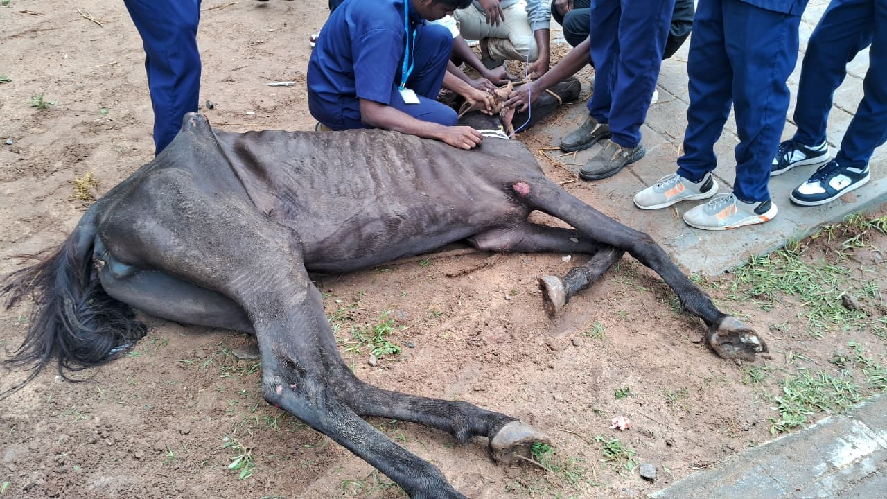 | 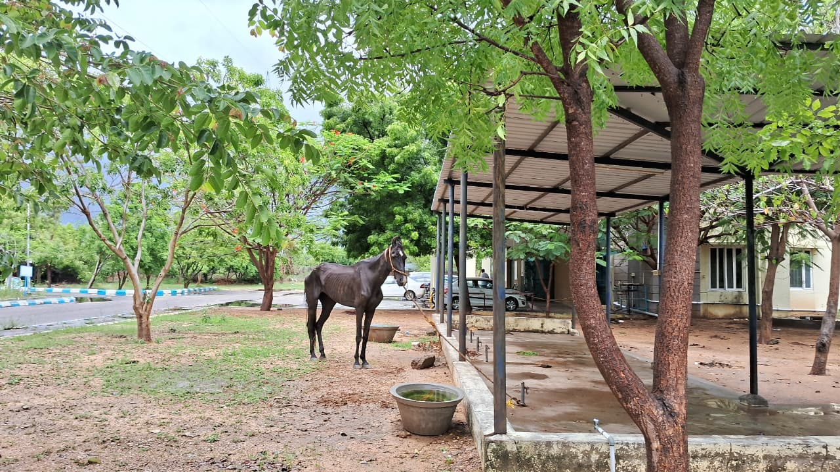
Fig.1 :Before treatment | Fig.2 : After treatment

Table 1 : Diagnostic Investigations

HAEMATOLOGY
 | OBSERVED VALUE | NORMAL VALUE
Hemoglobin (g/dl) | 11.4 | 10.1-16.1
PCV (%) | 35.3 | 27-43
RBC (m/cmm) | 6.89 | 6-10.4
WBC (/cmm) | 12200 | 5.6-12.1
Platelet (/cmm) | 185000 | 117000-256000

SERUM BIOCHEMISTRY
 | OBSERVED VALUE | NORMAL VALUE
BUN (mg/dl) | 64.07 | 11-27
Creatinine (mg/dl) | 1.90 | 0.4-2.2
Total protein (g/dl) | 6.61 | 5.6-7.6
Albumin (g/dl) | 2.79 | 2.6-4.1
Glucose (mg/dl) | 97.8 | 62-134

Conflict of Interest

The authors declare that there is no conflict of interest regarding the publication of this case report. The research was conducted in the absence of any commercial or financial relationships that could be construed as a potential conflict of interest.

Consent
Informed consent was obtained from the owner of the animal for clinical examination, diagnostic procedures, treatment, and publication of this case report
Ethical Approval
Ethical approval was not required for this case report as all diagnostic and therapeutic procedures were part of routine clinical management. The study did not involve experimental interventions.
AI Use Statement
The authors declare that artificial intelligence tools were used only to assist with language polishing, formatting, and structural organization of the manuscript. All clinical data, interpretations, and conclusions were generated by the authors, who retain full responsibility for the accuracy and integrity of the work.

References
Cohen, N. D., Gibbs, P. G., & Woods, A. M. (1999). Dietary and other management factors associated with colic in horses. Journal of the American Veterinary Medical Association, 215(1), 53-60.
Constable P.D., Hinchcliff K.W., Done S.H., Gruenberg W. 11th. St. Louis, Missouri, USA: Saunders; 2017. Veterinary medicine: a textbook of the diseases of cattle, horses, sheep, pigs and goats.
Curtis, L., Burford, J. H., England, G. C., & Freeman, S. L. (2019). Risk factors for acute abdominal pain (colic) in the adult horse: A scoping review of risk factors, and a systematic review of the effect of management-related changes. PLoS one, 14(7), e0219307.
Curtis, L., Burford, J. H., Thomas, J. S. M., Curran, M. L., Bayes, T. C., England, G. C. W., & Freeman, S. L. (2015). Prospective study of the primary evaluation of 1016 horses with clinical signs of abdominal pain by veterinary practitioners, and the differentiation of critical and non-critical cases. Acta Veterinaria Scandinavica, 57(1), 69.
Fereig, R. M. (2023). A review on equine colic: Etiology, differential diagnosis, therapy, and prevention. German Journal of Veterinary Research, 3(4), 1–12.
Fikri, F., Hendrawan, D., Wicaksono, A. P., Purnomo, A., Khairani, S., Chhetri, S., & Purnama, M. T. E. (2023). Incidence, risk factors, and therapeutic management of equine colic in Lamongan, Indonesia. Veterinary World, 16(7), 1408.
Grady, K., Gould, E., & Tolbert, M. K. (2024). From theory to therapy: a One Health approach guides current and future acid suppressant use in veterinary medicine. Journal of the American Veterinary Medical Association, 1, 1-9.
Mair, T., & Sherlock, C. (2023). Recurrent colic: diagnosis, management, and expectations. Veterinary Clinics: Equine Practice, 39(2), 399-417.
Roelvink, M. E., Goossens, L., Kalsbeek, H. C., & Wensing, T. H. (1991). Analgesic and spasmolytic effects of dipyrone, hyoscine-N-butylbromide and a combination of the two in ponies. The Veterinary Record, 129(17), 378-380.
Tharwat, M., & Al-Sobayil, F. (2025). Equine colic: A comprehensive overview of the sonographic evaluation, diagnostic criteria, and management of different categories. Open Veterinary Journal, 15(3), 1116.

