MYCORRHIZAL SYMBIOSIS AND SOIL FERTILITY BY LEPTADENIA HASTATA FROM THE RECOVERED SATARA SITE IN THE COMMUNE OF SIMIRI.

ABSTRACT (It is better to use past tense in the abstract)
Soil resources are rapidly degrading in Sahel under climatic hazards and demographic pressure. Appropriate cropping strategies could mitigate and reverse the accelerated trend of soil degradation. The use of species able to rapidly associateing with arbuscular mycorrhizal fungi (AMF) can restore the balance of terrestrial ecosystems. Arbuscular mycorrhizal fungi have the capacity to promote plant development in degraded environments by allowing the restoration and maintenance of soil fertility. The objective of the present study was to determine the mycorrhizal status of Leptadenia hastate and to show the importance of the mycorrhizal symbiosis of this plant in the restoration of the fertility of the degraded soils of Satara site in Simiri. Physicochemical parameters and mycorrhizal potential were determined. Ten soil and root samples were taken from a depth of 20 cm under the feet of Leptadenia hastata and another ten soil samples were taken from outside the feet. The results show that the soils in this area are characterised by a sandy-loamy texture and an acidic pH. However, organic matter, total phosphorus, assimilable phosphorus, carbon, nitrogen, sulphur and C/N ratio were higher in the Leptadenia soil. The spore density per 100g soil in Leptadenia soils (905 spores/100g of soil) is very high compared to that of bare soil (403 spores/100g of soil). Spores of Two arbuscular mycorrhizal fungi genera were found at the site: Glomus and Gigaspora with a predominance of the glomus genus. Under Leptadeniahastata, the genus Glomus is estimated at (72.07%) and Gigaspora at (27.93%). The mycorrhization frequency (F%) reached 100 in all roots of Leptadeniahastata. The mycorrhization intensity (M %) was 50.20 for all roots. On the other hand, the arbuscular content estimated by parameters (a) and (A) varies from one root to another. The highest value of (A %) recorded is 29.9% and the lowest value is 5.42%. As for (a %), the highest value is estimated at 62.97% and the lowest at 12.02%.
Key words: Degraded soils, restoration, Leptadeniahastata, physico-chemical parameters, mycorrhizae, Satara site.

- INTRODUCTION
Soil constitutes the foundation for most terrestrial biological activities (Azontonde, 1993). Niger is one of the Sahelian countries where soil resources are continually degrading under the combined effects of demographic pressure and climatic deterioration (Bielders et al., 2001; Tidjani et al., 2009). A large portion of the productive system is dominated by degraded lands or by surfaces covered with glacis and lateritic crusts (Ichaou, 2005). In response to this situation, environmental preservation, the sustainable management of natural resources, and the restoration of degraded lands have been identified as national priorities to support development in Niger (FAO, 2003).
Various initiatives at local, national, and even regional levels have been implemented to reduce and reverse the progressive trend of soil degradation. These include techniques for soil and water conservation (SWC) and for soil defense and restoration (SDR). Among these are demi-lunes (half-moons), stone bunds, micro-dams, grass strips, filter dikes, mulching, zaï pits, and the application of organic or mineral fertilizers (NouhouKoutcha, 2016; Oumarou, 2007; Traoré et al., 2003). Such techniques contribute to the restoration of soil fertility (Larwanouet al., 2006); however, their implementation inevitably depends on the users’ socio-economic conditions.
Due to the challenges encountered in disseminating certain techniques, scientific research has been mobilized to develop and promote more practical, ecological, and sustainable biological fertilization methods. Consequently, approaches that integrate biodiversity management have been developed. Restoration techniques must therefore incorporate the management of the soil’s biological potential, which plays a particularly crucial role in maintaining and enhancing soil fertility (Cardoso and Kuyper, 2006).
Among the key soil microorganisms are the mycorrhizal fungi, which are present in the majority of terrestrial ecosystems and associated with over 90% of terrestrial plant species (Van der Heijden et al., 1998). These symbiotic microorganisms are considered a "keystone" microbial group that facilitates plant development in degraded environments by restoring soil fertility. Among them, the arbuscular mycorrhizal fungi (AMF), formerly known as vesicular-arbuscular fungi, are the most significant (Lagrange, 2009; Hubert and Schaub, 2011; Sadhana, 2014).
The secretion of glomalin by the mycelial networks of these fungi has been observed in soils. Glomalin, a glycoprotein, plays a fundamental role in maintaining soil structural stability (Waligora and Vian, 2010; Huber and Schaub, 2011). It directly contributes to the renewal of soil organic matter stocks. Furthermore, dead mycelium adds to the organic matter pool, enhances soil aggregation, and improves porosity and aeration (Waligora and Vian, 2010).
Nevertheless, the use of highly mycotrophic plant species proves essential for restoring the fertility of degraded lands. The fungus sporulates in the soil or within plant roots, conferring upon the host plant resistance to both biotic and abiotic stresses (Fortin et al., 2015). Leptadeniahastata, an economically valuable plant, exhibits resistance to such stresses. It is characteristic of dry savanna vegetation, undemanding in terms of soil quality, capable of growing in a wide range of substrates, and remarkably drought-tolerant (Kawa, 2000). It continues to thrive under conditions in which other plants perish, tolerating pest attacks and poor soil conditions (Jansen, 2004).
Given these remarkable traits, this perennial species could be highly mycotrophic and may play a significant role in the restoration of degraded lands. However, scientific information regarding its mycorrhizal symbiosis remains unavailable. Hence, the present study aims to (i) determine the mycorrhizal status of Leptadeniahastata and (ii) assess its potential contribution to the restoration of degraded soil fertility.
2. MATERIALS & METHODS
2.1. Description of the Study Site
The study was conducted on the Satara site, located within the rural commune of Simiri (Figure 1), approximately 78 km north of Niamey, the capital city, and 16 km south of Ouallam, one of the departments of the Tillabéry Region. The commune lies along National Road No. 24, between latitudes 14°3′ and 15°50′ N and longitudes 1°52′ and 2°34′ E. It covers an area of 2,233 km², stretching 50 km from south to north and 85 km from west to east (PDC Simiri, 2016).
According to Boubacar and al. (2013), “the natural vegetation of the commune of Simiri consists of shrub steppes on glacis and shrub-to-tree formations in the lowlands, whereas the plateaus exhibit a contracted formation subject to severe degradation.” Satara, located on these plateaus, is a degraded site that has been partially rehabilitated through the efforts of the World Food Programme (WFP). This site was selected for the present study because it was partially reforested with Leptadeniahastata in August 2019. A total of 1000 Leptadeniahastata seedlings were produced in a nursery for this reforestation effort (Photo 1).
The topography of the rural commune of Simiri is characterized by plateaus, slopes, dunes, glacis, and lowlands (PDC Simiri, 2016). The dominant soils are sandy ferruginous tropical soils and lateritic plateaus (Boubacar et al., 2013). The population, estimated at 103,057 inhabitants (46 inhabitants/km²), is composed of approximately 99% Zarma (INS, 2012). The local economy relies primarily on agriculture, which is practiced on the glacis and in the lowlands (Boubacar et al., 2013), though it faces numerous constraints, notably declining soil fertility. The commune has an arid tropical climate, with an average annual rainfall of approximately 330.8 mm (Ali et al., 2015).

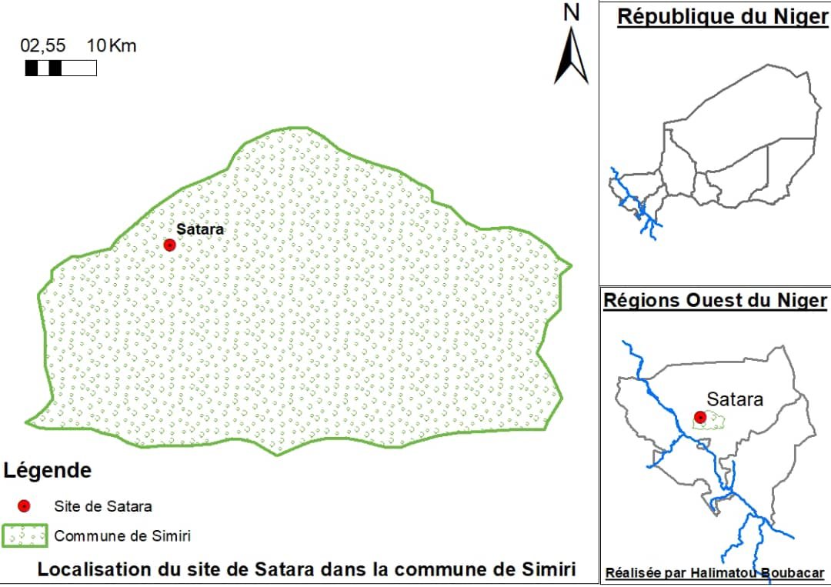
Figure 1: Location of the study area.
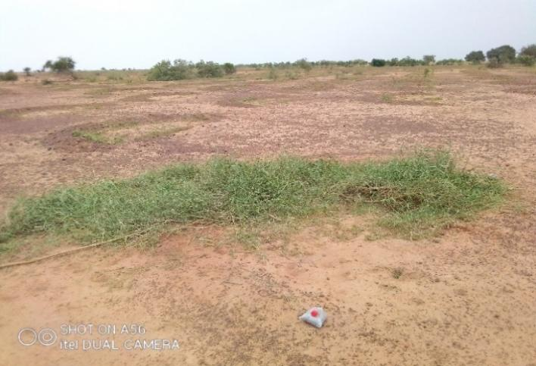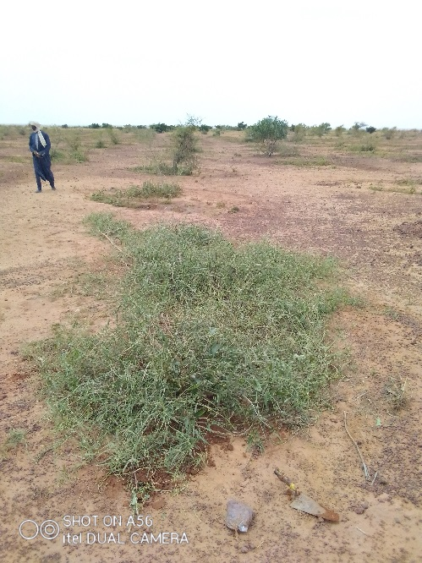
Figure 2 :Leptadeniahastata plants on the Satara site, three years after transplantation.
2.2. Soil and Root Sampling
Twenty (20) soil samples were collected from a depth of 20 cm at two distinct locations within the same site: ten samples from beneath Leptadeniahastata plants (hereafter referred to as “soils under Leptadenia”) and ten samples from unvegetated areas (hereafter referred to as “bare soils”). Sampling points were spaced 15 to 20 meters apart. Approximately 500 g of soil was collected from each of the ten rhizospheric soil samples. These subsamples were then mixed and homogenized to obtain one composite sample. The same procedure was applied to the ten bare soil samples.
The collected soil samples were air-dried under shelter, then stored in sterilized plastic bags. Root samples were also collected from the same locations as the Leptadenia soils, focusing exclusively on fine roots, as these are more suitable for microscopic observation. The collected roots were stored in numbered containers filled with GEW solution (Glycerol-Ethanol-Water). All soil and root samples were subsequently transported to the laboratory for analysis.

2.3. Physico-Chemical Characterization of Soils
Composite soil samples were analyzed at the Soil Science Laboratory of the Faculty of Agronomy, Abdou Moumouni University of Niamey, following standard analytical methods (Mathieu and Pieltain, 2003). The physico-chemical parameters determined, along with the corresponding analytical techniques, were as follows: Particle size distribution (five fractions) determined by the international pipette method of Robinson; Soil pH, measured electrometrically using a pH meter with a soil-to-water ratio of 1:2.5; Electrical conductivity, determined using a conductivity meter on a 1:5 soil-to-water extract; Exchangeable bases (Ca²⁺, Mg²⁺, K⁺, and Na⁺) and cation exchange capacity (CEC), extracted using ammonium acetate; Organic carbon, determined by the Walkley-Black method (1934); Total nitrogen, measured according to the Kjeldahl method; Total and available phosphorus, determined using the Bray 1 method (Bray and Kurtz, 1945).

2.4. Characterization of the Mycorrhizogenic Potential of Soils and Roots
2.4.1. Extraction, Enumeration, and Identification of Arbuscular Mycorrhizal Fungal Spores
The collected soil samples were analyzed at the Mycology Laboratory of the Higher Teachers’ Training College, Abdou Moumouni University of Niamey. Spore extraction was performed following the method of Walker (1982), which comprises three main steps:
1. Suspension preparation: A quantity of 100 g of soil was poured into a bucket filled to three-quarters with water and stirred for 10-15 seconds.
2. Sieving: The resulting suspension was passed successively through a series of five superimposed sieves with mesh sizes of 63 µm, 160 µm, 250 µm, 315 µm, and 630 µm, arranged from bottom to top.
3. Spore collection: The residues retained on each sieve were transferred into Petri dishes, mixed, and gently stirred.
The estimation of spore abundance was carried out under a stereomicroscope through direct counting. First, the number of viable spores contained in 1 ml of the supernatant was counted, and the total number was then extrapolated to the entire sample volume (10 ml).
The identification of spore genera was performed based on the morphological criteria proposed by Schenck and Smith (1982). Spores representing each morphotype were mounted between microscope slides and cover slips in a drop of a biochemical reagent, polyvinyl alcohol–lactic acid-glycerol (PVLG). Gentle pressure was applied on the cover slip to slightly crush the spores and rupture their wall, thereby enhancing visibility of internal structures. Identification was primarily based on spore size, pigmentation, surface ornamentation, wall structure, and suspensor hypha characteristics.

2.4.2. Detection and Evaluation of Root Association with Arbuscular Mycorrhizal Fungi
2.4.2.1. Detection of Root Infection
The detection of endomycorrhizal infection was performed through root staining, following the method of Phillips and Hayman (1970). For each Leptadeniahastata plant, thirty (30) root fragments approximately 1 cm in length were first washed with water and then soaked for 24 hours in a 10% potassium hydroxide (KOH) solution. The roots were subsequently bleached by adding a few drops of hydrogen peroxide (H₂O₂, 100 V) for 5 minutes, rinsed with distilled water, and acidified with 1% hydrochloric acid (HCl) for several minutes. After a final rinse with distilled water, the roots were stained with trypan blue for at least 24 hours at ambient temperature.
The assessment of mycorrhizal colonization intensity was conducted according to the scoring system developed by Trouvelot et al. (1986) (Figure 5.2). This system is based on a global evaluation of 10 root fragments. Each fragment was assigned a class score ranging from 0 to 5, corresponding to the estimated proportion of the root cortex colonized by the mycorrhizal symbiont. The presence of arbuscules and vesicles was simultaneously recorded.
Figure 3: Scoring system for evaluating the degree of mycorrhizal colonization (Trouvelot et al., 1986).
2.4.2.2. Evaluation of the Percentage of Natural Endomycorrhizal (AMF) Infection

To assess the mycorrhizal colonization parameters of the ten (10) root samples, thirty (30) root fragments of approximately one (1) cm in length from each stained root sample were selected, cut, and mounted between microscope slides and cover slips, at a rate of ten fragments per slide. Observations were made under a light microscope at magnifications of 100× and 400×. Each fragment was carefully examined along its entire length to detect the following mycorrhizal parameters:
Frequency of mycorrhization (F%): Defined as the proportion of mycorrhizal root fragments relative to the total number of fragments observed;
Intensity of mycorrhization (M%): Representing the extent of root fragments colonized by arbuscular mycorrhizal fungi (AMF);
Arbuscular content (A%): Indicating the proportion of root fragments colonized by arbuscules;
Relative arbuscular infection (a%): Representing the degree of infection within the endomycorrhizal portion of the fine roots.
2.5. Data Analysis
Analysis of variance (ANOVA) was employed to evaluate the chemical parameters of the two soil types. The statistical analyses were performed using the R software, version 3.2.4. Principal Component Analysis (PCA) was conducted to determine the correlations between spore genera and soil chemical parameters. The Mycocalc software was used to calculate the mycorrhizal parameters (F%, M%, and A%).
3. RESULTS
3.1. Physico-Chemical Parameters of Soils from the Satara Site
3.1.1. Physical Characteristics of the Soils from the Satara Site
The results of the physical analyses of the Satara site are presented in Table 1. They reveal a predominance of medium and fine sand fractions in both environments studied, with respective proportions of 23.83% and 29.97% in the bare soil, and 22.75% and 33.19% in the soil under Leptadeniahastata. These are followed by fine and coarse silt fractions, accounting for 12.64% and 17.75% in the bare soil, and 8.09% and 19.60% in the Leptadenia soil.
Clay and coarse sand fractions are less represented, ranging respectively from 8.18% to 7.63% and from 9.60% to 6.76% in the bare and Leptadenia soils. According to the international textural classification, the soils of Satara exhibit a sandy-loam texture.
Table 1: Physical parameters of Leptadeniahastata soils from the Satara site.
 | Particle size distribution %
 | C | FS | CSt | FS | MS | CS | TSt | TS
Référence | < 2µ | 2 µ à 20µ | 20 à 50µ | 50 à 200µ | 200 à 500µ | > 500µ | 2µ à50µ | 5à >500µ
Baresoil | 8,18 | 12,64 | 17,75 | 29,97 | 23,83 | 7,63 | 30, 39 | 61,43
LeptadeniaSoil | 9,60 | 8,09 | 19,60 | 33,19 | 22,75 | 6,76 | 27,69 | 62,7
C: Clay, FSt: Fine Silt, CSt: Coarse Silt, FS: Fine Sand, MS: Medium Sand, CS: Coarse Sand, TSt: Total Silt, TS: Total Sand
3.1.2. Chemical Characteristics of the Soils from the Satara Site
The results of the chemical analyses of the soils are presented in Table 2. These soils exhibit an acidic pH (4.8 ± 0.02 for the soil under Leptadenia and 4.2 ± 0.02 for the bare soil) and an electrical conductivity ranging from 30.50 μS/cm to 32.50 μS/cm. They are very poor in organic carbon, with values of 0.18% for the soil under Leptadenia and 0.14% for the bare soil.
The nitrogen content is 0.01% and 0.02% for the bare soil and the soil under Leptadenia, respectively, while the C/N ratios of 11.05 and 10.20 indicate a highly mineralized organic matter. The sulfur content is also higher in the soil under Leptadenia (9.54 meq/100 g) compared to the bare soil (8.10 meq/100 g).
The available phosphorus content is generally low, although slightly higher in the soil under Leptadenia. The cation exchange capacity (CEC) is low in both soils, with values around 11.25 and 11.75 meq/100 g.
The exchangeable bases, mainly dominated by calcium, magnesium, and potassium, are more abundant in the soil under Leptadenia than in the bare soil. Finally, the base saturation rate is higher in the soil under Leptadenia (0.82) than in the bare soil (0.72).
Table 2: Chemical parameters of Leptadeniahastata soils from the Satara site.
 | pH | EC 1/5 | TP | Avl P | C | OM | N | C/N | Ca²⁺ | Mg²⁺ | Na+ | K⁺ | S | CEC | S/T
Référence | 1/2,5 | µs/cm | Ppm |  | % |  |  |  | méq/100g
Bare soil | 4,25  ±0,02 | 30,50 ± 0,3 | 9,75  ±0,06 | 5,68  ±0,06 | 0,14  ±0,02 | 0,25  ±0,02 | 0,01  ±0 | 11,05  ±0 | 4,70  ±0,02 | 2,80  ±0,02 | 0,28  ±0,01 | 0,32 ±0,01 | 8,10  ±0,02 | 11,25  ± 0,03 | 0,72  ±0
Leptadenia  Soil | 4,85  ±0,02 | 32,50 ± 0,42 | 10,23 ±0,05 | 6,45  ±0,06 | 0,18  ±0,01 | 0,32  ±0,02 | 0,02 ± 0 | 10,20  ± 0 | 5,79  ±0,02 | 3,20  ±0,01 | 0,23  ±0,03 | 0,36  ±0,02 | 9,59  ±0,01 | 11 ,75  ± 0,01 | 0,82  ± 0
pH: potential of Hydrogen, EC: Electrical Conductivity, TP: Total Phosphorus, AvlP: Available Phosphorus, C: Carbon, OM: Organic matter, N: Nitrogen, Ca²⁺:Calcium Mg²⁺:Magnesium, Na+: Sodium,K⁺: Potassium, S: Bases Sum, CEC: Cation Exchange Capacity
The results of the analysis of variance (ANOVA) for the different chemical parameters of the Satara site are summarized in Table 5.3. This table reveals that the pH, electrical conductivity, and nitrogen content are higher in the soil under Leptadenia than in the bare soil, and these differences are highly significant at the 5% level.
Similarly, the total phosphorus and available phosphorus contents are higher in the soil under Leptadenia compared to the bare soil, and these differences are also highly significant at the 5% level. The cation exchange capacity, sulfur, and carbon contents are greater in the soil under Leptadenia, with these differences being significant at the 5% level.
The exchangeable bases viz. calcium, magnesium, and potassium are also higher in the soil under Leptadenia than in the bare soil. These differences are significant at the 5% level for potassium, and highly significant for calcium and magnesium.
The organic matter content is higher in the soil under Leptadenia than in the bare soil, and this difference is highly significant at the 5% level. However, the C/N ratio and sodium content are higher in the bare soil compared to the soil under Leptadenia; this difference is highly significant for sodium and very highly significant for the C/N ratio at the 5% level.
Table 3: Analysis of variance for the different chemical parameters of the Satara site
Parameters | Baresoil | Leptadeniasoil | P-value
pH | 4,25 ± 0,02 b | 4,85 ± 0,02 a | 0,000 ***
EC | 30,5 ± 0,3 b | 32,5 ± 0,42 a | 0,000 ***
TP | 9,75 ± 0,06 b | 10,23 ± 0,05 a | 0,000 ***
Avl P | 5,68 ± 0,06 b | 6,45 ± 0,06 a | 0,000 ***
C | 0,14 ± 0,02 b | 0,18 ± 0,01 a | 0,021 *
OM | 0,25 ± 0,02 b | 0,32 ± 0,02 a | 0,003 **
N | 0,01 ± 0 b | 0,02 ± 0 a | 0,000 ***
Ca²⁺ | 4,70 ± 0,06 b | 5,79 ± 0,02 a | 0,000 ***
Mg²⁺ | 2,8 ± 0,02 b | 3,2 ± 0,01 a | 0,000 ***
Na⁺  S  k⁺ | 0,28 ± 0,01 a  8,10 ± 0,02 b  0,32 ± 0,01 b | 0,23 ± 0,03 b  9, 59 ± a  0,36 ± a | 0,016 **  0,000 *  0,021*
CEC | 11,25 ± 0,03 b | 11,75 ± a | 0,000*
S | 0,72 ± 0 b | 0,82 ± 0 a | 0,000 ***
C/N | 11,05 ± 0 a | 10,2 ± 0 b | 0,000 ***

Meaning of the codes: ‘’ 0.001; ‘’ 0.01; ‘’ 0.05.
*: significant difference; **: highly significant difference; ***: very highly significant difference at the 5% threshold.
Within the same column, the letters (a) and (b) are used to classify the means into different groups, with (a) representing the higher mean and (b) the lower one.

3.2. Characteristics of the Mycorrhizal Potentialities of Soils and Roots
3.2.1. Number of Arbuscular Mycorrhizal Fungal Spores
The results concerning the number of arbuscular mycorrhizal fungal spores in the soils of the Satara site are presented in Table 4. The average number of spores per 100 grams of bare soil is 403, whereas that of the rhizospheric soils of Leptadenia hastata reaches 905 spores.
The results of the analysis of variance (ANOVA) indicate that this difference is very highly significant at the 5% level.
Table 4: Number of arbuscular mycorrhizal fungal spores in the Satara site by soil type
Types of Soil | Averagenumber of AMF propagules per 100g of soilP-value
BareSoil | 403 ± 18,30 b  0,000 ***
SLeptadeniaSoil | 905 ± 10,94 a

Meaning of the code: ‘***’ 0.001. *** denotes a highly significant difference at the 5% threshold.
Within the same column, the letters (a) and (b) are used to classify the means into distinct groups, with (a) representing the higher mean and (b) the lower one.
3.2.2. Identification and Density of Spore Genera Associated with Leptadeniahastata
Soil samples collected from the rhizosphere of Leptadeniahastata revealed, under a binocular stereomicroscope at high magnification, the presence of two genera of spores: Glomus (Photo 5.2 B) and Gigaspora(Photo 5.2 A), belonging respectively to the families Glomaceae and Gigasporaceae.Among these, the genus Glomus was the most abundant, with an average density of 652 spores per 100 g of soil, corresponding to 72.07% of the total spore population. In contrast, Gigaspora was less represented, with an average density of 253 spores per 100 g of soil, accounting for 27.93%. Figure 5.4 illustrates the relative density of these two fungal genera.
The size of the spores varied considerably, ranging from small to medium and large, depending on the mesh size of the five superimposed sieves used for separation: 63 μm, 160 μm, 250μm, 315 μm, and 630 μm.
The spores of the genus Glomus are most often spherical and, less frequently, ovoid. They exhibit a range of colors-ochre, yellow, grey, or black-and are characterized by a filament directly attached to the spore wall.
In contrast, the spores of the genus Gigaspora are solitary, spherical to ovoid, and typically black, brown, dark brown, ochre, or yellow in color. They differ morphologically from Glomus spores by the presence of a bulbous structure connecting the filament to the spore, which serves as a distinguishing diagnostic feature.
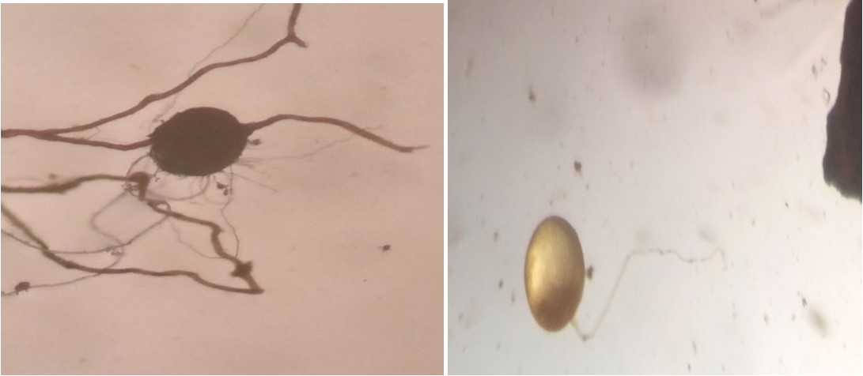
Figure 4: (A) Gigaspora- (B) Glomus (Source: Boubacar Halimatou)

Figure 5: Density of Glomus and Gigaspora spore genera in the soil beneath Leptadeniahastata
3.2.3. Degree of Natural Root Infection in Leptadeniahastata
Microscopic examination of the roots of Leptadeniahastata revealed that all analyzed root samples were colonized by arbuscular mycorrhizal fungi (AMF). Root staining with trypan blue revealed characteristic features of endomycorrhizal structures (Figure 5.4: A, B, C, and D). These mycorrhizal structures included intraradical hyphae (Figure 5.4 A) that spread within the intercellular spaces, form vesicles (Figure 5.4 B), and develop into intracellular arbuscules (Figure 5.4 D).
The mycorrhizal frequency (F%) reached 100% in all examined Leptadeniahastata roots, indicating a total colonization. The mycorrhizal intensity (M%) averaged 50.20% across all samples. The arbuscular content, estimated through the parameters A and a, varied among individual roots. The highest recorded A value was 29.9%, while the lowest was 5.42%. For a, the maximum value was 62.97%, and the minimum 12.02%. The mean values of A and a were 36.52% and 15.60%, respectively.
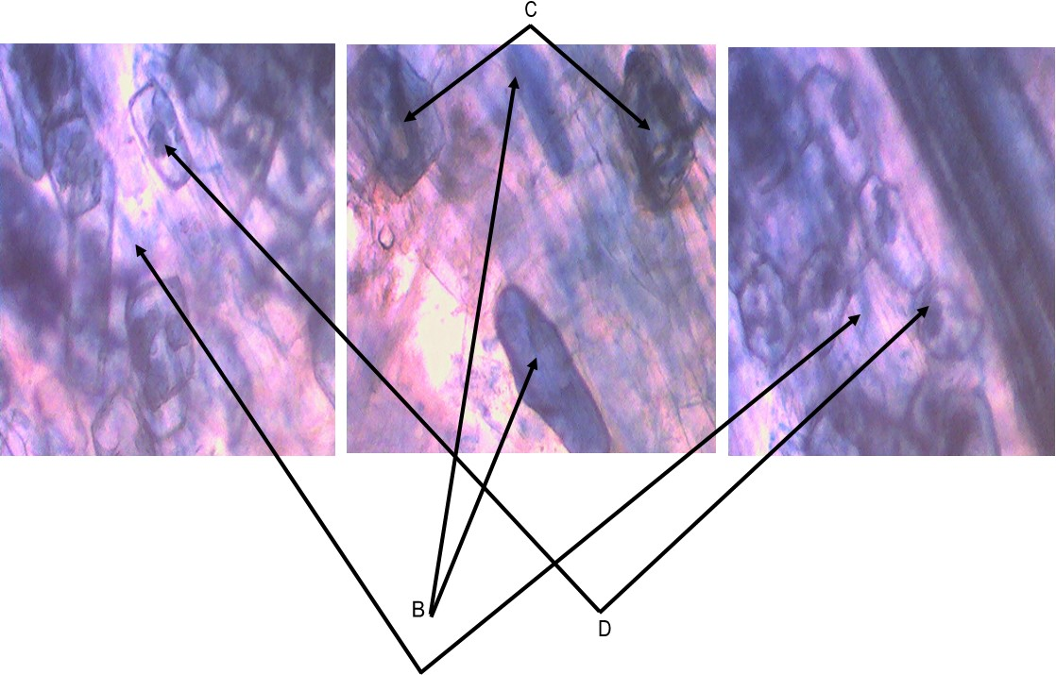
LEGEND
A. Hyphae (The legend A is not visble in the figure)
B. Vesicles
C. Vesicles developing into arbuscules
D. Arbuscules.

Figure 6: Characteristic structures of Leptadeniahastataendomycorrhizae
3.3. Relationships Between Chemical Parameters and Arbuscular Mycorrhizal Fungi (AMF)
The Principal Component Analysis (PCA) revealed a strong positive correlation between the two identified genera of arbuscular mycorrhizal fungi (Glomus and Gigaspora) and several soil chemical parameters (Figure 4).
Electrical conductivity and organic carbon showed a strong positive association with both Glomus and Gigaspora. Likewise, total phosphorus, available phosphorus, pH, sulfur content, cation exchange capacity (CEC), exchangeable base contents (calcium, nitrogen, and magnesium), base saturation rate, and organic matter exhibited a strong positive correlation with the Glomus genus, while maintaining a positive correlation with Gigaspora.
Conversely, the C/N ratio and sodium content were found to be negatively correlated with both fungal genera.
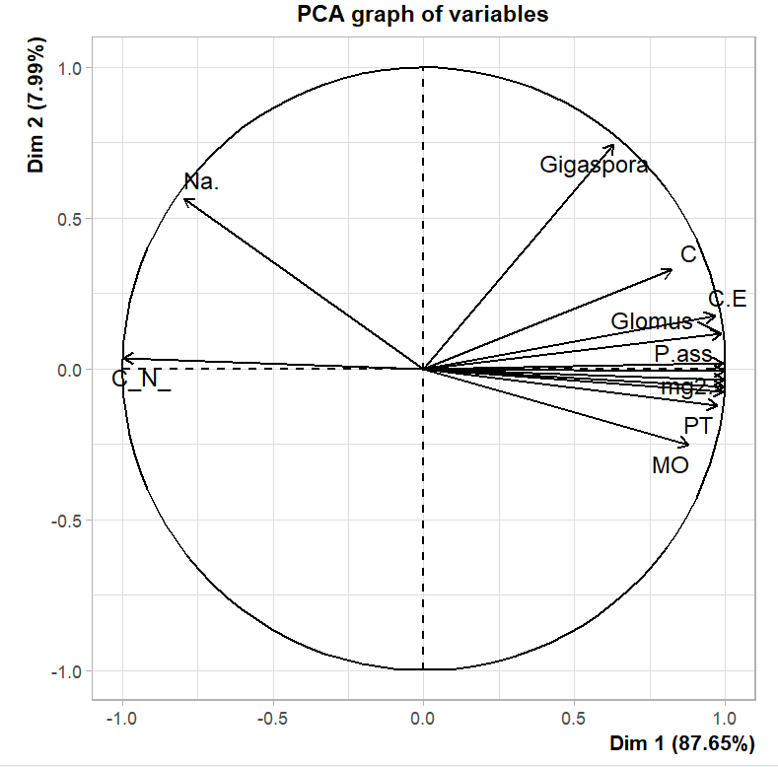
Figure 7: Correlations between soil chemical parameters and arbuscular mycorrhizal fungi

4. DISCUSSION
4.1. Spore Potential of Arbuscular Mycorrhizal Fungi (AMF) in the Satara Site Soils
At the Satara site, the number of spores in the soils associated with Leptadeniahastata was markedly higher than that observed in the bare soils. Specifically, the number of spores per 100 g of soil was 403 in the bare soil, while it reached 905 in the soil beneath Leptadeniahastata.
This clearly highlights the essential role of vegetation cover in promoting the proliferation of mycorrhizal propagules in soils.
4.2. Mycorrhizal Dependence of Leptadeniahastata
The AMF population collected from the Leptadeniahastatarhizospheric soils at the Satara site was composed of two genera, namely Glomus and Gigaspora. Among them, Glomus was the most abundant, with 652 spores per 100 g of soil, while Gigasporawas less represented, with 253 spores per 100 g of soil. The dominance of Glomus suggests that this fungal genus plays a crucial ecological role within this ecosystem.
Similar species compositions of AMF communities, dominated by Glomus spp., were reported by Abdoulaye (2013) in the same region (Sadoré). Comparable results were also observed by Stutz et al. (2000), who indicated that the genus Glomus is typically more representative than Gigaspora in arid and semi-arid ecosystems.
Microscopic examination of Leptadeniahastata roots revealed that this species is naturally colonized by AMF, reflecting its endomycotrophic nature. Leptadeniahastata possesses a mixed root system, consisting of deep taproots that penetrate the lower soil horizons and lateral roots that absorb surface water and nutrients. For optimal growth under harsh environmental conditions, the plant relies heavily on its fungal partners.
The 100% mycorrhizal frequency observed confirms the mycorrhizal dependence of this plant species. According to Gobat et al. (2003), certain plant species are incapable of normal growth without their fungal symbionts. Through its mycelium, the fungus explores the soil, absorbing mineral nutrients that it transfers to the plant, while in return, the plant supplies carbohydrates and lipids essential for fungal development and life cycle completion, establishing an obligate symbiosis (Keymer et al., 2017).
Moreover, fungal sporulation occurs in the soil or within roots, conferring enhanced biotic and abiotic stress resistance to the host plant (Fortin et al., 2015).
4.3. Improvement of Soil Quality under Leptadeniahastata
The physico-chemical analyses of the Satara soils revealed that they are sandy in texture, acidic in pH, and poor in essential nutrients a typical characteristic of arid and semi-arid soils (West et al., 1994). This nutrient deficiency reflects the overall infertility of the Satara soils, which in turn promotes mycorrhizal colonization of Leptadeniahastata. According to Hart et al., (2003), effective mycorrhizal functioning is often observed in nutrient-poor soils, where the host plant establishes symbiotic relationships to enhance nutrient acquisition through fungal partners.
The establishment of this symbiotic association also promotes the formation of soil aggregates, improving soil structure. The colonization of soil by extraradical mycelia and the production of glomalin by mycorrhizal hyphae contribute to the formation of more stable aggregates (Lovelock et al., 2004; Rilling & Mummey, 2006). According to Bearden and Petersen (2000), this stabilization mechanism results from the physical binding of soil particles by hyphae and roots, combined with polysaccharide exudation.
The enhancement and maintenance of soil aggregates lead to improved chemical properties (Tisdall, 1991). Indeed, comparative analyses between bare soils and soils beneath Leptadenia revealed a slight improvement in the chemical parameters of the latter. Notable increases were observed in organic matter, carbon, nitrogen, calcium, magnesium, sulfur, and potassium contents.
This improvement can be attributed to the ability of mycorrhizal fungi to decompose and mineralize organic matter, releasing nutrients that become available to the host plant (Gobat et al., 2003; Lambers et al., 2008). AMF are well known for their efficiency in enhancing ionic content and improving plant tolerance to both biotic and abiotic stresses (Meddichet al., 2015a; Meddichet al., 2015b; Oihabiet al., 1996; Meddichet al., 2000).
The total phosphorus content, initially 9.75 ppm in the bare soil, increased to 10.23 ppm in the soil beneath Leptadenia. Similarly, the available phosphorus content rose from 5.68 ppm to 6.45 ppm. Depending on soil pH, phosphorus is often immobilized by iron, aluminum, or calcium in forms that are poorly available to plants (Hinsinger, 2001). Native AMF possess the capacity to mobilize these insoluble forms of phosphorus, making them accessible to the host plant, thereby enhancing soil phosphorus availability (Gianinazzi-Pearson et al., 1988).
The most critical ecological role of AMF lies in their ability to mobilize nutrients with low soil mobility, particularly phosphorus, for plant uptake (Duponnoiset al., 2005; Lambers et al., 2008).

CONCLUSION
The study conducted at the Satara site in the rural commune of Simiri highlighted the presence of high mycorrhizal activity in the rhizosphere of Leptadeniahastata. Two spore genera were identified, namely Glomus and Gigaspora, with Glomus being the predominant genus. The observed 100% mycorrhizal frequency across all roots demonstrates the mycorrhizal dependence of this species and underscores its positive impact on the restoration of soil fertility in degraded areas of the Satara site, as well as on soil structural improvement.
Physico-chemical analyses comparing bare soils and soils under Leptadenia revealed higher concentrations of various chemical parameters in the latter. These soils exhibited a better base saturation and demonstrated significant organic matter degradation, indicating improved soil quality.
The study further revealed that the number of spores in soils beneath Leptadenia was higher than in bare soils. Indeed, the mycorrhizal symbiosis of Leptadeniahastata promoted a large number of mycorrhizal roots and AMF spores in the soil, thereby constituting a reservoir of propagules and a potential inoculum for trees to be transplanted at the site.
For the ecological restoration of degraded environments, the use of indigenous AMF from the local ecosystem is essential. It is therefore critical to isolate, identify, characterize, and propagate these fungi. However, large-scale production of AMF requires substantial resources. In this context, it would be more practical for developing countries to focus on sustainable management of native AMF, employing agronomic practices that respect both the environment and the integrity of these mycorrhizal communities.

REFERENCES
- ALI A., ABDOU L., DOUMA S., MAHAMANE A. & SAADOU M. (2016). Food-producingwoody plants in the rural communes of Tamou and Tondikiwindi:diversity and population structure’’, Journal of Animal & Plant Sciences. Vol. 31, Issue 1 4889 - 4900http://www.m.elewa.org/JAPS

- AZONTONDE H. A, (1993). Degradation and restoration of lateriticsoils (slightlydegradedclay-sandyferraliticsoils) in Benin. Conservation management of water, biomass and soilfertility (GCES), Orstom, Ser. Pedol., 28 (2) 217 ​​- 226https://horizon.documentation.ird.fr/exl-doc/pleins_textes/pleins_textes_6/colloques2/010009093.pdf

- BRAY R. H. & KURTZ L. T. (1945). “Determination of total, organic, and availableforms of phosphorus in soils”. Soil Science. Vol. 59. pp: 39-45.https://doi.org/10.1097/00010694-194501000-00006

- BEARDEN BN PETERSEN L., (2000). Influence of arbuscularmycorrhizal fungi on soil structure and aggregatestability of a vertisol. Plant Soil, 218: 173-183https://doi.org/10.1023/A:1014923911324

- BIELDERS C. L., ALVEY S. & CRONYN N. (2001). Wind erosion. "The perspective of grass-rootscommunities in the Sahel", Land DegradationDevelopment. Vol. 12. pp: 57 – 70https://doi.org/10.1002/ldr.424

- ABDOULAYE A. (2013). “Comparative study of the influence of sowingdensity on the mycorrhization of Bambara groundnut (Vignasubterranea L.), Lablabbean (Dolichoslablab L.) and Millet (Pennisetumglaucum L.) in soilfertility management” Abdou MoumouniUniversity of Niamey. 56 p.https://pmb.bibliotheques-niger.org/opac_css/index.php?lvl=notice_display&id=13956

- CARDOSO L.M, (2006). Mycorrhizas and tropical soilfertility. Agriculture, Ecosystems, Environment, vol.116. PP: 72-84.https://doi.org/10.1016/j.agee.2006.03.011

- Déziel M-H (2000). Influence of endomycorrhizal inoculation in the field on the yield and quality of potato (Solanum tuberosum L.). Laval University, Canada, Master of Science thesis, 112 p.

- Diallo A T (1998). Contribution to the taxonomic and ecologicalstudy of Glomales and the influence of mycorrhizationwith Glomus mosseae and Glomus versiforme on the growth and productivity of cowpea, Vignaunguiculata (L.) Walp. cultivatedunder water deficit conditions. 3rd cycle doctoral thesis in Plant Biology, UCAD, 113 p.

- DUPONNOIS R, COLOMBET A., HIEN V., THIOULOUSE,. (2005). “The Mycorrhizal fungus Glomus intraradices and rock phosphate amendment influence plant growth and microbialactivity in the rhizosphere of Acacia holosericea”. SoilBiology. Biochemistry. Vol. 3. Pphttps://doi.org/10.1016/j.soilbio.2004.09.016

- FAO (2003). Project to support foodsecurity, povertyalleviation and combatingsoildegradation in gum-producing countries. Project Document: Rome.
- FORTIN JA, PLENCHETTE C, PICHE Y (2015) The rise of the new green revolution. Quae.com. http://www.quae.com/fr/r4798-les-mycorhizes.html
- GIANINAZZI-PEARSON V., GIANINAZZI, S. SPRINGER-VERLAG, BERLIN. (1988). Deutschland 73–84: 1460-1468.
- GOBAT J.M., ARAGNO M., MATTHEY W. (2003). The Living Soil, 2nd Edition. Presses Polytechniques Universitaires Romandes, Lausanne, 568 p.https://www.cabidigitallibrary.org/doi/10.1079/CABICOMPENDIUM_20033067504

- HART M.M., READER R.J., KLIRONOMOS, J.N. (2003). “Plant coexistence mediated by arbuscularmycorrhizal fungi”. Trends in Ecology, Evolution, 18: 418-423.https://doi.org/10.1016/S0169-5347(03)00127-7

- HINSINGER P., (2001). Bioavailability of soilinorganic P in the rhizosphere as affected by root-inducedchemicalchanges: A review. Plant, Soil Vol. 23. pp: 173-195.https://doi.org/10.1023/A:1013351617532

- HUBER G. & SCHAUB C. (2011). Soilfertility: The importance of organicmatter. Chamber of Agriculture of Bas-Rhin. 46 p.https://agriculture-de-conservation.com/La-fertilite-des-sols-l-importance.html

- ICHAOU A. (2005). Capitalization of technical and methodologicaltoolsdeveloped by the PAFN for the management of the main forest formations in Niger. Natural Forest Management Project. Ministry of Hydraulics, Environment and the FightagainstDesertification of Niger: Niger; 1-56.

- MOUSSA M. B., RABIOU H., INOUSSA M. M., BAKASSO Y. & MAHAMANE A. (2015). “Bio-indicators of soilfertility and farmers' perception in Western Niger”. Journal of Applied Biosciences. vol 89. pp: 8281 – 8290.https://doi.org/10.4314/jab.v89i1.3

- BOUBACAR M. M., INOUSSA M. M., AMBOUTA K. J.-M., MAHAMANE A., JORGEN A. A., HARISSOU Y. & RABIOU H. (2013). “Characterization of woodyvegetation and surface crustorganizations of agroecosystems at different stages of degradation in the rural commune of Simiri”. Int. J. Biol. Chem. Sci., 7 (5) 1963 – 1975https://doi.org/10.4314/ijbcs.v7i5.15

- INS (2012), National Institute of Statistics, "Niger in figures:demographic data". JACOBSON K.M. (1997). Moisture and substratestabilitydetermine VA mycorrhizalfungalcommunity distribution and structure in aridgrassland. J. Arid Environ., 35 59–75.

- JANSEN P.C.M., (2004). Leptadeniahastata (Pers.) Decne. In:Grubben, G.J.H. Denton, O.A. (Editors). PROTA 2:Vegetables. [CD-Rom]. PROTA, Wageningen, Netherlands.https://uses.plantnet-project.org/en/Leptadenia_hastata_(PROTA)

- KAWA R. (2000). Trials on the propagation of L. hastata in a nursery, Experimental report, National Institute of AgronomicResearch of Niger, 10 p.

- LAGRANGE A. (2009). "Ecological and microbiologicalstudies of species of the genusCostularia (Cyperaceae) pioneeringultramaficsoils of New Caledonia: applications to ecologicalrestoration". University of New Caledoniahttps://www.theses.fr/2009NCAL0001

- LAMBERS H., RAVEN, J.A., SHAVER, G.R, SMITH, S.E. (2008). “Plant nutrient-acquisition strategies change withsoilage”. Trends in Ecology, Evolution, Vol .23. pp: 95-103 New Phytologist, 171: 41-53https://doi.org/10.1016/j.tree.2007.10.008

- LANDEWEERT R., HOFFLAND E., FINLAY R.D., KUYPER T.W, VAN BREEMEN N. (2001). “Linking plant to rocks:ectomycorrhizal fungi mobilizenutrientsfromminerals”. Trends in Ecology, Evolution, Vol.16. pp: 248-255.https://doi.org/10.1016/S0169-5347(01)02122-X

- LARWANOU M, ABDOULAYE M, REIJ C. (2006). « Le Etude de la Régénération Naturelle Assistée dans la Région de Zinder (Niger) une Première Exploration d’un Phénomène Spectaculaire ». United States Agency for International Development, USAID/EGAT, https://www.formad-environnement.org/RNA_Zinder_USAID, 56 p.https://www.formad-environnement.org/RNA_Zinder_USAID

- LOVELOCK C.E., WRIGHT S.F., CLARK D., A RUESSR W. (2004). “Soil stocks of glomalinproduced by arbuscularmycorrhizal fungi across a tropical rainforestlandscape”. Journal of Ecology, Vol. 92. pp: 278-287.https://doi.org/10.1111/j.0022-0477.2004.00855.x

- MATHIEU C, PIELTAIN F. (2003). Analyze Chemistry of Sols. TEC. & DOC ; 387p.https://www.eyrolles.com/Sciences/Livre/analyse-chimique-des-sols-9782743006204

- MEDDICH A., AIT EL MOKHTAR .M ., WAHBI., S, BOUMEZZOUGH A. (2017). «Evaluation of the potential of mycorhizogènes in line with the physico-chemicalparameters of the palm trees of Morocco (Marrakech and Tafilalet)». Cah. Agric. Vol. 26: 45012https://doi.org/10.1051/cagri/2017044

- MEDDICH A., JAITI F., BOURZIK W., EL ASLI ., A. HAFIDI M. (2015a). Ski Horti. Vol. 192 pp: 468-474.https://doi.org/10.1016/j.scienta.2015.06.024

- MEDDICH A., OIHABI A., JAITI F., BOURZIK W., HAFIDI M. (2015b). Can. J. Bot .V. 93. pp: 369-377https://doi.org/10.1139/cjb-2014-0249
- MEDDICH A., OIHABI A., ABBAS Y., BIZID E. (2000). Agronomy, Vol. 20. pp: 283-295.https://doi.org/10.1051/agro:2000103
- MOUSSA M. B., RABIOU M « Management of fertility of the sun » Université Abdou Moumouni de Niamey/ FA. 56 P

- NOUHOU KOUTCHA M, (2016). “Hydrological modeling of zaïplanting pit for rainwaterharvesting in agroforestryschemes for schemes for climate change adaptation in the Sudano-Sahelian Zone of Niger”. Kwame NkkrumahUniversity of Science and Technology, Kumasi, Ghana.https://wascal-academia.org/handle/123456789/100

- OIHABI A., MEDDICH A. (1996). « Cahiers Agricultures ». Vol. 5. pp: 382-386.https://doi.org/10.1051/cagri/199605050382
- OUMAROU D.H, (2007). « Adaptation of agriculture to climaticchanges: Cas du département de Téra au Niger du développement africain ». Mémoire de Master. Université Senghor d'Alexandrie, Egypte.

- Pasieczni N. &Reij C. (2021). « Restoration of the arid lands of Africa. » Tropenbos International, Ede, Pays-Bas. viii + 292 pp (Titre original en anglais : RestoringAfricanDrylands)https://www.regreeningafrica.org/wp-content/uploads/2020/12/ETFRN-News-60-Restoring-African-Drylands.pdf
- PDC SIMIRI (2016), Comité d'élaboration du PDC de la Commune Rurale de Simiri 2017-2021, 143p.

- RECA (2013). La Petite Jachère/ une Technologie essayée au Niger Réseau national des Chambres d’Agriculture de Niger Note d’information Réseau national des Chambres d’Agriculture de Niger Note d’information.https://reca-niger.org/spip.php?article100
- RILLING, M.C., MUMMEY D.L. (2006). Mycorrhizas and soil structure.https://doi.org/10.1111/j.1469-8137.2006.01750.x

- SADHANA B, (2014). ArbuscularMycorrhizal Fungi (AMF) as a Bio-fertilizer. Review International Journal of CurrentMicrobiology and Applied Sciences, Vol.3.N°4.pp:384-400.http://www.ijcmas.com/

- STUTZ J.C., COPEMAN R., MARTIN C.A. & Morton J.B. (2000). “Patterns of species composition and distribution of arbuscularmycorrhizal fungi in aridregions of southwestern North America and Namibia”. Afr. Can. J. Bot.vol 78. pp: 237–245.https://doi.org/10.1139/b99-183

- TIDJANI D., AMBOUTA K. J-M. & BILEDERS C-L. (2009). Rehabilitation of a living dune by mechanicalfixation:oil flow, sunfertility and herbaceousbiodiversity. Géo-Eco-Trop.Vol.33. pp : 81 - 98https://www.geoecotrop.be/index.php/geoecotrop/issue/view/33

- TISDALL J.M. (1991). “Fungalhyphae and structural stability of soil”. Aust. J. Soil Res.,29: 729-743https://doi.org/10.1071/SR9910729

- TRAORE K., HIEN F. & HIEN V. (2003). Durability of the existing system in the northern zone of Burkina Faso:Study of the flow of organicmaterials in the exploitation and management of agricultural production. Symposium Niamey “Sustainable Dry Land Agriculture System”.

- TROUVELOT A, KOUGH J.L, GIANINAZZI V. (1986). «Mesure de taux de mycorrhization VA d'un système radiculaire. Search for estimatingmethods for a meaningfulmeaning ». In physiological and genetic aspects of mycorhizical, V. Gianinazzi-Pearson et S. Gianinazzi). (edit), INRA, Paris. pp. 217-221.https://www.cabidigitallibrary.org/doi/10.1079/9780851985622.0000

- VAN DER HEIJDEN M.G.A., BOLIER T., WWMKEN, A., SANDERS I. R. (1998). “Differentarbuscularmycorrhizalfungalspecies are potentialdeterminants of plant community structure”. Ecology, vol 79: 2082-2091.https://doi.org/10.1890/0012-9658(1998)079[2082:DAMFSA]2.0.CO;2

- WALIGORA C. & VIAN J-F. (2010). Relations racines et sole un monde de communication et d'équilibres pp. 18-27-
- WALKER C. (1982). “Systematics and taxonomy of arbuscularendomycorhizal fungi (Glomales) a possible wayforward”. Elsevier/INRA. Agronomy12:887-897.https://doi.org/10.1051/agro:19921026

- WALKLEY A. & BLACK A. (1934). “An examination of the Degtjareffmethod for determiningsoilorganicmatter and a proposed modification of the chromicacid titration method”. SoilSci. 37 : 29 – 38 https://doi.org/10.1097/00010694-193401000-00003

- WARNER A., MOSSE B. (1982). Factorsaffecting the spread of vesicularmycorrhizal fungi in soil. New Phytologist. Vol. 90. pp: 529-536.https://doi.org/10.1111/j.1469-8137.1982.tb04485.x

- WEST N.E., STARK J.M., JOHNSON D.W., ABRAMS M.M., WIGHT J.R. HEGGEM D.,PECK S. (1994). Effects of climatic change on the edaphiccharacteristics of arid and semi-aridd lands of Nwestern North-America. AridSoilRes. Rehabil.Vol.8.N°4. pp : 307-351.

