Original Research Article
Histidine Rich Protein 2-Based Malaria Rapid Diagnostic Testing in sentinel sites of Gabon: Impact of Epidemiological Context and Microscopy Capacity

.
ABSTRACT

Introduction: Rapid diagnostic tests (RDTs) that detect the histidine-rich protein 2 (HRP2) antigen are fundamental to malaria diagnosis in sub-Saharan Africa. However, their diagnostic performance can vary depending on the epidemiological context and healthcare setting. This study aimed to evaluate the performance of HRP2-based RDTs in sentinel sites across Gabon, and to identify factors associated with positive test results.
Methods: A cross-sectional study was conducted among 447 patients recruited from multiple sentinel sites. Light microscopy of Giemsa-stained thick blood films was used as the reference standard. Malaria prevalence, diagnostic performance indicators (sensitivity, specificity, positive and negative predictive values, and overall accuracy) and discrepancies between diagnostic methods were estimated. Univariate and multivariable logistic regression analyses were performed to identify factors independently associated with HRP2-RDT positivity.
Results: Malaria prevalence was 32.2% according to microscopy and 43.4% according to the HRP2-RDT. The overall sensitivity of the RDT was 84%, with substantial variability between sites, ranging from 66% in Melen to 100% in Mouila. Specificity also varied substantially, reaching 95% in Melen and decreasing to 58% in Oyem. The positive and negative predictive values were 66% and 89%, respectively, giving an overall diagnostic accuracy of 79%. Among patients with a negative HRP2-RDT result, 10.7% had a malaria infection confirmed by microscopy. The overall discordance rate between the two diagnostic methods was 21%, primarily observed in Oyem and Moanda. Multivariable analysis revealed that patients attending health facilities in Mouila, Oyem and Bitam had a significantly higher likelihood of testing positive by HRP2-RDT than those in Melen.
Conclusion: The diagnostic performance of HRP2-based RDTs varied significantly across sentinel sites. These findings highlight the need for cautious interpretation of RDT results and for strengthening diagnostic capacities, particularly microscopy, within malaria surveillance systems in Gabon.

Keywords: Malaria, RDT, sensitivity, specificity, discordance, Gabon

1. INTRODUCTION

Malaria remains a significant public health issue worldwide, particularly in sub-Saharan Africa, where the highest rates of morbidity and mortality related to the disease are found (WHO, 2024). According to the World Health Organisation (WHO), the region accounts for around 95% of malaria cases and deaths, with the greatest impact being felt by children and adolescents living in areas of intense transmission. Despite progress through integrated malaria control strategies implemented since 2000, malaria remains endemic in Central African countries, including Gabon, where transmission is perennial and heterogeneous (Mawili-Mboumba et al., 2013; Moutombi-Ditombi et al., 2020; Ndong Ngomo et al., 2023).
In Gabon, the National Malaria Control Programme (NMCP) is implementing various malaria control strategies, including intermittent preventive treatment with sulfadoxine–pyrimethamine for pregnant women, artemisinin-based combination therapy (ACT) for uncomplicated malaria cases, and the widespread distribution of long-lasting insecticide-treated nets.
Parasitological confirmation is fundamental to both the clinical management of malaria and its epidemiological surveillance. Light microscopy, the reference method, enables both parasite detection and quantification of parasitaemia (Moody, 2002).
However, its use remains limited in peripheral health facilities due to the need for skilled personnel, appropriate equipment and continuous quality control (WHO, 2024). To overcome these constraints, malaria rapid diagnostic tests (RDTs) have been widely deployed and currently represent the most commonly used diagnostic tool in many endemic countries. This is in line with international recommendations that treatment should only be given after parasitological confirmation(WHO, 2010).
Following policy changes in malaria control, the increased use of RDTs has substantially contributed to reducing malaria-related mortality, which declined from approximately 806,000 deaths in 2003 to 589,000 in 2023 (WHO, 2025).
Most RDTs used in Africa are based on the detection of histidine-rich protein 2 (HRP2), which is specific to Plasmodium (P.) falciparum. A 2011 study conducted at the sentinel site of Centre Hospitalier Universitaire de Libreville showed that the Acon® HRP2 test exhibited 96.6% specificity and a relatively low false-positive rate of 9.3% (Bouyou Akotet et al., 2013). While several studies conducted in Libreville and Melen have demonstrated the good sensitivity and specificity of HRP2-based RDTs (Bouyou Akotet et al., 2013; Moutombi-Ditombi et al., 2020), their diagnostic performance may be compromised by various factors. These include low parasitaemia, user errors, inadequate storage conditions and the emergence of P. falciparum parasites harbouring hrp2 and hrp3 gene deletions. These genetic deletions are becoming increasingly prevalent in several African regions and may result in false-negative HRP2-RDT results. This raises concerns about the reliability of the diagnosis and the effectiveness of surveillance strategies that rely heavily on these tools (Agaba et al., 2024; Kong et al., 2021; Niyukuri et al., 2022).
In Gabon, malaria remains a major cause of paediatric consultations and hospital admissions, with transmission intensity varying across urban, semi-urban and rural settings. Previous data reported malaria prevalence of 17 %, 34–36 % and 48 % in Franceville, Melen and Bitam, respectively (Imboumy-Limoukou et al., 2023; Mawili-Mboumba et al., 2025; Ndong Ngomo et al., 2023). Higher prevalence rates have been reported among children, with a median age of 5 years, reaching up to 71 % in certain settings (Ndong Ngomo et al., 2025).
Although RDTs are widely used in healthcare facilities and the national malaria surveillance system, data comparing diagnostic discrepancies between RDTs and microscopy under routine field conditions is scarce. This is a significant public health concern as it can lead to the mismanagement of individual cases, an inaccurate estimation of malaria prevalence and compromised surveillance data quality, which is used to inform national malaria control policies. The aim of this study was to evaluate the sensitivity and specificity of the ACON RDT, as well as the rate of discordance between the RDT and microscopy, in the context of malaria epidemiological surveillance and strengthening the diagnostic capacities of lab technician in the sentinel sites in Gabon.

2. methodology

2.1. Study design
A prospective analytical study was conducted from February to December 2023 at sentinel sites operating under the supervision of the Department of Parasitology–Mycology and Tropical Medicine (SPMET), University of Health Sciences (USS), Gabon.

2.2. Study setting and sites
The study was carried out in five sentinel sites, which were selected according to their level of malaria endemicity. The Centre "Hospitalier Régional de l’Estuaire Melen" (CHREM) is an urban healthcare facility located in Libreville, in the Estuaire province (0.4220° N, 9.4910° E), situated approximately 11 km from the centre of Libreville. The "Centre de Santé de Mouanda" (CSM) is situated in a rural mining area in Haut-Ogooué Province (1.5667° S, 13.2640° E), approximately 950 km from Libreville. The "Centre Hospitalier Régional d’Oyem" (CHRO), located in Woleu-Ntem Province (1.6167° N, 11.5833° E), is in a semi-urban area, around 470 km from Libreville. The "Centre Hospitalier Régional de Mouila" (CHRM) is situated in a rural area corresponding to a small town in Ngounié Province (1.8510° S, 11.0300° E), approximately 550 km from Libreville. Finally, the "Hôpital Départemental de Bitam" (HDB) is located in the northern part of the country, in the Woleu-Ntem province (2.0710° N, 11.4910° E) and represents a rural border setting approximately 650 km from Libreville. The distances between the study sites ranged from 470 to 950 km, providing coverage of diverse geographical profiles and epidemiological contexts, including urban, semi-urban, and rural settings. This distribution ensured broad national representativeness of malaria surveillance in Gabon.
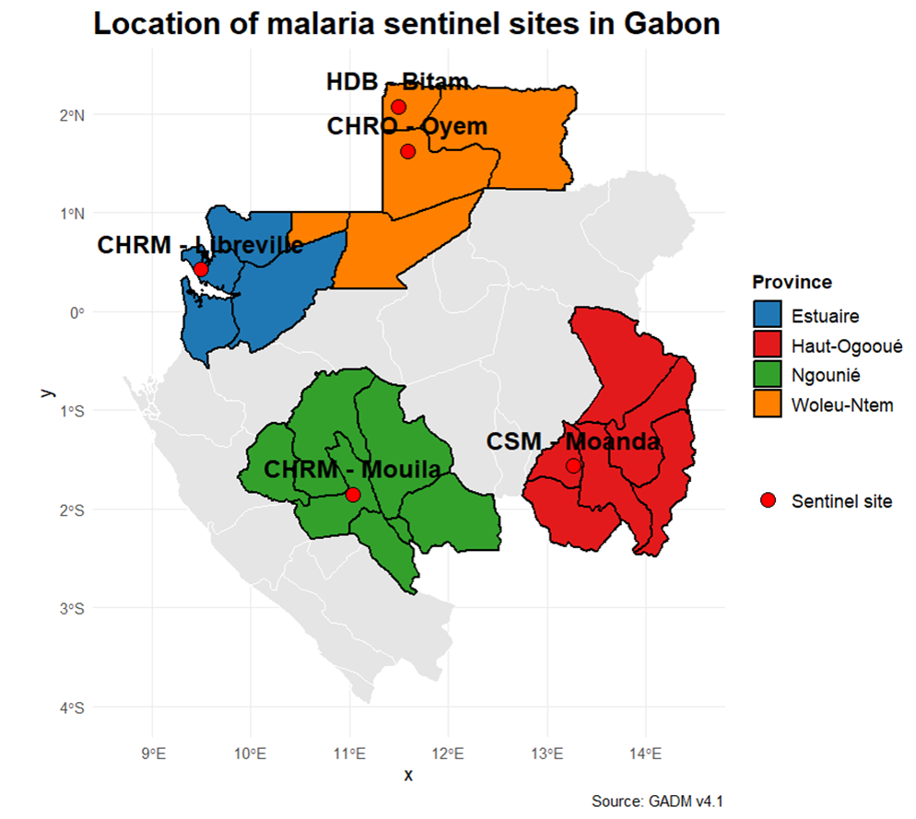
Map 1: Mapping of malaria sentinel sites in Gabon

2.3. Study population

The study population consisted of febrile children and adolescents (axillary temperature ≥ 37.5 °C) or individuals with a history of fever, aged under 20 years of age, who attended sentinel health facilities for clinical suspicion of malaria.

2.4. Sample size determination

The minimum sample size was determined to ensure a precise estimation of the proportion of discordance between RDT and microscopy. The calculation was performed using the standard formula for estimating a proportion in an analytical study, where n represents the minimum sample size, Z the critical value corresponding to a 95% confidence interval (Z = 1.96), p the prevalence of malaria, and d the desired precision.
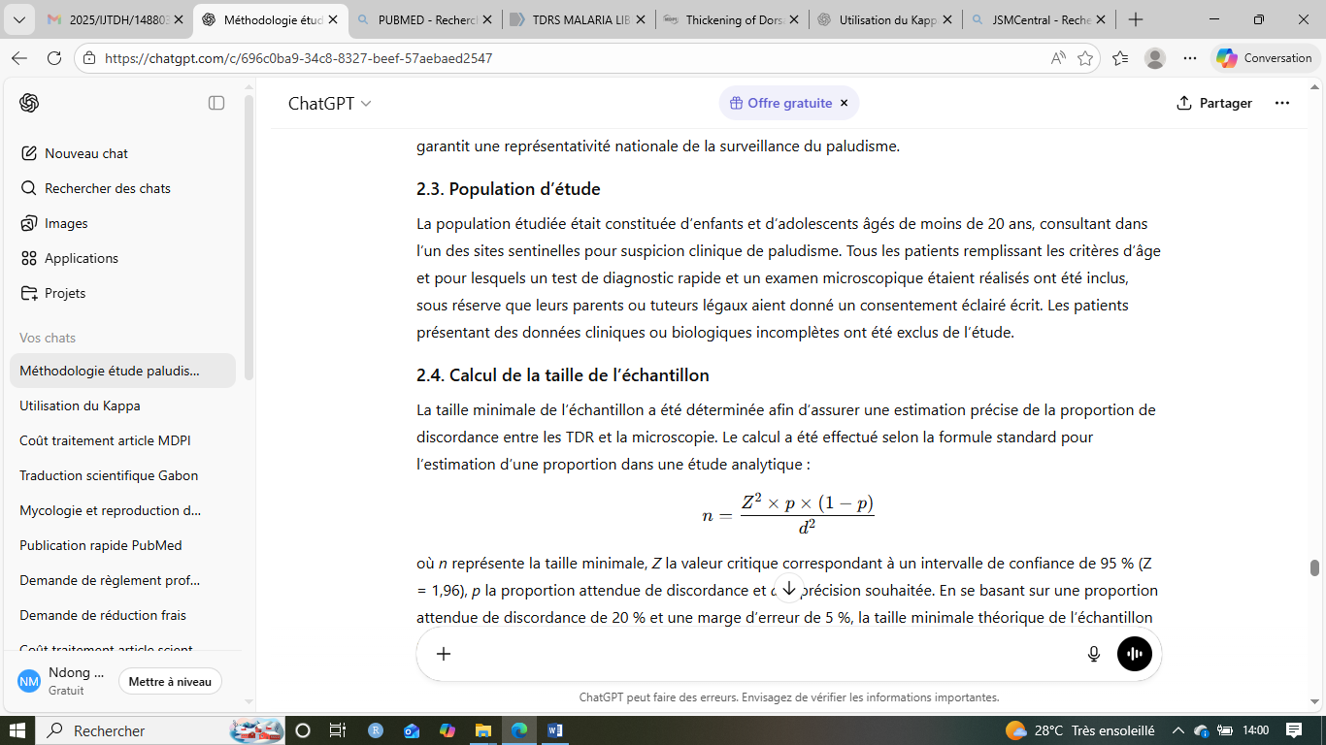
Based on an expected discordance proportion of 20% and a margin of error of 5%, the theoretical minimum sample size was estimated at 246 participants. This number was subsequently increased to account for secondary exclusions, missing data and inter-site heterogeneity. The final sample size therefore corresponded to the total number of patients consecutively enrolled across the five sentinel sites during the study period.

2.5. Screening
Parents or legal guardians of children were invited to provide written informed consent, and assent was obtained from adolescents aged over 12 years. Once consent was obtained, a pre-tested structured questionnaire was administered to collect sociodemographic, clinical and epidemiological data. The questionnaire covered sociodemographic characteristics (sex, age, level of education and occupation), malaria prevention methods, and history of fever.
Axillary temperature was measured using an electronic thermometer, and fever was defined as a body temperature ≥ 37.5 °C.

2.6. Malaria diagnostic procedures
Two milliliters (2 mL) of venous blood were collected from each child using sterile single-use syringes. Drops of whole blood were immediately applied to RDT using the manufacturer’s applicator and onto glass slides for the preparation of thick and thin blood films.

2.6.1. Microscopic diagnosis

Thick blood films were prepared using the Lambaréné method, which allows estimation of parasitaemia. For each patient, 10 µL of blood were used for the thick film and 2 µL for the thin film. After air-drying, slides were stained with 20% Giemsa for 10 minutes, rinsed and dried prior to examination under a microscope using a ×100 oil-immersion objective (Planche et al., 2001).
Parasite quantification was performed based on the number of microscopic fields examined on the thick film and the identification of asexual parasite stages (trophozoites and schizonts). Parasitaemia was expressed as parasites/µL (Planche et al., 2001). A double reading by an expert WHO-validated microscopist carried out a double reading at the Melen sentinel site, while a locally experienced microscopist carried out a double reading at the other sites. Data were recorded in case report forms prior to statistical analysis.

2.6.2. ACON® malaria rapid diagnostic test

The ACON® Malaria Pf/Pan rapid diagnostic test (ACON Laboratories Inc., San Diego, CA, USA) is an immunochromatographic assay intended for the in vitro diagnosis of Plasmodium infection. It enables qualitative detection of the HRP2 antigen specific to Plasmodium falciparum and the pan–lactate dehydrogenase (pLDH) antigen common to other human-infecting Plasmodium species (P. vivax, P. ovale and P. malariae).
Each ACON® Malaria Pf/Pan kit (Ref L031-1091, Lot: MALPA3060003) contained 25 individually sealed test cassettes, a buffer solution vial, 25 sterile single-use lancets, disposable capillary pipettes and 70% alcohol swabs for skin disinfection. The test has a shelf life exceeding 12 months and recommended storage conditions between 2 °C and 30 °C, in accordance with the manufacturer’s instructions.
The test device consists of a nitrocellulose membrane pre-coated with capture bands comprising monoclonal antibodies directed against P. falciparum HRP2 antigen and pan-pLDH antigen, as well as an internal control band ensuring test validity. The antibodies are conjugated to a colourimetric tracer, typically colloidal gold, allowing direct visual interpretation of results.
Each ACON® cassette was labelled with a unique code corresponding to the study participant and the associated microscopy slide. Approximately 5 µL of venous whole blood were dispensed into the sample well using the provided pipette, followed by the addition of two drops (≈60 µL) of buffer. The test was left at room temperature, and results were read after 15–20 minutes, in accordance with the manufacturer’s recommendations.
A result was considered negative when only the control band was visible. The presence of two bands, corresponding to the control band and the HRP2 band, was interpreted as P. falciparum infection. The appearance of the pan-pLDH band, with or without the HRP2 band, indicated infection with another Plasmodium species or a mixed infection. Any test lacking a control band was considered invalid and repeated.

2.9. Ethical considerations
In Gabon, the Ministry of Health, represented by the National Malaria Control Programme (NMCP), mandated the Department of Parasitology–Mycology and Tropical Medicine of the Faculty of Medicine of Libreville to monitor malaria prevalence and antimalarial drug resistance in sentinel surveillance sites. Approval for data publication was obtained from the NMCP. Adolescents and parents or guardians of children attending the sentinel sites were informed of the purpose of data use for public health and research purposes. In this context, patients and parents or guardians of participating children were informed of the activities conducted at the sentinel sites, and written informed consent was obtained. Children aged over 12 years provided their assent to participate in the study. The study was conducted in accordance with the principles of the Declaration of Helsinki and formed part of the national malaria surveillance framework.

3. results

A total of 447 patients were screened. Microscopic and immunological diagnosis using the HRP2-based rapid diagnostic test (HRP2-RDT) revealed a plasmodial infection prevalence of 32.2% (144/447) and 43.4% (194/447), respectively (Figure 1).
447 Patients screened
Microscopy

TDR-HRP2

133 P. falciparum infections
134 P. falciparum infections
59 P. falciparum infections + Pan
6 co-infections P. falciparum + P. malariae
2 Pan
1 co-infection P. falciparum + P. ovale

213 Negatives
2 P. ovale infections

1 P. malariae infections

251 Negatives

Figure 1: Study profile

3.1. Characteristics of population
A total of 447 patients were included in the study (Table 1). The median age was 11 years [3 – 31]. More than three quarters of the patients presented with hyperthermia (> 37.5 °C) (87%; 318/447). All patients from Moanda and almost all patients from Melen, Mouila and Oyem were febrile, whereas approximately 30% (89/157) of patients from Bitam were afebrile.
The median parasitaemia was 5,620 parasites/µL [420 – 35,000]. Parasitaemia levels were highest in Mouila (17,150 parasites/µL), followed by Bitam (13,825 parasites/µL) and Oyem (11,200 parasites/µL). The proportion of patients with a parasitaemia below 200 parasites/µL was 3.5 times lower than that of patients with a parasitaemia above 200 parasites/µL.
Table 1 : General characteristics of the study population
Characteristics | CHRM-MELEN (n=108) | HDB-BITAM  (n=157) | CSM-MOANDA  (n=46) | CHRM-MOUILA  (n=43) | CHRO-OYEM  (n=93) | Overall
 |  |  |  |  |  | 447
Median age (IQR), (year) | 2 [1 - 6] | 21 [6-42] | 14 [3 - 25] | 16 [6 - 32] | 19 [9 - 33] | 11 [3 - 31]
Men, % (n/N) | 29 (57/108) | 34 (65/157) | 12 (23/46) | 7.2 (14/43) | 18 (35/93) | 43 (194/447)
Fever at admission, %, (n/N) | 98 (104/108) | 70 (98/157) | 100 (46/46) | 90 (35/43) | 97 (35/93) | 71 (318/447)
Median parasitaemia (IQR), parasites p/µL | 700 [70 - 3220] | 13825 [1330 - 67200] | 1640 [115- 17473] | 17150 [2450 - 33600] | 11200 [1540 - 42000] | 5620 [420 - 35000]
Parasitaemia <200p/µL, %, (n/N) | 41 (12/29) | 17 (10/59) | 35 (7/20) | 5.0 (1/20) | 12% (2/17) | 22 (32/145)
Parasitaemia ≥200p/µL, %, (n/N) | 59 (17/29) | 83 (49/59) | 65 (13/20) | 95 (19/20) | 88% (15/17) | 78 (113/145)
CHRM : Centre Hospitalier Régional de l’Estuaire Melen, HDB : Hopital Départemental de Bitam, CSM : Centre de Santé de Mouanda, CHRO : Centre Hospitalier Régional d’Oyem, IQR : [25% - 75%]

3.2. Concordance

Among the 223 patients who tested negative with the RDT, 10.7% (24/223) had a confirmed Plasmodium infection (Table 3).

Table 2 : Overall frequency of cross-referenced results between RDTs and microscopy
 | Microscopy-Positive | Microscopy-Negative | Overall
RDT-positive, % (n/N) | 66.1 (123/186) | 33.9 (63/186) | 100 (186/186)
RDT-negative, % (n/N) | 10.7 (24/223) | 85.3 (199/233) | 100 (223/223)

3.3. Diagnostic performance of the ACON RDT
The results from the sentinel sites showed an overall sensitivity of 84%. Sensitivity reached 100% in Mouila (95% CI: 83–100) and was high in Bitam (93%; 95% CI: 84–98), whereas it was lower in Melen (66%; 95% CI: 46–82). By contrast, test specificity was highest in Melen (95%; 95% CI: 86–99) and lowest in Oyem (58%; 95% CI: 45–69).
The overall positive predictive value (PPV) was 66%, with the highest value observed in Mouila (100%) and a high PPV in Melen (86%). The overall negative predictive value (NPV) was estimated at 89%, with a lower value in Melen (74%) compared with the other sites. The overall diagnostic accuracy of the test was 79%, being higher in Mouila (95%) and Melen (85%).

Table 3: RDT validity to diagnose Plasmodium falciparum malaria according to sentinel sites
Indicator | CHREM-MELEN | HDB-BITAM | CMM-MOANDA | CHRM-MOUILA | CHRO-OYEM | Overall
Sensitivity % (CI 95%) | 66 (46-82) | 93 (84-98) | 71 (48-89) | 100 (83-100) | 78(52-94) | 84 (77-89)
Specificity % (CI 95%) | 95 (86-99) | 74 (63-82) | 81 (58-95) | 89 (67-99) | 58 (45-69) | 76 (70-81)
PPV % (CI 95%) | 86 (65-97) | 70 (58-79) | 79 (54-94) | 91 (71-99) | 32 (19-48) | 66 (59-73)
NPV % (CI 95%) | 85 (74-93) | 94(86-98) | 74 (52-90) | 100(89-100) | 91(79-98) | 89 (84-93)
Overall diagnostic accuracy (CI 95%) | 85(76-92) | 81(74-87) | 76 (61-88) | 95(83-99) | 62(51-72) | 79 (74-83)
PPV: positive predictive value, CI: confidence interval, NPV: negative predictive value, CHRM : Centre Hospitalier Régional de l’Estuaire Melen, HDB : Hopital Départemental de Bitam, CSM : Centre de Santé de Mouanda, CHRO : Centre Hospitalier Régional d’Oyem

3.4. Frequency of discordances
The frequency of negative concordance between the rapid diagnostic test (RDT) and microscopy was 49% (123/409), with a higher value observed in Melen (64%; 57/89). The proportion of HRP2 false positives was 15.0% (63/409), being lower in Melen (3.4%; 3/89) and Mouila (5.1%; 2/39), but higher in Oyem.
The overall discordance rate between the two diagnostic methods was 21% (87/409). Discordances were highest in Oyem (38.0%; 34/89), followed by Moanda (24.0%; 10/42) and Bitam (19.0%; 28/50), whereas they were significantly lower in Mouila (5.1%; 2/39) and Melen (15.0%; 13/89).

Table 4 : Discordance and concordance rates between RDT and microscopy results
Results | CHREM-MELEN  N = 108¹ | HDB-BITAM  N = 157¹ | CSM-MOANDA  N = 46¹ | CHRM-MOUILA  N = 43¹ | CHRO-OYEM  N = 93¹ | Overall  N = 447¹
Positive concordance, % (n/N) | 21 (19/89) | 37 (55/150) | 36 (15/42) | 51 (20/39) | 16.0 (14/89) | 30.0 (123/409)
Negative concordance, % (n/N) | 64 (57/89) | 45 (67/150) | 40 (17/42) | 44 (17/39) | 46.0 (41/89) | 49.0 (199/409)
HRP2 false positives, % (n/N) | 3.4 (3/89) | 16 (24/150) | 9.5 (4/42) | 5.1 (2/39) | 34.0 (30/89) | 15.0 (63/409)
HRP2 false negatives, % (n/N) | 11.0 (10/89) | 2.7 (4/150) | 14 (6/42) | 0.0 (0/39) | 4.5 (4/89) | 5.9 (24/409)
Overall discordance, % (n/N) | 15 (13/89) | 19 (28/150) | 24 (10/42) | 5.1 (2/39) | 38.0 (34/89) | 21.0 (87/409)
CHRM : Centre Hospitalier Régional de l’Estuaire Melen, HDB : Hopital Départemental de Bitam, CSM : Centre de Santé de Mouanda, CHRO : Centre Hospitalier Régional d’Oyem

3.5. Logistic Regression Analysis
Taking Melen as the reference, multivariate analysis indicated that patients at Mouila, Oyem, and Bitam had significantly higher odds of testing positive by RDT, with adjusted odds ratios of 5.09 (95% CI: 2.17–12.4), 5.0 (95% CI: 2.09–12.5), and 3.38 (95% CI: 1.76–6.66), respectively. At Moanda, an elevated risk was observed in univariate analysis only.

Table 5: Logistic regression model examining factors associated with malaria RDT positivity
Characteristic | Prevalence by RDT |  |  | Univariate regression |  |  | Multivariate regression
Characteristic | Prevalence by RDT, % (n/N) | Overall  N = 425¹ | p-value² | OR | 95% CI | p-value | OR | 95% CI | p-value
Gender |  |  | 0.8
Women | 46 (108/236) | 100% (236/236) | Reference
Men | 45 (81/181) | 100% (181/181) |  | 0.96 | 0.65, 1.42 | 0.8 | 1.05 | 0.67- 1.66 | 0.8
Age groupe (in year) |  |  | 0.093
˂ 5 | 40 (51/129) | 100% (129/129) | Reference
≥ 5 | 48 (137/283) | 100% (283/283) |  | 1.44 | 0.94, 2.20 | 0.094 | 1.13 | 0.67- 1.92 | 0.6
Fever (Temperature ≥ 37°C) |  |  | 0.2
Yes | 46 (138/299) | 100% (299/299) | Reference
No | 55 (27/49) | 100% (49/49) |  | 1.43 | 0.78, 2.65 | 0.2 | 0.91 | 0.46-1.82 | 0.8
Sentinel sites |  |  | <0.001
CHRM-MELEN | 25 (22/89) | 100% (89/89) | Reference
HDB-BITAM | 53 (83/157) | 100% (157/157) |  | 3.42 | 1.95, 6.17 | <0.001 | 3.38 | 1.76- 6.66 | <0.001
CSM-MOANDA | 42 (19/45) | 100% (45/45) |  | 2.23 | 1.04, 4.80 | 0.040 | 2.07 | 0.94- 4.62 | 0.072
CHRM-MOUILA | 58 (25/43) | 100% (43/43) |  | 4.23 | 1.97, 9.33 | <0.001 | 5.09 | 2.17-12.4 | <0.001
CHRO- OYEM | 49 (45/91) | 100% (91/91) |  | 2.98 | 1.60, 5.69 | <0.001 | 5.00 | 2.09, 12.5 | <0.001

CI = Confidence Interval, OR = Odds Ratio

4. DISCUSSION

This study evaluated the diagnostic performance of the ACON® Malaria Pf/Pan rapid diagnostic test (RDT), which detects the HRP2 antigen for Plasmodium falciparum and pLDH for non-falciparum species, across five sentinel sites in Gabon, compared with microscopy. The results highlight a marked inter-site variability in RDT performance, underscoring the combined influence of epidemiological context, parasite density, and local operational conditions on diagnostic effectiveness.
The prevalence of Plasmodium infection estimated by HRP2-based RDT (43.4 %) was higher than that obtained by microscopy (32.2 %). This overestimation is widely reported in African studies and is mainly attributed to the persistence of HRP2 in the blood for several days to weeks after effective treatment, leading to false-positive results (Shiff et al., 1993; WHO, 2023). Comparable findings were reported by Ning Teh et al. in Cameroon, who observed a significantly higher prevalence estimated by HRP2-based RDT (47 %) compared with microscopy (31 %), particularly in areas of perennial transmission (Ning Teh et al., 2019). The authors highlighted that this discordance reflects recent exposure rather than active infection, limiting the interpretation of RDTs as indicators of true prevalence (Moutombi-Ditombi et al., 2020). Similar observations have been made in the Democratic Republic of Congo, Tanzania, and Ghana (Cunningham et al., 2019; Maltha et al., 2014).
The overall sensitivity observed in this study (84 %) meets the minimal thresholds recommended by the WHO for operational use of RDTs in sub-Saharan Africa (WHO, 2022). High sensitivities at Mouila (100 %) and Bitam (93 %) corresponded to high median parasitaemia in these sites, confirming the close relationship between parasite density and HRP2-RDT performance (Ning Teh et al., 2019). These results align with studies conducted in health centres and communities in DRC and Cameroon, reporting sensitivities of 95–98 % and 97 %, respectively (Christian et al., 2025; Ilombe et al., 2014). Conversely, lower sensitivity at Melen may be explained by a higher proportion of low-density infections (<200 parasites/µL) or frequent self-medication with antimalarials (Mawili-Mboumba et al., 2025; Mihindou et al., 2024).
HRP2-RDT specificity was heterogeneous, with a high value at Melen (95 %) and a markedly lower value at Oyem (58 %), likely reflecting differences in transmission intensity and recent antimalarial exposure. These data are consistent with findings from DRC, where community specificity was higher (75 %) compared to health centre specificity (58 %) (Ilombe et al., 2014). Conversely, studies in Senegal, a country with seasonal transmission, reported specificity of 94 %, suggesting that malaria risk and local epidemiology may influence test specificity (Diallo et al., 2017) Furthermore, studies in Uganda and Ghana showed that HRP2 false positives were more frequent in highly endemic areas, reducing positive predictive value (PPV) (Ansah et al., 2013; Kyabayinze et al., 2008). The overall moderate PPV (66 %) and high negative predictive value (NPV, 89 %) reinforce the role of microscopy as the first-line diagnostic tool, as recommended by WHO (WHO, 2025).
At Oyem, the low PPV (32 %) suggests that a substantial proportion of RDT-positive patients did not have microscopically detectable infections. In high-transmission areas, such as Oyem and Bitam, HRP2 persistence after treated infection may result in residual positive RDTs, reflecting recent exposure rather than active infection. Frequent or recent antimalarial use without parasitological confirmation may also artificially inflate RDT positivity.
False negatives occurred in 10.7 % of RDT-negative patients, a clinically concerning proportion. Comparable rates have been reported in Côte d’Ivoire, Senegal, and Cameroon, especially in early or low-density infections (< 200 parasites/µL) (Gaye et al., 2020; Ning Teh et al., 2019; Ouattara et al., 2014).
Multivariate analysis identified the sentinel site as an independent factor associated with RDT positivity. Higher odds at Mouila, Oyem, and Bitam suggest that RDT positivity reflects not only active infection but also local transmission intensity and diagnostic practices. Similar findings in Cameroon demonstrated that recruitment site was a major determinant of HRP2-RDT positivity, independent of microscopy results, highlighting the importance of local context in result interpretation (Ning Teh et al., 2019).
Key study limitations include the lack of molecular analyses for Pfhrp2/Pfhrp3 deletions, reliance on microscopist expertise, incomplete data on recent antimalarial use, and variable sample sizes across sites.
Beyond the intrinsic performance of rapid diagnostic tests, the quality of reference microscopy remains a major determinant of diagnostic accuracy, as it relies heavily on the competence of microscopists, the standardisation of procedures, and local working conditions. Although considered the gold standard, microscopy may show reduced sensitivity in the presence of low parasite densities, suboptimal slide preparation, or high workload. The inter-site variability observed in this study suggests that differences in microscopy competence contributed to the heterogeneity of diagnostic performance. Melen, used as the reference site, exhibited high specificity, reflecting strong parasitological identification skills and a robust capacity to exclude false-positive results. The lower sensitivity observed at Melen is more likely attributable to a higher proportion of low-density infections rather than technical limitations. In contrast, the marked discordance observed at Oyem, characterised by a low positive predictive value and high RDT positivity, indicates a priority need for capacity strengthening in microscopy, particularly for the detection of low-density parasitaemia. The high performance observed at Mouila and Bitam suggests more consistent microscopy expertise, which could serve as a foundation for inter-site mentorship activities and for harmonising diagnostic quality at the national level.

5. Conclusion
HRP2-RDT performance varies significantly across sentinel sites. These findings underscore the need for cautious interpretation of RDTs and strengthened diagnostic capacity, particularly microscopy, within malaria surveillance systems in Gabon, such as CHRO.

Consent

It is not applicable.

Ethical approval

In Gabon, the Ministry of Health, represented by the National Malaria Control Programme (NMCP), mandated the Department of Parasitology–Mycology and Tropical Medicine of the Faculty of Medicine of Libreville to monitor malaria prevalence and antimalarial drug resistance in sentinel surveillance sites. Approval for data publication was obtained from the NMCP. Adolescents and parents or guardians of children attending the sentinel sites were informed of the purpose of data use for public health and research purposes. In this context, patients and parents or guardians of participating children were informed of the activities conducted at the sentinel sites, and written informed consent was obtained. Children aged over 12 years provided their assent to participate in the study. The study was conducted in accordance with the principles of the Declaration of Helsinki and formed part of the national malaria surveillance framework.

COMPETING INTERESTS DISCLAIMER:
Authors have declared that they have no known competing financial interests OR non-financial interests OR personal relationships that could have appeared to influence the work reported in this paper.

References

Agaba, B.B., Nankabirwa, J.I., Yeka, A., Nsobya, S., Gresty, K., Anderson, K., Mbaka, P., Prosser, C., Smith, D., Opigo, J., Namubiru, R., Arinaitwe, E., Kissa, J., Gonahasa, S., Won, S., Lee, B., Lim, C.S., Karamagi, C., Cheng, Q., Nakayaga, J.K., Kamya, M.R., 2024. Correction: Limitations of rapid diagnostic tests in malaria surveys in areas with varied transmission intensity in Uganda 2017–2019: Implications for selection and use of HRP2 RDTs. PLOS ONE 19, e0304728. https://doi.org/10.1371/journal.pone.0304728
Ansah, E.K., Reynolds, J., Akanpigbiam, S., Whitty, C.J., Chandler, C.I., 2013. “Even if the test result is negative, they should be able to tell us what is wrong with us”: a qualitative study of patient expectations of rapid diagnostic tests for malaria. Malar J 12, 258. https://doi.org/10.1186/1475-2875-12-258
Bouyou Akotet, M.K., Mawili-Mboumba, D.P., Madoungou, B., Kombila, M., 2013. Performances des tests de dépistage rapide du paludisme Pf /Pan Acon® ( Pf HRP2/pan aldolase) et Pf HRP2 pour le diagnostic du paludisme chez les adultes et les enfants vivant au Gabon, en Afrique centrale . Diagnostic Microbiology and Infectious Disease 77, 58–63. https://doi.org/10.1016/j.diagmicrobio.2013.05.007
Christian, M., Ekawati, L.L., Pratama, A.R., Cahyaningati, S., Bere, H.K., Rustam, M., Kalbuadi, I., Andini, J., Yuliana, J., Fadilah, I., Ley, B., Thriemer, K., Price, R.N., Sutanto, I., Baird, J.K., 2025. Evaluation of CareStartTM malaria HRP2/pLDH (Pf/PAN) combo rapid diagnostic test for diagnosis of Plasmodium falciparum infection in malaria co-endemic areas in association with parasite density. Malar J 24, 39. https://doi.org/10.1186/s12936-025-05276-y
Cunningham, J., Jones, S., Gatton, M.L., Barnwell, J.W., Cheng, Q., Chiodini, P.L., Glenn, J., Incardona, S., Kosack, C., Luchavez, J., Menard, D., Nhem, S., Oyibo, W., Rees-Channer, R.R., Gonzalez, I., Bell, D., 2019. A review of the WHO malaria rapid diagnostic test product testing programme (2008–2018): performance, procurement and policy. Malar J 18, 387. https://doi.org/10.1186/s12936-019-3028-z
Diallo, M.A., Diongue, K., Ndiaye, M., Gaye, A., Deme, A., Badiane, A.S., Ndiaye, D., 2017. Evaluation of CareStartTM Malaria HRP2/pLDH (Pf/pan) Combo Test in a malaria low transmission region of Senegal. Malar J 16, 328. https://doi.org/10.1186/s12936-017-1980-z
Gaye, S., Kibler, J., Ndiaye, J.L., Diouf, M.B., Linn, A., Gueye, A.B., Fall, F.B., Ndiop, M., Diallo, I., Cisse, M., Ba, M., Thwing, J., 2020. Proactive community case management in Senegal 2014–2016: a case study in maximizing the impact of community case management of malaria. Malar J 19, 166. https://doi.org/10.1186/s12936-020-03238-0
Ilombe, G., Maketa, V., Mavoko, H.M., da Luz, R.I., Lutumba, P., Van geertruyden, J.-P., 2014. Performance of HRP2-based rapid test in children attending the health centre compared to asymptomatic children in the community. Malar J 13, 308. https://doi.org/10.1186/1475-2875-13-308
Imboumy-Limoukou, R.K., Lendongo-Wombo, J.B., Nguimbyangue-Apangome, A.F., Biteghe Bi Essone, J.-C., Mounioko, F., Oyegue-Libagui, L.S., Ngoungou, B.E., Lekana-Douki, J.-B., 2023. Severe malaria in Gabon: epidemiological, clinical and laboratory features in Amissa Bongo Hospital of Franceville. Malar J 22, 88. https://doi.org/10.1186/s12936-023-04512-7
Kong, A., Wilson, S.A., Ah, Y., Nace, D., Rogier, E., Aidoo, M., 2021. HRP2 and HRP3 cross-reactivity and implications for HRP2-based RDT use in regions with Plasmodium falciparum hrp2 gene deletions. Malar J 20, 207. https://doi.org/10.1186/s12936-021-03739-6
Kyabayinze, D.J., Tibenderana, J.K., Odong, G.W., Rwakimari, J.B., Counihan, H., 2008. Operational accuracy and comparative persistent antigenicity of HRP2 rapid diagnostic tests for Plasmodium falciparum malaria in a hyperendemic region of Uganda. Malar J 7, 221. https://doi.org/10.1186/1475-2875-7-221
Maltha, J., Guiraud, I., Kaboré, B., Lompo, P., Ley, B., Bottieau, E., Geet, C.V., Tinto, H., Jacobs, J., 2014. Frequency of Severe Malaria and Invasive Bacterial Infections among Children Admitted to a Rural Hospital in Burkina Faso. PLOS ONE 9, e89103. https://doi.org/10.1371/journal.pone.0089103
Mawili-Mboumba, D.P., Akotet, M.K.B., Kendjo, E., Nzamba, J., Medang, M.O., Mbina, J.-R.M., Kombila, M., MCORU team, 2013. Increase in malaria prevalence and age of at risk population in different areas of Gabon. Malaria Journal 12, 3. https://doi.org/10.1186/1475-2875-12-3
Mawili-Mboumba, D.P., Batchy Ognagosso, F.B., M’Bondoukwé, N.P., Ndong Ngomo, J.M., Moutombi Ditombi, B.C., Agbanrin, A.A., Nymane, T., Pongui Ngondza, B., Moutongo Mouandza, R., Mihindou, C.J., Mabika Moussavou, D.A., Mbang Nguema, O.A., Bouyou-Akotet, M.K., 2025. Hospital attendance, malaria prevalence and self-medication with an antimalarial drug before and after the start of COVID-19 pandemic in a sentinel site for malaria surveillance in Gabon. Malaria Journal 24, 28. https://doi.org/10.1186/s12936-025-05272-2
Mihindou, C.J., Ditombi, B.C.M., Mabicka, D.A.M., Temoazango, F.V., Ognagosso, F.B.B., Nguema, O.A.M., Ngomo, J.M.N., M’bondoukwe, N.P., Mboumba, D.P.M., Akotet, M.K.B., 2024. La Fréquence de l’automédication aux antipaludiques et impact sur les caractéristiques du paludisme au Gabon. Revue Marocaine de Santé Publique 11.
Moody, A., 2002. Rapid Diagnostic Tests for Malaria Parasites. Clinical Microbiology Reviews 15, 66–78. https://doi.org/10.1128/cmr.15.1.66-78.2002
Moutombi-Ditombi, B.C., Minko, J.I., Tsamba, R.P., Ngomo, J.M.N., Nymane, T., Ognagosso, F.B.B., M’bondoukwe, N.P., Mawili-Mboumba, D.P., Akotet, M.K.B., 2020. Comparative performance of four malaria rapid diagnostic tests, Vikia Malaria Pf/Pan, Meriline-Meriscreen Pf/Pv/Pan, Right Sign Malaria Pf/Pan, and Right Sign Malaria Pf, among febrile patients in Gabon. Rev Soc Bras Med Trop 53, e20190274. https://doi.org/10.1590/0037-8682-0274-2019
Ndong Ngomo, J.M., Mawili-Mboumba, D.P., M’Bondoukwé, N.P., Ditombi, B.M., Koumba Lengongo, J.V., Batchy Ognagosso, F.B., Bouyou-Akotet, M.K., 2023. Drug Resistance Molecular Markers of Plasmodium falciparum and Severity of Malaria in Febrile Children in the Sentinel Site for Malaria Surveillance of Melen in Gabon: Additional Data from the Plasmodium Diversity Network African Network. Trop Med Infect Dis 8, 184. https://doi.org/10.3390/tropicalmed8040184
Ndong Ngomo, J.M., Mihindou, C.J., Ndong Mouity, J.T., Moussavou Mabika, D.A., Moutom-Ditombi, B.C., Mbang Nguema, O.A., Angoune Ndong, D.C., Oyono, F., Koumba, T., M’bondoukwe, N.P., Bouyou Akotet, M.K., Mawili-Mboumba, D.P., 2025. IDENTIFICATION DES BIOMARQUEURS INFLAMMATOIRES POUR LA DISCRIMINATION DES PATIENTS ATTEINTS DU PALUDISME GRAVE ET ÉVOLUTION DES BIOMARQUEURS HÉMATOLOGIQUES CHEZ LES ENFANTS FÉBRILES PRISES DANS LES CONDITIONS DE DIAGNOSTIC DE ROUTINE DANS LES SITES SENTINELLES AU GABON. Revue Bio-Africa, © EDUCI 2025 18–28.
Ning Teh, R., Sumbele, I.U.N., Asoba Nkeudem, G., Meduke, D.N., Ojong, S.T., Kimbi, H.K., 2019. Concurrence of CareStartTM Malaria HRP2 RDT with microscopy in population screening for Plasmodium falciparum infection in the Mount Cameroon area: predictors for RDT positivity. Trop Med Health 47, 17. https://doi.org/10.1186/s41182-019-0145-x
Niyukuri, D., Sinzinkayo, D., Troth, E.V., Oduma, C.O., Barengayabo, M., Ndereyimana, M., Holzschuh, A., Vera-Arias, C.A., Gebre, Y., Badu, K., Nyandwi, J., Baza, D., Juma, E., Koepfli, C., 2022. Performance of highly sensitive and conventional rapid diagnostic tests for clinical and subclinical Plasmodium falciparum infections, and hrp2/3 deletion status in Burundi. PLOS Global Public Health 2, e0000828. https://doi.org/10.1371/journal.pgph.0000828
Ouattara, A.F., Dagnogo, M., Olliaro, P.L., Raso, G., Tanner, M., Utzinger, J., Koudou, B.G., 2014. Plasmodium falciparum infection and clinical indicators in relation to net coverage in central Côte d’Ivoire. Parasites Vectors 7, 306. https://doi.org/10.1186/1756-3305-7-306
Planche, T., Krishna, S., Kombila, M., Engel, K., Faucher, J.F., Ngou-Milama, E., Kremsner, P.G., 2001. Comparison of methods for the rapid laboratory assessment of children with malaria. Am J Trop Med Hyg 65, 599–602. https://doi.org/10.4269/ajtmh.2001.65.599
Shiff, C., Premji, Z., Minjas, J.N., 1993. Le test manuel rapide ParaSight®-F . Un nouvel outil de diagnostic pour Plasmodium falci parum infection. Transactions of the Royal Society of Tropical Medicine and Hygiene 87, 646–648.
WHO, 2025. World malaria report 2025 [WWW Document]. World health organization. URL https://www.who.int/publications/i/item/9789240117822 (accessed 1.21.26).
WHO, 2024. World malaria report 2024 (Rapport Annuel).
WHO, 2023. World malaria report 2023 [WWW Document]. URL https://www.who.int/publications/i/item/9789240086173 (accessed 10.31.25).
WHO, 2022. World malaria report 2022 (Rapport Annuel). World Health Organization.
WHO, 2010. World Malaria Report 2010 [WWW Document]. URL https://www.who.int/publications/i/item/9789241564106 (accessed 10.31.25).

