Flexible Statistical Trend Modelling of a Forty-Year Malaria Mortality in Ghana.

Abstract
Malaria is a public health issue that has continued to be a significant challenge in Ghana despite decades of continuous control interventions. This paper aimed to measure the nonlinear dynamics of age-standardised malaria mortality in Ghana over the long run and to overcome the statistical constraints of past trend analyses, which are based on linear or segmented models and do not account for uncertainty in burden estimates. Its goals were to describe sex-specific mortality patterns, determine multi-phase temporal regimes, and generate uncertainty-constrained inference on policy evaluation. Based on the standardised age-specific malaria mortality between 1980 and 2023 in Ghana, using the Global Burden of Disease, a generalised additive model with inverse-variance weighting was estimated to fit nonlinear time curves and adjust for sex disparities. The smooth TV was essential, and the degrees of freedom were 11.07 and F = 270.35 (p < .001). 96.65% of the deviance was explained by the model, which had an adjusted R² of 0.963. The death rates between females were also significantly lower than those of males (B = -9.31, SE = 0.99, p =.001), with both-sexes series falling between them. The highpoint of mortality was in the early 2000s, when it was close to 130-140 deaths per 100,000, and then reduced to 55-65 per 100,000 by 2023. This study presents a nonlinear modelling framework that is more robust and better than the linear trend methods employed in earlier studies. The conclusions favour long-term ITN and case management coverage, the incorporation of climate-informed early warning systems, and enhancements to mortality surveillance to accelerate the goal of malaria elimination under SDG 3.
Keywords: Age standardised death rates, Nonlinear trend analysis, Generalised additive model, Uncertainty aware modelling, Sex specific disparities.
Introduction
Malaria is one of the most endemic health concerns in sub-Saharan Africa, and Ghana is still registering a heavy burden of infections despite decades of control efforts (Oladipo et al., 2022; Sarfo et al., 2023; Sarpong et al., 2022; Alum et al., 2025; Mawuli et al., 2025). It is a complex interplay between climatic, environmental, socio-economic, and health system factors that leads to the spread of the disease by the bite of the infected female Anopheles mosquito. The tropical climate, seasonal rains, and the large mosquito breeding areas make Ghana conducive to continued transmission (Sabtiu et al., 2025; Yamba et al., 2025; Akorli et al., 2025). Children below the age of five years and pregnant women are the most vulnerable groups, whereas the malaria mortality impacts all age groups and both sexes (Okova et al., 2025; Adum et al., 2023; Mbishi et al., 2024).
Ghana has adopted several malaria control measures over the last 40 years, including insecticide-treated bed nets, indoor residual spraying, intermittent preventive treatment during pregnancy, rapid diagnostic tests, and artemisinin-based combination therapy (Abu Bonsra et al., 2025; Yeboah et al., 2023; Afagbedzi et al., 2023). Such interventions have also led to some decline in malaria morbidity and mortality. Nevertheless, there has not been a steady advancement. Periods of revival have been documented in a number of periods, usually associated with climatic variability, insecticide resistance, limitations in the health system, and shifts in funding cycles.
The national and global malaria surveillance systems, with reference to the Global Burden of Disease programme, come up with long-term estimates of the prevalence of malaria mortality with uncertainty threshold (Joseph et al., 2022; Sirimatayanant et al., 2023; Cao et al., 2022; Kagoro et al., 2025; Bashir et al., 2025). Such data sets offer the potential for robust trend analysis over long time scales. Understanding the nonlinear temporal dynamics of malaria mortality is needed to understand past intervention effectiveness, the times when policies have helped change the situation, and future malaria eradication efforts.
Although high-quality longitudinal data on malaria burden in Ghana are available, most analyses rely on descriptive summaries and simple linear trend models (Barimah et al., 2025; Oppong et al., 2025; Oheneba-Dornyo et al., 2022). These methods are weak at identifying nonlinear mortality cycles, regime shifts, and the effects of policy periods. A flexible modelling framework is, therefore, needed to reflect the actual temporal mapping of malaria mortality and other interventions to aid evidence-based decision-making in public health.
In sub-Saharan Africa, malaria is one of the most frequent causes of avoidable deaths (Abdulzeid et al., 2025; Kolawole et al., 2023; Sarpong et al., 2022; Nketiah-Amponsah et al., 2025). According to the estimates by the World Health Organisation, Africa is where more than 90 per cent of all people dying of malaria live; West Africa also occupies a significant position (Shin et al., 2024; Sankineni et al., 2023; World Health Organisation, 2022). The research on the Global Burden of Disease estimates that malaria mortality rates decreased considerably during 2000-2015 due to the scaled-up, deliberate measures to control vectors and to effectively treat the disease. Nevertheless, this has started to decrease since 2016, and some countries have recorded stagnation or a reversal of gains (Patouillard et al., 2023; Katushabe et al., 2024; Lawal et al., 2024).
Malaria is consistently among the leading causes of outpatient visits and hospital admissions in Ghana (Tetteh et al., 2023; Peprah et al., 2024; Mintah-Agyeman et al., 2024). According to national surveillance reports, malaria accounts for a large share of deaths among children under five and is a leading cause of adult morbidity (Adjei et al., 2022; Tetteh et al., 2023; Malm et al., 2024; Asante et al., 2025). Long-term mortality projections exhibit significant annual variation, reflecting changes in intervention coverage, climatic factors, and health system performance.
Various interacting factors determine trends of malaria mortality. Climatic conditions (rainfall, temperature, humidity) affect mosquito breeding and evolution (Trzebny et al., 2024; Brown et al., 2023). The exposure risk and treatment-seeking behaviour are influenced by socio-economic factors such as housing quality, urbanisation and access to healthcare (Gbaguidi et al., 2025; Rahaman et al., 2023; Merga et al., 2025). The capacity of a health system is defined by the availability of diagnostics, effective medications, and preventive measures.
Various studies have attributed decreases in malaria deaths to greater use of insecticide-treated nets and better access to artemisinin-based treatments (Barker et al., 2023; Onyinyechi et al., 2023). According to other research, resurgence may occur due to insecticide and drug resistance, and the undermining of programme operations to control vectors (Suh et al., 2023; Kamya et al., 2024). The resulting dynamics exhibit complex nonlinear temporal behaviour that cannot be adequately represented by simple linear models.
Linear regression, join-point regression, segmented regression, or autoregressive models are often used in time-series analyses of malaria burden (Segala et al., 2024; Garcia et al., 2024). Although these techniques are effective at identifying trends of averageness and sudden discontinuities, they are limited by assumptions of linearity or gradual variation. The assumptions can simplify the epidemiological processes involved.
Flexible modelling methods, such as Bayesian hierarchical models and spline-based regression, are increasingly used in recent epidemiological studies to model nonlinear dynamics in disease (Takramah et al., 2025; Rotejanaprasert et al., 2024). Generalised additive models have been effectively used in climate health analysis, vector-borne disease modelling, and environmental epidemiology. Such models enable the data to identify the form of the temporal trend whilst remaining interpretable and statistically rigorous.
Nevertheless, there is a paucity of use of generalised additive models for long-term mortality data on malaria in Ghana. The available focused Ghana studies are mostly based on descriptive trend plots, annual percentage change estimates, or segmented regressions that assume linear behaviour over predefined time intervals. There has been a paucity of studies that capitalise on the full-time resolution of the multi-decade series of malaria deaths with data-motivated smooth functions.
The current body of knowledge on malaria mortality trends in Ghana has been characterised by descriptive statistics and linear or segmented regression, which assume simple time behaviour. These methods do not capture nonlinear mortality cycles, gradual regime changes, or the effects of policy periods that define long-term malaria dynamics. Secondly, uncertainties quantified from global malaria data are not typically used in formal statistical inference, so that all available information is not fully utilised. #combined to a single paragraph
This paper fills these gaps by using a generalised additive modelling approach in four decades of age-standardised malaria mortality rates in Ghana. The model clearly describes the non-linear trends over time, sex-adjusts, and accounts for uncertainty via inverse-variance weighting. The aim is to measure the actual form of malaria mortality dynamics in Ghana, identify the phases of rapid increases or decreases, and provide a statistically sound baseline for assessing malaria control efforts.
This study will provide a new contribution to the research method used in the study of malaria epidemiology in Ghana by no longer relying on the assumption of a linear trend and maximising the use of the structure of high-quality global malaria datasets. The results support evidence-based malaria policy, enhanced surveillance and evaluation systems, and a model of advanced disease trend analysis in other high-burden locations.

Materials and Methods
Sources of data and their characteristics
In the study, secondary data were utilised, retrieved from the Global Burden of Disease Results Tool repository, hosted by the Institute for Health Metrics and Evaluation. The data consisted of annual estimates of the malaria mortality rate in Ghana, stratified by age and sex, for the years 1980-2023. The types of each observation were a point estimate and the lower and upper limits of the uncertainty based on the Global Burden of Disease modelling framework.
The data access point is the repository that can be accessed: https://vizhub.healthdata.org/gbd-results
The analysis sample comprised 132 analytic observations filtered by Ghana, malaria as the cause of death, rate as the measure, and age-standardised by age group. It had a longitudinal time-series structure with repeated observations by calendar year and sex strata. The age-adjusted malaria death rate was the response variable, expressed per 100,000 population. This was a continuous variable which was strictly positive. The ultimate explanatory variable was the calendar year, which was used as a continuous time index. Sex was also a categorical variable with three groups: male, female, and both sexes. The uncertainty information was provided as lower and upper bounds corresponding to the 95 per cent uncertainty interval. These limits were used to approximate the standard errors for each annual estimate.
Let
$y_{t}$ denote the malaria mortality rate in year $t$, #derivation missing
$L_{t}$ denote the lower uncertainty bound
$U_{t}$ denote the upper uncertainty bound
The standard error was approximated as,# equation number, punctuations missing
$$SE_{t}=\frac{U_{t}-L_{t}}{2×1.96}$$
The inverse-variance weight for each observation was computed as
$$w_{t}=\frac{1}{SE_{t}^{2}}$$

This weighting scheme assigns greater influence to more precise estimates and down-weights observations with wider uncertainty ranges.
Statistical modelling framework
A generalised additive model was used to model nonlinear temporal dynamics of malaria mortality and sex differences. The generalised additive model is a semi-parametric regression model, in which the linear predictor is a combination of parametric and smooth terms.
The model specification was $y_{t}=β_{0}+s\left(t\right)+β_{1}{\text{Sex}}_{t}+ε_{t}$,
where
$y_{t}$ is the age-standardised malaria death rate in year $t$ # the definition of y_t contradicting, the author should consider using a different symbol. Punctuations missing
$β_{0}$ is the intercept
$s\left(t\right)$ is a smooth function of calendar year
$β_{1}$ represents the vector of sex-specific regression coefficients
$ε_{t}∼N\left(0,σ^{2}\right)$ is the Gaussian error term
The smooth function $s\left(t\right)$ was estimated using penalised thin-plate regression splines. Thin-plate splines give the best low-rank basis on which to estimate smooth functions at a minimum of the integrated squared second derivative, subject to a smoothing penalty. The smoothness parameter was estimated using restricted maximum likelihood.
The penalised likelihood maximised was $l_{p}=l\left(β,s\right)-λ∫{\left[s″\left(t\right)\right]}^{2}dt$,
where
$l\left(β,s\right)$ is the Gaussian log-likelihood
$λ$ is the smoothing penalty parameter controls the trade-off between the fidelity to the data and the smoothness of the curve. The effective degrees of freedom quantify the complexity of the estimated smooth function and provide a data-driven measure of curvature.
Estimation and inference
Model estimation was performed using Restricted maximum likelihood with inverse-variance-weights. The weighted likelihood for observation $t$ was
$$l_{t}=-\frac{1}{2}w_{t}\left[log\left(2πσ^{2}\right)+\frac{{\left(y_{t}-μ_{t}\right)}^{2}}{σ^{2}}\right]$$
where $μ_{t}=β_{0}+s\left(t\right)+β_{1}{\text{Sex}}_{t}$.
The full likelihood was obtained by summing across all years and sex strata. Wald tests were used to test the statistical significance of parametric coefficients. Approximate F-tests based on the spline basis representation have been used to determine the significance of the smooth temporal component. The adequacy of the model was assessed through diagnostics of the residual values and an inspection of the fitted versus observed values. Symmetry and homoscedasticity were observed on Pearson residuals. The temporal structure of the residual was evaluated using plots of residual-versus-time and nonparametric smoothing. These diagnostics were selected to ensure that the nonlinear time series represented the major systematic trend in the mortality series.
Results and discussion
Table 1: Parametric coefficients from GAM
Term | B | SE | t | p
(Intercept) | 102.5893 | 0.7696 | 133.309 | < .001
sex_nameFemale | -9.3088 | 0.9915 | -9.389 | < .001
sex_nameBoth | -4.1566 | 1.0305 | -4.034 | < .001

Table 1 suggests that there are systematic sex differences in the age-standardised rates of death due to malaria, even after adjusting for the nonlinear temporal relationship represented by the smooth term. The coefficient for females versus males is negative, indicating that females die at a lower rate overall, and the combined series for both sexes lies between the sex-specific series, consistent with population aggregation. It is this sex gradient that is consistent with evidence indicating that malaria risk and outcomes differ across demographic and behavioural backgrounds, both in patterns of exposure and in differences in healthcare utilisation that influence mortality patterns across populations (Sarfo et al., 2023; Peprah et al., 2024). The trend-based publications on Ghana and facility-based analyses generated in the past often explain the disparities among subgroups based on descriptive comparisons or linear models that fail to jointly estimate sex effects and flexible temporal change, which could mask the existing sex gaps in case the underlying trend is nonlinear (Barimah et al., 2025; Malm et al., 2024). The current modelling model makes inferences stronger by estimating sex effects conditional on the nonlinear trend, which further enables more focused programmatic planning of high-risk groups under SDG 3 on health and well-being, and also applies to SDG 10 due to the consideration of subgroup disparities (World Health Organisation, 2022; Lawal et al., 2024).
Table 2: Smooth term significance and complexity in the GAM
Smooth | EDF | Ref df | F | p
s(year) | 11.066 | 12.337 | 270.351 | < .001

Table 2 reveals a significant nonlinear temporal effect, with an effective number of degrees of freedom, indicating substantial curvature in the Ghana malaria mortality curve. This result confirms the underlying methodological assumption that malaria mortality in Ghana over the long run is multi-phased rather than linear. There are similar conclusions in the general literature of malaria that refer to cycles as a result of the increase or decrease of intervention, resistance trends, climate variability, and health system disturbances, which can cause gradual accelerations and decelerations and not sharp step changes (Oladipo et al., 2022; Suh et al., 2023; Yamba et al., 2025). The research of many previous studies in Ghana and similar environments is based on joinpoint or segmented regression, which introduces a piecewise linear form and may overemphasise abrupt breakpoints at the expense of gradual changes in regimes that are significant in epidemiology (Segala et al., 2024; Garcia et al., 2024). The fact that the smooth term enables the data to dictate the trend shape, enhancing sensitivity to gradual changes throughout transmission and mortality in line with policy cycles and changing ecology of vectors, makes Table 2 innovative (Takramah et al., 2025; Rotejanaprasert et al., 2024).
Table 3: Model fit indices
Metric | Value
N | 132.0000
R-squared (adj.) | 0.9628
Deviance explained (%) | 96.6500
AIC | 796.0900
REML score | 405.6595

Table 3 shows that the explanatory performance is high, with high deviance explained and an adjusted R-squared, indicating that the GAM structure is adequate for explaining these rate series. The fit is consistent with the visual similarity between the observed values and the fitted trajectories in Figure 4, indicating that the model captures most of the systematic temporal and sex-specific variation. Interpretation must be in tandem with the characteristics of the data source. They are age-specific standardised mortality rates with uncertainty values and can be synthesised when multiple data sources are used instead of full vital registration, meaning that model fit is assessed by the coherence of the estimated series in addition to the epidemiology (World Health Organisation, 2022). The literature often presents trend direction without conducting a formal test of goodness-of-fit of a flexible model, thereby limiting reproducibility and the interpretation of causality of intervention eras (Oheneba-Dornyo et al., 2022; Barimah et al., 2025).
Table 3 provides methods for transparency in its methodology, which reinforce evidence-based monitoring for SDG 3 and, indirectly, link to SDG 1 through the role of malaria mortality in poverty and economic vulnerability (Patouillard et al., 2023; Nketiah-Amponsah & Adjotor, 2025).
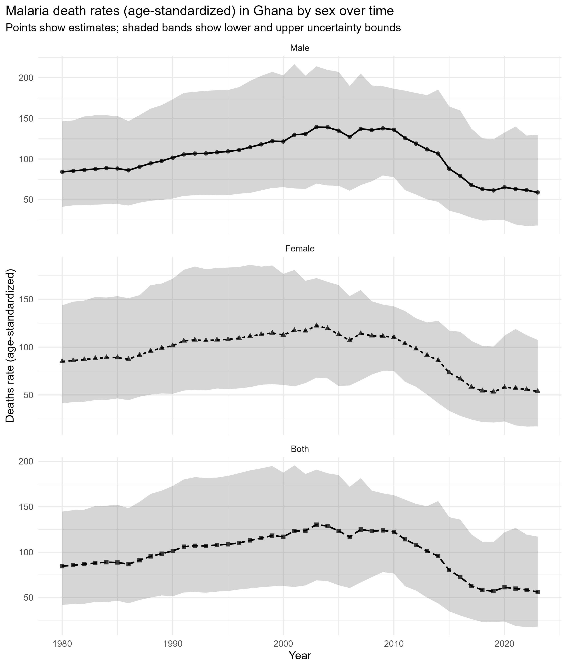
Figure 1: Malaria Death rates (age-standardised) in Ghana by sex over time
Figure 1 reveals a prolonged increase in mortality rates dating back to the early years of the past century and into the early years of the 2000s, followed by a steady decline in the later years of the series, across male, female, and both-sex series. This trend is aligned with regional trends of improvements in malaria burden coinciding with an increase in the scale of the vector control program, diagnostics and effective treatment, followed by changes in the level of the program pressure and climatic variability (World Health Organisation, 2022; Oladipo et al., 2022; Lawal et al., 2024). In Figure 1, the uncertainty bands become broad in certain intervals, reflecting increased estimation uncertainty, which may result from either a poor underlying data density or increased model uncertainty in burden estimation systems. Hundreds of past studies simply show point trends without fully accounting for uncertainty, which can lead to false-positive statements about changes between neighbouring years or brief sub-periods (Sarpong et al., 2022; Sirimatayanant et al., 2023). The definite illustration of uncertainty in Figure 1 is directly related to the research aim of generating strong inference based on the burden information, and it is relevant to the policy priority on enhancing the surveillance and vital statistics system to monitor precision under SDG 3 (Joseph et al., 2022; Kagoro et al., 2025).
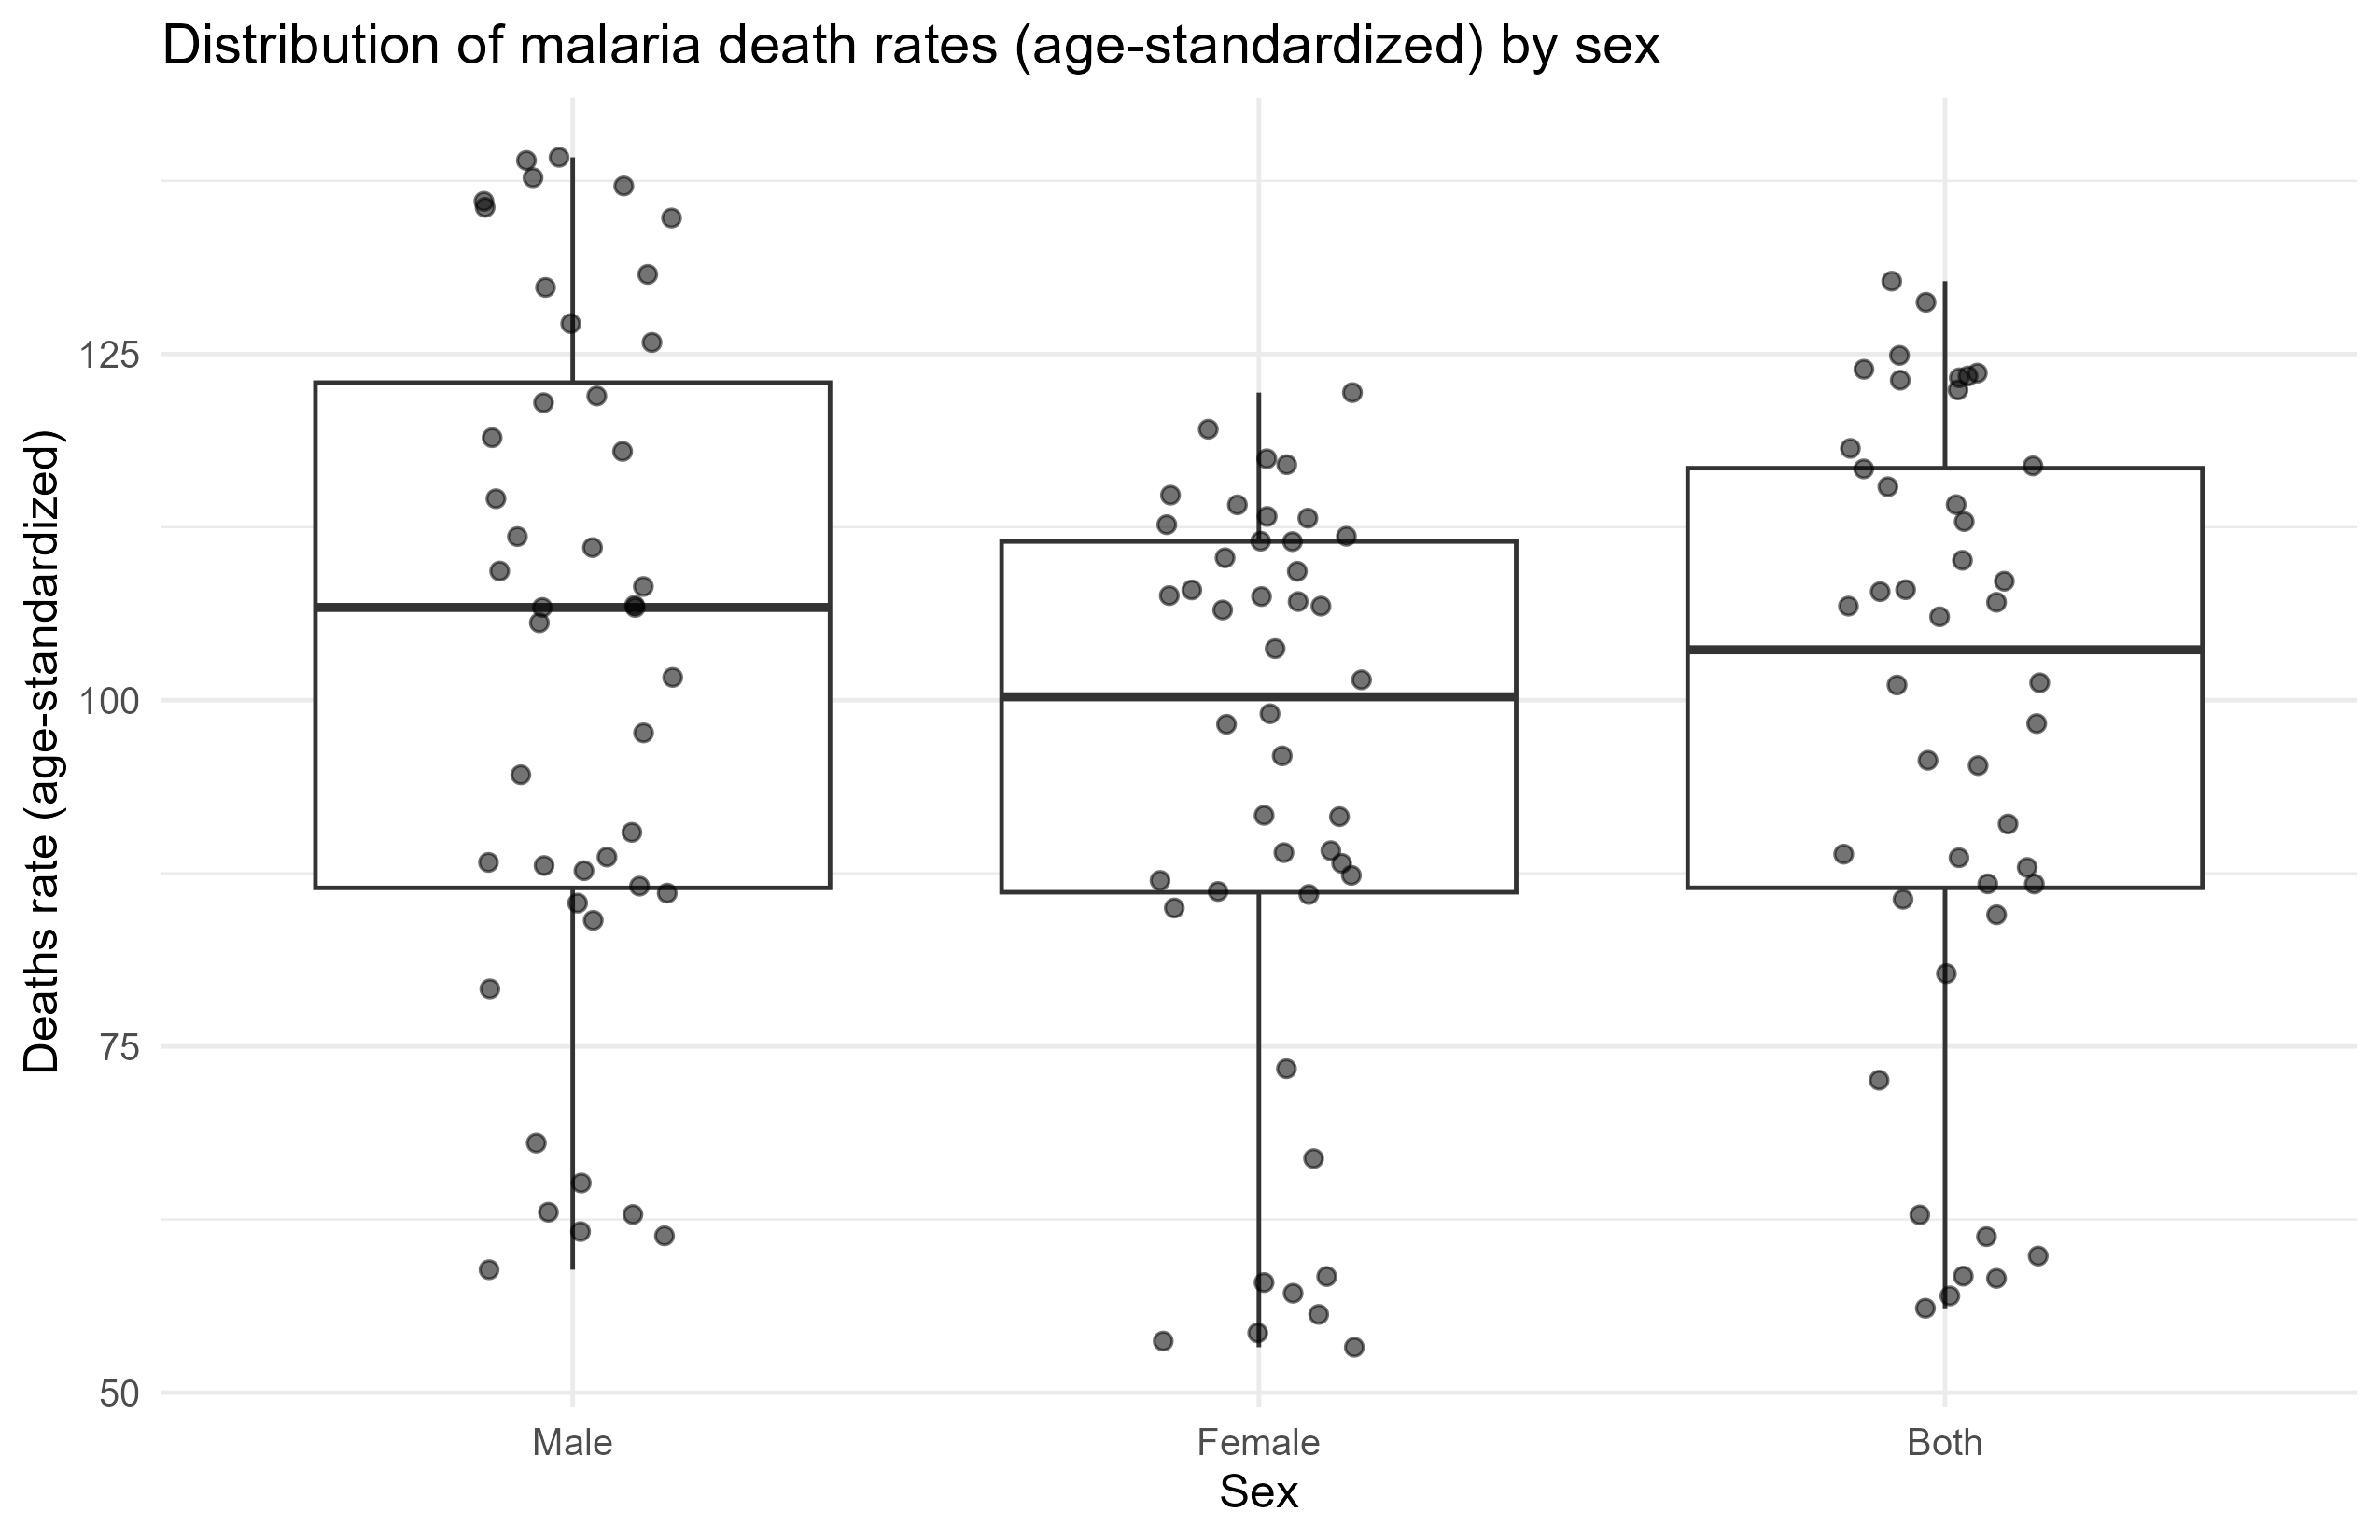
Figure 2: Distribution of malaria mortality rates by sex
Figure 2 shows differences in dispersion and central tendency across sex series, completing Table 1 by showing how sex differences vary over the full-time span rather than at a single point. The observed trend suggests that malaria mortality in Ghana exhibits high- and low-risk periods, a pattern confirmed by the need for models that capture nonlinearities and heteroscedasticity that arise under changing epidemiological conditions and varying program implementation intensity. At times, past Ghana research has been based on shorter windows, series of health facilities, or prevalence data, which may be under-representative of long-run variability in mortality, especially where program and climate conditions vary over decades (Tetteh et al., 2023; Abdulzeid et al., 2025; Barimah et al., 2025). Figure 2 highlights novelty through a distributional perspective, placing sex differences in the context of variability, which should prioritise sustained and consistent coverage of interventions and equity-sensitive approaches to meet SDG 3 and SDG 10 (Afagbedzi et al., 2023; Okova et al., 2025).
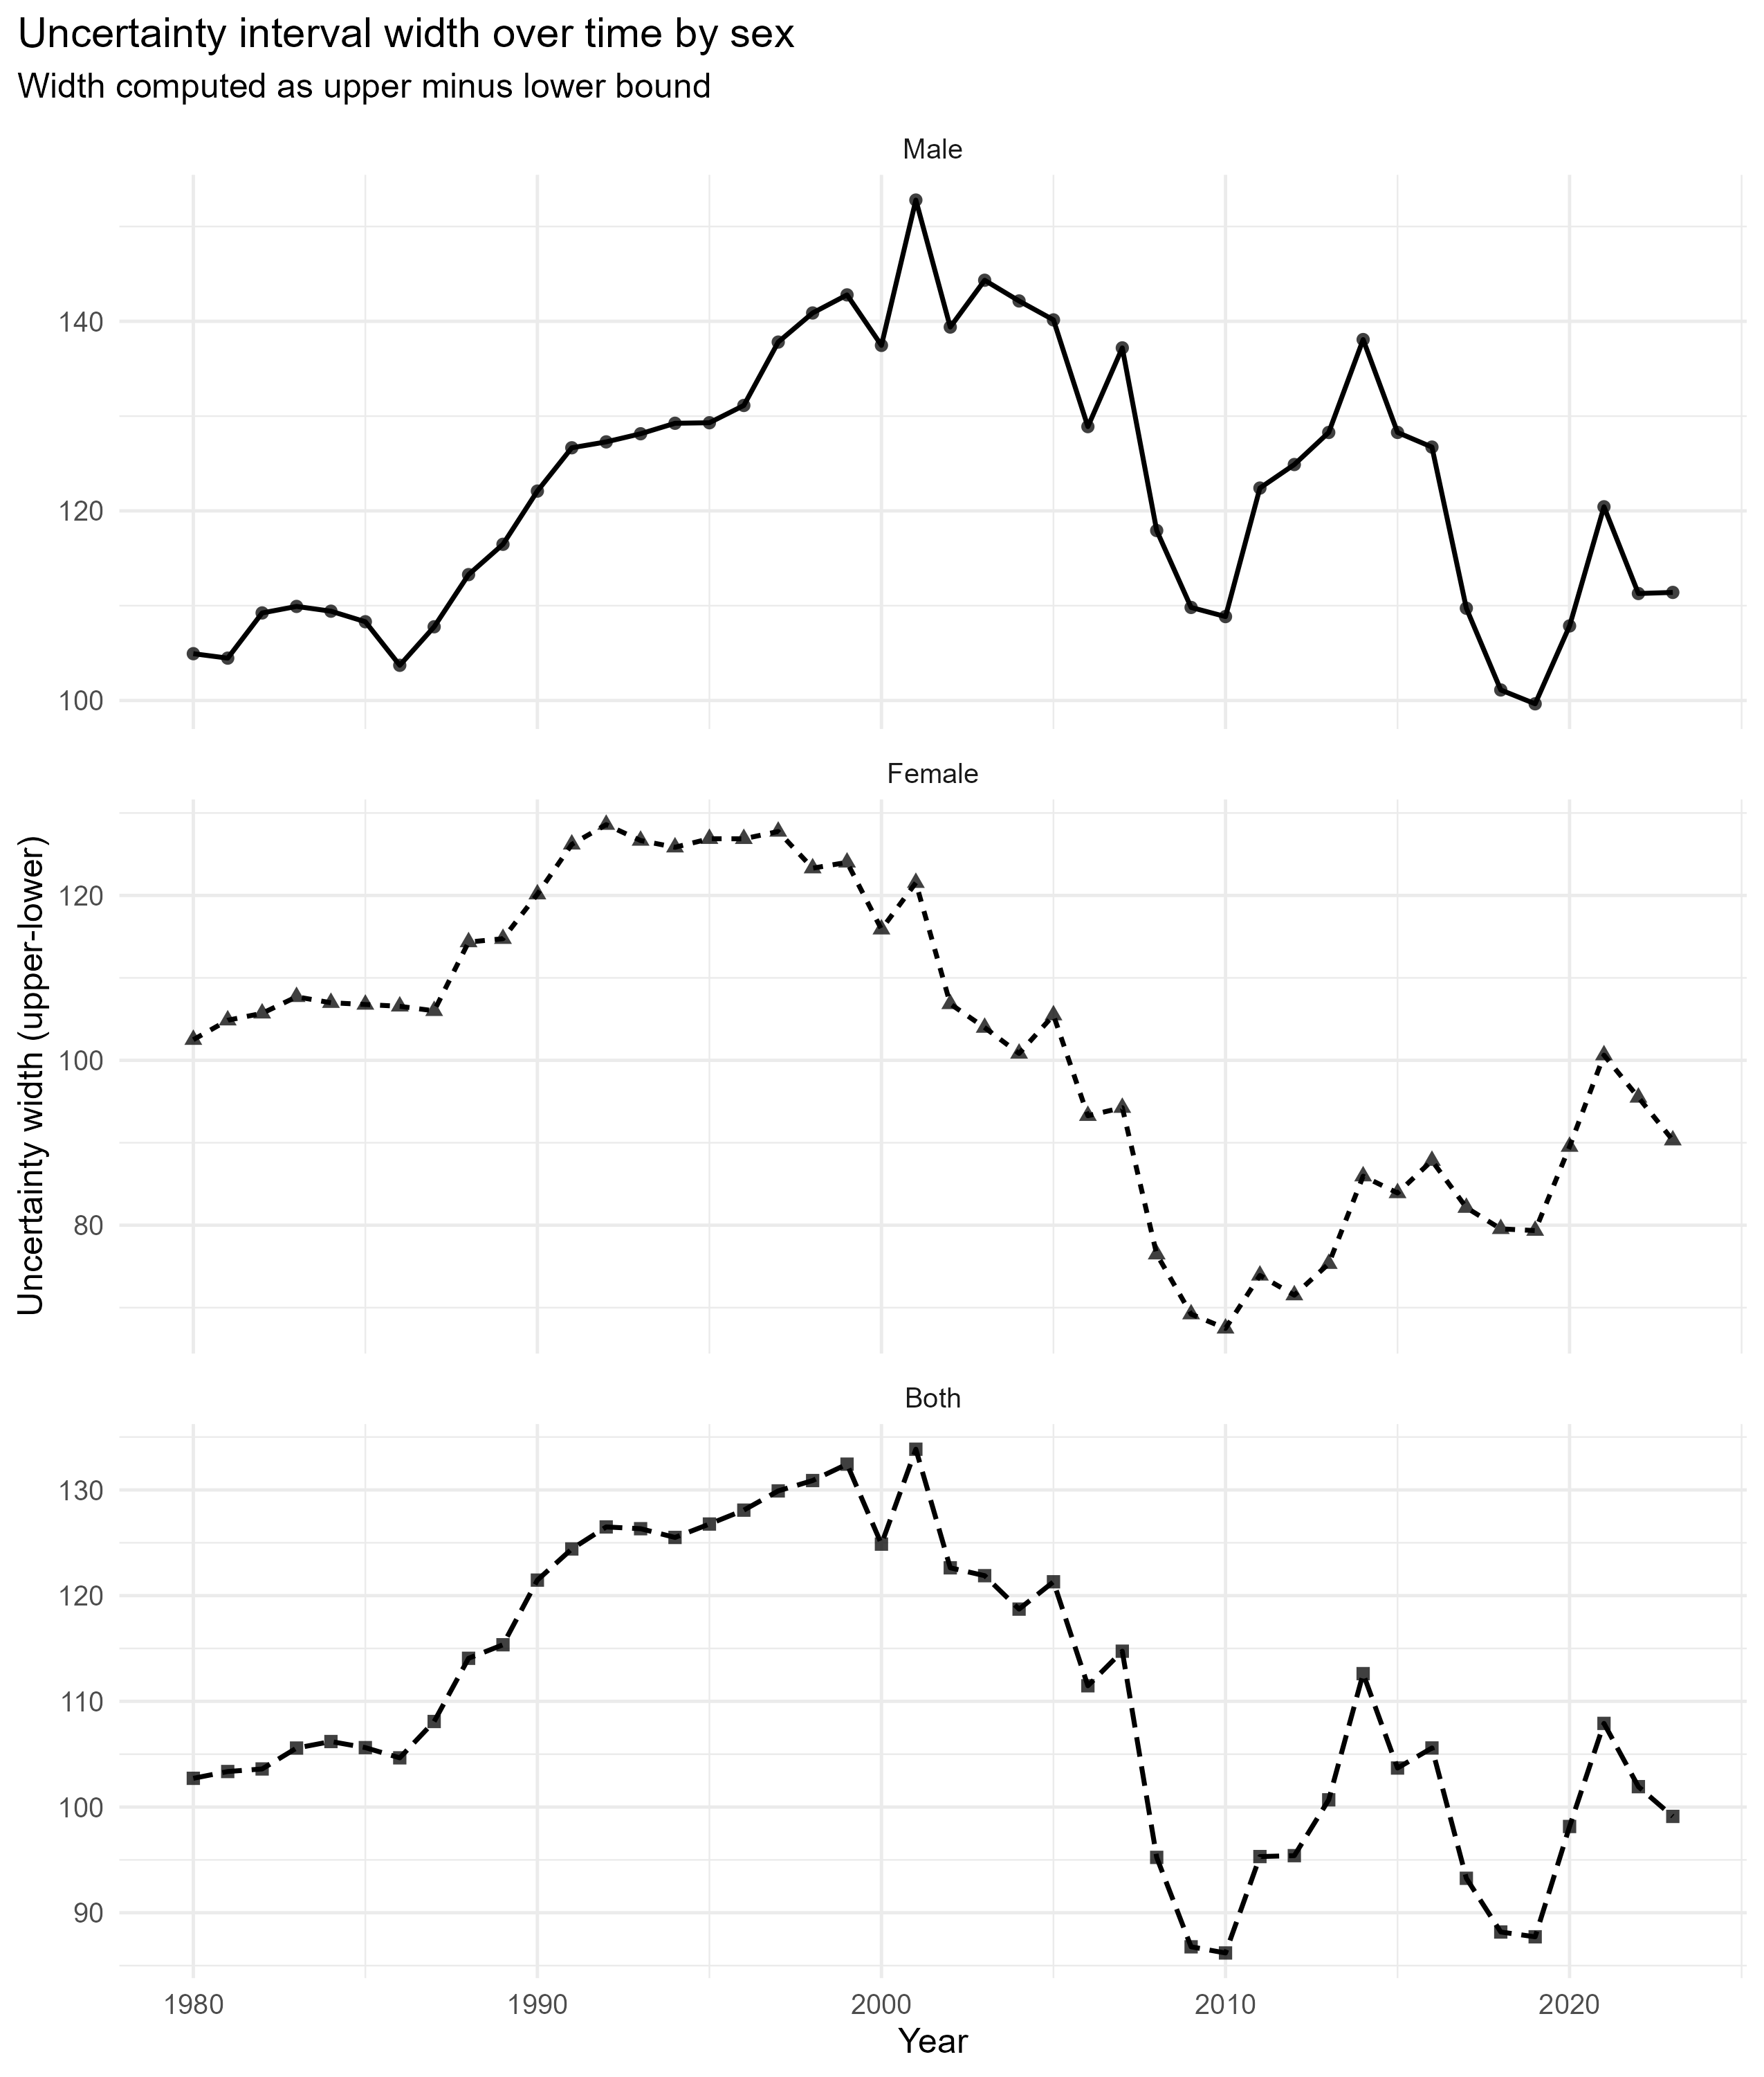
Figure 3: Uncertainty interval width over time by sex
Figure 3 demonstrates that the uncertainty width does not remain constant over time and varies across sex series; hence, the accuracy of the estimated rates varies by period. This is important for the interpretation of changes over time, as years with greater uncertainty should have less inferential weight than those with lesser uncertainty. Past analyses of malaria trends usually assume that all annual estimates are equally precise, which may bias trend estimation and undermine policy inference based on disturbed parts of the series (Sirimatayanant et al., 2023; Cao et al., 2022). The modelling approach applied to this work is based on inverse-variance-style weighting of the uncertainty bounds, which, in other words, turns Figure 3 into a descriptive plot into a methodological justification that directly confronts a common limitation in studies of burden trends. This enhances the quality of evidence in the evaluation of malaria programs under SDG 3 and SDG 17 by strengthening malaria surveillance partnerships and developing analytical capacity through better data (Joseph et al., 2022; Sirimatayanant et al., 2023).
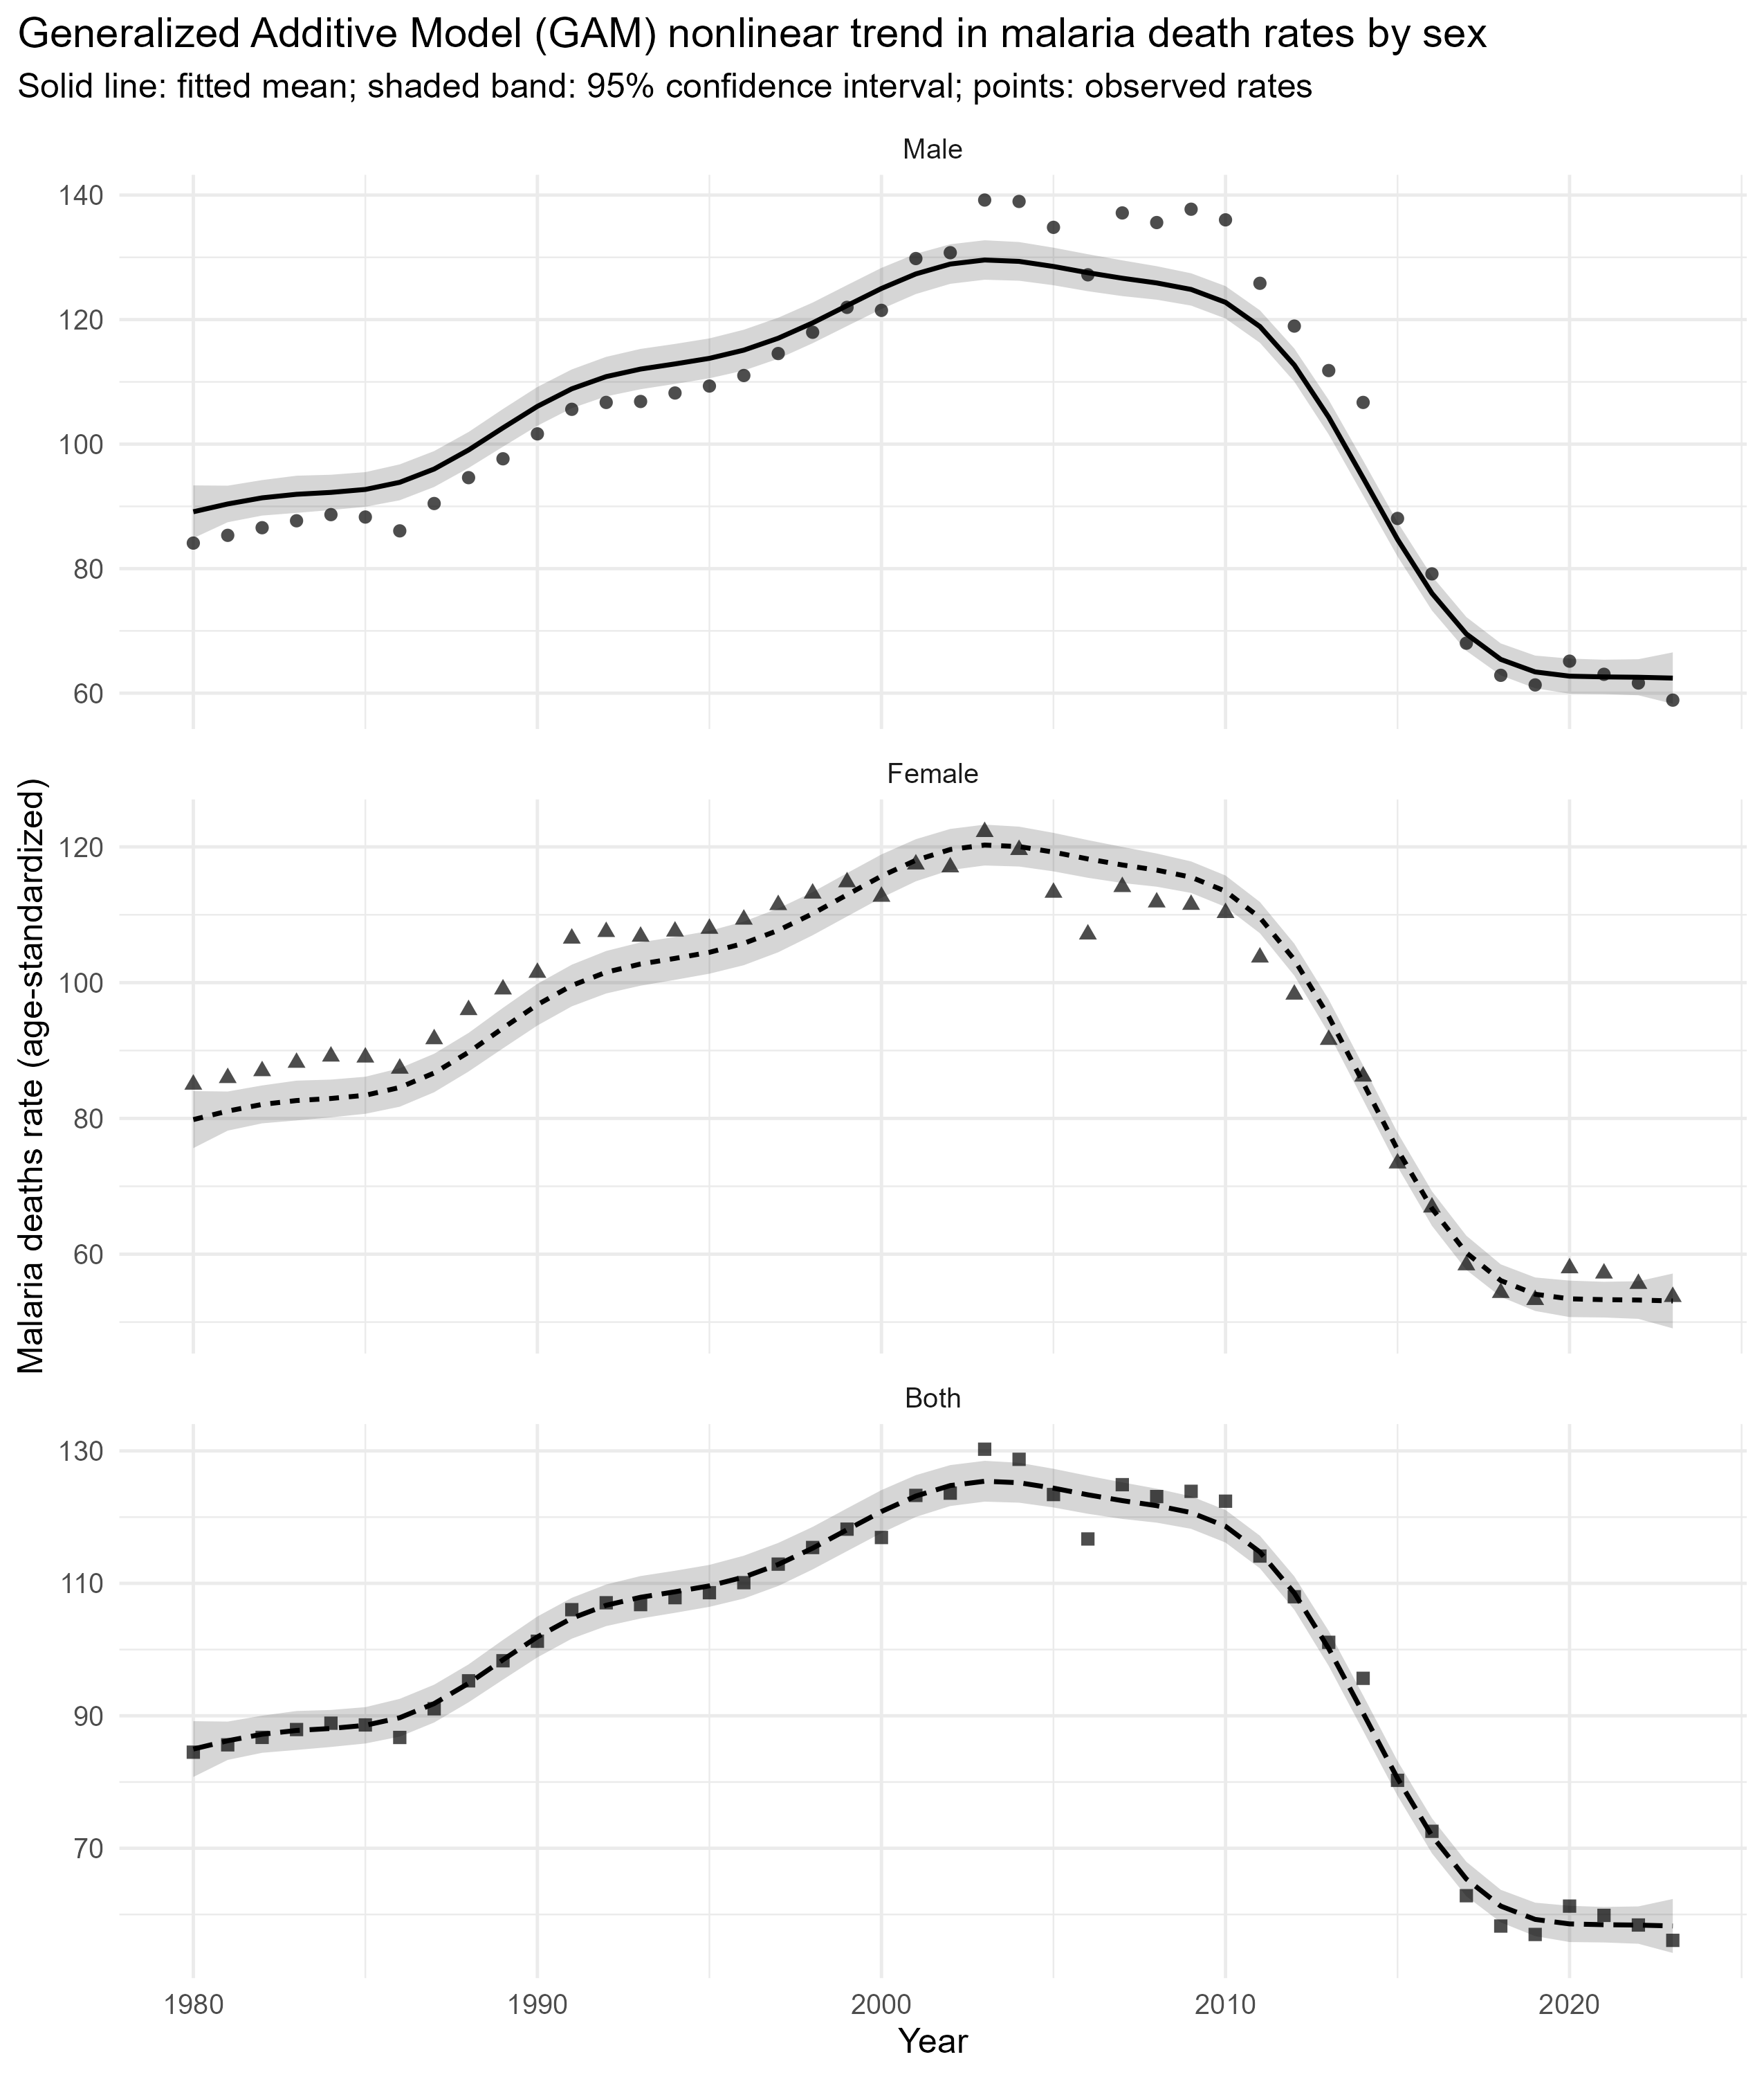
Figure 4: Generalised Additive Model (GAM) nonlinear trend in malaria death rate by sex
The most comprehensive summary of the study's overall contribution is as follows in Figure 4. A smooth, data-driven model of the malaria mortality trend across decades by sex in Ghana, where the confidence interval quantifies the uncertainty around the fitted mean trend. The fitted curves reflect a smooth increase of acceleration to a peak period and the steep decrease of the curve consistent with the fact that the impact of malaria control manifests itself through gradual changes in intervention coverage, access to treatment, and ecology of vectors, rather than discontinuities (Oladipo et al., 2022; Barker et al., 2023; Takramah et al., 2025). Prior studies based on linear trends or segmented regression may fail to capture this smooth curvature and misrepresent the transition phases as abrupt jumps or stable plateaus, thereby undermining the consistency of statistical inferences and the dynamics of a plausible malaria system (Segala et al., 2024; Garcia et al., 2024). Figure 4 is the first instance of flexible trend estimation combined with uncertainty-sensitive weighting and provides a more justifiable basis for detecting policy-relevant periods of development and stagnation. The decline stage facilitates hopefulness in line with elimination-focused discourses in the literature, and it is acknowledged that the potential of resurgence exists in environments with opposition and climate stressors, which require long-term investment to achieve the SDG 3 goals (Sarpong et al., 2022; Suh et al., 2023; Yamba et al., 2025).
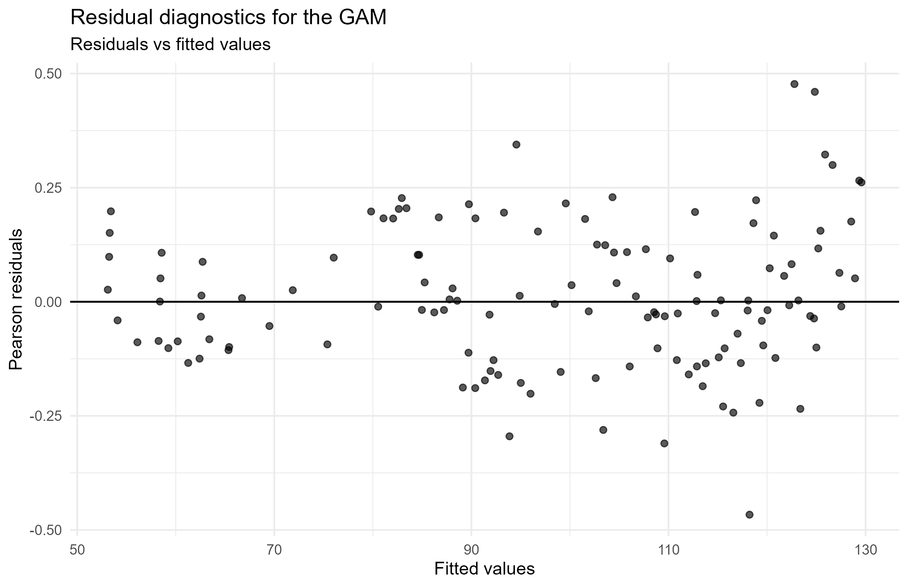
Figure 5: Residual diagnostics for the GAM
Figure 5 supports the adequacy of the model by demonstrating that the residuals are centred around zero when the outcome is modelled and that the weighted rate outcome exhibits a reasonable error structure, with very little major systematic misfit. This diagnosis is not always performed in applied malaria trend studies, especially in those that describe trends or use simple regressions, which compromises trust in the observed associations and the deduced changes in trend (Oheneba-Dornyo et al., 2022; Barimah et al., 2025). The fact that it is not possible to measure everything and that it still deviates indicates the limitation of the current specification: unmeasured drivers of the observation, including rainfall mis-alignment, temperature change, net coverage changes, insecticide resistance, and healthcare interference are not represented as covariates in the current specification, and thus residual variability can still be due to factors not yet captured (Brown et al., 2023; Trzebny et al., 2024; Suh et al., 2023). This solidifies the forward-moving research direction that incorporates climate, intervention coverage, and surveillance quality indicators into flexible models to enhance the mechanistic explanatory power, in support of SDG 13 in terms of more climate-sensitive health planning and SDG 3 in terms of more impactful evaluation of malaria control (Oheneba-Dornyo et al., 2022; Yamba et al., 2025).
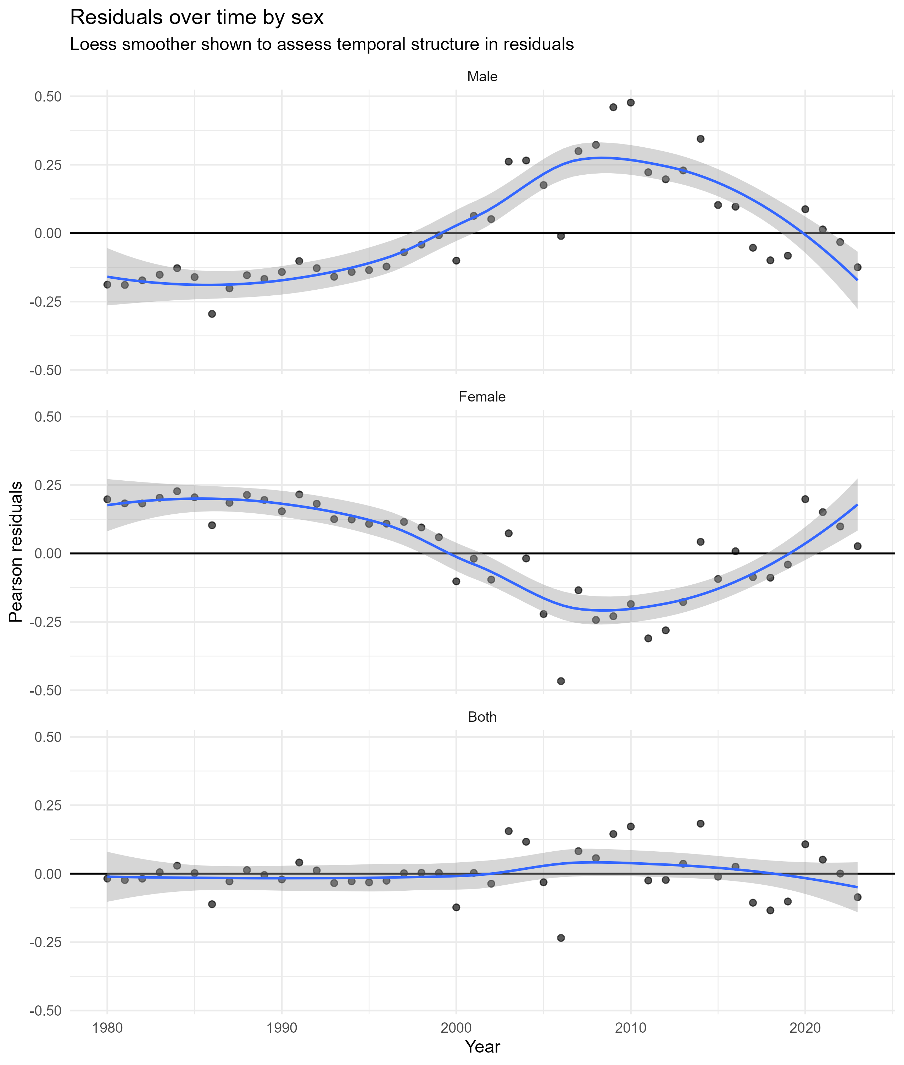
Fig. 6: Residuals over time by sex
Figure 6, assesses the temporal structure that remains after the GAM fit. The residual smoothers near zero support the statement that the primary nonlinear trend is effectively explained, and the remaining unexplained time variation is not excessive at the sex-stratified level. This increases trust that the fitted curves in Figure 4 reflect the true long-run structure rather than artefacts of serial correlation per se. Other previous studies with less complex time trend models often report time-dependent variations that are not explicitly evaluated in terms of residual time structure, which is prone to wildly overstate significance and falsely identify turning points (Segala et al., 2024; Garcia et al., 2024). Another limitation is inherent to the type and scope of the data: the analysis based on national age-standardised mortality rates, which facilitates national-level surveillance and cross-temporal comparability, but has a poor ability to identify subnational heterogeneity, recorded in Ghana and in Africa in general, where ecological and socioeconomic gradients affect exposure and access to healthcare (Gbaguidi et al., 2025; Okova et al., 2025; Takramah et al., 2025). This indicates a policy and research agenda to match national trend models with subnational spatial-temporal analyses and enhanced routine surveillance, providing a geographically targeted approach to high-burden areas under SDG 3 and equity gains under SDG 10 (Takramah et al., 2025; Okova et al., 2025).
Using Tables 1 to 3 and Figures 1 to 6, the results can be related to the research objective of measuring the nonlinear dynamics of malaria mortality in Ghana over decades using a model that accounts for uncertainty in the burden estimates. The contribution to the current literature is the replacement of linear or piecewise linear assumptions with a more flexible GAM model, which is coupled with uncertainty-sensitive weighting, and the reporting of model diagnostics, which enhance reproducibility and policy credibility. Such developments underpin the realistic priorities that involve continued coverage of ITN and case management, resistance surveillance and adaptation investment, enhancing surveillance systems and information quality, and climate-sensitive health protection-oriented malaria program planning, which are the most aligned with SDG 3 and related to SDG 13 through the explicit focus on disparities in subgroups and SDG 10 through the explicit focus on disparities in subgroups (Oladipo et al., 2022; Afagbedzi et al., 2023; Kagoro et al., 2025
The multi-decade age-adjusted malaria mortality data for Ghana showed a well-defined nonlinear mortality curve, consistently observed in the male, female, and both-sexes series. The descriptive trends in Figure 1 indicated consistent growth in the early period, peaking around the end of the 1990s and the beginning of the twenty-first century, followed by a sharp decrease in the latest years. This time-series pattern suggests that malaria deaths in Ghana have not decreased in a monotonic fashion, which underlies the assumption that long-term malaria control outcomes are multi-phase and that dynamics are determined by the scale-up of interventions, ecological factors, and the health system's outputs. The trend shape is consistent with larger data that confirm the malaria progress in sub-Saharan Africa has been characterized by periods of rapid gains and periods of slow gains, especially following the early expansions of interventions and the emergence of new insecticide resistance and climate changes (Oladipo et al., 2022; Lawal et al., 2024; Suh et al., 2023; Yamba et al., 2025).
The sex-specific differences were statistically significant and remained significant after adjustment for the nonlinear temporal trend. Table 1 demonstrated that female malaria death rates were lower than male rates during the period under study, and the combined-sex series, predictably, lay between the two sex-specific curves. This trend suggests that sex is a significant stratifier of the risk of malaria mortality in the Ghanaian age-standardised mortality. The sex differentials that remain despite the time-adjustment indicate that there are probably behavioural, occupational, biological and equally health system access systems which lead to disproportional exposure and case fatality by sex groups. This finding adds to evidence pointing to differences in malaria outcomes across demographic subgroups and to the possibility of conditioning the effectiveness of interventions by socio-behavioural context and prevention practices (Sarfo et al., 2023; Okova et al., 2025; Peprah et al., 2024).
The generalised additive model provided strong statistical evidence that the malaria mortality trend was nonlinear rather than linear or strictly segmented. As shown in Table 2, the smooth function of year was very significant, and the effective degrees of freedom showed high curvature. This result confirms the study's novelty assumption, namely that Ghana's long-run malaria mortality is inadequately modelled by linear or piecewise linear models, which prevail in the applied trend literature. This model thus offers a more realistic depiction of gradual regime change, capturing the cumulative impact of intervention coverage, changes in population behaviour, changing vector ecology, and different climatic conditions (Takramah et al., 2025; Rotejanaprasert et al., 2024; Brown et al., 2023).
The proposed modelling framework was highly explanatory, as evidenced by the model performance metrics, in explaining the observed national mortality series. Table 3 demonstrated high deviance explained and an adjusted R-squared, indicating that the combination of the nonlinear temporal smooth and sex stratification explained the strong systematic structure of the mortality rates. This reinforces the belief that the fitted curves in Figure 4 are not a statistical artefact but statistical summaries of significant temporal structure in the mortality burden. The good fit also justifies the usefulness of combining flexible epidemiological trend models with national burden data, especially when long-run analysis of the program is needed to track progress on the SDG 3 targets for malaria control and elimination (World Health Organisation, 2022; Sarpong et al., 2022).
One of the most relevant contributions to methodologies is the explicit use and analysis of the uncertainty information reflected in the data set. Figure 3 showed that the widths of uncertainty intervals varied over time and differed among sex series, indicating that annual estimates were not equally precise. This feature is not frequently included in most malaria burden analyses, and annual point estimates are generally considered to be equally precise. Inverse-variance weighting based on uncertainty bounds used in the analytic strategy directly overcame this limitation by giving more weight to more accurate estimates and less weight to noisier periods. It enhances inferential reliability and reinforces the interpretation of policies, particularly to detect stages of accelerated decline or possible stagnation in malaria mortality reduction (Cao et al., 2022; Sirimatayanant et al., 2023).
Model diagnostics were used to justify the appropriateness of specifying a Gaussian GAM for these age-specific mortality rates. Figure 5 indicated that the residuals were usually centred around zero and no overriding structure of the fitted values, whereas Figure 6 indicated that there was a little remaining temporal drift after modelling the nonlinear trend. All these diagnostics suggested that the fitted model reflected the major pattern over time and that the remaining variation was likely due to year-to-year shocks and unmeasured factors such as climate shocks, changes in vaccination coverage, dynamics of resistance, and health system shocks. This makes the modelling approach all the more practically relevant and encourages further efforts to incorporate covariates, including rainfall, temperature, ITN coverage, and resistance surveillance indicators, into the modelling approach to gain a more profound insight into causality (Oheneba-Dornyo et al., 2022; Suh et al., 2023; Yamba et al., 2025).
Conclusion
It was an error-sensitive, methodologically robust evaluation of the long-term dynamics of malaria mortality in Ghana based on age-standardised malaria death rate estimates. Findings indicated that the pattern of malaria mortality in Ghana is highly nonlinear, with a long-term period of increasing mortality up to the late 1990s to the early 2000s, followed by a long-term downward trend since then, extending well into recent years. This data challenges the traditional use of linear or segmented trend models in malaria burden studies and shows that an adaptable modelling method is required to establish long-run mortality shifts in high-burden areas.
The presence of sex differences persisted throughout the study, and females had lower mortality rates than males despite the nonlinear temporal trend. This observation underlines the significance of sex-disaggregated surveillance and indicates that such malaria control policies can be effective through subgroup-sensitive interventions that address exposure patterns, care-seeking behaviour, and disproportionate vulnerability. Uncertainty bounds, both graphically and analytically via weighting, enhanced inference and directly counteracted a major limitation of studies that assume burden estimates are error-free.
The modelling framework to be implemented in the proposed study adds new analytical value to the theory: generalised additive modelling will be paired with uncertainty-aware estimation to produce a more plausible representation of Ghanaian malaria mortality dynamics. The outputs provide a statistically justifiable basis for policy analysis, support the importance of long-term malaria management investments, enhanced surveillance mechanisms, and flexible policies that anticipate resistance and climate pressures. These discoveries align best with SDG 3 in support of reducing malaria morbidity and improving health system responsiveness, with SDG 13 in support of climate-sensitive planning, and with SDG 10 in considering subgroup disparities.
Declarations
Data availability statement
The data access point is the repository that can be accessed.
https://vizhub.healthdata.org/gbd-results
Ethics Statement
As the data are deidentified and aggregated at the population level, no ethical approval was needed. The study adheres to all ethical guidelines for the use of publicly accessible data. It ensures that the information is used solely for academic and research purposes to inform public health strategies.
Conflicts of interest
The authors declare that they have no competing interests.
Consent for Publication
Not applicable in the clinic

References
Abdulzeid, A., Bosson-Amedenu, S., Gmayinaam, V. U., Enock, A., Ocloo, S., & Acquah, J. (2025). Evaluating malaria burden in children under-five and intervention outcomes in Tarkwa-Nsuaem municipality. BMC Infectious Diseases, 25(1), 294.
Abu Bonsra, E., Amankwah Osei, P., Sekyi, A. G., & Kyere, G. A. (2025). Insecticide-treated bed nets (ITN) ownership and utilization patterns among caregivers with children under five years: a community-based cross-sectional study in Battor, North Tongu District, Ghana. PLOS Global Public Health, 5(2), e0004228.
Adjei, M. R., Kubio, C., Buamah, M., Sarfo, A., Suuri, T., Ibrahim, S., ... & Baafi, J. V. (2022). Effectiveness of seasonal malaria chemoprevention in reducing under-five malaria morbidity and mortality in the Savannah Region, Ghana. Ghana medical journal, 56(2), 64-70.
Adum, P., Agyare, V. A., Owusu-Marfo, J., & Agyeman, Y. N. (2023). Knowledge, attitude and practices of malaria preventive measures among mothers with children under five years in a rural setting of Ghana. Malaria Journal, 22(1), 268.
Afagbedzi, S. K., Alhassan, Y., Kenu, E., Malm, K., Bandoh, D. A. B., Peprah, N. Y., ... & Guure, C. (2023). Universal coverage and utilization of free long-lasting insecticidal nets for malaria prevention in Ghana: a cross-sectional study. Frontiers in Public Health, 11, 1140604.
Akorli, J., Oware, S. K., Sackitey, D. B., Pul, R. M., Akyea-Bobi, N. E., Akporh, S. S., ... & Dadzie, S. K. (2025). Climate-driven models reveal temporal trends in Aedes breeding: implications for outbreak preparedness and control interventions. BMC Public Health, 25(1), 2735.
Alum, E. U., Ainebyoona, C., Egwu, C. O., Onohuean, H., Ugwu, O. P. C., Uti, D. E., ... & Echegu, D. A. (2025). Mitigation of Malaria in Sub-Saharan Africa through Vaccination: A Budding Road Map for Global Malaria Eradication. Ethiopian Journal of Health Sciences, 35(3).
Asante, K. P., Bozonnat, M. C., Savic, M., Owusu-Agyei, S., Kaali, S., Otieno, W., ... & Haine, V. (2025). Incidence rates of malaria, meningitis, and mortality in children younger than 5 years: a prospective cohort study in Ghana and Kenya before the roll-out of the RTS, S/AS01E malaria vaccine from 2016 to 2022. The Lancet Global Health, 13(5), e859-e869.
Barimah, A. J., Commey, R. D., Salomey, N. D., Dumba, J., Nketiah, Y. B., Amoah, B. O., ... & Sandra, G. O. (2025). A ten-year trend analysis of malaria prevalence at Sunyani Municipal Hospital, Ghana. Discover Public Health, 22(1), 358.
Barker, T. H., Stone, J. C., Hasanoff, S., Price, C., Kabaghe, A., & Munn, Z. (2023). Effectiveness of dual active ingredient insecticide-treated nets in preventing malaria: A systematic review and meta-analysis. Plos one, 18(8), e0289469.
Bashir, S. G., Ahmed, N. I., Abdullahi, Y. B., Abdi, Y. H., Abdi, M. S., & Musa, M. K. (2025). The burden of malaria in East Africa: prevalence, risk factors, and control strategies. Malaria Journal, 24(1), 255.
Brown, J. J., Pascual, M., Wimberly, M. C., Johnson, L. R., & Murdock, C. C. (2023). Humidity–The overlooked variable in the thermal biology of mosquito‐borne disease. Ecology letters, 26(7), 1029-1049.
Cao, Y., Lu, G., Cotter, C., Wang, W., Yang, M., Liu, Y., ... & Cao, J. (2022). Improving the surveillance and response system to achieve and maintain malaria elimination: a retrospective analysis in Jiangsu Province, China. Infectious diseases of poverty, 11(01), 56-67.
Garcia, K. K. S., Soremekun, S., Abrahão, A. A., Marchesini, P. B., Drakeley, C., Ramalho, W. M., & Siqueira, A. M. (2024). Is Brazil reaching malaria elimination? A time series analysis of malaria cases from 2011 to 2023. PLOS global public health, 4(1), e0002845.
Gbaguidi, G. J., Topanou, N., Begedou, K., & Ketoh, G. K. (2025). Environmental and socio-economic determinants of malaria transmission in West Africa: a systematic review. One Health Outlook, 7(1), 1-16.
Joseph, J. J., Mkali, H. R., Reaves, E. J., Mwaipape, O. S., Mohamed, A., Lazaro, S. N., ... & Ngondi, J. M. (2022). Improvements in malaria surveillance through the electronic Integrated Disease Surveillance and Response (eIDSR) system in mainland Tanzania, 2013–2021. Malaria Journal, 21(1), 321.
Kagoro, F. M., Allen, E., Raman, J., Mabuza, A., Magagula, R., Kok, G., ... & Barnes, K. I. (2025). Factors affecting integration of an early warning system for antimalarial drug resistance within a routine surveillance system in a pre-elimination setting in Sub-Saharan Africa. PLoS One, 20(6), e0305885.
Kamya, M. R., Nankabirwa, J. I., Arinaitwe, E., Rek, J., Zedi, M., Maiteki-Sebuguzi, C., ... & Dorsey, G. (2024). Dramatic resurgence of malaria after 7 years of intensive vector control interventions in Eastern Uganda. PLOS Global Public Health, 4(8), e0003254.
Katushabe, J., Nnyanzi, J. B., & Muwanga, G. S. (2024). Exploring the role of spending on malaria incidence in Uganda using the auto-regressive distributed lag approach. Malaria Journal, 23(1), 129.
Kolawole, E. O., Ayeni, E. T., Abolade, S. A., Ugwu, S. E., Awoyinka, T. B., Ofeh, A. S., & Okolo, B. O. (2023). Malaria endemicity in Sub-Saharan Africa: Past and present issues in public health. Microbes and Infectious Diseases, 4(1), 242-251.
Lawal, L., Buhari, A. O., Jaji, T. A., Alatare, A. S., Adeyemo, A. O., Olumoh, A. O., ... & Abdul‐Rahman, T. (2024). Lingering challenges in malaria elimination efforts in sub‐Saharan Africa: Insights and potential solutions. Health Science Reports, 7(6), e2122.
Malm, K. L., Peprah, N. Y., Mohammed, W., Adomako, B. Y., Oppong, S., Boateng, P., ... & Frimpong, J. (2024). A retrospective analysis of malaria deaths in the pre-and intra-COVID 19 pandemic era, Ghana, 2016–2021. Plos one, 19(2), e0286212.
Mawuli, M. A., Amoah, L. E., Sraku, I. K., Donu, D., Abagna, H. B., Acquah, F. K., ... & Afrane, Y. A. (2025). Assessment of the infectivity of malaria parasites from asymptomatic school children to Anopheles gambiae mosquitoes in a high transmission area in Ghana. Scientific Reports, 15(1), 22561.
Mbishi, J. V., Chombo, S., Luoga, P., Omary, H. J., Paulo, H. A., Andrew, J., & Addo, I. Y. (2024). Malaria in under-five children: prevalence and multi-factor analysis of high-risk African countries. BMC Public Health, 24(1), 1687.
Merga, H., Degefa, T., Birhanu, Z., Lee, M. C., Yan, G., & Yewhalaw, D. (2025). Urban malaria and population mobility in sub-Saharan Africa: systematic review and meta-analysis. Malaria Journal, 24(1), 264.
Mintah-Agyeman, E., Adomako, B. Y., Adu, G. A., Oteng, B., Duvor, F., Abubakari, I., ... & Malm, K. L. (2024). Patterns and predictors of malaria among head porters: a mobile population in Ghana. Malaria Journal, 23(1), 222.
Nketiah-Amponsah, E., & Adjotor, F. N. (2025). The impact of Malaria-related expenditures on Malaria incidence and mortality rates in Sub-Saharan Africa (SSA). Development Studies Research, 12(1), 2481830.
Oheneba-Dornyo, T. V., Amuzu, S., Maccagnan, A., & Taylor, T. (2022). Estimating the impact of temperature and rainfall on malaria incidence in Ghana from 2012 to 2017. Environmental Modeling & Assessment, 27(3), 473-489.
Okova, D., Lukwa, A. T., Edusei, M., Bodzo, P., Atta-Obeng, C., Chiwire, P., & Hongoro, C. (2025). Between-and within-socioeconomic groups temporal inequality in the uptake of malaria prevention strategies among pregnant women and under-five children in Ghana (2003–2022). Malaria Journal, 24(1), 273.
Oladipo, H. J., Tajudeen, Y. A., Oladunjoye, I. O., Yusuff, S. I., Yusuf, R. O., Oluwaseyi, E. M., ... & El-Sherbini, M. S. (2022). Increasing challenges of malaria control in sub-Saharan Africa: Priorities for public health research and policymakers. Annals of Medicine and Surgery, 81, 104366.
Onyinyechi, O. M., Mohd Nazan, A. I. N., & Ismail, S. (2023). Effectiveness of health education interventions to improve malaria knowledge and insecticide-treated nets usage among populations of sub-Saharan Africa: systematic review and meta-analysis. Frontiers in public health, 11, 1217052.
Oppong, S. K., Owusu-Akrofi, O., Atta-Obeng, C., Coleman, S., Amratia, P., Symons, T. L., ... & Malm, K. L. (2025). Reductions in malaria cases after deployment of dual-active ingredient insecticide treated nets (ITNs) in Ghana–a Bayesian interrupted time series analysis. medRxiv, 2025-08.
Patouillard, E., Han, S., Lauer, J., Barschkett, M., & Arcand, J. L. (2023). The macroeconomic impact of increasing investments in malaria control in 26 high malaria burden countries: an application of the updated EPIC model. International Journal of Health Policy and Management, 12, 7132.
Peprah, N. Y., Mohammed, W., Adu, G. A., Dadzie, D., Oppong, S., Barikisu, S., ... & L. Malm, K. (2024). Patient socio-demographics and clinical factors associated with malaria mortality: a case control study in the northern region of Ghana. Malaria Journal, 23(1), 230.
Rahaman, M. A., Kalam, A., & Al-Mamun, M. (2023). Unplanned urbanization and health risks of Dhaka City in Bangladesh: uncovering the associations between urban environment and public health. Frontiers in public health, 11, 1269362.
Rotejanaprasert, C., Malaphone, V., Mayxay, M., Chindavongsa, K., Banouvong, V., Khamlome, B., ... & Maude, R. J. (2024). Spatiotemporal patterns and association with climate for malaria elimination in Lao PDR: a hierarchical modelling analysis with two-step Bayesian model selection. Malaria Journal, 23(1), 231.
Sabtiu, A. R. M., Hinne, I. A., Sraku, I. K., Halou, D. K., Doe, R. T., Attah, S. K., ... & Afrane, Y. A. (2025). Larval habitat diversity, physicochemical characteristics and their effect on the larval density of malaria vectors in the city of Accra, Ghana. Malaria Journal, 24(1), 299.
Sankineni, S., Chauhan, S., Shegokar, R., & Pathak, Y. (2023). Global health and malaria: Past and present. In Malarial drug delivery systems: Advances in treatment of infectious diseases (pp. 1-16). Cham: Springer International Publishing.
Sarfo, J. O., Amoadu, M., Kordorwu, P. Y., Adams, A. K., Gyan, T. B., Osman, A. G., ... & Ansah, E. W. (2023). Malaria amongst children under five in sub-Saharan Africa: a scoping review of prevalence, risk factors and preventive interventions. European journal of medical research, 28(1), 80.
Sarpong, E., Acheampong, D. O., Fordjour, G. N. R., Anyanful, A., Aninagyei, E., Tuoyire, D. A., ... & Thomford, N. E. (2022). Zero malaria: a mirage or reality for populations of sub-Saharan Africa in health transition. Malaria Journal, 21(1), 314.
Segala, F. V., Ictho, J., L’Episcopia, M., Onapa, E., De Vita, E., Novara, R., ... & Di Gennaro, F. (2024). Impact of the COVID-19 pandemic on malaria in pregnancy indicators in Northern Uganda: a joinpoint regression analysis. Pathogens and Global Health, 118(3), 253-261.
Shin, H. I., Ku, B., Jung, H., Lee, S. D., Lee, S. Y., Ju, J. W., ... & Lee, H. I. (2024). 2023 world malaria report (Status of world malaria in 2022). Public Health Weekly Report, 17(32), 1351.
Sirimatayanant, M., Hein, P. S., Anderson, L. F., Montoya, L. F., Potter, R., Nghipumbwa, M., ... & Maude, R. J. (2023). Gaps in research and capacity development for malaria surveillance and response in the Asia–Pacific: meeting report. Malaria Journal, 22(1), 91.
Suh, P. F., Elanga-Ndille, E., Tchouakui, M., Sandeu, M. M., Tagne, D., Wondji, C., & Ndo, C. (2023). Impact of insecticide resistance on malaria vector competence: a literature review. Malaria Journal, 22(1), 19.
Takramah, W. K., Afrane, Y. A., & Aheto, J. M. K. (2025). Bayesian spatiotemporal modelling and mapping of malaria risk among children under five years of age in Ghana. BMC Infectious Diseases, 25(1), 430.
Tetteh, J. A., Djissem, P. E., & Manyeh, A. K. (2023). Prevalence, trends and associated factors of malaria in the Shai-Osudoku District Hospital, Ghana. Malaria Journal, 22(1), 131.
Tetteh, J., Yorke, E., Boima, V., & Yawson, A. E. (2023). Prevalence of malaria infection and the impact of mosquito bed net distribution among children aged 6–59 months in Ghana: evidence from the Ghana demographic health and malarial indicator surveys. Parasite epidemiology and control, 21, e00302.
Trzebny, A., Nahimova, O., & Dabert, M. (2024). High temperatures and low humidity promote the occurrence of microsporidians (Microsporidia) in mosquitoes (Culicidae). Parasites & Vectors, 17(1), 187.
World Health Organization. (2022). World malaria report 2022. World Health Organization.
Yamba, E. I., Badu, K., Kyeimiah, T. A., Abrokwah, N. O., Asare, S., Adjei, M. J., ... & Amekudzi, L. K. (2025). Warming temperatures reduce lifespan and vectorial capacity of Anopheles mosquitoes in Ghana. Infectious Disease Modelling.
Yeboah, D., Boah, M., & Adokiya, M. N. (2023). Caregivers’ use of insecticide-treated nets is associated with the use of ITNs by children under the age of five in Ghana. Plos one, 18(1), e0280065.

