Case report
A Case Report of an Abdominal Ectopic Pregnancy at Georgetown Public Hospital Corporation

Abstract
Aim
To demonstrate the diagnostic challenges encountered along with the surgical complications that can arise in patients diagnosed with an abdominal ectopic pregnancy.

Presentation of case
A 26-year-old, para two, Afro-Guyanese woman was referred to the high-risk clinic at the Georgetown Public Hospital Corporation (GPHC) due to an ultrasound finding of multiple foetal malformations, the patient had a failed medical termination of pregnancy and was taken for exploratory laparotomy, where she was diagnosed with an abdominal ectopic pregnancy with placental tissue adhered to the small and large bowel as well as the omentum along with a small defect noted in the right Fallopian tube

Discussion:
The abdominal location for an ectopic pregnancy is one of the rarest forms at 0.9–1.4% of all ectopic pregnancies and can present a challenge with diagnosis. Abdominal ectopic pregnancies carry a higher risk of mortality because of hemorrhaging and injury to surrounding organs. Diagnosis of an abdominal ectopic pregnancy can be difficult, with some cases requiring more advanced imaging techniques.

Conclusion
We report on a case of a patient that was undergoing medical termination of pregnancy for an intrauterine foetal demise along with foetal malformations. There was subsequently suspicion of a uterine rupture, and she was taken for an emergency exploratory laparotomy which revealed a ruptured abdominal ectopic pregnancy. We aim to highlight the diagnostic challenges posed by these cases, which can lead to increased morbidity and mortality.

Introduction

An ectopic pregnancy (EP) occurs when a fertilized ovum is embedded outside of the endometrial cavity's lining with a rate of about 1-2% in general and 2-5% in pregnancies that use artificial reproductive technology (ART).¹ Of these 1.4% will be abdominal.² hence it is one of the rarest forms and has serious medical complications, thus research on AEP is mostly limited to case reports because of how rare this disease is.^{3,4}
An abdominal EP (AEP) can be a primary AEP if the conceptus first implants and grows on an abdominal organ within the peritoneal cavity or secondary if implantation first occurs within the reproductive system (Fallopian tube, ovary, or uterus),⁵ and a subsequent event such as a rupture causes it to implant in the peritoneal cavity. Abdominal locations that have been described include the omentum, liver, spleen, bowel, large vessels, pelvic cul-de-sac, broad ligament, and pelvic side wall.³
The clinical presentation varies depending on the location and if it is ruptured or not and may present with non-specific abdominal pain and painful foetal movements. Sometimes the discovery of an AEP is made only upon delivery at cesarean section.⁶
We report a case of AEP that was discovered after undergoing medical termination of pregnancy (TOP) for an intrauterine foetal demise (IUFD) and foetal malformation. This case demonstrates the difficulties with ultrasonographic diagnosis.

Case presentation

A 26-year-old, para two, Afro-Guyanese woman was referred to the high-risk clinic at the Georgetown Public Hospital Corporation (GPHC) due to an ultrasound finding of multiple foetal malformations. This patient had an obstetrical history of post-partum hemorrhage (PPH) after her first delivery, and a cesarean delivery for her second delivery because of breech presentation. She had normal menstrual cycles and was not on any contraceptives.
The ultrasound done before she was seen at GPHC, reported a foetus with ascites, dolichocephaly or molding, with a posterior placenta, and uterine fibroid of 6.9 centimeters (See Figure 1). This patient requested to have a TOP done after counselling and was admitted for same. Her physical examination was benign, and the procedure commenced at 18 weeks 1 day of gestation (dated by an ultrasound done at 16 weeks and 3 days of gestation) with mifepristone on day one followed by misoprostol the next day. Her cervix remained closed after receiving 3 doses of 400 micrograms (μg) misoprostol (one buccally and 2 vaginally), she started to present with increasing abdominal pain and vomiting and was given analgesia and antiemetics. An urgent haemaglobin revealed a value of 6.2 milligrams per decilitre (mg/dL), and an urgent ultrasound showed the presence of a uterine fibroid blocking the cervical os with free fluid in the abdomen. A suspected diagnosis of a uterine rupture was made, and she was taken for an emergency exploratory laparotomy. Her vitals at this moment revealed a blood pressure (BP) of 80/46 mmHg (millimetres of mercury) and a pulse of 110 beats per minute.
Upon entering the peritoneal cavity foetal parts were noted in the abdominal cavity (See Figure 2) with placental tissue adhered to the small and large bowel as well as the omentum. There was a small defect in the right interstitial portion of the Fallopian tube with abundant fibrin deposits extending to the cul-de-sac. General surgeons were called in on the case due to the involvement of adhesions to the small and large bowel and omentum. A right salpingectomy was performed with repair of the right cornu, along with a partial omentectomy, adhesiolysis, and a prophylactic appendectomy. The estimated blood loss was 2 litres, and an abdominal drain was left in situ. The patient was transfused with blood products and received a dose of methotrexate. She had a favourable postoperative evolution with adequate resolution of her beta-human chorionic gonadotropin (β-hCG). The patient was discharged on postoperative day 5 and was counselled regarding future pregnancies and the associated risks.
Histopathological examination confirmed the implantation site to be the omentum, there was also evidence of chronic appendicitis.

Discussion

The abdominal location for an EP is one of the rarest forms at 0.9–1.4% of all EPs and can present a challenge with diagnosis.₃ AEPs have serious medical consequences on maternal morbidity and mortality. The maternal and neonatal mortality rates are higher when compared to tubal EPs and intrauterine pregnancies (IUPs) [7-8 and 90 times, respectively], especially with advancing gestation.₇ The main reason is thought to be attributed to massive haemorrhage or damage to abdominal organs.
AEP was first reported after a post-mortem investigation for a maternal death in 1708_{8,} and later, Studifford in 1942, described criteria to differentiate a primary AEP from a secondary AEP.₇ Our case would be considered a secondary AEP because of evidence of a utero-peritoneal fistula.
Many EPs, including our case, may present without any known risk factors₈, and the presentation may vary, but often include vague abdominal pain and key features like failed induction of labour and an abnormal lie. Our patient initially was asymptomatic until signs of hypovolemic shock were noted, with no cervical change, which could raise concern for a failed IOL/TOP.
Diagnosis is made mostly after ultrasound imaging, and sonographic criteria have been described by Allibone et al. (1981)_{9,10} . In our case, the patient had two ultrasounds done that reported an intrauterine pregnancy, which highlights the diagnostic challenges that can arise.
Due to the risk of bleeding, surgical intervention is preferred. The removal of the placenta carries the risk of bleeding because of the absence of myometrial contractions for haemostasis,_{11,12} but there are case reports of pregnancies that have reached the third trimestre with successful placental removal.₁₁ The option exists of medical or expectant management, even interventional radiology treatment if the placenta is left in situ, but these can lead to complications ₇ It is best to have a multidisciplinary approach for surgical intervention, as in our case, where the general surgeons preserved bowel integrity.
There is an increased risk of complications due to the abnormal placentation outside the uterine cavity _{13,14} our patient experienced a blood loss of 2 litres during surgery.
Case reports exist for neonates that have made it to the late preterm/term period without any complications, but very close monitoring with a multidisciplinary team approach is needed.
Though rare, AEPs pose a high risk of morbidity and mortality, hence early recognition and prompt intervention are crucial. Our case underscores the diagnostic challenges that may arise, and the importance of a collaborative and integrative approach that comes with this pathology.

Conclusion

This case highlights the importance of a high index of suspicion for an EP in patients presenting with a failed TOP or induction of labour. Timely diagnosis and surgical intervention are critical for survival and well-being in cases of AEPs.

References:

- Hendriks E, Rosenberg R, Prine L. Ectopic Pregnancy: Diagnosis and Management. Am Fam Physician. 2020 May 15;101(10):599-606. PMID: 32412215.

- Vadakekut ES, Gnugnoli DM. Ectopic Pregnancy. [Updated 2025 Mar 27]. In: StatPearls [Internet]. Treasure Island (FL): StatPearls Publishing; 2025 Jan-. Available from: https://www.ncbi.nlm.nih.gov/books/NBK539860

- Dunphy L, Boyle S, Cassim N, et alAbdominal ectopic pregnancyBMJ Case Reports CP 2023;16:e252960.

- Mengistu, Z., Getachew, A. & Adefris, M. Term abdominal pregnancy: a case report. J Med Case Reports 9, 168 (2015). https://doi.org/10.1186/s13256-015-0635-3

- Li, Y., Geng, J., He, Q. et al. Abdominal ectopic pregnancy following a frozen embryo transfer cycle: a case report. BMC Pregnancy Childbirth 21, 707 (2021). https://doi.org/10.1186/s12884-021-04133-5

- Lee R, Dupuis C, Chen B, Smith A, Kim YH. Diagnosing ectopic pregnancy in the emergency setting. Ultrasonography. 2018 Jan;37(1):78-87. doi: 10.14366/usg.17044. Epub 2017 Aug 19. PMID: 29061036; PMCID: PMC5769947.

- Anna Sokalska, Anupama Rambhatla, Christina Dudley, Bala Bhagavath, Nontubal ectopic pregnancies: overview of diagnosis and treatment, Fertility and Sterility, Volume 120, Issue 3, Part 2 ,2023 https://doi.org/10.1016/j.fertnstert.2023.07.014.(https://www.sciencedirect.com/science/article/pii/S001502822300701X),2023,Pages 553-562, ISSN 0015-0282-0282.

- Barnhart KT, Sammel MD, Gracia CR, Chittams J, Hummel AC, Shaunik A. Risk factors for ectopic pregnancy in women with symptomatic first-trimester pregnancies. Fertil Steril 2006;86:36–43 (Level II-2)

- Sitthipong Srisajjakul, Patcharin Prapaisilp, Sirikan Bangchokdee,Magnetic resonance imaging in tubal and non-tubal ectopic pregnancy,European Journal of Radiology,Volume 93,2017,Pages 76-89,ISSN 0720-048X.

- Allibone, G.W., Fagan, C.J. and Porter, S.C. (1981), The sonographic features of intra-abdominal pregnancy. J. Clin. Ultrasound, 9: 383-387. https://doi.org/10.1002/jcu.1870090706

- Zuñiga LA, Alas-Pineda C, Reyes-Guardado CL, Melgar GI, Gaitán-Zambrano K, Gough S. Advanced Abdominal Ectopic Pregnancy with Subsequent Fetal and Placental Extraction: A Case Report. Biomed Hub. 2022 Feb 25;7(1):42-47. doi: 10.1159/000521733. PMID: 35433710; PMCID: PMC8965619

- Mora-Enríquez, J. A., Arreaza-Graterol, M., Nossa-Moreno, H. H., & Rodríguez-Ortiz, J. A. (2014). Embarazo abdominal avanzado: diagnóstico y manejo: Reporte de caso y revisión de la literatura. Revista Colombiana de Obstetricia y Ginecología, 65(3), 256-261.

- Atrash HK, Friede A, Hogue CJ. Abdominal pregnancy in the United States: frequency and maternal mortality. Obstet Gynecol. 1987 Mar;69(3 Pt 1):333-7. PMID: 3822281.

- Worley, Kevin C. et al. Advanced extrauterine pregnancy: diagnostic and therapeutic challenges. American Journal of Obstetrics & Gynecology, Volume 198, Issue 3, 297.e1 – 297.e7
Figure 1. Ultrasound images prior to admission.

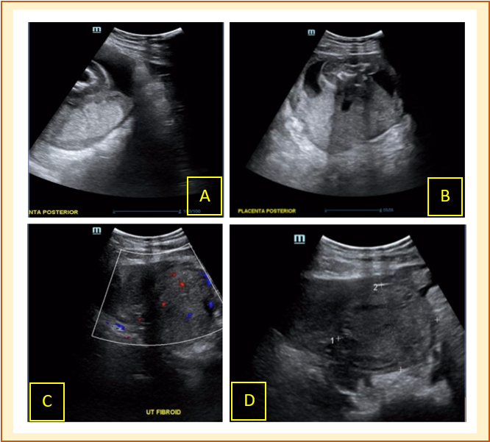
A and B - Ultrasound image showing posterior placenta;
C - Ultrasound showing uterine fibroid with Doppler flow;
D - Ultrasound showing uterine fibroid without Doppler flow

Figure 2. Surgical findings.

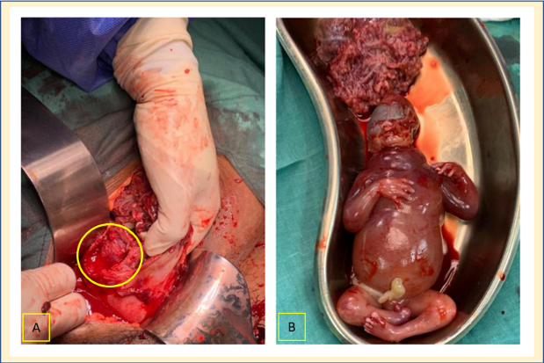
A – Defect seen to the right interstitial portion of the Fallopian tube, B – Foetus and placental tissue that were removed, notice foetus with oedema around the neck and distorted head.

