Case Report

Management of Endo-Periodontal lesion – A case report

Abstract

The relationship between periodontium and pulp makes the treatment of combined endo-periodonta l lesions (EPL) more challenging. It involves successful elimination of both periodontal and endodontic lesion. Endo–perio lesions are a common finding in dental practice. Progression of an endodontic lesion, if allowed leads to periodontal involvement or vice versa. This is a case series of a cases of the endodontic lesion with periodontal involvement that has been treated by performing root canal treatment followed by flap surgery. The tooth was first endodontically treated that was followed by periodontal treatment. nine months postoperatively, there was a significant gain in clinical attachment level.

Keywords
Endo–perio lesions, root canal treatment, periodontal open flap

Introduction

The connection between periodontium and the pulp has been well addressed. The embryonic, anatomical, and functional interrelationships are defined by the lateral, dentinal tubulesand accessory canals, and apical foramen and they might be assumed for the combined problems responsible for more than 50% of tooth mortality.[1] Endoperiodontal lesion or endo-perio is used to describe lesions which inflammatory saw are found both in the periodontium and in the pulp. This interrelation between periodontal disease and pulpal diseases was first described by Simring [2]. Periodontal and pulpal structures are anatomically related through apical foramina, dentinal tubules, lateral, apical foramen, accessory, secondary and canals dentinal tubules, . These means of communication are responsible from one structure to another, thus giving rise to the possibility of a pulpal disease[3,4].
Classification
The most commonly used classification was given by Simon, Glick, and Frank in 1972, which includes:[5]
1. Primary endodontic lesion
2. Primary periodontal lesion
3. Primary endodontic lesion with secondary periodontal involvement
4. Primary periodontal lesion with secondary endodontic involvement
5. Truly combined lesion.

Case report
A 28-year-old man came to get services in Periodontology unit, Department of Endodontic, Faculty of Dentistry, University of Health Sciences. complained of swallowing and pain around tooth #41 associated with pus discharge for 3 weeks. At the first visit, the existing systemic antimicrobial therapy (amoxicillin 500 mg) was administered for seven days. During the detailed clinical examination after 1 week, the Lingual of tooth #41 presented pocket with probe (PPD=8 mm) and labial probing was probe – 2 mm, The radiographic assessment demonstrated periapical endodontic lesion of tooth #41 and . The diagnosis was made by the presence of periapical endodontic lesion . Root canal treatment RCT by Calcium Hydroxide 30 days and then root canal filling by gutta-percha was performed and periodontal open flap technique, After anesthetizing with local anesthesia: ubistesin 4% with adrenaline 1:200 000, a full thickness flap was reflected starting with intrasulcular incision mesial line of #43 to the mesial line angle of #33 at the Lingual aspect and a vertical hokey-stick incision in the keratinized tissue was performed at the mesial aspect of the flap – between the papilla of teeth #31 and #41. The reflection of the full thickness flap extended to the residual alveolar bone. After reflection, thorough degranulation and debridement was done at the defect area using Gracey’s curette #3 and #4. Also, thorough scaling and root planning was carried out on the exposed root surface area of the defect , and the flap is then apically repositioned and suturing with 4-0 nylon. Medicine (drug suspension): Amoxicillin 500 mg, 2 tablets times 3 per day during 7 days; Ibuprofen 400 mg, 1 tablet every 6 or 8 hours after meal during 5 days; Chlorhexidine gluconate 0.12% rinse one a day during 2 weeks; and also asked the patient to give oral health hygiene after that recall for checkup in 10 days and also asked the patient to give oral health hygiene. After treatment, the patient was recalled periodically at 1, 3, 6 and 9 months . Clinical examination showed that PD recovered to within a normal range (approximately 3 mm), and tooth not mobility.

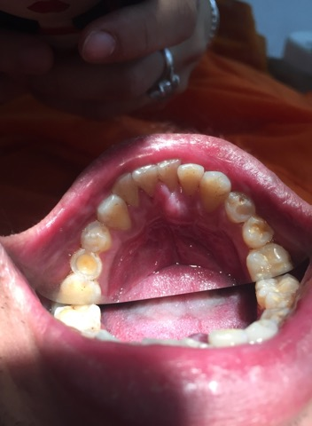
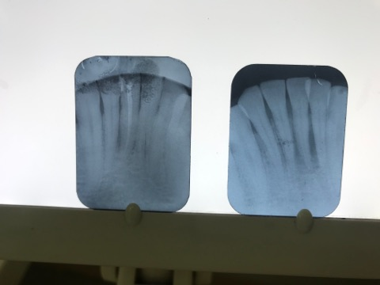
B
A

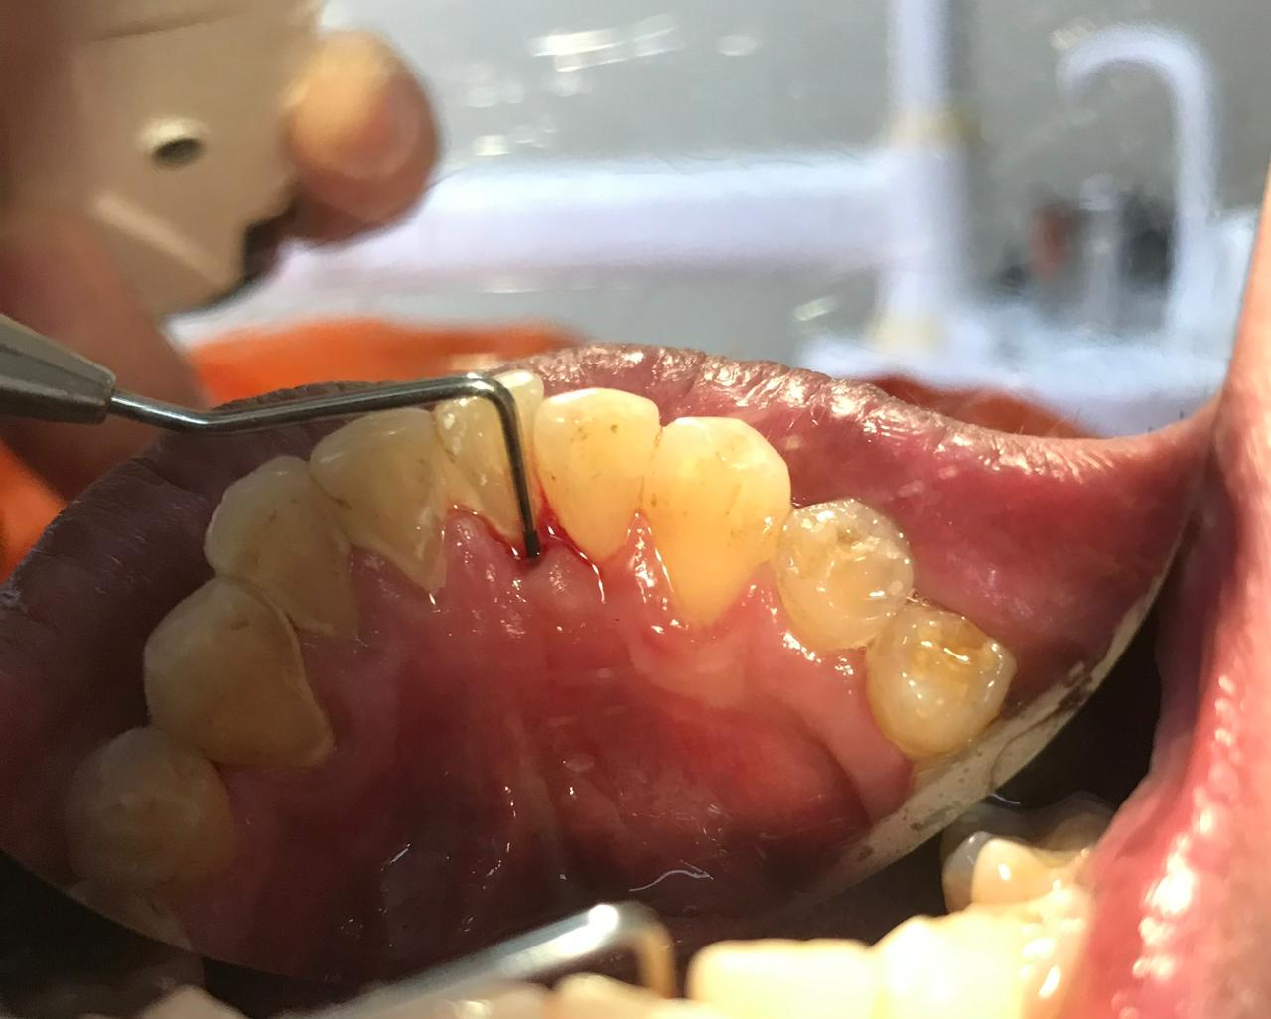
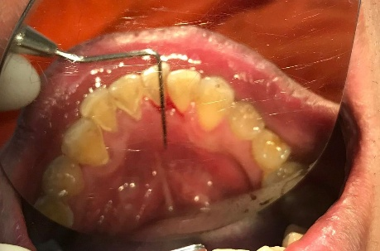

D
C

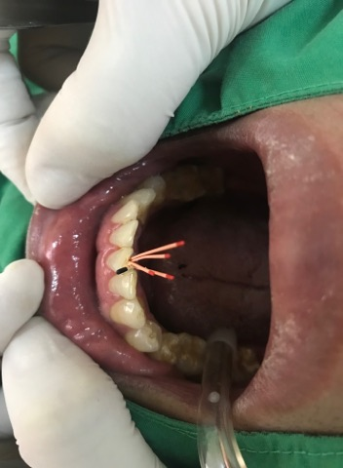
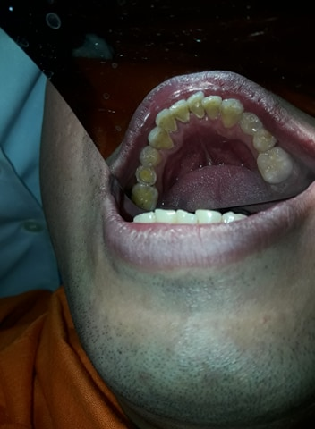

F
E

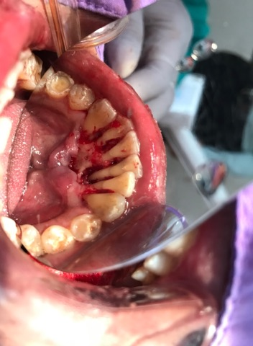
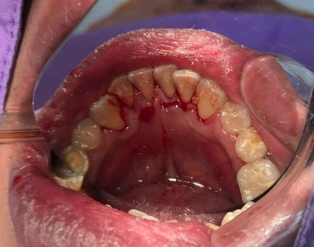

H
G

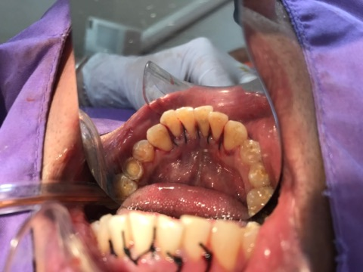
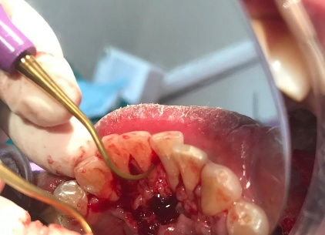

J
I
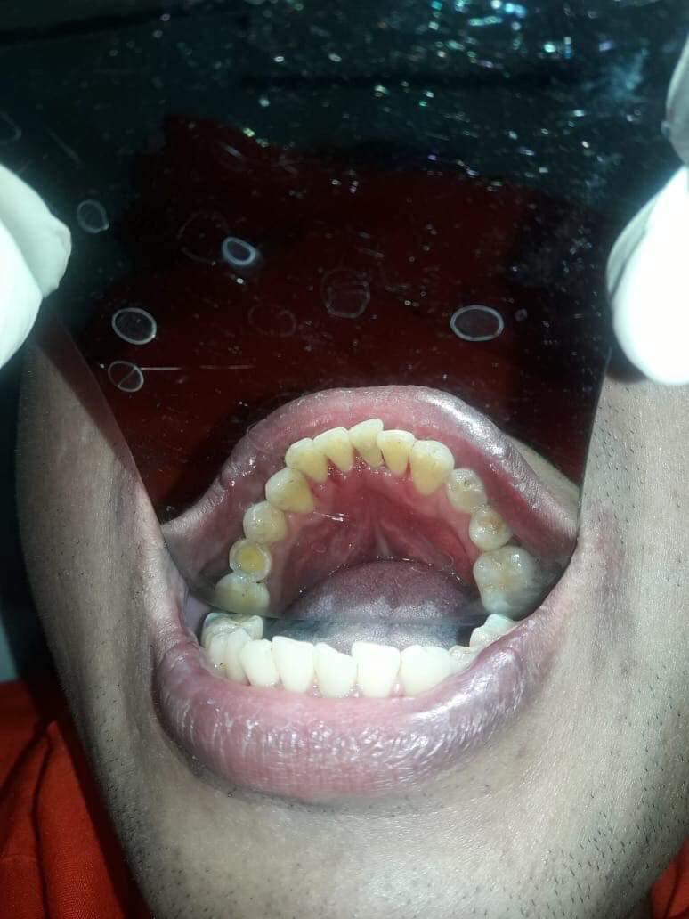
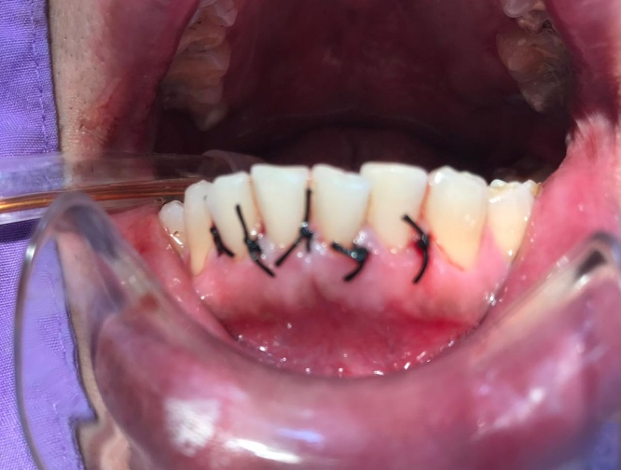
L
K

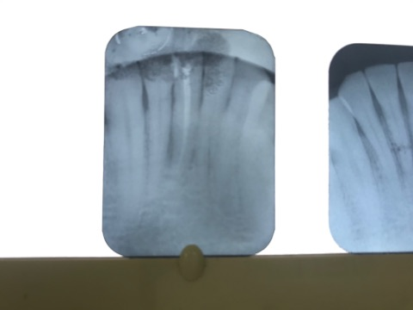
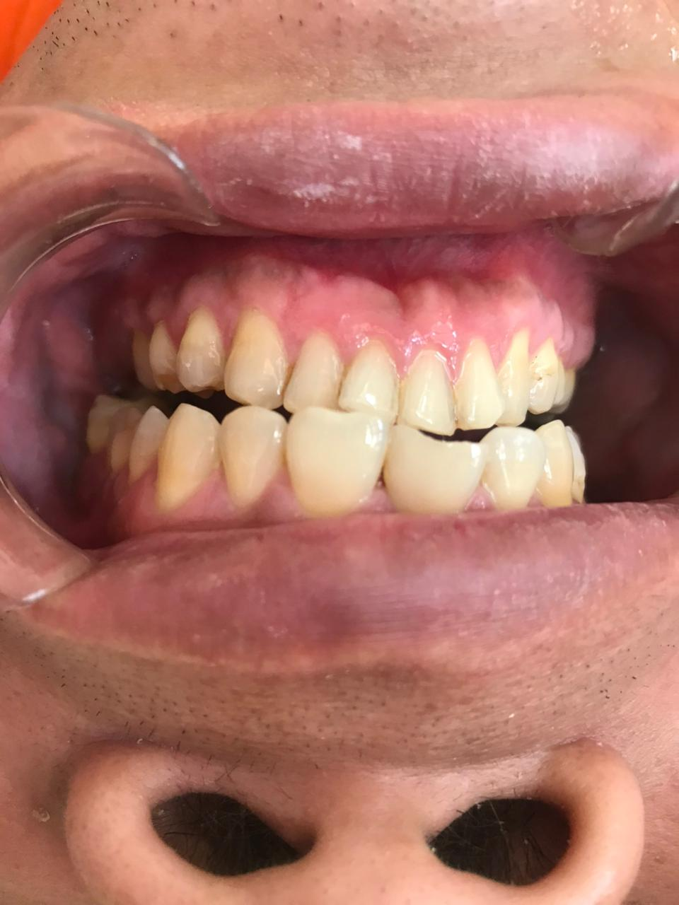

N
M
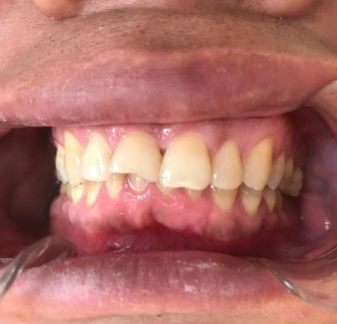

O
Figure: (A) Initial x-ray of tooth 41 with chronic inflammation around root, (B) periapical abscess, chronic infection, pain, swelling and pus, (C, D) Preoperative probing, PPD=8 mm (E,F) RCT by Calcium Hydroxide 30 days and then root canal filling by gutta-percha, (G,H) Full-thickness flap raised, (I) the defect area using Gracey’s curette #3 and #4. scaling and root planning was carried out on the exposed root surface area of the defect (J,K) suturing with 4-0 nylon, (L,M.N.o) The results post 9 months have shown a significantamount of bone fill in the bony defect areas and tooth not mobility .
Discussion:
The diagnosis and prognosis of the tooth having endo–perio lesions present a challenge to the clinicians. Correct diagnosis is important to determine the treatment and long‑term prognosis. However, treating a complex endodontic periodontal lesion is still one of the most common challenges in today’s clinical practice. The simultaneous existence of endodontium and periodontium tissue destruction can complicate the diagnosis and subsequently affect the prognosis of the involved teeth.[6,7] Treatment of endo–perio lesion requires both endodontic treatment and periodontal regenerative treatment. The treatment strategy is to first focus on debridement and disinfection of the root canal system followed by an observation period. The goal of periodontal surgery is to remove all necrotic tissues from the surgical site and facilitate the regeneration of hard and soft tissue along with the formation of new attachment apparatus. In the reported cases, the established diagnosis in case was primary endodontic with secondary periodontal lesion Endodontic therapy was done and followed by periodontal surgery, the bony defect was present and there was a furcation . The results post 9 months have shown a significantamount of bone fill in the bony defect areas and in furcation involvement region also.
Conclusion:
With the treatment and follow-up of the present case, it is possible to conclude that there is clinical success when endodontic treatment is performed before periodontal treatment, since the primary need for therapy of an endoperiodontal lesion is to treat the two origins of the lesion.

COMPETING INTERESTS DISCLAIMER:
Authors have declared that they have no known competing financial interests OR non-financial interests OR personal relationships that could have appeared to influence the work reported in this paper.

REFERENCES
1. Narang S, Narang A, Gupta R. A sequential approach in treatment of perio-endo lesion. J Indian Soc Periodontol 2011; 15:177–80.
2. Simring M, Goldberg M. The pulpal pocket approach: retrograde periodontitis. JPeriod. 1964;35:22-48.
3. Xia M, Qi Q. Bacterial analysis of combined periodontal-endodontic lesions by polymerase chain reaction denaturing gradient gel electrophoresis. J Oral Sci. 2013;55(4):287-91.
4. Simon JH, Glick DH, Frank AL. The relationship of endodontic‑Periodontic lesions. J Periodontol. 1972;43:202‑8.
5. Harrington GW, Steiner DR, Ammons WF. The periodontal‑endodontic controversy. Periodontol 2000 2002;30:123‑30
6. Xia M, Qi Q. Bacterial analysis of combined periodontal-endodontic lesions by
polymerase chain reaction denaturing gradient gel electrophoresis. J Oral Sci.
2013;55(4):287-91.
7. Gomes BPFA, Berber VB, Kokaras AS, Chen T, Paster BJ. Microbiomes of endodontic-
periodontal lesions before and after chemomechanical preparation. J Endod.
2015;41(12):1975-84.

