 | Journal Name: | International Journal of Plant & Soil Science
 | Manuscript Number: | Ms_IJPSS_152532
 | Title of the Manuscript: | Interactive Effects of Soil Texture and Sowing Depth on Seedling Emergence Dynamics of Bambara groundnut (Vigna subterranea L. Verdc.)
 | Type of the Article | Original Research Article
PART 1: Comments
 |  |  | Reviewer’s comment  Artificial Intelligence (AI) generated or assisted review comments are strictly prohibited during peer review. | Author’s Feedback (It is mandatory that authors should write his/her  feedback here)
Please write a few sentences regarding the importance  of this manuscript for the scientific community. A minimum of 3-4 sentences may be required for this part. |  |  | The subject of the study presented by the authors is interesting and topical, with scientific and practical importance.
Is the title of the article suitable?  (If not please suggest an alternative title) |  |  | The title of the article is appropriate, in relation to the topic addressed.
Is the abstract of the article comprehensive? Do you  suggest the addition (or deletion) of some points in this section? Please write your suggestions here. |  |  | The article Abstract is comprehensive and the keywords are representative of the article topic.
Is the manuscript scientifically, correct? Please write here. |  |  | The subsections and structure of the manuscript are appropriate, in accordance with the General Guideline for Authors.  Scientifically, the article has a correct approach.
Are the references sufficient and recent? If you have  suggestions of additional references, please mention them in the review form. |  |  | The scientific literature, to which the reporting was made, is recent and representative in the field.

Is the language/English quality of the article suitable for scholarly communications? | The English language and the quality of the article are suitable for academic communications, and the article is accessible to readers.
Optional/General comments | 1.  It is recommended to review the writing of bibliographical sources in the text.  e.g.  ";" between two bibliographic sources, instead of "," "et al., 2013" instead of "et al. 2013"  “(Touré et al., 2013)” instead of “((Touré et al. 2013)”  “Author, year” instead of “Author year” – comma  Similar situations were found elsewhere in the article. Revision and surgery are recommended, as appropriate. 2.  It is recommended to review the positioning of figures on the article page.  e.g. Figure 6  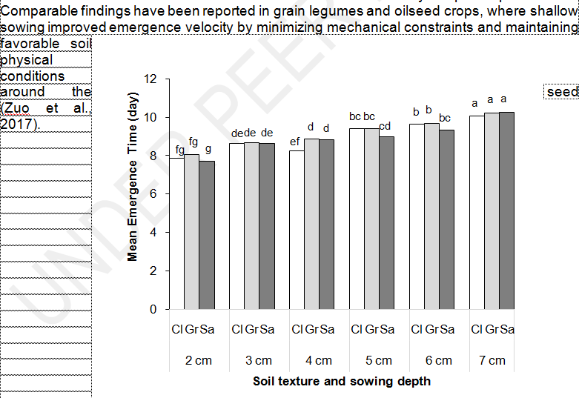  A central position is recommended, with no text around the figure.  3.  It is recommended to revise the References chapter.  All sources cited in the article should be presented in the References chapter, and vice versa. It is recommended to cite the authors of each bibliographic source correctly and completely.  The subject of the study is interesting and topical, with high scientific and practical importance. The introduction is presented correctly, in accordance with the subject.  Methodology of the study was clearly presented, and appropriate to the proposed objectives.  The obtained results are important and have been analyzed and interpreted correctly, in accordance with the current methodology. The scientific literature, to which the reporting was made, is recent and representative in the field.  I appreciate that the article can be accepted for publication after minor corrections.

PART 2:
 | Reviewer’s comment | Author’s Feedback (It is mandatory that authors should write his/her  feedback here)
Are there ethical issues in this manuscript? | (If yes, Kindly please write down the ethical issues here in detail)  Not identified, not the case.

Reviewer details:
. Florin SALA, University of Life Sciences “King Mihai I” , Romania

