The effects of organic matter on soil chemistry of composted mounds under sweet potato production in the highlands of Papua New Guinea

Abstract

The reduced fallow period and continuous cultivation of sweet potato on the same land have resulted in the depletion of soil nutrients and poor yields in Papua New Guinea (PNG), necessitating improved soil fertility management practices. In this study, we conducted a field experiment to understand the roles of organic matter in composted mounds used for sweet potato production in the highlands of PNG, utilizing cogon grass material (high carbon) and fern leaves (high nitrogen). The first treatment was set without amendment and planted as control. The second and third treatments were solely amended, respectively, and the fourth was amended with a combination of the two. All treatments were replicated five times, set up in a randomized complete block design, planted with the same number of vines, and allowed to grow in the field for twelve months. During production, soil and tuber samples were taken after six and twelve months, processed, and subjected to instrumental analysis. The average data from four replicates of each treatment were pooled, averages calculated, and statistically analysed. The results showed that composted mounds improve soil parameters and increase the concentration of nutrients in both soil and tubers. In almost all cases, nutrient availability in the soil and tissue was dependent on the type of organic matter and the time of production. Nutrient availability was high due to the high nitrogen amendment for six months and then decreased thereafter, implications for human and livestock, as well as sustainable soil health.

Keywords: Composted mounds, organic matter, Papua New Guinea, soil chemistry, sweet potato.

1. Introduction

Sweet potato (Ipomoea batatas, Lam.) is a staple crop grown in Papua New Guinea (PNG) (Bourke, 2009) and globally (Yared et al., 2014; FAO, 2017; Ejechi et al., 2020; Esan et al., 2021), essential to the rural people and livestock (e.g., pigs), with more than 5 million people depending on it. In the lowland, sweet potato is cultivated alone or with other crops such as cassava, yam, and taro. Throughout PNG, sweet potato is a subsistence food crop with its production limited to subsistence family gardens and production inputs mainly coming from within the family units. Depending on the farmers’ choice, mixed cropping with vegetables (in the highlands) or other root and tuber crops (in the lowlands) is common (Peter and Michael, 2023). In most of the village sweet potato farms, mixed cropping is the preferred system because of the added advantage of diversification, security against soil health, and deterrence of pests and disease issues. As it is in Oceania (Peter and Michael, 2023), sweet potato production is limited to subsistence farming, and the crop is grown using two principal techniques - flatbeds or mounds with or without organic matter (Fig. 1) (Bourke and Allen, 2009). Propagation is primarily by vine cuttings, however, sprouts from the storage tubers are used as the propagules.
Sweet potato production in beds, compared to composted mound shown in Figs. 1 and 2, is such that once the land is cleared, some tillage is done using small handheld tools to break the soil, the beds are formed, and planting is done. The shapes of the flatbeds vary in size and shape and can be irregular or rectangular and 5 m wide and 10 m long (even much wider and longer). In the flatbed technique, organic matter addition consideration is quite common. In most cases, the availability of excess plant materials such as fallen trees and twigs from newly cleared land is often burnt, the ashes spread, and beds made. In older gardens, the plant materials that become available are grasses and shrubs. If these are not burnt, they are incorporated into the soil of the beds. Too much fresh organic matter in the bed soil often makes farmers delay planting. Therefore, all cleared plant materials are allowed to dry up for a month or two before working on the land to prepare the beds (applies to the mound-making techniques).
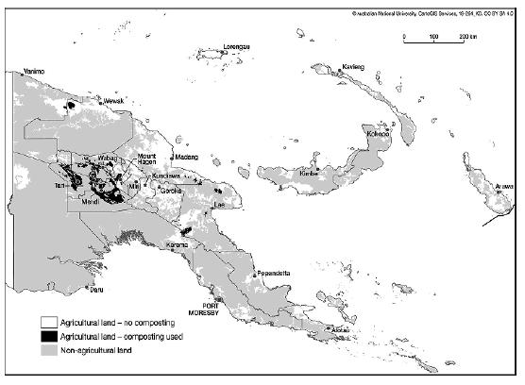
Figure 1. Map of PNG showing areas where composted mound making practice is common in food gardens (Bourke and Allen, 2009).

In the western central PNG highlands (Fig. 2), sweet potato is cultivated on ‘composted mounds,’ the technique is limited to sweet potato production. Based on Engan oral history, composted mounding technique was developed singly by a man from the Itokone tribe, middle Lai Valley, Wabag District, in Enga Province, following the introduction of sweet potato (Healey, 1999; Wiessner, 2005; Taraken and Ratsch, 2012). During land preparation, an old garden following a shorter fallow (2 – 5 years) or a new land (often a piece of land that has been fallowed a bit longer (3 – 5 years) is cleared manually (Fig. 3). The slashed or chopped plant materials are left in the open air to dry for a few weeks or even longer to be used as compost organic matter. Logs, fallen branches, twigs, and other bigger plant materials are burnt and maintained in heaps to be used as composts. Organic matter sources, e.g., kunai and fern leaves, that are not available from the cleared material are also collected from the nearby sites or bushes, sun dried, and used in the composted mounds.
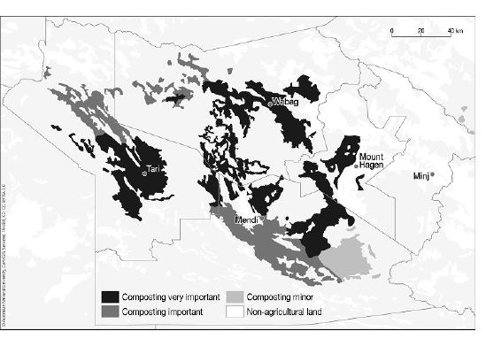
Figure 2. Map of the western central PNG highlands (Enga, Southern Highlands, Hela and Western Highlands Provinces) showing the distribution of the composted mound making practice (Bourke and Allen, 2009). The study site is shown by the red cycle.

In the new land where mounds have not been made previously, the burnt ashes or debris of land clearing are gathered in parallel rows of equal spacing, forming a round (plano-convex) heap (Wohlt, 1986). Sometimes, the shape is elongated (Taraken and Ratsch, 2009). In fallowed land with old mounds, the dried grass clippings or those collected from the nearby bushes are placed along the space separating two mounds like that in the new land. To make the mounds, the organic is covered with soil, either obtained by digging around the organic matter heap in a new soil/land or from the adjacent mounds in fallowed soil (Wohlt, 1986). More soil is added to the mounds until the desired shape and size are obtained. And a single mound is made by two women (girls or mothers) working on either side of the mound until it is completed, and the pair moves to the next mound. The mound-making technique requires shared responsibilities. The menfolk are involved in land clearing, collecting and gathering organic matter, and loosening or digging up the soil before the womenfolk makes the mounds. In the instances of a lack of strong women, men are involved in all the activities, e.g., in a family of aging mothers.
The soil type directly determines the mounds' size and the organic matter availability (Floyd et al., 1988). In places of deep topsoil (friable A horizon) and high organic matter sources availability (Wood, 1984), the sizes of the mounds are elongated. The size of mounds and the amount of organic matter are further influenced by phenomena such as frost and soil drainage systems. In higher altitude areas (>2000 m) of Kandep, Sirunki, and Lagaip, where frost is common, more organic matter is added in smaller mounds (1.5 – 2.3 m in diameter and 0.6 – 1.2 m in height). In frost-free areas of Ambum Kompiam, Wabag Central, Laiagam, and Wapenamanda, the standard size of mounds is bigger (2.5 – 3.5 m in diameter and 0.7 – 1.5 m in height) (Taraken and Ratsch, 2009). In poor drainage, swampy or waterlogged areas, mounds are much higher and sloppy to avoid inundation and deformation.
A bundle of vines (in most cases, 5 of them) is held by the cut ends and planted in a single spot (planting point) by pushing the hand with the vines into the soil. The vines were released by opening the fingers, and the hand gently withdrawn, leaving the vines inside the holes. The soil immediately above the vines is then gently pressed to ensure the vines are in contact with the soil. Depending on the size of the mounds, a total of 5 – 10 holes can be planted. In some rural farmers, the bottom part of the mounds is planted with early maturing vegetables or corps, diversifying crop production. The shape of the mounds is deformed during planting, and experienced mothers use their bare hands to reshape them afterward. The sweet potato stays in the mounds for more than 195 days in the cooler central highlands (Michael, 2020a), and the womenfolk manage the production (mainly weeding at the establishment, vegetative stage, and tuberisation) throughout. The menfolk must fence the production sites against domestic pigs and provide security against theft.
The composted mound-making technology developed by a curious and primitive farmer after the introduction of sweet potato to New Guinea (Bourke, 2009) caught the attention of many researchers. Taraken and Ratsch (2009) and Wood (1984) pointed out that composted mounds improve soil biological, chemical, and physical parameters and raise crops above water tables and prevents roots from drowning (Pardales and Yamauchi, 2003). Composting generates heat to enhance tuberisation, reduce soil-borne diseases, minimize soil erosion, enhance land use, and allow crop diversification and multiple harvesting – important for soil health and security (Kirchhof, 2006). Most importantly, composted mounds shorten fallow periods compared to shifting cultivation (15 – 30 years) and enhance permanent land uses. In the central highlands, volcanic ash soil of poor water-holding capacity is dominant. The organic matter in the mounds is essential for the moisture content (Wood, 1984), even with excessive rainfall.
In all the studies, sweet potato yield was high in the composted mounds, and composting increased the above-ground biomass (D’Souz and Bourke, 1982; Preston, 1990). Wood (1984) measured a high concentration of potassium in tubers of sweet potato in composted mounds. Michael (2020b) recently estimated low potassium content in the soil sweet potato was planted in a pot trial, suggesting that the high yield is in response to increased uptake of potash. Wood (1984) also reported that phosphate was responsible for the high yield. A survey of sweet potato gardens in 2005 showed a decline in soil fertility (P, K, and S) was threatening the production of sweet potato in the PNG highlands (Taraken et al., 2012). The sweet potato literature in composted mounds from 1977 to 2009 does not clearly show the types of organic matter used and the changes in soil properties measured (Hartemink and Bourke, 2000. The need to understand the limitations of trace elements (micronutrients) in composted mounds to sweet potato production is not established (Taraken et al., 2010), like that of P, K, and S. In almost all cases, the results of studies (e.g., Hartemink, 2003; Yeng et al., 2012; Shekhar et al., 2015; Ngailo et al., 2016; Yeboah et al., 2017) cannot be extrapolated (differences in soil types, the organic matter used as composts, and even study objectives). Further, several studies have clearly shown that intensification of sweet potato production in PNG over the last ten years have led to a decline in soil nutrients (Floyd et al., 1989; Hartemink et al., 2000; Bailey et al., 2009; Wang et al., 2015; Fujinuma et al., 2018; Hazenbosch et al., 2021).
The first aim of this study was to assess the effects of two organic matter sources of varying nutrient content on the chemistry of composted mound soils and their implications on crop yield in the high-altitude areas of PNG. The second aim was to assess the long-term consequences of using locally available organic matter on trace element availability in the composted mound soils as a measure of soil health.

2. Materials and Methods

2.1 Location, soil, and organic matter types

The study was conducted in a volcanic ash soil (Andepts) at an elevation of 2,693 m in Pilikambi Rural LLG., Sirunki, Laiagam, Enga Province (S 050 29’ 08.1”, E 1430 34’ 48.2”) using two organic matter of varying nutrient contents. The first organic matter source is cogon grass (Imperata cylindrica) materials, used as the low soil nutrient source. This perennial grass is widely available in the high-altitude areas of the composting zones, is invasive in unmanaged areas (Michael, 2020b) and fallowed mounds, and is a first-choice organic matter in composted mounds. The farmers manage the invasiveness by setting the invaded land on fire during the dry seasons, which is often seen as a source of CO₂ contributing to greenhouse gas emissions (Michael, 2020a). The nutrient status of the soil and the contents of the organic matter sources are shown in Table 1. The garden grasses were made up of different weed species, therefore, contained more nutrients than cogon grass or fern leaves.

Table 1. The nutrient contents of the soil and organic matter sources used.
 | Treatments and soil nutrient contents (mg kg⁻¹)
Nutrients | Soil | Cogon | Fern | Grasses* |  | Total
Nitrogen | 1.12±1.44 | 0.72±4.44 | 1.67±0.44 | 1.58±0.14 |  | 5.09±0.36
Phosphorus | 2.57±1.24 | 18.37±3.54 | 23.29±2.44 | 50.92±4.48 |  | 93.15±5.44
Potassium | 3.65±0.34 | 189.68±1.44 | 27.15±2.55 | 121.26±3.43 |  | 338.74±2.44
Magnesium | 8.70±3.14 | 134.12±2.14 | 187.41±3.44 | 310.61±3.49 |  | 640.84±3.55
Sodium | 19.56±1.34 | 7.70±0.44 | 8.88±0.66 | 13.88±1.84 |  | 50.02±1.44
Calcium | 55.29±2.54 | 252.85±4.44 | 249.93±4.44 | 377.71±6.45 |  | 935.78±2.57
Sulfur | 0.02±0.21 | 1.89±0.04 | 3.77±0.44 | 6.36±1.44 |  | 12.04±0.04
Manganese | 0.53±0.44 | 3.50±0.24 | 4.78±0.33 | 3.72±0.44 |  | 65.00±2.66
Zinc | 0.14±0.44 | 0.48±0.02 | 0.57±0.02 | 0.67±0.04 |  | 1.86±0.24
Boron | 5.54±0.24 | 1.77±0.03 | 0.76±0.14 | 1.77±0.49 |  | 9.84±0.54
Copper | 0.12±0.34 | 0.42±0.02 | 0.17±0.12 | 0.38±0.45 |  | 1.09±0.66
Iron | 1.32±0.44 | 46.45±3.46 | 9.23±0.22 | 89.24±5.44 |  | 146.24±3.48
Aluminium | 71.12±3.66 | 76.95±3.54 | 129.55±3.44 | 198.88±4.64 |  | 476.50±5.44
*Grasses are several weeds in the fallowed land that were slashed, dried, and gathered to form the mounding stations.

The second organic matter source of high nutrient content is elephant fern (Angiopteris evecta) leaves. The fern plant of choice is widely available in the nearby bushes. It is always the first-choice organic matter source for the farmers when availability becomes limited, and there is a need to do an additional collection from the bushes. In almost all the new land cleared and used for composted mound making, fern leaves are the first-choice organic matter, even if the ashes and cogon grass are available. Preston (1990) conducted an agronomic trial investigating organic matter and fertilizer interaction in the Taluma area (2570 m) in the Sirunki Plateau between 1986 – 1987. Our study site was at Mulisoas (2600 m) within the same Plateau.

2.2 Organic matter collection, land preparation and mound construction

Figure 3 shows the processes involved in composted mound making. The organic matter sources were collected from within the study site as traditionally done throughout the composting zones. Young men from the village where the study was conducted were engaged as field assistants to collect cogon grass materials from the nearby fallowed land, and fern leaves from the nearby bushes. The cogon grass was collected by slashing them off from the soil surface. Therefore, the whole aboveground biomass. The fern leaves were collected by chopping off from the petiole and were the entire leaf. The collection was indiscriminate. Thus, both young and old were collected. All the plant materials were sun-dried by direct exposure for two weeks and used in the composted mounds when fresh but dry enough.
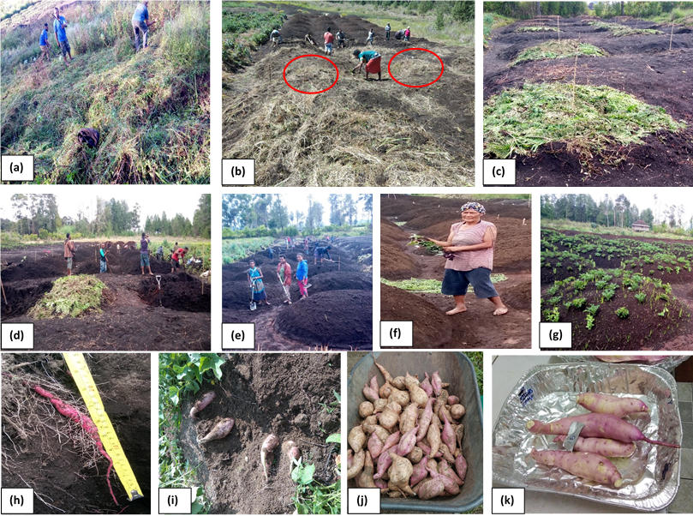
Figure 3. The sweet potato production processes undertaken in composted mounds. Clearing and slashing a fallowed land (a), making mounding stations as shown by the red cycle (b), adding composts (c), loosening the soil (d), mound construction by girls (e), vine planting (f), a new composted mound (g), yield monitoring (h), harvesting (i), cleaning (j), and sorting and grading (k) (Peter et al., 2024).

A fallowed piece of land (80 m x 20 m) was selected, and male field assistants cleared it manually by slashing (Fig. 3a). The slashed grasses and shrubs were open-dried by exposure for two weeks. Young women were engaged as field assistants to do the row marking when the plant materials were dried enough. Row marking establishes a mounding station to show where the mounds would be located and constructed. The row marking is done by gathering loose soil, and the dry plant materials (grasses) available from the slashing (Fig. 3b) forming a convex heap in equally spaced (50 cm within and 20 cm between) rows that are laid out parallelly. The organic matter (30 t per mound or 100 per ha) was carefully placed around the convex heap (Fig. 3c), and young men dug the soil around the heap (Fig. 3d) to make it easy for women and girls to construct the mounds (Fig. 3e). All the mounds were 80 cm in height and 330 cm in diameter. Planting was done within the top 30 cm of the mounds by grabbing them firmly (Fig. 3f) and pushed into the soil with the help of the clinched fingers. Four vines were planted in a single spot, and five spots per mound were planted, a total of 20 vines per mound (Fig. 3g). The mounds were managed as usually done by weeding, providing security against theft and feral pigs. After six months of planting, tuber formation was monitored by gently removing the soil under the vines (Fig. 3h). Harvesting was done after 360 days (Fig. 3i), and basic postharvest treatments like washing and cleaning (Fig. 3j) and grading and sorting into marketable sizes (Fig. 3k) were carried.

2.3 Treatments

Thirsty six mounds were constructed and four were allocated to each treatment (n=4):

(i) Control – There were 12 mounds, four each with cogon grass and fern leaves and the others without organic matter.
(ii) Cogon grass – A total of 8 mounds, four with sweet potato and the others without it.
(iii) Fern leave - A total of 8 mounds, four with sweet potato and the others without it.
(iv) Cogon + fern - A total of 8 mounds, four with sweet potato and the others without it.

All the treatments were randomized in a randomized complete block design (RCBD) manner and allowed to run for twelve months. As a standard practice, female field assistants assisted in weeding at various stages of production (vegetation, tuberisation, and near maturity), harvesting, and shorting tubers into marketable sizes.

2.4 Soil sampling and plant growth parameter measurements

Soil samples were collected from two profiles, 0 – 30 cm (top) and 30 – 60 cm (deep), twice. The first sampling was done after six and the second after twelve months, respectively. A metallic augur was used to sample the topsoil, followed by the deep. Each sample was placed in prelabelled paper bags separately until all the treatments were sampled. The sealable plastic bags containing the respective soil samples were placed in several polythene crakes, taken to the laboratory, and frozen at 4 °C before laboratory analysis. During the first sampling, several vine stations (spots) were chosen and gently dug under the vines, and the biggest tubers formed were identified, their length measured (Fig. 3h) and sampled for nutrient analysis. The vine stations were tagged using metal tags to be identified in the second sampling after twelve months. The plant materials collected from the first sampling were gently washed under running water and air-dried for 2 hours under lab conditions (24 ± 2 °C). The fresh weights were taken using a top pan balance. These were then chopped into small pieces using a kitchen knife and oven dried at 75 – 85 °C for three days (Hartmink, 2003) until dry enough to be ground to a fine powder using a grinder. The ground plant materials (tuber) were packed into labelled paper bags and kept dry before laboratory analysis.

2.5 Analyses and measurements using soil samples

Triplicate samples (n=3) from the 0 ˗ 30 cm profiles were used. The soil pH was measured using a standard dilution (1:5 soil: water w/v)) method (e.g., Michael et al., 2015). The electrical conductivity (EC) was measured using a Direct Soil EC meter using solutions (1:5 soil: water w/v). The soil organic carbon (SOC) content was analysed using the weight loss-on-ignition method (Schutle and Hopkins, 1996). A 5 g sample was weighed into a crucible and heated in a muffle furnace for 12 h at 105 °C (W_{f}), combusted at 375 °C for 17 h (F_{w}) and cooled for 2 h, and weighed. The SOC content was estimated by multiplying the carbon value by a conversion factor (1.72) and expressed as a percentage:
SOC (%) = [((W_{f} – F_{w}) ÷ W_{f})1.72)100] (1)

The conversion factor was used to convert the soil organic matter content to organic carbon, assuming there was 58% C in the organic matter. The size of the C stock (tonnes per hectare) in each profile was calculated as the sum of the individual C fractions (%) × bulk density (BD, g cm⁻³) × profile depth (SP, m) as follows:
C_{stock} (t C ha⁻¹) = [(SOC x BD x SP)ha (2)

The SOC (%) was determined using (eqn. 1) and BD (g cm⁻³) was calculated by oven drying of the cores at 105 °C for 48 h, followed by re-weighing. The oven dry weights were divided by the volume of the core and kept as the BD. The soil organic matter (SOM) contents were estimated using the SOC content and the conversion factor as follows:
SOM (%) = [(SOC) x C_{f})] (3)

Total porosity was determined as per (Landon, 1991) as follows:
(4)
$$P=\left.\left(1- \frac{BD}{d}\right.\right)$$

P is total porosity (%), BD is bulk density and d is particle density equals to 2.65 g cm⁻³.

The weight of the SOM to a given depth and area was estimated as follows:
SOM (tonnes) = [(SOC x BD x SP x ha)1.72] (5)
Where SOC is in %, BD is in g cm⁻³, SP is in m and ha is hectare (10 000 m²). The SOC, carbon stock, SOM, WHC, P, and SOM (tonnes) estimated for the original soil using equations 1 to 5 were: 70%, 80%, 89%, 60% and 400 tonnes.
Total nitrogen was determined by the Kjeldahl method and available phosphorous was determined by Olsen (Shimadzu 1800 UV/VIS spectrophotometer). All the other nutrients were extracted with a Melich3 extracting solution (1 M NH₄Cl) and analysed using an ICP OES (Spectro ARCOS). Prior to the measurements, all the plant tissues were digested by wet ashing using HNO₃/H₂0² (Yang et al., 2013).
The data in milli-equivalent (mEq./100 g soil) were converted to milligrams (mg) as follows:

mg = [(mEq x Aw) ÷ V)] (6)

Where Aw is the atomic weight of an element (e.g., nitrogen) and V is valence, respectively.

Statistical analysis

The treatment averages of a profile of all the parameters (e.g., pH) were obtained as per Michael et al. (2015) by taking the mean of the three replicates. To compare the treatment means, significant differences (p<0.05) between the treatment means of each profile were determined by two-way ANOVA using statistical software JMPIN, AS Institute Inc., SAS Campus Drive, Cary, NC, USA 27513. If an interaction between the treatments and profile depths was found, one-way ANOVA with all combinations was performed using Turkey’s HSD (honest significant difference) and pairwise comparisons (e.g., Michael et al., 2016).

3. Results and Discussion

3.1 Changes in selected soil parameters

The changes in important soil parameters that affect soil fertility and soil nutrient status measured are shown in Table 2. Soil organic matter (SOM) is an important soil parameter that affects soil microbial, chemical, and physical properties (e.g., Hafifah et al., 2016; Novianatya et al., 2017). Planting in unamended soil decreased the SOM in the short term but increased it in the long term (Table 2). The addition of the carbon source increased it by nearly 18% and decreased in the other treatments long-term (12 months), and more so in the soil, where nitrogen was low and carbon was high. When planting was done without an amendment, there was no clear relationship between the SOM content and the soil organic carbon (SOM) content; the SOC content was the same. In the amended soils, the SOC content generally increased by a small amount, and that decreased over time. The decrease in the SOC content in the long-term was due to the pant use of the carbon. Similarly, the carbon stock reflected on the changes in SOC content measured. The higher the SOC content, the higher the soil carbon stock and the opposite was the same (Table 2).

Table 2. Long-term changes in soil chemistry following organic matter amendments
Soil parameters | Treatments
Soil parameters | Pl | Cn+Pl | Fn+Pl | Cn+Fn+Pl
SOMª (%) | 38.76±0.23 | 56.82±0.46* | 42.43±0.45 | 45.38±0.78*
SOM^{b} | 40.68±0.34 | 37.11±0.55 | 40.06±0.35 | 43.37±0.98
SOCª (%) | 23.23±0.46 | 23.08±0.35 | 24.62±0.24 | 23.47±0.78
SOC^{b} | 23.63±0.62 | 21.58±0.25 | 23.29±0.54 | 25.21±0.44*
Cstockª (ton ha⁻¹) | 4.11±0.25 | 7.38±0.38* | 6.88±0.65 | 7.03±0.49*
Cstock^{b} | 3.85±0.27 | 6.57±0.29* | 6.61±0.58 | 7.81±0.37*
pHª | 7.22±0.44 | 6.01±0.52 | 7.61±0.33 | 7.72±0.54
pH^{b} | 7.55±0.25 | 6.68±0.43 | 6.49±0.21 | 6.31±0.32
ECª (mS cm⁻¹) | 0.37±0.06 | 53.1±0.34* | 44.32±0.25* | 41.13±0.62*
EC^{b} | 0.09±0.04 | 39.8±0.22* | 36.22±0.14* | 128.71±0.86*
BDª (gcm⁻³) | 0.73±0.36 | 0.62±0.15 | 0.54±0.48* | 0.58±0.28
BD^{b} | 0.75±0.74 | 0.59±0.24 | 0.55±0.39 | 0.62±0.37
TPª (%) | 64.41±0.92 | 77.84±0.24* | 78.83±0.37* | 78.56±0.29*
TP^{b} | 31.82±0.53 | 34.89±0.12* | 30.92±0.19 | 29.12±0.38
CECª (meq/100) | 49.72±0.42 | 35.5±0.22 | 17.11±0.13* | 15.47±0.47*
CEC^{b} | 55.56±0.21 | 7.67±0.45* | 7.87±0.18* | 12.71±0.57*
BSª (%) | 96.23±0.10 | 97.11±0.36 | 98.24±0.21 | 99.12±0.54
BS^{b} | 89.23±0.42 | 73.16±0.45 | 80.63±0.22 | 61.61±0.44*
The superscripts denote 6- and 12-months changes in key soil parameters. An asterisk shows a significant difference (p<0.05) in micronutrients between the unamended and amended and planted soils.

The optimal pH range of sweet potato is 5.8 – 6.8 (Valennzuela et al., 1994) and the overall pH range seemed to be within this range (Table 2). Soil pH was high in the planted without an amendment, and amended with fern leaves and planted (Fn+Pl). The pH of the soil amended with cogon plant material and planted (Cn+Pl) was low by 1.21 units (Table 2). The changes in pH induced by the nitrogen source organic matter (Fn) were higher than the effects of the carbon source (Cn) over six months, which decreased and increased over 12 months. These results indicated that changes in soil pH amended with an organic matter of high nitrogen content are immediate compared to a high carbon source organic matter. The combined amendment of the soil was seen to be important for an instant increase in the pH, but over time, it was not as crucial as it decreased compared to the unamended and planted soil pH. To a certain extent, the presence of the nitrogen source aided to the microbial oxidation of the much tougher carbon source plant material, resulting in the depletion of the energy source for the microbes to sustain the microbial ecology that generated the alkalinity. The EC was low in the planted soil, indicating that there was nutrient use by the plants. The EC increased following the amendment in the first six months because of the carbon source. The co-existence of carbon and nitrogen decreased the EC. In twelve months, EC decreased and more so in the soil amended with the nitrogen source, which meant the removal of the nutrients by microbes. The EC was high in the soil combined amendment was made, demonstrating long-term availability of soil nutrients (Table 2).
The changes in SOM content were reflected in the soil bulk density measured. A low content resulted in low bulk density. For example, in the unamended and planted soil, the content was 39% in the first six months and increased by 1% over twelve months. The changes in bulk density in the same soil over the period ranged from 0.73 g cm⁻³ to 0.75 g cm⁻³. Although the change was small, there is an indication that higher content in the soil increases soil bulk density. The scenario for total porosity was the same as that for SOM and bulk density. A decrease in bulk density increased total porosity, which was high in the first six months, consistent with the anticipated availability of organic matter. As organic matter was decomposed ultimately long-term, total porosity generally decreased, and a rise in the bulk density was observed, especially when carbon and nitrogen co-existed. The total porosity decreased by nearly 50% in the long term, showing complete depletion of the organic matter in the soil, strengthening the importance of SOM in soil porosity maintenance.
The cation exchange capacity (CEC) was high in the unamended soil and planted, which decreased following organic matter amendment. The decrease in CEC was much more significant in the soil amended with the nitrogen source and a combined amendment, short-term. In the long term, a proportionate change in CEC was measured (Table 2). Base saturation (BS) was almost 100% in the first six months, where CEC was high, and that decreased in time. The co-existence of carbon and nitrogen resulted in the highest decrease in BS by 27% (Table 2). Over time, the reduction in CEC and BS indicated that soil cations (calcium, magnesium, and potassium) were depleted (Fig. 5), and more so in the soil, both carbon and nitrogen were available. To a certain extent, this phenomenon indicates that soil microbes were partly involved in the nutrient depletion using the carbon as an energy substrate and the nitrogen for growth and development, just like plants.

3.2 Changes in soil primary macronutrients

The changes in primary macronutrients measured are shown in Fig. 4. and are very much in line with the original content of the soil and organic matter sources shown in Table 1. Generally, planting in soil without an amendment resulted in the depletion of nutrients. In six months, the contents of all the primary macronutrients were in the order K, P, and N and were the same over twelve months (Fig. 4). Comparatively, the fern leaf materials seemed to be a good source of nitrogen and phosphorus than potassium and the cogon plant materials a good source for potassium, phosphorus than nitrogen. In almost all cases, planting decreased the primary macronutrient contents with or without an amendment. The results further showed that nitrogen is used up first in the long term, followed by phosphorus and potassium. In the soil amended with the nitrogen source organic matter, potassium decreased to nearly 3 mg kg⁻¹. This showed that the presence of nitrogen enhances soil potassium use by plants (Duncan et al., 2018), and this seems to be an interactive mechanism of these nutrients (Anjana and Iqbal, 2009).
The decrease in soil nutrients without plants resulted from microbial oxidation of organic matter and microbes' use of the nutrients, especially nitrogen (e.g., Nabi, 2023; Kiprotich et al., 2025; Liu et al., 2025). The overall results showed that the primary macronutrient requirement for sweet potato is nitrogen>phosphorus>potassium. We have reported that potassium is the most limiting soil nutrient in sweet potato production (Michael, 2020b) similar to the findings of an earlier that showed high K requirement for sweet potato (Byju and George, 2005). The data in Fig. 4 indicated that the potassium concentrations were high. These different results seem to come from the influence of the soil type, organic matter sources, maturity, established microbial ecology, and other agroclimatic conditions that influence decomposition. The overall results showed planting without an organic matter amendment results in depletion of the macronutrients.
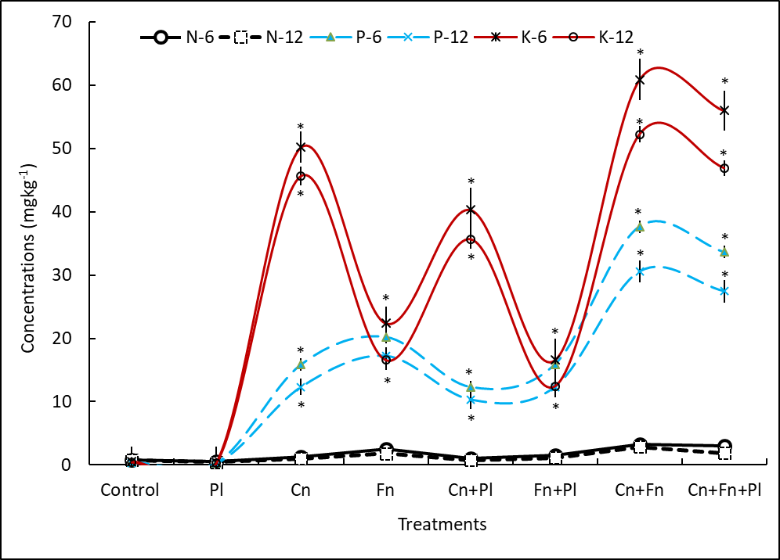
Figure 4. Changes in soil primary macronutrient compositions following organic matter amendment with or without planting sweet potato over six and twelve months. An asterisk shows a significant difference (p<0.05) in composition of the micronutrients between the unamended and amended and planted soils.

3.3 Changes in soil secondary macronutrients

The changes in secondary macronutrients are shown in Fig. 5. Generally, planting in soil with or without amendment decreased all the secondary macronutrients as a result of use and more so in soil amended with organic matter of high carbon content. In the amended soil without plants, the organic matter used as a nitrogen source increased the concentrations of the secondary macronutrients. It was also evident that the contents of the nutrients were high in the first six months and gradually decreased over the twelve months. The decrease in the nutrient concentrations was higher in the soil amended with the carbon source than the nitrogen, indicating that the nitrogen source is significant in the long term and that carbon availability as an energy source is important for plant nutrient use. The decrease in soil nutrients over time in the soil without plants has already been discussed, and the leading cause of that is microbial. The overall results, as shown, may also mean that the secondary macronutrient requirement for sweet potato may be sulphur>sodium>magnesium>calcium (Fig. 5). This could probably mean that sulphur is more important to sweet potato than calcium although the deficiency of the latter nutrient can lead to reduce root growth and tuber yield. A balance presence of sulphur is a requirement for N use and the low concentrations measured confirms that established knowledge.

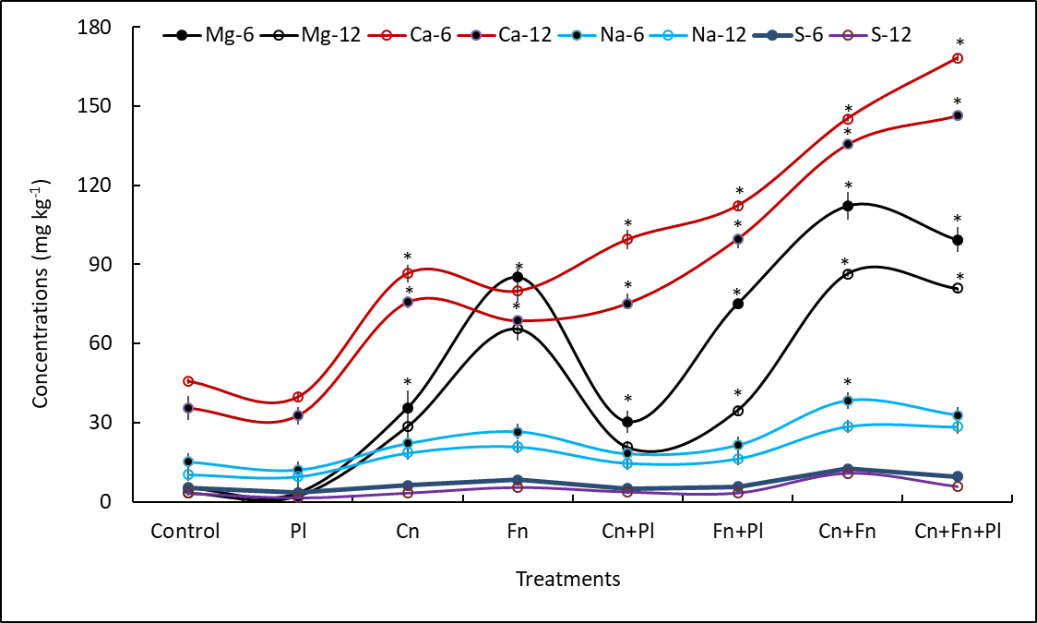
Figure 5. Changes in secondary macronutrient compositions following organic matter amendment with or without planting sweet potato over six and twelve months. An asterisk shows a significant difference (p<0.05) in composition of the micronutrients between the unamended and amended and planted soils.

3.4 Changes in micronutrients

The micronutrients copper and Zinc concentrations were well below 5 mg kg⁻¹ in all the treatments throughout the twelve months (Fig. 6). These micronutrients were followed by manganese and boron whose concentrations were higher and more so iron and aluminium. The elevated micronutrient levels were mainly measured in the soil amended with organic matter of higher nitrogen content than carbon. The increase being common in the treatments combined amendment was made means availability of both carbon and nitrogen are important for soil micronutrient sustainability. For plant use of micronutrients, presence of carbon in the soil seems to be more important than nitrogen, as demonstrated by the decrease measured in the soil amended with the carbon source and planted (Fig. 6).

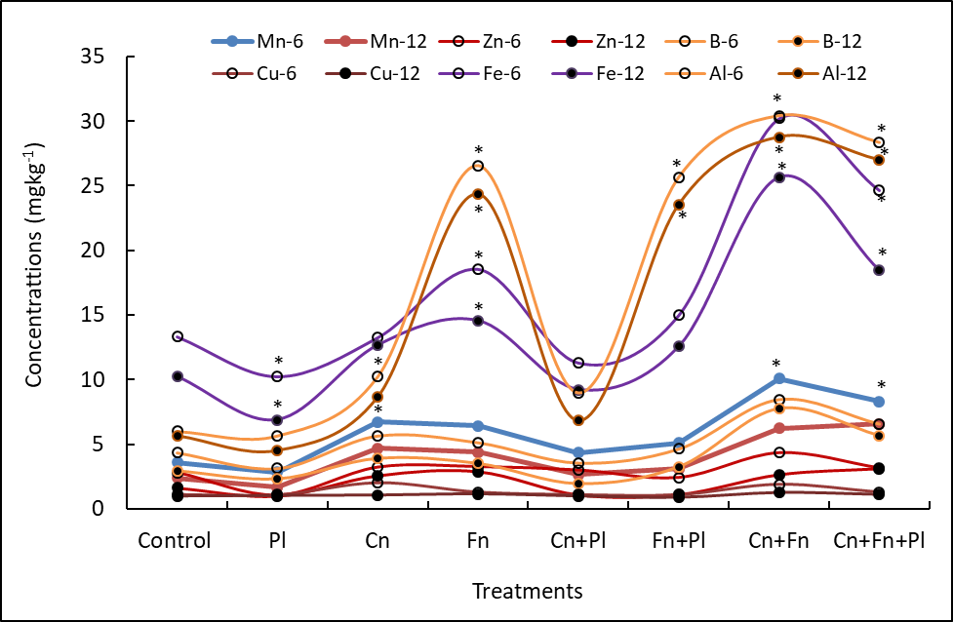
Figure 6. Changes in micronutrient compositions following organic matter amendment with or without planting sweet potato over six and twelve months. An asterisk shows a significant difference (p<0.05) in composition of the micronutrients between the unamended and amended and planted soils.

3.5 Changes in tuber tissue concentration of macronutrients

Understanding the tissue composition of nutrients in sweet potato tubers is essential from a food and feed perspective, as they are often fed to livestock and consumed by humans. In almost all cases, the tuber compositions of primary and secondary macronutrients of plants planted in soil without an organic matter amendment were lower than those planted in soil amended with organic matter (Table 3). When the soil was amended and planted, the composition of all the nutrients decreased over time, but the decrease depended on the organic matter type. In the soil amended with an organic matter of high carbon, the tuber composition decreased compared to the high nitrogen source (Table 3). For instance, the decrease in nitrogen composition of the tubers from the Cn amended was 29.17% compared to that of the Fn amended which was 64.64%. The nitrogen composition decreased further over twelve months when a combined (Cn+Fn) amendment was made by 64.45%. Similar decreases in tuber compositions of the secondary primary nutrients were evident even though the changes were quite variable, with concentrations of some nutrients higher than others. The main reason for the decrease in composition is nutrient use by plants, as the supplies in the soil became limited. The compositions of nutrients such as magnesium, calcium, and sodium were high throughout compared to sulfur and very much pointed out their importance to plants and their use.
The results further showed that nutrient compositions of tubers from plants planted in soil amended with much tougher organic matter sources such as Cn are slow, and that would be related to the much slower decomposition associated with the microbial ecology it can establish. The much faster decrease in the composition of nutrients measured in soil amended with the high nitrogen source is associated with the much quicker establishment of microbial ecology and the resultant decomposition. Carbon is the energy source of microbial ecology, but growth and development depend on the soil's nitrogen supply (e.g., Michael et al., 2015; 2016). The faster the microbial ecology established by a higher nitrogen source, the quicker the decomposition and the release of nutrients to the soil, which resulted in immediate availability, enhanced plant growth, and depletion over time (twelve months). The opposite is true for the tough plant material, the microbial ecology it established, and the resultant decomposition and release of nutrients to the plants. The results further showed that the availability of nitrogen enhances the decomposition of the much tougher organic matter, and the sole reason for that is the much faster microbial ecology establishment and the kind of microbes its presence can recruit.

Table 3. Tuber compositions of primary and secondary macronutrients over six to twelve months in soil amended with organic matter and planted.
Concentrations  (mg kg⁻¹) | Treatments
Concentrations  (mg kg⁻¹) | Pl | Cn+Pl | Fn+Pl | Cn+Fn+Pl
Nª | 2.12±0.56 | 2.40±1.33 | 2.80±1.55 | 1.83±0.87*
N^{b} | 1.79±1.12 | 1.71±1.22 | 0.99±0.65* | 0.65±0.12*
Pª | 50.23±2.33 | 59.36±2.42* | 60.76±2.33* | 55.40±2.54
P^{b} | 30.55±2.11 | 40.22±3.21* | 51.33±2.44* | 50.32±3.22*
Kª | 120.12±2.41 | 271.55±3.11* | 132.66±4.22* | 269.66±4.44*
K^{b} | 56.17±3.44 | 150.33±2.25* | 97.33±3.22* | 182.44±3.42*
Mgª | 298.56±3.45 | 412.33±3.46* | 412.23±4.34* | 536.66±3.49*
Mg^{b} | 250.66±2.56 | 389.66±3.54* | 387.22±3.47* | 426.87±3.47*
Sª | 4.56±0.48 | 7.33±0.22* | 8.22±0.24* | 10.55±0.33*
S^{b} | 2.33±0.01 | 5.22±0.10* | 6.55±0.45* | 7.22±0.36*
Caª | 300.22±3.64 | 500.66±3.49* | 623.58±4.44* | 789. ±13.54*
Ca^{b} | 289.25±5.47* | 477.99±3.46* | 566.87±3.46* | 656.55±10.44*
Naª | 26.33±2.25 | 35.22±1.22* | 38.36±1.44* | 46.55±2.45*
Na^{b} | 24.25±1.44 | 30.11±1.14* | 34.66±1.24* | 42.68±1.47*
The values are mean ± standard error of four replicates (n=4). The superscripts “a” and “b” denote six and twelve months’ tuber composition of macronutrients. An asterisk shows a significant difference (p<0.05) in composition of the micronutrients between the unamended and the amended and planted soils.

3.6 Changes in tuber tissue concentration of micronutrients

Micronutrients play essential roles in human and livestock nutrition and the growth and development of plants such as sweet potato. This study investigated the changes in the composition of a number of micronutrients in the tubers of sweet potatoes planted in soil amended with different organic matter sources, and the changes over six and twelve months measured are shown in Table 4. Generally, a similar trend in the decrease in the composition of the micronutrients and the variability in the changes were observed. Among the changes measured, manganese, boron, and iron were significant in all the treatments, including those of the unamended soil, and very much depended on the organic matter types. These are the same micronutrients whose concentrations were expected to be high in the soil following amendment, as per the data shown in Table 1. The overall results showed that the presence of carbon and nitrogen is important for the sustainability of the soil's micronutrients and tissue composition. Over twelve months, manganese, for example, was 2.19 mg kg⁻¹ in the soil planted without an amendment, was higher by 1.17 mg kg⁻¹ when Cn amendment was done, and even higher in the Fn and Cn+Fn amended soil (Table 4). These results showed that organic matter from different nutrient sources is important for the short-term needs of nutrients by plants and their long-term sustainability for soil fertility management, as well as the other soil factors that support it.

Table 4. Tuber compositions of micronutrients over six to twelve months in soil amended with organic matter and planted.
Concentrations  (mg kg⁻¹) | Treatments
Concentrations  (mg kg⁻¹) | Pl | Cn+Pl | Fn+Pl | Cn+Fn+Pl
Mnª | 3.55±0.40 | 5.55±0.11 | 7.36±0.45* | 8.22±1.25*
Mn^{b} | 2.19±1.22* | 3.36±0.12* | 4.25±0.22* | 30.44±1.24*
Znª | 0.99±0.20 | 1.19±0.04 | 1.29±0.22 | 1.76±0.01*
Zn^{b} | 0.76±0.02 | 0.88±0.02 | 0.89±0.32 | 1.22±0.03*
Bª | 6.12±0.01 | 8.89±0.50* | 7.98±0.60 | 9.56±0.62*
B^{b} | 3.45±0.04* | 6.57±0.40* | 5.66±0.43* | 6.63±0.47*
Feª | 85.65±2.33 | 130.55±3.22* | 80.99±4.77 | 135.33±2.40*
Fe^{b} | 78.66±2.48* | 120.36±3.89* | 69.87±3.69* | 119.55±3.40*
The values are mean ± standard error of four replicates (n=4). The superscripts “a” and “b” denote six and twelve months’ tuber composition of micronutrients. An asterisk shows a significant difference (p<0.05) in composition of the micronutrients between the unamended and amended and planted soils.

4. Conclusions

This study has shown that organic matter in composted mounds is vital in regulating soil parameters that affect soil fertility and soil and crop nutrient availability. Organic matter in composted mounds improved soil parameters (that regulate soil health and nutrient availability to crops) and nutrients and tuber composition essential for human and livestock health. The overall changes in soil chemistry and tuber composition of nutrients were dependent on OM type with significant effect from the high nitrogen content source, and the duration of production influenced availability in the long-term. The soil and tuber concentrations of the minerals were high short-term and decreased as the duration of production was longer. As sweet potato is the only staple for over five million people, sustainable production is essential, especially in light of climate change. The findings of this study have implications for sustainable sweet potato production in the altitudinal agroclimatic zones of the highlands of PNG, where land availability for increased food production is low due to high population pressure.

Disclaimer (AI)

The authors declare that no generative AI technologies and text-to-image generators have been used during the writing or editing of this manuscript.

Declaration of competing interest

The authors declare that they have no known competing financial interests that could have appeared to influence the work reported in this paper. We declare that the first author was a Masters’ student under the supervision of the second author.

COMPETING INTERESTS DISCLAIMER:
Authors have declared that they have no known competing financial interests OR non-financial interests OR personal relationships that could have appeared to influence the work reported in this paper.

References

Anjana, S. U., & Iqbal M. (2009). Effect of applied potassium in increasing the potential for N assimilation in spinach (Spinacea oleracea L.). Electronic International Fertilizer Correspondent, 9, 8–10. https://www.ipipotash.org/publications/eifc-3.
Bailey, J. S., Ramakrishna A., & Kirchhof G. (2009). An evaluation of nutritional constraints on sweet potato (Ipomoea batatas) production in the central highlands of Papua New Guinea. Plant and Soil, 316, 97–105. https://doi.org/10.1007/s11104-008-9762-6.
Bose, P., Ray M., Patra P. K., & et al. (2025). Different organic and inorganic sources of plant nutrients influence soil health, leading to improve the productivity and profitability of a fourteen-year long-term rice–potato–groundnut cropping pattern. Applied and Environmental Soil Science, 1, 9943996. https://doi.org/10.1155/aess/9943996.
Byju, G., & George J. (2005). Potassium nutrition of sweet potato. Advances in Horticultural Science, 19, 221– 239. https://www.jstor.org/stable/42883410.
D’Souza, E., & Bourke, R. M. (1982). Compost increases sweet potato yields in the highlands. Harvest, 8, 171─175.
Duncan, E. G., O’Sullivan, C. A., Roper, M. M., Biggs, J. S., & Peoples, M. B. (2018). Influence of co-application of nitrogen with phosphorus, potassium and sulphur on the apparent efficiency of nitrogen fertiliser use, grain yield and protein content of wheat: Review. Field Crops Research, 226, 56–65. https://doi.org/10.1016/j.fcr.2018.07.010.
Ejechi, M. E., Ode, I. O., & Sugh E. T. (2020). Empirical analyses of production behaviour among small-scale sweet potato farmers in Ebonyi state Nigeria. Nigerian Agricultural Journal, 51, 17–21. https://www.ajol.info/index.php/naj/article/view/196737.
Esan, V. I., Omilani, O. O., & Okedigba I. (2021). Effects of organic and inorganic fertilizers on sweet potato production in Iwo, Nigeria. African Journal of Plant Science, 15, 131–137. https://doi.org/10.5897/AJPS2021.2130.
FAO. (2017). Food and Agricultural Statistical Database. http://faostat.fao.org. (accessed 20th December, 2025).
Floyd, C. N., Lefroy, R. D. B., & D’Souza, E. J. (1988). Soil fertility and sweet potato production on volcanic ash soils in the highlands of Papua New Guinea. Field Crops Research, 19, 1–25. https://doi.org/10.1016/0378-4290(88)90030-5.
Fujinuma, R., Kirchhof, G., Ramakrishna, A., Sirabis, W., Yapo, J., Woruba, D., Gurr, G., & Menzies, N. (2018). Intensified sweetpotato production in Papua New Guinea drives plant nutrient decline over the last decade. Agriculture, Ecosystems and Environment, 254, 10–19. https://doi.org/10.1016/j.agee.2017.11.012.
Hafifah, H., Sudiarso, S., Maghfoer, M. D., & Prasetya B. (2016). The potential of Tithonia diversifolia green manure for improving soil quality for cauliflower (Brassica oleracea var. Brotrytis L.). Journal of Degraded and Mining Lands Management, 3, 499–506. https://doi.org/10.15243/jdmlm.2016.032.499.
Hartemink, A. E. (2003). Integrated nutrient management research with sweet potato in Papua New Guinea. Outlook on Agriculture, 32, 173–182. https://doi.org/10.5367/000000003101294442.
Hartemink, A. E., & Bourke R. M. (2000). Nutrient deficiencies of agricultural crops in Papua New Guinea. Outlook on Agriculture, 29, 97–108. https://doi.org/10.5367/000000000101293.
Hartemink, A. E., Johnston, M., O’Sullivan J., & Poloma, S. (2000). Nitrogen use efficiency of taro and sweet potato in the humid lowlands of Papua New Guinea. Agriculture, Ecosystems and Environment, 79, 271–280. https://doi.org/10.1016/S0167-8809(00)00138-9.
Hazenbosch, M., Sui, S., Isua, B., & et al. (2021). Using locally available fertilisers to enhance the yields of swidden farmers in Papua New Guinea. Agricultural System, 192, 103089. https://doi.org/10.1016/j.agsy.2021.103089.
Healey, C. (1999). Historical Vines: Enga Networks of Exchange, Ritual, and Warfare in Papua New Guinea. American Ethnologist, 26, 743–744. https://doi.org/10.1525/ae.1999.26.3.743.
Kiprotich, K., Esther, M., Clabe, W., Stephen, N., John, M., Dennis, O., Hamond, M., & Sipho, M. (2025). Unveiling the roles, mechanisms and prospects of soil microbial communities in sustainable agriculture. Discover Soil, 2. https://doi.org/10.1007/s44378-025-00037-4.
Kirchhof, G. (2006). Analysis of biophysical and socio-economic constraints to soil fertility management in the PNG highlands, Report on ACIAR soil fertility scoping study. ACIAR: Canberra. https://about.uq.edu.au/experts/project/7855 (accessed 26 June 2025).
Landon R. J. (1991). Booker tropical soil manual: A handbook for soil survey and agricultural land evaluation in the tropics and subtropics, (John Wiley and Sons Inc.,), New York.
Liu, L., Tou, C., Zhou, J., & et al. (2025). Plant litter decomposition is regulated by its phosphorus content in the short term and soil enzymes in the long term. Geoderma, 457, 117283. https://doi.org/10.1016/j.geoderma.2025.117283.
Michael P. S. (2020b). Soil fertility status and sweet potato cultivation in composted mounds under humid lowland tropical climatic conditions. Sains Tana Journal of Soil Science and Agroclimatology, 17, 144─151. https://doi.org/10.20961/stjssa.v17i2.43426.
Michael P. S., Fitzpatrick, R., & Reid, R. (2015). The importance of organic matter on amelioration of acid sulfate soils with sulfuric horizons. Geoderma, 225, 42–49. https://doi.org/10.1016/j.geoderma.2015.04.023.
Michael, P M. (2020a). Agriculture versus climate change – narrow staple-based subsistence agriculture is a threat to rural livelihood under climate change. Sains Tana Journal of Soil Science and Agroclimatology, 17, 78–93. https://doi.org/10.20961/stjssa.v17i1.41545.
Michael, P. S., Fitzpatrick, R., & Reid, R. (2016). The importance of soil carbon and nitrogen in amelioration of acid sulphate soils. Soil Use and Management, 32, 97–105. https://doi.org/10.1111/sum.12239.
Michael, P. S., Fitzpatrick, W. R., & Reid J. R. (2017). Effects of live wetland plant macrophytes on acidification, redox potential and sulfate content in acid sulphate soils. Soil Use and Management, 33, 471─481. https://doi.org/10.1111/sum.12362.
Nabi, M. (2023). Role of microorganisms in plant nutrition and soil health. In: Sustainable Plant Nutrition (T. Aftab, K. R. Hakeem, eds.). Academic Press, 263 – 282. https://doi.org/10.1016/B978-0-443-18675-2.00016-X.
Ngailo, S., Shimelis, H. A., Sibiya J., & Mtunda K. (2016). Assessment of sweetpotato farming systems, production constraints and breeding priorities in Eastern Tanzania. South African Journal of Plant and Soil, 33, 105–112. https://doi.org/10.1080/02571862.2015.1079933.
Novianantya, A. C., Fardany, N. K., & Nuraini Y. (2017). Improvement of sweet potato yield using mixtures of ground fish bone and plant residues. Journal of Degraded and Mining Lands Management, 4, 759– 765. https://doi.org/10.15243/jdmlm.2017.042.759.
Pardales, J. R., & Yamauchi A. (2003). Regulation of root development in sweetpotato and cassava by soil moisture during their establishment period. In: Roots: The Dynamic Interface between Plants and the Earth (J. Abe, ed.). Developments in Plant and Soil Sciences. Springer, Dordrecht. https://doi.org/10.1007/978-94-017-2923-9_19.
Peter, M. T., Chung, R. Y., & Michael, P. S. (2024). Augmenting of primary and secondary macronutrients by chopped leucaena leaves used as organic matter in composted sweet potato mounds under tropical humid lowland conditions. International Journal of Environment, 13, 48–64. https://doi.org/10.3126/ije.v13i1.70632.
Peter, T. M., & Michael, P. S. (2023). Sweet potato is a strategic root crop in Oceania: A synthesis of the past research and future direction. Sains Tana Journal of Soil Science and Agroclimatology, 20, 51–65. https://doi.org/10.20961/stjssa.v20i1.66319.
Preston, S. R. (1990). Investigation of compost x fertilizer interaction in sweet potato grown on volcanic ash soil in the highlands of Papua New Guinea. Tropical Agriculture, 67, 239─242. https://journals.sta.uwi.edu/ojs/index.php/ta/article/view/1784.
Schulte, E. E., & Hopkins, B. G. (1996). Estimation of soil organic matter by weight loss-on-ignition. In: Soil Organic Matter: Analysis and Interpretation (F. R. Magdoff, Tabatabai M. A., Hanlon E. A., eds.). https://doi.org/10.2136/sssaspecpub46.c3.
Shekhar, S., Mishra, D., Buragohain, A. K., Chakraborty, S., & Chakraborty, N. (2015). Comparative analysis of phytochemicals and nutrient availability in two contrasting cultivars of sweet potato (Ipomoea batatas L.). Food Chemistry, 173, 957–965. https://doi.org/10.1016/j.foodchem.2014.09.172.
Taraken, I. T. (2012). Potential of composted mounding in sustaining soil productivity and sweetpotato yields in the Papua New Guinea highlands. Journal of Pacific Studies, 32, 147–161.
Taraken, I. T., & Ratsch, R. (2009). Sweet potato cultivation on composted mounds in the highlands of Papua New Guinea. In: Soil fertility in sweet potato-based cropping systems in the highlands of Papua New Guinea (Kirchhof, G., ed.). Australian Centre for International Agricultural Research, Canberra, Australia.
Valenzuela, H., Fukuda, S., & Arakaki, A. (1994). Sweetpotato production guides for Hawaiʻi. College of Tropical Agriculture and Human Resources, University of Hawaiʻi at Mānoa. http://www.extento.hawaii.edu/kbase/reports/sweetpot_prod.htm (accessed 27th December, 2025).
Wang, J. D., Wang, H., Zhang, Y., Zhou, J., & Chen, X. (2015). Intraspecific variation in potassium uptake and utilization among sweet potato (Ipomoea batatas L.) genotypes. Field Crops Research, 170, 76–82. https://doi.org/10.1016/j.fcr.2014.10.007.
Wiessner, P. (2005). Social, symbolic and ritual roles of the sweet potato in Enga, Papua New Guinea. In: The sweet potato in Oceania: A Reappraisal (Ballard, C., Brown, P., Bourke, R. M., Harwood, T., eds.). Oceania Monographs 56, University of Sydney: Australia (2005). https://carta.anthropogeny.org/libraries/bibliography/social-symbolic-and-ritual-roles-sweet-potato-enga-its-introduction-until (accessed 25 June 2025).
Wohlt, P. B. (1986). Kandep: challenge for development. Department of Enga Province, Division of Primary Industry, Subsistence Unit: Wabag, Enga Province. Technical Bulletin No.2 (1986). pp. 32–42, https://hdl.handle.net/1885/733721572.
Wood, A. W. (1984). The humic brown soils of the Papua New Guinea Highlands: A reinterpretation. Mountain Research and Development, 7, 145–156. https://doi.org/10.2307/3673308.
Yang, L., Li, Y., Jx, G., Ma, X., & Yan, Q. (2013). Comparison of dry ashing, wet ashing and microwave digestion for determination of trace elements in periostracum serpentis and periostracum cicadae by ICP-AES. Journal of the Chilean Chemical Society, 58, 1876–1879. http://dx.doi.org/10.4067/S0717-97072013000300018.
Yared, D., Tewodros, M., & Asfaw K. (2019). Development of high yielding taro (Colocacia esculenta L.) variety for mid altitude growing areas of Southern Ethiopia. Journal of Plant Sciences, 2, 50–54. https://doi.org/10.11648/j.jps.20140201.19.
Yeboah, S., Zhang, S., Cai, L., Li, L., Xie, J., Luo, Z., Wu, J., & Antille, D. L. (2017). Soil water content and photosynthetic capacity of spring wheat as affected by soil application of nitrogen-enriched biochar in a semiarid environment. Photosynthetica, 55, 532–542. https://doi.org/10.1007/s11099-016-0672-1.
Yeng, S. B., Agyarko, K., Dapaah, H. K., Adomako, W. J., & Asare, E. (2012). Growth and yield of sweet potato (Ipomoea batatas L.) as influenced by integrated application of chicken manure and inorganic fertilizer. African Journal of Agriculture Research, 7, 5387–5395. https://doi.org/10.9734/AJEA/2016/22440.

