Original Research Article

Effect of trees density on the soil physical properties in agroforestry parkland systems dominated by Shea trees in Burkina Faso

ABSTRACT
Aims: Agroforestry Parkland systems (APS) stand for the most widespread production systems in the agricultural landscapes of Burkina Faso. Better understanding of these systems would allow better management perspectives and improved productivity of associated crops. This study was to assess the effect of trees density on the soil water infiltration, soil texture and bulk density in the APS.
Study design:
Place and Duration of study
The experimental design was made of 20 elementary plots of which surface area was 2500m² each. These 20 plots were divided into 5 different trees density ranging from 0 to 48 trees/hectare. Each density was used in 4 replicates. In each plot, 9 subplots were set up for evaluating water infiltration, bulk density, soil moisture and texture.
Results: theys showed that tree density had no effect on the soil bulk density in the dominated V. paradoxa APS. But Shea dominated tree density affected significantly the soil water infiltration speed (P˂0.001). The water infiltration speed was found to be higher (ranging from 3.02 to 3.64 L/h) in plots of which tree densities were 16 trees/ha, 28 trees/ha, 36 trees/ha et 48 trees/ha than plots without trees (1.65L/h). Further, soil water infiltration rate showed good regression with the sand (R²= 0.9273), silt (R²=0.9078) and clay content (R²=0.915). On the other hand, soil water infiltration rate showed a very significant relationship with dendrometric parameters, including basal area, tree height and tree cover with a regression coefficient of R²=0.92, R²=0.86 and 0,79 respectively.
Conclusion: the presence of trees in plots improved the soil water infiltration rate.
Keywords: Burkina Faso, Agroforestry parklands; bulk density; water infiltration, tree cover.

.1. INTRODUCTION

Agroforestry Parklands System (APS) are land use systems in which perennial woody plants are deliberately conserved in association with crops and or livestock in a dispersed spatial arrangement (Bonkoungou et al., 1993). Parklands are organized and structured based on the managers and user’s vision and needs. The APS are found in most West African countries (Boffa, 2000). The APS provide ecosystem goods and services to local communities particularly food and folders for human and animals and ecological functionals. The ecosystem services provided by these systems are largely dependent on the trees that make up the system. In Burkina Faso, the trees species found in these systems vary, depending on the location. Vitellaria paradoxa Gaertn. of the Sapotaceae family, commonly known as karité in French and Shea tree in English are the most common local species (Bazié et al., 2012; Yaméogo et al., 2019). V paradoxa makes these agroforestry Parklands to be a source of non-timber forest products, food and additional income for farmers and users particularly for women (Pouliot et al., 2012; Koueta et al., 2023). However, they can also compete with annual crops for growth resources, particularly in the Sahel, where the soil is poor, rainfall is low, and it is not distributed evenly. Many studies reported crops yields reduction under trees (Bayala et al., 2002; Bazié et al., 2012). Recently, there has been a notable decline in tree cover in these systems in response to light competition between trees and crops. Therefore, it is important to define the optimal density of this species in parkland, taking into account the trade-offs between crop productivity and ecosystem functions. Through the presence of shea tree also contribute to reducing soil degradation, protecting soil from erosion, improving soil water conservation and soil fertilization (Hien, 2022; Sanou et al., 2022; Koueta et al., 2023). Soils in semiarid West Africa zone are typically sensitive and vulnerable to degradation particular runoff, which is mainly a result of their low structural stability (Bationo et al., 2007). Studies demonstrate that tree cover has a strong influence on soil and groundwater recharge through the alteration of various components of the hydrological cycle, including interception, transpiration, soil infiltration, and preferential flow (Fan et al. , 2014; Tobella-Bargues et al. 2014, Ilstedt et al., 2016) and this is attributable to the role trees play in improving soil infiltrability and preferential flow, mainly by enhancing macroporosity through root and faunal activity (Bargués Tobella et al., 2014).
The effect of trees on water infiltration was also investigated. Authors agree that water infiltration increased with increasing distance from the tree trunk (Zomboudré, 2009; Sanou et al., 2010 and Revell et al, 2022). All these studies were conducted based on woody plants and its immediate environment in agroforestry Parklands on the one hand. On the other hand, these studies focused on the density of shrub-type trees or low-frequency trees in agroforestry Parklands. Thus, beyond these knowledge, further research is needed for providing more understanding especially the influence of the most frequent and dominant species in agroforestry Parklands in sub-Saharan Africa. Few studies to our knowledge except Koala et al. (2019) and Gnissien et al. (2023) has examined the effect of tree density on water infiltration in parkland in a semi-arid tropical environment. Within the context of adaptation to climate change, it is therefore highly relevant to investigate the potential impacts of the tree density on soil proprieties particular to water infiltration. Therefore, our investigation focuses on understanding the effect of tree density and dendrometric parameters of trees dominated by Vitellaria paradoxa Gaertn. f. on the soil physical properties. The overall objective of this study was to assess the effect of different density of tree dominated by V. paradoxa and dendrometric parameters on the soil physical properties. Specifically, it was to determine (i) the effect of tree density on soil bulk density and texture. (ii) on soil water infiltration rate and (iii) the relationship between tree dendrometric parameters and soil properties.

.2. MATERIALS AND METHODS

2.1. Study area

This study was conducted in agroforestry Parklands in the Sudano-Sahelian zone, specifically in the municipality of Saponé (12º03´N, 1º43´W, altitude 200 m.a.s.l) located 30 km south of Ouagadougou, the capital city of Burkina Faso, West Africa (Figure 1). The climate is of Sudano-Sahelian type, with rainfall ranging from 600 mm to 900 mm. There is a single rainy season marked by intermittent rains starting from May, heavy rains starting from June and ending in October. This area is characterised by cold and dry winds (harmattan).
The soils in Saponé consist of two (02) subgroups belonging to the soils class with iron and/or manganese sesquioxides (BUNASOLS 1999). These soils are hardened leached tropical ferruginous ones and leached tropical ferruginous soils with patches and concretions. Physical properties of these soils are characterised from the top layer with 7% clay, 19% silt, 74% sand and 0.8% organic matter (Pallo, 2001). The soils in the studied agroforestry Parklands are sandy-loamy regosols according to the FAO classification, shallow (averaging about 60 cm deep) and very low in nutrients (Bayala, 2002).
Based on the classification of Fontes and Guinko (1995), vegetation in the municipality of Saponé is characteristic of the North Sudanese one in which trees and shrub savannahs were observed. Furthermore, riparian formations along watercourses, often associated with perennial herbaceous plants were found in this area. The plant species found are local fruit and exotic species, local species for domestic and medicinal uses, and those of forest. Thus, these species include P. biglobosa, V. paradoxa, F. albida, S. birrea, B costatum (Bazié, 2013; Ouédraogo, 2018).

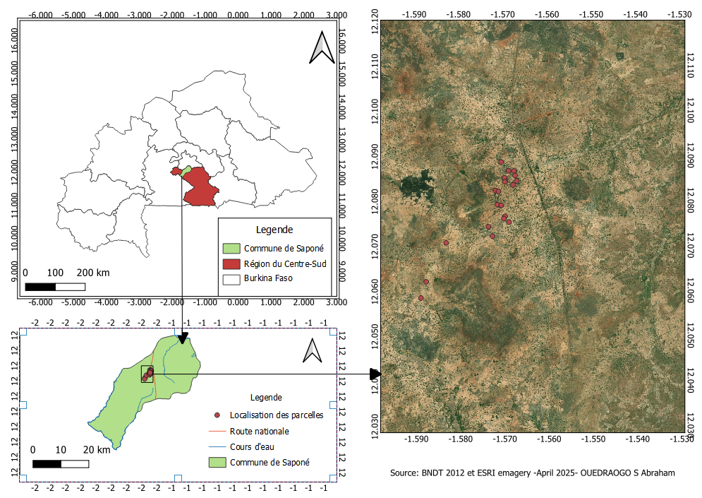
Figure 1: Study area and location of our study plots in Saponé, Burkina Faso

2.2. Plant Material

The perennial woody plants in agroforestry Parklands consisted mainly of V paradoxa. A preliminary inventory was carried out across the entire site to determine areas of high and low tree density of Shea trees. Based on that, our plots were allocated by considering all possibilities offered by the parkland.
An inventory of the existing woody plants in the studied plots reveals the presence of eight (08) species divided into six (6) families. The classification most represented families in terms of species number and importance are those of Mimosaceae and Anacardiaceae with two (2) species. Other families are represented by a single species, namely Sapotaceae, Combretaceae, Verbenaceae and Meliaceae. Vitellaria paradoxa Gaertn. f. appeared to be the species with the high number of individuals.

2.3. Experimental design

This experiment was set up during April 2023. Thus, the setup consisted of twenty (20) square plots randomly set up, each measuring 50 m x 50 m (2,500 m²). The studied factor was the trees density in each of our plots, with 5 tree density levels being designed. These 5 progressive levels of tree density were chosen based on inventory data in the area. The first density class was 0 trees/ha, i.e. 0 trees in the plot (D1), the second was 16 trees/ha, i.e. 4 trees in the plot (D2), the third was 28 trees/ha, i.e. 7 trees in the plot (D3), the fourth was 36 trees/ha i.e. 9 trees in the plot (D4), and finally the fifth was 48 trees/ha i.e. 12 trees in the plot (D5) (Figure1 and 2). Each density class is repeated four times. The position of the trees in each plot and from one repetition to another is random. The tree layer is the result of farmers' selection and retention of these trees after clearing natural woodlands for cultivation and through Farmers’ Managed Natural Regeneration (FMNR) on cultivated fields (Boffa, 1999).

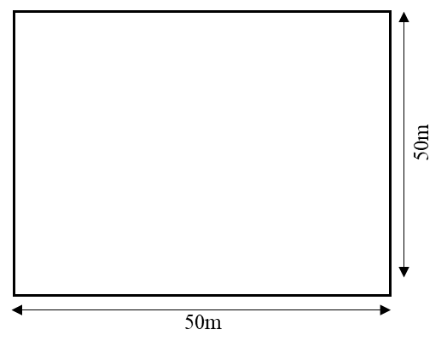 | 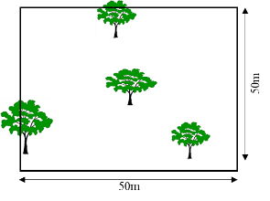 | 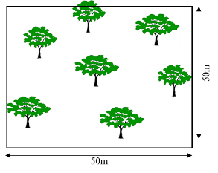 |  | 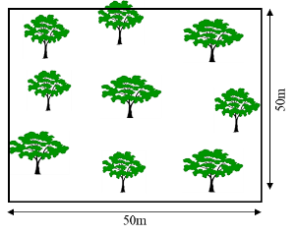 | 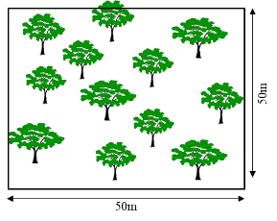
D1 | D2 | D3 |  | D4 | D5
D1: 0 trees/ha, D2: 16 trees/ha, D3: 28 trees/ha, D4: 36 trees/ha, D5: 48 trees/ha,
Figure 2: Diagram of the experimental set-up (D1: 0 trees/ha, D2: 16 trees/ha, D3: 28 trees/ha, D4: 36 trees/ha, D5: 48 trees/ha).
V. paradoxa was the main and dominant species in our 20 plots. The tree height in density levels ranged from 8.38±0.43m to 9.36±0.57m (Table I). As for diameter at breast height (DBH), it varied from 39.60±2.95 cm and 52.77±5.26 cm. The Tree canopy cover ranged from 14.56% to 36.45% (Table I).

Table I: Study trees dendrometric parameters according tree density in the 20 plots
Dendrometric Parametters | D1 | D2 | D3 | D4 | D5
Avarage height (m) | 0±0 | 9,36±0,57 | 8,80±0,573 | 8,38±0,43 | 8,41±0,43
DBH (cm) | 0±0 | 52,77±5,26 | 46,88±4,32 | 40,94±3,02 | 39,60±2,95
Basal area ( m²/ha) | 0±0 | 40,62±1,132 | 58,608±1,248 | 55,404±1,1 | 77,504±1,64
Tree Crown area ( m²) | 0±0 | 366,196±6,523 | 548,165±18,545 | 619,312±16,739 | 915,220±10,076
Tree cover (%) | 0 | 14,56 | 21,96 | 24,99 | 36,45
D1: 0 trees/ha, D2: 16 trees/ha, D3: 28 trees/ha, D4: 36 trees/ha, D5: 48 trees/ha, DBH: diameter at breast height.
Within each 2,500 m² plot, nine (09) elementary subplots of 4 m² each (2m x2m) were set up A that give total of 180 subplots (Figure 3). In each plot, the subplots were separated from each other by twenty-two meters (22 m). In these 180 subplots, data of bulk density, soil texture, soil moisture and water infiltration were collected (Figure 3). Thus, for each plot, the average value from the nine sub-plots represents the value of that plot.

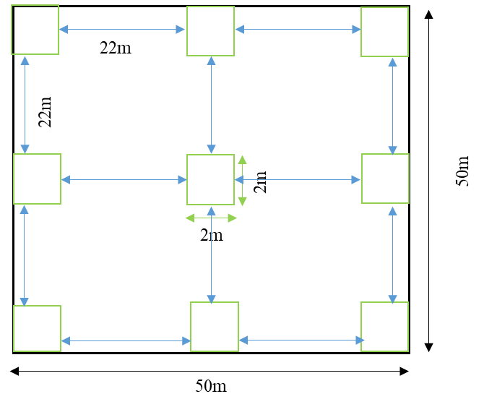
Sampling points pprélèvements
Figure 3: Diagram showing the plots distribution in the study plot for different measurements.

In order to study the direct effects of trees on various soil parameters, the distance from the center of each subplot to the nearest tree was first measured, and the 180 subplots were grouped into four types according to trees position in the plot. This allowed us to design subplots which were directly under the tree canopy (SUC), those located outside the tree canopy but under the influence of tree shade (SSCI), those located outside the tree canopy without being under the influence of tree shade (SOC), and finally those in plots without trees (SWT).

2.4. Data collection

2.4.1. Determination of soil particle size distribution and bulk density

The soil particle size in each plot was obtained by first collecting soil samples from the 9 subplots per plot (Figure 3) at a depth of 0-30 cm using an auger. Collected samples were carefully packaged and labelled in plastic bags and brought to the laboratory for analysis. The particle size distribution was determined using three fractions: sand, silt and clay (Fournier et al., 2012). The soil samples were before dried and then passed through different sieves with different mesh sizes. Each sieve corresponds to a fraction of soil texture. We selected the clay fraction less than 0.002 mm, the silt fraction between 0.002 mm and 0.063 mm, and the sand fraction between 0.063 mm and 2 mm. The percentage of each fraction was obtained by dividing the weight of the fraction by the total weight of the sample.
The bulk density of the soil was obtained using the method described by Yoro and Godo, (1990). Thus, soil core samples were collected at a depth of 0-20 cm using 1570 cm³ cylinders in each subplot. These samples were then placed in an oven at 105°C for 24 hours and weighed again to obtain the dry weight of each core. The soil density or bulk density (Da) expressed in g/cm³ was calculated using the following formula.
$Da=\frac{Dry weight of the sample(g)}{Cylinder Volume ({cm}^{3})}$
The soil moisture was determined twice. The first time was during the dry season in mid-April 2023 and the second time was during the wet season in mid-July after 48 hours of rainfall of at least 30 mm. The water content was determined after take soil samples in each subplot at a depth of 0-30 cm using an auger using the method described by Delalande et al., (2017). Moisture was obtained by calculating the difference between the weight of the soil sample in the field and that of the soil sample after drying in an oven, divided by the weight of the soil sample after drying in an oven, multiplied by one hundred using the formula below.
$M=\frac{weight wet soil-weight dry soil}{weight dry soil }*100$
Where M is the moisture content (%); the weight of the soil sample in the field; the weight of the soil sample after drying.

2.4.2. Evaluation of the soil water infiltration

The evaluation of water infiltration into the soil was performed in situ using the method described by Koala et al. (2014). This involves using a single-ring metal infiltrometer measuring 30 cm in height with 20 cm diameter. For each measurement point, the cylinder is pushed 5 cm into the soil. Vegetation, debris from branches and leaves, and large stones inside the cylinder were removed without disturbed the soil surface. After setting the cylinder, a volume of 628 cm³ of water was first poured into it up to the 20 cm water level mark. Then, the first reading was realized after five minutes (5 min), and to carefully and to quickly refill the water to the mark after each reading. This 5-minute recording series were repeated six times, i.e. thirty minutes. The same procedure of reading and adding water up to the gauge mark was repeated for the 10-minute series six times, i.e. one hour. Finally, the same procedure was repeated for the 20-minute series, which were carried out three times, i.e. one hour. Knowing the water level at the start and at the time of reading in the cylinder, the volume of infiltrated water was calculated during the time interval considered. We then determined the cumulative infiltration, which is the amount of water in mm (fi) at each recording period by using the following formula:
$fi(t)=(HO-Hn)*Sc$
Where fi(t) is the cumulative infiltration (in liters) for each time interval, Sc is the surface area of the cylinder, Hn is the water level at the end of the measurement period, and H0 is the water level at the start of the measurement.
The infiltration rate, which is the ratio of the infiltrated volume to the infiltration time, is calculated using the formula
$Vi=\frac{fi(t)}{t }$
Where Vi(t) = is the infiltration rate in liter per hour (l/h) at each recording period, t = is time of this period and fi(t) = is cumulative infiltration during this period (in l).

2.4.3. Data analysis

Collected data were typed using Excel version 2021, which was also used to create the graphs. Statistical analysis was performed using R software version 4.4.3. A Shapiro-Wilk normality test was first performed for the collected data. Our data were not normally distributed. Then, a variance analysis with a non-parametric Kruskal-Wallis test at a 5% threshold was performed, followed by a post-hoc test, specifically Duun's test using the Bonferroni method, in order to compare the treatment means. Finally, we investigated the effect of tree density on water infiltration velocity and the relationships between tree dendrometric parameters and the soil physical parameters through linear regressions.

.3. RESULTS AND DISCUSSION

3.1. Results

3.1.1. Effect of tree density on the soil bulk density and moisture in agroforestry Parklands
Statistical analysis of soil bulk density (P=0.3218) and soil moisture during the wet season (P=0.517) revealed no significant difference among different tree density (Table II). However, soil moisture during the dry season was significantly different (P˂0.0001) according tree density. The tree density D5 in the dry season had the highest soil moisture of 1.07±0.07% compared to the other tree density (Table II).

Table II: Comparison Soil bulk density and soil moisture in according tree density
Tree Density | Soil bulk density  (g/ cm³) | Soil moisture in  dry season (%) |  | Soil moisture in  wet season (%)
D1 | 1,575±0,015a | 0,79±0,089b |  | 6,33±0,618a
D2 | 1,588±0,024a | 0,60±0,034a |  | 5,79±0,397a
D3 | 1,561±0,042a | 0,769±0,017b |  | 5,32±0,37a
D4 | 1,564±0,017a | 0,66±0,05ab |  | 5,64±0,58a
D5 | 1,557±0,018a | 1,07±0,070c |  | 6,14±0,34a
p-Value | 0,3218 | ˂0,001 |  | 0,517
D1: 0 trees/ha, D2: 16 trees/ha, D3: 28 trees/ha, D4: 36 trees/ha, D5: 48 trees/ha. Values in the same column that are followed by the same letter are not significantly different at the 5% threshold.
.
Regressions between soil bulk density and dendrometric parameters of trees show decreasing trends with regression coefficients ranging from 0.00 to 0.49. The best regression coefficients were obtained with tree density, with R² = 0.49, and canopy cover, with R² = 0.42 (Figure 4).

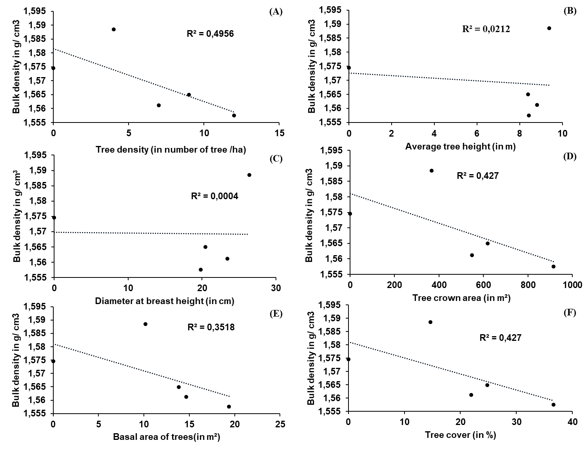
Figure 4: The relationship between soil bulk density and tree density (A), tree height (B) diameter at breast height (C), Tree crown area (D), basal area (E) and Tree cover (F).

3.1.2. Effect of tree density on the soil particle size in agroforestry Parklands

The proportions of sand, silt and clay showed a statistical difference depending on tree density (P˂0.05) (Table III). The lowest proportion of sand was recorded in density D1 (62.11±2.14%) and the highest in density D5 (75.93±0.86%). With regards to the silt, the lowest proportion was obtained in density D5 (16.12±0.66%) and the obtained highest value was 21.86±1.51% in density D1. In terms of the clay, its proportion was 16.03±1.22% for density D1 which was the highest value, and the lowest clay rate was found in density D5 (7.95±0.63%) (Table III).

Table III: Soil texture in according tree density (Mean±SE).
Tree density | Sand rate (%) | Silt rate (%) | Clay rate (%)
D1 | 62,11±2,14a | 21,86±1,51a | 16,03±1,22a
D2 | 73,44±1,21bc | 17,59±0,85ab | 8,96±0,65b
D3 | 72,47±1,11bc | 17,65±0,7ab | 9,88±0,6b
D4 | 70,40±1,4ab | 19,17±1,07ab | 10,43±0,62b
D5 | 75,93±0,86c | 16,12±0,66b | 7,95±0,63b
p-Value | ˂0,001 | 0,03 | ˂0,001
D1: 0 trees/ha, D2: 16 trees/ha, D3: 28 trees/ha, D4: 36 trees/ha, D5: 48 trees/ha. Values in the same column that are followed by the same letter are not significantly different at the 5% threshold.

The regression for sand, clay and silt content based on the dendrometric parameters for different density levels showed a downward trend (Figure 5, 6 and 7). The results show good relationships with tree dendrometric parameters, which explain between 69% and 90% of soil texture.

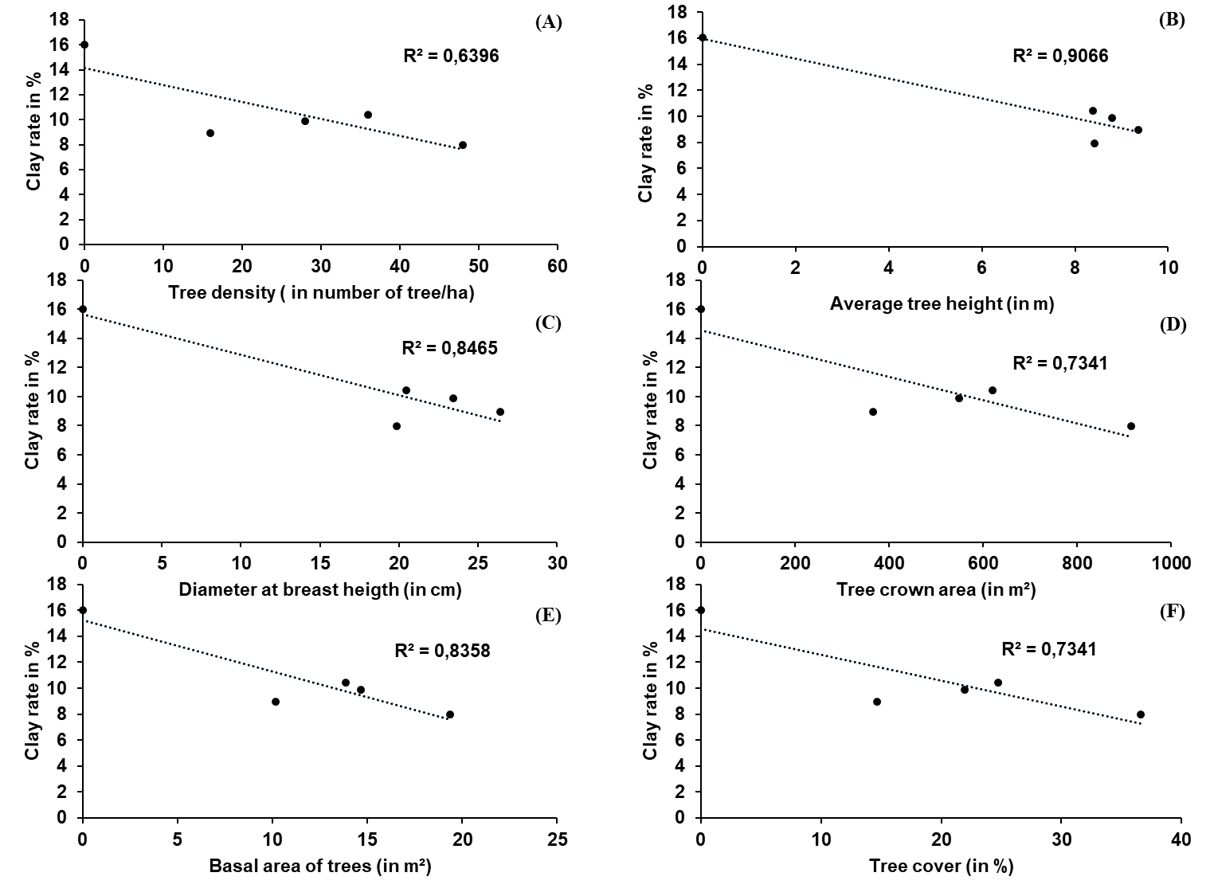
Figure 5: The relationship between soil clay rate and tree density (A), Average tree height (B) diameter at breast height (C), Tree crown area (D), basal area (E) and Tree cover (F).

The various regression lines for silt content based on tree dendrometric parameters with regards to density levels showed a downward trend. However, the regression coefficients remain low (Figure 6). The regression line based on tree density had the lowest regression coefficient value of 0.61. The highest regression coefficient value was 0.81 for the regression line of silt content based on basal area.

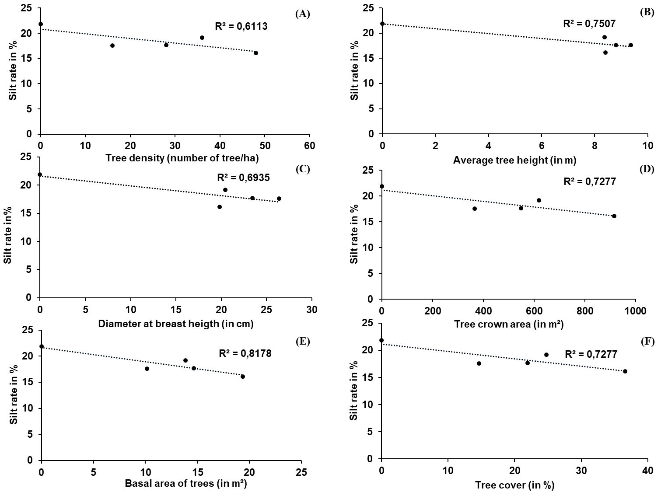
Figure 6: The relationship between soil silt rate and tree density (A), Average tree height (B) diameter at breast height (C), Tree crown area (D), basal area (E) and Tree cover (F).

In contrast to the clay and silt content, the regression lines between the sand content and the dendrometric parameters of the trees showed an upward trend. Overall, the regression lines had regression coefficients greater than 0.6. The regression coefficients for the regression lines for sand as a function of diameter at breast height, tree height, basal area, canopy cover and density were 0.79, 0.85, 0.84, 0.74 and 0.63, respectively.

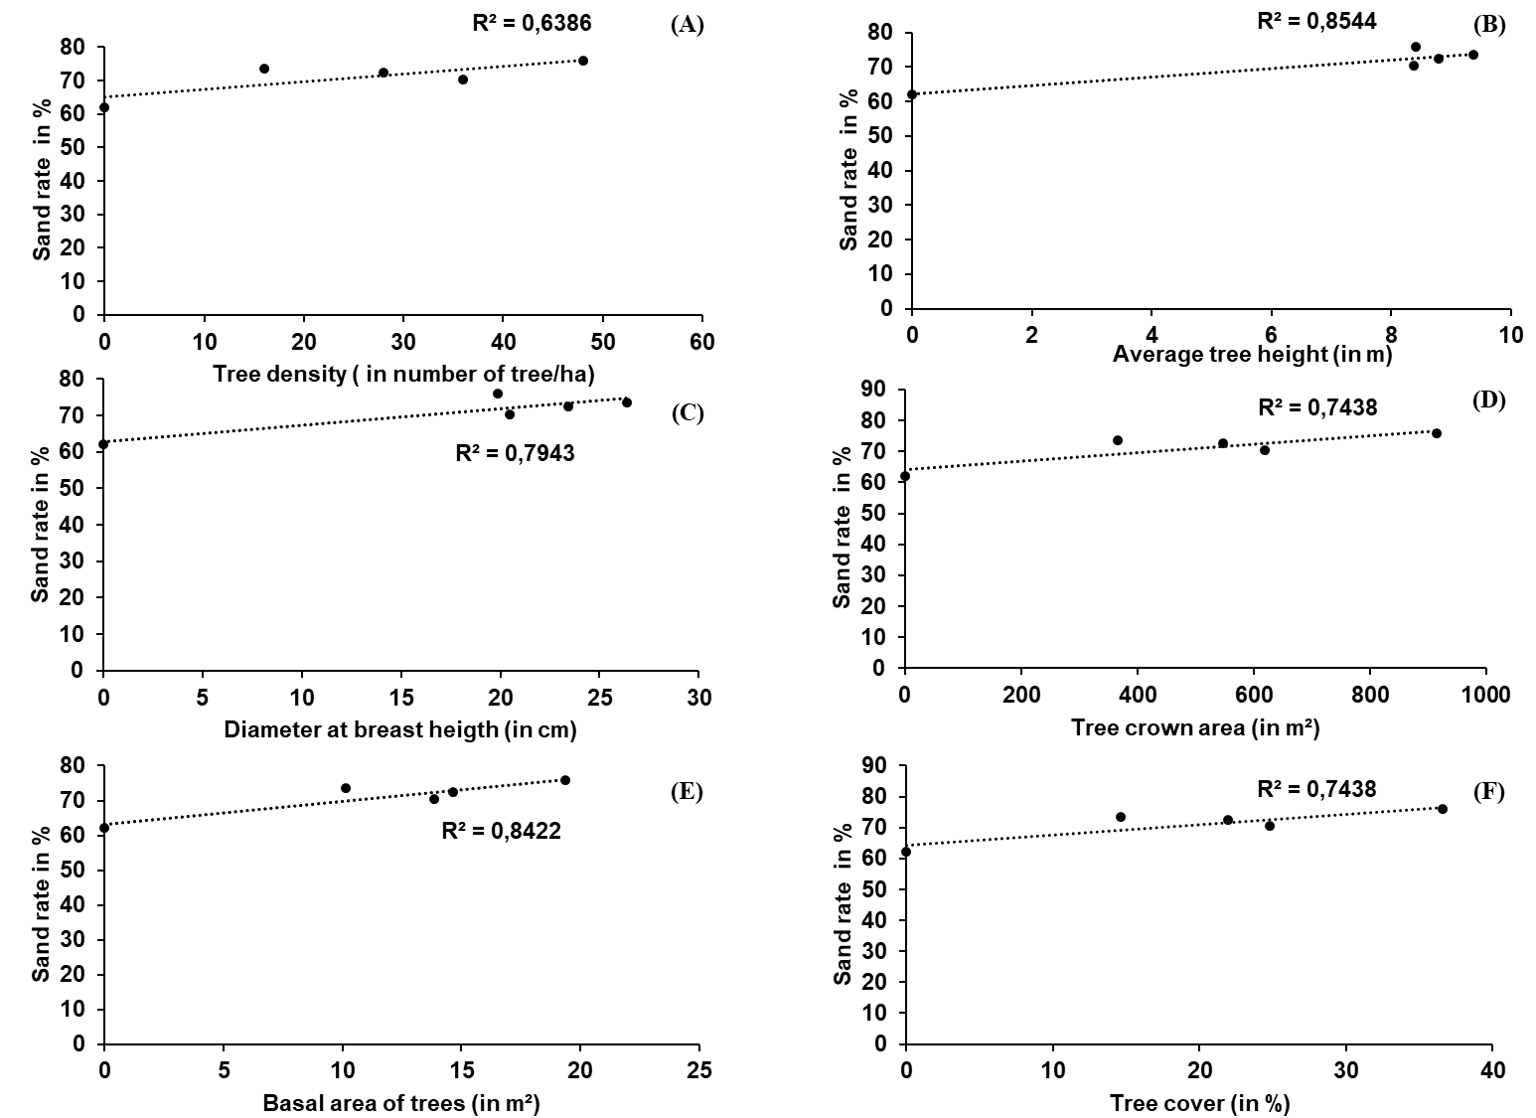

Figure 7: The relationship between soil silt rate and tree density (A), Average tree height (B) diameter at breast height (C), Tree crown area (D), basal area (E) and Tree cover (F).

3.1.3. Effect of trees on the soil water infiltration

3.1.3.1. Effect of trees proximity on the water infiltration

Analysis of the curves showed variation in the water infiltration velocity based on the tree position. This revealed significant differences between infiltration in plots with woody vegetation and that in plots without woody vegetation (Figure 8). However, the curves showed that there was no difference (P>0.05) in the evolution of water infiltration velocity in plots with trees and according to the position of the measurements in relation to the tree (outside the tree canopy, under the canopy and under the influence of shade from the tree canopy) (Figure 8). The four curves had the same downward trend, with a rapid decrease over the period from 0 to 30 minutes (min) and a slow decrease over the interval from 30 min to 150 min (Figure 8). The water infiltration curve for measurements performed in plots with woody vegetation and those located outside the tree canopy was above the other curves.

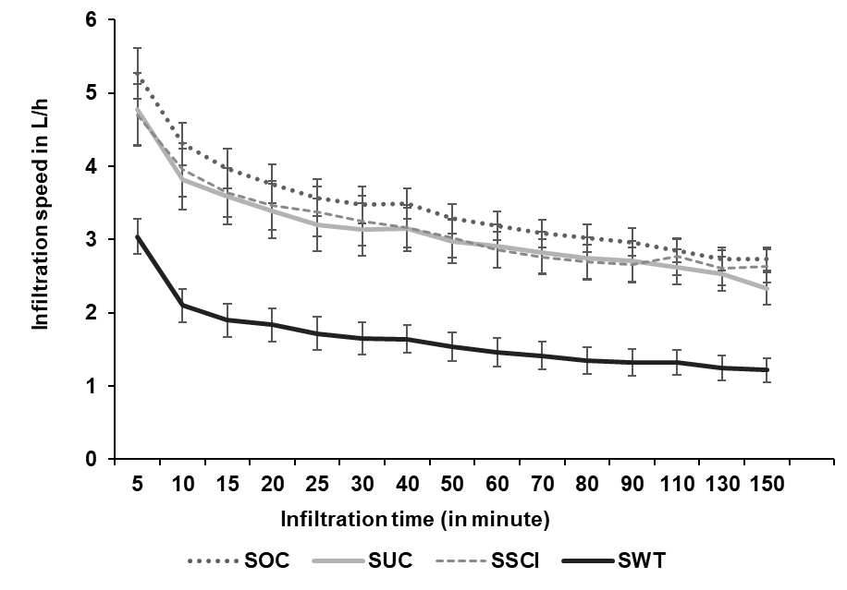

SUC: subplots which were directly under the tree canopy; SSCI: subplot located outside the tree canopy but under the influence of tree shade; SOC: subplot located outside the tree canopy without being under the influence of tree shade and SWT: subplot in plots without trees.
Figure 8: Curves showing the evolution of average water infiltration speeds in the soil according to the position of the tree

Statistical analysis revealed a significant difference in the water average infiltration velocity depending on the position of the plot relative to the nearest tree (Figure 9). The average values were 1.559± 0.164 for measurements outside the canopy without a tree present in the plots, 3.26±0.28 L/h for measurements under the canopy, 3.508±0.230 L/h for those outside the canopy, and 2.79±0.24 L/h for those under the influence of shade. The lowest infiltration rate was 0.335 L/h and the highest average infiltration rate was 8.767 L/h for measurements outside the canopy without trees and outside the canopy, respectively.

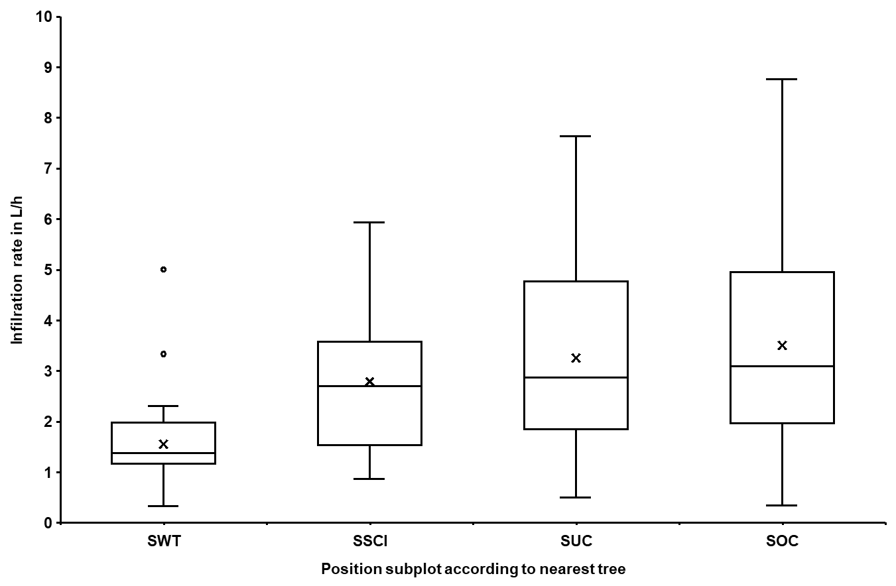
SUC: subplots which were directly under the tree canopy; SSCI: subplot located outside the tree canopy but under the influence of tree shade; SOC: subplot located outside the tree canopy without being under the influence of tree shade and SWT: subplot in plots without trees.
Figure 9: Boxplot of average soil water infiltration rates according to tree position

3.1.3.2. Effect of tree density on the soil water infiltration

Analysis of changes in water infiltration according tree density showed a significant difference (Figure 10). The water infiltration curve for density D1 was found to be significantly lower than that the rest other trees densities (D2 to D5) (Figure 10). However, the infiltration curve for density D5 remains above the other curves regardless of the measurement interval (Figure 10). Nevertheless, all the curves showing the evolution of the infiltration rate over time for the different density levels had a similar pattern, namely a decrease with a rapid decline phase over the period from 0 to 30 minutes. This was followed by decline phase over the period of 30 to 150 minutes.

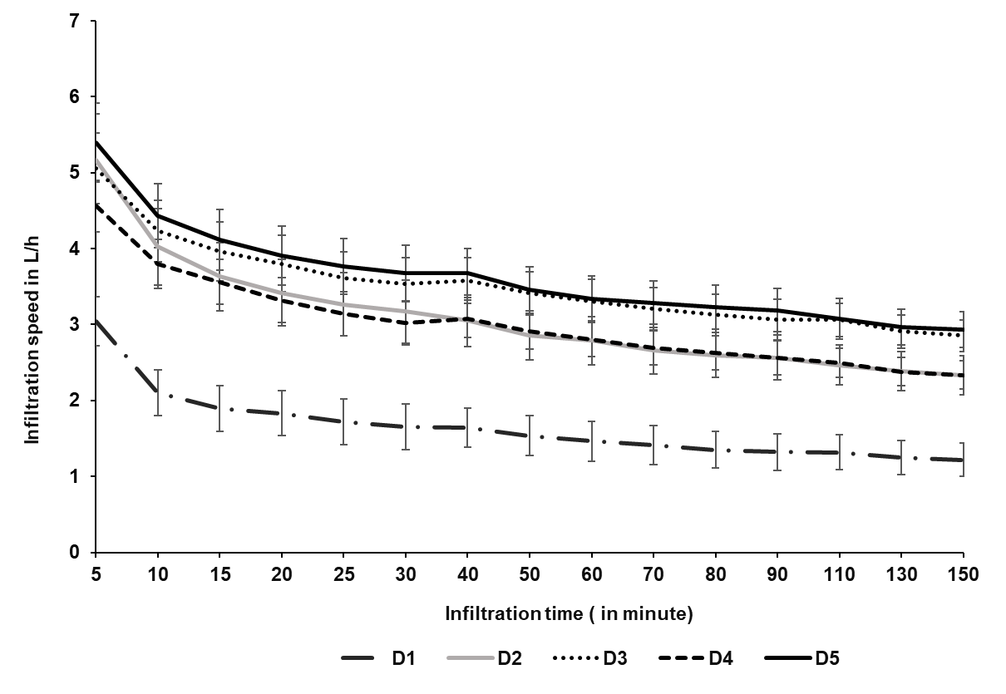
Figure 10: Evolution of Soil water infiltration velocity according trees densities
D1: 0 trees/ha, D2: 16 trees/ha, D3: 28 trees/ha, D4: 36 trees/ha, D5: 48 trees/ha.

With regards to the average water infiltration based on different tree densities, a significant difference was observed (p˂0.001). The average water infiltration (1.651± 0.15 l/h) with no tree (D1) was significantly lower than water infiltration for the other densities D2, D3, D4, and D5, with trees (Figure 11). The highest average infiltration rate (3.64± 0.32 l/h) was recorded for density D5. But statistical different was found for water infiltration between trees densities D2 (3.09±0.35 l/h), D3 (3.52±0.3 l/h), D4 (3.02±0.25 l/h).

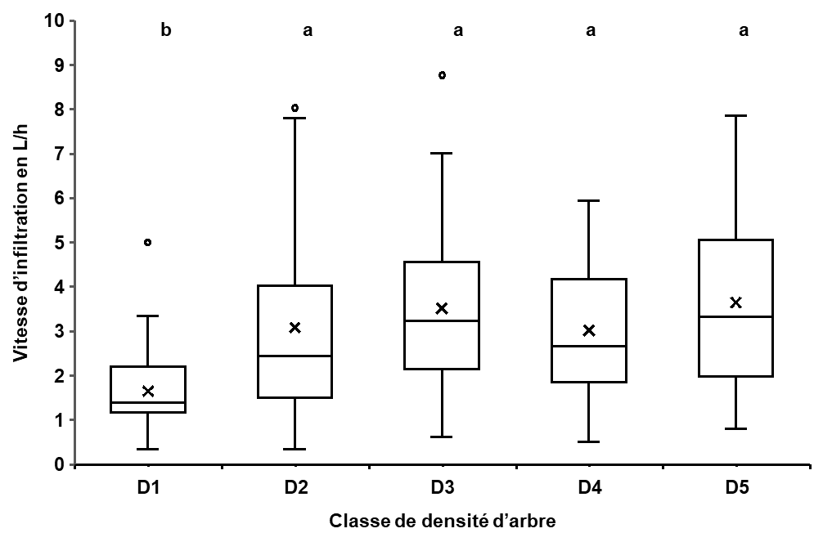
Figure 11: Box plots of average soil water infiltration rates for different density classes (D1: 0 trees/ha, D2: 16 trees/ha, D3: 28 trees/ha, D4: 36 trees/ha, D5: 48 trees/ha).

3.1.4. Effect of trees dendrometric parameters on soil water infiltration

The regression lines for the water average infiltration velocity as a function of dendrometric parameters for different density levels showed an upward trend (Figure 12). Their regression coefficients had values between 0.70 and 0,92. The regression coefficient. The largest regression coefficient value of 0.92 was found between water infiltration velocity and trees basal area (Figure 12).

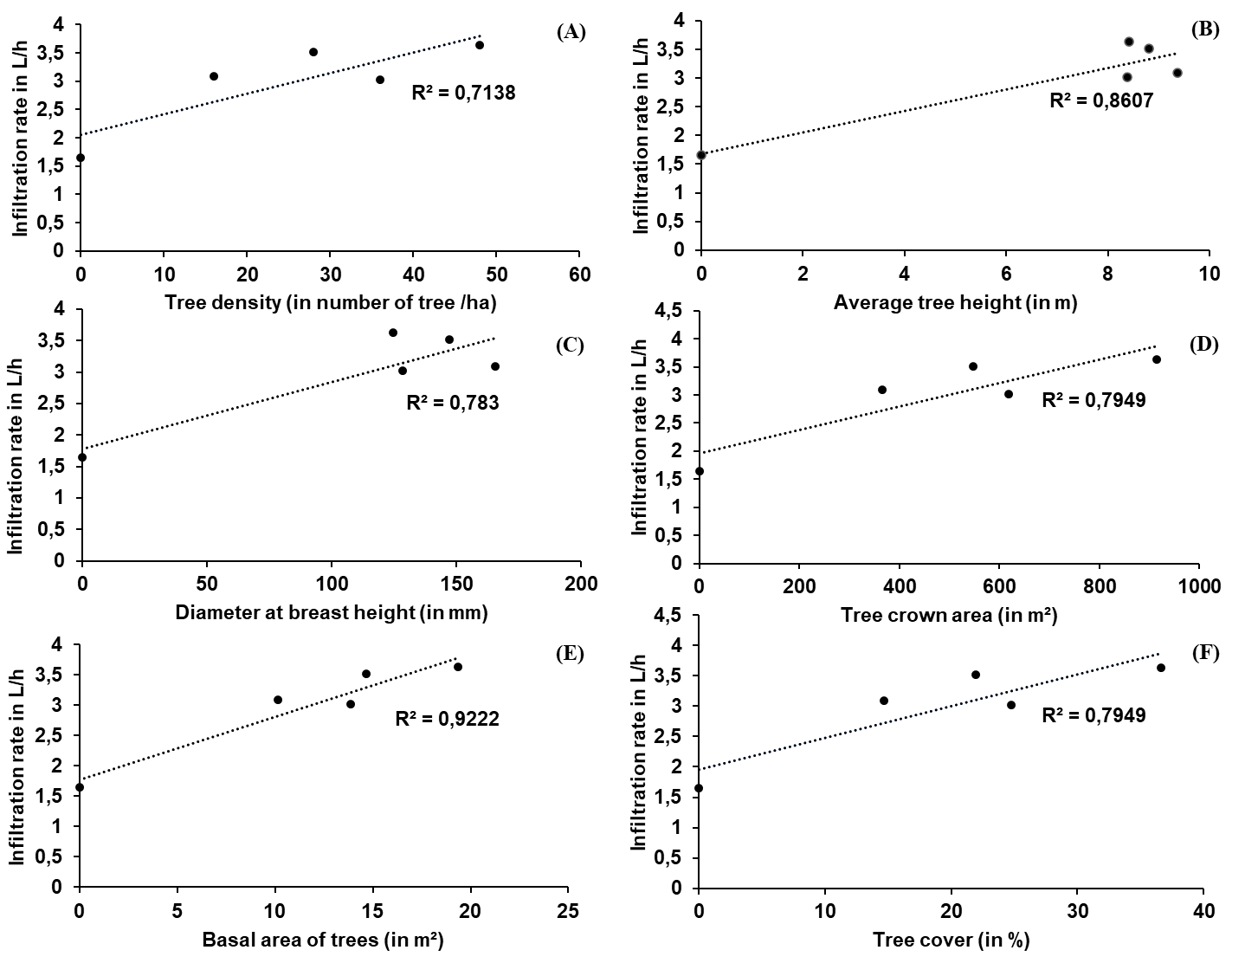
Figure 12: The relationship between water infiltration and tree density (A), tree height (B) DBH (C), Tree crown area (D), basal area (E) and Tree cover (F).

3.1.5. Effect of soil physical parameters on soil water infiltration

We found statistically significant relationships between water infiltration and soil sand (R²=0.92), soil silt (R²=0.90) and clay (R²=0.91) (Figure 13). However, the regression coefficient was low with soil bulk density (R²=0.18) (Figure 13).

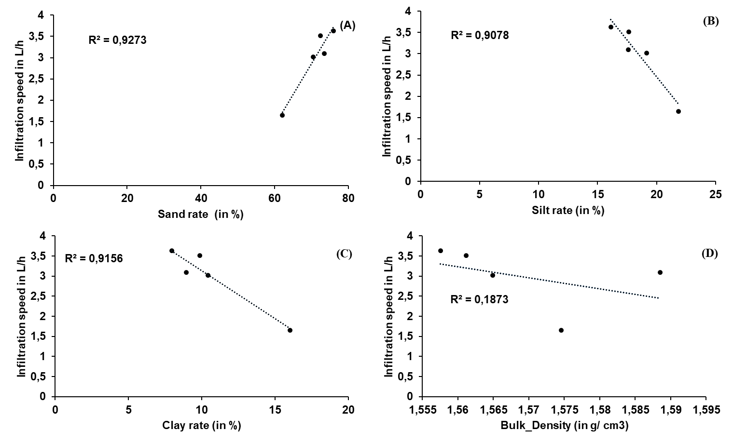
Figure 13: The relationship between water infiltration and soil sand rate (A), soil silt rate (B) soil clay rate (C), soil bulk density (D).

3.2. Discussion

3.2.1. Effect of Vitellaria paradoxa dominated trees density on the bulk density and soil texture.

The Soil bulk density is one of the parameters used to assess soil compaction, porosity and aeration. The bulk density of the soil is impacted by trees through their litterfall and root activity. Thus, Duan et al., (2019) showed that planting density significantly influenced bulk density, which decreased as planting density increased. Furthermore, Mitrová et al. (2025) revealed that the presence of woody components generally improves the hydrophysical properties of soil in various agroforestry parklands. They reported a consistent decrease in bulk density in these parklands. Using the same logic, Joseph et al. (2025) discovered that the bulk density of soil is greater in cultivated soils than in cashew and oil palm plantations at depths of 0–15 cm and 15–30 cm. However, our results contradict these studies, as statistical analyses revealed no significant difference in soil bulk density based on tree density. This could primarily be explained by soil disturbances caused by cultivation operations during the agricultural season. Belagrouz et al. (2016) demonstrated that soil bulk density varies significantly depending on the tillage method employed. These results can also be explained by the measurement depth. In our study, bulk density was determined at a depth of 0 to 20 cm, which is the most disturbed during cultivation operations. Duan et al. (2019) showed that soil bulk density varies depending on the depth at which it is measured. However, the same authors have shown that there is no statistical difference in bulk density according to tree density at the same measurement depth. Finally, as the study was conducted in an agroforestry parkland where the position and distribution of trees is random, significant variation in bulk density may be observed between plots. However, taking into account the distance of the subplot from the trunk and crown of the trees, our results are consistent with those of Tesfaye and Lemma (2019), who emphasised that soil bulk density is significantly influenced by distance from the tree base and soil depth. Tanga et al. (2014) also demonstrated that the bulk density of soil increased with distance from the trunk of Balanites aegyptiaca, Acacia tortilis and Acacia seyal. Abdella and al. (2021) found that soil bulk density was notably lower under canopy of F.albida and C. africana trees than outside canopy, and increased with increasing radial distances.
Tree density had an effect on the soil texture including sand, silt and clay content depending on the density level. The sand content was lower in plots without trees compared to plots with trees. On the other hand, the silt and clay content in plots without trees was higher than it was in plots with trees. Our results are consistent with those of Abebaw et al., (2025): These results contradict previous studies which showed that woody plants do not affect soil texture. Therefore, Abdella and al. (2021) found that Soil textural fractions (sand, silt and clay) were not considerably influenced by presence of Faiderbia albida and Cordia africana trees. This could be explained partly by the effect of runoff. In fact, the runoff is greater in plots without trees because the water erosion protection provided by trees appeared to be lost. This results in the transport of sand particles to other locations, hence the low sand content in these plots. These coarse particles transport is also detrimental to the fine silt and clay particles that remain. Secondly, runoff will reduce the rate of infiltration, thereby reducing the transport of fine particles to lower horizons. In plots with trees, an opposite effect is observed, as trees can be a natural barrier against wind and water erosion. This means that fewer sand particles will be torn away and/or transported to other locations, which is favorable for high sand content in these plots. Further, less runoff was observed and therefore a higher infiltration rate. This can be as result in the fine fraction transport, particularly silt and clay, to the lower horizons, mainly through percolation.
It was observed that trees density affected the soil moisture content during dry periods. Moisture content values differed considering different levels of tree density. The results obtained are in line with those reported by Nsanzimfura (2015), who showed that Piliostigma reticulatum has a beneficial effect on soil moisture. Our results also corroborated with those of Ouédraogo (2021), who found that soil moisture during dry periods in plots with a tree density greater than 15 trees/ha was higher than those in plots with a tree density of less than 15 trees/ha. Indeed, trees in agroforestry Parklands could contribute to an improved soil texture when organic matter was supplied to the soil through litter decomposition and the addition of animal manure provided by animals using these Parklands as habitats or food sources. It could also contribute to improving the soil structure through root activity and the stimulation of soil fauna. Furthermore, trees are responsible for creating microclimate which is conducive to moisture conservation. Soil moisture in the plots varied depending on whether the soil was wet or dry. During wet periods, there was no significant difference in terms of the average soil moisture values. Our results were found to be different from those of Ouédraogo (2021), who showed that soil moisture during wet periods in plots with a tree density greater than 15 trees/ha were higher than those in plots with a tree density of less than 15 trees/ha. This could be explained by the fact that our soils have similar textural properties.

3.2.2. Effect of tree density and dendrometric parameters in Vitellaria paradoxa Gaertn. f. dominated Parklands on the soil water infiltration speed

The evolution of infiltration velocity over time according to the trees position (without trees, under the canopy, outside the canopy and under the influence of shade) with regards to the tree density showed a decreasing trend. These patterns were also obtained by Koala et al. (2014) in Laba and Tiogo in the Sudanian wooded savannah of Burkina Faso and by Zoumboudré (2009) in western Burkina Faso. The infiltration rate is linked to the water status, the soil structure and texture. The infiltration rate is higher when the soil moisture content is low (Yasim et al., 2021). The observed shape of the curves can be explained by the fact that the dry soil absorbed water gradually until saturation, resulting in a continuous decrease in the infiltration rate over time.
Indeed, Koala et al. (2014) noted that disturbances of the soil and the soil types had impact on the soil water infiltration. Furthermore, the average soil water infiltration rates based on the measurement position in relation with the tree (without canopy, outside the canopy, under the influence of the canopy and under the tree canopy) was different among these parameters. This difference depends on whether trees were close or far from the position. Regarding the soil water infiltration rate in relation with distance from the tree, the authors agree in their work that infiltration decreases as we move away from the tree. Zapata-Sierra et al. (2008) indicated that the water infiltration in the soil decreases as distance from the tree increased. Bazié (2013) indicated that water infiltration in the soil varied according to the distance from the trunk. The study by Tesfaye and Lemma (2019) revealed that soil moisture content (SMC) is impacted by two key factors: distance from the tree base and soil depth. Revell (2022) confirmed this variation in relation to the position of the tree, indicating in his study that the average infiltration at 10 cm from the tree (4.11 ml) was higher than that at 200 cm (2.34 ml). Their studies also showed that infiltration is much better under the tree canopy compared to areas outside the canopy. Hasson (2006) showed that soil water infiltration was higher under the tree canopy than outside the tree canopy. This situation relates to the ground cover provided by the foliage. The soil cover farming system, as demonstrated by Koulibaly et al. (2018), enhances soil moisture and boosts water infiltration into the soil. Zomboudré (2009) revealed an increased soil water infiltration rate under the canopy of Vitellaria paradoxa Gaertn. F., compared to areas which were not influenced by the tree canopy. This could be explained by the direct or indirect effect of the trees on soil water infiltration. Through its root activity, trees influence the soil structure in its surrounding environment, thereby improving soil infiltration. Trees contribute to improving the texture of the soil in its environment through its litter input, particularly leaf litter, which are decomposed and transformed into organic fertilizer. Sweet et al. (2025) found that water infiltration into the soil was much greater in compost-amended soils than in unamended soils. Further, woody plants could be considered as responsible as, they might contribute to disrupting some of the infiltrating water through their roots. On the other hand, the average soil water infiltration rates based on tree density levels showed were found to be different. This was consistent with studies of Sanou et al. (2010) of which findings showed that soil water infiltration in agroforestry Parklands is neither homogeneous nor uniform. The Average soil water infiltration rates were higher in plots with trees than it was in plots without trees. Koala et al. (2021) found that trees density had a significant impact on the soil water infiltration. Authors showed that water infiltration values were better in high-density plots compared to those in low-density plots. Similarly, Gnissien et al. (2023) found that the infiltration rates were much higher in plots with trees than those in plots without trees. These results could be explained by the direct effect of trees through water absorption and the indirect effect through improvement of the structural and textural conditions of the soil. Indeed, with regard to the direct effect of woody plants, it should be noted that woody plants consume water and appeared to be part of the soil-water-plant-atmosphere interface. Therefore, the larger and more numerous the woody plants are, the greater the demand for water, resulting in greater infiltration in plots with a high density of woody plants. This was found to have an impact on the soil water status. Ilstedt et al. (2016) demonstrated that, contrary to popular belief, moderate tree cover can improve groundwater recharge, and that tree preservation and management can increase groundwater resources. In terms of the indirect effect, trees had capacity for limiting both wind and water erosion. Thus, their root activity improves the soil structure. In addition, trees contribute to provide organic matter to the soil through leaf litter and bird as well as animal manure (from birds and other animals which use the trees as their habitat). Koala et al. (2021) showed that the agroforestry Parklands had high carbon sequestration potential. This organic matter, which undergoes various processing, could improve the soil texture. Bazongo et al. (2024) argue that the high levels of carbon, potassium and phosphorus indicated that Shea Parklands could contribute to improving the chemical properties of the soil. Improving the soil properties through the existing woody plants promotes soil water infiltration in agroforestry Parklands. This was in line with Koala et al. (2014), who showed that physical properties, particularly soil type, are a key factor in explaining soil water infiltration. Yasim et al. (2021) reported that soil bulk density and texture affected soil infiltration. For infiltration in plots with woody plants, we observed a moderate difference in soil water infiltration values depending on the levels. Zomboudré (2009) noted that the reduction of differences between the measured infiltration rates under and outside tree canopies is due to the high trees density in agroforestry Parklands.

3.2.3. Effect of the soil physical and trees dendrometric parameters on soil water infiltration speed.

The soil physical parameters, particularly its texture, can be used to predict the infiltration velocity with 60% accuracy based on regression lines. These results confirmed those of Bakaché et al. (2019) of which studies showed that infiltration was better in uncompacted soils than it was in the compacted ones. Infiltration of water in the soil decreased with increasing clay content. This could be explained by the fact that the process of water getting in the soil depends mainly on the soil nature composition and arrangement. Our results are consistent with those of Mbilou et al. (2016), who show that infiltration rates are linked to soil texture. The authors reveal that infiltration rates are higher in more or less sandy soil horizons and lower in clayey soil horizons. We did not find a strong correlation between soil bulk density and infiltration rates. This could be because bulk density itself depends on soil texture and structure. Therefore, its effect would not be directly proportional to infiltration. However, the influence of bulk density on soil infiltration has been demonstrated by authors. Yasim et al. (2021) indicate that soil bulk density affects infiltration rates. Indeed, they found that the infiltration rate was inversely proportional to bulk density values. Put simply, the lower the apparent density, the higher the infiltration rate. In addition, Al-Ogaidi et al. (2023) was also found that the infiltration rate was affected by the density of the upper stratum more than its influence by the change in the density of the lower stratum. Mitrová et al., (2025) report that a steady decrease in bulk density and an increase in porosity lead to improved water infiltration, retention and storage capacity in agroforestry parklands.
Our study shown that tree dendrometric parameters such as canopy cover, basal area and tree height affects water infiltration and can be used to predict the soil water infiltration. These findings corroborated with previous studies which showed that trees size had effects on the soil water infiltration and its hydraulic conductivity (Sierra et al., 2008).

.4. CONCLUSION

Agroforestry Parklands were found to be the most widespread production systems in the agricultural sector in Burkina Faso. Vitellaria paradoxa dominated Parklands happened to be the most common systems. This allowed rising interests in the studies of agroforestry Parklands dominated by Vitellaria paradoxa, in order to determine the effect of different tree density levels in Parklands dominated by Vitellaria paradoxa and the trees dendrometric parameters on the soils physical properties in agroforestry Parklands. In this study, it can be concluded the following: Firstly, Vitellaria paradoxa is the dominant species in our plots, accounting for at least 70% of the tree density in plots with trees. Secondly, there was no sufficient evidence to highlight the influence of tree density on soil bulk density and moisture during the wet season. Trees density levels affected the soil texture. The sand content in plots with trees was much higher than that in plots without trees. On the other hand, the silt and clay content was much higher in plots without trees compared to those with trees. Finally, the average soil infiltration rates were higher in fields with trees (density 16 trees/ha, 28 trees/ha, 36 trees/ha and 48 trees/ha) with average values between 3.02 and 3.64 L/h than those in fields without trees (density 0 trees/ha) with an average value of 1.65 L/h. Further, dendrometric parameters and sand, silt and clay content were better predictors of the soil water infiltration rate. Thus, this study emphasised that the presence of trees in plots improved soil water infiltration rate. High tree density also increased soil water infiltration rate. The basal area was also found to be the best predictor for soil water infiltration rate, with a regression coefficient of R²=0.92, followed by tree height, with a regression coefficient of R²=0.86. This study provided an understanding of the effect of tree density on soil physical properties. As agroforestry Parklands are dynamic systems, it would be interesting to ascertain the effect of tree density on the soil physical properties within this dynamic.

Data availability statement

The dataset generated for this study is available upon request from the corresponding author.

Conflict of interest statement
The authors declare no conflict of interest with respect to this manuscript.

COMPETING INTERESTS DISCLAIMER:
Authors have declared that they have no known competing financial interests OR non-financial interests OR personal relationships that could have appeared to influence the work reported in this paper.

References
Abdella , M. and Nigatu , L. ( 2021 ). Effects of scattered Faidherbia albida and Cordia africana trees on soil properties under their canopies in Fedis District, East Hararghe Zone, Oromia. International Journal of Plant & Soil Science, 33(20), 38-53. DOI: 10.9734/IJPSS/2021/v33i2030628.
Abebaw , A. , Jemberu , W. , Getahun , M. , Mengiste , W. and Endalew , A. ( 2025 ). Influence of Land Use and Management Practices on Soil Physicochemical Properties across Slope Gradients. Water and Soil Management and Modeling, 5(4), 15-27. doi: 10.22098/mmws.2025.18301.1674
Al-Ogaidi , A. A. M. , Mahmood , M. T. , Mohammed , A. K. and Yasin , H. I. (2023). Effect of Soil Bulk Density on Water Infiltration in Layered Soils. Tikrit Journal of engineering Sciences, 30(3), 174-189. DOI:10.25130/tjes.30.3.16.
Al-Ogaidi, p. A. M. , Mahmood , M. T. , Mohammed , A. K. and Yasin ., H. I. ( 2023 ). Effect of soil bulk density on water infiltration in layered Soil. Tikrit Journal of Engineering Sciences, 30(3), 174-189. DOI: http://doi.org/10.25130/js.30.3.16.
Avakoudjo , J. , Alladassi , F. K. , Akplo , V. , Kindomihou , V. , Azontondé , H. A. , Amadji , L. G. and Sinsin , B. A. (2020). Water infiltration in the dongas soils in subhumid zone in West Africa. Benin Agronomic Research Bulletin (BRAB), Vol 30 n 05., p13.
Bakache M., Hammani A., Cooper M. and Bartali E. (2019). Effect of soil texture on water infiltration in inland sediments at the perimeter of Jorf (Errachidia Province). Moroccan Review of Agronomic and Veterinary Sciences, 7(3), 481-590.
Bationo , A. , Kihara , E. , Vanlauwe , B. , Waswa , B. (2007). Dynamics, functions and management of soil organic carbon in West African agroecosystems. Agricultural Systems, vol 94, n°1, p13-25.
Bayala , J. , Bayala , J. , Teklehaimanot , Z. & Ouedraogo S.J. (2002). Millet production under crown pruned trees in a parkland system in Burkina Faso. Agroforestry Systems, 54, 203-214.
Bayala , J. , Heng , L.K. , Noordwijk M.V. and Ouedraogo S.J. (2008). Hydraulic redistribution study in two native tree species of agroforestry parklands of West African dry savanna. Actaoecologica, 34 , 370-78. DOI: 10.1016/j.actao.2008.06.010
http://dx.doi.org/10.1037/0021-843X.103.2.202 Bayala, J., Kindt, R., Belem, M. & Kalinganire, A. (2011). Factors affecting the dynamics of tree diversity in agroforestry Parklands of cereal and cotton farming systems in Burkina Faso. New Forests, 41: 281-296.
Bazie, H. R. (2009). A study of competition for growth resources and experimental segregation of tree-soil-crop interactions in a saponé agroforestry park, Burkina Faso. Memoir of the Diploma of Advanced Studies (DEA), University of Ouagadougou (UFR/SVT) / -Burkina Faso, 58p.
Bazie, H. R. (2013). Tree-crop interactions and roles of agroforestry parks to Vitellaria paradoxa (C.F. Gaertn.) on water balance parameters in Burkina Faso. PhD thesis, University of Ouagadougou UFR/SVT-Burkina Faso, 146p.
Bazie , H. R. , Bayala , J. , Zombre , G. , Sanou , J. and Ilstedt U. (2012). Separating competition- related factors limiting crop performance in an agroforestry Parkland system in Burkina Faso. Agroforestry Systems, 84, 377–388.
Bazie , H. R. , Sanou , J. , Bayala , J. , Bargues-Tobella , A. , Zombré , G. & Ilstedt U. ; 2018. Temporal variations in transpiration of Vitellaria paradoxa in West African agroforestry parklands. Agroforestry. Syst. DOI 10.1007/s10457-017-0115-4.

Bazié, P. (2019). Influence of two land-use modes on the phenology and physiology of Vitellaria paradoxa (C. F. Gaertn.) in the South Sudanese zone of Burkina Faso. Doctoral thesis, University of Ouagadougou UFR/SVT-Burkina Faso, 118p.
Belagrouz, A., Chennafi, H., Hakimi, M., Soualili, N., Razem, R., Boutalbi, W., Ferras, K. (2016). Hydraulic Conductivity and Bulk Density under Conservation Tillage. Agriculture Review, Special Issue 1, 100–105.
Bhattacharjee, R., Yadahalli, V. G., Yadahalli, G. S., and Savita, B. (2025). Residual Effect of Permanent Manurial Trial on Soil Physical, Chemical and Biological Properties under Northern Dry Zone of Karnataka, India. International Journal of Plant & Soil Science, 37 (11):19–26. DOI:10.9734/ijpss/2025/v37i115819.
Boffa, J-M. (1999). Agroforestry Parklands in sub-Saharan Africa. FAO Conservation Guide 34. Rome, Italy, 230 p.
Boffa, J-M., (2000). Agroforestry parklands in sub-Saharan Africa. ICRAF, ISSN 1020-1149 FAO Conservation Guide 34. Rome, Italy, 258 p.
Bonkoungou, E. G., Alexandre, D. Y., Ayuk, E. T., Depommier, D., Morant, P. and Ouadba, J. M. (1994). Agroforestry Parklands of West African semi-arid lands. Conclusions and recommendations of an international symposium. ICRAF-SALWA, October 25-27, 1993, Ouagadougou, Burkina Faso. 18p. Bonkoungou, E. G., Ayuk, E. T. & Zoungrana, I.; 1993. Agroforestry parks in the semi-arid zones of West Africa. ICRAF, Nairobi, 226 p.
BUNASOLS, (1999). Morpho-pedological study of the Bazèga province. Technical report No. 112, 82p.
Coulibaly, K., Gomgnimbou, A. P. K., Traoré M., Sanon, J. F. K. and Nacro, H. B. (2018). Effects of conservation agriculture on water dynamics and carbon stock of a tropical ferruginous soil in western Burkina Faso. Science and Technology, Natural and Applied Sciences, Special issue No. 4, pp. 273-282.
Daniel, Y. A. (2002). Introduction to agroforestry in the Sahelian zone: The field trees of the Central Plateau in Burkina Faso. ISBN (IRD): 2-7099-1475-1 75010 Paris, IRD Editions and KARTHALA, 215p.
Derivry, E. (2018). Technical sheets on soil quality indicators. ORION, APREL, 17p.
Duan, A., Jie Lei, J., Hu, X., Zhang, J., Du, H., Zhang, X., Guo, W. and Sun, J. (2019). Effects of planting density on soil bulk density, pH and nutrients of unthinned Chinese fir mature stands in the south subtropical region of China. Forests, 10(4), 351, p17; doi:10.3390/f10040351.
Fan, B., Zhao, Z., Tao, F., Liu, B., Tao, Z., Gao, S. et al. (2014). Characteristics of carbonate, evaporite, and silicate weathering in the Huanghe River basin: a comparison between upstream, middle, and downstream units. Journal of Asian Earth Sciences, 96, 17-26. https://doi.org/10.1016/j.jseaes.2014.09.005.
Fournier, J., Bonnot-Courtois C., Paris R., Voldoire O., Le Vot M. (2012). Granulometric analyses, principles and methods. CNRS, Dinard, 100 p.
Fournier, J., Bonnot-Courtois, C., Paris, R., Voldoire, O., Le Vot, M. (2012). Granulometric analyses, principles and methods. CNRS, Dinard, 100 p.
Gnissien, M. (2018). Evaluation of the agro-environmental effects and impacts of agroecological practices and their development conditions in the Eastern region of Burkina Faso. Master in Plant Production. Institute of Rural Development/Nazi Boni University of Bobo-Burkina Faso, 64 p.
Gnissien, M. (2024). Effects of agroforestry park management methods on the physicochemical and biological properties of soils and crop yields in the North Sudanese and Sub-Sahelian zones of Burkina Faso. Doctoral Thesis. Doctoral School of Natural Sciences and Agronomy/Nazi Boni University of Bobo-Burkina Faso, 64 p.
Gnissien, M., Coulbaly, K., Barro, M., Douzet, J-M., Cournac, L., Cicek, H. and Nacro, H. B. (2023). Long-term effects of different densities of Piliostigma reticulatum (DC) Hochst on carbon and water storage and dynamics in an epipetric Plinthosol in the North Sudanian zone of Burkina Faso. International Journal of Biological and Chemical Sciences, 17(3), 1220-1236. DOI: 10.4314/ijbcs.v17i3.36.
Guiatin, E. (2016). Fertilization options for sustainable millet and sorghum production in agroforestry parklands of south-central Burkina Faso. Rural Development Design Engineer Thesis. Institute of Rural Development / Polytechnic University of Bobo - Burkina Faso, 38 p.
Hansson, L. (2006). Comparisons of Infiltrability Capacities in Different Parklands and Farming Systems of Semi-Arid Burkina Faso. MSc, Swedish University of Agricultural Sciences, Umeå, Sweden, 20 p.
Hien, S. J. W. W. (2022). The contribution of agroforestry parklands to the well-being of the populations of Burkina Faso: the case of the Bougouriba province. Research and Perspectives from Africa Collection, Vol 1, No 1, pp. 122-149.
Ilstedt, U., Malmer, A., Verbeeten, E. and Murdiyarso D. (2007). The effect of afforestation on water infiltration in the tropics: A systematic review and meta-analysis. Intermediate tree cover can maximize groundwater recharge in the seasonally dry tropics. Forest Ecology and Management 251 45–51. DOI: 10.1016/j.foreco.2007.06.014. Ilstedt, U., Tobella, B. A., Bazié, H. R., Bayala, J., Verbeeten, E., Nyberg, G., Sanou, J., Benegas, L., Murdiyarso, D., Laudon, H., Sheil, D. and Malmer, A. (2016). Intermediate tree cover can maximize groundwater recharge in the seasonally dry tropics. SCIENTIFIC REPORTS, 6, 21930. DOI: 10.1038/srep21930.
Iro, D. G., Boubé, M., Habou, R. and Mahamane, L. (2016). Pressure factors on Vitellaria paradoxa and Neocarya macrophylla agroforestry parks in southwest Niger (West Africa). Journal of Applied Biosciences, 107, 10407-10417. http://dx.doi.org/10.4314/jab.v107i1.6.
Joseph, P. O., Abel aina, A. O., Ojomah, F. O., Adede A. C. and Abioye, J. B. (2025). Soil carbon storage response to land–use change in loamy–sand textured soil of Anyigba, Kogi state, Nigeria. Agriculture and Forestry Journal Available, vol. 9, no. 1, p. 1-6.
Koala, J., Kagambega, O. R. and Yelemou, B. (2021). Influence of tree densities in water infiltration improvement In agroforestry Parklandland in Burkina Faso. International Journal of Agriculture and Environmental, Vol: 07, p332-p343. DOI: https://doi.org/10.51193/IJAER.2021.7209
Koala, J., Savadogo, P., Zida, D., Mohammed, S., Sawadogo, L. and Nacro, H.B. (2014). Cumulative effects of 20 years of fire, grazing, and selective tree cutting on soil water infiltration in the Sudanese savanna and West African forest ecosystem. Int. J. Biol. Chem. Sci, 8(6), 2424-2440, DOI: http://ajol.info/index.php/ijbcs
Koueta, T. R., Gomgnimbou, P. K. A., Nakoulma, D., and Sanon, A. (2023). Evaluation of soil carbon in agroforestry systems in the commune of Bobo-Dioulasso in Burkina Faso. International journal of advanced research, 13 (03), 1235-1246. DOI: 10.21474/IJAR01/20673.
Koueta, T. R., Nakoulma, G., and Gomgnimbou, P. K. A. (2023). Agroforestry Practices and Factors Determining Their Adoption in the Rural Commune of Bobo-Dioulasso, Burkina Faso. International Journal of Progressive Sciences and Technologies, Vol. 40 No. 2, pp. 298-311.
Mahamane, A. (1997). Structure, functioning and dynamics of agroforestry parks in western Niger. Doctoral thesis, University of Ouagadougou UFR/SVT-Burkina Faso, 118p.
Mbilou, U. G., Mabonzo, M. N., Miyouna, T. (2016). Measurement of water infiltration rate in the soil: Case of soils in the Niari Valley in the Republic of Congo. Journal of Applied Biosciences, Vol. 100, 9494–9503. DOI: 10.4314/jab.v100i1.1. Mitrová, A. M., Vichta, T., Zapletal, P., Volánek, J., Neubauer, S. and Vranov, V. (2025). Effects of tree characteristics on hydrophysical soil properties in European agroforestry systems: systematic review. Agroforest Syst, 99,246, p18. DOI:10.1007/s10457-025-01352-z.
Nenge, A. S., Ibrahim, N., and Adaikwu, A. O. (2025). Analysis of Impacts of Tillage Practices for Integrated Nutrients Management Systems on Maize Performance. Asian Journal of Plant and Soil Sciences, 10 (1):1-11. DOI:10.56557/ajopss/2025/v10i1112.
Nsanzinfura, T., (2015). Study of the bulk density of the soil in the crop-news experimental setup of Kamboinsé (Burkina Faso). Master's thesis in Water and Environmental Engineering. 2iE Ouagadougou- Burkina Faso, 43p.
Ouédraogo, S. A. (2018). Influence of physicochemical parameters and soil moisture on sorghum production in an agroforestry park in the rural commune of Saponé, Burkina Faso. Rural Development Engineering thesis. Institute of Rural Development/Nazi Boni University of Bobo-Burkina Faso, 64p.
Ouedraogo, S. A., (2021). Effect of Vitellaria paradoxa C. F. Gaertn. f. on pedoclimatic parameters and the productivity of Sorghum bicolor (L.) Moench in agroforestry parks in western Burkina Faso. Master II thesis in Plant Ecophysiology. UFR-SVT/Joseph Ki-Zerbo University-Burkina Faso, 54p.
Ouoba, H. Y., Bastide, B., Kabore, S. A., Seghieri, J. and Boussim, I. J. (2023). Population structure of Vitellaria paradoxa F. Gaertn. (shea) in agroforestry parks in Burkina Faso. Biotechnol. Agron. Soc. Environ, 27(3), 121-133. DOI: 10.25518/1780-4507.20329.
Ouoba, P., Yaméogo, T. J., Ouédraogo, A. and Kouaman, S. (2018). Agroforestry potential of Maranthes polyandra (Benth.) Prance in southwestern Burkina Faso. Journal of Applied Biosciences, No. 128, pp. 12920-12931.
Pallo, P. F. (2001). Soil fertility studies. In: Douglas J.D., Munro R.C. (Eds) The second annual report of the project minimizing competition in dryland agroforestry. INCODC ERBIC18CT98 0322. Center for Ecology and Hydrology, Edinburgh, UK., p. 8-17.
Pouliot, M., Treue, T., Obiri, B. D., & Ouedraogo, B. (2012). Deforestation and the limited contribution of forests to rural livelihoods in West Africa: evidence from Burkina Faso and Ghana. AMBIO, 41, 738-750. DOI:10.1007/s13280-012-0292-3
Revell, N., Lashford, C., Rubinato, M. and Blackett, M. (2022). The Impact of tree planting on infiltration depends on tree proximity and maturity at a clay site in Warwickshire, England. Water 2022, 14, DOI: 10.3390/w14060892.
Sanou, J., Bayala, J., Teklehaimanot, Z. and Bazié,P. (2012). Effect of shading by baobab (Adansonia digitata) and nere (Parkia biglobosa) on yields of millet (Penniselum glaucum) and taro (Colocasia esculenta) in Parkland systems in Burkina Faso. West Africa Agroforest Sysl, Vol. n085, p.431-441.
Sanou, J., Zougmoré, R., Bayala, J. and Teklehaimanot, Z. (2010). Soil infiltrability and water content as affected by Baobab (Adansonia digitata L.) and Néré (Parkia biglobosa (Jacq.) Benth.) trees in farmed Parklands of West Africa. Soil Use and Management, Vol n26, p.75–81. DOI: 10.1111/j.1475-2743.2009.00250.x.
Sanou, L., Koala, J., Ouédraogo, S. and Ouattara, B. (2022). Perceptions, ecosystem services and vulnerability of multi-purpose woody species in the 20th Ramsar site in Burkina Faso, West Africa. Africa SCIENCE, 20(3), 25–40.
Sawadogo, T. (2019). Comparative study of the structure of the woody component in the agroforestry parks of Cassou and Kongoussi. Rural Development Design Engineer's Thesis/Agronomy option. IDR/UNB, Burkina Faso, 64p.
Sierra, A. Z. and Agugliaro, F. M. (2008). Influence of six tree species on water infiltration in soil. Agrociencia, Vol 42, No. 7, pp. 835-845.
Sweet, S. K., Bassuk, N. L. and Miller, B.M. (2025). Deep compost amendment reduces soil bulk density resulting in improved growth of urban Gymnocladus dioicus trees over time. Urban Forestry & Urban Greening, 108, p12. DOI: 10.1016/j.ufug.2025.128822
Tanga, A. A., Erenso, T. F. and Lemma, B. (2014). Effects of three tree species on microclimate and soil amelioration in the central rift valley of Ethiopia. Journal of Soil Science and Environmental Management, Vol. 5(5), pp. 62-71, DOI 10.5897/JSSEM12.060
Tesfaye, A. and Lemma, B. (2019). Soil bulk density, soil moisture content and yield of Tef (Eragrostis tef) influenced by Acacia seyal Del canopy in Parkland agro-forestry system. Journal of Soil Science and Environmental Management, Vol. 10(6), no. 4p. 124-129, DOI: 10.5897/JSSEM2019.0738.
Tobella, B.A., Reese, H., Almaw, A., Bayala, J., Malmer, A., Laudon, H. and Ilstedt, U. (2014). The effect of trees on preferential flow and soil infiltrability in an agroforestry Parkland in semiarid Burkina Faso. Water Resour. Res., 50, 3342–3354, DOI:10.1002/2013WR015197.

Togbévi, Q. F., Ploeg, M. V., Tohoun, K. A., Preko, S. K., and Preko, A. (2022). Assessing the Effects of Anthropogenic Land Use on Soil Infiltration Rate in a Tropical West African Watershed (Ouriyori, Benin). Hindawi Applied and Environmental Soil Science, Vol. 2022 No.1, 11p. DOI/10.1155/2022/856557
Vandana, V. J., Latare, A. M., Patel, K., Diwakar, A. K., Prajapati, S. K., Sachan, D. S., and Soni, R. L. (2023). Study of Physio-chemical Properties of Soil in Various Land Use Systems of Krishna District, Andhra Pradesh, India. International Journal of Plant & Soil Science, Volume 35, Issue 11, Page 180-188, ISS DOI: 10.9734/IJPSS/2023/v35i11295.
Yaméogo, G., Ouédraogo, H., and Yelémou, B. (2019). Dynamics of Biodiversity in the Agroforestry Parks of Vipalogo in the Northern Sudanese Zone of Burkina Faso. International Journal of Biological and Chemical Sciences, 13(6): 2765-2776. DOI: http://www.ifgdg.org
Yasin, H. I. and Ghazal, E. M. (2021). Infiltration and Some Physical Properties of Soil. Al-Rafidain Engineering Journal (AREJ), Vol.26, No.2, p.249-258.
Yoro, G. and Godo, G. (1990). Methods for Measuring Bulk Density: Analysis of the Dispersion of Results in a Given Horizon. Cah. ORSTOM, ser. Pedol., vol. XXV, no. 4, 423-429. Zaraee, M. and S. Afzalinia, S. (2016). Effect of Conservation Tillage on the Physical and Mechanical Properties of Silty-Clay Loam Soil. International Journal of Plant & Soil Sciences,
Zomboudré, G. (2009). Biophysical characterization and impact of Vitellaria paradoxa Gaertn and Faidherbia albida (Del.) A. Chev. parklands on pedoclimatic factors and maize (Zea mays L.) production in the western zone of Burkina Faso. Doctoral Thesis, University of Ouagadougou, 103 p.
Zoungrana, A. (2019). Characterization of agroforestry systems and their impacts on the restoration of the peripheral vegetation cover of corridor No. 1 of the PONASI ecological complex, South-Central region (Burkina Faso). Master's Thesis in Tropical Plant Biodiversity. UFR-SVT/Joseph Ki-Zerbo University-Burkina Faso, 57 p.

