Aggressivity and virulence of three species of Colletotrichum spp. in cassava cultivars produced in the northern region of Brazil

Abstract: Cassava (Manihot esculenta Crantz) can be affected by several diseases among which anthracnose stands out. Despite its importance, few studies have been conducted on aggressiveness and virulence in cassava-producing areas ofs northern Brazil. Isolates of three species of Colletotrichum (C. musicola, C. chrysophillum, and C. truncatum) were obtained from collections of diseased cassava plants previously collected in the states of Tocantins and Pará. Inoculation was performed on the leaves of nine cassava cultivars grown in pots. The inoculated plants were kept in a humid chamber for 48 hours at a temperature of 25°C and after two days, the first symptoms appeared on the leaves. All inoculated Colletotrichum species caused symptoms of anthracnose on the leaves. Although C. musicola was in general the more aggressive species, there was a significant difference in virulence between C. chrysophillum and C. truncatum. Among the studied cultivars, “Água morna” proved to be more resistant, considering both the variable aggressiveness and virulence. The Lagoão cultivar was the most susceptible in both variables. Currently, there are no recommendations for the effective control of anthracnose in cassava; however, the results obtained in the present work confirmed the variation in aggressiveness and virulence of Colletotrichum species that infect cassava as well as the existence of possible sources of resistance. The results obtained can be used as important information in the management of anthracnose and in the implementation of a genetic improvement program aimed at the development of cultivars resistant to anthracnose in commercial tropical areas.
Keywords: Anthracnose; Manihot esculent; resistance; pathogenicity.
INTRODUCTION

Cassava (Manihot esculenta Crantz) is a widely adaptable crop and plays a key role in food security and income generation for small farmers worldwide. Currently, it is the second most produced and the most exported starch in the world its uses extend as a raw material in several industrial products and animal feed (Santos et al., 2024; Vilpoux, 2024). It is a crop that develops from the rootstock of previous crops and is a rustic root that can survive in adverse conditions, e.g., drought and acidic/low fertility soil (Gonçalves et al., 2024). Thus, is being cultivated in underdeveloped or developing countries, especially in African, Southeast Asia, and Latin American continents.
In Brazil, cassava is one of the most important crops exploited by farmers in the north and northeast of the country (Cruz et al., 2021; Visses et al., 2018). However, the growing demands for cassava have resulted in changes in the cultivation system and the expansion of commercial areas, resulting in different management practices that can influence the severity and incidence of diseases caused by pathogens. Thus anthracnose, has become one of the main diseases of economic importance for cassava cultivation in the productors region (Morais et al., 2013; Oliveira et al., 2020). The symptoms of anthracnose disease are characterized by necrotic lesions irregular in shape distributed along the leaf blade which can cause damage to both the leaves and the stems of the plants (Bragança et al., 2016; Sangpueak et al., 2018). It affects their productivity and makes cutting unavailable for planting especially in large-scale production systems. And is known that various pathogens agents causing this disease, mainly the Species of the genus Colletotrichum are considered among the most important phytopathogens in several crops of economic interest such as fruit, leguminous, including cassava (Barbieri et al., 2017; Lima et al., 2015; Liu et al., 2019).
There are currently several records of Colletotrichum species related to cassava, including C. plurivorum, C. karstii, C. fructicola, C. siamense, C. musicola, C. C. chrysophillum, and C. truncatum that were found in the symptomatic tissues of cassava leaves (Liu et al., 2019; Machado, Veloso, et al., 2021; Machado et al., 2022; Machado, Vieira, et al., 2021). The fungus Colletotrichum siamense and C. theobromicola also has been reported to cause anthracnose in two species of wild cassava (Oliveira et al., 2018); existing the possibility of extenders to cassava commercial crops. In contrast also exist report of resistance of cassava cultivars to anthracnose caused by these pathogens (Amusa, 2001; Kunkeaw et al., 2010). It is therefore important to evaluate on the one hand the ability of the pathogens to attack and colonize the host, and by the other hand as well as the tolerance or resistance of certain genotypes or cultivars to these diseases.
Although there are several reports of Colletotrichum species related to cassava, there is no information on the aggressiveness and virulence of the Colletotrichum species (C. truncatum C. musicola and C. chrysophillum) recently identified in producing areas in northern Brazil, which cause the anthracnose disease. Therefore, this study aimed to determine the aggressiveness and virulence of three Colletotrichum species as well as the susceptibility of different cassava cultivars.

MATERIAL AND METHODS

Origin of isolates and pathogenicity
The isolates of C. truncatum C. musicola and C. chrysophillum used in this work belong to the collection of "Mycotheque of the Phytopathology Laboratory" at the Universidade Federal do Tocantins (UFT), Campus Gurupi, Tocantins-Brazil. The isolates were previously obtained from diseased plants collected in several municipalities in the states of Pará and Tocantins.

Preparation of cassava seedlings
Initially, were selected and collected nine cassava stalks; four “table cassava” cultivars (Kiriris, Todo Tempo, Água Morna, and Vassourinha) and five “industry cassava” cultivars (Formosa, Amansa Burro, Mulatinha, Sergipe, and Lagoão) from the agricultural field of the Instituto Federal de Educação Ciência e Tecnologia from Pará – IFPA, in the city of Conceição do Araguaia. These cultivars are recommended for cultivation in brazilian north region (Machado, Veloso, et al., 2021; Machado et al., 2022; Machado, Vieira, et al., 2021).

After, stalks of each cultivar were planted individually in plastic pots of capacity eight litters contend 2000g of substrate previously prepared (2000g soil of horizont b of an oxisol + dolomitic limestone 1.3g/kg + calcium sulfate dihydrate 0.65g/kg). The pots were maintained under greenhouse conditions and the humidity in the vases was maintained daily, until the time of inoculation of the seedlings.

Aggressiveness assay of Colletotrichum species to cassava cultivars
Aggressiveness assays were performed on the same nine cultivars described above and inoculated artificially and individually with isolates of Colletotrichum musicola, Colletotrichum chrysophillum and Colletotrichum truncatum. For this we applied the methodology porpoise by Cavalcante et al. (2019); briefly, were prepared and cultivated spore suspension of the pathogen in Potato Dextrose Agar - PDA culture mean (Potato 200 g; Dextrose 20 g; Agar 20 g.L-¹) for 15 days in a growth chamber at 20ºC ± 1ºC and photoperiod of 12 hours. After this period 15 mL of distilled and autoclaved water were added and after that the spore mass was homogenized. Then gauze was used to filter and remove impurities such as culture mean or colony fragments and the concentration was adjusted to 1 x 10⁶ conidia mL⁻¹ using the Neubauer chamber. Subsequently, leaves of cassava plants with 90 days age and grown in a greenhouse and free of symptoms of disease were inoculated with spore suspension using a hand sprayer. The treated plants were kept in a humid chamber in a climate-controlled room at a of 25°C for 48 hours. After two days of inoculation, when the first symptoms of the disease were observed, the aggressivity was measured in the three plants of each cultivar and treatment; for these visual estimates obtained with the aid of a rating scale proposed by (Cavalcante et al., 2019).

Virulence assay of Colletrotichum specie to cassava cultivars
The same plants after of the evaluation of aggressivity were transferred to a greenhouse where they remained for 10 days of evaluation. Each 48 hours the severity defined as the percentage of diseased leaf area was determined in three plants of each cultivar with visual estimates obtained with the aid of a rating scale where: 0 = healthy plant; 1 = less than 1% of the diseased leaf area; 3 = 1 to 5% of the diseased leaf area; 5 = 6 to 25% of the diseased leaf area; 7 = 26 to 50% of the diseased leaf area; and 9 = more than 50% of the diseased leaf area (Dalcin et al., 2022; Santos et al., 2005). Virulence of each species of Colletotrichum to one same cassava cultivar was measured 10 days after inoculation considering a total of ten random lesions per each repetition.

Statistical analysis
Differences in the aggressivity and virulence of each specie to one same cultivar were submitted to one-way Analyses of Variance test (ANOVA) (P < 0.05) with Sigma Plot 12.5 software. The evolution of virulence was submitted to Measures Repeated Analysis procedure (SAS. 9.1). All dates were submitted to normality and homogeneity test, and when need transformed were done using $(\sqrt{n+1}.5$). When it was not possible to homogenize the dates Kruskal-Wallis test also was used (P < 0.05).

RESULTS
4.1. Aggressivity of Colletrotichum species to cassava cultivars
In the initial pathogenicity test in the cassava cultivar it was verified that all three species of Colletotrichum inoculated were pathogenic and thus all steps of Koch's Postulates were completed. The aggressivity of each Colletotrichum specie after two days of inoculated was equal for all cassava cultivars (Table 1). However, considering each cultivar individually there were differences in relation to the pathogen species. The cultivar Amansa burro (H= 9.71; df= 2; P= 0.008) was the most susceptible to C. musicola and the cultivar Kiriris (H= 9.76; df= 2; P= 0.008) and Formosa (H= 9.39; df= 2; P= 0.009) to C. chrysophillum (Figure 1).

Table 1. Aggressiveness of Colletotrichum species to cassava cultivars two days after the inoculation.

Cultivars | Aggressiveness (mm)
Cultivars | C. musicola | C. chrysophillum | C. truncatum
Água Morna | 1.67±0.67a | 2.33±0.67a | 1.00±0.00a
Amansa Burro | 4.33±1.33a | 2.33±0.67a | 1.00±0.00a
Formoso | 2.33±0.67a | 4.33±0.67a | 1.67±0.67a
Kiriris | 1.67±0.67a | 3.67±0.67a | 1.00±0.00a
Lagoão | 2.33±0.67a | 5.00±0.00a | 2.33±0.67a
Mulatinha | 3.00±0.00a | 3.67±0.67a | 1.67±0.67a
Vassourinha | 3.67±0.67a | 3.00±0.00a | 3.67±0.67a
Sergipe | 2.33±0.67a | 2.33±0.67a | 2.33±0.67a
Todo Tempo | 2.33±0.67a | 3.67±0.67a | 3.00±0.00a
*The same letter in the column not differ significantly from each other according to Tukey's test (P < 0.05).

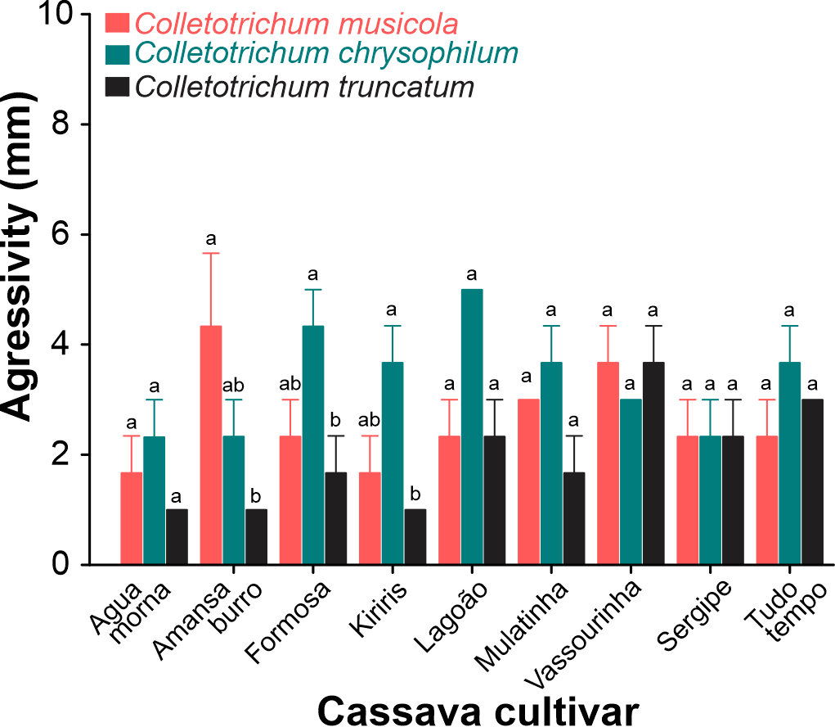
Figure 1. Aggressiveness of three Colletotrichum species to cassava cultivars two days after the inoculation. Different letters on the upper the bars of the same cassava cultivar differ significantly from each other according to Tukey's test (P < 0.05).

4.2. Virulence evolution.
The virulence of Colletotrichum species fungus was affected significantly by the specie of the fungi, cultivar and the interaction between theses (Table 2). Similarly, significant effects of time and the interaction between time and fungi time and cassava cultivar and time fungi e cassava cultivar exposure were recorded (Table 2). In C. musicola, was observed on increase on the virulence to Formoso, Lagoão, Sergipe and Todo Tempo (Figure 2A); for C. chrysophillum, this was observed in Mulatilha and Kiriris (Figure 2B) and for C. truncatum for Lagoão, Sergipe and Todo tempo (Figure 2C)
Table 2. Repeated measures analysis of variance (ANOVA) between subjects for the virulence evolution fungus of Colletotrichum species to nine cassava cultivars.

Variation source |  | df | F | P
between subjects
Fungi (F) |  | 2 | 14.37 | <.0001
Cassava Cultivars (CC) |  | 8 | 6.45 | <.0001
F vs CC |  | 16 | 4.01 | <.0001
Error |  | 54 | - | -
Within subject effects | df_{den} | df_{num} | Wilks’ lambda | F | P
Time (T) | 51 | 4 | 0,1805 | 57,88 | <.0001
T vs F | 102 | 8 | 0,6100 | 3,57 | <.0011
T vs CC | 189.67 | 32 | 0,2347 | 2,85 | <.0001
T vs F vs CC | 201.93 | 64 | 0.0868 | 2,74 | <.0001

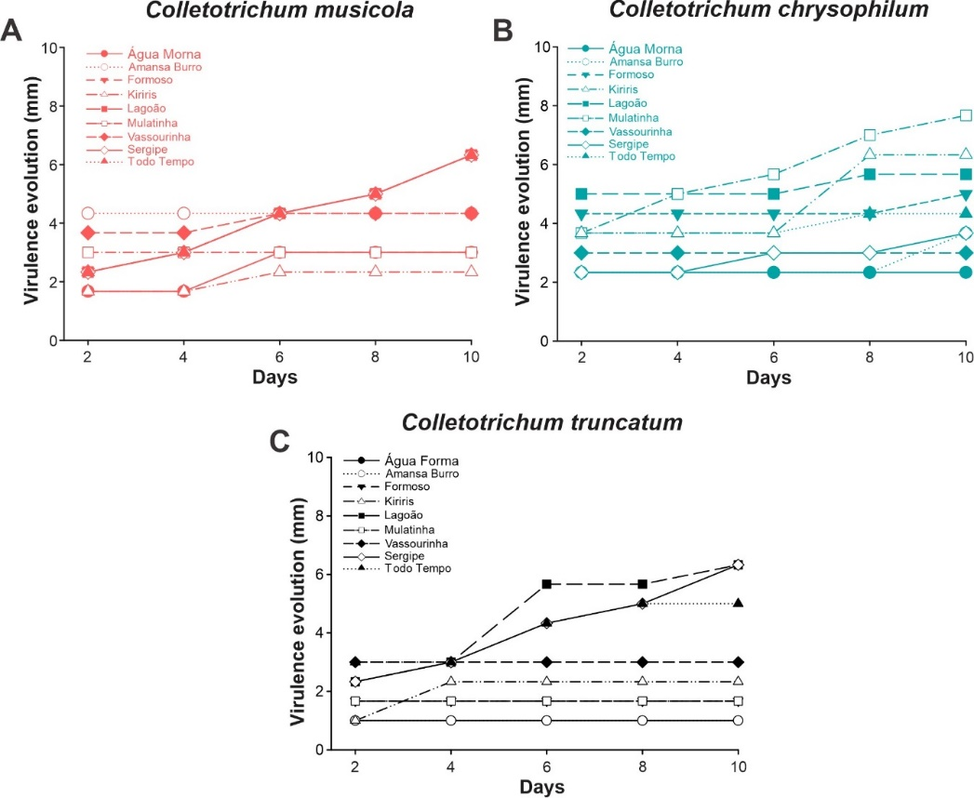
Figure 2. Evolution of virulence of Colletotrichum musicola (A), Colletotrichum chrysophillum (B) and Colletotrichum truncatum (C) in different cassava cultivars.

On the other hand, each cultivar individually, there were differences in relation to the pathogen species virulence. The specie C. truncatum the less virulent to Água Morma (F= 7.91; df= 2; P= 0.005), Formosa (F= 7.8; df= 2; P= 0.021), and Mulatinha (H= 6.88; df= 2; P= 0.01), cassava cultivar (Figure 3); on the others cultivars was not find differences when exposed to the Colletotrichum specie.
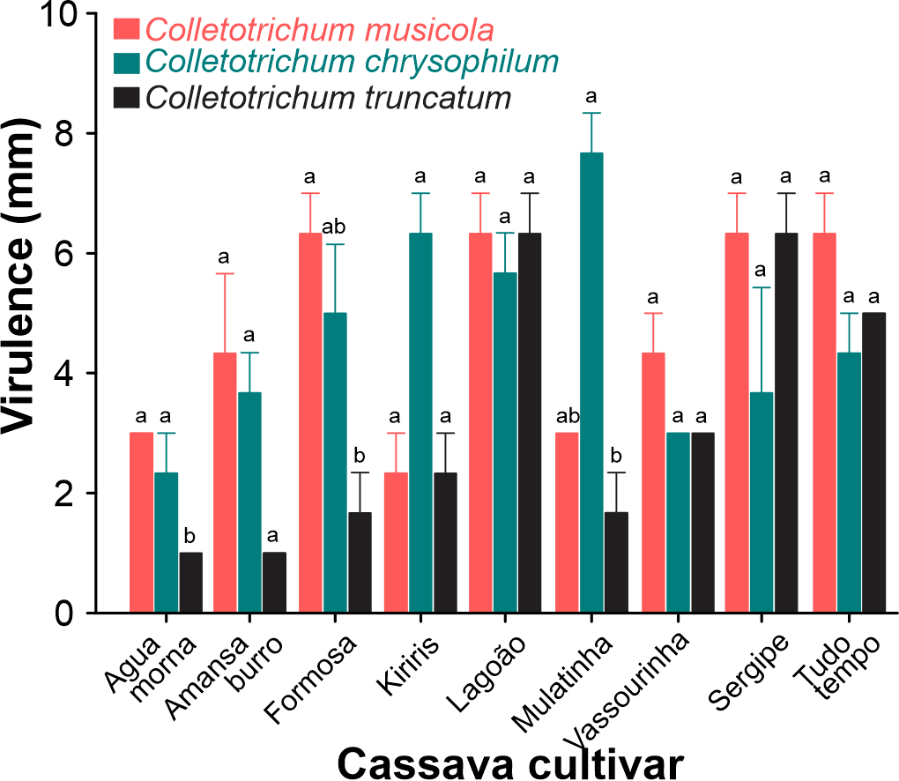
Figure 3. Virulence of three Colletotrichum species to one same cassava cultivars ten days after the inoculation. Different letters on the upper the bars of the same cassava cultivar differ significantly from each other (P < 0.05).

DISCUSSION
The Colletotrichum musicola, C. chrysophillum and C. truncatum are causing of anthracnose in cassava in northern region of Brazil . Our results are the first to evaluate the aggressiveness and virulence of these species of Colletotrichum in cassava cultivars produced in commercial areas of municipalities in the states of Pará and Tocantins, . We find that the three species of Colletotrichum were aggressive and virulent to cassava crops; however, the C. truncatum specie colonized less to three cassava cultivars.
The capacity aggressive of C. musicola and C. chrysophillum and C. truncatum to all cassava cultivars here evaluated put of manifest the susceptibility of this crop to fungi species. In this sense exist records of others species of Colletotrichum attacking Manihot sculenta, being reported C. gloeosporioides f.sp. manihotis, C. plurivorum, C. karstii, C. fructicola, C. siamense and C. theobromicola (Amusa, 2001; Bragança et al., 2016; Kunkeaw et al., 2010; Liu et al., 2019; Oliveira et al., 2018; Sangpueak et al., 2018). And more recently in Brazil were reported anthracnose in cassava caused by C. chrysophillum, C. musicola and C. truncatum (Machado, Veloso, et al., 2021; Machado et al., 2022; Machado, Vieira, et al., 2021). Although, Colletotrichum species colonized all the cassava cultivars here evaluated, the aggressivity of C. truncatum was lower in three cultivars; In opposite to the reported Liu et al. (2019) where C. truncatum was most aggressive to cassava crops in China. Is know that during the colonization process the pathogens seek to overcome intrinsic barriers to infection with production of enzymes for degradation of the structural material and cellular constituents. And was reported that for successful infection and ability to cause anthracnose disease by Colletotrichum is aided by production of phytotoxic metabolites that have been vary with the host plant and the Colletotrichum species (García-Pajón & Collado, 2003; Joshi, 2018; Vieira et al., 2019). Therefore, this resistance to C. truncatum could be associate with the impossibility of this specie to overcome the chemical and physical defense in these specific cassava cultivars. However, was suggested that Colletotrichum species including C. truncatum could be show a quiescent period before causing disease and started to colonize the cells when the environmental conditions and host physiology were conducive to completing the disease cycle (De Silva et al., 2017; García-Pajón & Collado, 2003; Joshi, 2018; Rampersad & Teelucksingh, 2012). And Ranathunge et al. (2012) reported a quiescent stage in C. truncatum after initial infection of chili (Capsicum annuum) fruit with no apparent symptoms until six days after inoculation.
By the other hand the virulence of Colletotrichum species also was dependent of the specie and cassava cultivar, here the three species were virulent; the cultivar of Agua Morma, Formosa and Mulatinha were less affected by C. truncatum. Although, the colonization phase of pathogens in plants could be success the capacity to maintain itself and reproduce continuously in the host can be a challenge. And this permanence depends of the effectors of pathogen for suppress or avoid the immune systems of the host's as well as manipulate the metabolism to increase the availability of nutrients for the pathogen (Vleeshouwers & Oliver, 2014). Is know that the phytopathogenic fungi colonization phase includes one enzymatic process and mechanical penetration (Villa-Rivera et al., 2017). However, is know that plants in pathogen attack, commonly use two patterns of immunity; one innate associate to recognition of pathogen-/microbe, and a highly specific immune, in which plant resistance proteins can recognize pathogen elicitors or effector proteins (Jones & Dangl, 2006). And in cassava several defense mechanisms can act simultaneously and restrict the attack of species of the genus Colletotrichum. These cultivars through of their chemical defense could have the capacity of increase the peroxidase activity; enzymes that contribute in the lignin synthesis around the dark brown lesion formed increasing so mechanical resistance. Thus, was related that fungal infections are associated with increase of peroxidase activity in cassava plants (Bruggen et al., 1990; Fokunang, Dixon, Ikotun, Akem, et al., 2002); and resistant plants accumulate most phenolic compound when exposed to C. truncatum (Chongo et al., 2002). In addition cassava plants have the ability to release cyanogenic compounds toxic that imposing resistance to pathogenic invasion by fungi (Fokunang, Dixon, Ikotun, Asiedu, et al., 2002); since that cyanide is toxic to many microorganisms to prevent to cells from using the oxygen (de Oliveira et al., 2017). This information obtained can be used as important tools in the management of anthracnose and in the implementation of a genetic improvement program aimed at developing cultivars for resistance to anthracnose in commercial tropical areas.

Declarations:
Ethics approval and consent to participate:
The authors are committed to upholding the integrity of the scientific record and maintained integrity of the research and its presentation. All of the material is owned by the authors and/or no permissions are required.
Consent for publication All authors agreed with the content and that all gave explicit consent to submit and that all obtained consent from the responsible authorities at the organization where the work has been carried out.
Conflict of Interest Statement:
The authors have no conflict of interest to declare that is relevant to this article.

References

Amusa, N. A. (2001). Screening of cassava and yam cultivars for resistance to anthracnose using toxic metabolites of Colletotrichum species. Mycopathologia, 150(3), 137-142. https://doi.org/https://doi.org/10.1023/A:1010955402457
Barbieri, M. C. G., Ciampi-Guillardi, M., Moraes, S. R. G., Bonaldo, S. M., Rogério, F., Linhares, R. R., & Massola, N. S. (2017). First report of Colletotrichum cliviae causing anthracnose on soybean in Brazil. Plant Disease, 101(9), 1677-1677. https://doi.org/https://doi.org/10.1094/PDIS-07-16-0963-PDN
Bragança, C. A. D., Silva, L. L., Haddad, F., & Oliveira, S. A. S. (2016). First report of Colletotrichum fructicola causing anthracnose in cassava (Manihot esculenta) in Brazil. Plant Disease, 100(4), 857. https://doi.org/https://doi.org/10.1094/PDIS-06-15-0645-PDN
Bruggen, P. v. d., Gregoire, D., & Maraite, H. (1990). Temperature-induced alterations in the expression of susceptibility of cassava to Colletotrichum gloeosporioides f. sp. manihotis. Journal of Phytopathology, 130(1), 46-58. https://doi.org/https://doi.org/10.1111/j.1439-0434.1990.tb01152.x
Cavalcante, G. R. S., Barguil, B. M., Vieira, W. A. S., Lima, W. G., Michereff, S. J., Doyle, V. P., & Câmara, M. P. S. (2019). Diversity, prevalence, and virulence of Colletotrichum species associated with lima bean in Brazil. Plant Disease, 103(8), 1961-1966. https://doi.org/https://doi.org/10.1094/PDIS-11-18-2002-RE
Chongo, G., Gossen, B., & Bernier, C. (2002). Infection by Colletotrichum truncatum in resistant and susceptible lentil genotypes. Canadian Journal of Plant Pathology, 24(1), 81-85. https://doi.org/ https://doi.org/10.1080/07060660109506977
Cruz, I. A., Santos Andrade, L. R., Bharagava, R. N., Nadda, A. K., Bilal, M., Figueiredo, R. T., & Romanholo Ferreira, L. F. (2021). Valorization of cassava residues for biogas production in Brazil based on the circular economy: An updated and comprehensive review. Cleaner Engineering and Technology, 4, 100196. https://doi.org/https://doi.org/10.1016/j.clet.2021.100196
Dalcin, M. S., Dias, B. L., Viteri Jumbo, L. O., Oliveira, A. C. S. S., Araújo, S. H. C., Moura, W. S., . . . Santos, G. R. (2022). Potential action mechanism and inhibition efficacy of Morinda citrifolia essential oil and octanoic acid against Stagonosporopsis cucurbitacearum infestations. Molecules, 27(16), 5173. https://doi.org/https://doi.org/10.3390/molecules27165173
de Oliveira, E. J., de Oliveira, S. A. S., Boas, S. A. V., Hohenfeld, C. S., & da Silva Santos, V. (2017). Selection of cassava accessions with multiple resistance to pathogens associated with root rot disease. Euphytica, 213(8), 185. https://doi.org/https://doi.org/10.1007/s10681-017-1973-6
De Silva, D. D., Crous, P. W., Ades, P. K., Hyde, K. D., & Taylor, P. W. J. (2017). Life styles of Colletotrichum species and implications for plant biosecurity. Fungal Biology Reviews, 31(3), 155-168. https://doi.org/https://doi.org/10.1016/j.fbr.2017.05.001
Fokunang, C. N., Dixon, A. G. O., Ikotun, T., Akem, C. N., & Tembe, E. A. (2002). Rapid screening method of cassava cultivars for resistance to Colletotrichum gloeosporioides f.sp. manihotis. Journal of Phytopathology, 150(1), 6-12. https://doi.org/https://doi.org/10.1046/j.1439-0434.2002.00708.x
Fokunang, C. N., Dixon, A. G. O., Ikotun, T., Asiedu, R., Tembe, E. A., & Akem, C. N. (2002). In vitro, greenhouse and field assessments of cassava lines for resistance to anthracnose disease caused by Colletotrichum gloeosporioides f.sp. manihotis. Mycopathologia, 154(4), 191-198. https://doi.org/https://doi.org/10.1023/A:1016372208982
García-Pajón, C. M., & Collado, I. G. (2003). Secondary metabolites isolated from Colletotrichum species [10.1039/B302183C]. Natural Product Reports, 20(4), 426-431. https://doi.org/https://doi.org/10.1039/B302183C
Gonçalves, L. d. O., Julião, S. M. S., Zago, L., & Santana, I. (2024). Cassava, an illustrious (un)known: Consumption of recipes with the root and its derived products. International Journal of Gastronomy and Food Science, 35, 100812. https://doi.org/https://doi.org/10.1016/j.ijgfs.2023.100812
Jones, J. D. G., & Dangl, J. L. (2006). The plant immune system. Nature, 444(7117), 323-329. https://doi.org/https://doi.org/10.1038/nature05286
Joshi, R. (2018). A Review on Colletotrichum spp. Virulence mechanism against host plant defensive factors. Journal of Medicinal Plants Studies, 6(6), 64-67. https://doi.org/https://doi.org/10.22271/plants.2018.v6.i6b.02
Kunkeaw, S., Worapong, J., Smith, D. R., & Triwitayakorn, K. (2010). An in vitro detached leaf assay for pre-screening resistance to anthracnose disease in cassava (Manihot esculenta Crantz). Australasian Plant Pathology, 39(6), 547-550. https://doi.org/https://doi.org/10.1071/AP10024
Lima, N. B., Lima, W. G., Tovar-Pedraza, J. M., Michereff, S. J., & Câmara, M. P. S. (2015). Comparative epidemiology of Colletotrichum species from mango in northeastern Brazil. European Journal of Plant Pathology, 141(4), 679-688. https://doi.org/https://doi.org/10.1007/s10658-014-0570-y
Liu, X., Shi, T., Li, B., Cai, J., Li, C., & Huang, G. (2019). Colletotrichum species associated with cassava anthracnose in China. Journal of Phytopathology, 167(1), 1-9. https://doi.org/https://doi.org/10.1111/jph.12765
Machado, S. d. C. S., Veloso, J. S., Câmara, M. P. S., Campos, F., Sarmento, R. d. A., Giongo, M. V., & dos Santos, G. R. (2021). First report of Colletotrichum chrysophillum Causing cassava anthracnose in Brazil. Plant Disease, 105(4), 1196-1196. https://doi.org/https://doi.org/10.1094/PDIS-09-20-1925-PDN
Machado, S. d. C. S., Veloso, J. S., Camara, M. P. S., Campos, F. S., Damascena, J. F., de Souza Ferreira, T. P., . . . Santos, G. R. (2022). Occurrence of Colletotrichum musicola causing anthracnose on Manihot esculenta. Plant Disease, 106(10), 2758.
Machado, S. d. C. S., Vieira, W. A. S., Duarte, I. G., Amaral, A. G. G., Veloso, J. S., Câmara, M. P. S., & dos Santos, G. R. (2021). First report of Colletotrichum truncatum causing anthracnose in cassava in Brazil. Plant Disease, 105(11), 3745. https://doi.org/https://doi.org/10.1094/PDIS-03-21-0571-PDN
Morais, M. d. S., Nascimento, L. C. d., Moreira, K. A., Cavalcanti, M. d. S., & Oliveira, N. T. d. (2013). Levantamento e avaliação da incidência das doenças da mandioca no estado da Paraíba. Summa Phytopathologica, 39, 204-206. https://doi.org/https://doi.org/10.1590/S0100-54052013000300011
Oliveira, S. A. S., Silva, L. L., Diamantino, M. S. A. S., & Ferreira, C. F. (2018). First report of Colletotrichum theobromicola and C. siamense causing anthracnose on cultivated and wild cassava species in Brazil. Plant Disease, 102(4), 819-819. https://doi.org/https://doi.org/10.1094/PDIS-09-17-1502-PDN
Oliveira, S. A. S., Silva, L. L., Nascimento, D. d. S., Diamantino, M. S. A. S., Ferreira, C. F., & de Oliveira, T. A. S. (2020). Colletotrichum species causing cassava (Manihot esculenta Crantz) anthracnose in different eco-zones within the Recôncavo Region of Bahia, Brazil. Journal of Plant Diseases and Protection, 127(3), 411-416. https://doi.org/https://doi.org/10.1007/s41348-020-00327-9
Rampersad, S. N., & Teelucksingh, L. D. (2012). Differential responses of Colletotrichum gloeosporioides and C. truncatum isolates from different hosts to multiple fungicides based on two assays. Plant Disease, 96(10), 1526-1536. https://doi.org/https://doi.org/10.1094/PDIS-10-11-0906-RE
Ranathunge, N. P., Mongkolporn, O., Ford, R., & Taylor, P. W. J. (2012). Colletotrichum truncatum Pathosystem on Capsicum spp: infection, colonization and defence mechanisms. Australasian Plant Pathology, 41(5), 463-473. https://doi.org/https://doi.org/10.1007/s13313-012-0156-0
Sangpueak, R., Phansak, P., & Buensanteai, N. (2018). Morphological and molecular identification of Colletotrichum species associated with cassava anthracnose in Thailand. Journal of Phytopathology, 166(2), 129-142. https://doi.org/https://doi.org/10.1111/jph.12669
Santos, A. D., Bandeira e Sousa, M., Alves, A. A. C., & Oliveira, E. J. d. (2024). Environmental factors influence the production of flowers and fruits of cassava. Scientia Horticulturae, 323, 112498. https://doi.org/https://doi.org/10.1016/j.scienta.2023.112498
Santos, G. R. d., Café-Filho, A. C., Leão, F. F., César, M., & Fernandes, L. E. (2005). Disease progress and crop losses due to watermelon gummy stem blight. Horticultura Brasileira, 23, 228-232. https://doi.org/https://doi.org/10.1590/S0102-05362005000200013
Vieira, A., Diniz, I., Loureiro, A., Pereira, A. P., Silva, M. C., Várzea, V., & Batista, D. (2019). Aggressiveness profiling of the coffee pathogen Colletotrichum kahawae. Plant Pathology, 68(2), 358-368. https://doi.org/https://doi.org/10.1111/ppa.12950
Villa-Rivera, G. M., Conejo-Saucedo, U., Lara-Marquez, A., Cano-Camacho, H., Lopez-Romero, E., & Zavala-Paramo, G. M. (2017). The role of virulence factors in the pathogenicity of Colletotrichum sp. Current Protein & Peptide Science, 18(10), 1005-1018. https://doi.org/http://dx.doi.org/10.2174/1389203717666160813160727
Vilpoux, O. F. (2024). Chapter 2 - Cassava starch processing units: comparison of industrial technologies from China, Thailand, and Brazil. In M. P. Cereda & O. F. Vilpoux (Eds.), Starch Industries: Processes and Innovative Products in Food and Non-Food Uses (pp. 9-35). Academic Press. https://doi.org/https://doi.org/10.1016/B978-0-323-90842-9.00011-X
Visses, F. d. A., Sentelhas, P. C., & Pereira, A. B. (2018). Yield gap of cassava crop as a measure of food security - an example for the main Brazilian producing regions. Food Security, 10(5), 1191-1202. https://doi.org/https://doi.org/10.1007/s12571-018-0831-2
Vleeshouwers, V. G. A. A., & Oliver, R. P. (2014). Effectors as tools in disease resistance breeding against biotrophic, hemibiotrophic, and necrotrophic plant pathogens. Molecular Plant-Microbe Interactions®, 27(3), 196-206. https://doi.org/https://doi.org/10.1094/MPMI-10-13-0313-IA

