Case report
A Severe Case of Drug Reaction with Eosinophilia and Systemic Symptoms After Sequential Cephalosporin and Vancomycin Exposure

ABSTRACT
Aims: To describe a severe case of Drug Reaction with Eosinophilia and Systemic Symptoms (DRESS) associated with sequential cephalosporin and vancomycin exposure, and to highlight the diagnostic challenges and hematologic and thromboembolic complications encountered during the clinical course.
Study Design: Case report.
Place and Duration of Study: Central Maine Medical Center, Lewiston, Maine, USA; September 2024 to November 2024.
Methodology: Clinical data were obtained through detailed review of the patient’s medical records, including medication timeline, laboratory trends, imaging studies, histopathology reports, and clinical response to therapeutic interventions. Serial eosinophil percentages and absolute neutrophil counts were analyzed in relation to antibiotic exposure, development of systemic complications, and initiation of systemic corticosteroid therapy.
Results: A 45-year-old woman with transfusion-dependent chronic anemia, cognitive delay, and chronic kidney disease developed a progressive morbilliform rash, facial edema, marked eosinophilia, and profound neutropenia following prolonged exposure to intravenous ceftriaxone and oral cefdinir for a complicated urinary tract infection secondary to an obstructive renal stone. Brief exposure to vancomycin was followed by rapid clinical worsening, raising concern for immunologic amplification of an evolving hypersensitivity reaction. Her course was further complicated by acute deep vein thrombosis and pulmonary embolism. Skin biopsy demonstrated findings consistent with a drug-induced hypersensitivity reaction. Initiation of systemic corticosteroids resulted in rapid improvement in both cutaneous and hematologic abnormalities.
Discussion: This case underscores the importance of early recognition of DRESS in patients receiving sequential antibiotic therapy. The clinical timeline supports cephalosporins as the likely primary sensitizing agents, with vancomycin acting as a potential immunologic accelerator. Prompt initiation of systemic corticosteroids may be critical in reversing severe hematologic and systemic complications.
Keywords: DRESS syndrome; drug hypersensitivity; eosinophilia; cefdinir; vancomycin; antibiotic adverse reaction
1. INTRODUCTION
Drug-induced hypersensitivity reactions represent a complex challenge in clinical medicine due to their unpredictable nature and potential to affect multiple organ systems. Although adverse drug reactions are common, severe systemic reactions such as Drug Reaction with Eosinophilia and Systemic Symptoms (DRESS) occur in approximately 1 per 1,000 to 10,000 drug exposures and are associated with reported mortality rates ranging from 10 to 20 percent, most commonly due to hepatic failure or multiorgan dysfunction.
Unlike immediate immunoglobulin E-mediated hypersensitivity reactions, DRESS is believed to involve drug-specific T-cell activation, cytokine dysregulation, and prolonged immune system activation. Interleukin-5 plays a central role in eosinophil proliferation, activation, and survival, while interferon-gamma contributes to systemic inflammation and end-organ involvement. Viral reactivation, particularly of human herpesvirus-6 and cytomegalovirus, has also been implicated in the pathogenesis of severe and protracted cases.
Anticonvulsant medications have historically been the most frequently reported triggers of DRESS; however, growing evidence suggests that antibiotics, including beta-lactams and glycopeptides such as vancomycin, are increasingly recognized as causative or exacerbating agents, particularly in hospitalized and medically complex patient populations.
Diagnosis remains challenging due to the delayed onset of symptoms, which typically occurs two to eight weeks after initial drug exposure, and the nonspecific nature of early clinical findings that may mimic infection, sepsis, or dermatologic conditions. Laboratory abnormalities including eosinophilia, leukocyte dyscrasias, and evidence of organ dysfunction are central to diagnosis and classification, most commonly using the RegiSCAR scoring system.
This report describes a severe, biphasic presentation of DRESS following sequential exposure to cefdinir and vancomycin, complicated by profound eosinophilia, acute neutropenia, and thromboembolic events. The case highlights the importance of early recognition and immunomodulatory therapy in patients receiving overlapping or sequential antibiotic treatment.

2. CASE PRESENTATION
A 45-year-old woman with a history of transfusion-dependent chronic anemia, cognitive delay, and chronic kidney disease status post ureteral stent placement presented to Central Maine Medical Center on 29 October 2024 with worsening rash, facial edema, and abnormal laboratory findings. One month prior, on 27 September 2024, she was diagnosed with a urinary tract infection secondary to an obstructing infected renal stone and was treated with a ten-day course of intravenous ceftriaxone at an outside facility. On 10 October 2024, she was transitioned to oral cefdinir, which she continued as an outpatient.
During cefdinir therapy, the patient developed a subtle erythematous rash on her lower back shortly after receiving a blood transfusion for chronic anemia. Over the following days, the eruption gradually extended across her trunk. In the 48 hours preceding hospital admission, the rash spread to her face and extremities, and she developed progressive facial swelling and generalized edema.
On admission, the patient was febrile and hemodynamically stable. Physical examination revealed marked periorbital and facial edema and a widespread morbilliform eruption involving the trunk and all extremities. Oral cefdinir was discontinued. She was briefly restarted on intravenous ceftriaxone for presumed complicated urinary tract infection; however, due to concern for a cephalosporin-associated drug reaction, ceftriaxone was discontinued the same day and intravenous vancomycin was initiated. Within 24 hours of vancomycin administration, the patient experienced further worsening of the rash and facial edema, prompting discontinuation of vancomycin on 30 October 2024. Ciprofloxacin was initiated for treatment of concurrent pyogenic osteomyelitis and continued throughout the remainder of the hospitalization.
Initial laboratory evaluation demonstrated progressive eosinophilia and declining neutrophil counts. The eosinophil percentage increased from 14 percent on admission to a peak of 57 percent on 4 November 2024. Concurrently, the absolute neutrophil count declined from 3.6 ×10³ per microliter to a nadir of 0.1 ×10³ per microliter. An initial punch biopsy performed on 31 October 2024 was nondiagnostic.
On 5 November 2024, Doppler ultrasound of the lower extremities revealed acute deep vein thrombosis involving the mid to distal femoral and popliteal veins. On 6 November 2024, computed tomography pulmonary angiography demonstrated a right lower lobe pulmonary embolism and a left lower lobe subsegmental pulmonary embolism, along with bilateral axillary lymphadenopathy. A repeat punch biopsy performed on 6 November 2024 demonstrated focal interface dermatitis with scattered eosinophils and interstitial histiocytes, findings favoring a drug-induced hypersensitivity reaction.
Systemic corticosteroid therapy with oral prednisone was initiated on 6 November 2024. Over the ensuing days, the patient’s cutaneous findings and systemic symptoms improved. The eosinophil percentage declined to 1 percent by 12 November 2024, and the absolute neutrophil count recovered to greater than 20 ×10³ per microliter by the time of discharge on 14 November 2024.
Figure 1. Clinical course of Drug Reaction with Eosinophilia and Systemic Symptoms (DRESS).
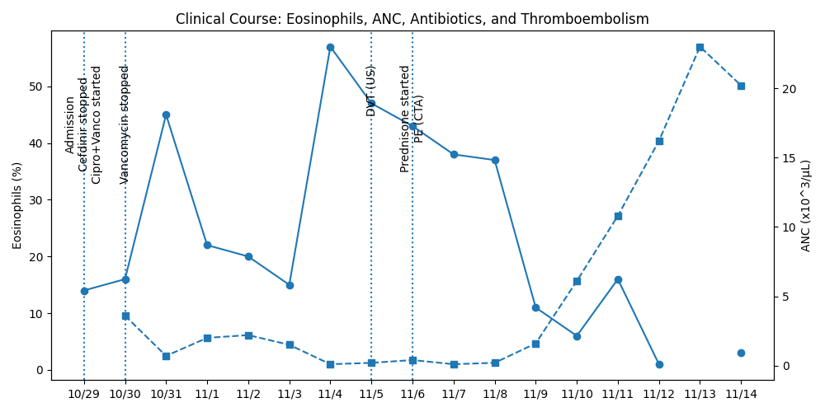
Fig 1. Clinical course of Drug Reaction with Eosinophilia and Systemic Symptoms (DRESS). Eosinophil percentage (solid line) and absolute neutrophil count (ANC; dashed line) are shown over time. Vertical markers indicate key clinical events, including hospital admission and cessation of cefdinir, brief vancomycin exposure, diagnosis of deep vein thrombosis by Doppler ultrasound, pulmonary embolism by computed tomography angiography, and initiation of systemic corticosteroids. A biphasic pattern with peak eosinophilia and nadir ANC preceded rapid hematologic recovery following prednisone initiation.
Table 1. RegiSCAR Scoring System for DRESS Syndrome
Clinical Feature | Criteria | Score
Fever ≥ 38.5°C | Present / Absent | +1 / 0
Enlarged lymph nodes | ≥2 sites, ≥1 cm | +1
Eosinophilia | 700–1,499/µL or ≥10% / ≥1,500/µL or ≥20% | +1 / +2
Atypical lymphocytes | Present | +1
Skin involvement | >50% body surface area | +1
Skin biopsy | Suggestive of DRESS | +1
Internal organ involvement | Liver, kidney, lung, heart, pancreas | +1
Resolution ≥15 days | Yes | +1
Other causes excluded | Yes | +1
RegiSCAR interpretation: Final score <2 = no case; 2–3 = possible case; 4–5 = probable case; ≥6 = definite case.
3. DISCUSSION
DRESS syndrome is a severe delayed type IV hypersensitivity reaction mediated by drug specific T cells and characterized by cytokine dysregulation, particularly interleukin 5 and interferon gamma. These cytokines promote eosinophil expansion, activation, and prolonged survival, contributing to tissue injury in the skin, hematopoietic system, and internal organs.
In this case, the timeline supports cefdinir as the primary sensitizing agent, given the development of symptoms within the classic two-to-eight-week latency period associated with DRESS. The rapid clinical deterioration following brief vancomycin exposure suggests an immunologic amplification effect in a previously sensitized host, rather than primary induction of DRESS.
Thromboembolic complications remain rare in DRESS but have been reported in association with marked eosinophilia. Proposed mechanisms include eosinophil mediated endothelial injury, release of cytotoxic granule proteins, and systemic inflammation leading to a hypercoagulable state. In this patient, venous thrombosis and pulmonary embolism developed at the time of peak eosinophilia, suggesting a contributory role of the inflammatory and eosinophilic milieu.
Systemic corticosteroids remain the cornerstone of therapy for moderate to severe DRESS, particularly in cases with hematologic or internal organ involvement. Suppression of T cell activation and inhibition of interleukin 5 driven eosinophil survival provide a mechanistic explanation for the rapid improvement in both eosinophilia and neutropenia observed following initiation of prednisone in this patient.
PATIENT CONSENT
Verbal informed consent was obtained from the patient for publication of this case report and accompanying clinical images. Written consent is in process.

REFERENCES
1. Chen CB, Yang CW, Wen YH, et al. Advances in understanding of the pathogenesis and therapeutic strategies of DRESS/DIHS. Front Med. 2023;10:1187937. https://doi.org/10.3389/fmed.2023.1187937
2. Sharifzadeh S, Mohammadpour AH, Tavanaee A, Elyasi S. Antibacterial antibiotic-induced DRESS syndrome: a literature review. Eur J Clin Pharmacol. 2021;77:275–289. https://doi.org/10.1007/s00228-020-03020-2
3. Blumenthal KG, et al. Drug Reaction With Eosinophilia and Systemic Symptoms (DRESS) syndrome. J Am Acad Dermatol. 2024. https://www.ncbi.nlm.nih.gov/pmc/articles/PMC10863630/
4. Kardaun SH, et al. Variability in the clinical pattern of cutaneous side-effects of drugs. Br J Dermatol. 2007;156:609–611. https://doi.org/10.1111/j.1365-2133.2007.07730.x

