Case report

Phenytoin Toxicity Presenting with Gait Disturbance and Cerebellar Signs: A Case Report

.
ABSTRACT

Introduction:- Phenytoin is a widely used antiepileptic drug with a narrow therapeutic index and non-linear pharmacokinetics, predisposing patients to toxicity even at therapeutic doses. Neurological manifestations often mimic cerebrovascular or cerebellar disorders, making diagnosis challenging.
Case Presentation:- A 26-year-old woman with a 15-year history of seizure disorder on phenytoin and levetiracetam presented with bilateral lower limb weakness, gait instability and impaired coordination for one week. She had a prior posterior circulation stroke. On examination, she was conscious and oriented with bilateral motor weakness (upper limbs 4/5; lower limbs 3/5) and impaired finger–nose testing. Laboratory investigations showed hemoglobin 12.2 g/dL, total leukocyte count 11,640 cells/mm³, random blood sugar 60 mg/dL, and serum creatinine 0.6 mg/dL. Serum phenytoin level was elevated at 35 µg/mL (therapeutic range 10–20 µg/mL). A diagnosis of phenytoin toxicity with seizure disorder and old posterior circulation stroke was established. Phenytoin was discontinued and the patient was managed with intravenous levetiracetam, valproate, supportive therapy and monitoring, resulting in clinical improvement.
Discussion:- Phenytoin toxicity can present with cerebellar signs due to its narrow therapeutic index and non-linear pharmacokinetics. In this patient, elevated serum phenytoin levels led to gait disturbance and impaired coordination, mimicking cerebrovascular pathology. Early therapeutic drug monitoring and withdrawal of phenytoin resulted in clinical improvement and emphasizing the importance of vigilant monitoring during long-term therapy
Conclusion:- Phenytoin toxicity should be suspected in patients with new-onset cerebellar signs or neurological deterioration. Prompt therapeutic drug monitoring and early intervention are essential to prevent complications.

Keywords:- Phenytoin toxicity, antiepileptic drugs, cerebellar dysfunction, therapeutic drug monitoring, case report.

1. INTRODUCTION
Phenytoin is a hydantoin derivative and one of the earliest antiepileptic drugs (AEDs) introduced into clinical practice for the management of generalized tonic–clonic and focal seizures. Despite the development of newer antiepileptic agents, phenytoin continues to be widely prescribed, particularly in resource-limited settings, owing to its efficacy and cost-effectiveness. However, its use is complicated by a narrow therapeutic index and significant interindividual pharmacokinetic variability.^{[1]}
Phenytoin demonstrates dose-dependent, non-linear (Michaelis–Menten) pharmacokinetics due to saturation of hepatic metabolism mediated primarily by CYP2C9 and CYP2C19 enzymes. As metabolic pathways become saturated, small increments in dosage can result in disproportionate increases in serum concentration, predisposing patients to toxicity.^{[1,2]} The accepted therapeutic serum concentration ranges from 10–20 µg/mL; concentrations exceeding this range are associated with concentration-dependent neurological adverse effects.^{[2]}
Phenytoin exerts its antiepileptic action through use-dependent blockade of voltage-gated sodium channels, stabilizing neuronal membranes and limiting repetitive firing. At supratherapeutic levels, excessive sodium channel inhibition produces central nervous system depression. Clinical manifestations of toxicity are classically neurological and include nystagmus, ataxia, dysarthria, tremor, altered sensorium and in severe cases, coma.^{[2,3]} Chronic toxicity may mimic cerebellar or brainstem pathology, leading to diagnostic challenges.^{[3]}
Predisposing factors for phenytoin toxicity include drug–drug interactions, hypoalbuminemia, hepatic dysfunction, renal impairment, genetic polymorphisms affecting metabolism, and prolonged therapy resulting in accumulation.^{[1,2]} Because of its nonlinear pharmacokinetics and variable protein binding, therapeutic drug monitoring (TDM) remains essential to ensure safety and optimize treatment outcomes.^{[1,4]}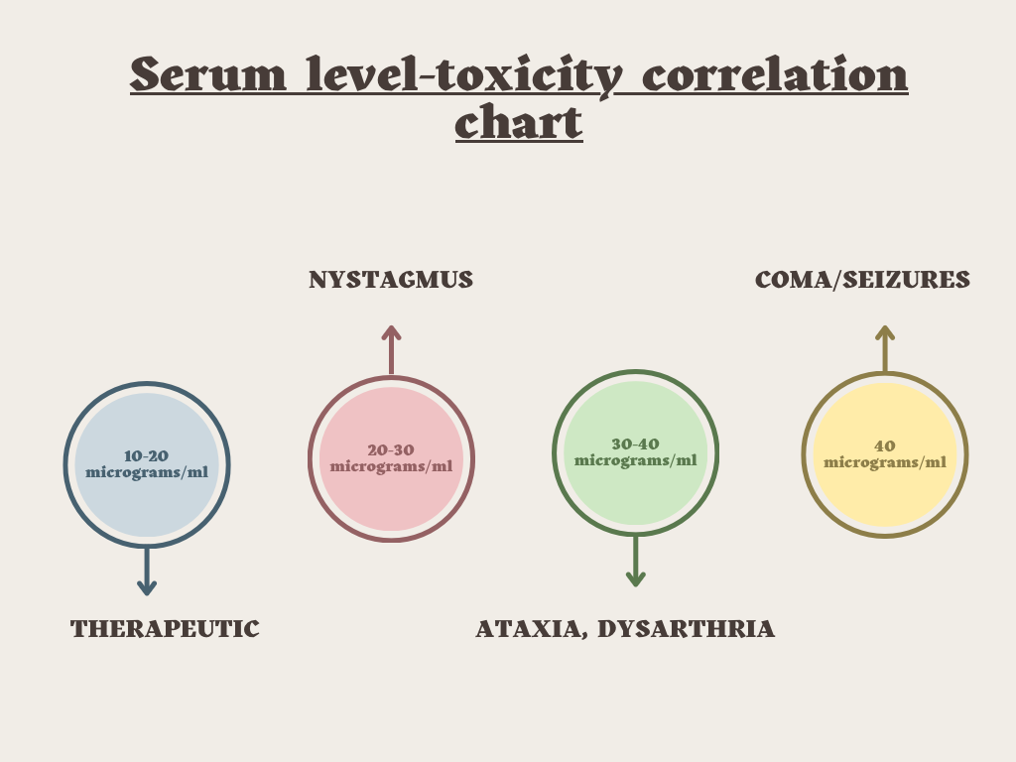Figure 1. Relationship between serum phenytoin concentration and neurological manifestation.*Figure created by authors for illustrative purposes based on publication literature.*^{[5-7]}
Early identification of toxicity and timely dose adjustment are critical to prevent potentially irreversible neurological complications. This case report highlights a clinically significant presentation of phenytoin toxicity, emphasizing the importance of vigilant monitoring and careful pharmacotherapeutic management.
2. CASE PRESENTATION

A 26 years old female patient was admitted to the female medical ward of general medicine in tertiary care hospital, with the chief complaints of weakness of bilateral lower limbs since 1week in the form difficulty walking with the form of tendency to sway in all directions, history of difficulty in bringing food to mouth. Her past history revealed that she was a known case of seizure disorder since 15 years on medication Tab. Levetiracetam 500mg (1-0-1) and Tab. Phenytoin 100mg (1-0-2), past admission 1month back known case of posterior circulation stroke. On examination her BP was 110/80mm of Hg, Pulse rate was 91bpm and SPO₂ was 95% @ RA.

SYSTEMIC EXAMINATION
CNS : conscious and oriented E₄ V₅ M_{6,} pupil – BERL
1. Motor system -TONE- right upper limbs and lower limbs was normal and left upper limbs and lower limbs was normal
2.POWER- right upper limbs score was 4/5, right lower limb was 3/5 and left upper limbs was 4/5, left lower limbs 3/5, REFLEX- right 2+ and left 2+
3.PLANTAR- right mute and left mute and cerebellar function revealed that finger nose test- right impaired and left impaired.
4.DYSDIADOCHOKINESIA- right negative and left negative.

Hence physician advised for tests like complete blood count, liver function tests, kidney function tests, serum electrolyte, Biochemistry, Serum Phenytoin level test, CT Scan, X-ray.
TABLE 1 LABORATORY PARAMETERS
SL NO | TESTS | PARAMETERS | RESULTS ON ADMISSION | REFERENCE RANGE
1 | COMPLETE BLOOD COUNT | HEMOGLOBIN | 12.2 | 12.5-16gm%
 |  | TOTAL WBC COUNT | 11640 | 4000-11000cells/cumm
 |  | NEUTOPHILS | 71 | 40-70%
 |  | RBC COUNT | 4.27 | 4.5-5.5million/cumm
 |  | PDW-CV | 19.4% | 10-18%
2 | LIVER FUNCTION TESTS | TOTAL PROTIEN | 5.6 | 5-8.3g/dl
 |  | GLOBULIN | 2.3 | 2.5-3g/dl
 |  | BILLIRUBIN UNCONJUGATED | 0.1 | 0.2-0.7mg/dl
3 | RENAL FUNCTION TESTS | SERUM CREATININE | 0.6 | 0.7-1.4mg/dl
4 | BIOCHEMISTRY | RANDOM BLOOD SUGAR | 60 | 70-140mg/dl
5 | SERUM PHENYTOIN LEVEL TEST |  | 35µg/ml | 10-20µg/ml

Based on the external and laboratory examinations, final diagnosis was confirmed as “PHENYTOIN TOXICITY, SEIZURE DISORDER AND OLD CEREBROVASEULAR ACCIDENT-POSTERIOR CIRCULATION STROKE”.
TABLE-2 TREATMENT CHART
SL NO | NAME OF THE MEDICATIONS | DOSE | ROUTE | FREQUENCY | DURATION
1 | INJ LEVETIRACETAM | 500mg | IV | 1-0-1 | DAY 1-3(500mg),DAY 4-6(750mg)
2 | INJ. PHENYTOIN | 100mg | IV | 1-0-1 | DAY 1-3(DAY4-6 STOP)
3 | TAB. ASPIRIN | 75mg | PO | 0-1-0 | DAY1-3
4 | TAB. ATORVASTATIN | 40mg | PO | 0-0-1 | DAY1-3
5 | INJ. MVI+DNS |  | IV | 1-0-0 | DAY1-6
6 | INJ. VALPROATE | 1g/500 | IV | STAT/1-0-1 | DAY1-3
7 | INJ. TRAMADOL | 100ml | IV | SOS | DAY3-6
8 | INJ. IRON SUCROSE | 100mg in 100ml NS | IV | 1-0-0 | DAY 3 ONLY

TABLE – 3 DISCHARGE MEDICATIONS
SL NO | NAME OF THE MEDICATION | DOSE | ROUTE | FREQUENCY
1 | TAB.LEVETIRACETAM | 500mg | PO | 1-0-1
2 | TAB.ATORVASTATIN | 40mg | PO | 0-0-1
3 | TAB.ASPIRIN | 75mg | PO | 0-1-0
4 | TAB.B COMPLEX |  | PO | 0-1-0
5 | SYP.MULTIVITAMIN | 5ml | PO | 1-1-1
6 | TAB.CLOPIDOGREL | 75mg | PO | 0-1-0
Recommended to review after 2 weeks.
SUMMARY
The patient condition was showing clinical improvement on the day of discharge it was identified that patient’s serum phenytoin level were elevated that is 35µg/mg (10-20µg/ml). For this reason phenytoin was stopped on day 4 and treatment was continued with levetiracetam and valproate.
3. discussion
Phenytoin is a commonly used antiepileptic drug with a narrow therapeutic index. Even a slight increase in dosage or alteration in metabolism can result in toxicity. The normal therapeutic serum concentration of phenytoin ranges between 10–20 µg/mL and levels above this range are associated with neurological adverse effects. In the present case, the patient’s serum phenytoin level was elevated to 35 µg/mL, confirming the diagnosis of phenytoin toxicity.
The patient presented with bilateral lower limb weakness, gait instability, poor coordination and impaired finger–nose testing, which are characteristic neurological manifestations of phenytoin toxicity, particularly cerebellar dysfunction. Long-term phenytoin therapy may lead to drug accumulation due to its non-linear pharmacokinetics, resulting in progressive neurological deterioration.
Several risk factors may have contributed to toxicity in this patient, including prolonged phenytoin use for seizure disorder and a prior history of posterior circulation stroke. These factors may have increased susceptibility to neurological impairment and masked early signs of toxicity.
Management of this case highlights the importance of timely therapeutic drug monitoring (TDM). Once toxicity was suspected and serum phenytoin levels were measured, the diagnosis was confirmed. Clinical improvement following withdrawal of phenytoin and supportive care further supports the diagnosis and emphasizes that early recognition and appropriate intervention can prevent permanent neurological damage.
4. CONCLUSION
This case report highlights that phenytoin toxicity is a serious complication of long-term antiepileptic therapy. The presence of neurological signs such as gait disturbance and impaired coordination should raise suspicion of toxicity, particularly in patients receiving chronic phenytoin treatment. Regular therapeutic drug monitoring and appropriate clinical follow-up are essential to minimize adverse effects. Early identification and prompt discontinuation of phenytoin led to significant clinical improvement in this patient, underscoring the importance of vigilant pharmaceutical care in optimizing treatment outcomes and ensuring patient safety.
CONSENT
As per international standards or university standards, patient(s) written consent has been collected and preserved by the author(s).
ETHICAL APPROVAL
It is not applicable.
DISCLAIMER (ARTIFICIAL INTELLIGENCE)
Author(s) hereby declare that NO generative AI technologies such as Large Language Models (ChatGPT, COPILOT, etc) and text-to-image generators have been used during writing or editing of this manuscript.
COMPETING INTERESTS
Authors have declared that no competing interests exists.
REFERENCE
- Patsalos PN, Berry DJ. Pharmacokinetic and pharmacodynamic properties of phenytoin. Clin Pharmacokinet. 2013;52(7):519-536. Available from: https://www.ncbi.nlm.nih.gov/pmc/articles/PMC2902172/
- Suddock JT, Cain MD. Phenytoin toxicity. StatPearls [Internet]. Treasure Island (FL): StatPearls Publishing; 2024. Available from: https://www.ncbi.nlm.nih.gov/books/NBK482444/
- Thanacoody RHK. Phenytoin poisoning. Clin Med (Lond). 2016;16(6):601-604. Available from: https://www.ncbi.nlm.nih.gov/pmc/articles/PMC6292145
- Eadie MJ. Therapeutic drug monitoring—antiepileptic drugs. Br J Clin Pharmacol. 2001;52(Suppl 1):11S-20S. Available from: https://www.ncbi.nlm.nih.gov/pmc/articles/PMC1873678/
- Awasthi A, Agrawal N, Chakraborty PP, Maiti A. Phenytoin toxicity. BMJ Case Rep. 2022;15(11):e253250.
- StatPearls Publishing. Phenytoin Toxicity. StatPearls [Internet]. Treasure Island (FL): StatPearls Publishing; 2024. Available from: https://www.ncbi.nlm.nih.gov/books/NBK482444/
- Olson KR. Antiepileptic drug poisoning. Emerg Med Clin North Am. 2014;32(1):41–60.

