PRODUCTION OF BIO-BRIQUETTES FROM AGRICULTURAL WASTE

Abstract
This study focuses on the production and characterization of bio-briquettes using locally available agricultural residues such as rice husk, sugarcane bagasse, cotton stalk, coconut shell, groundnut shell, banana peel, corn cobs, and sawdust. The utilization of agricultural waste for briquette production offers a sustainable solution to increasing energy demand while reducing environmental pollution caused by open burning and improper disposal of biomass residues. The briquette production process involves systematic steps including collection, drying, size reduction, mixing with natural binders, compaction, drying, cooling, and quality assessment. The produced bio-briquettes were evaluated for key fuel properties such as moisture content, ash content, volatile matter, fixed carbon, density, calorific value, and combustion efficiency. The results of the analysis should be captured here for example, the density of the produced briquettes has 496.89, shatter index ranged between 46.81 – 95.54%, fixed carbon is 89.56%,etc for example with a calorific value of 4536 kcal/kg The results indicate that bio-briquettes possess good mechanical strength, satisfactory calorific value, low smoke emission, and efficient burning characteristics, making them a reliable renewable energy source. Without telling the readers the various percentages of the analysis? The use of agricultural residues for briquette production not only minimizes waste disposal problems but also contributes to reduced greenhouse gas emissions, rural employment generation, and energy security. Hence, bio-briquettes serve as an eco-friendly, cost-effective, and sustainable alternative to conventional fossil fuels.
Keywords: Bio-briquettes, Agricultural residues, Biomass energy, Renewable energy, Waste utilization, Briquetting process, Sustainable fuel, Calorific value, Combustion efficiency , six keywords are okay remove the underlined ones
1.INTRODUCTION
Today, energy is the most important potential need for humanity, and its requirements have been radically increasing due to increased energy consumption, fossil fuel depletion, and environmental degradation. Likewise, fuels are also of potential importance because they could be burned to produce energy. Worldwide demands for fuel efficiency, instability of oil prices, global warming, energy security,( poverty) and future requirements are some of the most important problems the world are facing. Worldwide, the maximum (about 90%) energy requirements are met by fossil fuels, but by 2040, it is expected that usage of renewable resources will increase to about 50% . source? .To fulfil these requirements, there is a continuous demand to look for an alternative fuel that is renewable, inexpensive, eco-friendly, has lower GHGG emissions, sustainable, and is economically competitive, with several major benefits.(Kamala ,2021) not need to put initial of the author, just surname and year of publication?
Bio-briquettes are solid biofuels produced by compressing biomass residues into dense, compact forms that can be used for cooking, heating, and industrial applications. Agricultural residues such as rice husk, sugarcane bagasse, groundnut shell, coconut shell, cotton stalk, corn cobs, banana peel, and sawdust are generated in large quantities, especially in rural and agricultural regions. These materials are often underutilized or openly burned, leading to severe environmental pollution and loss of potential energy resources (Widjaya et al., 2022). Converting these residues into bio-briquettes provides an effective solution for waste management while simultaneously producing a clean and renewable source of energy (Sanchez, 2022).
The process of bio-briquette production involves several systematic steps, including collection of raw materials, drying to reduce moisture content, size reduction, mixing with suitable binders, compaction using briquetting machines, and final drying and cooling. The quality and performance of bio-briquettes are influenced by factors such as moisture content, particle size, binder type, compaction pressure, and feedstock composition (Marreiro et al., 2021). Natural binders such as starch-rich biomass and lignin-containing materials enhance the mechanical strength and durability of briquettes, often eliminating the need for synthetic binders (Idris et al., 2021).
Several studies have reported that briquettes produced from agricultural waste exhibit favorable fuel properties, including high calorific value, low ash content, low smoke emission, and improved combustion efficiency. For instance, coconut shell and groundnut shell-based briquettes possess high fixed carbon and calorific value, making them suitable for both domestic and industrial energy applications (Olaleru et al., 2025). Additionally, proper densification through mechanical or hydraulic briquetting machines significantly improves fuel handling, storage, and transportation efficiency (Nikiforov et al., 2023).
Fossil fuels dominate the world's energy consumption, including transportation, chemicals, and materials generation. Conversely, using conventional energies has resulted in massive environmental damage and climate change(Godif Alene Geberehiet et.al.,2025). Therefore, the present study focuses on the production and evaluation of bio-briquettes from locally available agricultural wastes, aiming to assess their fuel properties and potential as an eco-friendly and cost-effective alternative to conventional energy sources. (join the paragraphs together)

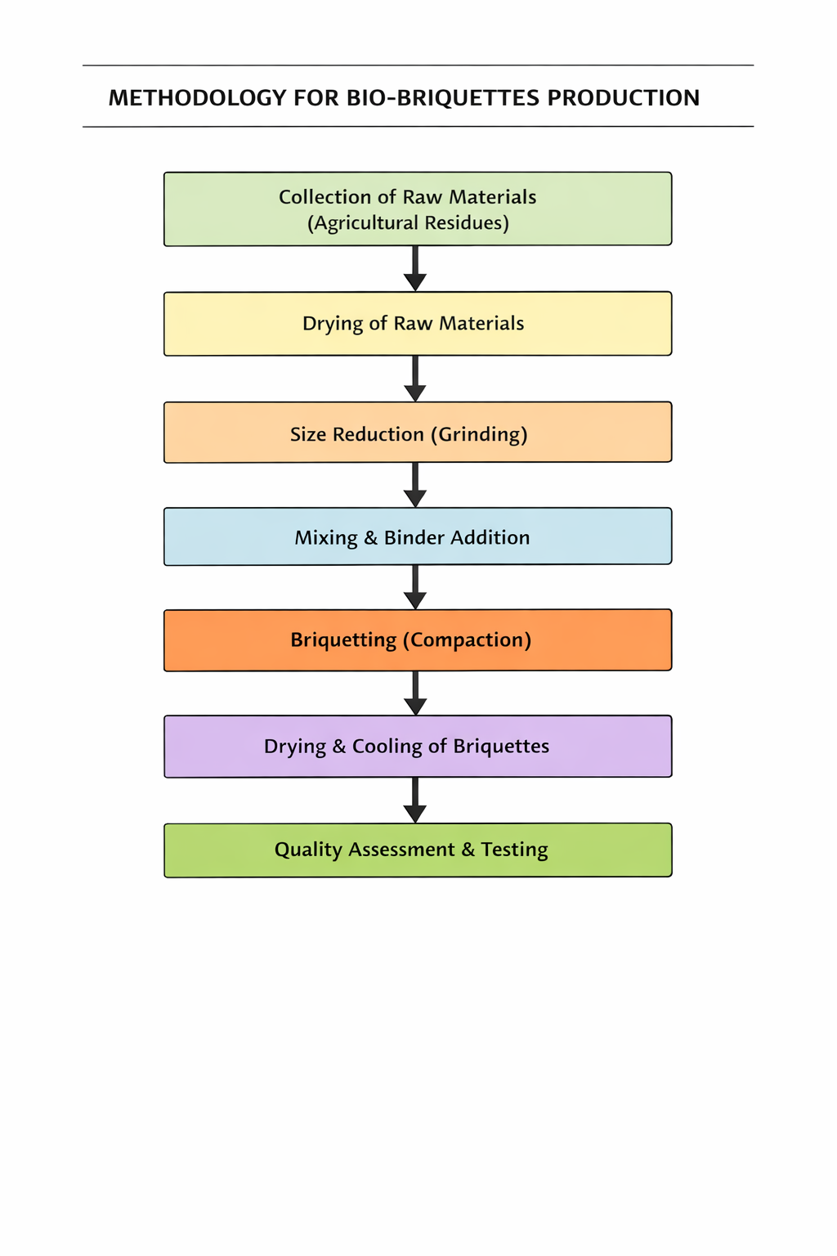
Figure:-1 Methodology flowchart

2.COLLECTION OF RAW MATERIALS
The materials such as rice husk, corn cobs, saw dust, banana peel, cotton stalk, coconut shell, groundnut shell and sugarcane bagasse are the wastes collected from the farmers, mills, etc., thrown as waste.
2.1.RICE HUSK
Rice husk was collected from the Dr. M. S. Swaminathan field laboratory at Paavai engineering college. Rice husk has high volatile content and low moisture, which helps briquettes ignite easily and burn steadily. It enhances air circulation within the briquette due to its fibrous structure, promoting better combustion. The silica content in rice husk provides structural strength, making briquettes more durable and less brittle. It serves as a bulking agent, improving binding and compressibility of biomass mixtures. Using rice husk converts an agricultural waste that is often burnt in fields (causing air pollution) into a valuable energy product.
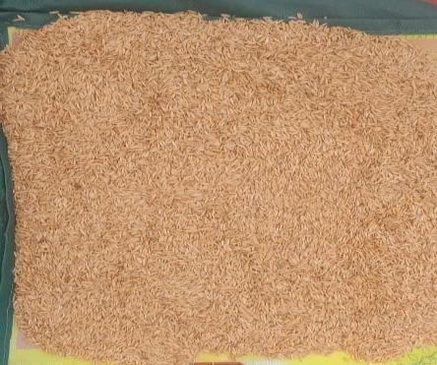
Figure:- 2 Rice husk
2.2.SAW DUST
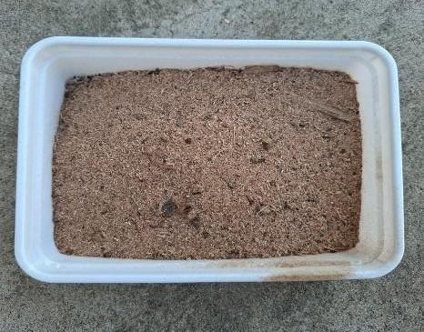
Saw dust were collected from saw mills at nearby area in our town. A Saw dust are an energy efficient, carbon neutral fuel that are used as energy. Sawdust contains natural lignin, which acts as a binder when heated, helping the briquettes hold their shape firmly without extra chemicals. It burns easily and evenly, improving the ignition and burning rate of briquettes. It provides a smooth and consistent texture, making briquettes easier to mold and press. Sawdust has a good energy value, increasing the overall heat output of the briquettes.
Figure:-3 Saw dust

2.3. COCONUT SHELL
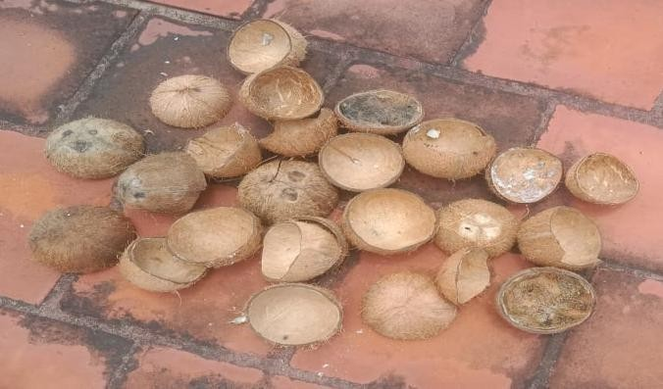
Coconut shell collected from the domestic area which is thrown as waste in our village. It has high fixed carbon content 40–45% which contributing to long-lasting heat. The volatile matter (35–40%) facilitates easy ignition. Coconut shells have a very high calorific value (about 5000–6000kcal/kg), which significantly increases the energy output of briquettes. Briquettes made with coconut shell burn hotter and longer, making them ideal for domestic and industrial use. Coconut shells naturally contain low moisture (6–10%) and produce very little ash after combustion.
Figure: 4 Coconut shell
2.4. COTTON STALK
Cotton stalk collected from the farmers at Puthuchathiram. It has a calorific value of about 3500–4100 kcal/kg, making them a good energy source for briquette fuel. When blended with other biomass materials like rice husk or bagasse, cotton stalk improves briquette uniformity, air circulation, and combustion efficiency. Cotton stalks are abundant residues left after cotton harvesting. Cotton stalk fibers contain lignin, a natural binder that improves briquette strength and cohesion during compression. This enhances the durability, density, and handling quality of the briquettes.
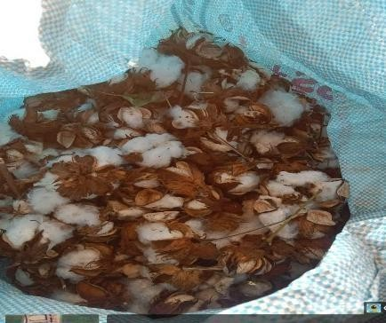
Figure:-5 Cotton stalk
2.5. GROUNDNUT SHELL
Groundnut shells contain natural lignin that acts as a binding agent during briquetting, reducing the need for external binders. This improves the mechanical strength and durability of the briquettes. The ash produced after burning is minimal and can be used as a soil conditioner. When blended with other feedstocks, groundnut shells enhance briquette compactness and uniformity, resulting in better handling, storage, and transport characteristics. Groundnut shell collected from mill at Kattuputhur. Being a low-cost waste material, groundnut shells help reduce the total production cost of briquettes. They can easily be mixed with other biomass materials such as sawdust or rice husk to produce economical briquettes.

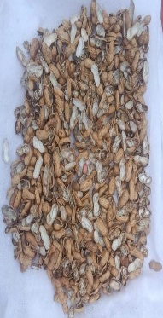
Figure:-6 Groundnut shell
2.6. SUGARCANE BAGASSE
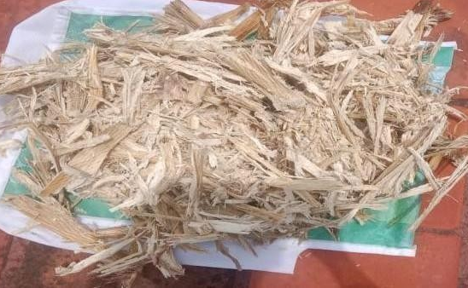
A Sugarcane bagasse is a by-product of sugar industries, available in large quantities at very low or no cost. Sugarcane bagasse has a moderate calorific value of about 3500–4000 kcal/kg, making it a useful biomass fuel. When mixed with other high-energy materials like coconut shell or groundnut shell, it enhances the overall energy efficiency of briquettes. Bagasse contains natural fibers and lignin, which act as binding agents during compression. This improves the compactness, durability, and mechanical strength of briquettes without needing external binders.
Figure:-7 Sugarcane bagasse
2.7. BANANA PEEL
Banana peel collected from the farmers. Banana peels contain natural starch and lignin, which serve as binding agents during briquetting. The fibrous nature of banana peels contributes to better cohesion and structural integrity, resulting in durable, crack-free briquettes. This reduces the need for external binders and improves the mechanical strength and compactness of briquettes. The fibrous nature of banana peels contributes to better cohesion and structural integrity, resulting in durable, crack-free briquettes.
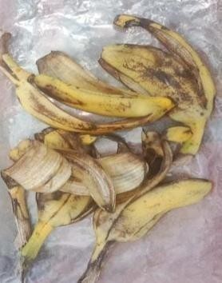
Figure:-8 Banana peel
2.8. CORN COBS
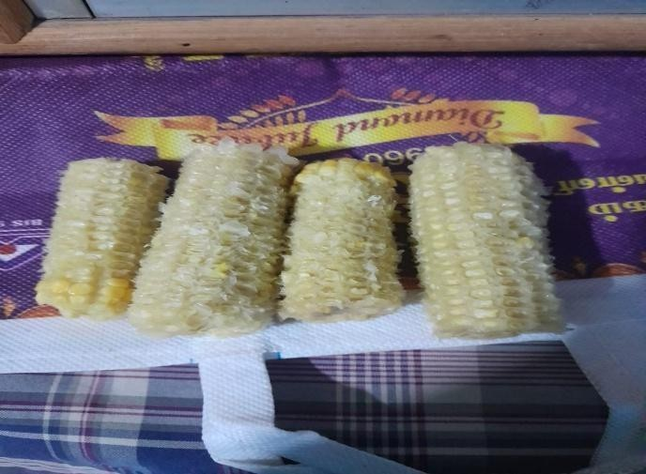
Corn cobs were collected from the mill. A Corn cobs have a high energy content (about 4000–4500 kcal/kg), which helps produce high-heat briquettes suitable for cooking and industrial heating. They ensure steady combustion and efficient energy output. Corn cobs burn uniformly with low smoke and ash, resulting in clean and efficient burning. They provide a stable flame and maintain consistent heat release during use. Natural lignin in corn cobs also contributes to mechanical strength without additional binders. Corn cob briquettes are carbon- neutral, emitting far less CO₂ compared to fossil fuels. The ash content is minimal, and it can be used as organic fertilizer after combustion.
Figure:-9 Corn cobs

3.DRYING OF RAW MATERIALS
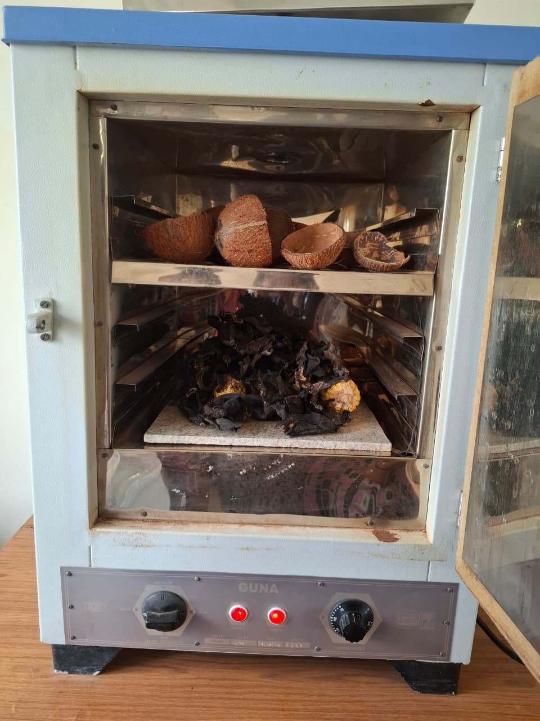
Drying is a crucial step in the briquette production process, as it ensures the quality, strength, and efficiency of the final product. Drying removes excess moisture from the biomass material, reducing it to the ideal range (usually 8–12%) for effective briquetting. Properly dried material allows better bonding during compression, leading to strong and durable briquettes. Dry biomass produces less smoke and vapor during combustion, improving fuel quality. Drying prevents microbial growth and spoilage, ensuring longer storage life of briquettes. Moisture- free material requires less energy during pressing and combustion, improving the overall process efficiency. Drying the wastes usually in the temperature at 120° C for 2 hours but we dried the wastes at 100° C for 1 hours due to the products were dried under sunlight for a days.
Figure:-10 Hot air oven
4.SIZE REDUCTION
Size reduction is one of the primary and essential steps in the briquette production process. It involves breaking down the raw biomass materials (such as crop residues, wood waste, sawdust, husks, shells, etc.) into smaller and uniform particle sizes suitable for briquetting. Size reduction is the mechanical process of reducing large biomass materials into smaller particles using cutting, grinding, or crushing equipment. It ensures that the material achieves the required particle size for efficient densification during briquetting. Pulverizer is a high-speed mechanical grinder widely used for pulverizing agricultural waste materials. It operates on the principle of impact and attrition, where high-speed rotating hammers crush and grind the materials into fine powder. It is typically running at around 4000 RPM, has a double- chamber design that ensures efficient grinding with reduced heat generation. The finely ground material passes through a mesh screen, which can be adjusted to achieve the desired particle size. It is energy- efficient, easy to operate, and suitable for small to medium-scale agro-industrial applications, contributing significantly to waste utilization and sustainable agriculture. The compacted structure breaks down rapidly into small granules. A sieve/screen controls the final particle size 0.50 mm.

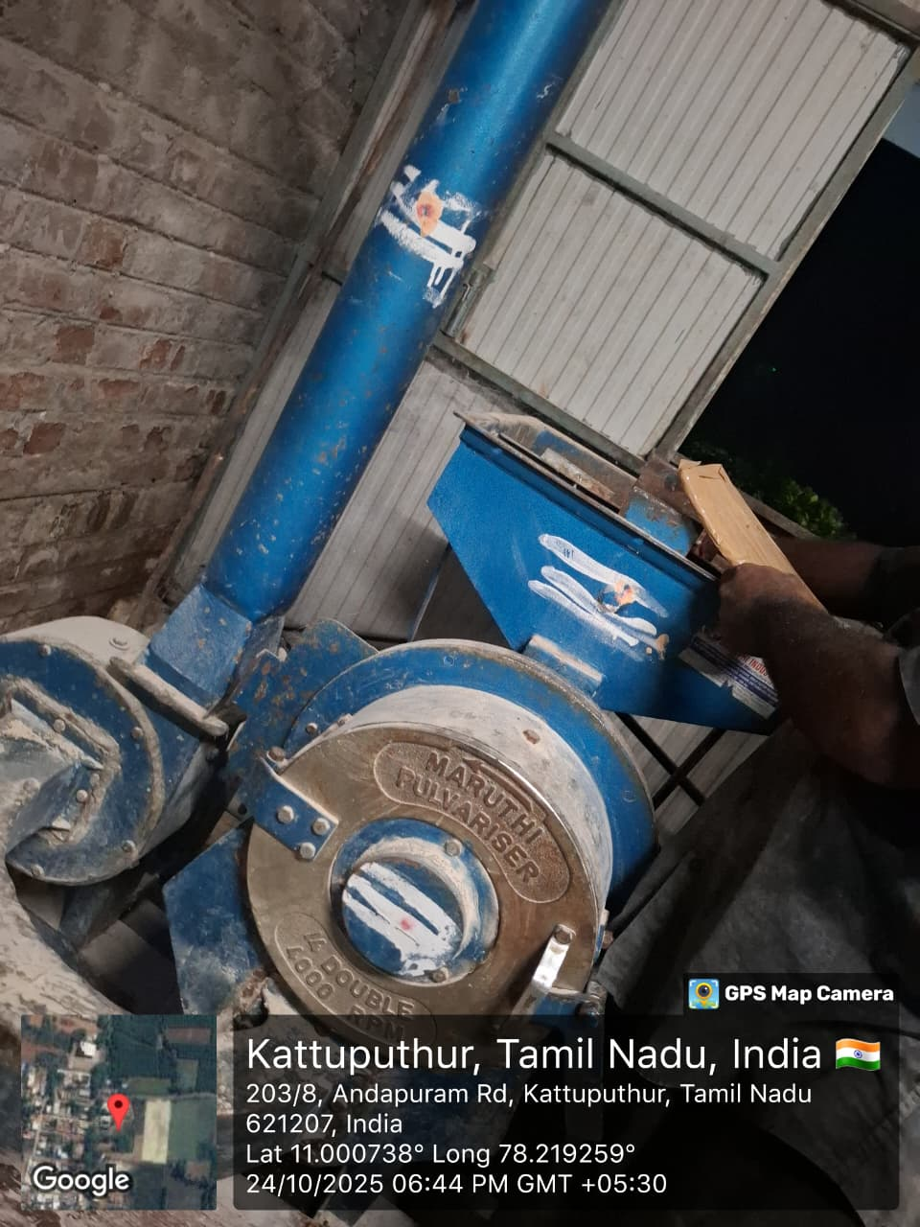
Figure:-11 Pulveriser

5.MIXING AND BINDER ADDITION
The biomass (after size reduction and drying) is brought to an optimum moisture level (usually 8–12%). The binder (natural or synthetic) be specific which one? is prepared by dissolving or mixing with water if required. The binder is added in calculated proportions depending on the type of biomass and briquetting method. State the proportion of water used ?The usual binder proportion ranges from 5–15% by weight of the biomass. The binder acts as a glue, holding the particles together during compression and solidification. Both biomass and binder are thoroughly mixed to ensure even coating and distribution. Mechanical mixers such as paddle mixers, ribbon blenders, or screw mixers are commonly used. Proper mixing ensures uniform consistency and prevents segregation during briquetting. Here, the saw dust and banana peel as a binder. Sawdust contains natural lignin, which acts as a binder when heated, helping the briquettes hold their shape firmly without extra chemicals. Banana peels contain natural starch and lignin, source? which serve as binding agents during briquetting. This reduces the need for external binders and improves the mechanical strength and compactness of briquettes.
6.COMPACTION
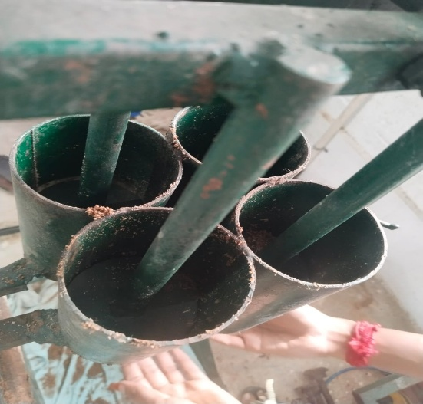
Agricultural residues such as of rice husk, sawdust, sugarcane bagasse, groundnut shells, and corn cobs are first pulverized into fine powder using a pulverize. The material should have low moisture content (below 10%) to ensure proper binding and compaction. The powdered biomass is filled into the cylindrical moulds of the briquetting machine. Each mould determines the size and shape of the final briquette. A hydraulic jack or mechanical lever system applies high pressure on the material through plungers or pistons. The pressure compacts the loose biomass particles tightly, expelling air and slightly increasing the temperature. This heat softens the lignin naturally present in the biomass, which acts as a binding agent, holding the briquette together. Under sustained pressure, the biomass takes the shape of the mould and forms a dense, solid briquette with high mechanical strength and uniform structure. Once compressed, the briquettes are ejected from the moulds using a manual or spring-assisted mechanism. They are then dried to remove remaining moisture and harden the structure. Compacted using hydraulic press at 10-30Mpa.

Figure:-12 Briquetting machine
7.DRYING AND COOLING
After briquetting, the freshly formed bio-briquettes contain residual moisture due to binder addition and compaction. Proper drying is essential to improve mechanical strength, storage stability, and combustion performance. The moisture content of briquettes should be reduced to below 10–12% for efficient combustion and reduced smoke emission. In this study, the briquettes were initially subjected to natural air drying by placing them on drying racks under ambient conditions with adequate ventilation. This method allows gradual moisture removal and prevents surface cracking. After drying, the briquettes were allowed to cool naturally to room temperature. Cooling is a critical step, as it enables the solidification of softened lignin and binder materials, which enhances the structural stability and hardness of the briquettes. Proper cooling also prevents deformation and cracking during handling, packaging, and storage. Well-dried and cooled briquettes exhibit improved durability, reduced moisture reabsorption, and enhanced calorific performance, making them suitable for storage and end-use applications.
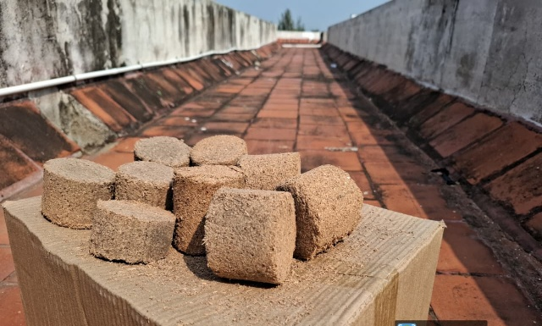
Figure:-13 Drying under sunlight
8.QUALITY ASSESSMENT AND TESTING
Study of proximate analysis of biomass was carried out for determination of moisture content, volatile matter, fixed carbon content and ash content in the biomass. The proximate analysis of the biomass and briquettes was carried out as follows,
- Moisture content
- Volatile matter
- Ash content
- Fixed carbon
- Calorific value

8.1. Moisture content (M.C)
The moisture content played an important role in the formation of briquette and subsequently its combustion. The crucible was placed in an electric hot air-oven maintained at 105±5°C as per ASTM D-3174.
M. C. percent = [(W1-W2) / W1] × 100
Table:-1.Moistue content of Briquettes
SAMPLE  NO | WEIGHT OF SAMPLE BEFORE OVEN DRYING  W1 (G) | WEIGHT OF SAMPLE AFTER OVEN DRYING  W2(G) | MOISTURE IN PERCENTAGE  (%)
1 | 100 | 91 | 9%
2 | 120 | 108 | 10%
3 | 150 | 133.5 | 11%
Average in percentage |  |  | 10%
8.2. Volatile matter (V.M)
Volatile matter was determined by keeping the dried sample obtained after moisture content determination in a closed crucible at 925 plus/minus 20 deg °C for seven minutes in a muffle furnace as per ASTM D-3175. The difference in the weight due to loss of volatiles was taken as the volatile matter present in the sample on percentage basis. The volatile matter of sample was calculated by following equation.
V.M. percent = [(loss in weight due to removal of volatile matter) / (weight of sample taken)] x 100
Table:-2.Volatile Matter of the briquettes

SAMPLE  NO | WEIGHT OF SAMPLE TAKEN (G) | LOSS IN WEIGHT (G) | VOLATILE MATTER IN PERCENTAGE (%)
1 | 100 | 70 | 70%
2 | 120 | 86.4 | 72%
3 | 150 | 111 | 74%
Average in percentage |  |  | 72%
8.3. Ash content (A.C)
The residual samples obtained after volatile matter determination were heated gradually in a muffle furnace to 700 plus/minus 50 deg °C for half an hour as per ASTM D- 3174. The crucible was taken out, cooled first in air, then in desiccator and weighed. Heating, cooling and weighing was repeated till constant weight was obtained. The weight of residue was reported as the ash content of the sample on percentage basis.
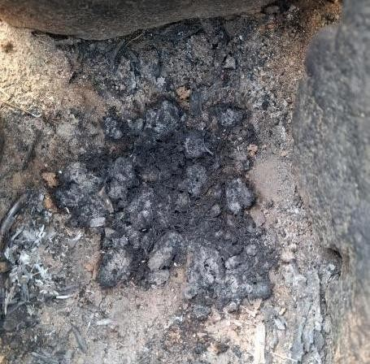
A.C. per cent = [(Weight of ash left) / (Weight of sample taken)] x 100
Figure:-14 Ash content

Table:-3 Ash content of the briquette
SAMPLE  NO | WEIGHT OF SAMPLE TAKEN (G) | WEIGHT OF ASH LEFT (G) | ASH CONTENT IN PERCENTAGE (%)
1 | 100 | 5 | 5%
2 | 120 | 7.2 | 6%
3 | 150 | 10.5 | 7%
Average in percentage |  |  | 6%

8.4. Fixed carbon (F.C)
The fixed carbon content was the value obtained after subtracting the value of moisture content; volatile matter and ash content from the hundred percent, gives the percentage of fixed carbon.
Percent of F.C.=100 - (VM + MC + AC)
Table:-4 Fixed carbon of the briquette
SAMPLE  NO | MOISTURE CONTENT IN  (%) | VOLATILE MATTER  IN (%) | ASH CONTENT IN (%) | FIXED CARBON  IN(%)
1 | 100 | 5 | 5% | 16%
2 | 120 | 7.2 | 6% | 12%
3 | 150 | 10.5 | 7% | 8%
Average in percentage |  |  |  | 12%

8.5. Calorific value (C.V)
Calorific value is a fundamental property used to evaluate the energy potential of fuels. It represents the total amount of heat released during the complete combustion of a fuel. This parameter helps in comparing different fuels based on their energy efficiency. In biomass and wood fuels, calorific value is influenced by moisture, ash, and carbon content.
C.V(MJ/Kg) = 0.3536(F.C) + 0.1559(V.M) - 0.0078(A.C)
Table:-5 Fixed carbon of the briquette
SAMPLE  NO | FIXED CARBON IN  (%) | VOLATILE MATTER  IN (%) | ASH CONTENT IN (%) | CALORIFIC VALUE  IN (MJ/Kg) | CALORIFIC VALUE  IN (kcal/Kg)
1 | 16 | 70 | 5 | 18.71 | 4470
2 | 12 | 72 | 6 | 18.44 | 4404
3 | 8 | 74 | 7 | 18.16 | 4337
Average in percentage |  |  |  |  | 4404

9. ANALYSIS OF VARIOUS BIO-FUEL
The given Bio-briquette evaluates the quality of a bio-briquette, comparing the experimental observations against ideal industry standards or ranges. Moisture Content is measured at 10%, falling perfectly within the ideal range of 8-12%. This indicates the briquette is dry enough to burn efficiently without losing energy to water evaporation. Ash Content is observed at 6%, which is well under the <10% maximum standard. Low ash content is preferable as it means less residue remains after burning. Volatile Matter at 72%, it sits at the high end of the 60-75% ideal range, suggesting the briquette ignites easily. Fixed Carbon is calculated at 12%.12% represents the solid combustible residue left after volatile matter is released. Calorific Value: The briquette produced 4404 kcal/kg, which is comfortably within the high-quality range of 3500-5000kcal/kg. Density is recorded at 231kg/m³. High density is preferred for easier storage and longer burning times. Durability & Resistance of the briquette passed the "Shatter Resistance" test (no major cracks) and the "Durability Test" (rated as strong and compact), indicating it can withstand transport and handling. Ignition of the briquette showed "Easy ignition and low smoke," meeting the standard for a clean-burning fuel source. Analysis on wood by Paramasivan, et.al. (2019) provided the quality of a bio-briquette and a wood sample against industry standards. The bio-briquette demonstrates high efficiency with a calorific value of 4536 kcal/kg, low ash (6%), and excellent durability. The wood sample likewise meets all benchmarks, notably achieving a high fixed carbon content of 85% and optimal moisture (7%). Collectively, the data proves that converting agricultural waste such as rice husks and banana peels into bio-briquettes creates a viable, eco-friendly alternative to fossil fuels that matches or exceeds the performance of traditional wood fuel. Analysis on coal by Peter sahupala, et.al.,(2018) provided the proximate analysis of 60 mesh and 80 mesh coal briquettes reveals key differences in their fuel composition and potential combustion behavior. The 80 mesh (finer) briquettes have a lower moisture content (8.66% vs. 9.16%) and a higher proportion of both volatile matter (43.86% vs. 37.04%) and fixed carbon (20.78% vs. 18.64%), suggesting better ignition and a higher potential calorific value from the coal content itself. However, they also contain more ash (7.21% vs. 6.18%), which could lead to greater residual waste after burning. The components for each briquette type do not sum to 100% (71.02% for 60 mesh, 80.51% for 80 mesh), indicating a significant portion of the briquette mass is made up of non-coal materials, such as binders, used in the briquette formation process.

Table:-6 Analysis of various bio-fuel
PROXIMATE ANALYSIS | ANALYSIS ON WOOD Paramasivan,et.al.,(2019) | ANALYSIS IN OUR BRIQUETTE | 60 MESH COAL BRIQUETTE Peter sahupala, et.al.,(2018) | 80 MESH COAL BRIQUETTE Peter sahupala, et.al.,(2018)
MOISTURE CONTENT | ~7% | 10% | 9.16% | 8.66%
ASH CONTENT | ~5% | 6% | 6.18% | 7.21%
VOLATILE MATTER | ~15% | 72% | 37.04% | 43.86%
FIXED CARBON | ~85% | 12% | 718.64% | 20.78%

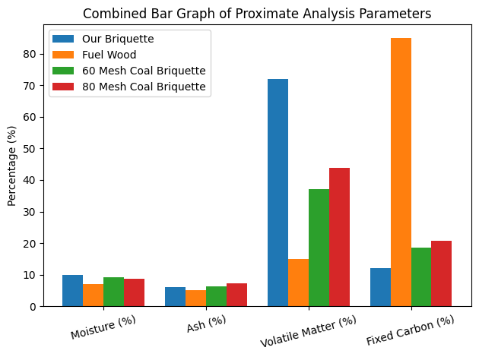
Figure:-15 Comparative analysis of various Briquettes

10. COMPARATIVE ANALYSIS OF VARIOUS BRIQUETTES
The combined bar graph presents a comparative evaluation of proximate analysis parameters-moisture content, ash content, volatile matter, and fixed carbon-for our briquette, fuel wood, and 60-mesh and 80-mesh coal briquettes. The moisture content of all fuels remains within acceptable limits, indicating proper drying and suitability for combustion. Ash content is relatively low across all samples, suggesting minimal residue formation and efficient burning characteristics. Briquette produced exhibits a notably high volatile matter content, which favours easy ignition and rapid flame development. In contrast, fuel wood shows significantly higher fixed carbon, indicating a longer and steadier combustion period. The coal briquettes demonstrate moderate volatile matter and fixed carbon contents, with the 80-mesh briquette performing slightly better than the 60-mesh due to finer particle size and improved combustion efficiency. Overall, the bar graph highlights the distinct combustion behaviors of each fuel type and confirms that the developed briquette possesses desirable fuel properties comparable to conventional solid fuels.

11.CONCLUSION
The production of bio-briquettes from agricultural waste such as rice husk, sawdust, sugarcane bagasse, groundnut shell, coconut shell, cotton stalk, banana peel, and corn cobs proved to be an efficient, sustainable, and eco-friendly method of generating renewable energy. The study successfully demonstrated that these locally available residues can be converted into high-density, energy- rich briquettes through processes such as drying, size reduction, mixing with natural binders, compaction, and drying. The briquettes produced exhibited good combustion characteristics, acceptable calorific value, low smoke emission, and improved durability. This project highlights the significant potential of agricultural residues in reducing environmental pollution caused by open burning and waste disposal. Furthermore, bio-briquettes serve as an economical economic alternative to fossil fuels, providing benefits such as cost-effectiveness, reduced greenhouse gas emissions, and enhanced rural energy security. Thus, the project not only supports sustainable waste management but also contributes to clean energy production, rural employment generation, and overall environmental conservation.

REFERENCES
1. U.S.P.R.Arachigue, et.al., "Briquettes Production As An Alternative Fuel" (2021) e-ISSN: 2395-3454 ; DOI: https://doi.org/10.46488/NEPT.2021.v20i04.029
2. Philip Donald C. Sanchez a, et.al., “ An Overview on the Production of Bio-briquettes from Agricultural Wastes: Methods, Processes, and Quality (2022)”; e-ISSN: 2716-6236. DOI: http://doi.org/10.37865/jafe.2022.0036
3. Andre Azhar Winata,et.al.,"Potential production and characterization of charcoal based bio-briquettes from ulin wood waste as an alternative sustainable energy resource" (2025) e-ISSN :595-608 ; DOI: 10.59957/jctm.v60.i4.2025
4. Ibrahim MS,et.al., "Biomass briquettes as an alternative source of cooking fuel towards green recovery post COVID-19 (2020) " e-ISSN : 2415-6272 ; DOI: 10.36348/sjet.2020.v05i06.005
5. V Jadhav "Biomass briquette system: Pollution free thermal energy resources" (2015) e-ISSN: 2319-8753 ; DOI: 10.15680/IJIRSET.2015.0501102
6. Yusuf Kpalo "Briquettes from agricultural residues; An alternative clean and sustainable fuel for domestic cooking in nasarawa state" (2020) DOI: 10.5923/j.ep.20201002.03MB
7. Godif Alene Geberehiet "Development of briquettes suitable for energy generation from residue of sorghum stalk and groundnut husk" (2025) DOI: https://doi.org/10.1007/s40243-025-00309-7

8. Olufunke O. Oyebamiji;et.al., “Evaluation And Characterization Of Biochar And Briquettes From Agricultural Wastes For Sustainable Energy Production(2025)” e-ISSN: 2949-7507 ; DOI:10.1016/j.wmb.2025.100198
9. Sriram M,et.al., "Experimental investigation of biomass briquettes from agri waste and forest waste" (2022) e-ISSN: 2455-4537 ; DOI: https://doi.org/10.46632/jemm/8/3/1
10. Apurva Kelwade,et.al., "Biomass Briquettes From Agriculture Waste" (2025) e-ISSN: 2456-3463 ; DOI: https://doi.org/10.46335/IJIES.2025.10.3.4
11. Mamta Kumari,et.al., "Environmental, Social And Economic Impact Of Briquetting Plant And Briquettes" (2022) e-ISSN: 2710-6012 ; DOI: https://doi.org/10.26480/jwbm.01.2022.32.40
13. Ebube Daniel Ezeokolie,et.al., "Production And Optimization Of Briquette (Solid Fuels) From Waste Biomass Using Industrial Starch As Binder” (2024) ; DOI: https://doi.org/10.29333/ejosdr/15138

