Rhesus monkey induced losses in Muga Culture: A study in Dhakuakhana sub-division of Lakhimpur district of Asssam

ABSTRACT:
Human-rhesus monkey conflict due to raiding in muga cultivation is one of the major problem affecting different villages of Dhakuakhana block of Lakhimpur district.During 2024-25,We assessed various socio-ecological parameter with the help of Quentionnaire. In all, we surveyed fourteen villages, covering twenty-four households, and collected data on the percentage damage to silkworm larva rearing, shifts in occupation, measures to mitigate locally, economic loss incurred by rearers, estimated annual earnings, and any other vertebrate damage to the sericulture in Dhakuakhana. An average number of 367.14 individuals spaning in an area of average 2.6km causing livelihood damage of 68.57% incurring an average financial loss of Rs 36041.66 per crop thereby shifting their occupation to growing Tea and daily wage earning. Thus the study suggest for a special mitigation measures along with community support to curb the menace of Rhesus monkey.

Key words: Dhakuakhana, Induced losses, Muga culture, Rhesus monkey,
INTRODUCTION

The North- Eastern states of India has been practising since time immemorial, where Assam is one of the major silk producing states. Assam produces all the four Silkworm i.e Muga, Eri, Tasar and Mulberry, but not all places of Assam are suitable for it as the silkworm rearing demands an approximately 23°–27°C temperature with Humidity around 65-85% and an average annual rainfall of 600-2500 mm along with fresh air quality and only few parts of the state of Assam favours, the kind of climate suitable for mugaculture and such places or districts are Lakhimpur, Sivasagar, Jorhat, Dhemaji, Tinsukia, Boko etc, wherein Lakhimpur district is considered as one of the most climatically suitable for silk production. Therefore, Lakhimpur district is higher in the production of silk among other districts in Assam, and approximately around 70% of people in Lakhimpur district choose sericulture for their domestic use (Gogoi and Phukan 2025).The climatic conditions of Assam is suitable for rearing of all four different varieties of silkworm. Hugon in 1837 stated that Antheraea assamensis Helfer i.e Muga silkworm is endemic to Assam and other north Eastern States including Myanmar., Muga silkworm is multivoltine in nature as it is reared for 5-6 generations in a year (Thangavelu et al.2005). The primary host plant of Muga silkworm is Som (Persea bombycina) but during unavailability of Som, it also feeds on Soalu (Litsea monopetala), Dighloti (Litsea salicifolia) and Mejankari(Litsea citrata) (Tikader et. al 2013). Muga silkworm is primarlily reared outdoor hence more prone to attack by predator, parasites and diseases. Income of reares from Mugaculture comes from various sources, the muga pupae which is edible and important source of protein are sold locally and its price varies from Rs. 500 to Rs. 700 per kg, after formation of cocoon the rearers sell some of the cocoons which amount to around Rs. 50000 per kg to other weavers of their own district or to some other places, lastly the muga golden thread is sold at around Rs. 18,000 per kg. Moreover, the woven cloths are also being sold by the weavers. Thus, Income from different sources can be calculated to generate the total income from Mugaculture and the income from selling muga threads and clothes is more than selling cocoons and pupae (Konwar et. al. 2024).
Rhesus monkey are thought to have being evolved in northern Africa around 6 million years ago. In due course of time they started splitting to different places primarily to the southern and eastern parts of Asia. Presently there are 19 species known to exist in varied environments. Macaques are generally omnivorous, leaning more towards wild fruits. They are roam in regiments, which are typically huge and cohesive, and are in multimale multifemales composition. Within the troops, kinship and hierarchy are the primary behavior regulators. Females are polyestrous and have a sexual cycle that lasts about 30 days on average. After humans, rhesus monkeys are the most adaptable primate species.They can live in almost all environments from tropical rainforests to deserts and under a variety of conditions such as sea levels up to 4000 meters high. Their range goes from Afghanistan to west China and they can be found in countries like India, Nepal, Vietnam, Hong Kong, among others (Rowe, 1936). Macaques are omnivorous in general. After humans, rhesus monkeys are the most adaptable primate species. Rhesus monkeys prominently prefer to live near around human habitats but they are also perfectly capable of surviving in the wild too, away from human settlements. The rhesus monkey society is organized in a hierarchy of dominance, on top of which is the alpha male, who is usually the biggest and boldest male. He protects the troop members and is responsible for most of the conflicts either with other males or human (Cronin et al., 1980). Rhesus monkey diet normally includes natural plant- based foods and and food of anthropogenic origin from arounf human settlements adapting themselves to human coexistence.To depict their 'ordinary' diet without pondering the impact of human food is hard as maximum portion of their diet was found to include human food (Seth et al. 1989). Fooden et al. (2000) stated that rhesus macaques eat mostly fruits, vegetables, and plant products. Other foods include creepy crawlies, crawfish, crabs, shellfish, bird eggs, and honeycombs. Rhesus monkey cause more damage to crops than they consume and depending on the availability and scarcity of food in the area they cause harm to both palatable and unpalatable crops as a result the residents become more aggressive against monkeys when they face an economic loss due to monkey raid. Moreover, human aggression influences primates also to become aggressive and destroy unpalatable crops (Beisner et al. 2015).Man-monkey conflicts has been increased because of the uncontrolled growth of rhesus monkey population every year and its raising population is attributed to its high birth rate and absence of natural predator (Imam 1995).
MATERIALS AND METHODS
Dhakuakhana is a sub-division of Lakhimpur district of Assam lies in 27.31⁰ N latitude and 94.45⁰ E longitude. The economy is based on agriculture and the cottage-based industry is Sericulture. The survey was carried out in 12 different villages of Dhakuakhana sub-division. We made direct count of rhesus monkey group numbers and total individuals in a group. Data were collected both by interviewing the farmers and based on information from Questionnaires. The Quentionnaire was prepared to record information on the percentage damage to silkworm larva rearing, shift in occupation, measures to mitigate locally, economic loss incurred by rearers, estimated earning annualy, any other vertebrate damage to the sericulture in Dhakuakhana.
RESULT:
Rhesus monkey individuals and its damage percentage to livelihood :
The study identified total number of individuals in a single group ranges from 20 to 1000. In an average radial area of 2.4km average individuals found to be 367.14 number (Table.1). We recorded the list of livelihood activities where sericulture was once found to be prominent. We recorded the livelihood damage due to the rhesus monkey varied from 40-80% and an average of 68.57% damage in the overall studied area.
Estimated earning and financial loss incurred by rearers due to attack by Rhesus monkeys
Rhesus monkey diet completes with the food items collected from their surrounding which include fruits, vegetables, tree leaves and most importantly, the muga silkworm larvae in silkworm rearing villages of Dhakuakhana sub-division. We calculated the average earnings of 24 rearers from muga cultivation and it was found to be Rs 70625 per crop with a maximum of Rs 3,50,000 and a minimum of Rs 20,000. We also calculated the financial loss bore by rearer, it ranges between Rs 10,000 to 1,50,000 with an average loss of Rs 36041 per crop.(Table.2)
Measures to mitigate locally and shift in occupation:
Our survey included 24 households. When questioned about the mitigation measures, most of the rearers were unaware of any measures as muga cultivation is done outdoors in tall som trees, while a few of them uses slingshots to drive away monkeys. Moreover, almost all rearers converted a part of their rearing land to a small tea garden and daily wage earning in order to sustain their livelihood. Apart from monkey other vertebrate pests such as birds and squirrels were also found attacking muga silkworm larvae.
KAP analysis
The participatory approach not only strengthened farmer engagement but also ensured that the management practices developed are practical, location-specific, and ecologically sustainable. Through joint observation and feedback, we could better understand local wildlife behaviour and crop vulnerability patterns, facilitating more effective and adaptive management strategies. This program was carried out with the active involvement of local farmers. To evaluate the current level of understanding and adoption of Vertebrate Pest Management (VPM) practices among farmers, a Knowledge, Attitude, and Practice (KAP) survey was conducted during the 2024-25. The results provide valuable insights into the extent of awareness, perception, impact and adoption behaviour among farmers regarding rhesus monkey management. The findings also highlight areas that require focused capacity-building and policy support to ensure the sustainable integration of management techniques in Sericultural practice. A comparative analysis of Knowledge, Attitude, and Practice (KAP) mean percentage scores regarding rhesus monkey management for 24 rearers is compiled. The mean knowledge scores demonstrated that among twenty four numbers of rearers, only 33.32% of them were aware of management technologies, rest 66.66% were unaware of idea of managing monkey menace. Despite having low knowledge on management techniques, 75% of rears showed a positive attitude towards the adoption of new technologies rest 25% of them showed reluctance as they believe rhesus monkey holds religious significance and loss of habitat is the prime cause of monkey raids. While analyzing their practice of new tehnologies it was recorded that not a single rearer practiced new technologies for keeping their rearing site safe from monkeys.The practice scores lowest or zero of the three metrics among all the areas, highlighting a potential "know-do" gap where theoretical knowledge and positive attitude are not fully translating into practical application(Fig.3)

Table.1. Rhesus monkey distribution and damage in different villages of Dhakuakhana sub-division

Village | Coordinates | Radius(Km) | Total individuals | % damage to livelihood
Deolia | Lat:27.240,Long:94.461 | 2 | 60 | 50
Amguri | Lat: 27.244,Long :94.471 | 7 | 150 | 80
2 No.Thekeraguri | Lat:27.253,Long: 94.477 | 3 | 150 | 80
1 No. Thekeraguri | Lat:27.252,Long: 94.474 | 2 | 400 | 80
Goroimari Chapori | Lat: 27.267,Long:94.464 | 1 | 1000 | 60
Kochuoni | Lat:27.278,Long:94.461 | 2 | 400 | 80
Lowkuth murutta | Lat:27.287,Long:94.459 | 2 | 200 | 70
Deolia Gobindapur | Lat:27.242,Long:94.458 | 1 | 500 | 70
Lahibari | Lat:27.254,Long:94.448 | 4 | 1000 | 50
Ghatapara Kathonichuk | Lat:27.261,Long:94.441 | 2 | 60 | 70
Cherpating | Lat:27.259,Long:94.449 | 2 | 200 | 80
Gharmara | Lat:27.319,Long:94.483 | 5 | 500 | 80
Kathalpara | Lat:27.325,Long:94.488 | 2 | 500 | 70
Madhupur | Lat:27.329,Long:94.499 | 2 | 20 | 40
Average |  | 2.64 | 367.14 | 68.57

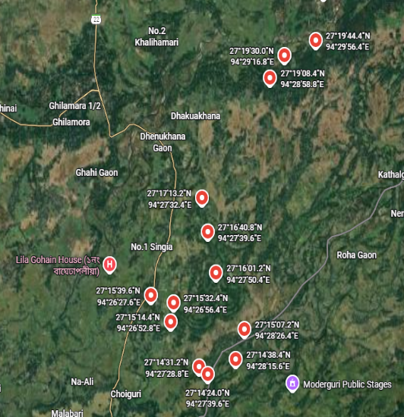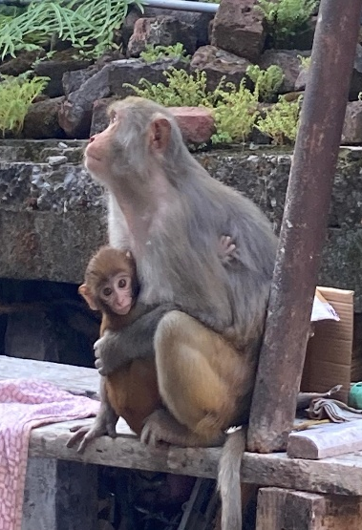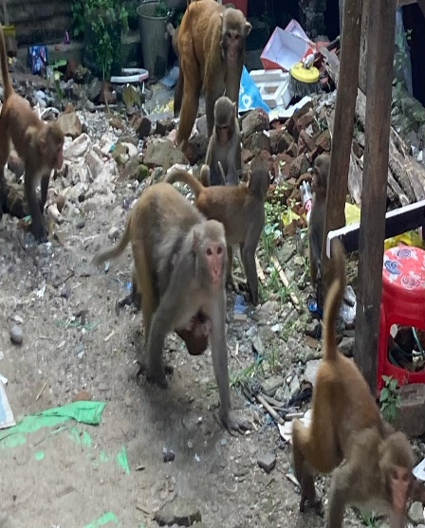
Fig.2. Rhesus mokey interrupting household activities
Fig.1. Distribution of Rhesus monkey in Dhakuakhana sub-division of Lakhimpur District

Table 2. Financial analysis of losses and estimated earnings by Muga silkworm rearer

Name of the rearers | Financial loss(Rs) per crop due to monkey raid | Estimated earning from sericulture(Rs)/crop | Measures to mitigate locally | Shift in occupation
Shankar Borah | 50000 | 100000 | nil | Tea
Krishna Bhorali | 20000 | 25000 | nil | Tea
Anil Koch | 20000 | 25000 | Slingshot | Tea
Mahendra Baruah | 10000 | 20000 | nil | Tea
Dipak Koch | 20000 | 30000 | nil | Tea
Dip Borah | 25000 | 40000 | nil | Tea
Dinesh Koch | 1,50,000 | 3,50,000 | Slingshot | Tea
Raju Borah | 10,000 | 1,50,000 | nil | Tea
Uttam Koch | 70000 | 100000 | nil | Tea
Milan Boruah | 10000 | 25000 | nil | Tea
Dipamoni Chutia | 60000 | 100000 | nil | Daily wage
T. Chutia | 50000 | 70000 | nil | Tea
Brojen Koch | 20000 | 45000 | Slingshot | Tea
Konsali Koch | 30000 | 70000 | Slingshot | Tea
Rajumoni Konwar | 15000 | 40000 | Slingshot | Daily wage
Pradeep Gogoi | 50000 | 60000 | nil | Tea
Binod Gogoi | 20000 | 25000 | nil | Daily wage
Amiya G.Bora | 15000 | 20000 | nil | Tea
Humen Handikoi | 40000 | 90000 | Slingshot | Tea
Bipul Gogoi | 35000 | 65000 | nil | Tea
Renu Gogoi | 20000 | 30000 | nil | Daily wage
Tapan Bora | 70000 | 100000 | nil | Daily wage
Pranab Phukan | 30000 | 50000 | Slingshot | Daily wage
Bijoy Gual | 25000 | 65000 | nil | Tea
Average | 36041.66 | 70625 | - | -

Fig 3. KAP analysis regarding adoption of new technology

DISCUSSION

Our study area is unique in sense, as least research is being conducted on Rhesus monkey damage to muga cultivation in Dhakuakhana. Rhesus monkey diet is heavily influenced by the relationship that exists between the environment in which it lives and the primate himself or herself (Robbins and Hohmann (2006) and as almost every households in Dhakuakhana sub-division engage in either large or small scale rearing of muga, the conflict between livelihood and monkey become inevitable, proximity to forest area is also an another reason of monkey raids as described by Hill (2002) that closeness to a forest edge results in suffering crop loss, moreover as they are both arboreal and terrestrial allowing them to feed both ground and trees which includes fruits, leaves, seeds, buds, flowers, soil, insects and many others small creatures (Cronin et al., 1980) thus destroying both silkworm larvae and the som plants. Rhesus monkey wanders in an average home range of 2.64 km Home range is a term used by Jay (1965) and Jewell (1966) to refer to the entire area in which a social troop spends most of its time and over which it wanders. Crook and Gartlan (1966) suggested that the availability and distribution of food sources and protection from predators stand out as the two principal factors of the environment, which determine group size. During the study it was found that group size vary from 20 to 1000 individuals in a group. Although the rate of destruction is very high, when asked about any management strategies the response was luke warm or they were not aware of any such measures. Aryal and Chalise, 2013 noted screaming and chasing monkeys using stones and catapults were the most prevalent deterrent methods, while the farmers of Dhakuakhana mostly uses slingshot to deter monkey.
CONCLUSION
The present study revealed that the population of rhesus monkey is thriving challenge to muga cultivation in Dhakuakhana sub-division of Lakhimpur district. These social problem will be exacerbated if timely measures are not taken. Therefore, it is recommended that some measures should be taken to control the rhesus monkey menace like Johnson et al. (1991) relocation of rhesus macaque population to a different location, Radha et. al, 2024 suggested Smart Repeller, that make use of ultrasonic sound waves, Calcium Carbide Cannon, computer vision technology to detect the presence of monkeys and automatically activating repelling mechanisms. This solution eliminates the need for human intervention, making it efficient and cost-effective, natural deterrent, techniques like use of boneless dry fish pieces properly sealed in small packets placing around the field, beating drum to drive monkeys away and use of well trained dogs, chilli powder mixed with bananas and biscuits, using loud-speakers to play sound of 4-5 dogs barking, Growing of Monkey Puzzle Tree (Araucaria araucana) has been a very effective measure(Reddy, 2018). To mitigate the problem of monkey menace surgical sterilisation of male macaques by thermocauteric coagulative vasectomy and of female macaques by endoscopic thermo-cauteric tubectomy is generally practiced and for long-term population control immuno-contraception using certain chemicals, hormones and vaccines.(MoEFCC, GoI, 2023-24). Along with different mitigation measures, arranging regular monitoring program for measuring demographic trend is also crucial.

REFERENCES:
- Aryal, K. and Chalise, M.K. (2013). Human-monkey interface in Arkhale and Nayagaun, Gulmi, West Nepal. Nepalese Journal of Zoology, 1(1): 30-40.
- Beisner, B. A.; Jin, J.; Fushing, H. and Mccowan, B. (2015). Detection of social group instability among captive rhesus macaques using joint network modeling. Current zoology, 61(1): 70-84.
- Cronin, J.E.; Cann, R. and Sarich, V.M. (1980). Molecular evolution and systematics of the genus Macaques: Studies in Ecology and Behavior. Evolution, pp. 31-51.
- Cronin, J.E.; Cann, R. and Sarich, V.M. (1980). Molecular evolution and systematics of the genus Macaques: Studies in Ecology and Behavior. Evolution, pp. 31-51
- Crook, J.H. and Gartlan, J.S. (1966). Evolution of primate societies. Nature, 210(5042): 1200-1203
- Fooden, J. (2000). Systematic review of the rhesus macaque, Macaca mulatta (Zimmermann, 1780). Field Mus of Nat Hist, Chicago, Illinois, USA
- Gogoi, D and Phukan, K.K., (2025), Muga Silk Production and Engagement of Family in Different Category of Silk Production: A Study in Lakhimpur District of Assam, India During 2013-23. International Journal for Multidisciplinary Research, 7(1).
- Guidelines for Mitigating Human–Rhesus Macaque Conflict - Taking a Harmonious-Coexistence Approach (2023). Ministry of Environment, Forest and Climate Change, Government of India.
- Hill, C.M. (2002). Primate conservation and local communities-ethical issues and debates. American Anthropologist, 104(4): 1184-1194.
- Hugon T. Remarks on the silkworms of Assam. Journal of the Asiatic Society of Bengal.1837; 6(1):21-38.
- Imam, I. and Yahya, H.S.A.,(1995), Population dynamics and distribution of rhesus monkey Macaca mulatta in Aligarh district, Uttar Pradesh. Journal of ecobiology, 71,pp 001-009.
- Jay, P. (1965). The common langur of North India. I. DeVore (Ed.), Primate Behavior. Field Studies of Monkeys and Apes, New York etc. (Holt, Rinehart and Winston), pp. 197-249
- Jewell, P.A. (1966). The concept of home-range in monkey. Sym Zool Soc Lond, 18: 85-109
- Johnson, R.L.; Malik, I. and Berman, C.M. (1991). Age-and dominance-related variation in feeding time among free-ranging female rhesus monkeys. International Journal of Primatology, 12(4): 337-356
- Konwar, J.,Borthakur, M.K. and Goswami. J.,(2024), Impact of Muga Silkworm Culture in Augmenting Rural Income of Assam, India. Asian Journal of Agricultural Extension, Economics & Sociology, 42, pp 133-139.
- Radha, R., Balaji, G., Anita, X. & Mridhula, N. (2024). SMART REPELLER: A Smart system to prevent Rhesus Macaque Trespassing in Human Settlements and Agricultural Areas. EAI Endorsed Transactions on Internet of Things. 10:1-14
- Reddy, M.D. (2018). Monkey menace, its management. International Journal of Management, Technology And Engineering. 8 (XII): 5904-5908
- Robbins, M.M. and Hohmann, G.O.T.T.F.R.I.E.D. (2006). Primate feeding ecology: an integrative approach. Feeding ecology in apes and other primates, pp. 1-13
- Seth, A.K.; Baars, B.J. and Edelman, D.B. (1989). Criteria for consciousness in humans and other macaques. Consciousness and cognition, 14(1): 119-139.
- Thangavelu K,Tikader A, Sen AK. Strategies for conservation of muga host plant genetic resources. Present status and constraints of muga silkworm host plant germplasm conservation. In proceedings: Strategies for maintenance of non-mulberry silkworm and host plant germplasm held at Central Muga Eri Research & Training Institute, Lahdoigarh, Jorhat, Assam. 2005:37- 47
- Tikader A, Vijayan K, Saratchandra B. Improvement of host plants of Muga silkworm (Antheraea assamensis) for higher productivity and better adaptation-A review. Plant 8. Knowledge Journal. 2013;2:83-88

