Flower bud Extract of Syzygium aromaticum (clove) Modulates Weight, Oxidative Stress and Glycaemic Indices in Alloxan-Induced Diabetic Rats

Abstract
Syzygium aromaticum is a flowering plant whose dried flower buds (cloves) are widely used as a spice. Aim: This study aims to evaluate the modulatory potentials of aqueous extract of clove on oxidative stress and glycaemic indices of alloxan-induced diabetic Wistar rats. Methodology: Eighty male rats weighing 100-130g were grouped into eight (n=10). NEXC1 served as the normal experimental control. Groups 2-8 were fed a high-fat diet for 28 days and administered a single intraperitoneal injection of 150 mg kg⁻¹ body weight of alloxan to induce diabetes and are designated HFAD2, HFAD3, HFAD4, HFAD5, HFAD6, HFAD7 and HFAD8, respectively. Diabetes was established after three consecutive days of Fasting Blood Sugar measurement between 11 and 13 mmol/L. HFDA2 did not receive any treatment. HFDA3 was treated with 500 mg kg⁻¹ body weight of metformin. HFDA4, HFDA5, HFDA6, HFDA7, and HFDA8 were treated with 500, 1000, 1500, 2000, and 2500 mg kg⁻¹ body weight of the extract, respectively, for 28 days. Biochemical indices and histological examination were assessed. Results: HFDA4, HFDA5, HFDA6, HFDA7 and HFDA showed significant increase (p<0.05) in superoxide dismutase (53.64±3.04 U/ml), catalase (4.87±0.36 U/ml)), with a significant decrease (p>0.05) in glucose (4.00±0.03 mmol/l), amylase (28.72±0.72), nitric oxide (1.13±0.28 ug/L), and glutathione activities (10.27±1.22 nmol/L) when compared to HFAD2. The photomicrographs showed atrophic pancreatic islets and tubular necrosis with discontinuous brush borders of renal cells in HFAD2. However, the treatment groups were ameliorated by different concentrations of the extract, and the tissues were restored to normal. Conclusion: The extract, at 2500 mg kg⁻¹, showed ameliorative effect on glucose, amylase and a reduction in oxidative stress indices and can therefore be harnessed in the management of diabetes.
Keywords: Syzygium aromaticum, Fasting Blood Sugar, High-fat-diet, Pancreas, Histology

Introduction
Diabetes mellitus (DM) is a common endocrine disorder that affects more than 100 million people worldwide. It is caused by a deficiency or ineffective production of insulin by the pancreas, which results in an increase or decrease in concentrations of glucose in the blood (Antar et al., 2023). Diabetes mellitus, especially type 2 diabetes, is strongly associated with a high-fat diet, obesity and insulin resistance. The presence of DM shows an increased risk of many complications such as peripheral vascular diseases, stroke, neuropathy, renal failure, retinopathy, blindness, amputations, etc (Li et al., 2023; Sreedevi et al., 2025). Drugs are used primarily to save lives and alleviate symptoms. Secondary aids are to prevent long-term diabetic complications and, by eliminating various risk factors, to increase longevity. Insulin replacement therapy is the mainstay for patients with type 1 DM, while diet and lifestyle modifications are considered the cornerstone for the treatment and management of type 2 DM (Tegegne et al., 2024; Praveen et al., 2024). Various types of hypoglycaemic agents, such as biguanides and sulfonylureas, are also available for the treatment of diabetes. However, the main disadvantage of currently available drugs is that they have to be given throughout the life span of the individual, and they produce side effects (Xie et al., 2023).
Alloxan-induced diabetes in experimental animal models mimics human Type 1 diabetes through the selective destruction of pancreatic β-cells, mediated by reactive oxygen species (ROS) generation. The resulting oxidative imbalance contributes to hyperglycaemia-related metabolic disturbances, including lipid peroxidation, protein oxidation, and enzymatic inactivation. Consequently, antioxidants that counteract oxidative stress have become important therapeutic adjuncts in diabetes management (Bukhari et al., 2024).
Plants have been used in ethnomedicine since ancient times to cure many diseases, including diabetes (Obakiro et al., 2023). In recent times, medicinal plants have been gaining wider acceptance due to the perception that these plants, being natural products, have fewer side effects and improved efficacy than their synthetic counterparts (Batiha et al., 2020). Currently, about 80% of the world’s inhabitants rely on traditional medicine as a major form of their primary health care (Dubale et al., 2025). Medicinal plants can be used for the treatment of DM, especially in countries where access to conventional anti-DM agents is inadequate (Li et al., 2023; Sreedevi et al., 2025).
In the face of escalating DM prevalence, particularly in regions like Nigeria where hyperlipidaemia coexists, there is an escalating interest in ethnopharmacological interventions (Meka et al., 2025; Li et al., 2025). Clove a spice derived from the Myrtaceae family, has been traditionally employed for its analgesic, anti-inflammatory, and antimicrobial properties. Its seeds are rich in bioactive phytochemicals, including eugenol (a phenylpropanoid), flavonoids (e.g., quercetin, kaempferol), tannins, and phenolic acids (e.g., gallic acid, ellagic acid), which confer antioxidants, antihyperglycemic, and tissue-protective attributes (Zhao et al., 2024). This study aimed to evaluate the modulatory potentials of aqueous seed extracts of cloves on alloxan-induced diabetic Wistar rats.
Methodology
Procurement of Experimental Animals
Eighty male Wistar rats, 100-130 g, were purchased from the animal house of the Department of Biochemistry, University of Port Harcourt, Choba, Rivers State. The rats were weighed and divided into eight (8) groups of ten (10) each and were housed differently in standard cages. The Wistar rats were housed according to the laboratory conditions (12 hours light; dark cycle, 28 ± 2 °C) and acclimatised for 2 weeks with free access to standard rat chow and water ad libitum before the study began. All experiments were carried out in strict compliance with internationally accepted principles for laboratory animal use and care in accordance with the Canadian Council on Animal Care Guidelines and Protocol Reviews (Petkov et al., 2022).
Preparation of the Extracts
The purchased seeds of S. aromaticum were properly washed with distilled water, air dried at room temperature for 3 weeks in the absence of moisture and dust. They were ground and pulverised to coarse powder using an electric blender. One hundred millilitres of distilled water was added to each 10 g portion of the blended seed. This was mixed intermittently for 3 days before it was vacuum-filtered through Whatman No. 1 filter paper and concentrated using a vacuum rotary evaporator (Eyla N-1000, Japan). The extract was stored in an air-tight container.
Experimental protocol
After the period of acclimatisation, during which all the rats were fed with normal rat chow and water ad libitum via oral gavage daily. The Eighty Wistar rats were divided according to their body weight into eight (8) groups of ten (10) rats each. NEXC1 served as the normal experimental control group. Groups 2-8 were designated HFAD2, HFAD3, HFAD4, HFAD5, HFAD6, HFAD7 and HFAD8 respectively. NEXC1 rats were fed normal rat chow and clean water throughout the experiment; HFAD2, HFAD3, HFAD4, HFAD5, HFAD6, HFAD7 and HFAD8 were fed with a high-fat diet (20% sucrose + 20 % butter + 60% grower mash) for four weeks. Thereafter, 150 mgkg-¹ body weight of alloxan dissolved in normal saline was injected into HFAD2, HFAD3, HFAD4, HFAD5, HFAD6, HFAD7 and HFAD8 rats to induce diabetes. The rats were observed for 72 hours with fasting blood sugar (FBS) tests assayed every 24 hours to confirm a diabetic state. Consecutive FBS results exceeding 11 - 13.0mmol/L confirmed the diabetic states of the rats. The fasting blood glucose levels for the rats in each group were monitored at a 7-day interval using a glucometer. Metformin was administered to HFAD3 rats, while HFAD4, HFAD5, HFAD6, HFAD7 and HFAD8 were treated orally with 500, 1000, 1500, 2000 and 2500 mg kg-¹ bodyweight of the aqueous extract of clove (CLE), respectively, for 28 days.
Determination of blood biochemical indices
The animals from all the groups were sacrificed at the end of the treatment. They were anaesthetised with chloroform. The animals were sacrificed by severing the jugular vein with a surgical blade. Blood was allowed to flow freely and was collected into Lithium Heparin bottles for biochemical analysis. Superoxide dismutase (SOD), Nitric oxide (NO), Catalase (CAT), reduced glutathione (GSH) and Malondialdehyde (MDA) were measured according to a method previously described by Usoh et al. (2005). Follicle-stimulating hormone, testosterone and luteinizing hormone were analysed using the sandwich enzyme-linked immunosorbent assay (ELISA) kit (Boditech Med Incorporated, Republic of Korea), using the ichroma machine (Boditech: BOD13303, Korea). The pancreas and kidney were harvested into sterile universal bottles and preserved in 10% formalin. Histological analysis was then carried out according to the method described by Kiernan (2008).
Data Analysis
Data obtained from this study were analysed using Statistical Product and Service Solution (SPSS) for Windows version 23.0, USA. Descriptive statistics were done by one-way analysis of variance (ANOVA), and multiple comparisons of the mean values were done using the Turkey Post hoc test at 95% (p˂0.05) confidence level. All data obtained from this study are represented as means ± standard deviation (M±SD).
Results
The impact of the aqueous extracts of the seeds of S. aromaticum on weekly weight gains and overall weight gains of Wistar rats is presented in Figure 1. A weekly and overall weight gain across all groups in the study was observed. HFDA8 rats, which were treated with 2500 mg kg⁻¹ bodyweight of the aqueous seed extract of S. aromaticum, recorded the highest weight gain (129.16 ±.68 g) when compared to the other experimental groups, while NEXC1, which was the normal control, had the least weight gain (71.68 ± 20.84 g) at the end of the study.
The influence of the aqueous extracts of clove on glucose and amylase levels of Wistar rats is presented in Figure 2. The maximum glucose level, 10.47±5.28 mmol/l and amylase concentration, 47.70 ± 33.05, were obtained by the HFAD3 group. There was a significant decrease (p<0.05) in NEXC1, HFAD3 and the respective extract-treated groups when compared to HFAD2.
The effect of the aqueous extracts of clove on hepatic enzyme levels of Wistar rats is presented in Figure 3. The results revealed no significant difference (p<0.05) in the alkaline phosphatase (ALP) levels of NEXC1 and the CLE-treated groups when compared to those of HFAD2. Conversely, alanine aminotransferase (ALT) and aspartate aminotransferase (AST) levels of NEXC1 and the CLE-treated groups were significantly lower or reduced (p>0.05) when compared to those of HFAD2.
The validity of the aqueous extracts of clove on plasma electrolytes, urea and creatinine levels of Wistar rats is presented in Table 1. There was no significant difference (p<0.05) in the electrolytes (potassium and sodium) levels and urea levels of NEXC1 and CLE-treated groups when compared to HFAD2. However, there was an observed significant reduction (p<0.05) in the creatinine levels of NEXC1 and the CLE-treated groups when compared to HFAD2. The minimum potassium level was seen in NEXC1 (2.13 ± 1.76 mmol/L), and the maximum potassium level was observed in HFAD2 (3.67 ± 0.87 mmol/L); the minimum sodium level was seen in HFAD5 (high fat diet + 150mg/kg b.w alloxan + 1000 mgkg⁻¹ b.w S. aromaticum) with a value of 141.81 ± 2.76 meq/L. Minimum value of 55.31 ± 1.82mg/dl was seen in HFAD5 for urea level; minimum creatinine level was seen in NEXC1 (118.4 ± 3.54 µmol/L), and the maximum creatinine level was seen in HFAD2 (146.91 ± 22.23 µmol/L).
The outcome of treatment with aqueous extracts of clove on biomarkers of oxidative stress levels of Wistar rats is presented in Table 2. The activities of nitric oxide, catalase, reduced glutathione, superoxide and malondialdehyde of HFAD2 were significantly increased or higher (p>0.05) than those of NEXC1 and CLE-treated groups. Minimum activities of NO (1.13 ± 0.28 ug/L), GSH (10.27 ± 1.22 nmol/L) were recorded in HFAD8; NEXC1 had the minimum activity of catalase (39.67 ± 10.43 U/ml), and SOD (1.38 ± 0.23 unit/mL) were observed in HFAD2. The minimum MDA activity was seen in NEXC1 (9.13 ± 0.24 µmol/L). Maximum activities of NO (9.71 ± 1.06 ug/L), catalase (59.67 ± 10.43 U/ml), GSH (62.74 ± 3.33 nmol/L), SOD (4.38 ± 0.23 unit/mL) and MDA (22.11 ± 0.20 µmol/L) were seen in HFAD2.

Figure 1: Impact of the aqueous extracts of clove on weekly weight gains and overall weight gains of Wistar rats

Figure 2: Influence of aqueous extracts of clove on glucose and amylase levels of Wistar rats.

Figure 3: Effect of the aqueous extracts of clove on hepatic enzymes of Wistar rats
Table 1: Effect of aqueous extracts of clove on plasma electrolytes, urea and creatinine levels of Wistar rats
Experimental Groups (n=10) | Potassium (mmol/L) | Sodium (meq/L) | Urea (mg/dl) | Creatinine (µmol/L)
NEXC1 | 2.13 ± 1.76ª | 144.71 ± 4.15ª | 55.82 ± 2.00ª | 118.4 ± 3.54ª
HFAD2 | 3.67 ± 0.87ª | 142.50 ± 2.45ª | 57.97 ± 1.80ª | 146.91 ± 22.23^{b}
HFAD3 | 2.75 ± 2.35ª | 144.23 ± 2.39ª | 56.15 ± 2.83ª | 123.41 ± 0.60ª
HFAD4 | 2.48 ± 1.50ª | 143.77 ± 6.79ª | 57.52 ± 1.10ª | 133.9 ± 8.29^{ab}
HFAD5 | 2.52 ± 1.93ª | 140.73 ± 4.87ª | 55.31 ± 1.82ª | 126.22 ± 3.37ª
HFAD6 | 2.91 ± 1.14ª | 141.81 ± 2.76ª | 56.58 ± 4.99ª | 128.61 ± 4.47ª
HFAD7 | 2.68 ± 1.55ª | 142.43 ± 6.54ª | 56.97 ± 1.51ª | 125.44 ± 3.87ª
HFAD8 | 2.67 ± 1.07ª | 145.99 ± 3.41ª | 56.41 ± 1.36ª | 126.43 ± 1.95ª
Values are expressed as mean ± SD. (n= 10 rats). Means in the same column with the same superscript alphabets are not significantly different at p<0.05, while means in the same column with different superscript alphabets are significantly different at p<0.05
Table 2: Effect of aqueous extracts of clove on biomarkers of oxidative stress in Wistar rats
Experimental  Groups (n=10) | NO  (ug/L) | CAT  (U/ml) | GSH  (nmol/L) | SOD  (unit/ml) | MDA (µmol/L)
NEXC1 | 1.98 ± 0.64ª | 56.01± 0.86^{b} | 10.68 ± 1.03ª | 4.92 ± 0.51^{b} | 9.13 ± 0.24ª
HFAD2 | 9.71 ± 1.06^{b} | 39.67±10.43ª | 62.74 ± 3.33^{b} | 1.38 ± 0.23ª | 22.11 ± 0.20^{b}
HFAD3 | 2.94 ± 0.47ª | 50.31± 2.61^{b} | 15.74 ± 3.46ª | 4.64 ± 0.22^{b} | 9.82 ± 0.82ª
HFAD4 | 2.70 ± 0.52ª | 50.91± 7.84^{b} | 14.83 ± 1.75ª | 4.87 ± 0.36^{b} | 11.96 ± 0.54ª
HFAD5 | 2.97 ± 0.76ª | 52.17± 2.62^{b} | 13.85 ± 1.23ª | 4.66 ± 0.19^{b} | 10.12 ± 0.25ª
HFAD6 | 2.05 ± 0.72ª | 52.74± 1.32^{b} | 12.97 ± 2.25ª | 4.58 ± 0.63^{b} | 10.68 ± 1.86ª
HFAD7 | 1.83 ± 0.94ª | 53.64± 3.04^{b} | 14.14 ± 1.46ª | 4.69 ± 0.25^{b} | 10.68 ± 1.98ª
HFAD8 | 1.13 ± 0.28ª | 51.43± 6.84^{b} | 10.27 ± 1.22ª | 4.58 ± 0.06^{b} | 10.99 ± 1.28ª
Values are expressed as mean ± SD. (n= 10 rats). Means in the same column with the same superscript alphabets are not significantly different at p<0.05, while means in the same column with different superscript alphabets are significantly different at p<0.05

Histology Results
Fig 4: Histology of the Endocrine Islet of Langerhans and Exocrine Pancreas
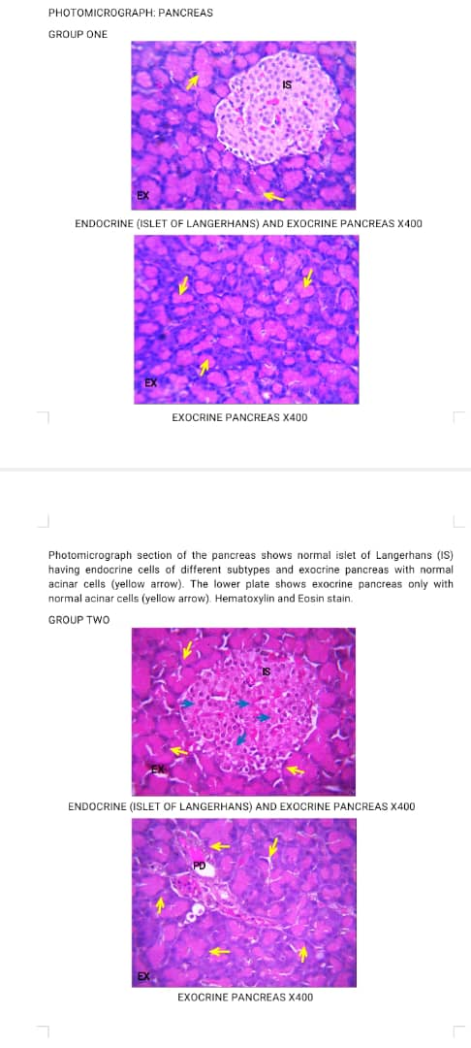 |  | 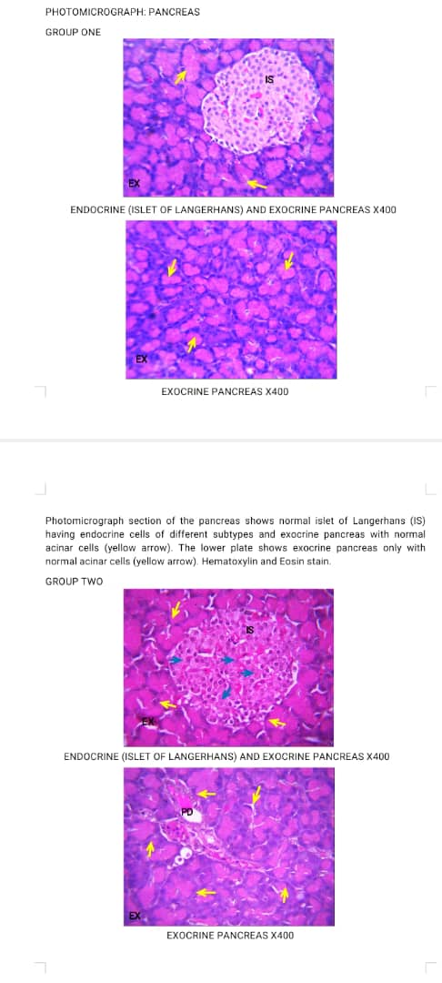
NEXC1 Islet of Langerhans | NEXC1 Exocrine Pancreas | HFAD2 Islet of Langerhans | HFAD2 Exocrine Pancreas
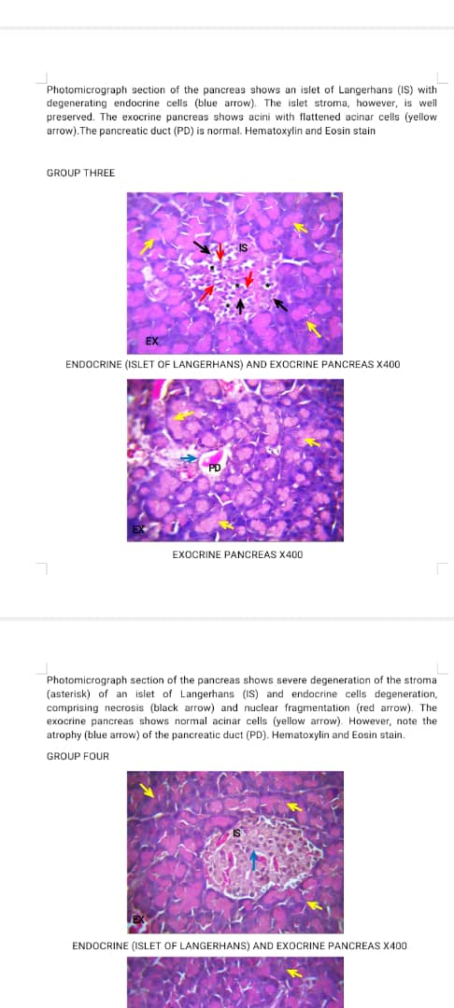 |  | 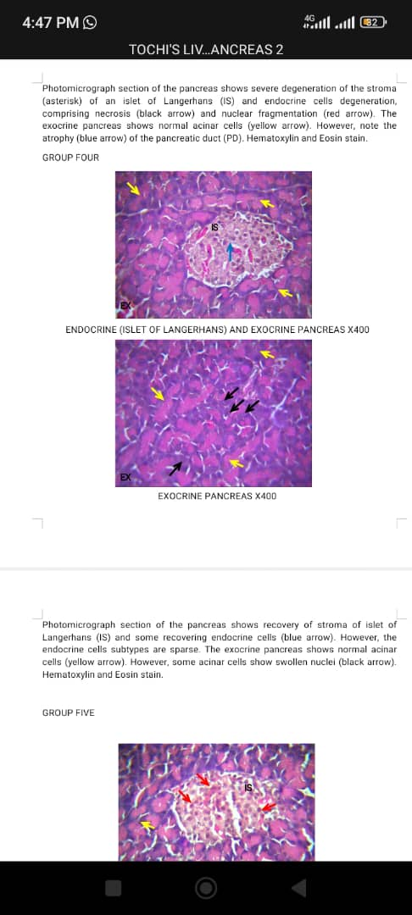
HFAD3 Islet of Langerhans | HFAD3 Exocrine Pancreas | HFAD4 Islet of Langerhans | HFAD4 Exocrine Pancreas
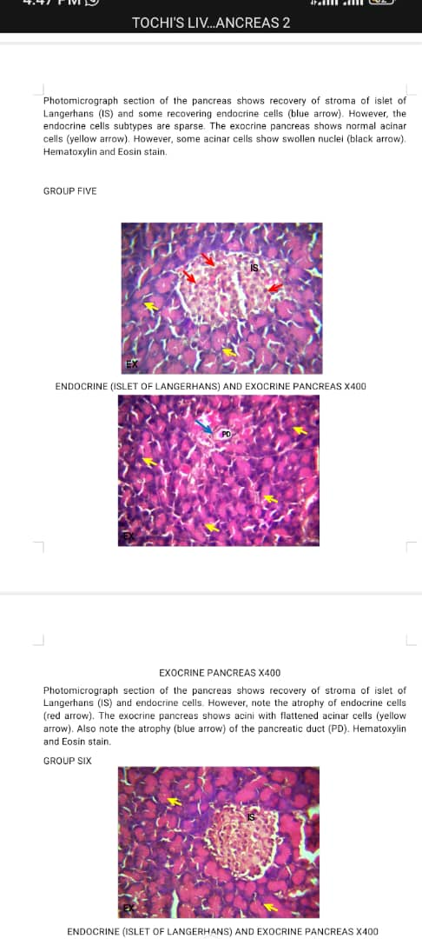 |  | 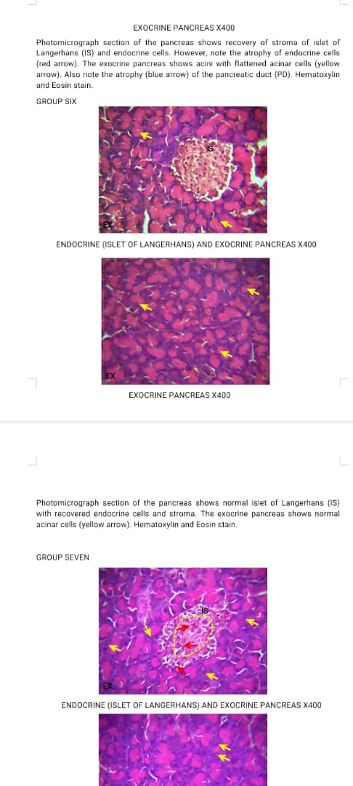
HFAD5 Islet of Langerhans | HFAD5 Exocrine Pancreas | HFAD6 Islet of Langerhans | HFAD6 Exocrine Pancreas
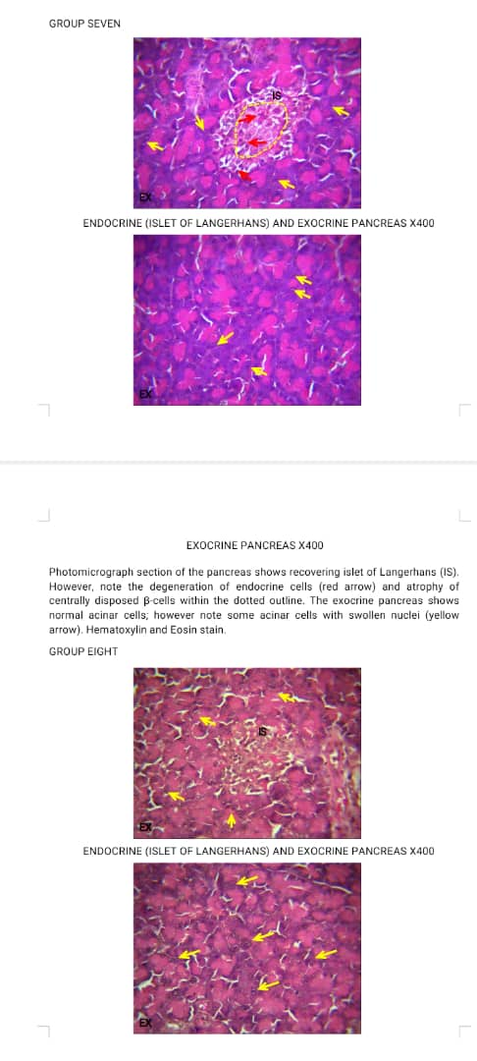 |  | 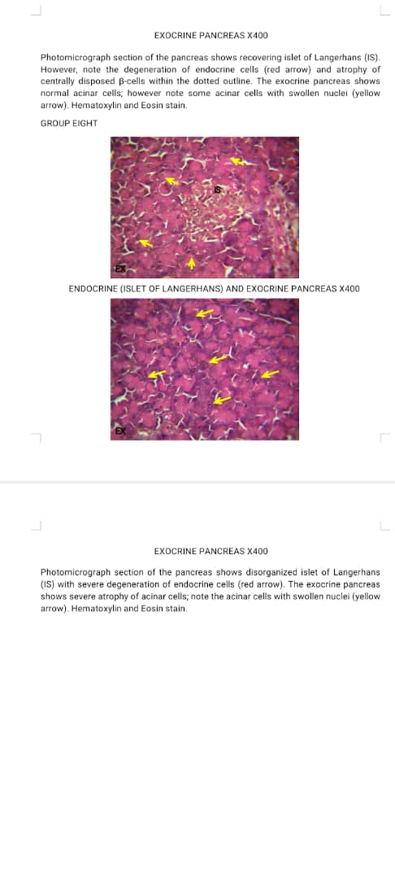
HFAD7 Islet of Langerhans | HFAD7 Exocrine Pancreas | HFAD8 Islet of Langerhans | HFAD8 Exocrine Pancreas
H&E X400
The pancreas of the normal control (NEXC1) rats displayed intact islets of Langerhans with densely packed β-cells. In the diabetic control group (HFAD2), there was severe distortion of pancreatic islets, cellular necrosis, and loss of β-cell density, confirming alloxan-induced cytotoxicity. Treatment with clove extract restored the pancreatic histoarchitecture in a dose-dependent manner. The low-dose group showed partial regeneration of β-cells (HFAD3 – HFAD6), while the high-dose group (HFAD7 and HFAD8) exhibited nearly normal islet morphology comparable to the metformin-treated group. These observations indicate that clove may protect and stimulate regeneration of β-cells, thereby improving insulin secretion and glycaemic control.

Fig 5: Histology of the Liver
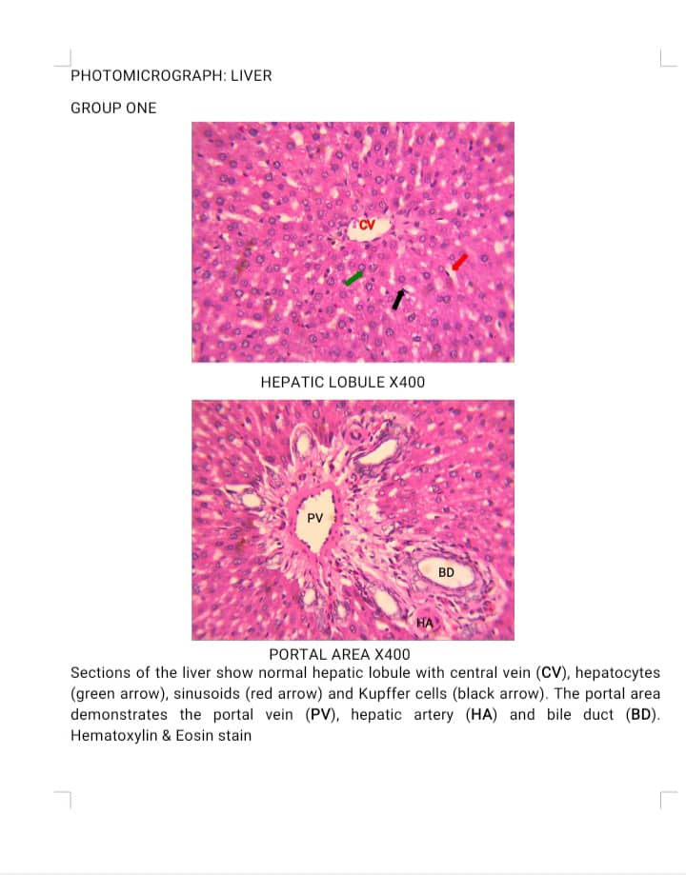 |  | 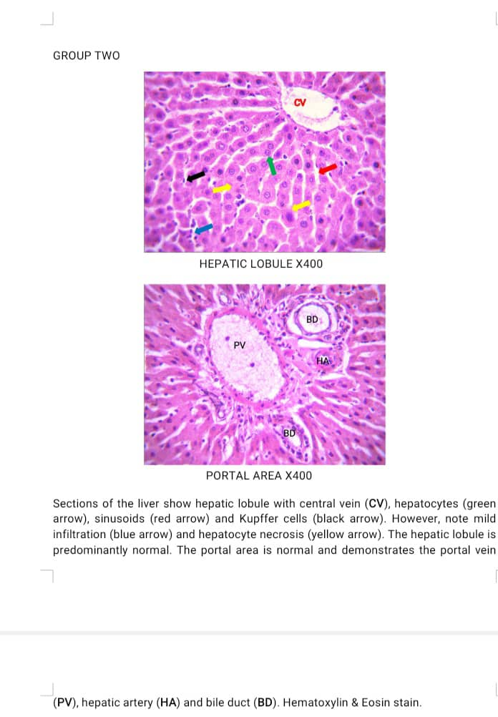
NEXC1 Hepatic Lobule | NEXC1 Portal Area | HFAD2 Hepatic Lobule | HFAD2 Portal Area
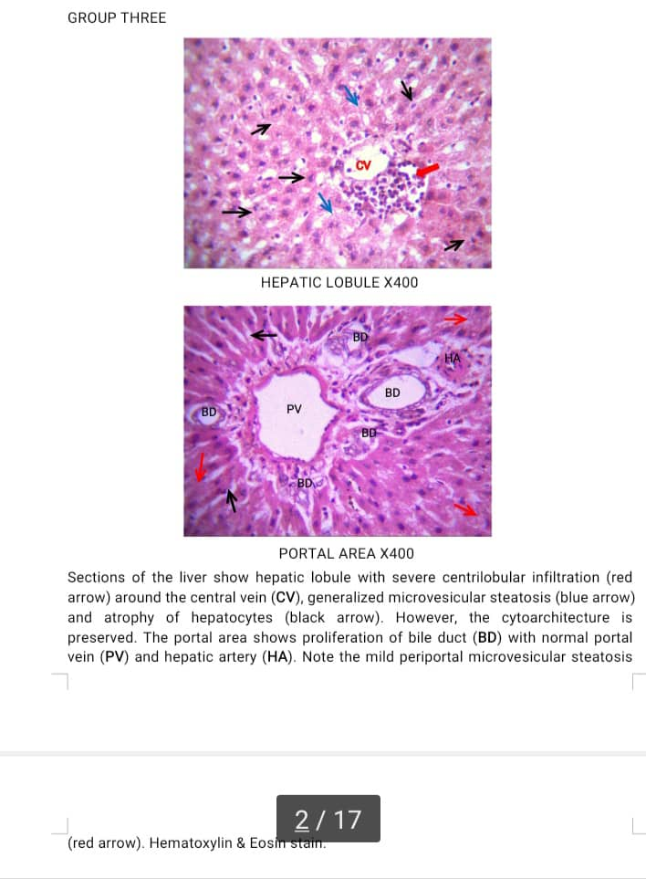 |  | 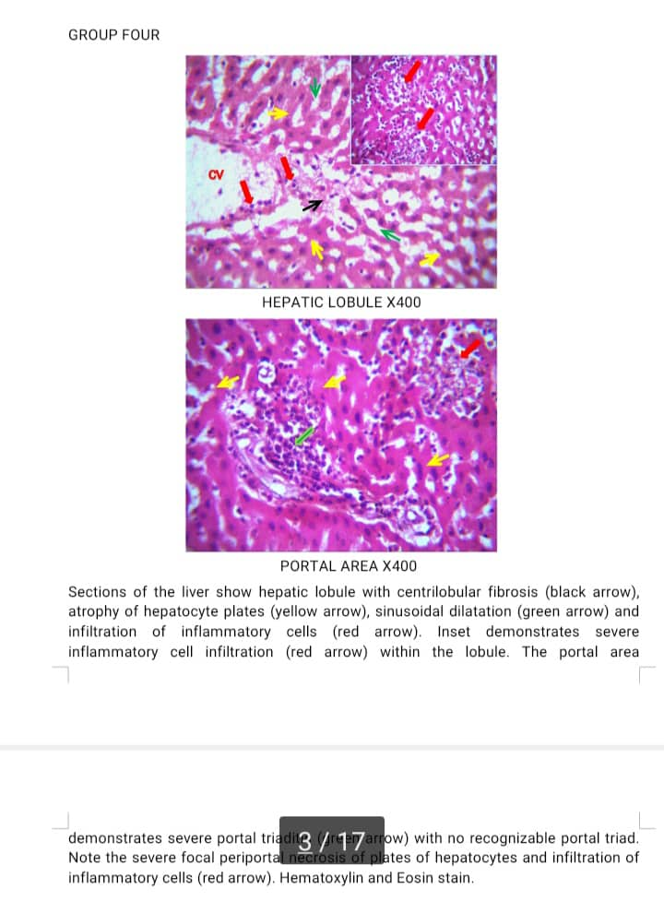
HFAD3 Hepatic Lobule | HFAD3 Portal Area | HFAD4 Hepatic Lobule | HFAD4 Portal Area
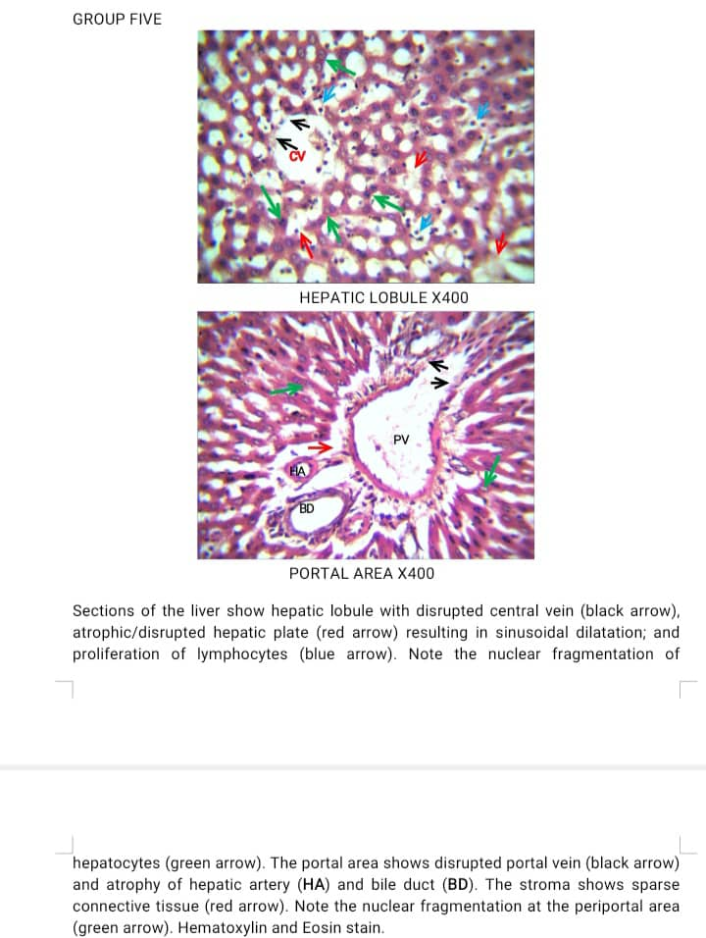 |  | 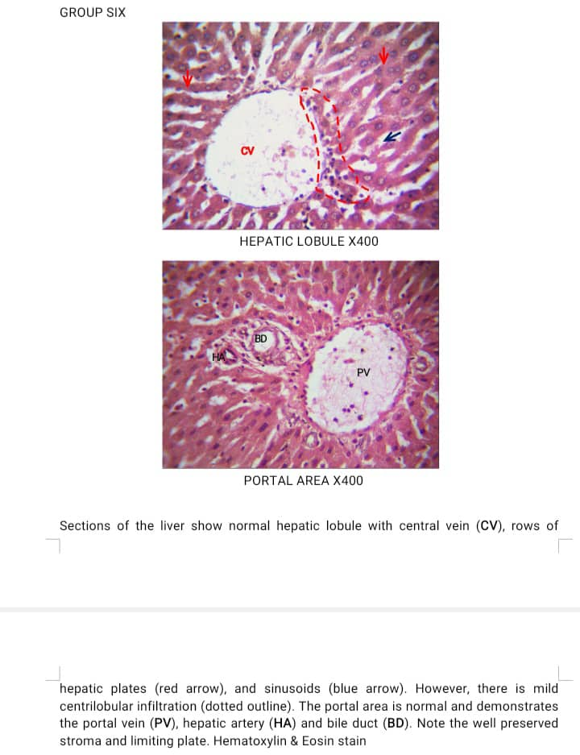
HFAD5 Hepatic Lobule | HFAD5 Portal Area | HFAD6 Hepatic Lobule | HFAD6 Portal Area
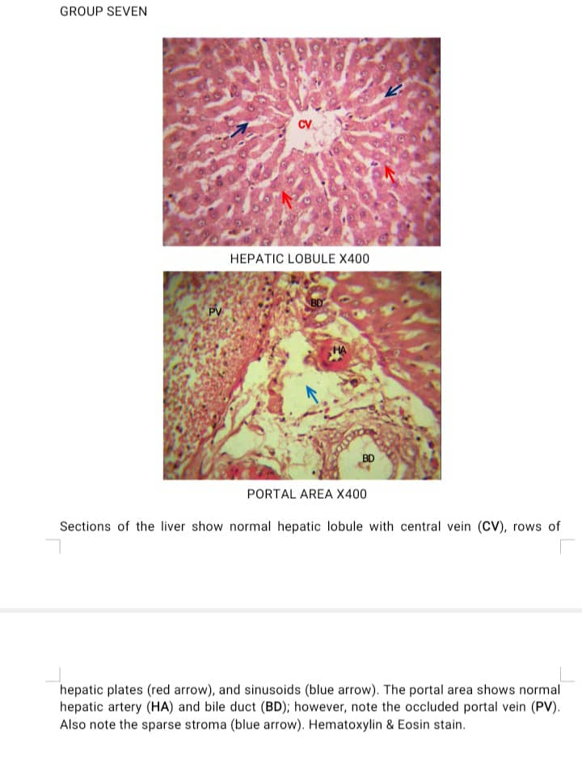 |  | 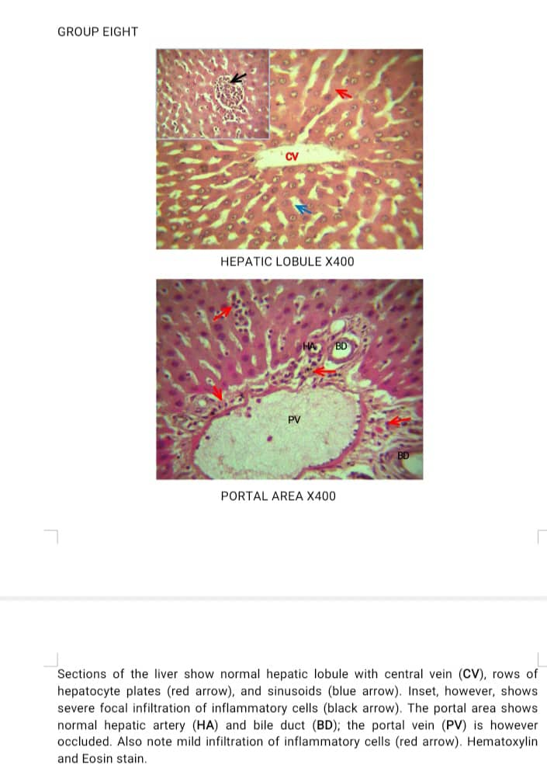
HFAD7 Hepatic Lobule | HFAD7 Portal Area | HFAD8 Hepatic Lobule | HFAD8 Portal Area
H&E X400
The liver sections of the NEXC1 rats revealed normal hepatic architecture, with well-arranged hepatocytes and clearly defined central veins. In contrast, diabetic control rats, HFAD2, showed vacuolar degeneration, congestion of the central vein, and inflammatory cell infiltration, indicating hepatic injury due to alloxan toxicity. However, treatment with clove extract produced dose-dependent improvements in liver histoarchitecture (HFAD3 – HFAD8). The hepatic cords appeared more organised, and there was a marked reduction in cytoplasmic vacuolation, particularly in the HFAD8, suggesting significant hepatoprotective activity of the extract.

Fig 6: Histology of the Kidney
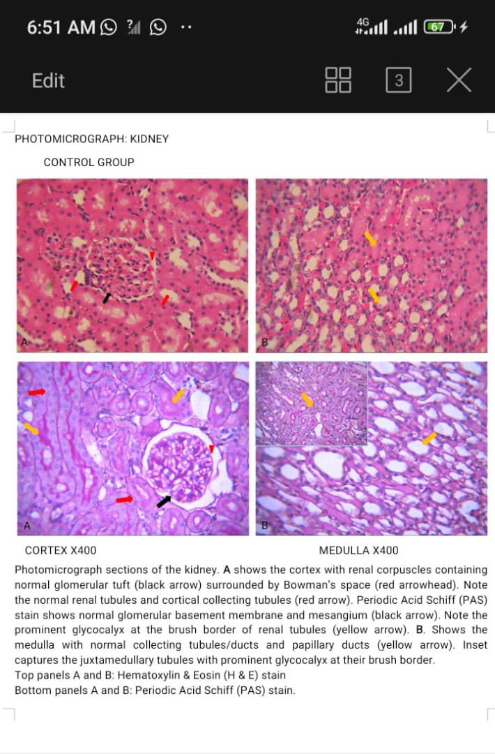 | 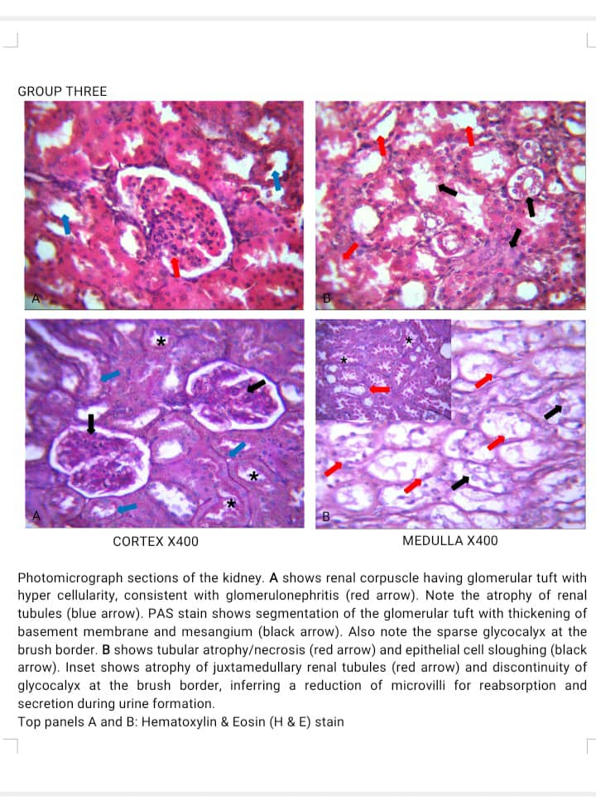
NEXC1 Cortex NEXC1 Medulla | HFAD2 Cortex HFAD2 Medulla
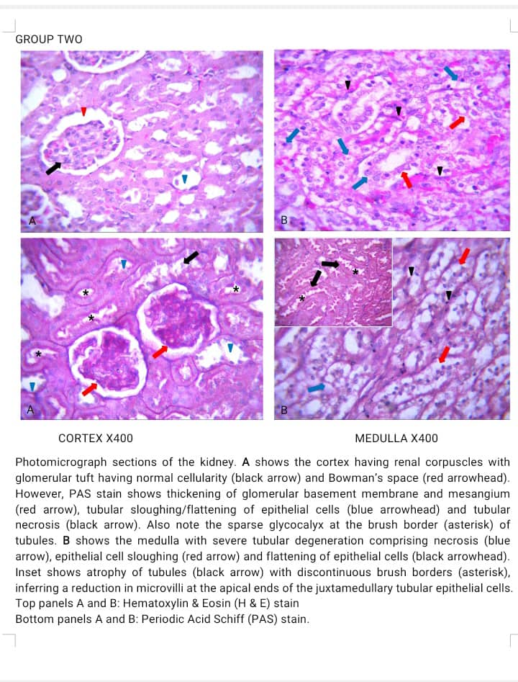 | 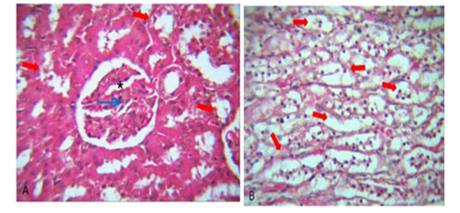
HFAD3 Cortex HFAD3 Medulla | HFAD4 Cortex HFAD4 Medulla
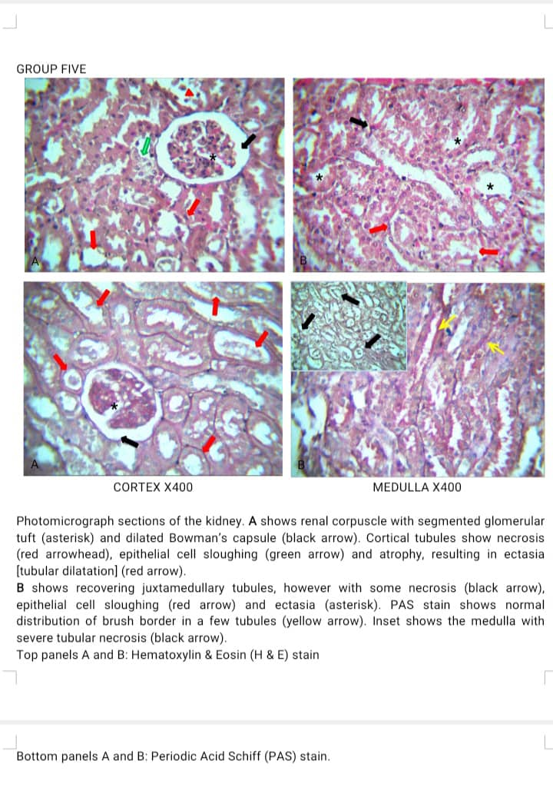 | 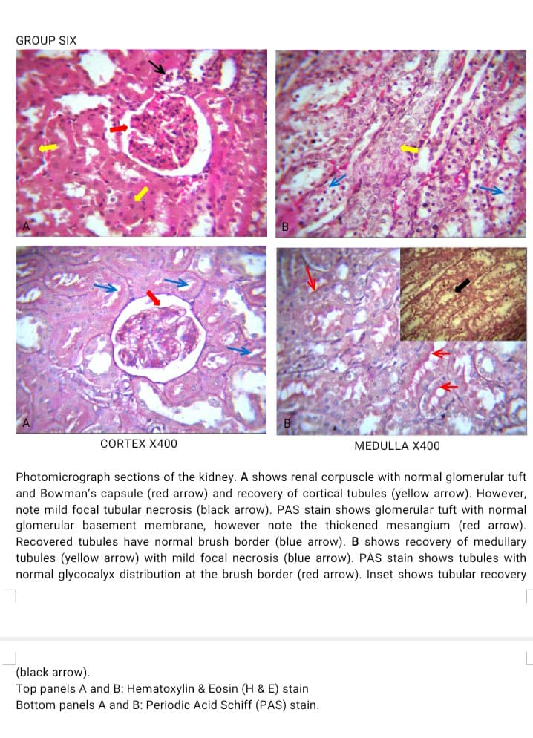
HFAD5 Cortex HFAD5 Medulla | HFAD6 Cortex HFAD6 Medulla
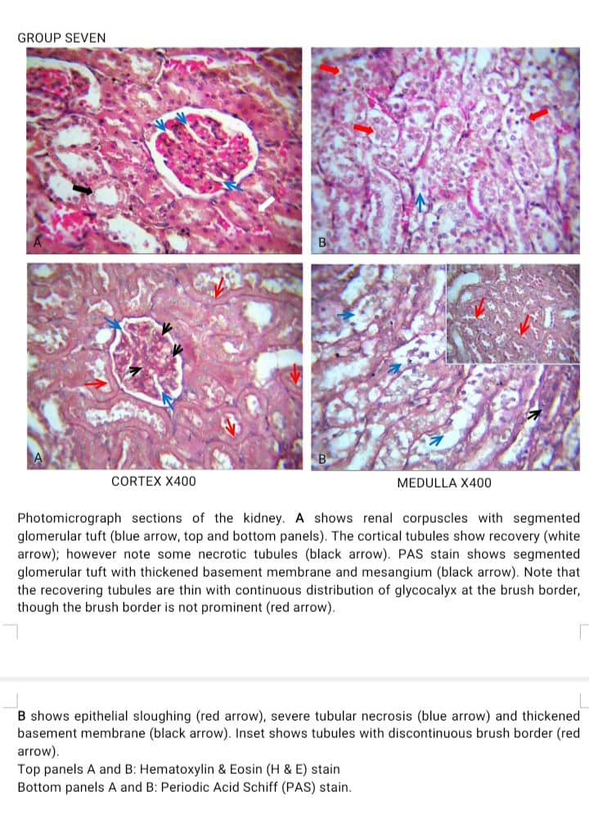 | 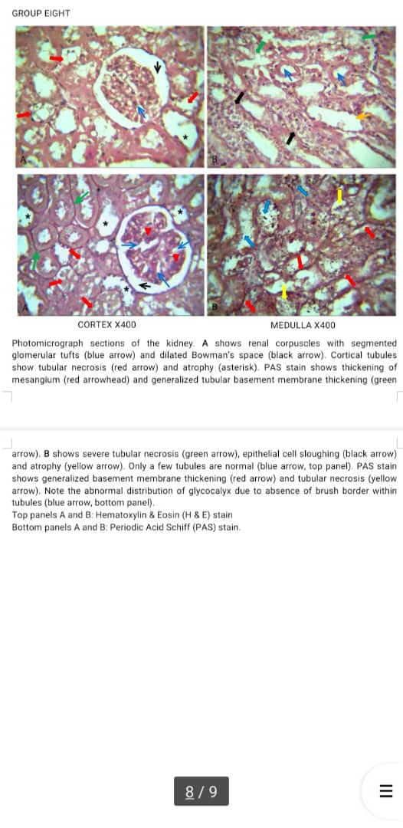
HFAD7 Cortex HFAD7 Medulla | HFAD8 Cortex HFAD8 Medulla
H&E X400
Histological examination of the kidneys of the control rats (NEXC1) revealed normal glomeruli, intact Bowman’s capsules, and well-arranged renal tubules. In the diabetic control rats (HFAD2), there was marked glomerular atrophy, tubular necrosis, and interstitial congestion, signifying nephrotoxic effects of alloxan. Treatment with clove extract reversed these histopathological alterations in a dose-dependent manner (HFAD3 – HFAD8). The high-dose clove extract–treated rats (HFAD8) showed near-normal renal architecture with reduced tubular degeneration and restored glomerular integrity, highlighting the nephroprotective effect of the plant extract.
Discussion
This study meticulously evaluated the ameliorative potential of aqueous extract of clove in alloxan-induced diabetic Wistar rats. Alloxan induction precipitated significant weight loss in diabetic controls (HFAD2), attributable to catabolic states involving gluconeogenesis from muscle proteins, lipolysis, and osmotic diuresis-induced dehydration, which are hallmarks of uncontrolled hyperglycaemia leading to dyslipidaemia, hyperketonaemia, and lactic acidosis (Emejuru et al. 2023; Gamde et al. 2023). Conversely, administration of clove extractelicited dose-dependent weight restoration, most pronounced at 2500 mg kg⁻¹ (HFAD8), suggesting anabolic promotion via improved nutrient utilisation and reduced metabolic wastage.
Fasting blood glucose escalated dramatically in diabetic controls (10.47 ± 5.28 mmol/L), validating alloxan's β-cytotoxic mechanism via ROS-induced DNA fragmentation and GLUT-2 transporter-mediated uptake (Elsner et al. 2002). Treatment with clove extract yielded significant (p<0.05) dose-responsive decrements: 4.80 ± 0.29 (HFAD4), 5.03 ± 0.24 (HFAD5), 4.65 ± 0.49 (HFAD6), 5.39 ± 0.36 (HFAD7), and 4.81 ± 0.48 mmol/L (HFAD8). Paralleling this, serum α-amylase activity, pivotal in starch hydrolysis and postprandial glucose surges, diminished from 47.70 ± 33.05 mmol/L in controls to 28.72–35.74 mmol/L across doses. This inhibitory effect likely stems from phytochemical interactions with α-amylase's active site, delaying carbohydrate digestion and attenuating glucose absorption, mirroring mechanisms of acarbose-like inhibitors (Longe et al. 2014). Eugenol and flavonoids may further enhance peripheral glucose uptake via GLUT-4 translocation, stimulate residual β-cell insulin secretion, and ameliorate insulin resistance through PPAR-γ agonism or PI3K/Akt pathway activation (Ajiboye et al. 2002; Ogboye et al., 2018).
Hepatic involvement in DM is profound, given the liver's role in glycogenolysis, gluconeogenesis, and insulin clearance. Diabetic rats exhibited elevated ALT (marker of hepatocellular injury) and AST (indicative of mitochondrial damage), reflecting ROS-mediated membrane peroxidation and disrupted amino acid/carbohydrate metabolism, potentially compromising ATP synthesis (Yusuf et al. 2018). Clove extract intervention normalised ALT and AST (p<0.05) across doses, with no significant ALP perturbation, implying selective hepatoprotection without cholestatic interference. This restoration posits clove's phenolic constituents as stabilisers of hepatocyte membranes, inhibitors of lipid peroxidation, and enhancers of phase II detoxification enzymes (e.g., glutathione-S-transferase).
Diabetic nephropathy, characterised by glomerular hyperfiltration, mesangial expansion, and tubular dysfunction, elevates serum urea, creatinine and disrupts Na⁺/K⁺ balance, fostering nephrosclerosis and electrolyte imbalances (Onyegeme-Okerenta et al., 2018). Alloxan-induced rats displayed these aberrations, rectified dose-dependently by the extract, with optimal efficacy at 1000 mg kg⁻¹. Phenolic compounds, notably eugenol and ellagic acid, likely underpin this nephroprotection by scavenging ROS, inhibiting advanced glycation end-products (AGEs) formation, and modulating renin-angiotensin system activity, thereby preserving glomerular filtration rate and tubular reabsorption (Ganesan et al. 2018; Oboh et al., 2019; Aguwamba et al., 2022).
Oxidative stress underpins DM pathogenesis, with hyperglycaemia fuelling mitochondrial electron transport chain overload, polyol pathway activation, and AGEs accumulation, yielding excess ROS and impaired antioxidants. Diabetic controls manifested heightened MDA (lipid peroxidation proxy) and NO (nitrosative stress mediator), alongside depleted SOD (O₂⁻• dismutase), CAT (H₂O₂ decomposer), and GSH (non-enzymatic scavenger). Extract treatment significantly (p<0.05) reversed these: reducing MDA/NO while augmenting SOD/CAT/GSH, often to levels indistinguishable from normal/metformin controls. This antioxidant prowess is ascribed to eugenol's direct ROS quenching (via phenolic hydroxyl donation), quercetin-mediated Nrf2 activation (upregulating antioxidant response elements), and overall phenolic synergy (Oboh et al., 2017). Notably, lower doses (500–1500 mg kg⁻¹) showed mild elevations in NO/GSH/MDA versus controls, suggesting threshold-dependent efficacy. DM induces haematological anomalies via ROS-mediated erythrocyte fragility, suppressed erythropoietin, and inflammatory cytokine surges (Obeagu, 2024; Tkachenko et al., 2025). Untreated diabetics presented anaemia (decreased PCV, Hb, RBC) and WBC fluctuations (indicative of immune dysregulation). Extract of clove administration restored these parameters, implying haematopoietic stimulation, membrane stabilisation, and anti-inflammatory effects, potentially via flavonoid inhibition of NF-κB and promotion of iron bioavailability (Rupasinghe & Jayasinghe, 2024; Antoniadou et al., 2025).
Microscopic examination reinforced biochemical data. Diabetic pancreatic sections revealed atrophic islets, β-cell necrosis, and ductal absence, which are hallmarks of alloxan cytotoxicity. Hepatic tissues showed vacuolar degeneration, inflammatory infiltrates, and cord disarray; renal sections exhibited glomerular atrophy, tubular necrosis, and interstitial congestion (Zou et al., 2024). These findings evoke type 1 DM-like insulinitis (lymphocytic infiltration), underscoring immune-modulatory potential. However, clove extract-treated groups, especially at 1500 – 2500 mg kg⁻¹, displayed remarkable regeneration: reconstituted β-cells (possibly via flavonoid-induced proliferation or anti-apoptotic Bcl-2 upregulation), normalised hepatocytes, and preserved glomeruli/Bowman's capsules. Lower doses showed partial recovery, attributable to experimental duration or dose thresholds, and extended washout (Onyegeme-Okerenta et al., 2017; Ahmed et al., 2023; Emejuru et al., 2023).
Conclusion
This study demonstrated that aqueous extract of clove possesses significant antidiabetic and antioxidant effects in alloxan-induced diabetic Wistar rats. The extract improved glycaemic control, enhanced endogenous antioxidant defence through elevation of SOD, CAT and GSH levels, and reduced oxidative stress as evidenced by lowered MDA and nitric oxide concentrations. Additionally, the extract restored altered haematological parameters and mitigated histopathological damage to the liver, pancreas, and kidney, suggesting protective and regenerative potential. These findings justify the ethnomedicinal use of clove in the management of diabetes mellitus and its associated complications and can serve as a viable therapeutic agent for nutraceutical development in low-resource settings like Nigeria.
References
Aguwamba, C. (2022). Effect of Hunteria umbellata ethanolic seed extracts on streptozotocin-induced diabetic albino rats. Asian Journal of Biochemistry, Genetics and Molecular Biology, 12(3), 14-27.
Ahmed, O.M., Abdel Fattah, A.A., Abdul-Hamid, M., Abdel-Aziz, A.M., Sakr, H.I., Damanhory, A.A., Abdel-Kawi, S.H., Ghaboura, N., & Awad, M.M.Y. (2023). Antidiabetic and Liver Histological and Ultrastructural Effects of Cynara scolymus Leaf and Flower Head Hydroethanolic Extracts in Nicotinamide/Streptozotocin-Induced Diabetic Rats. Evidence-Based Complementary and Alternative Medicine: ECAM, 2023, 4223026. https://doi.org/10.1155/2023/4223026.
Ajiboye, T.O., Hussaini, A.A., Nafiu, B.Y., & Ibitoye, O.B. (2017). Aqueous seed extract of Hunteria umbellata (K. Schum.) Hallier f. (Apocynaceae) palliates hyperglycaemia, insulin resistance, dyslipidaemia, inflammation and oxidative stress in high-fructose diet-induced metabolic syndrome in rats. Journal of Ethnopharmacology, 198(1), 184–193.
Antar, S.A., Ashour, N.A., Sharaky, M., Khattab, M., Ashour, N.A., Zaid, R.T., Roh, E.J., Elkamhawy, A., & Al-Karmalawy, A.A. (2023). Diabetes mellitus: Classification, mediators, and complications; A gate to identify potential targets for the development of new effective treatments. Biomedicine & Pharmacotherapy, 168, 115734. https://doi.org/10.1016/j.biopha.2023.115734
Antoniadou, C., Gavriilidis, E., Ritis, K., & Tsilingiris, D. (2025). Anemia in diabetes mellitus: Pathogenetic aspects and the value of early erythropoietin therapy. Metabolism Open, 25, 100344. https://doi.org/10.1016/j.metop.2024.100344.
Batiha, G.E., Luay, M.A., Lamiaa, G., Wasef, A.M.B., Eman, H.N., & Eman, K.R. (2020). Clove L. (Myrtaceae): Traditional Uses, Bioactive Chemical Constituents, Pharmacological and Toxicological Activities. Biomolecule, 10(202), 1-16.
Bukhari, H.A., Afzal, M.A.F., Sheikh, R.A., Alqurashi, M.M., Bawadood, A.S., Alzarea, S.I., Alamri, A., Sayyed, N., & Kazmi, I. (2024). In vivo and computational investigation of butin against alloxan-induced diabetes via biochemical, histopathological, and molecular interactions. Scientific Reports, 14(1), 1-26. https://doi.org/10.1038/s41598-024-71577-y.
Dubale, S., Usure, R.E., Mekasha, Y.T., Hasen, G., Hafiz, F., Kebebe, D., & Suleman, S. (2025). Traditional herbal medicine legislative and regulatory framework: A cross-sectional quantitative study and archival review perspectives. Frontiers in Pharmacology, 16, 1475297. https://doi.org/10.3389/fphar.2025.1475297.
Elsner, M., Tiedge, M., Guldbakke, B., Munday, R., & Lenzen, S. (2002). Importance of the GLUT2 glucose transporter for pancreatic beta cell toxicity of alloxan. Diabetologia, 45(11), 1542–1549. https://doi.org/10.1007/s00125-002-0955-x.
Emejuru, S.W., Onyegeme-Okerenta, B.M. and Amadi, B.A. (2023). The ameliorative potential of aqueous extract of Hunteria unbellata on alloxan-induced diabetes and hyperlipidemia in Wistar rats. Scientia Africana, 22(3): 299-318. https://dx.doi.org/10.4314/sa.v22i3.27
Gamde, S.M., Ugwah-Oguejiofor, C.J., Garba, A., Avwioro, G.O., Moronkeji, A., & Jimoh, A.A. (2023). Histologic and Biochemical Effect of Balanite aegyptiaca Fruit Extract on Alloxan-Induced Diabetes in Wistar Rats. Ethiopian Journal of Health Sciences, 33(3), 441–450.
Ganesan, D., Al‐Sayed, E., Albert, A., Paul, E., Singab, A.N.B., Selvam, G.S., & Saso, L. (2018). Antioxidant activity of phenolic compounds from extracts of Eucalyptus globulus and Melaleuca styphelioides and their protective role on D-glucose-induced hyperglycemic stress and oxalate stress in NRK-49Fcells. Natural Product Research, 32(11), 1274–1280.
Kiernan, J.A. (2008). Histological and Histochemical Methods: Theory and Practice. 4th Edn. Scion, Bloxham, UK.
Li, X., & Yun, M. (2025). The impact of sulfonylureas on diverse ion channels: An alternative explanation for the antidiabetic actions. Frontiers in Cell and Developmental Biology, 13, 1528369. https://doi.org/10.3389/fcell.2025.1528369.
Li, Y., Liu, Y., Liu, S., Gao, M., Wang, W., Chen, K., Huang, L., & Liu, Y. (2023). Diabetic vascular diseases: Molecular mechanisms and therapeutic strategies. Signal Transduction and Targeted Therapy, 8(1), 1-29. https://doi.org/10.1038/s41392-023-01400-z.
Longe, A.O., & Momoh, J. (2014). Effects of methanolic seed extract of Hunteria umbellata (abeere) on blood glucose level, hematological and lipid profile parameters in alloxan-induced diabetes in male rats. Pinnacle of Medicine & Medical Science, 1(2), 225- 230.
Meka, I.A., Okwor, C.J., Arum, E.J., Otokunefor, O., Anyim, O.B., & Ogamba, M.I. (2025). Short and long-term glycemic control among Type 2 DM patients in a resource-limited setting. African Health Sciences, 25(2), 176. https://doi.org/10.4314/ahs.v25i2.23.
Obakiro, S.B., Kiyimba, K., Lukwago, T.W., Lulenzi, J., Owor, R.O., Andima, M., Hokello, J.F., Kawuma, C., Nantale, G., Kibuule, D., Anywar, G., Waako, P., & Gavamukulya, Y. (2023). Ethnobotanical study of plants used in management of diabetes mellitus in Eastern Uganda. Phytomedicine Plus, 3(4), 100486. https://doi.org/10.1016/j.phyplu.2023.100486.
Obeagu, E.I. (2024). Red blood cells as biomarkers and mediatorsin complications of diabetes mellitus: A review. Medicine, 103:8(e37265).
Oboh, G., Adebayo, A.A., Ademosun, A.O., & Aegunde, O.A. (2019). Aphrodisiac effect of Hunteria umbellata seed extract: modulation of nitric oxide level ad arginase activity in vivo. Pathophysiology, 26(1), 39-47.
Oboh, G., Olasehinde, T. A., & Ademosun, A.O. (2017). Inhibition of enzymes linked to type-2 diabetes and hypertension by essential oils from peels of orange and lemon. International Journal of Food Properties. 20(1), S586–S594.
Ogboye, P.O., Onyegeme-Okerenta B.M., & Monago-Ighorodje, C.C. (2018). Proximate Composition, Antioxidant and Hypoglycaemic Potential of Aqueous Extracts of Seeds of Delonix regia on High Fat Diet and Streptozotocin-Induced Diabetes in Female Wistar Rats. Clinical and Experimental Medical Sciences, 6(1), 33 – 46.
Onyegeme-Okerenta, B.M., & Anacletus, F. (2017). Hypoglycaemic and hypolipidaemic potentials of Sennaalata and its effect on the pancrease of Alloxan –diabetic induced Albino – Rats. Journal of Applied Life Sciences International, 11(1), 1-10.
Onyegeme-Okerenta, B.M., Ogboye, P.O., Monago-Ighorodje, C. (2018). Ameliorative Effect of Aqueous Extracts of Seeds of Delonix regia (Hook) Raf on the Liver, Kidney and Spleen of High-fat Diet Streptozotocin-induced Diabetes in Female Wistar Rats. European Journal of Medicinal Plants, 25(2), 1-14.
Petkov, C.I., Flecknell, P., Murphy, K., Basso, M.A., Mitchell, A.S., Hartig, R., & Thompson-Iritani, S. (2022). Unified ethical principles and an animal research ‘Helsinki’ declaration as foundations for international collaboration. Current Research in Neurobiology, 3, 100060. https://doi.org/10.1016/j.crneur.2022.100060.
Praveen, N., Felic, S., Sabu, K.K., Grant, G.G.C.J. (2024). A Review on Diabetes Pathophysiology, Pharmacological Treatments, and Lifestyle Interventions: Review Article. Journal of Pharma Insights and Research, 2(4), 223-233. https://doi.org/10.69613/ch8rgd71
Rupasinghe, S., & Jayasinghe, I.K. (2024). Prevalence and associated factors of anaemia in patients with type 2 diabetes mellitus: a cross-sectional study in a tertiary care medical unit, Sri Lanka. BMC Endocrine Disorders 24, 156 https://doi.org/10.1186/s12902-024-01681-7.
Sreedevi, A., Pillai, G.S., Sathish, S., Numpeli, M., Menon, V.B., Varughese, S.A., Georgy, S., Najeeb, S.S., Selvam, S., Menon, J.C., Ajay, A., Mohandas, N.V., Nair, R.R., Rijju, V., Radhakrishnan, R.K., Nai, P. (2025). Prevalence and determinants of complications of type 2 diabetes in a community screening program in Kerala. BMJ Public Health, 3:e002333. https://doi.org/10.1136/bmjph-2024-002333.
Tegegne, B.A., Adugna, A., Yenet, A., Yihunie Belay, W., Yibeltal, Y., Dagne, A., Hibstu Teffera, Z., Amare, G.A., Abebaw, D., Tewabe, H., Abebe, R.B., & Zeleke, T.K. (2024). A critical review on diabetes mellitus type 1 and type 2 management approaches: From lifestyle modification to current and novel targets and therapeutic agents. Frontiers in Endocrinology, 15, 1440456. https://doi.org/10.3389/fendo.2024.1440456.
Tkachenko, A., Alfhili, M. A., Alsughayyir, J., Attanzio, A., Bukowska, B., Cilla, A., Föller, M., Havranek, O., Jilani, K., Onishchenko, A., Pretorius, E., Prokopiuk, V., Restivo, I., Tesoriere, L., Virzì, G.M., & Wieder, T. (2025). Current understanding of eryptosis: Mechanisms, physiological functions, role in disease, pharmacological applications, and nomenclature recommendations. Cell Death & Disease, 16(1), 1-36. https://doi.org/10.1038/s41419-025-07784-w.
Usoh, I.F., Akpan, E.J., Etim, E.O., & Farombi, E.O. (2005). Antioxidant actions of dried flower extracts of Hibiscus sabdariffa L. on sodium arsenite-induced oxidative stress in rats. Pakistan Journal of Nutrition, 4(3)135-141..
Xie, X., Wu, C., Hao, Y., Wang, T., Yang, Y., Cai, P., Zhang, Y., Huang, J., Deng, K., Yan, D., & Lin, H. (2023). Benefits and risks of drug combination therapy for diabetes mellitus and its complications: A comprehensive review. Frontiers in Endocrinology, 14, 1301093. https://doi.org/10.3389/fendo.2023.1301093.
Yusuf, A. J., Baiyewu, O., Bakari, A., Garko, S. B., Jibril, M. E., Suleiman, A. M., Muktar, H. M., & Amedu, M. A. (2018). Low education and lack of spousal relationship are associated with dementia in older adults with diabetes mellitus in Nigeria. Psychogeriatrics, 18(3), 216–223.
Zhao, K., Wonta, K.B., Xia, J., Zhong, F., & Sharma, V. (2024). Phytochemical profiling and evaluation of antimicrobial activities of common culinary spices: Clove (clove) and Piper nigrum (black pepper). Frontiers in Nutrition, 11:1447144. doi: 10.3389/fnut.2024.1447144.
Zou, J., Chen, Q., Wu, M., Lin, F., & Zhang, L. (2024). A rare concurrence of acute tubular necrosis and chronic glomerular sclerosis in a patient with wasp stings. Heliyon, 10(14), e34353. https://doi.org/10.1016/j.heliyon.2024.e34353.

