Original Research Article
Impact of Cold Chain Disruption on Food Safety and Economic Losses: A Case Study of Frozen Food Imports from France to Togo

.
ABSTRACT

ABSTRACT
Aims: The primary objective of this study was to assess the microbiological, sensory, and financial repercussions of a cold chain disruption affecting frozen food commodities imported from France to Togo. The study aimed to validate a multi-integrated framework for post-incident risk assessment to distinguish between food safety risks and quality degradation while quantifying economic prejudice.
Study design: This work employs a descriptive and analytical cross-sectional study design.
Place and Duration of Study: The investigation was conducted at the Port of Lomé, the Laboratory of Biochemistry Applied to Nutrition and Food Sciences (University of Lomé), and the Institut National d’Hygiène (INH) in Lomé, Togo, between December 2024 and March 2025.
Methodology: A shipment of frozen products (18,689 kg) subjected to a documented 72-hour temperature excursion (peaking at +2°C) was analyzed. A comprehensive forensic evaluation was performed on 135 samples (105 test and 30 control) across five product categories. The methodology integrated four dimensions: (1) thermal traceability using a TempTale® Ultra data logger; (2) visual physical inspection for macroscopic deterioration; (3) microbiological screening for pathogens (Listeria monocytogenes, Salmonella spp.) according to ISO 6579 and NF V08-059 standards; and (4) sensory profiling using a 70-member panel and ANOVA statistics. Economic loss was quantified based on damaged inventory and auxiliary logistical costs.
Results: Visual auditing identified macroscopic deterioration, including deformation and recrystallization, in 350 cartons (2,153.8 kg), representing 11.52% of the total cargo mass. Despite the thermal stress, microbiological analyses confirmed 100% compliance with safety standards, with no pathogenic proliferation detected in any samples. However, sensory evaluation revealed specific organoleptic failures; while most matrices remained stable, Whole Camembert (250g) exhibited significant textural degradation (friability) compared to controls (p < 0.05). The total economic prejudice was established at €25,749.11, representing 22.65% of the shipment's initial valuation. Notably, auxiliary costs (logistics, expertise, destruction) effectively doubled the financial burden of the direct product loss.
Conclusion: The findings indicate that while short-duration thermal excursions may not compromise microbiological safety, they induce critical physical and sensory degradation that necessitates economic write-offs. The study highlights vulnerabilities in the "last mile" of West African logistics and underscores the necessity for resilient thermal monitoring and power supply protocols to mitigate economic wastage.

Keywords: [Cold chain integrity, frozen foods, microbiological safety, sensory analysis, economic loss, Togo }

1. INTRODUCTION
Refrigeration serves as a critical technological barrier against food deterioration, effectively mitigating a spectrum of deleterious processes ranging from microbiological proliferation and physiological senescence to biochemical oxidation and physical moisture loss (James & James, 2014). Consequently, it plays a pivotal role in ensuring food safety and quality while addressing the escalating global demand for food security. An efficient cold chain is a fundamental prerequisite in the logistics of perishable goods, spanning transport, storage, and distribution to preserve the intrinsic value of products (Munoz, 2018)
Any significant deviation from these thermal requirements, whether during maritime transit, port handling, or final distribution, can precipitate quality degradation, rendering products unfit for human consumption. In maritime logistics, reefer containers are engineered to maintain frozen products between –18°C and –25°C. However, evidence suggests that technical failures, power interruptions, or suboptimal handling practices frequently induce cold chain breaks (CCB). Even short-duration thermal abuses can lead to irreversible consequences (Jedermann et al., 2009).
The implications of CCB are multifaceted. Microbiologically, even temporary temperature elevations can facilitate the resuscitation and growth of pathogenic bacteria such as Listeria monocytogenes, Salmonella spp., and Escherichia coli, while accelerating fungal proliferation, particularly in animal-derived products (Mu et al., 2017). Furthermore, thermal fluctuations significantly curtail shelf life, potentially reducing the useful life of sensitive products like cheese, salmon, or poultry by 25% to 57% (Ndraha et al., 2018). From a physico-chemical perspective, such fluctuations catalyze protein denaturation, lipid oxidation, and textural degradation (Giannakourou & Taoukis, 2003). These alterations inevitably compromise the sensory profile of the food, negatively impacting consumer acceptance (Hsiao et al., 2018; Ndraha et al. 2018 ; Ndraha et al., 2019 ; Yuan et al., 2024). Beyond safety and quality, these inefficiencies contribute to substantial economic burdens. Approximately 15% of food losses within the logistics sector are attributed to temperature mismanagement, translating to nearly 200 million tons of global waste annually (Kawińska & Zalewski, 2022).
These challenges are disproportionately acute in developing nations, particularly within the Sub-Saharan African context. In countries like Togo, port infrastructures often face significant constraints regarding the availability of reliable energy sources for reefer containers and the implementation of continuous thermal monitoring protocols (Castelein et al., 2019). The logistical "last mile" and port-side handling in high-ambient temperature zones pose severe risks. Even where equipment exists, maintenance gaps and distinct deficiencies in technical training, particularly within public structures, hamper efficacy (James & James, 2014). Consequently, these structural vulnerabilities lead to considerable losses of imported perishables due to inadequate storage and ineffective thermal control (Kitinoja, 2013).
Given the heightened risk of cold chain disruption at the Port of Lomé, a strategic hub for West Africa, it is imperative to adopt a rigorous, multidimensional assessment framework when failures are suspected. The integration of microbiological, physico-chemical, sensory, and economic analyses is increasingly recognized as the gold standard for post-incident risk assessment (EFSA, 2021). This study applies such an integrated approach to evaluate the consequences of a documented cold chain break on a shipment of frozen foods imported from France to Togo. Following the detection of a thermal excursion upon arrival, a comprehensive forensic evaluation was conducted to determine the sanitary conformity, quality retention, and economic impact of the incident.

2. material and methods
2.1. Study design
This work employs a descriptive and analytical cross-sectional study design. The primary objective was to evaluate the impact of a confirmed cold chain break on frozen food commodities imported via maritime freight. The assessment methodology integrates four complementary dimensions : visual physical inspection, microbiological safety testing, sensory (organoleptic) analysis, and economic loss quantification.
2.2. Sampling and product categorization
The study analyzed a shipment of frozen products weighing 18,689 kg, imported from France and received at the Port of Lomé, Togo. A total of 135 representative samples were selected for detailed analysis. The cargo comprised five distinct categories:
- Raw animal proteins: Beef chuck, meatballs, and capon.
- Cooked animal proteins: Sautéed chicken and smoked salmon.
- Dairy products: Various butters (Héritage, Isigny, Président) and cheeses (Old Porche Camembert, Emmental, Fourme d’Ambert, Cantal, Comté, Gouda, and whole Camembert).
- Vegetables and starchy foods: Extra-fine peas, green beans, sliced onions, mixed vegetables (macédoine), and hash browns (pommes rissolées).
- Desserts: Caramel praline crumble.
Following the detection of the incident on December 23, 2024, the entire shipment was immediately placed in emergency negative cold storage (-20°C) at the port facility to halt further degradation. Samples for microbiological and sensory analysis were drawn from this stabilized stock in February 2025. A total of 135 samples were analyzed, comprising 105 test samples (5 per product category) and 30 control samples taken from compliant batches of identical brands.
2.3. Thermal traceability and monitoring
Temperature history throughout the supply chain was monitored using a TempTale® Ultra (Sensitech) data logger positioned within the container. The shipment departed France on November 4, 2024, with a scheduled arrival in Lomé on November 26, 2024. The total valuation of the container, including goods and logistics, was €113,670.04. The container was offloaded at the Port of Lomé on December 17, 2024. Data retrieval indicated compliance with frozen storage standards until December 19, 2024. A critical thermal excursion was recorded starting December 20, 2024, at 14:30 GMT, attributed to a disconnection from the power supply. The internal temperature rose from -15.15°C to +2°C by December 23, 2024, marking a continuous cold chain rupture of 72 hours (Figure 1).
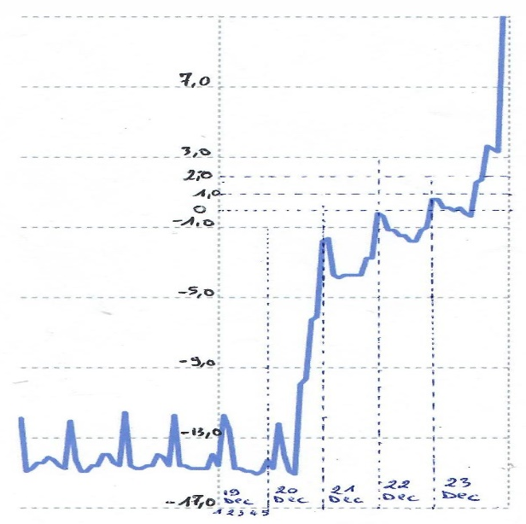
Figure 1: Temperature traceability curve of the Thermobutton
2.4. Physical and visual inspection
A systematic visual inspection was conducted to assess physical integrity. This was performed as a joint inspection involving the Quality, Health, Safety, and Environment (QHSE) team of the importing company (December 23, 2024), an independent insurance surveyor (January 7, 2025), and the Togolese Directorate of Livestock (February 18, 2025). Evaluation criteria focused on packaging integrity (deformation, crushing, moisture saturation) and product state (presence of recrystallized ice, signs of thawing/refreezing, texture collapse).
2.5. Microbiological analysis
To verify food safety, microbiological assays were performed on 135 samples (5 samples per suspected product type). Analyses were conducted in a comparative expertise framework involving the Institut National d’Hygiène (INH) in Lomé, Togo, and the exporter’s reference laboratory in France. The screening targeted hygiene indicators and specific pathogens in accordance with ISO 6579 and NF V08-059 standards. Parameters included aerobic mesophilic bacteria, total coliforms, coagulase-positive Staphylococci, Salmonella spp., and Listeria monocytogenes.
2.6. Sensory analysis
Sensory profiling was conducted between February 25 and March 11, 2025, using a panel of 70 untrained consumers selected for their familiarity with the product categories. For each tested item (e.g., peas, sliced onions, mixed vegetables), a composite of five samples was evaluated against control samples of the same brand and lot (where available) or compliant reference products. Raw products were cooked under identical standardized conditions prior to tasting. Attributes including taste, odor, texture, aroma, color, and general acceptability were rated using a standard 9-point hedonic scale. Statistical differences were evaluated using a one-way Analysis of Variance (ANOVA) followed by Tukey’s HSD post-hoc test (p < 0.05).

2.7. Economic evaluation
The economic impact assessment was restricted to lots identified as non-compliant via visual or laboratory inspection. The financial loss was calculated based on the volume of damaged goods (number of cartons and weight in kg), the unit value of the products, and associated direct costs. These costs included expenses for expert appraisal, laboratory certification, additional port storage during the investigation, and destruction of spoiled goods. Costs were calculated in Euros (€) and converted to West African CFA Francs (XOF) for local reporting.
]

3. results and discussion

3. RESULTS

3.1. Thermal profile of the container during the critical interval
3.1. Thermal profile analysis: Analysis of the data retrieved from the Thermo-button logger identified a critical cold chain breach spanning 72 hours (December 20–23, 2024). During this interval, the internal temperature rose significantly from a baseline of -15.15 °C to a peak of +2 °C (Figure 1). This excursion occurred during the handling phase at the Port of Lomé, where ambient tropical conditions pose a severe risk to frozen cargo

Figure 2: Curve showing the evolution of the container temperature during the critical period

3.2. Physical inspection and visual assessment
Physical inspections conducted upon the container’s clearance revealed substantial physical deterioration affecting approximately 350 cartons. This damaged volume corresponds to a total mass of 2,153.8 kg, representing 11.52% of the total cargo load (18,689 kg). The observed anomalies were primarily characterized by structural deformation or collapse of packaging, evidence of excessive internal condensation, and the presence of stagnant water within cartons containing vegetable products. Furthermore, signs of recrystallization and significant textural degradation were documented. Specifically, the Whole Camembert (250g) exhibited a loss of structural cohesiveness, resulting in a crumbly and friable texture inconsistent with the standard product profile.
Table 1: Inventory of Products Exhibiting Physical Alterations and Packaging Anomalies
Product type | Observed anomalies | Number of damaged cartons
Extra fine peas | Deformed/damaged cartons, thawed product, presence of ice crystals | 15
Hash browns (pommes rissolées) | Wet, deformed, and flattened cartons | 64
Sliced onions | Wet/flattened cartons, ice crystals, signs of thawing | 86
Green beans | Severely damaged cartons, thawed product | 20
Crumble cara pralin | Collapsed cartons, product degradation | 60
Whole camembert (250g) | Collapsed/damaged cartons, deformed and flattened product | 25
Camembert vieux porche | Damaged/deformed cartons, thawed product | 80
Total |  | 350

3.3. Microbiological safety evaluation
To assess the sanitary impact of the thermal breach, microbiological assays were conducted by the client’s reference laboratory in France (n=1) and the Institut National d’Hygiène (INH) in Togo (n=5). Results demonstrated full compliance with safety standards for human consumption across all suspected batches (Table 2). No pathogenic flora were detected, confirming the sanitary safety of the food products within the limits of their respective Expiry Dates (DLC), despite the recorded temperature fluctuations.

Table 2: Pathogen screening results by product type and laboratory
Data indicates absence of pathogens across all samples
Product type | Expiry date (DLC) | Reference Lab (n=1) | INH Togo (n=5)
Peas | 05/10/2025; 28/02/2027 | Absent | Absent
Green beans | 31/08/2026 | Absent | Absent
Mixed vegetables | 26/09/2026; 06/01/2027 | Absent | Absent
Sliced onions | 23/04/2027 | Absent | Absent
Hash browns | 18/03/2026; 31/08/2026 | Absent | Absent
Crumble cara pralin | 10/12/2025 | Absent | Absent
Butter (Héritage) | 09/04/2026 | Absent | Absent
Butter (Président) | 04/10/2025 | Absent | Absent
Butter (Isigny) | 23/09/2025 | Absent | Absent
Capon | 23/12/2025; 24/12/2025 | Absent | Absent
Cheese (Cantal) | 10/10/2025 | Absent | Absent
Cheese (Comté) | 30/09/2025; 10/10/2025 | Absent | Absent
Cheese (Fourme d’Ambert) | 11/07/2025 | Absent | Absent
Cheese (Gouda) | 15/10/2025 | Absent | Absent
Cheese (Emmental) | 14/10/2025 | Absent | Absent
Camembert Vieux Porche | 15/11/2025 | Absent | Absent
Whole Camembert | 08/11/2025 | Absent | Absent
Smoked Salmon | 28/02/2026 | Absent | Absent
Cooked Chicken Sauté | 30/12/ 2025; 30/04/2026 | Absent | Absent
Beef Chuck | 08/08/2026 | Absent | Absent
Beef Meatballs | 24/09/2026 | Absent | Absent

3.4. Sensory analysis
Sensory evaluation served as a critical complement to microbiological testing to determine organoleptic viability. During the observation period (February 25 – March 11, 2025), no adverse health events or intoxication were reported by the panel. Sensory profiles (detailed in Annex 3) indicated that the majority of suspected dairy products (butters and cheeses including Emmental, Fourme d’Ambert, and Gouda) maintained organoleptic characteristics statistically comparable to control samples (p > 0.05).
However, a divergence was noted for the Whole Camembert (250g). While this product scored higher than the control in terms of aroma, odor, and taste, its texture was rated significantly lower, being described as friable. The overall difference in acceptability for this specific product was statistically significant (p < 0.05). Conversely, evaluations for desserts, cooked and raw proteins (beef, poultry, salmon), and vegetable products revealed no significant sensory deviations between the thermal-abuse samples and controls (p > 0.05).

3.5. Economic loss estimation
The financial impact was stratified into direct product losses and associated auxiliary costs. While the physically damaged goods accounted for 11.52% of the cargo by weight, the total economic prejudice amounted to €25,749.11, representing 22.65% of the initial shipment valuation (Table 3). This discrepancy highlights that post-incident management ; including storage, expert appraisal fees, and destruction costs ; effectively doubles the financial burden of the physical loss itself.

Table 3 : Valuation of frozen cargo and logistics costs (€)

Item | Value (€)
Product Value | 103,780.00
Maritime Transport | 6,717.86
Local Transit Fees | 3,172.18
Total | 113,670.04

Direct financial losses were calculated referencing the specific quantity of damaged goods identified in the visual inspection (Table 4).

Table 4: Financial loss estimation for damaged goods (Values in XOF)
Product | Cartons | Quantity (Kg) | Unit price | Total (XOF)
Whole Camembert 250g | 25 | 75 | 19,593 | 489,834
Extra fine peas | 15 | 150 | 11,204 | 680,540
Hash browns | 64 | 640 | 11,538 | 738,441
Green beans | 20 | 200 | 11,414 | 228,270
Sliced onions | 86 | 860 | 10,233 | 880,019
Crumble cara pralin | 60 | 43.2 | 20,398 | 1,223,889
Camembert vieux porche | 80 | 185.6 | 10,679 | 854,320
Total | 350 | 2,153.8 |  | 4,582,827

The cumulative value of goods exhibiting physical non-compliance was estimated at 4,582,827 XOF. This valuation was based on specific damaged volumes identified during visual inspection, accounting for unit prices and weight-based losses.
Additional costs incurred due to the incident, including counter-expertise and administrative fees, are detailed in Table 5.
Table 5: Expertise and administrative costs (XOF)
Item | Value (XOF)
INH Bacteriological Analysis | 3,132,250
Ref. Lab Bacteriological Analysis | 2,003,348
Sanitary Certificate | 313,250
TOTAL | 5,448,848
The cumulative economic prejudice, combining destroyed goods and associated logistical/expertise costs, amounts to 16,891,344 XOF, equivalent to €25,749.11 (Table 6).
Table 6: Total economic prejudice summary (€)
Component | Value (€)
Value of Destroyed Goods | 6,986.47
Reference Lab Analysis | 3,054.58
INH Analysis | 4,775.47
Directorate of Livestock Analysis | 477.56
Storage Container Rental | 5,036.91
Destruction of Damaged Goods | 3,963.47
Logistics for Destroyed Goods | 1,454.65
TOTAL | 25,749.11
This total loss represents 22.65% of the total container value. Consequently, nearly one-fifth of the initial investment was compromised due to this single logistics incident at the port of entry.

4. DISCUSSION
The recorded temperature elevation from -15.15 °C to 2 °C over 72 hours represents a critical deviation from international safety standards. This thermal behavior aligns with experimental models described by Laguerre et al. (2008), which demonstrate that product temperature in insulated containers correlates closely with ambient fluctuations, a factor particularly relevant in the high-ambient-temperature context of the Togolese coast. The consensus in food science and international regulation establishes -18 °C as the reference threshold for frozen storage (IIR, 2025). Maintaining this temperature is essential to inhibit enzymatic activity and microbial growth while preserving nutritional integrity (EFSA, 2018). The breach observed here highlights the vulnerability of the "last mile" in African port logistics, where infrastructure challenges often intersect with extreme climatic conditions.
Visual inspections confirmed that 11.52% of the cargo suffered physical degradation. The prevalence of deformed packaging and ice crystals is indicative of a thaw-refreeze cycle. The initial temperature rise to +2°C caused partial melting of the ice matrix. Subsequent refreezing in emergency storage likely induced the formation of large, irregular ice crystals, causing mechanical damage to the cellular structure (syneresis) and disrupting the protein-fat network in sensitive dairy matrices like Camembert (Laguerre, 2010). The friable texture of the Camembert specifically suggests a loss of cohesion between the fat phase and protein matrix induced by thermal stress.
Despite the physical markers of temperature abuse, microbiological analysis confirmed the absence of pathogenic proliferation (e.g., Listeria monocytogenes, Salmonella spp.). This outcome can be attributed to the specific dynamics of the incident: the peak temperature reached only 2 °C, which remains below the 4 °C threshold typically required for the rapid exponential growth of most foodborne pathogens (ICMSF, 2005; EFSA, 2018). Thus, while the physical quality was compromised, the sanitary safety of the products was preserved, likely due to the limited duration of the exposure (72 hours) and the thermal inertia of the frozen mass.
Sensory analysis revealed that most products, particularly hard cheeses and cooked proteins, exhibited high resilience to the thermal shock, maintaining organoleptic profiles similar to the control group (p > 0.05). This resilience in dairy products with lower free water content is supported by previous studies on cheese microstructure stability (Fontecha et al., 1996; Meneghel et al., 2020). However, the statistically significant degradation in the texture of the Whole Camembert underscores that sensory acceptability is product-specific and that texture is often the first quality attribute to fail during thermal excursions.
The economic loss of €25,749 (22.65% of the total value) extends beyond the cost of goods to include substantial post-incident management expenses. This magnitude of loss aligns with global estimates citing 15% wastage in cold chains due to temperature abuse (Aung & Chang, 2014). However, in the context of developing countries and specifically West African ports, such losses are exacerbated by infrastructural deficits. Kitinoja (2013) and African Logistics Global (2023) note that losses in African perishable supply chains can reach 40-50% due to unreliable power supplies and handling gaps. This case study validates those macro-level observations at a micro-level, demonstrating how a single breakdown in port electrical supply can erode nearly a quarter of a shipment's value.

4. Conclusion
This investigation into a cold chain rupture at the Port of Lomé highlights the multifaceted consequences of thermal excursions on imported frozen goods. While the incident, characterized by a 3-day rise to +2 °C, did not compromise the microbiological safety of the food, it resulted in significant physical degradation and a 22.65% economic loss. The study confirms that while pathogens like Listeria may not proliferate below 4 °C, physical quality markers (texture, crystallization) are far more sensitive to temperature fluctuations.
To mitigate such risks and enhance cold chain resilience in tropical logistics hubs, several corrective measures are imperative. First, the implementation of integrated logistics protocols specifically for frozen cargo upon arrival is essential. This should be coupled with mandatory continuous power supply measures, such as the requisite use of clip-on gensets during all port-side transfers to eliminate thermal breaks during offloading. Furthermore, establishing a bi-daily physical monitoring schedule for reefer containers and enforcing strict adherence to preventive maintenance protocols for cooling units will reduce mechanical failures. Finally, defining clear liability frameworks for transit agents and instituting independent data logging systems will ensure transparency and accountability throughout the custodial chain.
Implementing these measures is essential not only for reducing economic wastage but also for guaranteeing food security in import-dependent supply chains]

CONSENT
All authors declare that written informed consent was obtained from the 70 participants who served on the sensory evaluation panel. Participants were fully briefed on the nature of the food matrices and the safety protocols followed prior to the tasting sessions. Documentation regarding the panel’s consent is available for review by the Editorial Board of this journal upon request.

ETHICAL APPROVAL
The authors hereby declare that all experimental procedures were performed in accordance with the ethical standards of the University of Lome. The sensory evaluation involving human subjects was conducted following established food science protocols for hedonic testing, ensuring the safety of participants through prior microbiological validation of the food samples. Microbiological analyses were carried out in accredited laboratories (INH Lomé and the exporter’s reference laboratory) in strict compliance with ISO 6579 and NF V08-059 standards for food safety. This study did not involve any experiments on animal subjects.

REFERENCES
African Logistics Global. (2023). Exploring potential and overcoming challenges in the cold chain in Africa. https://www.alg-global.com/
Aung, M. M., & Chang, Y. S. (2014). Temperature management for the quality assurance of a perishable food supply chain. Food Control, 40, 198–207.
Castelein, B., Geerlings, H., & Van Duin, J. H. R. (2019, May). Cold chain strategies for seaports Towards a worldwide policy classification and analysis (Paper presentation). BIVEC-GIBET Transportation Research Days 2019, Ghent, Belgium.
EFSA Panel on Biological Hazards (BIOHAZ). (2018). Scientific opinion on the evaluation of the safety and efficacy of freezing at −18 °C for food preservation. EFSA Journal, 16(7), Article 5432
European Food Safety Authority (EFSA). (2018). Listeria monocytogenes contamination of ready-to-eat foods and the risk for human health in the EU. EFSA Journal, 16(1), Article 5134.
EFSA (European Food Safety Authority), & ECDC (European Centre for Disease Prevention and Control). (2021). The European Union One Health 2020 Zoonoses Report. EFSA Journal, 19(12), 6971
Fontecha, J., Kaláb, M., Medina, J. A., Juárez, M., & Rodríguez de Santiago, E. (1996). Effects of freezing and frozen storage on the microstructure and texture of ewe's milk cheese. Zeitschrift für Lebensmittel-Untersuchung und -Forschung, 203(3), 245–251.
Giannakourou, M. C., & Taoukis, P. S. (2003). Application of a TTI-based distribution management system for quality optimization of frozen vegetables at the consumer end. Journal of Food Science, 68(1), 201–209.
Hsiao, H. I., Vlajic, J., Yang, M.-F., & Ndraha, N. (2018). Time-temperature abuse in the food cold chain: Review of issues, challenges, and recommendations. Food Control, 89, 12–21.
International Commission on Microbiological Specifications for Foods (ICMSF). (2005). Microorganisms in foods 6: Microbial ecology of food commodities (2nd ed.). Springer.
International Institute of Refrigeration (IIR). (2025). IIR Position Statement: Frozen food set points and energy efficiency. Paris: IIR
James, S. J., & James, C. (2014). The food cold-chain and climate change. Food Research International, 43(7), 1944–1956.
Jedermann, R., Ruiz-Garcia, L., & Lang, W. (2009). Spatial temperature profiling by semi-passive RFID loggers for perishable food transportation. Computers and Electronics in Agriculture, 65(2), 145–154.
Kawińska, E., & Zalewski, R. (2022). Economic impact of temperature control during food transportation - A COVID-19 perspective. Foods, 11(3), Article 467.
Kitinoja, L. (2013). Use of cold chains for reducing food losses in developing countries. Global Cold Chain Alliance.
Laguerre, O., Ben Amara, S., & Flick, D. (2008). Heat transfer modelling in a refrigerated display cabinet: The influence of operating conditions. Journal of Food Engineering, 84(4), 526-537
Laguerre, O. (2010). Heat transfer and air flow in a domestic refrigerator. International Journal of Refrigeration, 33(3), 604-610
Leygonie, C., Britz, T. J., & Hoffman, L. C. (2012). Impact of freezing and thawing on the quality of meat: Review. Meat Science, 91(2), 93–98.
Meneghel, J., Passot, S., Fonseca, F., & Gervais, P. (2020). Impact of temperature fluctuations on frozen food quality: A review. Trends in Food Science & Technology, 97, 30–39.
Mu, G., Jónsson, Á., Bergsson, A. B., & Thorarinsdóttir, K. A. (2017). The effects of short-time temperature abuse on the microbial and sensory quality of chilled saithe (Pollachius virens) fillets. Journal of Food Science, 82(11), 2690–2699.
Munoz, N. (2018). Using Oxygen and Biopreservation as Hurdles to Improve Safety of Cooked Food during Storage at Refrigeration Temperatures. Washington State University.
Ndraha, N., Hsiao, H. I., Vlajic, J., Yang, M. F., & Lin, H. T. V. (2018). Time-temperature abuse in the food cold chain: Review of issues, challenges, and recommendations. Food Control, 89, 12-21.
Ndraha, N., Sung, W. C., & Hsiao, H. I. (2019). Evaluation of the cold chain management options to preserve the shelf life of frozen shrimps: A case study in the home delivery services in Taiwan. Journal of food engineering, 242, 21-30.
Yuan, J., Wang, Z., Li, H., & Xu, B. (2024). Effects of temperature fluctuations on the quality and microbial diversity of beef meatballs during simulated cold chain distribution. Journal of the Science of Food and Agriculture, 104(12), 7704-7712.

APPENDIX
Annexe 1 : Temperature Recording Curve of the Frozen Container Data

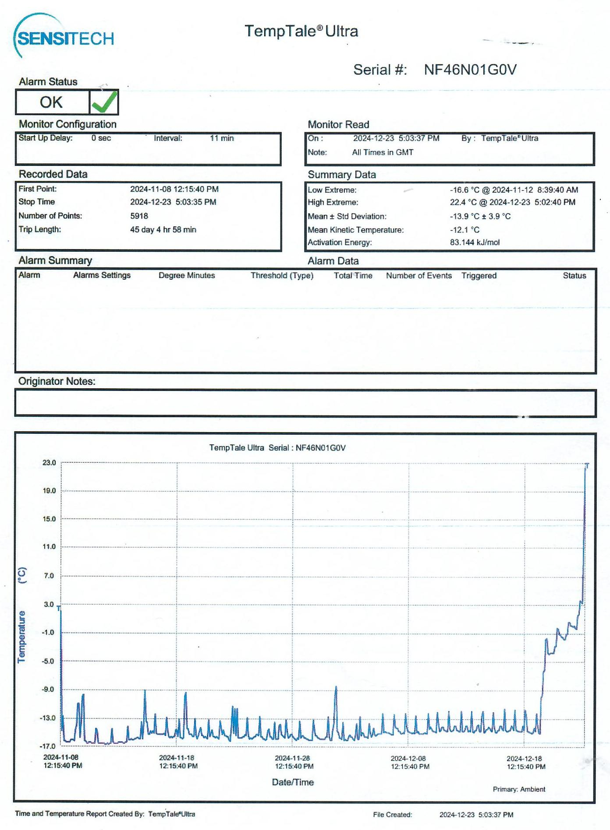

Annexe 2 : Damaged and spoiled food products

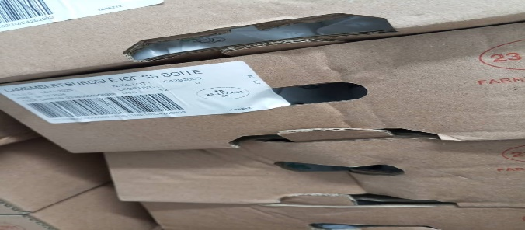
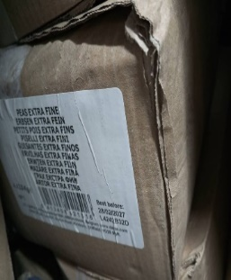
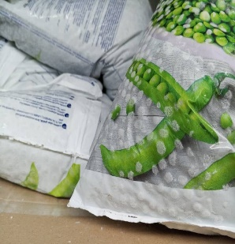
C
B
A
A
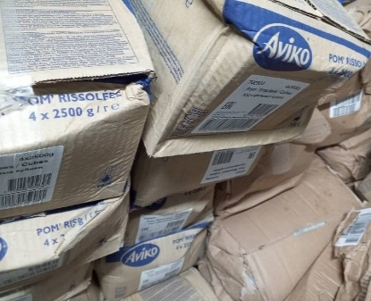

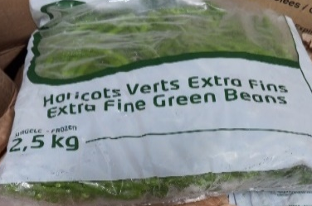

E
F
D
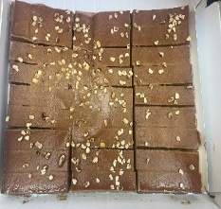
G

Legend for Products A-G:
A: Extra Fine Peas
B: Whole Camembert 250g
C: Vieux Porche Camembert
D: Sautéed Potatoes (Pommes rissolées)
E: Sliced Onions
F: Green Beans
G: Cara Praline Crumble

Annexe 3 : Sensory profile of products

Butters and cheeses
Figure 3: Sensory Profile of Héritage Butter (Héritage butter 101: control sample, Héritage butter 102: test sample). . | Figure 4: Sensory Profile of Isigny Butter (Isigny butter 301: test sample, Isigny butter 300: control sample).
Figure 5: Sensory Profile of Président Butter (Président butter 201: test sample, Président butter 200: control sample). | Figure 6: Sensory Profile of Vieux Porche Camembert (Vieux Porche Camembert 1001: test sample, Vieux Porche Camembert 1000: control sample).
Figure 7: Sensory Profile of Emmental Cheese (Emmental 801: test sample, Emmental 800: control sample). | Figure 8: Sensory Profile of Fourme d’Ambert Cheese (Fourme d’Ambert 601: test sample, Fourme d’Ambert 602: control sample).
Figure 9: Sensory Profile of Cantal Cheese (Cantal 401: test sample, Cantal 402: control sample). | Figure 10: Sensory Profile of Comté Cheese (Comté 501: test sample (Expiry Date 10/10/2026), Comté 502: test sample (Expiry Date 30/09/2025), Comté 503: control sample).
Figure 11: Sensory Profile of Gouda Cheese (Gouda 701: test sample, Gouda 702: control sample). | Figure 12: Sensory Profile of Whole Camembert Cheese (Whole Camembert 901: test sample, Whole Camembert 900: control sample).

Cooked and uncooked proteins
Figure 13: Sensory Profile of Beef Chuck (Beef chuck 1101: test sample, Beef chuck 1100: control sample). | Figure 14: Sensory Profile of Beef Meatballs (Beef meatballs 1201: test sample, Beef meatballs 1200: control sample).
Figure 15: Sensory Profile of Smoked Salmon (Smoked salmon 1301: test sample, Smoked salmon 1300: control sample). | Figure 16: Sensory Profile of Cooked Chicken Cooked chicken specimens 1401 (batch 295), 1402 (batch 297), 1403 (batch 156), and 1404 (batch 296)

Vegetables, starches, and dessert
Figure 17: Sensory Profile of Peas (Peas 1501 and 1502: test samples, Peas 1500: control sample). | Figure 18: Sensory Profile of Sliced Onions (Sliced onions 1601: test sample, Sliced onions 1600: control sample).
Figure 19: Sensory Profile of Sautéed Potatoes (Sautéed potatoes 1701 and 1702: test samples, Sautéed potatoes 1700: control sample). | Figure 20: Sensory Profile of Green Beans (Green beans 1801: test sample, Green beans 1800: control sample).
Figure 21: Sensory Profile of Mixed Diced Vegetables (Mixed diced vegetables 2001 and 2002: test samples, Mixed diced vegetables 2000: control sample). | Figure 22: Sensory Profile of Crumble (Crumble 1901: test sample, Crumble 1900: control sample)

