Development and Nutritional Assessment of Finger Millet-Based Edible Cutlery Incorporated with Jaggery

Abstract
The increasing accumulation of single-use plastic cutlery poses a serious environmental threat due to its non-biodegradable nature and long persistence in landfills. This study aimed to develop and evaluate nutritionally enriched, eco-friendly edible cutleries using finger millet (Eleusine coracana L.) flour as a partial or complete substitute for wheat flour. Edible cutleries were formulated using varying proportions of wheat flour and finger millet flour (0, 25, 50, and 100%), with jaggery as a natural sweetener and binding agent. The prepared cutleries were baked at 160°C for 20 minutes and assessed for physicochemical, textural, sensory, and nutritional characteristics.Proximate analysis revealed that the incorporation of finger millet significantly influenced the nutritional composition of the cutleries. The T2 formulation (50% finger millet flour) exhibited optimal nutritional properties, with moisture content of 6.4%, energy value of 382.3 kcal/100 g, carbohydrates of 86.81 g/100 g, protein of 8.02 g/100 g, fat of 1.09 g/100 g, fiber of 4.45 g/100 g, and ash content of 1.74 g/100 g. Statistical analysis using one-way ANOVA indicated significant differences (p < 0.001) among treatments for most parameters except fat content. Texture analysis demonstrated a progressive decrease in hardness with increasing finger millet content, attributed to reduced gluten strength. Sensory evaluation using a 9-point hedonic scale showed that the 100% finger millet sample (T2) achieved the highest overall acceptability despite lower hardness.Overall, the study concludes that finger millet-based edible cutleries are nutritionally superior, structurally stable, and sensorially acceptable, offering a sustainable and biodegradable alternative to conventional plastic cutlery while promoting the utilization of nutrient-rich traditional grains.
Keywords: Edible cutlery, Finger millet, Biodegradable, Sustainable development.

Graphical Abstract
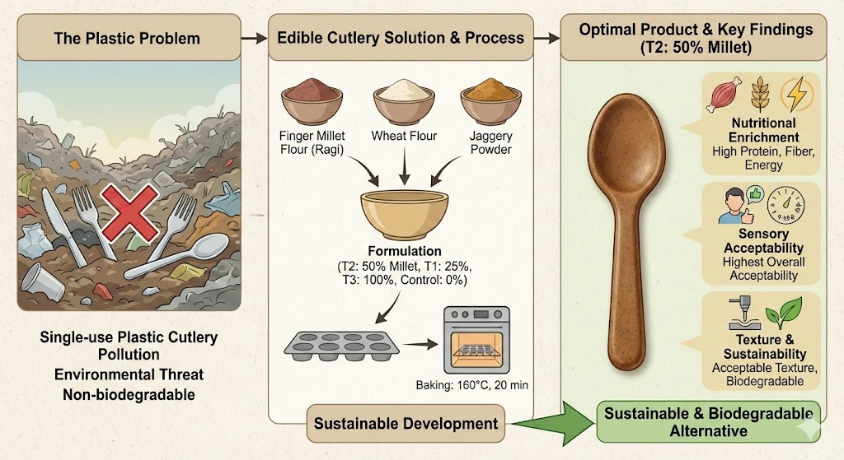
Introduction
Over 120 million discarded plastic cutlery pieces end up in Indian landfills each year.Since plastics are robust and long-lasting, it may take decades or even hundreds of years for them to break down. Since commercial plastic production started in the 1950s, human life has improved and been made easier. All living things, including people, are at danger as a result of inappropriate disposal and the growing amount of plastic in the environment. About half of all plastic trash is made up of disposable plastic, which significantly contributes to pollution and damages ecosystems all over the world.(Lebreton and Andrady, 2019; Prata et al., 2020)
Edible cutlery can be made with a variety of substances, however some flours provide the desired qualities for the finished product. When combined with other ingredients, such as millet flour, wheat flour, jaggery, etc., they can improve the edible product's physico-chemical qualities while also offering their own nutritional advantages. In this regard, it is strongly advised to use biobased dinnerware instead of plastic-based ones. Eco-friendly and biodegradable dinnerware and cutlery made from plant flour have gained popularity recently.
Edible cutlery and dinnerware can be made using plant flour and natural ingredients. One of India's oldest crops, finger millet (Eleusine coracana L.) was also called "Rajika" or "Markataka" meaning "Dancing Grain" in ancient Indian Sanskrit literature. The earliest mention of finger millet dates from about 2300 BC and is from Hallur in Karnataka, India(Khatal et al.,2024; Thul et al., 2025 and Khatal et al., 2025). Ragi is famous for its high nutritional content, which includes significant levels of minerals, dietary fiber, protein, and starch. It was chosen for its many health benefits. According to reports, finger millet comprises approximately 5–8% protein, 65–75% carbs, 15–20% dietary fiber, and 2.5–3.5% minerals(Xiang et al., 2019).
Additionally, the principal components of the unrefined wheat flour include protein (~10%–12%), starch (~70–75%), and polysaccharides (~2–3%) and lipids (~2%). This purpose is fulfilled by the formulation's use of rice flour as a binding agent. Along with essential minerals like calcium, phosphorus, and iron, it also supplies essential amino acids, antioxidants, and phenolics. Moisture (~11–14%), proteins (~5.5–9.3%), carbs (~73–81%), fiber (~0.2–1.0%), and mineral matter (~0.8–2.0%) are all present in rice flour. One ingredient used for its sweetening properties is jaggery(Rao and Singh, 2022).
It is preferable to use jaggery rather than sugar because it contains nutrients (vitamins and minerals) and antioxidants. This decision improves baked goods' flavor, texture, and color. Carbohydrates (glucose, fructose, and sucrose), a variety of minerals (Ca, P, Mg, Na, Fe, Zn, Mn, Cl, etc.), and trace amounts of lipids and proteins are all present in jaggery. Regardless of the source, consuming a lot of sugar can result in diabetes, heart disease, and obesity. Jaggery can be used in its place for a number of health advantages, such as better digestion, liver health, and anemia prevention(Rao and Singh, 2022).
Thus, the primary goal of this project is to develop a recipe and produce Edible Cutlerys using ragi flour. As far as we are aware, no reports on Edible Cutlerys made with rice flour, wheat, and cinnamon powder have been published, despite the fact that there are already a few reports on similar bowls. The structural integrity, color, moisture content, and other physicochemical characteristics of Edible Cutlery s manufactured with ragi flour were assessed. Under simulated environmental conditions, the biodegradability of Edible Cutlerys made with ragi flour was evaluated. Sensory research was used to compare the palatability and acceptability of Edible Cutlery s made with ragi flour to standard disposable plastic bowls.
Material and Methods
Material
Unrefined wheat flour (Triticum aestivum L.), finger millet flour (Eleusine coracana L.), jaggery powderwere all purchased fresh from a nearby market and combined in varied proportions to create the edible spoons. The component was used directly without further purification or modification.
Methods
To develop a sticky dough formulation for the edible cutlery, specific quantities of ingredients including ragi flour, wheat flour, and jaggery were mixed together, as indicated in Table 1. The resulting solid dough was subjected to a rigorous process that included completely mixing all components, pressing, and rolling with a rolling pin in order to attain sheet shape. The dough was then shaped, placed in metal molds, and baked for 20 minutes at 160°C to achieve the proper mouthfeel and rigidity.
Table 1: Various composition of edible cutleries
 | Control | T1 | T2 | T3
Wheat flour (g) | 100 | 75 | 25 | 0
Ragi flour (g) | 0 | 25 | 50 | 100
Jaggery (g) | 50 | 50 | 50 | 50
Salt (g) | 5 | 5 | 5 | 5
water (ml) | 60 | 60 | 60 | 60

Determination of Moisture content
A method for measuring approximately the amount that water is in a substancetypically a solidis the moisture content test. To perform this, weigh an edible portion of cutlery, put it in a hot air oven set to 105°C, and check its weight every 30 minutes until it stabilizes(AOAC, 2000)
Moisture content Percentage (%) = $\frac{W₂- W₁ }{W₁}$ × 100
Where, W₂ = initial weight of sample,
W₁= weight after drying
Determination of Ash content
The minerals and inorganics that are left over while a sample is cooked to a very high temperature, eliminating moisture, volatiles, and organics, are referred to as the ash content in food. To do this, weigh a crucible (W₁), then weigh it again after adding a 5 g piece of edible cutlery (W₂). Heat it before placing it in the muffle furnace. After that, weigh the crucible (W₃) after setting the temperature to 550°C in a muffle furnace(AOAC, 2000).
Ash content (%) = $\frac{W₃- W₁ }{W₂- W₁}$×100
Where,
W₁= weight of empty crucible,
W₂= weight of crucible with 5 g of sample,
W₃= weight of crucible with grey ash.
Determination of fiber
In a beaker with 0.5 to 1.0 g of dry material, 5 ml of 1.26% diluted H₂SO₄ was added, and the mixture was refluxed for 15 minutes. After filtering the mixture, 5 ml of a 1.26% NaOH solution were added to the filtrate, and the mixture was refluxed for an additional 15 minutes. After straining the mixture once more, the filtrate was cleaned with ethanol and stirred for 15 minutes. After another filter, it was left to dry for fifteen minutes(AOAC, 2000).
Crude fiber (%) =$\frac{W₂-W₁}{W₁}$×100
Determination of Protein
It was determined by the Kjeldahl method (AOAC, 2000). The 0.5-1 g sample was transferred to a digestion flask in which catalyst mixture [9 parts potassium sulphate (K₂SO.) one of copper sulphate (CuSO₄)] ml concentrated sulphuric acid was transparent liquid was obtained. The digested liquid was allowed cool and ml of distilled 40 % NaOH solution and the liberated ammonia collected 50 ml of 4% boric acid solution. Containing 5-7 drops of mixed indicator [100 ml of 0.1% methyl red indicator 95% ethanol) + 200 ml 0.2% bromocresol green (95% ethanol)]. Entrapped ammonia was then titrated against 0.1 hydrochloric acid. A reagent blank was similarly digested and distilled. Nitrogen content in the sample was calculated as follows and a factor of 6.25 was used to convert Nitrogen content to protein content.
The percent protein content was calculated by using the following formula
Protein content (%) = $\frac{\left(S-B\right) x N x 14.01 x 100 x 6.25}{W X 1000}$
Where,
S= Volume of standard acid (0.1 N HCl) used for titration, ml
B= Volume of 0.1 N HCl used for blank, ml
W= Weight of sample, g
N= Normality of acid used for titration (0.1 N HCL)
Determination of Fat content
The dried powdered sample that has been previously weighed is placed in a filter paper thimble and stored in a glass cylinder of Soxhlet device. This cylinder comes with a siphon tube and an intake tube. A water condenser is attached to the top of the cylinder. The entire arrangement is attached to the neck of a flask with a circular bottom that holds the solvent. The flask is heated in a burner. The solvent vapors enter the cylinder through the inlet tube and ascend into the condenser.As the condensed solvent comes into touch with the crude organic substance, it dissolves it. right away as the solution reaches the top of the siphon tube. This keeps the flow of solvent vapors in the cylinder steady as the dissolved organic material returns to the flask. After stopping the heating, the liquid in the flask is distilled to extract the solvent and leave the organic product left (AOAC, 2000).
$$Fat (\%)= \frac{Loss of weight in the sample}{Weight of the sample}×100$$
Determination of Carbohydrates
The following formula was used for calculation of carbohydrates (AOAC, 2000).
Total carbohydrate = 100 – (Fat + Fiber + Ash + Protein)
Determination of Energy
The following formula was used for calculation of energy (AOAC, 2000).
Energy (kcal) = 4.0 × protein (g) + 4.0× carbohydrate (g) + 9.0 × fat (g)
Determination of the texture analysis
Texture qualities were evaluated using the TA-XT plus Texture Analyzer at pretest speeds of 25 mm/s and posttest speeds of 30 mm/s. The cutting force was obtained using this test. The analyzer was calibrated by comparing the cutlery's hardness through penetration using a 30 mm flat probe.
Sensory analysis
The appropriate flour content0, 25, 50 and 100was used to bake the edible cutleries. The sensory study was conducted using a 9-point hedonic scale. Six panelists with training assessed the edible cutleries. Pleasantness of appearance, color intensity, scent intensity, surface features, texture pleasantness, and overall acceptance were all evaluated.
Statistical analysis
RStudio (Version 4.5.2 – © 2025 RStudio, Inc.) was used for statistical analyses. One-way analysis of variance (ANOVA) was used to determine the significance of each mean property value. The data collected from the various organoleptic and functionality trials were statistically analyzed to ascertain the impact of different ingredient proportions on the developed product's quality and functionality.
Results and discussion
Development of edible cutleries
The bakery's foods method was followed in the preparation of the edible cutlery. The basic dough formulation is made up of wheat flour, finger millet flour (finger millet flour is added at levels 0, 25,50, and 100% as a partial substitution for wheat flour based on preliminary trials), 50 grams of jaggery powder for sweetness, colour, strength, and good nutrient content, and 5 gm of salt (NaCl), which has a binding effect on glutin content and particularly helps to bring out the flavor and aroma of the flour. Different amounts of water were added to the dough to achieve the desired consistency.A wooden rolling board and wooden rolling pin were used to make a plane sheet of dough, which was then cut into the shape of the molds using a knife and inserted into the molds. The molds were baked for 20 minutes at 160°C in a microwave oven.
Jaggery powder was mixed to a foundation of wheat and ragi flour to create edible cutlery. The production procedure is hassle-free and the development of edible cutlery is straightforward.The developed cutlery exhibited structural integrity, maintaining its shape and lacking any obvious holes or fractures. Compared to the control sample, which was pale to slightly brown in color, the ragi-containing sample was substantially darker.
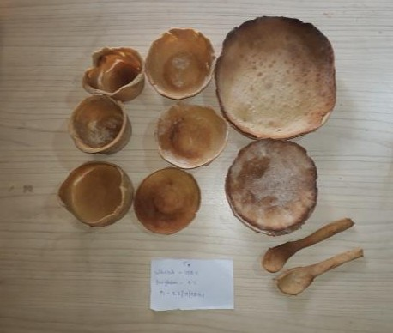

Fig. 1snap of the edible cutleries
Proximate analysis of edible cutleries
Based on biochemical analysis, in edible cutleriesbased on finger millet flour, the treatment T2 was found to be the best. The nutritive value of T2 treatment as best treatment of finger millet flour based edible cutleries observed to have moisture (6.4%), energy (382.3 Kcal), carbohydrate (86.81g/100 g), protein (8.02g/100g), fat (1.09g/100g), fiber (4.455g/100g), and total ash (1.74g/100g) and other treatment analysis shown in Table 2. After all analysis we have conclude that, the moisture content, fat, protein, carbohydrates and energy increase with increase the finger millet flour proportion from control, while ash content and fiber content decrease with increase proportion. Sindhu et al. (2023) reported that edible spoon has moisture (5.32%), protein(3.8g/100g), fat (1.6%) and total ash (1.38%).
Table 2.Proximate analysis of edible cutleries
Parameter | Source | DF | Sum Sq | Mean Sq | F Value | Pr(>F) | Significance
Moisture | Treatment | 3 | 1.961 | 0.6536 | 581 | 1.07e-09 | ***
Moisture | Residuals | 8 | 0.009 | 0.0011 | — | — | —
Ash | Treatment | 3 | 0.3353 | 0.11176 | 167.6 | 1.47e-07 | ***
Ash | Residuals | 8 | 0.0053 | 0.00067 | — | — | —
Fiber | Treatment | 3 | 0.4422 | 0.14739 | 232.7 | 4.04e-08 | ***
Fiber | Residuals | 8 | 0.0051 | 0.00063 | — | — | —
Fat | Treatment | 3 | 0.2695 | 0.08983 | 1.621 | 0.26 | ns
Fat | Residuals | 8 | 0.4433 | 0.05542 | — | — | —
Protein | Treatment | 3 | 4.675 | 1.5584 | 968.9 | 1.39e-10 | ***
Protein | Residuals | 8 | 0.013 | 0.0016 | — | — | —
Carbohydrates | Treatment | 3 | 396.6 | 132.20 | 1015 | 1.16e-10 | ***
Carbohydrates | Residuals | 8 | 1.0 | 0.13 | — | — | —
Energy | Treatment | 3 | 1710.5 | 570.2 | 237.7 | 3.71e-08 | ***
Energy | Residuals | 8 | 19.2 | 2.4 | — | — | —
*** = p < 0.001; ns = non-significant
In addition, the correlation matrix presented in Fig. 2 illustrates the relationships between the Moisture content, fat, ash, fiber, protein, carbohydrates, energy and hardness of prepared edible cutleries. From the correlation matrix, it was shown that ash content had a positive correlation with hardness, indicating that higher mineral content strengthens the edible cutleries. Moisture content, on the other hand, showed a negative correlation with hardness, as the higher water content in the samples made the cutleries softer. Fiber content exhibited a positive correlation with hardness, as fiber adds structural rigidity and reduces expansion, resulting in harder cutleries compared to other samples. Energy was moderately correlated with fat and highly correlated with carbohydrates because these components are calorie-dense.
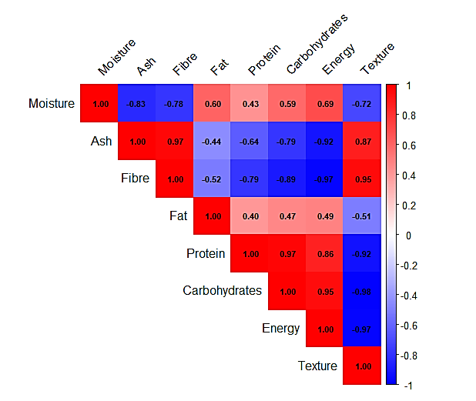
Fig. 2 correlation matrix of biochemical analysis
Texture Analysis of edible cutleries
Using a texture analyzer, the edible cutleries textural characteristics as crushing strength were examined. The impact of wheat flour incorporation levels with finger millet on the edible cutlerieshardness was examined. The shift in gluten intensity could be the reason for the variation in the edible cutleriestexture. The control sample, which contained 100% wheat flour, had the greatest hardness of 89.9 N, followed by 72.16 N (T1), 60.73 N (T2)and 48.96 N (T3), in that order.In addition, the Bar graph with mean ± SDpresented in Fig. 3 illustrates the texture analysis for all samples. When compared to other edible cutleries samples, the control edible cutlerieshad the best texture and the highest hardness rating.
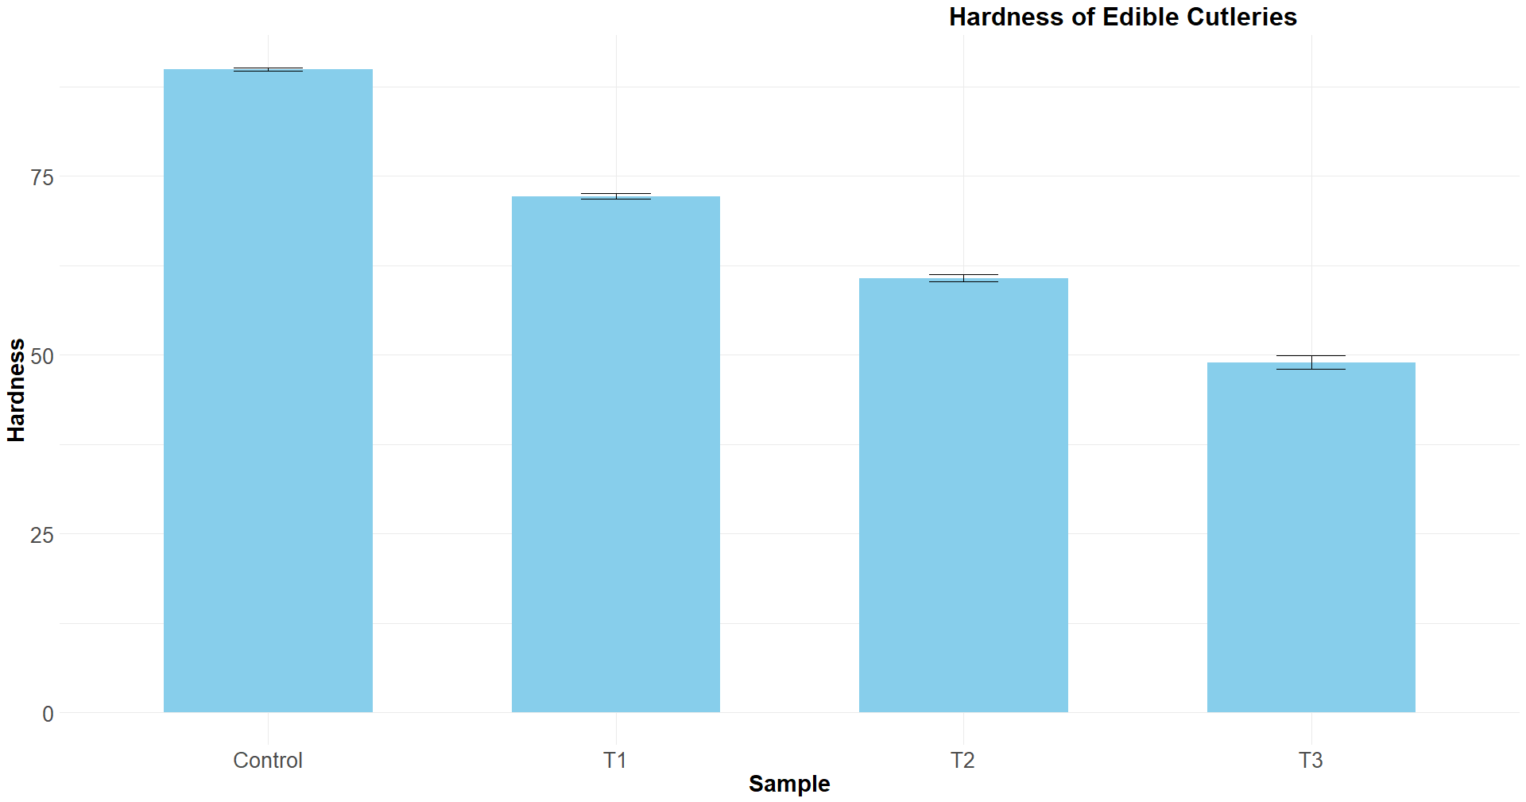
Fig. 3 Bar graph with mean ± SD for Texture analysis
Sensory analysis
The organoleptic evaluation was carried out utilizing a complete 9- point hedonic scale that included taste, texture, scent, colour, and overall acceptability (OA). The 9-point hedonic scale is widely accepted as a standard method for assessing the desirability of meals. A panel of six experienced assessors evaluated the product rigorously across key attributes such as colour, taste, and texture, offering a comprehensive review. The aggregate Sensory analysisscores for each sample are graphically represented in the Fig 4. The T2 sample found a best sample based on overall acceptance as compared to other samples.
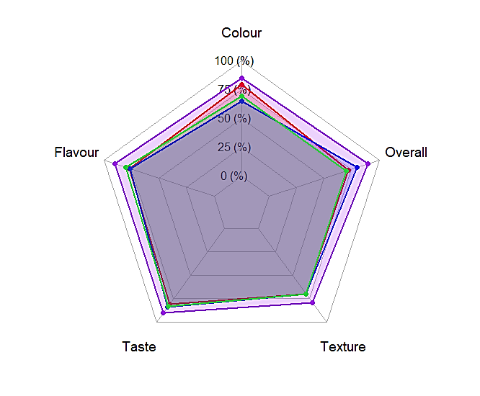
Fig. 4 Sensory analysis of edible cutleries
Conclusion
A plastic cutlery generally composed of organic polymers which is considered as biggest threat to mankind and the nature which may leads to soil erosion, ocean toxicity and air pollution. Edible cutlery is a sustainable way for better alternative to one time use plastic cutlery. This research highlights the development of edible cutlery using finger millet flour and wheat flour for nutritional enrichment. In comparison to the all samples, sample T3 found to best samples among all samples.Plant based edible cutleriescan be a suitable alternative to synthetic plastic-based cutleriesand in this connection finger millet,wheat flour and jaggery were combined to make edible cutleries. These edible cutleries were made using a simple mixing and baking technique. The addition of ragiand jaggery in wheat flour was beneficial to impart favourable physical and functional performance of the edible cutleries.
References
AOAC International. (2000). Official methods of analysis (17th ed.). AOAC International. https://books.google.com/books/about/Official_Methods_of_Analysis_of_AOAC_Int.html?id=y_4_AAAAMAAJ.
Dordevic, D., Pencak, T., Slamova, D., Zeljkovic, S. C., Tremlova, B., &Zamaratskaia, G. (2025). Development of edible spoons using non-traditional flours. Applied Food Research. https://doi.org/10.1016/j.afres.2025.100995
Khatal, M. M., Kumar, A., Thul, P. P., Sawant, A. A., &Kalse, S. B. (2025). Study on the Effect of Different Baking Temperature on Finger Millet Khari and It's Cost Implication. European Journal of Nutrition & Food Safety, 17(4), 22–31. https://doi.org/10.9734/ejnfs/2025/v17i41676
Khatal, M. M., Sawant, A., Shirsat, B., Chavan, P., Bansode, P., &Kutwal, A. (2024). Performance evaluation of deck oven for baking of finger millet biscuit. International Journal of Advanced Biochemistry Research, 8(9S), 1416–1420. https://doi.org/10.33545/26174693.2024.v8.i9Sq.2366
Lebreton, L., &Andrady, A. (2019). Future scenarios of global plastic waste generation and disposal. Palgrave Communications, 5(1), 1–11. https://doi.org/10.1057/s41599-018-0212-7
Prata, J. C., da Costa, J. P., Lopes, I., Duarte, A. C., & Rocha-Santos, T. (2020). Environmental status of (micro)plastics contamination in Portugal. Ecotoxicology and Environmental Safety. https://doi.org/10.1016/j.ecoenv.2020.110753
Rajendran, S. P., Saravanan, A., Namachivayam, G. K., Jambunathan, J., & Ramachandran, G. (2020). Optimization of composition for preparation of edible cutlery using response surface methodology (RSM). AIP Conference Proceedings, 2240(1), Article 050001. https://doi.org/10.1063/5.0011042
Rao, G. P., & Singh, P. (2022). Value addition and fortification in non-centrifugal sugar (Jaggery): A potential source of functional and nutraceutical foods. Sugar Tech, 24(2), 387–396. https://doi.org/10.1007/s12355-021-01020-3
Rishi, P., Zade, T., Abhiraj, P., Pandey, V. S., & Roy, S. (2024). Exploring the Potential of Ragi, Wheat, and Rice Flours as a Sustainable Solution for Edible Bowl: A Suitable Substitution for Disposable Plastic Bowl. Food and Humanity. https://doi.org/10.1016/j.foohum.2024.100455
Sindhu, K., Swamy, R., & Prashanthi, M. (2023). Enrichment of edible spoons with natural colours. The Pharma Innovation Journal, 12(5), 4259–4263. https://www.thepharmajournal.com/archives/2023/vol12issue5/PartAX/12-5-248-127.pdf
Thagunna, B., Shrestha, G., Karki, R., Baral, K., & Kaur, J. (2023). Development and quality evaluation of biodegradable edible cutlery: a replacement for a conventional one. Asian Journal of Pharmaceutical and Clinical Research. https://doi.org/10.22159/ajpcr.2023v16i2.46382
Thul, P. P., Kalse, S. B., Bansode, P. B., Khatal, M. M.,& Sawant, A. A. (2025). Physicochemical Properties of Cookies Developed from Maida Substituted with Cashew Apple Powder. Asian Journal of Current Research, 10(1), 65–72. https://doi.org/10.56557/ajocr/2025/v10i19078
Xiang, J., Apea-Bah, F. B., Ndolo, V. U., Katundu, M. C., & Beta, T. (2019). Profile of phenolic compounds and antioxidant activity of finger millet varieties. Food Chemistry. https://doi.org/10.1016/j.foodchem.2018.09.120

