Original Research Article
ANN-assisted prediction of groundwater WQI for drinking-water screening in Salur Mandal, Andhra Pradesh, India

ABSTRACT
Aim:
Groundwater quality monitoring in hard-rock aquifer systems is essential for sustainable resource management. This study aims to assess groundwater quality using the weighted arithmetic Water Quality Index (WQI) method and to develop an Artificial Neural Network (ANN) model for reliable prediction of WQI in the Salur region of Andhra Pradesh, India.
Study Design: A quantitative analytical study integrating WQI assessment with predictive modeling was conducted using field-monitored groundwater quality data collected over a three-year period (November 2018 to October 2021).
Methodology:
A total of 468 groundwater samples were collected from 13 monitoring stations between November 2018 and October 2021 and analyzed for fifteen physicochemical parameters adopting standard procedures prescribed by APHA 1998. WQI was computed using the weighted arithmetic method to classify groundwater suitability. A feed-forward ANN model with a 15–5–1 architecture was developed using the Levenberg–Marquardt algorithm. The dataset was randomly divided into 70% training, 15% validation, and 15% testing subsets using MATLAB toolbox.
Results:
WQI results revealed that 77% of groundwater samples fall within the Good category (WQI = 26–50), while 23% fall under the Poor category (WQI = 51–75), indicating moderate hydro chemical variability without critical contamination. The ANN model demonstrated high predictive accuracy, with Root Mean Square Error (RMSE=0.438) and coefficient of determination (R²) of 0.998
Conclusion:
The developed ANN model effectively predicts groundwater WQI with high accuracy and can serve as a robust decision-support tool for sustainable groundwater management in hard-rock aquifer regions, particularly in data-scarce rural areas.

Keywords: Water Quality Index; Artificial Neural Network; hard-rock aquifer; groundwater sustainability; Levenberg–Marquardt; India

1. INTRODUCTION
Groundwater constitutes the primary source of drinking water in rural India, particularly in hard-rock aquifer regions where surface water availability is limited. Its quality is governed by lithology, recharge dynamics, mineral dissolution, and anthropogenic influences.
Water Quality Index (WQI) methods provide simplified representation of hydrochemical status by integrating multiple parameters into a single indicator. The weighted arithmetic WQI approach, originally conceptualized by Horton (1965) and later refined by Brown et al. (1972), has been widely applied for groundwater suitability assessment.
In India, Previous studies have reported groundwater quality assessment using WQI in various Indian regions (Ramakrishnaiah, Sadashivaiah & Ranganna, 2009; Vasanthavigar et al., 2010; Srinivasa Rao & Nageswararao, 2013; Nayar, 2020). However, conventional WQI approaches remain descriptive and lack predictive capability.
Recent advancements in deep learning have enabled robust groundwater quality forecasting (Li et al., 2023; Singh, Gupta & Maity, 2024). Machine learning applications for water quality prediction have expanded recently (Maier & Dandy, 2000; Pavan Kumar, Partha Sarathi & Srinivasa Rao, 2017b; Muthukumaran & Vinoth Kumar, 2022; Rabah Ismail et al., 2024; Ghadai et al., 2022; García-del-Toro et al., 2025). ANN models are especially advantageous in data-scarce hydro geological settings due to their capacity to approximate complex functional mappings without explicit physical equations.
Despite increasing ANN applications, predictive WQI modeling remains limited in inland hard-rock aquifer systems of rural India. Therefore, this study aims to:
- Assess groundwater quality using weighted arithmetic WQI
- Develop and validate an ANN-based predictive model for monthly WQI estimation
- Evaluate model robustness and performance
This integrated approach contributes toward proactive and data-driven groundwater sustainability management.

2. MATERIALS AND METHODS

2.1 Study Area
The study area is located (Fig.1) in Salur Mandal (currently Parvathipuram Manyam District), Andhra Pradesh, India, covering ~328 km² between 18°28′12″–18°46′48″N and 83°01′12″–83°17′24″E. The region is characterized by hard-rock aquifers dominated by Khondalite Group formations of the Eastern Ghats. The climate is tropical monsoonal, with seasonal recharge influencing groundwater chemistry. Groundwater serves as the principal drinking water source for rural and tribal communities.
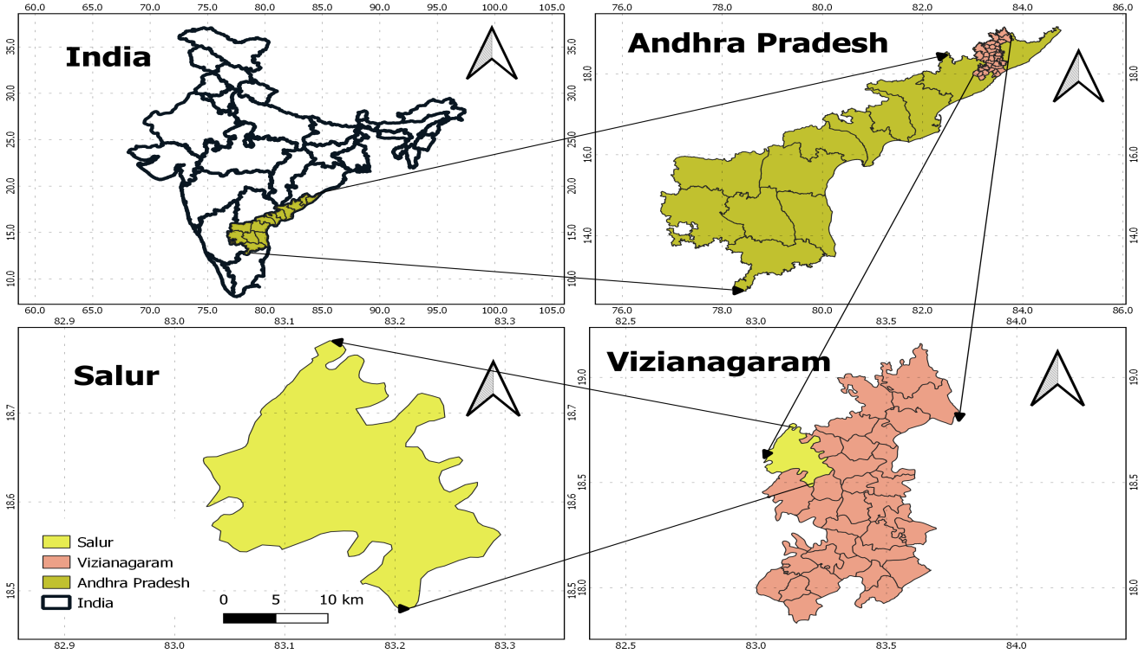
Fig. 1: Location map of the study area

2.2 Sampling and Laboratory Analysis
A total of 468 groundwater samples (monthly each sample from each sampling location for 36 months) were collected from November 2018 to October 2021 from thirteen monitoring locations in the study area. Geological coordinates of the sampling locations are presented in Table 1. Samples were collected in pre-cleaned polyethylene bottles washed with non-ionic detergent, rinsed with tap water, treated with 1:1 hydrochloric acid, and finally rinsed with deionized water. Prior to sample collection, the bottles were rinsed three times with the respective groundwater. Tube wells were pumped for at least five minutes before sampling to obtain representative aquifer water.
Physico-chemical parameters were analyzed following standard procedures prescribed by APHA (1998). PH and electrical conductivity (EC) were measured using digital pH meter (Elico LI-120) and conductivity meter (Elico CL-351), respectively. Total dissolved solids (TDS) were determined by the gravimetric method. Total hardness (TH), total alkalinity (TA), calcium (Ca²⁺), magnesium (Mg²⁺), chloride (Cl⁻), carbonate (CO₃²⁻), and bicarbonate (HCO₃⁻) were estimated by standard titrimetric methods. Nitrate (NO₃⁻) was determined using a UV–Visible spectrophotometer (Elico SL-177) with a 1 cm quartz cell by the phenol disulphonic acid method. Fluoride (F⁻) was analyzed by the SPADNS method, while sulphate (SO₄²⁻) was determined by the turbidimetric method using standard barium chloride solution. Sodium (Na⁺) and potassium (K⁺) were measured using a flame photometer (Elico CL-361).
A total of fifteen physico-chemical parameters (pH, EC, TDS, TH, TA, Ca²⁺, Mg²⁺, Na⁺, K⁺, NO₃⁻, Cl⁻, F⁻, SO₄²⁻, CO₃²⁻, and HCO₃⁻) were utilized to compute the Water Quality Index (WQI) using the weighted arithmetic method.
Table 1: Groundwater sampling locations and coordinates
Sample Id | Sampling Station | Mandal | Latitude(N) | Longitude(E)
S1 | Annamarajuvalasa | Salur | 18°37′46″ | 83°11′04″
S2 | Borabanda | Salur | 18°33′35″ | 83°14′31″
S3 | Chinavootagedda | Salur | 18°42′05″ | 83°11′43″
S4 | Jilleduvalasa | Salur | 18°43′16″ | 83°08′07″
S5 | Kandulapalem | Salur | 18°38′40″ | 83°09′22″
S6 | Karasuvalasa | Salur | 18°34′34″ | 83°10′05″
S7 | Kurukutti | Salur | 18°35′20″ | 83°05′35″
S8 | Maripalle | Salur | 18°37′54″ | 83°09′07″
S9 | Mirtivalasa | Salur | 18°36′4″ | 83°13′44″
S10 | Neliparti | Salur | 18°30′16″ | 83°10′57″
S11 | Parannavalasa | Salur | 18°32′22″ | 83°15′11″
S12 | Puroithunivalasa | Salur | 18°34′08″ | 83°14′33″
S13 | Sivarampuram | Salur | 18°32′11″ | 83°14’36”

2.3 Water Quality Index
Several Water Quality Index (WQI) models have been proposed by researchers, notably Horton (1965) and Brown et al. (1972), and have since been widely adopted by governmental agencies and researchers for water quality assessment. Among these, the Weighted Arithmetic Water Quality Index (WAIWQI) method is one of the most popular and extensively applied approaches. The WQI was computed using the below equations (Eq.1- Eq. 4).

$WQI=\frac{\sum{Q_{i}W_{i}}}{\sum{W_{i}}}$ (Eq. 1)
The quality rating scale (Qi) for each parameter is calculated by using this expression:
$Q_{i}=100\left(\frac{V_{i}-V_{o}}{S_{i}-V_{o}}\right)$ (Eq. 2)
Where, V_{i}= estimated concentration of ith parameter in the analysed water, V_{o}=The ideal value of this parameter in pure water
V_{o}=0 (except pH =7.0)
S_{i}=Standard value of i^{th}parameter
The unit weight (W_{i}) for each water quality parameter is calculated by using the following formula:
$W_{i}=\frac{K}{S_{i}}$ (Eq. 3)
Where, K=proportionality constant and can also be calculated by using the following equation:

$K=\frac{1}{\sum{\left(\frac{1}{S_{i}}\right)}}$ (Eq. 4)
Using these equations, WQI values were computed for all sampling locations and periods. Based on the obtained WQI values, Brown et al 1972 the groundwater quality was classified into standard rating categories to interpret its suitability for drinking purposes. It is presented in Table 2.
Table 2: Water Quality rating as per WA-WQI model
Brown et al (1972)]

WQI Value | Rating of Water Quality | Suitability for drinking
0-25 | Excellent | Fit for drinking
26-50 | Good | Acceptable for drinking
51-75 | Poor | Moderately polluted
76-100 | Very Poor | Excessively polluted
Above 100 | Unsuitable for drinking purpose | Unfit for drinking

2.4 Artificial Neural Network (ANN) Modeling development for prediction WQI
A feed-forward Multilayer Perceptron (MLP) Artificial Neural Network (ANN) was developed to predict monthly Water Quality Index (WQI) values using hydro chemical parameters as inputs. The dataset comprised out of 468 samples, 390 monthly groundwater samples from 13 monitoring stations over a 30-month period taken as training and validation period. A period six of months was considered as testing period. The dataset was randomly divided using MATLAB’s random split default dividerand function into training (70%, n = 273), validation (15%, n = 59), and testing (15%, n = 58) subsets. The validation subset was utilized for early stopping to control overfitting during training, whereas the testing subset was reserved exclusively for independent model evaluation.
Fifteen physicochemical parameters—pH, EC, TDS, Ca²⁺, Mg²⁺, Na⁺, K⁺, Cl⁻, SO₄²⁻, HCO₃⁻, CO₃²⁻, NO₃⁻, F⁻, Total Hardness(TH) , and Total Alkalinity(TA) —served as input neurons, and the calculated WQI was treated as the single output neuron. Prior to model development, all input variables were normalized to the range of 0–1 using min–max scaling to enhance training efficiency and numerical stability.
The optimized ANN architecture (Fig.2) consisted of 15 input neurons, one hidden layer containing 5 neurons, and one output neuron (15–5–1 configuration). A tangent sigmoid (tansig) activation function was employed in the hidden layer to model nonlinear relationships among the hydro chemical variables, while a linear (purelin) function was applied at the output layer to generate continuous WQI predictions.
The selection of hidden neurons was performed through iterative trials by testing networks with 3 to 10 neurons and comparing validation errors. The configuration chose with five hidden neurons the best balance between prediction accuracy and generalization performance. Increasing the number of neurons beyond five did not significantly reduce validation error and posed a greater risk of overfitting.
Training was carried out using the Levenberg–Marquardt backpropagation algorithm (trainlm) available in the Neural Network Toolbox of MATLAB (R2023a, MathWorks Inc., USA), chosen for its rapid convergence with moderate-sized datasets. The final model comprised 86 adjustable parameters, which is substantially lower than the number of training samples (n = 273), thereby ensuring statistical adequacy and limiting over-parameterization.
Model performance was assessed using the coefficient of determination (R²), root mean square error (RMSE), mean absolute error (MAE), and mean bias error (MBE), to comprehensively evaluate model accuracy and predictive capability. The performance indicators are calculated using below equations.

Model Performance Evaluation indicators
Model performance was evaluated using the equations (Eq.5 – Eq. 8) presented below.

Coefficient of Determination
R² = 1 − [Σ(Oi − Pi)² / Σ(Oi − Ō)²] (Eq. 5)

Root Mean Square Error
RMSE = √[(1/n) Σ(Oi − Pi)²] (Eq. 6)

Mean Absolute Error
MAE = (1/n) Σ|Oi − Pi| (Eq. 7)
Mean Bias Error
MBE= (1/n) Σ(Pi – Oi) (Eq. 8)
where
Oi = observed WQI
Pi = predicted WQI
Ō = mean observed WQI
n = number of samples

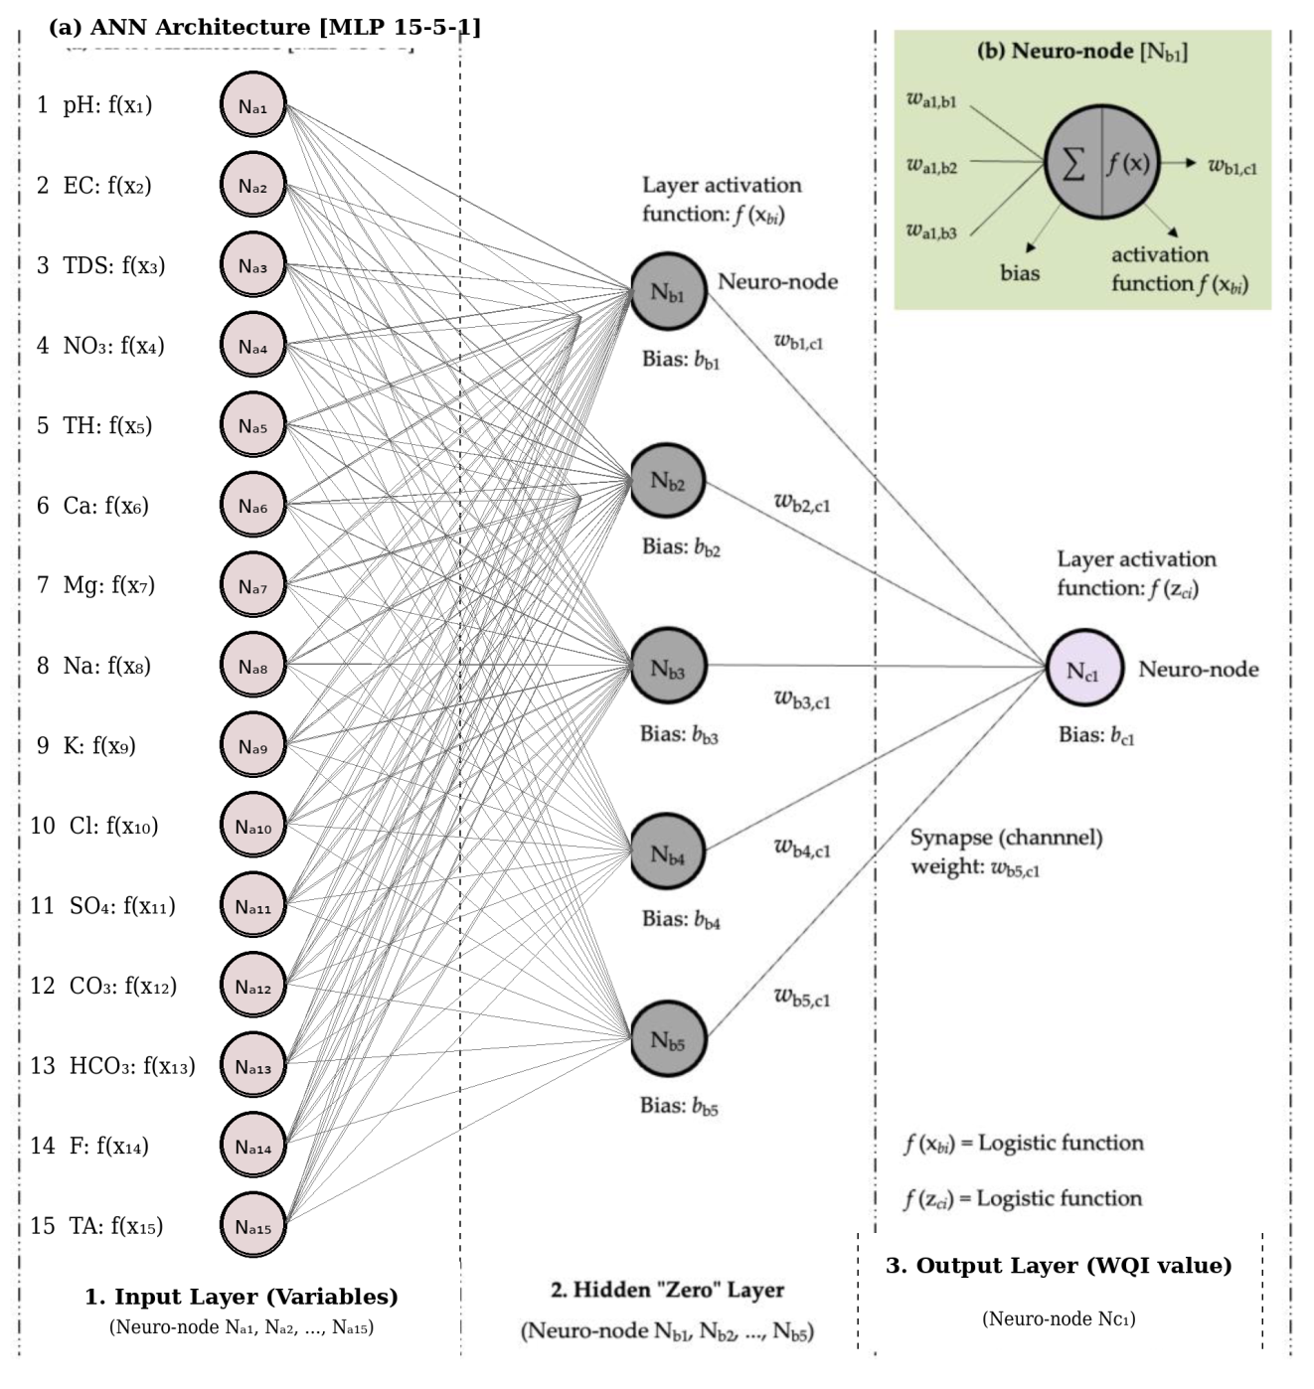
Figure 2: Architecture of the feed-forward ANN model used for WQI prediction

RESULTS AND DISCUSSION

3.1 Water Quality Index Distribution
Monthly WQI values were computed for all 468 groundwater samples collected between November 2018 and October 2021. And the year wise average and overall average WQI values and their ratings (as per Table 2) are presented in Table 3.

Table 3: Average WQI Values and their ranking
Sample ID | Yearly Average WQI Values |  |  | Average WQI values | WQI ranking
Sample ID | Year 1 | Year 2 | Year 3 | Average WQI values | WQI ranking
S1 | 39.01 | 40.94 | 40.70 | 40.21 | Good
S2 | 42.96 | 44.89 | 44.65 | 44.17 | Good
S3 | 35.42 | 37.35 | 37.11 | 36.63 | Good
S4 | 33.73 | 35.66 | 35.42 | 34.94 | Good
S5 | 42.04 | 43.97 | 43.73 | 43.25 | Good
S6 | 40.42 | 42.35 | 42.11 | 41.63 | Good
S7 | 38.97 | 40.90 | 40.66 | 40.18 | Good
S8 | 28.84 | 30.77 | 30.53 | 30.04 | Good
S9 | 56.74 | 58.67 | 58.42 | 57.94 | Poor
S10 | 29.33 | 31.26 | 31.02 | 30.54 | Good
S11 | 60.51 | 62.44 | 62.20 | 61.72 | Poor
S12 | 61.48 | 63.41 | 63.17 | 62.69 | Poor
S13 | 38.75 | 40.68 | 40.44 | 39.95 | Good
WQI result from Table 3 states that the majority of samples (77%) were classified as Good, indicating overall acceptable groundwater quality for drinking purposes with minor treatment. A smaller proportion of samples (23%) fell within the Poor category, indicating localized deterioration likely associated with geogenic mineral dissolution and seasonal concentration effects. No samples were categorized under Very Poor or Unsuitable classes, indicating the absence of severe contamination during the monitoring period.
The observed WQI variability reflects nonlinear interactions among major cations, anions, and physicochemical parameters. Seasonal recharge and evapoconcentration likely influence fluctuations in TDS, hardness, and major ion chemistry, which in turn affect WQI values. However, the absence of extreme WQI classes (WQI 76-100, WQI >100) suggests that groundwater quality degradation is moderate rather than critical within the investigated region.

3.2. ANN Performance Evaluation
The comparison between experimentally computed and ANN-predicted Water Quality Index (WQI) values for six months (from May-2021 to October-2021) is presented in Table 4. The model demonstrated excellent predictive performance, with a high coefficient of determination (R² = 0.998), indicating a very strong agreement between observed and predicted values.
Table 4: Comparison Between Experimented and ANN Predicted WQI Values during Testing
Sample ID | Month& Year  → | May-2021 | Jun-2021 | Jul-2021 | Aug-2021 | Sep-2021 | Oct-2021
S1 | Experimented | 48.41 | 48.77 | 37.03 | 35.52 | 34.52 | 31.62
S1 | ANN Predicted | 48.41 | 48.98 | 36.28 | 35.23 | 34.36 | 30.94
S2 | Experimented | 50.72 | 50.43 | 40.54 | 38.24 | 38.54 | 38.44
S2 | ANN Predicted | 50.59 | 50.62 | 40.43 | 37.94 | 38.97 | 38.30
S3 | Experimented | 40.75 | 40.78 | 34.23 | 34.13 | 32.37 | 35.49
S3 | ANN Predicted | 40.97 | 41.00 | 34.26 | 34.12 | 32.15 | 35.54
S4 | Experimented | 38.60 | 39.44 | 33.12 | 32.62 | 33.06 | 31.92
S4 | ANN Predicted | 38.58 | 39.10 | 33.05 | 32.65 | 32.94 | 32.24
S5 | Experimented | 51.66 | 49.14 | 40.24 | 36.38 | 35.13 | 38.19
S5 | ANN Predicted | 50.43 | 49.21 | 40.02 | 36.32 | 35.10 | 37.85
S6 | Experimented | 44.24 | 45.80 | 40.62 | 38.79 | 40.61 | 39.07
S6 | ANN Predicted | 44.00 | 45.98 | 40.12 | 39.05 | 40.40 | 38.21
S7 | Experimented | 43.80 | 45.04 | 39.71 | 38.10 | 36.21 | 36.36
S7 | ANN Predicted | 43.72 | 45.19 | 39.66 | 38.14 | 36.76 | 35.98
S8 | Experimented | 33.55 | 34.16 | 26.73 | 28.36 | 26.38 | 28.96
S8 | ANN Predicted | 33.52 | 34.31 | 26.01 | 28.22 | 25.12 | 29.16
S9 | Experimented | 62.08 | 62.67 | 55.98 | 56.36 | 54.72 | 53.64
S9 | ANN Predicted | 62.18 | 62.82 | 56.13 | 56.09 | 54.42 | 53.53
S10 | Experimented | 35.45 | 34.99 | 29.62 | 27.84 | 27.99 | 26.28
S10 | ANN Predicted | 35.48 | 35.24 | 29.76 | 27.83 | 28.68 | 26.01
S11 | Experimented | 67.74 | 68.14 | 56.22 | 55.15 | 56.75 | 54.51
S11 | ANN Predicted | 67.32 | 67.85 | 57.80 | 55.13 | 56.04 | 54.42
S12 | Experimented | 67.70 | 69.30 | 61.10 | 57.82 | 56.24 | 56.99
S12 | ANN Predicted | 68.09 | 69.50 | 60.92 | 57.55 | 54.58 | 56.93
S13 | Experimented | 45.52 | 45.38 | 36.54 | 36.71 | 38.95 | 36.72
S13 | ANN Predicted | 45.01 | 45.54 | 36.59 | 36.73 | 39.13 | 36.55
The error metrics further confirm the robustness of the developed ANN model, as evidenced by low Root Mean Square Error (RMSE = 0.438), Mean Absolute Error (MAE = 0.287), and minimal bias (−0.098). These results indicate high prediction accuracy, low dispersion of errors, and negligible systematic overestimation or underestimation.
The regression performance plot for Sample 1 is illustrated in Fig. 3, demonstrating the close clustering of predicted values along the 1:1 line. The regression coefficient (R) values for all samples are provided in Table 5, representing the strength of correlation between experimentally observed (actual) and ANN-predicted WQI values. The consistently high R values across samples confirm the reliability and generalization capability of the developed ANN model.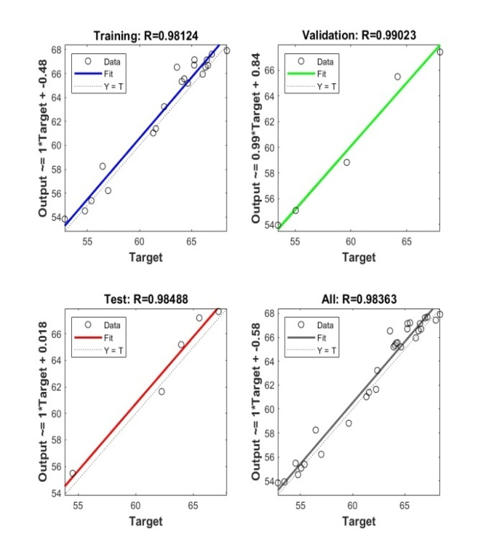
Figure 3 Regression performance of the ANN model during training, validation, and testing phases (Sample S1).

Table 5: Regression coefficient (R) values
Sample ID | Training | validation | Testing | All
S1 | 0.99997 | 0.99633 | 0.97176 | 0.99509
S2 | 0.97815 | 0.99412 | 0.98929 | 0.97985
S3 | 0.99982 | 0.99643 | 0.99301 | 0.99575
S4 | 0.96993 | 1 | 0.92065 | 0.97223
S5 | 0.99956 | 0.98976 | 0.98369 | 0.99314
S6 | 0.94363 | 0.99709 | 0.99954 | 0.97622
S7 | 0.99984 | 0.99652 | 0.99014 | 0.99761
S8 | 0.97688 | 0.98551 | 0.98003 | 0.97487
S9 | 0.99783 | 0.96785 | 0.96241 | 0.98251
S10 | 0.98274 | 0.99831 | 0.97242 | 0.98216
S11 | 0.98124 | 0.99023 | 0.98488 | 0.98363
S12 | 0.99489 | 0.99727 | 0.97409 | 0.99229
S13 | 0.99964 | 0.99927 | 0.99449 | 0.99782
.

CONCLUSIONS
(i) Based on WA-WQI analysis from Table 3,

a) The results indicated that the water samples collected from ten sampling stations (S1, S2, S3, S4, S5, S6, S7, S8, S10 and, S13) of the study area meet the required standards for drinking purpose as their status was classified under Good category.
b) The remaining water samples at three sampling stations (S9, S11, S12) Mittivalasa, Parannavalasa and Puroithunivalasa reported as Poor category. It is proposed to take appropriate treatment measures before the consumption of water collected from these stations.

(ii) Based on ANN Performance Evaluation from Table 4 and Table 5,

it is observed that the 15–5–1 ANN developed model achieved strong predictive performance with consistent generalization across independent datasets. The framework enables rapid WQI estimation from routine hydro chemical measurements and may serve as a practical decision-support tool in hard-rock aquifer systems.
Future work should explore reduced-parameter ANN models and cross-regional validation to enhance scalability.
Consent
All authors declare that ‘written informed consent was obtained from the patient (or other approved parties) for publication of this case report and accompanying images. A copy of the written consent is available for review by the Editorial office/Chief Editor/Editorial Board members of this journal
Ethical approval
Not applicable
Disclaimer (Artificial Intelligence)
Author(s) hereby declare that NO generative AI technologies such as Large Language Models (ChatGPT, COPILOT, etc) and text-to-image generators have been used during writing or editing of this manuscript.
Data Availability: The data supporting the findings of this study are available from the corresponding author upon reasonable request.
COMPETING INTERESTS DISCLAIMER:
Authors have declared that they have no known competing financial interests OR non-financial interests OR personal relationships that could have appeared to influence the work reported in this paper.

5. References
APHA, AWWA, WEF, (2017). Standard Methods for the Examination of Water and Wastewater, 23rd ed. American Public Health Association, Washington, DC.
Appala Raju, N., Harikrishna, K., Satyanarayana, P., Suneetha, P., Sachi Devi, S., (2014). Spatial distribution of groundwater quality in Vizianagaram District, Andhra Pradesh, India. International Journal of Science, Environment and Technology 3 (1), 148–160.
BIS, (2012). Indian Standard Drinking Water Specification IS 10500, Bureau of Indian Standards, New Delhi
Basim, H.K., Jasimb, M.M., Alsaqqar, A.S., (2018). Artificial neural network model for the prediction of groundwater quality. Civil Engineering Journal 4 (12), 2959–2970.
Brown, R.M., McClelland, N.I., Deininger, R.A., O’Connor, M.F., (1972). A water quality index – crashing the psychological barrier. In: Indicators of Environmental Quality. Springer, Boston, pp. 173–182. https://doi.org/10.1007/978-1-4684-1698-5_15
Chen, H., Zhao, Q., Yaseen, Z.M., (2025). Explainable artificial intelligence for water quality assessment and risk analysis. Water Research, 225, 119362.
García-del-Toro, E.M., Mas-López, M.I., Mateo, L.F., Quijano, M.Á., (2025). Groundwater quality prediction for drinking and irrigation uses using artificial neural networks. Applied Water Science 15, 247.
Ghadai, M., Satapathy, D.P., Krishnasamy, S., Ramalingam, M., Sreelal, G.P., Dhilipkumar, B., (2022). Artificial neural network and weighted arithmetic indexing approach for surface water quality assessment of the Brahmani River. Global NEST Journal 24 (4), 562–568.
Gummadi, S., Swarnalatha, G., Venkataratnamma, V., Vishnuvardhan, Z., (2014). Determination of water quality index for groundwater of Bapatla Mandal, Guntur District, Andhra Pradesh, India. International Journal of Engineering Research & Technology 3 (3), 77–80.
Hariharan, A.V.L.N.S.H., Lakshmi, B., (2011). Determination of fluoride in some areas of Vizianagaram District, Andhra Pradesh. International Journal of Pharmacy and Biological Sciences 1 (2), 8–10.
Liu, L., Sun, W., Zhao, X., (2022). Scenario-based prediction of groundwater quality under climate change using machine learning. Science of the Total Environment, 812, 152467.
Li, J., Wang, Y., Zhang, X., et al., (2023). Deep learning models for groundwater quality prediction: a comparative analysis. Journal of Hydrology, 621, 127⁠—139.
Maier, H.R., Dandy, G.C., (2000). Neural networks for the prediction and forecasting of water resources variables: A review of modelling issues and applications. Environmental Modelling & Software 15, 101–124.
Muthukumaran, V., Vinoth Kumar, V., (2022). Water quality index process using artificial neural networks. International Journal of Information Technology, Research and Applications 1 (1), 33–37. https://doi.org/10.59461/ijitra.v1i1.12
Nayar, R., (2020). Assessment of water quality index and monitoring of pollutants by physicochemical analysis in water bodies: A review. International Journal of Engineering Research & Technology 9 (1), 178–185.
Pavan Kumar, G.V.S.R., Chandrasekhar, T., Sreerama Murty, B., (2017a). Assessment of groundwater quality status based on water quality index method in Konada and Chintapalli villages of Vizianagaram District, Andhra Pradesh, India. Journal of the Indian Chemical Society 94, 1–9.
Pavan Kumar, G.V.S.R., Partha Sarathi, T.V.N., Srinivasa Rao, K., (2017b). Assessment and prediction of water quality index using artificial neural networks in selected coastal villages of Vizianagaram District, Andhra Pradesh. Journal of the Indian Chemical Society 94, 1–8.
Rabah Ismail, Rawashdeh, A., Al-Mattarneh, H., Hatamleh, R., Telfah, D.B., Jaradat, A.,(2024). Artificial intelligence for application in water engineering: The use of ANN to determine water quality index in rivers. Civil Engineering Journal 10 (7), 2261–2274.
Ramakrishnaiah, C.R., Sadashivaiah, C., Ranganna, G., (2009). Assessment of water quality index for the groundwater in Tumkur Taluk, Karnataka State, India. E-Journal of Chemistry 6 (2), 523–530.
Srinivasa Rao, G., Nageswararao, G., (2013). Assessment of groundwater quality using water quality index. Archives of Environmental Sciences 7, 1–5.
Singh, R.K., Gupta, P.K., Maity, S., (2024). Hybrid machine learning and geostatistical framework for groundwater quality prediction. Environmental Modelling & Software, 169, 105271.
Vasanthavigar, M., Srinivasamoorthy, K., Vijayaragavan, K., Rajiv Ganthi, R., Chidambaram, S., Anandan, P., Manivannan, R., Vasudevan, S., (2010). Application of water quality index for groundwater quality assessment: Thirumanimuttar sub-basin, Tamil Nadu, India. Environmental Monitoring and Assessment 171, 595–609.
WHO, (2017). Guidelines for Drinking-Water Quality, 4th edn, World Health Organization, Geneva.

