Original Research Article

ISOLATION AND MEDIA OPTIMIZATION OF OLEAGINOUS YEAST FOR ENHANCED LIPID PRODUCTION FROM SOIL SAMPLES

Abstract

Aim-The aim of this study was to isolate oleaginous yeast from soil and to optimize media components for enhanced lipid accumulation using different carbon and nitrogen sources, followed by statistical analysis at a 5% significance level.

Study Design, Place, and Duration- An experimental laboratory-based study was conducted in the Microbiology laboratory of the institution. The study was carried out over a period of several months.

Methodology-Oleaginous yeasts are defined as yeasts capable of accumulating more than 20% lipid of their dry biomass. Soil samples were collected and subjected to enrichment culture, followed by plating on Yeast Extract Peptone Dextrose (YPD) agar for yeast isolation. The enrichment culture yielded 2.22 × 10⁸ CFU/mL. White, creamy, round colonies were considered as yeast and selected for further screening. Screening for oleaginous yeast was performed using nitrogen-limited medium (NLM), as nitrogen limitation is known to be the most effective condition for inducing lipogenesis. Media optimization was carried out using different carbon sources (glucose, molasses, and agricultural waste) and nitrogen sources (ammonium sulphate and peptone). Lipids were extracted from yeast biomass using the Bligh and Dyer method. The obtained data were statistically analyzed using one-way ANOVA at a 5% significance level.

Results-The isolated yeast strains accumulated lipid content exceeding 20% of dry biomass, confirming their oleaginous nature. Media containing glucose, molasses, and ammonium sulphate resulted in significantly higher lipid accumulation compared to media containing peptone and agricultural waste. Among the carbon sources tested, molasses supported the highest lipid yield.

Conclusion-The study successfully isolated oleaginous yeast from soil and demonstrated that nitrogen limitation significantly enhances lipid accumulation. Media optimization revealed that glucose, molasses, and ammonium sulphate are effective substrates for lipid production, with molasses showing the highest potential. These findings highlight the applicability of low-cost substrates for sustainable microbial lipid production.
KEY WORDS: Oleaginous Yeast, Lipid accumulation, Lipid extraction, Trans esterification, Microbial lipid.

1. INTRODUCTION
The value of microorganisms as a source of novel lipids is becoming more widely acknowledged. Oleaginous oils, often referred to as solo cell oils (SCOs), unicellular oils, or microbial oils, are defined as oils having at least 20% oleic acid. (Ochsenreither et al., 2016)Because microbes are so common, it has long been recognized that they may be sources of oils and fats. Lipids, which include fats and oils, are the building blocks of oleochemicals, which are substances made from animal and plant fats and utilized in paints, plastics, biofuels, surface coatings, surfactants, and cosmetics, among other applications.(Temelli, 2009) (Yan & Pfleger, 2020) Fatty acids and alcohols make up 75% of the total oleochemicals, which also comprise amines, fatty methyl esters, and fatty acids. (Zhou et al., 2016) Consequently, there has been a growing interest in discovering alternative, sustainable, and cost-effective energy sources in recent years. (Biermann et al., 2021) Oleaginous yeasts offer attractive platforms for the long-term manufacture of fatty acid-derived oleochemicals because of their capacity to synthesize and store lipids, notably triacylglycerides.(Adrio, 2017) One sustainable, low-carbon liquid biofuel that helps lower greenhouse gas emissions is biodiesel. (Jeswani et al., 2020) Waste oils, non-edible oils, and vegetable oils were initially used in the manufacturing of biodiesel. (Demirbas et al., 2016) These sources are still expensive and come with a number of drawbacks, including the requirement for labor and land. Furthermore, there is not enough waste oil available to fulfill demand. (Abdel-Shafy & Mansour, 2018) According to recent research, lignocellulosic materials can be used in conjunction with oleaginous bacteria to generate biodiesel. (Chintagunta et al., 2021) Under stress, these bacteria collect more lipids and have a lipid profile like that of vegetable oils. Biodiesel production from lignocellulosic substrates is achieved by a series of processes that include pretreatment, saccharification, lipid extraction, transesterification, fermentation with oleaginous bacteria, and biodiesel purification.(Chintagunta et al., 2021) In addition, the integration of liquid biofuels which are critical for advancing a circular economy and the significance of metabolic engineering for the development of biofuels and biorefineries are emphasized. (Nath, 2024)
1.2.Lipids in Yeasts
Organic substances known as lipids are soluble in nonpolar natural solvents but insoluble in water. These tiny biomolecules have a wide range of physical characteristics, from extreme hydrophobicity to amphiphilia. (Ye et al., 2021) Based on their structure and function, lipids may be classified into eight categories: fatty acids (FA), glycerol lipids, glycerol phospholipids, sterols and sterol products, sphingolipids, prenol lipids, glycolipids, and polyketides. (Fahy et al., 2005) Lipids are substances found in biological membranes or accumulated in different organelles that function as energy suppliers, structural rudiments, signaling molecules, and intermediaries of membrane fusion and apoptosis. They are fundamental elements of intracellular organelle contents and cell membranes (Casares et al., 2019). The main organelles in charge of lipid synthesis are the mitochondria, the Golgi apparatus, and the endoplasmic reticulum (ER). It's interesting to note that these organelles contain very little amounts of some lipids. To move lipids since their source of amalgamation to their destination, a lipid transport mechanism is therefore necessary. Because of its many advantageous traits and the fact that eukaryotic processes are substantially conserved, Saccharomyces cerevisiae has emerged as a leading model for lipid research. An efficient strategy to study lipid production, breakdown, and storage is to create yeast mutant strains lacking in particular lipid metabolic processes.(Jiang et al., 2022)
Yeast cells use a variety of processes, including lipid synthesis, lipid absorption from the environment, and lipid recycling, to satisfy their lipid requirements. Lipotoxicity is the result of an excess of lipids within the cell.(Rockenfeller & Gourlay, 2018) Lipids are kept in specialized organelles known as lipid droplets (LDs) to avoid this. When needed, these stored lipids can be synthesized into complex lipids or used to produce energy.(Olzmann & Carvalho, 2019) The isolation was done by enrichment and plating on a specific media and by providing an optimum physical condition for yeast culture. Screening for oleaginous yeast was done by using a nitrogen limited media.(Osman et al., 2022) Then oleaginous yeast culture from nitrogen limited media was transferred to the media containing different carbon and nitrogen sources. Following incubation biomass was harvested and dried for 24hrs and biomass yield was estimated by weight. It was from biomass that lipid was isolated using the Bligh and Dyer process. Lipid yield was then estimated by weighing as lipid per gram of biomass.(Breil et al., 2017) The data obtained in this study were analyzed using one way ANOVA at 5% significance level. On confirming significant difference among media tested, post- hoc ANOVA test (with Bonferroni correction) was employed to identify the media showing most significant difference by doing multiple comparisons among pairs of tested media.(McHugh, 2011)

2.RESOURCES AND TECHNIQUES
2.1.Isolation of Yeast
Soil samples were collected from the Aurangabad, Maharashtra.Ten milliliters of regular saline were combined with one gram of dirt, and one milliliter of this mixture was added to fifty milliliters of enrichment medium that had been pH-adjusted to 4.5 and included (in grams per liter) yeast extract five, peptone five, and glucose 70. This combination was incubated for 24 hours at 30°C and 150 rpm of shaking in a shaker incubator. Using the serial dilution approach, the enriched sample was diluted following incubation. Next, 0.1 ml of each dilution (10^-1 to 10^-5) was spread out on YPD agar plates with the following concentrations (in g/l): glucose 20, peptone 20, yeast extract 10, and agar 20. The plates had been pH-adjusted to 4.5.The saucers were incubated at 30°C for 4 days. Characteristic colonies were then identified based on their facade and maintained on YPD agar slants.
2.2.Screening for oleaginous yeast
A loopful of 48-hour long-standing culture was put into 50 milliliters of inoculant media with a pH of 6 adjusted to contain 40 g/l glucose, 15 g/l yeast extract, and 5 g/l peptone. This combination was incubated for 24 hours at 150 rpm and 30°C in a shaker. Then, 5 milliliters of this inoculums were added to 45 milliliters of nitrogen-limited medium that had the pH adjusted to 5, 100 grams of glucose, 0.5 grams of yeast extract, 1.8 grams of peptone, 0.4 grams of MgSO4·7H₂O, 2.0 grams of KH₂PO₄, 0.003 grams of MnSO₄·H2O, and 0.0001 grams of CuSO4·H₂O. Later that, this was shaken at 150 rpm for six days at 30°C.
2.3.Optimization of media
A volume of 5 ml culture from nitrogen limited media was transferred to the 45ml of different nitrogen sources and carbon sources containing media, and incubated at 30○ Celsius with shaking at 150 rpm for 6 days.Ammonium sulphate (g l-1) is present in the following nitrogen sources: glucose 100, yeast extract 0.5, MgSo₄.7H₂O 0.4, KH₂PO₄ 2.0, MnSO₄.H₂O 0.003, CuSO₄.pH 5; H₂O 0.0001, (NH₄)₂SO₄ 1. (1-1)Peptone: 100 glucose, 0.5 yeast extract, 0.4 MgSO4.7H2O, 2.0 KH2PO4, 0.003 MnSO4.H2O, 0.0001 CuSO4.H2O, 1.5 Peptone, pH 5. Among the origins of carbon are: Glucose (g l-1) = 100 g, 0.5 g of yeast extract, 1.8 g of peptone, 0.4 g of MgSO4.7H2O, 2.0 kH2PO4, 0.003 mNSO4.H2O, 0.0001 CuSO4.H2O, pH 5.
( l-1g) Molasses: 80 molasses, (NH4)2SO4 1, KH2PO4 2.0, pH 5. Sorghum powder (l-1g) composed of 80 agri-waste, 0.5 yeast extract, 1.8 peptone, 0.4 MgSO4.7H2O, 2.0 KH2PO4, 0.003 MnSO4.H2O, 0.0001 CuSO4.H2O, and pH 5.
2.4.Extraction of lipid
The soup was stirred at 10,000 revolutions per minute for 15 minutes at room temperature following a 6-day incubation. Drying the biomass at 105°C for 24 hours followed by discarding the supernatant. The Bligh and Dyer recommended technique was used to extract lipids. To guarantee full hydrolysis, the biomass was suspended in 10 milliliters of 4M HCl and cultivated at 60°C for two hours. After that, the acid-hydrolyzed biomass was agitated for two hours at areawarmth in 20 milliliters of a 1:1 chloroform/methanol mixture. The organic layer, interphase, and aqueous layer were then separated. Then lower organic layer containing lipid was recovered and kept for evaporation to recover lipid. Then lipid yield was estimated by weight.
2.5.Transesterification
One milliliter of a CHCl3/MeOH (2:1) mixture was used to dissolve the dried lipid extract. 200 µl of the lipid extract was taken out of this mixture and put into 15 ml Pyrex tubes. An internal standard solution (250 µM C16:0 in methanol) containing 100 µl was added to each tube, and the solvent was let to evaporate. Then, 0.5 ml of toluene and 3 ml of 2% HCl in methanol were added to each tube. After briefly being vortexed, the tubes were roasted for an hour at 100°C. Following chilling, each tube received 1 ml of ice-cold deionized water and 2 ml of newly made hexane/CHCl3. After 15 minutes of vortexing, the tubes were centrifuged for 5 minutes at ambient temperature at 2000 rpm. A fresh, clean tube was used to hold the top organic phase. Next, two milliliters of freshly prepared hexane/CHCl3 and one milliliter of frozen deionized water were added to each tube.After being vortexed for fifteen minutes, the tubes were centrifuged for five minutes at ambient temperature at 2000 rpm . After separating the upper organic phase, the upper phases were mixed and allowed to dry. 500 µl of hexene were added to each tube and carefully stirred. The tube's bottom was where the FAMEs were gathered. After the material was dried, 100 µl of hexene was used to dissolve it.
3.CHEMICALS AND MATERIALS.
Hot air oven of Shital scientific industries; Autoclave of Accumax India; Bacteriological incubator of Tempo equipment and industries; Incubator shaker of Sciencetech; borosil glasswares and other general instruments like Laminar air flow, Compound Microscope and Centrifuge were used during experiment.
Chloroform, methanol, and sulphuric acid (99%pure) of fisher scientific; Dipotassium phosphate (98-101% pure) of MERCK and magnesium sulphate (99% pure) of Lobachemie; and other chemicals like toluene, hexane and deionized water etc. were used and all are of AR grade. Components of media are of HI Media (Agar is Bacteriological grade).

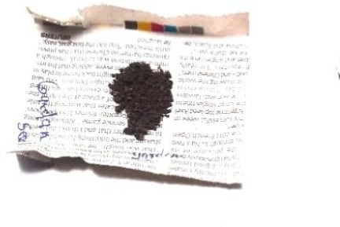 | 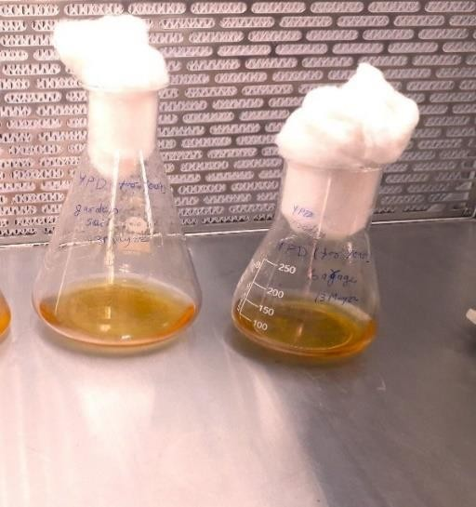
Fig1: Soil sample (collected from garage of Aurangabad). | Fig 2: Enrichment media contains glucose, yeast extract, and peptone. On the right, control without inoculation and on right, 24hrs enriched culture
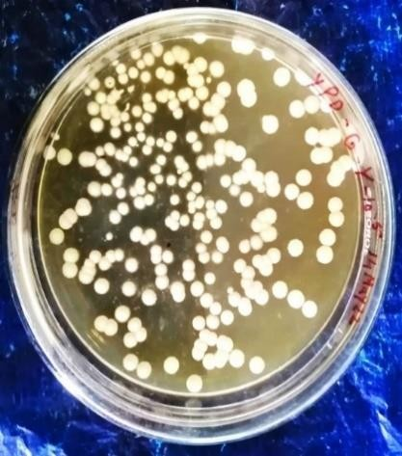  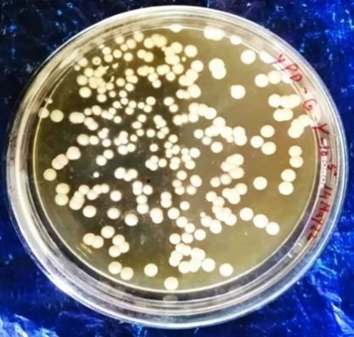 | 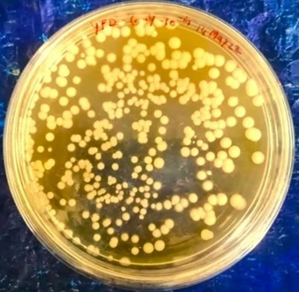
Fig 3: After 4 days of incubation Yeast colonies developed on YPD agar plate. On left, plate contains 10-5 dilution of enriched culture and on right plate contains 10-4dilution of enriched culture.
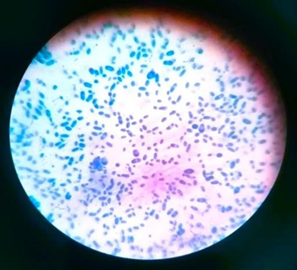 | 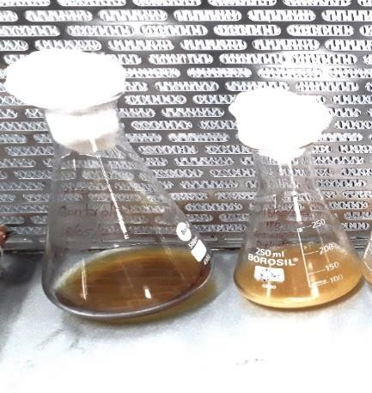
Fig 4: Yeast cells stained by lacto phenol cotton blue. | Fig 5: Culture in nitrogen limited media (NLM) for screening. On left control without inoculation shows no turbidity. On right NLM contains culture after 6 day so incubation
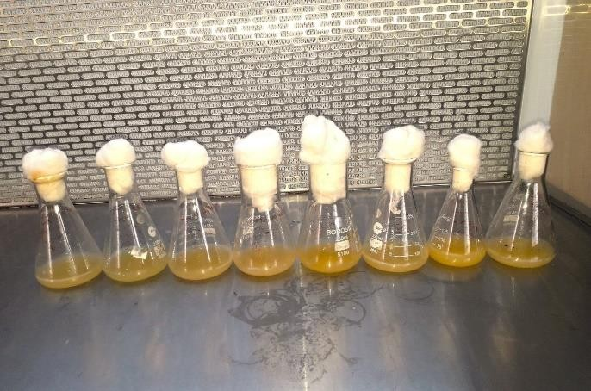 | 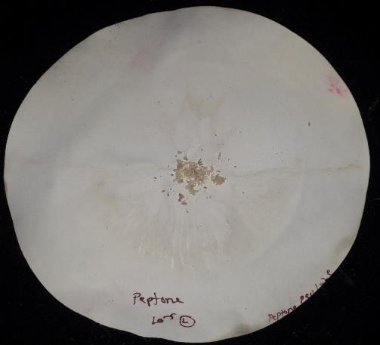
Fig 6: Growth obtained after 06 days of incubation. Enriched isolate were grown on media containing different nitrogen sources (ammonium sulphate, peptone) and different carbon sources (glucose, molasses, agriculture waste). | Fig 7: Harvested biomass obtained by filtering the culture and drying the filtrate in oven at 1050C for 24hrs.
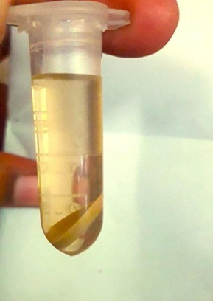 | 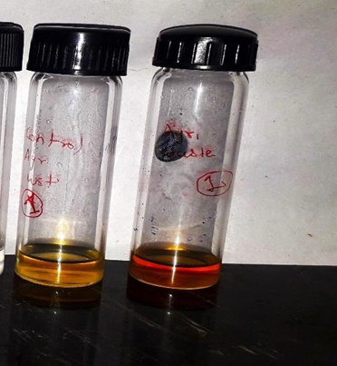
Fig 8: Lipid extracted from biomass (upper-aqueous, middle-interphase, lower-organic phase). | Fig 9: Extracted lipid after trans esterification reaction.

A single culture was inoculated into media containing different carbon and nitrogen sources in triplicate (A, B, and C).

Media | A | B | C
glucose | 2.6 | 1 | 2.2
molasses | 3.4 | 2.2 | 4.8
peptone | 0.2 | 0.2 | 0.04
ammonium  sulphate | 1.56 | 1.56 | 0.6
Agriwaste | 2.2 | 1.23 | 1.61

Table1:Biomass yield obtained (ing/l) in different media

Media | A | B | C
glucose | 1.04 | 0.44 | 1.04
molasses | 1.64 | 1.6 | 2.2
peptone | 0.03 | 0.03 | 0.005
Ammonium  sulphate | 0.78 | 0.54 | 0.08
Agriwaste | 0.08 | 0.4 | 0.4

Table no.2:Extracted Lipid weight (ing/l)

Media | A | B | C
glucose | 40.00% | 44% | 47.20%
molasses | 48.20% | 72.70% | 45.80%
peptone | 15% | 15% | 12.50%
ammonium  sulphate | 50% | 34.61% | 13.30%
Agriwaste | 3.60% | 32.50% | 24.80%

Table no 3: Lipid Percentage of dry biomass

ANOVA: for Biomass
SUMMARY
Groups | Count | Sum | Average | Variance
Glucose | 3 | 5.8 | 1.933333 | 0.693333
Molasses | 3 | 10.4 | 3.466667 | 1.693333
Peptone | 3 | 0.44 | 0.146667 | 0.008533
Ammonium sulphate | 3 | 3.72 | 1.24 | 0.3072
Agri waste | 3 | 5.04 | 1.68 | 0.2389
ANOVA
Source of  Variation | SS | df | MS | F | P-value | Fcrit
Between Groups | 17.40053 | 4 | 4.350133 | 7.394916 | 0.004877 | 3.47805
Within Groups | 5.8826 | 10 | 0.58826
Total | 23.28313 | 14
Table 4- The biomass yield differed among the tested media groups.

Anova: Single Factor for lipid percentage
SUMMARY
Groups | Count | Sum | Average | Variance
glucose | 3 | 1.312 | 0.437333 | 0.001301
molasses | 3 | 1.667 | 0.555667 | 0.02216
peptone | 3 | 0.425 | 0.141667 | 0.000208
Ammonium sulphate | 3 | 0.9791 | 0.326367 | 0.033964
Agriwaste | 3 | 0.609 | 0.203 | 0.022399
ANOVA
Source of  Variation | SS | df | MS | F | P-value | Fcrit
Between Groups | 0.342054 | 4 | 0.085514 | 5.342377 | 0.014505 | 3.47805
Within Groups | 0.160067 | 10 | 0.016007
Total | 0.502121 | 14
According to the above table, the calculated F value is greater than the critical F value, indicating that the biomass yield differs among the media.
Table 5- The lipid percentage of biomass differed among the tested media groups.

However, the ANOVA post hoc test showed no statistically significant differences between the individual groups.
As shown in the table, the calculated F value exceeded the critical F value, demonstrating that the lipid percentage of biomass differed significantly among the tested media groups.

4.ANOVA POST-HOC TEST ( BONFERRONI CORRECTION )
t-Test:Two-Sample Assuming Unequal Variances
 | glucose | molasses
Mean | 0.437333333 | 0.555666667
Variance | 0.001301333 | 0.022160333
Observations | 3 | 3
Hypothesized Mean Difference | 0
df | 2
T Stat | -1.338099152
P(T<=t)one-tail | 0.156355408
tCritical one-tail | 2.91998558
P(T<=t)two-tail | 0.312710815
tCritical two-tail | 4.30265273
Bonferroni adjustment |  | 0.005
significant |  | NO
Table 6- Two-sample T-test between glucose and molasses
t-Test: Two-Sample Assuming Unequal Variances
 | glucose | peptone
Mean | 0.437333333 | 0.141666667
Variance | 0.001301333 | 0.000208333
Observations | 3 | 3
Hypothesized Mean Difference | 0
df | 3
t Stat | 13.18021393
P(T<=t) one-tail | 0.000471787
t Critical one-tail | 2.353363435
P(T<=t) two-tail | 0.000943574
t Critical two-tail | 3.182446305
Bonferroni adjustment |  | 0.005
Significant  Table 7- Two-sample T-test between glucose and peptone |  | Yes
t-Test: Two-Sample Assuming Unequal Variances
 | glucose | ammonium sulphate
Mean | 0.437333333 | 0.326366667
Variance | 0.001301333 | 0.033964303
Observations | 3 | 3
Hypothesized Mean Difference | 0
df | 2
t Stat | 1.023475152
P(T<=t) one-tail | 0.206859819
t Critical one-tail | 2.91998558
P(T<=t) two-tail | 0.413719638
t Critical two-tail | 4.30265273
Bonferroni adjustment |  | 0.005
significant |  | NO

Table 8- Two-sample T-test between glucose and ammonium sulphate
t-Test: Two-Sample Assuming Unequal Variances
 | glucose | Agri waste
Mean | 0.437333333 | 0.203
Variance | 0.001301333 | 0.022399
Observations | 3 | 3
Hypothesized Mean Difference | 0
df | 2
t Stat | 2.636437441
P(T<=t) one-tail | 0.059387828
t Critical one-tail | 2.91998558
P(T<=t) two-tail | 0.118775656
t Critical two-tail | 4.30265273
Bonferroni adjustment |  | 0.005
significant |  | NO

Table 9 - Two-sample T-test between glucose and Agri waste
t-Test:Two-Sample Assuming Unequal Variances
 | molasses | peptone
Mean | 0.555666667 | 0.141666667
Variance | 0.022160333 | 0.000208333
Observations | 3 | 3
Hypothesized Mean Difference | 0
df | 2
t Stat | 4.794473467
P(T<=t) one-tail | 0.020427716
t Critical one-tail | 2.91998558
P(T<=t) two-tail | 0.040855433
t Critical two-tail | 4.30265273
Bonferroni adjustment |  | 0.005
significant |  | YES

Table 10- Two-sample T-test between molasses and peptone
t-Test: Two-Sample Assuming Unequal Variances
 | molasses | ammonium sulphate
Mean | 0.555666667 | 0.326366667
Variance | 0.022160333 | 0.033964303
Observations | 3 | 3
Hypothesized Mean Difference | 0
df | 4
t Stat | 1.676439599
P(T<=t) one-tail | 0.084479643
t Critical one-tail | 2.131846786
P(T<=t) two-tail | 0.168959286
t Critical two-tail | 2.776445105
Bonferroni adjustment |  | 0.005
Significant  Table 11- Two-sample T-test between molasses and ammonium sulphate |  | NO
t-Test: Two-Sample Assuming Unequal Variances
 | molasses | Agri waste
Mean | 0.555666667 | 0.203
Variance | 0.022160333 | 0.022399
Observations | 3 | 3
Hypothesized Mean Difference | 0
df | 4
t Stat | 2.893714617
P(T<=t) one-tail | 0.022198509
t Critical one-tail | 2.131846786
P(T<=t) two-tail | 0.044397017
t Critical two-tail | 2.776445105
Bonferroni adjustment |  | 0.005
significant |  | NO
Table12- Two-sample T-test between molasses and agri waste

ANOVA analysis evaluating the effect of various media components on biomass accumulation and lipid production revealed that molasses, glucose, and ammonium sulphate did not differ significantly from each other. In contrast, post hoc analysis indicated that the use of peptone and agricultural waste resulted in a significant reduction in lipid accumulation. Thus, the study concluded that media containing molasses, glucose, and ammonium sulphate are most suitable for lipid accumulation in oleaginous yeast.

5. RESULTS

5.1 Isolation and Screening of Oleaginous Yeast
Soil samples obtained from a garage in Aurangabad, Maharashtra, India (Fig. 1), were submitted to enrichment in a medium comprising glucose, yeast extract, and peptone. After 24 hours of incubation, the enriched culture showed apparent turbidity compared to the uninoculated control (Fig. 2), indicating microbial proliferation. After four days of incubation at 30°C, serial dilutions of the enriched sample were plated on YPD agar, leading to the formation of yeast colonies. Plates containing 10^{-4} and 10^{-5} dilutions showed clear, spherical, white, creamy colonies that were typical of yeast (Fig. 3). The enrichment culture yielded a colony count of 2.22 × 10^8 CFU/mL. Using lactophenol cotton blue staining, selected colonies were verified as yeast under a microscope, displaying typical yeast cell shape (Fig. 4). Isolates were inoculated into nitrogen-limited medium (NLM) and incubated for six days in order to screen for oleaginous strains. The NLM cultures revealed substantial turbidity, demonstrating development under nitrogen-limiting conditions known to promote fat formation (Fig. 5). Strains accumulating more than 20% lipid of their dry biomass were designated as oleaginous and selected for further optimization.

5.2 Media Optimization: Biomass Yield
In medium supplemented with several carbon sources (glucose, molasses, agricultural waste) and nitrogen sources (ammonium sulphate, peptone), a single oleaginous yeast isolate was grown in triplicate (A, B, and C). After 6 days of incubation, biomass was extracted by centrifugation, dried at 105°C for 24 hours (Fig. 7), and weighed to measure yield (g/L).

As shown in Table 1, biomass yields varied across the media:
- Glucose: Yields ranged from 1.0 g/L to 2.6 g/L, with an average of 1.93 g/L.
- Molasses: Yields ranged from 2.2 g/L to 4.8 g/L, with an average of 3.47 g/L (highest overall).
- Peptone: Yields were consistently low, ranging from 0.04 g/L to 0.2 g/L, with an average of 0.15 g/L.
- Ammonium sulphate: Yields ranged from 0.6 g/L to 1.56 g/L, with an average of 1.24 g/L.
- Agricultural waste: Yields ranged from 1.23 g/L to 2.2 g/L, with an average of 1.68 g/L.
These results were supported by visual growth after six days (Fig. 6), which showed denser colonies in molasses and glucose media than in peptone-based media.
One-way ANOVA analysis for biomass yield (Table summarizing ANOVA findings) revealed significant differences across the groups (F = 7.39, df = 4/10, p = 0.0049 < 0.05). The computed F value was more than the crucial F value (3.48), suggesting that the composition of the media had a major impact on biomass output.

5.3 Media Optimization: Lipid Yield and Percentage
The Bligh and Dyer method, which involves acid hydrolysis and chloroform-methanol extraction, was used to extract lipids from the dried biomass. Different layers containing lipids were produced by the extraction process: organic (lower), interphase (middle), and aqueous (upper) (Fig. 8). The extracted lipids were represented as a percentage of dry biomass after being weighed (g/L).
Table 2 presents the extracted lipid weights:
- Glucose: 0.44 g/L to 1.04 g/L, average 0.84 g/L.
- Molasses: 1.6 g/L to 2.2 g/L, average 1.81 g/L (highest).
- Peptone: 0.005 g/L to 0.03 g/L, average 0.022 g/L (lowest).
- Ammonium sulphate: 0.08 g/L to 0.78 g/L, average 0.47 g/L.
- Agricultural waste: 0.08 g/L to 0.4 g/L, average 0.29 g/L.
Table 3 shows lipid percentages of dry biomass:
- Glucose: 40.0% to 47.2%, average 43.7%.
- Molasses: 45.8% to 72.7%, average 55.6% (highest).
- Peptone: 12.5% to 15.0%, average 14.2% (lowest).
- Ammonium sulphate: 13.3% to 50.0%, average 32.6%.
- Agricultural waste: 3.6% to 32.5%, average 20.3%.
In at least some replicates, every strain in the glucose, molasses, and ammonium sulphate medium above the 20% criterion for oleaginous classification; molasses exhibited the most consistent high accumulation. Because the F value exceeded the threshold value (3.48), a one-way ANOVA for lipid % (summarized in the ANOVA table) revealed significant differences among medium (F = 5.34, df = 4/10, p = 0.0145 < 0.05).

5.4 Transesterification
Extracted lipids were treated to transesterification using HCl in methanol to yield fatty acid methyl esters (FAMEs) appropriate for biodiesel (Fig. 9). The technique comprised solvent evaporation, incubation at 100°C, and phase separation with hexane/chloroform. Although quantitative yields were not specified beyond visual confirmation, the resulting FAMEs were collected and dried, confirming the possibility of biodiesel conversion.

5.5 Post-Hoc Analysis
To identify specific pairwise differences in lipid percentages, t-tests with Bonferroni correction (α = 0.005 for multiple comparisons) were performed:
  - Glucose vs. Molasses: t = -1.34, p = 0.313 (not significant).
  - Glucose vs. Peptone: t = 13.18, p = 0.0009 < 0.005 (significant; glucose higher).
  - Glucose vs. Ammonium sulphate: t = 1.02, p = 0.414 (not significant).
  - Glucose vs. Agricultural waste: t = 2.64, p = 0.119 (not significant).
  - Molasses vs. Peptone: t = 4.79, p = 0.041 (not significant after correction, but borderline; molasses higher).
  - Molasses vs. Ammonium sulphate: t = 1.68, p = 0.169 (not significant).
  - Molasses vs. Agricultural waste: t = 2.89, p = 0.044 (not significant after correction).

6. DISCUSSION
The isolation of oleaginous yeast from soil samples agrees with earlier studies highlighting soil as a rich source of lipid-accumulating microorganisms due to its various microbial communities (Ochsenreither et al., 2016). Since nitrogen limitation is a known cause of lipogenesis in yeasts, the enrichment technique employing high-carbon, low-nitrogen media successfully selected for oleaginous strains (Osman et al., 2022). The colony morphology and staining (Figs. 3-4) indicated yeast identity, presumably species such as Rhodotorula or Yarrowia, while molecular identification was not undertaken in this study. Molasses, a cheap byproduct abundant in sugars like sucrose and glucose that promotes quick yeast growth, had the highest biomass yields (Table 1) at an average of 3.47 g/L (Chintagunta et al., 2021). Glucose, a simple carbon source, provided moderate biomass (1.93 g/L), consistent with its role in efficient fermentation. Peptone, on the other hand, produced poor growth (0.15 g/L) when used as a nitrogen source. This could be because peptone is organic, which makes it less effective at assimilating nitrogen under lipid-inducing conditions. The idea that inorganic nitrogen improves lipid redirection over biomass proliferation is supported by the moderate yields of ammonium sulphate, an inorganic nitrogen source (1.24 g/L) (Adrio, 2017). Agricultural waste (sorghum powder) yielded 1.68 g/L, demonstrating potential as a sustainable substrate but with fluctuation due to its complex composition necessitating processing. Lipid yields and percentages (Tables 2-3) followed a similar trend, with molasses achieving the highest average lipid content (55.6% of dry biomass, up to 72.7% in one replicate). This surpasses glucose (43.7%) and highlights molasses' efficiency, possibly due to its mix of fermentable sugars and trace elements that replicate stress conditions for lipid storage in lipid droplets (Olzmann & Carvalho, 2019). The importance of nitrogen limitation in changing metabolism from development to storage was reinforced by ammonium sulphate, which supported 32.6% lipid. Agricultural waste and peptone both fared poorly (14.2% and 20.3%, respectively). Peptone's inability to produce enough lipogenesis may be due to its abundant amino acids, which promote protein synthesis over lipid synthesis. Agricultural waste's low lipid output may come from inhibitors or insufficient saccharification, as documented in lignocellulosic biofuel research ANOVA indicated substantial overall effects of medium on both biomass (p=0.0049) and lipid percentage (p=0.0145), confirming the optimization technique. Although there was no significant difference between molasses, glucose, and ammonium sulphate, post-hoc tests showed that they performed better than peptone and agricultural waste, highlighting the preference for simple or byproduct carbons with inorganic nitrogen for lipid formation. Transesterification successfully converted lipids to FAMEs (Fig. 9), demonstrating compatibility with biodiesel pipelines. This addresses the drawbacks of conventional sources like vegetable oils and promotes the use of oleaginous yeasts for sustainable biofuels (Jeswani et al., 2020; Abdel-Shafy & Mansour, 2018). Fatty acid profile, scale-up data, and strain identification are among the limitations. Future research could integrate with lignocellulosic pretreatments (Nath, 2024) or investigate genetic engineering for increased yields (Yan & Pfleger, 2020).

7. CONCLUSION
In this study, oleaginous yeast were effectively isolated from soil samples in Aurangabad, Maharashtra, and their capacity to accumulate more than 20% lipid under nitrogen-limited circumstances was demonstrated. Media optimization found that molasses as a carbon source and ammonium sulphate as a nitrogen source generated the highest biomass (up to 4.8 g/L) and lipid content (up to 72.7% of dry biomass), significantly surpassing peptone and agricultural waste (p < 0.05 via ANOVA). With the ability to produce biodiesel by transesterification, these inexpensive substrates demonstrate a sustainable method for microbial lipid production. The findings contribute to improving circular economy concepts in biofuel production, reducing reliance on food oils and encouraging waste valorization. Additional investigation on process scaling and strain engineering may improve industrial applicability.

REFERRENCE

Abdel-Shafy, H. I., & Mansour, M. S. M. (2018). Solid waste issue: Sources, composition, disposal, recycling, and valorization. Egyptian Journal of Petroleum, 27(4), 1275–1290. https://doi.org/10.1016/j.ejpe.2018.07.003
Adrio, J. L. (2017). Oleaginous yeasts: Promising platforms for the production of oleochemicals and biofuels. Biotechnology and Bioengineering, 114(9), 1915–1920. https://doi.org/10.1002/bit.26337
Biermann, U., Bornscheuer, U. T., Feussner, I., Meier, M. A. R., & Metzger, J. O. (2021). Fatty Acids and their Derivatives as Renewable Platform Molecules for the Chemical Industry. Angewandte Chemie International Edition, 60(37), 20144–20165. https://doi.org/10.1002/anie.202100778
Breil, C., Abert Vian, M., Zemb, T., Kunz, W., & Chemat, F. (2017). “Bligh and Dyer” and Folch Methods for Solid–Liquid–Liquid Extraction of Lipids from Microorganisms. Comprehension of Solvatation Mechanisms and towards Substitution with Alternative Solvents. International Journal of Molecular Sciences, 18(4), 708. https://doi.org/10.3390/ijms18040708
Casares, D., Escribá, P. V., & Rosselló, C. A. (2019). Membrane Lipid Composition: Effect on Membrane and Organelle Structure, Function and Compartmentalization and Therapeutic Avenues. International Journal of Molecular Sciences, 20(9), 2167. https://doi.org/10.3390/ijms20092167
Chintagunta, A. D., Zuccaro, G., Kumar, M., Kumar, S. P. J., Garlapati, V. K., Postemsky, P. D., Kumar, N. S. S., Chandel, A. K., & Simal-Gandara, J. (2021). Biodiesel Production From Lignocellulosic Biomass Using Oleaginous Microbes: Prospects for Integrated Biofuel Production. Frontiers in Microbiology, 12, 658284. https://doi.org/10.3389/fmicb.2021.658284
Demirbas, A., Bafail, A., Ahmad, W., & Sheikh, M. (2016). Biodiesel production from non-edible plant oils. Energy Exploration & Exploitation, 34(2), 290–318. https://doi.org/10.1177/0144598716630166
Fahy, E., Subramaniam, S., Brown, H. A., Glass, C. K., Merrill, A. H., Murphy, R. C., Raetz, C. R. H., Russell, D. W., Seyama, Y., Shaw, W., Shimizu, T., Spener, F., Van Meer, G., VanNieuwenhze, M. S., White, S. H., Witztum, J. L., & Dennis, E. A. (2005). A comprehensive classification system for lipids. Journal of Lipid Research, 46(5), 839–861. https://doi.org/10.1194/jlr.E400004-JLR200
Jeswani, H. K., Chilvers, A., & Azapagic, A. (2020). Environmental sustainability of biofuels: A review. Proceedings of the Royal Society A: Mathematical, Physical and Engineering Sciences, 476(2243), 20200351. https://doi.org/10.1098/rspa.2020.0351
Jiang, W., Li, C., Li, Y., & Peng, H. (2022). Metabolic Engineering Strategies for Improved Lipid Production and Cellular Physiological Responses in Yeast Saccharomyces cerevisiae. Journal of Fungi, 8(5), 427. https://doi.org/10.3390/jof8050427
McHugh, M. L. (2011). Multiple comparison analysis testing in ANOVA. Biochemia Medica, 203–209. https://doi.org/10.11613/BM.2011.029
Nath, S. (2024). Biotechnology and biofuels: Paving the way towards a sustainable and equitable energy for the future. Discover Energy, 4(1), 8. https://doi.org/10.1007/s43937-024-00032-w
Ochsenreither, K., Glück, C., Stressler, T., Fischer, L., & Syldatk, C. (2016). Production Strategies and Applications of Microbial Single Cell Oils. Frontiers in Microbiology, 7. https://doi.org/10.3389/fmicb.2016.01539
Olzmann, J. A., & Carvalho, P. (2019). Dynamics and functions of lipid droplets. Nature Reviews Molecular Cell Biology, 20(3), 137–155. https://doi.org/10.1038/s41580-018-0085-z
Osman, M. E., Abdel-Razik, A. B., Zaki, K. I., Mamdouh, N., & El-Sayed, H. (2022). Isolation, molecular identification of lipid-producing Rhodotorula diobovata: Optimization of lipid accumulation for biodiesel production. Journal of Genetic Engineering and Biotechnology, 20(1), 32. https://doi.org/10.1186/s43141-022-00304-9
Rockenfeller, P., & Gourlay, C. W. (2018). Lipotoxicty in yeast: A focus on plasma membrane signalling and membrane contact sites. FEMS Yeast Research, 18(4). https://doi.org/10.1093/femsyr/foy034
Temelli, F. (2009). Perspectives on supercritical fluid processing of fats and oils. The Journal of Supercritical Fluids, 47(3), 583–590. https://doi.org/10.1016/j.supflu.2008.10.014
Yan, Q., & Pfleger, B. F. (2020). Revisiting metabolic engineering strategies for microbial synthesis of oleochemicals. Metabolic Engineering, 58, 35–46. https://doi.org/10.1016/j.ymben.2019.04.009
Ye, Z., Xu, Y.-J., & Liu, Y. (2021). Influences of dietary oils and fats, and the accompanied minor content of components on the gut microbiota and gut inflammation: A review. Trends in Food Science & Technology, 113, 255–276. https://doi.org/10.1016/j.tifs.2021.05.001
Zhou, Y. J., Buijs, N. A., Zhu, Z., Qin, J., Siewers, V., & Nielsen, J. (2016). Production of fatty acid-derived oleochemicals and biofuels by synthetic yeast cell factories. Nature Communications, 7(1), 11709. https://doi.org/10.1038/ncomms11709

