Chemotaxonomic insights and bioactive potential of Five Euphorbia species revealed by GC–MS and Qualitative Phytochemical Markers

ABSTRACT

Background: Chemotaxonomy employs metabolite profiles to clarify relationships among plant taxa. The genus Euphorbia, one of the most diverse in the family Euphorbiaceae, is widely used in traditional medicine, yet comparative chemical evidence for species delimitation remains scarce. Methods: Five species (E. milli, E. caranensis, E. maculata, E. heterophylla, and E. hirta) were analyzed using gas chromatography–mass spectrometry (GC–MS) to characterize volatile and semi-volatile constituents, complemented by qualitative phytochemical screening for major secondary metabolite classes. Results: Across the taxa, ten compounds were consistently detected, with dodecanoic acid and tetradecane occurring ubiquitously. The chemical spectra were dominated by fatty acids, fatty acid methyl esters, hydrocarbons, and phenolic derivatives. Distinct species-specific signatures emerged: E. heterophylla exhibited the highest content of dodecanoic acid (16.24%); E. milli was distinguished by cis-vaccenic acid and long-chain alkenes; E. caranensis was marked by high levels of dodecanoic acid and 2,4-di-tert-butylphenol; whereas E. maculata and E. hirta displayed moderate but consistent amounts of dodecanoic and tetradecanoic acids. Phytochemical assays further revealed variation in tannins, flavonoids, alkaloids, and saponins, reinforcing metabolic divergence among species. Conclusion: The shared presence of dodecanoic acid and tetradecane underscores conserved chemotaxonomic traits within Euphorbia, while interspecific variations in fatty acids, hydrocarbons, and phenolics highlight diagnostic markers valuable for species delimitation. These chemical fingerprints strengthen taxonomic resolution within the genus and establish a biochemical framework for linking evolutionary relationships with ethnomedicinal applications.
Keywords: Euphorbia species, Chemotaxonomy, GC-MS Phytochemical, Tetradecane, Vaccenic acids.

Introduction

The genus Euphorbia (family Euphorbiaceae) represents one of the most morphologically and chemically diverse lineages of flowering plants. With over 2,000 recognized species, it is the third largest genus of angiosperms, surpassed only by Astragalus and Psychotria (Ernst et al., 2015). Members of Euphorbia are globally distributed and encompass a wide range of growth forms, from herbaceous annuals and perennials to woody shrubs, trees, and drought-adapted succulents, with particular abundance in arid and semi-arid regions. A distinctive feature of the genus is the cyathium inflorescence and the characteristic milky latex exudate released upon injury. This latex contains diverse secondary metabolites which serve as chemotaxonomic markers and are associated with anticancer, anti-inflammatory, antiviral, and multidrug resistance–modifying properties (Vasas & Hohmann, 2014; Wu et al., 2009; Govaerts et al., 2000; Horn et al., 2012). Some species have also shown activity against HIV-1, alongside traditional use as analgesics and antipyretics (Vasas & Hohmann, 2014; Ernst et al., 2015).
The common name “spurge” is derived from the Old French espurge (“to purge”), reflecting the historical use of Euphorbia latex as a purgative. The botanical name itself honors the Greek physician Euphorbos, whose writings described the medicinal properties of these plants, later formalized in Linnaean taxonomy. Across cultures, Euphorbia species have been integral to traditional medicine for the treatment of gastrointestinal disorders (such as diarrhea and indigestion), skin ailments, warts, migraines, helminthic infections, and sexually transmitted diseases (Ernst et al., 2015). Decoctions of E. hirta, for example, are widely used as anti-diarrheal remedies in Africa and Asia, while E. peplus latex has been developed into the modern topical agent ingenol mebutate for actinic keratosis and superficial skin cancers.
Chemotaxonomy is the classification of plants based on the distribution and types of chemical constituents (primary and secondary metabolites) present in them, which serve as reliable taxonomic markers for identifying relationships among taxa (Singh, 2016).
Despite extensive traditional use and reports of pharmacological potential, comparative phytochemical studies across multiple Euphorbia species remain limited. This research was therefore designed to (i) profile and compare the volatile and semi-volatile metabolites of five selected Euphorbia species (E. milli, E. caranensis, E. maculata, E. heterophylla, and E. hirta) using gas chromatography–mass spectrometry (GC–MS); (ii) conduct qualitative phytochemical screening to assess the distribution of major secondary metabolite classes such as alkaloids, flavonoids, tannins, and saponins; (iii) identify compounds conserved across species that may serve as chemotaxonomic markers; and (iv) highlight bioactive constituents that could underpin the traditional medicinal applications of these plants. The integration of GC–MS profiling with classical phytochemical assays provides both taxonomic insight and a biochemical basis for further pharmacological evaluation of these Euphorbia species

Materials and Methods
Plant Material
Five species of Euphorbia (E. milli, E. caranensis, E. maculata, E. heterophylla, and E. hirta) were collected from Umuahia, Abia State Nigeria. Voucher specimens were authenticated and deposited at the Herbarium, Department of Plant Science and Biotechnology, Abia State University.
Extraction of Plant Materials
The leaf samples of the five Euphorbia species were air-dried at room temperature for two weeks (14 days) to preserve phytochemical integrity. The dried leaves were then ground into a fine powder using an electric blender and stored in airtight containers until needed for extraction.
Methanol Extraction
Five grams (5 g) of the powdered leaf sample was placed in a 250 ml conical flask and extracted with 100 ml of methanol. The flask was tightly sealed and allowed to stand at room temperature for 24 hours with occasional shaking to enhance extraction. The mixture was filtered using Whatman No. 1 filter paper, and the filtrate was collected. A portion (2 ml) of the methanolic extract was used for phytochemical screening.
Phytochemical screening (Qualitative analysis of plant extract)
Tests for Alkaloids
a. Mayer’s Test:
One milliliter (1 mL) of the extract was treated with 1 mL of Mayer’s reagent (potassium mercuric iodide solution). A white or cream-colored precipitate confirms the presence of alkaloids (Trease & Evans, 1989; Wallis, 1989; Pandey & Tripathi, 2014; Beena et al., 2016).
b. Hager’s Test:
One milliliter (1 mL) of extract was mixed with 1 mL of Hager’s reagent (saturated picric acid solution) and shaken. The formation of a yellow precipitate indicates the presence of alkaloids (Trease & Evans, 1989; Wallis, 1989; Pandey & Tripathi, 2014; Beena et al., 2016)
Tests for Glycosides
a. Legal’s Test (for Cardiac Glycosides):
One milliliter (1 mL) of extract was mixed with an equal volume of sodium nitroprusside solution, followed by a few drops of sodium hydroxide. The formation of a pink to blood-red precipitate indicates the presence of cardiac glycosides (Trease & Evans, 1989; Wallis, 1989; Pandey & Tripathi, 2014; Beena et al., 2016)
b. Keller–Killiani Test (for Digitoxose in Cardiac Glycosides):
Two milliliters (2 mL) of extract were diluted with an equal volume of water. Then, 0.5 mL of lead acetate was added, mixed, and filtered. The filtrate was extracted with an equal volume of chloroform, which was then evaporated. The residue was dissolved in glacial acetic acid, followed by the addition of a few drops of ferric chloride. This solution was then carefully layered over 2 mL of concentrated sulfuric acid. The appearance of a reddish-brown layer turning bluish-green confirms the presence of digitoxose. (Trease & Evans, 1989; Wallis, 1989; Pandey & Tripathi, 2014; Beena et al., 2016)
Tests for Steroids and Triterpenoids
a. Liebermann-Burchard’s Test (for Steroids):
An alcoholic extract of the sample was first evaporated to dryness and then re-extracted using chloroform. A few drops of acetic anhydride were added to the chloroform solution, followed by concentrated sulfuric acid, added carefully along the side of the test tube. The formation of a violet to blue-colored ring at the interface indicates the presence of steroids (Trease & Evans, 1989; Wallis, 1989; Pandey & Tripathi, 2014; Beena et al., 2016; Dhawan & Gupta, 2017)
b. Salkowski’s Test (for Triterpenoids):
One milliliter (1 mL) of the extract was mixed with 2 mL of chloroform, shaken, and filtered. A few drops of concentrated sulfuric acid were then added to the filtrate, shaken, and left to stand. The appearance of a golden-yellow precipitate indicates the presence of triterpenes (Trease & Evans, 1989; Wallis, 1989; Pandey & Tripathi, 2014; Beena et al., 2016; Dhawan & Gupta, 2017)
Test for tannins
(a) Gold Beater’s Skin Test: Gold Beater’s Skin, derived from ox skin, was first soaked in 2% hydrochloric acid and rinsed thoroughly with distilled water. It was then immersed in the extract solution for 5 minutes, followed by another wash with distilled water. Finally, the skin was placed in a 1% ferrous sulfate solution. A color change to brown or black indicates the presence of tannins (Trease & Evans, 1989; Wallis, 1989; Pandey & Tripathi, 2014; Beena et al., 2016).
(b) Gelatin Test: One milliliter of the extract was mixed with 1% gelatin solution containing sodium chloride in a test tube and shaken gently. The formation of a white precipitate confirms the presence of tannins (Trease & Evans, 1989; Wallis, 1989; Pandey & Tripathi, 2014; Beena et al., 2016; Dhawan & Gupta, 2017).
Test for flavonoids
(a) Shinoda’s test. 1 mL of extract was taken and placed into a test tube. Then, few drops of concentrated hydrochloric acid was added followed by 0.5 mg of mRimandoium turnings and shaken. Emergence of pink coloration indicates the presence of flavonoids (Trease and Evans, 1989; Wallis, 1989; Pandey and Tripathi, 2014; Beena et al., 2016). (b) Lead acetate test. To detect the presence of flavonoids, 1mL of extract was taken and placed into a test tube. Then few drops of lead acetate added and shaken. Formation of yellow precipitate signifies the presence of flavonoids (Trease and Evans, 1989; Wallis, 1989; Pandey and Tripathi, 2014; Beena et al., 2016). (c) Alkaline reagent test. 1 mL of extract was taken and placed into a test tube. Then few drops of sodium hydroxide solution were added and shaken. Emergence of intense yellow color that turns to colorless after adding dilute acid implies the existence of flavonoids (Trease and Evans, 1989; Wallis, 1989; Pandey and Tripathi, 2014; Beena et al., 2016; Dhawan and Gupta, 2017 ).
(a) Ferric chloride test. 1 mL solution of an extract was taken and placed into a test tube. Then 1% gelatin solution containing sodium chloride was added and shaken. Formation of bluish-black color indicates the presence of phenols (Trease and Evans, 1989; Wallis, 1989; Pandey and Tripathi, 2014; Beena et al., 2016). (b) Lead acetate test. 1 mL solution of an extract was taken and placed into a test tube. Then 1mL of alcoholic solution was added, followed by dilution with 20 % sulfuric acid. Finally, solution of sodium hydroxide was added. Formation of red-to-blue color signifies the occurrence of phenols (Trease and Evans, 1989; Wallis, 1989; Pandey and Tripathi, 2014; Beena et al., 2016). (c) Gelatin test. A solution of plant extract was placed into test tube followed by 2mL of 1% gelatin solution and shaken. Appearance of white precipitate indicates the presence of phenols (Trease and Evans, 1989; Wallis, 1989; Pandey and Tripathi, 2014; Beena et al., 2016). (d) Mayer’s reagent test (potassium mercuric iodide test). To a solution of plant extract, 1 mL of Mayer’s reagent was added in an acidic solution. Manifestation of white precipitate shows the existence of phenolic compounds (Trease and Evans, 1989; Wallis, 1989; Pandey and Tripathi, 2014; Beena et al., 2016).
Test for Saponins (FROTHING TEST)
The presence of saponin were determine using the methods stated below.
Libermann Test (Foam Test) - If stable, characteristic honeycomb like froth is obtained, saponins are present.
Burchard test- A white precipitate indicates the presence of saponin.

Gas Chromatography-Mass Spectrometry (GC-MS) Analysis
Soxhlet Extraction: Ten grams (10 g) of homogenized plant sample were mixed with 60 g of anhydrous sodium sulfate in an agate mortar to remove moisture. The mixture was placed in a 500 mL beaker and extracted with 300 mL of n-hexane using the Soxhlet extraction method for 24 hours. The resulting crude extract was concentrated to dryness using a rotary vacuum evaporator at 40 °C (Harborne, 1998; Doughari, 2012; Hossain et al., 2014; Pandey & Tripathi, 2014; Azwanida, 2015; Majekodunmi, 2015; Ingle, 2017).
Sample Processing for GC Injection
One milliliter (1 mL) of the filtered residue was dissolved in 50 mL of chloroform, transferred into a 100 mL volumetric flask, and diluted to volume. Most of the chloroform was evaporated at room temperature. Then, 1 mL of a reagent mixture (20% benzene, 55% methanol) was added, sealed, and heated in a water bath at 40 °C for 10 minutes. To this, 1 mL each of hexane and water was added to form a 1:1:1 ratio with the reagent. The mixture was shaken vigorously for 2 minutes to form an emulsion and centrifuged for phase separation. The top hexane layer was carefully removed and transferred to a test tube for GC-MS injection to avoid water contamination of the column.
GC-MS Analytical Conditions
The analysis was performed using an Agilent GC-MS system (Model GC-7890A/MS-5975C) equipped with an HP-5MS capillary column (30 m × 250 μm × 0.25 μm film thickness). The electron ionization source operated at 70 eV. Helium (99.995%) served as the carrier gas at a flow rate of 1 mL/min.
The oven temperature was programmed as follows:
Initial temperature at 50 °C
Increased to 150 °C at a rate of 3 °C/min with a 10-minute hold
Further ramped to 300 °C at 10 °C/min
One microliter (1 μL) of a 1% diluted extract was injected in splitless mode. The relative abundance of compounds was calculated based on peak areas from the chromatogram.
Identification of Phytochemicals
The identification of bioactive constituents was achieved by comparing their retention times and mass spectra with standard libraries (Replib and Mainlib) embedded in the GC-MS software, following the method of Buss and Butler (2010).
Results
The GC–MS profiles of the five Euphorbia species revealed a diverse range of metabolites, with alkanes, alkenes, fatty acids, fatty acid methyl esters, and phenolic derivatives predominating. Ten compounds were identified in each species, with variation in retention times and relative abundance. Despite these differences, dodecanoic acid and tetradecane were consistently detected across all species, serving as potential chemotaxonomic markers at the genus level.
Euphorbia milli (Table 1) was characterized by cis-vaccenic acid (3.34%) and long-chain alkenes such as 1-docosene, 1-eicosene, and 17-pentatriacontene (4.68%), alongside smaller amounts of dodecanoic acid (2.60%) and tetradecane. In E. caranensis (Table 2), dodecanoic acid (6.89%) dominated, supplemented by 2,4-di-tert-butylphenol (1.86%) and a mixture of aliphatic hydrocarbons and fatty acid methyl esters. E. maculata (Table 3) displayed moderate concentrations of dodecanoic acid (4.11%) and tetradecanoic acid (2.47%), combined with long-chain alkenes and fatty acids. E. heterophylla (Table 4) stood out for its exceptionally high content of dodecanoic acid (16.24%), accompanied by n-hexadecanoic acid (4.72%) and tetradecanoic acid (2.47%). In contrast, E. hirta (Table 5) was distinguished by balanced amounts of tetradecanoic acid (2.90%) and dodecanoic acid (2.83%), with additional contributions from hexadecanoic acid methyl ester (1.63%).
Phytochemical assays (Table 6) revealed further taxonomic patterns. Alkaloids were restricted to E. caranensis and E. hirta, while flavonoids were absent in E. milli and E. heterophylla but present in other species. Tannins were uniformly abundant across all species, reflecting a stable metabolic trait within the genus. Saponins, however, showed striking variation: abundant (+++) in E. heterophylla but absent in E. hirta.
Hierarchical clustering of the binary data revealed two major clades (Figure 6). The first grouped E. hirta and E. heterophylla, both characterized by high levels of dodecanoic and tetradecanoic acids, and the presence of 2,4-di-tert-butylphenol. These species also shared similar tannin and fatty acid profiles, suggesting a conserved lineage possibly adapted for antimicrobial and anti-inflammatory defense. E. maculata emerged as an intermediate taxon, sharing phenolic content with E. heterophylla but lacking alkaloids and showing moderate saponin accumulation.
The second clade comprised E. caranensis and E. milli. These two species showed distinctive profiles with long-chain hydrocarbons and methylated fatty acids, and they also clustered due to the presence of saponins and the absence or low abundance of phenolics. Notably, E. milli displayed a unique enrichment of cis-vaccenic acid and long-chain alkenes, aligning with previous reports of hydrocarbon-dominant Euphorbia extracts.

Chemotaxonomic Key (Based on Major Chemical Markers)
1. Species rich in cis-vaccenic acid and long-chain alkenes → E. milli
1’. Species without cis-vaccenic acid → 2

2. Species with high dodecanoic acid (>10%) and abundant saponins → E. heterophylla
2’. Species with moderate dodecanoic acid (<10%) → 3

3. Species containing 2,4-di-tert-butylphenol and alkaloids → E. caranensis
3’. Species without 2,4-di-tert-butylphenol → 4

4. Species with moderate dodecanoic and tetradecanoic acids, no alkaloids → E. maculata
4’. Species with dodecanoic + tetradecanoic acids plus alkaloids → E. hirta

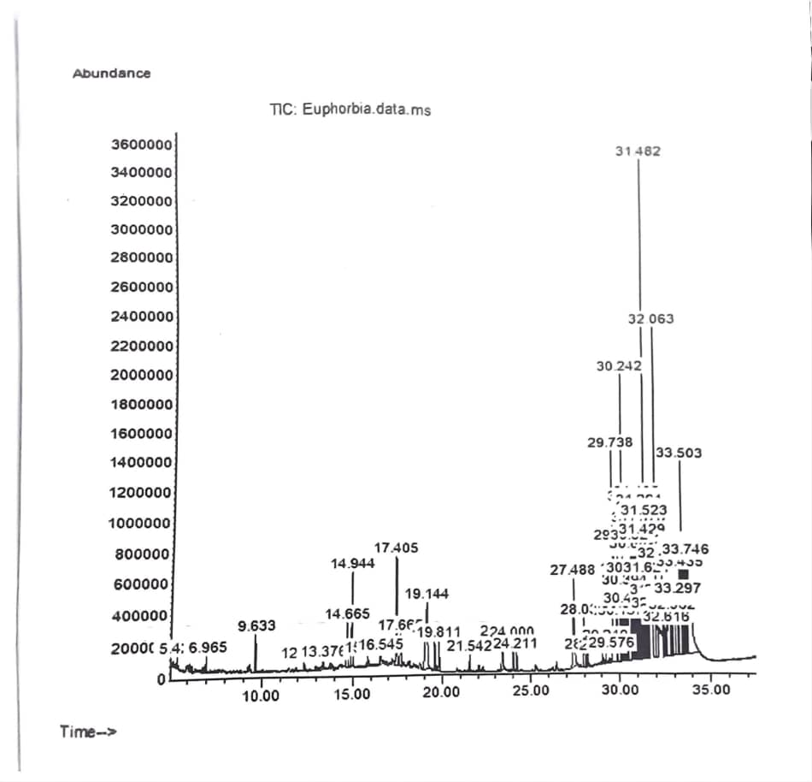

Figure 1: GC-MS Chromatogram of Euphorbia milii

Table 1: GC-MS Phytochemical profile of Euphorbia milli
Name of compound | Retention time | Peak area (%) | Nature | Biological activities | References
Cyclodecene | 5.427 | 0.12 | Alkene | _ | _
Undecane | 6.965 | 0.18 | Alkene | Mild sex attractant | Duke, 1992; Meher et al., 2019
Dodecane | 9.633 | 0.51 | Alkene | Antibacterial, antifungal | Duke, 1992; Meher, et al., 2019
Tridecane | 12.326 | 0.13 | Alkene | Antimicrobial | Duke, 1992
9-Eicosene (E)- | 13.376 | 0.26 | Fatty acid | Antimicrobial | Ugbogu et al., 2019
Tetradecane | 14.944 | 1.40 | Fatty acid | Antimicrobial, cytotoxicity, antipyretic, anthelmintic, tumor, tuberculosis, dyspepsia, anemia, elephantiasis, anti-diabetic, antiinflammatory, anti-diarrhoeal | Duke, 1992; Meher et al., 2019
Dodecanoic acid (Lauric acid) | 19. 144 | 2.60 | Fatty acid | Antibacterial, antibiofilm, antiviral, food preservation | Yang (2009); Huang (2014); Qingyan (2024)
Tetradecanoic acid (Myristic acid) | 23.421 | 0.67 | Fatty | antibacterial, anti‑virulence in derivatives | Casillas-Vargas 2021; Jumina et al., 2019; Juárez-Rodríguez et al., 2021
cis-Vaccenic acid | 31.038 | 3.34 | Fatty acid | Anti-inflammatory, metabolic regulation, Anti-hypercholesterolemic | Jacome-Sosa 2016; Pintus et al., 2012
1-Docosene | 31.482 | 4.68 |  | antimicrobial | de Oliveira et al., 2015; Fleischer & Krieger, 2018; Keke et al., 2023; Mujeeb & Pathak, 2014,

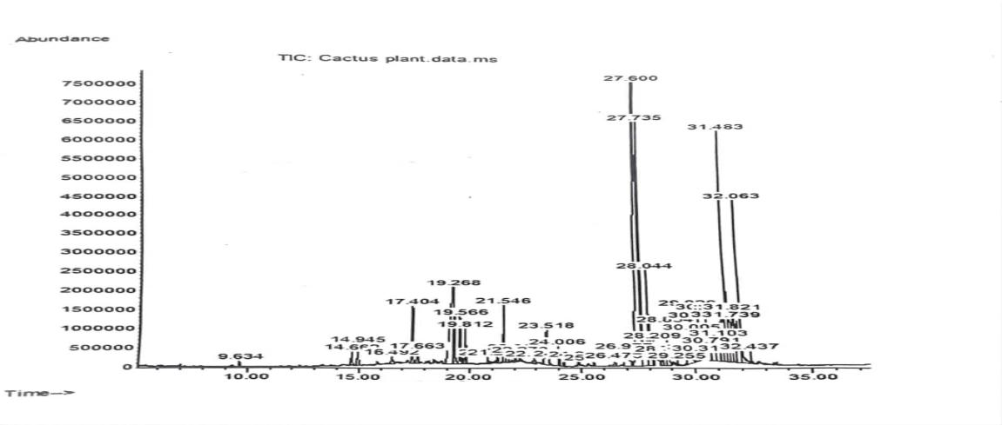

Figure 2: GC-MS Chromatogram of Euphorbia caranensis

Table 2: GC-MS profile of phytochemical constituents of Euphorbia canariensis
Peak | Name of compound | Retention time | Peak area (%) | Nature | Biological activities | References
1 | Dodecane | 9.634 | 0.15 | Alkane | Antibacterial, antifungal | Duke, 1992; Meher, et al., 2019
2 | 5 -Tetradecene | 14.662 | 0.43 | Alkene | _ | _
3 | Tetradecane | 14. 945 | 0.61 | Alkene | Antimicrobial, cytotoxicity, antipyretic, anthelmintic, tumor, tuberculosis, dyspepsia, anemia, elephantiasis, anti-diabetic, antiinflammatory, anti-diarrhoeal | Duke, 1992; Meher et al., 2019
4 | Cyclododecane | 16.492 | 0.35 | Cycloalkane | hydrophobic mask, as a temporary consolidant agent | Rowe & Rozeik, 2008
5 | 2,4-Di-tert-butylphenol | 17.404 | 1.86 | Alkanol group | Antimicrobial, antioxidant, antibiofilm, anti-inflammatory | Zhao (2020); Seenivasan (2022); Rouvier (2024)
6 | Undecanoic acid, | 17.663 | 0.42 | Fatty acid methyl ester | Antifungal | Rossi et al., 2021
7 | Dodecanoic acid | 19.221 | 6.89 | Fatty acid | Antibacterial, antibiofilm, antiviral, food preservation | Yang (2009); Huang (2014); Qingyan (2024)
8 | Hexadecane | 19.812 | 0.96 | Alkene | Antifungal, antibacterial, antioxidant, cytotoxicity, antipyretic, anthelmintic, anti-inflammatory, antidiarrheal, antidiabetic | Faridha et al., 2016; Banakar & Jayaraj, 2018
9 | Cyclohexane, 1,1'-(1,4-butanediyl) bis- | 20.815 | 0.22 | Cycloalkane | _ | _
10 | 1,2,4-Butanetriol, trinitarian | 22.904 | 0.26 | Methyl ester group | _ | _

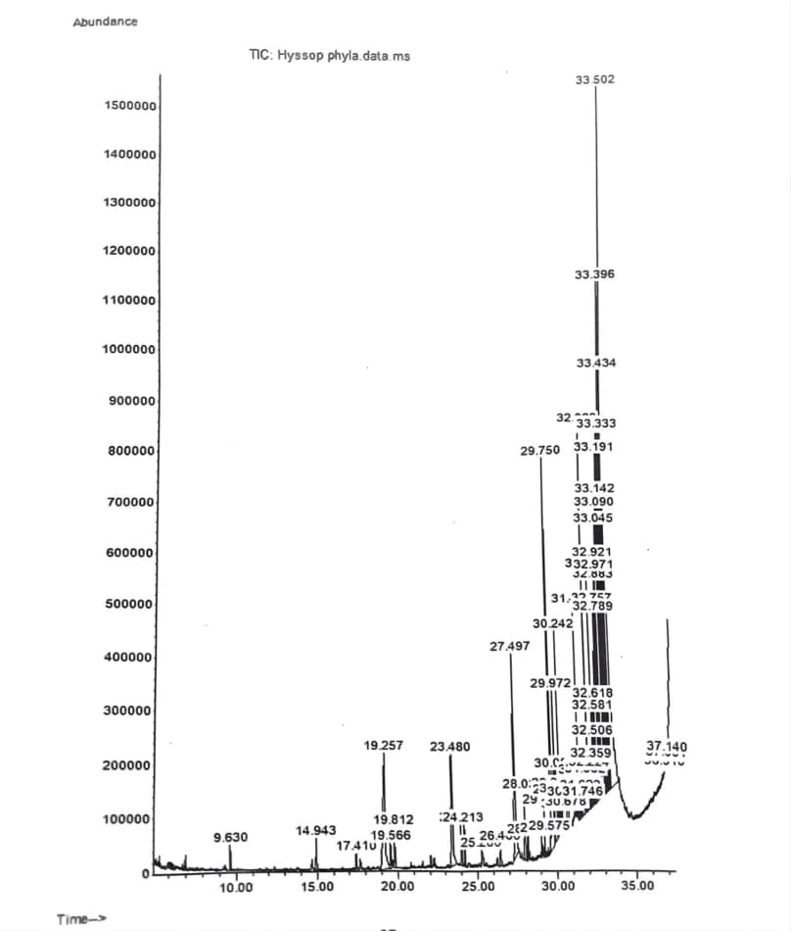

Figure 3: GC-MS Chromatogram of Euphorbia maculata

Table 3: GC-MS Phytochemical profile of Euphorbia maculata
Peak | Name of compound | Retention time | Peak area (%) | Nature | Biological activities | References
1 | Dodecane | 9.630 | 0.28 | Alkene | Antibacterial, antifungal | Duke, 1992; Meher, et al., 2019
2 | Tetradecane | 14.943 | 0.35 | Alkene | Antimicrobial, cytotoxicity, antipyretic, anthelmintic, tumor, tuberculosis, dyspepsia, anemia, elephantiasis, anti-diabetic, antiinflammatory, anti-diarrhoeal | Duke, 1992; Meher et al., 2019
3 | 2,4-Di-tert-butylphenol | 17.410 | 0.23 | Alkenol | Antimicrobial, antioxidant, antibiofilm, anti-inflammatory | Zhao (2020); Seenivasan (2022); Rouvier (2024)
4 | Dodecanoic acid | 19.257 | 4.11 | Fatty acid | Antibacterial, antibiofilm, antiviral, food preservation | Yang (2009); Huang (2014); Qingyan (2024)
5 | 9-Octadecene | 19.566 | 0.33 | Fatty acid | Antifungal, antioxidant, anticancinogenic and antimicrobial | Akpuaka et al., 2013; Godwin et al., 2015
6 | Hexadecane | 19.812 | 0.46 | Fatty acid | Antifungal, antibacterial, antioxidant, cytotoxicity, antipyretic, anthelmintic, anti-inflammatory, antidiarrheal, antidiabetic | Faridha et al., 2016; Banakar & Jayaraj, 2018
7 | Tetradecanoic acid | 23.480 | 2.47 | Fatty acid | antibacterial, anti‑virulence in derivatives | Casillas-Vargas 2021; Jumina et al., 2019; Juárez-Rodríguez et al., 2021
8 | 9-Eicosene, (E)- | 24.002 | 0.43 | Fatty acid | Antimicrobial | Ugbogu et al., 2019
9 | Tetratetracontane  Tetratetracontane | 24.213 | 0.47 | Alkane | Antioxidant, | Mallick & Dighe, (2014); Midhun et al., 2025
10 | Cyclohexane, (1-methylethyl)- | 25.286 | 0.03 | Fatty acid methyl | _ | _

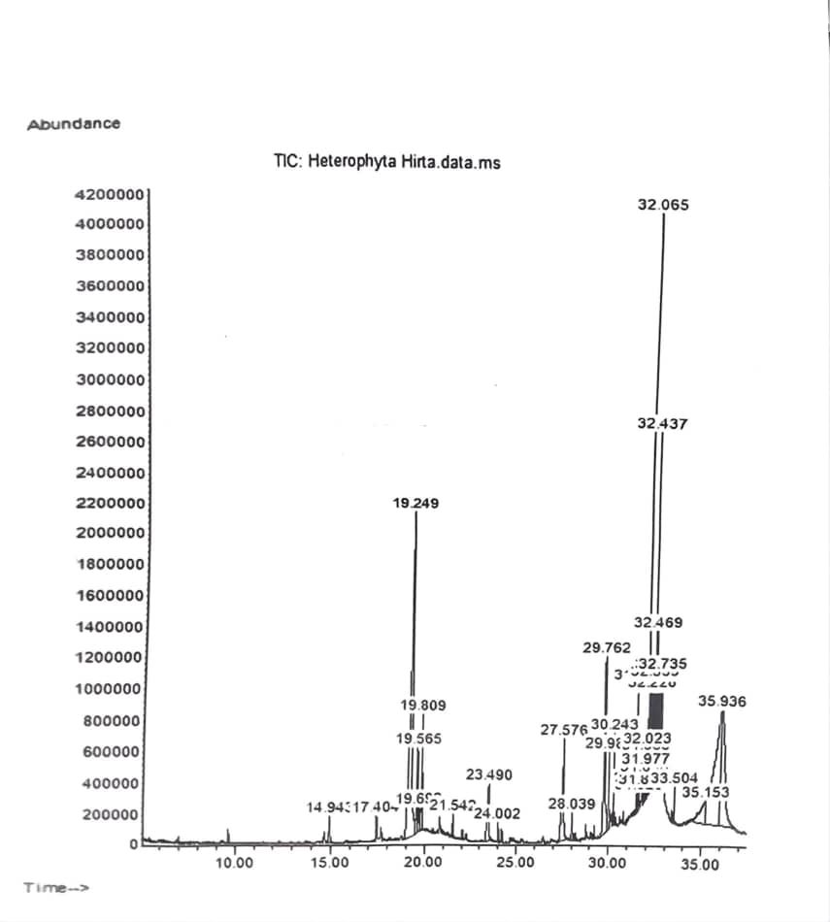

Figure 4: GC-MS Chromatogram of Euphorbia heterophylla

Table 4: GC-MS Phytochemical profile of Euphorbia heterophylla
Peak | Name of compound | Retention time | Peak area (%) | Nature | Biological activities | References
1 | Tetradecane | 14.943 | 0.53 | Alkane | Antimicrobial, cytotoxicity, antipyretic, anthelmintic, tumor, tuberculosis, dyspepsia, anemia, elephantiasis, anti-diabetic, antiinflammatory, anti-diarrhoeal | Duke, 1992; Meher et al., 2019
2 | 2,4-Di-tert-butylphenol | 17.410 | 0.64 | Alkanol | Antimicrobial, antioxidant, antibiofilm, anti-inflammatory | Zhao (2020); Seenivasan (2022); Rouvier (2024)
3 | Dodecanoic acid | 19.249 | 16.24 | Fatty acid | Antibacterial, antibiofilm, antiviral, food preservation | Yang (2009); Huang 4(2014); Qingyan (2024)
 | Z-8-Hexadecene 4-Heptafluorobutyryloxyhexadecane  Cetene | 19.565 | 2.13 | Fatty acid | Antimicrobial | Strobel et al., 2010
5 | 2-Tetradecene, (E)-4-  Tetradecene, (Z)-  Cyclohexadecane | 19.692 | 0.67 | Fatty acid | _ | _
6 | Hexadecane | 19.809 | 2.29 | Fatty acid | Antifungal, antibacterial, antioxidant, Cytotoxicity, antipyretic, anthelmintic, anti-inflammatory, antidiarrheal, antidiabetic | Faridha et al., 2016; Banakar & Jayaraj, 2018
7 | Dodecyl acrylate | 21.542 | 0.43 | Fatty acid | Antibacterial, antifungal | Awan et al., 2023; Fahem et al., 2020
8 | Tetradecanoic acid | 23.490 | 2.47 | Fatty acid | antibacteria, anti‑virulenece in derivatives | Casillas-Vargas 2021; Jumina et al., 2019; Juárez-Rodríguez et al., 2021
9 | E-15-Heptadecenal | 24.002 | 0.36 | Fatty acid | Antibacterial, antioxidant | Karanja et al. (2021); Faridha Begum et al. (2016); Supardy et al., (2012); Si (2024)
10 | n-Hexadecanoic acid | 27.576 | 4.72 | Fatty acid methyl | Antibacterial, immunomodulatory (context-dependent);Hypocholesterolemic, Nematicide, Antiandrogenic, pesticides, Hemolytic | Casillas-Vargas 2021; Duke, 2013; Aparna et al., 2012

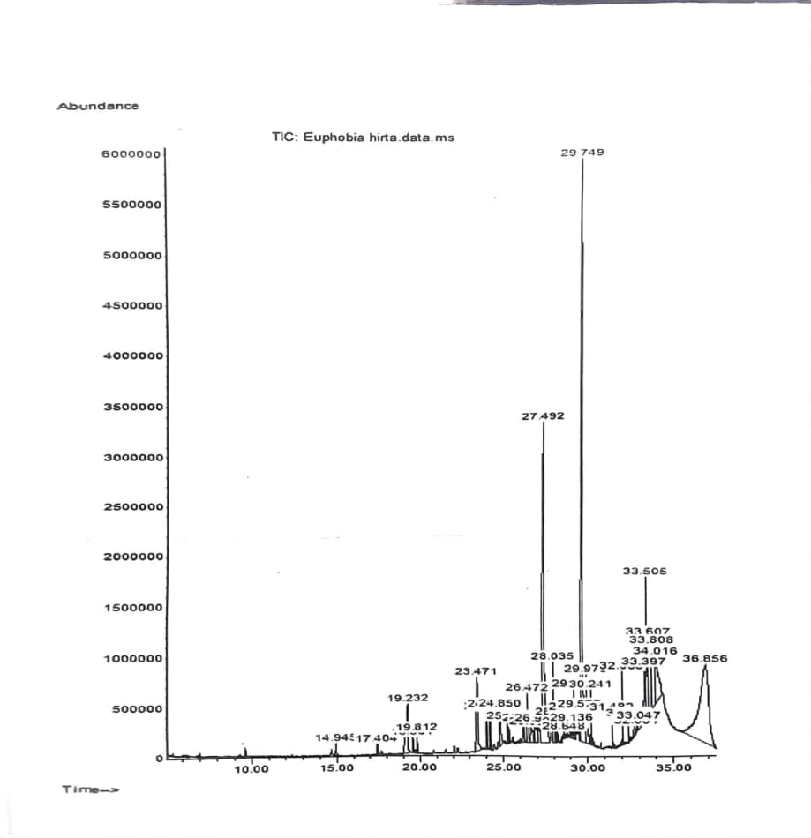
Figure 5 : GC-MS Chromatogram of Euphorbia hirta

Table 5: GC-MS Phytochemical profile of Euphorbia hirta
Peak | Name of compound | Retention time | Peak area (%) | Nature | Biological activities | References
 | Tetradecane | 14.945 | 0.26 | Alkene | Antimicrobial, cytotoxicity, antipyretic, anthelmintic, tumor, tuberculosis, dyspepsia, anemia, elephantiasis, anti-diabetic, antiinflammatory, anti-diarrhoeal | Duke, 1992; Meher et al., 2019
2 | 2,4-Di-tert-butylphenol | 17.404 | 0.26 | Alkanol | Antifungal, antimalarial, antioxidant, antibacterial, antiinflammatory, cytotoxicity, antiviral, insecticidal, nematicidal | Zhao (2020); Seenivasan (2022); Rouvier (2024); Varsha et al., 2015
3 | Dodecanoic acid | 19.232 | 2.83 | Fatty acid | Antibacterial, antibiofilm, antiviral, food preservation | Yang (2009); Huang (2014); Qingyan (2024)
4 | 3-Eicosene, (E) | 19.564 | 0.31 | Fatty acid | Antimicrobial, anti-hyperglycemic, cytotoxic activity, antioxidant, insecticidal | Banakar & Jayaraj, 2018
5 | Hexadecane | 19.812 | 0.40 | Alkane | Antifungal, antibacterial, antioxidant, Cytotoxicity, antipyretic, anthelmintic, anti-inflammatory, antidiarrheal, antidiabetic | Faridha et al., 2016; Banakar & Jayaraj, 2018
6 | Tetradecanoic acid | 23.471 | 2.90 | Fatty acid | Antibacterial, anti-virulence in derivatives | Casillas-Vargas 2021; Jumina et al., 2019; Juárez-Rodríguez et al., 2021
7 | Octadecane | 24.214 | 0.84 | Alkane | Antibacterial antifungal activity, Anti-inflammatory, detoxification, cough relief, lung disease treatment, fever and cold management, antioxidant, antiseptic, anticorrosion activities | Girija et al., 2014; Banakar & Jayaraj, 2018
8 | Hexadecane | 26.259 | 0.56 | Fatty acid | Mild antimicrobial | Mohamed (2022)
9 | Pentadecanoic acid, 1- methyl-, methyl ester  Hexadecanoic acid, methyl ester | 26.472 | 1.63 | Fatty acid methyl ester | Anti-inflammatory, hypocholesterolemic, anti-cancer, hepatoprotective, nematicide, nsectifuge, antihistaminic, anticorona, antiarthritic | Jegadeeswari et al., 2012
10 | Dodecane | 26.694 | 0.85 | Fatty acid | Antibacterial, antifungal | Duke, 1992; Meher, et al., 2019

Table 6: Qualitative phytochemical screening of five Euphorbia species
Species | Alkaloids | Flavonoids | Tannins | Saponins
Euphorbia milli | - | ++ | +++ | +
Euphorbia heterophylla | - | + | ++ | +++
Euphorbia maculata | - | + | +++ | +
Euphorbia caranensis | + | ++ | +++ | ++
Euphorbia hirta | + | ++ | +++ | -
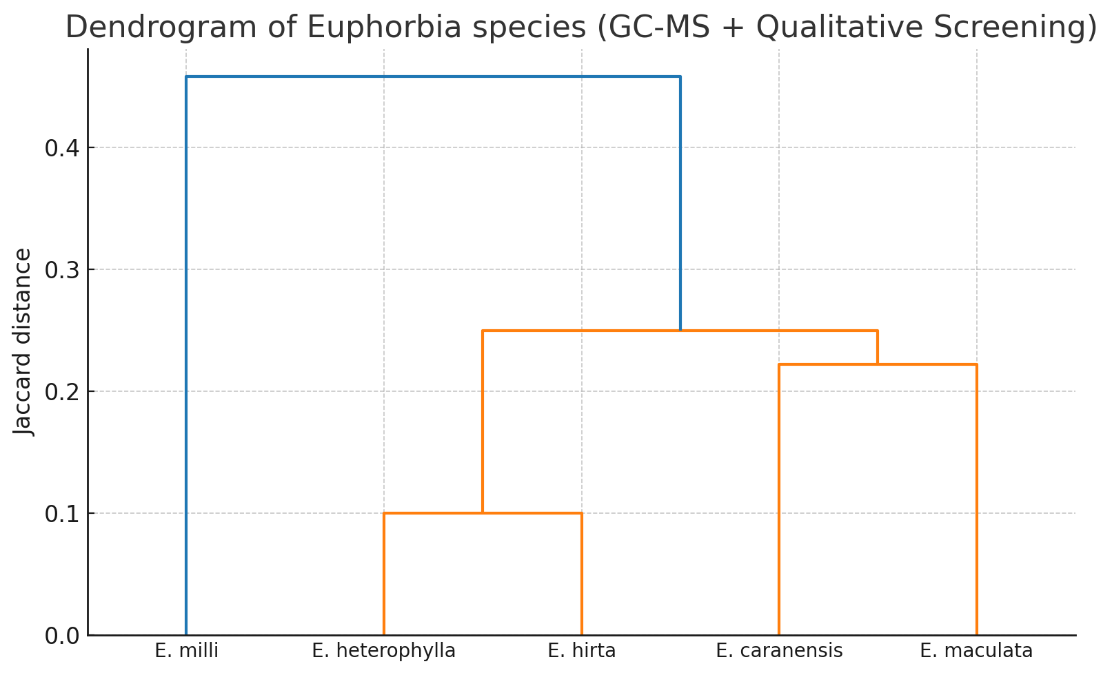

Fig 6 Dendrogram of Euphorbia species (GC-MS + Qualitative Screening)

Figure 6: Dendrogram of the phytochemical constituents of five Euphorbia species

Discussion
The comparative phytochemical evaluation of five Euphorbia species offers valuable insights into their chemosystematic relationships. The repeated detection of dodecanoic acid, tetradecane, and consistently high tannin levels across all taxa points to a set of conserved biochemical traits within the genus. These metabolites are likely core features that have been maintained through evolutionary time, reflecting their importance in basic structural and defensive functions, as also noted for fatty acids and hydrocarbons in plant defense metabolism (Casillas-Vargas et al., 2021).
Despite this phylogenetic conservatism, significant metabolic divergence was observed among the species. E. heterophylla was notable for its exceptionally high levels of dodecanoic acid (16.24%) and abundant saponins, suggesting lineage-specific adaptations possibly linked to stress tolerance. E. caranensis was unique for its accumulation of 2,4-di-tert-butylphenol, a strong antioxidant with antimicrobial potential, as well as its distinctive alkaloid profile. In contrast, E. milli stood apart due to enrichment in cis-vaccenic acid and long-chain alkenes, distinguishing it chemically from the other taxa.
Chemotaxonomic clustering patterns further support these interspecific distinctions. E. maculata and E. hirta grouped together based on their moderate but consistent levels of dodecanoic and tetradecanoic acids, alongside comparable fatty acid patterns. Conversely, E. caranensis and E. heterophylla formed a separate cluster due to their shared dominance of fatty acids and defensive secondary metabolites. E. milli emerged as an outlier because of its unique unsaturated fatty acid and hydrocarbon profile. Similar clustering patterns have been reported in Balkan and Turkish Euphorbia species, where fatty acids and phenolic derivatives served as reliable markers for interspecific differentiation (Yener et al., 2019; Sofrenić et al., 2023).
The dendrogram (Figure 6) reflects both phylogenetic conservatism and adaptive divergence. Conserved metabolites such as lauric and tetradecanoic acids, shared across all species, suggest ancestral metabolic traits retained throughout the genus. In contrast, restricted distribution of secondary metabolites—such as alkaloids (found only in E. hirta and E. caranensis) and flavonoids (absent in E. milli)—imply lineage-specific evolutionary adaptations, possibly in response to ecological pressures (Wink, 2015).
These clustering results support earlier chemosystematic investigations of Euphorbia species, in which lipid and phenolic profiles provided robust taxonomic resolution (Sofrenić et al., 2023; Yener et al., 2019). Together, the results validate the use of integrative phytochemical markers in resolving species boundaries and understanding evolutionary relationships within Euphorbia.
The distribution of secondary metabolite classes also adds evolutionary context. Alkaloids, which were confined to E. caranensis and E. hirta, may represent a restricted trait maintained in specific evolutionary lineages. Flavonoids, present in most species but absent or less abundant in E. milli and E. heterophylla, suggest divergence in polyphenolic metabolism. Meanwhile, saponins showed pronounced variability—being abundant in E. heterophylla but absent in E. hirta, highlighting chemical plasticity associated with ecological specialization (Wink, 2015).
Across the five Euphorbia species analyzed, the chromatograms are dominated by long‑chain alkanes/alkenes and fatty acids (and a few fatty‑acid methyl esters). This chemical space is consistent with prior GC‑MS work on Euphorbia spp., where petroleum‑ether or non‑polar extracts typically yield palmitic (n‑hexadecanoic) and oleic/linoleic series fatty acids alongside high‑m.w. hydrocarbons (e.g., tetratetracontane) (Yener et al., 2019).
For Euphorbia heterophylla profile shows abundant fatty acids (notably dodecanoic acid at 16.24% area) plus 2,4‑di‑tert‑butylphenol (DTBP). Recent GC‑MS work on E. heterophylla chloroform extracts likewise reported DTBP as a prominent constituent and a suite of hydrocarbons/aliphatic alcohols, although the exact rank order differs. This supports DTBP as a recurring, diagnostic volatile/semi‑volatile in this species, while differences in relative abundance likely reflect solvent, plant part, season and instrument
E. hirta shows typical lipid signatures (dodecanoic and tetradecanoic acids; methyl esters) plus DTBP. Multiple reports on E. hirta methanol extracts also find fatty acids (often palmitic and unsaturated C18 species) by GC‑MS, in agreement with a lipid‑rich volatile fraction (Karki et al., 2020; Rautela et al., 2020).
Qualitative screening table records no saponins in E. hirta, whereas other studies frequently detect saponins (alongside flavonoids and tannins) in methanolic extracts. The mismatch may arise from: (i) extraction differences, (ii) assay sensitivity/cutoffs, or (iii) tissue and phenology (Karki et al., 2020).
The E. milli chromatogram is dominated by hydrocarbons and fatty acids, such as cis-vaccenic acid and C20–C35 alkenes. A comparative GC-MS study of E. hirta and E. milli similarly reported a high abundance of aliphatic lipids and hydrocarbons in the methanolic leaf extract of E. milli, although the specific compound identities and relative peak intensities varied. These differences are consistent with expected intra-species variability and methodological influences (Rautela et al., 2020).
The E. maculata GC-MS profile is characterized by C12–C14 alkanes/alkenes and common fatty acids, such as dodecanoic and tetradecanoic acids. This aligns with the broader Euphorbia pattern in which aliphatic compounds dominate non-polar fractions. However, much of the E. maculata literature focuses on non-volatile triterpenoids, typically isolated through chromatographic methods rather than GC-MS. Because these high-molecular-weight constituents are poorly detected without derivatization, they are under-represented or absent in direct GC-MS analyses, explaining the lipid-rich but triterpene-poor spectral profile (Sun et al., 2018).
GC‑MS data for Euphorbia caranensis are scarce however, cross‑species surveys in Euphorbia show that long‑chain fatty acids (palmitic, linoleic) and very‑long‑chain hydrocarbons often dominate GC‑MS profiles, again aligning with the finding of C14–C16 alkanes/alkenes and fatty‑acid methyl esters.
Compounds recurring across species includes dodecanoic acid, tetradecanoic acid, tetradecane/hexadecane, and C18–C20 mono‑enes recur in multiple species. Comparable multi‑species Euphorbia surveys identify palmitic/oleic/linoleic series fatty acids and high‑m.w. n‑alkanes as frequent GC‑MS hits, reinforcing that these are conserved chemotaxonomic features of the genus’ lipophilic fraction (Yener et al., 2019).
Differences in exact compound identities and peak intensities between this study and published Euphorbia GC-MS reports can be plausibly explained by several factors: (i) the plant part analyzed and its phenological stage; (ii) geographic origin and edaphic or other environmental stresses; (iii) extraction solvent polarity (e.g., methanol vs. chloroform vs. hexane); (iv) derivatization steps, such as FAME preparation, which enhance detection of fatty acid methyl esters; and (v) variations in GC-MS library versions, spectral deconvolution parameters, and search settings. Such methodological and biological variables are well-documented sources of variation across Euphorbia GC-MS studies (Karki et al., 2020).
The prevalence of saturated and monounsaturated fatty acids, along with DTBP, aligns with the reported antioxidant, antimicrobial, and cytotoxic activities of Euphorbia extracts. However, these bioactivities are often primarily driven by less volatile constituents such as phenolics and diterpenes, which are poorly represented in GC-MS data unless targeted approaches such as LC-MS or compound isolation are employed. The qualitative phytochemical screening results (showing strong tannin and flavonoid presence across all four species) support the occurrence of such polar bioactives, even if they are not reflected as major peaks in the GC-MS profiles (Salehi et al., 2019).
The dominance of fatty acids (such as lauric, myristic, palmitic, and vaccenic acids) in all species is consistent with earlier reports on the genus Euphorbia, where these compounds are associated with antimicrobial and anti-inflammatory effects (Casillas-Vargas et al., 2021). Notably, dodecanoic acid (one of the most recurrent compounds) has demonstrated broad-spectrum antimicrobial activity and is a key component in coconut oil with applications in food preservation (Yang et al., 2009; Huang et al., 2014).
The presence of 2,4-di-tert-butylphenol in several species is noteworthy, as it is a potent antioxidant and biofilm inhibitor (Zhao et al., 2020), suggesting potential applications in combating microbial resistance. Long-chain hydrocarbons such as n-alkanes and docosenes, while primarily structural components of plant cuticular waxes, have been reported to possess mild antimicrobial effects and play ecological roles in plant–insect interactions (Wu et al., 2018).
The GC-MS profiles are broadly consistent with Euphorbia literature for lipophilic fractions—typically dominated by long-chain hydrocarbons and fatty acids, with occasional phenolic volatiles such as 2,4-di-tert-butylphenol. Where deviations occur (for instance, the detection of saponins in E. hirta through qualitative assays or the absence/presence of specific C16–C18 fatty acids) these can be attributed to methodological differences and plant-specific variables, rather than representing true contradictions.

Conclusion
This study underscores the dual pattern of phylogenetic conservatism and adaptive divergence within the genus Euphorbia. The consistent presence of dodecanoic acid, tetradecane, and tannins across all five species highlights their potential as conserved chemotaxonomic markers, reflecting shared evolutionary ancestry. In contrast, the variable distribution of alkaloids, saponins, and certain phenolic derivatives reveals species-specific adaptations, which may be linked to ecological pressures and specialized functions in defense or stress tolerance.
The GC–MS analysis predominantly revealed lipophilic compounds such as fatty acids, fatty acid methyl esters, and hydrocarbons, while qualitative screening provided evidence of polar metabolites that contribute to the ethnomedicinal value of these species. Together, these conserved and divergent chemical profiles not only support traditional taxonomic classification but also enhance our understanding of evolutionary trajectories within Euphorbia.
Importantly, the findings provide a biochemical framework that connects morphological taxonomy, ecological adaptation, and medicinal applications. The recognition of conserved metabolites as evolutionary signatures, alongside species-specific differences as adaptive markers, validates the role of chemosystematics in species delimitation and evolutionary inference.
Future integration of chemical markers with molecular phylogenetics and morphological traits will improve taxonomic resolution within the genus. Moreover, the identified compounds (particularly dodecanoic acid, tetradecane, and phenolic derivatives) warrant further pharmacological investigation to isolate bioactive principles that may underpin the therapeutic efficacy of these plants. Thus, this study demonstrates that combining GC–MS profiling with qualitative phytochemical screening offers a robust chemosystematic approach for understanding diversity, adaptation, and medicinal potential in Euphorbia.

References
Akpuaka, A., Ekwenchi, M. M., Dashak, D. A., & Dildar, A. (2013). Biological activities of characterized isolates of n-hexane extract of Azadirachta indica A. Juss (Neem) leaves. Nature and Science, 11(5), 141–147.
Aparna, V., Dileep, K. V., Mandal, P. K., Karthe, P., Sadasivan, C. & Haridas, M. (2012). Anti-inflammatory property of n-hexadecanoic acid: structural evidence and kinetic assessment. Chem. Biol. Drug Des. 80, 434–439. doi: 10.1111/j.1747-0285.2012.01418.x
Awan, Z. A., Shoaib, A., Schenk, P. M., Ahmad, A., Alansi, S., & Paray, B. A. (2023). Antifungal potential of volatiles produced by Bacillus subtilis BS-01 against Alternaria solani in Solanum lycopersicum. Frontiers in Plant Science, 13, 1089562. https://doi.org/10.3389/fpls.2022.1089562
Banakar, P., & Jayaraj, M. (2018). GC–MS analysis of bioactive compounds from ethanolic leaf extract of Waltheria indica Linn. and their pharmacological activities. International Journal of Pharmaceutical Sciences and Research, 9(5), 2005–2010. https://doi.org/10.13040/IJPSR.0975-8232.9(5).2005-10
Beena, V., Prakash, V., Bindu, A. R., & Bindu, K. (2016). Phytochemical screening methods: A comparative overview. International Journal of Pharmacognosy and Phytochemical Research, 8(3), 387–392.
Casillas-Vargas, G., Ocasio-Malavé, C., Medina, S., Morales-Guzmán, C., García Del Valle, R., Carballeira, N. M., & Sanabria-Ríos, D. J. (2021). Antibacterial fatty acids: An update of possible mechanisms of action and implications in the development of the next generation of antibacterial agents. Progress in Lipid Research, 82, 101093. https://doi.org/10.1016/j.plipres.2021.101093.
Choi, S. J., Kim, J. K., Kim, H. K., Harris, K., Kim, C. J., Park, G. G., Park, C. S., & Shin, D. H. (2013). 2,4-Di-tert-butylphenol from sweet potato protects against oxidative stress in PC12 cells and in mice. Journal of Medicinal Food, 16(11), 977–983. https://doi.org/10.1089/jmf.2012.2664
de Oliveira Ramalho, T. R., Pacheco de Oliveira, M. T., de Araujo Lima, A. L., Bezerra-Santos, C. R., & Piuvezam, M. R. (2015). Gamma-terpinene modulates acute inflammatory response in mice. Planta Medica, 81(14), 1248–1254. https://doi.org/10.1055/s-0035-1546262
Dhawan, D., & Gupta, J. (2017). Comparison of different solvents for phytochemical extraction potential from Datura metel plant leaves. International Journal of Biological Chemistry, 11(1), 17–22. https://doi.org/10.3923/ijbc.2017.17.22.
Duke, J. A. (1992). Database manual of biologically active phytochemicals and their activities (1st ed.). Boca Raton, FL: CRC Press.
Duke, J. A. (2013). Dr. Duke's Phytochemical and Ethnobotanical Databases. U.S. Department of Agriculture, Agricultural Research Service. [online] Available at: https://phytochem.nal.usda.gov/ [Accessed 20 August 2025].
Ernst M., Grace O.M., Saslis-Lagoudakis C.H., Nilsson N., Simonsen H.T., Rønsted N. (2015). Global medicinal (Euphorbiacb1eae) uses of Euphorbia L. Journal of Ethnopharmacology, 176, 90–101. https://doi.org/10.1016/j.jep.2015.10.025
Fahem, N., Djellouli, A. S., & Bahri, S. (2020). Cytotoxic activity assessment and GC-MS screening of two Codium species extracts. Pharmaceutical Chemistry Journal, 54(7), 755–761. https://doi.org/10.1007/s11094-020-02243-3
Faridha Begum, I., Mohankumar, R., Jeevan, M., & Ramani, K. (2016). GC–MS analysis of bio-active molecules derived from Paracoccus pantotrophus FMR19 and the antimicrobial activity against bacterial pathogens and MDROs. Indian Journal of Microbiology, 56(4), 426–432. https://doi.org/10.1007/s12088-016-0609-1
Fleischer, J., & Krieger, J. (2018). Insect Pheromone Receptors - Key Elements in Sensing Intraspecific Chemical Signals. Frontiers in cellular neuroscience, 12, 425. https://doi.org/10.3389/fncel.2018.00425
Girija, S., Duraipandiyan, V., Kuppusamy, P. S., Gajendran, H., & Rajagopal, R. (2014). Chromatographic characterization and GC-MS evaluation of the bioactive constituents with antimicrobial potential from the pigmented ink of Loligo duvauceli. International Scholarly Research Notices, 2014, 1–8. https://doi.org/10.1155/2014/82074
Godwin, A., Akinpelu, B. A., Makinde, A. M., Aderogba, M. A., & Oyedapo, O. O. (2015). Identification of n-hexane fraction constituents of Archidium ohioense (Schimp. Ex Mull) extract using GC-MS technique. British Journal of Pharmaceutical Research, 6(6), 366–375.
Govaerts, R., Frodin, D.G. & Radcliffe-Smith, A., (2000). World checklist and bibliography of Euphorbiaceae (with Pandaceae), vol. 4. Royal Botanic Gardens, Kew, UK.
Horn, J.W., van Ee, B.W., Morawetz, J.J., Riina, R., Steinmann, V.W., Berry, P.E., & Wurdack, K.J. (2012). Phylogenetics and the evolution of major structural characters in the giant genus Euphorbia L. (Euphorbiaceae). Mol. Phylogenet. Evol., 63(2), 305–326. https://doi.org/10.1016/j.ympev.2011.12.022
Huang, W. C., Tsai, T. H., Chuang, L. T., Li, Y. Y., Zouboulis, C. C., & Tsai, P. J. (2014). Anti-bacterial and anti-inflammatory properties of capric acid against Propionibacterium acnes: a comparative study with lauric acid. Journal of dermatological science, 73(3), 232–240. https://doi.org/10.1016/j.jdermsci.2013.10.010
Jegadeeswari, P., Nishanthini, A., Muthukumarasamy, S., & Mohan, V. R. (2012). GC-MS analysis of bioactive components of Aristolochia krysagathra (Aristolochiaceae). Journal of Current Chemical and Pharmaceutical Sciences, 2(4), 226–232.
Jacome-Sosa, M., Vacca, C., Mangat, R., Diane, A., Nelson, R. C., Reaney, M. J., Shen, J., Curtis, J. M., Vine, D. F., Field, C. J., Igarashi, M., Piomelli, D., Banni, S., & Proctor, S. D. (2016). Vaccenic acid suppresses intestinal inflammation by increasing anandamide and related N-acylethanolamines in the JCR:LA-cp rat. Journal of lipid research, 57(4), 638–649. https://doi.org/10.1194/jlr.M066308
Juárez-Rodríguez, M. M., Cortes-López, H., García-Contreras, R., González-Pedrajo, B., Díaz-Guerrero, M., Martínez-Vázquez, M., Rivera-Chávez, J. A., Soto-Hernández, R. M., & Castillo-Juárez, I. (2021). Tetradecanoic Acids With Anti-Virulence Properties Increase the Pathogenicity of Pseudomonas aeruginosa in a Murine Cutaneous Infection Model. Frontiers in cellular and infection microbiology, 10, 597517. https://doi.org/10.3389/fcimb.2020.597517
Jumina, J., Mutmainah, M., Purwono, B., Kurniawan, Y. S., & Syah, Y. M. (2019). Antibacterial and Antifungal Activity of Three Monosaccharide Monomyristate Derivatives. Molecules, 24(20), 3692. https://doi.org/10.3390/molecules24203692
Karanja, L. N., K’Owino, I. O., Wangila, P. T., & Ramkat, R. C. (2021). Phytochemical composition and antibacterial activity of fruit extract of Solanum incanum L. against Ralstonia solanacearum. Asian Journal of Applied Chemistry Research, 9(4), 1–16. https://doi.org/10.9734/ajacr/2021/v9i430218
Karki, S., Shrestha, K., Gautam, R., & Jha, R. N. (2020). Phytochemical screening, FT-IR and GC-MS analysis of Euphorbia hirta. Journal of Pharmacognosy and Phytochemistry, 9(1), 1883–1889. https://www.phytojournal.com/archives/2020/vol9issue1/PartAB/9-1-256-949.pdf
Keke, C. O., Nsofor, W. N., Kumabia, F. K. R., Iloabuchi, G. C., Ejiofor, J. C., & Osuagwu, O. L. (2023). GCMS and FTIR analysis of ethanol and methanol leave extract of Urena lobata (Caesar weed) for bioactive phytochemical constituents. Journal of Drug Delivery and Therapeutics, 13(1), 99–115. https://doi.org/10.22270/jddt.v13i1.5722
Mallick, S. S., & Dighe, V. V. (2014). Detection and estimation of alpha-amyrin, betasitosterol, lupeol and n-tricontane in two medicinal plants by high performance thin layer chromatography. Advances in Chemistry, 2014, 143948.
Meher, A., Behera, B., & Nanda, B. K. (2019). GC–MS investigation of phytocomponents present in ethanolic extract of Ichnocarpus frutescens (L.) W. T. Aiton aerial part. International Journal of Pharmaceutical Sciences and Research, 10(10), 4711–4716. https://doi.org/10.13040/IJPSR.0975-8232.10(10).4711-16
Midhun, N. K., Saravanamoorthy, M. D., & Abdussalam, A. K. (2025). Gas chromatography–mass spectrometry (GC-MS) analysis of phytoconstituents from leaves of Rhynchoglossum notonianum (Wall.) B.L. Burtt. European Journal of Medicinal Plants, 36(4), 7–16. https://doi.org/10.9734/ejmp/2025/v36i41276
Mujeeb, F., Bajpai, P., & Pathak, N. (2014). Phytochemical evaluation, antimicrobial activity, and determination of bioactive components from leaves of Aegle marmelos. BioMed Research International, 2014, 497606. https://doi.org/10.1155/2014/497606
Pandey, A., & Tripathi, S. (2014). Concept of standardization, extraction and pre phytochemical screening. International Journal of Pharmacy and Life Sciences, 5(2), 400–404.
Pintus, S., Murru, E., Carta, G., Cordeddu, L., Batetta, B., Accossu, S., Pistis, D., Uda, S., Elena-Ghiani, M., Mele, M., Secchiari, P., Almerighi, G., Pintus, P., & Banni, S. (2012). Sheep cheese naturally enriched in α-linolenic, conjugated linoleic and vaccenic acids improves the lipid profile and reduces anandamide in the plasma of hypercholesterolaemic subjects. British Journal of Nutrition, 107(1), 24–33. https://doi.org/10.1017/S0007114511002714
Rautela, I., Joshi, P., Thapliyal, P., Pant, M., Dheer, P., & Bisht, S. (2020). Comparative GC-MS analysis of Euphorbia hirta and Euphorbia milli for therapeutic potential utilities. Plant Archives, 20(2), 3515–3522.
Rossi, A., Martins, M. P., Bitencourt, T. A., Peres, N. T. A., Rocha, C. H. L., Rocha, F. M. G., Von Zeska Kress, M. R., Goldman, G. H., & Martinez-Rossi, N. M. (2021). Reassessing the use of undecanoic acid as a therapeutic strategy for treating fungal infections. Mycopathologia, 186(3), 327–340. https://doi.org/10.1007/s11046-021-00550-4
Rowe, S., & Rozeik, C. (2008). The uses of cyclododecane in conservation. Studies in Conservation, 53(sup2), 17–31. https://doi.org/10.1179/sic.2008.53.Supplement-2.17
Salehi, B., Iriti, M., Vitalini, S., Antolak, H., Pawlikowska, E., Kręgiel, D., Sharifi-Rad, J., Oyeleye, S. I., Ademiluyi, A. O., Czopek, K., Staniak, M., Custódio, L., Coy-Barrera, E., Segura-Carretero, A., Cádiz-Gurrea, M. L., Capasso, R., Cho, W. C., & Seca, A. M. L. (2019). Euphorbia-Derived Natural Products with Potential for Use in Health Maintenance. Biomolecules, 9(8), 337. https://doi.org/10.3390/biom9080337
Seenivasan, A., Radhakrishnan, M., Kaari, M., Sahu, A. K., Said, M., & Dastager, S. G. (2022). 2,4-Di-tert-butylphenol (2,4-DTBP) purified from Streptomyces sp. KCA1 from Phyllanthus niruri: Isolation, characterization, antibacterial and anticancer properties. Journal of King Saud University – Science, 34(2), Article 102088. https://doi.org/10.1016/j.jksus.2022.102088
Si, T., Wang, A., Yan, H., Kong, L., Guan, L., He, C., Ma, Y., Zhang, H., & Ma, H. (2024). Progress in the Study of Natural Antimicrobial Active Substances in Pseudomonas aeruginosa. Molecules (Basel,
Singh, R. (2016). Chemotaxonomy: A tool for plant classification. Journal of Medicinal Plants Studies, 4(2), 90–93.Switzerland), 29(18), 4400. https://doi.org/10.3390/molecules29184400
Sofrenić, I., Anđelković, B., Gođevac, D., Ivanović, S., Simić, K., Ljujić, J., Tešević, V., & Milosavljević, S. (2023). Metabolomics as a potential chemotaxonomical tool: Application on the selected Euphorbia species growing wild in Serbia. Plants, 12(2), 262. https://doi.org/10.3390/plants12020262
Strobel, G., Tomshek, A., Geary, B., Spackowicz, D., Strobel, S., Matter, S., & Mann, R. (2010). Endophyte strain NRRL 50072 producing volatile organics is a species of Ascocoryne. Mycology, 1(3), 187–194. https://doi.org/10.1080/21501203.2010.491589
Supardy, N. A., Ibrahim, D., Sulaiman, S. F., & Zakaria, N. A. (2012). Inhibition of Klebsiella pneumoniae ATCC 13883 cells by hexane extract of Halimeda discoidea (Decaisne) and the identification of its potential bioactive compounds. Journal of Microbiology and Biotechnology, 22(6), 872–881. https://doi.org/10.4014/jmb.1111.11053
Sun, Y., Gao, L.-L., Tang, M.-Y., Feng, B.-M., Pei, Y.-H., & Yasukawa, K. (2018). Triterpenoids from Euphorbia maculata and their anti-inflammatory effects. Molecules, 23(9), 2112. https://doi.org/10.3390/molecules23092112
Trease, G. E., & Evans, W. C. (1989). Pharmacognosy (11th ed.). Baillière Tindall.
Ugbogu, E. A., Akubugwo, I. E., Ude, V. C., Gilbert, J., & Ekeanyanwu, B. (2019). Toxicological evaluation of phytochemical characterized aqueous extract of wild dried Lentinus squarrosulus (Mont.) mushroom in rats. Toxicological Research, 35(2), 181–190. https://doi.org/10.5487/TR.2019.35.2.181
Varsha, K. K., Devendra, L., Shilpa, G., Priya, S., Pandey, A., & Nampoothiri, K. M. (2015). 2,4-Di-tert-butyl phenol as the antifungal, antioxidant bioactive purified from a newly isolated Lactococcus sp. International Journal of Food Microbiology, 211, 44–50. https://doi.org/10.1016/j.ijfoodmicro.2015.06.025
Vasas, A. & Hohmann, J. (2014). Euphorbia diterpenes: Isolation, structure, biological activity, and synthesis (2008–2012). Chemical Reviews, 114(15), 8579–8612. https://doi.org/10.1021/cr400541j
Wallis, T. E. (1989). Textbook of Pharmacognosy (5th ed.). New Delhi: CBS Publishers & Distributors.
Wink, M. (2015). Modes of action of herbal medicines and plant secondary metabolites. Medicines, 2(3), 251–286. https://doi.org/10.3390/medicines2030251
Wu Q., Tang Y., Ding A., You F., Zhang L., Duan J. (2009). 13C-NMR data of three important diterpenes isolated from Euphorbia species. Molecules, 14(11), 4454–4475. https://doi.org/10.3390/molecules14114454
Yang, D., Pornpattananangkul, D., Nakatsuji, T., Chan, M., Carson, D., Huang, C.-M., & Zhang, L. (2009). The antimicrobial activity of liposomal lauric acids against Propionibacterium acnes. Biomaterials, 30(30), 6035–6040. https://doi.org/10.1016/j.biomaterials.2009.07.033
Yener, İ., Ertaş, A., Yilmaz, M. A., Ölmez, Ö. T., Yılmaz, P. K., Yeşil, Y., Kaplaner, E., Öztürk, M., Temel, H., Kolak, U., & Topçu, G. (2019). Characterization of the chemical profile of Euphorbia species from Turkey by gas chromatography–mass spectrometry (GC-MS), liquid chromatography–tandem mass spectrometry (LC-MS/MS), and liquid chromatography–ion trap–time-of-flight–mass spectrometry (LC-IT-TOF-MS) and chemometric analysis. Analytical Letters, 52(7), 1031–1049. https://doi.org/10.1080/00032719.2018.1512608
Zhao, F., Wang, P., Lucardi, R. D., Su, Z., & Li, S. (2020). Natural sources and bioactivities of 2,4-di-tert-butylphenol and its analogs. Toxins, 12(1), 35. https://doi.org/10.3390/toxins12010035

