A Statistical Framework of Modelling Breast Cancer Disease Pathways with Multistate and Competing Risks Approaches

Abstract
Background: Breast cancer is one of the leading causes of mortality in women in Ghana; prognostic studies are still dominated by single endpoint Kaplan-Meier and Cox models, which do not take into account [change the words] recurrence, progression, and competing mortality. The study aimed to come up with a robust multistate competing risks survival model to define disease processes in Ghanaian breast cancer patients and provide dynamic prognostic profiles.
Objectives: To measure transition-specific hazards between diagnosis and progression, breast cancer event with competing risk death; to obtain the cumulative probability of breast cancer event in the presence of competing mortality; and to obtain state occupation probabilities over follow-up time.
Methods: A retrospective cohort of 558 patients was analysed using cause-specific Cox multistate models, Fine-Gray sub-distribution hazards, nonparametric cumulative incidence functions, and Aalen-Johansen estimators. The baseline predictors were age, stage, grade, lymph node involvement, tumour size, molecular subtype and hormone receptor status in determining the Hazard Ratio (HR) and the Sub-distribution Hazard Ratio (SHR).
Findings: After five years of follow-up with a median of about five years, 241 incidences of breast cancer and 40 competing risks deaths were verified. The advanced stage was a strong predictor of transition adverse outcomes (HR = 1.55, 95% CI: 1.192.01, p = 0.001), whereas lymph node involvement was a strong predictor of adverse outcomes (HR = 1.23, 95% CI: 1.051.44, p = 0.012). The cumulative incidence of breast cancer events was strongly increased by stage (SHR = 2.12, 95% CI: 1.48-3.04, p < 0.001) and lymph node status (SHR = 1.49, 95% CI: 1.25-1.78, p < 0.001), as observed in the Fine-Grey model.
Conclusion: This research incorporates rephrase the word progression and competing mortality into a multistate survival model in Ghana to overcome the statistical limitations of single-endpoint models. The evidence supports early diagnosis, expanded molecular profiling, and the implementation of state-based prognostic instruments to strengthen precision oncology and cancer control policy.
Keywords: Fine-Gray model, Cause-specific hazards, Aalen-Johansen estimator, Disease progression modelling, Cumulative incidence, State occupation probabilities

Introduction
Breast cancer is one of the most common causes of cancer morbidity and mortality worldwide and is an increased burden on the population of low and middle-income countries (Arnold et al., 2022; Rauniyar et al., 2023; Elbasheer et al., 2025; Fu et al., 2025; Zhang et al., 2025). The incidence is increasing globally due to population ageing, urbanisation, lifestyle changes, and greater detection (Arnold et al., 2022; Xu et al., 2023; Kim et al., 2025; Li et al., 2022). The diagnosis of breast cancer has been significantly rising in Sub-Saharan Africa in the last twenty years. Women are diagnosed at younger ages and at more advanced stages in some countries (Bray et al., 2022; Dlamini et al., 2024; Parenté et al., 2025; Ngwa et al., 2022). The survival rates are significantly low and demonstrate delays in diagnosis, inadequate access to screening, disjointed referral pathways, and limitations in specialised oncology (An et al., 2023; Aronson et al., 2025).
The cancer of the West African population is characterised by a higher proportion of aggressive subtypes of triple-negative and HER2-enriched tumours with high frequencies of aggressive progression and lower survival (Martini et al., 2022; Miyashita et al., 2023; Manirakiza et al., 2025; Abubakar et al., 2025; Alum et al., 2025). These biological patterns interplay with structural adversities like financial disadvantage, diagnostic capacity and delayed start of treatment lead to a multifaceted disease course that does not end on a terminal outcome alone. Change the sentence The most frequently diagnosed cancer in women in Ghana is breast cancer, and it is the most common cause of cancer deaths in women (Wongnaah et al., 2025; Ofosuhene et al., 2025; Nair et al., 2025; Sekyere et al., 2025). Hospital-based registries and national estimates show a gradual increase in new cases, with many cases diagnosed at advanced stages.
Breast cancer can be clinically managed with several intermediate disease stages, namely, the recurrence of the disease in the locality, the progression of the disease, metastasis, complications associated with therapy, and death caused by breast cancer or other causes (Gradishar et al., 2022; Khan et al., 2022; Xiong et al., 2025; Boughey et al., 2023). Time-to-single-endpoint standard survival analysis frameworks do not capture the dynamic nature of this disease process. The already limited resources in the health systems are further limited by competing mortalities caused by infectious and non-communicable conditions, thus making it more difficult to estimate survival (Ayeni et al., 2023; Chasimapha et al., 2022; Bennett et al., 2025; Kang et al., 2025; Dessie & Zewotir, 2025). Strong analytical systems are hence necessary to characterise the complete spectrum of breast cancer development as well as to quantify transition-specific risks in heterogeneous patient groups.
There has been extensive documentation of epidemiological trends of breast cancer in sub–Saharan Africa. The literature of Ghana, Nigeria, Senegal, and South Africa consistently mentions the younger age at diagnosis, large proportions of stage III and IV disease, and the lack of access to hormone receptor testing (Bray et al., 2022; Bosompem et al., 2024; Sharma et al., 2022; Mohammed et al., 2024; Zulum et al., 2025). Survival estimates using population data range from 40 per cent to 60 per cent at age five, compared with more than 85 per cent in most high-income nations (Giaquinto et al., 2022; Unger-Saldaña et al., 2023; Wagle et al., 2025; Mohammed et al., 2024). Median survival in hospital-based cohorts in Ghana is reported to be below 4 years for patients with advanced-stage disease and very poor in patients with triple-negative and HER2-positive tumours (Daniels et al., 2025; Dedey et al., 2024; Akakpo et al., 2023; Boaitey et al., 2024).
Classical Kaplan Meier survival curves and Cox proportional hazards regression have been the main prognostic modelling approaches in the African breast cancer population (Senyefia et al., 2022; Baidoo et al., 2025; Toffaha et al., 2025). These strategies have established that age, stage, grade, lymph node involvement, tumour size, molecular subtype, and delay in treatment are predictors of mortality. Ghanaian research has shown that the risk of death among patients with triple-negative disease is significantly higher, as well as those who present with metastatic spread (Schmid et al., 2024; De Vis et al., 2025; Gupta et al., 2025). Although these models provide useful insights into mortality risk, they treat death as a terminal event and do not account for the processes of disease in between, such as recurrence and progression. rephrase the sentence
The methodology of competing risks has also received greater consideration in oncology research, as it has been acknowledged that patients may succumb to other causes unrelated to cancer (Schonberg et al., 2025; Mancini et al., 2025). Cumulative incidence of breast cancer-specific mortality in the presence of cardiovascular disease, diabetes, and other competing causes has been estimated using Fine-Gray sub-distribution hazard models and cause-specific Cox models in breast cancer cohort studies in Europe, North America, and Asia (Bosson-Amedenu et al., 2025; Blondeaux et al., 2025; Abdou et al., 2025). These papers show that traditional Kaplan Meier procedures overestimate cancer mortality in the event of competing risks that are very high. The use of competing risks models in African breast cancer cohorts is, however, very scarce, though the mortality due to non-cancers is very high.
Multistate survival models are survival analysis models that describe disease progression as a process consisting of transitions between clinically meaningful states (de Boer et al., 2022; Alsaedi et al., 2026; Sari et al., 2025; Wang et al., 2025). Multistate frameworks have been adopted in the study of breast cancer to model transition between the diagnosis and recurrence, metastasis and death to estimate transition-specific hazards, and state occupation probabilities over time. European and North American studies indicate that recurrence and metastasis significantly alter the risk of subsequent mortality, and that treatment effects vary by disease stage (Morgan et al., 2024; Cardoso et al., 2023). The models facilitate dynamic forecasting of patient prognosis and the assessment of interventions across the entire disease pathway. rephrase the sentence Although multistate models are clinically relevant, they have not been widely used in oncology research in sub-Saharan Africa.
It has further been shown that molecular profiling has uncovered significant heterogeneity in the biology of breast cancer. Luminal A and Luminal B tumours are considered to bear a good prognosis through endocrine treatment, but triple-negative and HER2-enriched tumours are aggressive and early relapsing. African cohorts have an unusually high incidence of triple-negative disease, indicating a unique biological risk environment (Oladeru et al., 2024; Hercules et al., 2022; Mugo & Contino, 2025). In the majority of prognostic studies in the field, molecular subtype is treated as a baseline covariate in single-endpoint survival models, but its role in mechanisms of recurrence and progression is not examined.
The available literature indicates that some methodology has limitations. To begin with, the predominant use of single endpoint Cox models does not take into account change the word intermediate disease events, and it does not characterise the entire natural history of breast cancer. Second, the competing mortality is not usually considered, resulting in bias in estimating the specific risk of breast cancer. Third, dynamic transitions in disease, including recurrence and metastasis, are not directly modelled, limiting the ability to produce clinically actionable prognostic trajectories. Fourth, state-based models of survival do not incorporate African-specific tumour biology, which could facilitate personalised risk stratification.
The reason behind this study is the necessity to go beyond traditional survival analysis and to formulate an extensive framework of modelling that would capture the reality of the clinical progression of breast cancer in Ghana. This study will implement a multistate competing risks survival model that jointly integrates progression, breast cancer mortality, and competing mortality to quantify transition-specific hazards, approximate state-occupation probabilities, and generate dynamic prognostic profiles stratified by molecular subtype and clinical characteristics. The research fills essential knowledge gaps in the literature by incorporating recurrence and metastasis into survival modelling, accounting for competing risks, and drawing on an African-specific evidence base to improve accuracy in oncology and health system planning.
Materials and Methods
Design, setting and source of data of the study
The analysis of routinely collected clinical data of breast cancer patients managed in Ghana was done using a retrospective cohort design. The data included specific follow-up time at the event signal level, rival risk grouping, intermediate illness indicators, and baseline clinicopathological covariates. The analytical objective was to quantify disease progression pathways and the risks of events using the multistate competing-risks framework, which combines cause-specific and sub-distribution hazards.
Multistate competing risks model
The development of breast cancer was modelled as a continuous-time multistate process $\{X\left(t\right):t≥0\}$ on a finite state space. The pragmatic definition of a state of the variables was taken as:
State 1: Alive at baseline
State 2: Progression (indicator of recurrence and or metastasis)
State 3: Breast cancer event
State 4: Competing risk event
Given the limited progression events, the estimation focused on transition-specific hazards, primarily between the Alive state and the next states. Let $α_{rs}\left(t\right)$ denote the transition intensity from state $r$ to state $s$ at time $t$, defined as
$$α_{rs}\left(t\right)=\lim_{Δt→0}\frac{P\{X\left(t+Δt\right)=s∣X\left(t\right)=r\}}{Δt}, r≠s.$$
The transition probability matrix $P\left(s,t\right)$ with entries $p_{rs}\left(s,t\right)=P\{X\left(t\right)=s∣X\left(s\right)=r\}$, was estimated nonparametrically using the Aalen-Johansen estimator after fitting transition-specific hazard models.
Cause-specific hazards modelling
For each transition $r→s$, a cause specific Cox proportional hazards model was used:
$$α_{rs}\left(t∣Z\right)=α_{rs0}\left(t\right)exp\left(β_{rs}^{⊤}Z\right),$$
where $Z$ is the vector of baseline covariates and $α_{rs0}\left(t\right)$ is the transition-specific baseline intensity. The partial likelihood for each transition was maximised using Cox regression with transition stratification:
$$λ\left(t∣Z,\text{trans}\right)=λ_{0,\text{trans}}\left(t\right)exp\left(β^{⊤}Z\right),$$
implemented by having a strata-term transition, with each transition having its own baseline hazard.
Hazard ratios were reported as $exp\left(\hat{β}\right)$ with 95% confidence intervals and Wald p-values. The Breslow approximation was used for Ties. The instability in estimation caused by a sparse category was addressed by eliminating predictors with no variation and presenting non-estimable coefficients as unavailable.
Competing risks modelling using Fine-Gray sub-distribution hazards
To determine the impact of covariates on the cumulative incidence of breast cancer events in the presence of competing mortality, a Fine-Gray sub-distribution hazard model was applied. In the case of event type 1 (breast cancer event), the subdistribution hazard is
$${\tilde{λ}}_{1}\left(t∣Z\right)={\tilde{λ}}_{10}\left(t\right)exp\left(γ^{⊤}Z\right),$$
which directly links covariates to the cumulative incidence function
$$F_{1}\left(t\right)=P\left(T≤t,ϵ=1\right).$$
Estimation was implemented via Fine-Gray pseudo data using the weighted risk set representation, followed by a weighted Cox model:
$$\text{coxph}\left(\text{Surv}\left(t_{\text{start}},t_{\text{stop}},δ\right)∼Z, \text{weights}=w\left(t\right)\right),$$
with robust variance and clustering on patient ID to account for within-subject correlations induced by pseudo-data expansion. The sub-distribution hazard ratios were reported as $exp\left(\hat{γ}\right)$ with 95% confidence intervals.
Besides this, cumulative incidence functions for breast cancer events and competing risk were estimated nonparametrically:
Fkt=u≤t​Su-dNkuYu,
where $\hat{S}\left(t\right)$ is the Kaplan Meier estimate for the overall survival function for any event type, $dN_{k}\left(u\right)$ is the number of events of type $k$ at time $u$, and $Y\left(u\right)$ is the risk set size.
State occupation Probabilities using Aalen-Johansen estimation
After obtaining the estimated cumulative transition hazards $\hat{A}\left(t\right)$, the transition probability matrix was estimated using the product integral:
P0,t=u≤t​I+dAu.
State occupation probabilities were obtained from the first row of $\hat{P}\left(0,t\right)$, yielding the estimated probability of being in each state at time $t.$Numerical warnings indicating small negative diagonal elements occur in finite samples with sparse transitions. When these events occur, it is possible to stabilise the probabilities by truncating small negative values to zero and renormalising when plotting, but use the original estimator output when reporting inferences.
Results and discussion

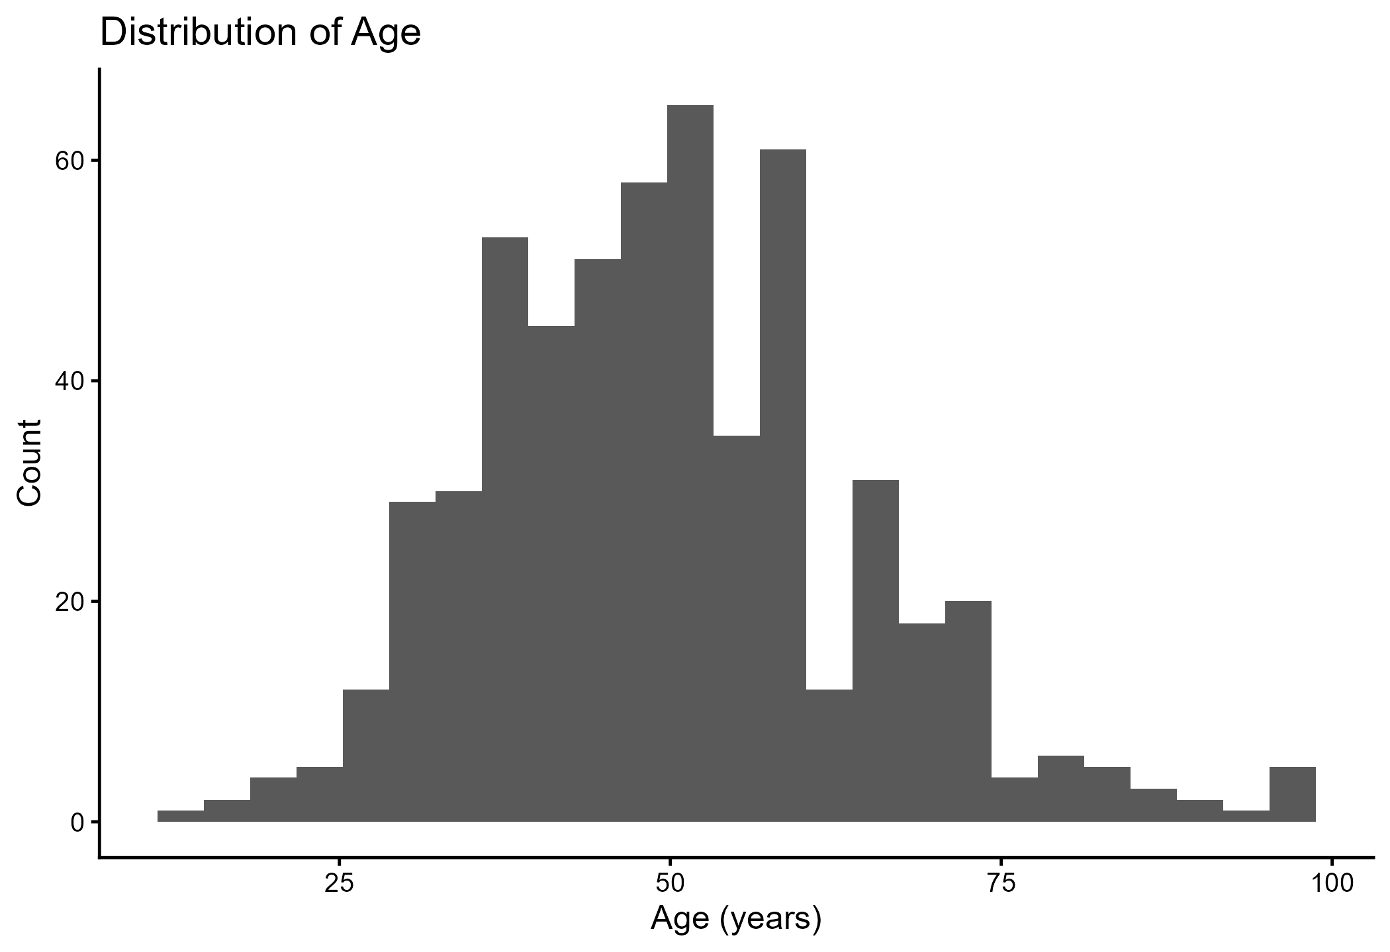Figure 1: Distribution of Age don’t spread image
Figure 1 indicates that the age range is broad, with a definite distribution in middle adulthood and a small tail into old age. This trend is consistent with the evidence that breast cancer in sub-Saharan Africa frequently occurs in relatively younger and economically active women in comparison to most high-income contexts (Bray et al., 2022; Bosompem et al., 2024; Ngwa et al., 2022). Age was usually summarised (either using a mean or dichotomously) in previous Ghanaian and regional studies, which may conceal the degree of age heterogeneity and its interplay with tumour biology and health system delays (Dedey et al., 2024; Akakpo et al., 2023). The current distribution justifies risk stratification that is age-dependent instead of basing it on rough categorisation, especially in the planning of timely detection and treatment pathways, associated with SDG 3 targets on the reduction of premature mortality and the enhancement of access to key health services (Wongnaah et al., 2025; Nair et al., 2025).
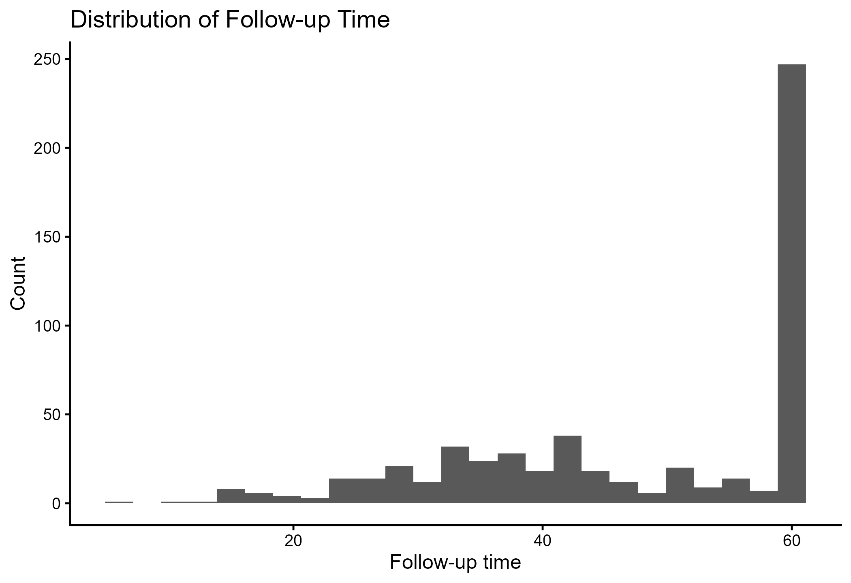Figure 2. Follow-up Time Distribution. don’t spread the image
Figure 2 shows that heaping is pronounced near the upper limit of follow-up, suggesting administrative censoring at a commonly used maximum follow-up period, a typical phenomenon in retrospective hospital cohorts. These follow-up patterns are also reported in facility-based research, where record systems and scheduled follow-up time limit the duration of observation (Dedey et al., 2024; Boaitey et al., 2024). Previously used modelling in the region often applied Cox or Kaplan-Meier models without explicitly accounting for the administration's censoring structure, which can complicate long-term risk interpretation, especially regarding recurrence or late competing mortality (Senyefia et al., 2022; Baidoo and Rodrigo, 2025). This follow-up design enhances the justification of multistate competing risks modelling as it integrate hazard estimation of transitions as well as interpretable state occupancy forecasts in the context of the observed time frame in support of SDG 3, informing clinical follow-up schedules and survivorship plans (Gradishar et al., 2022; Cardoso et al., 2023).
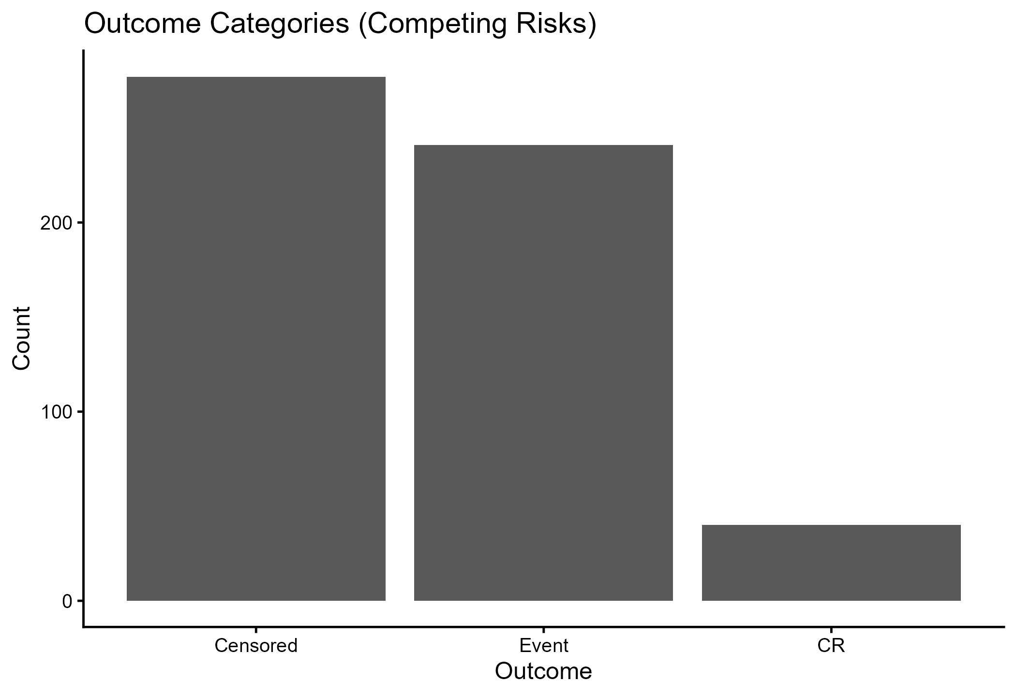Figure 3: Competing Risks Outcome Categories don’t spread image
In Figure 3, it is validated that there is a non-trivial competing risk burden, breast cancer events and censoring. This agrees with the literature stating that a significant proportion of non-cancer deaths are possible in low and middle-income environments because of multimorbidity and health systems limitations (Ayeni et al., 2023; Chasimpha et al., 2022). Most previous Ghana-based studies treated death as an endpoint, effectively assuming the absence of competing mortality or that competing mortality is negligible, which may bias absolute risk estimates when competing risks are present (Senyefia et al., 2022; Baidoo & Rodrigo, 2025). The analysis is consistent with the international recommendations stating that Kaplan Meier may overestimate disease specific event probability in the presence of competing events, encouraging the use of Fine-Gray and Cox specific methods based on the better support of decision making and SDG 3 policy goals, which include equitable, accurate risk assessment (Schonberg et al., 2025; Mancini et al., 2025).
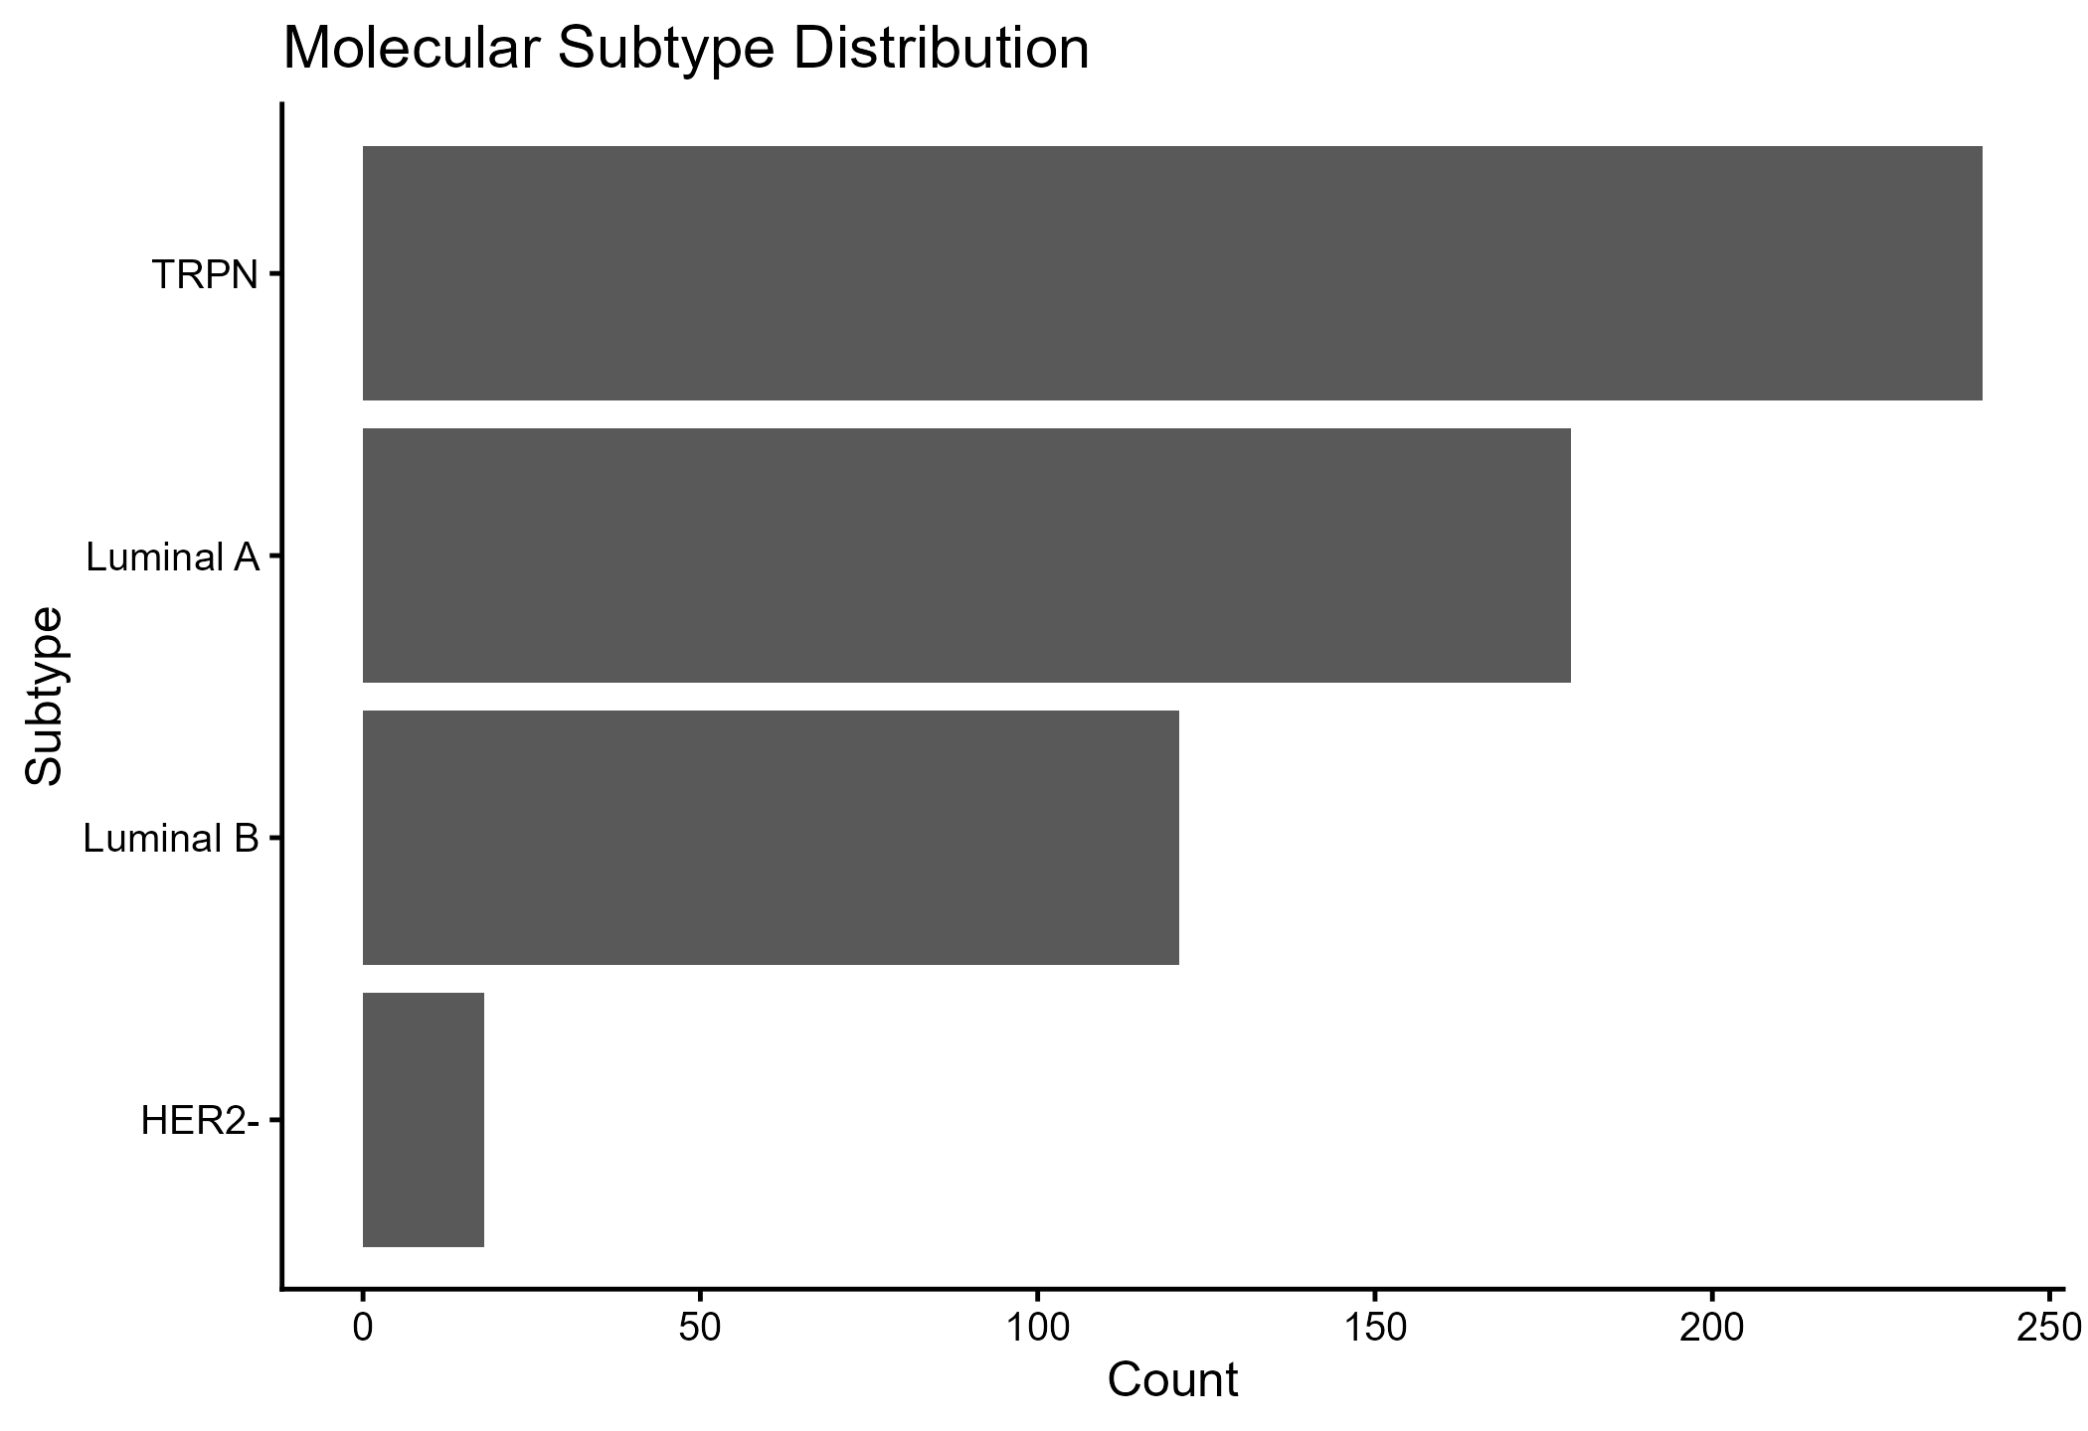Figure 4: Molecular Subtypes Distribution don’t spread image
The present number of individuals in the TRPN category is high as compared to some other subtypes (Figure 4), which is expected due to several reports of greater prevalence of triple negative phenotypes in African ancestry groups and African contexts (Hercules et al., 2022; Martine et al., 2022; Mugo & Contino, 2025). Subtype was commonly included as a baseline covariate in single-endpoint models in previous regional studies, hindering understanding of the effects of subtype on progression pathways, including recurrence and metastasis, before terminal events (Boaitey et al., 2024; Dedey et al., 2024). The recorded subtype profile substantiates the novelty assertion in the study that pathway-based modelling is particularly required in the African cohorts, where aggressive phenotypes can expedite the process of crossing disease states, and that has implications of SDG 3 in terms of prioritisation of timely diagnostic profiling and treatment allocation (Ngwa et al., 2022; Gradishar et al., 2022).
Table 1: Transition records and observed events in the multistate data
Transition | Records | Events
Alive->Progression | 558 | 10
Alive->BC_Event | 558 | 241
Alive->CR_Event | 558 | 40
Cause-specific Cox fitted with strata(strata).
According to Table 1, the Alive to breast cancer event transition is widespread, and the Alive to competing risk event is also widespread, the recorded progression events are not many. This trend is educative in two senses. First, the competing risk events support the necessity to estimate breast cancer event risk based on the competing risk methodology, as opposed to competing deaths being considered non-informative censoring, a drawback of much of the previous single endpoint analyses in the area (Schonberg et al., 2025; Mancini et al., 2025; Senyefia et al., 2022). Second, the small sample of observed progression events is indicative of either a truly low recurrence rate or metastasis during this period, under ascertainment in record books or a designation in which the recurrence is not systematically recorded but rather a discrete endpoint before death. The lack of documentation and incomplete pathways for follow-up have been identified in previous research as obstacles to measuring intermediate outcomes with confidence in sub-Saharan Africa (Bray et al., 2022; Ngwa et al., 2022). The multistate framework is a major contribution, as it formalises progression as a state and provides a framework to better capture data in future registries, in line with SDG 3, which aims to enhance surveillance and continuity of cancer care (Nair et al., 2025).
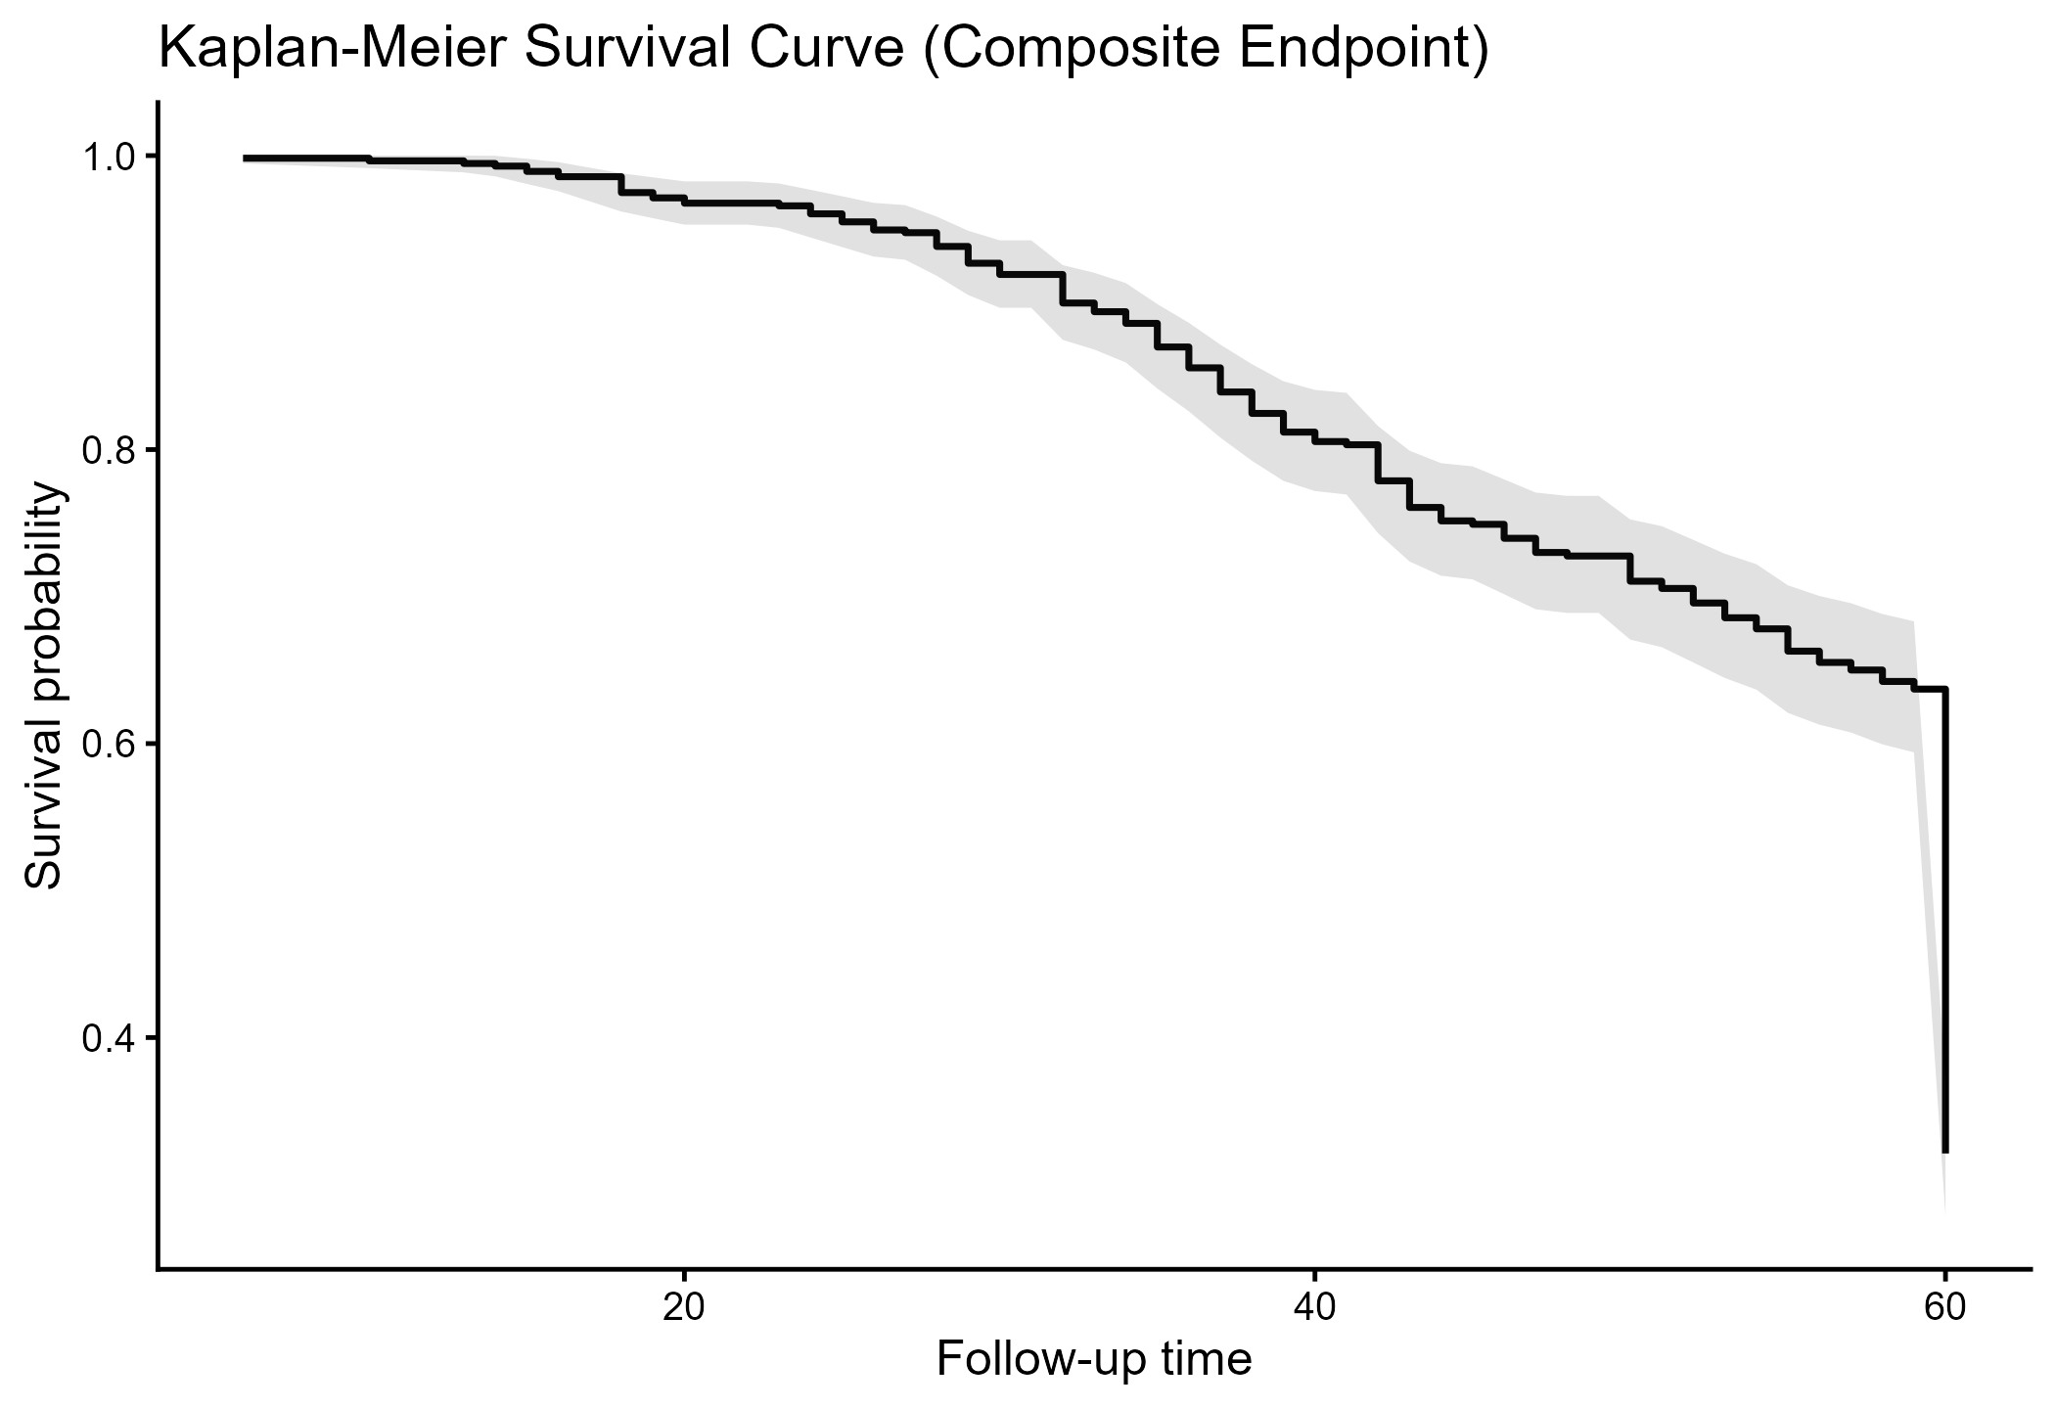Figure 5: Kaplan Meier Survival Curve (Composite Endpoint)
Figure 5 shows a linear decrease in follow-up survival probability as uncertainty increases later, due to a reduced risk set. This is directionally consistent with poor survival patterns observed in facility-based cohorts in Ghana and neighbouring settings, particularly at the advanced stage (Dedey et al., 2024; Daniels et al., 2025; Boaitey et al., 2024). Kaplan Meier survival was frequently reported as the main outcome of the previous work, which is convenient in comparison to the descriptive one, but is unable to distinguish between breast cancer failure and competing mortality and cannot track the change in intermediate disease (Senyefia et al., 2022; Baidoo & Rodrigo, 2025). The current analysis establishes Kaplan Meier as a descriptive baseline benchmark, followed by the superiority of competing risks and multistate estimators, which enhances the interpretability of the analysis results in the context of clinical planning and SDG 3 objectives that are oriented towards better results and health system performance (Cardoso et al., 2023; Schonberg et al., 2025).
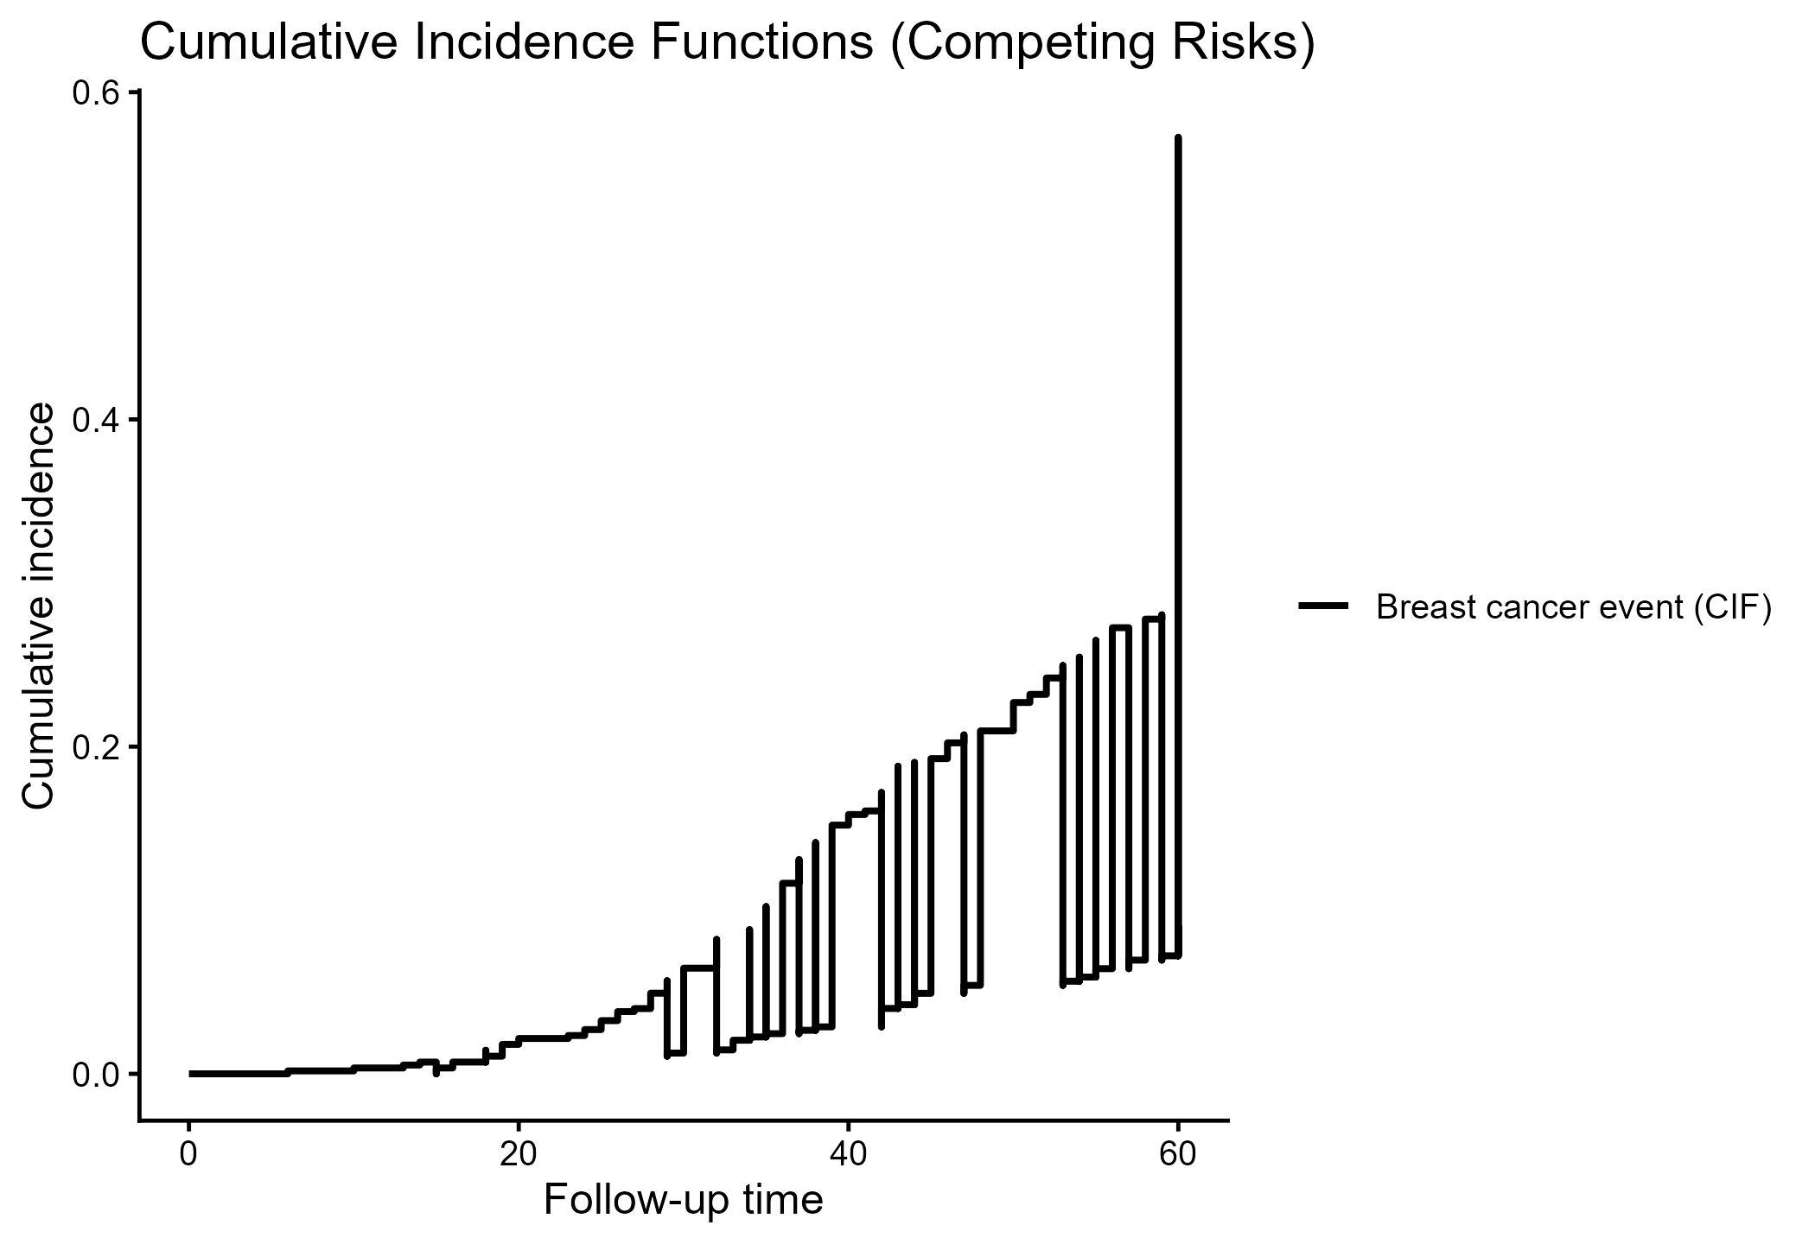Figure 6: Cumulative Incidence Functions (Competing Risks)
Figure 6 illustrates the cumulative incidence curve of breast cancer occurrence under competent risks. This methodology is consistent with the rest of the oncology literature, which shows that, in the presence of competing outcomes, the absolute risk of disease-specific events should be presented using cumulative incidence (Schonberg et al., 2025; Blondeaux et al., 2025). Competing risk-adjusted absolute risks were often not reported in previous analyses of African breast cancer, thereby limiting the applicability of policy-based estimates to follow-up schedules, survivorship care, and resource planning (Bray et al., 2022; Ngwa et al., 2022). The new aspect in this case is that the probability of survival is replaced by the probability of an event in the presence of competing risks, which facilitates a better expression of absolute burden. One technical aspect to note is that the output plotted in this study seems to depict only a single labelled curve; if the competing risk curve should have been used, visual validation is advised so that both types of events are clearly represented to communicate SDG 3 monitoring and decision support (Schonberg et al., 2025; Mancini et al., 2025).
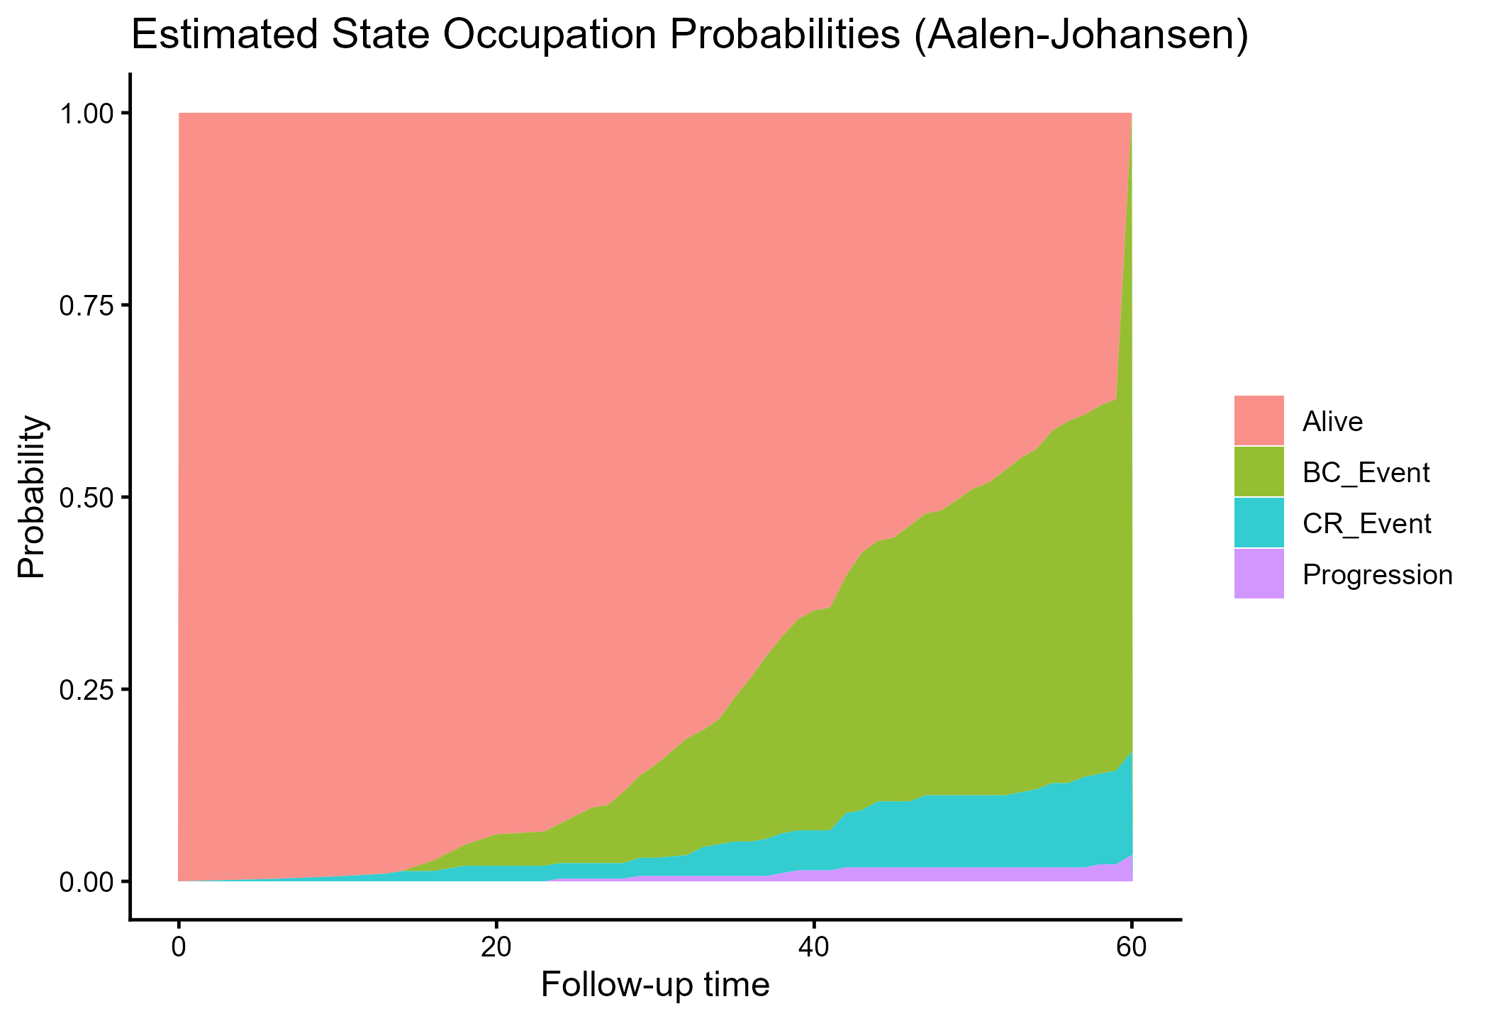Figure 7: Estimated State occupation Probabilities (Aalen Johansen).
Figure 7 presents the time-varying distributions of the probability mass for Alive, breast cancer event, competing risk event, and progression states, which provide a pathway-level summary not available in single-endpoint models. This goes to the heart of a fundamental shortcoming of previous regional studies, in which prognosis was defined as time to death, but the likelihood of being in clinically meaningful intermediate states, such as progression, was not quantified (Senyefia et al., 2022; Baidoo & Rodrigo, 2025). Elsewhere, multistate modelling has been demonstrated to enhance interpretability by separating patients' locations along the disease pathway and the intensity of transitions based on their overall effects (de Boer et al., 2022; Wang et al., 2025). These state-occupancy curves apply to the design of follow-up intensity, palliative care referral timing, and survivorship resource assignments in a Ghanaian context, aligning with SDG 3's aim to reinforce patient-centred continuity of care (Cardoso et al., 2023; Nair et al., 2025). The freedom to create low probability artifacts with sparse transitions or timing structure is a potential drawback of Aalen Johansen estimation, which means that thin slices are created with a low probability; this is a well-known problem of finite sample estimation and is the reason for careful reporting and sensitivity analysis to be considered, and not only one summary curve (Alsaedi et al., 2026; de Boer et al., 2022).
Table 2: Cause-specific hazards (HR, 95% CI, p)
term | HR | CI | p
Age | 1.022 | [1.005, 1.038] | 0.009
AgeCAT>50 | 1.242 | [0.814, 1.895] | 0.315
HER2positive | 1.460 | [0.532, 4.002] | 0.462
ERpositive | 0.689 | [0.095, 5.014] | 0.713
PRpositive | 0.285 | [0.076, 1.069] | 0.063
MSubtypeTRPN | 0.411 | [0.037, 4.598] | 0.470
MSubtypeLuminal B | 1.726 | [0.594, 5.011] | 0.316
MSubtypeHER2- | 0.330 | [0.024, 4.451] | 0.404
Grade |  | [NA, NA]
Stage | 1.546 | [1.189, 2.010] | 0.001
LymphNode | 1.226 | [1.047, 1.436] | 0.012
MenopauseYes | 0.719 | [0.483, 1.069] | 0.103
TumorSize>10mm<=20mm | 0.238 | [0.070, 0.816] | 0.022
TumorSize>20mm<=50mm | 0.664 | [0.350, 1.258] | 0.209
TumorSize>50mm<60mm | 1.348 | [0.947, 1.921] | 0.098
TumorSize>60mm |  | [NA, NA]
GeneticsBRCA1 |  | [NA, NA]
HospitalizationYes | 1.093 | [0.779, 1.535] | 0.606
EthnicityAkan | 1.133 | [0.800, 1.604] | 0.481
EthnicityGaAdangbe | 1.117 | [0.763, 1.635] | 0.568
EthnicityEwe | 1.129 | [0.739, 1.725] | 0.574
Ties = Breslow. Predictors with zero variance removed. Add space in above table
Table 2 suggests that Age and Stage have a positive relationship with greater cause-specific hazards, and also LymphNode add spacing indicates a greater hazard, as prognostic relationships have been previously established, such that later stage and nodal burden indicate greater mortality risk (Gradishar et al., 2022; Boaitey et al., 2024; Dedey et al., 2024). These findings are consistent with regional findings demonstrating that advanced presentation is a leading cause of unfavourable survival in sub-Saharan Africa (Bray et al., 2022; Ngwa et al., 2022). The Tumour Size categories show heterogeneity, with a protective relationship between the >10mm <= 20mm category and the reference category that could be due to clinical selection, measurement error, or confounding by diagnostic and treatment variables that might not be fully reported in retrospective cohorts. Previous research using single-endpoint Cox models generally interpreted these associations without differentiating between effects attributable to progression, competing mortality, or direct breast cancer failure, which the multistate cause-specific approach is starting to address by modelling transition-specific hazards (de Boer et al., 2022; Sari et al., 2025). Some of the predictors, such as Grade, Tumour Size>60mm, and GeneticsBRCA1, have NA estimates, meaning sparse categories, quasi-separation or zero variance within some strata, which is a typical limitation in African hospital datasets with incomplete biomarker testing and genomic profiling coverage (Miyashita et al., 2023; Manirakiza et al., 2025). This points to a very important gap in the previous literature that generally failed to denote estimator instabilities or scarcity of data, and is policy-directed under SDG 3 and SDG 10 by supporting the application of the need to increase diagnostic completeness and unbiased biomarker testing to permit effective risk modelling and equitable clinical decision making (Nair et al., 2025; Aronson et al., 2025).
Table 3: Fine-Gray model for breast cancer event (SHR, 95% CI, p)
term | SHR | CI | p
Age | 0.956 | [0.937, 0.974] | < .001
AgeCAT>50 | 1.966 | [1.253, 3.084] | 0.003
HER2positive | 0.874 | [0.291, 2.626] | 0.810
ERpositive | 0.987 | [0.135, 7.228] | 0.990
PRpositive | 0.404 | [0.087, 1.870] | 0.246
MSubtypeTRPN | 0.699 | [0.055, 8.876] | 0.783
MSubtypeLuminal B | 2.121 | [0.657, 6.853] | 0.209
MSubtypeHER2- | 1.052 | [0.070, 15.830] | 0.971
Grade |  | [NA, NA]
Stage | 2.118 | [1.475, 3.043] | < .001
LymphNode | 1.491 | [1.253, 1.775] | < .001
MenopauseYes | 1.616 | [1.054, 2.477] | 0.028
TumorSize>10mm<=20mm | 0.207 | [0.036, 1.178] | 0.076
TumorSize>20mm<=50mm | 0.665 | [0.288, 1.536] | 0.340
TumorSize>50mm<60mm | 1.524 | [0.979, 2.370] | 0.062
TumorSize>60mm |  | [NA, NA]
GeneticsBRCA1 |  | [NA, NA]
HospitalizationYes | 0.570 | [0.375, 0.866] | 0.008
EthnicityAkan | 1.114 | [0.757, 1.639] | 0.585
EthnicityGaAdangbe | 1.004 | [0.653, 1.545] | 0.984
EthnicityEwe | 0.949 | [0.582, 1.547] | 0.833
Fine-Gray fitted using survival::finegray pseudo-data and a weighted Cox model.
Table 3 presents sub-distribution hazard ratios for breast cancer events, adjusted for competing risks, which provide absolute-risk-oriented inference closer to prognostic counselling than competing-death-adjusted hazard models (Schonberg et al., 2025; Mancini et al., 2025). Stage and Lymph Node demonstrate a positive correlation with the incidence of the breast cancer event in a strong positive manner, which is in line with the established and well-established biological and clinical anticipations of tumour burden as well as spread, accelerating the disease-specific failure (Gradishar et al., 2022; Boaitey et al., 2024). Also, Menopausal status effects may be less interpretable because some studies in the region previously failed to distinguish between the incidence of disease events and competing mortality (Bosompem et al., 2024; Dedey et al., 2024). Hospitalisation seems to be protective in the Fine-Gray model, which possibly reflects previous contact with care or intensity of monitoring; this kind of health system pathway signifier is challenging to identify in traditional models and demonstrates the value added of modelling frameworks that can factor in with competing risk and state-based progression models in resource-constrained environments (Ayeni et al., 2023; Chasimpha et al., 2022). As in Table 2, NA estimates for some covariates reflect sparse data or unstable estimates for certain categories, consistent with previous findings that the limited completeness of genomic and biomarker data limits robust inference in African cohorts (Mugo & Contino, 2025; Miyashita et al., 2023). This confirms the study's novelty claim by demonstrating that advanced modelling can be applied and indicating the data quality and coverage upgrades required to fully achieve the goals of precision oncology in line with SDG 3 (Nair et al., 2025; Cardoso et al., 2023).
In Table 1, Table 2, and Table 3, the prevalence of Stage and Lymph Node is uniform, supporting the idea that late presentation is the primary focus of the modifiable factor of poor outcomes, which is also supported by regional data regarding the delay in diagnosis and limited access to treatment (Bray et al., 2022; Ngwa et al., 2022; Dedey et al., 2024). The novelty of the study is the shift to a multistate competing risks architecture, which could be used to measure transition-specific hazards and convert them into clinically meaningful state occupation probabilities in Figure 7, the reporting practice that is still uncommon in African breast cancer cohorts (de Boer et al., 2022; Wang et al., 2025). Such a pathway-based perspective underlies SDG 3 by addressing the early detection, follow up scheduling, and survivorship care better, and SDG 10 by identifying the systematic way that incomplete biomarker coverage and sparse category data can limit model reliability and possibly increase inequities in risk stratification in case there is disparity in diagnostic access (Aronson et al., 2025; Nair et al., 2025). The weaknesses of previous studies are the lack of modelling of competing mortality, the scarcity of reports of progression states, and the lack of transparency about instability in estimation in case of sparse covariate categories which are directly tackled in the design and reporting decisions in this study as well as the impulse to improve concrete registry completeness and regular biomarker recording to enhance the effectiveness of multistate inferences in the future (Schonberg et al., 2025; Bray et al., 2022; Miyashita et al., 2023
Baseline characteristics were characterised by a wide age distribution with the highest concentration in the age group 35-60 years, and this demonstrated the trend of persistent prevalence of breast cancer among women in economically productive ages in Ghana. The time-to-follow-up distribution was skewed to the right, with a peak at 5 years, which is representative of typical oncology follow-up plans in tertiary hospitals. The classification of outcome showed that breast cancer events were highly burdened compared to competing risk death, with a smaller percentage of patients having reported recurrence or progression before terminal outcomes. The profiling of molecular subtypes indicated that triple-negative and Luminal A tumours were the most common, followed by Luminal B and HER2-enriched disease. This distribution is comparable to the accumulating data of aggressive tumour biology in populations of West Africa and underlies regional reports of high triple-negative prevalence.
The multistate transition table revealed that the transitions between the state of Alive and breast cancer event were the leading transition pathways, followed by transitions between the state of Alive and competing risk death. The progression events were less common, indicating under-reporting of recurrence in normal clinical records and also supporting the rationale for using state-based modelling, which can accommodate sparse intermediate events. Despite this shortcoming, the multistate framework enabled the inference of all outcomes of clinical significance in a single framework.
Cause-specific Cox multistate modelling identified age, stage, and lymph node involvement as significant predictors of transition hazards. Older age is associated with greater transition intensity, suggesting greater vulnerability to poor outcomes. The stage of diagnosis at transition had a very significant impact on transition hazards, underscoring the ongoing problem of late presentation in Ghana. Lymph node involvement was a strong predictor of poor prognosis, indicating the potential for distant metastasis. The use of tumour size produced inconsistent results across categories: moderate-sized tumours had a lower transition hazard than the smallest reference group, whereas very large tumours had a higher risk. Directionally consistent, yet statistically imprecise, effects were observed in hormone receptor status and expression, and in HER2, indicating sparse subgroups and inadequate coverage of molecular testing. The molecular subtypes showed worse outcomes in triple-negative disease than in Luminal A tumours, but had wide confidence intervals, limiting statistical power.
The Fine-Gray competing risks model was provided, offering supplementary inference on breast cancer-specific cumulative incidence under competing mortality. The age group above 50 years was linked with a significantly large sub-distribution of breast cancer event which showed a steeper cumulative incidence curve in the elderly patients. Once more, advanced stage and lymph node involvement were prevalent predictors, indicating their pivotal role in determining long-term disease burden. In postmenopausal women, interactions between hormonal milieu and tumour aggressiveness were found to be associated with menopausal status in terms of cumulative incidence. The history of hospitalisation emerged as an important protective factor in the sub-distribution model, suggesting that patients receiving inpatient services may receive earlier diagnosis and closer, more intensive treatment. The effects of tumour size and molecular subtype were similar to those in the cause-specific model, with triple-negative and Luminal B tumours having higher cumulative incidence curves than Luminal A tumours.
The cumulative incidence functions, which were nonparametric, showed a progressive increase in the probability of breast cancer occurrence throughout the period of follow-up, reaching about a quarter of the cohort after five years, with competing risk mortality being relatively lower and non-negligible. These results affirm that the traditional Kaplan Meier approaches would inflate the deaths among breast cancer patients by considering the competing deaths as non-informative censoring. The Kaplan-Meier curve for the composite endpoint showed a gradual decrease in survival probability over time, followed by a sharp rise in the incidence of both cancer-related and competing events after 3 years.
The Aalen Johansen state occupation probabilities gave a dynamic picture of disease evolution. Thus, the likelihood of not having progressed and being alive was decreasing steadily with time of follow-up, and likewise, the likelihood of developing breast cancer was also increasing steadily. Competing risk death had a smaller but increasing proportion of state occupancy. Progression was a minor state, as shown by scanty documentation rather than by biological rarity. Such a representation of the state enables the provision of clinically interpretable probabilities that facilitate dynamic risk communication and longitudinal care planning.
Together, these results prove that the outcomes of breast cancer in Ghana are multi-pathway processes that are influenced by tumour biology, stage at diagnosis, and competing mortality. The findings are strong indications that single-endpoint survival models do not provide a comprehensive picture of the disease continuum and that multistate competing-risks models are crucial for accurate prognosis and health system planning.
Conclusion
The study presents the multistate competing-risks survival model for breast cancer outcomes in Ghana. The study goes beyond traditional survival analysis by the joint modelling of progression, breast cancer mortality and competing mortality, which provides a more realistic clinical view of the disease progression in a resource-limited environment.
The results confirm that late diagnosis, lymph node status, and age are the most prevalent factors contributing to poor outcomes, with molecular subtype heterogeneity as an additional stratification factor for long-term risk. The incidence of breast cancer events is very high in the long run, and the competing mortality is not insignificant, which has highlighted the importance of the competing risks approach in estimating these events unbiasedly. The probability of state occupation shows a gradual shift from survival to negative consequences over the years, further supporting the need to detect the disease early and to start treatment promptly.
The study is methodologically valid and proves the usefulness and practicability of multistate modelling in African oncology studies. The framework facilitates the prediction of transition-specific risks, cumulative incidence functions, and dynamic condition possibilities, and serves as the basis for individualised risk stratification and longitudinal care pathways. The methodology addresses the most important gaps in the literature by incorporating recurrence and metastasis into survival modelling and explicitly accounting for competing mortality.
The findings suggest that early diagnosis through population-based screening and community awareness, molecular testing to guide precision therapy, and enhanced referral and treatment infrastructure to reduce delays should be prioritised. These priorities are directly related to Sustainable Development Goal 3 on the need to ensure healthy lives and well-being, and specifically to the target of reducing premature mortality from non-communicable diseases.
To sum up, multistate competing-risks survival analysis can be one of the most powerful and appropriate contexts for studying breast cancer trajectories in Ghana. Its incorporation as a regular cancer monitoring and research tool can change the concept of prognostic assessment, inform precision oncology, and aid in evidence-based health system planning in sub–Saharan Africa.
Declarations
Data availability: The datasets used and analysed during the current study are available from the corresponding author upon reasonable request.
Ethics Statement
ETHICAL CONSIDERATIONS As per international standards or university standards, written ethical approval has been collected and preserved by the author(s).
Conflicts of interest
The authors declare that they have no competing interests.
Consent for Publication
Not applicable in the clinic
Trial Number
Not applicable

COMPETING INTERESTS DISCLAIMER:
Authors have declared that they have no known competing financial interests OR non-financial interests OR personal relationships that could have appeared to influence the work reported in this paper.

References
Abdou, Y., Barlow, W. E., Gralow, J. R., Meric-Bernstam, F., Albain, K. S., Hayes, D. F., ... & Kalinsky, K. (2025). Race and clinical outcomes in hormone receptor-positive, HER2-negative, node-positive breast cancer in the randomized RxPONDER trial. JNCI: Journal of the National Cancer Institute, 117(5), 889-897.
Abubakar, M., Ahearn, T. U., Duggan, M. A., Lawrence, S., Adjei, E. K., Clegg-Lamptey, J. N., ... & Ghana Breast Health Study Team. (2025). Contribution of prediagnostic host factors to shaping the stromal microenvironment of breast cancer among Sub-Saharan African women. Cancer Epidemiology, Biomarkers & Prevention, 34(4), 462-473.
Akakpo, P. K., Imbeah, E. G., Edusei, L., Naporo, S., Ulzen-Appiah, K., Clegg-Lamptey, J. N., ... & Jiagge, E. M. (2023). Clinicopathologic characteristics of early-onset breast cancer: a comparative analysis of cases from across Ghana. BMC women's health, 23(1), 5.
Alsaedi, H. J. N., Al-Juboori, F. S., & Kadhim, R. J. (2026). Estimating survival rates using artificial intelligence combined with the Aalen–Johansen estimator in multi-state models. Sustainable Engineering and Innovation, 8(1), 1.
Alum, E. U., Tufail, T., Uti, D. E., Aja, P. M., Offor, C. E., Ibiam, U. A., ... & Alum, B. N. (2025). Utilizing indigenous flora in East Africa for breast cancer treatment: an overview. Anti-Cancer Agents in Medicinal Chemistry, 25(2), 99-113.
An, J., Hershberger, P. E., & Ferrans, C. E. (2023). Delayed presentation, diagnosis, and treatment of breast cancer among Chinese women: an integrative literature review. Cancer Nursing, 46(3), 217-232.
Arnold, M., Morgan, E., Rumgay, H., Mafra, A., Singh, D., Laversanne, M., ... & Soerjomataram, I. (2022). Current and future burden of breast cancer: Global statistics for 2020 and 2040. The Breast, 66, 15-23.
Aronson, J., Bhatta, M., Carey, L. A., Jobanputra, K., Gupta, G. P., & Abdou, Y. (2025). Bridging the gap: ctDNA, genomics, and equity in breast cancer care. NPJ Breast Cancer, 11(1), 92.
Ayeni, O. A., Joffe, M., Mapanga, W., Chen, W. C., O’Neil, D. S., Phakathi, B., ... & Norris, S. A. (2023). Multimorbidity and overall survival among women with breast cancer: results from the South African Breast Cancer and HIV Outcomes Study. Breast Cancer Research, 25(1), 7.
Baidoo, T. G., & Rodrigo, H. (2025). Data-driven survival modeling for breast cancer prognostics: A comparative study with machine learning and traditional survival modeling methods. PloS one, 20(4), e0318167.
Bennett, J. E., O'Driscoll, O. N., Stevens, G. A., Aldea-Ramos, N., Bray, F., Farzadfar, F., ... & Ezzati, M. (2025). Benchmarking progress in non-communicable diseases: a global analysis of cause-specific mortality from 2001 to 2019. The Lancet, 406(10509), 1255-1282.
Blondeaux, E., Sonnenblick, A., Agostinetto, E., Bas, R., Kim, H. J., Franzoi, M. A., ... & Lambertini, M. (2025). Association between risk-reducing surgeries and survival in young BRCA carriers with breast cancer: an international cohort study. The Lancet Oncology, 26(6), 759-770.
Boaitey, G. A., Martini, R., Stonaker, B., Bonsu, E. O., Adjei, E., Kyei, I., ... & Fondjo, L. A. (2024). Patterns of breast cancer locoregional relapse, metastasis, and subtypes in Ghana. BMC cancer, 24(1), 1485.
Bosompem, K., Yorke, J., Buckman, T. A., Brenu, S. G., Nyantakyi, M., Aitpillah, F. S. K., ... & Acheampong, E. (2024). Comparative analysis of breast cancer characteristics in young premenopausal and postmenopausal women in Ghana. Scientific reports, 14(1), 2704.
Bosson-Amedenu, S., Ayitey, E., Ayiah-Mensah, F., & Asare, L. (2025). Evaluating key predictors of breast cancer through survival: a comparison of AFT frailty models with LASSO, ridge, and elastic net regularization. BMC cancer, 25(1), 665.
Boughey, J. C., Rosenkranz, K. M., Ballman, K. V., McCall, L., Haffty, B. G., Cuttino, L. W., ... & Partridge, A. H. (2023). Local recurrence after breast-conserving therapy in patients with multiple ipsilateral breast cancer: results from ACOSOG Z11102 (Alliance). Journal of Clinical Oncology, 41(17), 3184-3193.
Bray, F., Parkin, D. M., Gnangnon, F., Tshisimogo, G., Peko, J. F., Adoubi, I., ... & Chingonzoh, T. (2022). Cancer in sub-Saharan Africa in 2020: a review of current estimates of the national burden, data gaps, and future needs. The Lancet Oncology, 23(6), 719-728.
Cardoso, F., McCartney, A., Ponti, A., Marotti, L., Vrieling, C., Eniu, A., ... & Biganzoli, L. (2023). European society of breast cancer specialists/advanced breast cancer global alliance quality indicators for metastatic breast cancer care. European Journal of Cancer, 187, 105-113.
Chasimpha, S., McCormack, V., Cubasch, H., Joffe, M., Zietsman, A., Galukande, M., ... & dos-Santos-Silva, I. (2022). Disparities in breast cancer survival between women with and without HIV across sub-Saharan Africa (ABC-DO): a prospective, cohort study. The Lancet HIV, 9(3), e160-e171.
Daniels, J., Kyei, K. A., Walubo, R., Nyantakyi, A. Y., Ayabilah, E. A., & Tackie, J. N. O. (2025). Prevalence and clinicopathological characteristics of breast cancer patients with brain metastases in Ghana: A single-center cross-sectional study. Plos one, 20(8), e0329308.
de Boer, A. Z., Bastiaannet, E., Schetelig, J., de Glas, N. A., Manevksi, D., Putter, H., ... & de Wreede, L. C. (2022). Breast cancer mortality of older patients with and without recurrence analysed by novel multi-state models. European Journal of Cancer, 174, 212-220.
De Vis, J. B., Wang, C., Nguyen, K. V., Sun, L., Jia, B., Sherry, A. D., ... & Rafat, M. (2025). Body composition as a potential biomarker of recurrence risk in patients with triple-negative breast cancer. Breast Cancer Research and Treatment, 1-9.
Dedey, F., Nsaful, J., Essoun, S., Anie, H. A., Nartey, E., & Clegg-Lamptey, J. N. (2024). Metastatic patterns of breast cancer: a retrospective study in a Teaching Hospital in Ghana. Health Sciences Investigations Journal, 6(2), 860-868.
Dessie, Z. G., & Zewotir, T. (2025). Global determinants of breast cancer mortality: a comprehensive meta-analysis of clinical, demographic, and lifestyle risk factors. BMC Public Health, 25(1), 2640.
Dlamini, Z., Molefi, T., Khanyile, R., Mkhabele, M., Damane, B., Kokoua, A., ... & Hull, R. (2024). From incidence to intervention: a comprehensive look at breast cancer in South Africa. Oncology and Therapy, 12(1), 1-11.
Elbasheer, M. M., Dodwell, D., & Gathani, T. (2025). Understanding global variation in breast cancer mortality. British Journal of Radiology, 98(1173), 1369-1372.
Fu, M., Peng, Z., Wu, M., Lv, D., Li, Y., & Lyu, S. (2025). Current and future burden of breast cancer in Asia: A GLOBOCAN data analysis for 2022 and 2050. The Breast, 79, 103835.
Giaquinto, A. N., Sung, H., Miller, K. D., Kramer, J. L., Newman, L. A., Minihan, A., ... & Siegel, R. L. (2022). Breast cancer statistics, 2022. CA: a cancer journal for clinicians, 72(6), 524-541.
Gradishar, W. J., Moran, M. S., Abraham, J., Aft, R., Agnese, D., Allison, K. H., ... & Kumar, R. (2022). Breast cancer, version 3.2022, NCCN clinical practice guidelines in oncology. Journal of the National Comprehensive Cancer Network, 20(6), 691-722.
Gupta, S., Jones, J. E., & Smith-Graziani, D. (2025). Disparities in hereditary genetic testing in patients with triple negative breast cancer. Clinical Breast Cancer, 25(1), 12-18.
Hercules, S. M., Alnajar, M., Chen, C., Mladjenovic, S. M., Shipeolu, B. A., Perkovic, O., ... & Daniel, J. M. (2022). Triple-negative breast cancer prevalence in Africa: a systematic review and meta-analysis. BMJ open, 12(5), e055735.
Kang, M., Song, J., Kang, E. S., Jang, S., Kwak, T., Kim, Y., ... & Jeong, S. (2025). Pathophysiology, development, and mortality of major non-communicable diseases in metabolic dysfunction-associated steatotic liver disease: A comprehensive review. International Journal of Biological Sciences, 21(13), 5691.
Khan, S. A., Zhao, F., Goldstein, L. J., Cella, D., Basik, M., Golshan, M., ... & Sledge, G. W. (2022). Early local therapy for the primary site in de novo stage IV breast cancer: results of a randomized clinical trial (E2108). Journal of Clinical Oncology, 40(9), 978-987.
Kim, J., Harper, A., McCormack, V., Sung, H., Houssami, N., Morgan, E., ... & Fidler-Benaoudia, M. M. (2025). Global patterns and trends in breast cancer incidence and mortality across 185 countries. Nature Medicine, 1-9.
Li, Y., Zheng, J., Deng, Y., Deng, X., Lou, W., Wei, B., ... & Dai, Z. (2022). Global burden of female breast cancer: age-period-cohort analysis of incidence trends from 1990 to 2019 and forecasts for 2035. Frontiers in oncology, 12, 891824.
Mancini, S., Bucchi, L., Biggeri, A., Giuliani, O., Baldacchini, F., Ravaioli, A., ... & Vattiato, R. (2025). Incidence and temporal patterns of true recurrences and second primaries in women with breast cancer: A 10-year competing risk-adjusted analysis. The Breast, 80, 103883.
Manirakiza, A. V., Mutesa, L., Mathew, C. G., & Olopade, O. I. (2025). Breast Cancer: Genetic Risk Assessment, Diagnostics, and Therapeutics in African Populations. Annual Review of Genomics and Human Genetics, 26.
Martini, R., Delpe, P., Chu, T. R., Arora, K., Lord, B., Verma, A., ... & Davis, M. B. (2022). African ancestry–associated gene expression profiles in triple-negative breast cancer underlie altered tumor biology and clinical outcome in women of African descent. Cancer discovery, 12(11), 2530-2551.
Miyashita, M., Bell, J. S., Wenric, S., Karaesmen, E., Rhead, B., Kase, M., ... & Olopade, O. I. (2023). Molecular profiling of a real-world breast cancer cohort with genetically inferred ancestries reveals actionable tumor biology differences between European ancestry and African ancestry patient populations. Breast Cancer Research, 25(1), 58.
Mohammed, A., Melak, D., Demeke Bayou, F., Yasin, H., Zerga, A. A., Wagaye, B., ... & Endawkie, A. (2024). Prevalence and associated factors of depression among breast cancer patients in Sub-Saharan Africa: A systematic review and meta-analysis. SAGE Open Medicine, 12, 20503121241226897.
Mohammed, M. A., Mokhtar, S., Osama, E., & Sherif, O. (2024). Retrospective descriptive analysis of the demographic and clinicopathological presentation of breast cancer patients in Kasr Al-Ainy Hospital over 5 years. The Egyptian Journal of Surgery, 43(2).
Morgan, E., O’Neill, C., Shah, R., Langselius, O., Su, Y., Frick, C., ... & Arnold, M. (2024). Metastatic recurrence in women diagnosed with non-metastatic breast cancer: a systematic review and meta-analysis. Breast Cancer Research, 26(1), 171.
Mugo, N., & Contino, G. (2025). Genomic landscapes of breast cancer in African populations: a systematic review. NPJ Breast Cancer, 11(1), 91.
Nair, S., Ngwa, W., Addai, B. W., Addai, A. O., & Oti, B. A. (2025). The role of a national cancer registry in effective implementation and monitoring of the Global Breast Cancer Initiative (GBCI) framework in Ghana: a narrative review. Translational Breast Cancer Research, 6, 20.
Ngwa, W., Addai, B. W., Adewole, I., Ainsworth, V., Alaro, J., Alatise, O. I., ... & Kerr, D. (2022). Cancer in sub-Saharan Africa: a lancet oncology commission. The Lancet Oncology, 23(6), e251-e312.
Ofosuhene, R., Effah, A., Sam‐Awortwi Jr, W., Boamah, R. A. B., Akosah, P., & Obirikorang, C. (2025). Breast Cancer Awareness and Knowledge Among Women at a Municipal Hospital in Ghana: A Cross‐Sectional Study. Cancer Reports, 8(9), e70347.
Oladeru, O., Rajack, F., Esnakula, A., Naab, T. J., Kanaan, Y., & Ricks-Santi, L. (2024). Beyond Triple-Negative: High Prevalence of Quadruple-Negative Breast Cancer in African Americans. Biomedicines, 12(7), 1522.
Parenté, A., Gnangnon, F. H. R., Kinsou, D., Chkeir, M., Adou, C., Sacca, H. R., ... & Blanquet, V. (2025). Prognostic factors of breast cancer and survival in Sub-Saharan Africa: A systematic review and meta-analysis. Bulletin du Cancer.
Rauniyar, S. K., Hashizume, M., Yoneoka, D., & Nomura, S. (2023). Projection of morbidity and mortality due to breast cancer between 2020 and 2050 across 42 low-and middle-income countries. Heliyon, 9(6).
Sari, Y. W., Megawati, N. Y., & Hutajulu, S. H. (2025). Cox-Based Estimation Model for Critical Illness Insurance Policy for Breast Cancer Based on the Possible Transition of Status. Malaysian Journal of Mathematical Sciences, 19(1).
Schmid, P., Cortes, J., Dent, R., McArthur, H., Pusztai, L., Kümmel, S., ... & O’Shaughnessy, J. (2024). Overall survival with pembrolizumab in early-stage triple-negative breast cancer. New England Journal of Medicine, 391(21), 1981-1991.
Schonberg, M. A., Wolfson, E. A., Eliassen, A. H., Rosner, B. A., Lacroix, A. Z., Nelson, R. A., ... & Ngo, L. H. (2025). Population attributable risk of a competing-risk model for breast cancer and non-breast cancer death among women≥ 65 years. Breast Cancer Research and Treatment, 211(3), 687-698.
Sekyere, A. O., Iddrisu, M., & Konlan, K. D. (2025). “The disease and its treatment make you less of a woman”: self-reported experiences of women with breast cancer receiving care in Kumasi, Ghana. Supportive Care in Cancer, 33(8), 677.
Senyefia, B. A., Joseph, A., Cynthia, N. C., & Ouerfelli, N. (2022). A comparison between accelerated failure time models in analyzing the survival of breast cancer patients. J Cancer Tumor Int, 12(1), 16-28.
Sharma, R., Nanda, M., Fronterre, C., Sewagudde, P., Ssentongo, A. E., Yenney, K., ... & Ssentongo, P. (2022). Mapping cancer in Africa: a comprehensive and comparable characterization of 34 cancer types using estimates from GLOBOCAN 2020. Frontiers in public health, 10, 839835.
Toffaha, K., Emre Simsekler, M. C., Shehhi, A. A., Sleptchenko, A., & AlAwadhi, A. (2025). Comprehensive survival analysis of breast cancer patients: a bayesian network approach. BMC Medical Informatics and Decision Making, 25(1), 349.
Unger-Saldaña, K., Bandala-Jacques, A., Huerta-Gutierrez, R., Zamora-Muñoz, S., Hernández-Ávila, J. E., Cabrera-Galeana, P., ... & Lajous, M. (2023). Breast cancer survival in Mexico between 2007 and 2016 in women without social security: a retrospective cohort study. The Lancet Regional Health–Americas, 23.
Wagle, N. S., Nogueira, L., Devasia, T. P., Mariotto, A. B., Yabroff, K. R., Islami, F., ... & Siegel, R. L. (2025). Cancer treatment and survivorship statistics, 2025. CA: A Cancer Journal for Clinicians.
Wang, C., Qi, S., & Jiang, J. (2025). Bayesian analysis of Box-Cox transformation model for multi-state progression-free survival data. Journal of the Korean Statistical Society, 54(1), 194-219.
Wongnaah, F. G., Aboagye, R. G., Storph, R. P., Seidu, A. A., Adnani, Q. E. S., & Ahinkorah, B. O. (2025). Breast cancer screening uptake and its associated factors among women in Ghana: evidence from the 2022 Demographic and Health Survey. Archives of Public Health, 83(1), 262.
Xiong, X., Zheng, L. W., Ding, Y., Chen, Y. F., Cai, Y. W., Wang, L. P., ... & Yu, K. D. (2025). Breast cancer: pathogenesis and treatments. Signal transduction and targeted therapy, 10(1), 49.
Xu, Y., Gong, M., Wang, Y., Yang, Y., Liu, S., & Zeng, Q. (2023). Global trends and forecasts of breast cancer incidence and deaths. Scientific data, 10(1), 334.
Zhang, Y., Ji, Y., Liu, S., Li, J., Wu, J., Jin, Q., ... & Huang, Y. (2025). Global burden of female breast cancer: new estimates in 2022, temporal trend and future projections up to 2050 based on the latest release from GLOBOCAN. Journal of the National Cancer Center, 5(3), 287.
Zulum, G. L., Ojo, B. A., Eke, B. A., Umobong, E. O., Unande, H. M., Kawen, P. T., ... & Edo, A. V. (2025). Breast Cancer in Makurdi, North Central Nigeria: A 10-YearHistopathological Retrospective Survey. Western Journal of Medical and Biomedical Sciences, 6(2).

