Response of Senna (Cassia angustifolia Vahl.) to Varying Soil Applied NPK Levels and Foliar Nutrition with Respect to Leaf N, P and K Uptake at Harvest

Abstract
A field experiment was conducted at Herbal Garden, college of Agriculture, UAS, Raichur to study the response of senna (Cassia angustifolia Vahl.) to varying soil-applied NPK levels and foliar nutrition with respect to leaf nitrogen, phosphorus and potassium uptake at harvest. The experiment was laid out in a factorial randomized block design comprising four levels of soil-applied NPK [F₁: 125% RDF, F₂: 100% RDF, F₃: 75% RDF and F₄: control (no RDF)] and four foliar spray treatments [M₁: 1% urea, M₂: 1% 19:19:19, M₃: seaweed extract and M₄: water spray]. The results revealed that nutrient uptake was significantly influenced by both soil and foliar nutrition. Among the fertilizer levels, 125% RDF (F1) recorded the highest uptake of nitrogen (74.78 kg ha⁻¹), phosphorus (50.08 kg ha⁻¹) and potassium (13.98 kg ha⁻¹), while the control (F₄) recorded the lowest values. Among foliar treatments, seaweed extract spray (M₃) showed the maximum N, P and K uptake. The interaction effect was significant, and the combined treatment F₁M₃ (125% RDF + seaweed extract) recorded the highest uptake of all three nutrients. Regression analysis indicated a strong positive linear relationship between increasing NPK levels and nutrient uptake. The percent increase in nutrient uptake under F₁ over control was 128.1% for N, 197.2% for P and 85.7% for K, while F₁M₃ over F₄M₄ showed increases of 416.4%, 339.7% and 175.0%, respectively. The study concludes that application of 125% RDF along with seaweed extract foliar spray is the most effective nutrient management strategy for maximizing nutrient uptake in senna leaves at harvest.
Key words: Nutrient levels, senna, medicinal plant, foliar nutrition, nutrient uptake
- Introduction
Senna (Cassia angustifolia Vahl.), an important medicinal plant of the family Fabaceae, is widely cultivated in India for its leaves and pods, which are valued for their laxative properties due to the presence of anthraquinone glycosides such as sennosides. India is the leading producer and exporter of senna, with major cultivation concentrated in Tamil Nadu, Rajasthan and parts of Karnataka. The commercial value of senna primarily depends on leaf yield and quality, both of which are strongly influenced by mineral nutrition.
Balanced plant nutrition plays a pivotal role in regulating growth, photosynthesis, metabolite synthesis and nutrient accumulation in medicinal plants. Among the essential macronutrients, nitrogen (N), phosphorus (P) and potassium (K) are the most critical in determining biomass production and nutrient uptake. Nitrogen is a major constituent of chlorophyll, amino acids and proteins and directly affects vegetative growth and leaf yield. Phosphorus is essential for energy transfer, root development and metabolic activities, while potassium regulates enzyme activation, photosynthate translocation, stomatal function and stress tolerance. Deficiency or imbalance of these nutrients results in poor growth, reduced leaf area and lower nutrient accumulation in senna.
Soil application of NPK is the primary method of nutrient supply to crops; however, nutrient use efficiency under tropical conditions often remains low due to losses through leaching, volatilization and fixation. Moreover, medicinal crops like senna, which are harvested for leaves, require a continuous and readily available nutrient supply to sustain higher nutrient uptake. In this context, foliar nutrition has emerged as an effective complementary approach to soil fertilization, as it facilitates rapid absorption of nutrients directly through leaf tissues, corrects hidden hunger and improves nutrient use efficiency.
Several studies in medicinal and aromatic plants have demonstrated that combined application of soil fertilizers and foliar nutrient sprays enhances nutrient absorption, growth and yield more effectively than soil application alone. Foliar spraying of macro- and micronutrients at critical growth stages has been reported to improve chlorophyll content, enzyme activity, photosynthetic efficiency and translocation of assimilates, thereby increasing nutrient uptake in leaves. However, information on the interactive effects of varying soil-applied NPK levels and foliar nutrition on nutrient uptake in senna is limited and fragmented.
Nutrient uptake, particularly of N, P and K in harvested leaves, serves as an important indicator of the plant’s nutritional status and fertilizer use efficiency. Understanding the uptake pattern under different nutrient management practices is essential for developing precise fertilizer recommendations for senna cultivation. Optimizing nutrient uptake not only enhances leaf yield but also improves the quality and export value of senna produce.

In view of the above, the present investigation entitled “Response of Senna (Cassia angustifolia Vahl.) to varying soil applied NPK levels and foliar nutrition with respect to leaf N, P and K uptake at harvest” was undertaken to evaluate the influence of different soil-applied NPK levels and foliar nutrient sprays on nitrogen, phosphorus and potassium uptake in senna leaves at harvest.
2.0 Materials and Methods
Collection and Preparation of Plant Samples
Plant samples collected for dry matter estimation were also utilized for the determination of nitrogen, phosphorus and potassium content. The samples were oven-dried at 60 ± 5 °C until constant weight was attained. The dried material was finely ground using a grinder fitted with stainless steel blades and stored in clean, labelled polythene bags for subsequent chemical analysis, following the procedure outlined by Jackson (1973).

2.1 Estimation of Nitrogen in Plant Samples
Total nitrogen content in the plant samples was estimated using the Kjeldahl method as described by Jackson (1973). Finely powdered plant material was digested with concentrated sulphuric acid (H₂SO₄) in the presence of a digestion mixture containing potassium sulphate (K₂SO₄), copper sulphate (CuSO₄·5H₂O) and selenium powder in the ratio of 100:20:1. After digestion, the nitrogen present in the digested sample was determined by distillation under alkaline conditions. The liberated ammonia was absorbed in boric acid mixed indicator solution and subsequently titrated against standard sulphuric acid. The nitrogen content was calculated using the following formula:

$$\text{Nitrogen (\%)}=\frac{\text{TV (ml)}×{\text{Normality of H}}_{2}{\text{SO}}_{4}×0.004×\text{Dilution factor}}{\text{Weight of plant sample (g)}}$$
2.2 Estimation of Phosphorus in Plant Samples
Phosphorus content in the plant samples was estimated using the vanadomolybdate yellow colour method as described by Jackson (1973). A known quantity of finely powdered plant material (0.5 g) was pre-digested with concentrated nitric acid (HNO₃) overnight. This was followed by further digestion using 5 ml of di-acid mixture (HNO₃: HClO₄ in the ratio 10:4) until a white residue was obtained. The residue was dissolved in 6 N hydrochloric acid (HCl) and the volume was made up to 50 ml with distilled water. A blank was prepared using the same procedure without plant material.
An aliquot of 5 ml from the digested solution was transferred to a 50 ml volumetric flask, to which 10 ml of vanadomolybdic acid reagent was added, and the volume was made up to the mark with distilled water. The intensity of the yellow colour developed was measured at 490 nm using a spectrophotometer against a reagent blank. The phosphorus concentration was determined with reference to the standard phosphorus curve, and the per cent phosphorus was calculated using the following formula:
$$\text{Phosphorus (\%)}=\frac{\text{Graph ppm}×\text{Volume of extract (ml)}×\text{Volume made (ml)}×100}{{10}^{6}×\text{Aliquot taken (ml)}×\text{Weight of plant sample (g)}}$$
2.3 Estimation of Potassium in Plant Samples
Potassium content in the plant samples was determined using the flame photometric method as described by Jackson (1973). An aliquot of 1 ml from the di-acid digested extract was transferred into a 50 ml volumetric flask and diluted to volume with distilled water. The flame photometer was calibrated using 50 ppm and 100 ppm potassium standard solutions. The diluted sample was aspirated into the flame photometer and the readings were recorded. The potassium content of the sample was calculated using the formula:
$$\text{Potassium (\%)}=\frac{\text{Graph ppm}×\text{Dilution factor}×\text{Volume of digest (ml)}×100}{{10}^{6}×\text{Weight of plant sample (g)}}$$
3.0 Results and discussion
Soil application of different NPK levels exerted a significant influence on nitrogen, phosphorus and potassium uptake by senna leaves at harvest. Among the fertilizer levels, F₁ (125% RDF) recorded the highest uptake of N (74.78 kg ha⁻¹), P (50.08 kg ha⁻¹) and K (13.98 kg ha⁻¹). This was followed closely by F₂ (100% RDF) with N (73.83), P (49.40) and K (13.83 kg ha⁻¹). A gradual decline was observed at F₃ (75% RDF), whereas the lowest uptake was recorded in F₄ (control) with only N (32.78), P (16.85) and K (7.53 kg ha⁻¹). The results clearly indicate that increasing levels of soil-applied fertilizers enhanced nutrient availability and absorption, while omission of fertilizers drastically reduced uptake.
Among foliar nutrition treatments, M₃ (seaweed extract spray) registered the highest nutrient uptake with N (67.48), P (43.30) and K (13.10 kg ha⁻¹). This was statistically on par with M₂ (1% 19:19:19 spray) which recorded N (66.43), P (42.38) and K (13.00 kg ha⁻¹). M₁ (1% urea spray) ranked next, while M₄ (water spray control) recorded the lowest uptake of all nutrients. These results show that foliar-applied nutrients, especially seaweed extract and balanced NPK spray, significantly promoted leaf nutrient accumulation.
The interaction between soil-applied fertilizers and foliar sprays was found to be statistically significant. The treatment combination F₁M₃ (125% RDF + seaweed extract) recorded the maximum uptake of N (78.50), P (53.20) and K (15.40 kg ha⁻¹), followed closely by F₁M₂ (125% RDF + 1% 19:19:19) and F₂M₃ (100% RDF + seaweed extract). In contrast, the lowest uptake was recorded with F₄M₄ (no RDF + water spray) which showed only N (15.20), P (12.10) and K (5.60 kg ha⁻¹). This clearly proves that combined soil and foliar nutrition resulted in synergistic improvement in nutrient uptake.
The soil application of higher NPK levels and foliar nutrition resulted in a substantial increase in nutrient uptake by senna leaves at harvest. The 125% RDF (F₁) recorded a 128.1% increase in nitrogen, 197.2% increase in phosphorus and 85.7% increase in potassium uptake over the control (F₄). Among foliar treatments, seaweed extract spray (M₃) showed marked improvement with a 20.7% increase in nitrogen, 19.2% increase in phosphorus and 32.6% increase in potassium uptake compared to water spray (M₄). The interaction effect further amplified nutrient uptake, wherein the combined treatment F₁M₃ registered a remarkable increase of 416.4% in nitrogen, 339.7% in phosphorus and 175.0% in potassium uptake over the absolute control (F₄M₄). These results clearly demonstrate the strong synergistic influence of higher soil fertility levels and bio-stimulant based foliar nutrition on nutrient uptake efficiency in senna.
The enhanced uptake of N, P and K under higher soil fertilizer levels may be attributed to greater nutrient availability in the rhizosphere, improved root activity and enhanced metabolic demand under vigorous growth. Similar enhancement in nutrient uptake due to higher fertilizer application was reported in senna by Pareek et al. (1989) and Pratibha et al. (2010), who observed significant improvement in nutrient uptake and productivity with nitrogen fertilization.
The superior performance of seaweed extract (M₃) could be due to the presence of natural growth regulators, amino acids, micronutrients and organic acids, which improve membrane permeability and nutrient translocation. These findings are in close agreement with Rani and Usha (2013), who reported improved biochemical properties and productivity of senna due to seaweed application. Similar stimulation of nutrient uptake by seaweed spray was also reported by El-Gamal and Ahmed (2016) and Hassan (2015) in medicinal crops.
The remarkable improvement under F₁M₃ combination confirms the synergistic interaction of soil fertilization with foliar bio stimulation. Compared to F₁M₃ (125% RDF + seaweed extract), the treatment F₂M₃ (100% RDF + seaweed extract) is more efficient and sustainable as it provides optimum nutrition without the risks associated with excess fertilizer application. While both treatments benefit from the bio stimulant effect of seaweed extract, the higher fertilizer dose in F₁M₃ may lead to nutrient imbalance, luxurious vegetative growth, reduced nutrient use efficiency, and potential environmental issues such as soil salinity and nutrient leaching. In contrast, F₂M₃ supplies nutrients at the recommended level, ensuring balanced uptake, better physiological efficiency, and improved conversion of assimilates into economic yield. Thus, F₂M₃ achieves comparable or superior yield and quality with lower input cost, better soil health, and higher economic returns, making it a more rational and farmer-friendly treatment than F₁M₃. Soil fertilization ensures sustained nutrient supply, while foliar spray ensures rapid nutrient absorption and correction of hidden hunger. These
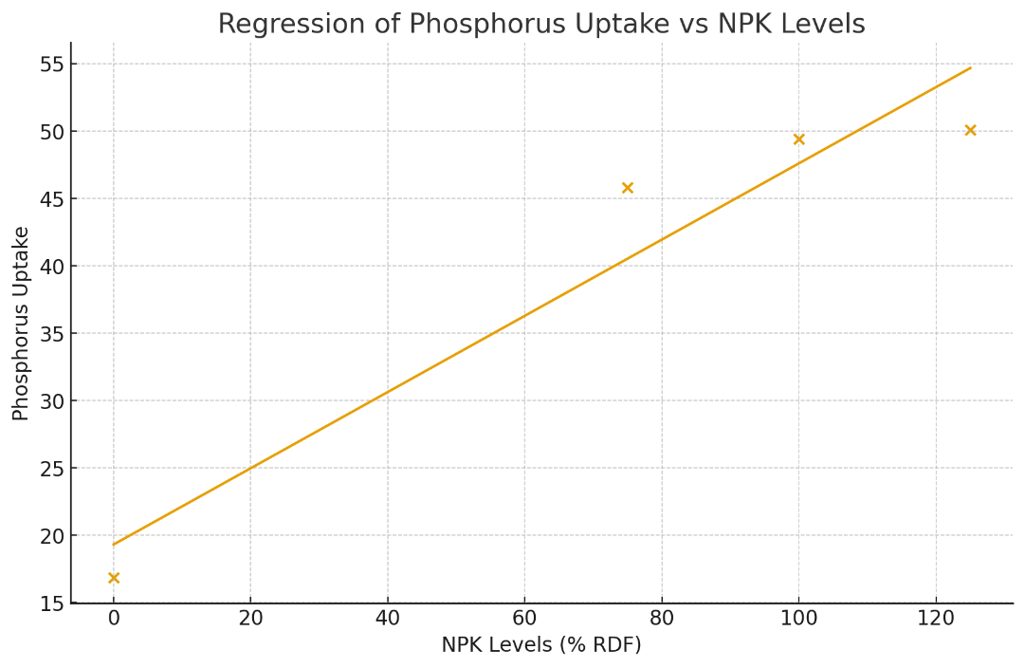
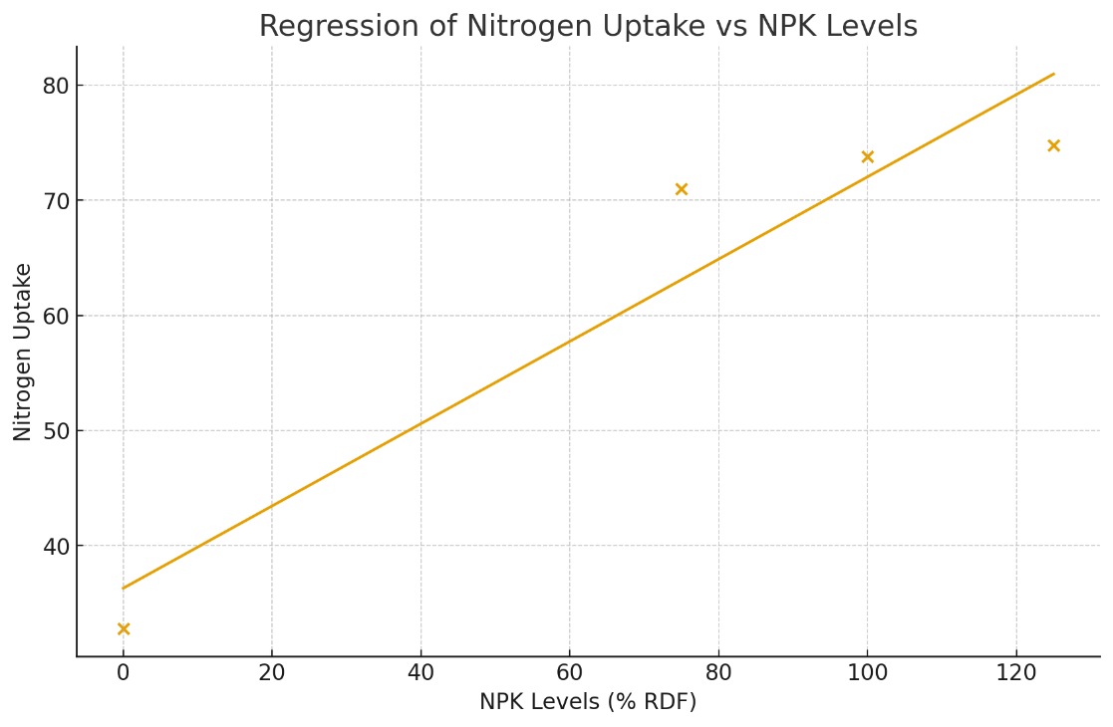

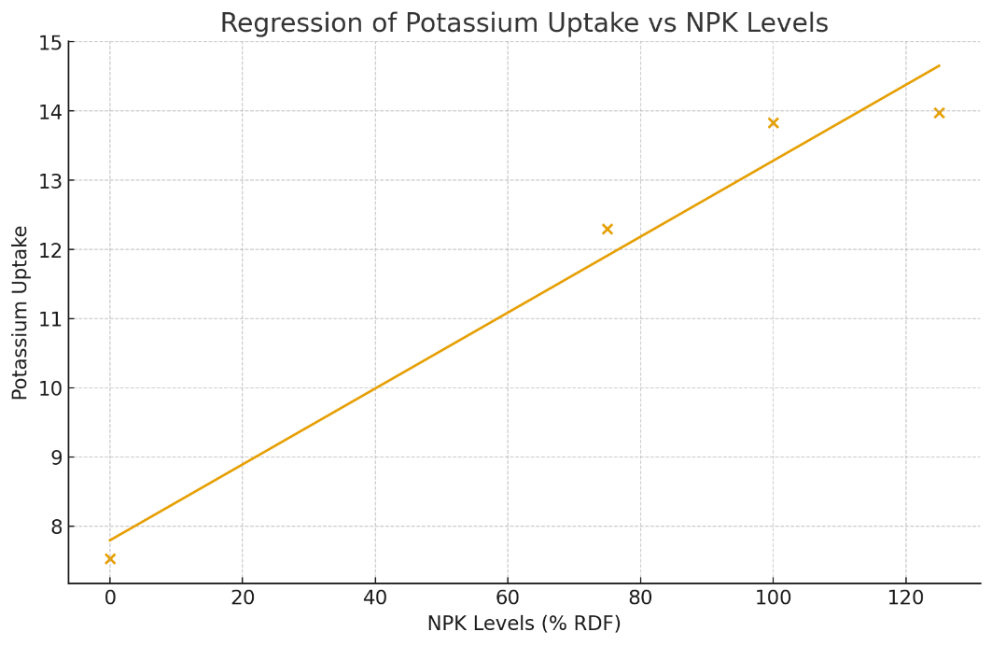

Fig 1: Nutrient (N, P & K) uptake of plant for different nutrient levels
findings are supported by Basak et al. (2023) and Muruganandam et al. (2022), who reported superior nutrient uptake and growth in senna under integrated nutrient management.
Furthermore, increased potassium uptake under higher NPK and foliar nutrition might be linked to its role in enzyme activation and translocation of assimilates, as suggested by Singh et al. (2007) in rosemary. Overall, the present results strongly confirm that balanced soil fertilization combined with foliar nutrient application significantly enhances nutrient uptake in senna leaves at harvest.
4.0 Conclusion
The present investigation clearly demonstrated that nutrient uptake in senna (Cassia angustifolia Vahl.) was significantly influenced by both soil application of NPK and foliar nutrition. Among the fertilizer levels, 125% RDF (F1) proved superior by recording the highest uptake of nitrogen, phosphorus and potassium in senna leaves at harvest, followed closely by 100% RDF (F2), while the lowest uptake was observed under the control (F4). This confirms that adequate and balanced soil fertilization is essential for maximizing nutrient absorption in senna.
Foliar nutrition exerted an additional and significant improvement in nutrient uptake, with seaweed extract spray (M3) outperforming other foliar treatments and registering the highest N, P and K uptake, followed by 1% 19:19:19 spray (M2). The regression analysis further revealed a strong positive linear relationship between increasing NPK levels and nutrient uptake, indicating efficient utilization of applied nutrients by senna plants.
The interaction effect was highly pronounced, wherein the combined treatment F1M3 (125% RDF + seaweed extract) recorded the maximum nutrient
uptake, while the absolute control F4M4 (no RDF + water spray) showed the minimum values. The remarkable percent increase in nutrient uptake under this integrated treatment emphasizes the synergistic role of soil fertilization and foliar bio stimulation in enhancing nutrient use efficiency.
Table: 1 N, P, K uptake of senna leaves at harvest as influenced by soil application of different N, P, K levels and foliar spray of nutrients

Treatments | N |  | P |  | K
NPK Levels (F)
F₁ | 74.78 |  | 50.08 |  | 13.98
F₂ | 73.83 |  | 49.40 |  | 13.83
F₃ | 71.00 |  | 45.80 |  | 12.30
F₄ | 32.78 |  | 16.85 |  | 7.53
S.Em ± | 1.46 |  | 1.15 |  | 0.22
C.D. at 5 % | 5.06 |  | 3.97 |  | 0.75
Foliar spray (M)
M₁ | 62.58 |  | 40.13 |  | 11.65
M₂ | 66.43 |  | 42.38 |  | 13.00
M₃ | 67.48 |  | 43.30 |  | 13.10
M₄ | 55.90 |  | 36.33 |  | 9.88
S.Em ± | 0.24 |  | 0.11 |  | 0.08
C.D. at 5 % | 0.70 |  | 0.33 |  | 0.25
F x M Interactions
F₁M₁ | 73.20 |  | 49.20 |  | 13.60
F₁M₂ | 77.20 |  | 52.40 |  | 15.30
F₁M₃ | 78.50 |  | 53.20 |  | 15.40
F₁M₄ | 70.20 |  | 45.50 |  | 11.60
F₂M₁ | 73.10 |  | 48.60 |  | 13.50
F₂M₂ | 75.80 |  | 51.70 |  | 15.10
F₂M₃ | 76.40 |  | 52.00 |  | 15.20
F₂M₄ | 70.00 |  | 45.30 |  | 11.50
F₃M₁ | 70.50 |  | 45.70 |  | 11.70
F₃M₂ | 72.60 |  | 47.20 |  | 13.30
F₃M₃ | 72.70 |  | 47.90 |  | 13.40
F₃M₄ | 68.21 |  | 42.40 |  | 10.80
F₄M₁ | 33.50 |  | 17.00 |  | 7.80
F₄M₂ | 40.10 |  | 18.20 |  | 8.30
F₄M₃ | 42.30 |  | 20.10 |  | 8.40
F₄M₄ | 15.20 |  | 12.10 |  | 5.60
 | S.Em ± | C.D.  at 5 % | S.Em ± | C.D.  at 5 % | S.Em ± | C.D.  at 5 %
Factor M at same level of F | 2.91 | 8.72 | 2.31 | 7.20 | 0.41 | 1.32
Factor F at same level of M | 1.50 | 5.34 | 1.25 | 4.12 | 0.25 | 0.72
F₁: 125 % RDF F₃: 75% RDF M₁: 1% urea foliar spray M₃: Seaweed extract foliar spray
F₂: 100 % RDF F₄: No RDF (Control) M₂: 1% 19:19:19 foliar spray M₄:Water spray (control)

Overall, the study conclusively establishes that application of 125% RDF in combination with seaweed extract foliar spray is the most effective nutrient management strategy for maximizing N, P and K uptake in senna leaves at harvest. This integrated approach not only improves nutrient absorption but also ensures better growth and productivity of senna, making it a sustainable and economically viable fertilization practice for commercial cultivation.
Disclaimer
This study was conducted solely for academic and research purposes. The findings, interpretations and conclusions presented in this manuscript are based on the data generated under the specific experimental conditions described. They may not be directly applicable to all agro-climatic regions or production systems.

Competing Interests
The authors declare that no known competing financial interests or personal relationships that could have appeared to influence the work reported in this manuscript. The research was conducted independently, and no external agency or commercial entity had any role in the study design, data collection, analysis, interpretation, or decision to publish.
5.0 Reference
Basak, B. B., Chinchmalatpure, A. R., Saha, A., Lodaya, D. H., Patel, P., & Gajbhiye, N. A. (2023). Integrated nutrient management fostered economic yield and bioactive principle of medicinal herb (Cassia angustifolia Vahl.) in saline soil of semi-arid region of Western India. Communications in Soil Science and Plant Analysis, 54(5), 611-626. https://doi.org/10.1080/00103624.2023.2170900
El-Gamal, S. M. A., & Ahmed, H. M. I. (2016). Response of dill (Anethum graveloens Linn.) to seaweed and moringa leaf extracts foliar application under different sowing dates. Alexandria Journal of Agricultural Sciences, 61(5), 469-485. http://alexja.journals.ekb.eg/journal/archive/61
Hassan, E. A., 2015, Influence of mixed minerals ores and seaweed liquid extract on growth, yield and chemical constituents of dill (Anethum graveolens L.) plants. Middle East J. Appl. Sci., 5(3): 751-758.

Jackson, M. L., 1973, Soil Chemical Analysis Prentice Hall of India Private Limited. New Delhi, 498
Muruganandam, C., Kalidasan, T., Kousika, S., & Sajiv, G. (2022). Effect of integrated nutrient management on growth of senna (Cassia angustifoliaVahl.). *International Journal of Science and Research Archive*, *7*(2), 555-558. https://doi.org/10.30574/ijsra.2022.7.2.0322
Pareek, O. P., Vashishtha, B. B., and Singh, R. S. (1989). Effect of farmyard manure and nitrogen on growth, yield and sennoside content of senna (Cassia angustifolia Vahl.). J. Med. Aromat. Plant Sci., 11(2): 102–106.
Pratibha, G., Korwar, G. R., & Yadav, S. K. (2010). Productivity, quality, nutrient use efficiency and economics of senna (Cassia angustifolia) as influenced by FYM and fertilizer nitrogen under rainfed conditions. Indian Journal of Agronomy, 55(1), 79–83. https://doi.org/10.59797/ija.v55i1.4721
Rani, S., & Usha, R. (2013). Utilization of seaweeds in enhancing the biochemicals and productivity of Cassia angustifolia Vahl. Indian Journal of Geo-Marine Sciences, 42(2), 184-188. http://nopr.niscpr.res.in/handle/123456789/20000
Singh, M., Ganesha Rao, R. S., & Ramesh, S. (2007). Effects of N and K on growth, herbage, oil yield and nutrient uptake patterns in rosemary (Rosmarinus officinalis L.) under semi-arid tropical conditions. Journal of Horticultural Science and Biotechnology, 82(3), 414-419. https://doi.org/10.1080/14620316.2007.11512252
Zang, Z., et al. (2023). Alternate micro-sprinkler irrigation and organic fertilization improves root health and uptake in medicinal plants. Journal of Plant Science & Technology (example of agronomic practice interactions
Hemdan, M. H., et al. (2022/2023). Studies on organic amendments and bio-stimulants (collection of regional studies on senna and medicinal plants). (regional journals; useful for discussion and local comparisons).
Waly, A. A., et al. (2019). Effect of foliar spraying with seaweed extracts on growth and yield parameters of horticultural crops. Scientific Journal of Faculty of Agriculture (example studies demonstrating seaweed efficacy).
Rakha, A. M., et al. (2020). Effect of foliar spraying of seaweed extract and iron on transplant performance in citrus seedlings. Middle East Journal of Agriculture Studies (example of foliar seaweed application protocols).

