Case Report

Lipomatous polyp associated with perforated solitary jejunal diverticulum : A rare cause of Acute abdomen

ABSTRACT

Introduction :Small intestinal diverticula are rare; their incidence ranges from 0.06 to 1.3%, Among these small intestinal diverticula, duodenal diverticula are common, followed by diverticula of the jejunum and ileum. A jejunal diverticulum is usually asymptomatic. Perforation of a jejunal diverticulum is a rare clinical entity.
Case :We report a case of a 70 year old female who presented with acute abdomen and the diagnosis was an abscess resulting from a perforated solitary jejunal diverticulum, which was successfully managed with initial resuscitation and definitive surgery - Resection and anastomosis of the involved jejunal segment was performed.
Conclusion :Diagnosis of complicated jejunal diverticula can be quite difficult, and may depend on surgical exploration.

Keywords – jejunum, diverticula , perforation, laparotomy

Introduction :

Small intestinal diverticula are very rare; their incidence ranges from 0.06 to 1.3% [1]. Except for Meckel’s diverticulum, which is congenital, all diverticula are usually acquired. Among these, duodenal diverticula are the most frequent (in 79% of patients), followed by diverticula of the jejunum or ileum (18%) and diverticula in all segments together (3%) [2]. The prevalence of diverticula increases with age and peaks in the 6th–8th decades of life. A jejunal diverticulum is usually asymptomatic; only 29% of the patients present with symptoms like nausea, abdominal pain, and malabsorption. Complications such as perforations, adhesion, fistula, and peritonitis are more common than massive lower gastrointestinal bleeding, and these complications are reported only in 10% of cases [1, 3]. Surgery is the definitive treatment option in case of complicated diverticulitis with perforation like in our case.

Case presentation:

A 70 year old female presented with pain abdomen and bilious vomiting for one day associated with constipation. No h/o obstipation , GI bleed , significant weight loss , jaundice , fever. She is known hypothyroidism , underwent hysterectomy 35 years ago. On examination – she was conscious , oriented. She was afebrile , HR – 88/min , BP – 110/70 mm Hg, Sa O2 – 97% on room air. Per abdomen – Tenderness and guarding in umbilical and hypogastric regions. Lower midline scar present. Rectal examination was normal. She was evaluated with Xray abdomen and Ultrasound abdomen were inconclusive. On hemotological investigations – Hb – 11.8 gm% , TLC – 6900, platelets – 2.57 Lakhs , Creatinine – 0.7, LFT was normal , albumin was 4.1. She was evaluated with CECT abdomen - An ill-defined thin -thick walled collection measuring approx 5.3x4.7x4.6 cm in supra pubic region associated with internal irregular air foci and multiple peripheral calcified foci along the rim of the lesion (Fig 1 and 2).

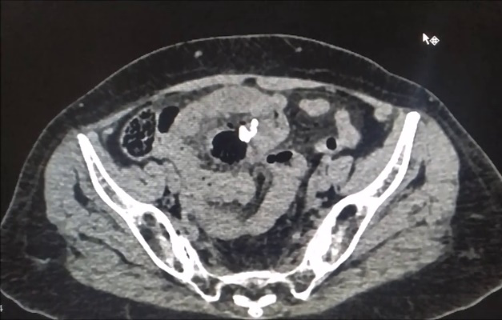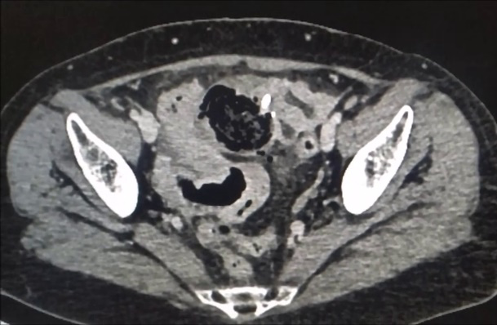
Fig 1 and Fig 2: Supra pubic region associated with internal irregular air foci and multiple peripheral calcified foci along the rim of the lesion

After resuscitation , Diagnostic laproscopy was done - findings are omental adhesions to previous scar were present, Dilated small bowel . So exploratory laparotomy was done – 6 x 4 cm jejunal diverticulum at 40 cm from Duodenojejunal flexure on mesenteric border (Fig 3 and 4) which was perforated leading to abscess ( 20cc ). Lipomatous polyp of size 4 cm just adjacent to diverticulum( Fig 5). Diverticular segment of jejunum was resected and end to end jejunal anastomosis was done. Postoperative recovery was uneventful except for surgical site infection.
Final Histopathological examination report was Diverticulitis along with lipomatous polyp.

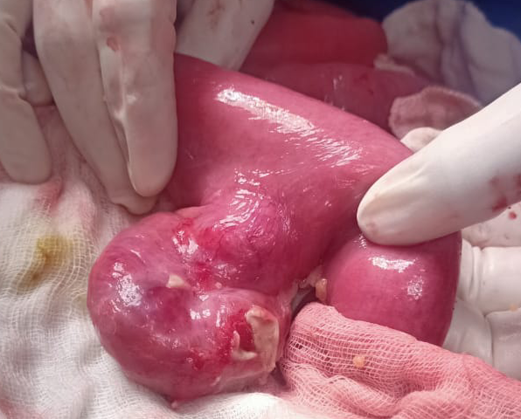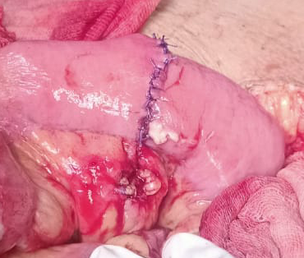
Fig 3&Fig 4: Exploratory Laparotomy showing the distance of the jejunal diverticulum from the Duodenojejunal flexure on the mesenteric border

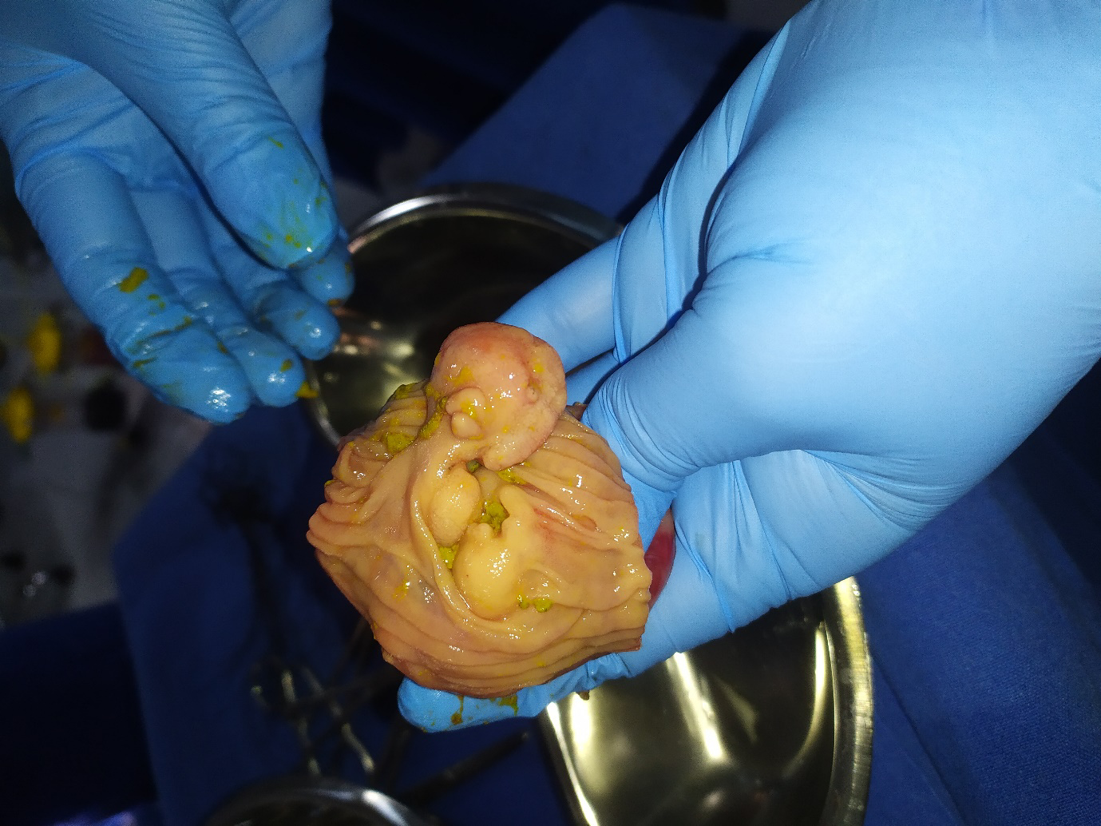
Fig 5: Lipomatous polypadjacent to Diverticulum

Discussion :
Sömmering and Baille first reported a case of jejunoileal diverticula in 1794 [4]. Jejunal diverticula are usually multiple and common in the proximal jejunum. The prevalence is 2% in the population, slightly higher among men than women, and slightly higher in elderly patients [5, 6]. They develop due to herniation of the mucosa, submucosa, and serosa through the muscular layer of the bowel at the point where the vasa recta enter the muscularis propria (the locus minorisresistentiae of the small intestine). It is a pseudodiverticulum, because it does not involve all layers of the bowel wall. These diverticula are frequently associated with disorders of intestinal motility, such as progressive systemic sclerosis, visceral neuropathies, and myopathy. Their causes are unclear, but intestinal dyskinesia, abnormal peristalsis, and high intraluminal pressure are implicated in their pathogenesis. In this case , the lipomatous polyp may have caused partial bowel obstruction leading to increased intraluminal pressure causing jejunal diverticulum. Both conditions: jejunal diverticula and small bowel lipomatous polyp are relatively uncommon. To our knowledge there are not any published reports describing the perforated jejunal diverticulum in connection with the lipomatous polyp. On the other hand, lipoma is the third most common benign small bowel tumour arising from either submucosal adipose tissue or serosal fat [7]. The occurrence increases from the duodenum to the ileum. Jejunal diverticulosis usually asymptomatic; only 29% of the patients develop signs and symptoms [4], and 10% develop complications [3] such as perforation, obstruction, adhesion, fistula, peritonitis, and lower gastrointestinal bleeding. Acute complications are related to the inflammation of the mucosa, Since the diverticulum occurs on the mesenteric border, perforation will remain concealed within the mesentery resulting in abscess- localized peritonitis [8] , as in our patient. Perforation of jejunal diverticula is a serious complication that occurs in 2–6% of cases [9]. Diagnosis is often challenging therefore, a high degree of clinical suspicion is required. A plain abdominal radiograph is the initial imaging modality of choice, since it can show signs of perforation such as the presence of free air, or signs of intestinal obstruction such as the presence of air-fluid levels. CT scan help recognize the condition, exposing signs of inflammation, thickening of the bowel wall with outpouchings, lesions, free air, and air-fluid levels [10]. Mortality from jejunal diverticulitis ranges from 0 to 5%, increasing to 40% in case of perforation [11].
Acute uncomplicated jejunal diverticulitis is managed with intravenous fluids, bowel rest, and antibiotics [12]. Acute complicated diverticulitis causing perforation with generalized peritonitis needs surgical intervention such as laparotomy with segmental small bowel resection with primary anastomosis. Overall mortality after surgery is 24% because of poor prognostic factors such as advanced age and delays in diagnosis and treatment.
Altemeier and associates [13] suggested that, if there is evidence of a dilated, hypertrophied segment of bowel with large diverticula, representing a progressive form of disease, the diverticular segment should be resected. This suggestion has been supported by other authors based on collected data [14,15,16]. Most authors agree that the removal of a solitary non-meckelian small bowel diverticulum in an adult is not warranted [14, 15]

Conclusion :
Isolated jejunal diverticulum is a rare entity and usually asymptomatic. In an elderly patient presenting with abdominal pain and fever – colonic diverticulitis is mainly suspected, but jejunal diverticulitis should also be considered as a differential diagnosis. It requires a high degree of clinical suspicion, given the low incidence of the condition. Early diagnosis and prompt treatment are essential because it may lead to life-threatening complications and death. Resection of the involved jejunal segment and primary anastomosis is the treatment of choice, although conservative treatment has been reported.

Conflicts of interest – The authors don’t have any conflict of interest.

Ethical statement – Informed consent has been obtained , Confidentiality of patient was
kept.

Data availability – Data was available regarding this case.

COMPETING INTERESTS DISCLAIMER:
Authors have declared that they have no known competing financial interests OR non-financial interests OR personal relationships that could have appeared to influence the work reported in this paper.

References :

1Staszewicz W, Christodoulou M, Proietti S, Dermartines N. Acute ulcerative jejunal diverticulitis: case report of an uncommon entity. World J Gastroenterol. 2008 Oct;14(40):6265–7.
2 Akhrass R, Yaffe MB, Fischer C, Ponsky J, Shuck JM. Small-bowel diverticulosis: perceptions and reality. J Am Coll Surg. 1997 Apr;184(4):383–8.
3 Transue DL, Hanna TN, Shekhani H, Rohatgi S, Khosa F, Johnson JO. Small bowel diverticulitis: an imaging review of an uncommon entity. EmergRadiol. 2017 Apr;24(2):195–205.
4 Singal R, Gupta S, Airon A. Giant and multiple jejunal diverticula presenting as peritonitis a significant challenging disorder. J Med Life. 2012 Sep;5(3):308–10.
5 Maglinte DD, Chernish SM, DeWeese R, Kelvin FM, Brunelle RL. Acquired jejunoileal diverticular disease: subject review. Radiology. 1986 Mar;158(3):577–80.
6 Fintelmann F, Levine MS, Rubesin SE. Jejunal diverticulosis: findings on CT in 28 patients. AJR Am J Roentgenol. 2008 May;190(5):1286–90.
7 MilovicV . Small Bowel Diverticula . In: BasowDS , ed. Waltham, Massachusetts : UpToDate 2011 .
8 Herrington J. I. Perforation of acquired diverticula of the jejunum and ileum. Surgery, 1962, 51 : 426-433.
9 Sibille A, Willocx R. Jejunal diverticulitis. Am J Gastroenterol. 1992 May;87(5):655–8.
10 Butler JS, Collins CG, McEntee GP. Perforated jejunal diverticula: a case report. J Med CaseReports. 2010 Jun;4:172.
11 Kassir R, Boueil-Bourlier A, Baccot S, Abboud K, Dubois J, Petcu CA, et al. Jejuno-ileal
diverticulitis: etiopathogenicity, diagnosis and management. Int J Surg Case Rep. 2015;10:151–3.
12 de Bree E, Grammatikakis J, Christodoulakis M, Tsiftsis D. The clinical significance of acquiredjejunoileal diverticula. Am J Gastroenterol. 1998 Dec;93(12):2523–8.
13 Altemeier W. A., Bryant L. R., Wulsin J. H. The surgical significance of jejunal diverticulosis. Arch Surg, 1963, 86 : 733-745.
14 Wilcox R. D., Shatney C. H. Surgical implications of jejunal diverticula. South Med J, 1988, 781 : 1386-1391.
15 Longo W. E., Vernava A. M. III. Clinical implications of jejunoileal diverticular disease. Dis Colon Rectum, 1992, 35 : 388-381.
16 Akhrass R., Yaffe M. B., Fischer C., Ponsky J., Shuck J. M. Small bowel diverticulosis : Perceptions and reality. J Am Coll Surg, 1997, 184 : 383-388.

