Original Research Article
Mortality of zebrafish (Danio rerio) due to acute hypoxia

ABSTRACT
Ornamental fish production has been increasing in recent years. The zebrafish (Danio rerio) is widely used in scientific research as a model organism in various fields. Hypoxia, a reduction in dissolved oxygen levels in water, is a critical condition that directly impacts the maintenance and survival of several aquatic organisms, including fish. Here, we report a case of hypovolemic shock in a zebrafish, resulting from hypoxia caused by a sudden drop in dissolved oxygen levels. Eight Danio rerio specimens from a bioterium were studied. A high mortality rate was reported after a drop in dissolved oxygen levels caused by a power outage. Microscopically, the myocardium appeared slightly hypertrophic, and the pericardium presented dense hemorrhages. The kidney tubular cells showed marked edema, with whitish, foamy cytoplasm. Some tubular cells showed pronounced eosinophilia, and some tubules showed necrotic cells detaching from the tubular basement membrane. The brain parenchyma showed pericellular edema, increased Virchow-Robin spaces, and mild glial proliferation. Therefore, we conclude that the underlying cause of death was a decrease in environmental oxygen levels, which, combined with preexisting branchial lesions, generated hypoxia that produced cardiac failure due to diffuse hemorrhages.
Keywords: Ornamental fish. Oxygen. Hypovolemia. Histopathology.

INTRODUCTION
The production of ornamental fish has increased in recent years, particularly those intended for scientific research. Among these species, the most important is the zebrafish (Danio rerio).
The zebrafish (Danio rerio) is a tropical freshwater teleost species belonging to the order Cypriniformes and the subfamily Danioninae. It is native to freshwater habitats in South Asia, where it occurs in India, Pakistan, Bangladesh, Nepal, and Bhutan (Whiteley et al., 2011; Engeszer et al., 2007). It typically inhabits clear, shallow waters such as streams, ponds, canals, ditches, and rice fields (Spence et al., 2006). The water pH ranges from neutral to basic, and the optimal temperature lies between 16.5 and 34 °C (MacClure et al., 2006). The zebrafish is widely used in scientific research as a model organism in various fields of science(Orger & Polavieja, 2017).
Most teleost fish breathe through their gills. The functions of this organ are multiple and of great importance to fish, including osmoregulation, excretion of nitrogenous compounds, and ion regulation. For branchial respiration to be efficient, the gills require a highly specialized structure characterized by a thin epithelium and a large surface area that allows gas exchange between the blood and the surrounding environment, ensuring the transport of oxygen and nutrients to different tissues. Conversely, both external and internal factors can impair the efficiency of the gill apparatus, such as elevated levels of nitrogenous compounds, parasitic diseases, branchial hyperplasia, and gill necrosis, among others (Laurent & Perry, 1991; Evans, 2007; Kwong, 2014; Kim et al., 2019; Ahmad et al., 2021).
Hypoxia, defined as a reduction in dissolved oxygen levels in water, is a critical condition that directly affects the maintenance and survival of various aquatic organisms, including fish (Wang et al., 2023). When dissolved oxygen (DO) concentrations fall below 1.5 mg/L, the respiratory capacity of fish may be compromised (Wannamaker & Rice, 2000; Tawwab et al., 2019). Several factors can cause this condition, such as water pollution, nutrient overload leading to algal blooms, overpopulation, and inadequate water recirculation in aquariums and tanks, among others (Pollock et al., 2007). As oxygen levels decrease, fish tend to exhibit metabolic and physiological alterations, including difficulty performing gas exchange through the gills, lethargy, behavioral changes, and, in more severe cases, death (Baton & Taylor, 1996; Wang et al., 2023). Thus, hypoxia is a condition in which an organism’s body does not receive sufficient oxygen, regardless of the underlying cause (Convertino et al., 2019).
Hypovolemic shock, in turn, is characterized by a significant loss of intravascular volume, whether due to hemorrhagic mechanisms (external or internal bleeding) or non-hemorrhagic mechanisms (vomiting, diarrhea, extensive burns, among others) (Taghavi et al., 2023). This loss of volume leads to a reduction in venous return and, consequently, a decrease in cardiac output, resulting in tissue hypoperfusion and impaired delivery of oxygen and nutrients to vital organs. If not diagnosed and treated promptly, it can progress to progressive cellular dysfunction and multiple organ failure (Alencar et al., 2025).
Here, we report a case of hypovolemic shock in zebrafish (Danio rerio) resulting from hypoxia caused by a sudden drop in dissolved oxygen (DO) levels. Macroscopically, the fish exhibited gill pallor, skin lesions, and hemorrhages.

MATERIAL AND METHODS
Eight specimens of Danio rerio from a laboratory facility were studied. According to the background information, a high mortality rate was observed following a decrease in dissolved oxygen (DO) levels caused by a power outage. The animals were euthanized by immersion in benzocaine, and necropsies were performed to collect samples for histopathological analysis.
The collected tissues were fixed in 10% buffered formalin. All samples were processed in a LEICA TP1020 automatic tissue processor and embedded in paraplast. Tissue blocks were sectioned at a thickness of 3 µm using a LEICA RM2245 microtome. Histological sections were stained with Hematoxylin and Eosin (H&E) and PAS. Microphotographs were obtained using an Olympus B201 microscope equipped with a PM20 system.

RESULTS AND DISCUSSION
At necropsy, cutaneous hemorrhagic lesions were observed during macroscopic examination. The microscopic examination revealed the following histological alterations: In the heart, the myocardium showed mild hypertrophy, the endocardium exhibited no lesions, and the pericardium presented dense hemorrhages occupying the entire pericardial cavity. In the abdominal cavity, the abdominal organs exhibited preserved architecture, with isolated foci of intrahepatic hemorrhages and massive hemorrhages throughout the cavity.
The renal parenchyma displayed preserved architecture. In the interstitium, lymphohematopoietic elements were observed. The renal glomeruli showed no significant alterations, whereas the tubular cells exhibited marked edema with whitish, foamy cytoplasm (hydropic degeneration). In other areas, tubular cells showed pronounced eosinophilia (cloudy swelling). Finally, in some tubules, necrotic cells were observed detaching from the tubular basement membrane and lying free within the tubular lumen (Fig. 1A e 1B).
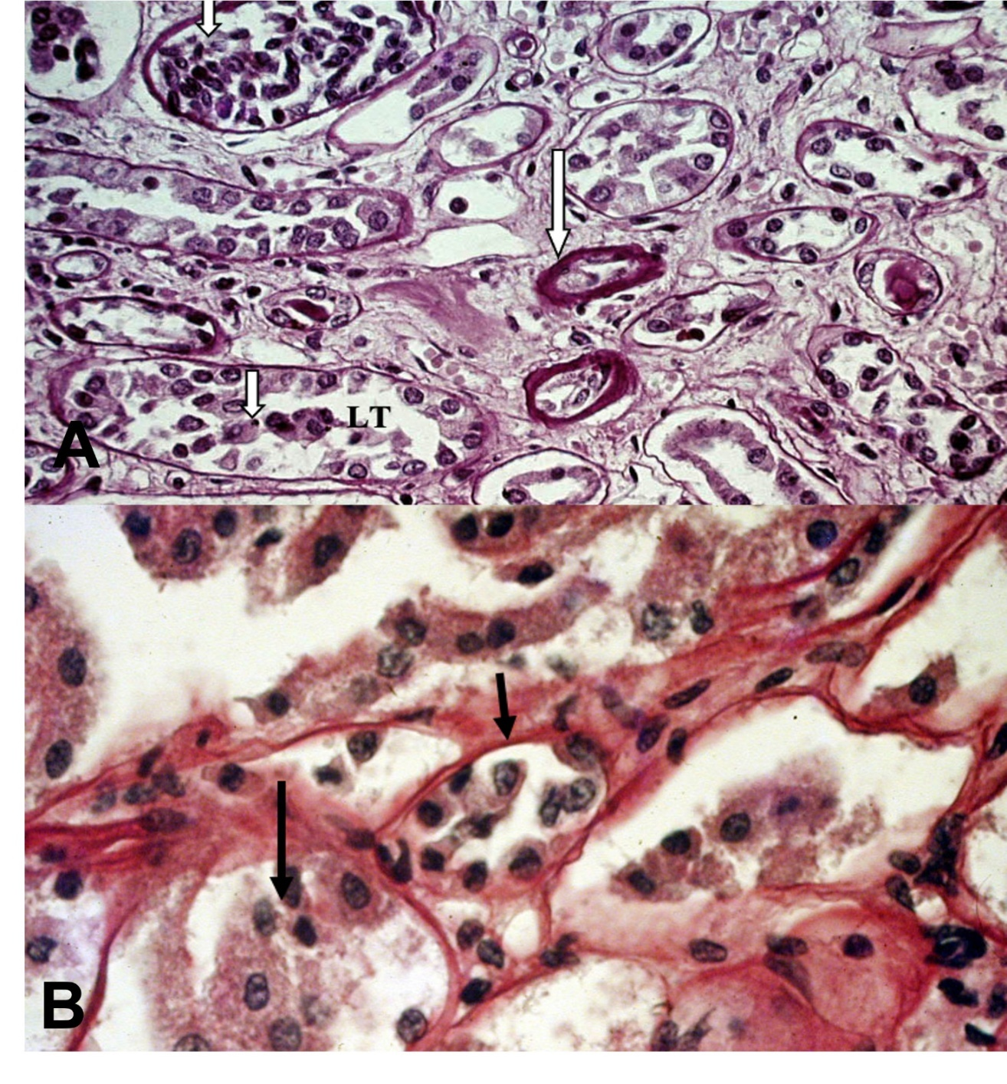Figur e 1: A: Tubules with thickened basement membranes (long arrow) and necrotic tubular cells detached from the tubular basement membrane (short arrow), occupying the tubular lumen (TL). 40× magnification. B: Higher magnification of Figure A showing basement membranes (short arrow) and necrosis of tubular cells with detachment from the basement membrane and accumulation within the tubular lumen. H-E 100 X.
LT

The encephalic parenchyma exhibited preserved architecture. Pericellular edema, enlargement of the Virchow–Robin spaces, and mild glial proliferation were observed (Fig. 2A e 2B).
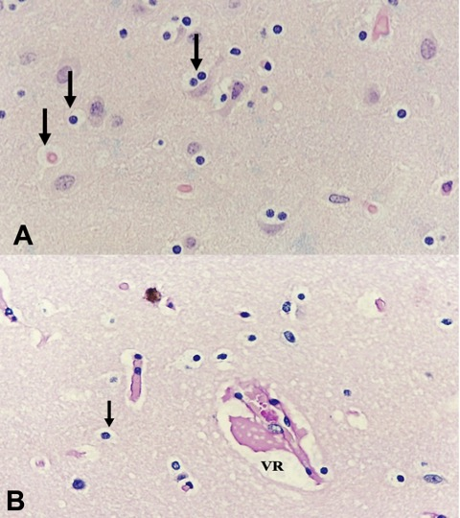
Figure 2: A: Cerebral parenchyma showing marked pericellular edema (arrows). H&E, 40× magnification. B: Cerebral parenchyma with pronounced pericellular edema (arrow) and enlarged Virchow–Robin space (VR). H-E 40 X.

The zebrafish is a species widely used as an experimental model for mammals, including humans, since fish have been increasingly recommended for experimental designs involving human diseases (Orger & Polavieja, 2017).
In aquaculture-related research, this species serves as an important model for understanding the effects of farming conditions on animal physiology (Kent et al., 2002; Spitsbergen et al., 2003; Spence et al., 2007). Hypoxia, a common condition affecting the production of ornamental fish, particularly impacts zebrafish, as this species is highly susceptible to decreased oxygen levels. Hypoxia affects the entire organism and can produce noticeable effects in virtually all fish organs.
Although hypoxia also causes gill lesions (Perry & MacDonald, 1993; Randall & Daxboeck, 1994; Araújo-Luna et al., 2018; Abdel-Tawwab et al., 2019), in the case described here, the gill lesions appear to have been pre-existing. Therefore, pre-existing gill damage, combined with a decrease in dissolved oxygen, led to a reduced capacity for blood oxygenation and subsequent systemic effects on other organs.
Li et al. (2021) described physiological responses in cardiac tissue under hypoxic conditions, including effects on structure, enzymatic activity, and gene expression in the heart of silver carp (Hypophthalmichthys molitrix). Similarly, the histological analysis of cardiac lesions in the present study revealed disorganized, edematous, and ruptured myocardial fibers resulting from hypoxia.
Along with acute cardiac injury, renal lesions were also observed. These lesions are typical of hypovolemia, as indicated by the diffuse tubular necrosis found in the histopathological examination (Pacheco et al., 2022; Turgut et al., 2023).
Another tissue affected by hypovolemia was the brain, where glial proliferation, signs of neuronal damage, and enlargement of the Virchow–Robin spaces were observed. Such alterations are systematically seen in cases of hypovolemia, since nervous tissue is highly susceptible to reduced oxygen levels (Sekhon et al., 2017; Ineichen et al., 2022; Lacerte et al., 2023).

CONCLUSION
Based on the findings discussed above, we conclude that the fundamental cause of mortality in zebrafish was a decrease in environmental oxygen which, combined with pre-existing gill lesions, led to hypoxia and consequently to acute cardiac injury associated with diffuse hemorrhages.

REFERENCES
Abdel-Tawwab, M., Monier, M.N., Hoseinifar, S.H., Faggio, C., (2019). Fish response to hypoxia stress: growth, physiological, and immunological biomarkers. Fish Physiol Biochem 45, 997–1013. https://doi.org/10.1007/s10695-019-00614-9
Ahmad, I., Ahmed, I., Fatma, S., Peres, H., (2021). Role of branched‐chain amino acids on growth, physiology and metabolism of different fish species: A review. Aquacult Nutr 27, 1270–1289. https://doi.org/10.1111/anu.13267
Alencar, W.D.S.D., Pinheiro, J.L., Barbosa, L.B.A., Souza, J.L.D.A.S., Narcizo, I.O., Nunes, L.G.D.S., Vigatti, T.P.P., Neves, A.D.C.D., Ferreira, L.G.N.M., Andrade, M.D.S.R., Couto, M.E.D.C., Machado, A.R.G., Pena, T.C., Pires, P.L., Tymniak, J.R., Lopes, D.A., (2025). Abordagem integrada no choque hipovolêmico traumático: relato de caso. Revft 29, 45–46. https://doi.org/10.69849/revistaft/ni10202503231045
Araújo-Luna, R., Ribeiro, L., Bergheim, A., Pousão-Ferreira, P., (2018). The impact of different rearing condition on gilthead seabream welfare: Dissolved oxygen levels and stocking densities. Aquac Res 49, 3845–3855. https://doi.org/10.1111/are.13851
Barton, B.A., Taylor, B.R., (1996). Oxygen Requirements of Fishes in Northern Alberta Rivers with a General Review of the Adverse Effects of Low Dissolved Oxygen. Water Quality Research Journal 31, 361–410. https://doi.org/10.2166/wqrj.1996.022
Convertino, Victor A. et al. Comparação fisiológica de choque hemorrágico e V ̇ O2max: uma estrutura conceitual para definir a limitação do fornecimento de oxigênio (2019).. Biologia e Medicina Experimental, v. 244, n. 8, p. 690-701.
Engeszer, R.E., Patterson, L.B., Rao, A.A., Parichy, D.M., (2007). Zebrafish in The Wild: A Review of Natural History And New Notes from The Field. Zebrafish 4, 21–40. https://doi.org/10.1089/zeb.2006.9997
Evans, D.H., Piermarini, P.M., Choe, K.P., (2005). The Multifunctional Fish Gill: Dominant Site of Gas Exchange, Osmoregulation, Acid-Base Regulation, and Excretion of Nitrogenous Waste. Physiological Reviews 85, 97–177. https://doi.org/10.1152/physrev.00050.2003
Ineichen, B.V., Okar, S.V., Proulx, S.T., Engelhardt, B., Lassmann, H., Reich, D.S., (2022). Perivascular spaces and their role in neuroinflammation. Neuron 110, 3566–3581. https://doi.org/10.1016/j.neuron.2022.10.024
Kent, M.L., Bishop-Stewart, J.K., Matthews, J.L., Spitsbergen, J.M., (2002). Pseudocapillaria tomentosa, a nematode pathogen, and associated neoplasms of zebrafish (Danio rerio) kept in research colonies. Comp Med 52, 354–358.
Kim, Jun-Hwan, Kang, Y.J., Kim, K.I., Kim, S.K., Kim, Jong-Hyun, (2019). Toxic effects of nitrogenous compounds (ammonia, nitrite, and nitrate) on acute toxicity and antioxidant responses of juvenile olive flounder, Paralichthys olivaceus. Environmental Toxicology and Pharmacology 67, 73–78. https://doi.org/10.1016/j.etap.2019.02.001
Lacerte, M., Hays Shapshak, A., Mesfin, F.B., (2025). Hypoxic Brain Injury, in: StatPearls. StatPearls Publishing, Treasure Island (FL).
Laurent, P., Perry, S.F., (1991). Environmental Effects on Fish Gill Morphology. Physiological Zoology 64, 4–25. https://doi.org/10.1086/physzool.64.1.30158511
Li, X., Li, F., Zou, G., Feng, C., Sha, H., Liu, S., Liang, H., (2021). Physiological responses and molecular strategies in heart of silver carp (Hypophthalmichthys molitrix) under hypoxia and reoxygenation. Comparative Biochemistry and Physiology Part D: Genomics and Proteomics 40, 100908. https://doi.org/10.1016/j.cbd.2021.100908
Orger, M.B., de Polavieja, G.G., (2017). Zebrafish Behavior: Opportunities and Challenges. Annu Rev Neurosci 40, 125–147. https://doi.org/10.1146/annurev-neuro-071714-033857
Pacheco, L.P., Pereira, A.C.V., Silva, A.D.C.D., Brock, D.P.P., Abreu, F.M.D.S., Silva, L.E.D.A., Andrade, L.M.N., Tissi, L.S., Carneiro, Y.V., Miura, F.K., (2022). Abordagem atualizada da Lesão Renal Aguda (LRA): uma revisão narrativa. Acervo Médico 7, e10162. https://doi.org/10.25248/reamed.e10162.2022
Pollock, M.S., Clarke, L.M.J., Dubé, M.G., (2007). The effects of hypoxia on fishes: from ecological relevance to physiological effects. Environ. Rev. 15, 1–14. https://doi.org/10.1139/a06-006
Randall, D., Daxboeck, C., (1984). 5 Oxygen and Carbon Dioxide Transfer Across Fish Gills, in: Fish Physiology. Elsevier, pp. 263–314. https://doi.org/10.1016/S1546-5098(08)60321-0
Sekhon, M.S., Ainslie, P.N., Griesdale, D.E., (2017). Clinical pathophysiology of hypoxic ischemic brain injury after cardiac arrest: a “two-hit” model. Crit Care 21, 90. https://doi.org/10.1186/s13054-017-1670-9
Spence, R., Fatema, M.K., Reichard, M., Huq, K.A., Wahab, M.A., Ahmed, Z.F., Smith, C., (2006). The distribution and habitat preferences of the zebrafish in Bangladesh. Journal of Fish Biology 69, 1435–1448. https://doi.org/10.1111/j.1095-8649.2006.01206.x
Spitsbergen, J.M., Kent, M.L., (2003). The State of the Art of the Zebrafish Model for Toxicology and Toxicologic Pathology Research—Advantages and Current Limitations. Toxicol Pathol 31, 62–87. https://doi.org/10.1080/01926230390174959
Taghavi, S., Nassar, A.K., Askari, R., (2025). Hypovolemia and Hypovolemic Shock, in: StatPearls. StatPearls Publishing, Treasure Island (FL).
Turgut, F., Awad, A., Abdel-Rahman, E., (2023). Acute Kidney Injury: Medical Causes and Pathogenesis. JCM 12, 375. https://doi.org/10.3390/jcm12010375
Wang, S., Sun, M., Ning, Z., Chen, Y., Zhou, H., Mu, W., (2023). The effects of sustained and diel-cycling hypoxia on high-latitude fish Phoxinus lagowskii. Comparative Biochemistry and Physiology Part D: Genomics and Proteomics 45, 101059. https://doi.org/10.1016/j.cbd.2023.101059
Wang, Z., Pu, D., Zheng, J., Li, P., Lü, H., Wei, X., Li, M., Li, D., Gao, L., (2023). Hypoxia-induced physiological responses in fish: From organism to tissue to molecular levels. Ecotoxicology and Environmental Safety 267, 115609. https://doi.org/10.1016/j.ecoenv.2023.115609
Wannamaker, C.M., Rice, J.A., (2000). Effects of hypoxia on movements and behavior of selected estuarine organisms from the southeastern United States. Journal of Experimental Marine Biology and Ecology 249, 145–163. https://doi.org/10.1016/S0022-0981(00)00160-X
Whiteley, A.R., Bhat, A., Martins, E.P., Mayden, R.L., Arunachalam, M., Uusi‐Heikkilä, S., Ahmed, A.T.A., Shrestha, J., Clark, M., Stemple, D., Bernatchez, L., (2011). Population genomics of wild and laboratory zebrafish ( Danio rerio ). Molecular Ecology 20, 4259–4276. https://doi.org/10.1111/j.1365-294X.2011.05272.x

