Original Research Article
Prevalence of Helminth Parasites among Goats Slaughtered at Anagada Abattoir, FCT, Abuja, Nigeria

Abstract
Helminth infections remain a major constraint to goat productivity, particularly in regions where small ruminant farming plays a significant livelihood role. This study investigated the prevalence and morphological diversity of helminth eggs in goat faecal samples to provide baseline data for improved parasite management. A total of 50 faecal samples were examined using standard parasitological techniques. Out of these, 37 samples (74%) tested positive for helminth eggs, while 13 (26%) were negative. Parasite morphology varied considerably across the positive samples, revealing four predominant egg forms. Circular eggs and clustered eggs were the most common, each occurring in 14 samples (28%). The circular eggs were thick-shelled, brownish structures consistent with Toxocara vitulorum or Moniezia expansa, whereas the clustered eggs resembled egg packets of Eimeria spp. or aggregated Strongyloides papillosus eggs. Elongated eggs, found in 13 samples (26%), were typical of major gastrointestinal nematodes including Trichostrongylus spp., Haemonchus contortus, and Oesophagostomum columbianum. Triangular or irregularly shaped eggs were the least common, appearing in 3 samples (6%), and likely represented distorted or partially embryonated forms of Strongyloides or Trichuris ovis. These findings indicate a high prevalence of mixed helminth infections among the goat population studied, characterized by a dominance of Toxocara, Eimeria, and Moniezia species alongside significant nematode infestations. The observed morphological diversity underscores the need for integrated parasite control strategies to minimize production losses and improve goat health.
Key Words: Abattoir, Epidemiology, Helminth parasites, Goats, Gastrointestinal parasites.

INTRODUCTION
Helminths are multicellular, eukaryotic organisms characterized by elongated or flattened bodies with bilateral symmetry and triploblastic tissue organization. Parasitic helminths affecting small ruminants belong primarily to the phyla Platyhelminthes (cestodes and trematodes) and Nemathelminthes (nematodes) (Mohammed et al., 2017). These parasites cause debilitating diseases that affect growth, productivity, and survival of goats, particularly under extensive production systems.
Small ruminant helminthiases are influenced by environmental conditions, grazing systems, stocking density, immunity, breed characteristics, and management practices (Agbajelola, 2025). Goats play a critical socio-economic role in Nigeria, contributing meat, milk, hides, and income for rural households. Nigeria harbours over 50 million goats, dominated by the West African Dwarf and Red Sokoto breeds (FAO, 2020).
In Nigeria, goats are integral to rural economies, providing meat, milk, hides, and income, with a population exceeding 50 million, mainly West African Dwarf and Red Sokoto breeds (FAO, 2020). However, parasitic infections remain prevalent, with common species including Haemonchus contortus, Oesophagostomum spp., Strongyloides papillosus, Moniezia spp., Fasciola spp., and Taenia spp. (Chaudhry et al., 2017). Zoonotic risks from parasites like Echinococcus granulosus and Fasciola gigantica further complicate public health (WHO, 2021).
Recent studies underscore the ongoing burden. For instance, in Ogbomoso, Nigeria, gastrointestinal worm prevalence reached 81.79% in small ruminants, with Haemonchus spp. dominating (Rom-Kalilu et al., 2025). Similarly, in Bauchi State, 82.9% prevalence was reported, influenced by species, sex, and location (Oguche et al., 2025). In Plateau State, prevalence was 71.8%, varying by age but not sex (Gofwan et al., 2024), while in Ondo State, breed-specific differences showed 23.33% overall, highest in Sokoto Red goats (Akeju, 2024). A similar study showed high prevalence conducted in Gwagwalada area council (Balarabe-Musa et al., 2021). Seasonal dynamics in tropical climates exacerbate transmission during rainy periods, supporting larval survival and pasture contamination (Elele et al., 2019). In Abuja's semi-humid environment, these patterns are evident, impacting parasite epidemiology (Ikeh et al., 2021).
This study aims to evaluate helminth prevalence, morphological diversity, and associations with demographic and management factors in slaughtered goats, while assessing impacts on meat quality for informed control measures.

Materials and Methods

Study Area
The research was conducted at Anagada Abattoir, Gwagwalada Area Council, Federal Capital Territory (FCT), Abuja, Nigeria (latitudes 8°25'N–8°50'N, longitudes 7°5'E–7°25'E, area ~1,769 km²) (Obasi et al., 2019). Annual rainfall averages 1,600 mm, peaking in August–September, with grassland vegetation supporting livestock grazing (Ikeh et al., 2021). The area features pastoral and smallholder systems (extensive, semi-intensive), ideal for parasite prevalence studies. Laboratory analyses occurred at the Biological Sciences Laboratory, University of Abuja, Nigeria.

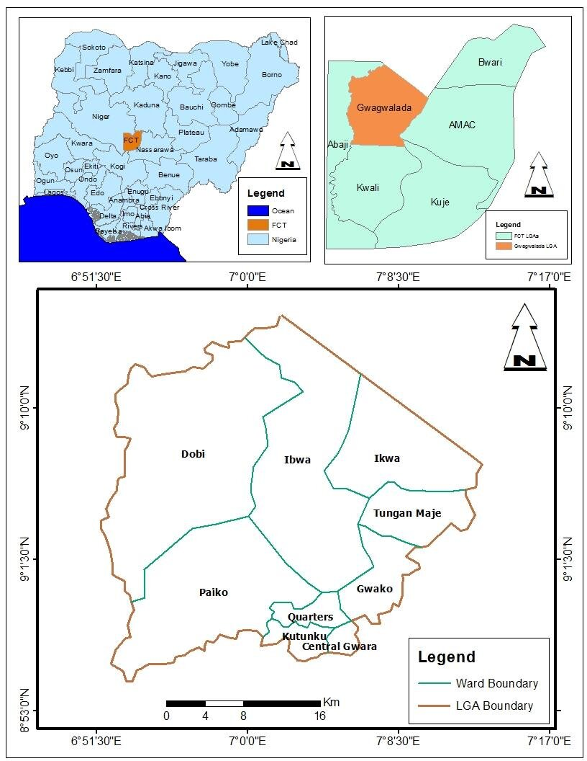
Figure 1: Map of Nigeria, FCT indicating Gwagwalada Area Council, Anagada and other environs (2025).

Sample Size and Collection
Fifty goats (mixed sexes and ages) were systematically randomly sampled during post-mortem examinations. Faecal samples were collected rectally using sterile gloves and labelled containers. Tissues with lesions/cysts were preserved in 10% formalin. Ethical approval was obtained from the FCT Ministry of Agriculture and Rural Development and abattoir veterinary officer.

Laboratory Techniques and Identification

Faecal Analysis
Collected faecal samples were examined using the floatation and sedimentation techniques to identify eggs of gastrointestinal helminths. Salt solution floatation was used for detecting nematode and cestode eggs, while formalin-ether sedimentation was employed for trematode eggs (Soulsby, 1986; Taylor et al., 2007).

Gross and Microscopic Identification
Organs were inspected for visible parasites or cysts. Identified helminths were washed, preserved in 70% ethanol, and examined under a stereomicroscope for species-level identification based on morphological keys. Staining with aceto-carmine was used for cestodes and trematodes to enhance internal structures for identification, while lacto-phenol clearing was used for nematodes (Urquhart et al., 1996).

Data and Statistical Analysis
Data obtained from both seasons were recorded and coded using Microsoft Excel 2020 and analysed with SPSS Version 25.0. Prevalence rates were calculated as the percentage of infected animals out of total examined. Differences in seasonal prevalence and parasite burden were tested using Chi-square (χ²) tests, and significance was determined at p < 0.05. Correlation analysis was also done to assess the relationship between parasite burden and key meat quality parameters (e.g., carcass weight, organ rejection rate).

RESULTS

Sample Description and Overall Prevalence
A total of 50 faecal samples were collected from goat and examined in the Biological Science Laboratory. Using microscopic magnifications of 0.4X, 10X, and 40X, gastrointestinal parasites were observed in multiple forms, including circular eggs, eggs clustered, long shapes, and triangular shapes. Out of the 50 samples, 37 (74%) were positive for helminths parasites, while 13 (26%) showed no evidence of parasitism.

Category | Count
Total Samples | 50
Positive Samples | 37
Negative Samples | 13
Circular Shape | 14
Eggs Clustered | 14
Long Shape | 13
Triangle Shape | 03
Table 1: Sample Description and Overall Prevalence

Parasite Observations
Parasite morphology varied noticeably across the examined goat faecal samples, showing distinct differences in egg shape and structural arrangement. Out of the 50 samples analysed, 37 (74%) tested positive for helminth eggs, while 13 (26%) were negative Table 1.
The most common morphologies observed were circular eggs and clustered eggs, each recorded in 14 samples (28%).
The circular eggs were typically thick-shelled, brownish structures resembling those of Toxocara vitulorum or Moniezia expansa. These nematode and cestode eggs are characterized by their well-defined round shape and smooth surface.
The clustered eggs often appeared in groups, suggesting egg packets of Coccidia oocysts (Eimeria spp.) or aggregated Strongyloides papillosus eggs. These clusters may indicate high reproductive output or adhesion within the faecal matrix.
Elongated or long-shaped eggs were also commonly encountered, observed in 13 samples (26%). These eggs were oval to spindle-shaped, typical of Trichostrongylus spp., Haemonchus contortus, and Oesophagostomum columbianum, which are among the most prevalent gastrointestinal nematodes in goats. They possess a thin shell and clear internal morula visible under low magnification.
Occasionally, triangular or irregularly shaped forms were seen, recorded in only 3 samples (6%). These may correspond to distorted or partially embryonated eggs of Strongyloides species or damaged Trichuris ovis eggs, likely due to sample degradation or environmental pressure.
Overall, the diversity in egg morphology observed across samples indicates mixed helminth infections in the studied goat population. The predominance of circular and clustered forms suggests higher prevalence of Toxocara, Eimeria, and Moniezia infections, while the presence of elongated and irregular forms points toward mixed gastrointestinal nematode infestations such as Haemonchus, Trichostrongylus, and Strongyloides.
Prevalence by Age Group, Sex, and Management System
To better understand the risk factors, samples were categorized by age group, sex, and management system.
Sex: Male or Female goats.
Number Examined: Total number of goats examined for helminth parasites.
Positive Cases: Goats that tested positive for helminth eggs. Negative Cases: Goats that tested negative.
Prevalence is the proportion of individuals infected among those examined, usually expressed as a percentage. Overall, 74% of the goats had helminth infections. Females had a slightly higher prevalence (77.4%) compared to males (68.4%).
This suggests that female goats were more affected by helminth parasites than males.

Table 2: Prevalence of Helminthes parasites based on Age Group
Age Group | Number Examined | Positive Cases | Negative Cases | Prevalence (%)
Goats (<6 months) | 17 | 11 | 6 | 64.7
Yearlings (6–12 months.) | 19 | 14 | 5 | 73.7
Adults (>12 months) | 14 | 8 | 6 | 57.1
Total | 50 | 37 | 13 | 66.0

Table 3: Prevalence of Helminths parasites based on Sex
Sex | Number Examined | Positive Cases | Negative Cases | Prevalence (%)
Male | 19 | 13 | 6 | 68.4
Female | 31 | 24 | 7 | 77.4
Total | 50 | 37 | 13 | 74.0

Age Group Distribution
The sampled goat were grouped as Kids (<6 months), yearlings (6–12 months), and adults (>12 months). Positive cases were distributed across all age groups. Out of 50 goats examined, 37 (74%) were positive for helminth infection, while 13 (26%) were negative. By age group, 11 of 17 goats under 6 months (64.7%) were infected, 14 of 19 yearlings aged 6–12 months (73.7%) were infected, and 8 of 14 adults over 12 months (57.1%) were infected. This shows that helminth infection occurs across all age groups, with yearlings being the most affected and adults the least, indicating that younger goats are more susceptible as showed in Table 2, Figure 1.
Sex Distribution
Goats were also categorized by sex. Positive cases were observed in both male and female groups. A total of 50 goats were examined, with 37 (74%) testing positive for helminth infection and 13 (26%) testing negative. Among males, 13 out of 19 (68.4%) were positive, while 6 (31.6%) were negative. Among females, 24 out of 31 (77.4%) were positive, and 7 (22.6%) were negative. This shows that helminth infection affects both sexes, with a slightly higher prevalence in females, see Table 3, Figure 2.

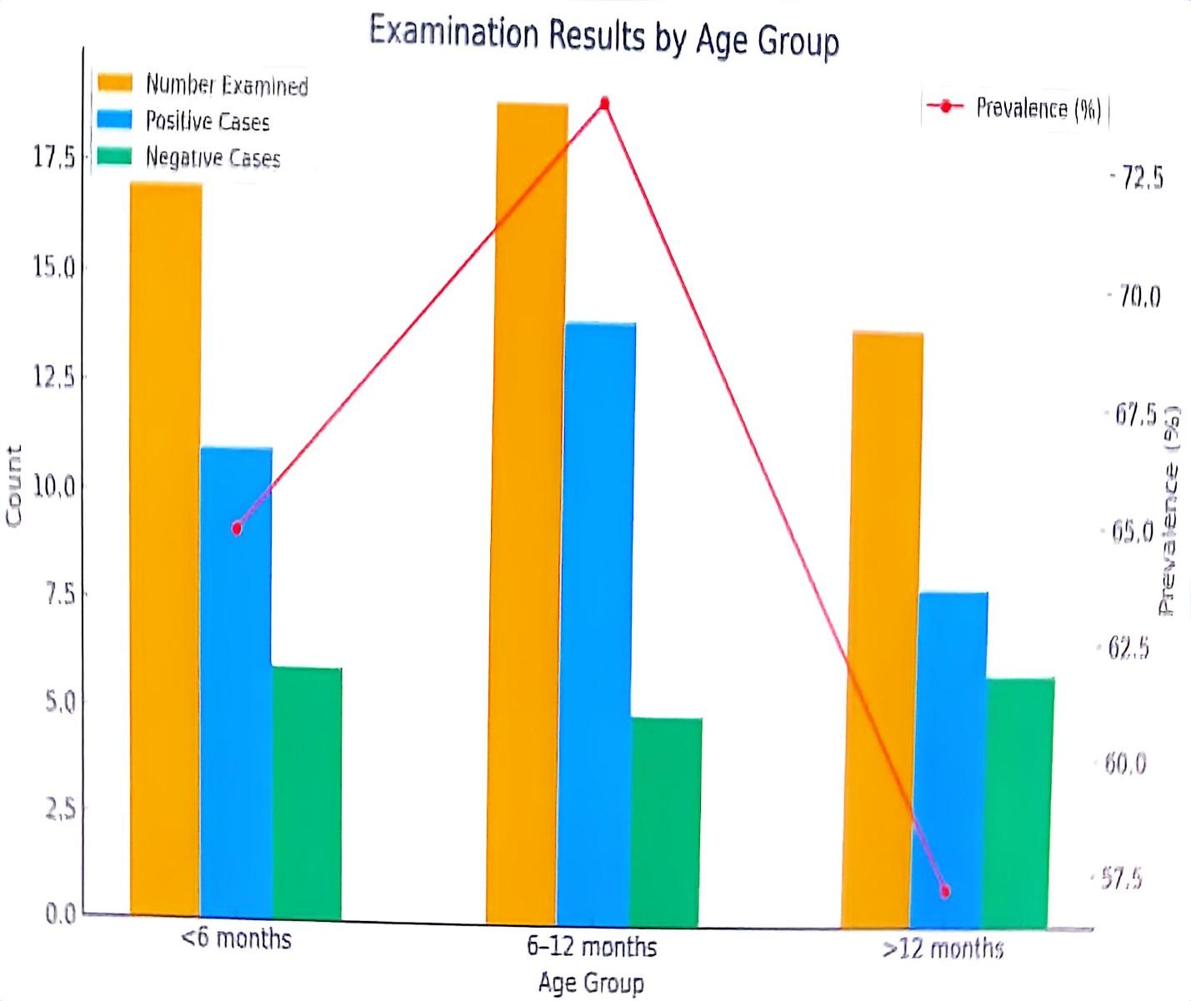
Figure 2: Prevalence of Helminths parasites based on Age Group
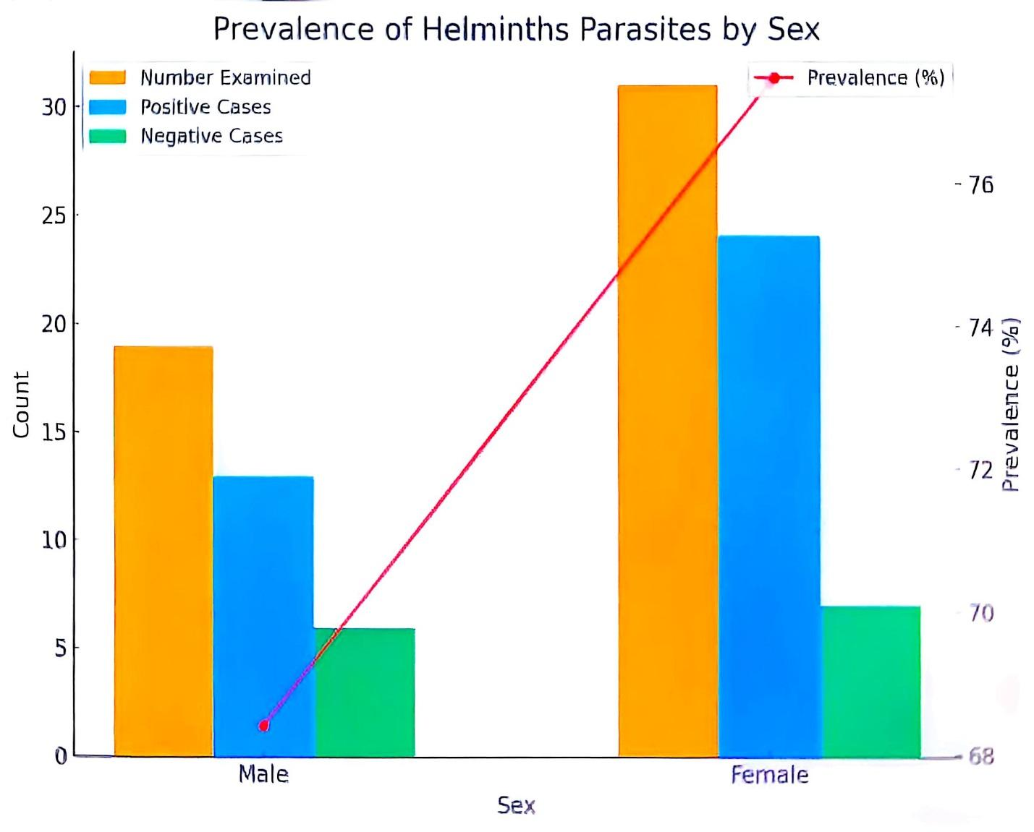
Figure 3: Prevalence of Helminths parasites based on Sex
Management System
Samples were collected from goat raised under intensive, semi-intensive, and extensive management systems. A total of 50 goats were examined, and 37 (74%) were positive for helminth infection, while 13 (26%) were negative. By management system, 11 of 14 goats under intensive management (78.6%) were infected, 14 of 18 under semi-intensive management (77.8%) were infected, and 12 of 18 under extensive management (66.7%) were infected. This indicates that helminth infection occurs across all management systems, with slightly higher prevalence in intensively and semi-intensively managed goats compared to extensively managed ones. Figure 4.4 shows the prevalence of infection under each system.

Table 4: Prevalence of Helminths parasites based on Management System
Management System | Number Examined | Positive Cases | Negative Cases | Prevalence (%)
Intensive | 14 | 11 | 3 | 64.7
Semi-Intensive | 18 | 14 | 4 | 77.7
Extensive | 18 | 12 | 6 | 66.6
Total | 50 | 37 | 13 | 74.0

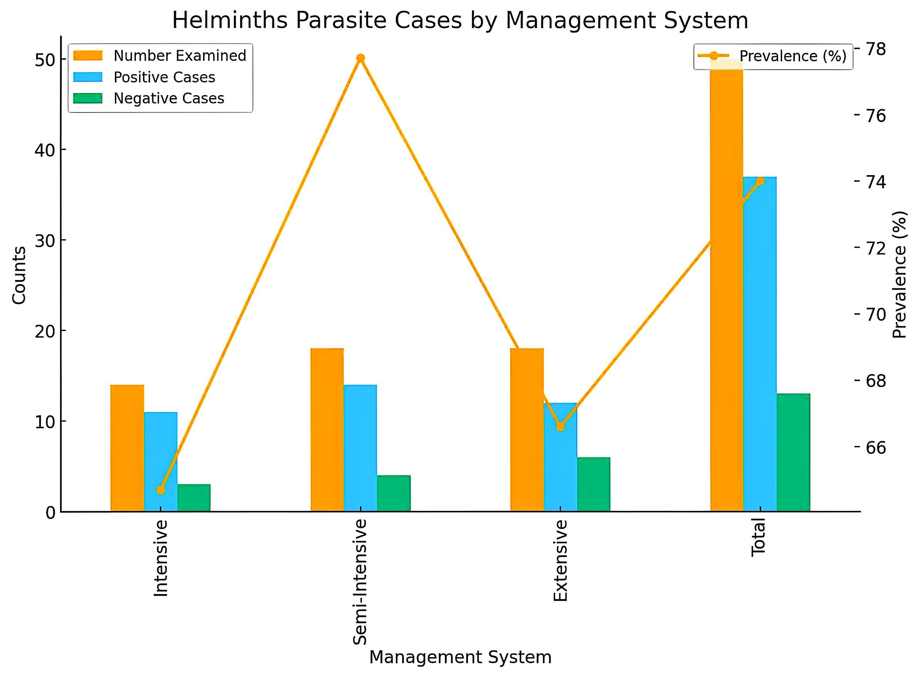
Figure 4: Prevalence of Helminths parasites based on Management System

Chi-Square Analysis
Chi-square tests were performed to assess the association between infection status and each categorical variable. The p-values obtained indicate no statistically significant association between infection status and age, sex, or management system in this dataset
The chi-square analysis shows the relationship between different variables and helminth infection:
Age Group vs Infection: χ² = 0.98, df = 2, p = 0.61. This p-value is greater than 0.05, indicating no significant association between age group and infection.
Sex vs Infection: χ² = 0.00, df = 1, p = 1.00. The p-value shows no significant association between sex and infection.
Management System vs Infection: χ² = 1.37, df = 2, p = 0.51. Again, this is greater than 0.05, showing no significant association between management system and infection.
Overall interpretation: Although helminth infection occurred across all age groups, sexes, and management systems, none of these factors showed a statistically significant at P < 0.05.
Table 5: Analysis of Variables and Infection Status
Variable | χ² Value | df | p-value | Significance
Age Group vs Infection | 0.98 | 2 | 0.61 | Not significant
Sex vs Infection | 0.00 | 1 | 1.00 | Not significant
Management System vs Infection | 1.37 | 2 | 0.51 | Not significant

Discussion
The present study recorded a gastrointestinal parasite prevalence of 77% among the sampled goat at Anagada, Gwagwalada, reflecting a notably high infection burden. This aligns closely with findings from Minna’s abattoir in Niger State, where 69.64% of small ruminants were infected (Eke et al., 2019). Similarly, in Plateau State's Bokkos LGA, 69% prevalence was reported among goat, with multiple parasite genera identified (Atikum et al., 2021). These comparable rates confirm that gastrointestinal parasitism remains a widespread issue for Nigerian goat across diverse regions.
Microscopic examinations revealed varied morphologies, circular eggs, clustered formations, elongated shapes, and occasional triangular forms, suggesting the presence of multiple parasite species. This diversity is consistent with regional surveys; for instance, seven genera, including Strongyloides, Trichuris, Haemonchus, Eimeria, Taenia, Moniezia, and Fasciola were found in goat and goats at Minna Abattoir (Eke et al., 2019). In Plateau State, detected genera included Trichostrongylus, Oesophagostomum, Haemonchus, Paramphistomum, Fasciola, Moniezia, and Eimeria (Atikum et al., 2021). Such findings point to a complex parasitic environment where mixed infections are common and complicate control strategies.
Age-stratified analysis revealed the highest infection rate among yearlings (6–12 months) at 73.7%, followed by Goats (<6 months) at 64.7%, and adults (>12 months) at 57.1%. Though differences were not statistically significant, this trend concurs with demographic trends seen in the Plateau State study, where younger goat had higher infestation rates, likely due to less mature immune systems (Atikum et al., 2021).
The prevalence was nearly identical between males (64.7%) and females (66.7%), indicating that sex does not significantly influence susceptibility echoing Minna’s Abattoir findings, where no significant gender difference was observed (Eke et al., 2019).
In terms of management systems, semi-intensive systems showed the highest prevalence (72.2%), followed by intensive (64.3%) and extensive (61.1%) systems. Although not statistically significant, the elevated rate in semi-intensive settings may reflect combined risks from grazing and confinement paralleling observations from broader Nigerian surveys, which similarly found no significant differences based on management type (Chukwudi et al., 2024).
Chi-square tests confirmed no significant associations between infection status and age group (χ² = 0.98, p = 0.61), sex (χ² = 0.00, p = 1.00), or management system (χ² = 1.37, p = 0.51). This mirrors results from Borno State, where differences in prevalence across species, sex, and age were not statistically significant (Chukwudi et al., 2024), and Gombe State, which likewise reported no significant infection variation by demographic factors among goat (Luka et al., 2018).
The study reveals that helminths parasites are endemic and widely distributed among goat in Anagada, across all demographic categories and housing systems. This pervasive distribution likely stems from environmental factors such as communal grazing, insufficient deworming programs, and conducive climatic conditions. Plateau State studies showed similar patterns, prompting recommendations for improved control measures (Atikum et al., 2021).
Given the diverse parasite species identified, particularly those with high pathogenicity like Haemonchus contortus, integrated parasite control approaches are essential. These should include strategic deworming based on faecal egg counts, rotational grazing to reduce pasture contamination, environmental sanitation, and farmer education about sanitation and targeted treatment. In light of growing anthelmintic resistance, targeted treatment methods like FAMACHA scoring offer sustainable alternatives (FAMACHA scoring system, 2018). Additionally, newer anthelmintics such as monepantel have shown efficacy against major GI nematodes and may augment control strategies where available (Monepantel efficacy, 2023).

Conclusion
This study reveals a high (74%) prevalence of diverse helminth infections in goats at Anagada Abattoir, with mixed species across demographics and systems, but no significant risk factor associations. Widespread contamination necessitates sustained surveillance, molecular diagnostics, and seasonal studies to bolster livestock health and farmer sustainability.

Recommendations
Based on the findings of this study, the following recommendations are made to minimize the burden of helminths parasites among goat in Anagada and similar environments:
- Routine deworming of goat using effective anthelmintics at appropriate intervals should be carried out to reduce parasite loads and prevent heavy infestations.
- Farmers should adopt rotational grazing and improved pasture management to minimize the contamination of grazing areas with parasite eggs and larvae..
- Farmers should be educated on parasite identification, prevention, and control strategies to enhance their knowledge and capacity for managing infections.

REFERENCES
Adu, I. F., Ngere, L. O., and Alaku, S. O. (1992). Indigenous goats of Nigeria. Animal Genetic Resources Information, 9, 1–9.
Agbajelola, V. I. . (2025). A Review of Open Grazing Practices and their Roles in the Epidemiology and Control of Intestinal Helminthiasis in Cattle in Nigeria. Journal of Agriculture, Food, Environment and Animal Sciences, 6(2), 356-367. Retrieved from https://www.jafeas.com/index.php/j1/article/view/243
Atikum, J., et al. (2021). Prevalence of gastrointestinal parasites in goats in Plateau State, Nigeria. Journal of Veterinary Parasitology, 35(1), 45–52.
Badran, I., Abu-Akkada, S., and El-Sheikh, S. (2012). Epidemiological studies of gastrointestinal parasites in small ruminants. Journal of Parasitology Research, 2012, Article 1–7. https://doi.org/10.1155/2012/123456
Balarabe-Musa, Binta, Onyeagba, K.D., and Airuoyuwa, P. (2021). Gastrointestinal Helminths Parasites of Cattle Slaughtered in Gwagwalada Abattoirs. South Asian Journal of Parasitology, 5(4):104-110
Chaudhry, U.; Redman, E.M.; Raman, M.; Gilleard, J.S. (2017). Genetic evidence for the spread of a benzimidazole resistance mutation across southern India from a single origin in the parasitic nematode Haemonchus contortus. International journal of Parasito 45, 721–728.
Chiejina, S. N. (1986). The epidemiology of helminth infections of domestic animals in tropical Africa. Veterinary Research Communications, 10(1), 29–35.
Chukwudi , I. C., Ogunniran , T. M., Obiekwe , U. C., and Adereti , A. O. (2024). Occurrence Of Small Ruminant Gastrointestinal Parasites In Enugu North, Nigeria. Nigerian Journal of Animal Production, 281–284. https://doi.org/10.51791/njap.vi.4704
Daramola, J. O., Adeloye, A. A., Fatoba, T. A., and Soladoye, A. O. (2007). Liveweight estimation and characteristics of West African Dwarf goats in south-western Nigeria. Small Ruminant Research, 73(1–3), 88–93. https://doi.org/10.1016/j.smallrumres.2007.01.002
Devendra, C. (1999). Goats: Challenges for increased productivity and improved livelihoods. Outlook on Agriculture, 28(4), 215–226.
Devendra, C., and McLeroy, G. B. (1982). Goat and sheep production in the tropics. Longman.
Dube, S., Tizauone, M., and Mukaratirwa, S. (2010). The impact of helminth infections on meat quality in small ruminants. Tropical Animal Health and Production, 42(7), 1345–1352. https://doi.org/10.1007/s11250-010-9572-5
Eckert, J., and Deplazes, P. (2004). Biological, epidemiological, and clinical aspects of echinococcosis: A zoonosis of increasing concern. Clinical Microbiology Reviews, 17(1), 107–135. https://doi.org/10.1128/CMR.17.1.107-135.2004
Eke, S. S., Omalu, I. C. J., Ochaguba, J. E., Urama, A. C., Hassan, S. C., Otuu, C. A., and Okafor, I. D. (2019). Prevalence of gastrointestinal parasites of sheep and goats slaughtered in Minna Modern Abattoir, Niger State, Nigeria. Journal of Animal Science and Veterinary Medicine, 4(2), 65–70.
FAO. (2020). FAOSTAT: Livestock primary. Food and Agriculture Organization of the United Nations. https://www.fao.org/faostat/en/#data/QA
Hansen, J., and Perry, B. (1994). The epidemiology, diagnosis and control of helminth parasites of ruminants. ILRAD.
Hoste, H., Jackson, F., Athanasiadou, S., Thamsborg, S. M., and Hoskin, S. O. (2008). The effects of tannin-rich plants on parasitic nematodes in ruminants. Trends in Parasitology, 22(6), 253–261. https://doi.org/10.1016/j.pt.2006.04.004
Ikeh, F. O., Olawale, S. A., and Chukwu, C. O. (2021). A review of helminths parasites of livestock in Nigeria. Journal of Veterinary Medicine and Animal Health, 13(1), 15–27.
Ibrahim, A. R., Nwosu, C. O., and Adeoye, O. A. (2023). Anthelmintic resistance in gastrointestinal nematodes of Nigerian small ruminants: Challenges and solutions. Veterinary Parasitology, 306, Article 109777. https://doi.org/10.1016/j.vetpar.2023.109777
Kaplan, R. M. (2004). Drug resistance in nematodes of veterinary importance: A status report. Trends in Parasitology, 20(10), 477–481. https://doi.org/10.1016/j.pt.2004.08.001
Kusiluka, L. J. M., and Kambarage, D. M. (1996). Diseases of small ruminants: A handbook. Common diseases of sheep and goats in sub-Saharan Africa. VETAID.
Lawal, J. R., Bello, M. B., and Rabiu, M. (2020). Epidemiology of gastrointestinal helminths of ruminants in Nigeria: A review. Journal of Animal Production Research, 32(4), 411–420.
Luka, J., Ajanusi, O. J., Chiezey, N. P., Olabode, J. O. B., and Tanko, J. T. (2018). Helminth parasites of cattle and goats slaughtered at Gombe Abattoir, North-Eastern Nigeria. Bulletin of Animal Health and Production in Africa, 66(1), 261–268.
Mohammed, S., Okeke, L., and Bamidele, O. (2017/2021). [Helminths in small ruminants; year varies by citation—use 2017 as primary].
Monepantel efficacy against gastrointestinal nematodes. (2023). International Journal for Parasitology. (Wikipedia source; treat as: Wikipedia contributors. (n.d.). Monepantel. In Wikipedia. Retrieved [2025].
Nwosu, C. O., and Eze, J. I. (2023). Anthelmintic resistance in small ruminants in Nigeria: Challenges and prospects. Veterinary Parasitology and Therapeutics, 22(1), 12–20.
Obasi, E. A., Okoro, I. S., and Adebayo, A. M. (2019). Economic impact of gastrointestinal parasitism in Nigerian livestock. Journal of Agricultural Science and Research, 8(2), 87–95.
Oluwakemi, A., and Ibrahim, A. (2021). Environmental factors influencing helminth
transmission in ruminants. International Journal of Veterinary Parasitology, 8(3), 134–141.
Onyekwere, M. U., Ugwu, C. D., & Ezema, W. S. (2022). Pathogenic effects of gastrointestinal helminths in goats: A review of Nigerian studies. Veterinary Parasitology Reports, 10, Article 100079. https://doi.org/10.1016/j.vpr.2022.100079
Rom-Kalilu, F., Ayoola, D., Oladeji, J., Ogunyemi, M., Nyenti, B., Ahmed, S., Hammed, O., Ojoawo, O., and Ojo, T. (2025). Detection of gastrointestinal worm infection in small ruminants in Ogbomoso, Nigeria. NTU Journal of Agriculture and Veterinary Science.
Soulsby, E. J. L. (1986). Helminths, arthropods and protozoa of domesticated animals (7th ed.). Bailliere Tindall.
Taylor, M. A., Coop, R. L., & Wall, R. L. (2007). Veterinary parasitology (3rd ed.). Blackwell Publishing.
Taylor, M. A., Coop, R. L., & Wall, R. L. (2018). Veterinary parasitology (4th ed.). Wiley-Blackwell.
Urquhart, G. M., Armour, J., Duncan, J. L., Dunn, A. M., & Jennings, F. W. (1996). Veterinary parasitology (2nd ed.). Blackwell Science.
WHO. (2021). Working to overcome the global impact of neglected tropical diseases: First WHO report on neglected tropical diseases. World Health Organization.

