Language of new-gen toddlers: Early screen induced selective communication delay

Abstract

Language development is a natural and but complex development process in human life which starts from day 1 of infant in form of birth cry and keeps on developing with age , experiences and interests. Toddlers who were exposed to intensive screen > 4hours a day was presented as perceived language delay. There came a high rise in Selective language delay where child were able to speak virtual content ranging from Alphabets, numbers ,rhymes to favorite cartoon dialogues but unable to make need based or meaningful conversation.
Aims: 1.To study effect of early screen exposure on language development of toddlers.
- To study the effect of reducing screen to zero hours on language development.
Study design: Qualitative method using case study technique
Place and duration of study : Online and Offline at Department of Child development at My Family Physio Clinic Bhopal MP India
Methodology: A Qualitative method with case study was conducted on 90 toddlers who presented with selective speech delay during online consultation with help of set of Interviews with Parents and video consultation at regular intervals with toddlers .
Results : It was found that 1. Child is not able to communicate with Family and peers. 2. He is always reciting Alphabets/ numbers / rhymes/ Cartoon voices of his own. 3. He was exposed to Screen before 1 year of age for more than 4 hours( 10 hours in few cases).
Conclusion: This was Perceived as selective speech delay as child was able to speak whatever he observed/ learned from screen of their own but was not able to talk or communicate with Peer or family members and not able to express their needs Verbally because of lack of interactive and social communication during developmental years resulting in Perceived Speech delay. There was a positive relationship between Selective speech delay and Screen exposure and was recovered when screen was reduced and interactive conversation was started within Family environment.

Keywords: Toddlers, language development, speech delay, impact of screen on development of toddlers

Introduction
New era Toddlers are expressing selective language processing disorder where they are able to speak ( one way communication) but not able to talk ( interactive conversation). (Jama pediatrics 2013) . Early intensive screen exposure was found responsible for complaint of this selective speech delay . ( Abdulaziz rola xxxx year??). Language development is a natural process in which child learns by ways, meanings and techniques of using gestures and words via receiving different language inputs and sequentially using these learned techniques in expressing needs and interaction.( Kazi et al).
A Child learns to communicate initially via crying gradually progressing to cooing , babbling, monosyllable, bisyllable, sentences , phrases , paragraphs and so on. The basic tool being Listening and observing the speaker in front and that is how a child tend to learn by repeating words he is being exposed to. ( Piagets theory, xxxx year?). Toddlers who were exposed to screen before 1 year of age were found to mimic perceived language delay where they were able to speak ( one way communication) all the virtual content they were exposed to including alphabets, numbers, colors, shapes, and variety of rhymes and interestingly in similar accent as of virtual content irrespective of their mother tongue and family background. ( Marius zamfir). On the other hand they were found poor in talking(two way communication or expressive language) which includes addressing there parents as papa mumma or expressing their daily needs in words or recognizing family members and surroundings as appropriate to their age. Parents initially were satisfied with their childs intellectual property of speaking virtual content fluently with phonation but later realized absence of interactive communication.
Kids born in this era of technology are born with screens at hand similar to born with silver spoon in old times (Ciaran et al 2015). They are tech savvy and learns and understands technology before and better than there needs of interoception ( understanding inner needs of body like hunger and toilet) (N Elias et al 2017) . Stimuli received by electronic medium contains fine digital sounds and high resolution visuals which does not align with real world audio visual stimuli and child with early screen missed to differentiate between them in absence of appropriate social and environmental interaction. Toddlers can make sounds as loud as they can….They can speak what they want When they want with their abilities but lacks behind in Language development.
According to Abdulaziz Rola (2023) an English language lecturer found drastic change in speaking skills of preschool children’s in Saudi Arab. He conducted survey based cross sectional study with parents of 2-5 years old children with language delay and found impact of excessive screen exposure as one of common reason associated with most of the kids.
Amreen Raheem , Sikandar khan et al (2023) studied about negative effect of excessive screen time on speech , language and other developmental areas of child in 2023. They did a literature review and found negative neurocognitive consequences of early and prolonged screen exposure . Various investigations conducted revealed reduced microstructural rectitude of brain in areas responsible for speech and language developmental milestones.
Anderson and Hanson 2010 found that infants and toddlers have limited screen viewing skills. They found that children’s are “video deficit” till 30 months of age which means they are unable to comprehend multidimensional representation without appropriate training at appropriate time. This study is important as it reveals the fact that child viewing screen is only receiving colour’s, sounds and visuals without understanding concept or theme behind. Hence child with more screen exposure is fascinated with high sounds and high colour’s and not pays attention to real world easily.
Kanwal S et al (2023) did extensive study on 318 participants and found that increase in screen time delays milestone achievement .
Stefanie , Nugroho and Meryana (2023) conducted observational research at PHC Surabaya hospital on 75 kids and found positive correlation between higher intensity of gadget usage and delay in speech and language development of toddlers.

Methods and Materials
- A Qualitative research method using case study technique was done on 90 toddlers in 2024 on kids born during or after covid time.
- Study was done both online and offline to study realistic impact of screen on language development everywhere.
- Complaint of speech and language delay along with history of early ( before 1 year) and excessive ( more than 4 hours) screen exposure was recorded.
- Any history associated with birth and developmental milestones were not considered for selecting sample.
- An age appropriate speech and language assessment tool developed by American Speech language and hearing association was used to record there language developed.
- Parents were asked to reduce screen to zero hours and spend quality time with their child and start interactive conversation for language development.
- Assessment was recorded again after an interval of three months .
Sampling technique
Convenient Sampling method was used to select children.
Samples were selected from online consultation ( which was started during Covid to help children with Developmental delays.) Online and Offline mode was used to collect data with speech and language delays.
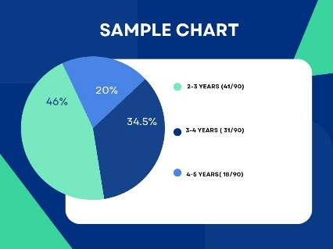
Data recorded was kept confidential.

Inclusion criteria
Fig 1- Chart of Sample Data
- Age 2-5 years
- History of early and excessive screen exposure
- Complaint of speech and language delay
Exclusion criteria
- Age above 5 years
- No or minimum screen exposure
- Other associated complaints or History of developmental disorders
Research Tool:
An age appropriate speech and language assessment tool developed by American Speech language and hearing association ( ASHA) was used to assess language development. This tool is taken from the study” How does your child hear and talk?” And was designed to assess functional language of child at different ages.
Child was categorised in three categories as per age group and related test was administered on day 1 and repeated after 3 months . Scoring was done on the basis of questions answered before and after intervention .
Procedure:
Parents of selected children were counseled properly and purpose of study was properly explained . Research tool was selected as per age of the child. Parents were requested to reduce screen to zero hours for a period of three months .
I. Research Tool for kids aging 2-3 years includes 5 questions which includes:
- Having one word for almost everything- this was answered yes mostly as children learnt most vocabulary from screen and were able to answer appropriately. But they will nae object on seeing it usually not as per need of or demanding that object.
- Uses two or three words phrases to talk about or ask for things- it was answered as No mostly as kids were not able to communicate in phrases or sentences.
- Uses k,g,F,t, d and n sounds- yes they uses random sounds of unknown origin to engage themselves, while playing or even as a means of communication in their own way.
- Speaks in a way that is understood by family members and friends- No near ones will understand with expressions but verbal communication was missing.
- Names objects to ask for them or to direct attention to them – No initially they didn’t responded when asked which later improved to responding well.
Case study
Duggu ( 28 months/ M) consulted with his parents with complaint of language delay. He was able to recognise and recite alphabets and numbers but not able to speak mumma papa and other need based communication suggested for his age. On consultation parents confirmed history of screen exposure for more than 4 hours since 10 months of age. Other milestones were achieved at normal pace. On reducing screen for zero hours and parental interaction Duggi was able to speak in two- three words phrases and name objects when asked in language understandable to general public.

II. Research tool for kids ageing 3-4 years included 6 questions including
- Hears you when you call from another room – yes most kids were aware of their name or responded well for sounds of food , packet of chips and chocolate as well.
- Hears the television or radio at the same sound level as other family members- yes Child Hears Electronic media at same sound level bit prefers to watch their favorite content mostly and will throw tantrums for other content.
- Answer simple “who? What? Where? And why? “ questions- No child didn’t understood questions of any type from surroundings initially but later responded well .
- Talks about activities at day care, preschool or friends home – No child didn’t paid attention and didn’t cooperated initially at day care or peer group buy later started noticing them and interacting and then they didi answered about daily events.
- Use sentences with four or more words – No initially at this age child was using one or two need based words and was unable to communicate in sentences. With experience and practice they started making interactive conversation meaningfully.
- Speaks easily without having to repeat syllables or words- No children faced difficulty in finding words for conversation so they use to repeat syllables and words during assessment but later they improved with reciprocal conversation
Case study
A 3.6 years/ female was able to respond to name when called from other room and responded quickly to sound of TV , mobile and even packets of market snacks. Parents were concerned about missing active conversation for needs and emotions appropriate for age. During assessment excessive screen exposure was revealed along with Less interaction with parents and caregivers. With zero screen protocol pihu was able to repeat syllables and words and started speaking in sentences, report about activities of daily living in meaningful self paced clear or limited words along with answering few of where ? And what? When and why were in learning phase.
III. Research tool for kids ageing 4-5 years included 9 questions where kids were able to answer 2-3 questions on random basis few kids used rhyming or alphabets or grammer or responded well for already heard words whereas few were able to focus on stories or contests already heard on electronic media. Also few kids managed to communicate with children and adults on their favorite topics or on virtual content. Later with zero screen and practice kids improved in responding 7-8 questions varying from meaningful conversations to speaking meaningful words and sentences.
Case study
A 4.2 years male child was happy child with lots of vocabulary but not relevant to object or timing. Parents were concerned about selective communication but lack of verbal skills appropriate to his peers. He developed a tendency to stay in front of screen for hours without physical interaction and will keep on repeating content watched on screen. He likes to speak about his favorite cartoon but does not want to talk to family members for needs or demands. On reducing screen Rhythm started spending time with family members and friends and started learning meaningful appropriate words useful for communication and participate actively on discussion about favorite topics in sentences.

Results and Discussions:
There is a mark improvement in language development of toddlers after reducing screen to zero hours for three months. Parents were asked to engage children in active interactive communication throughout the day within families , schools and societies to receive more words and expressions at same time. This helped kids learn words and kids started repeating initially later on improving to active conversation. Kids with screen remains engaged without active interacton for hours and time required for learning by observation and imitation is reduced. Screen provides one way communication. Child can listen but is not asked to talk. Child if reduced content with screen he does not understands its importance or is not appreciated. Screen creates barrier in providing normal language development which needs active interactive conversation with words, expressions, gestures, voice modulation, emotions, appreciation, grammer and understanding. Screen introduces words at times with expressions but screen will neither wait for child to repeat nor it will correct if pronounced wrong or delayed . Also it will not teach expressive communication or diffrent uses of similar words or expressions with emotional skills.
On reducing screen child has sufficient time to look around, observe and interact with surroundings, experience diffrent sounds at diffrent volumes with different meanings approaching similar content in variety. This makes Child learn and repeat and later use learned vocabulary in meaningful conversation. This takes time and efforts but we can see positive improvements .
Improvements were appropriate to age as follwed:
- Kids between age of 2-3 year shown improvement from 40%to 80%.
- Kids between age of 3-4 years shown improvement of 83% from 33%.
- Kids between age of 4-5 years shown a improvement of 77% from 33%.
Group I – age 2-3 years
41 out of 90 children were selected in this category. Total 5 questions were asked . Children on day 1 were able to speak two questions like making sounds and able to name few objects in one word only but improved to four questions like improving to speak in phrases and in language which is understandable after reducing screen to zero hours after three months.
Group II – age 3-4 years
31 out of 90 children were selected in this category. Total 6 questions were asked . Children initially were able to respond to name calling or to sound of Television from another room scoring 2/6 which later improved to speak in sentences, recall evenys at day care without repeating words scoring 5/6 after three months of zero screen hours.
Group III- age 4-5 years
18 out of 90 children were selected in this category. Total 9 questions were designed to assess language achieved. Children initially were able to answer 3 questions later improving to 7 questions after screen was reduced to zero hours for three months but still lacked behind in interactive conversation and fluent speech as compared to other children of same age.
Fig 2-statistical data analysis
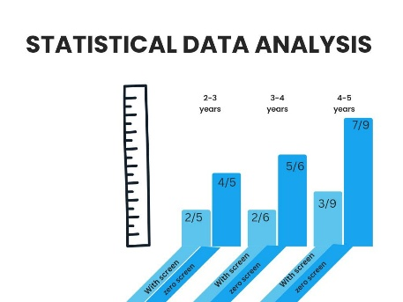
Conclusion
Early screen exposure is dangerous to innocent brains of new gen toddler. Similar results were recorded during studies of Abdulaziz Rola [1] and Amreen raheem[5]] who found that toddlers exposed to screen are experiencing speech and language delay . Society must be warned about ill effects of early screen exposure and associated speech and language delay. Pal subir and team also found negative effect of early screen exposure on childs language and learning development. Parents track their childs developmental milestones with various parental apps but still they missed the speech and language development appropriate to their age . This research will provide a milestone in Creating healthy Parenting techniques and will try to develop few techniques to guard kids from screen induced speech and language delay.

Competing interest
None
Operational definitions

Voice is the sound produced by vibration of Vocal folds larynx when air passes through lungs.
Speech is the sound produced by coordinated work of muscles of tongue, lips, jaw and vocal trac . It is one way of communication.
Language is a meaningful way of interaction or exchanging communication. It involves receiving and expressing thoughts and emotions by verbal means audible words and non verbal methods like gestures, writing or signing.
Toddlers means To Do and learn . They will observe and imitate to learn across their developmental milestones are achieved.
Screen time is non interactive time spent in front of electronic devices which provide audio visual inputs. Excessive Screen time kills toddlers time of doing and learning. Their brain will receive one way audio and visual stimuli where they are not asked or forced to repeat, demand and interact. This will limit their brains ability to understand and express their needs in words, exchange thoughts , share emotions and meaningful interactions.
Zero screen hours refer to hours of zero or No interaction with screen .

References

[1]
R. Abdulaziz Abdullah Alibrahim (xxxx), “The Impact of Screen Time on Language Development among Preschool-Age Saudi Children,” Arab World English Journal, pp. 1–61, Jan. 2023, doi: 10.24093/awej/th.289.
[2]
Alamri (xxxx), “relationship between speech delay and smart media in children,” cureus, 2013.
[3]
N. Elias and I. Sulkin, “YouTube viewers in diapers: An exploration of factors associated with amount of toddlers’ online viewing,” Cyberpsychology: Journal of Psychosocial Research on Cyberspace, vol. 11, no. 3, Nov. 2017, doi: 10.5817/CP2017-3-2.
[4]
U. M. Ghaisani and A. R. Salam, “Association of Excessive Screen Time in Children with Language Delay During Covid-19 Pandemic: A Systematic Review,” Jurnal Psikiatri Surabaya, vol. 11, no. 2, pp. 91–102, Nov. 2022, doi: 10.20473/jps.v11i2.34589.
[5]
A. Raheem, S. G. Khan, M. Ahmed, F. J. Alvi, K. Saleem, and S. Batool, “Impact of Excessive Screen Time on Speech and Language in Children,” Journal of Liaquat University of Medical & Health Sciences, vol. 22, no. 03, pp. 155–159, Sep. 2023, doi: 10.22442/jlumhs.2023.01020.
[6]
I. Takahashi et al(xxx)., “Screen Time at Age 1 Year and Communication and Problem-Solving Developmental Delay at 2 and 4 Years,” JAMA Pediatrics, vol. 177, no. 10, p. 1039, Oct. 2023, doi: 10.1001/jamapediatrics.2023.3057.
[7]
F Silvana , G J Vasilka , E A Biljana ., 2015 “ The silent epidemic: The link between screen exposure and delays in Speech and Language Development in preschool Children, issue sep 2025
[8]
Robyn Ritchie,(xxx) “The impact of television on child development ,” Journal of Waldorf Education, vol. 15, no. 1, Mar. 2013.
[9]
Ciaran Haughton, Mary Aiken, and Carly Cheevers, “Cyber Babies: The Impact of Emerging Technology on the Developing Infant,” Journal of Psychology Research, vol. 5, no. 9, Sep. 2015, doi: 10.17265/2159-5542/2015.09.002.
[10]
J. S. Hutton, J. Dudley, T. Horowitz-Kraus, T. DeWitt, and S. K. Holland, “Associations Between Screen-Based Media Use and Brain White Matter Integrity in Preschool-Aged Children,” JAMA Pediatrics, vol. 174, no. 1, p. e193869, Jan. 2020, doi: 10.1001/jamapediatrics.2019.3869.
[11]
D. L. Linebarger and S. E. Vaala, “Screen media and language development in infants and toddlers: An ecological perspective,” Developmental Review, vol. 30, no. 2, pp. 176–202, Jun. 2010, doi: 10.1016/j.dr.2010.03.006.
[12]
M. S. Maulana, “RISK OF LANGUAGE DELAY IN TODDLERS WITH PROLONGED SCREEN TIME : EVIDENCE BASED CASE REPOR,” JECIES: Journal of Early Childhood Islamic Education Study, vol. 1, no. 1, pp. 34–48, Mar. 2020, doi: 10.33853/jecies.v1i1.53.
[13]
Pal Subir, Mukherjee soumen, and das Jayshree, “ DELAYED SPEECH IN TODDLER ASSOCIATED WITH INCREASE SCREEN TIME. International Education and Research Journal (IERJ), 7(6). Retrieved from,” International journal and research journal, vol. 7, Jun. 2021.
[14]
N. F. Karani, J. Sher, and M. Mophosho, “The influence of screen time on children’s language development: A scoping review,” South African Journal of Communication Disorders, vol. 69, no. 1, Feb. 2022, doi: 10.4102/sajcd.v69i1.825.
[15]
G. Korres et al., “Unsupervised Screen Exposure and Poor Language Development: A Scoping Review to Assess Current Evidence and Suggest Priorities for Research,” Cureus, Mar. 2024, doi: 10.7759/cureus.56483.
[16]
M. M. Alamri, M. A. Alrehaili, W. Albariqi, M. S. Alshehri, K. B. Alotaibi, and A. M. Algethami, “Relationship Between Speech Delay and Smart Media in Children: A Systematic Review,” Cureus, Sep. 2023, doi: 10.7759/cureus.45396.
[17]
S. S. al Hosani, E. A. Darwish, S. Ayanikalath, R. S. AlMazroei, R. S. AlMaashari, and A. T. Wedyan, “Screen time and speech and language delay in children aged 12–48 months in UAE: a case–control study,” Middle East Current Psychiatry, vol. 30, no. 1, p. 47, Jun. 2023, doi: 10.1186/s43045-023-00318-0.
[18]
S. B. Rayce, G. T. Okholm, and T. Flensborg-Madsen, “Mobile device screen time is associated with poorer language development among toddlers: results from a large-scale survey,” BMC Public Health, vol. 24, no. 1, p. 1050, Apr. 2024, doi: 10.1186/s12889-024-18447-4.
[19]
Kanwal S et al., “Association between excessive screen time and language delay in preschooler children” , JHRLMC, Vol.3 , issue 2,ISSN 2791-156X
[20]
Stefanie, Michele, Nugroho, and Pauline Meryana. 2023. “Use of Gadgets in Speech and Language Development in Toddlers at PHC Surabaya Hospitals”. Asian Journal of Pediatric Research 11 (2):17-24. https://doi.org/10.9734/ajpr/2023/v11i2216.
[21]
D. Kesavelu and P. V, “Association of Screentime and Speech Delay among Pre-School Age Children – An Exploratory Study,” Indian Journal of Pediatrics, vol. 90, no. 12, pp. 1260–1260, Dec. 2023, doi: 10.1007/s12098-023-04770-y.
[22]
Waheed S et al., 2025 “ Screen exposure and early childhood development”, Insights JHR, vol. 3, issue 5, p 252-259
[23]
Z. M. Zain, F. N. N. Jasmani, N. H. Haris, and S. M. Nurudin, “Gadgets and Their Impact on Child Development,” MDPI AG, Sep. 2022, p. 6. doi: 10.3390/proceedings2022082006.

Websites
  - www.asha.org
  - www.aapd.com
  - www.nidcd.nih.gov

. APPENDIX
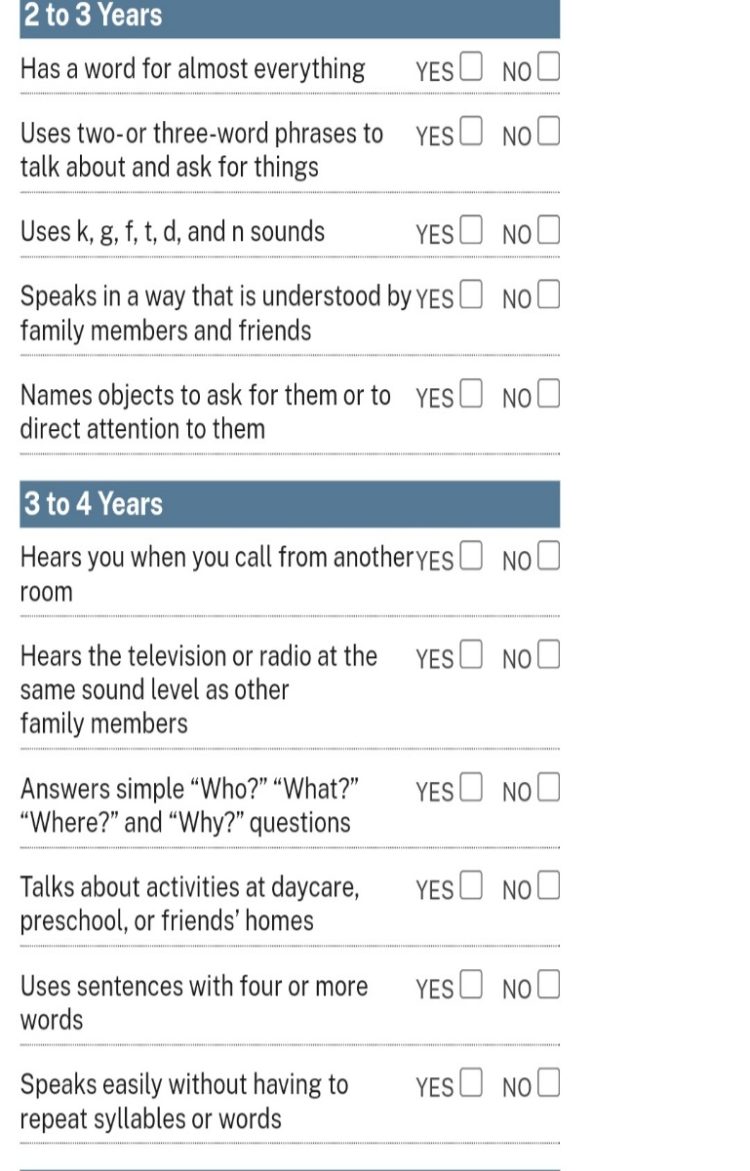
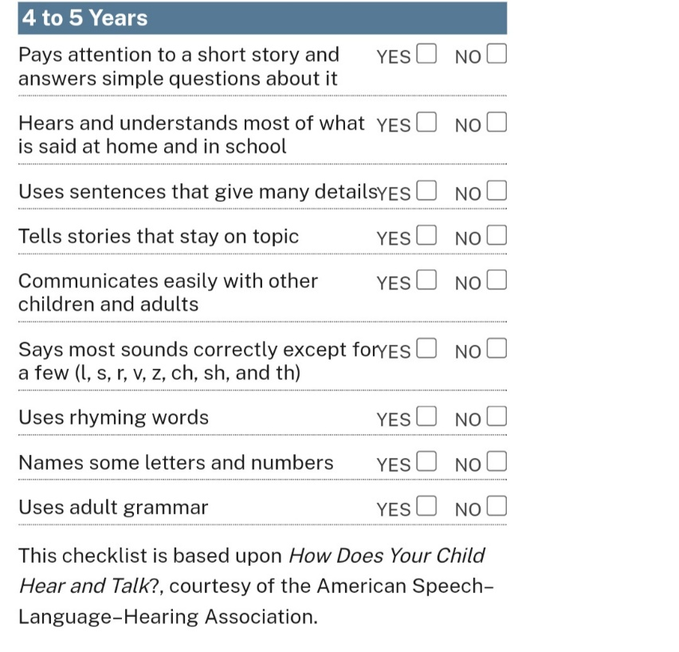
Assessment tool developed by American Speech language and hearing association www.asha.org

