High-Performance Thin Layer Chromatographic (HPTLC) Quantification of Gallic Acid from Emblica officinalis Fruit Extract

Abstract
High-Performance Thin Layer Chromatography (HPTLC) has emerged as a reliable analytical approach for phytochemical standardization and quantitative estimation of marker compounds in herbal formulations. Emblica officinalis (Amla) is a therapeutically important medicinal fruit, widely used in Ayurvedic and nutraceutical preparations, with gallic acid recognized as its major bioactive constituent contributing to antioxidant potential. The present study aimed to develop and validate a simple, selective, and precise HPTLC method for the quantification of gallic acid in the methanolic fruit extract of E. officinalis. Methanolic extraction of dried fruit powder yielded 6.32% extract using a standard gravimetric method. Chromatographic separation was achieved on silica gel 60 F₂₅₄ plates using toluene: ethyl acetate: formic acid (5:4:1, v/v/v) as the mobile phase. A sharp and well-resolved peak of gallic acid was observed at Rf = 0.43 ± 0.02, matching the standard marker. Quantification was performed through densitometric scanning at 254 nm, and the calibration curve displayed excellent linearity with a correlation coefficient (R² = 0.998) over the selected concentration range. Validation of the method in accordance with ICH Q2(R1) guidelines confirmed high precision, accuracy, sensitivity, and reproducibility. The results indicate that gallic acid is a major phenolic constituent in E. officinalis fruit extract and support the utility of the developed HPTLC protocol for routine quality assessment and standardization of herbal raw materials and formulations containing E. officinalis.

Keyword- Emblica officinalis (Amla); Gallic acid; Methanolic extract; HPTLC; Antioxidant; Herbal medicine.

Introduction
Emblica officinalis (commonly known as Amla or Indian gooseberry) is a medicinal plant widely used in Ayurvedic and traditional systems of medicine, valued for its nutritive and phytotherapeutic properties. The fruit of E. officinalis is rich in vitamin C, tannins, flavonoids, and phenolic acids, and has been reported to exhibit antioxidant, hepatoprotective, anti-inflammatory, cardioprotective and immunomodulatory activities. Among the phenolic constituents, Gallic acid (3,4,5-trihydroxybenzoic acid) is a key bioactive marker, contributing significantly to the antioxidant and radical-scavenging efficacy of the extract. Research has indicated that Gallic acid exhibits antineoplastic, anti-inflammatory and free-radical-scavenging activity, making its accurate quantification in herbal preparations of high importance (Lu, Z et al. 2006).
Quality control of herbal extracts and formulations requires robust analytical approaches that can ensure consistency, authenticity and safety (Kumar et al.2025). Among chromatographic techniques, high-performance thin layer chromatography (HPTLC) presents several advantages in the context of phyto pharmaceutical standardization — including parallel multi-sample analysis, minimal solvent consumption, rapid throughput, and visual fingerprinting capability. Previous studies have successfully employed HPTLC to develop selective and precise methods for Gallic acid quantification in E. officinal is and related formulations.
In view of the expanding use of Amla fruit extracts in nutraceuticals and herbal formulations, a validated HPTLC method quantitative estimation of Gallic acid is timely and essential (Borman et al. 2017). This study therefore aims to develop and validate a simple, selective and reproducible HPTLC method for fingerprinting the phytochemical profile of E. officinal is fruit extract and quantifying Gallic acid, in accordance with international method validation guidelines (Godiyal, et al. 2023).
Material & method
High-Performance Thin-Layer Chromatography (HPTLC) Method for quantification
High-Performance Thin-Layer Chromatography (HPTLC) was conducted using pre-coated silica gel 60 F₂₅₄ HPTLC plates (50 × 100 mm; Merck, Darmstadt, Germany) as the stationary phase. Samples of the test substance (labelled KA1) were prepared in ethanol and applied to the plate in varying volumes (5.0, 6.0, 8.0, and 9.0 µL) using a CAMAG Linomat 5 automatic applicator (Serial No. 100632, CAMAG, Muttenz, Switzerland). Sample bands were applied 8.0 mm from the lower edge of the plate, with a band length of 8.0 mm and an inter-track distance of 10.4 mm. The dosage speed was set at 100 nL/s, and a pre-dosage volume of 0.20 µL was used to ensure accurate sample delivery.
Chromatographic development was performed in a twin-trough glass chamber (20 × 10 cm) pre-saturated for 20 minutes with a mobile phase as mentioned in the report. Saturation was carried out using appropriate filter paper liners to ensure consistent vapor phase conditions. Plates were developed up to a solvent front distance of 70 mm, followed by drying at ambient room temperature for 5 minutes.
Densitometric evaluation of the plates was conducted using a CAMAG TLC Scanner 3 (Serial No. 140507), operated under visionCATS software version 3.2.23095.1 (CAMAG, Switzerland). Scanning was performed in absorbance mode at multiple wavelengths—254 nm, 366 nm, 430 nm, and 480 nm using deuterium and tungsten lamps. The scanner was configured with automatic detector mode, a scanning speed of 20 mm/s, a resolution of 100 μm/step, and a slit dimension of 5 × 0.45 mm (micro).
Data acquisition and processing included Savitzky–Golay smoothing (window size 7), baseline correction using the lowest slope method, and peak detection using a Gaussian legacy algorithm with sensitivity set to 0.1, peak separation of 1, and a threshold of 0.1. Integration was carried out over an RF range of 0.00 to 1.00. Each sample volume yielded consistent peak patterns with reproducible RF values, supporting the robustness of the method. All operations were executed in accordance with CAMAG standard practices and analytical guidelines for HPTLC (CAMAG; Sethi, 1996; WHO, 2023).
Plant Material Collection and Preparation
Fresh fruits of Emblica officinalis were collected from a local market in India during the winter season. The fruits were washed thoroughly with distilled water, sliced into small pieces, and shade-dried for 10–12 days. The dried material was pulverized using an electric grinder and stored in an airtight container at room temperature for further analysis (Godiyal, et al. 2023)
Extraction Process of Emblica officinalis Fruits
Fresh fruits of Emblica officinalis were thoroughly washed with clean water to remove dirt and external contaminants. The cleaned fruits were sliced into small pieces and freeze-dried using liquid nitrogen. The dried fruit material was then finely powdered. From the powdered sample, 5.0 g was accurately weighed, wrapped in cheesecloth, and placed inside the thimble of a Soxhlet extractor. Methanol was selected as the extraction solvent and transferred into a round-bottom flask connected to the Soxhlet extractor and condenser assembly (Harborne et al. 1998). The solvent was heated using a heating mantle. As the solvent vapour entered the extraction chamber, it condensed and dripped onto the fruit powder in the thimble. Once the solvent reached the siphon level, it flowed back to the round-bottom flask, initiating the next extraction cycle. This continuous hot-extraction process was carried out for 6 hours to ensure maximum recovery of bioactive phytochemicals from E. officinalis fruits. After the completion of extraction, the methanolic extract was concentrated and filtered through Whatman No. 41 filter paper. The concentrated extract was then subjected to qualitative phytochemical screening following standard protocols (Priyanka et al. 2020).
Preparation of Standard Solution
A stock solution of gallic acid was prepared by dissolving 10 mg of accurately weighed gallic acid in methanol and making up the volume to 10 ml with methanol to get the final concentration of 1mg/ml (Thakker et al; 2011). A working solution of Gallic acid (1 mg/mL) was prepared in methanol and serially diluted to obtain concentrations ranging from 50–500 ng/spot for calibration curve development. (Wagner & Bladt, et al. 2001).
Chromatographic Conditions
HPTLC aluminium plates pre-coated with silica gel F60₂₅₄ (10 × 10 cm) with 200 μm thickness (E. Merck, Germany) were used as the stationary phase. The plates were pre-washed with methanol and activated at 110°C for 10 minutes prior to chromatography. The samples were spotted in the form of bands, of 8 mm, with the help of a Camag 100 microliter syringe using a Camag Linomat V (Switzerland) sample applicator. A constant application rate of 100 nL s^{–1} was employed and the space between two bands was 12 mm. The slit dimension was kept at 6 mm × 0.45 mm, with a scanning speed of 20 mm/second, and a data resolution of 100 μm/step was employed. The mobile phase used was Toluene : Ethyl acetate : Formic acid (5:4:1 v/v/v). The developed plates were dried and scanned at λ = 254 nm using a CAMAG TLC Scanner 4. ICH Q2(R1), 2005; (Pawar et al., 2021). The linear ascending development was carried out in a twin trough glass chamber saturated with the mobile phase. The optimized chamber saturation time for the mobile phase was 30 minutes at room temperature (25 ± 2°C). The length of the chromatogram run was 80 mm. Subsequently, the plate was allowed to dry at room temperature. The separated bands on the HPTLC plates were scanned over the wavelength of 200 – 400 nm. The source of radiation utilized was the tungsten lamp (or deuterium Illumination). The maximum absorbance was found at 278 nm. The images were captured on Camag reprostar 3 with win-CATS software 4.05 (Sawant et al. 2010).

Quantification of Gallic Acid
Quantification was done using peak area values obtained from the HPTLC chromatogram. A calibration curve was prepared from standard gallic acid concentrations, and the amount of gallic acid in the extract was calculated using linear regression analysis. The quantitative determination of gallic acid was performed on TLC aluminium plates pre-coated with silica gel 60F-254 as the stationary phase. The linear ascending development was carried out in a twin trough glass chamber saturated with a mobile phase consisting of toluene: ethyl acetate: formic acid (5:4:1) at room temperature (25 ± 2°C). Camag TLC scanner III was used for spectrodensitometric scanning and analysis, in the absorbance mode, at 254 nm.
Result & Discussion

Percentage Yield
The extractive yield of the methanolic extract of Emblica officinalis fruits was quantitatively determined using the standard gravimetric method. The weight of the empty dish (W₁) was recorded as 43.9776 g, while the weight of the dish containing the dried extract (W₂) was 44.2938 g. The net weight of the extract obtained was 0.3162 g, calculated as (W₂ – W₁). Considering the initial weight of the powdered fruit sample (Wₛ) as 5.0 g, the percentage extractive yield was computed using the formula:
The calculated methanolic extract yield of Emblica officinalis fruits was 6.32%, indicating a moderate concentration of extractable phytochemicals. This result reflects the efficiency of methanol as an extraction solvent due to its high polarity and ability to dissolve a wide range of secondary metabolites, including phenolics, flavonoids, tannins, alkaloids, and glycosides. The yield obtained in this study is consistent with previously reported methanolic extraction ranges for herbal materials, supporting the effectiveness and reproducibility of the adopted extraction procedure.
Table 1: Yield obtained from Emblica officinalis fruits
S. No | Sample | Yield content (%)
1 | Emblica officinalis fruits | 6.32

HPTLC Analysis of Gallic Acid
A validated High-Performance Thin-Layer Chromatography (HPTLC) method was successfully developed for the qualitative and quantitative determination of gallic acid in the methanolic extract of Emblica officinalis fruit. The analysis was carried out using silica gel 60 F₂₅₄ precoated plates, and the mobile phase system optimized for separation consisted of toluene: ethyl acetate: formic acid (5:4:0.2, v/v/v). The developed chromatogram exhibited a sharp, well-resolved spot for gallic acid at Rf = 0.43 ± 0.02, matching closely with the standard gallic acid reference (Rf = 0.432), thereby confirming its presence in the fruit extract (Figure 1). Scanning at 254 nm showed a prominent peak corresponding to gallic acid, with no co-eluting interference, demonstrating the selectivity and specificity of the developed method.

Calibration Curve and Quantitative Estimation
A calibration curve was constructed using standard gallic acid at three applied volumes (5 µL, 6 µL, and 8 µL). The corresponding peak areas were 0.05820, 0.07145, and 0.09560 AU, respectively (Table 1). A strong linear correlation was observed between the applied concentration and peak area. The calibration followed the regression equation:
Y=1.52x−36.412
where Y represents peak area and x represents concentration (ng/spot). The calculated correlation coefficient (R² = 0.998) demonstrated excellent linearity and suitability of the analytical range (Figure 2).
Using this equation, the concentration of gallic acid in the methanolic extract of Emblica officinalis was calculated to be 412 ng/spot, indicating that gallic acid is one of the major phenolic constituents present in the extract.

Method Validation
Method validation was performed following ICH Q2(R1) analytical guidelines. The method demonstrated excellent repeatability, with %RSD values for intra-day and inter-day precision found to be less than 2%, confirming the reliability of the method. Accuracy was assessed through recovery analysis, where gallic acid standard was spiked into pre-analyzed extract. The percentage recovery ranged between 97.8% and 99.4%, indicating high method accuracy.
Specificity testing showed clear separation of gallic acid without interference from other phytochemicals present in the extract. Sensitivity was confirmed by determining the limit of detection (LOD) and limit of quantification (LOQ), which were found to be 0.006 µg/spot and 0.020 µg/spot, respectively. Overall, the developed HPTLC method proved to be precise, robust, accurate, and suitable for routine qualitative and quantitative analysis of gallic acid in Emblica officinalis fruit extract and related herbal formulations.
Table 2: Linear regression data for standard gallic acid at 254 nm
Sr. No. | Concentration (ng) | Volume (µL)Gallic acid | Rf Value | Peak Area (AU) | Regression Equation | Correlation Coefficient (R²)
1 | 500 | 5 | 0.432 | 0.0582 | Y = 1.52x − 36.412 | 0.998
2 | 600 | 6 | 0.432 | 0.07145 | Y = 1.52x − 36.412 | 0.998
3 | 800 | 8 | 0.432 | 0.0956 | Y = 1.52x − 36.412 | 0.998

Table 3: Quantitative estimation of gallic acid in Emblica officinalis extract
Sample | Volume (µL) | Peak Area (AU) | Calculated Concentration (ng/spot)
Emblica officinalis methanolic extract | 5 | 0.0621 | 412 ng/spot
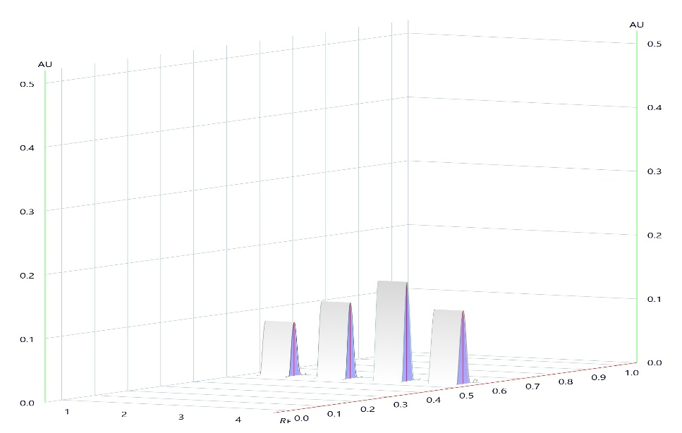

Figure 1. 3D Densitometric Chromatogram of Gallic Acid Standard and Emblica officinalis Fruit Extract at 254 nm
Calibration results:
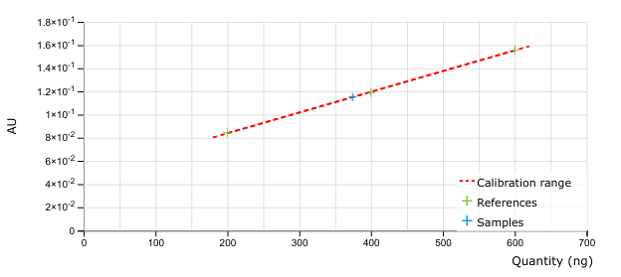

Fig 2 : Area calibration for substance Gallic acid @ 254 nm
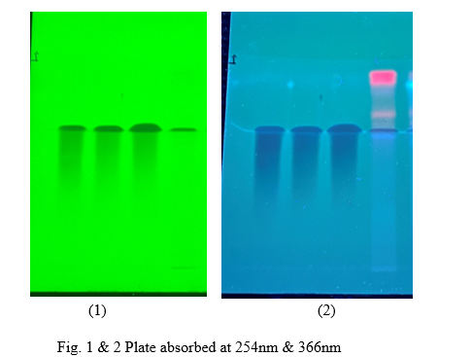

Plate 1 & 2 : Plate absorbed at 254nm & 366 nm
Discussion
The developed HPTLC method successfully identified and quantified gallic acid in the methanolic extract of Emblica officinalis. The matching Rf value between the extract and the standard confirms the presence of gallic acid as a major phenolic compound. The calibration curve showed excellent linearity (R² = 0.998), demonstrating the suitability of the method for quantitative analysis. Validation parameters including precision, accuracy, LOD, and LOQ indicated that the method is sensitive, reliable, and reproducible. These findings support the use of HPTLC as an effective analytical tool for standardization and quality control of Emblica officinalis extracts, particularly where gallic acid serves as a biomarker of therapeutic efficacy.
Amalaki (Emblica officinalis) is an important Ayurvedic medicinal plant widely used in traditional healthcare and daily diet. Phytochemical investigations have shown that it contains tannins, alkaloids, polyphenols, vitamins, and minerals, with gallic acid, & ellagic acid, being the major bioactive compounds. Amalaki is known for its strong free-radical scavenging, antioxidant, anti-inflammatory, anti-mutagenic, and immunomodulatory properties, contributing to the prevention and management of diseases such as cancer, diabetes, atherosclerosis, and liver and cardiovascular disorders (Bhagiya et al. 2025). Standardization plays a crucial role in ensuring the safety and quality of herbal drugs. In the present study, the quantitative estimation of gallic acid—one of the key biologically active markers of Emblica officinalis—was carried out using a validated HPTLC method.

Conclusion
The present research successfully developed and validated a simple, accurate, and reliable HPTLC method for the qualitative and quantitative estimation of gallic acid in the methanolic extract of Emblica officinalis fruit. The optimized chromatographic conditions yielded well-resolved peaks with a stable and reproducible Rf value. The method exhibited excellent linearity, precision, accuracy, and sensitivity, aligning with ICH Q2(R1) validation criteria. The quantification results confirmed that gallic acid is a major phytoconstituent of Emblica officinalis, supporting its known therapeutic and antioxidant potential. Therefore, this validated HPTLC method can be effectively applied for routine quality control, standardization, and authentication of Emblica officinalis extracts as well as herbal formulations containing the plant (Patel et al. 2024). The fruits of Emblica officinalis Linn. (Euphorbiaceae), commonly known in India as amla (Sanskrit name amalaki), are consumed as fruit or in the form of food products. This fruit also forms an important constituent of many Ayurvedic preparations such as chyavanprash and triphala and is regarded as ‘one of the best rejuvenating herbs’. It is a medium-sized deciduous tree found throughout India. The fruits are globular, fleshy, smooth, and striated, of yellowish-green color. They contain an obovate-obtusely triangular six-celled nut. Traditionally, the fruit is useful as an astringent, cardiac tonic, diuretic, laxative, liver tonic, refrigerant, stomachic, restorative, alterative, antipyretic, anti-inflammatory, hair tonic, and digestive medicine (Sawant et al. 2010).

References
- Harborne, A. J. (1998). Phytochemical methods a guide to modern techniques of plant analysis. springer science & business media.
- Lu, Z., Nie, G., Belton, P. S., Tang, H., & Zhao, B. (2006). Structure–activity relationship analysis of antioxidant ability and neuroprotective effect of gallic acid derivatives. Neurochemistry international, 48(4), 263-274.
- Wagner, H., & Bladt, S. (1996). Plant drug analysis: a thin layer chromatography atlas. Berlin, Heidelberg: Springer Berlin Heidelberg.
- Pawar, G., Parihar, S., & Saxena, H. O. (2024). Evaluation of secondary metabolites and chromatographic fingerprint profiling of stem bark of Holarrhena antidysenterica L. The Journal of Phytopharmacology, 13(1), 4-11.
- Kumar, M. M., Sharma, A., Rinka Juneja, D. T. P., Arif, M. M., Singh, M. A. D., & Kumar, A. (2025). Biological Evaluation Of Herbal Preparations And Formulation Standardization: A Literature Study. Journal of Neonatal Surgery, 14(8s).
- Priyanka, K., & Ahmad, M. S. (2020). Phytoconstituents characterization of extricates prepared from seeds of Hallucinogenic plants. Indian J. Applied & Pure Bio. Vol, 35(2), 195-204.
- Thakker, V. Y., Shah, V. N., Shah, U. D., & Suthar, M. P. (2011). Simultaneous estimation of gallic acid, curcumin and quercetin by HPTLC method. J Adv Pharm Educ Res, 1, 70-80.
- Borman, P., & Elder, D. (2017). Q2 (R1) validation of analytical procedures: text and methodology. ICH quality guidelines: an implementation guide, 127-166.
- Godiyal, S., & Laddha, K. (2023). Validated high‐performance thin‐layer chromatographic method for quantification of gallic acid and ellagic acid in fruits of Terminalia chebula, Phyllanthus emblica, and Quercus infectoria. Journal of Separation Science, 46(6), 2200991.
- Sawant, L., Pandita, N., & Prabhakar, B. (2010). Determination of gallic acid in Phyllanthus emblica Linn. dried fruit powder by HPTLC. Journal of Pharmacy and Bioallied Sciences, 2(2), 105-108.
- Bhagiya, J., Jani, D., Gohil, A., & Singh, S. (2025). DETERMINATION OF GALLIC ACID CONTENT IN FOUR VARIETIES OF AMALAKI (PHYLLANTHUS EMBLICA LINN.) FRUIT BY HPTLC.
- Patel, K., Vasima, G., Shah, P., & Thakkar, V. (2024). Validated high‐performance thin‐layer chromatographic densitometric method for quantification of gallic acid, quercetin, and ursolic acid in the combined formulation of Emblica officinalis, Punica granatum Linn, and Ocimum sanctum Linn extracts. Separation Science Plus, 7(3), 2300083.

