Students’ Perceptions on the Use of AI Chatbots to Improve EFL Speaking Skill: A Qualitative Investigation of Saudi EFL Learners’ Experiences with ELSA Speak

Abstract
The introduction of Artificial Intelligence (AI) to the field of English education has changed the way that learners of English as a Foreign Language (EFL) develop their abilities in the area of communicative competence. AI chatbots provide immediate conversational interaction with users and adapted feedback, allowing speaking practice during and outside of English classes. We undertook a qualitative research study examining EFL learners’ perceptions at King Abdulaziz University of the role of the AI-powered chatbot ELSA Speak in developing their speaking proficiency, specifically, fluency and pronunciation accuracy, while also looking at issues involved in interacting with the chatbots. Based on an interpretivist paradigm, data were gathered from eight undergraduate preparatory-year students in interviews conducted following a three-week period of chatbot use and analysed through Braun and Clarke’s (2006) six-phase thematic method. The study produced four overarching themes: fluency enhancement, because of permanent speaking partner and uninterrupted practice; better pronunciation through immediate corrective feedback and clear pronunciation modelling; curriculum disconnect, because of misalignment between chatbot content and academic objectives leading to a lack of sustained use; and feedback challenges, because of the complexity of language found to be beyond learners’ proficiency level and feedback detail saturation. Overall, we found that there is much potential for AI chatbots to help EFL learners develop their speaking especially if opportunities for oral practice are scarce, but they must be in alignment with institutional curricula and calibrated to learners’ levels, suggesting the need for institution-specific AI chatbots that meet curricular objectives and learner needs.
Keywords: Artificial Intelligence; EFL Learners; AI Chatbots; ELSA Speak; Speaking Proficiency; Pronunciation Accuracy; Fluency Development; Thematic Analysis; Saudi Arabia; Vision 2030

1. Introduction
Acquiring speaking skills in English is doubtlessly one of the most difficult tasks that learners of English as a Foreign Language (abbreviated EFL learners) all over the world work on to equip themselves for living in a globally connected environment as productive global citizens. An act of communication verbally, of course, could be more than a mere use of the most complex of the four macro-skills (Bygate, 2001). Effective oral proficiency in English is critical to succeed in communication, education, and career advancement. An effective oral practice environment is often not established in the area of EFL where learners develop their ability to speak spontaneously with others in society as these learners will often lack or have very low levels of confidence with speaking (Alrabai, 2014). As such, this has gained much needed interest from both researchers and policymakers alike, particularly in light of Saudi Arabia’s vision for achieving goals established in Vision 2030.
The Saudi Arabia’s Vision 2030 intent that focuses on investment in technology, tourism, renewable energy and international partnerships, and on the fastest growing sectors of the global economy where English is already the primary medium of the professional communication (Alshahrani, 2016); and The FIFA World Cup that Saudi Arabia is preparing to host in 2034 and requires a workforce capable of communicating effectively in real time with visitors from across the globe and communicate efficiently in the shortest time possible.
Given this context, the rise of AI-driven chatbots as added value for language learning has generated enthusiasm among scholars as a promising disruptive technology for language learning. These smart conversational agents engage the EFL learner in real conversations whilst providing instantaneous corrective feedback. This speaking practice takes place in low-anxiety settings separated from time and space. Among commercially available chatbot applications, ELSA Speak (English Language Speech Assistant) has emerged as a prominent tool (Du & Daniel, 2024). In view of this interest in AI-assisted language learning, a surprising gap exists. Du and Daniel (2024) systematic review illustrates that qualitative methods make up only 8% of studies in the AI language learning field, signifying a need for more in-depth qualitative studies and context-specific studies such as those in the Saudi EFL context. This study hopes to plug these gaps to explore qualitatively Saudi EFL learners’ perceptions of using ELSA Speak for fluency and pronunciation accuracy and the challenges of using a chatbot.

2. Literature Review

2.1 Defining AI Chatbots in Language Education
The definition of this term has been evolving during the last decade. According to Smutny and Schreiberova (2020): “a chatbot is a software that can communicate with people in natural dialogue about specified topics or domain, and it can be used in many areas including education and training” (pp. 6). Fryer and Thompson (2020) explained that a language-learning chatbots as an AI-based tool that enables learners to have interactive conversations in the target language so that they can practise language skills in a safe but real communicative environment. Grounded on this definition, we define AI chatbots in EFL as digital conversational agents that afford EFL learners interactive and personalised experiences for speaking practice through simulated conversations and automated feedback. The use of chatbot is not limited to production: Behforouz and Al Ghaithi (2024) observed that chatbot-mediated instruction significantly improved reading comprehension in the experimental group in comparison with the control group. Huang and Zhang (2024) found that long-term productive vocabulary retention could be improved through communication with chatbots; moreover, such conversational interactions led to incidental vocabulary acquisition.

2.2 AI Chatbots and Speaking Skill Development
The link between AI chatbot and speaking skills has begun to garner some empirical interest. Kim et al. (2021) explored the use of chatbots in an experimental study with learners at low and intermediate levels of proficiency and reported no gains in pronunciation in the experimental group, but substantial gains in fluency and suprasegmentals such as stress. Tran and Vu et al. (2024) used a mixed-methods approach to explore EFL students’ perceptions of chatbots and found that AI chatbots created a low-anxiety environment that reduced social judgement fears which also enhanced learner motivation. Ding and Yusof (2025) used an explanatory sequential design to show experimental group advantages on fluency, grammatical accuracy, and pronunciation in in an explanatory sequential design.
Within the Saudi EFL context specifically, the evidence is somewhat promising, but incomplete. Abu Sahyon (2023) found that 52% of Saudi students reported that AI chatbot would be most helpful for practicing speaking skills, and Alqahtani (2024) found positive perceptions toward AI chatbot for pronunciation improvement and developing fluency. However, rich qualitative studies into how Saudi students engage with and perceive chatbot oral practice use are relatively rare.
Table 1. Summary of Key Empirical Studies on AI Chatbots and Speaking Skills
Study | Context | Method | Focus | N | Key Finding
Kim et al. (2021) | South Korea | Experimental | Fluency & stress | 80 | Significant fluency gains; no pronunciation improvement
Tran & Vu (2024) | Vietnam | Mixed methods | Anxiety & motivation | 60 | Low-anxiety environment; increased motivation
AbuSahyon et al. (2023) | Saudi Arabia | Survey | Perceptions | 125 | 52% found chatbots most helpful for speaking
Alsalem (2024) | Saudi Arabia | Mixed methods | Pronunciation & fluency | 45 | Positive perceptions of pronunciation gains
Ding & Yusof (2025) | China | Sequential explanatory | Fluency, grammar, pronunciation | 96 | Significant gains across all three dimensions
Present Study | Saudi Arabia | Qualitative (interviews) | Fluency, accuracy, challenges | 8 | In-depth perceptions; curriculum & feedback challenges

2.3 Research Gap and Rationale
While the research suggests the promise of AI chatbots in speaking development, it also highlights a number of important gaps. A notable preponderance of quantitative and mixed-methods approaches have left the qualitative realm to be explored, and in particular the lived experience of learners using these conversational agents. There are also not enough context-specific studies examining use in the Saudi context, which is specific politically, educationally, and socioculturally. Finally, not many studies focused specifically on the gaps and limitations in learners’ perceptions, and they tended to focus on effectiveness. We seek to fulfil these areas, by investigating Saudi students’ perceptions of using AI chatbots to practice speaking in an in-depth qualitative manner.

3. Research Questions
This study is guided by two research questions:
- How do EFL learners perceive the role of the AI chatbot ELSA Speak in enhancing their speaking skills in terms of fluency and accuracy?
- What challenges do EFL learners encounter when using AI chatbots for speaking practice?

4. Methodology

4.1 Research Design
The qualitative research design used in this study is grounded in an interpretivist paradigm, which seeks to investigate meaning through participants’ subjective experiences (Creswell & Poth, 2018). Given the documented scarcity of qualitative approaches in AI-assisted language learning research (Du & Daniel, 2024), this design was selected to provide rich, contextualised insights into learners’ lived experiences with AI chatbots that quantitative measures alone cannot capture.

4.2 Participants
Eight female preparatory-year students from King Abdulaziz University were recruited through purposive sampling based on their experience with and expressed interest in using AI-powered language learning tools. Table 2 presents the demographic profile of the participants.
Table 2. Demographic Profile of Participants (N = 8)
Participant | Age | CEFR Level | AI Tool Familiarity | Prior Speaking Practice Tool
P1 | 19 | A2 (Elementary) | ChatGPT | None
P2 | 20 | A2 (Elementary) | ChatGPT, Gemini | YouTube videos
P3 | 19 | A2 (Elementary) | ChatGPT | None
P4 | 20 | A2 (Elementary) | ChatGPT, Gemini | Language exchange app
P5 | 19 | A2 (Elementary) | ChatGPT | None
P6 | 20 | A2 (Elementary) | Gemini | None
P7 | 19 | A2 (Elementary) | ChatGPT, Gemini | YouTube videos
P8 | 20 | A2 (Elementary) | ChatGPT | None

The research's goals called for the purposeful selection of a smaller sample size that would enable deeper and more complex understanding of the participant's lived experiences, as opposed to achieving statistical generalisation (Creswell & Poth, 2018). Using the Common European Framework of Reference for Languages (CEFR), each participant was assessed and found to be at the A2 proficiency level which indicated that they had previously used some of the tools (e.g., ChatGPT or Google Gemini) but had not used ELSA Speak.

4.3 Instrument and Procedure
Semi-structured interviews were the major method of collecting data. Semi-structured interviews allow researchers and participants to establish a common understanding of the data collected through an open-ended, two-way discussion (DiCicco-Bloom & Crabtree, 2006). The interview questions were designed using prior research on the benefits of using chatbots for fluency development and for improving pronunciation accuracy, as well as the issues that the respondents had experienced using chatbots.
This research was conducted using a systematic approach. Prior to participation, subjects were provided with an information sheet that contained a wealth of information about the study, and all subjects signed an informed consent form that allowed the research to be audio recorded. Subjects were shown how to use the ELSA Speak mobile app (to practice speaking using the app's conversation capabilities, receive tone rating scores, and role-play) and were allowed to practice using the app independently for three weeks prior to their individual semi-structured interview, which were done online (via Zoom platform) with audio recording. All interviews were conducted in Arabic (the native language of our participants) so that subjects understood the content and could express themselves authentically.

5. Data Analysis
The data from the interviews were analysed using the six-phase framework developed by Braun and Clarke (2006) for identifying, analysing and reporting themes in qualitative data. A visual representation of the analysis can be found in Figure 1.
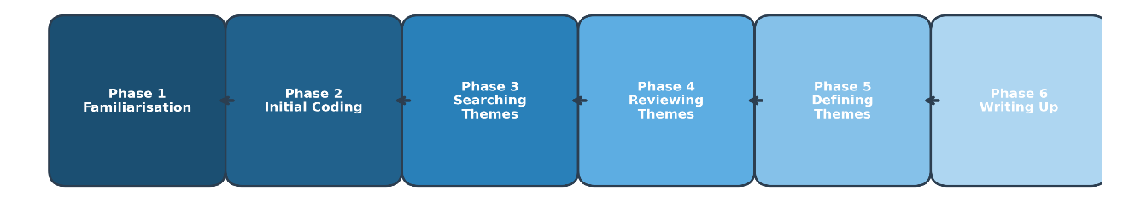

Figure 1. Braun and Clarke’s (2006) six-phase thematic analysis framework applied in this study.
In Phase 1, the researcher familiarised themselves with the data through multiple readings of the transcripts and gained a thorough understanding of both its richness and extent. In Phase 2, the researcher conducted an initial coding of all transcripts to produce codes reflecting both the explicit and the implicit content of the transcripts. In Phase 3, the researcher searched for themes by grouping together codes into potential thematic clusters. Phase Four ‘Reviewing themes’; the researcher checked the coherence of the candidate themes against the coded extracts and full transcripts and iteratively refined them. Phase five ‘Defining the different themes’; the essence of each of the various themes and descriptive labels were then defined. Finally, in phase six ‘Producing the report’; the researcher communicated the analytical narrative and collated representative data extracts. As there was an emphasis on improving the validity of findings related to the trustworthiness of interpreted data collected from participants through member-checking, researchers provided participants with the opportunity to review the transcripts and preliminary findings and provide their feedback on how their perspectives, voices and experiences were represented throughout the data analysis process (McKim, 2023).

6. Results
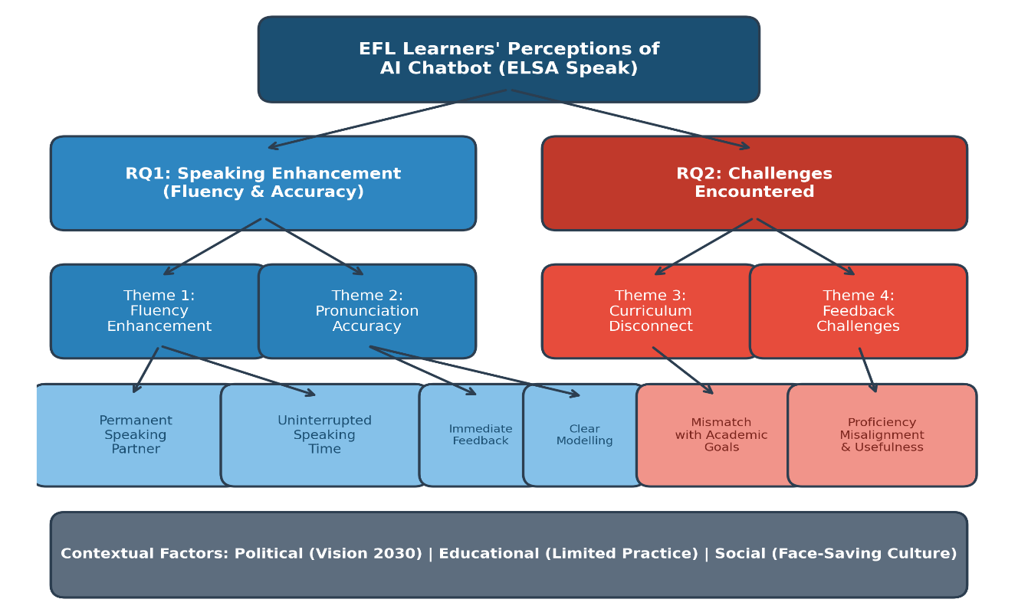
The results of the thematic analysis identified four key themes in the two research questions based on how the participants viewed ELSA Speak as a tool for improving their speaking performance. Within this, there are two main themes, fluency enhancement and pronunciation accuracy, that speak to benefits perceived by participants as well as two challenges experienced by participants in using ELSA Speak as a learning tool, including curriculum issues (curriculum disconnect) and feedback issues (feedback challenges). Figure 2 depicts the complete thematic structure and shows the relationship among each theme, sub-theme, and context.

Figure 2. Thematic map illustrating the hierarchical structure of themes, sub-themes, and contextual factors.

Table 3. Summary of Themes, Sub-Themes, and Illustrative Codes
RQ | Theme | Sub-Theme | Coded Refs. | Participants
RQ1 | Fluency Enhancement | Permanent Speaking Partner | 18 | 8/8 (100%)
 |  | Uninterrupted Speaking Time | 14 | 7/8 (87.5%)
 | Pronunciation Accuracy | Immediate Feedback | 21 | 8/8 (100%)
 |  | Clear Modelling | 12 | 6/8 (75%)
RQ2 | Curriculum Disconnect | Mismatch with Academic Goals | 16 | 7/8 (87.5%)
 |  | Reduced Usage | 9 | 6/8 (75%)
 | Feedback Challenges | Proficiency Misalignment | 13 | 5/8 (62.5%)
 |  | Feedback Usefulness | 11 | 5/8 (62.5%)
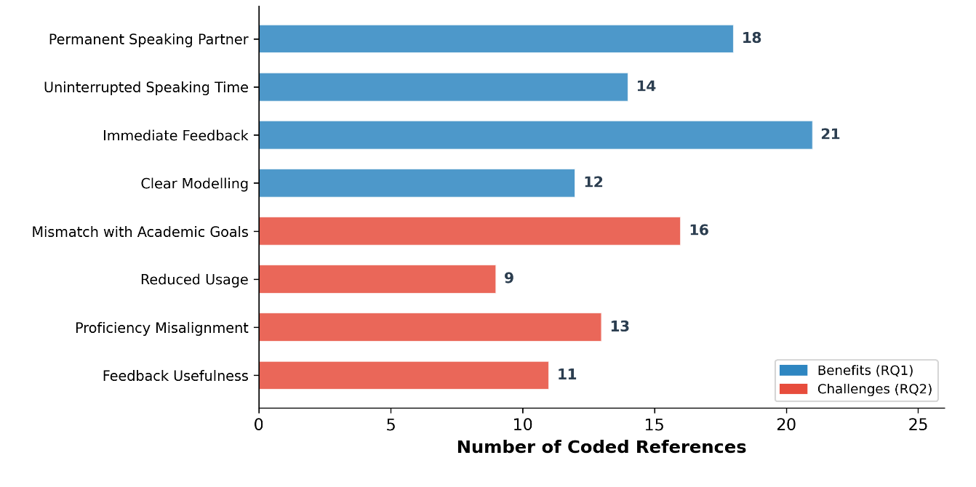

Figure 3. Frequency of coded references by sub-theme across all participant interviews.

6.1 Research Question 1: Speaking Enhancement

6.1.1 Theme 1: Fluency Enhancement
Participants of the study indicated that they benefitted from the use of an AI chatbot for their development as a fluent speaker. In conducting the thematic analysis of all participants written responses from this study, it was revealed that part of the reason for this benefit was twofold, the provision of a permanent speaking partner and the provision of uninterrupted speaking time.

Sub-Theme 1.1: A Permanent Speaking Partner. Across the eight interviews, a common theme was how much importance participants placed on having a partner who would be consistently available to practice with them. The participants in the interviews indicated that the amount of time they had available for speaking practice in a formal classroom setting was very limited, as was the number of times they had to practice speaking, which limited their ability to develop fluency when speaking. The AI chatbot met this need by being an always-available conversational partner for participants to practice with, thereby eliminating a major barrier to developing fluency: the lack of opportunities for authentic communication, both inside and outside of the classroom. “It definitely helped me to gain fluency since I do not have a lot of opportunities to speak in the classroom, even though we take an English class every single day”. (P4)
“Having something available to talk to at any time was the biggest advantage. I could practise at midnight if I wanted to, and it would never get tired of me”. (P1)
Sub-Theme 1.2: Uninterrupted Speaking Time. The participants expressed that chatbot interactions allowed them to have no temporal constraints on their speech. Consequently, they were able to speak more freely and likewise have their complete cognitive resources available for enhancing their fluency of speech. In addition, unlike speaking with another human being, there was no apprehension that participants would be using up the time or energy of their interlocutor. As a result of this psychological freedom, participants were able to engage in extended turn-taking, deliberate self-correction, and experimentation with novel linguistic structures.
“I was not in a rush to finish, which helped me gain more fluency... for example, I noticed that I used new vocabulary and new structures”. (P5)

6.1.2 Theme 2: Pronunciation Accuracy
The participants expressed that this second theme reflected their perceptions about the functioning of the chatbot to assist in improving their pronunciation accuracy. Two sub-themes were identified: accuracy achieved through immediate feedback and accuracy achieved through clear modelling.
Sub-Theme 2.1: Accuracy Through Immediate Feedback. The eight participants unanimously agreed that the instant corrective feedback provided through the chatbot has transformed the way they develop their pronunciation skills and the improvement they achieved would have taken much longer without it. All participants reported that receiving immediate, phoneme-specific corrective feedback allowed them to eliminate the guesswork related to independent practice of speaking since it provided pinpoint accuracy for identifying their pronunciation mistakes and determining the necessary adjustments to correct those mistakes. Moreover, participants expressed positive feedback about the colour-coded highlighting system in ELSA Speak, whereby pronunciation mistakes were highlighted in red, thereby allowing instant visual recognition of incorrect pronunciation areas.
“I especially found it helpful because I would not have understood where I made a mistake in my pronunciation”. (P3)
“The red colour made it very clear which sounds I needed to work on. It was like having a mirror for my pronunciation”. (P6)
Sub-Theme 2.2: Accuracy Through Clear Modelling. According to participants, the chatbot provided good samples of how to pronounce words clearly. By playing back the chatbot's pronunciation of a particular word as often as necessary, participants could better notice small differences in pronunciation and changes in rhythm when trying to reproduce those differences and learn from them. This way of repeating the sounds allowed for better identification of how similar (or dissimilar) the pronunciation of that particular word was to their own pronunciation of that same word.
“Hearing the AI chatbot pronouncing the word made me aware of the accurate pronunciation”. (P7)

6.2 Research Question 2: Challenges Encountered

6.2.1 Theme 3: Curriculum Disconnect
A persistent concern articulated by participants was the perceived misalignment between the chatbot’s content and their institutional academic curriculum.
Sub-Theme 3.1: Mismatch with Academic Goals. Out of the eight participants, seven reported that the tasks performed by the chatbot did not match the goals set by the instructors for the course. They reported that their use of ELSA Speak did not lead to improved performance in the assessments of the course, which made them feel that using the product was not an effective use of their time, especially during exam time.
“I felt like I was wasting time that I should use to study for my exams”. (P4)
Sub-Theme 3.2: Reduced Usage. During the 3-week trial phase, six participants indicated declining levels of engagement with chatbots due to concerns regarding the applicability of their curriculum materials through their Chatbot use. Attrition of this type points to the necessity for continued interest in chatbots, by providing an indication to users on how their use of the additional learning resources aligns with their short-term academic goals.

6.2.2 Theme 4: Feedback Challenges
Sub-Theme 4.1: Proficiency Misalignment. As part of their experiences, five participants reported that, on average, many of the responses generated by the chatbot were above what would be expected for A2 (beginner) level speakers. The vocabulary and grammatical complexity in the responses made it difficult for participants to understand assessment summaries and caused disruptions when they practiced using the chatbot.
“After the role-play task, I was given a long assessment summary of my speaking performance, which I did not fully understand. I had to stop and look up the English word for the correction, which slowed down my speaking practice”. (P8)
Sub-Theme 4.2: Feedback Usefulness. Participants expressed their concerns about the quality and relevance of the feedback they received. Participants appreciated the timely provision of the feedback; however, many reported experiencing cognitive overload due to the amount and level of detail included in some of the feedback they received from reviewers, resulting in some participants deliberately skipping the feedback entirely.
“Sometimes it was a lot of information that was not useful, which made me skip the feedback often”. (P2)

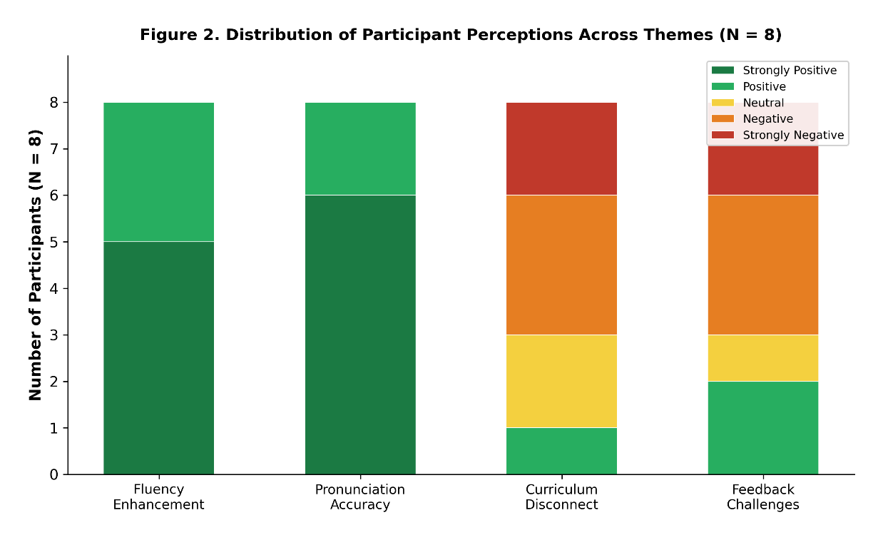

Figure 4. Distribution of participant perceptions across the four identified themes (N = 8).

7. Discussion
Through this study, an analysis was conducted on how an AI Chatbot (ELSA Speak) can assist English as Second Language (EFL) learners from Saudi Arabia, to improve their spoken English. In contrast, the results of this study demonstrate conflicting, but interestingly so, views about how these EFL learners feel they benefit from the use of ELSA Speak. The following section will present findings from the current study and analyse them in terms of existing literature and contextual elements present within the Saudi EFL context.

7.1 Fluency Enhancement: Political and Educational Dimensions
The finding that participants perceived the AI chatbot as instrumental in developing speaking fluency resonates strongly with existing literature. Fitria (2024) emphasised that Fluency is improved through consistent repetitive practice over time. Furthermore, Kim et al. (2021) found that when lower-proficient learners have access to Chatbots for practicing speaking, this led to increased fluency. The present study adds to this research by identifying additional ways in which the enhancement of fluency takes place by the provision of a permanently available speaking partner and the creation of temporally unconstrained practice opportunities.
Two contextual factors explain the results found in the EFL educational landscape of Saudi Arabia. Politically, students experience a lack of continuity between secondary and post-secondary educational policies when it comes to learning English. In other words, while students learn English in secondary school through grammar and translation, with little regard to developing their ability to communicate (Alharbi, 2024), in university, they are expected to communicate in English. Therefore, there is a disconnect between these two policies that leaves students unprepared for the oral requirements of their university coursework. Through its creation of a low-threat, interactive communicative environment, the AI chatbot has filled this gap.
Due to the amount of classroom time allocated to speaking practice and the number of students in many classes, there is not enough private time for each student to practice speaking. All the students who participated in this study agreed that their daily English lessons did not provide enough time to practice speaking in a meaningful way. Duong and Suppasetseree (2024) confirmed this finding in an earlier study, showing that AI chatbot instructional models allow for additional opportunities for students to practice speaking outside of formal instructional settings, which allows students to overcome the time constraints associated with this type of instructional model.

7.2 Pronunciation Accuracy: Social and Cultural Dimensions
Previous research by ElEbyary and Shabara (2024) supports the view that chatbots can be an effective way of helping learners develop accurate pronunciation; for example, they show that the use of instantaneous correction tools enables users to demonstrate their ability to accurate pronounce words. Similarly, Ding and Yusof (2025) concluded that interacting with chatbots significantly improved an individual’s ability to pronounce words accurately. Beyond the findings from these previous studies, the unique social interactional environment of the Saudi EFL context provides an opportunity to view this phenomenon through a different lens. In the Saudi culture, there is a high priority put on not being embarrassed in public. Because of how significant students' anxiety levels can become when it comes to making mistakes pronouncing their words while trying to live up to peer and instructor expectations, the process of practicing speaking in class can often be challenging (Alrabai, 2014). With the development of chatbots for students, the students can have a private space to practice this type of learning activity more often. Thus, they can practice their pronunciation without being concerned with any negative or damaging social ramifications of either their teachers or their peers when doing so. This finding provides further evidence to support the conclusion that the use of chatbots will assist in reducing the fear of social judgment that is commonly associated with speaking English and/or using other languages. The finding seems especially relevant to people from collectivist cultures, where the effect of saving face is exacerbated through public error correction.
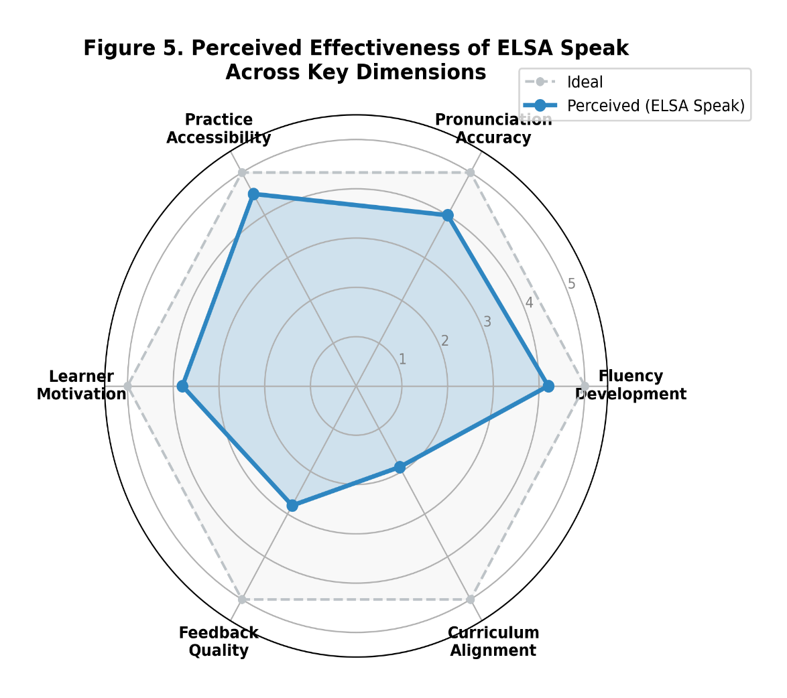

Figure 5. Perceived effectiveness of ELSA Speak across key dimensions based on participant reports.

7.3 Challenges: Implications for Design and Implementation
The findings from this study highlight important considerations for successfully incorporating AI chatbots into EFL courses. Participants identified disconnections between ELSA Speak’s content and institutional learning objectives. This supports Kim and Lee (2024) position that in order to maximise the effectiveness of AI chatbots, there needs to be a sufficiently clear and well-defined instructional guide for their presentation and inclusion in EFL Curriculums. The observed decrease in the number of uses of ELSA Speak over time indicates that how much a learner engages with ELSA Speak is dependent upon the extent of the connection between the use of ELSA Speak and the learner's immediate academic goals. The challenges associated with the feedback received from ELSA Speak (i.e. inappropriate level of proficiency and too much information) are also similar to the challenges that were identified by Lee and Kim (2025) regarding the use of AI-assisted language learning tools. Therefore, the data from this study provide a strong basis for a practical recommendation to develop AI chatbots that are developed for use by a specific Institution (i.e. with a specific Curriculum Alignment) and are based on the Learner's current Level of Proficiency and will provide relevant, concise, actionable feedback.
Table 4. Practical Recommendations for AI Chatbot Integration in EFL Contexts
Challenge Area | Recommendation | Target Stakeholder
Curriculum Disconnect | Develop institution-specific AI chatbots aligned with course learning outcomes and assessment formats | Curriculum designers, IT departments, administrators
Proficiency Misalignment | Calibrate feedback language to learners’ CEFR proficiency levels using adaptive algorithms | AI developers, educational technologists
Feedback Overload | Implement tiered feedback systems offering concise summaries with optional detailed expansion | AI developers, UX designers
Reduced Engagement | Integrate gamification elements and progress tracking linked to course milestones | Instructors, platform developers
Limited Practice Time | Formally incorporate chatbot practice into course syllabi with structured weekly targets | Instructors, programme coordinators

8. Conclusion
This qualitative study indicates that Saudi EFL learners perceive ELSA Speak, a chat bot used to facilitate speaking skill development, as a helpful tool. As a result of this study, we can better understand how AI chatbots can help improve the oral fluency and accuracy of pronunciation in contexts where students do not have access to face-to-face communication or suffer from culturally mediated anxiety toward speaking through oral practice. ELSA Speak acts like an easy-going and friendly digital application which will help students improve their pronunciation or fluency by giving real-time visual feedback on mistakes they make in these two areas. Many language learners do not have access to support for pronunciation and fluency errors, which makes the use of ELSA Speak very important when trying to learn a foreign language through conventional means.
While the findings of this study indicate the potential for positive changes through the use of an AI-based chatbot, they also highlight the need for careful consideration when developing methods for integrating AI technology into the educational systems within institutions. Based on how participants described the misalignment between AI-based chatbots and the institutions’ curriculum as well as the challenges faced by students when receiving feedback, it is necessary that developers of AI-based tools consider these students’ needs as well as the academic objectives of the institutions, and further consider how to ensure that the AI-based tools are designed to take into account the various levels of proficiency and the cognitive load that students must experience when using the tools. These results collectively indicate the need for a shift from commercially generic AI-based chatbots to institution-specific and pedagogically based AI tools that promote the use of technology while simultaneously allowing for tools that bridge the gap between technological innovation and situated educational practice.

9. Limitations
While interpreting the findings of this study, it is important to take into account some of the limitations. First, because the sample consisted of only eight females recruited from a single institution, the results may not be applicable to other educational contexts or populations: i.e., males and other proficiency levels. Second, a three-week trial, while adequate for collecting information regarding participants' perceptions, may not be long enough for participants to develop a more complete understanding of the effects of using a chatbot. Third, reliance solely on self-reported interview data does not allow for comparison of perceived benefits to actual improvements made in speaking ability without using objective measures of speaking performance, such as standardised pre- and post-tests. Lastly, the findings are based on the use of only one commercially available chatbot (ELSA Speak) while there are many other AI-speaking practice tools available today that have different design features and instructional strategies; therefore, it cannot be assumed that these results can be transferrable to the other AI-speaking practice tools.

10. Recommendations for Future Research
Future investigations should address the limitations of the present study through several methodological and substantive extensions. By utilizing larger, more heterogeneous samples that include participants from different institutions, levels of proficiency, and genders, it would be possible to provide a broader generalisation of the results of the current study. A longitudinal study following learners’ paths of engagement and developments in their speaking skills over the course of an extended period (e.g., one to two academic terms) would provide better evidence of the recurring effects of AI chatbots. Utilising mixed methods designs that combine qualitative data on participant perceptions with quantitative measures of speaking abilities, such as acoustic analysis of fluency and pronunciation, would provide a fuller, more triangulated evaluation of the effectiveness of the chatbot in achieving its goals. Additionally, comparing different platforms of AI chatbots would highlight the manner in which different design characteristics and teaching methodologies affect different types of outcomes. Finally, developing, implementing, and evaluating institution-specific AI chatbots that reflect a curriculum will be an area of significant promise for future research.

COMPETING INTERESTS DISCLAIMER:
Authors have declared that they have no known competing financial interests OR non-financial interests OR personal relationships that could have appeared to influence the work reported in this paper.

References
Abu Sahyon, A. (2023). Investigating the impact of AI-driven chatbots on the acquisition of English as a foreign language among Saudi undergraduate students. International Journal of Management Studies and Social Science Research, 1(5), 105–118. https://doi.org/https://doi.org/10.15379/ijmst.v10i2.3049
Alharbi, W. (2024). The challenges of effective English language teaching in Saudi schools. English Language Teaching, 17(10), 96–107. https://doi.org/10.5539/elt.v17n10p96
Alqahtani, M. (2024). Saudi EFL male students' perspectives on AI tools for enhancing English speaking skills. Arab World English Journal (AWEJ) Special Issue on CALL, 10(2), 30–45. https://doi.org/10.24093/awej/call.10.2.3
Alrabai, F. (2014). A model of foreign language anxiety in the Saudi EFL context. English Language Teaching, 7(7), 82–97. https://doi.org/10.5539/elt.v7n7p82
Alshahrani, M. (2016). A brief historical perspective of English in Saudi Arabia. Journal of Literature, Languages and Linguistics, 26, 43–50.
Behforouz, B., & Al Ghaithi, A. (2024). Investigating the effect of an interactive educational chatbot on EFL reading comprehension skills. International Journal of Engineering Pedagogy (iJEP), 14(4), 139–154. https://doi.org/10.3991/ijep.v14i4.48461
Braun, V., & Clarke, V. (2006). Using thematic analysis in psychology. Qualitative research in psychology, 3(2), 77–101. https://doi.org/10.1191/1478088706qp063oa
Bygate, M. (2001). Speaking. In R. Carter & D. Nunan (Eds.), The Cambridge guide to teaching English to speakers of other languages (pp. 14–20). Cambridge University Press. https://doi.org/10.1017/cbo9780511667206.003
Creswell, J. W., & Poth, C. N. (2018). Qualitative inquiry and research design: Choosing among five approaches. SAGE Publications.
DiCicco-Bloom, B., & Crabtree, B. F. (2006). The qualitative research interview. Medical Education, 40(4), 314–321. https://doi.org/10.1111/j.1365-2929.2006.02418.x
Ding, D., & Yusof, M. B. (2025). Investigating the role of AI-powered conversation bots in enhancing L2 speaking skills and reducing speaking anxiety: a mixed methods study. Humanities and Social Sciences Communications, 12(1), 1-16. https://doi.org/https://doi.org/10.1057/s41599-025-05550-z
Du, J., & Daniel, B. K. (2024). Transforming language education: A systematic review of AI-powered chatbots for English as a foreign language speaking practice. Computers and Education: Artificial Intelligence, 6, Article 100230. https://doi.org/10.1016/j.caeai.2024.100230
Duong, T. T. N., & Suppasetseree, S. (2024). The effects of an artificial intelligence voice chatbot on improving Vietnamese undergraduate students’ English speaking skills. International Journal of Learning, Teaching and Educational Research, 23(3), 293–321. https://doi.org/10.26803/ijlter.23.3.15
ElEbyary, K., & Shabara, R. (2024). ChatGPT-generated corrective feedback: Does it do what it says on the tin? Teaching English with technology, 24(3), 68–89. https://doi.org/10.56297/vaca6841/BFFO7057/MYEH4562
Fitria, T. N. (2024). AI chatbots: Developing English language proficiency in EFL students. Arab World English Journal, 15(2), 26–42. https://doi.org/10.24093/awej/vol15no2.3
Fryer, L. K., Nakao, K., & Thompson, A. (2020). Chatbot learning partners: Connecting learning experiences, interest and competence. Computers in human behavior, 93, 279–289. https://doi.org/10.1016/j.chb.2018.12.023
Huang, X., & Zhang, Z. (2024). The impact of chatbots based on large language models on second language vocabulary acquisition. Heliyon, 10(3), Article e25370. https://doi.org/10.1016/j.heliyon.2024.e25370
Kim, H.-S., Cha, Y., & Kim, N. Y. (2021). Effects of AI chatbots on EFL students’ communication skills. Korean Journal of English Language and Linguistics, 21, 712–734. https://doi.org/10.15738/kjell.2021.21.3.712
Kim, J., & Lee, Y. (2024). Voices from the flip: Teacher perspectives on integrating AI chatbots in flipped language classrooms. Education Sciences, 14(9), Article 1219. https://doi.org/10.3390/educsci14091219
Lee, J., & Kim, S. (2025). Generative AI and L2 written feedback studies: A scoping review. RELC journal, Advance online publication. https://doi.org/10.1177/00336882251386530
McKim, C. A. (2023). Meaningful member-checking: A structured approach to member-checking. American Journal of Qualitative Research, 7(2), 41–52. https://doi.org/10.29333/ajqr/12973
Smutny, P., & Schreiberova, P. (2020). Chatbots for learning: A review of educational chatbots for the Facebook Messenger. Computers & Education, 151, Article 103862. https://doi.org/10.1016/j.compedu.2020.103862
Vu, D. C., Nguyen, T. V., & Kitjaroonchai, N. (2024). Exploring the Relationship Between Working Memory Capacity and L2 Oral Fluency. Theory and Practice in Language Studies, 14(7), 2002-2012. https://doi.org/https://doi.org/10.17507/tpls.1407.06

