Spatial Variation of Total Dissolved Solids in the Dungarpur District, Rajasthan

Abstract: Total Dissolved Solids (TDS) is a key indicator of groundwater quality, representing dissolved minerals, salts, and organic matter that influence water usability for drinking and agriculture. This study assesses TDS variations across Dungarpur district, Rajasthan, using water samples collected from 21 locations. The results indicate that 76% of the samples fall within the desirable limit (≤500 mg/L), ensuring good water quality. However, Odabada (1225 mg/L), Virwada (778 mg/L), and Simalwada (607 mg/L) exhibit elevated TDS levels, likely influenced by mineral dissolution, agricultural runoff, and anthropogenic contamination. Conversely, Chandradiya (227 mg/L), Kanba (298 mg/L), and Aspur (285 mg/L) show the lowest TDS levels, which may necessitate mineral supplementation for drinking purposes. Spatial analysis using QGIS 3.24 highlights Bichhiwara Tehsil as the most affected region, requiring targeted water treatment interventions. The findings emphasize the need for regular groundwater monitoring, improved filtration techniques, and sustainable water management practices. Rainwater harvesting and public awareness initiatives are recommended to mitigate high TDS effects and ensure safe and sustainable groundwater resources in Dungarpur district.
Keywords: Groundwater quality, Total Dissolved Solids (TDS), Dungarpur district, Spatial analysis, Water management, Contamination sources

- Introduction:
“Total Dissolved Solids (TDS) is a critical indicator of water quality that reflects the combined concentration of dissolved minerals, salts, and organic matter.” According to Indian standards (IS 10500: 2012), the desirable limit for TDS in drinking water is 500 mg/L, with a permissible limit of 2,000 mg/L in the absence of alternative sources. TDS levels below 300 mg/L are considered excellent, while values above 1,200 mg/L are deemed unacceptable. High TDS levels can affect water taste, cause scaling in pipelines and appliances, and may indicate harmful contaminants like heavy metals. Prolonged consumption of high TDS water can lead to health issues such as kidney stones and hypertension, while water with excessively low TDS may lack essential minerals, potentially causing deficiencies. Dungarpur district, located in southern Rajasthan, faces significant challenges related to groundwater quality, which is a critical resource for drinking, agriculture, and daily use. The district's water quality has been assessed through various parameters, including fluoride, nitrate, iron, and Total Dissolved Solids (TDS), among others. Studies reveal that while TDS levels are generally within permissible limits in most areas, localized instances of elevated levels have been recorded, influenced by factors such as mineral dissolution, agricultural runoff, and waste disposal. High fluoride concentrations in several blocks, including Aspur, Dungarpur, and Sagwara, exceed permissible limits and pose risks of dental and skeletal fluorosis. Similarly, elevated nitrate levels, particularly in Simalwara and Sagwara tehsils, have raised concerns about methemoglobinemia, especially among infants. Iron concentrations also exceed safe limits in about 19.7% of samples, contributing to water quality concerns. Although parameters like chloride and TDS are typically within safe ranges, occasional spikes highlight the need for continuous monitoring. The district's tribal-dominated population is particularly vulnerable to health risks stemming from poor water quality, emphasizing the importance of interventions such as improved water treatment, source protection, and public awareness campaigns to ensure access to safe and sustainable drinking water.
The need to analyze Total Dissolved Solids (TDS) in groundwater research in Dungarpur district is crucial due to its direct impact on water quality, human health, and agricultural sustainability. TDS represents the total concentration of dissolved substances, including minerals, salts, and organic matter, which influence the potability, taste, and usability of groundwater. In Dungarpur, where groundwater is a primary source of drinking water, high TDS levels may indicate contamination from natural sources (rock dissolution) or human activities (agricultural runoff, wastewater disposal). Monitoring TDS helps identify areas with deteriorating water quality and potential health risks, such as kidney problems and gastrointestinal issues linked to excessive dissolved salts. Additionally, high TDS can affect crop yield by increasing soil salinity, making it essential to assess its impact on agricultural sustainability. Given the district’s tribal-dominated population, many of whom rely on untreated groundwater, studying TDS variations can guide policymakers in implementing water treatment solutions, conservation measures, and public awareness programs. Regular TDS monitoring in groundwater research ensures early detection of water quality issues, helping safeguard both public health and local livelihoods.
Beyond basic concentration levels, the spatial and temporal variation of Total Dissolved Solids (TDS) in groundwater is strongly governed by hydrogeochemical processes operating within aquifer systems. In Dungarpur district, the interaction between groundwater and host rock material plays a decisive role in determining dissolved solid loads. The region is underlain by complex geological formations, including gneisses, schists, quartzites, and phyllites, which influence groundwater chemistry through prolonged water–rock interaction. As groundwater residence time increases, enhanced dissolution of silicate and carbonate minerals contributes to gradual enrichment of dissolved ions, thereby affecting TDS levels.
Climatic conditions further regulate TDS variability. The semi-arid climate of southern Rajasthan is characterized by high evaporation rates, limited rainfall, and uneven monsoonal distribution. During prolonged dry periods, reduced recharge and increased evaporation lead to concentration of dissolved solids in groundwater. Post-monsoon recharge may temporarily dilute TDS concentrations; however, this dilution effect is often short-lived due to rapid withdrawal for domestic and agricultural purposes. Seasonal fluctuations in groundwater levels thus directly influence the chemical composition and TDS concentration of aquifers.
TDS does not act as an isolated parameter but is closely linked with the overall ionic composition of groundwater. Elevated concentrations of calcium, magnesium, sodium, bicarbonate, sulfate, and chloride collectively influence TDS values. Changes in any of these constituents can alter the overall dissolved solid load. Therefore, TDS serves as an integrative indicator reflecting the combined effect of multiple chemical processes rather than a single contaminant source.
The correlation between TDS and electrical conductivity (EC) is particularly useful in groundwater studies. EC measurements offer a rapid, cost-effective proxy for estimating TDS variations across large spatial scales. In regions like Dungarpur, where extensive laboratory testing may not always be feasible, EC-based monitoring can support preliminary groundwater quality assessments and help identify zones requiring detailed chemical analysis.

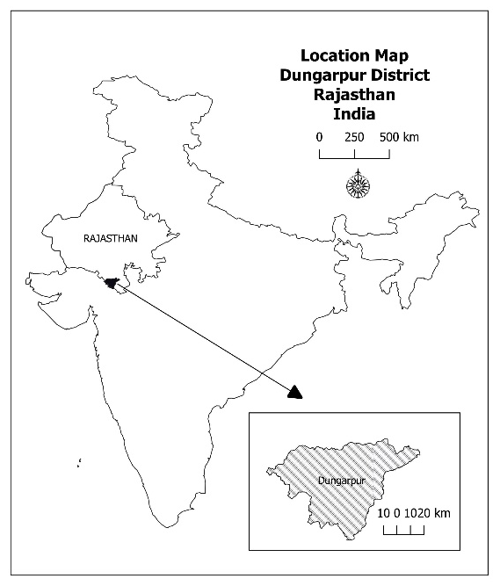
- The study area Figure 1 Location Map
Dungarpur district is located in the southernmost part of Rajasthan, India, and shares its borders with Udaipur district to the north, Banswara district to the east, and Gujarat state to the south and west. It lies between 23°20' to 24°01' North latitude and 73°21' to 74°23' East longitude, covering an area of approximately 3,770 square kilometers. The district is characterized by its undulating terrain, with hills and forests, and forms part of the Aravalli Mountain range. The major rivers flowing through the region include Mahi, Som, and Jakham, which are crucial for agriculture and groundwater recharge. Dungarpur is a tribal-dominated district, with a significant population of Bhil and Garasiya communities, who primarily depend on agriculture and allied activities for their livelihood. The district experiences a semi-arid climate, with an average annual rainfall of about 700 mm, mostly received during the monsoon season.
- Materials and Methods
  - Water sample collection
Water sampling was carried out between March to May 2023 at twenty-one stations within the Dungarpur District. The locations of sampling are presented in figure 2 and a detailed description of sampling points is displayed in table 1. Some environmental parameters including temperature, pH, and dissolved oxygen were measured in the field. Water samples were collected in 1 L glass bottles and were placed in cooler boxes with ice at approximately 4°C before analysis.

Table .1 Sampling Locations in the study area
Location | Latitude | Longitude
Bichhiwara | 23.78 | 73.52
Kanba | 23.81 | 73.57
Odabada | 23.82 | 73.59
Balbada | 23.82 | 73.62
Bori | 23.82 | 73.68
Genji | 23.72 | 73.69
Paldi | 23.71 | 73.73
Virwada | 23.63 | 73.74
Dhambola | 23.6 | 73.75
Simalwada | 23.53 | 73.76
Jorawarpura | 23.52 | 73.79
Chandradiya | 23.51 | 73.86
Sohanborli | 23.52 | 73.88
Bhimai | 23.56 | 73.92
Semlia ghata | 23.58 | 73.94
Khuntwada | 23.6 | 73.98
Sagwada | 23.66 | 74.01
Oad | 23.73 | 74.004
Punjpur | 23.86 | 74.03
Aspur | 23.94 | 74.07
Garda | 24.001 | 74.08
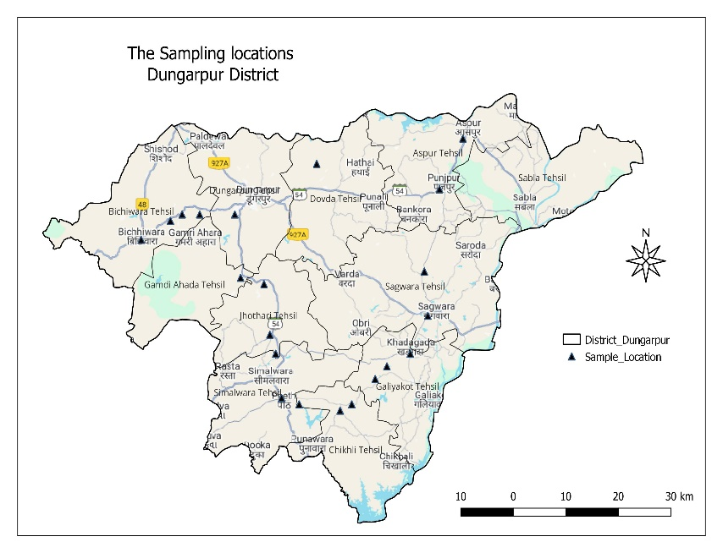

Figure 2 The Sampling Locations
3.2 Laboratory Analysis of TDS
Collected groundwater samples were analyzed for Total Dissolved Solids using standard analytical procedures recommended by recognized water quality guidelines. TDS values were determined through gravimetric and conductivity-based methods under controlled laboratory conditions to ensure accuracy and consistency. Quality assurance measures, including calibration of instruments and duplicate sample analysis, were employed to minimize analytical errors.
3.3 Spatial Interpolation and GIS Mapping
The collected data were processed and analyzed using QGIS 3.24 for tabulation and graphical representation. This approach helped in identifying spatial patterns, potential contamination sources, and the overall impact of various factors on groundwater quality in the study area. Geographic Information System (GIS) techniques were used to visualize the spatial distribution of TDS across Dungarpur district. Sampling point data were georeferenced using geographic coordinates and imported into GIS software. Spatial interpolation was performed using an appropriate interpolation technique to generate a continuous surface representing TDS concentration trends across the district. This method estimates TDS values for unsampled locations based on the spatial relationship among observed data points.
The interpolated TDS surface was clipped to the administrative boundary of Dungarpur district to ensure spatial accuracy. Tehsil boundaries were overlaid on the map to enable tehsil-wise interpretation of groundwater quality patterns.
3.4 Map Preparation and Visualization
The final TDS distribution map was prepared using a graded color scheme, where lighter shades represent lower TDS concentrations and darker shades indicate higher levels. This visual classification enhances interpretability and allows quick identification of areas with relatively elevated TDS levels. Essential cartographic elements such as legend, scale bar, north arrow, and administrative labels were incorporated to improve map readability and scientific presentation.

- Result and Discussion
The analysis of groundwater Total Dissolved Solids (TDS) levels in Dungarpur district reveals significant spatial variations, influencing water quality and usability. The TDS values range from 227 mg/L in Chandradiya to 1225 mg/L in Odabada, with an average of approximately 440 mg/L, which is within the desirable limit of 500 mg/L set by IS 10500:2012 for drinking water. Most locations (76%) fall within the safe limit, indicating generally good water quality. However, Odabada (1225 mg/L) exceeds the desirable limit, raising concerns about potential mineral leaching, agricultural runoff, or anthropogenic contamination. Virwada (778 mg/L) and Simalwada (607 mg/L) also show moderately high TDS levels, which may impact water taste and usability over time. On the other hand, Chandradiya (227 mg/L), Kanba (298 mg/L), and Aspur (285 mg/L) have the lowest TDS, which, while indicating low salinity, may lack essential minerals necessary for human consumption.
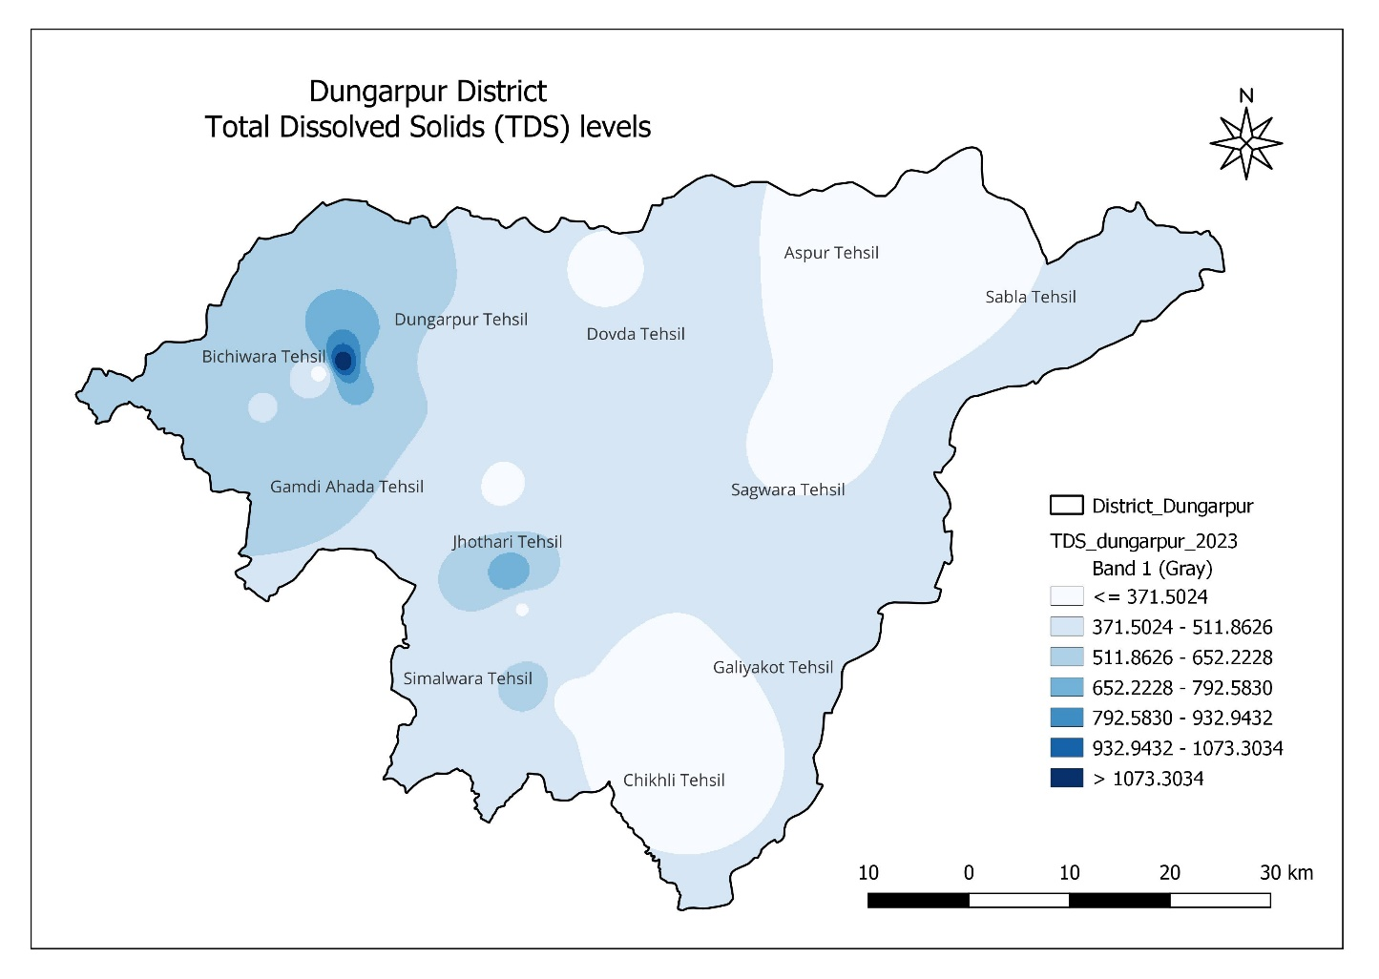
Figure 3 TDS levels in Dungarpur District
The TDS (Total Dissolved Solids) map (Figure 3) of Dungarpur district visually represents the spatial distribution of groundwater salinity across different tehsils. The color gradient indicates varying TDS levels, ranging from ≤ 371.5 mg/L (lightest shade) to > 1073.3 mg/L (darkest shade).
Key Observations from the Map:
- High TDS Zones:
  - The Bichhiwara Tehsil shows the highest TDS levels, with dark blue zones exceeding 1073 mg/L, indicating possible groundwater contamination or natural mineral dissolution.
  - Some parts of Jhothari Tehsil also exhibit moderate to high TDS levels.
- Moderate TDS Zones:
  - Dungarpur, Simalwara, and Gamdi Ahada Tehsils have TDS values ranging between 511 to 792 mg/L, which is within permissible limits but could affect water taste and usage over time.
- Low TDS Zones:
  - Aspur, Sabla, Galiakot, and Chikhli Tehsils have the lowest TDS concentrations, mostly ≤ 371 mg/L, suggesting good groundwater quality with minimal dissolved solids.
  - These areas may require mineral supplementation if used for drinking purposes, as excessively low TDS can lead to demineralized water, which lacks essential nutrients.

The variations in TDS could be attributed to geological formations, agricultural activities, and seasonal changes affecting groundwater recharge. To ensure water safety, regular monitoring, improved filtration techniques, and sustainable water management practices are essential. Areas with high TDS should consider reverse osmosis (RO) treatment, while promoting rainwater harvesting can help dilute mineral concentrations, ensuring long-term groundwater sustainability.
4.1 Influence of Geology and Land Use
The spatial variation of TDS in Dungarpur district can be largely attributed to geological heterogeneity and land-use patterns. The district lies within the Aravalli Supergroup, characterized by metamorphic rocks such as phyllite, quartzite, schist, and gneiss. Weathering and dissolution of these rock types release various ions into groundwater, thereby influencing TDS concentrations. Areas with shallow aquifers and limited recharge tend to exhibit higher TDS due to evaporation and concentration effects, particularly during pre-monsoon periods.
Anthropogenic factors such as agricultural practices, use of chemical fertilizers, unregulated disposal of domestic waste, and over-extraction of groundwater further exacerbate TDS levels in certain pockets. Similar observations have been reported in other semi-arid regions of India, where groundwater quality deterioration is closely linked with intensive land use and inadequate water management practices.
4.2 Socio-Economic Dimensions of TDS-Related Water Quality Issues
Groundwater quality issues associated with TDS have broader socio-economic implications, particularly in tribal-dominated regions like Dungarpur. Communities with limited access to treated water supplies often depend on locally available groundwater regardless of its chemical quality. In such contexts, even moderate deterioration in water quality can exacerbate existing vulnerabilities related to health, nutrition, and income security.
Women and children are disproportionately affected, as they are primarily responsible for water collection and household water use. Time spent accessing alternative water sources during periods of water quality deterioration can reduce opportunities for education and income-generating activities. Thus, TDS-related groundwater degradation extends beyond environmental concerns and intersects with issues of social equity and human development.
4.3 Implications for Drinking and Irrigation
From a drinking water perspective, groundwater with high TDS levels may cause taste-related issues, gastrointestinal discomfort, and scaling of pipes and household appliances. Long-term consumption of high TDS water has also been linked with kidney-related ailments and hypertension. For irrigation, elevated TDS can increase soil salinity, adversely affecting crop productivity and soil structure, especially in areas dependent on groundwater for irrigation.
4.4 Management and Mitigation Measures
The findings underscore the urgent need for regular groundwater quality monitoring in Dungarpur district, particularly in high-TDS zones such as Bichhiwara and adjoining areas. Adoption of appropriate water treatment technologies, including reverse osmosis (RO) and community-level filtration units, is recommended in affected villages. Additionally, rainwater harvesting and artificial recharge structures should be promoted to enhance groundwater dilution and reduce dissolved solid concentrations.
Public awareness programs focusing on groundwater conservation, judicious use of fertilizers, and protection of recharge zones can play a crucial role in maintaining groundwater quality. Sustainable groundwater management strategies, integrated with spatial analysis tools like GIS, are essential to ensure long-term water security in this tribal-dominated and environmentally sensitive region.
4.5 Policy and Management Implications
Effective groundwater management in Dungarpur district requires incorporation of TDS assessment into broader water resource planning frameworks. Policies aimed at groundwater sustainability must address both quantity and quality aspects. Promoting controlled fertilizer use, improving sanitation infrastructure, and encouraging artificial recharge techniques can help mitigate long-term TDS enrichment.
Community-based water management approaches are equally important. Educating local populations about groundwater quality, safe water practices, and simple household treatment methods can reduce exposure to poor-quality water. Involving local institutions and tribal governance systems in water monitoring initiatives can enhance awareness and foster collective responsibility for groundwater protection.
4.6 Research Gaps and Future Directions
Despite existing studies, several research gaps remain regarding TDS dynamics in the region. There is a need for detailed isotopic and geochemical studies to differentiate between natural and anthropogenic sources of dissolved solids. Understanding aquifer-specific processes can improve prediction models and guide targeted interventions.
Future research should also focus on climate change impacts on groundwater chemistry. Altered rainfall patterns, increased frequency of droughts, and rising temperatures are likely to influence recharge processes and dissolved solid concentrations. Integrating climate projections with groundwater quality studies will be essential for long-term water security planning.

- Conclusion
The analysis of Total Dissolved Solids (TDS) levels in Dungarpur district reveals notable spatial variations, with certain tehsils experiencing elevated TDS concentrations, potentially impacting groundwater quality and usability. Bichhiwara Tehsil shows the highest TDS levels, necessitating water treatment interventions, while Aspur, Sabla, and Chikhli Tehsils have the lowest values, indicating better water quality. The variation in TDS can be attributed to geological formations, agricultural runoff, and groundwater recharge patterns. To ensure sustainable water use, regular groundwater monitoring, advanced filtration methods, and rainwater harvesting should be prioritized. Implementing effective water management strategies will help mitigate high TDS effects, ensuring safe and sustainable groundwater for drinking and agricultural purposes in Dungarpur district.
References:
- Adimalla, N., & Qian, H. (2019). Groundwater quality evaluation using water quality index and GIS techniques in semi-arid regions of India. Environmental Science and Pollution Research, 26(4), 3461–3473. https://doi.org/10.1007/s11356-018-3868-2
- Appelo, C. A. J., & Postma, D. (2005). Geochemistry, groundwater and pollution (2nd ed.). A.A. Balkema Publishers.
- Bureau of Indian Standards. (2012). Indian standard drinking water—Specification (IS 10500:2012). BIS, Government of India.
- Central Ground Water Board. (2020). Groundwater quality in India. Ministry of Jal Shakti, Government of India.
- Central Ground Water Board. (2022). Groundwater quality report of Rajasthan. CGWB, Government of India.
- Freeze, R. A., & Cherry, J. A. (1979). Groundwater. Prentice Hall.
- Gupta, N., Pandey, P., & Hussain, J. (2017). Effect of industrial and agricultural activities on groundwater quality: A review of Indian case studies. Environmental Science and Pollution Research, 24(1), 1–13. https://doi.org/10.1007/s11356-016-7786-1
- Hem, J. D. (1985). Study and interpretation of the chemical characteristics of natural water (Water-Supply Paper No. 2254). U.S. Geological Survey.
- Kumar, M., & Puri, A. (2012). A review of permissible limits of drinking water with special reference to India. Journal of Environmental Science and Engineering, 54(1), 94–102.
- Li, P., Qian, H., Wu, J., & Zhang, Y. (2021). Groundwater quality assessment for drinking and irrigation purposes. Science of the Total Environment, 770, 145299. https://doi.org/10.1016/j.scitotenv.2021.145299
- Selvam, S., Singaraja, C., Venkatramanan, S., & Chung, S. Y. (2018). Spatial distribution of groundwater quality and its suitability for drinking and irrigation purposes. Arabian Journal of Geosciences, 11, 1–14. https://doi.org/10.1007/s12517-018-3502-0
- Singh, S., Yadav, S. K., & Kumar, P. (2020). Assessment of groundwater quality in arid regions using water quality index (WQI) and GIS-based techniques. Environmental Monitoring and Assessment, 192(4), 251. https://doi.org/10.1007/s10661-020-8182-4
- Subba Rao, N., Marghade, D., Dinakar, A., Chandana, I., Sunitha, B., & Ravindra, B. (2020). Hydrogeochemical processes controlling groundwater quality in hard rock aquifers. Environmental Earth Sciences, 79, 1–15. https://doi.org/10.1007/s12665-020-09088-7
- Todd, D. K., & Mays, L. W. (2005). Groundwater hydrology (3rd ed.). John Wiley & Sons.
- World Health Organization. (2017). Guidelines for drinking-water quality (4th ed.). World Health Organization.

