A study on the socio-economic status of the fishermen community at Diamond Harbour Block-I, West Bengal.

Abstract
This study examined the socioeconomic status of Diamond Harbour Block-I fishermen in South 24 Parganas, West Bengal. Additionally, the study sought to determine the obstacles faced by fishermen in the defined area. The study included door-to-door surveys and questionnaires. Most homes have more than four members, and many lack literacy skills. Both men and women fish in this area. In this area, Hindus and Muslims coexist without conflict. The bulk of the community fishes, with a tiny minority working in agriculture and manual jobs. Most people use public restrooms and government tube wells for drinking water. A large number of people couldn't afford a sturdy, permanent home. Some received training. Many government programmes and facilities are lacking. Fishermen face damage to gear and craft, natural calamities, and other challenges. Implementing appropriate fisheries management legislation, input supply, technical aid, and social support can improve fishers' livelihoods. These strategies could boost fisheries yields in West Bengal and India.

Keywords: Socio-economic status, Fishermen, Fisheries, Gears, Coastal area
Introduction:
Asia, the largest of the seven continents on Earth, boasts a staggering population of 4.2 billion individuals, constituting almost sixty percent of the whole global populace. India, according to the Food and Agriculture Organisation (FAO) in 2010, possesses a population of 1.21 billion individuals, accounting for 17.5 percent of the global population. Consequently, it ranks as the second most populated country in Asia and globally. A significant proportion of the Indian population, over 65 percent, continues to depend on agriculture as a primary source of sustenance and employment. Within this sector, fisheries are recognised as one of the subsectors contributing to the overall agricultural economy. Moreover, the fishing industry plays a crucial role in supplying the nation with a substantial and economically viable source of protein. The fishing industry holds considerable importance in contributing to the broader socioeconomic development of the nation. The recognition of its significant contribution to revenue generation and employment stems from its ability to foster the establishment of many ancillary enterprises. Moreover, it acts as a cost-effective and nutritionally rich food supply while also facilitating the acquisition of foreign currency. Moreover, fish and derivatives originating from the fishing sector are renowned for their exceptional gastronomic qualities, rendering them highly desirable culinary options for individuals. Significantly, this implies that it offers a method of sustenance for a considerable portion of the socioeconomically deprived population within the nation. By the conclusion of the year 2000, the total number of individuals engaged in the occupation of fishing had numbered 570,000. In the nine coastal districts under consideration, the total number of individuals engaged in fishing activities was estimated to be roughly 53,000. However, it is noteworthy that only 10,000 of these individuals demonstrated active interest and involvement in the practice of fishing. Numerous fishing towns exhibit economic disadvantages, geographical remoteness, and restricted accessibility to the general public, vital infrastructure, and necessary services. Additionally, these settlements often face limited coverage by social laws, notably in terms of population regulations. The prevailing social and economic conditions in their environment tend to foster a culture that promotes high rates of reproduction. Consequently, families that possess a surplus of labourers gain a competitive advantage in the utilisation of open-access fishery resources. Moreover, a larger number of offspring facilitates the expansion of income streams (Krishna, 2004). Throughout human history, fishing has been employed as a method for acquiring sustenance, with its origins dating back to the Stone Age. The practice of extracting fish and other aquatic organisms from their native environments for the purpose of sustenance and economic gain is commonly referred to as fishing. This activity, initially developed as a means of subsistence, has subsequently transformed into a commercial enterprise. According to the Food and Agriculture Organisation (FAO) of the United Nations, there was a twofold rise in fish production in India between the years 1990 and 2010. India has significantly increased its coastal area by a distance of 8129 miles, resulting in the inclusion of over 1.5 million individuals who are engaged in the fishing industry, either directly or indirectly. Fish is considered to be a dual-purpose entity, serving as both a vital source of sustenance and a means of generating cash. This is attributed to its status as a natural resource that fulfils the dietary needs of individuals while simultaneously contributing to the food security of India. The activity of fishing can be classified into two distinct categories: freshwater fishing, often referred to as inland fishing, and saltwater fishing, also known as marine fishing. Marine fishing is widely recognised as a substantial contributor to foreign exchange earnings and a key source of essential nutritional provisions for a large population. The former option is favoured by local consumers in India due to its diverse array of flavours, while the latter is regarded as a significant provider of substantial nutritional needs for this pulation. India's coastal waterways contribute to almost 60% of the nation's overall fish production. In 1977, the governmental authorities made the decision to extend their territorial boundaries by an additional 200 nautical miles of maritime expanse, with the aim of promoting and stimulating heightened engagement in deep-sea fishing endeavours. The government classified this particular area as an Exclusive Economic Zone (EEZ). According to Majumder (2018), the fishing industry in India contributes approximately 6.3% to global fish production, 1.1% to the nation's gross domestic product, and 5.15% to the agricultural GDP.
Adapting population policies and programmes to the socioeconomic context of the target population is imperative. This adaptation should consider the influence of demographic patterns on the formulation of long-term family strategies. Additionally, it is crucial to involve social entities in an active manner, as emphasised by Krishna (2004). The primary aim is to incorporate population, health, and welfare programmes with fisheries development and management activities to enhance the effectiveness of policies aimed at enhancing living standards and promoting sustainable utilisation of the fisheries industry. The implementation of fishery management systems that protect and acknowledge the rights of artisanal fishing groups has the potential to enhance the sustainable management of resources while also guaranteeing a fair distribution of benefits derived from fishing activities. This phenomenon can be attributed to the fact that these fishery management systems serve to safeguard and recognise the entitlements of artisanal fishing groups (Marcoux, 1997). Others, like Gaffar (2015), Wulandari et al. (2019), and Sudarso et al. (2019), also carried out studies on the socioeconomic status of fishermen.
West Bengal, boasting a coastline spanning around 158 kilometres, inclusive of the Hoogly-Matlah estuary, holds significant prominence as one of the foremost states in India in terms of marine fish production. According to Bandyapadhyay (2003), The entire inshore region, which is estimated to have a maximum depth of 10 feet, spans an area of 777 square kilometres. The extent of the offshore region, reaching a maximum depth of 40 feet, spans an area of 1813 square kilometres. In contrast, the continental shelf encompasses a significantly larger area of 17049 square kilometres. The entire inshore region, which is estimated to have a maximum depth of 10 feet, spans an area of 777 square kilometres. The mean production capacity is estimated to be roughly 35344.35 metric tonnes, while the offshore region, extending to a depth of 40 feet, spans an area of 1813 square kilometres. The size of the continental shelf is 17,049 square kilometres. In all, there exist a total of 19 districts, of which merely two own a coastline location, namely Purba Medinipur and South 24-Parganas. The rich maritime resources present in the area serve as a significant economic asset, generating income for over 2.15 million individuals. The aforementioned industry plays a pivotal role in the advancement of the socio-economic status of individuals engaged in fishing activities. The socio-economic condition of coastal fishermen in various regions of West Bengal has been investigated by multiple researchers (Bhaumik et al., 1994; Jha et al., 2003). The aforementioned industry plays a pivotal role in advancing the socio-economic status of individuals engaged in fishing activities. Nevertheless, the available information is characterised by its inconsistent and inadequate nature. The marine sector contributes to roughly 17.6% of the total fish production in West Bengal and 6.2% of India's annual marine production. The geographical area under investigation in this study predominantly employs two primary fishing methods: active fishing, which involves the use of a small trawler, and passive fishing, which uses a behundi net within a neretic region with a maximum depth of 50 metres. The next section provides a description of both of these strategies. This study aimed to observe the average catch and effort per fishing day over a six-month period (from mid-October to mid-March) for both mechanised and non-mechanised fishing vessels. There exists a dearth of published literature pertaining to the socioeconomic status, educational attainment, health indicators, living conditions, and other relevant dimensions of the individuals engaged in fishing activities within the specific locality and block of Diamond Harbour. The primary objectives of the present study are to classify the many cohorts engaged in different facets of fishing and to examine the socioeconomic circumstances of traditional fishermen.
Materials and methods:
Study site:
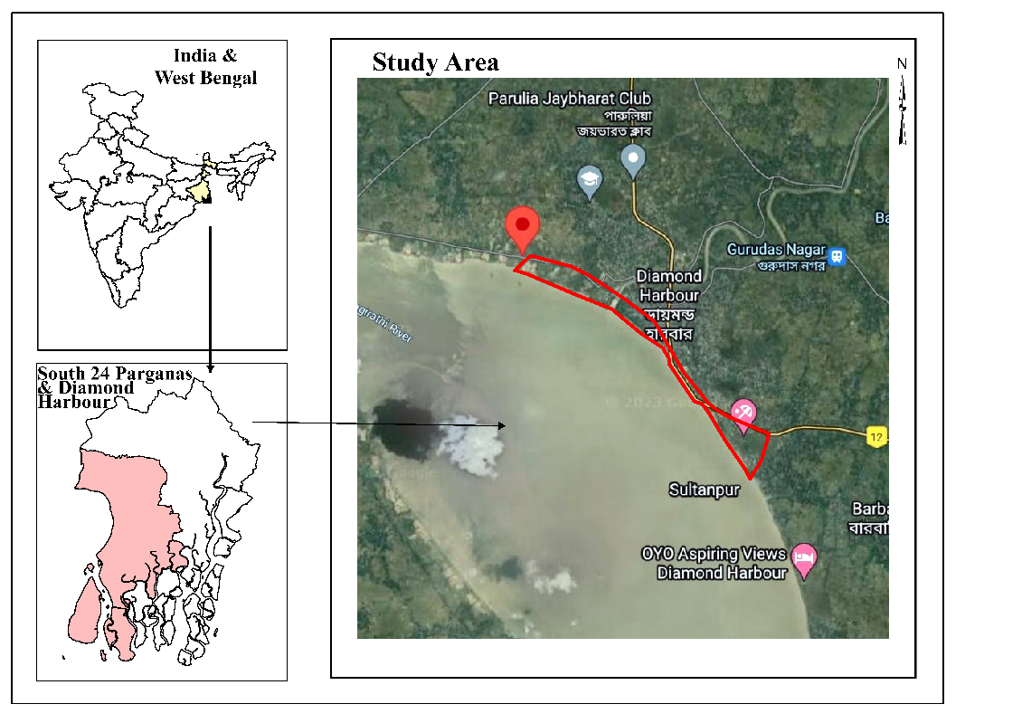
The present work was based on investigations that were conducted over the course of a year, beginning in May 2022 and ending in May 2023 in a location on the bank of the Hooghly River known as Diamond Harbour Block I (Ramrampur, Naiyapara, Diamond Harbour Choto Nodir Par, Sultanpur, Hanra and Jelepara). This location is in the South 24 Parganas District and is approximately 50 kilometres distant from Kolkata (Fig 1).

Fig 1. Study site (Source: Google).
Data collection:
The study was based on an analysis of data regarding various aspects of the socio-economic state of the fishing community. The fishermen who participated in the study fished either full-time (as their primary source of income) or part-time (as their secondary source of income). With the use of the questionnaire that had been produced, a survey of households was carried out. A survey that went door to door was conducted, and as part of that procedure, fishermen who were the primary breadwinners for their families were asked questions during the poll. It was determined that the majority of the population was illiterate, so questionnaires were not given out to solicit their feedback. Instead, the responses to each question on the questionnaire were recorded in the column that was most pertinent to that topic. During the course of the study, information was gathered from 113 fishing households located in the region bordering the river. These families were chosen at random using a comprehensive questionnaire (Fig 2).

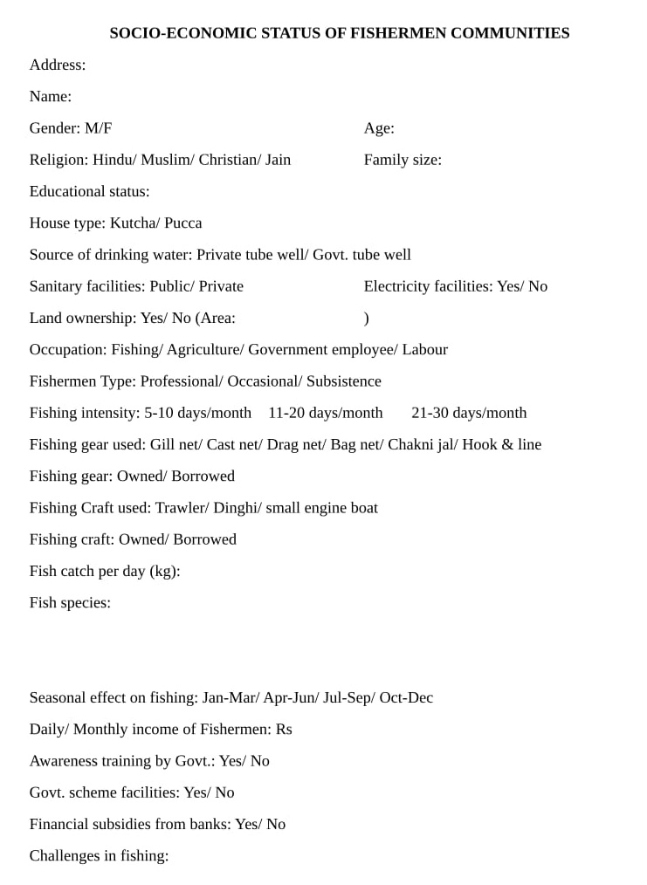

Fig 2. The Format of the Questionnaire sheet.
Data Analysis:
For the data interpolations, all the data were calculated in Microsoft Excel-2019.

Result:
In the course of the research, a variety of qualitative and quantitative aspects have been investigated. The measurements have been carried out for the purpose of determining the unprocessed metric values. The information was gathered from the fisherman with the use of a questionnaire, which includes the particulars of the people who live in Diamond Harbour block-I. When doing an analysis of socioeconomic status, several factors such as gender, age, level of education, the kind of housing, the presence or absence of government facilities, and occupation are noted. A total 113 numbers of fishermen interacted during the study period from five spots of Diamond Harbour block-I.
Among 113 numbers of fishermen most are male and a very smaller number of females are involved in fishing with a approx. percentage of 81% and 19% respectively (Fig 3).

Fig 3. Graphical representation of gender percentage.
Among the total male and female fishermen 80% belong to Hindu and 20% belong to Muslim religious status (Fig 4). 82% people of the total community stays in Kutcha houses and the remaining 18% of people stay in Pucca houses (Fig 5).

Fig 4 & 5. Percentage of religion and house type of the people living in Diamond Harbour block-I.
Among the total community 93.8% people depend on Government tube well for getting drinking water and 6.2% people have their own private tubewell to fulfill the demand of drinking water (Fig 6). 67% people depend on public sanitary facility and 33% people have their own sanitary facility (Fig 7).

Fig 6. Percentage of drinking water sources available for the people living in Diamond Harbour block-I.

Fig 7. Percentage of people depend on different sanitary facility.
Among the total 113 fishermen community 0.89% have qualified 2nd standard, 3.54% have qualified 3rd standard, 13.28% have qualified 4th standard, 14.16% have qualified 5th standard, 4.42% have qualified 6th standard, 5.3% have qualified 7th standard, 8.84% have qualified 8th standard, 3% have qualified 9th standard, 3.53% have qualified 10th standard, 0.89% have qualified 12th standard, 0.89% have qualified graduate level of education and remaining 41.6% people are illiterate (Fig 8).

Fig 8. Educational level of the people living in Diamond Harbour block-I.
Most of the fishermen (about 96.46%) are availing electric facility and rest of the community (3.54%) have no electric facility. Most of the people (98.2%) do not have any agricultural land but 1.8% people have agricultural land (Fig 10).

Fig 9. Availability of electricity in Diamond Harbour block-I.

Fig 10. Presence of agricultural land of the people living in Diamond Harbour block-I.
Among the total community 70.78% people involved in fishing and occupation, 28.3% people involved in fishing and labour occupation and 0.89% people involved in fishing and agriculture for maintaining livelihood (Fig 11). 76.99% of the fishermen community are occasional fishermen with a fishing intensity of 11 to 20 days/month, 21.23% are professional fishermen with a fishing intensity of 21 to 30 days/month and 1.76% of them are subsistence fishermen with a fishing intensity of 1 to 10 days/month (Fig 12).

Fig 11. Percentage of people involved in different occupations.

Fig 12. Fishing type-wise percentage of fishermen in Diamond Harbour block-I.
There also found 40.43% use of Drag net, 37.15% use of Gill net, 8.74% use of Hook and Line, 6.01% use of Bag net, 4.37% use of Chaknijal and 3.27% use of Cast net for fishing activity (Fig 13). They also use different fishing craft like Dinghi (10.61%), Trawler (7.96%), Small engine boat (7.07%) and Raft (0.89%) and most of them about 73.45% people don’t use any fishing craft (Fig 14).

Fig 13. Percentage of fishing gears used by the fishermen of Diamond Harbour block-I.

Fig 14. Percentage of fishing crafts used by the fishermen of Diamond Harbour block-I.
Table 1. List of fish species caught by the fishermen of Diamond Harbour block-I.

Categories | Species
Maximum | Macrobrachium rosenbergii, Penaeus monodon, Macrospinosa cuja, Arius thalassinus, Arius maculates, Arius gagora,
Moderate | Tenualosa ilisha, Pampus argenteus,Polynemus paradiseus, Sardinella longiceps
Minimum | Portunus pelagicus, Scylla serrata, Harpodon nehereus, Scatophagus argus, Rastrelliger kanagurta, Osteobrama cotio

Among 113 fishermen 39 people belong to 0 to 200 Rs/day income scale, 55 people belong to 201 to 500 Rs/day income scale, 7 people belong to 501 to 1000 Rs/scale, 5 people belong to 1001 to 3000 Rs/day income scale, 5 people belong to 3001 to 5000 Rs/day income scale and 2 of them belong to 5001 to 6000 Rs/day income scale (Fig 15). Among the total fishermen community, 35.4% of people get benefits of the Government scheme and the remaining 64.6% don’t get benefits of the Government scheme yet (Fig 16). And few of them about 11.5% people got awareness training and rest 88.5% people are still untrained (Fig 17).

Fig 15. Slap-wise daily income in (Rs.) of the fishermen of Diamond Harbour block-I.

Fig 16. Percentage of fishermen benefitted through different govt. schemes.

Fig 17. Percentage of fishermen attend different awareness training programme.

Discussion:
Based on the results of the present investigation concerning the socioeconomic backgrounds of fishermen in Diamond Harbour Block-I, it is evident that a higher proportion of male individuals engage in fishing activities compared to their female counterparts (19.46 percent versus 80.53 percent). Due to its proximity to an estuary, the research facility's location has led to a predominant reliance on catch fisheries among the local fishermen as their major means of livelihood. Due to the higher physical demands associated with capture fisheries compared to culture-based fisheries, a larger proportion of male individuals are employed in this particular sector. The study site mostly comprised residential districts, where the Hindu and Muslim communities held a dominant presence. The proportion of individuals engaged in fishing activities who identified as Hindu was notably greater compared to those who identified as Muslim. Due to the elevated prevalence of Hindu communities inside the research site, the study had an increased likelihood of effectively involving Hindu groups in comparison to Muslim communities. Due to the prevailing socio-economic conditions of the fishermen residing in the research location, a significant proportion (80%) of their households are constructed in the Kutcha architectural style. Furthermore, it was contended that the construction of Pucca houses did not get any form of government subsidy or assistance. Prabhavathi and Krishna (2017) obtained comparable results, indicating that fishermen experience not just economic disadvantage but also social backwardness and low literacy levels. Moreover, the economic circumstances of these individuals tend to foster the formation of families with high fertility rates, resulting in a plentiful labour force that confers advantages in the realm of marketing and other related endeavours. The study revealed that a significant majority of fishermen, namely over 93 percent, possess the privilege of using drinking water facilities provided by the government. Approximately 67 percent of fishermen were found to utilise communal sanitary facilities that were originally intended for 10 to 12 families. It is noteworthy that the government bears the majority of the expenses involved with the provision and maintenance of these facilities. Furthermore, it is worth noting that a significant proportion, specifically one-third, of the fishermen have taken the initiative to construct their own dedicated bathroom and shower amenities. Since the initiation of the Swachh Bharat Mission by the Indian government in 2014, a significant number of fishermen have become cognizant of the importance of cleanliness and sanitation.
The illiteracy rate among fishermen exceeds forty percent, while over fifty-two percent of fishermen have attained education up to the second standard or beyond. A mere three percent of fishermen have completed their education up to the tenth standard, and a minority of 0.88% of fishermen have successfully obtained a college degree. Due to the prevalence of individuals originating from economically disadvantaged fishing households, a significant proportion of the population commenced their involvement in the fishing industry at a young age, resulting in a temporary suspension of their educational pursuits. Biswas et al. (2018) reported the same findings in the North 24 Parganas area of West Bengal. Over 96.46 percent of the residences belonging to fishermen are supplied with electricity. A significant majority of fishermen, specifically over 98.23 percent, have limited availability of agricultural land as they typically commence their fishing occupations at an early age and persist in this profession throughout their lifetimes. Their livelihood is entirely dependent on engaging in fishing operations, which primarily consist of capturing fish. The predominant occupation among fisherman is capture fishing, which is pursued by a significant majority, accounting for approximately 70.79% of individuals in this profession. Additionally, a notable proportion of fishermen, approximately 28.79%, are primarily involved in fishing and labour-related activities. Due to limited arable land, a significant proportion of the populace chooses to engage in the fishing industry as an alternative means of employment. Among the members of this cohort, a notable proportion of 21.23 percent actively participate in the industry, while the majority, comprising 79.99 percent, engage with it less frequently.
The Gill net and the Chakni Jal were the primary fishing gear utilised, accounting for 40% and 37% of usage, respectively. The species often collected through the utilisation of gill nets in the estuary region include Illish, Bhola, Sona tangra, and Topse. Given their prevalence and availability, it may be inferred that these places serve as favourable fishing grounds. The Chakni Jal, as depicted in Figure 30, serves as the major fishing equipment utilised by women who participate in the collection of fish seedlings. Due to the prevalence of catch fisheries located around coastal areas, it is observed that a significant proportion, specifically 73.45%, of individuals lack access to any type of watercraft. Furthermore, only a few, approximately 10%, have dinghi crafts, as depicted in Figure 31. In recent years, there has been a notable rise in the proportion of fishermen who opt to outfit their boats with motorised propulsion systems. This discovery bears a notable resemblance to the findings presented by Prabhavathi and Krishna (2017).

The species of M. rosenbergii, P. monodon, M. cuja, A. thalassinus, and A. gagora were the ones that were caught the most frequently. Less frequent species are Portunus pelagicus, Scylla serrata, Harpodon nehereus, Scatophagus argus, Rastrelliger kanagurta, and Osteobrama cotio. The following species are included in the medium catch: Tenualosa ilisha, Pampus argenteus, Polynemus paradiseus, and Sardinella longiceps. Among them, Tenualosa ilisha is the most catchy species during the monsoon season as they migrate to rivers for breeding purposes, and the gill net is the most used gear, so the catch is also high (Table 1). The study by Bhaumik (2017) also supports the findings of the present study.
Out of the total sample size of 113 fishermen, it was observed that 39 individuals fell within the income range of 0 to 200 Rs/day, while 55 individuals fell within the income range of 201 to 500 Rs/day. Additionally, 7 individuals belonged to the income bracket of 501 to 1000 Rs/day, 5 individuals belonged to the income bracket of 1001 to 3000 Rs/day, 5 individuals belonged to the income bracket of 3001 to 5000 Rs/day, and 2 individuals belonged to the income bracket of 5001 to 6000 Rs/day (Figure 32). There exists a positive association between the number of fishermen in a family and their daily income, as indicated by a multiple R square value of 0.21. Given the observed positive correlation between family size and annual income, it is logical to infer that the annual income will exhibit a proportional increase in tandem with the number of employed people within a family unit. This result is consistent with the findings of Bhattacharya (2011), who reported a correlation coefficient of 0.4889. Hence, the size of the family has a significant role in the demographic composition of the fishing population within the designated study region, facilitating a comprehensive comprehension of the community's economic context. Hence, the optimisation of revenue leads to a corresponding augmentation in the overall resilience of the household's fishermen. There is a correlation between income and several factors, such as spending patterns, educational attainment, livestock ownership, housing type, occupational status, educational level, and overall living conditions. Income is additionally associated with various other attributes. Hence, the financial earnings of a household emerge as the primary determinant while seeking to comprehend the socio-economic status of the population. A mere 35.4% of the fishing community as a whole currently receives benefits from government programmes, leaving the remaining 64.6% of fishermen without access to such benefits. Out of the fishermen questioned, 88.49% of individuals had received periodic instruction from the government on sustainable fishing practices. In addition to the aforementioned concerns, the individuals encountered several additional obstacles. These included the absence of an appropriate distribution channel, insufficient governmental support in the form of loans, grants, and other initiatives, and the damage inflicted upon their fishing equipment due to vessel activity and various natural calamities. Furthermore, the gathered prawn seed did not receive the appropriate valuation. It has been proposed that a government survey be conducted in the research region to address the plight of impoverished fishermen who have been deprived of their entitlements.

Conclusion:
Based on the results of this study, it is evident that farmers have managed to attain a very low level of production, despite their little educational background and minimal financial and technical assistance from governmental and non-governmental entities. Moreover, the farmers possess a significant amount of expertise. In order to facilitate improvements in living conditions, it is imperative to execute several measures, such as the integration of agriculture with a system for fish and prawn farming, the increase of educational opportunities, and the insistence on adherence to family planning. The provision of government support to this community is expected to result in a consequential rise in the quantity of fish harvested, likely bolstering the economic conditions of the nation. Based on the results of the investigation, it is suggested that the implementation of proficient regulations in fishery management, along with the provision of effective input supply and technical and social assistance, might potentially enhance the well-being of fishers. This, in turn, has the potential to contribute to an overall increase in India’s fishing productivity. Due to the limitations imposed by the study, such as a limited coverage area and a relatively small sample size, there is potential for future enhancement of the research by incorporating more regions and augmenting the participant pool.
In summary, the examination of the socio-economic situation of fishermen holds significant importance in fostering the sustainable advancement of coastal communities and the fishing sector. This study offers significant contributions in terms of designing specific treatments, enhancing social well-being, advocating for environmental conservation, and formulating policies that bolster the livelihoods and resilience of fishing communities amidst a dynamic global landscape.

References:
Bandyapadhyay, P., BhaweshSawam, S., Chakraborty, S. 2003. Status of Fisheries Development in W.B. Fishing Chimes, 23 (1), 146-153.
Bhattacharya, M. 2011. A study on the socio-economics of coastal fisheries with special reference to the Sundarbans of West Bengal, India. Int J Curr Res, 3, 286-291.
Bhaumik, U. 2017. Fisheries of Indian Shad (Tenualosa ilisha) in the Hooghly–Bhagirathi stretch of the Ganga River system. Aquatic Ecosystem Health & Management, 20(1-2), 130-139.
Biswas, B., Das, S. K., & Mandal, A. 2018. Socio-economic dimensions and their impacts upon productivity of composite fish farming in north 24 parganas district, West Bengal. Nature, 25(35), 41-67.
FAO, World review of fisheries and aquaculture. In: The state of world fisheries and aquaculture 2009. FAO, Rome, 2010; 3-87.
Gaffar, S. B. 2015. The contribution of modernized fishing technology on the socio-economic status of the Takalar People of South Sulawesi in Indonesia. Journal of Sustainable Development, 8(6), 31.
Jha, S.K., Bandopadhyay, B.K., Majhi, B. and Tripathi, S. 2003. Socio-economic profile of Typical coastal village of Sundarbans. J. Indian Soc. Coastal Agric. Res., 21 (2) : 45-48.
Krishna P.V. 2004.Socio-economic conditions of fishermen community in some selected coastal villages of West Godavari district, Andhra Pradesh coast. Aquacult. 5(2):241-246.
Majumder, A. 2018. An Empirical Study on Socio-Economic Conditions of Fishermen of North-East Coastal Region of India. IRA-International Journal of Management & Social Sciences (ISSN 2455-2267), 11(2), 69-86. doi: http://dx.doi.org/10.21013/jmss.v11.n2.p2
Marcoux, A. 1997.Fisheries and fisheries-population concerns and sustainable natural resources management. Presented at the workshop on population characteristics and changes in coastal fishing communities, Madras. India. 10- 14, 566:47-50.
Prabhavathi, K., Krishna, P. V. 2017. Socio-economic conditions of fishermen community in some selected areas of Nizampatnam area, Guntur district, Andhra Pradesh. International Journal of Zoology Studies, 2(5), 212-215.
Sudarso, S., Keban, P. E., &Mas’udah, S. 2019. Gender, religion and patriarchy: The educational discrimination of coastal Madurese women, East Java. Journal of International Women's Studies, 20(9), 2-12.
Wulandari, R. D., Qomarrudin, M. B., Supriyanto, S., Laksono, A. D., Qomaruddin, B., &Laksono, A. D. 2019. Socioeconomic disparities in hospital utilization among elderly people in Indonesia. Indian J Public Heal Res Dev, 10(11), 1800-4.

Fig3: Survey work

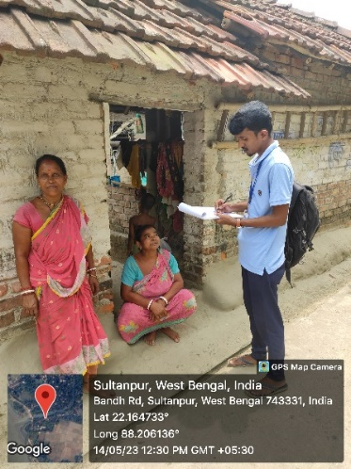
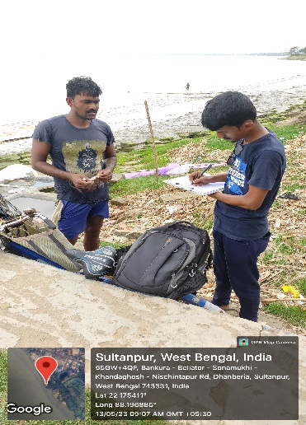
18 19
Fig 18 and 19: Door to door questionnaires to fishermen.
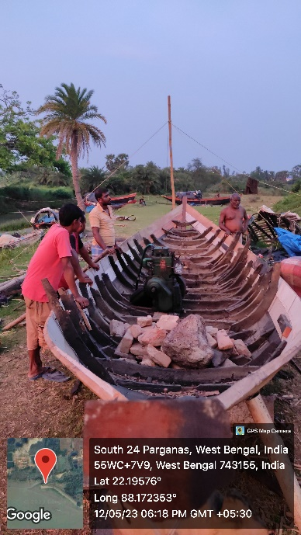
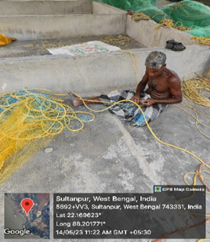
20 21
Fig 20 and 21: Gear and craft repairing of fishermen during off fishing season.

