Original Research Article

The Mediating Effect of Out-of-field Teaching on the Relationship Between Teacher Competence and Academic Performance Among College Students

ABSTRACT
This study examined the mediating effect of out-of-field teaching on the relationship between teacher competence and academic performance of college students. This study used a stratified random sampling technique and mediation analysis with 197 college students within Santo Tomas, Davao del Norte who were enrolled in the second semester of the Academic Year (A.Y) 2024-2025. The statistical tools utilized in this study were Mean, Pearson r, and Path Analysis. The information was accumulated from the respondents using modified adapted survey questionnaires which were subjected to teacher competence, out-of-field teaching, and grades from specific subjects. The findings revealed that out-of-field teaching had an overall mean of 3.46, and teacher competence had a mean of 3.49 while academic performance had a mean of 87.49 which meant that out-of-field teaching and teacher competence both had a descriptive level of high while the students’ academic performance was satisfactory. Furthermore, the interrelationship between teacher competence and academic performance showed a positive and medium correlation. Teacher competence and out-of-field teaching showed a positive and very strong correlation while out-of-field teaching and academic performance had a positive but weak correlation. Additionally, the mediation analysis revealed that out-of-field teaching had no significant mediation effect. The result indicated that while out-of-field teaching is associated with both variables, it does not significantly mediate the effect of teacher competence on student outcomes. This highlights the direct importance of enhancing teacher competence to improve academic performance, regardless of field alignment.

Keywords - out-of-field teaching, teacher competence, student academic performance, mediation analysis, Philippines.

1. INTRODUCTION
1.1 Background of the Study
Academic performance is defined as the lengths to which educational goals and objectives are met by instructors, institutions, and students (Nepali, 2021). Multiple studies have proven that students’ performance has shown to be affected negatively by inadequate pedagogical competence of teachers (Sukma, 2022).
In Ghanaian basic schools, out-of-field teaching negatively impacts their students’ performance due to teachers struggling with lesson preparation conducting assessments, and managing the classroom effectively (Apau, 2022). It is also evident in Botswana that there is a significant decline in performance of the students’ education which was also attributed to the teachers’ lack of awareness regarding the shifts in teaching approaches (Dinama et al., 2021).
In the Philippines, out-of-field teaching also poses a significant challenge for teachers and can potentially impact students’ performance. Being assigned to subjects that aren’t their expertise led to difficulties in content mastery, establishing authority, and appropriate teaching strategies (Bugwak, 2021). In struggling with content mastery, teachers from public senior high schools’ divisions of Eastern Samar also have a declining student performance (Lagria, 2021). With this, the lacking amount of qualified teachers in their specialty leads to gaps in students’ understanding and overall performance (Arendain & Limpot, 2022).
Much of the previous research explores the relationship between teacher competence and the students’ academic performance, but only limited studies include out-of-field teaching as a mediating factor especially within the local context. The increasing number of issues regarding the effect of out-of-field teaching poses a significant challenge for educational quality. With this, the researchers find it urgent to give immediate attention to this issue since it is essential to bridge the gap in the literature covering the mediating effect of out-of-field teaching on the relationship between teacher competence, and students’ academic performance. The results of this study hope to provide evidence-based recommendations for addressing the challenges of out-of-field teaching in enhancing both teachers’ competence and students’ academic performance.
1.2 Statement of the Problem
This study examined the mediating effect of out-of-field teaching on the relationship between teacher competence and academic performance among college students. Specifically, this aimed to answer the following questions:
1. What is the level of out-of-field teaching among college students in terms of:
1.1 contextualizing content;
1.2 emphasizing content over performance; and
1.3 embracing mentorship and assistance?
2. What is the level of teacher competence among college students in terms of:
2.1 pedagogic competency; and
2.2 professional competency?
3. What is the level of academic performance among college students in terms of grade in:
3.1 ELECT 101: Entrepreneurial mind;
3.2 GE 6: Arts Appreciation;
3.3 EDUC 104: Technology for teaching and learning; and
3.4 EDUC 106: Assessment on learning 1?
4. Is there a significant relationship between:
4.1 teacher competence and academic performance among college students;
4.2 teacher competence and out-of-field teaching; and
4.3 out-of-field teaching and academic performance among college students?
5. Is there a significant mediating effect of out-of-field teaching on the relationship between teacher competence and academic performance among college students?
1.3 Hypotheses
The following hypotheses were tested using 0.05 level of significance.
1. There is no significant relationship between:
1.1 teacher competence and academic performance among college students.
1.2 teacher competence and out-of-field teaching among college students.
1.3 out-of-field teaching and academic performance among college students.
2. There is no significant mediating effect of out-of-field teaching on the relationship between teacher competence and academic performance among college students.
1.4 Theoretical Framework
This study was based on the Pedagogical Content Knowledge theory (PCK) that was introduced by Shulman (1987) where the need for teachers to have the knowledge both on a specific subject and pedagogy was emphasized to effectively teach the subject matter. According to him, out-of-field teaching negatively impacts a teacher’s pedagogical content knowledge in the same way that it negatively affects the academic performance of the students. With that said, teachers who have higher levels of pedagogical content knowledge are likely going to be more effective in teaching (Moh’d et al., 2021). Additionally, Kabilan et al. (2023) stated that knowledge in the teachers’ area of content and pedagogy is necessary because without this, their students are prone to facing difficulty in learning. Lastly, the study also showed that teachers’ instructional practices could be improved by also enhancing their pedagogical content knowledge which consequently leads to better academic performance of the students.
Similarly, Bandura’s (1997) Self-Efficacy theory emphasized that the performance of an individual is influenced by their confidence in their own abilities. Due to the unfamiliarity with the subject, out-of-field teaching may lower the self-efficacy of teachers that may impact their competence, leading to poor academic performance of the students. Tran (2023) also stated that out-of-field teaching may either hinder or boost teachers’ competence depending on how they see their role in teaching. Those who have a high level of efficacy are more likely to find out-of-field teaching as an opportunity rather than a challenge which can greatly affect their students’ performance.

1.5 Conceptual Framework
In Figure 1, the conceptual framework of the study was presented. The independent variable of the study was the teacher competence. This independent variable constructed two (2) indicators which were pedagogic competency and professional competency (Sumaryanta et al., 2018).
The dependent variable of the study was the academic performance. This dependent variable constructed four (4) indicators which were; ELECT 101: Entrepreneurial mind, GE 6: Arts appreciation, EDUC 104: Technology for teaching and learning, and EDUC 107: Assessment on learning 1.
The mediating variable of the study was the out-of-field teaching. The mediating variable constructed three (3) indicators which were contextualizing content, emphasizing content over performance, and embracing mentorship and assistance (De La Cruz & Alda, 2024).
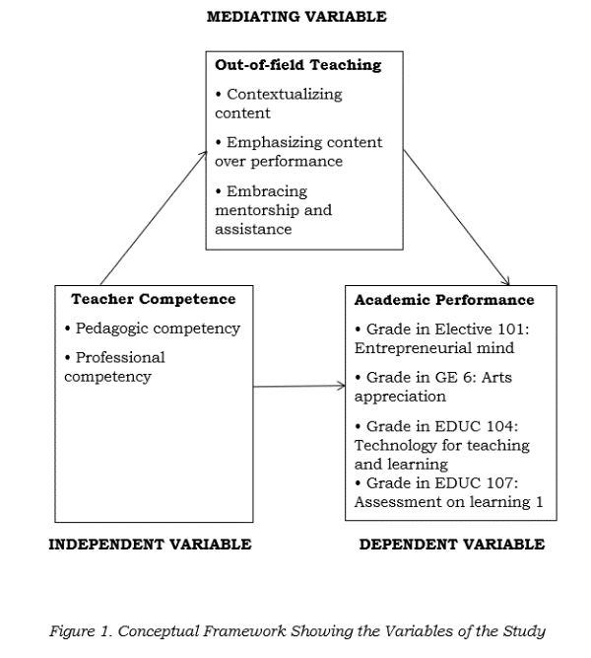

2. METHODOLOGY
2.1 Research Design
To elucidate the quantitative data collected about the level of the three variables, including out-of-field teaching, teacher competence, and the academic performance, quantitative non-experimental descriptive correlational was utilized. It tested the significant relationship of variable and the mediating effect of out-of-field teaching on the relationship between teacher competence and academic performance among college students. Additionally, quantitative research uses research methods related to statistics and numbers to attain, explain, and analyze data (Barella et al., 2024). This approach explained the relationship between variables, test the hypothesis, and generalize the finding from a large sample size (Helmold, 2019).
Descriptive research utilized an observational approach that is used in various fields including healthcare and developmental science. It hovers over a range of studies like case reports with a goal of analyzing and documenting phenomenons (Indu & Vidhukumar, 2020). Moreover, correlational research is a quantitative method which examines the relationships between two or more variables without manipulating them (Kettler, 2019).
This research used mediation analysis that ultimately focused on recognizing the procedure that brings an evident relationship between teacher competence and students’ academic performance through incorporating out-of-field teaching as a potential mediating variable. A mediation model hypothesizes that the independent variable impacts the dependent variable. In this manner, the mediating variable highlights the relationship between both the independent and dependent variable. Mediation analysis was utilized to comprehend the relationship by identifying the procedure or the primary system by which one variable (X) impacted another variable (Y) through a mediator (M).
2.2 Research Subject
The study’s respondents were the 197 college students out of 401 who were currently studying in a higher educational institution within Santo Tomas, Davao del Norte and were enrolled in the second semester of the Academic Year (A.Y) 2024-2025 who already had grades for Elective 101: Entrepreneurial mind, GE 6: Arts appreciation, EDUC 104: Technology for teaching and learning, and EDUC 107: Assessment on learning 1. The researchers used the Raosoft calculator to determine the population size. This study utilized stratified random sampling techniques. According to Nguyen et al. (2019), Stratified Random Sampling (SRS) is a method that aims to improve the accuracy of estimation in approximate processing by taking a group from a population then randomly sampling from each group.
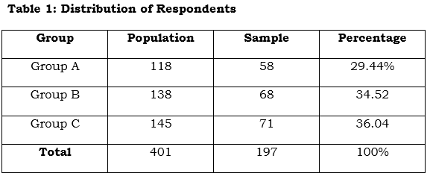

2.3 Research Instrument
The researchers utilized two (2) survey questionnaires which were adapted for both the independent and mediating variable. A group of experts reviewed and approved these questionnaires.
Teacher Competence. This survey questionnaire was used to get the level of teacher competence which was from the research study titled “Assessing Teacher Competence and Its Follow-up to Support Professional Development Sustainability” by Sumaryanta et al. (2018). The questionnaire consisted of 15 items covering the following aspects: Pedagogic Competency (10 items), and Professional Competency (5 items). Respondents rated each item using a 5-point Likert scale, ranging from 5 for "Strongly Agree" , 4 for “Agree”, 3 for “Moderate”, 2 for “Disagree” and 1 for "Strongly Disagree."
Table 2- A 5-point Likert scale assessing Teacher Competence
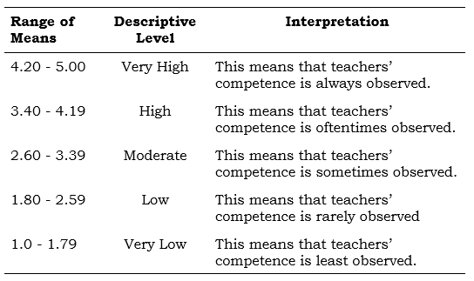

Academic Performance. In determining the level of academic performance in Elective 101: Entrepreneurial mind, GE 6: Arts appreciation, EDUC 104: Technology for teaching and learning, and EDUC 107: Assessment on learning 1, the researcher utilized the grades given by the subject instructor from the office of the college registrar.
These grades were based on the different outcomes performed by the students in accordance with the syllabus set by the Commission on Higher Education. The scoring guide for the academic performance of students was categorized into five levels.
Table 3- The five levels of the scoring guide for the academic performance of students
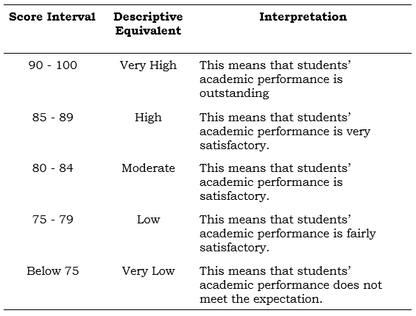

Out-of-field Teaching. This survey questionnaire was used to get the level of teacher competence. It was from the research study titled "Out-of-field teaching: English Teachers’ experiences and practices” by De La Cruz and Alda (2023). The questionnaire consisted of 6 items covering the following aspects: Contextualizing content (2 items), Emphasizing content over performance (2 items), and Embracing mentorship and assistance (2 items). Respondents rated each item using a 5-point Likert scale, ranging from 5 for "Strongly Agree", 4 for “Agree”, 3 for “Moderate”, 2 for “Disagree” and 1 for "Strongly Disagree."
Table 4- 5-point Likert scale assessing the level of teacher competence in Out-of-field teaching
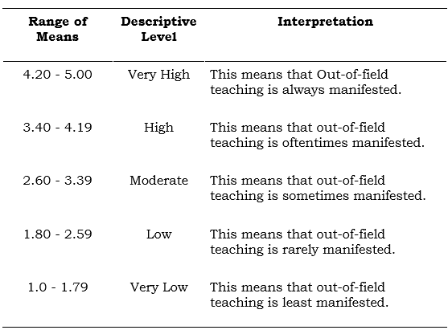

2.4 Statistical Treatment of Data
Mean. It is a wide and commonly used measure of central tendency, the calculation or the sum of each value divided by their count (Motzer, 2021). This was utilized to identify the level of Teacher Competence, Students’ academic performance, and Out-of-field Teaching.
Pearson r. It is commonly used as a measure of linear association between variables, though the way it is interpreted has been a subject for debate and is traditionally considered appropriate for linear relationships only (Rohwer, 2022). This was utilized to identify the level of interrelationship between Teacher Competence, Students’ academic performance, and Out-of-field Teaching.
Path Analysis. It is a method statistically used for decomposing a zero-order or a total correlation between two variables into a single direct effect and one or more indirect effects (Wooldredge, 2021). This was utilized to ascertain the mediating effect of out-of-field teaching on the relationship between teacher competence and academic performance among college students.
3. RESULTS AND DISCUSSIONS
Level of Teacher Competence
The results for the level of teacher competence are presented in table 5. The mean ranged from 3.47 to 3.51 with an overall mean of 3.49 and a standard deviation of 1.03, which was described as high. These results implied that teacher competence were oftentimes observed.
table 5- Levels of teacher competence based on mean scores, standard deviations, and descriptive ratings
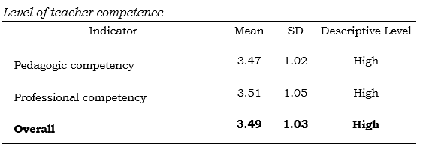

Moreover, the data revealed that the indicator ‘‘Professional Competency’’ got the highest mean score of 3.51 which was described as high. This implied that teachers mastered the knowledge materials, standard of competence, and utilized information and communication technology. The indicator “Pedagogic Competency” got the lowest mean score of 3.47 which was also described as high implying that teachers also mastered learning theories, organized educational learning, assisted the improvement of students’ potential, and utilized the results of evaluation and assessment for learning endeavors. Therefore, the teachers possessed both professional and pedagogic competency on a high level.
This study conformed to the study of Yang and Kaiser (2022) which stated that professional competence, including classroom performance, highly impacts the teachers’ instructional quality and competence. It also relates to the study of Kovalenko and Chernyuk (2021) which stated that the teachers’ professional competency is an accumulation of personal, and pedagogical qualities that are necessary for teaching.
Level of Out-of-field Teaching
The results for the level of out-of-field teaching were presented in table 3. The mean ranges from 3.38 to 3.58 with an equivalent overall mean of 3.46 and a standard deviation of 1.05 which was described as high. Moreover, the data showed that the indicator “Embracing mentorship and assistance” got the highest mean score of 3.58 which was described as high. The indicator “Contextualizing Content” got the lowest mean score of 3.38 which was described as moderate. These results implied that out-of-field teaching was oftentimes observed.
The indicator embracing mentorship and assistance among teachers were oftentimes observed implying that teachers shared the need to reach out to others for help while the indicator contextualizing content among teachers were sometimes observed implying that teachers moderately considered the materials available in the locality, and related concepts to concepts in the subject they were teaching. Therefore, the teachers embraced mentorship and assistance, emphasized content over performance, and occasionally contextualized the content that they taught.
Table 6- Levels of Out-of-field Teaching competence based on mean scores, standard deviations, and descriptive ratings
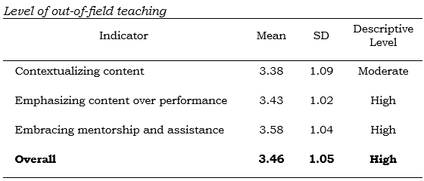

The results align to the study of Lagria (2021) which stated that teachers who are teaching outside of their field struggles with content mastery and copes with self-learning, and seeking assistance. It also conforms to the study of Bugwak (2021) which stated that out-of-field teachers struggled in navigating the content and recognizing the students’ concern.
Level of Academic Performance
The results for the level of academic performance were presented in table 7. The mean ranged from 84.98 to 89.13 with an equivalent overall mean of 87.49 and a standard deviation of 4.82 which was described as high. Moreover, the data showed that the indicator “EDUC 104: Technology for teaching and learning” got the highest mean score of 89.13 which was described as high. While the indicator “ELECT 101: Entrepreneurial mind”, got the lowest mean score of 84.98 which was described as moderate.
The overall findings implied that the academic performance of the students were very satisfactory. The student’s performance in EDUC 104: Technology for teaching and learning was very satisfactory, while the student’s performance in ELECT 101: Entrepreneurial mind was satisfactory. Therefore, the students’ academic performance was good, indicating their adequate understanding and competency in these areas.
Table 7- Level of Academic Performance based in mean scores, standard deviations, and descriptive ratings
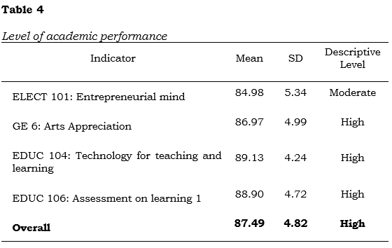

The results aligned with Chophel and Choden’s (2024) idea that high academic performance is influenced by a combination of external factors such as the learning environment, the individuals’ study habits, family support, and role models. It was predicted by factors such as physical, psychological, sociological, cognitive control, and lifestyle factors (Dubuc et al., 2022).

Correlation between Teacher Competence and Academic Performance
The relationship between teacher competence and academic performance was displayed in Table 8. The overall coefficient of correlation was 0.417, with a p-value of <0.001, which was lower than 0.05 level of significance. This means that there was a positive, medium, and significant relationship between teacher competence and academic performance because the p-value was p<0.001. Therefore, the null hypothesis of no significant relationship was rejected.
This implied that teacher competence had a moderate but significant relationship with academic performance. The findings implied that the teachers’ skills and proficiency improvement can contribute meaningfully to the students’ achievement.

Table 8- Relationship between teacher competence and academic performance
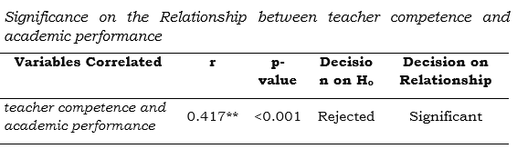

It conformed to the study of Abrar and Syahputra (2021) which stated that there was a medium correlation between teacher competence and the academic performance of students. Additionally, Garba (2020) also stated that there was a medium and positive correlation between teacher competence including teaching skills and subject knowledge, and academic performance.
Correlation between Teacher Competence and Out-of-field Teaching
Displayed in Table 9 is the relationship between teacher competence and out-of-field teaching. The overall coefficient of correlation was 0.845, with a p-value of <0.001, which was lower than 0.05 level of significance. This meant that there was a positive, very strong, and significant relationship between teacher competence and out-of-field teaching because the p-value was p<0.001. Therefore, the null hypothesis of no significant relationship was rejected. This implied that teacher competence had an exemplary and significant relationship with out-of-field teaching.
The correlation between both variables was supported by the idea of Tran (2023) which stated that the teachers’ sense of competence may be hindered or enhanced by out-of-field teaching depending on how they make of their teaching role.
Table 9-Relationship between teacher competence and out-of-field teaching
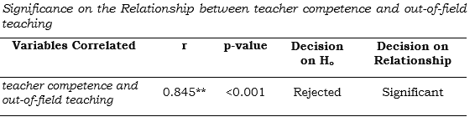

Correlation between Out-of-field Teaching and Academic Performance
Displayed in Table 10 is the relationship between out-of-field teaching and academic performance. The overall coefficient of correlation was 0.386, with a p-value of <0.001, which was lower than 0.05 level of significance. This implied that there was a positive, weak, and significant relationship between out-of-field teaching and academic performance since the p-value was p<0.001. Therefore, the null hypothesis of no significant relationship was rejected. This implied that out-of-field teaching had a poor but significant relationship with academic performance.
The result indicated that even though out-of-field teaching could contribute to students’ achievement, its influence is very limited and may even be affected by other intervening factors.
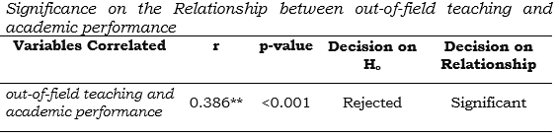
Table 10- Relationship between out-of-field teaching and academic performance

The result affirmed to the idea of Pendergast et al. (2022b) which stated that out-of-field teaching impacts students’ performance and leads to lower quality teaching and experience. This result also conformed to the study of Taylor et al. (2020) which stated that out-of-field teaching only had a small effect on students’ academic performance.
Mediation Analysis of Teacher Competence, Academic Performance, and Out-of-field Teaching using Path Analysis
Displayed in the Figure 2 were the results of the path analysis, which illustrated the relationships between independent variable (IV) Teacher Competence, the dependent variable (DV) Academic Performance, and the mediating variable (MV) Out-of-field teaching. Additionally, the results of the path analysis were visually represented in the Path Diagram for the Regression Model figure 2.
In Step 1, path C (IV and DV), the finding had a 1.538 estimate and a .240 standard error (SE) with a p<value of 0.000, which was lower than the 0.05 level. This meant that there was a significant influence between teacher competence and academic performance since the probability value was p<0.000. Therefore, the null hypothesis of no significant relationship was rejected.
In Step 2, path A (IV and MV), with the presence of mediating variable, the finding had a .802 estimate and a .036 standard error (SE) with a p<value of 0.000, which was lower than the 0.05 level of significance. This meant that there was a significant influence existing between teacher competence and out-of-field teaching since the probability value was p<0.000. Therefore, the null hypothesis of no significant relationship was rejected.
In Step 3, which is path B (MV and DV), with the occurrence of mediating variable, the finding had a .465 estimate and a .472 standard error (SE) with a p<value of 0.324, which was higher than the 0.05 level. This meant that there was no significant influence between out-of-field teaching and academic performance since the probability value was p>0.324. Therefore, the null hypothesis of no significant relationship was accepted.
Additionally, Path C’, the combination of IV and MV on DV, found that Academic Performance (DV) does not regress on Out-of-field Teaching (MV) and Teacher Competence (IV). The results accumulated an estimate of 1.165 with a .447 standard error (SE) and a p-value of 0.009 which was lower than the 0.05 significance level. This implied that there was a significant influence. Therefore, the null hypothesis of no significant relationship was rejected.
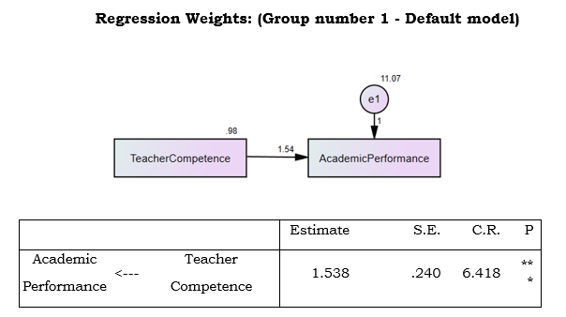

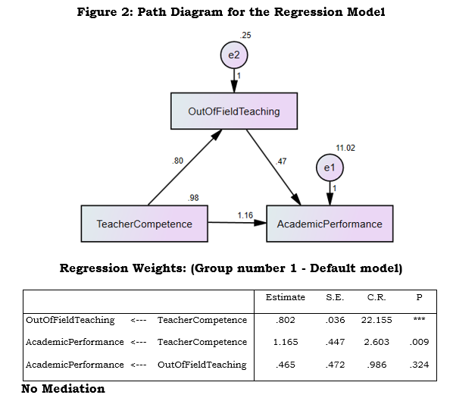

Since all correlation results were significant, mediation analysis was warranted. However, the mediation analysis, Path B showed no significant relationship since the p value was 0.324 which was greater than the level of significance which is 0.05. This indicated that out-of-field teaching does not mediate the relationship between teacher competence and academic performance.
‘ The result of the mediation analysis supports the Pedagogical Content Knowledge (PCK) theory of Shulman (1987) where he stated that even though out-of-field teaching may impact the students’ academic performance, the teachers are likely going to be more effective in teaching if they are competent and had higher pedagogical content knowledge.
This supported the idea that teachers who were outside of their field can mitigate the negative impact of out-of-field teaching with strong self-efficacy and content knowledge (Rao et al., 2023). For instance, Fliarkovska et al. (2022) stated that by enhancing teacher competence, out-of-field teachers’ quality of instruction can be improved.

4. SUMMARY OF FINDINGS, CONCLUSIONS, AND RECOMMENDATIONS
4.1 Summary of Findings
The key outcomes of the study were the following:
1. The level of teacher competence had an overall descriptive equivalent of High. Additionally, teacher competence attained an overall mean of 3.49, which meant that it was oftentimes observed. Among the two indicators, professional competency had the highest mean of 3.51, while pedagogic competence had the lowest mean of 3.47.
2. The level of academic performance had an overall descriptive equivalent of High. Additionally, academic performance attained an overall mean of 87.49 indicating that the students’ academic performance were satisfactory.
3. The level of out-of-field teaching had an overall descriptive equivalent of High. Additionally, out-of-field teaching attained an overall mean of 3.46, indicating that it was oftentimes observed. Among the three indicators, embracing mentorship and assistance had the highest mean of 3.58, while contextualizing content had the lowest mean of 3.38.
4. The relationship between teacher competence and academic performance proved to have a positive, and medium correlation, with an r-value of 0.417 and a p-value of <0.001, which was less than the 0.05 significance level set for the study, indicating a statistically significant variable. This result implied that the null hypothesis was rejected.
5. The relationship between teacher competence and out-of-field teaching exhibited a positive, and very strong correlation, with an r-value of 0.845 and a p-value of <0.001, which was lower than 0.05. This result led to the rejection of the null hypothesis, confirming a significant relationship between teacher competence and out-of-field teaching.
6. The relationship between out-of-field teaching and academic performance exhibited a positive but weak correlation, with an r-value of 0.386 and a p-value of <0.001, which was less than the significance level of 0.05, indicating statistically significant variable.
7. The mediation analysis revealed no significant mediation effect. This meant that out-of-field teaching did not mediate the relationship between teacher competence and academic performance. This implied that teacher competence influences the students’ academic performance with or without the presence of out-of-field teaching.
4.2 Conclusions
In light of this study’s findings, the following statements were constructed:
1. The results regarding the teacher competence revealed a high level, which was oftentimes observed. The overall findings implied that even in out-of-field settings, teachers are able to demonstrate adaptive expertise which may help mitigate the negative effects associated with out-of-field teaching.
2. The level of academic performance was high, and was very satisfactory. This implied that highly competent teachers are capable of delivering quality instruction and fostering academic success even when teaching subjects outside of their specialization.
3. The level of out-of-field teaching was high, which was oftentimes observed. The overall findings implied that out-of-field teaching occurs frequently and may challenge subject-area expertise and underscores the need for continuous professional development to ensure sustained instructional quality across subject ares.
4. The result showed that there was a relationship between teacher competence and academic performance, which exhibited a medium correlation. This implied that while strengthening teacher competence is important, addressing other factors that can contribute to students’ academic performance may further enhance student outcomes.
5. The result showed the significance of teacher competence and out-of-field teaching, which exhibited a very strong correlation. The result implied that when teachers possess high level of competence, they can overcome out-of-field teaching challenges.
6. The result showed that there was a relationship between out-of-field teaching and academic performance, which exhibited a weak correlation. The result implied that out-of-field teaching may not have a substantial direct impact on students’ academic performance.
7. The mediation analysis confirmed that there was no mediation effect. This indicates that out-of-field teaching did not mediate in the association between teacher competence and their academic performance. The overall results implied that teacher competence directly impacts students’ academic performance regardless of whether teachers are teaching within or outside their field of specialization.
4.3 Recommendations
Based on the findings, analysis, and conclusion drawn in this study, the following recommendations are summarized:
1. The Commission on Higher Education (CHED) may develop a policy wherein school administrations do not allow or teachers to be assigned outside of their field of specialization or lessen the field misalignment since the result only shows a poor relationship towards the students’ academic performance. They may also develop a policy wherein teachers who are to teach outside of their fields of specialization should undergo a mandatory regular training that focuses on improving their content knowledge about the subjects that they are to teach and to enhance their professional, and pedagogical competence. This initiative would ensure the continuous enhancement of overall competence, subject mastery, and navigate through difficulties despite field misalignment.
2. The school administration may not assign teachers outside of their field of specialization and if they are put in a situation where they have to do so, they may come up with programs for training and development to improve overall teachers’ competence especially in contextualizing the content they’re teaching because based on the result, this indicator only reached a moderate level by having a mean of 3.38. The school administration may also emphasize the importance of every subject taught by the teachers for even though the result showed a high level of teacher competence, the subject ELECT 101: Entrepreneurial mind only had a moderate level, averaging only 84.98.
3. Teachers may willingly participate in programs and/or seminars crafted to improve their content knowledge in about the subjects that they are to teach mitigating the potential out-of-field teaching issues that may occur. They may also cultivate a genuine passion for learning, which can translate into more effective and engaging instruction. In addition, they may increase the frequency of conducting assessments and evaluation to identify which subject areas the students need improvement in, such as ELECT 101: Entrepreneurial mind.
4. Future researchers may further explore the complexity and dynamics between out-of-field teaching, teacher competence, and students’ academic performance by considering additional variables. Additional variables such as teaching strategies, institutional support, or student motivation may offer deeper insight into these dynamics.

CONSENT
As per international standards or university standards, Participants’ written consent has been collected and preserved by the author(s).
ETHICAL APPROVAL
As per international standards or university standards written ethical approval has been collected and preserved by the author(s).
DISCLAIMER (ARTIFICIAL INTELLIGENCE)
Author(s) hereby declares that NO generative AI technologies such as Large Language Models (ChatGPT, COPILOT, etc.) and text-to-image generators have been used during the writing or editing of this manuscript.
COMPETING INTERESTS
Authors have declared that no competing interests exist.

REFERENCES
Abrar, A., & Syahputra, I. (2021). The influence of English teachers’ competency on students’ learning achievement. Proceeding of International Conference on Language Pedagogy (ICOLP), 1(1), 6– 13. https://doi.org/10.24036/icolp.v1i1.15
Apau, S. K. (2022). Out-of-Field Teaching in Ghanaian Basic Schools: A Matrix of Basic School Teachers’ Experiences in Ekumfi District. Social Education Research, 188–199. https://doi.org/10.37256/ser.3120221314
Arendain, N. I. E., & Limpot, N. M. Y. (2022). PHENOMENOLOGICAL APPROACH OF OUT-OF-FIELD TEACHING: CHALLENGES AND OPPORTUNITIES. EPRA International Journal of Multidisciplinary Research (IJMR), 165–170. https://doi.org/10.36713/epra9379
Bandura, A. (1997). Self-Efficacy: The Exercise of Control. Macmillan.
Barella, Y., Fergina, A., Mustami, M. K., Rahman, U., & Alajaili, H. M. A. (2024). Quantitative Methods in Scientific Research. Jurnal Pendidikan Sosiologi Dan Humaniora, 15(1), 281. https://doi.org/10.26418/j-psh.v15i1.71528
Bugwak, E. R. (2021). Travails of Out-of-Field Teachers: A Qualitative Inquiry. Journal of World Englishes and Educational Practices, 3(2), 36–57. https://doi.org/10.32996/jweep.2021.3.2.4
Chophel, Y., & Choden, T. (2024). A Qualitative Investigation of Academic Success: Insights from High School Achievers. Polaris Global Journal of Scholarly Research and Trends, 3(1), 1–21. https://doi.org/10.58429/pgjsrt.v3n1a156
De La Cruz, J. ., & Alda, R. (2024). OUT-OF-FIELD TEACHING: ENGLISH TEACHERS’ EXPERIENCES AND PRACTICES. Journal of Education and Innovation, 26(3), 33–45. Retrieved from https://so06.tci thaijo.org/index.php/edujournal_nu/article/view/263343
Dinama, B., Olesitse, G.V., Kaazumikua, D., Manyenyengwa, M., & Oratile, Z. (2021). Declining Academic Performance in Multi- faith Religious Education in Botswana Public Junior Secondary Schools.
Dubuc, M., Aubertin-Leheudre, M., & Karelis, A. D. (2022). Predictors of Academic Performance in High school Students: The Longitudinal ASAP Study. International Journal of Exercise Science, 15(4). https://doi.org/10.70252/zazq9758
Fliarkovska, O., Chupryna, O., & Liashchenko, T. (2022). Professional competence of the head of the club as a component of quality out-of-school education. Problemi Osvìti, 1(96), 284–304. https://doi.org/10.52256/2710-3986.1-96.2022.18
Garba, A.S. (2020). Perceived Teacher Competence as Correlate of Students’ Academic Performance in Bauchi State. ATBU Journal of Science, Technology and Education, 7, 364-367.
Helmold, M. (2019). Excellence in PM. In Management for professionals (pp. 39–49). https://doi.org/10.1007/978-3-030 20534-8_3
Indu, P. V., & Vidhukumar, K. P. (2020). Descriptive studies (Research Methods in Psychiatry). Kerala Journal of Psychiatry, 33(2). https://doi.org/10.30834/kjp.33.2.2020.239
Kabilan, M. K., Annamalai, N., & Chuah, K. (2023). Practices, purposes and challenges in integrating gamification using technology: A mixed-methods study on university academics. Education and Information Technologies, 28(11), 14249–14281. https://doi.org/10.1007/s10639-023-11723-7
Kettler, R. J. (2019). Correlational and Causal Comparative Designs in School Psychology. In Routledge eBooks (pp. 112–131). https://doi.org/10.4324/9781315724072-6
Kovalenko, O., & Chernyuk, T. (2021). Formation of high school teacher’s professional competence. Humanities Science Current Issues, 2(38), 126–131. https://doi.org/10.24919/2308-4863/38-2-21
Lagria, G. C. (2021). Pragmatic Sentiments and Coping Strategies of Out-Of-Field English Teachers in Public Senior High Schools. International Journal of Qualitative Research, 1(2), 112–119. https://doi.org/10.47540/ijqr.v1i2.3 55
Moh’d, S. S., Uwamahoro, J., Joachim, N., & Orodho, J. A. (2021). Assessing the Level of Secondary Mathematics Teachers’ Pedagogical Content Knowledge. Eurasia Journal of Mathematics Science and Technology Education, 17(6), em1970. https://doi.org/10.29333/ejmste/10883
Motzer, R. (2021). Various Mean Values. In Essentials (pp. 51–54). https://doi.org/10.1007/978-3-658-32574-9_10
Nepali, S. (2021). The impact of academic stress on the academic performance of CBSE higher secondary students, with special reference to Ernakulam district. In Quest Journals, Journal of Research in Humanities and Social Science (Vol. 9, Issue 8, pp. 88–94) [Journal-article]. https://www.questjournals.org
Pendergast, D., McManus, S., Deagon, J. R., & Du Plessis, A. (2022b). Teaching out-of-field in Home Economics: A Systematic Quantitative Literature Review. Korean Home Economics Education Assciation, 34(4s), 37–70.
Rao, N., Li, Q., Murphy, S., & Chu, S. L. (2023). The Context for Contextualizing - Design Implications for Adaptive Teacher Support Systems for More Relevant Instruction, 71–73. https://doi.org/10.1109/icalt58122.2023.00027
Rohwer, D. (2022). Interpreting correlations. In Routledge eBooks (pp. 209–229). https://doi.org/10.4324/9781003057703-14
Shulman, L. (1987). Knowledge and Teaching:Foundations of the New Reform. Harvard Educational Review, 57(1), 1–23. https://doi.org/10.17763/haer.57.1.j463w79r56455411
Sukma, F. a. O. (2022). Teachers’ Pedagogical Competencies and Students’ Performance. Deleted Journal, 1(1), 59–69. https://doi.org/10.19109/literal.v1i1.13088
Sumaryanta, N., Mardapi, D., Sugiman, N., & Herawan, T. (2018). Assessing Teacher Competence and Its Follow-up to Support Professional Development Sustainability. Journal of Teacher Education for Sustainability, 20(1), 106–123. https://doi.org/10.2478/jtes-2018-0007
Taylor, J., Banilower, E., & Clayton, G. (2020). National Trends in the Formal Content Preparation of US Science Teachers: Implications of Out-of-Field Teaching for Student Outcomes. Journal of Science Teacher Education, 31(7), 768–779. https://doi.org/10.1080/1046560x.2020.1762992
Tran, H. L. (2023). TEACHING OUTSIDE AREA OF EXPERTISE: A BARRIER TO OR ENABLER OF TEACHERS’ SENSE OF COMPETENCE? VNU Journal of Foreign Studies, 39(6), 86–99. https://doi.org/10.63023/2525-2445/jfs.ulis.5162
Wooldredge, J. (2021). Path Analysis. The Encyclopedia of Research Methods in Criminology and Criminal Justice, 515–522. https://doi.org/10.1002/9781119111931.ch105
Yang, X., & Kaiser, G. (2022). The impact of mathematics teachers’ professional competence on instructional quality and students’ mathematics learning outcomes. Current Opinion in Behavioral Sciences, 48, 101225. https://doi.org/10.1016/j.cobeha.2022.101225

