LEARNER PERSPECTIVES ON FIRST LANGUAGE USE IN EFL CLASSROOMS

ABSTRACT
This research paper aims to explore how strategic first-language use affects willingness to communicate (WTC) of the university-level English as a foreign language (EFL) learners within Turkish context. The study of the following intricate interdependence between first-language and English immersion was conducted using a mixed-methods research design that included 85 survey participants and 15 participants in the interview, which allows a thorough investigation of the topic of the issue. The quantitative analysis demonstrates that 93.2 percent of the respondents consider their native language to be an inalienable instructional tool; however, these students, at the same time, note that they have a strong desire to communicate with English in the classroom setting. According to qualitative data, two major functions of first-language integration are determined. First, the language acts as a cognitive mediator and this helps learners to process abstract linguistics and academic concepts using the previously existing linguistic knowledge. Second, the use of mother tongue is a support mechanism which works as an affective mechanism, reducing speaking anxiety and enhancing learning in a psychologically safe environment. On the whole, these results suggest that inadaptable English-only policies hamper communicative intentions of learners by increasing cognitive and emotional load of learners. The proposed study is thus a balanced model of instruction that emphasizes the use of the first language as either a cognitive or an affective scaffold while simultaneously suggesting as much exposure to the target language as possible.

Keywords: Willingness to Communicate (WTC), Cognitive Mediator, L1 Use, P
1. INTRODUCTION
The process of language acquisition is, first and foremost, dynamic, social, and meaning-oriented, including the development of linguistic competence, personal identity and agency. Language is not merely a set of grammatical rules to be learnt by heart; instead, it is a multifunctional tool that allows for communication, self-expression and interaction within social contexts (Larsen-Freeman, 2011). Traditional paradigms that view language as a finite set of discrete principles of grammar are increasingly at odds with the complexity and functionality of modern communication. In practice, language is a living, adaptive system used by learners in negotiating meaning, building relationships and taking part in culturally and socially relevant activities (Kramsch, 2006).
A key role of language is transacting the distance between people's perspectives, experiences, and contexts. Consequently, pedagogical approaches should focus on language use in authentic situations rather than an exclusive emphasis on abstract rules. Speaking, in particular, is the primary medium in which the learners participate in a real-life communication. By engaging in oral interaction, learners work in collaboration to make their intended meaning clear, provide social signals to support communication, and modify their linguistic output in the light of context (Long, 1996). Each speaking opportunity allows students to experience cognitive, social and affective dimensions of language use while developing fluency, confidence and a sense of ownership over the target language (Norton, 2013).
Within this dynamic framework, the use of learners' first language (L1) has emerged as an important pedagogical resource in the English as a Foreign Language (EFL) classrooms. The traditional monolingual paradigms often discourage use of the first language (L1) unlike complete immersion; however, empirical studies that have been conducted in recent times show that L1 can be used as an asset rather than a constraint. These studies illustrate that strategic use of the L1 is a central cognitive support, which allows learners to orientate themselves in complicated tasks as well as to solve grammatical problems, which would otherwise seem difficult to resolve (Storch and Wigglesworth, 2003).
Furthermore, according to Cook (2001), both languages are connected in the mind set of the learner, therefore, cross-linguistic support offers a natural way out towards understanding. From an affective perspective, the use of L1 has been found to have the significant effect of reducing learner anxiety by offering 'a sense of security' (Auerbach, 1993). This lowers the affective filter thereby creating a more favourable learning environment (Schweers, 1999). Accordingly, some insight into learners' perceptions of L1 use is of particular importance, as attitudes significantly influence comfort as well as efficacy with which learners use their mother tongue as a linguistic resource. These perceptions become especially salient in EFL contexts where English-only policies are still widely implemented.
Expressions that are likely to deceive stage performances and learners with shallow minds, notwithstanding an increasing realisation that language learning is a socially mediated process, a substantial percentage of EFL classrooms still follows policies and guidelines that permit English only instruction. Although these policies are designed to maximise exposure to the target language, they often have the undesired side effect of cognitive overload, anxiety and a reduced willingness to communicate. Recent studies have shown that such lessons held in the learner's first language (L1) can improve understanding and stimulate participation; however not much thought has been given to the learners subjective attitudes of L1 use in classrooms which are located in the widespread English-speaking environment. This lack of research has discouraged the development of a pedagogical strategy that could successfully use the L1 to promote the development of communicative competence.
The present study aims to explore EFL learners' perceptions about the use of L1 in terms of scaffolding instructional process. This investigation aims at giving authentic representation of the attitude of learners by focusing on mother tongue's role in development of oral proficiency and comprehension. The pedagogical theory that underpins this work assumes the use of L1 as a strategic tool that promotes effective communication, reduces cognitive barriers and promotes the tendency of the learners to use the language in a naturalistic way. The results will provide an input in the design of efficient instructional strategies using scaffolding as a means to foster communicative competence and a more practical and conducive learning environment for EFL learning. Based on the above discussion, this study seeks to address the following research questions:
1. How do EFL students perceive the use of the mother tongue as a pedagogical scaffold in the classroom?
2. What are the specific cognitive and emotional functions of L1-mediated support in the language learning process?
2. LITERATURE REVIEW
2.1. Historical Context
For most of the twentieth century, language learning was dominated by the "Monolingual Assumption" - a paradigm that claimed that the target language (L2) should be used as the sole medium of instruction to maximise language acquisition. This perspective was rooted in historical methodologies like the Direct Method, which characterized the mother language as a disruptive element that impeded the natural progression of target language proficiency (Howatt & Widdowson, 2004). The assumption was also reinforced by the Maximum Exposure Hypothesis that assumed that proficiency is directly related to the amount of L2 input, regardless of the learner's ability to process this input.
Although input is quite undoubtedly central to language acquisition (Krashen, 1985), critics have long argued that exposure is insufficient in the absence of the cognitive and linguistic resources needed to process it. Forced immersion environments, particularly when used in the context of foreign language environments, can create an environment of confusion, anxiety and superficial participation that misses the point of engendering substantive learning (Macaro, 2001). Empirical investigations have shown that the prohibition of the L1 does not automatically result in greater L2 gains while, on the contrary, it may disrupt the ability of a learner to negotiate meaning, consider linguistic form, and maintain engagement (Turnbull & Dailey-O'Cain, 2009).
A great theoretical shift took place with the advent of the perspectives oriented toward bilingualism, with the challenge of the concepts of the monolingual ideal learner. One of the most influential alternative to monolingualism is Vivian Cook's Multi competence theory. Cook (1991) argues that an L2 user's mind is not made up of two separate and isolated linguistic systems, but one, integrated system, where the L1 and L2 interact constantly. From this point of view, the presence of the L1 is not an indication of deficiency but a defining characteristic of the bilingual cognition.
Multi-competence reconceptualizes language learners as legitimate language users rather than imperfect native speakers. Importantly, this framework legitimizes some pedagogical applications of the L1, and suggests that drawing on learners' existing linguistic knowledge might facilitate greater depth of processing, metalinguistic awareness and more efficient learning. Rather than conceptualizing L1 influence as negative transfer, Cook frameworks it as a cognitive resource that can be supportive to L2 development, especially with tasks that are complex.
2.2. Cognitive Scaffolding and Cognitive Load: The L1 as Cognitive Aid
The cognitive scaffolding is one area where the instructional utility of the native language of the learner (L1) comes out clearer. Basing the conceptualization of language acquisition on the conceptualization of the Zone of Proximal Development (ZPD) developed by Vygotsky (1978), language acquisition is viewed as the process of socially mediated gradual shift in autonomous competence to competence, which is increasingly mediated by support. In this hypothetical paradigm, the L1 will assume the role as an intermediate scaffold, which will provide learners the access to rather complicated linguistic or conceptual content, which is beyond the scope of their existing independent proficiency in the second-language (L2), at the moment.

In this context, proficient mediation is the basic component of the ZPD. The enforcement of the English-dominance paradigm in EFL contexts may lead to a multitude of normative situations where an educational resource is above the learner's present developmental level. If technical directions or complex grammatical principles are presented in the target language only, the learner is usually tempted to experience hindrances due to linguistic impediments and not to the natural complexity of the matter presented, thus hindering the internalization of concepts. The strategic use of the L1 in teaching allows instructors to target teaching to the cognitive preparedness of the learner to provide such students with an essential pathway to advanced L2 achievement.
The pedagogical premise mentioned above is also supported by Cognitive Load Theory (CLT), which outlines the boundaries of the working memory in acquiring the complex informational systems (Sweller, 1988; Sweller et al., 2011). According to the Cognitive Load Theory, learning is hindered when extraneous cognitive load (the effort involved by a learner to make sense out of the instructional medium) consumes a wrongful proportion of the learner's limited processing ability. This may happen in a context where in depth explanations provided only in the second language may result in a cognitive bottleneck thereby limiting the learner's cognitive resources to be used for linguistic decoding and not for internalising the contents.
According to the CLT approach, the problem lies not in recommending the use of English language but in the disproportionate strains placed on the learner. The need to face syntactic structures that are foreign to the linguistic schemas of the learner, attempt to decode the lexicons with which the learner is not familiar; and struggle with complex structures of the grammar can simultaneously lead to cognitive exhaustion. This can mostly be realized in cases whereby the foreign language input is restricted, there is lack of immersion and thus the incidental processing is also lost.
Based on the findings of the empirical studies, it can be concluded that using L1 interventions can be an appropriate method with cognitive mediators which will successfully decrease the extraneous load and at the same time maintain working memory in the process of higher-order cognitive processing (Brooks and Donato, 1994; Macaro, 2009). By using the L1 to explain the purpose of tasks or abstract grammatical rules, teachers create the conditions for moving the learner's way of thinking more to natural language productions and communication. It is important to note that, thanks to the prudent use of the L1, an exposure of the target language is not replaced; instead, it acts as a cognitive tool that helps to fine-tune the zone of proximal development (ZPD). As a result, before being able to engage successfully with the L2, the learners have the necessary psychological and cognitive predispositions.
2.3. Willingness to Communicate (WTC), and the Affective Filter
Willingness to Communicate (WTC) is one of the core concepts in second language acquisition, as it refers to a learner's readiness to engage in communication when opportunities exist (MacIntyre, 2007). MacIntyre's WTC Pyramid shows that WTC is affected by a variety of factors, including communicative confidence, motivation, personality traits and affective variables such as anxiety and self-perception. These affective variables show a high incidence to Krashen's (1985) Affective Filter hypothesis, a theoretical construct that explains the role of affective processes on the language learning processes of acquisition and language communication practices. Specifically, high levels of stress, anxiety, or low levels of confidence raise the affective filter, which, in turn, limits the learner's access to input and reduces the learner's engagement in communication; on the other hand, a low affective filter enables greater communicative involvement and better levels of effective learning.
Facilitation of the strategic L1 use as a means of affective determinants is a critical mechanism in second language acquisition contexts. Allowing learners to use their mother language for clarification or cross-linguistic scaffolding functions as a pedagogical "safety net" and thereby lowers the affective filter and reduces the anxiety that is involved in spontaneous L2 production (Auerbach, 1993). When learners are assured that they may use their mother language in the moments of linguistic breakdown, the likelihood of being affected by the "paralysis" or panic usually associated with cognitively demanding tasks is reduced (Nation, 2003).
The deliberate application of the L1, in its turn, serves as an incitement factor to willingness to communicate (WTC). The approach enables learners to become more motivated to undertake speaking activities, to seek clarifications, and to sustain more natural interaction in the language of instruction through the intervention of this pedagogical strategy by allowing learners to afford a greater sense of security and linguistic agency (Littlewood and Yu, 2011).
The use of the academic material on WTC and the bilingual scaffolding paradigms proves that a cognitively informed implementation of the L1 does not only promote the cognitive work but provokes the emotional engagement as well. The resulting synergy creates the classroom environment where truly communicating is realistic and viable (Macaro, 2009).
3. METHODOLOGY
3.1. Research Design
The research design used in the study was that of a mixed-method design which incorporated qualitative and quantitative based research design to investigate the perception of the L1 use by the EFL learners as a pedagogical tool. The choice of this methodological synthesis was made based on the need to provide absolute perspective on the phenomenon with the survey providing a general-based quantitative picture of 85 interviewees and semi-structured interviews with 15 students producing the detailed data concerning the individual experiences and the reasoning behind the latter. The combination of various types of data allows conducting triangulation and thus increasing the credibility and trustworthiness of the results, as the convergence of self-reported perceptions and personal experiences is revealed (Park, 2021; Riazi and Candlin, 2014).
3.2. Participants
Data were obtained from 85 participants in a preparatory setting of three different universities, then 15 of the participants were purposively chosen for follow-up in-depth interviews. Table 2 defines the demographic characteristics of the survey respondents. A total of 47 female and 39 male students were used as a sample. Sixty-two and eight percent (62.8) of the respondents were in private universities and the rest in the state universities. In terms of international exposure, 17 respondents indicated an overseas experience with the majority (80.2) not having overseas experience. This demographic non-homogeneity gives such a broad coverage of the perceptions EFL learners have towards using L1 in the classroom.
Table 1. Demographic Profile of the Participants in the Study (N=86)
Demographic Variable | Category | Number (N) | Percentage (%)
Gender | Female | 47 | 54.7
 | Male | 39 | 45.3
University Type | Private University | 54 | 62.8
 | State University | 32 | 37.2
Overseas Experience | Yes | 17 | 19.8
 | No | 69 | 80.2

Survey respondents included students with diverse disciplinary backgrounds in the EFL curriculum, spanning a range of English proficiency levels. From this initial pool, 15 participants were purposefully selected for interview in an attempt to represent a variety of perspectives that were based on gender, proficiency and previous exposure to L1 and its context of language acquisition. The study followed ethical research standards with data collection having been carried out on voluntary basis and after receiving informed consent from the respondents.
Table 2. Profile and Selection Criteria of Interview Participants (N = 15)
Variable | Categories / Description
Sampling Method | Purposeful sampling
Gender | Representation of both female and male students
English Proficiency Level | Lower- and higher-level EFL learners
Disciplinary Background | Diverse academic departments within the EFL program
Prior Exposure to L1 Use | Varied experiences with L1 use in language learning contexts
Participation | Voluntary participation with informed consent
3.3. Data Collection Tools
A three-item Likert scale questionnaire was created to determine learner's perception of the L1 deployment in the classroom context. Prior to full-scale administration, the questionnaire was piloted with a small group of learners from a similar EFL context with the aim of ensuring the clarity, appropriateness, and comprehensibility of the items. Based on the pilot feedback, minor linguistic changes were made to the items. Data were collected through a five-point Likert scale, with response options extending from Strongly Disagree to Strongly Agree.
Semi-structured interviews were administered to 15 participants. The interview protocol used open-ended questions that focused on learner's attitudes, experiences and perceptions related to the strategic use of L1 to support communicational, comprehension and overall language development. Questions were designed to evoke answers about both cognitive and affective aspects of L1 use, which refers to its influence on confidence, anxiety, and willingness to communicate. To improve the credibility of the qualitative portion of the study, the interview protocol was thoroughly reviewed for clarity and relevance to make sure the interviews followed a consistent structure among all participants. Triangulation was created through the considered integration of survey and interview data, thus creating development of the convergence of findings from different methodological approaches. Furthermore, the researchers used member checks with selected excerpts from the interviews to make sure that qualitative interpretations aligned with the intended meanings of the participants. This respondent validation was a stringent instrument in improving the credibility of the dataset in general.
3.4. Procedure
Data collection took place for a period of 2 weeks. During the initial phase, the survey was administered to all 85 participants via Google Forms, a widely used online data collection platform, with assurances of participant anonymity and voluntary participation. Subsequently, 15 people were invited to take part in individual semi-structured interviews of approximately 20-30 min. Interviews were audio recorded with permission of participants and then transcribed verbatim for the purpose of analysis.
3.5. Data Analysis
In this study, descriptive and content analysis were used to analyze the qualitative data. Quantitative data were analysed using descriptive statistical methods, including calculation of mean values, standard deviations and proportions of agreement. These metrics provided a rich description of central tendencies and dispersion that are inherent in the dataset and as a result this allowed a detection of overarching trends and patterns in the perceptions of L1 utilization in the EFL classroom. The descriptive analysis consequently supported an initial interpretation of learners' attitudes towards the use of L1, by providing some of the concordance and discordance across survey items, thereby providing a quantitative basis for subsequent qualitative investigation. Qualitative data were analysed using descriptive analysis, a qualitative data analysis method usually applied to the systematic organisation and interpretation of the data collected from qualitative research methods (Punch, 2014). Descriptive analysis has a structured process which consists of four key stages. As described by Yildirim and Simsek (2013) the process includes construction of thematic framework, organisation of data for predetermined themes, then the description and interpretation of findings.
In accordance with the procedure used, the qualitative data obtained during the present research study was initially coded and categorised. Themes were then identified through examining patterns and commonies between codes and relevant codes were grouped under relevant thematic headings. The data was then described and interpreted according to this thematic structure. To increase clarity and support for the credibility of the resulting findings, direct quotations were used to illustrate the perspective of participants. For anonymity purposes, participants were given identification codes (S1, S2, S3) which were used when presenting excerpts.
4. RESULTS
The purpose of the present study was to investigate the perceptions of English as a Foreign Language learners on the utilization of L1 in classroom setting with a particular interest on the alleged contributions of L1 to speaking proficiency, understanding, and overall linguistic growth. The findings are presented in two separate sections: quantitative findings obtained from the survey analysis and qualitative data obtained from the interviews. The integration of both data sources allows for a comprehensive understanding of learners’ cognitive and affective experiences with the use of L1 in EFL classroom setting.
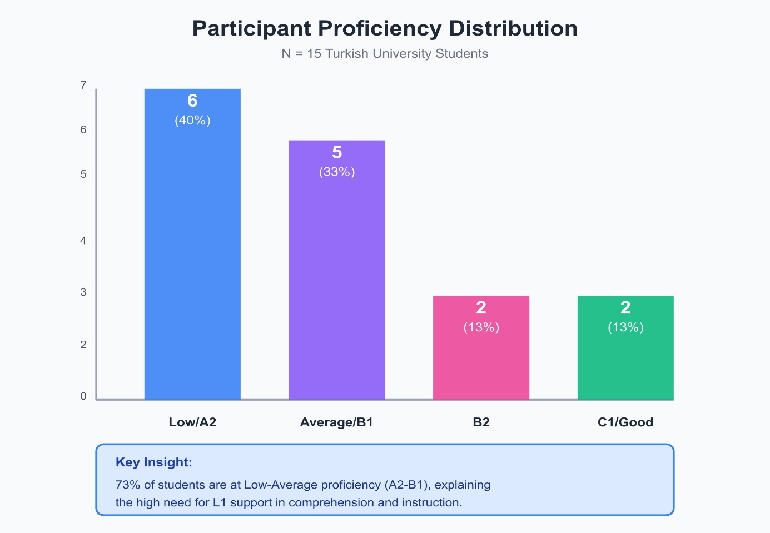
Figure 1: Participant Proficiency Distribution
RQ1: How do EFL students perceive the use of the mother tongue as a pedagogical tool?
The survey results provided an overview of learners’ attitudes toward the use of L1 in the classroom
Table 3. Descriptive Statistics for Learner Attitudes toward L1 and English Use
Item ID | Statement | Mean (xˉ) | SD | Agreement  (%)
1 | The teacher should use the first language (L1) to clarify complex or incomprehensible topics. | 3.32 | 0.65 | 93.2%
2 | I stop paying attention when the teacher switches to the native language. | 1.88 | 0.73 | 12.5%
3 | The teacher should decrease the frequency of English use in the classroom. | 1.88 | 0.82 | 15.2%

The quantitative findings show that English as a Foreign Language (EFL) learners generally have a positive attitude towards the strategic use of the mother language in the classroom scenario. Specifically, the majority of respondents (93.2%) agreed that instructors should use the L1 to explain topics that are otherwise unintelligible (item 1), so it may be interpreted that the learners see the native language as a useful cognitive and affective tool that facilitates understanding and participation in oral activities. In contrast, a minority of the participants did not accept teacher L1 use (12.5% for item 2) or argued for a reduction of English exposure in the classroom (15.2% for item 3). These results suggest that learners do not feel that the mother language is replacing English instruction but rather is a complementary instrument to enrich a learner's understanding without giving up exposure to the target language. On balance, the findings suggest that learners prefer a balanced strategy in which the strategic use of their L1 strengthens their learning but allows them to keep actively using English.
The findings suggest that the EFL learners consider the first language not as an obstacle, but as a constructive pedagogical asset if used selectively and intentionally. The significant support for L1- assisted clarification is consistent with the sociocultural theory and the concept of cognitive scaffolding, highlighting the necessity of utilizing the learner’s existing linguistic knowledge to facilitate deep comprehension.
Furthermore, receptiveness of students to the use of instructor code-switching (item 2) indicates that L1 use does not affect classroom authority and attention. On the contrary, it suggests that incorporating the L1 can effectively bridge the gap between complex input and learner understanding, thereby challenging the rigid tenets of the monolingual instruction paradigm.
Importantly, the strong alignment with reduced English use indicates a learner-driven preference for a balanced instructional approach. Participants generally favor instruction that is primarily English-focused, with strategic and occasional use of the first language, rather than heavy dependence on the mother language. This observation supports previous research which suggests optimal L1 deployment as scaffolding mechanism rather than substitute. In sum, the findings, which relate to RQ1, confirm that students judge the use of L1 favourably, provided that it is targeted to explicit pedagogical goals.
RQ2: What are the specific cognitive and emotional functions of L1 use in the classroom?
Semi-structured interviews with 15 participants provided rich and substantive information about perceptions of the role of first language (L1) in supporting comprehension, speaking and language learning in EFL settings. Interrelationship between themes through thematic analysis of interview data was a revelation that generates interrelationship between the explanatory figures to the quantitative results.
Though the quantitative data of the survey show that most participants are highly motivated in terms of the instrumentality (93%), the qualitative data provides clarity on the stimuli of this motivation to learn the English language. In addition, the identified themes help understand the issues related to the English-only instruction, which explains the fact that 80 per cent of the respondents said that they experienced the cognitive overload, and 73 per cent said that they experienced speaking anxiety. Those statements reinforce the confirmations of the fact that the unqualified implementation of an English-only policy spurs a cognitive bottleneck, and thus hampers acquisition. Comprehensively, the qualitative data are in line with the quantitative data on the affective and cognitive advantages of strategic L1 scaffolding. It is confirmed by the fact that 87 percent of students confirm that L1 support is a crucial tool that helps to alleviate anxiety and that the same proportion of students find it extremely difficult to imagine the process of learning without it. Combining these data, the analysis shows that the strategic execution of L1 serves as an important tool of reducing the linguistic and emotional barrier portrayed in Figure 2.
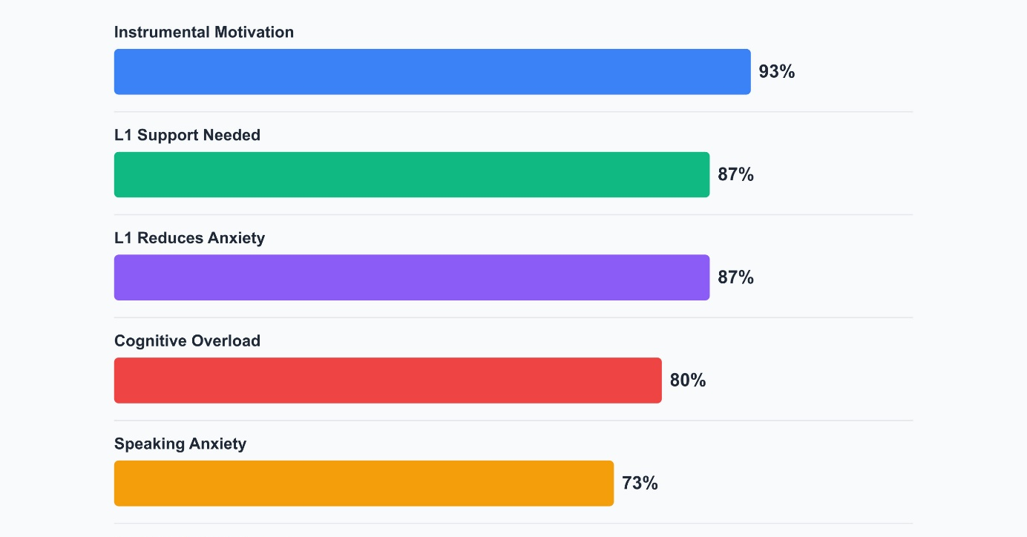
Figure 2: Theme Prevalance Across Participants
Instrumental Motivation for English Learning
In relation to this theme, the participants were asked the question, ‘’How important is learning English for you? Why are you learning / why do you want to learn English?’’ The data showed that participants conceptualized English as mostly an instrumental resource rather than an object of intrinsic interest; it highlighted by learners career promotion, global communication, and future aspirations including living or working abroad as the key motivations for learning English.
"Because of my job, and because I enjoy learning different languages" (S4)
"English is the common language of the world, and I have always wanted to live abroad" (S8)
"For job opportunities and to get to know other cultures" (S14)
"I want to learn English in order to go abroad and have a better life" (S13)
"I want to learn English for my job, career, and gaming" (S10)
One participant clearly expressed an affective attachment to the language when he said "I love English."
This result suggests that the learning process of most learners is mainly influenced by pragmatic and utilitarian aims. The instrumental orientation seems to influence the expectation of learners with respect to instruction which places special emphasis on pedagogical efficiency and support of comprehension.
L1 as a Comprehension Scaffold
Regarding this theme, the question ‘’How would a strict English-only rule affect your willingness to participate? How?” was probed to the participants. In contrast to the instruction conducted only in English, the majority of the participants viewed Turkish as a cognitive scaffold for semantic integration and maintaining the coherence of instruction. Participants further stated that the use of L1 produced specific benefits in explaining complex grammatical constructs and in understanding basic logic of the instructional content. Typical comments included:
"English-only explanations make understanding difficult; Turkish support helps clarify complex points" (S1)
"Understanding improves when Turkish is also used" (S2)
"We need Turkish to understand difficult concepts" (S13)
"Both languages are necessary to understand the lesson" (S14)
"It is difficult to understand details without occasional Turkish support" (S5)
Notably, learners consistently expressed a preference for a selective and occasional use of first language (L1) as opposed to its pervasive or continuous use through translation. This preference suggests an advanced level of metalinguistic awareness because of the fact that the participants seemed to be aware of pedagogical advantages linked to the strategic use of L1 to promote understanding, to clarify complex concepts, and to reduce cognitive load, whilst at the same time, they are maintaining meaningful exposure to the English language. In this sense, learners demonstrated an awareness of judicious use of L1 deployment as a supporting scaffolding, not as a replacement of target language interaction to provide possible balance between both language support and sustained interaction with English.
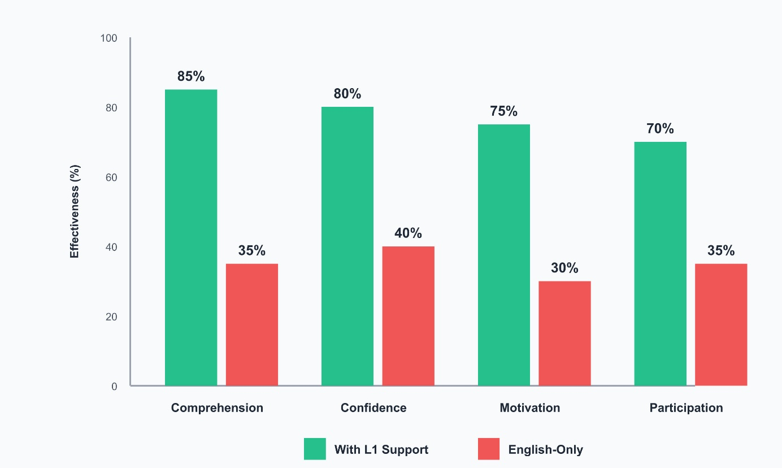
Figure 3: Effect of L1 support on Learning Outcomes
Affective Barriers to L2 Production
The researchers explored the roots of learner reluctance by asking participants: "Do you feel confident and comfortable when speaking in English class? If not, why do you feel nervous?". The data suggest that the factors that make learners reluctant to get involved in English speech come mainly from affective and social determinants and not so much from deficiencies in linguistic competence. Persistent concerns about assessment against peers, fear of exposing an error and pronunciation fears frequently arose.
"I feel embarrassed because I think I will speak incorrectly" (S1)
"Because I might answer incorrectly and everyone might make fun of me" (S11)
"I feel nervous because I might pronounce words incorrectly" (S12)
"I am afraid of being judged by my friends when I mispronounce the words" (S6)
"I don't hesitate to speak when the topic is familiar, but I am afraid of making mistakes" (S9)
Learners with higher level of proficiency reported a level of anxiety that was conditional upon factors contextualized to the situation; hence, suggesting that the reluctance to speak is not strictly linked to proficiency level but rather associated more with social dynamics in the classroom. These results highlight the role of peer evaluation and its importance as a critical determining factor of the willingness to engage in communication.

Peer Judgement
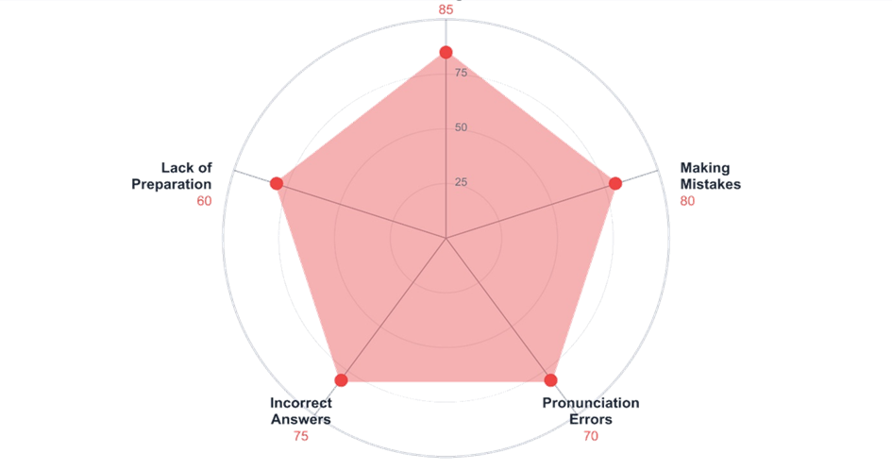
Figure 4: Sources of Speaking Anxiety
L1 Presence as Anxiety Regulator
Regarding this theme, the participants were asked the question "Does the presence of your mother tongue change your level of anxiety when speaking English?" Closely linked to speaking anxiety, the availability of the L1 was always described by participants as an emotional safety net. Thirteen out of fifteen participants in the interview have mentioned the effects of using Turkish as causing less anxiety, having more confidence and participating in discussing activities.
"Yes, it increases my self-confidence" (S10)
"Yes I feel relaxed" (S7)
"Yes, I feel comfortable" (S12)
"Turkish makes me feel relaxed" (S2)
"Yes because I am afraid of being misunderstood" (S5)
These results suggest that the use of L1 reduces the power of the affective filter and in turn facilitates L2 production.
Cognitive Overload in English-Only Instruction
A predominant theme across the interviews was how the mandatory English-only instruction had experienced a cognitive load among learners. To investigate the cognitive impact of monolingual instruction, participants were asked: "When you encounter a complex grammar point or a long reading text, how does it make you feel if the explanation is only in English?" Respondents had experiences of mental fatigue, feeling of confusion and difficulty maintaining coherence within lessons when the complexity of grammatical explanations or long text was delivered solely in English. Learners often referred to themselves as "lost," "confused," and "mentally exhausted," as presented in the excerpts below:
"I feel mentally tired and confused during long English explanations" (S6)
"I feel stressed and cognitively overloaded during English-only grammar explanations" (S13)
"I find English-only explanations too fast and feels lost when trying to follow complex topics"(S2)
"I feel lost and unable to see the overall structure of the lesson" (S14)
"English-only instruction makes it hard to grasp the logic of the lesson" (S5)
These accounts imply that prolonged L2-processing makes demands on the working memory of the learner that are too great with lower proficiency levels. Importantly, the difficulties that were reported were not specific to understanding, but were accompanied by emotional strain, suggesting that there was an interaction between cognitive overload and affective response.
Proficiency-Dependent Attitudes Toward L1 Use
To analyze how language ability influences student perceptions, responses to the question 'How would a strict English-only rule affect your willingness to participate?' were cross-referenced with participants' self-reported proficiency levels. Attitudes towards English-only instruction showed variability that depended on learner self-rated levels of proficiency. Participants rated as higher- (B2 - C1) proficiency indicated a disposition of comfort with instruction in English alone, in some instances numerous participants specifying that they favored such an approach. On the other hand, lower - proficiency learners (A2 - B1) expressed a strong dependency on the first language and an English-only teaching was depicted as demotivating and exclusionary.
"I have no difficulty with English-only explanations and feel comfortable following lessons in English. So just English should be used" (S8)
"It is necessary to have just English instruction" (S11)
"English-only explanations disadvantage lower-level students and reduce understanding" (S12)
"When everything is just in English, I feel demotivated" (S15)
‘’We need Turkish to understand difficult concepts.’’ (S13))
The two students who support an English-alone approach to teaching - who are at B2 and C1 levels of proficiency - show quite a break from the majority in the cohort. This phenomenon supports the threshold hypothesis in which learners who reach the level of an intermediate-high proficiency level can process instruction presented only in the target language. By contrast, the majority of the learners, who are in a proficient level (A2 -B1), feel that English only paradigm is exclusionary. A comment on preparatory demands by one such learner illustrates the situation that, even among individual students, the need for native language support may vary, depending on their particular readiness.
Cross Cutting Patterns Across Themes
Beyond the individual themes, a number of cross-cutting patterns of meaning emerged from the analysis that demonstrates how learners' cognitive and affective experiences interact in relation to L1 use and English-only instruction. These patterns do not represent extra themes but, means to recur to one's identification with more multiple patterns over many themes, and portray systematic tendencies of learners reported experiences.
The Comprehensional time Confidence Loop
Across Themes 3 (L1 as a Comprehension Scaffold), 5 (L1 Presence as an Anxiety Regulator), and 4 (Affective Barriers to L2 Production) a positive cycle was observed on repeated occasions. Participants repeatedly expressed that the availability of L1 support aided them to better understand the contents of individual lessons especially in the case of cognitively efforting work. Improved comprehension, in turn, led to high overall learner confidence and lower learner anxiety which as a result of having low confidence and anxiety increased learner willingness to participate orally in English. This reinforcing cycle proposes that strategic L1 use brings about not only understanding, but also productive language use by reducing affective barriers.
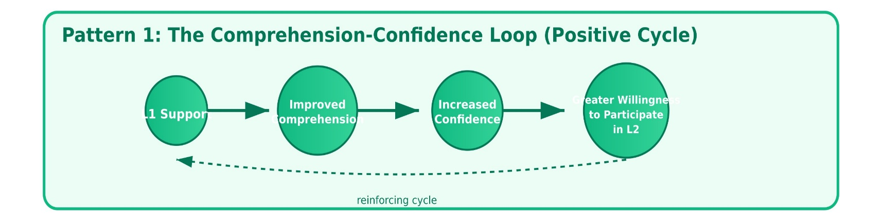
Figure 5: The Comprehension–Confidence Loop
The Demotivation Cascade
In comparison, information gathered throughout Themes 2 (Cognitive Overload in English-Only Instruction), 4 (Affective Barriers to L2 Production), and 6 (Proficiency-Dependent Attitudes Toward L1 Use) form a recurring negative theme, hereafter referred to as a demotivation cascade. Participants reported that rigorous instruction of English language skills, especially at lower proficiency levels, or in the course of delivering elaborate explanations, triggered cognitive overload and an accompanying breakdown in understanding. These cognitive difficulties were consistently accompanied by a high level of anxiety, frustration and a feeling of exclusion, which fostered the development of a low level of participation and in some cases the avoidance of interaction within the classroom. Figure 6 displays an empirical trend that suggests that demanding cognitive resource requirements imposed may trigger affective representations that would reduce engagement and motivation.
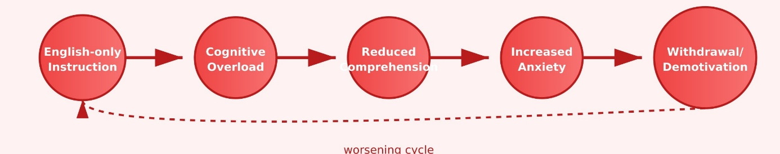
Figure 6 Demotivation Cascade
Social Versus Linguistic Anxiety
A further pattern that was apparent across Themes 4, 5, and 6 was the distinction between social and linguistic sources of speaking anxiety. The lack of eagerness among the learners to speak was not more related to the lack of linguistic knowledge than the fear of being judged by peers and embarrassment. Moreover, difficulty in comprehension was found to exacerbate both forms of anxiety suggesting some degree of interaction between the processing of information and evaluating others in relation to the willingness to communicate.
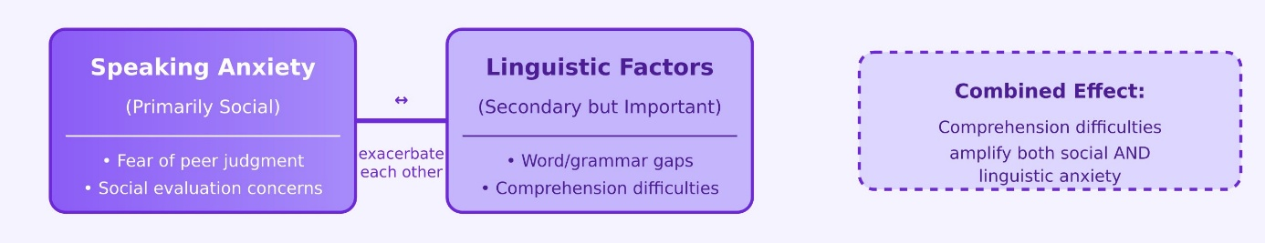
Figure 7: Social vs. Linguistic Anxiety (Complex Interaction)
5. DISCUSSION
The main aims of the given study were to analyze the perceptions of EFL students in terms of the application of the L1 at the classroom level and the use of the latter to develop speaking proficiency, understanding, and the overall language acquisition. The qualitative and quantitative data converging together create a detailed portrait of the attitudes towards the strategic use of their first language expressed by learners generally in a positive way.
The quantitative survey data demonstrated a strong support for the strategic integration of the L1 as a pedagogical instrument. The most notable consensus emerged was with regard to the role of the teacher in using the native language for making content, which seems to be too complex or incomprehensible, accessible. 93.2% of the participants agreed with the opinion that the teacher should use the native language for this purpose, while a negligible minority of the participants opposed this applications or advocated for a reduction in target language exposure.
These findings suggest that L1 is not viewed by the learners as being a replacement of English, but rather as a complementary cognitive tool that facilitates the learning process. Students prioritize English immersion but view the L1 as an essential bridge for both cognitive processing and affective engagement. This fact is in line with the previous studies that highlight the relevance of strategic L1 application to support a learning process and its scaffolding, as well as to facilitate learning engagement (García & Wei, 2014).
Qualitative data can further shed some light on the processes of these perceptions. All the respondents invariably defined L1 as a cognitive buffer facilitating understanding of complex grammatical explanations and lengthy texts, hence alleviating confusion and cognitive exhaustion. This perspective aligns with the Multi-competence framework (Cook, 2008), which posits that a second language learner’s mind functions as an integrated linguistic system rather than two isolated compartments.
In addition to cognitive benefits, salient affective benefits were identified among learners. Explanations made in Turkish language were related with a lower anxiety, high confidence, and more active speaking. The results support the Affective Filter Hypothesis of Krashen (1985) and the Willingness to Communicate model of MacIntyre (2007) to hypothesize that the instructional practices which provide emotional support lead to the increase in willingness to communicate among learners. Most importantly, the information shows that a strict English-only policy can potentially create affective barriers that will lead to an obstruction of meaningful communication.
7. CONCLUSION
This current study explored the opinion of EFL students with regard to L1 integration, which presented positive attitude to the strategic and premeditated use of the first language of the learner. Combining quantitative and qualitative data, one can see that learners find the mother tongue a useful pedagogical tool that helps to make understanding easier and lessens cognitive burden as well as language anxiety. These effects when put together have a significant effect on the willingness to communicate among students.
It is significant to note that the research results show participants avoid L1-dominant learning environment and instead adopt a balanced model of instruction. In this context, English is the language of instruction, whereas the L1 is used as a scaffolding tool on a very limited basis. These findings support the socio cultural theory, which postulates that linguistic flexibility acts as an instigant to both the cognitive as well as affective aspects of acquisition of language. On the whole, the paper highlights the necessity to go beyond the inflexible, English-only, requirements in favour of context-based, learner-centred, practices that draw on all the linguistic of a student.
6. LIMITATIONS AND FUTURE RESEARCH
The results of this study need to be interpreted within the context of some inherent limitations of the study. First, the research was only set within university preparatory school in Turkey, and therefore the general application of the results to other educational settings is limited. Learner perceptions as to the strategic use of the first language (L1) are strongly conditioned by particular institutional cultures and the sociocultural situations in general; thus, students in primary education, private language centers or in various geographic locations might have different attitudes. Second, while the quantitative data gave a clear snapshot picture of student trends, it was based on a limited number of survey items. Furthermore, the qualitative aspect of the study was based on self-reported details from interviews that can always be prone to subjective biases, such as social desirability or the fluctuating mood of the participants during the interviews. Such self-reporting may be reflective of what learners think they like, rather than what they actually subconsciously did linguistically during classroom interactions. To handle these limitations, future studies should be more longitudinal in nature, incorporating direct observation in the classroom and ethnographic approaches to help triangulate the self-reported data obtained with practicing an objective. Additionally, extending the sample size to include different proficiency levels and different areas of education would create a more holistic picture of what the 'threshold' might be where L1 support goes from being a functional requirement for cognition, to being seen as a hindrance.

REFERENCES
Auerbach, E. R. (1993). Reexamining English only in the ESL classroom. TESOL Quarterly, 27(1), 9. https://doi.org/10.2307/3586949
Brooks, F. B., Donato, R., & McGlonem, J. V. (1997). When are they going to say “it” right? Understanding learner talk during pair‐work activity. Foreign Language Annals, 30(4), 524-541.
Cook, V. (2001). Using the first language in the classroom. Canadian Modern Language Review, 57(3), 402-423.
García, O., & Wei, L. (2014). Translanguaging: Language, Bilingualism and Education. Palgrave Macmillan.
Horwitz, E. K., Horwitz, M. B., & Cope, J. (1986). Foreign language classroom anxiety. The Modern Language Journal, 70(2), 125–132. https://doi.org/10.1111/j.1540-4781.1986.tb05256.x
Howatt, A. P. R., & Widdowson, H. G. (2004). A history of ELT. Oxford university press.
Kramsch, C. (2006). Context and culture in language teaching. Oxford University Press.
Krashen, S. D. (1985). The Input Hypothesis: Issues and Implications. Laredo.
Larsen-Freeman, D. (2011). A complexity theory approach to second language development/acquisition. In D. Atkinson (Ed.), Alternative Approaches to Second Language Acquisition (pp. 48–72). Routledge.
Littlewood, W., & Yu, B. (2011). First language and target language in the foreign language classroom. Language teaching, 44(1), 64-77.
Long, M. H. (1996). The role of the linguistic environment in second language acquisition. In W. C. Ritchie & T. K. Bhatia (Eds.), Handbook of Second Language Acquisition (pp. 413–468). Academic Press.
Macaro, E. (2001). Analysing student teachers’ codeswitching in foreign language classrooms: Theories and decision making. The modern language journal, 85(4), 531-548.
Macaro, E. (2009). Developments in language learner strategies. Contemporary applied linguistics: Language teaching and learning, 1, 10-36.
MacIntyre, P. D. (2007). Willingness to communicate in the second language: Understanding the decision to speak as a volitional process. The modern language journal, 91(4), 564-576.
Nation, P. (2003). The role of the first language in foreign language learning.
Norton, B. (2013). Identity and Language Learning: Extending the Conversation. Multilingual Matters.
Park, E. (2021). Adopting a mixed method needs analysis for CALL research. SHS Web of Conferences, 102, 01002. https://doi.org/10.1051/shsconf/202110201002
Punch, K. F., & Oancea, A. E. (2014). Introduction to research methods in education.
Riazi, A. M., & Candlin, C. N. (2014). Mixed-methods research in language teaching and learning: Opportunities, issues and challenges. Language Teaching, 47(2), 135–173. https://doi.org/10.1017/s0261444813000505
Schweers, W. (1999). Using L1 in the L2 classroom. English Teaching Forum, 37(2), 6-9.
Storch, N., & Wigglesworth, G. (2003). Is there a role for the use of the L1 in an L2 setting?. TESOL quarterly, 37(4), 760-770.
Sweller, J. (1988). Cognitive load during problem solving: Effects on learning. Cognitive science, 12(2), 257-285.
Sweller, J., Ayres, P., & Kalyuga, S. (2011). The split-attention effect. In Cognitive load theory (pp. 111-128). New York, NY: Springer New York.
Turnbull, M., & Dailey-O’Cain, J. (Eds.). (2009). First language use in second and foreign language learning. Multilingual Matters.
Vygotsky, L. S. (1978). Mind in society: The development of higher psychological processes (Vol. 86). Harvard university press.
Yıldırım, A., Şimşek, H. (2013). Sosyal bilimlerde nitel araştırma yöntemleri. Ankara: Seçkin Yayıncılık.

