Case report
Comprehensive Dual-Arch Prosthetic Rehabilitation with a Convertible Mandibular Cast Partial Denture and Maxillary Overdenture: A Case Report

Abstract:
Preservation of the residual alveolar ridge is a primary goal in prosthodontic rehabilitation. Overdentures represent a proven treatment modality that aids in alveolar bone preservation while maintaining proprioceptive feedback through retained natural teeth. Hemisectioned molars can serve as effective abutments for overdenture support.
This case report describes rehabilitation using a maxillary tooth-supported overdenture and a convertible mandibular cast partial overdenture, using a hemisectioned molar as an abutment. A 62-year-old male patient reported with multiple missing teeth and difficulty in mastication. As the patient denied for extractions, a preventive prosthodontic approach involving tooth-supported overdentures was planned.
The present report highlights use of hemisectioned molar as an overdenture abutment. A convertible cast partial overdenture was designed to allow future modification in situation of abutment loss. This approach improves esthetics, mastication and overall patient satisfaction.
Keywords:
Alveolar ridge preservation, Cast partial denture, Convertible denture, Dual-arch rehabilitation, Hemisectioned teeth, Preventive prosthodontics, Tooth-supported overdenture.
Introduction:
DeVan’s classic principle, “Perpetual preservation of what remains is more important than the meticulous replacement of what is missing” continues to guide modern prosthodontic practice. ¹ Preventive prosthodontics is based on this philosophy, focusing on conservation of remaining oral structures while formulating treatment plans aimed at improving patient comfort and function. Among the available preventive treatment modalities, overdentures serve as a practical and reliable option and often provide superior outcomes when compared to conventional complete dentures, which are associated with several limitations.
According to the Glossary of Prosthodontic Terms (GPT-10), an overdenture is defined as a removable partial or complete denture that covers and is supported by one or more remaining natural teeth, tooth roots, and/or dental implants. Such prostheses are also referred to as overlay dentures, overlay prostheses, or superimposed prostheses. ² The concept of overdentures dates back to the nineteenth century, with landmark publications by Morrow et al. and Lord and Teel in 1969 describing simplified approaches to overdenture therapy. ³ Subsequent prosthodontic literature further elaborated on the principles, indications, and clinical protocols associated with overdenture treatment. ³ Appropriate treatment planning, including careful abutment selection and elective endodontic therapy, plays a decisive role in long-term success. ³ Miller conducted a six-year longitudinal study involving 46 overdenture patients and reported significantly reduced alveolar bone resorption when compared to complete denture wearers.⁴ Chen et al., in an observational study, demonstrated improved masticatory efficiency in tooth-supported overdenture patients compared with conventional denture wearers, with no statistically significant difference between tooth-supported and implant-supported overdentures.⁵ Crown and Rooney (1975) further confirmed that retention of mandibular canines for overdenture support resulted in effective preservation of alveolar bone.⁵ Glen et al. reported that hemisectioned teeth can be successfully employed as overdenture abutments.⁶ Hemisection is indicated in situations involving severe vertical bone loss affecting one root while the remaining root demonstrates healthy periodontal support, interradicular bone loss where osteotomy is not feasible, or non-restorable caries involving the furcation area.⁶ The primary objective of hemisection is to preserve a root with a healthy periodontium, thereby enabling its use as a functional abutment, particularly in mandibular distal extension cases.⁶ The present case report integrates the advantages of both overdentures and cast partial dentures. A hemisectioned mandibular molar with a retained mesial root was modified and used as an overdenture abutment. The mandibular prosthesis was termed a convertible cast partial overdenture due to its adaptability for future modifications in the event of abutment loss.
Case Report:
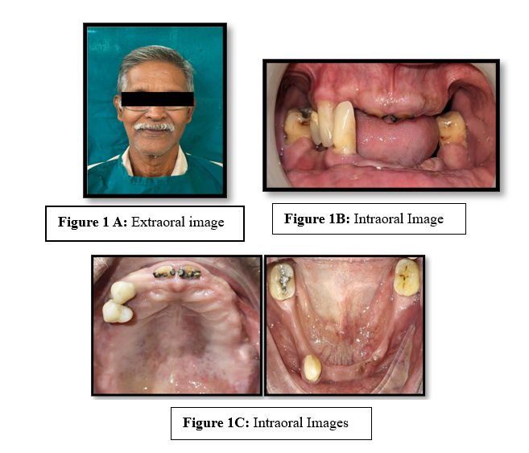
A 62-year-old male patient reported with the chief complaint of difficulty in mastication due to multiple missing teeth in both the maxillary and mandibular arches. Detailed medical and dental histories were recorded, followed by a comprehensive extraoral (Figure 1A) and intraoral examination (Figure 1B & 1C). An orthopantomogram (OPG) was advised for further evaluation. Radiographic assessment revealed previously underwent root canal treatment with respect to teeth 11, 12, and 21.
Figure 1: Extraoral and Intraoral images

Furcation involvement and a periapical lesion was noted with respect to tooth 37.
As the patient was not willing to undergo extractions, a preventive prosthodontic approach involving tooth-supported overdentures was planned after evaluating the tentative jaw relations. Due to poor prognosis, extraction 21 was advised.
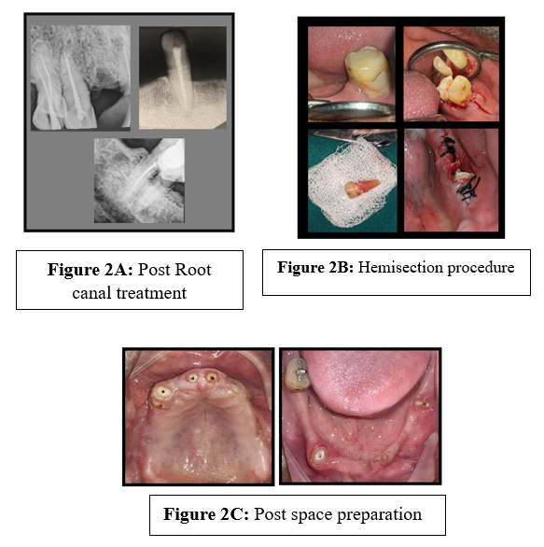
Diagnostic impression was made using irreversible hydrocolloid impression material (Zhermack SpA, Italy). Endodontic evaluation was done with respect to 11, 21 followed by that root canal treatment was performed with respect to tooth 37. Intentional root canal treatment was planned for teeth 13, 14, and 43(Figure 2A). Hemisection was carried out in relation to tooth 37 following endodontic therapy, retaining the healthy mesial root (Figure 2). Tooth 47 demonstrated favourable prognosis and was retained to receive a ring clasp for the mandibular cast partial denture.
Figure 2: Abutment tooth preparation

Cervical abrasion was restored using composite resin. A healing period of three months was allowed following hemisection. Soft tissue coverage over the retained root was further subjected to crown lengthening. Carious lesions in teeth 11 and 21 were excavated, followed by crown lengthening to facilitate proper seating of metal copings.
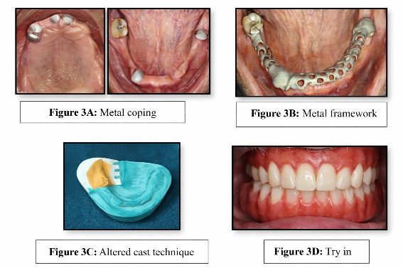
Post space preparation and abutment modification were completed to receive copings (Figure 3). Impressions were made using Putty and light-body elastomeric materials (DPI (Dental Products of India, The Bombay Burmah Trading Corporation Ltd, Mumbai, Maharashtra) and metal copings were fabricated and cemented using Glass ionomer cement (GC India Dental Pvt Ltd, Medak, India) (Figure 3A).
Figure 3: Try in

A mandibular cast partial overdenture was planned with a ring clasp engaging mesial and distal rest of tooth 47. After rest seat preparation, impression for metal framework fabrication was made using Putty and light body elastomeric impression (DPI (Dental Products of India, The Bombay Burmah Trading Corporation Ltd, Mumbai, Maharashtra). The designing of cobalt-chromium framework was made using EXOCAD software followed by milling (Figure 3B).
The framework try-in confirmed satisfactory fit. Maxillary primary impression was made, followed by custom tray fabrication, border molding, and final impression procedures. A custom tray was fabricated over the mandibular metal framework and an Altered cast technique was employed to accurately record the functional edentulous areas (Figure 3C). Occlusion rims were fabricated, followed by jaw relation and facebow transfer using Hanau’s spring bow. The casts were mounted on a semi-adjustable articulator. Following trial placement and evaluation of esthetics and phonetics (Figure 3D), Acrylization was completed using heat-cured polymethyl methacrylate. The maxillary denture was reinforced with a titanium mesh (Figure 4). The completed prostheses were inserted, and occlusion, retention, stability, and esthetics were evaluated. Necessary adjustments were made, and post-insertion instructions were provided. Follow-up visits at one week, three months, and six months revealed healthy abutment teeth with no evidence of secondary caries or pathology. The patient expressed complete satisfaction with the treatment outcome.

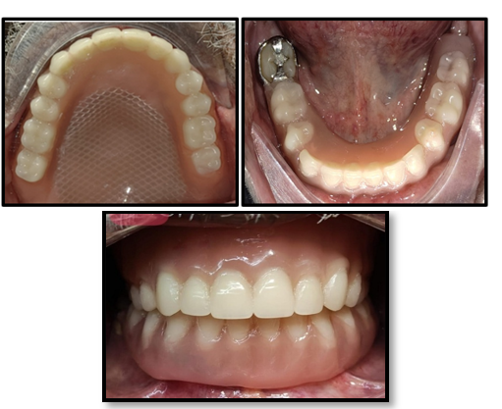

Figure 4: Final Insertion

Discussion
Preservation of natural teeth offers several advantages, including maintenance of alveolar bone, preservation of proprioception, enhanced retention and support, and reduced psychological impact associated with tooth loss.^{8,10} In the present case, the patient strongly preferred retaining of natural teeth, reinforcing the decision for a preventive prosthodontic approach. Tooth-tissue supported overdentures derive significant support from remaining natural teeth and their distribution and strategic positioning are critical for successful treatment planning. ⁹ Although overdentures are associated with an increased risk of abutment caries and technical complications, meticulous oral hygiene practices and regular use of topical fluorides significantly reduce these risks.⁹ Retention of natural teeth provides psychological reassurance to patients and contributes to reduced alveolar bone resorption, thereby improving prosthesis stability and support.⁹ Louis et al. demonstrated superior masticatory efficiency in overdenture wearers compared to complete denture patients, justifying the additional clinical effort and cost involved.⁹ Although prefabricated intraradicular attachments offer enhanced prosthetic flexibility, clasp-retained abutments, as used in the present case, also provide adequate retention.⁹ Glen et al. emphasized the successful use of hemisectioned teeth as overdenture abutments; a concept effectively applied in this case. The term convertible denture was used for the mandibular cast partial overdenture due to its adaptability following potential distal abutment loss.
Conclusion :
Tooth-supported overdentures represent the final conservative option before complete edentulism. They provide functional benefits, help preserve the residual alveolar ridge, and maintain proprioception through retained natural teeth. Critical considerations during treatment planning include strategic abutment selection, assessment of undercuts, evaluation of interocclusal space and reinforcement of the denture base. Patient-specific factors, such as oral hygiene, periodontal health, and bone support must be considered during the planning phase. Long-term success depends on careful case selection, precise execution of clinical steps, and regular follow-up visits to monitor abutment health. This article has described about a convertible cast partial denture which has added advantage to overdenture treatment where in the needed for new prosthesis fabrication is eliminated after the loss of abutment teeth.

References:
- Samra RK, Bhide SV, Goyal C, Kaur T. Tooth supported overdenture: a concept overshadowed but not yet forgotten! Journal of Oral Research and Review. 2015 Jan 1;7(1):16-21.
- “The Glossary of Prosthodontic Terms 2023: Tenth Edition.” The Journal of prosthetic dentistry vol. 130,4 Suppl 1 (2023): e1-e3. doi: 10.1016/j.prosdent.2023.03.003
- Fenton, A H. “The decade of overdentures: 1970-1980.” The Journal of prosthetic dentistry vol. 79,1 (1998): 31-6. doi:10.1016/s0022-3913(98)70190-8
- Crum RJ, Rooney Jr GE. Alveolar bone loss in overdentures: a 5-year study. The Journal of prosthetic dentistry. 1978 Dec 1;40(6):610-3.
- Samantaray RK, Nanda K, Sahoo D. Over-dentures and attachments: a review of literature. Indian Journal of Forensic Medicine & Toxicology. 2020 Oct 29;14(4):8660-6.
- Richard GE, Sarka RJ, Arnold RM, Knowles KI. Hemisected molars for additional overdenture support. The Journal of Prosthetic Dentistry. 1977 Jul 1;38(1):16-21
- Prakash VS, Shivaprakash G, Hegde S. Four and two tooth supported-Conventional over denture: Two case reports. International Journal of Oral Health Sciences. 2013 Jan 1;3(1):61-4.
- Preiskel HW. Overdentures Made Easy: A Guide to Implant and Root Supported Prostheses. London: Quintessence Publishing Co Ltd; 1996.
- Ahmed T, Mirza AJ. Oral Rehabilitation with Mandibular Cast Partial Overdenture Opposing Maxillary Cast Complete Denture-A Case Report. Annals of Abbasi Shaheed Hospital & Karachi Medical & Dental College. 2014 Jul 1;19(2).
- Mohd NR, Ahmad SF, Etajuri EA. An alternative technique for fabrication of a tooth-supported removable partial overdenture: A case report. Journal of International Oral Health. 2021 Sep 1;13(5):514-8.

