Case report

Delayed Gastric Perforation by a Retained Fish Bone in a Patient on Chronic Pantoprazole Therapy: A Case Report and Literature Review

.
ABSTRACT

Background: Gastric perforation from foreign body ingestion is rare, as the stomach’s high acidity and robust muscular wall typically facilitate digestion or safe transit. However, chronic proton pump inhibitor (PPI) therapy induces pharmacologic hypochlorhydria. This reduced acidity may compromise the breakdown of organic objects, such as fish bones, increasing the risk of retention and transmural injury.
Case Presentation: A 47-year-old man on pantoprazole therapy for six months presented with a two-week history of worsening epigastric pain, fever, and vomiting. He had no history of NSAID use or recent trauma. Contrast-enhanced computed tomography (CECT) revealed a 3.6 cm linear hyperdense foreign body associated with a complex fluid collection between the stomach and pancreas. Exploratory laparotomy confirmed gastric perforation at the lesser curvature caused by a fish bone, complicated by an abscess. The patient underwent distal gastrectomy with Roux-en-Y reconstruction and made a full recovery.
Discussion: Chronic acid suppression disrupts gastric defense mechanisms by elevating pH and inhibiting enzymatic degradation, which can facilitate foreign body retention and gradual perforation. Diagnosis is challenging due to nonspecific symptoms and the frequent inability of patients to recall ingestion. While plain radiography is often inconclusive, CECT is critical for identifying radiolucent bones and guiding management.
Conclusion: This case highlights the potential link between chronic PPI use and gastric perforation from occult foreign bodies. Clinicians should maintain a high index of suspicion in patients on acid-suppression therapy presenting with persistent abdominal symptoms. Timely CECT and surgical intervention are essential for successful outcomes.

Keywords: Gastric perforation, Fish bone ingestion, Proton pump inhibitors, CT imaging, Foreign body

1. INTRODUCTION

Foreign body ingestion is common, particularly involving fish bones, which account for a significant proportion of cases. While most ingested foreign objects transit the gastrointestinal tract without complications, serious adverse events including perforation occur in less than 1% of cases [Ngan JHK et al., 1990]. The stomach is rarely the site of perforation due to its robust muscular wall and highly acidic environment that facilitates breakdown of organic materials [Liew C. J. Y. et al, 2004]. However, chronic proton pump inhibitor (PPI) therapy suppresses gastric acid secretion, creating a hypochlorhydric environment [Freedberg DE et al., 2017]. This pharmacologically induced achlorhydria may compromise the digestion of organic foreign bodies such as fish bones, leading to the foreign body retention and delayed transmural injury. Herein, we present a rare case of gastric perforation caused by an ingested fish bone in a patient receiving chronic pantoprazole therapy, which was successfully managed via surgical intervention. The clinical presentation, imaging and management challenges are discussed to alert surgeons and clinicians to this rare but potentially life-threatening condition.

2. CASE PRESENTATION
A 47-year-old man presented to the emergency department with a 2-week history of epigastric pain that had worsened over the preceding 3 days, associated with fever and vomiting. He denied recent use of nonsteroidal anti-inflammatory drugs or alcohol consumption. He had been taking the proton pump inhibitor pantoprazole for peptic ulcer disease for the past 6months.
On physical examination, he was febrile with tenderness localized to the epigastrium. There were no signs of peritonism. Laboratory investigations revealed leukocytosis and elevated inflammatory markers. Serum amylase and liver function tests were within normal limits. Plain chest radiography showed no evidence of pneumoperitoneum. Following adequate fluid resuscitation and initiation of empirical broad-spectrum antibiotics, contrast-enhanced computed tomography (CECT) of the abdomen was performed. This revealed a 3.6 cm linear hyperdense foreign body within a complex fluid collection measuring 3.5 × 4.1 × 3.1 cm, located between the lesser curvature of the stomach and the head of the pancreas [Fig.1].
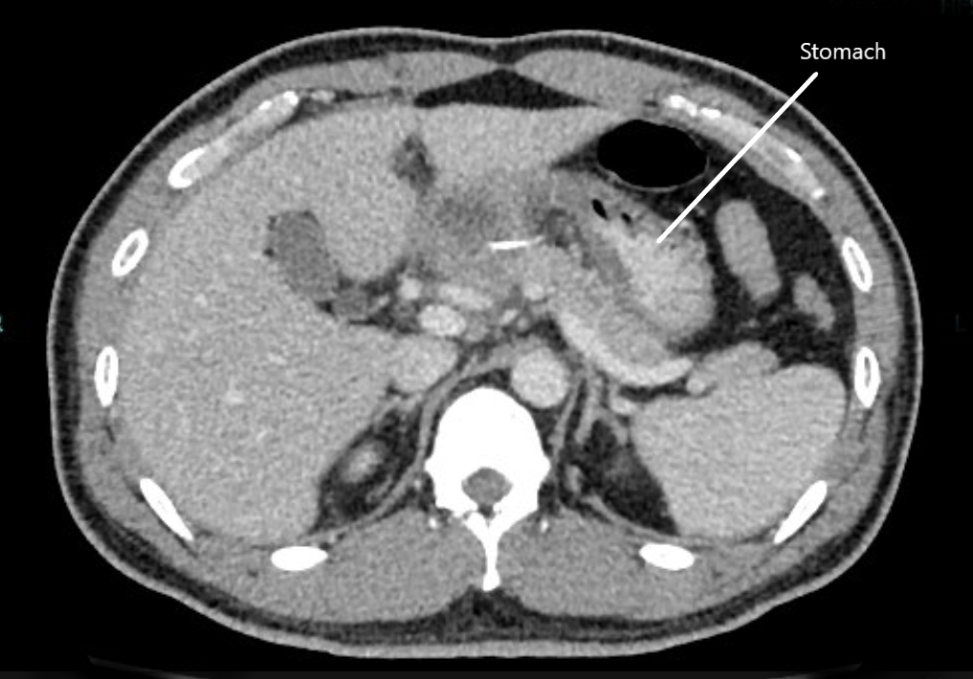
Fig.1: CECT abdomen revealed a 3.6 cm linear hyperdense foreign body within a complex fluid collection, located between the lesser curvature of the stomach and the head of the pancreas
The patient underwent exploratory laparotomy, which confirmed gastric perforation by a fish bone at the lesser curvature with adjacent abscess formation [Fig.2]. Distal gastrectomy with Roux-en-Y reconstruction was performed. His postoperative course in the high-dependency unit was uneventful, and he was discharged on postoperative day 10. At 12-month follow-up, he remained well.
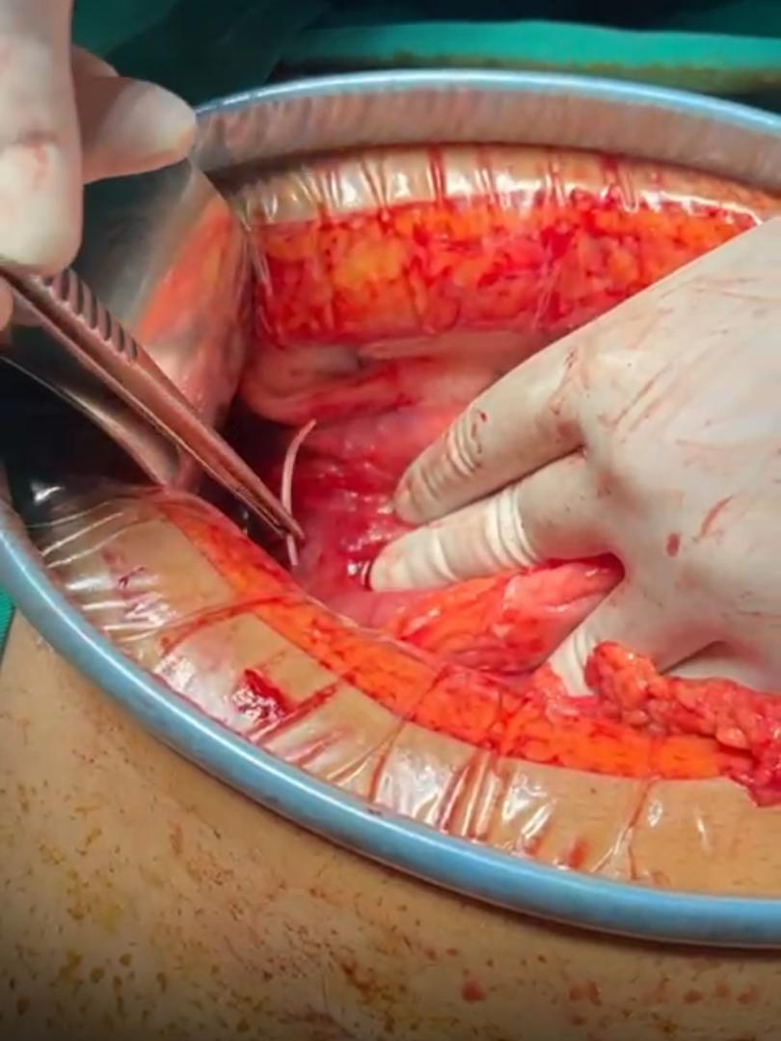
Fig. 2: Fish bone was retrieved during the surgery

3. discussion

Gastric perforation from foreign body ingestion is rare, accounting for less than 1% of GI perforations [Ngan JHK et al., 1990]. Fish bones are the most frequently reported sharp foreign bodies associated with perforation, particularly in populations with high fish consumption [3]. Perforation more commonly occurs in anatomically vulnerable locations yet can occur in the stomach under altered physiologic conditions.
The stomach's acidic environment and thick muscularis typically protect against perforation. However, long-term PPI therapy disrupts these defenses by elevating gastric pH, inhibiting enzymatic degradation, and altering mucosal immunity [Freedberg DE et al., 2017]. Chronic PPI use has also been associated with mucosal hypertrophy, decreased mucin secretion, and fundic gland cyst formation [Jung YS et al. 2007]. In our patient, these factors likely facilitated prolonged fish bone retention and gradual transmural penetration.
The clinical presentation of fish bone perforation is often nonspecific, and many patients do not recall ingestion. Plain radiographs may be normal due to the radiolucent nature of fish bones in up to 50% of cases [Coulier B. 2007]. Ultrasound can detect associated fluid but lacks specificity. In contrast, contrast-enhanced CT is highly sensitive for detecting hyperdense linear foreign bodies and their complications [Goh, B. K et al. 2006]. In this case, CT was pivotal in confirming the diagnosis and guiding surgical management. Management depends on the timing and severity of complications. Early endoscopic removal may be possible in stable cases without perforation. However, once perforation or abscess forms, surgical intervention is warranted. Laparoscopic approaches may be feasible but open laparotomy is preferred in cases with significant inflammation or anatomical complexity. For our patient, open surgery enabled definitive repair and abscess drainage.
4. Conclusion

This case highlights a rare but serious complication of gastric perforation caused by a retained fish bone in a patient receiving long-term PPI therapy. Chronic acid suppression impairs gastric defense mechanisms, promoting foreign body retention and delayed injury. Clinicians should consider occult foreign body perforation in patients with persistent upper abdominal symptoms on long-term PPI therapy, even in the absence of known ingestion. Contrast-enhanced CT remains the most reliable diagnostic modality, and timely surgical management is key to reducing morbidity and improving outcomes.

Consent

As per international standards, patient written consent has been collected and preserved by the authors

Ethical approval

As per international standards, patient written ethical approval has been collected and preserved by the authors

COMPETING INTERESTS DISCLAIMER:
Authors have declared that they have no known competing financial interests OR non-financial interests OR personal relationships that could have appeared to influence the work reported in this paper.

References

- Ngan JHK, Fok PJ, Lai E, Branicki FJ, Wong J (1990). A prospective study on fish bone ingestion. Am J Emerg Med, 8(5), 392–395.
- Liew C. J. Y., Poh A. C. C., Tan A. G. S. (2004). Fish bone ingestion with perforation of the gastric wall: CT findings. Singapore Med J, 45(10), 479–481.
- Freedberg DE, Kim LS, Yang YX (2017). The risks and benefits of long-term use of proton pump inhibitors: expert review and best practice advice. Nat Rev Gastroenterol Hepatol, 14(12), 697–710.
- Jung YS, Kim NH, Youn YH, Lee JH, Park H (2017). Histological changes in gastric mucosa during long-term PPI use. Gut Liver, 11(5), 639–646.
- Coulier B (2007). MDCT detection of a fish bone perforation of the gastric wall. JBR-BTR, 90(5), 449–450.
- Goh, B. K., Tan, Y. M., Lin, S. E., Chow, P. K., Cheah, F. K., Ooi, L. L. et al. (2006). CT in the preoperative diagnosis of fish bone perforation of the gastrointestinal tract. AJR Am J Roentgenol, 187(3), 710–714.

