Case report

Surgical Management of a Giant Zenker's Diverticulum with Intrathoracic Extension: A Case Report

Abstract
Introduction:
Zenker's diverticulum (ZD) is an acquired outpouching of mucosa and submucosa through the Killian triangle whose management, particularly for giant cases, remains a subject of discussion. Classic clinical signs, such as Boyce's sign, are crucial for diagnosis but are not always present.
Case Presentation: We present the case of a 62-year-old male with a long-standing history of progressive dysphagia, regurgitation, and a positive Boyce's sign on physical examination. A contrast-enhanced computed tomography scan and a barium swallow study revealed a giant ZD with a remarkable caudal extension down to the T2 vertebral level. The patient was successfully managed with an open transcervical diverticulectomy associated to a cricopharyngeal myotomy. His post-operative course was uneventful. At one-year follow-up, he reported complete and sustained resolution of all symptoms and had resumed a normal diet.
Conclusion: This case highlights that for giant Zenker's diverticula, the traditional open surgical approach remains a safe and highly effective treatment option. It provides the distinct advantages of complete excision and a controlled myotomy, leading to excellent long-term functional outcomes. Furthermore, it underscores the diagnostic importance of classic physical findings in the clinical evaluation of this condition.
Keywords: Zenker's Diverticulum; Boyce's sign; Diverticulectomy; Dysphagia; Case Report.
Introduction:
Zenker's diverticulum (ZD) is the most common type of esophageal diverticulum, with an estimated prevalence ranging from 0.01% to 0.11% in the general population.[1] It is an acquired, false, pulsion diverticulum, defined by the herniation of mucosa and submucosa through a posterior area of anatomic weakness known as Killian's triangle. This area is situated between the oblique fibers of the thyropharyngeal muscle and the horizontal fibers of the cricopharyngeal muscle.[2] The pathophysiology is primarily attributed to a dysfunction of the upper esophageal sphincter (UES), such as incomplete relaxation or hypertonicity, which results in increased intraluminal pressure during swallowing. This condition typically affects the elderly, with a peak incidence between the seventh and ninth decades of life and shows a male predominance.[3] Patients commonly present with symptoms such as dysphagia for solids and liquids, regurgitation of undigested food, halitosis, and chronic cough, which can significantly impair quality of life and lead to complications like aspiration pneumonia and malnutrition.
The management of ZD is indicated exclusively for symptomatic patients, with the primary goal of relieving the obstruction by performing a cricopharyngeal myotomy. For many years, the standard of care was an open transcervical surgery, consisting of a diverticulectomy or diverticulopexy combined with a myotomy.[4] While this approach offers excellent and durable symptom resolution, with success rates of 93-96% , it is associated with higher morbidity, including risks of recurrent laryngeal nerve injury (around 3.4%) and esophageal fistula (around 3.7%). To mitigate these risks, minimally invasive endoscopic techniques have been developed and are now widely considered first-line therapy in many centers. These include rigid transoral stapling and, more recently, flexible endoscopic septotomy (FES). The latest evolution in this field is the Zenker's per-oral endoscopic myotomy (Z-POEM), a third-space endoscopy technique that allows for a complete myotomy under direct visualization with a preserved mucosal layer, potentially reducing recurrence rates and overcoming the limitations of rigid approaches in patients with small diverticula or limited neck mobility.[5]
While endoscopic approaches are becoming the new standard, the open surgical technique remains a crucial component of the therapeutic armamentarium, particularly for very large diverticula, in cases of endoscopic failure, or based on surgeon and patient preference.[6][4]

Case Presentation
A 62-year-old male, a retired healthcare professional with a long-standing history of chronic tobacco use, was referred to our department for evaluation of progressive dysphagia. He reported a history of several years of difficulty swallowing both solids and liquids, associated with occasional episodes of aspiration, significant halitosis, and frequent eructations. Despite these debilitating symptoms, his general health status was well-preserved, and he had not experienced significant weight loss.
On physical examination, the patient appeared in good general condition with stable vital signs. The head and neck examination revealed a positive Boyce’s sign, which is a characteristic gurgling sound upon palpation of the neck that is highly suggestive of a Zenker’s diverticulum.[8] Figure 1
The diagnostic workup included a contrast-enhanced computed tomography (CT) scan of the neck and chest, performed following the ingestion of an oral contrast agent. This CT esophagogram revealed a massive posterior outpouching, filled with contrast material, air, and retained debris, originating from the pharyngoesophageal junction. The diverticular sac extended caudally through the superior and posterior mediastinum, with its distal tip reaching the level of the T2 vertebra, causing significant anterior compression of the thoracic esophagus. Figure 2,3,4
Based on its size, it was classified as a large (or giant) diverticulum, far exceeding the >10 cm threshold.
A careful upper gastrointestinal endoscopy was subsequently performed to inspect the diverticular mucosa and rule out any concurrent pathology, such as ulceration or malignancy, a rare but known complication. The esophageal lumen was identified, and the remainder of the upper endoscopy was unremarkable. Based on these findings, a diagnosis of a symptomatic, giant Zenker's diverticulum was confirmed, and the patient was scheduled for surgical intervention.
Surgical Procedure
An open surgical approach via a left-sided cervicotomy was chosen, as this method is often recommended for large diverticula and is associated with durable long-term results. Figure 5,6
The procedure was performed under general anesthesia with endotracheal intubation. The patient was placed in the supine position with the neck extended and the head rotated to the right to provide optimal exposure of the left cervical region. Following intubation, a nasogastric tube was inserted into the esophagus under direct vision to facilitate its identification during the dissection.
An incision was made along a skin crease over the anterior border of the sternocleidomastoid muscle. After incising the platysma, the dissection was carried down between the carotid sheath laterally and the strap muscles medially. To aid in precise localization of the diverticular sac amidst the surrounding tissues, intraoperative flexible endoscopy was utilized. The light from the endoscope provided excellent transillumination of the thin diverticular wall, clearly delineating its boundaries from the healthy esophagus. Figure 7,8

The diverticulum was dissected and mobilized down to its neck. A cricopharyngeal myotomy was then performed, extending approximately 3 cm distally onto the proximal esophagus to ensure complete release of the muscular obstruction. Figure 9
Following the myotomy, a linear cutting stapler was applied across the large base of the diverticular neck, and the diverticulum was resected. Figure 10
The resected specimen was sent for histopathological examination to rule out the presence of dysplasia or carcinoma.
Finally, after confirming hemostasis, a closed-suction drain was placed in the surgical bed, and the wound was closed in layers.

Follow-up and Outcomes
The patient's immediate post-operative course was Uneventful. A barium swallow study was performed on post-operative day 2, which demonstrated excellent passage of the contrast agent through the pharyngoesophageal junction with no evidence of staple line leak or esophageal stenosis. Figure 11
Following this reassuring result, the surgical drain was removed, and the patient was started on a liquid diet on post-operative day 3. He was subsequently discharged home on post-operative day 4 and successfully transitioned to a normal, unrestricted diet within 15 days of his surgery.
Histopathological examination of the resected specimen confirmed the diagnosis of a Zenker's diverticulum. The analysis described a true pulsion diverticulum containing squamous mucosa with chronic inflammatory changes, and importantly, there was no evidence of dysplasia or malignancy.
At his one-year follow-up appointment, the patient reported complete and sustained resolution of his preoperative symptoms. He expressed high satisfaction with the outcome of the procedure, which has significantly improved his quality of life.
Discussion
We have reported the successful management of a 62-year-old male presenting with a symptomatic, giant Zenker's diverticulum, which was notable for its remarkable caudal extension into the posterior mediastinum down to the T2 vertebral level. Surgical treatment is indicated only for symptomatic patients to improve quality of life and prevent severe complications like aspiration pneumonia.[4] In this case, the patient was treated effectively via an open transcervical diverticulectomy combined with a complete cricopharyngeal myotomy, which resulted in the complete and sustained resolution of his symptoms at one-year follow-up. This case highlights the enduring role and efficacy of the traditional open surgical approach, particularly in the management of anatomically complex or exceptionally large pharyngoesophageal diverticula.[4][9]
The management of Zenker's diverticulum has evolved significantly, with a clear trend towards minimally invasive endoscopic techniques. Flexible endoscopic septotomy (FES) and Zenker's per-oral endoscopic myotomy (Z-POEM) are now considered first-line therapy in many centers due to their lower complication rates, shorter hospital stays, and faster recovery.[4], [10] However, the open transcervical approach, as performed in our case, remains an indispensable and often superior option for a subset of patients, particularly those with exceptionally large or anatomically complex diverticula.[4] The giant size of the diverticulum in our patient, extending down to T2 , presented a significant challenge that favored an open approach. Such a large sac can be difficult to manage endoscopically, and an open procedure allows for complete excision of the diverticulum (diverticulectomy). This not only removes the symptomatic pouch entirely, thus minimizing the risk of recurrent symptoms from a residual sac, but also provides the entire specimen for histopathological analysis, which is crucial for definitively ruling out the rare occurrence of squamous cell carcinoma within the diverticulum.
Furthermore, the primary goal of any ZD treatment is to definitively address the underlying cricopharyngeal dysfunction by performing a myotomy. An incomplete myotomy is the principal cause of symptom recurrence. The open approach provides unparalleled direct visualization of the surgical field, ensuring that a complete and appropriately extended myotomy of the cricopharyngeus muscle can be performed with precision.[4][7] In our procedure, this was a critical step, and we extended the myotomy approximately 3 cm onto the esophagus to ensure complete release of the sphincter mechanism, a length commonly advocated for durable results. The use of a linear cutting stapler for the diverticulectomy also contributed to a secure and efficient closure of the pharyngotomy, a technique widely employed for its reliability. The additional use of intraoperative endoscopy for transillumination proved to be a valuable adjunct, facilitating the precise dissection and identification of the diverticular neck.
The primary limitation of this study is its design as a single case report. As such, its findings are not generalizable, and no definitive conclusions regarding the superiority of one technique can be drawn from this experience alone. However, this report contributes to the medical literature by providing a detailed roadmap for the successful management of a giant Zenker's diverticulum, an uncommon clinical entity.

Conclusion : this case powerfully demonstrates that the open transcervical approach is a safe and highly effective treatment for giant Zenker's diverticula. This traditional technique offers the distinct advantages of a complete diverticulectomy and a controlled, extensive cricopharyngeal myotomy, which are critical for achieving durable, long-term resolution of symptoms and preventing recurrence. While minimally invasive endoscopic therapies are rightly the first choice for most standard cases, the open surgical approach should be considered the standard of care for patients with exceptionally large or complex diverticula and must remain an essential skill for surgeons managing this pathology.[10]

Conflicts of interest/Competing interests :
All authors declare no conflicts of interest
Ethics approval
Not applicable
Consent to participate
Written informed consent was obtained from the patient to use medical data anonymously.
Written Consent for publication
Written informed consent was obtained from the patient for publication of this case report and accompanying images.
Availability of data and material
All data supporting the findings of this study are available within the paper and its supplementary information.
Large Language Model (LLM) was used to translate medical data from french to english, no data nor figure was generated by LLM tools

Figures
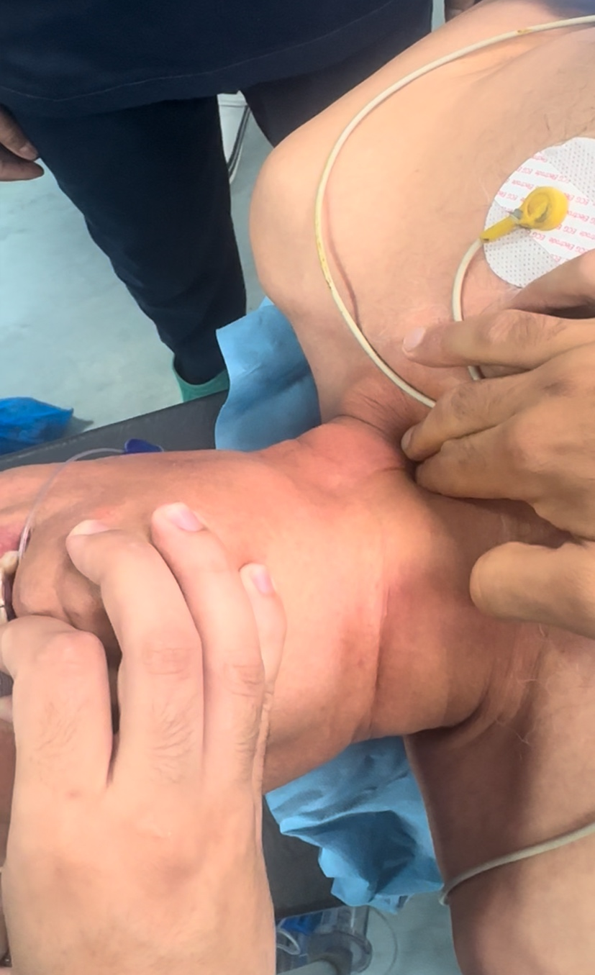
Figure1: Clinical Elicitation of Boyce's Sign. The image demonstrates the physical examination manoeuvre used to elicit Boyce's sign in our patient. This involves the gentle palpation and compression of the lateral neck over the presumed location of the Zenker's diverticulum. A positive sign, as was found in this case, is characterized by a palpable or audible gurgling sound, which results from the displacement of trapped air and fluid from the diverticulum back into the pharynx.

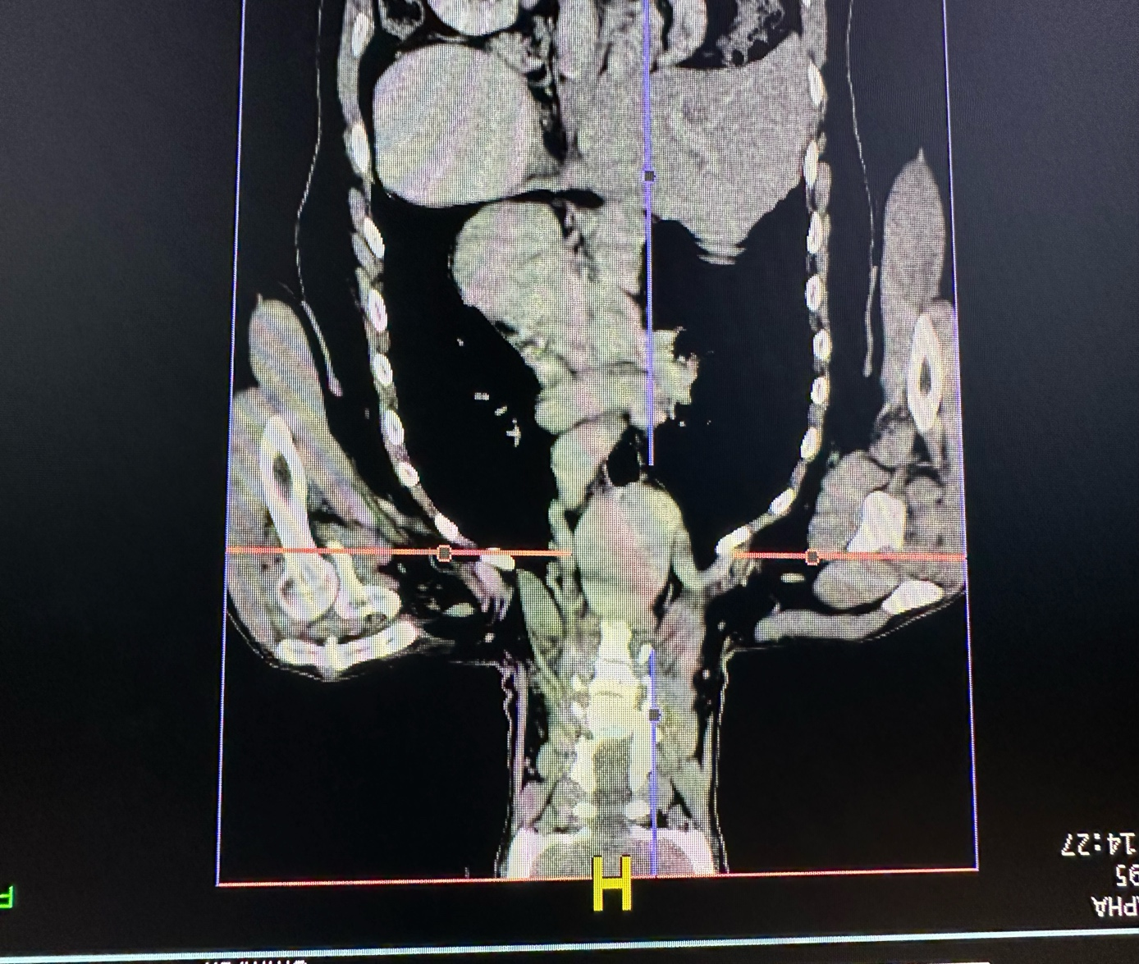
Figure 2: coronal contrast-enhanced CT scan demonstrating a giant Zenker's diverticulum with significant inferior extension into the posterior mediastinum, causing marked compression of the esophagus.

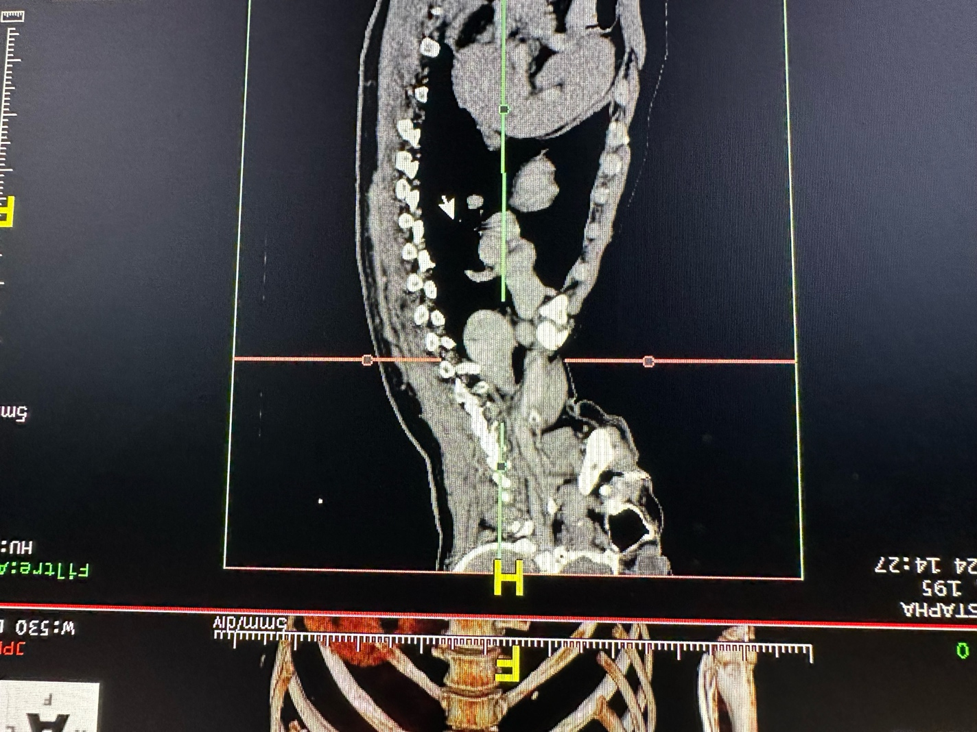
Figure 3: A sagittal view from the preoperative CT scan demonstrates the massive posterior diverticulum extending deep into the mediastinum

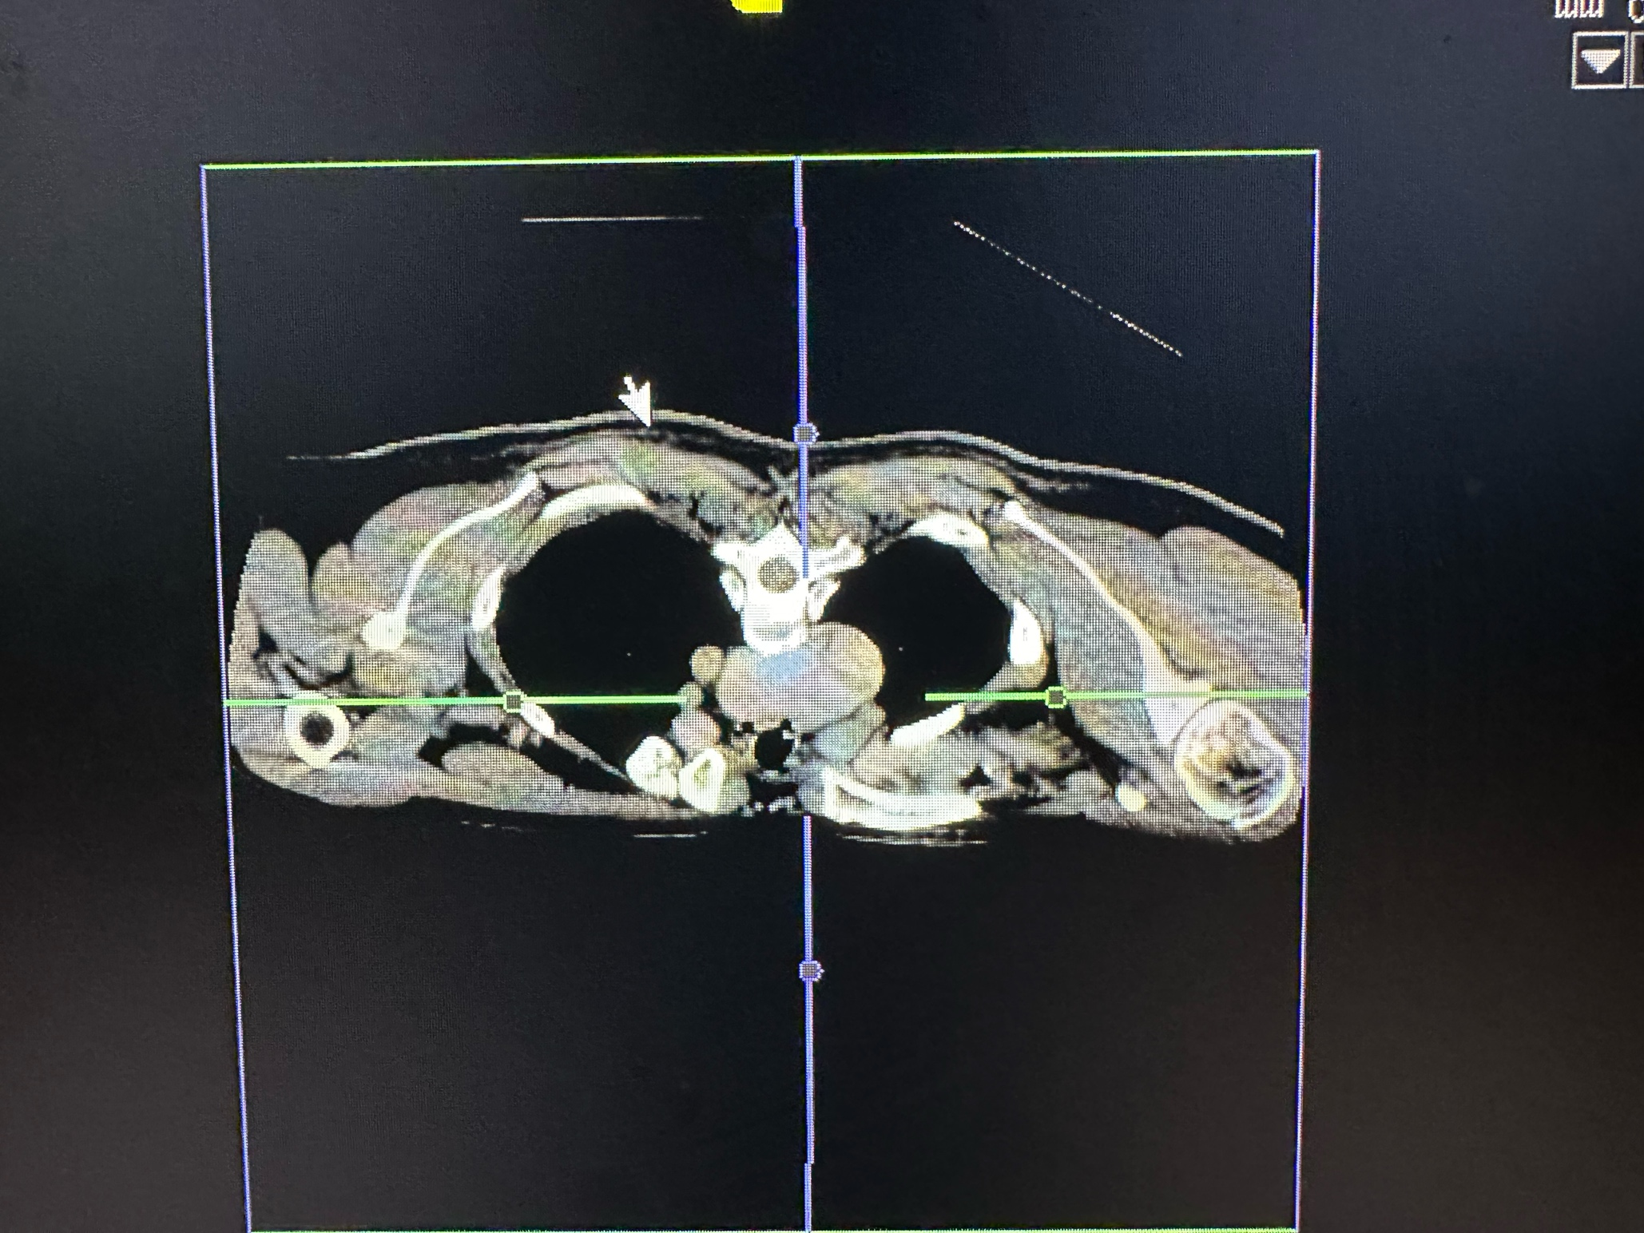
Figure 4: Axial view from the preoperative CT scan

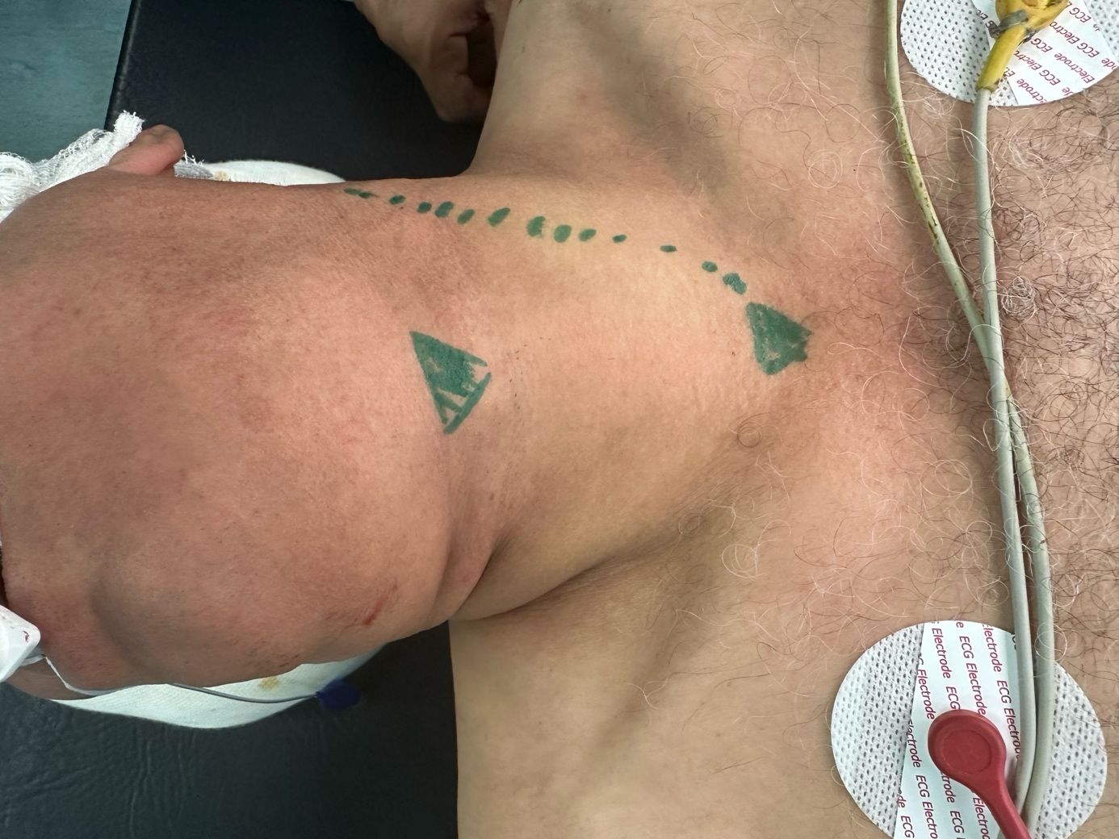
Figure 5: the surgical skin markings for the planned left-sided cervicotomy.
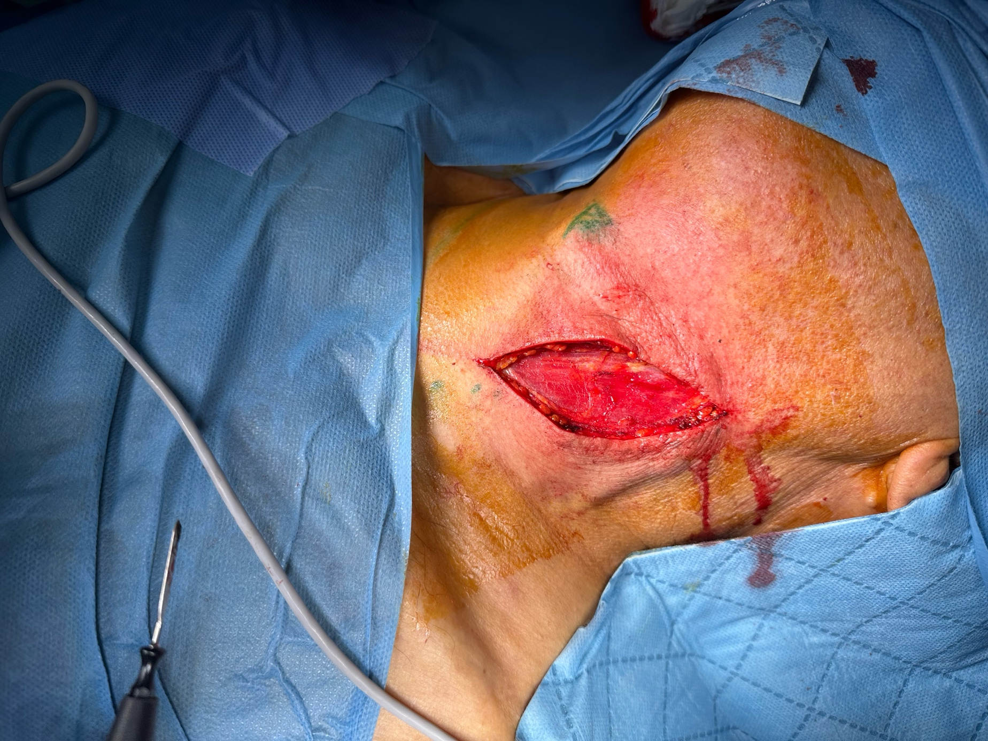
Figure 6: incision made along the anterior border of the sternocleidomastoid muscle
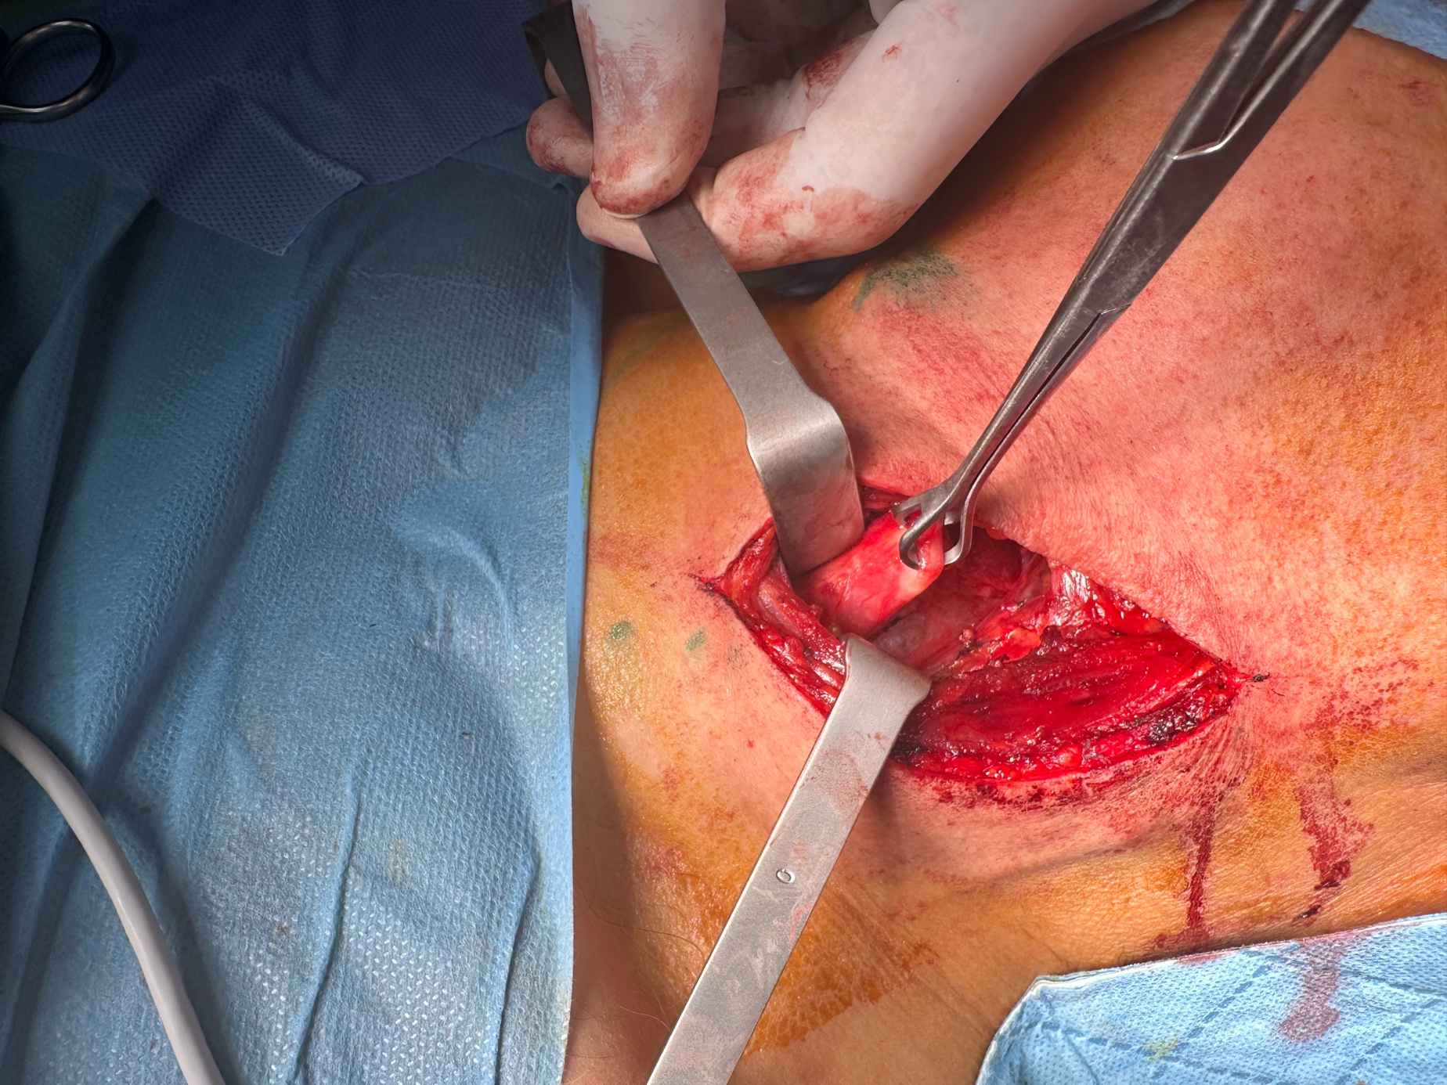
Figure 7: dissection of the Diverticulum
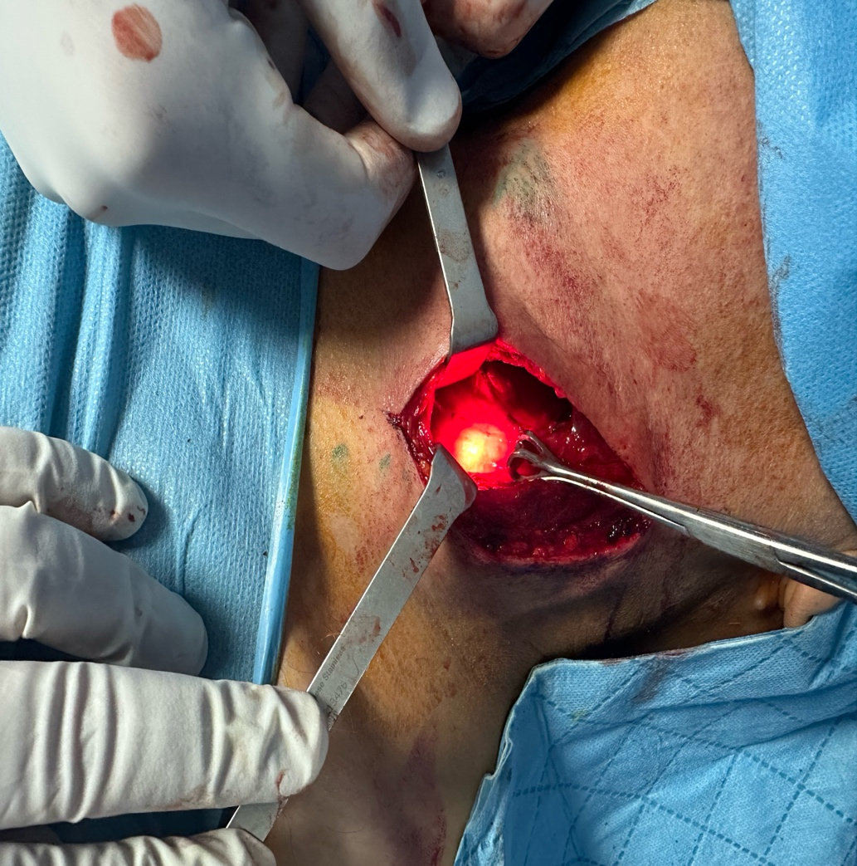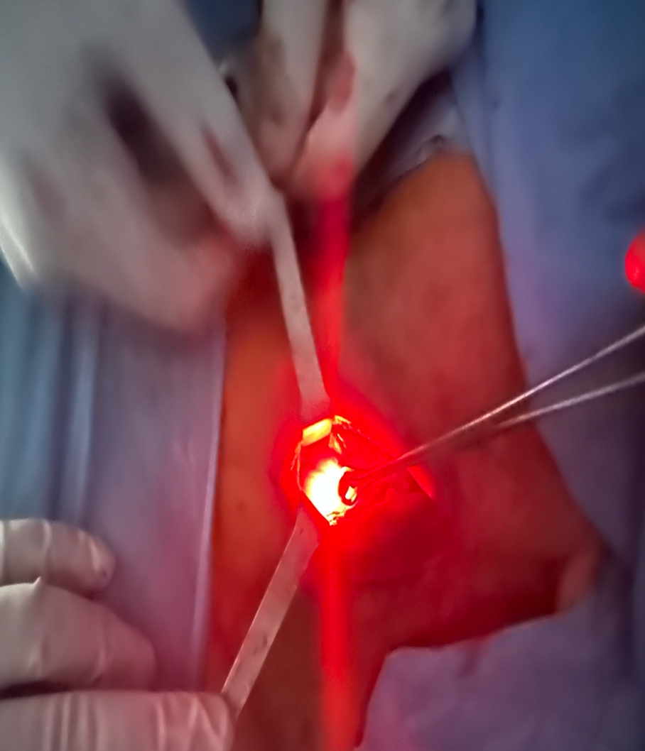
Figure 8: images illustrating the intraoperative use of flexible endoscopy for transillumination, aiding in the precise identification and dissection of the Zenker's diverticulum
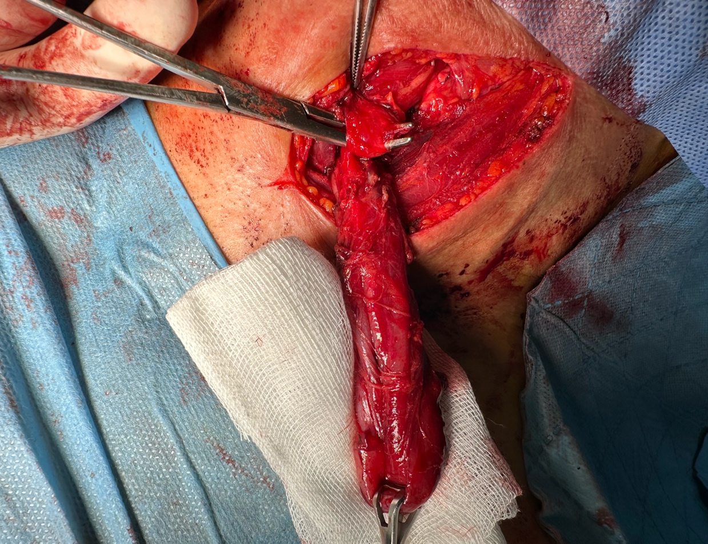

Figure 9: complete dissection of the diverticulum associated to a cricopharyngeal myotomy
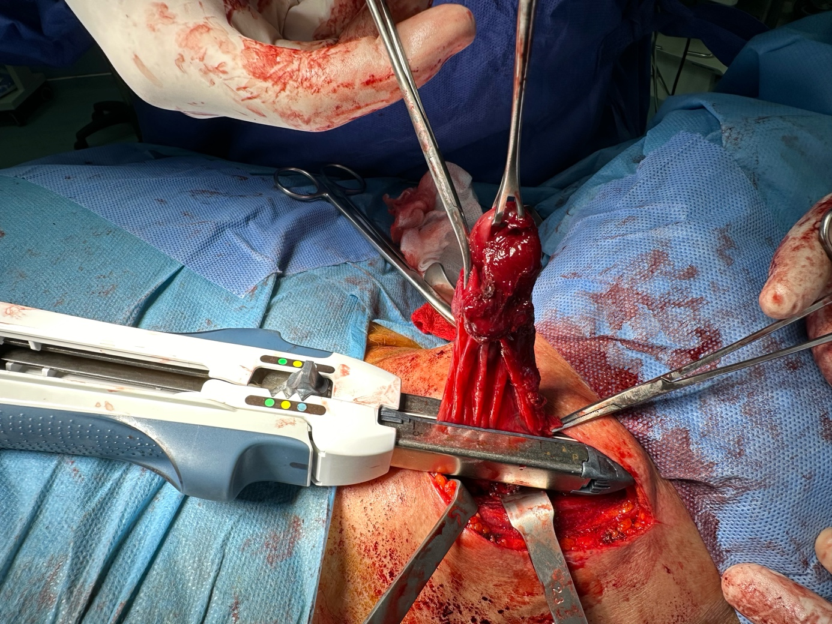
Figure 10: diverticulum section with a linear cutting stapler
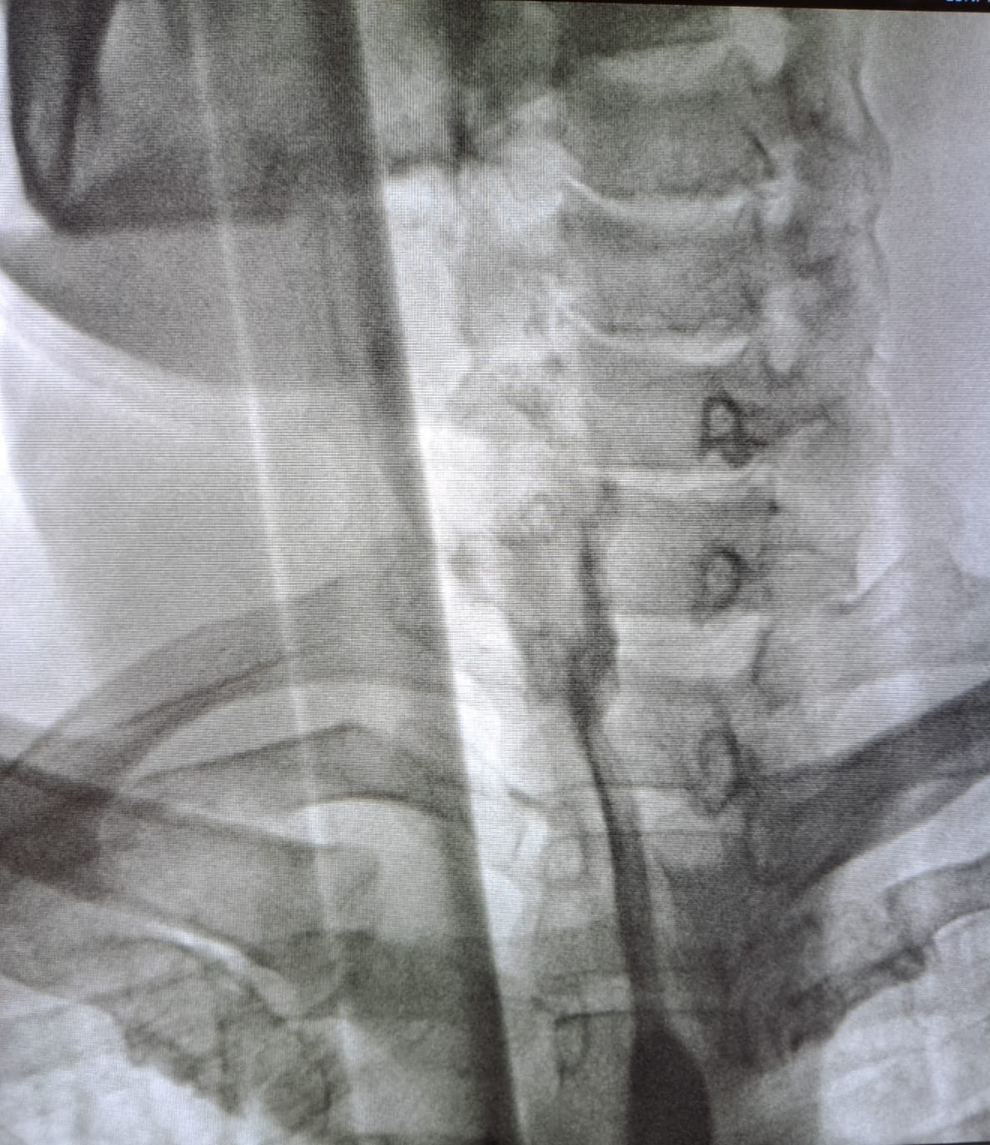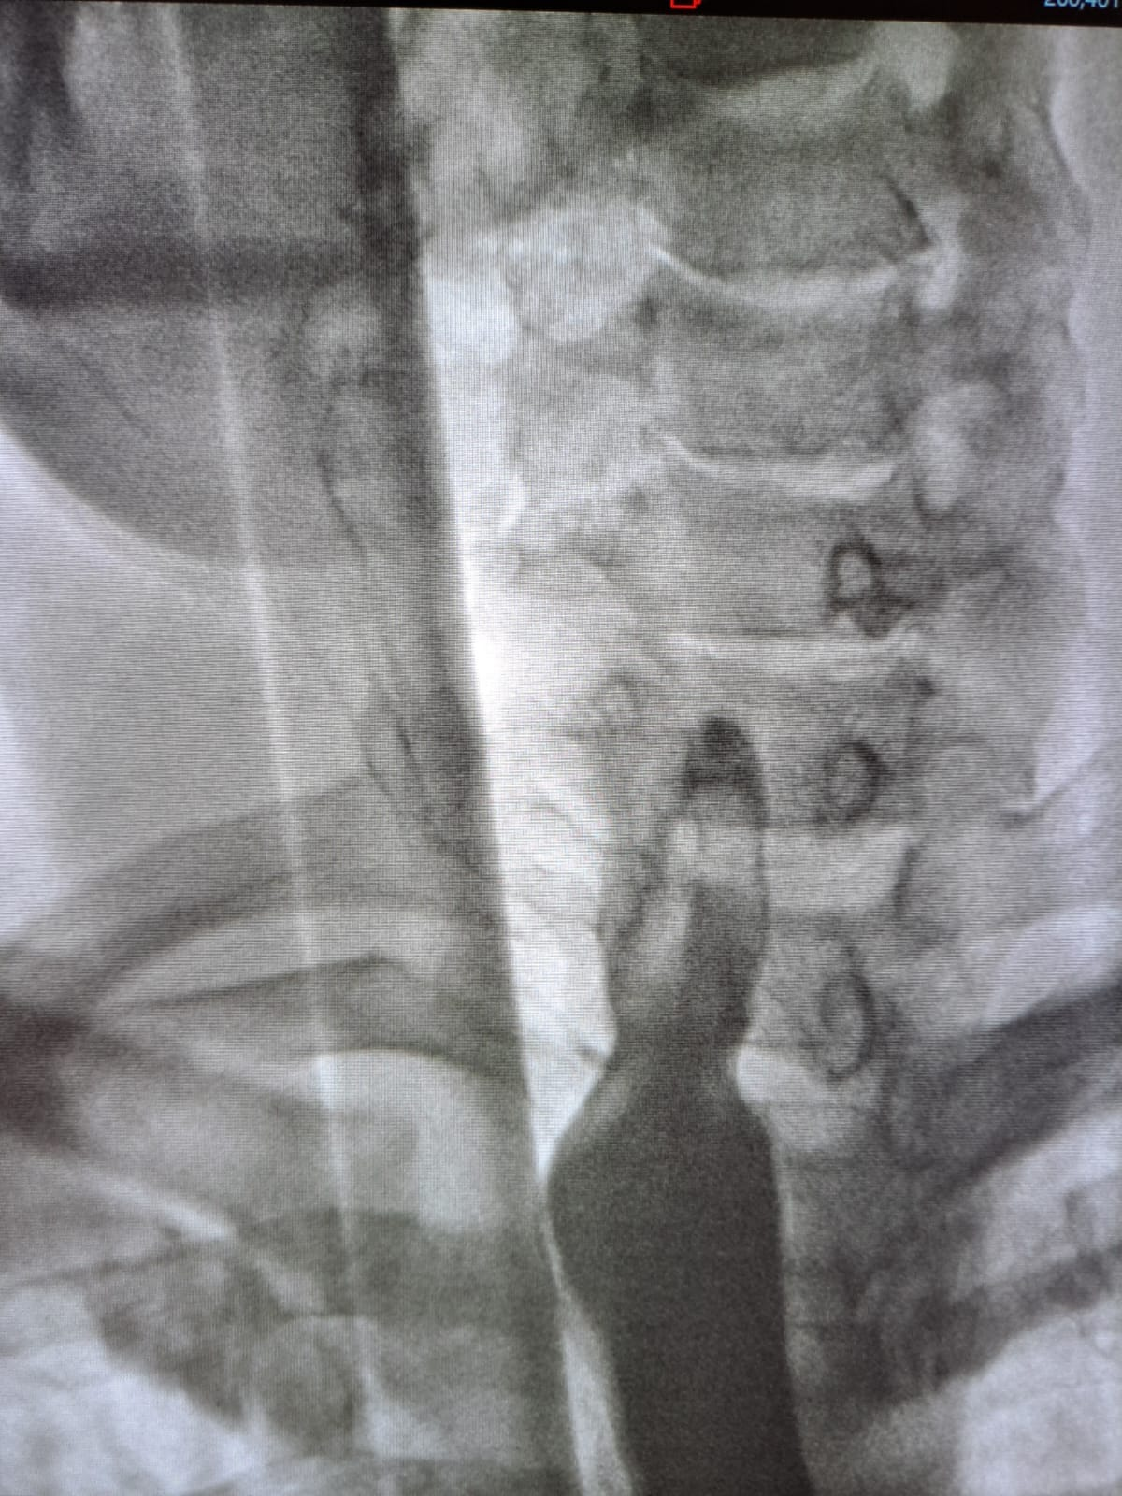
Figure 11: A barium swallow study demonstrates an excellent passage of the contrast agent through the pharyngoesophageal junction with no evidence of staple line leak or esophageal stenosis
References:

[1] P. Dahal, S. K. Malla, R. P. Upadhyaya, S. Parajuli, et N. Dhakal, « Zenker’s diverticulum: A case study of dysphagia in an elderly gentleman », Radiol. Case Rep., vol. 19, nº 10, p. 4417‑4421, oct. 2024, doi: 10.1016/j.radcr.2024.07.004.
[2] Ferri, Fred F., MD, « Zenker Diverticulum - ClinicalKey », Anu. 1 2024.
[3] L. Barbieri, F. Puccetti, et R. Rosati, « Zenker’s diverticulum from pathophysiology to novel therapeutic approaches », in Dysphagia, Elsevier, 2023, p. 105‑118. doi: 10.1016/B978-0-323-99865-9.00013-0.
[4] V. Porziella et al., « Surgical treatment of Zenker diverticula », Ann. Esophagus, vol. 6, p. 11‑11, mars 2023, doi: 10.21037/aoe-2020-25.
[5] V. Gupta et al., « Zenker per-oral endoscopic myotomy (Z-POEM): The ideal first-line therapy for treatment of Zenker diverticulum », J. Thorac. Cardiovasc. Surg., vol. 170, nº 1, p. 74‑83, juill. 2025, doi: 10.1016/j.jtcvs.2024.11.033.
[6] Manno, M., Piccoli, M., Frazzoni, M., & Conigliaro, R. (2017). Endoscopic and Surgical Management of Zenker’s Diverticulum: New Approaches (pp. 179–187). Springer, Cham. https://doi.org/10.1007/978-3-319-42358-6_11

[7] K. Alves De Lima Silva, T. L. A. Rosa, L. M. D. C. Sampaio, et O. M. E. Nobre, « Relato de Caso: Divertículo de Zenker », Braz. J. Implantol. Health Sci., vol. 6, nº 12, p. 282‑292, déc. 2024, doi: 10.36557/2674-8169.2024v6n12p282-292.
[8] S. C. Sharma, P. Sakthivel, S. Singh, et D. Kumar, « Boyce’s sign in a large Zenker’s diverticulum », Lancet Gastroenterol. Hepatol., vol. 4, nº 9, p. 742, sept. 2019, doi: 10.1016/S2468-1253(19)30187-6.
[9] M. Dallemagne, V. Favier, R. Garrel, « Traitement chirurgical du diverticule pharyngo-œsophagien », 2021, vol. 29, nº 1, 2000, doi: 10.1016/s2211-0402(21)76842-5.
[10] M. S. Wagh et P. V. Draganov, « How to Approach a Patient with a Zenker’s Diverticulum », Gastroenterology, vol. 160, nº 1, p. 10‑14, janv. 2021, doi: 10.1053/j.gastro.2020.11.018.

